Evaluation of Oxidative Stress and Histological Changes Caused by a Common Laundry Detergent in the Freshwater Fish, Channa punctatus

Abstract
Laundry detergents, with their pervasive domestic and industrial use, introduce chemically complex effluents into aquatic systems, where many components demonstrate significant toxicity to aquatic life. This study investigated the sublethal effects of a commercially prevalent detergent, Ariel, on the freshwater fish Channa punctatus, focusing on histopathological alterations and oxidative stress biomarkers in liver and gill tissues. The median lethal concentration (LC₅₀) for 96 hours was determined to be 32 ppm via probit analysis. To assess chronic toxicity, fish were exposed to a sublethal concentration (6.4 ppm, one-fifth of the LC₅₀) for 7 and 14 days. A significant (p<0.05) time-dependent decline was observed in the activities of key antioxidant enzymes catalase (CAT), superoxide dismutase (SOD), glutathione reductase (GR), glutathione-S-transferase (GST), and in glutathione (GSH) levels in both tissues. Concurrently, xanthine oxidase (XO) activity and malondialdehyde (MDA) levels, an indicator of lipid peroxidation, were markedly elevated. Histological examination revealed pronounced impairments, including disorganized and degenerated hepatocytes, sinusoidal dilation, and vacuolization in the liver. Gill tissues exhibited hyperemia, congestion in the secondary lamellae, and, after 14 days, curling and fusion of lamellae. The toxicological perturbations were more severe in the 14-day exposure group and consistently more pronounced in gill tissue compared to liver. These findings demonstrate that Ariel detergent induces significant oxidative stress, leading to time-dependent histopathological damage, likely due to the synergistic action of its chemical constituents, highlighting a substantial ecotoxicological risk to freshwater fish.

Keywords: Ariel detergent, Oxidative Stress, Histopathology, Channa punctatus, Sublethal Toxicity, Aquatic Toxicology, Antioxidant Enzymes

Introduction
The degradation of aquatic ecosystems through pollution represents a critical environmental challenge, primarily driven by the direct release of untreated urban and industrial wastewater into water bodies (Donat et al., 2020). Among the diverse pollutants entering aquatic systems, laundry and cleaning products constitute significant contributors due to their extensive household application worldwide (Doyinsola and Kafilat, 2020). Municipal and industrial effluents transport complex mixtures of chemical compounds, heavy metals, and pathogenic microorganisms into aquatic habitats, disrupting ecological stability and endangering marine life (Bamaniya et al., 2023). The expanding global surfactant industry, projected to surpass US$28.8 billion in market value (Brycki et al., 2017), highlights the escalating production and environmental release of detergent components. Substantial quantities of detergent residues enter aquatic environments through greywater systems, presenting considerable ecological risks. These chemical formulations adversely influence aquatic biodiversity, affecting both flora and fauna, while simultaneously disrupting microbial communities and fundamental water quality parameters. Documented environmental impacts include accelerated eutrophication, dissolved oxygen reduction, impaired light penetration, and alterations to pH and salinity regimes. Furthermore, detergent compounds interfere with bacterial populations essential for natural water purification processes. Consequently, aquatic organisms, particularly fish species, experience both direct physiological damage and indirect ecological consequences from these contaminants (Khan, 2022; Lee et al., 2022; Uc-Peraza and Delgado-Blas, 2012).
Commercial detergent products comprise sophisticated chemical blends containing both cationic and anionic surfactants supplemented with multiple additives including water softening agents, preservatives, bleaching compounds, color pigments, enzymatic preparations, foam stabilizers, and fragrance components (Bajpai and Tyagi, 2007). Environmental persistence represents a major concern, as many detergent constituents remain in ecosystems and induce various toxicological effects in aquatic organisms, particularly fish species (Uc-Peraza and Delgado-Blas, 2012). Synthetic surfactant compounds including alkyl benzene sulfonate (ABS), dodecylbenzene sulfonate (DBS), and linear alkylbenzene sulfonate (LAS) warrant particular attention due to their demonstrated adverse effects on aquatic biota (Uc-Peraza and Delgado-Blas, 2015; PROFEPA, 2002). Contemporary toxicological research has evaluated detergent components across multiple biological systems, examining their impacts on algal species (Jonsson, 2009), Daphnia magna (Pettersson et al., 2000), microalgae (Azizullah et al., 2011), and genotoxic potential in human leukocytes (Pedrazzani et al., 2012). Fish species represent particularly valuable bioindicators for aquatic pollution assessment, demonstrating rapid stress responses across multiple biological organization levels (Begum et al., 2005).
The toxicological mechanism of surfactants primarily involves cellular membrane disruption through oxidative stress generation and subsequent biomolecular damage (Li et al., 2015). Even at minimal concentrations, detergent compounds alter membrane permeability and disrupt metabolic processes (Argese et al., 1994), potentially causing population declines through catastrophic mortality events (Me-Hui, 2008). Synthetic detergent formulations containing LAS stimulate reactive oxygen species (ROS) production, resulting in cellular junction disruption and cytotoxicity (Bradai et al., 2014). Detergent components consequently promote tissue damage and histopathological deterioration in vital piscine organs including hepatic, renal, branchial, integumentary, cardiac, and neural tissues through ROS-mediated oxidative stress pathways (Kumar et al., 2007; Varsha et al., 2013).
Cellular antioxidant defense mechanisms, comprising enzymatic elements including SOD, CAT, GPx, and non-enzymatic antioxidants such as glutathione, typically counteract excessive ROS formation. However, overwhelming free radical production can compromise these protective systems, diminishing their capacity to prevent oxidative damage (Shukla and Trivedi, 2018). Elevated detergent concentrations additionally induce behavioral abnormalities in fish including irregular locomotion, muscular convulsions, and postural distortion (Cserhati et al., 2002). Recent investigations of commercial detergent products (Surf, Tide, Nirma) document significant behavioral and biochemical modifications, reduced respiratory efficiency, and equilibrium disturbances in exposed fish specimens (Chandanshive, 2013, 2015; Choudary and Jha, 2013). Notably, the commercial detergent Ariel has been shown to adversely impact oxidative enzymes and proteins in liver and heart tissue, while also causing degenerative changes in respiratory lamellae. Chronic exposure to this formulation has been linked to severe histopathological manifestations, including epithelial detachment and tissue atrophy, in species such as Oreochromis mossambicus (Nkpondion et al., 2016; Ubong et al., 2015; Raju et al., 1994).
While substantial scientific literature addresses the toxicity of individual detergent components, comprehensive evaluations of complete commercial formulations remain limited. This represents a significant knowledge gap, particularly for widely used products like Ariel. This deficiency is critical because detergent constituents may interact through antagonistic, additive, or synergistic mechanisms within aquatic environments (Warne and Schifko, 1999). Isolated assessment of individual components fails to accurately represent the net environmental impact of a commercial detergent, necessitating whole-product biological evaluation (Azizullah et al., 2011; Markina and Aizdaicher, 2007).
Therefore, this investigation was designed to evaluate the integrated toxicological effects of the complete, commercially available Ariel detergent formulation on the freshwater teleost Channa punctatus. Our specific research objectives were to: (1) determine the median lethal concentration (LC₅₀) of the whole Ariel product, and (2) evaluate the detergent-induced oxidative stress and consequent histopathological impairments in liver and gill tissues after sublethal exposure. The findings will provide a more ecologically relevant understanding of the toxicological mechanisms elicited by this commonly used laundry detergent, offering crucial insights for environmental risk assessment.

Materials and Methods

Experimental Organisms and Acclimatization
Healthy adult specimens of Channa punctatus (mean weight: 50 ± 2 g; mean length: 10 ± 2 cm) were sourced from the fisheries department in Tirupati, Andhra Pradesh, India. Upon arrival at the laboratory, the fish were immediately given a prophylactic bath in a 0.05% KMnO₄ (potassium permanganate) solution for two minutes to prevent superficial infections. They were then transferred to large cement tanks containing clean, dechlorinated tap water. An acclimatization period of two weeks was maintained under controlled conditions with a period of 12-hour light and 12-hour dark with continuous aeration and water filtration. The fish were fed a commercial pellet diet twice daily to satiation. To maintain optimal water quality and prevent hypoxia, approximately one-third of the tank water was replaced daily with fresh, oxygenated dechlorinated water.

Test Chemical
The chemical examined in this study was Ariel, a widely used laundry detergent manufactured by Procter & Gamble GmbH in Germany, which was purchased from a local market in India.

Determination of Median Lethal Concentration (LC₅₀) and Experimental Exposure
A preliminary range-finding test was conducted to establish the approximate toxic concentration of the Ariel detergent. Based on these results, a definitive acute toxicity test was performed using ten serially diluted concentrations ranging from 23 to 40 parts per million (ppm) over a 96-hour period. The median lethal concentration (LC₅₀) value was subsequently calculated using probit analysis (Finney, 1971; Stephan, 1977). For the sub-chronic toxicity study, a sub-lethal concentration equivalent to one-fifth of the 96-h LC₅₀ was selected. The fish were systematically divided into three experimental groups: Group I (Control): Maintained in clean, contaminant-free water without any test chemical; Group II: exposed to the sub-lethal Ariel concentration for 7 days. Group III: exposed to the same sub-lethal Ariel concentration for 14 days.

Tissue Sampling and Oxidative Stress Assays
Upon completion of the 7-day and 14-day exposure periods, fish from each group were euthanized. Gill and liver tissues were dissected, rinsed in ice-cold physiological 0.9% NaCl (saline), and blotted dry. The tissues were then homogenized in an appropriate cold buffer to create a 10% (w/v) homogenate. The resulting homogenates were centrifuged, and the supernatants were aliquoted and stored at -80°C to preserve enzyme integrity until subsequent biochemical analyses could be performed.

Biochemical Assays
Superoxide Dismutase (SOD) Activity
We measured SOD activity following the protocol by Misra and Fridovich (1972). Tissue samples were homogenized in an ice-cold 50 mM phosphate buffer (pH 7.0, with 0.1 mM EDTA) to create a 5% (w/v) homogenate. After centrifuging the homogenates at 10,000 rpm for 10 minutes at 4°C, we collected the supernatant for the assay. The reaction was initiated by adding 20 µl of 30 mM epinephrine (in 0.05% acetic acid) to a mixture containing 100 µl of tissue extract and 880 µl of carbonate buffer (0.05 M, pH 10.2, with 0.1 mM EDTA). We monitored the change in optical density at 480 nm for 4 minutes using a Hitachi U-2000 Spectrophotometer. Enzyme activity is defined as the amount of enzyme that causes 50% inhibition of the photoreduction and is reported as units of superoxide anion reduced per mg of protein per minute.
Catalase (CAT) Activity
Catalase activity was assessed based on a modified procedure from Aebi (1984). Tissue homogenates were centrifuged at 10,000 rpm for 10 minutes at 4°C to obtain the supernatant for analysis. We pre-treated 100 µl of tissue extract with 10 µl of absolute ethanol and incubated it on ice for 30 minutes. After bringing the samples to room temperature, we added 10 µl of Triton X-100 RS. The reaction was started by adding 250 µl of 0.066 M H₂O₂ (in phosphate buffer) to a cuvette containing 200 µl of phosphate buffer and 50 µl of the tissue extract. We measured the decrease in absorbance at 240 nm over 60 seconds. Using a molar extinction coefficient of 43.6 M⁻¹cm⁻¹, we calculated the activity, expressed as µmoles of H₂O₂ degraded per mg of protein per minute.
Glutathione Peroxidase (GPx) Activity
GPx activity was determined by monitoring NADPH oxidation at 340 nm in a coupled enzyme system (Tappel et al., 1982). The reaction mixture consisted of 48.5 µmol Tris-HCl buffer (pH 7.8), 77 mM EDTA, 0.25 µmol reduced glutathione (GSH), 0.12 µmol NADPH, 0.5 units of glutathione reductase, and 0.20 µmol cumene hydroperoxide. We calculated the activity using an extinction coefficient of 6,200 M⁻¹cm⁻¹ for NADPH, expressing the results as micromoles of NADPH oxidized per mg of protein per minute.
Glutathione Reductase (GR) Activity
GR activity was evaluated by tracking the oxidation of NADPH at 340 nm (Carlberg and Mannervik, 1975). The assay mixture contained 600 µl of buffer (0.1 M potassium phosphate, 0.5 mM EDTA, 0.1 mM KCl; pH 7.5), 100 µl of 0.1 mM NADPH, 100 µl of distilled water, and 100 µl of tissue homogenate. Following a 5-minute pre-incubation at 37°C, we started the reaction by adding 100 µl of 1 mM oxidized glutathione (GSSG). Activity is reported as µM of NADPH oxidized per minute per mg of protein.
Glutathione-S-Transferase (GST) Activity
We determined GST activity spectrophotometrically at 340 nm using 1-chloro-2,4-dinitrobenzene (CDNB) as the substrate, according to Habig et al. (1974). Tissues were homogenized in a 50 mM ice-cold Tris-HCl buffer (pH 7.4) containing 0.2 M sucrose and centrifuged at 16,000 g for 45 minutes at 4°C. The resulting supernatant served as the enzyme source. The complete reaction mixture (3 ml total volume) included 2.4 ml of 0.3 M potassium phosphate buffer (pH 6.9), 0.1 ml of 30 mM CDNB, 0.1 ml of 30 mM GSH, and 0.4 ml of the enzyme solution. The reaction began with the addition of glutathione, and we expressed the activity in µmoles of thioether formed per mg of protein per minute.
Total Glutathione (GSH) Level
We quantified total glutathione levels as reduced glutathione (GSH) using an enzymatic recycling assay (Rahman et al., 2006). In this method, GSH reacts with DTNB (5,5′-dithio-bis(2-nitrobenzoic acid)) to produce a yellow-colored TNB (5′-thio-2-nitrobenzoic acid). We combined 100 µL of tissue homogenate with 150 µL of a working solution containing 0.5 mM DTNB and 6.3 U/mL glutathione reductase in GSH buffer (185 mM phosphate buffer, pH 7.4, with 6.3 mM EDTA). After shaking for 5 minutes, we added 50 µL of 1 mM NADPH (in GSH buffer) and measured the absorbance at 412 nm. The results are given in mg of GSH per g of protein.
Xanthine Oxidase (XO) Activity
Xanthine oxidase activity was measured using the dye reduction method of Srikanthan and Krishnamurthy (1955). The assay mixture contained 100 µmoles of sodium phosphate buffer (pH 7.4), 50 µmoles of xanthine, 0.1 µmoles of NAD, 0.4 µmoles of INT, and the enzyme source. We initiated the reaction by adding 20 mg of the enzyme source and incubated it at 37°C for 30 minutes. The reaction was terminated with 5 ml of glacial acetic acid. The formazan produced was extracted into 5 ml of toluene, and its absorbance was read at 495 nm against a toluene blank. Activity is expressed as µmoles of formazan generated per mg of protein per hour.
Lipid Peroxidation (MDA Levels)
We assessed lipid peroxidation by measuring malondialdehyde (MDA) levels with the thiobarbituric acid (TBA) reaction (Ohkawa et al., 1979). Tissues were homogenized (5% w/v) in a 50 mM phosphate buffer (pH 7.0) containing 0.1 mM EDTA. The homogenates were centrifuged at 10,000 rpm for 10 minutes at 4°C, and the supernatant was used for the assay. We mixed 200 µl of the tissue extract with 50 µl of 8.1% SDS, vortexed it, and let it incubate at room temperature for 10 minutes. Then, we added 375 µl of 20% acetic acid (pH 3.5) and 375 µl of 0.6% TBA and heated the mixture in a boiling water bath for 60 minutes. After cooling, we added 1.25 ml of a butanol-pyridine mixture (15:1 ratio), vortexed, and centrifuged at 1000 rpm for 5 minutes. We measured the absorbance of the colored upper layer at 532 nm. Lipid peroxidation is expressed as nmoles of MDA formed per mg of protein per minute.
Protein Concentration
We determined the protein content of all samples using the Bradford method (1976) to standardize and express the enzymatic activities relative to tissue protein content.

Histological Analysis
Liver and gill samples were fixed in 4% formaldehyde for 24 hours. The fixed tissues were then processed through a graded ethanol series for dehydration, cleared in xylene, and embedded in paraffin blocks. We sectioned the tissues at 4-5 µm thickness using a Leica RM rotary microtome and mounted the sections on glass slides. The sections were stained with Delafield's hematoxylin and eosin (H&E), air-dried, and examined under an Olympus optical microscope for image capture.

Statistical Analysis
We performed statistical analyses using We performed statistical analyses by using SPSS software (version 10.1), and all data are mentioned as mean values with their standard deviations (SD). The One-way analysis of variance (ANOVA) was used to evaluate differences between experimental groups, followed by the Student-Newman-Keuls (SNK) post hoc test for multiple comparisons. A p-value less than 0.05 was considered statistically significant.
Results

Acute Toxicity of Laundry Detergent
The acute toxicity of the commercial detergent Ariel to C. punctatus was evaluated through a 96-hour bioassay. Figure 1 illustrates the concentration-dependent mortality, with the percentage of fish lethality rising as the detergent concentration increased. The median lethal concentration (LC₅₀) at 96 hours was calculated to be 32 ppm. Mortality rates progressed from 4-30% within the 25-29 ppm range, to 30-70% between 29-34 ppm, and reached 70-100% at concentrations from 34 to 40 ppm. These findings confirm a clear positive correlation between detergent concentration and mortality rate in the test species.

Biomarkers of Oxidative Stress
The impact of sublethal Ariel exposure on the oxidative stress response in C. punctatus is summarized in Figures 2 through 9. Exposure to the detergent resulted in significant, time-dependent alterations in the activity of key antioxidant enzymes and markers in both liver and gill tissues. A general suppression of the primary antioxidant defense system was observed. The activities of CAT, GPx, GR, and the level of GSH all showed a progressive decline over the 7- and 14-day exposure periods when compared to control fish. In contrast, the activity of xanthine oxidase (XO) and glutathione-S-transferase (GST) exhibited a time-dependent increase in both tissues. Superoxide dismutase (SOD) activity displayed a biphasic response, with an initial increase after 7 days of exposure followed by a significant decrease by day 14. The toxicological impact of the detergent exhibited a clear time-dependent exacerbation, with the 14-day exposure group demonstrating markedly more severe enzymatic perturbations relative to the 7-day group. Quantitatively, the activity and levels of key biomarkers in the 14-day group shifted as follows: SOD decreased by 24.2% in the liver and 47% in the gill; CAT fell by 31.2% (liver) and 42.3% (gill); and XO activity, in contrast, increased by 31% and 29.4% in the liver and gill, respectively. Similarly, GPx, GR, and GST activities were suppressed by 30.3%, 30.9%, and 31.2% in the liver and by 42.2%, 37.6%, and 51.2% in the gill, while GSH levels declined by 36.2% and 42.3% in the liver and gill. Concurrently, lipid peroxidation intensified significantly with exposure duration. From control values of 15.5 ± 1.3 and 8.8 ± 0.4 in the liver and gill at 7 days, MDA levels rose by 11.2% and 24.7% respectively after one week of exposure, and surged further by 28.3% in the liver and 39.7% in the gill after two weeks. Collectively, these results unequivocally demonstrate that the gill tissue suffered a greater magnitude of oxidative stress and cellular damage than the liver across all measured parameters.

Histopathological Alterations in Liver and Gill
Histological examination of liver and gill tissues from control and Ariel-exposed fish revealed significant detergent-induced damage, as depicted in Figure 10 (a & b). In the liver, tissues from the control group exhibited a normal, well-organized parenchymal structure, featuring polygonal hepatocytes arranged in intact cords around central veins and well-defined sinusoids (Fig. 10a). Conversely, liver sections from fish treated with Ariel detergent displayed profound architectural disarray. The hepatocytes were irregularly arranged, showed signs of degeneration, and were often separated by widely dilated sinusoidal spaces. Prominent cytoplasmic vacuolization and numerous hepatocytes with condensed, pyknotic nuclei were also prevalent, indicating advanced cellular injury (Fig. 10a).
The gill morphology of control fish was characterized by an orderly structure, with unbranched primary lamellae giving rise to thin, uniformly spaced secondary lamellae essential for respiration (Fig. 10b). In stark contrast, gills from the exposed groups exhibited extensive and progressive pathology. Key observations included hyperemia (engorgement of blood vessels) in the afferent and efferent arteries and noticeable congestion within the secondary lamellae. The damage was particularly severe after the 14-day exposure, manifesting as pronounced curling of the secondary lamellae, fusion of adjacent lamellae, and erosion of their delicate tips. The respiratory epithelium was severely degenerated, having lifted and separated from the underlying supportive cells, leading to a completely distorted architecture. Additional critical findings encompassed epithelial hyperplasia, widespread lamellar fusion, clear necrotic areas, and a loss of the filament epithelium (Fig. 10b).

Discussion
The potential adverse effects of detergent mixtures on aquatic ecosystems warrant significant investigation, given their complex chemical composition. Current understanding of the toxicity profiles of commercial laundry products and their specific ingredients remains limited. Consequently, elucidating the impact of these detergents on biochemical parameters and tissue morphology in fish and other aquatic organisms is crucial for developing effective regulatory frameworks for environmentally hazardous components in cleaning agents. Previous ecotoxicological research indicates that anionic and non-ionic surfactants can negatively impact aquatic life at concentrations ranging from 0.0025 to 300 ppm and 0.3 to 200 ppm, respectively (Lwarska-Bizukojc et al., 2005).
In our investigation, the computed 96-hour LC₅₀ value for Ariel detergent against C. punctatus was 32 ppm, with mortality rates escalating from 23 to 40 ppm. These findings align with previous work by Ndome et al. (2013), who reported 96-hour LC₅₀ values of 37.43-39.79 ppm for Ariel detergent in Nigerian fish fingerlings. Comparative analysis with other species reveals C. punctatus exhibits considerable resistance to Ariel detergent. For instance, Nkpondion et al. (2016) documented a significantly lower LC₅₀ value (0.11 g/L) in African Mud catfish (Clarias gariepinus), while Markina and Aizdaicher (2007, 2010) observed adverse effects on marine microalgae (Attheya ussurensis, Plagioselmis prolonga, and Dunaliella salina) at 10 mg L⁻¹. Furthermore, Azizullah et al. (2011) reported EC₅₀ values for motility inhibition in the freshwater flagellate Euglena gracilis ranging from 512 to 917 mg L⁻¹ across different exposure periods. The substantial interspecies variability in sensitivity to detergents and surfactants underscores the importance of conducting toxicity evaluations for individual species, as extrapolating results from one organism to another proves challenging.
Detergent exposure induces oxidative stress through enhanced production of reactive oxygen species (ROS), as documented by Shukla and Trivedi (2018). The cellular defense against ROS-mediated damage involves a sophisticated antioxidant system comprising enzymes like SOD, CAT, GPx, GST, GR, and the tripeptide GSH, which collectively protect fish from various environmental contaminants (Gyimah et al., 2020; Sobrino-Figueroa, 2013). As the primary defense against xenobiotic-induced oxidative stress, SOD catalyzes the conversion of superoxide radicals (O₂⁻) to hydrogen peroxide, which CAT subsequently detoxifies into harmless molecules (McCord, 2000; Ni et al., 2019).
Our results demonstrate a consistent decrease in CAT activity following both short- and long-term Ariel detergent exposure. However, SOD activity exhibited a biphasic response, increasing after 7 days but declining significantly after 14 days of exposure in both liver and gill tissues. This pattern corroborates the findings of Shukla and Trivedi (2018), who reported that LAS exposure significantly affected CAT and SOD activities only after prolonged periods in C. punctatus tissues. The variable response of antioxidant enzymes to surfactant exposure is further evidenced by Alvarez-Murioz et al. (2006), who observed increased CAT activity in clam gills following LAS exposure but decreased activity with NPEO treatment. Mustapha and Bawa-Allah (2020) similarly documented significant reductions in both SOD and CAT activities in fish exposed to anionic and non-ionic surfactants. These differential responses highlight that antioxidant enzyme activities can be either enhanced or suppressed depending on the toxicant's mode of action and concentration (Padmani and Rani, 2009).
The glutathione system plays a pivotal role in cellular defense mechanisms. GST, a multifunctional phase II biotransformation enzyme, along with GPx and GR, forms a crucial defense line against detergent-induced oxidative stress in fish (Flora et al., 2008). Our study revealed decreased activities of GPx, GR, and GSH levels, alongside increased GST and XO activities in both liver and gill tissues of exposed fish compared to controls. The stimulation of GR activity suggests detergent-induced ROS accumulation disrupts the antioxidant enzymatic balance, particularly affecting the reduced-to-oxidized glutathione ratio (Mukherjee et al., 2017). Contrasting findings by Nunes et al. (2006) reported significant GR activity reduction and marginal alterations in GPx and GST activities in Artemia parthenogenetica exposed to sodium dodecylsulphate (SDS).
Elevated ROS levels coupled with compromised antioxidant defense mechanisms can trigger lipid peroxidation, DNA strand breaks, and indiscriminate oxidation of biological molecules, ultimately causing cellular injury (Li et al., 2015). The increased MDA concentrations observed in gill and liver tissues reflect free radical-mediated damage and impaired mitochondrial function, which intensified with prolonged detergent exposure. Recent investigations confirm that detergent-induced ROS accumulation interferes with antioxidant enzymes, potentially leading to genotoxic stress and DNA damage in fish, suggesting micronuclei induction as a potential biomarker for detergent pollution (Gyimah et al., 2020; Shukla and Trivedi, 2019; Sobrino-Figueroa, 2013).
A clear correlation emerged between diminished antioxidant enzyme activities and the severity of histopathological damage in liver and gill tissues. The most pronounced tissue injuries corresponded with the lowest antioxidant enzyme levels, consistent with previous reports (Gyimah et al., 2020; Shukla and Trivedi, 2019; Sobrino-Figueroa, 2013). Gills, being the primary interface with the aquatic environment, demonstrated particular vulnerability to detergent-induced damage. Our histopathological analysis revealed degenerative changes in primary and secondary lamellae, epithelial erosion, and structural distortion, compromising respiratory and osmoregulatory functions. These findings align with Raju et al. (1994), who documented moderate degenerative changes in Oreochromis mossambicus gills after 2 days of Ariel exposure (5 ppm), progressing to epithelial separation and atrophy with chronic exposure. Previous studies have similarly described gradual gill filament destruction, epithelial swelling and thickening, lamellar clubbing and adhesion, and eventual tissue breakdown leading to fatal asphyxiation in detergent-exposed fish (Pratibha Saxena et al., 2005; Byrne et al., 1989). Chandanshive (2014) further reported that detergent components induce excessive mucus secretion and epithelial irritation in Mystus montanu gills, impairing respiratory function and oxygen exchange.
Hepatic tissues exhibited comparable vulnerability, with regularly arranged hepatocytes becoming distorted and disintegrated following Ariel exposure. Shukla and Trivedi (2018) similarly documented anionic surfactant-induced histopathological damage in C. punctatus liver, while Naeemi et al. (2013) observed congestion, sinusoidal dilation, vacuolar degeneration, and hepatocyte degeneration in R. frisiikutum liver tissues following LAS exposure. The generation of ROS appears to compromise antioxidant defense mechanisms, contributing to hepatocyte necrosis and hepatotoxicity development in fish (Alvarez-Munoz et al., 2009; Jaeschke et al., 2002).
Our findings collectively demonstrate that exposure to a common laundry detergent induces significant adverse effects on mitochondrial antioxidant enzymes, accompanied by substantial histopathological impairments in fish gill and liver tissues. While similar damage patterns occur with various toxicants, the extent to which gill and liver damage represents a generalized response versus a detergent-specific effect remains unclear and warrants further investigation.

Conclusion
This study provides clear evidence that exposure to the common laundry detergent Ariel, even at sublethal concentrations, disrupts mitochondrial antioxidant enzyme function and causes significant histopathological damage in the liver and gill tissues of C. punctatus. The observed toxicological effects were both time-dependent and tissue-specific, with gills demonstrating greater susceptibility than liver. The deleterious outcomes are likely attributable to the synergistic action of the detergent's various chemical constituents rather than a single component. Given these findings, the indiscriminate discharge of detergent-laden wastewater poses a substantial threat to aquatic ecosystems. Therefore, it is imperative to implement stricter environmental monitoring of surfactant levels in water bodies and to advocate for the development and use of eco-friendly alternatives in cleaning product formulations.

Data Availability
All data that support the findings of this study are included within the article

Compliance with Ethical Standards
Conflict of Interest
The authors declare that they have no known competing financial interests or personal relationships that could have appeared to influence the work reported in this paper.
Ethical Approval
All sampling and handling of fish were carried out in accordance with guidelines by the institutional ethical committee, committee of Department of Zoology, SVU College of Sciences, SV University, Tirupati, India and were performed in accordance with the relevant guidelines and regulations.
Acknowledgements: The authors are grateful to the Head, Department of Zoology, Sri Venkateswara University for providing necessary facilities to carry out the work. The authors would like to thank Dr. J. Priya Darshini, Department of Zoology, Sri Venkateswara University for her support and help during experiment.
Disclaimer (Artificial intelligence)
Option 1:
Author(s) hereby declare that NO generative AI technologies such as Large Language Models (ChatGPT, COPILOT, etc.) and text-to-image generators have been used during the writing or editing of this manuscript.
Option 2:
Author(s) hereby declare that generative AI technologies such as Large Language Models, etc. have been used during the writing or editing of manuscripts. This explanation will include the name, version, model, and source of the generative AI technology and as well as all input prompts provided to the generative AI technology
Details of the AI usage are given below:
1.
2.
3.

References
AebiPP H (1984) Catalase in vitro. Methods in Enzymology 105: 121–126.
Alvarez-Mun˜oz A, Go´mez-Parra DA, Blasco J, Sarasquete C, Gonza´lez-Mazo E. (2009) Oxidative stress and histopathology damage related to the metabolism of dodecylbenzene sulfonate in Senegalese sole. Chemosphere 74 (9): 1216–1223.

Álvarez-Muñoz D, M Sáez J, Blasco A, Gómez-Parra1 E, González-Mazo (2006) Enzymatic activity of acid and alkaline phosphatase and catalase in Ruditapes philippinarum as biomarkers of stress caused by anionic (C11-LAS) and non-ionic (NPEO2.8) surfactants. Ciencias Marinas 32(2B): 447–455.

Argese E, Marcomini A, Miana P, Bettiol C, Perin G (1994) Submitochondrial particle response to linear alkylbenzene sulfonates, nonylphenol polyethoxylates and their biodegradation derivatives. Environ Toxicol Chem 13(5):737–742.
Azizullah A, Richter P, Ha¨der DP (2011) Toxicity assessment of a common laundry detergent using the freshwater flagellate Euglena gracilis. Chemosphere 84(10):1392–1400.
Bajpai D, Tyagi VK (2007) Laundry detergents: an overview. J Oleo Sci 56(7):327-40.

Begum A, Amin MN, Kaneco S, Ohta K (2005) Selected elemental composition of the muscle tissue of three species of fish, Tilapia nilotica, Cirrhina mrigala and Clarius batrachus, from the fresh water Dhanmondi Lake in Bangladesh. Food Chemistry 93 (3): 439–443.

Bradai MJ, Han AEl, Omri N, Funamizu S, Sayadi HI (2014) Cytotoxic effect of linear alkylbenzene sulfonate on human intestinal Caco-2 cells: Associated biomarkers for risk assessment. Environ Sci and Pollu Res 21 (18): 10840–10851.
Bradford MM (1976) A rapid and sensitive method for the quantitation of microgram quantities of protein utilizing the principle of protein-dye binding. Analyt Biochem 72: 248-254.
Brycki BE, Kowalczyk IH, Szulc A, Kaczerewska O, Pakiet M (2017) Multifunctional gemini surfactants: structure, synthesis, properties and applications. R. Najjar (Ed.), Application and Characterization of Surfactants. InTech 10.5772/intechopen.68755.

Byrne P, Speare DJ, Ferguson HW (1989). Effects of a cationic detergent on the gills and blood chemistry of rainbow trout Salmo gairdneri. Diseases of Aquatic Organisms 6(3): 185-196.
Carlberg I, Mannervik B (1985) Glutathione reductase. Methods Enzymol 113:484–490.

Chandanshive NE (2013) Studies on Toxicity of Detergents to Mystus montanus and Change in behaviour of Fish, Res J Animal Veterinary and Fishery Sci 1(9): 14-19.

Chandanshive NE (2014) Effects of different Concentrations of Detergents on Dissolved Oxygen Consumption in fresh water fish Mystus montanus. Int Res J Environment Sci 3(8): 1-5.

Chandanshive NE (2015) Impact of Detergents on Nutritive values of Freshwater catfish Mystus Montanus Int Res J Environment Sci 4(8): 33-38.
Choudhary G, Jha BS (2013) Influence of the household detergents on some serum biochemical parameters of freshwater fish Channa punctatus (Bloch). Bioscan 8 (4): 1343–1345.

Cserhati T, Forgacs E, Oros G (2002) Biological activity and environmental impact of anionic surfactants. Environ Int 28: 337–348.
Donat-P Häder , Anastazia TB,Virginia EV, Maite AN, Raúl AG, Walter HE (2020) Anthropogenic pollution of aquatic ecosystems: Emerging problems with global implications Sci Total Environ 15, 713:136586.
Doyinsola SM, Kafilat AB (2020) Differential toxicities of anionic and nonionic surfactants in fish. Environ Sci Pollut Res Int 27(14):16754-16762.
Finney DJ (1971) Probit Analysis. Cambridge University Press, New York, USA, Pp. 337.

Flora SJS , Megha Mittal, Ashish Mehta (2008) Heavy metal induced oxidative stress & its possible reversal by chelation therapy. Indian J Med Res 128(4):501-23.
Gyimah E, Dong X, Qiu W , Zhang Z, Xu H (2020). Sublethal concentrations of triclosan elicited oxidative stress, DNA damage, and histological alterations in the liver and brain of adult zebrafish. Environ Sci Pollut Res Int 27(14):17329-17338.
Habig WH, Pabst MJ, Jacoby WB (1974) Glutathione-S-Transferase. The first enzymatic step in mercapturic acid formation. J Biol Chem 249: 7130-7139.
Jaeschke H, Gores GJ, Cederbaum AI, Hinson JA, Pessayre D, Lemasters JJ (2002) Mechanisms of hepatotoxicity. Toxicological Sciences 65 (2): 166–176.

Jonsson P (2009) Tres lecturas de las novelas de Mario Vargas Llosa: interpretacio´n psicoanalı´tica de la produccio´n novelesca de un autor. Lund: Lund University.
Kumar M, Trivedi SP, Abha Misra, Shuchi Sharma (2007) Histopathological changes in testis of the freshwater fish, Heteropneustes fossilis (Bloch) exposed to linear alkyl benzene sulphonate (LAS) . J Environ Biol 28(3):679-84.
Li F, Zhu L, Wang L, Zhan Y (2015) Gene expression of an arthrobacter in surfactant-enhanced biodegradation of a hydrophobic organic compound. Environ Sci Technol 49 (6) 3698-3704.
Liwarska-Bizukojc E, Miksch K, Malachowska-Jutsz A, Kalka J (2005) Acute toxicity and genotoxicity of five selected anionic and nonionic surfactants. Chemosphere 58(9):1249-1253.

Markina ZV, Aizdaicher NA (2007) Influence of laundry detergents on the abundance dynamics and physiological state of the benthic microalga Attheya ussurensis (Bacillariophyta) in laboratory culture. Russ J Mar Biol 33:391-398.

Markina ZV, Aizdaycher NA (2010) Influence of the ariel detergent on the growth and physiological state of the unicellular algae Dunaliella salina (Chlorophyta) and Plagioselmis prolonga (Cryptophyta). Hydrobiol J 46:49-56.
McCord JM (2000) The evolution of free radicals and oxidative stress. Am J Med 1;108(8):652-9.

Mei-Hui L (2008) Effects of nonionic and ionic surfactants on survival, oxidative stress, and cholinesterase activity of planarian. Chemosphere 70, 1796–1803.
Misra HP, Fridovich I (1972) The role of superoxide anion in the autoxidation of epinephrine and a simple assay for superoxide dismutase. J Biol Chem. 25;247(10):3170–3175.
Mukherjee Mainak, Moniruzzaman Mahammed, Kumar Saheli, Das Debjit, Chakraborty Suman Bhusan (2017) Neuronal and Oxidative Damage in the Catfish Brain Alleviated After Mucuna Seed Extract Treatment. International Journal of Pharmacognosy and Phytochemical Research 9(1); 52-57.
Naeemi A, Jamili S, Shabanipour N, Mashinchian A, Shariati Feizabadi S (2013) Histopathological changes of gill, liver and kidney in Caspian kutum exposed to Linear alkylbenzene sulfonate. Iranian Journal of Fisheries Sciences 12 (4): 887–897.

Ndome Christopher B, Dominic A, Mowang, Tonkumo T, Ayibaemi (2013) Comparative acute toxicity of local detergents (Omo and Ariel) on fingerlings of the Clarias gariepinus. Interl Jour of the Bioflux Soci 6:4. 415-420.
Ni H, Peng L, Gao X, Ji H, Ma J, Li Y, Jiang S (2019) Effects of maduramicin on adult zebrafish (Danio rerio): acute toxicity, tissue damage and oxidative stress. Ecotoxicol Environ Saf 168:249–259
Nkpondion NN, Ugwumba OA, Esenowo IK (2016) The Toxicity Effect of Detergent on Enzymatic and Protein Activities of African Mud Catfish (Clarias gariepinus). J Environ Anal Toxicol 6: 361.
Nunes B, Gaio AR, Carvalho F, Guilhermino L (2008) Behaviour and biomarkers of oxidative stress in Gambusia holbrooki after acute exposure to widely used pharmaceuticals and a detergent. Ecotoxicol Environ Saf 71(2):341-54.
Ohkawa H, Ohishi N, Yagi K (1979) Assay for lipid peroxidation in animal tissues by thiobarbituric acid reaction. Annals of Biochemistry 95:351–358.
Padmini E, Usha Rani M (2009) Evaluation of oxidative stress biomarkers in hepatocytes of grey mullet inhabiting natural and polluted estuaries. Sci Total Environ 15;407(15):4533-41.

Pedrazzani R, Ceretti E, Zerbini I, Casale R, Gozio E, Bertanza G, Gelatti U, Donato F, Feretti D (2012) Biodegradability, toxicity and mutagenicity of detergents: integrated experimental evaluations. Ecotoxicol Environ Saf 84:274-281.
Pratibha Saxena, Subhasini Sharma, Shweta Sharma, V Suryavathi, Ruby Grover, Pratima Soni, Suresh Kumar, K P Sharma (2005). Effect of an acute and chronic toxicity of four commercial detergents on the freshwater fish Gambusia affinis Baird & Gerard. J Environ Sci Eng 47(2):119-24.

PROFEPA (Procuraduría Federal de Protección al Ambiente) (2002) Analisis de calidad de detergentes. Revista del consumidor. (Mexico).
Rahman I, Kode A, Biswas, SK (2006) Assay for quantitative determination of glutathione and glutathione disulfide levels using enzymatic recycling method. Nat Protoc 1, 3159–3165.

Raju CS, Anil Kumar DMHS, Praskasa Babu P, Jayantharao K (1994) Effect of detergent (Ariel) on oxidative enzymes and histology of the teleost Oreochromis mossambicus, J Ecotoxic Environ Monit 4(3), 227-230.

Shukla Anubha, Trivedi Sunil P (2019) Anionic detergent induced DNA damage in fish channa punctatus (Bloch, 1793) Global Journal of Bio-Science and Biotechnology 8(1); 92-96.

Shukla Anubha, Trivedi Sunil P (2018) Anionic Surfactant, Linear Alkyl Benzene Sulphonate Induced Oxidative Stress and Hepatic Impairments in Fish Channa punctatus.Proceedings of the Zoological Society 71, 382-389.
Sobrino-Figueroa AS (2013) Evaluation of oxidative stress and genetic damage caused by detergents in the zebrafish Danio rerio (Cyprinidae). Comp Biochem Physiol A Mol Integr Physiol 165(4):528-32.
Srikanthan TN, Karishanmoorthy C (1955) Terazolium test for dehydrogenase. J Sci Indust Res 14: 206.
Stephan CE (1977) Methods for calculating an LC₅₀. In: Mayer F. L, HamelinkJL (eds). Aquatic toxicology and harzard evaluation. ASTM, STP 634, American Society for Testing and Materials Philadelphia Pp 65-84.
Tappel ME, Chaudiere J, Tappel AL (1982) Glutathione peroxidase activities of animal tissues. Comparative Biochemistry and Physiology 73B, 945-949.

Ubong G, Ini-Ibehe Nabuk E, Ekanim MP, Ubong O (2015) Acute toxicity of ariel detergent on the survival of fingerlings of nile tilapia (oreochromis niloticus). Int Jour Curre Resear 7:04, 14825-14828.
Uc-Peraza RG, Delgado-Blas VH (2012) Determinacio´n de la concentracio´n letal media (CL50) de cuatro detergentes dome´sticos biodegradables en Laeonereis culveri (Webster, 1879) (Polychaeta, Annelida). Rev Int Contam Ambient 28(2):137–144.
Uc-Peraza RG, Delgado-Blas VH (2015) Acute toxicity and risk assessment of three commercial detergents using the polychaete Capitella sp. C from Chetumal Bay, Quintana Roo, Mexico. International Aquatic Research 7, 251-261.

Varsha JK, Mishra, Govid P (2013) Effects of linear alkyl benzene sulfonate on the liver tissues of Puntius ticto fish. International Journal of Chemical and Life Sciences 2 (01): 1068-1070.

Warne MSJ, Schifko AD (1999) Toxicity of laundry detergent components to a freshwater cladoceran and their contribution to detergent toxicity. Ecotoxicol Environ Safety 44:196-206.

Khan, R. A. (2022). Detergents. In Environmental micropollutants (pp. 117-130). Elsevier.

Lee, H. J., Lee, H. S., Youn, T., Byrne, B., & Chae, P. S. (2022). Impact of novel detergents on membrane protein studies. Chem, 8(4), 980-1013.

Bamaniya, P. K., Iqbal, G., & Bambhaniya, I. J. (2023). Sewage and its impact on aquatic ecosystems. Occupational health hazards of workers. AgriGate-An International Multidisciplinary e-Magazine, 3(8).

Figure Legends
Fig. 1 (a)
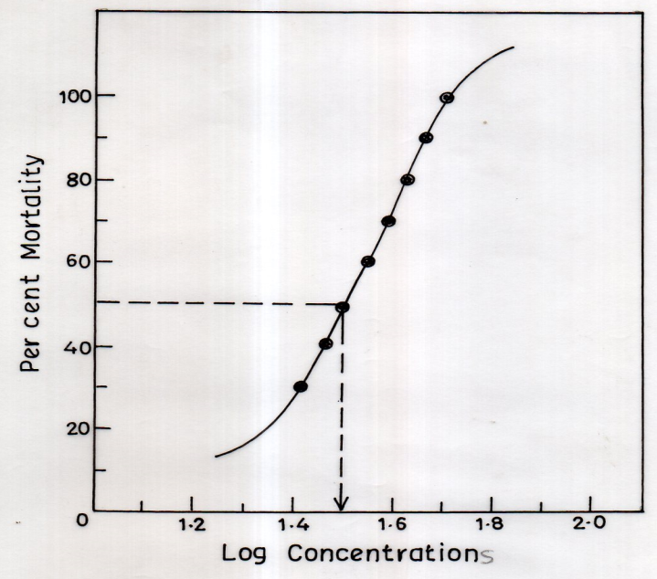
Fig.1 (b)

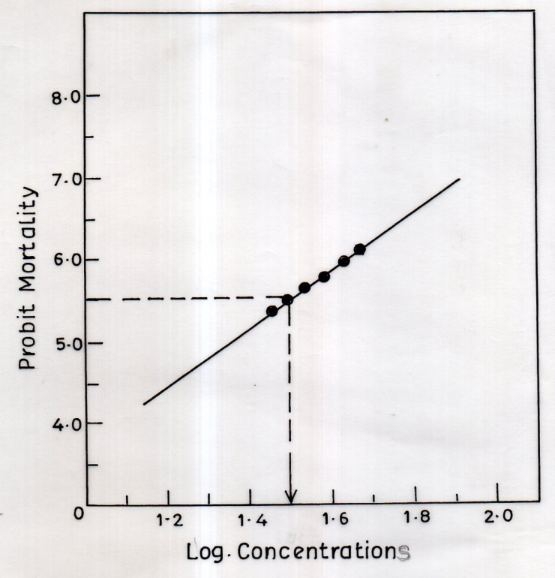

Fig. 1 (a&b) Probit for the percent mortality of freshwater fish, Channa punctatus exposed to varying concentrations of a common laundry detergent, Ariel for 96 h under laboratory conditions.
Fig.2

Fig. 2 Effects of Ariel detergent on superoxide dismutase (SOD) activity in liver and gill tissues of freshwater fish, Channa punctatus. Fish were exposed to 1/5th of 96h LC₅₀ concentration (6.4 ppm) for a period of 7 and 14 days. All the values are mean±SD of six individual observations. The values marked with ‘‘asterisk’’ are significantly different from corresponding controls as evaluated by the ANOVA followed by Student-Newman-Keuls (SNK) post hoc test (p<0.05).
Fig. 3
Fig. 3 Effects of Ariel detergent on catalase (CAT) activity in liver and gill tissues of freshwater fish, Channa punctatus. Fish were exposed to 1/5th of 96h LC₅₀ concentration (6.4 ppm) for a period of 7 and 14 days. All the values are mean±SD of six individual observations. The values marked with ‘‘asterisk’’ are significantly different from corresponding controls as evaluated by the ANOVA followed by Student-Newman-Keuls (SNK) post hoc test (p<0.05).
Fig. 4
Fig. 4 Effects of Ariel detergent on xanthine oxidase (XO) activity in liver and gill tissues of freshwater fish, Channa punctatus. Fish were exposed to 1/5th of 96h LC₅₀ concentration (6.4 ppm) for a period of 7 and 14 days. All the values are mean±SD of six individual observations. The values marked with ‘‘asterisk’’ are significantly different from corresponding controls as evaluated by the ANOVA followed by Student-Newman-Keuls (SNK) post hoc test (p<0.05).
Fig. 5

Fig. 5 Effects of Ariel detergent on glutathione peroxidase (GPx) activity in liver and gill tissues of freshwater fish, Channa punctatus. Fish were exposed to 1/5th of 96h LC₅₀ concentration (6.4 ppm) for a period of 7 and 14 days. All the values are mean±SD of six individual observations. The values marked with ‘‘asterisk’’ are significantly different from corresponding controls as evaluated by the ANOVA followed by Student-Newman-Keuls (SNK) post hoc test (p<0.05).
Fig. 6

Fig. 6 Effects of Ariel detergent on glutathione reductase (GRd) activity in liver and gill tissues of freshwater fish, Channa punctatus. Fish were exposed to 1/5th of 96h LC₅₀ concentration (6.4 ppm) for a period of 7 and 14 days. All the values are mean±SD of six individual observations. The values marked with ‘‘asterisk’’ are significantly different from corresponding controls as evaluated by the ANOVA followed by Student-Newman-Keuls (SNK) post hoc test (p<0.05).
Fig. 7

Fig. 7 Effects of Ariel detergent on glutathione-s-transferase (GST) activity in liver and gill tissues of freshwater fish, Channa punctatus. Fish were exposed to 1/5th of 96h LC₅₀ concentration (6.4 ppm) for a period of 7 and 14 days. All the values are mean±SD of six individual observations. The values marked with ‘‘asterisk’’ are significantly different from corresponding controls as evaluated by the ANOVA followed by Student-Newman-Keuls (SNK) post hoc test (p<0.05).
Fig. 8

Fig. 8 Effects of Ariel detergent on glutathione (GSH) levels in liver and gill tissues of freshwater fish, Channa punctatus. Fish were exposed to 1/5th of 96h LC₅₀ concentration (6.4 ppm) for a period of 7 and 14 days. All the values are mean±SD of six individual observations. The values marked with ‘‘asterisk’’ are significantly different from corresponding controls as evaluated by the ANOVA followed by Student- Newman-Keuls (SNK) post hoc test (p<0.05).
Fig. 9

Fig. 9 Effects of Ariel detergent on MDA levels in liver and gill tissues of freshwater fish, Channa punctatus. Fish were exposed to 1/5th of 96h LC₅₀ concentration (6.4 ppm) for a period of 7 and 14 days. All the values are mean±SD of six individual observations. The values marked with ‘‘asterisk’’ are significantly different from corresponding controls as evaluated by the ANOVA followed by Student-Newman-Keuls (SNK) post hoc test (p<0.05).

Fig.10 (a) Liver

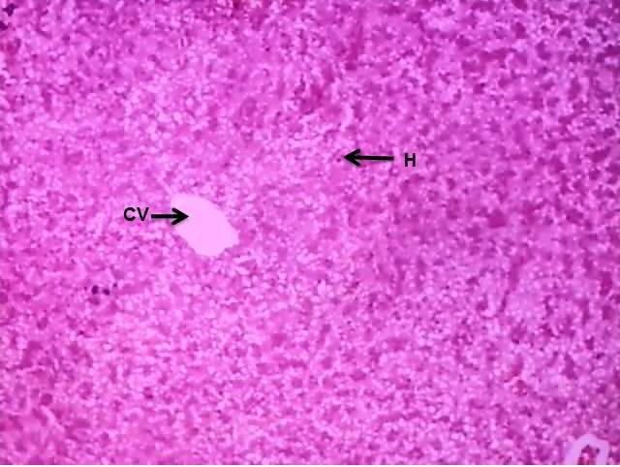 | 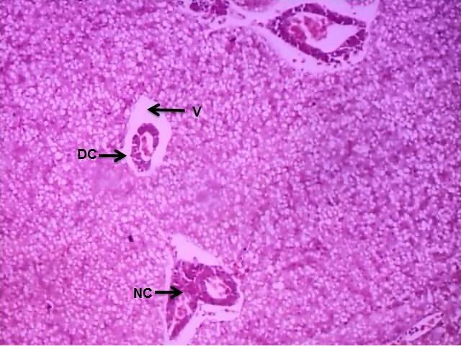 | 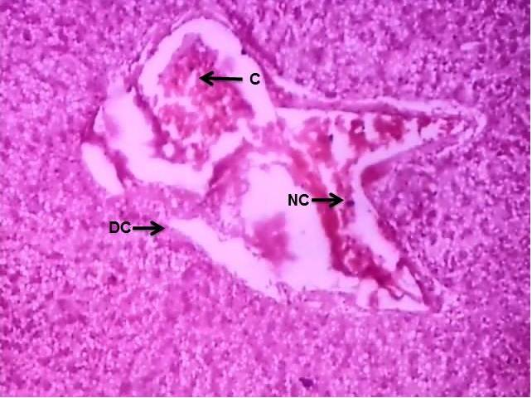
Control | 7 days Exposure | 14 days Exposure
Fig. 10 (b) Gills
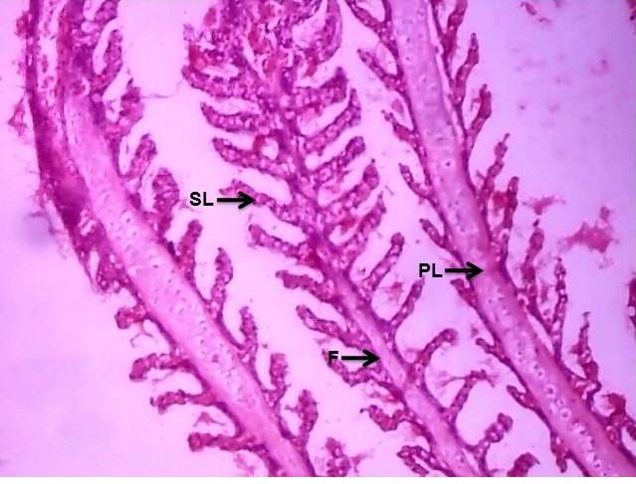 | 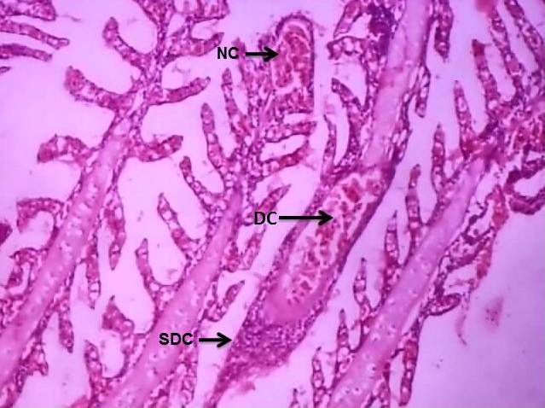 | 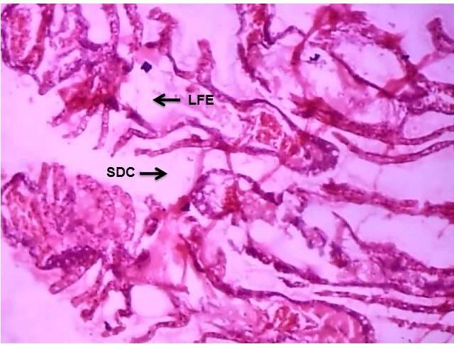
Control | 7 days Exposure | 14 days Exposure

Fig. 10 (a&b) Histograms of liver (a) and gill (b) tissues of freshwater fish, Channa punctatus. Fish were exposed to 1/5th of 96h LC₅₀ concentration (6.4 ppm) for a period of 7 and 14 days. All the values are mean±SD of six individual observations. The values marked with ‘‘asterisk’’ are significantly different from corresponding controls as evaluated by the ANOVA followed by Student-Newman-Keuls (SNK) post hoc test (p<0.05). [C=Congestion; CV=Central Vein; DC=Degenerative Changes; H=Hepatocytes; NC=Necrotic Changes; V=Vacuolization].

