Systematic Literature Review of Trends, Potentials and Challenges About Ecotourism and Learning: A Decade in Asia

.
ABSTRACT

Abstract
Background:
This study presents a systematic literature review (SLR) of research on ecotourism and learning conducted in Asia between 2015 and 2025, aiming to identify major trends, potentials, and challenges in linking ecotourism with sustainability-oriented education. It offers a decade-long synthesis that explicitly connects ecotourism with learning outcomes and Education for Sustainable Development (ESD), an angle that has received limited systematic attention in previous reviews.
Methods:
Data were retrieved from the Scopus database using a PRISMA-guided selection process, yielding 39 eligible open-access articles written in English. The analysis employed bibliometric mapping and thematic synthesis using VOSviewer and Biblioshiny to explore publication patterns, disciplinary distribution, conceptual networks, and thematic evolution. The review followed the updated PRISMA 2020 statement and its explanation and elaboration papers to ensure transparent and replicable reporting.
Results:
Results reveal a significant growth of research output after 2021, reflecting the increasing global recognition of Education for Sustainable Development (ESD) as a guiding framework for tourism studies. Social sciences, environmental sciences, and computer science dominate the field, indicating a strong interdisciplinary orientation integrating environmental modeling, community learning, and digital innovation. Keyword and thematic analyses identify ecotourism, sustainable tourism, tourism development, and learning as core themes, while emerging topics such as deep learning, social media, and decision-making illustrate a shift toward data-driven sustainability learning. Ecotourism demonstrates strong potential as a medium for experiential, community-based, cultural, and technological learning, yet its educational function remains constrained by commercialization, limited human capacity, and fragmented policy alignment. Comparative patterns across countries further show that community-based initiatives in Southeast Asia often struggle with governance and funding gaps, whereas destinations in East Asia face challenges related to overtourism, heritage commodification, and uneven access to digital learning infrastructures.
Conclusion:
The review concludes that ecotourism in Asia has evolved from a niche tourism activity into a transformative educational platform that connects nature, culture, and technology for sustainability learning. Future research should prioritize cross-sectoral collaboration, digital pedagogy, and long-term impact evaluation to advance ecotourism as a dynamic framework for Education for Sustainable Development (ESD). By integrating bibliometric mapping with thematic synthesis, this study clarifies how ecotourism-based learning has developed in Asian contexts, identifies persistent evidence gaps, and provides regionally nuanced directions for policymakers, educators, and tourism practitioners.

Keywords: Ecotourism; Sustainability Learning; Asia; Education for Sustainable Development

1. INTRODUCTION

In the last decade, Asia has become one of the most dynamic regions in developing ecotourism as a strategy to harmonize environmental conservation, cultural preservation, and community-based economic empowerment. The region’s rich biodiversity, cultural diversity, and rapidly growing tourism sectors have positioned it as a global hub for sustainability-oriented tourism initiatives (Jaya et al., 2024; Sisriany & Furuya, 2025). Ecotourism, defined as responsible travel to natural areas that conserves the environment and improves the well-being of local people, has evolved in Asia from a niche practice into a major policy instrument for sustainable development. Beyond its economic contributions, ecotourism in the Asian context increasingly embodies educational and transformative values that can foster environmental literacy, cultural understanding, and sustainable behavior among diverse stakeholders (Cossengue et al., 2025; M. Das & Chatterjee, 2015; Tilavova et al., 2024; Torsney et al., 2025).
Learning through ecotourism has emerged as a critical means of linking environmental experience with knowledge construction. As emphasized by Education for Sustainable Development (ESD) frameworks, learning does not only occur in classrooms but also through community interaction, environmental participation, and experiential engagement (Sánchez-Emeterio et al., 2025; Velempini & Maruatona, 2025). Ecotourism sites—such as protected areas, national parks, and community-based tourism villages—function as living laboratories that support place-based learning and environmental education. Through participatory approaches, visitors and local communities engage in knowledge exchange, reflection, and co-learning processes that reinforce conservation ethics and sustainability awareness (Jackson, 2025; López-Vera & Pelegrín-Entenza, 2025; Sianipar et al., 2025; Zainal et al., 2024). Thus, ecotourism can be understood not merely as recreation, but as a pedagogical process promoting lifelong learning and transformative citizenship.
Despite its significant potential, the learning dimension of ecotourism remains underrepresented in the scholarly literature, especially within the Asian region. Most research in Asia still prioritizes the economic benefits of ecotourism, visitor satisfaction, or biodiversity management (Baloch et al., 2023; Cossengue et al., 2025; da Silva et al., 2025; Dube & Ezeh, 2025; Le, 2024; Thuy & Thao, 2019; Wunder, 2000), while relatively few studies explore how ecotourism contributes to knowledge, attitudes, and behavioral change related to sustainability. Existing reviews tend to be narrative, lacking systematic synthesis of how ecotourism and learning are conceptually and practically interconnected. As a result, the academic understanding of how ecotourism functions as a medium for learning and capacity building in Asian contexts remains fragmented and underdeveloped.
In addition, Asia’s socio-cultural diversity presents both opportunities and challenges in implementing ecotourism as an educational platform. The region encompasses a wide spectrum of governance systems, environmental policies, and local wisdoms (Oltean et al., 2025; Purwoko et al., 2022; Tien et al., 2024)—from community-based tourism in Indonesia and Thailand (Azahra et al., 2025; Hariyadi et al., 2024; Sayuti, 2023) to heritage-based ecotourism in Japan and Korea (Bryce et al., 2015; Pai, 2013; Park et al., 2024; Salman et al., 2024). These variations influence how learning processes are embedded within ecotourism initiatives. Some countries have integrated environmental education into their national tourism policies, while others rely on informal community-driven practices. Understanding these diverse pathways is crucial for identifying models of success and the contextual barriers that shape the outcomes of ecotourism-based learning across Asia.
The growing relevance of the United Nations’ Sustainable Development Goals (SDGs), particularly SDG 4 (Quality Education), SDG 13 (Climate Action), and SDG 15 (Life on Land), further underscores the importance of connecting ecotourism and learning. Ecotourism can serve as a bridge between conservation goals and educational transformation, empowering individuals and communities to become active agents of sustainability. Global frameworks such as UNESCO’s Education for Sustainable Development (ESD) roadmap emphasize that learning environments—including non-formal and community settings—must be transformed to address climate, biodiversity, and equity challenges in an integrated way (UNESCO, 2020, 2023). However, the implementation of ecotourism as a learning vehicle often faces challenges such as commercialization pressures, limited local capacity, insufficient policy support, and a lack of integration between education and tourism sectors. A systematic understanding of these barriers is needed to guide more effective and inclusive strategies in the future.
To address these gaps, this study conducts a Systematic Literature Review (SLR) focusing on research from 2015 to 2025 that examines the intersection of ecotourism and learning in Asia. The review follows the PRISMA 2020 protocol to ensure transparency and reproducibility in identifying, screening, and analyzing relevant studies. It aims to synthesize empirical and conceptual insights to answer three main questions: (1) What are the research trends on ecotourism and learning in Asia during the past decade? (2) What potentials of ecotourism have been identified in supporting sustainability-oriented learning? And (3) What challenges persist in implementing ecotourism as an educational strategy in the region? By addressing these questions, this review seeks to provide an integrated perspective on how ecotourism can advance learning, strengthen community resilience, and contribute to achieving sustainable development in Asia.

2. methodology

2.1 Research Design
This study employed a Systematic Literature Review (SLR) guided by the PRISMA 2020 protocol (Preferred Reporting Items for Systematic Reviews and Meta-Analyses). The PRISMA approach was selected to ensure transparency, replicability, and methodological rigor throughout the review process. In line with recent guidance, the reporting of the review followed the PRISMA 2020 statement and its explanation and elaboration documents, which provide a 27-item checklist and detailed recommendations for systematic review reporting (Page et al., 2021a, 2021b). The SLR aimed to synthesize research focusing on the intersection between ecotourism and learning within the Asian region over the last decade (2015–2025). The main objective was to identify publication trends, explore educational potentials, and analyze the challenges documented in the literature regarding the integration of ecotourism and sustainability learning.
2.2 Data Source and Search Strategy
The data were retrieved from the Scopus database, which provides comprehensive indexing of high-quality peer-reviewed literature. The search was conducted using the advanced query: (TITLE-ABS-KEY (ecotourism AND learning)) AND (asia) AND (LIMIT TO (DOCTYPE, "ar")) AND (LIMIT-TO (PUBSTAGE, "final")) AND (LIMIT TO (LANGUAGE, "English")) AND (LIMIT-TO (OA, "all")). This query restricted the scope to open-access, peer-reviewed, and final-stage journal articles written in English, specifically affiliated with institutions across Asian countries. The temporal filter (2015–2025) was applied to focus on the most recent decade of research development, ensuring the relevance of findings to current sustainability education and tourism practices. The search strategy and screening process were designed and documented in accordance with PRISMA 2020 guidance to enhance reproducibility.
2.3 Screening and Selection Process
The literature selection followed the four PRISMA phases: Identification, Screening, Eligibility, and Inclusion, as illustrated in Figure 1. (1) Identification: A total of 474 records were initially retrieved from the Scopus database using the specified search string.
(2) Screening: After applying the open-access filter, 172 articles were retained, while 302 were excluded due to restrictions related to publication access categories (e.g., green, gold, hybrid, or bronze open access). (3) Eligibility: Further refinement excluded non-final or non-original publications such as book chapters, conference papers, retracted items, errata, and review articles, resulting in 145 original articles. (4) Inclusion: Only English-language studies focusing specifically on the Asian context within the 2015–2025 timeframe were retained. Three non-English articles (Spanish, Bosnian, and Indonesian) were removed, along with one outlier (published in 1993). The final dataset comprised 39 eligible articles, which formed the analytical corpus of this review. These steps correspond to the identification, screening, eligibility, and inclusion stages promoted in PRISMA 2020 flow diagrams, adapted here to the specific focus on ecotourism and learning.

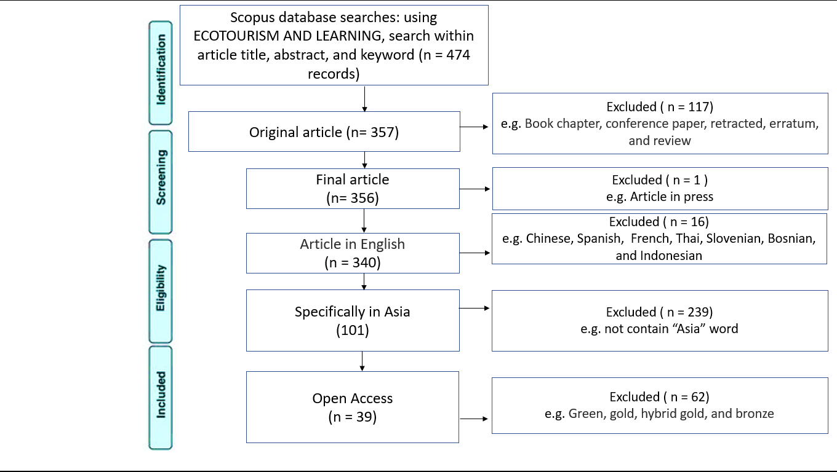

Fig. 1. PRISMA 2020 Flow Diagram of Article Selection Process (source: author’s data processing, 2025)

2.4 Inclusion and Exclusion Criteria
The inclusion criteria were formulated to ensure the consistency and academic quality of the analyzed studies. Eligible articles (1) were published between 2015 and 2025, (2) explicitly examined ecotourism in connection with learning, education, or knowledge transfer, (3) presented empirical or conceptual insights relevant to Asia, and (4) were available in full-text English versions. Conversely, articles were excluded if they (1) lacked a learning or educational component, (2) focused solely on the economic or ecological aspects of tourism, (3) were not open access, or (4) were non-peer-reviewed or non-final publications.
2.5 Data Extraction and Coding
Each selected article was reviewed in full to extract key bibliographic and thematic information, including (1) publication year, (2) authorship and country of origin, (3) research objectives, (4) methodological design, (5) educational or learning dimensions explored, and (6) major findings or implications for sustainability education. The extracted data were tabulated to enable comparison across studies and to facilitate bibliometric visualization of patterns, trends, and research clusters.
2.6 Data Analysis
Two complementary analytical approaches were employed. (1) Bibliometric Analysis was used to identify patterns in publication volume, authorship, institutional and national contributions, and keyword co-occurrence. Visualization techniques (e.g., network mapping and thematic evolution) were applied using tools such as VOSviewer and Biblioshiny.
(2) Thematic Analysis was then applied to qualitatively synthesize recurring themes, challenges, and conceptual frameworks emerging from the literature. Thematic coding focused on identifying how ecotourism contributes to knowledge acquisition, attitude formation, and participatory conservation learning, as well as the barriers that hinder the educational integration of ecotourism practices in Asian contexts.
2.7 Validity and Reliability
To maintain methodological integrity, the review process adhered strictly to PRISMA 2020 guidelines. Data extraction and coding were conducted independently by two reviewers to minimize bias and ensure inter-coder reliability. Any discrepancies in article classification or theme identification were discussed and resolved through consensus. The combination of quantitative (bibliometric) and qualitative (thematic) approaches strengthened the validity and depth of the synthesis. In addition, the use of established reporting standards (PRISMA 2020) and explicit inclusion/exclusion criteria enhances the transparency of study selection and supports critical appraisal by other scholars.

3. results and discussion

3.1 Publication Trend of Ecotourism and Learning Research in Asia
The publication trend illustrates the temporal growth of research connecting ecotourism and learning in Asia over the last decade. Figure 2 shows a clear increase in scholarly output between 2017 and 2025, reflecting the rising global concern for sustainability education and the integration of learning components into ecotourism practices. The data were obtained from Scopus-indexed studies included in this systematic review after screening for open-access, peer-reviewed journal articles written in English.

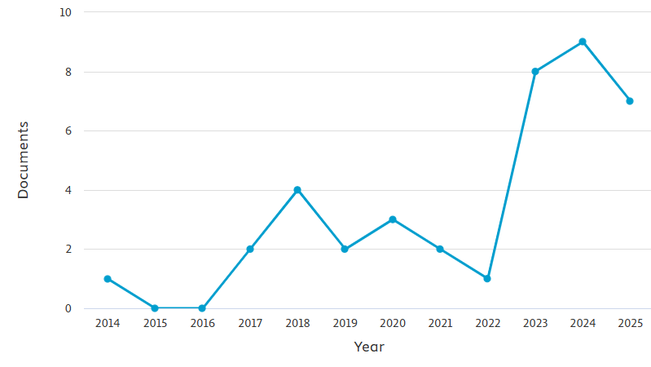
Fig. 2. Annual publication trends of ecotourism and learning research
As shown in Figure 2, research activity in this domain remained relatively low and sporadic between 2017 and 2021, with only one to five publications per year. This period represents the exploratory phase, during which most studies were conceptual or case-based, focusing on local initiatives or pilot programs. The turning point appears in 2022, when the number of publications began to rise steadily—from seven documents in 2022 to eleven in 2023, followed by a sharp increase to sixteen in 2024. This surge corresponds with global post-pandemic recovery efforts, where sustainability and outdoor experiential learning gained renewed attention as part of educational adaptation strategies (UNESCO, 2023).
The slight decline observed in 2025 (from sixteen to thirteen documents) is typical of temporal fluctuations in academic publication cycles rather than a true decrease in research interest. Notably, the cumulative trend confirms that ecotourism and learning has evolved from a marginal topic into a mainstream interdisciplinary field bridging tourism, environmental science, and education. The acceleration in publications after 2021 reflects growing recognition of Education for Sustainable Development (ESD) as a guiding framework for tourism studies (P. Das et al., 2025; S. Zhang et al., 2025; Y. Zhang et al., 2025).
Overall, the consistent upward trajectory in the number of publications indicates a strengthening scholarly commitment to exploring how ecotourism can serve as a transformative tool for sustainability-oriented learning. This trend also mirrors the broader academic shift toward integrating field-based, community-centered, and data-driven learning experiences within tourism education. Consequently, the 2017–2025 decade can be identified as a formative period in establishing ecotourism as both an educational and research priority in Asia. However, the distribution of studies remains uneven, with evidence concentrated in a limited set of countries (e.g., China, Indonesia, Vietnam, and South Korea), indicating that large parts of South Asia and Central Asia are still underrepresented in the literature.
3.2 Disciplinary Distribution of Ecotourism and Learning Research
To better understand the interdisciplinary nature of ecotourism and learning studies, this review analyzed the distribution of publications by subject area. Figure 3 presents the proportions of disciplines contributing to research in this field between 2014 and 2025, as indexed in Scopus. The classification reveals a diverse but uneven distribution, underscoring the inherently cross-sectoral character of ecotourism research, which integrates natural sciences, social sciences, and applied technologies to advance sustainability-oriented education.
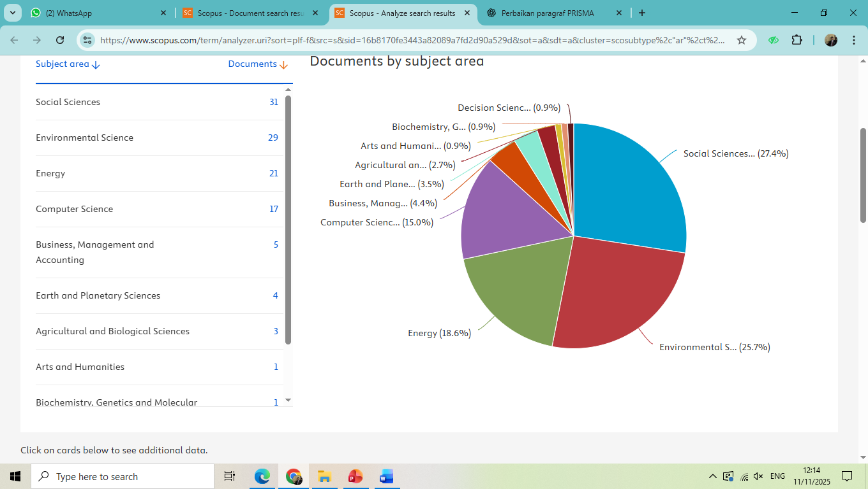
Fig. 3. Disciplinary distribution of ecotourism and learning research based on Scopus-indexed publications.

As illustrated in Figure 3, Social Sciences dominate the field, accounting for approximately 27.4% of all publications. This dominance reflects the focus on human–environment interactions, community participation, behavioral change, and educational practices within ecotourism contexts (Adulcharoen et al., 2020; Bahou et al., 2024; Eger et al., 2022; Jin & Han, 2025; Massiseng et al., 2022; Surjanti et al., 2020). The next largest categories, Environmental Sciences (25.7%) and Energy (18.6%), highlight the increasing incorporation of ecological modeling, environmental impact assessment, and digital tools into tourism and education research. These findings indicate a shift toward evidence-based and technology-enhanced approaches in sustainability learning.
Interestingly, disciplines such as Computer Science (15.0%), Agricultural and Biological Sciences (2.7%), and Earth and Planetary Sciences (3.5%) also contribute significantly. Their involvement suggests that ecotourism serves as a platform for applied environmental research, linking renewable energy management (Chang & McAleer, 2017; Sung & Shih, 2025), conservation of natural resources (Aswita et al., 2020; Shusheng et al., 2023), and agroecological education (Massiseng et al., 2022). Meanwhile, smaller shares in Business, Management (4.4%), Art and Humanitiess (0.9%), and Decision Sciences (0.9%) reveal emerging intersections related to sustainable management, design innovation, and policy decision-making.
The multidisciplinary spread of research themes demonstrates that ecotourism and learning are not confined to a single disciplinary framework but rather operate at the intersection of ecological sciences, educational psychology, and technological innovation. This integration aligns with the principles of Education for Sustainable Development (ESD), which emphasizes systems thinking and collaborative problem-solving (UNESCO, 2023). Consequently, the disciplinary composition underscores ecotourism’s potential to foster holistic sustainability education through the convergence of science, society, and technology. At the same time, the relatively small share of education-focused journals suggests that the pedagogical implications of ecotourism are still not fully mainstreamed within the broader education research community.
3.3 Keyword Co-Occurrence Analysis of Ecotourism and Learning Research
To explore the conceptual structure and thematic connections within the body of literature, a keyword co-occurrence analysis was conducted using VOSviewer. Figure 4 visualizes the network of dominant keywords derived from 39 Scopus-indexed articles on ecotourism and learning published in Asia between 2015 and 2025. The map identifies how frequently specific terms appear together within titles, abstracts, and author keywords, revealing major thematic clusters and the intellectual relationships that shape the research field.
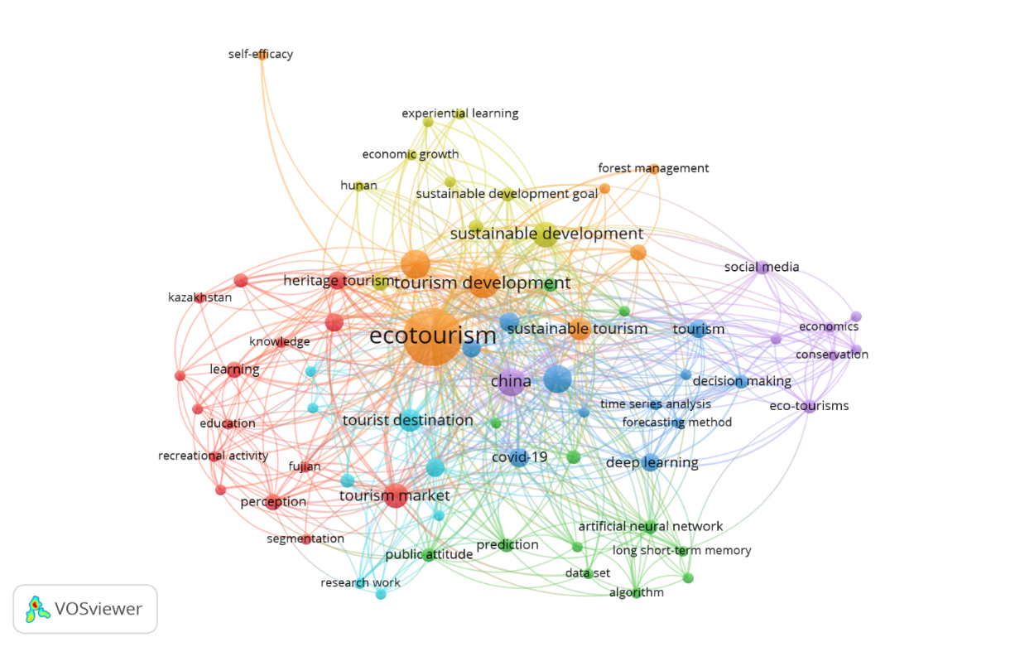
Fig. 4. Keyword co-occurrence network of ecotourism and learning research in Asia (2015–2025) generated using VOSviewer.

The visualization shows that “ecotourism” serves as the central and most frequently occurring keyword, closely connected to related terms such as sustainable tourism, tourism development, and sustainable development. This indicates that the field primarily focuses on linking tourism practices with sustainability principles and development goals. The proximity of terms such as education, learning, and heritage tourism suggests that scholars increasingly view ecotourism as a pedagogical arena for promoting environmental literacy and cultural awareness (P. Das et al., 2025). The cluster centered on learning and education (in red) underscores the pedagogical transformation of tourism into a medium for experiential and place-based learning.
Another major thematic cluster (yellow) connects sustainable development, forest management, economic growth, and sustainable development goals, highlighting the growing emphasis on policy integration and the socioeconomic dimensions of sustainability (Teeravarunyou et al., 2025). Meanwhile, the green and blue clusters demonstrate technological and data-driven developments, including keywords such as deep learning, artificial neural networks, forecasting method, and time series analysis. These terms reflect the emerging use of machine learning and predictive modeling in optimizing ecotourism planning, environmental monitoring, and learning analytics (Arup Baidya & Saha, 2024; S. Zhang et al., 2025; Y. Zhang et al., 2025).
Interestingly, smaller clusters indicate specialized or contextual themes. For instance, the purple cluster contains terms like conservation, economics, and social media, pointing to the integration of communication and marketing strategies in sustainability education. Similarly, the red cluster that includes heritage tourism, recreational activity, and public attitude represents sociocultural and behavioral approaches to ecotourism learning (Brennan & Kessler, 2025). These thematic groupings show that while ecological and technological aspects are well-represented, social and cultural learning dimensions remain central to the field’s development.
Overall, the keyword network demonstrates that research on ecotourism and learning in Asia is characterized by strong interdisciplinarity and conceptual convergence between sustainability, education, and technology. The dense interlinkages between clusters reveal an evolving scholarly consensus: that ecotourism should be designed not only for economic or environmental gain but also as a structured educational experience aligned with the Sustainable Development Goals (SDGs). This intellectual map thus affirms ecotourism’s emerging role as both a research domain and a transformative educational practice for sustainable development in the Asian context.
3.4 Thematic Evolution and Conceptual Structure of Ecotourism and Learning Research
To identify the structural dynamics and maturity level of research themes, a thematic mapping analysis was conducted using the Biblioshiny extension of R-Bibliometrix. Figure 5 presents a two-dimensional visualization that classifies themes according to their development degree (density) on the vertical axis and relevance degree (centrality) on the horizontal axis. This approach helps to distinguish between emerging, basic, niche, and motor themes within the corpus of 39 Scopus-indexed studies on ecotourism and learning. The distribution of keywords across the four quadrants illustrates the evolution and relative importance of thematic clusters shaping the field.

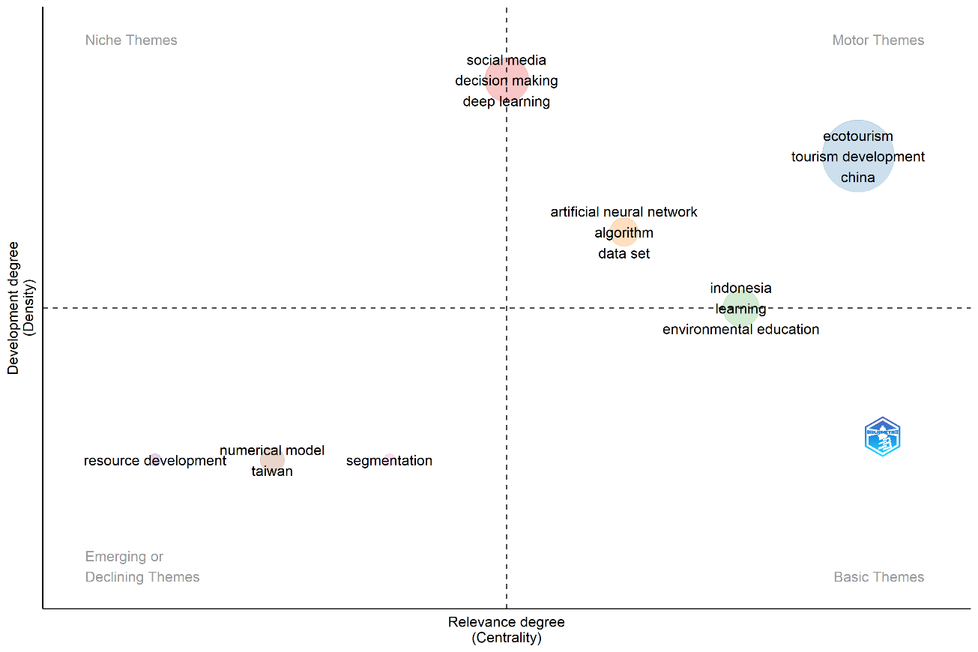
Fig. 5. Thematic map of ecotourism and learning research based on density and centrality metrics generated using Biblioshiny.

The upper-right quadrant, labeled Motor Themes, contains dominant and well-developed topics such as ecotourism, tourism development, and China. These themes exhibit both high centrality and density, indicating that they represent the intellectual core and driving force of the field. The consistent linkage of ecotourism with tourism development and sustainable practices demonstrates that scholarly attention remains focused on the role of tourism in promoting sustainability-oriented education and community empowerment (P. Das et al., 2025; Teeravarunyou et al., 2025). The prominence of “China” reflects the country’s increasing contribution to ecotourism scholarship, particularly in applying sustainability frameworks and data-driven tourism planning models (S. Zhang et al., 2025; Y. Zhang et al., 2025).
In contrast, the Niche Themes quadrant (upper-left) includes terms such as social media, decision making, and deep learning. These topics are characterized by high internal development but relatively low connectivity with the broader field. Their emergence highlights the growing interest in integrating technology, data analytics, and behavioral insights into ecotourism research (A Baidya et al., 2025; Arup Baidya & Saha, 2024). For instance, the incorporation of deep learning and decision support systems reflects the shift toward digital transformation and the use of artificial intelligence for visitor management, environmental monitoring, and sustainability forecasting. Although still peripheral, these themes are expected to become more central as digitalization expands in tourism education and management.
The lower-right quadrant, representing Basic Themes, includes keywords such as learning, environmental education, and Indonesia. These topics exhibit high centrality but moderate density, suggesting that they serve as foundational areas linking multiple research domains. The central position of learning and environmental education indicates their essential role in connecting tourism research with sustainability pedagogy (Brennan & Kessler, 2025). Indonesia’s appearance within this cluster underscores Southeast Asia’s growing role as a living laboratory for ecotourism-based education, where schools and communities collaborate to promote ecological awareness and conservation literacy.
Meanwhile, the lower-left quadrant, labeled Emerging or Declining Themes, contains terms such as resource development, numerical model, Taiwan, and segmentation. These themes have lower density and centrality, implying that they are either emerging lines of inquiry or previously important topics losing momentum. The presence of numerical model and resource development suggests that early research emphasized technical modeling and regional resource management but has since evolved toward more integrated socio-ecological frameworks. Future studies may revisit these concepts by linking quantitative modeling with participatory education and local policy development.
Overall, the thematic map confirms that ecotourism and learning research in Asia is evolving from descriptive and localized studies toward an integrated, technology-supported, and education-centered paradigm. The coexistence of mature motor themes (ecotourism, tourism development) and emergent niche themes (deep learning, social media) signals a balanced trajectory of theoretical consolidation and innovation. This progression indicates a field that is both conceptually stable and methodologically dynamic, aligning with global efforts to advance Education for Sustainable Development (ESD) through interdisciplinary research and practice (UNESCO, 2023). Yet, the persistence of emerging or declining themes related to resource development and numerical modelling suggests that more work is needed to connect technically oriented studies with concrete learning outcomes and community empowerment agendas.

3.5 Potentials of Ecotourism in Supporting Sustainability-Oriented Learning
3.5.1 Experiential and Place-Based Learning
Ecotourism functions as a living laboratory where learners engage directly with ecosystems and communities. Through guided interpretation, field activities, and interaction with local residents, participants develop environmental awareness and responsibility. Studies in Thailand and Indonesia confirm that experiential immersion and place-based learning significantly improve ecological literacy and pro-environmental behavior (Teeravarunyou et al., 2025). This pedagogical model connects theoretical knowledge with real-world experience, aligning with the transformative aims of sustainability education.

3.5.2 Integration with Education for Sustainable Development (ESD)
Recent evidence shows that ecotourism activities can effectively embed the principles of ESD into both formal and informal learning settings. Das et al. (2025) mapped sustainable tourism research themes against the 17 Sustainable Development Goals (SDGs) using BERTopic, demonstrating how each ecotourism activity can correspond to specific ESD competencies such as systems thinking, critical reflection, and participatory learning. Such alignment transforms tourism into a contextualized tool for sustainability education. This is consistent with UNESCO’s ESD roadmap, which calls for learning experiences that simultaneously transform policy, learning environments, educator capacities, youth engagement, and local action (UNESCO, 2020). By linking local practices to global goals, ecotourism strengthens the connection between knowledge, values, and actions toward sustainability.

3.5.3 Community Empowerment and Social Learning
Community-based ecotourism provides opportunities for mutual learning between visitors and residents. Local communities, as custodians of traditional ecological knowledge (TEK), become co-educators who help visitors understand ecological and cultural relationships. This interaction supports the development of social capital, reinforces collective stewardship, and nurtures empowerment among marginalized groups. The learning process becomes cyclical and participatory, fostering a sense of shared responsibility for sustainable living.

3.5.4 Cultural and Intercultural Learning
Ecotourism also promotes intercultural understanding through the preservation of heritage and cultural identity. The Templestays program in South Korea illustrates how mindfulness and cultural immersion can cultivate empathy and self-awareness, enabling visitors to reflect deeply on sustainability values (Brennan & Kessler, 2025). By integrating cultural learning with ecological consciousness, such programs exemplify a holistic form of education that unites moral, aesthetic, and environmental dimensions. They transform cultural tourism into an ethical learning experience aligned with the objectives of ESD.

3.5.5 Technological and Data-Driven Learning.
Emerging research emphasizes the integration of digital tools and geospatial analysis in ecotourism learning design. Baidya and Saha (2024) used machine learning and multi-criteria decision analysis to map ecotourism potential zones in India’s Sundarban region, offering evidence-based planning for interpretive routes and citizen-science projects. Similarly, S. Zhang et al. (2025) proposed the framework of “tourism learning resources,” highlighting how open learning infrastructures can scale educational impacts within tourism destinations. These cases demonstrate that digital innovation can bridge environmental modeling with hands-on STEM and sustainability learning in real-world contexts. Nevertheless, the rapid diffusion of digital tools also raises concerns about unequal access and the risk that technology-centric solutions may overshadow locally grounded, low-cost learning practices, particularly in rural Asian settings.

3.6 Challenges in Implementing Ecotourism as an Educational Strategy in Asia
3.6.1 Commercialization and Goal Drift
Economic pressures often dominate ecotourism development, leading to the prioritization of profit over educational outcomes. Das et al. (2025) identified that much of the literature on sustainable tourism focuses on market trends rather than pedagogical design. As a result, ecotourism is frequently reduced to branding exercises without measurable learning outcomes. To address this, learning goals must be clearly articulated and integrated into tourism management frameworks to preserve the educational essence of ecotourism. Comparatively, community-based ecotourism sites in Indonesia, Vietnam, and Thailand tend to struggle with balancing visitor numbers and conservation targets, whereas better-resourced destinations in East Asia are more likely to face issues of overtourism and experience commodification, which can dilute authentic learning opportunities.

3.6.2 Human Capacity and Pedagogical Gaps
Many Asian ecotourism programs face limitations in human resources, particularly in the training of guides, educators, and interpreters. Studies from Thailand and Vietnam show that inconsistent interpretive practices and lack of educator preparation weaken experiential learning quality (Bui et al., 2024; Ha et al., 2023; Phuong et al., 2025; World et al., 2020). Without professional capacity building and structured curricula, ecotourism fails to deliver its full educational potential. Continuous training and intersectoral collaboration are therefore crucial to enhance pedagogical effectiveness. The evidence also suggests that professional development is often project-based and short-term, leading to high staff turnover and weak institutional memory, especially in small island and rural communities.

3.6.3 Policy Fragmentation and Institutional Misalignment.
The separation between tourism and education policies limits the institutionalization of ecotourism-based learning. S. Zhang et al. (2025) and Y. Zhang et al. (2025) highlighted that fragmented governance systems prevent coordinated efforts between educational institutions and tourism stakeholders. Effective policy integration should involve joint planning, funding schemes, and shared indicators of educational success. Only through such coherence can ecotourism evolve from a voluntary initiative into a strategic educational framework. Cross-country comparisons indicate that countries with explicit ecotourism or environmental education strategies (e.g., South Korea, Japan, and China) tend to have clearer institutional arrangements than contexts where ecotourism emerges primarily from local initiatives without national policy anchors, such as parts of Indonesia and Vietnam.

3.6.4 Cultural and Ethical Tensions
When cultural or spiritual elements become commercialized, educational intentions may conflict with ethical values. The Templestays case shows that without proper community collaboration, sacred traditions risk being commodified for tourism rather than serving as tools for reflection and cultural understanding (Brennan & Kessler, 2025). Ethical co-design and community ownership are therefore essential for ensuring that cultural learning remains respectful, authentic, and educationally meaningful. Where host communities have limited bargaining power, there is a heightened risk that narratives presented to visitors will reflect external expectations rather than local epistemologies, undermining both cultural integrity and critical learning.

3.6.5 Infrastructure and Funding Constraints
Many community-based ecotourism projects in Asia suffer from inadequate infrastructure, limited interpretive materials, and unstable financial support. Field-based studies reveal that poor maintenance of trails, signage, and educational facilities restricts the continuity of learning activities (Duong et al., 2025; Irmawati & Hasnawati, 2024; Kim et al., 2019). Long-term funding and strategic partnerships are needed to institutionalize learning within tourism destinations. Public–private collaboration and local government investment could bridge these material gaps. Yet, funding mechanisms often prioritize short-term visitor infrastructure over investment in educational design, monitoring, and evaluation, meaning that learning outcomes are rarely tracked systematically.

3.6.6 Socio-Economic Vulnerability and Resilience Gaps
Ecotourism initiatives are often vulnerable to socio-economic disruptions, such as pandemics or climate-related disasters. Research in China’s Wulingyuan Scenic Area by Wu et al. (2025) indicates that households dependent on tourism experience severe instability, which in turn interrupts educational programs. Building resilience through diversified livelihoods and adaptive management ensures that ecotourism-based learning remains sustainable even during crises. Thus, strengthening local resilience becomes both a learning objective and a prerequisite for educational continuity. The COVID-19 pandemic demonstrated that sites with stronger social capital and diversified income sources were better able to maintain conservation and education activities, whereas highly tourism-dependent communities had to suspend or radically scale back learning programmes.
Taken together, these challenges are unevenly distributed within the region. Community-based ventures in Southeast and South Asia tend to struggle more with governance, funding, and human-capital gaps, while more institutionalized ecotourism systems in East Asia grapple with overtourism, heritage commodification, and digital divides between urban and rural learners. Recognizing this heterogeneity is crucial for designing regionally sensitive policy responses rather than relying on one-size-fits-all ecotourism blueprints.

4. Conclusion
The systematic synthesis of ecotourism and learning research in Asia from 2015 to 2025 demonstrates a rapidly expanding interdisciplinary field characterized by conceptual maturity and methodological diversification. The consistent increase in publications after 2021 signals the consolidation of ecotourism as both a pedagogical and sustainability strategy, supported by advances in environmental education, data-driven tourism planning, and community empowerment. Keyword and thematic analyses further confirm a strong convergence between ecological sciences, educational innovation, and technology integration, reflecting the growing influence of the Education for Sustainable Development (ESD) framework. Across the reviewed studies, ecotourism emerges not merely as a form of sustainable travel but as a transformative learning ecosystem that cultivates environmental literacy, cultural sensitivity, and socio-ecological resilience. These findings affirm that the Asian region has become a critical hub for advancing sustainability-oriented education through ecotourism practices that integrate experiential, cultural, and technological dimensions. At the same time, significant geographical and thematic gaps remain, particularly in under-studied subregions and in the rigorous evaluation of long-term learning and behavior-change outcomes.

Future research should aim to strengthen the theoretical and empirical linkages between ecotourism and sustainability learning through longitudinal, comparative, and participatory approaches. There remains a need to explore underrepresented contexts such as rural and post-conflict areas, as well as to evaluate the long-term impacts of ecotourism-based learning on behavior change and community resilience. Integrating emerging technologies such as artificial intelligence, big data analytics, and immersive learning tools (e.g., VR and AR) could deepen our understanding of how digital transformation supports sustainability pedagogy in ecotourism. Moreover, interdisciplinary collaboration between educators, policymakers, technologists, and local communities is essential to develop inclusive models that bridge environmental management with formal and informal education systems. Policy frameworks inspired by global ESD agendas (UNESCO, 2020, 2023) will be particularly important for aligning tourism, conservation, and education sectors and for ensuring that ecotourism contributes meaningfully to the SDGs rather than merely reproducing conventional growth-oriented tourism models. Such integrative and future-oriented research will ensure that ecotourism continues to evolve as a driver of innovation, equity, and ecological consciousness in sustainability education.

Disclaimer (Artificial intelligence)
The authors hereby declare that generative AI technology was used during the writing and editing of this manuscript. The assistance was limited to language refinement, structural organization, and formatting consistency. All intellectual and conceptual contributions—including the research design, data analysis, interpretation, and final approval—were solely conducted by the authors.
Details of AI usage:
- Technology Used: ChatGPT (GPT-5 model, OpenAI, 2025).
- Purpose of Use: To assist in improving academic writing style, grammar accuracy, and clarity of expression, as well as to structure reviewer responses and summarize methodological sections in clear scholarly English.
- Scope and Human Oversight: The authors carefully reviewed, edited, and validated all AI-generated suggestions to ensure factual accuracy, originality, and

References

Adulcharoen, W., Suntornvongsagul, K., & Lee, Y.-S. (2020). Assessment of sustainable utilization of ecosystem services in different stages of mangrove forest restoration at klong khone sub-district, Samut Songkhram province, Thailand. Applied Environmental Research, 42(1), 43–57. https://doi.org/10.35762/AER.2020.42.1.4
Aswita, D., Suryadarma, I. G. P., Suyanto, S., & Herawan, T. (2020). The natural resources potency of marine ecotourism as an environmental education source. Geojournal of Tourism and Geosites, 31(3), 996–1003. https://doi.org/10.30892/gtg.31310-533
Azahra, N. P., Saufi, A., & Suryani, E. (2025). Community-Based Tourism to Support Sustainable Tourism : Comparative Study in Sesaot ( Indonesia ) and Ban Na San ( Thailand ). Khazanah Sosial, 7(3), 768–776. https://doi.org/10.15575/ks.v7i3.48571
Bahou, Y., Triki, R., Maâloul, M. H., & Tissaoui, K. (2024). Development of E-Tourism to Achieve Excellence and Sustainable Development in Tourism: Ha’il Region Case Study. Sustainability (Switzerland), 16(20). https://doi.org/10.3390/su16208872
Baidya, A, Saha, A. K., & Roy, A. (2025). Application of deep learning, machine learning and multi-criteria decision analysis for ecotourism potentiality assessment: a case study of the Sundarban Biosphere Reserve, India. Discover Artificial Intelligence, 5(1). https://doi.org/10.1007/s44163-025-00496-2
Baidya, Arup, & Saha, A. K. (2024). Exploring the research trends in climate change and sustainable development: A bibliometric study. Cleaner Engineering and Technology, 18, 100720. https://doi.org/https://doi.org/10.1016/j.clet.2023.100720
Baloch, Q. B., Shah, S. N., Iqbal, N., Sheeraz, M., Asadullah, M., Mahar, S., & Khan, A. U. (2023). Impact of tourism development upon environmental sustainability: a suggested framework for sustainable ecotourism. Environmental Science and Pollution Research International, 30(3), 5917–5930. https://doi.org/10.1007/s11356-022-22496-w
Brennan, B. S., & Kessler, D. (2025). From Ritual to Renewal: Templestays as a Cross-Cultural Model of Sustainable Wellness Tourism in South Korea. Sustainability (Switzerland), 17(14). https://doi.org/10.3390/su17146483
Bryce, D., Curran, R., O’Gorman, K., & Taheri, B. (2015). Visitors’ engagement and authenticity: Japanese heritage consumption. Tourism Management, 46, 571–581. https://doi.org/https://doi.org/10.1016/j.tourman.2014.08.012
Bui, H. T. M., Bui, T., & Pham, B. T. (2024). The role of higher education in achieving sustainable development goals: An evaluation of motivation and capacity of Vietnamese institutions. The International Journal of Management Education, 22(3), 101088. https://doi.org/https://doi.org/10.1016/j.ijme.2024.101088
Chang, C.-L., & McAleer, M. (2017). Recent topical research on global, energy, health & medical, and tourism economics, and global software: An overview. Journal of Reviews on Global Economics, 6, 218–224. https://doi.org/10.6000/1929-7092.2017.06.20
Cossengue, P. R., Brea, J. F., & Tavares, F. O. (2025). The Transformative Power of Ecotourism: A Comprehensive Review of Its Economic, Social, and Environmental Impacts. Land, 14(8). https://doi.org/10.3390/land14081531
da Silva, A. E., Maracajá, K. F. B., Batalhão, A. C. S., Silva, V. F., & Borges, I. M. S. (2025). Ecotourism and Co-Management: Strengthening Socio-Ecological Resilience in Local Food Systems. Sustainability, 17(6). https://doi.org/10.3390/su17062443
Das, M., & Chatterjee, B. (2015). Ecotourism: A panacea or a predicament? Tourism Management Perspectives, 14(April 2015), 3–16. https://doi.org/10.1016/j.tmp.2015.01.002
Das, P., Mandal, S., Nedungadi, P., & Raman, R. (2025). Unveiling sustainable tourism themes with machine learning based topic modeling. Discover Sustainability, 6(1). https://doi.org/10.1007/s43621-025-01065-4
Dube, K., & Ezeh, P. C. (2025). A Global Perspective on Ecotourism Marketing Trends: A Review. Sustainability, 17(13). https://doi.org/10.3390/su17136035
Duong, M.-P. T., Lobry de Bruyn, L., Kristiansen, P., Marshall, G. R., & Wilkes, J. (2025). Community-based ecotourism and the challenges of local participation: insights from an ecotourism venture in Cat Tien National Park, Vietnam. Journal of Environmental Planning and Management, 2025, 1–27. https://doi.org/10.1080/09640568.2024.2428257
Eger, C., Munar, A. M., & Hsu, C. (2022). Gender and tourism sustainability. Journal of Sustainable Tourism, 30(7), 1459–1475. https://doi.org/10.1080/09669582.2021.1963975
Ha, N. T. T., Khoa, C. T., Huong, L. T. T., Linh, N. Q., & Bich, N. T. (2023). the Effectiveness of Experiential Learning Models in Teacher Training: a Case Study in Thai Nguyen Province, Vietnam. European Journal of Education Studies, 10(7), 431–446. https://doi.org/10.46827/ejes.v10i7.4899
Hariyadi, B. R., Rokhman, A., Rosyadi, S., Yamin, M., & Runtiko, A. G. (2024). the Role of Community-Based Tourism in Sustainable Tourism Village in Indonesia. Revista de Gestao Social e Ambiental, 18(7), 1–24. https://doi.org/10.24857/rgsa.v18n7-038
Irmawati, I., & Hasnawati, H. (2024). Community-based Ecotourism Strategy for Local Economic Empowerment. Journal of Education, Humaniora and Social Sciences (JEHSS), 7(2), 395–404. https://doi.org/10.34007/jehss.v7i2.2359
Jackson, L. A. (2025). Community-Based Tourism: A Catalyst for Achieving the United Nations Sustainable Development Goals One and Eight. Tourism and Hospitality, 6(1). https://doi.org/10.3390/tourhosp6010029
Jaya, P. H. I., Izudin, A., & Aditya, R. (2024). The role of ecotourism in developing local communities in Indonesia. Journal of Ecotourism, 23(1), 20–37. https://doi.org/10.1080/14724049.2022.2117368
Jin, J.-H., & Han, J.-S. (2025). A Phenomenological Study on the Experience of Searching for Tourism Information Following the Emergence of ChatGPT: Focused on the Uncanny Valley Theory. Sustainability (Switzerland), 17(1). https://doi.org/10.3390/su17010355
Kim, M., Xie, Y., & Cirella, G. T. (2019). Sustainable Transformative Economy: Community-Based Ecotourism. In Sustainability (Vol. 11, Issue 18). https://doi.org/10.3390/su11184977
Le, T. T. (2024). Influences of the ecotourism industry in Mekong Delta – Vietnam: The mediating role of Tourist Satisfaction. Cogent Business & Management, 11(1), 2353570. https://doi.org/10.1080/23311975.2024.2353570
López-Vera, B. M., & Pelegrín-Entenza, N. (2025). Methodological Reflection on Sustainable Tourism in Protected Natural Areas. Sustainability, 17(14). https://doi.org/10.3390/su17146558
Massiseng, A. N. A., Tuwo, A., Fachry, M. E., & Bahar, A. (2022). Characteristics of plastic waste and perceptions of coastal communities in the Baluno mangrove ecotourism area, West Sulawesi, Indonesia. Biodiversitas, 23(12), 6262–6274. https://doi.org/10.13057/biodiv/d231222
Oltean, F. D., Curta, P. A., Nagy, B., Huseyn, A., & Gabor, M. R. (2025). Changes in Tourists’ Perceptions of Community-Based Ecotourism (CBET) After COVID-19 Pandemic: A Study on the Country of Origin and Economic Development Level. In ISPRS International Journal of Geo-Information (Vol. 14, Issue 4). https://doi.org/10.3390/ijgi14040146
Page, M. J., McKenzie, J. E., Bossuyt, P. M., Boutron, I., Hoffmann, T. C., Mulrow, C. D., Shamseer, L., Tetzlaff, J. M., Akl, E. A., Brennan, S. E., Chou, R., Glanville, J., Grimshaw, J. M., Hróbjartsson, A., Lalu, M. M., Li, T., Loder, E. W., Mayo-Wilson, E., McDonald, S., McGuinness, L. A., Stewart, L. A., Thomas, J., Tricco, A. C., Welch, V. A., Whiting, P., & Moher, D. (2021a). The PRISMA 2020 statement: An updated guideline for reporting systematic reviews. BMJ, 372, n71. https://doi.org/10.1136/bmj.n71
Page, M. J., McKenzie, J. E., Bossuyt, P. M., Boutron, I., Hoffmann, T. C., Mulrow, C. D., et al. (2021b). PRISMA 2020 explanation and elaboration: Updated guidance and examples for reporting systematic reviews. BMJ, 372, n160.
Pai, H. I. L. (2013). Heritage Management in Korea and Japan: The Politics of Antiquity and Identity. University of Washington Press. http://www.jstor.org/stable/j.ctvcwnw9r
Park, E., Kim, Y., & Choi, H.-S. (2024). Institutional approach for ecotourism collaboration between South Korea and Japan: exploration of criteria for ecotourism joint-certification. Asia Pacific Journal of Tourism Research, 29(12), 1473–1489. https://doi.org/10.1080/10941665.2024.2401962
Phuong, H. Y., Tran, N. B. C., Nguyen, T. T. L., Lam, T. D., Bui, N. Q., & Le, T. T. (2025). From tests to tasks: how Vietnamese EFL teachers navigate washback through formative assessment practices. Language Testing in Asia, 15(1), 45. https://doi.org/10.1186/s40468-025-00392-7
Purwoko, A., Kuswanda, W., Situmorang, R. O., Hutapea, F. J., Saputra, M. H., & Pasaribu, P. H. (2022). Orangutan Ecotourism on Sumatra Island: Current Conditions and a Call for Further Development. Sustainability, 14(18). https://doi.org/10.3390/su141811328
Salman, A., Jaafar, M., Mohamad, D., Ebekozien, A., & Rasul, T. (2024). The multi-stakeholder role in Asian sustainable ecotourism: a systematic review. PSU Research Review, 8(3), 940–958. https://doi.org/10.1108/PRR-05-2022-0048
Sánchez-Emeterio, G., Honrubia Montesinos, C., Gómez Pozos, A., & Sanchez-Ramos, D. (2025). Transfer in Teacher Training: Integrating Socio-Environmental Issues Through an Educational Trail. Sustainability, 17(18). https://doi.org/10.3390/su17188098
Sayuti, R. H. (2023). Community Readiness in Implementing Sustainable Tourism on Small Islands: Evidence from Lombok, Indonesia. In Sustainability (Vol. 15, Issue 12). https://doi.org/10.3390/su15129725
Shusheng, X., Jingqian, X., & Chen, C. (2023). Integrated management improves emerging coastal industries and ecological restoration with the participation of social capital. Frontiers in Marine Science, 9. https://doi.org/10.3389/fmars.2022.1015262
Sianipar, I. M. J., Lee, C.-H., Kim, D.-C., & Suryawan, I. W. K. (2025). Adaptive strategies and community engagement for sustainable conservation and tourism in Komodo National Park, Indonesia. International Journal of Geoheritage and Parks, 13(3), 335–349. https://doi.org/https://doi.org/10.1016/j.ijgeop.2024.09.004
Sisriany, S., & Furuya, K. (2025). Does Ecotourism Really Benefit the Environment? A Trend Analysis of Forest Cover Loss in Indonesia. Land, 14(6). https://doi.org/10.3390/land14061237
Sung, Y.-C., & Shih, C.-H. (2025). Enhancing Environmental Cognition Through Kayaking in Aquavoltaic Systems in a Lagoon Aquaculture Area: The Mediating Role of Perceived Value and Facility Management. Water (Switzerland), 17(13). https://doi.org/10.3390/w17132033
Surjanti, J., Soejoto, A., & Seno, D. N. (2020). Mangrove forest ecotourism: Participatory ecological learning and sustainability of students’ behavior through self-efficacy and self-concept. Social Sciences and Humanities Open, 2(1). https://doi.org/10.1016/j.ssaho.2019.100009
Teeravarunyou, S., Kamolwit, K., Kitirojpan, P., Pattanachan, P., Tirachulee, B., & Buddhawong, S. (2025). Validating the Community Forest Intention Model: Exploring Tourist Experience, Satisfaction, and Sustainable Intentions in Community-Based Ecotourism. Sustainability (Switzerland), 17(17). https://doi.org/10.3390/su17177644
Thuy, V. T. N., & Thao, H. D. P. (2019). Ecotourists’ satisfaction and dissatisfaction: asymmetric effects of service attributes. Journal of Asian Business and Economic Studies, 26(2), 189–205. https://doi.org/10.1108/JABES-07-2018-0051
Tien, N. D., Lam Duyen, T. N., Thanh Huyen, N. T., Anh, P. Q., Oanh, N. T., Tich, V. Van, Dat, D. T., Hong Hanh, N. T., & Trang, V. H. (2024). Community-based ecotourism for sustainability: An evaluative analysis of Binh Son district, Quang Ngai province in Vietnam. Social Sciences & Humanities Open, 9, 100807. https://doi.org/https://doi.org/10.1016/j.ssaho.2024.100807
Tilavova, M., Safarova, N., Alimova, M., & Bo’ronova, N. (2024). Ecotourism as a sustainable development strategy: Exploring the role of natural resource management. E3S Web of Conferences, 587. https://doi.org/10.1051/e3sconf/202458705020
Torsney, A., O’Driscoll, P., & Buckley, Y. M. (2025). Defining ecotourism for mainstream application and to support sustainable tourism governance. Ecological Solutions and Evidence, 6(2), 1–13. https://doi.org/10.1002/2688-8319.70050
UNESCO. (2020). Education for Sustainable Development: A Roadmap. Paris: UNESCO. https://doi.org/10.54675/YFRE1448
UNESCO. (2023). Global Education Monitoring Report 2023: Technology in Education – A Tool on Whose Terms? Paris: UNESCO. https://digitallibrary.un.org/record/4020460?ln=en&v=pdf
Velempini, K., & Maruatona, T. (2025). A critical review of UNESCO’s influence on lifelong learning and environmental education delivery in Botswana. International Journal of Lifelong Education, 2025, 1–22. https://doi.org/10.1080/02601370.2025.2497411
World, A., Journal, E., & Id, T. (2020). Can I teach these students? A case study of Vietnamese teachers’ self-efficacy in relation to teaching English as a Foreign Language. Arab World English Journal, March, 1–270.
Wunder, S. (2000). Ecotourism and economic incentives — an empirical approach. Ecological Economics, 32(3), 465–479. https://doi.org/https://doi.org/10.1016/S0921-8009(99)00119-6
Zainal, S., Nirzalin, , Fakhrurrazi, , Yunanda, R., Ilham, I., & Badaruddin, . (2024). Actualizing local knowledge for sustainable ecotourism development in a protected forest area: insights from the Gayonese in Aceh Tengah, Indonesia. Cogent Social Sciences, 10(1), 2302212. https://doi.org/10.1080/23311886.2024.2302212
Zhang, S., Liu, J., & Li, Y. (2025). Tourism Learning Resources and Development Strategies in China: A Review and Conceptual Framework. Land, 14(7). https://doi.org/10.3390/land14071421
Zhang, Y., Tan, W. H., & Zeng, Z. (2025). Tourism Demand Forecasting Based on a Hybrid Temporal Neural Network Model for Sustainable Tourism. Sustainability (Switzerland), 17(5). https://doi.org/10.3390/su17052210

