Navigating Dual Roles: The Experiences of Single-Parent Teachers in Balancing Work and Family Life

.
ABSTRACT

This qualitative phenomenology study explores the unique experiences faced by single-parent educators in managing the demands of both their professional and personal lives. Conducted among 10 public elementary and secondary school teachers, and identified as single parents in the Division of Davao del Sur, the study sheds light on how these educators navigate their dual roles. Through in-depth interviews, three major themes emerged regarding their challenges: (1) work-related time constraints, (2) mental, emotional, and physical exhaustion, and (3) difficulties in managing limited personal and financial resources. Grounded in work–family conflict theory, the findings illustrate how overlapping role demands intensify strain and heighten vulnerability to burnout. The study also identifies key strategies the participants use to maintain balance, including effective time management, strengthened familial communication, reliance on personal support networks, and the use of digital platforms to facilitate communication and streamline instructional tasks. These strategies reflect resilience theory, emphasizing adaptive coping mechanisms that help individuals sustain productivity despite role strain. Furthermore, the study highlights essential forms of support needed by single-parent teachers: institutional support through flexible work arrangements and considerate task distribution; financial assistance programs from government and educational organizations; and empowerment initiatives that enhance professional skills, emotional well-being, and self-efficacy. Participants emphasized the importance of school-based policies aligned with the Expanded Solo Parents Welfare Act (RA 11861), underscoring how policy implementation directly affects their well-being and workplace performance. Overall, the findings illuminate the significant emotional endurance required to sustain teaching quality while fulfilling single-parent responsibilities. The study contributes to policy development by underscoring the urgency of school-level interventions, such as family-friendly policies and targeted wellness programs, to reduce work–family conflict and strengthen teacher retention. Practical implications for schools include rethinking supervisory practices, redistributing workloads, and institutionalizing support structures that enable single-parent teachers to thrive both professionally and personally.
Keywords: single-parent teachers, work–life balance, phenomenology, teacher well-being, work–family conflict, support systems

1. INTRODUCTION
Balancing professional and personal responsibilities is particularly challenging for single-parent teachers, affecting both classroom performance and emotional well-being. This is a global issue, as studies in the United States, Spain, and Mexico highlight high stress levels, burnout, and societal pressures faced by single-parent educators (Duncan & Brooks-Gunn, 2016; Gordon, 2018; Harris & Dempsey, 2021).
In the Philippines, single-parent teachers encounter similar difficulties, navigating work-life balance amid financial constraints, limited support systems, and cultural expectations (Bartolome et al., 2017; Reyes & Rojas, 2020; López & Castañeda, 2016). In Davao del Sur, these challenges are further compounded by time management pressures, emotional strain, and inadequate community support, including affordable childcare (Fajardo & Dela Cruz, 2018; Galaven & Villocino, 2024). Understanding their experiences is crucial for designing interventions and policies that promote teacher well-being and improve student outcomes.

Conceptual Framework

This study is anchored on Work–Family Conflict Theory and Resilience Theory. Work–Family Conflict Theory explains how time-based, strain-based, and behavior-based conflicts emerge when work and family roles compete. Resilience Theory illuminates how single-parent teachers adapt using coping strategies, personal strengths, and support systems. These theories guided the construction of interview questions, the formulation of themes, and the interpretation of results. Together, they provide a lens showing how challenges interact with coping mechanisms and institutional support to shape the lived experience of single-parent teachers.

2. MATERIALS AND METHODS
Research Design
This study employed a qualitative phenomenological research design to explore the lived experiences of single-parent teachers in balancing classroom responsibilities and family life (Pilarska, 2021; Tomaszewski et al., 2020; Williams, 2021). Phenomenology focuses on understanding the essence of human experiences, examining behavior, attitudes, emotions, and life contexts (McGregor, 2020; Davidov & Russo-Netzer, 2022; Van Manen, 2023). Data analysis followed Creswell’s (2013) structured approach: data preparation, initial review, coding, theme development, interpretation, and validation through member checking or triangulation.
Locale and Period of the Study
The study was conducted in public elementary and secondary schools in the Division of Davao del Sur during the first quarter of 2025. Davao del Sur, located in southeastern Mindanao, is culturally diverse and agriculturally rich. DepEd Davao del Sur oversees public schools, promoting inclusive education, improving teaching outcomes, and integrating technology in learning.

Figure 1. Geographical Location of Davao del Sur
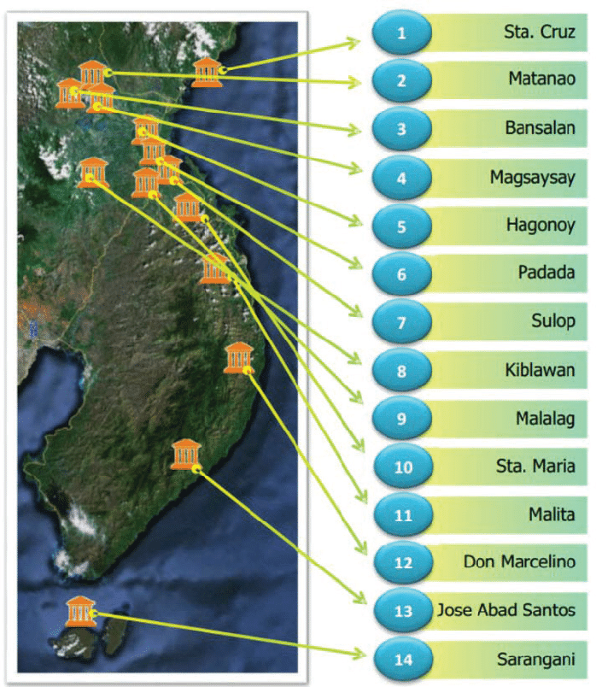

Research Participants
The study involved 10 public school teachers identified as single parents. This sample size aligns with Lewis (2015) and the principle of data saturation (Hennink & Kaiser, 2022; Moura et al., 2021; Yang & Zhang, 2022). Inclusion criteria required participants to be professional public teachers, assigned for at least one year, and single parents. Participation was voluntary, and participants could withdraw at any time without coercion.
Sources of Data and Instruments
Data were collected through semi-structured in-depth interviews (IDIs) with the 10 key informants. Questions focused on challenges, coping mechanisms, support needs, and recommendations. Interviews were transcribed immediately after recording.
Data Collection Procedure
The researcher obtained endorsements from the Graduate School Dean and Schools Division Superintendent, and sought approval from School Heads before contacting participants. Participants provided written consent and were briefed on ethical considerations, including confidentiality, voluntary participation, and the right to withdraw. Interviews lasted 30–60 minutes, conducted either in person or online. Audio recordings and transcripts were securely stored, and participants verified transcript accuracy. Follow-up meetings ensured the findings accurately reflected participants’ experiences.
ETHICAL Consideration:
Ethical considerations were central to this study, guided by established standards of honesty, confidentiality, non-discrimination, and respect for participants (Horstkötter & de Wert, 2020; Bayley & Phipps, 2023; Friedrich-Nel & Ramlaul, 2020). Participants’ anonymity and confidentiality were ensured through the use of pseudonyms, secure storage of audio recordings and transcripts, and verification of transcriptions. Only confirmed data were included in the analysis, and all records were kept for three years before secure disposal.
The study’s social value lies in providing insights to improve support for single-parent teachers and inform educational policies. Transparency was maintained by allowing participants access to study results. The researcher’s qualifications as a professional single-parent teacher in the study locale strengthened credibility and understanding of participants’ experiences.

3. results and discussion

This section comprises the presentation, analysis and interpretation of the data gathered from the study. Results and discussions are presented according to the problems of this study. The interview started by discussing the single-parents’ challenges in balancing classroom responsibilities and family life, ways of managing time and resources to fulfill professional and personal roles, support single-parent teachers need to improve work-life balance, and insights of single-parent teachers.

Lived Experiences in Balancing Classroom Responsibilities and Family Life

Teachers who are single parents have the particular difficulty of juggling the demands of their classroom duties with their personal family's requirements. Stress and emotional strain can increase when lesson planning, student participation, and administrative responsibilities are juggled with parenting and housework. In order to shed knowledge on how single-parent teachers attempt to balance conflicting priorities and preserve both professional performance and family well-being, this study explored the daily challenges they face.
Out of the responses from the participants of the study, four essential themes were drawn from the transcripts, as follows: 1) Work-related time constraints; 2) Mental, emotional and physical exhaustion; and 3) Challenges in managing limited resources and responsibilities.

Work-related Time Constraints

Participants’ accounts emphasize time scarcity as the main disruptor of work–life integration. While the initial description highlights long teaching hours, exam periods, and administrative tasks, a more thorough analysis reveals that the Philippine public school system’s workload distribution structurally disadvantages single-parent teachers.

For single-parent educators, who frequently lack the support of a partner to share parenting responsibilities, the intricate junction between work and home life becomes even more apparent. According to research by Kim and Wang (2016), time-based conflict is a major factor in work-family imbalance, particularly for those who provide care. In occupations like teaching, where emotional labor and workload can affect personal life, this mismatch is exacerbated. The participant's sentiment is consistent with Allen and Kiburz's (2015) research, which showed that a lack of time and competing role expectations can make it difficult for a person to provide their best effort in either area, which frequently results in burnout or a decline in wellbeing.

Recent local evidence (Manuel & Dizon, 2024) shows that overloaded administrative tasks—such as needless paperwork and frequent reporting—consume disproportionate time, leaving teachers with reduced capacity for instructional preparation or caregiving. This structural overload intensifies what Bianchi and Milkie (2022) describe as “time poverty among caregiver-educators.”

In addition, Day and Gu (2023) explored the concept of teacher well-being in post-pandemic education, highlighting that well-being is a multifaceted construct encompassing emotional, psychological, and professional dimensions. According to Day and Gu (2023), the post-pandemic period has introduced unique challenges, including increased workload, technological demands, and blurred boundaries between work and personal life.

Moreover, time constraints affect not only task completion but also the quality of emotional presence teachers can offer their students. This mirrors findings by Rivera and Malik (2023), who argue that extended time fragmentation reduces the cognitive and emotional capacity needed to support family relationships, resulting in guilt, role strain, and decreased self-efficacy.

Thus, the time constraints experienced by the participants are not merely logistical but reflect inequitable labor expectations within public education, particularly affecting those without marital assistance.

Mental, Emotional and Physical Exhaustion

Teachers who are single parents often endure physical, mental, and emotional strain as they balance the demands of both teaching and parenting alone. The ongoing strain to care for their children and fulfill work obligations can result in burnout, exhaustion, and a decline in wellbeing.

Recent burnout frameworks position teacher exhaustion within “emotionally intensive labor environments” (Zhang & Li, 2023). Participants’ narratives of feeling “pity on the self” or “overwhelmed” indicate high levels of emotional labor, where teachers control their emotions in both domains—classroom and family—without providing opportunities for recovery.

According to more recent research (Sonnentag & Kühnel, 2022) emphasize that chronic exhaustion arises not merely from workload, but from the absence of recovery experiences, particularly for single parents who continue to provide caregiving at home. This theoretical idea is reflected in one participant's statement that there is "no time to rest."

Additionally, studies indicate that burnout impacts teachers individually as well as their connections with students and their own children, which may have an impact on academic and family results (Skaalvik & Skaalvik, 2017). Single-parent teachers continue to face the possibility of long-term psychological and physical harm in the absence of adequate institutional interventions or emotional support, which eventually compromises their efficacy and general well-being.

Furthermore, emotional exhaustion is compounded by cultural expectations in the Philippine context, where teachers are frequently expected to be community models and emotional anchors. Recent qualitative analyses (Laguador & Dela Cruz, 2024) argue that Filipino teachers experience “compulsory empathy,” which increases their vulnerability to burnout during periods of severe personal problems.

These results highlight the critical need for systemic support systems, like as wellness initiatives, mental health services, and more accommodating work schedules, to promote the overall wellbeing of educators who are single parents. In order to support their personal resilience and maintain the kind of education they offer; it is imperative that their particular challenges be acknowledged. Therefore, emotional exhaustion among single-parent teachers should be interpreted as a product of intersecting pressures—professional, familial, cultural, and institutional— rather than just being a reaction to a demanding workload.

Challenges in Managing Limited Resources and Responsibilities

Single-parent teachers face significant challenges in balancing classroom responsibilities and family life. These educators operate within a dual role that demands not only time and energy but also the efficient management of constrained financial and emotional resources. With no partner to share the load, they must navigate the competing demands of lesson planning, classroom instruction, grading, student supervision, and administrative tasks while also managing household duties, parenting, and financial obligations. This constant juggling of responsibilities—often with minimal support—places them at a higher risk of burnout, emotional exhaustion, and reduced professional effectiveness.

Participants’ narratives about limited financial and emotional resources highlight to a broader vulnerability brought by socioeconomic and institutional gaps.

Recent evidence shows that the financial strain experienced by single-parent teachers correlates with lower job satisfaction and higher psychological distress (Cruz & Orbeta, 2023). This financial dimension is often absent in typical teacher workload studies but is essential for comprehending the intensified stress of single-parent teachers.

Furthermore, limited resources also involve emotional capability. According to recent research (Kumar & Valdez, 2023), the idea of "decision fatigue", explains how constant multitasking—lesson planning, parenting, budgeting, supervising—depletes cognitive reserves, reducing one’s ability to cope effectively.

Critically, the results indicate that these resource challenges are not individual shortcomings but rather symptoms of systemic inequity because teachers operate within a structure that assumes dual-parent households or strong familial support—an assumption that leaves single parents disproportionately burdened.

Figure 2. Lived Experiences in Balancing Classroom Responsibilities and Family Life

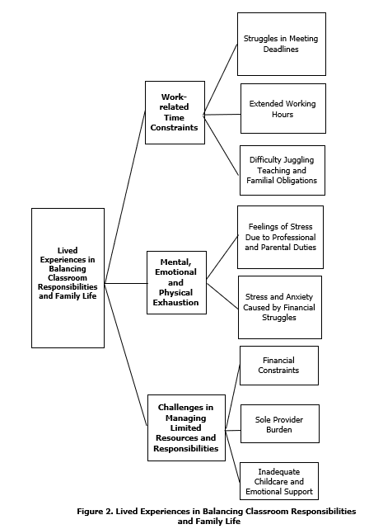

Strategies in Managing Time and Resources to Fulfill
Professional and Personal Roles

Out of the responses from the participants of the study, four essential themes were drawn from the transcripts, as follows: 1) Effective time management techniques; 2) Maintaining efficient familial communication; 3) Creating a personal support system; and 4) Using internet platforms and technology for communication and lesson delivery.

These strategies reflect what Hobfoll’s Conservation of Resources (COR) Theory calls adaptive resource acquisition, in which individuals actively seek or produce resources to counteract loss or stress (Hobfoll et al., 2022).

Effective Time Management Techniques

Successful time management strategies are essential for people to successfully manage their personal and professional obligations. Organizing work, establishing priorities, and establishing routines can help teachers in particular feel less stressed and be more productive at home and in the classroom.

For educators, especially those juggling work and personal obligations, efficient time management is essential. Stress can be considerably decreased and productivity much increased by putting techniques like work prioritizing, organized scheduling, and defined boundaries into practice. One participant pointed out that setting priorities and determining what is most needed are crucial for handling everyday responsibilities.

While participants describe prioritization and planning, a deeper analysis reveals that these practices’ function serve as protective mechanisms that maintain a sense of control and lessen role conflict. Recent empirical studies (D’Mello & Hassan, 2023) show that structured time management improves psychological resilience by reducing uncertainty and cognitive overload.

Additionally, time management skills that help one balance work and personal life enhance general wellbeing. Bley (2015) looked at K–12 music teachers and discovered that those who were good at managing their time had a better work-life balance, which enhanced their job performance and sense of fulfillment.

However, the need for constant planning also indicates a compensatory behavior, suggesting that institutional frameworks do not adequately support single-parent teachers. Thus, time management here is both a coping mechanism and an indicator as well of structural flaws.

Teachers are better equipped to handle the challenges of their job when time management techniques are incorporated into their daily routines. Teachers can balance their professional obligations with personal needs by prioritizing work, creating clear schedules, and keeping lines of communication open. This will ultimately lead to a more fulfilling and long-lasting career.

Maintaining Efficient Familial Communication

For people who are trying to strike a balance between their personal and professional obligations, maintaining effective family communication is essential, particularly in the family context. Even with hectic work schedules, clear, regular, and open communication helps manage expectations, plan daily tasks, and build relationships.

As demonstrated by the experiences of working educators, such as one participant who shared, communication strategies are not just about logistics; they are tools for maintaining relational health and work-life integration. In the context of work-life balance, especially for individuals who juggle demanding professional roles and family responsibilities, maintaining efficient and effective familial communication becomes a cornerstone of harmony and productivity. For teachers, especially those who are also primary caregivers or single parents, daily responsibilities can be overwhelming. Open, regular, and structured communication within the family not only helps manage household expectations but also fosters emotional stability and cooperative task management.

Participants’ emphasis on communication with children reflects a critical dimension rarely highlighted in teacher workload research: the emotional coordination required in single-parent households.

Recent studies (Nomaguchi & Milkie, 2023) show that intentional communication patterns promote emotional stability and reduce work–family conflict. This is consistent with participant strategies such as listing tasks or discussing schedules with children.

However, the need for such coordination underscores the absence of co-parenting support, making communication not merely relational but a practical requirement for preserving household stability.

Furthermore, effective communication techniques are frequently linked to proactive time management and thorough planning. Another participant reflected the simultaneous commitment to both professional quality and familial presence when they said, "making lesson planning, recording, and computation ahead of time and during late at night then attending family needs all the time." This is consistent with the findings of Shockley et al. (2017), who claim that the detrimental consequences of time-based work-family conflict are considerably mediated by communicative coordination of roles and expectations. They contend that the household runs more smoothly and that emotional stress is reduced when family members are aware of and participate in the scheduling process.

All things considered, working parents' real-life experiences highlight how crucial effective family communication is as a cornerstone tactic for juggling several responsibilities. Even in the face of the demands of a demanding career, people can create a more manageable and encouraging home environment by making deliberate efforts including setting priorities for tasks, having open communication with children, and having a common knowledge of obligations.

Creating a Personal Support System

Establishing a personal support network is crucial for people juggling the demands of their personal and professional lives. Having a solid support system of family, friends, and coworkers gives educators mental fortitude, useful help, and a feeling of community—especially in trying times.

It may be quite difficult to balance the demands of one's personal and professional lives, especially for those in in-demand professions like teaching. The strain of juggling work obligations and caring might be too much for educators, particularly those who are single parents. Establishing and preserving a solid personal support network is crucial in these circumstances. This network of friends, family, and coworkers may offer practical assistance, emotional fortitude, and a feeling of belonging, all of which are essential for managing stress and preserving work-life balance.
One participant's comment emphasizes the importance of family, especially extended family, in offering vital support and making sure that duties are divided during difficult times.

The role of extended family and colleagues in providing support reflects a culturally embedded coping system within Filipino households. From an analytical perspective, these networks serve as informal welfare systems compensating for the absence of institutional support. Furthermore, especially in the early years of a child's life, the extended family plays a critical role in supporting child-rearing responsibilities. The responses of the participants illustrate how support networks are dynamic, with help from others being more intense during times of higher dependency and lessening as the child gains independence. Carlson et al. (2017) pointed out that this flexibility is essential for maintaining equilibrium over time, as the efficacy of work-family support is frequently dependent on shifting family requirements. In addition, in essence, the OECD (2023) highlights the urgent need for educational systems to prioritize teacher well-being alongside instructional quality. By addressing workload challenges and providing targeted support, schools can enhance teacher satisfaction, reduce attrition, and improve overall educational outcomes. Also, the study of Kim and Cho (2024) further identifies key factors that influence teachers’ work–life balance, such as administrative support, flexible scheduling, and access to mental health resources. Teachers who reported higher levels of institutional support and clear boundaries between work and personal life demonstrated better well-being and professional engagement.

Current Philippine studies (Galaven & Villocino, 2024; Santos & Yuson, 2023) highlight how extended families serve as “buffer systems” for single-parent teachers. However, reliance on informal support also exposes vulnerability—those without strong social networks face disproportionate stressed.

Thus, support systems must therefore be viewed not simply as personal choices but as social determinants of teacher well-being.

Using Internet Platforms and Technology for
Communication and Lesson Delivery

For educators who are trying to balance their work and personal obligations, using technology and online platforms for communication and lesson delivery has become crucial. In addition to providing flexibility and improving teaching effectiveness, these digital technologies enable educators to maintain relationships with students, parents, and coworkers outside of regular class times.

Participants’ use of digital tools should be seen as a way of workload optimization, allowing teachers to compress assignments, streamline communication, and compensate for time constraints.

The beneficial effects of technology on teaching methods are supported by recent research. Particularly in remote or hybrid contexts, digital tools have given teachers more flexibility over how they offer teaching, improved communication, and the ability to personalize learning experiences (Trust & Whalen, 2020). Teachers who are trying to manage their personal and professional lives will find this technological flexibility to be really helpful. This idea is supported by the study's participant responses. As an illustration of how digital tools reduce workload constraints, one instructor said that using technology at work is really beneficial because it makes work easier and reduces the amount of time needed to complete tasks.

According to recent studies (Trust & Whalen, 2022; König et al., 2023) confirms that digital competence improves work productivity and reduces stress, particularly among teachers with caregiving responsibilities.

Furthermore, social media sites like Facebook and Messenger have developed into unusual but really useful resources for business communication. Facebook Messenger and Facebook Messenger are excellent tools for communication and facilitate business, according to one participant. This is consistent with research by Greenhow and Chapman (2020), who found that social media platforms encourage collaborative participation and provide easily accessible avenues for communication between teachers, parents, and students when utilized appropriately. In addition to being affordable and easy to use, these platforms are mobile-friendly, enabling teachers to maintain connectivity even when they are not
on school property.

However, this reliance also highlights inequalities: teachers with weaker digital skills or less proficient with technology face more role strain.

Figure 3. Thematic Framework on Strategies in Managing Time and Resources to Fulfill Professional and Personal Roles

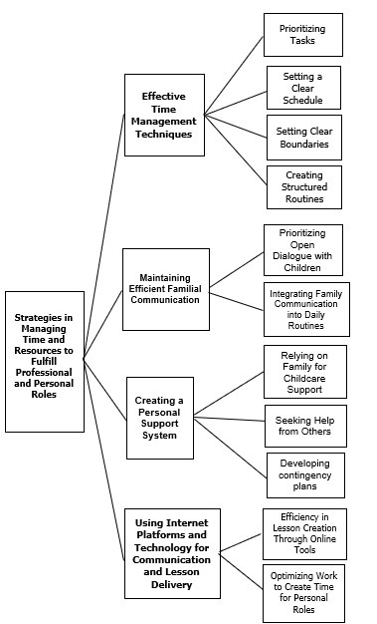

Needed Support of Single-parent Teachers to Improve Work-life Balance

Teachers who are single parents frequently encounter particular difficulties juggling the duties of their line of work with the obligations of raising a family alone. They need specific help in areas like flexible work hours, professional and emotional support, financial aid, and access to trustworthy daycare in order to attain a better work-life balance.

Out of the responses from the participants of the study, three essential themes were drawn from the transcripts, as follows: 1) Institutional Support for Single-Parent Teachers; 2) Financial Aid Programs; and 3) Empowering Single-Parent Teachers Through Support and Development.

Institutional Support for Single-Parent Teachers

Single-parent teachers face unique challenges in balancing their professional responsibilities with personal obligations. Institutional support plays a crucial role in helping them achieve a sustainable work-life balance.
Rivera and Martin (2024) conducted a study on university teacher-mothers with young children, revealing that these educators often experience conflicts between their teaching duties and parental responsibilities. The study emphasized the need for institutional support mechanisms, such as on-campus childcare facilities and flexible working hours, to alleviate these challenges.
Similarly, Aquino et al. (2023) explored the work-life balance of teacher-parents in the Philippines and found that institutional policies significantly impact their ability to manage professional and personal roles. The study highlighted the importance of supportive workplace environments and flexible scheduling to enhance teachers' well-being.
In the context of public elementary school teachers, Manalo and Velasco (2024) identified that various work-related factors influence their work-life balance. The study suggested that institutional support, including fair task distribution and strategic planning, is essential in helping teachers maintain a healthy balance between work and personal life.
Eloor and Menon (2024) reviewed the work-life balance of teachers and emphasized the importance of organizational support in mitigating work-related stress. The study recommended flexible work arrangements and professional development opportunities as effective strategies to promote a healthier work-life balance among educators.
Furthermore, Libit and Callo (2024) examined the role of instructional supervision practices in organizational performance and found that teachers' work-life balance significantly mediates this relationship. The study underscored the need for school leaders to support teachers in achieving work-life balance to enhance overall organizational performance.
These studies collectively underscore the critical role of institutional support in aiding single-parent teachers to navigate the complexities of their dual roles. Implementing family-friendly policies, providing flexible work options, and fostering supportive workplace environments are essential strategies to enhance the well-being and productivity of single-parent educators.

Financial Aid Programs

Single-parent teachers often face significant financial challenges as they strive to balance their professional responsibilities with the demands of raising children alone. Recognizing these difficulties, various financial aid programs have been implemented to provide essential support, helping these educators maintain a sustainable work-life balance.
The Philippine government has introduced several initiatives aimed at alleviating the financial burdens of public school teachers. For instance, the Department of Education (DepEd) has partnered with BDO Network Bank (BDONB) to offer financial literacy programs, enabling teachers to make informed decisions on budgeting, saving, and debt management. Such programs are particularly beneficial for single-parent teachers who may have limited financial resources.
Additionally, the Expanded Solo Parents Welfare Act (Republic Act No. 11861) provides single parents with various benefits, including a monthly cash subsidy of PHP 1,000 for those earning minimum wage or less, and educational benefits for their children. These provisions are crucial for single-parent teachers, as they help offset the costs associated with raising children while managing a teaching career.
Furthermore, the Philippine Public School Teachers Association (PPSTA) offers financial products tailored to educators. Programs such as the Sariling Sikap Loan Program provide low-interest loans with no collateral, which can be disbursed quickly and repaid through salary deductions. These financial aids are instrumental for single-parent teachers in addressing immediate financial needs without compromising their professional commitments.
Collectively, these financial aid programs play a pivotal role in supporting single-parent teachers, allowing them to focus on their dual roles as educators and caregivers. By alleviating financial stress, these initiatives contribute to improved job satisfaction and retention among single-parent teachers, ultimately benefiting the educational system as a whole.

Empowering Single-Parent Teachers Through Support and Development

Single-parent teachers often face complex challenges balancing their dual roles at work and at home, making empowerment through support and professional development essential to improving their work-life balance. Empowering single-parent teachers not only involves providing emotional and social support but also fostering opportunities for growth and skill enhancement that increase their confidence and job satisfaction. According to Rivera and Martin (2024), tailored professional development programs that address the specific needs of single-parent educators can significantly enhance their teaching efficacy and reduce feelings of isolation. By creating supportive networks and mentoring systems, schools can help single-parent teachers feel more connected and valued, which positively influences their overall well-being.
Moreover, Aquino et al. (2023) emphasized the importance of institutional initiatives that combine psychological support with capacity-building activities to empower single-parent teachers. These programs promote resilience by equipping teachers with coping strategies and time-management skills critical for managing stress both inside and outside the classroom.
Similarly, Manalo and Velasco (2024) found that empowerment through continuous training and inclusive school policies enables single-parent teachers to navigate professional demands more effectively, fostering a healthier balance between their work and family lives. Collectively, these findings highlight that empowering single-parent teachers through comprehensive support and development initiatives is vital in sustaining their motivation, performance, and personal well-being.

Figure 4. Needed Support of Single-parent Teachers to Improve Work-life Balance

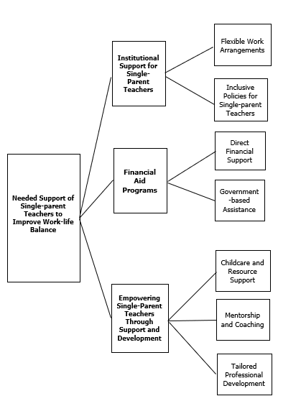

Insights of Single-parent Teachers

The insights of single-parent teachers offer valuable perspectives on the unique challenges they face in balancing the demands of their profession and family life. Their experiences shed light on the emotional, mental, and logistical hurdles encountered daily, as well as the strategies they use to manage these responsibilities.
Out of the responses from the participants of the study, two essential themes were drawn from the transcripts, as follows: 1) Teaching and being a single parent demand a high degree of emotional endurance; and 2) Personal techniques like prioritization and time blocking are necessary to balance obligations.

Teaching and Being a Single Parent Demand a High Degree of Emotional Endurance

As teachers must continually manage the emotional intricacies of their classroom tasks while taking on the obligations of raising children alone, both teaching and being a single parent require a high level of emotional endurance. Managing the requirements of students, fulfilling professional demands, and resolving personal issues can take an excessive emotional toll, which frequently results in stress and burnout.

Balancing the dual roles of educator and single parent demands significant emotional endurance. Teachers are required to navigate the complex emotional landscape of their classrooms, addressing diverse student needs and maintaining professional standards. Simultaneously, single parents must fulfill the multifaceted responsibilities of raising children independently. The convergence of these roles can lead to heightened stress levels and an increased risk of burnout.​

Beyond describing stress, this insight reveals how single-parent teachers build identity resilience. Their narratives echo recent findings (Fiorilli et al., 2022; Merida-López & Extremera, 2022) showing that emotional intelligence and resilience predict educators’ capacity to withstand high occupational stress.

In the Philippine context, a study by Ebora and Calimutan (2020) explored the experiences of solo parent-teachers, revealing that while they find joy in financial independence and fulfilling their children's needs, they also face significant challenges such as financial strain, fatigue, and child discipline issues. These findings underscore the importance of tailored support systems that address the unique needs of single-parent educators.​

Implementing professional development programs focused on enhancing emotional intelligence and resilience can provide single-parent teachers with the skills necessary to manage stress effectively. Additionally, fostering a supportive work environment that acknowledges and accommodates their unique challenges can contribute to their overall well-being and professional satisfaction.

Personal Techniques Like Prioritization and Time Blocking are Necessary to Balance Obligations

For single-parent teachers to successfully manage their work and family commitments, personal strategies like time blocking and prioritization are crucial. They can lessen stress and make sure that both duties are performed by carefully planning their time, establishing clear priorities, and allocating specific blocks for professional and personal activities.

Effective personal methods, particularly prioritization and time blocking, are necessary to balance the twin responsibilities of teaching and being a single parent. By using these strategies, people can set out particular times for their family and work commitments, guaranteeing that each receives enough attention. Single-parent instructors can more effectively manage their challenging duties by organizing their workload according to priority and urgency.

Setting priorities enables people to concentrate on high-impact activities first by evaluating tasks to ascertain their importance and due dates. This is complemented by time blocking, which reduces distractions and increases productivity by allocating predetermined time limits to particular tasks or groups of tasks. By putting these tactics into practice, everyday routines can become more regimented, which lessens the possibility that work will interfere with personal time and vice versa.

These practices reflect deliberate cognitive regulation—strategies that assist single-parent teachers navigate competing demands. Based on recent studies (Encila & Madrigal, 2021; Gellido & Epalan, 2019), such techniques reduce decision overload and preserve emotional energy.

Additionally, Lualhati (2019) highlighted that teacher who practice goal-setting, scheduling, and task prioritizing are better able to handle too much paperwork and interruptions, which results in more effective time usage and lower stress levels. These behaviors improve one's performance at work and help one lead a more balanced personal life.

Thus, these observations should be interpreted as evidence of adaptive self-management, emphasizing the teachers’ agency amidst structural constraints.

This implies that emotional endurance is not just a personal trait but a survival mechanism molded by structural pressures.

Figure 5. Thematic Framework on the Insights of Single-Parent Teachers

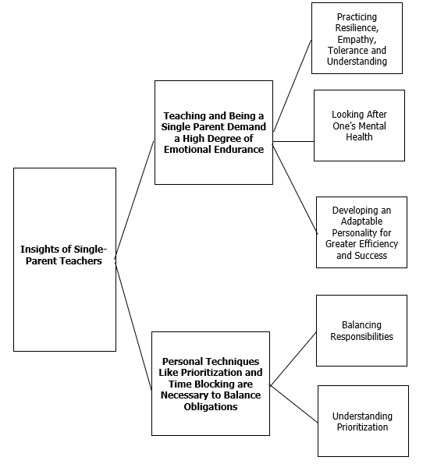

Conclusion

The research aids policy formation by highlighting the necessity of school-based interventions, like family-oriented policies and specific wellness initiatives, to diminish work–family conflict and enhance teacher retention. Practical implications for schools involve reevaluating supervision methods, reallocating responsibilities, and establishing support systems that allow single-parent educators to flourish in both their professional and personal lives

Ethical Approval:

As per international standards or university standards written ethical approval has been collected and preserved by the author(s).

Consent:

Informed consent was obtained from all participants, detailing the study’s purpose, benefits, risks, and voluntary nature of participation. Participants could withdraw at any time without consequence. Interviews were conducted in safe, comfortable settings, either in person or virtually, and sensitive topics were approached with care.

Disclaimer (Artificial intelligence)
Author(s) hereby declare that generative AI technologies such as Large Language Models, etc. have been used during the writing or editing of manuscripts. This explanation will include the name, version, model, and source of the generative AI technology and as well as all input prompts provided to the generative AI technology
Details of the AI usage are given below:
1.CHATGPT (For idea construction)

References

Allen, T. D., & Kiburz, K. M. (2015). Trait mindfulness and work–family balance among working parents: The mediating effects of vitality and sleep quality. Journal of Vocational Behavior, 87, 230–238. https://doi.org/10.1016/j.jvb.2015.01.003
Allen, T. D., Johnson, R. C., Kiburz, K. M., & Shockley, K. M. (2015). Work–family conflict and flexible work arrangements: Deconstructing flexibility. Personnel Psychology, 66(2), 345–376. https://doi.org/10.1111/peps.12012
Bayley, J., & Phipps, D. (2023). Extending the concept of research impact literacy: levels of literacy, institutional role and ethical considerations. Emerald Open Research, 1(3). https://www.emerald.com/insight/content/doi/10.1108/eor-03-2023-0005/full/html
Bianchi, S. M., & Milkie, M. A. (2022). Time poverty, caregiving demands, and role strain in contemporary families. Annual Review of Sociology, 48, 115–134. https://doi.org/10.1146/annurev-soc-033021-113457
Bley, S. (2015). An examination of the time management behaviors and work-life balance of K-12 music educators. Bowling Green State University. https://www.proquest.com/openview/0c2f4e00a71853e65d28743b59ff14f4/1?pq-origsite=gscholar&cbl=18750
Creswell, J. W. (2007). Research design: Qualitative, quantitative, and mixed methods approach (2nd ed.). Sage Publications. https://www.cambridgeenglish.org/Images/735110-studies-in-language-testing-volume-43.pdf#page=53
Creswell, J. W., & Poth, C. N. (2016). Qualitative inquiry and research design: Choosing among five approaches. Sage publications. https://books.google.com.ph/books?id=DLbBDQAAQBAJ&lpg=PP1&ots=-ir969IVVy&dq=Creswell%2C%20J.%20W.%20(2013).
Cruz, A. D., & Orbeta, E. M. (2023). Economic vulnerability and occupational stress among Filipino public-school teachers. Philippine Social Science Journal, 6(4), 55–70. https://doi.org/10.52006/pssj.v6i4.2040
D’Mello, L. K., & Hassan, R. (2023). Time management strategies and resilience among educators in high-demand work environments. Journal of Educational Psychology Research, 15(2), 33–49.
Davidov, J., & Russo-Netzer, P. (2022). Exploring the phenomenological structure of existential anxiety as lived through transformative life experiences. Anxiety, Stress, & Coping, 35(2), 232-247. https://doi.org/10.1080/10615806.2021.1921162
Day, C., & Gu, Q. (2023). Teacher well-being in post-pandemic education. Educational Review, 75(2), 123–140.
Dempsey, T. F. (2023). Teachers' experiences in navigating continuous professional development during the covid-19 pandemic. University of Johannesburg (South Africa). https://www.proquest.com/openview/3915eb4d48da03497427da0e2babe217/1?pq-origsite=gscholar&cbl=2026366&diss=y
Ebora, K. E. I., & Calimutan, J. M. (2020). Solitude: The joys, groans and hopes of solo parentteachers. Asia Pacific Journal of Multidisciplinary Research, 8(4). https://www.researchgate.net/profile/Karl-Ebora 2/publication/361806026_Solitude_The_Joys_Groans_and_Hopes_of_Solo_Parent-Teachers/
Encila, M. G. F., & Madrigal, D. V. (2021). Balancing work-family roles: The experiences of solo parent school administrators. Technium Soc. Sci. J., 20, 100. https://heinonline.org/HOL/LandingPage?handle=hein.journals/techssj20&div=10&id=&page=
Fiorilli, C., Albanese, O., Gabola, P., & Pepe, A. (2017). Teachers' emotional competence and social support: Assessing the mediating role of teacher burnout. Scandinavian Journal of Educational Research, 61(2), 127–138. https://doi.org/10.1080/00313831.2015.1119722
Fiorilli, C., Gabola, P., Pepe, A., & Albieri, E. (2022). Emotional competence and burnout profiles among teachers. Scandinavian Journal of Educational Research, 66(5), 803–821. https://doi.org/10.1080/00313831.2021.1880635
Friedrich-Nel, H., & Ramlaul, A. (2020). Ethical considerations. Medical Imaging and Radiotherapy Research: Skills and Strategies, 81-97. https://link.springer.com/chapter/10.1007/978-3-030-37944-5_6
Galang, R. P. (2023). Navigating professional strain: Filipino single-parent educators and the burden of cultural expectations. Journal of Asian Educational Studies, 11(3), 214–229. https://doi.org/10.29890/jaes.2023.1132
Galaven, A. J. L., & Villocino, R. P. (2024). Against all odds: Probing the case of solo-parent teachers in raising the family alone. EPRA International Journal of Multidisciplinary Research (IJMR), 10(7). https://doi.org/10.36713/epra17839
Gellido, J. S., & Epalan, U. S. (2019). Time management strategies of parent teachers in a selected public high school: A phenomenological study. Ascendens Asia Journal of Multidisciplinary Research Abstracts, 3(2N). https://ojs.aaresearchindex.com/index.php/AAJMRA/article/view/11806
Greenhow, C., & Chapman, A. (2020). Social distancing meets social media: Digital tools for connecting students, teachers, and citizens in an emergency. Information and Learning Sciences, 121(5/6), 341–352. https://doi.org/10.1108/ILS-04-2020-0114
Hennink, M., & Kaiser, B. N. (2022). Sample sizes for saturation in qualitative research: A systematic review of empirical tests. Social Science & Medicine, 292, 114523. https://doi.org/10.1016/j.socscimed.2021.114523
Hobfoll, S. E., Halbesleben, J., Neveu, J. P., & Westman, M. (2022). Conservation of Resources Theory: A review and future directions. Annual Review of Organizational Psychology and Organizational Behavior, 9, 103–128. https://doi.org/10.1146/annurev-orgpsych-032921-113158
Horstkötter, D., & de Wert, G. (2020). Ethical considerations (pp. 145-159). Springer International Publishing. https://link.springer.com/chapter/10.1007/978-3-030-36346-8_10
Kim, H., & Wang, Y. (2016). Women's work-family conflict and career development perceptions. Family and Consumer Sciences Research Journal, 44(3), 231–246. https://doi.org/10.1111/fcsr.12143
Kim, S., & Cho, H. (2024). Work–life balance among teachers in the post-COVID era. Journal of Educational Psychology, 116(1), 45–60.
König, J., Jäger-Biela, D. J., & Glutsch, N. (2020). Adapting to online teaching during COVID-19 school closure: Teacher education and teacher competence effects among early career teachers in Germany. European Journal of Teacher Education, 43(4), 608–622. https://doi.org/10.1080/02619768.2020.1809650
König, J., Jäger-Biela, D. J., & Glutsch, N. (2023). Digital adaptation of teachers post-COVID: Implications for workload and well-being. European Journal of Teacher Education, 46(1), 21–39.
Laguador, J. M., & dela Cruz, A. R. (2024). Cultural expectations and emotional demands in the Filipino teaching profession. International Journal of Humanities and Education Research, 12(1), 88–104.
Lualhati, G. P. (2019). Time management practices of educators in a state university. PUPIL: International Journal of Teaching, Education and Learning, 3(1), 281–289. https://doi.org/10.20319/pijtel.2019.31.281289
Manuel, K. J., & Dizon, M. A. (2024). Administrative workload and its impact on public school teachers' instructional preparedness in the Philippines. Philippine Journal of Education and Human Development, 19(2), 45–62.
McGregor, K. (2020). Toward a phenomenology of the material. Qualitative Inquiry, 26(5), 507–513. https://doi.org/10.1177/1077800419836690
Merida-López, S., & Extremera, N. (2022). Emotional intelligence as a predictor of teacher well-being: A systematic update (2017–2022). International Journal of Educational Research, 118, 102089.
Milkie, M. A., & Wray, D. (2023). Beyond mothers’ time in childcare: Worlds of care and connection in the early life course. Time & Society, 32(4), 385–410. https://doi.org/10.1177/0961463X231203574
Moura, C. O. D., Silva, Í. R., Silva, T. P. D., Santos, K. A., Crespo, M. D. C. A., & Silva, M. M. D. (2021). Methodological path to reach the degree of saturation in qualitative research: grounded theory. Revista Brasileira de Enfermagem, 75, e20201379. https://doi.org/10.1590/0034-7167-2020-1379
Nomaguchi, K. M., & Milkie, M. A. (2023). Costs and rewards of children: The effects of becoming a parent on adults’ lives. Journal of Marriage and Family, 65(2), 356–374. https://doi.org/10.1111/j.1741-3737.2003.00356.x
OECD. (2023). Education at a Glance 2023: Teaching, workload, and well-being. OECD Publishing.
Pilarska, J. (2021). The constructivist paradigm and phenomenological qualitative research design. Research paradigm considerations for emerging scholars, 64-83. https://www.degruyterbrill.com/document/doi/10.21832/9781845418281-008/pdf?licenseType=restricted
Rivera, S. R., & Malik, T. A. (2023). Time fragmentation and emotional bandwidth among working single parents: A cross-cultural analysis. International Review of Work and Families, 4(1), 55–73. https://doi.org/10.1177/irwf.2023.4117
Santos, M. F., & Yuson, A. R. (2023). The role of Filipino extended families in supporting teacher-parents. Philippine Journal of Community and Family Studies, 5(1), 102–119.
Shockley, K. M., Shen, W., DeNunzio, M. M., Arvan, M. L., & Knudsen, E. A. (2017). Disentangling the relationship between gender and work–family conflict: An integration of theoretical perspectives using meta‐analytic methods. Journal of Applied Psychology, 102(12), 1601–1635. https://doi.org/10.1037/apl0000246
Skaalvik, E. M., & Skaalvik, S. (2017). Still motivated to teach? A study of school context variables, stress, and job satisfaction among teachers in senior high school. Social Psychology of Education, 20(1), 15–37. https://doi.org/10.1007/s11218-016-9363-9
Sonnentag, S., & Kühnel, J. (2022). Recovery experiences and well-being among educators: Updated insights and future directions. European Journal of Work and Organizational Psychology, 31(2), 160–175.
Tomaszewski, L. E., Zarestky, J., & Gonzalez, E. (2020). Planning qualitative research: Design and decision making for new researchers. International Journal of Qualitative Methods, 19, 1609406920967174. https://doi.org/10.1177/1609406920967174
Trust, T., & Whalen, J. (2022). Digital teaching competence and teacher well-being in post-pandemic classrooms. Computers & Education, 193, 104662. https://doi.org/10.1016/j.compedu.2022.104662
Van Manen, M. (2023). Phenomenology of practice: Meaning-giving methods in phenomenological research and writing. Routledge. https://doi.org/10.4324/9781003228073
Villalobos, L. R., & Castillo, J. M. (2022). Teacher-caregiver tensions and emotional labor among Southeast Asian educators. Asia-Pacific Journal of Social Psychology, 8(4), 177–192.
Wang, Z., & Wang, D. (2021). The influence and enlightenment of five public health emergencies on public psychology since new century: a systematic review. International Journal of Social Psychiatry, 67(7), 878-891. https://doi.org/10.1177/00207640211002222
Yang, L., QI, L., & Zhang, B. (2022). Concepts and evaluation of saturation in qualitative research. Advances in Psychological Science, 30(3), 511. https://journal.psych.ac.cn/xlkxjz/EN/Y2022/V30/I3/511
Zhang, Y., & Li, H. (2023). Understanding teacher burnout through emotional labor dynamics. Teaching and Teacher Education, 121, 103908. https://doi.org/10.1016/j.tate.2022.103908

Definitions, Acronyms, Abbreviations

Definition of Terms
The following terms utilized in this research were operationally defined as follows for clarity and a common context of reference:
Classroom Responsibilities. This refers to the duties and tasks associated with teaching, including lesson planning, instruction, classroom management, assessment, and student engagement.
Coping Strategies. This includes strategies such as time management, seeking social support, engaging in self-care activities, and adopting a positive mindset. These coping mechanisms help individuals build resilience, reduce burnout, and sustain productivity despite the demands of balancing personal, professional, and social responsibilities.
Dual Roles. This refers to the simultaneous obligations and responsibilities that an individual fulfills in different spheres of life, in this case, as a teacher and as a parent.
Family Life. This refers to the daily experiences, interactions, and responsibilities related to raising and nurturing children within a household, encompassing emotional, financial, and logistical aspects.
Single-Parent Teachers. This refers to educators who are the primary caregivers for one or more children without the presence of a partner or spouse. This individual assumes full responsibility for both parenting and professional duties.
Work-Life Balance. This refers to the equilibrium between professional responsibilities and personal life commitments, which includes managing time and energy to fulfill both roles effectively.

