Integrating Local Wisdom into Science Learning: A Systematic Review of Pedagogical Frameworks and Educational Practices

ABSTRACT

Background:
The integration of local wisdom into science learning has gained increasing attention as an approach to contextualize scientific knowledge and promote sustainable education. However, existing research remains fragmented in its frameworks and practices. This study systematically reviews the evolution, dominant pedagogical models, and educational outcomes of local wisdom–based science learning to establish a comprehensive understanding of its theoretical and practical landscape.
Methods:
A systematic literature review (SLR) was conducted in accordance with the PRISMA 2020 guidelines. Data were retrieved from the Scopus database using the query TITLE-ABS-KEY (“local wisdom” AND “science learning”), limited to open-access, English-language journal articles published between 2004 and 2025. A total of 58 records were identified, screened, and filtered, yielding 17 eligible articles for full-text analysis. Quantitative bibliometric data (publication year, country, subject area, and keyword trends) were analyzed using VOSviewer 1.6.20, while qualitative synthesis identified recurring pedagogical frameworks and instructional patterns.
Results:
The review revealed a marked growth in publications after 2020, dominated by studies from Indonesia within the domains of education, environmental science, and sustainability. Five key frameworks emerged: (1) Ethnoscience + Inquiry/Discovery, (2) Ethnoscience + STEM/STEAM, (3) Ethnopedagogy + Character Education, (4) Ethnoscience + Problem-/Project-Based Learning, and (5) Digital/Game-Based Ethnoscience. Thematic analysis indicated a shift toward inclusive, digital, and value-integrated science pedagogy.
Conclusion:
Local wisdom functions as a transformative foundation that connects scientific reasoning with cultural and moral dimensions. Ethnoscience-based learning provides a sustainable pathway for integrating tradition and modernity, aligning with Education for Sustainable Development (ESD) and fostering global citizenship through culturally grounded science education. The review concludes with recommendations for curriculum design and teacher education programs that promote culturally responsive and sustainability-oriented science learning.

Keywords: Cultural pedagogy; educational practices; Ethnoscience; Local wisdom; Science learning;

1. INTRODUCTION

In recent years, the integration of local wisdom into science learning has received growing attention as educators seek to contextualize scientific concepts within learners’ cultural and ecological realities. Global challenges such as environmental degradation, biodiversity loss, and cultural homogenization have underscored the need for education systems that not only transmit scientific knowledge but also sustain local identities and values (Rizkil, 2025; Verawati & Wahyudi, 2024). The call for culturally responsive and place-based education resonates strongly with the principles of Education for Sustainable Development (ESD) and the Sustainable Development Goals (SDGs), particularly SDG 4 (Quality Education), SDG 13 (Climate Action), and SDG 15 (Life on Land) (Compan et al., 2025; Mulero et al., 2024; Nguyen et al., 2025). Science learning that draws upon local wisdom is increasingly viewed as an avenue for fostering environmental awareness, social responsibility, and scientific literacy aligned with local contexts (Husamah et al., 2025, 2024; Phandini et al., 2023; Rahardjanto et al., 2025).
Local wisdom, broadly defined as the accumulated knowledge, practices, and values developed by a community through long-term interaction with its environment, offers rich pedagogical potential. In many indigenous and traditional societies, local wisdom embodies empirical observation, ecological ethics, and problem-solving strategies that parallel scientific inquiry (Albar et al., 2025; Lestari et al., 2024; UNESCO, 2022; Eliyahu-Levi & Ganz-Meishar, 2020). When appropriately integrated into formal science education, it can serve as a bridge between students’ lived experiences and abstract scientific principles. For instance, local ecological practices such as sustainable farming, herbal medicine, or traditional meteorology can be used as contextual entry points to teach concepts in biology, chemistry, or environmental science. Such integration enhances the relevance of science learning, promotes cultural appreciation, and supports the development of higher-order thinking skills (Acut, 2024; Leal Filho et al., 2021; Siebrecht, 2020; Sunkur et al., 2023).
Despite its potential, integrating local wisdom into science learning presents theoretical and practical challenges. Studies have reported that while many teachers and curriculum developers acknowledge the importance of local wisdom, its implementation in classrooms often remains superficial—limited to anecdotal references or cultural illustrations without deep conceptual connection to scientific content (Fitrianto & Farisi, 2025; Isma & Yusuf, 2025; Pugu et al., 2024; Sakti et al., 2024; Sofiyah et al., 2025). Moreover, there is still a lack of coherent pedagogical frameworks that systematically guide the process of incorporating local wisdom into curriculum design, instructional strategies, and assessment. The diversity of cultural settings further complicates the creation of universal models, leading to fragmented research findings across regions and disciplines.
Previous reviews have primarily addressed the role of indigenous knowledge in environmental education or sustainability education (Druker-Ibáñez & Cáceres-Jensen, 2022; Ijatuyi et al., 2025; Lopez, & Vallejos, 2022; Manns et al., 2025; Ogunniyi, 2021; Sandoval-Rivera, 2020). However, a comprehensive synthesis focusing specifically on how local wisdom is pedagogically integrated into science learning—including frameworks, models, strategies, and learning outcomes—remains limited. The need for such a synthesis is critical for identifying effective practices, revealing gaps in theoretical understanding, and proposing future research directions that align with transformative education goals.
Therefore, this study aims to systematically review and synthesize the body of knowledge on the integration of local wisdom into science learning. By examining peer-reviewed Scopus-indexed articles that discuss local wisdom and science learning between 2010 and 2025, this review seeks to: (1) identify the dominant pedagogical frameworks employed, (2) analyze educational practices and their outcomes, and (3) map emerging trends and research gaps. The findings are expected to contribute to the development of contextually grounded science education frameworks that honor cultural diversity while promoting scientific competence and sustainability values.

2. methodology

2.1 Research Design
This study employed a Systematic Literature Review (SLR) approach guided by the Preferred Reporting Items for Systematic Reviews and Meta-Analyses (PRISMA 2020) framework. The review combined bibliometric analysis to map publication trends and qualitative synthesis to identify pedagogical frameworks and educational practices related to the integration of local wisdom into science learning. This hybrid design ensured a comprehensive understanding of both the quantitative trends and the conceptual depth of the field.
2.2 Data Source and Search Strategy
The data were obtained from the Scopus database, which was selected due to its broad and authoritative coverage of peer-reviewed international publications. The search was conducted in October 2025, using the following query string: TITLE-ABS-KEY (“local wisdom” AND “Science Learning”) AND (LIMIT-TO (DOCTYPE, “ar”)) AND (LIMIT-TO (LANGUAGE, “English”)) AND (LIMIT-TO (OA, “all”)). This strategy ensured that only journal articles written in English and indexed in Scopus were included, with the search targeting occurrences of the keywords in the title, abstract, or keywords. The initial search produced 58 records.
2.3 Screening and Eligibility
The PRISMA-based selection process consisted of four sequential stages—identification, screening, eligibility, and inclusion—as illustrated in Figure 1. (1) Identification:
A total of 58 records were retrieved from Scopus using the search string above. These records were exported in BibTeX format for further processing and screening. (2) Screening: Records were screened to include only original research articles. Non-article sources such as conference papers, book chapters, and reviews were excluded (n = 33), leaving 25 original articles. (3) Eligibility: Articles were filtered by language and accessibility. All remaining 25 records were published in English, and only open access papers were retained to ensure full-text availability. Seven articles that required payment for access (gold or hybrid gold open access) were excluded (n = 7), leaving 18 open-access articles. (4) Inclusion: Articles published between 2004 and 2024 were then screened based on abstract and full-text relevance to the research theme. One article could not be accessed in full text and was therefore excluded. A final total of 17 articles were included for analysis. The PRISMA flow diagram (Figure 1) summarizes this process and the number of studies excluded at each stage.
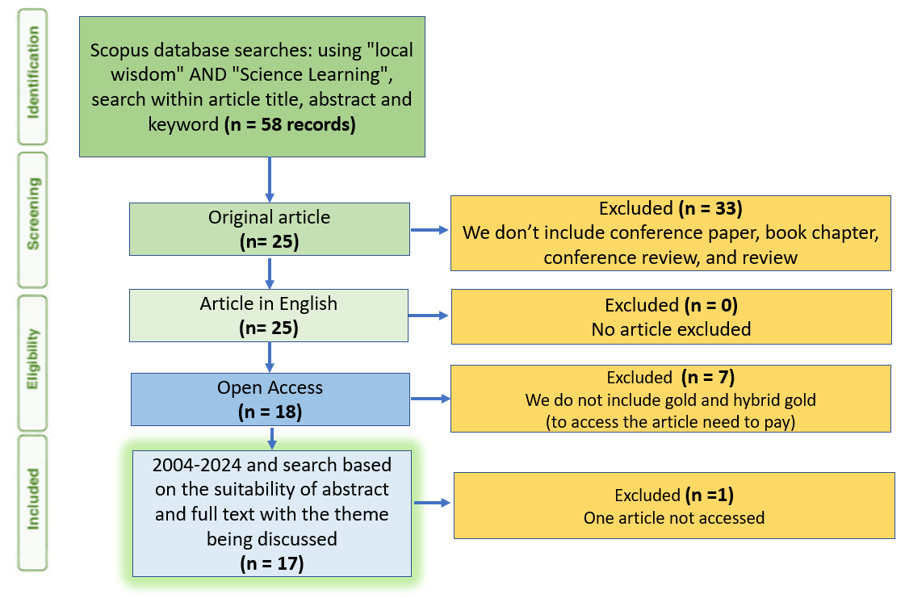

Fig. 1. The PRISMA flow diagram

2.4 Inclusion and Exclusion Criteria
To maintain consistency and quality, several inclusion and exclusion criteria were applied. The inclusion criteria required that each publication be a peer-reviewed journal article indexed in Scopus, written in English, explicitly connecting the concepts of local wisdom (or indigenous/local knowledge) and science learning, available as an open-access full-text article, and published between 2004 and 2024. Conversely, the exclusion criteria eliminated non-journal publications such as book chapters, reviews, and conference papers; articles that did not address the pedagogical aspects of science learning; non-open-access papers requiring subscription or payment; and studies that were unavailable in full text.

  - Data Extraction and Coding
Data extraction covered two major dimensions: (1) Bibliometric data: publication year, country/affiliation, journal source, subject area, and author keywords. (2) Qualitative data: pedagogical framework used (e.g., ethnoscience, contextual learning, ESD-based models), educational practices (e.g., project-based, inquiry-based, local-context learning), and reported learning outcomes (e.g., scientific literacy, character values, environmental awareness).
The dataset was managed and coded using Microsoft Excel and Zotero. For bibliometric visualization, VOSviewer 1.6.20 was employed to analyze keyword co-occurrence and thematic clusters. Coding reliability was ensured through independent review and consensus discussion among researchers.

  - Data Analysis
The analysis proceeded in two integrated phases: (1) Bibliometric Analysis — descriptive statistics were generated to reveal temporal publication trends (documents by year), geographical distribution (documents by country), subject area proportions, and keyword trends. (2) Qualitative Synthesis — a thematic content analysis (Braun & Clarke, 2006) was conducted to identify dominant pedagogical frameworks and patterns of educational practice in integrating local wisdom into science learning. Findings from both phases were then triangulated to construct a holistic picture of the research landscape, theoretical orientations, and implementation strategies in this field. To ensure reliability, the data coding process was cross-checked independently by two researchers, and minor discrepancies were resolved through discussion until consensus was reached.

3. results and discussion

3.1 Publication Trends
To gain a comprehensive understanding of the research landscape, the 17 selected articles were analyzed based on their publication year, country of origin, subject area distribution, and keyword co-occurrence network. These bibliometric indicators reveal how scholarly attention toward the integration of local wisdom into science learning has evolved over time and across regions.
3.1.1 Documents by Year
Figure 2 presents the annual publication trend of research linking local wisdom and science learning from 2017 to 2025. As illustrated, research activity remained minimal between 2017 and 2020, with only one article published in 2017 and no publications from 2018 to 2020. A notable increase began in 2021, followed by a rapid rise in 2022–2025, peaking at five publications per year in both 2024 and 2025.

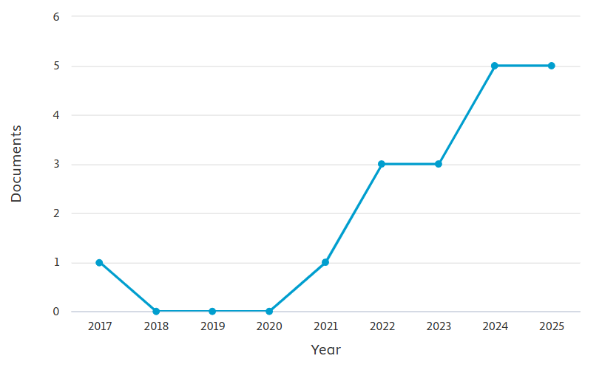
Fig. 2. Documents by Year of Publication
This steady growth reflects an increasing scholarly interest in contextualizing science education. It shows how cultural and local perspectives are being reintroduced into formal science learning. The turning point around 2021 coincides with the global expansion of Education for Sustainable Development (ESD) programs and the increasing integration of local culture into school curricula in Southeast Asia. The surge from 2022 onwards also aligns with the post-pandemic emphasis on community-based and culturally rooted education reforms, indicating a paradigm shift from conventional content delivery to contextualized learning that bridges scientific understanding and socio-cultural identity (Aldhafeeri & Alotaibi, 2023; Asmayawati et al., 2024; Mhlongo et al., 2023).
3.1.2 Documents by Country
Figure 3 displays the geographical distribution of publications. The data reveal a dominant contribution from Indonesia (n = 17), with only isolated studies from Cambodia, Oman, Poland, Saudi Arabia, South Africa, and Thailand, each contributing a single document.
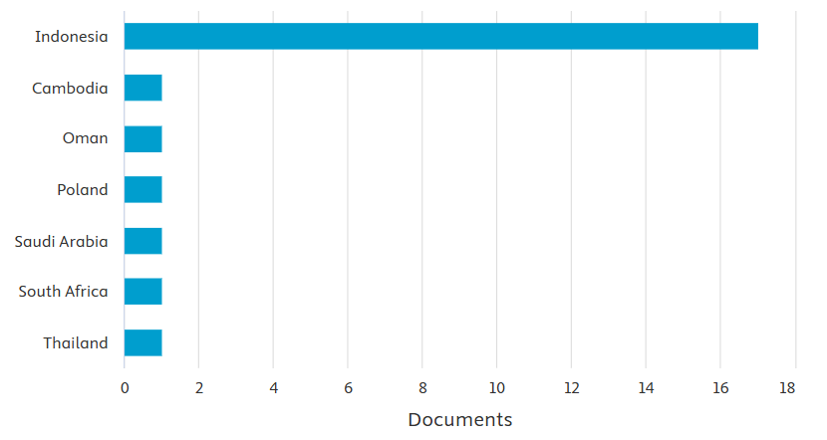
Fig. 3. Documents by Country
Indonesia’s overwhelming representation underscores the country’s rich repository of indigenous knowledge systems (kearifan lokal) and the strong academic discourse surrounding ethnoscience-based education. The prominence of Indonesian scholars also reflects the integration of local wisdom into the Kurikulum Merdeka and Adiwiyata environmental education programs, which encourage culturally embedded science learning. The limited contributions from other countries suggest that while the concept of local wisdom is globally acknowledged, its systematic integration into science learning remains largely regionalized and underexplored outside the Indonesian context.
3.1.3 Documents by Subject Area
Figure 4 summarizes the subject area distribution of the analyzed articles. The majority of studies fall under Social Sciences (57.7%), followed by Environmental Science (11.5%), Computer Science (7.7%), Psychology (7.7%), and smaller proportions in Economics, Medicine, Multidisciplinary studies, and Pharmacology (each 3.8%).
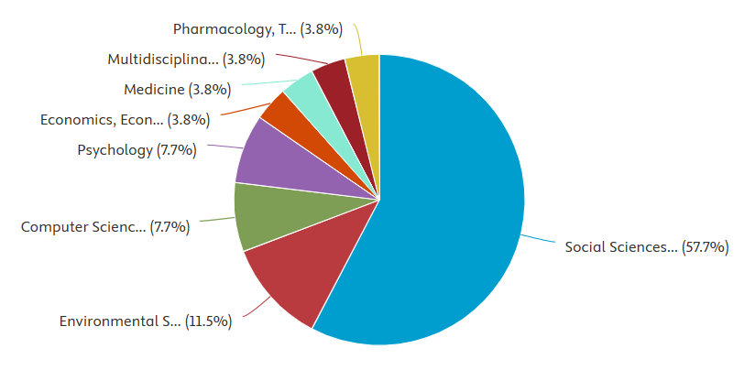
Fig. 4. Documents by Subject Area
The dominance of the social sciences reflects the pedagogical orientation of this research domain, emphasizing education, culture, and social values in science learning. Environmental science’s presence highlights the ecological dimension of local wisdom, where indigenous practices often relate to sustainable resource management and environmental ethics. Interestingly, the emerging inclusion of computer science indicates an emerging trend toward digital ethnoscience—the use of digital media and e-learning tools to preserve and teach local knowledge in science classrooms. This interdisciplinary blend signals a gradual convergence between cultural education, environmental sustainability, and digital transformation in modern pedagogy.
3.1.4 Keyword Co-occurrence Analysis
Figure 5 depicts the VOSviewer keyword co-occurrence network visualizing how frequently keywords appear together across the reviewed studies. The network reveals two central nodes—“local wisdom” and “science learning”—surrounded by related clusters. The blue cluster connects local wisdom with community-based and cultural themes such as huluhula, catur pramana, and panggadakkang tuparrita, reflecting indigenous philosophical constructs. The green cluster is dominated by terms like ethnoscience, critical thinking, scientific literacy, and cultural literacy, highlighting the pedagogical focus. The red cluster links learning models with environmental technology and digital platforms (e.g., e-books, Google website), while smaller clusters (purple and yellow) relate to bibliometric and global diversity themes.
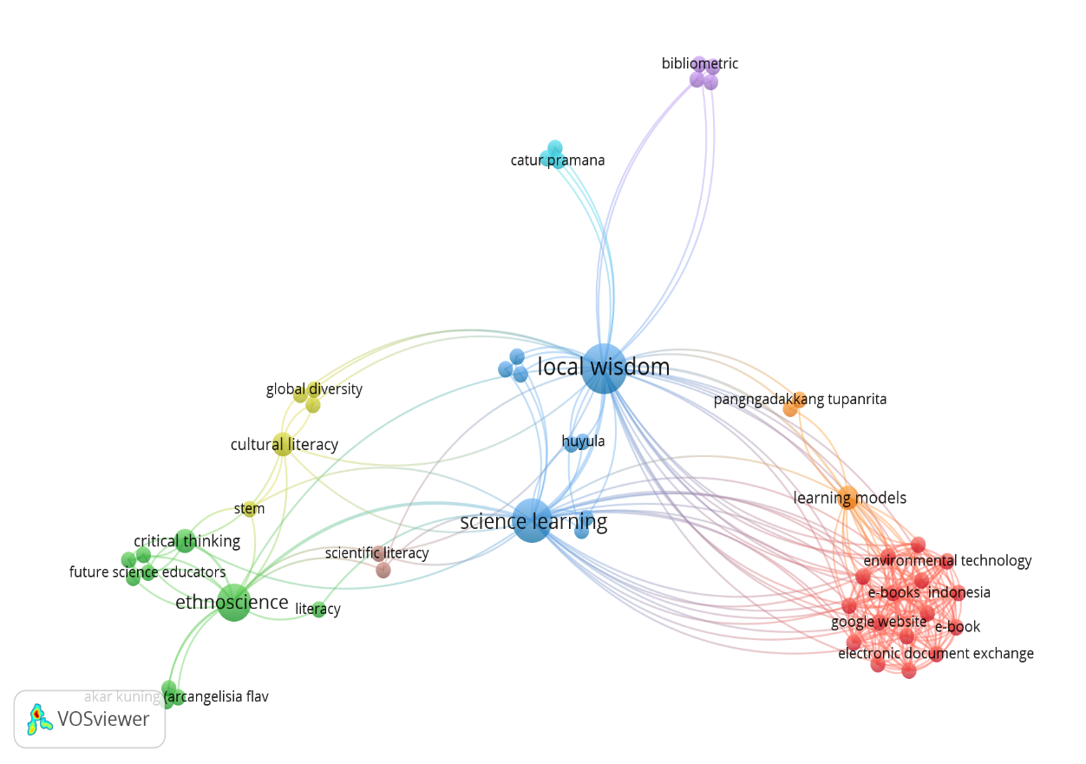
Fig. 5. Keyword Co-occurrence Analysis
The keyword map suggests that recent research emphasizes ethnoscience-based pedagogy, cultural and scientific literacy, and the integration of technology in teaching local wisdom. This indicates an ongoing evolution from descriptive documentation of indigenous practices toward transformative learning frameworks that employ digital tools and interdisciplinary strategies. The intersection between ethnoscience, critical thinking, and STEM education reflects efforts to merge traditional ecological knowledge with modern scientific reasoning—a trend aligned with UNESCO’s ESD 2030 framework (Kioupi & Voulvoulis, 2019).
Moreover, the visualization reveals that Indonesian local concepts (e.g., huluhula, panggadakkang tuparrita) are being scientifically contextualized, illustrating how local epistemologies are entering mainstream science education discourse. Such blending of local and global paradigms reinforces the vision of culturally responsive and sustainable education.
Overall, the bibliometric patterns demonstrate that research on integrating local wisdom into science learning has expanded significantly over the past decade, driven primarily by Indonesian scholarship and interdisciplinary collaboration. The dominance of social science and education journals reflects the field’s pedagogical core, while the emergence of technology-related and environmental themes signals diversification and innovation in recent years (Alemayehu Tegegn, 2024; Rame et al., 2024; Samala et al., 2025; Wang et al., 2024). The keyword mapping confirms a conceptual shift toward holistic, culturally grounded, and technology-enhanced science education—bridging local knowledge, sustainability, and scientific literacy.

3.1.5 Distribution of Publications by Education Level
The pie chart (Fig. 6) illustrates the proportional focus of thirteen research articles on different educational levels. The analysis reveals that Junior High School (31%) and Higher Education (31%) each contribute the largest share of publications, indicating a balanced emphasis on both secondary education and university-level research. These studies mainly explore ethnoscience integration, local wisdom, and digital learning innovation—reflecting a strong connection between classroom practice and teacher professional development.
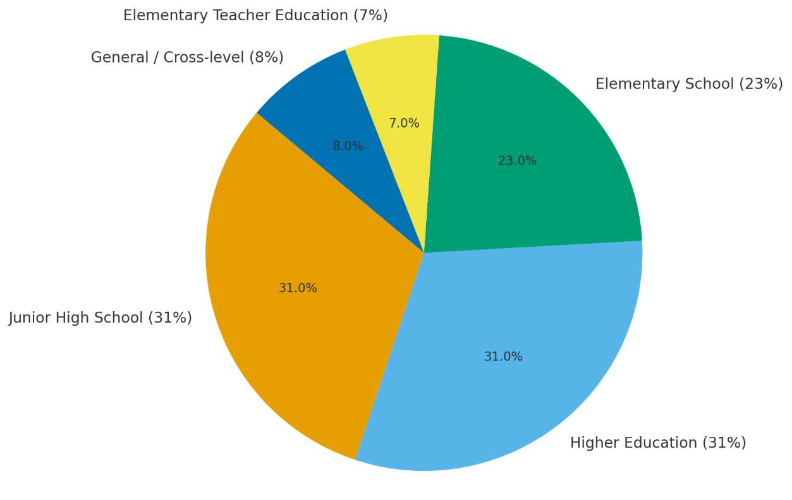
Fig. 6. Distribution of Publications by Education Level (2017–2025)

Meanwhile, Elementary School (23%) research shows an increasing trend in recent years, particularly emphasizing character education, Pancasila Student Profile development, and environmentally oriented science learning. The Elementary Teacher Education (PGSD) category (7%) contributes through module and e-learning development aimed at strengthening pedagogical competence for pre-service teachers. The General / Cross-level (8%) category, represented by bibliometric and comparative studies, provides an overarching framework that connects research findings across all levels.
Overall, the pie chart underscores a continuum of research focus extending from basic to higher education. It highlights that local wisdom–based science learning has evolved into a systemic educational model, bridging foundational science learning in schools with teacher education and higher academic inquiry, aligning well with SDG 4 (Quality Education) and the Education for Sustainable Development (ESD) framework.
3.2 Dominant Pedagogical Frameworks in Local Wisdom–Based Science Learning
The synthesis of 17 reviewed Scopus-indexed articles reveals five dominant pedagogical frameworks recurring across contexts, with ethnoscience serving as an overarching approach that integrates scientific reasoning, cultural values, and socio-ecological realities.

3.2.1 Ethnoscience and Inquiry/Discovery Learning
Early work by Dwianto et al. (2017) positioned ethnoscience as a strategy grounded in scientific process skills and attitudes among junior high school students through a hybrid 4D Thiagarajan and Borg & Gall development model. The framework emphasized five domains of science learning—knowledge, process, creativity, attitude, and application—and demonstrated effectiveness in enhancing students’ science process skills and scientific attitudes through culturally contextualized materials.
This finding is reinforced by Darmayanti et al. (2025), who developed an environment-oriented practicum guide based on the Balinese philosophical construct Catur Pramana—comprising pratyaksa (direct perception), anumana (inference), upamana (comparison), and sabda (authoritative testimony). Using a one-group quasi-experimental design, the study reported significant improvement across six indicators of science process skills (moderate category), confirming inquiry–hands-on learning rooted in local wisdom as a dominant pedagogical framework.
3.2.2 Ethnoscience and STEM/STEAM Integration
A second major trend involves the hybridization of ethnoscience with STEM/STEAM education to foster interdisciplinary learning and inclusivity. Odja et al. (2025) presented an integration of STEM pedagogy with Huyula values—Gorontalo’s traditional principles of cooperation, empathy, and social harmony. This combination of local wisdom and cooperative STEM learning significantly enhanced concept mastery (N-Gain = 0.74; large effect size r = –1.00) for both regular students and those with special educational needs, demonstrating the framework’s effectiveness in inclusive settings. The model expands ethnoscience toward inclusive STEM education, aligning with the principles of Sustainable Development Goal 4 (Quality Education), which emphasizes equity and contextual relevance in learning.
3.2.3 Ethnopedagogy and Character-Based or Value-Oriented Learning
Several studies foreground ethnopedagogy as a moral and spiritual dimension within local wisdom-based science education. The Catur Pramana framework, for instance, not only enhanced 4C skills (critical thinking, creativity, collaboration, and communication) but also cultivated scientific habits of mind, linking epistemic inquiry with ethical awareness (Darmayanti et al., 2025). Similarly, the Tri Kaya Parisudha philosophy—“thinking good, speaking good, and acting good”—was employed in self-instruction modules for elementary-level science and social studies to build students’ integrity, reflection, and spirituality.
In a parallel effort, Minsih et al. (2025)) integrated cultural literacy within the Pancasila Student Profile, embedding traditional games, regional languages, and cultural exhibitions into science learning. Their qualitative findings revealed that ethnopedagogical learning enhances students’ sense of identity, tolerance, and civic values while strengthening interdisciplinary understanding.
3.2.4 Ethnoscience and Problem-/Project-Based Learning
Problem-Based Learning (PBL) and Project-Based Learning (PjBL) approaches frequently appear as vehicles for applying ethnoscience to real-world contexts. Studies employing Papua-based ethnoscience modules demonstrated significant improvement in students’ conservation attitudes (p < 0.05) by linking local ecological issues with scientific inquiry. These models emphasize authentic learning through problem-solving grounded in community realities, encouraging students to generate sustainable, locally relevant solutions (Damopolii et al., 2024).
3.2.5 Digital- and Game-Enhanced Ethnoscience
Digital adaptation represents a recent transformation in the ethnoscience framework. Studies developed e-learning ethnoscience platforms that integrate inquiry cycles with critical thinking development, as well as post-pandemic e-books promoting environmental-care attitudes through culturally contextual case studies (Darmayanti et al., 2025). Moreover, game-based ethnoscience innovations—such as the “Mueang Kung Pottery Chessboard Game” from Chiang Mai, Thailand—illustrated learning efficiency of E1/E2 ≈ 80/82 and very high student satisfaction, indicating strong engagement and motivation (Chaijalearn et al., 2023).
Collectively, these frameworks mark the emergence of gamified and digital ethnoscience pedagogy, merging cultural heritage with modern learning technologies to foster active, meaningful, and sustainable science education.
3.3 Pedagogical Frameworks Analysis
3.3.1 Instructional Practices
The reviewed studies collectively highlight the centrality of contextualization of scientific concepts, where teachers consistently bridge cultural artefacts such as fishing tools, pottery, and herbal plants to explain physics, chemistry, and biology phenomena. This practice situates science within students’ lived experiences, making abstract concepts more tangible and meaningful.
Another recurring practice is the integration of local philosophies into science experimentation. Lessons are reframed as ethical and epistemological inquiries grounded in indigenous wisdom such as Catur Pramana, emphasizing observation, inference, and moral responsibility in scientific processes. This approach not only fosters cognitive understanding but also internalizes ethical dimensions of knowledge (Darmayanti et al., 2025).
Collaborative and inclusive learning emerges as a distinctive practice, particularly through the incorporation of Huyula and gotong royong values (Odja et al., 2025). These foster empathy, cooperation, and peer support in mixed-ability classrooms, aligning with inclusive education principles under SDG 4.
The use of digital and multimedia tools enhances the accessibility and personalization of learning. Digital modules, e-books, and online inquiry environments facilitate self-paced exploration and foster independent learning habits among students (Budiningsih et al., 2024; Prayogi et al., 2023).
Community engagement serves as a pedagogical bridge between formal and informal education. Cultural exhibitions, eco-projects, and field-based science activities connect school-based learning with societal contexts, strengthening civic awareness and environmental stewardship (Chaijalearn et al., 2023; Diliarosta et al., 2021).
3.3.2 Documented Outcomes
Before discussing the quantitative outcomes, it is crucial to emphasize that the studies under review consistently demonstrate improvements across cognitive, affective, and psychomotor domains. These effects are not limited to academic achievement but extend to behavioral change and character development. The following table summarizes the core findings of learning outcomes from each pedagogical framework.
Table 1. Summary of Learning Outcomes in Local Wisdom–Based Science Learning
Learning Outcome | Representative Model | Result/Effect Size
Science Process Skills | Catur Pramana Practicum | Moderate gains across all indicators
Scientific Attitude | Science Domain + Local Wisdom | Significant affective improvement
Critical Thinking & Cultural Literacy | STEM + Ethnoscience | ΔCT +19.8, ΔCL +16.9 (p < 0.005)
Conservation Attitude | PBL + Papua Context | Effective (p < 0.05)
Science Concept Mastery | Cooperative + Huyula | High N-Gain = 0.74, strong effect size
Environmental Care | e-Book Innovation | Effect size = 0.63
Engagement & Satisfaction | Pottery Chessboard Game | E1/E2 ≈ 80/82
Cultural Identity | Cultural Literacy Integration | Reinforced belonging and tolerance
Science Literacy | Ethnoscience SLR (2014–2024) | Enhanced scientific, cultural, and environmental literacy

The results indicate that integrating local wisdom consistently enhances both scientific understanding and socio-cultural awareness. The combination of ethnoscience and STEM frameworks yields the highest cognitive gains, while character-oriented models such as Tri Kaya Parisudha and Catur Pramana demonstrate strong affective outcomes. Game-based and digital approaches sustain engagement and broaden inclusivity, especially in post-pandemic education. Collectively, these outcomes reaffirm that contextualized learning grounded in cultural identity produces holistic growth in students—intellectually, emotionally, and ethically.

3.3.3 Cross-Cutting Insights
- Pedagogical Convergence: All reviewed frameworks converge on contextual inquiry that integrates scientific reasoning with socio-cultural meaning. This synthesis transforms classrooms into culturally resonant laboratories where science is both universal and locally grounded.
- Transformative Outcomes: The reviewed literature reveals that learning outcomes transcend cognitive mastery. Students not only gain knowledge but also develop moral, ecological, and civic consciousness—key attributes for sustainable citizenship.
- Emerging Methodologies: Post-2020 studies reflect a paradigm shift toward digital ethnoscience and inclusive pedagogical design. The incorporation of virtual laboratories, multimedia ethnoscience materials, and digital storytelling enhances participation and critical reflection.
- Global Perspective: Although dominated by Indonesian scholarship, emerging contributions from Thailand, Oman, and South Africa demonstrate the scalability of ethnoscience-based education across diverse cultural contexts. This suggests the growing recognition of local wisdom as a universal resource for scientific inquiry and sustainable development.

4. Conclusion
This systematic review reveals that integrating local wisdom into science learning fosters a multidimensional transformation in both pedagogy and learner outcomes. Ethnoscience serves as a meta-framework that bridges scientific inquiry with cultural, moral, and environmental consciousness, creating learning experiences that are both intellectually rigorous and socially grounded. Across the 17 reviewed studies, hybrid models—combining ethnoscience with inquiry, STEM, problem-based, and digital learning—consistently demonstrated significant gains in students’ science process skills, critical thinking, cultural literacy, and environmental care attitudes. These outcomes affirm that culturally responsive science education strengthens not only students’ conceptual mastery but also their sense of identity, ethics, and sustainability awareness. Beyond cognitive and affective improvements, the synthesis highlights an ongoing pedagogical evolution toward inclusivity and technological adaptability. The integration of digital and game-based ethnoscience, as well as cooperative and value-oriented learning models, indicates a paradigm shift toward meaningful, context-driven education aligned with the Sustainable Development Goals (SDG 4 and SDG 13). Collectively, these findings suggest that local wisdom is not a peripheral cultural artifact but a living epistemic source that can transform how science is taught and experienced across global and local settings.
This review bridges culture and science by demonstrating how local wisdom can serve as a pedagogical foundation for contextual and sustainable science education. Building on these insights, future research should expand the scope of ethnoscience-based learning through longitudinal, cross-national, and multi-disciplinary studies. Investigations should employ mixed methods and AI-supported analytics to track the long-term effects of local wisdom integration on scientific literacy, environmental ethics, and socio-emotional resilience. Moreover, curriculum developers and policymakers should embed ethnoscience principles systematically within the national and regional curriculum frameworks, aligning them with the Education for Sustainable Development (ESD) and Pancasila Student Profile agendas. In practice, teacher education programs must emphasize culturally responsive pedagogy by providing pre-service and in-service training focused on developing ethnoscience-based materials, local contextual assessment tools, and digital learning innovations. Strengthening partnerships among schools, local communities, and indigenous knowledge holders is also essential to ensure authenticity and sustainability. Ultimately, the success of ethnoscience education lies in its ability to produce scientifically literate citizens who are culturally rooted, ethically grounded, and globally aware.
Limitations and Future Research
This review was limited to Scopus-indexed, English-language, open-access articles, which may not capture relevant local-language publications or regional case studies. Future research should expand database coverage, include grey literature, and adopt mixed bibliometric–meta-analytic approaches to capture a broader picture of local wisdom integration in science education globally.
Practical and Policy Implications
The findings of this review provide actionable insights for educators, curriculum developers, and policymakers. Teachers should integrate ethnoscience-based modules and community engagement projects into their daily teaching to bridge scientific and cultural learning. Curriculum authorities are encouraged to embed local wisdom into national and regional science education frameworks, ensuring that learning outcomes include sustainability competencies and cultural literacy. Furthermore, policymakers can leverage these insights to support teacher professional development, particularly in designing culturally responsive STEM education aligned with ESD 2030 goals.
Disclaimer (Artificial intelligence)
The authors hereby declare that generative AI technology was used during the writing and editing of this manuscript. The assistance was limited to language refinement, structural organization, and formatting consistency. All intellectual and conceptual contributions—including the research design, data analysis, interpretation, and final approval—were solely conducted by the authors.
Details of AI usage:
- Technology Used: ChatGPT (GPT-5 model, OpenAI, 2025).
- Purpose of Use: To assist in improving academic writing style, grammar accuracy, and clarity of expression, as well as to structure reviewer responses and summarize methodological sections in clear scholarly English.
- Scope and Human Oversight: The authors carefully reviewed, edited, and validated all AI-generated suggestions to ensure factual accuracy, originality, and alignment with the intended meaning. No AI system contributed to data analysis, result interpretation, or scientific conclusions.

References

Acut, D. P. (2024). From classroom learning to real-world skills: an autoethnographic account of school field trips and STEM work immersion program management. Disciplinary and Interdisciplinary Science Education Research, 6(1), 20. https://doi.org/10.1186/s43031-024-00111-x
Albar, Daswati, Nawawi, M., & Syufri. (2025). Local Wisdom-Based Science and Environmental Education Management: Perspectives from the Bunggu Indigenous Community. Jurnal Penelitian Pendidikan IPA, 11(5), 408–418. https://doi.org/10.29303/jppipa.v11i5.11167
Aldhafeeri, Fayiz M, & Alotaibi, Asmaa A. (2023). Reimagining Education for Successful and Sustainable Digital Shifting. Sage Open, 13(1), 21582440231154470. https://doi.org/10.1177/21582440231154474
Alemayehu Tegegn, D. (2024). The role of science and technology in reconstructing human social history: effect of technology change on society. Cogent Social Sciences, 10(1), 2356916. https://doi.org/10.1080/23311886.2024.2356916
Asmayawati, Yufiarti, & Yetti, E. (2024). Pedagogical innovation and curricular adaptation in enhancing digital literacy: A local wisdom approach for sustainable development in Indonesia context. Journal of Open Innovation: Technology, Market, and Complexity, 10(1), 100233. https://doi.org/https://doi.org/10.1016/j.joitmc.2024.100233
Budiningsih, C. A., Suwarjo, S., Puspitasari, E., & Harefa, E. (2024). Development of a social sciences learning model based on local wisdom pangngadakkang tupanrita by utilizing digital resources to improve prosocial behavior of elementary school: Students South Sulawesi Province, Indonesia. Revista de Gestao Social e Ambiental, 18(8). https://doi.org/10.24857/rgsa.v18n8-062
Chaijalearn, Y., Ratchawet, A., Sappan, P., Thanaparn, N., Kaensongsai, J., & Intharawiset, T. (2023). Development of Local Wisdom-Based Science Learning Innovation to Promote Creative Problem-solving Skill: Case Study Chessboard Game of Mueang Kung Pottery, Chiang Mai. Journal of Curriculum and Teaching, 12(3), 58–69. https://doi.org/10.5430/JCT.V12N3P58
Compan, P., Prommachan, T., Kongyok, C., Cheablam, O., & Socheath, M. (2025). Integrating Local Plant Knowledge into Elementary Curriculum: A Scalable Model for Community Sustainability. Sustainability, 17(17). https://doi.org/10.3390/su17178060
Damopolii, I., Nunaki, J. H., Jeni, J., Rampheri, M. B., & Ambusaidi, A. K. (2024). An Integration of local wisdom into a problem-based student book to Empower Students’ Conservation Attitudes. Participatory Educational Research, 11(1), 158–177. https://doi.org/10.17275/per.24.10.11.1
Darmayanti, N. W. S., Alsulami, N. M., Pradnyana, P. B., Fitriyana, N. I., Sueca, I. N., & Isnawan, M. G. (2025). The Effectiveness of the Environment-Oriented Practicum Guide Integrated with Catur Pramana in Developing Students’ Science Process Skills. Educational Process: International Journal, 15. https://doi.org/10.22521/edupij.2025.15.96
Diliarosta, S., Sudarmin, S., Efendi, A., Dillasamola, D., Oktomalioputri, B., & Ramadhani, R. (2021). Reconstruction and scientific explanation of akar kuning (Arcangelisia flava Merr.) from west sumatra as ethnomedicine and source of science learning. Pharmacognosy Journal, 13(1), 206–211. https://doi.org/10.5530/pj.2021.13.29
Druker-Ibáñez, S., & Cáceres-Jensen, L. (2022). Integration of indigenous and local knowledge into sustainability education: a systematic literature review. Environmental Education Research, 28(8), 1209–1236. https://doi.org/10.1080/13504622.2022.2083081
Dwianto, A., Wilujeng, I., Prasetyo, Z. K., & Suryadarma, I. G. P. (2017). The development of science domain based learning tool which is integrated with local wisdom to improve science process skill and scientific attitude. Jurnal Pendidikan IPA Indonesia, 6(1), 23–31. https://doi.org/10.15294/jpii.v6i1.7205
Eliyahu-Levi, D., & Ganz-Meishar, M. (2020). Designing pedagogical practices for teaching in educational spaces culturally and linguistically diverse. Journal of New Approaches in Educational Research, 9(1), 74–90. https://doi.org/10.7821/naer.2020.1.449
Fitrianto, I., & Farisi, M. (2025). Integrating Local Wisdom into 21st Century Skills: A Contextual Framework for Culturally Relevant Pedagogy in Rural Classrooms. International Journal of Post Axial: Futuristic Teaching and Learning, 3(2), 109–121. https://doi.org/10.59944/postaxial.v3i2.444
Husamah, H., Rahardjanto, A., Lestari, N., Permana, T. I., & Hadi, S. (2024). Supporting Sustainability through Maritime Literacy and Valuable Reflections for the Future: A Systematic Literature Review. Tadris: Jurnal Keguruan Dan Ilmu Tarbiyah, 9(2), 287–308. https://doi.org/10.24042/tadris.v9i2.24288
Husamah, Rahardjanto, A., Permana, T. I., & Lestari, N. (2025). Islam and sustainability issues, how far has the relationship progressed? A bibliometric analysis. Social Sciences and Humanities Open, 12(March), 101703. https://doi.org/10.1016/j.ssaho.2025.101703
Ijatuyi, E. J., Lamm, A., Yessoufou, K., Suinyuy, T., & Patrick, H. O. (2025). Integration of indigenous knowledge with scientific knowledge: A systematic review. Environmental Science & Policy, 170, 104119. https://doi.org/https://doi.org/10.1016/j.envsci.2025.104119
Isma, N., & Yusuf, M. (2025). The Influence of the Implementation of Extracurricular Activities of the Islamic Propagation Agency on the Practice of Religious Worship at Mutia Rahma Bulu Cina Middle School , Hamparan Perak District. Jurnal Riset Ilmu Pendidikan, 5(1), 211–215. https://doi.org/10.30596/jcositte.v1i1.xxxx
Kioupi, V., & Voulvoulis, N. (2019). Education for sustainable development: A systemic framework for connecting the SDGs to educational outcomes. Sustainability (Switzerland), 11(21), 6104. https://doi.org/10.3390/su11216104
Leal Filho, W., Sima, M., Sharifi, A., Luetz, J. M., Salvia, A. L., Mifsud, M., Olooto, F. M., Djekic, I., Anholon, R., Rampasso, I., Kwabena Donkor, F., Dinis, M. A. P., Klavins, M., Finnveden, G., Chari, M. M., Molthan-Hill, P., Mifsud, A., Sen, S. K., & Lokupitiya, E. (2021). Handling climate change education at universities: an overview. Environmental Sciences Europe, 33(1), 109. https://doi.org/10.1186/s12302-021-00552-5
Lestari, N., P., & Suyanto, S. (2024). A systematic literature review about local wisdom and sustainability: Contribution and recommendation to science education. Eurasia Journal of Mathematics, Science and Technology Education, 20(2), 1–19. https://doi.org/10.29333/ejmste/14152
Lopez, L. M., & Vallejos, V. (2022). Indigenous knowledge and science education in the Amazon: Toward sustainable and intercultural learning. Environmental Education Research, 28(9), 1291–1308.
Manns, Mark, Heiss, Julia, Morohashi, Jun, & Loupis, Leila. (2025). Harnessing Indigenous Knowledge for Education for Sustainable Development. Journal of Education for Sustainable Development, 09734082251360875. https://doi.org/10.1177/09734082251360875
Mhlongo, S., Mbatha, K., Ramatsetse, B., & Dlamini, R. (2023). Challenges, opportunities, and prospects of adopting and using smart digital technologies in learning environments: An iterative review. Heliyon, 9(6), e16348. https://doi.org/https://doi.org/10.1016/j.heliyon.2023.e16348
Minsih, M., Mujahid, I., & Mukminin, A. (2025). The integration of culture literacy in strengthening the profile of Pancasila students in science learning for elementary schools. Jurnal Ilmiah Ilmu Terapan Universitas Jambi, 9(2), 609–618. https://doi.org/10.22437/jiituj.v9i2.41764
Mulero, L., Grau, D., Cunill, J., Fàbregas, A., & Rossell, J. M. (2024). Promoting and Prioritizing the Sustainable Development Goals in Young People. Sustainability, 16(24). https://doi.org/10.3390/su162410813
Nguyen, A. T., Latapí, M., Kemper, J. A., Berger, P., & Lam, H. (2025). Sustainability and sustainable development goals in business higher education research: a systematic literature review. Environmental Education Research, 31(8), 1721–1750. https://doi.org/10.1080/13504622.2025.2482743
Odja, A. H., Ratha, D., Pikoli, M., Yunus, R., Mohamad, W. M., & Mursalin, u. (2025). The effectiveness of cooperative learning integrated with Huyula values and variety of media to improve science mastery in inclusive environments. Jurnal Pendidikan IPA Indonesia, 14(2), 282–295. https://doi.org/10.15294/jpii.v14i2.24087
Ogunniyi, M. B. (2021). Integrating indigenous knowledge systems with science teaching in Africa: Prospects and challenges. International Journal of Science Education, 43(10), 1621–1638.
Phandini, I., Miharja, F. J., Husamah, H., Fauzi, A., & Nuryady, M. M. (2023). STEM-PBL integrative electronic module: Is that effective in improving students’ critical thinking skills? Jurnal Inovasi Pendidikan IPA, 9(2), 118–126. https://doi.org/10.21831/jipi.v9i2.60871
Prayogi, S., Ahzan, S., Rokhmat, J., & Verawati, N. N. S. P. (2023). Dynamic blend of ethnoscience and inquiry in a digital learning platform (e-learning) for empowering future science educators’ critical thinking. Journal of Education and E-Learning Research, 10(4), 819–828. https://doi.org/10.20448/jeelr.v10i4.5233
Pugu, M. R., Nurhayani, N., Asy’ari Politeknik, F., & Pontianak, N. (2024). Implementation of Local Wisdom in Learning in Schools Around Rural Areas. Jurnal Ilmu Pendidikan Dan Kearifan Lokal (JIPKL), 4(2), 105–116.
Rahardjanto, A., Husamah, H., Lestari, N., Hadi, S., & Permana, T. I. (2025). Assessment instruments for sustainability competences in applied biology: A systematic literature review. Edubiotik : Jurnal Pendidikan, Biologi Dan Terapan, 10(01), 11–26. https://doi.org/10.33503/ebio.v10i01.998
Rame, R., Purwanto, P., & Sudarno, S. (2024). Industry 5.0 and sustainability: An overview of emerging trends and challenges for a green future. Innovation and Green Development, 3(4), 100173. https://doi.org/https://doi.org/10.1016/j.igd.2024.100173
Rizkil, T. (2025). Integration of local wisdom in science learning to improve science literacy of junior high school students. Journal of Science Education and Environmental Literacy Global, 1(1), 1–7.
Sakti, S. A., Endraswara, S., & Rohman, A. (2024). Revitalizing local wisdom within character education through ethnopedagogy apporach: A case study on a preschool in Yogyakarta. Heliyon, 10(10). https://doi.org/10.1016/j.heliyon.2024.e31370
Samala, A. D., Rawas, S., Rahmadika, S., Criollo-C, S., Fikri, R., & Sandra, R. P. (2025). Virtual reality in education: global trends, challenges, and impacts—game changer or passing trend? Discover Education, 4(1), 229. https://doi.org/10.1007/s44217-025-00650-z
Sandoval-Rivera, J. C. A. (2020). Environmental education and indigenous knowledge: Towards the connection of local wisdom with international agendas in the framework of the Sustainable Development Goals (SDGs). Diaspora, Indigenous, and Minority Education, 14(1), 14–24. https://doi.org/10.1080/15595692.2019.1652588
Siebrecht, N. (2020). Sustainable Agriculture and Its Implementation Gap—Overcoming Obstacles to Implementation. Sustainability, 12(9). https://doi.org/10.3390/su12093853
Sofiyah, R. A., Suwandayani, B. I., & Kumalasani, M. P. (2025). Characteristics of Local Wisdom in Building Character Based on the Perspectives of Teachers and Students in Batu City Elementary Schools. Cetta: Jurnal Ilmu Pendidikan, 8(1), 173–182. https://doi.org/10.37329/cetta.v8i1.3858
Sunkur, R., Kantamaneni, K., Bokhoree, C., & Ravan, S. (2023). Mangroves’ role in supporting ecosystem-based techniques to reduce disaster risk and adapt to climate change: A review. Journal of Sea Research, 196, 102449. https://doi.org/https://doi.org/10.1016/j.seares.2023.102449
UNESCO. (2022). Reimagining our futures together: A new social contract for education. Paris: UNESCO.
Verawati, N. N. S. P., & Wahyudi, W. (2024). Raising the Issue of Local Wisdom in Science Learning and Its Impact on Increasing Students’ Scientific Literacy. International Journal of Ethnoscience and Technology in Education, 1(1), 42. https://doi.org/10.33394/ijete.v1i1.10881
Wang, S., Wang, F., Zhu, Z., Wang, J., Tran, T., & Du, Z. (2024). Artificial intelligence in education: A systematic literature review. Expert Systems with Applications, 252, 124167. https://doi.org/https://doi.org/10.1016/j.eswa.2024.124167

