Invisible Dispossessions: Gendered Impacts of Urban Land-Use Change on Food Security in Sub-Saharan Africa

Abstract
The background of this study is the recognition that as cities in sub-Saharan Africa continue to grow at a rapid rate, the urban development of peri-urban agricultural zones has important implications for the food system and livelihoods. Such impacts are thoroughly gendered in nature but the relationship between Land-use Change, Food Security, and Gender Inequality is an under researched domain.

The research aimed to examine the effects of urban land use change and the influence of gender, specifically in sub-Saharan Africa, highlighting the relationship between spatial change and women's accessibility to land, food provisioning, as well as food system agency.

The method used was a systematic review, which led to a thorough search of the peer-reviewed and grey literature using Scopus, Web of Science, Google Scholar, and IFPRI and FAO institutional repositories, adhering to the PRISMA guidelines for systematic review. The inclusion criteria contained studies published between the years 2000 and 2024 that examined six themes Tenure Security, Land Governance, Spatial Exclusion, Nutrition Inequality, Gender/Public Norms, and Economic Empowerment in Sub-Saharan Africa contexts. Data was synthesized thematically utilizing a two-layered theoretical perspective.

The results revealed a more profound understanding achieved through the creation of a combined theoretical-conceptual framework on invisible dispossessions, in addressing the land-related problems that fall heavily on the female population because of land-use change due to insecure tenure status, socio-spatial marginalization, and exclusion from urban planning processes. In addition, loss of access to arable land, informal food markets, and reduced household nutrition were disclosed.
.
Urban land use planning practices in sub-Saharan Africa perpetuate gender disparities related to food systems. Closing the gaps demand a gender-sensitive approach to spatial planning and tenure security reforms and the integration of food provisioning systems with urban development principles. The policies include (1) strengthening legal tenure protections, (2) institutionalize gender in urban planning, and (3) empowering women food entrepreneurs.

Keywords: Gendered land access, urban sprawl, food security, feminist political ecology, peri-urban agriculture, SDG 11, sub-Saharan Africa.

1. Introduction
Urbanization in sub-Saharan Africa has been occurring at a rate unprecedented in history, and expected to rise from 472 million in 2020 to over 1 billion by 2050 (UN-Habitat 2022). This has been predominantly driven by the horizontal expansion of peri-urban and rural areas with little or no regulation. This has led to the development of a landscape characterized by the conglomeration of informal settlements, business ventures, and infrastructure development that increasingly uses arable land. The peri-urban area plays a vital role in the food chain. They have long been identified as very important hubs for the production of goods like vegetables, meat products, and cereals for the consumption of city inhabitants (Ayambire et al., 2019).
Significantly, the main stock of labour participating in such spaces consists of women as cultivators of small plots of land, vendors in open markets, and as caretakers responsible for the preparation of food (FAO, 2011; Tacoli and Vorley, 2015). Nonetheless, the changing land uses in urban areas increasingly negate the above functions through the disempowerment of the, women’s land resources, and the changing geography of food access. Counterintuitively, the relationship between land use change and food insecurity has been considered as a gender-blind (gender neutral) concern in the discourse of urban planning. Mainstream approaches to urban planning in the context of Africa hardly account for the role of the commodification of land resources and planning systems, thereby undermining the role of women in the food sector (Odeny 2013; Njoh et al., 2016; Nchanji et al., 2023).
The two most pervasive paradigms of urbanisation in the African context tend to promote economic development and that of infrastructure as more important than other aspects like equity and the sustainable use of natural resources (Watson 2013). Within the paradigmatic structure mentioned above, the role of gender tends to remain at the margins of the conversation related to the use of the land and tends not to play a pivotal role as a core dimension related to access. However, existing studies that tend to validate empirical assertions have clearly shown the following: Women tend to lack access to the use of land. They tend not to remain involved as pivotal stakeholders during the planning phase, as well as disengage from stakeholder roles in the development of peri-urban food systems (Mutopo, 2011; Owusu Twum et al., 2020; Nchanji et al., 2023). The initial scan for pre-existing knowledge in this area identified the lack of comprehensive syntheses related to the pivotal role of the effects of land use changes as mentioned above. In cases where the topic of gender was considered, it happened in the context of studies that were exclusively focused on rural agriculture or informality in urban areas, but did not link the transitional geography between the two spheres (HLPE 2024).
This review fills this important lacuna by systematically synthesizing the available evidence with regard to the gender implications of urban land-use change and food security in sub-Saharan Africa. Its specific aim is to review the empirical evidence available that has investigated the effect of urban land-use change on the availability of food-producing land for women in sub-Saharan African cities and the geographies of exclusion where by women are marginalized in the food systems of cities. This review engages with the nexus of Sustainable Development Goals 2 (Zero Hunger), 5 (Gender Equality), and 11 (Sustainable Cities and Communities).
  - Theoretical Framework
This review employed a two-tiered theoretical framework to critically analyze the role of gendered experiences of urban land-use change and food insecurity in Sub-Saharan Africa. On the fundamental level (tier one), the lens of the Feminist Political Ecology (FPE) perspective enables the fundamental analysis of the role of the politics of gender in the construction of land and resource access (Rocheleau et al., 2013).
Table 1: Theoretical Framework
SN | Theory / Framework | Emphasis | Relevance | Issues
1. | Feminist Political Ecology  (FPE) | How gender, education, class, and power affect access to and control over natural resources. | Explain how urban land-use change disproportionately impacts women’s access to land and food. | Women, Economy, Ecology,  Politics.
2. | Political Economy of Land  (PEL) | Reveals land-use change in broader political and economic processes (commodification of land). | Probes how land tenure & urbanization policies marginalize women in agriculture & food systems to benefit elite groups. | Women, Economy, Ecology,  Politics.
3. | Intersectionality Theory  (IT) | Explains how multiple social groups, like race, class, and gender, overlap to create experiences of discrimination or disadvantage. | Recounts why in peri-urban areas, single mothers face more severe consequences of land dispossession than other women. | Women, Economy, Ecology,  Politics.
4. | Urban Political Ecology  (UPE) | It explains how urban land-use change affects ecological outcomes and social inequalities. | Depicts how infrastructure development alters access to water, urban food systems, and women's livelihoods. | Women, Economy, Ecology,  Politics.
5. | Sustainable Livelihoods Framework  (SLF) | A holistic, people-centered approach, that influence people's ability to secure a sustainable living. | Reveals how urban expansion affect women-headed households, reduce access to land and food security. | Women,  Economy,  Livelihoods.
6. | Gender and Development (GAD) | How development policies and practices affect men and women differently. | Explains how urban land policies avoid or fortify gender inequalities in food production. | Women,  Development.
7. | Food Sovereignty and Food Justice  (FSFJ) | Interrelated platitudes focused on transforming food systems to be more sustainable and equitable. | Upholds local control of food systems, especially for women in informal urban settlements. | Women, Economy, Ecology,  Politics.
Source: Authors’ Construct (2025)
In order to find the broader structural context of the aforementioned experiences involving land use in the city, the perspective of the Political Economy of Land (PEL) illustrates how the commodification processes driven by the development of the urban sectors continue to disempower females involved in food systems (Gyapong 2021). Another layer of the theoretical perspective – the Intersectionality Theory (IT), (Chigbu, Paradza & Dachaga 2019), expands the aforementioned perspective to incorporate aspects of multiple intersections like class and marital status.
Urban Political Ecology (UPE) focuses on the ecologically disruptive effects of infrastructure construction (Heynen, Kaika, and Swyngedouw 2006); Sustainable Livelihoods Framework (SLF) outlines the resilience aspects at the household level (Chambers and Conway 1992); Gender and Development (GAD) critically addresses policy neglected aspects in urban planning (Moser 1993); Food Sovereignty and Food Justice (FSFJ) outlines normatively appropriate alternatives for a more just and equity-based food systems (Patel 2009). This framework together provides a comprehensive understanding at multiple levels of how the transformation of urban land goes unnoticed in its dispossession of women and how the food security landscape in Sub-Saharan Africa gets altered. The overlap represents the area of focus for the research: ‘Invisible Dispossessions’, where each of the seven theories has been positioned at two levels to highlight the gender aspects of the land transformation and food insecurity in Sub-Saharan Africa.
- LITERATURE REVIEW
The reviewed literature appears to represent a growing but disjointed academic effort at understanding the gender dimensions of the effects of urban land-use change and its influence on food security in Africa.
  - Women’s Land Tenure Insecurity
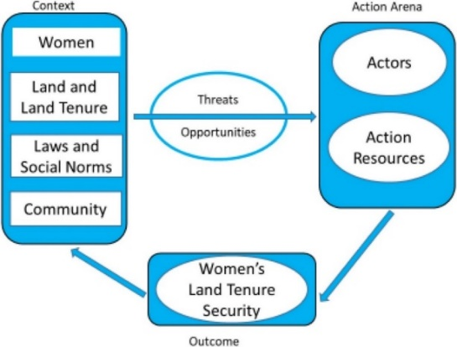
Figure 1: Conceptual Framework to analyse women’s land tenure security
Source: (Doss & Meinzen-Dick, 2020)
A conceptual framework presented in Figure 1 above has been employed by Doss & Meinzen-Dick (2020) to analyze the land tenure security of women. For the purpose of comparison of the tenure security of women across locations, it is required that information about the context, threats and opportunities associated with the tenure security of women, the action arena encompassing the individuals involved in shaping the tenure security of women as well as the resources employed for such purposes should be available (Doss & Meinzen-Dick, 2020). Mutopo (2011) explains the ways in which Zimbabwe’s land reform program impacted the higher percentage of disempowered women who had been affected by the patriarchal nature of the land allocation program. In peri-urban locations where the acquisition of the land is informal or through custom law, the female population is the first to lose their access to the land as the locations get reclassified as urban zones. According to RRI (2017), the same situation affects many countries in Africa.
  - Displacement from Informal Food Markets
Research by Tacoli and Vorley (2015) and Okoye (2020) highlights the displacement of women from both agricultural land and informal markets, driven by zoning regulations and urban gentrification that lead to market closures and demolitions (Spire & Choplin, 2018).
  - Food System Restructuring and Spatial Marginalisation
Peri-urban agricultural systems in Ghana are deteriorating due to real estate development, as noted by Cofie (2015) and Adarkwah et al. (2018). As a result of this, women have lost both water and land resources. These patterns support the existence of gender differences in household nutritional disparity. According to FAO (2011), strategies and policies have disregarded women's essential role in the food system.
  - Policy Blind Spots and Planning Exclusion
The absence of both gender and food security components in the strategic vision of the planning frameworks is a significant issue raised by Cofie (2015) and Adarkwah et al. (2018). For example, Odeny (2013) and Watson (2013) contend that the absence of legal means to protect women's land rights can prolong the loss.
  - Development of Theoretical-Conceptual Framework
The conceptual framework created by Doss & Meinzen-Dick (2020) can be used as a convenient means to explain the land tenure security of women. The relationships and complexities between the ‘invisible dispossessions’ must instead be addressed utilizing a broader conceptual framework. There are 2 groups of theories. The first group of theories encompasses the red circular shapes. These represent basic theories as well as the fundamental solutions for the invisible dispossessions. The other group of theories encompasses the blue rectangular shapes. These represent the supporting theories as well as their solutions. The purple shape represents the resultant effect of both the fundamental and supporting theories.
This framework proposes the Combined Theoretical-Conceptual Framework (CIF) that combines a set of seven interrelated theories to analyze the structural and differential aspects of invisible dispossessions. This framework has been developed based on the context of Feminist Political Ecology (FPE), thereby incorporating the structural, gendered, and inter-sectional realms of the concept of dispossession. In essence, FPE (Rocheleau et al., 1996) offers the conceptual focal point, highlighting the links between the Gender-Environment-Power complex and the mediation of access to and control over resources. Intersectionality Theory (Crenshaw 1989) acts as the differentiator. In this case, the intersecting nature of different factors like Gender-Class-ethnicity explains the cumulative effect of vulnerabilities. Political Ecology of Land (PEL) acts as the skeleton (Zoomers 2010; Borras and Franco 2012). In this regard, the commodification and management of land resources form the core dispossession strategy. Sustainable Livelihoods Framework (SLF) (Chambers and Conway 1992; Scoones 1998) and Gender and Development (GAD) approaches (Moser 1993; Razavi and Miller 1995) form the additional components of the ISF. In this case, the strategies for adaptation and empowerment act as the main mediation factor.

Figure 2: Combined Theoretical-Conceptual Framework on ‘invisible dispossessions’
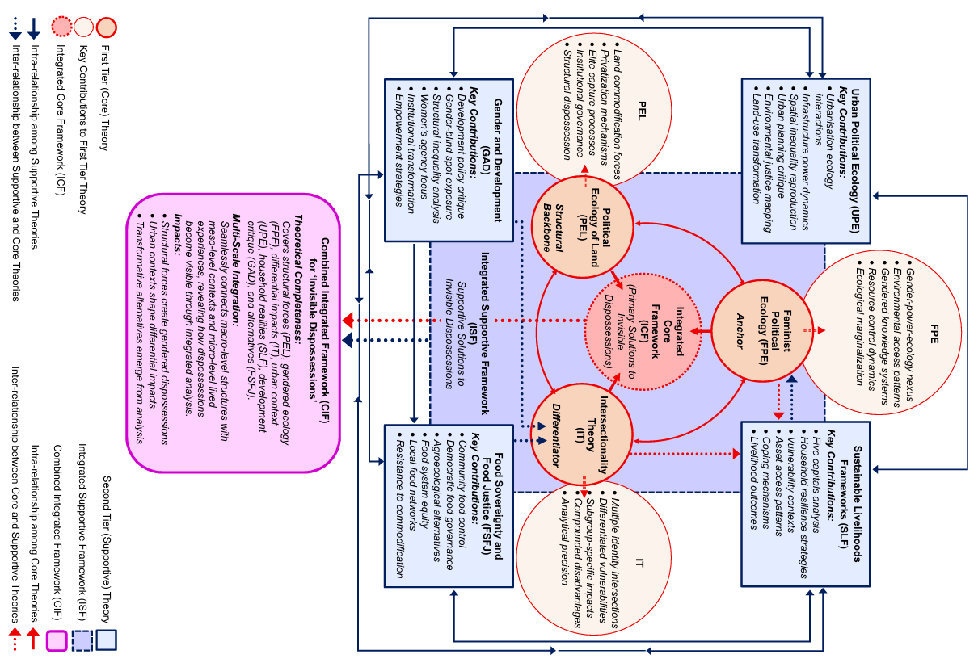
Source: Authors’ Construct (2025)
In Urban Political Ecology (UPE), (Heynen et al., 2006 and Lawhon et al., 2013) take the analysis further to the spatial dimension of the city, unpacking how regimes of infrastructure and planning produce socio-environmental injustices. Finally, Food Sovereignty and Food Justice (FSFJ) as a perspective introduces the aspect of livelihoods and governance (Patel 2009; Holt-Giménez and Shattuck 2011).
  - Recent African Literature on Feminist Urban Planning (2020–2024)
Recent African feminist urban planning literature reveals how gendered dispossession is embedded in spatial design, land governance, and urban policy. Feminist Africa (2024) emphasizes that post-pandemic urban recovery efforts have largely ignored women’s spatial needs, reinforcing tenure insecurity and economic marginalization (Feminist Africa, 2024). This aligns with Deka’s (2024) pan-African review, which identifies persistent legal and cultural barriers to women’s land ownership, particularly in urbanizing zones where customary tenure systems are displaced. Lawanson et al. (2023) argue that mobility planning in African cities often excludes gendered perspectives, resulting in spatial exclusion and reduced access to food markets and services. Their policy analysis in Ghana and Nigeria shows that infrastructure regimes reinforce gender/public norms that limit women’s visibility and agency in urban space.
Similarly, the LUDI Report (2020) highlights how urban design fails to incorporate safety and accessibility for women, reinforcing spatial exclusion and tenure insecurity in South African and Nigerian cities. Maina et al. (2024) provide case studies from Kenya and Zimbabwe showing how land redistribution programs, while ostensibly progressive, often reproduce patriarchal land governance structures. Their work maps the intersection of land commodification and gendered access, reinforcing the relevance of Political Ecology of Land (PEL) and Gender and Development (GAD) frameworks in analyzing invisible dispossessions. Oxfam Africa (2024) underscores the role of civil society in advocating for gender-equitable land reform. Their policy brief links economic empowerment to spatial justice, arguing that land rights must be reframed through feminist and intersectional lenses to address structural exclusion.
Table 2: Recent African Literature per themes (2020–2024)
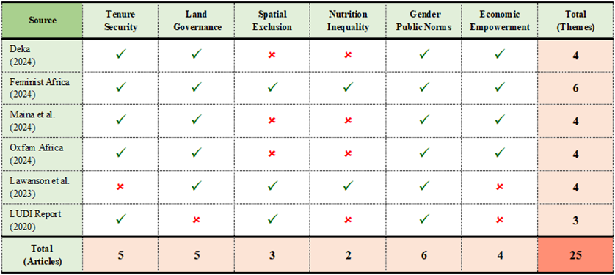
Source: Authours’ construct, (2025)
In table 2, 6 articles/reports touching on 6 themes, reveal a total mention 25 out of the 36 possible outcomes (approximately 70%). While only one article mentioned all 6 themes, it is important to recognize that ‘Gender Public Norms’ was mentioned by all authors, underscoring its significance. Tenure Security and Land Governance scored 83% mention, followed by Economic Empowerment with 67%. This shows how the issues of women land dispossession are serious and should be urgently addressed.
Together, these works reinforce the Combined Theoretical-Conceptual Framework (CIF) by grounding its macro-structural and eco-gendered components in contemporary African scholarship. They validate the use of Feminist Political Ecology (FPE), Urban Political Ecology (UPE), as well as vulnerabilities of Intersectionality Theory (IT) and those related to the resilience of living activities (SLF and FSFJ), in analyzing how gendered dispossession unfolds across urban land-use change, food systems, and planning regimes.
- METHODOLOGY
This systematic review adheres to the guidelines of the Preferred Reporting Items for Systematic Reviews and Meta-Analyses (PRISMA) 2020 as shown in Figure 3 below. This framework is aimed at enhancing the transparency and replicability of the review as per the requirements described in Page et al. (2021). This review uses a qualitative approach to synthesizing the results. The review encompasses both peer-reviewed as well as the gray literature published between January 2000 and December 2024. An extensive search was carried out using the following academic and gray literature databases: Google Scholar, Scopus, Web of Science, IFPRI and FAO databases. The search did not exclusively include AJOL databases. They overlapped with those already stated. Keywords for the search string were: “land use change” AND “female-headed households” AND “food insecurity” AND “SSA”.
The inclusion criteria included the following: empirical or theoretical studies published between 2000 and 2024; peer-reviewed journal articles, book chapters, policy documents, and theses; studies conducted in the sub-Saharan African countries; and the article must refer to at least two of the following: land-use change, gender issues, or food security. Studies were excluded if they fell outside the geographic scope defined for this review or focused exclusively on rural agricultural interventions. The initial search produced 372 records. After removing the duplication and applying the title/abstract screening, 102 studies were thoroughly examined. Finally, 56 studies were chosen for a thorough review. Every eligible study among the 56 studies used a specially designed 3-point quality-scored rubric stemming from the MMAT and the JBI rubric shown below in Table 3.

Table 3: Quality Appraisal
Criterion | Score
Clearly defined objectives and relevance to the research question | 1
Use of empirical or systematic methods (not anecdotal) | 1
Transparent presentation of findings and thematic clarity | 1
Source: Authors’ Construct (2025)

Independently, two reviewers with high understanding of the subject area, and with methodical competence scored each of the 56 studies. Inter-rater reliability was calculated using Cohen’s kappa. The obtained k value was 0.80), indicating a high acceptance response for ‘substantial agreement’ category. Studies scoring 2 or more were included in the final synthesis (n = 44); The 12 studies were excluded due to the lack of rigour in the method used or because the studies were irrelevant to the topic of the gender-land-food nexus.

Figure 3: PRISMA Flowchart for the review.

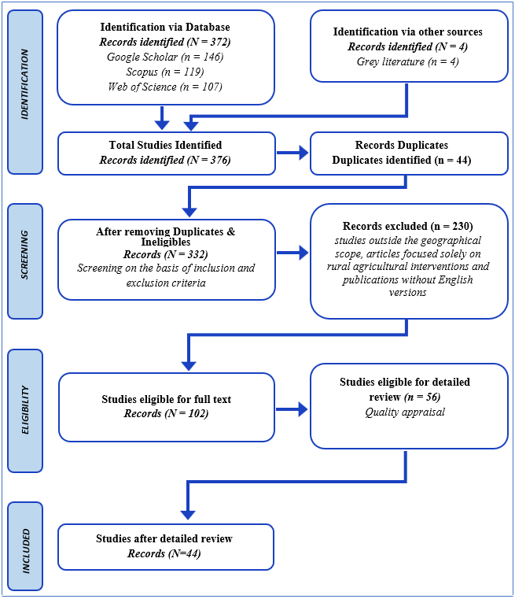
Source: Authors’ Construct (2025)

Table 4: Summary of included studies by country, method and focus.
SN | Article | Country | Method | Focus
 | Danso et al., 2004 | Ghana | Case Study | Gender and Urban Agriculture
 | Mougeot, 2005 | Botswana, Côte d'Ivoire, Namibia, Togo, Tunisia,  Zimbabwe, Argentina,  Cuba, England, and France. | Statistical  Analysis | Urban agriculture.
 | Havorka and Lee-Smith, 2006 | N/A | Case Study | Gendered perspective of urban food security.
 | Quan and Payne, 2008 (UN Habitat) | N/A | N/A | Secure land rights, gender discrimination, social exclusion, and wider inequalities.
 | Thompson,  Berrang-Ford and  Ford, 2010 | Sub-Saharan Africa (SSA) | Systematic  Literature  Review | Climate change and food security.
 | McNicoll, 2011 | N/A | Gender  Case  Study  Analysis | Importance of integrating gender into decision-making in urban agriculture and food security, and on women's roles and the need for gender analysis.
 | Ali, Deininger, and Goldstein, 2012 | Sub-Saharan Africa (SSA) | Econometric | Environmental and gender impacts of land tenure regularization in Africa.
 | Battersby, 2013 | Sub-Saharan Africa (SSA) | Historical and  Political  Analysis | General review of urban food security research in the region.
 | Domenech, 2013 | Africa south of the Sahara | Literature  Review | Health, nutrition, and gender linkages of irrigation deployment in the region.
 | Doss et al. 2013 | Africa | Conceptual  Discussion and Systematic  review | Gender inequalities in land ownership and control in Africa, challenging myths and providing new statistics.
 | Stewart et al. 2013 | Low and middle-income countries; Johannesburg, South Africa; Accra, Ghana | Systematic  Review | Impacts of urban agriculture programs on food security in low and middle-income countries.
 | Doss, Summerfield  and Tsikata, 2014 | Low- and middle-income countries | Qualitative  Literature  Review | Gendered effects of large-scale land acquisitions on food security in sub-Saharan Africa.
 | Korth et al. 2014 | Low and middle-income countries, particularly in west and east Africa. | Systematic  Literature  Review | Urban agriculture, food security in low and middle-income countries.
 | Alemu 2015 | Africa, Ethiopia | Systematic  Review | Women's insecure land tenure and property rights in Africa, household food security.
 | Arisunta, 2015 | Zimbabwe | Systematic  Review | Changes in land tenure and rights, women's agricultural productivity, food security and poverty in Zimbabwe.
 | Chop et al., 2017 | DR Congo, Swaziland, Uganda, Zambia, Canada | Systematic  Review | Food insecurity.
 | Levien, 2017 | Sub-Saharan Africa, focusing in particular on East and West African countries | Literature  Review | Gendered impacts of urban land-use change and dispossession on food security in Sub-Saharan Africa.
 | Karg and Drechsel, 2018 | Burkina Faso and Ghana | N/A | West African urban food systems.
 | Boneya, Ahmed, and Yalew, 2019 | Ethiopia, Senegal, Uganda, Brazil, Canada, United States, India, Russia, | Systematic  Review and Meta-Analysis | Effect of gender on food insecurity.
 | Jarzebski et al., 2019 | Sub-Saharan Africa (SSA) | Systematic  Review | Food security in sub-Saharan Africa.
 | Titz and Chiotha, 2019 | Southern and Eastern Africa | Literature  Review | Potential of green infrastructure to address urban challenges in Southern and Eastern Africa.
 | Bachange, 2020 | Cameroon | Scoping Study | Gender-insensitive land tenure reforms in Cameroon, food insecurity, women's access to, and control over land.
 | Davies et al., 2020 | Kenya and Zambia | Survey Data  Collection | Barriers to urban agriculture in sub-Saharan Africa, settlement formality, property rights, and distance from food retailers.
 | Djurfeldt, 2020 | Kenya, Rwanda, Uganda | Systematic  Review | Legal reforms and social norms around women's land rights in Kenya, Rwanda and Uganda.
 | Negesse et al., 2020 | Ethiopia | Systematic  Review | Female-headed households, food insecurity, male-headed households.
 | Twum et al., 2020 | Ghana, specifically the Adenta Municipality | Case study  and Mixed  Method | Gender disparity in land and food access in Ghana's suburban cities, particularly the Adenta Municipality.
 | de Bruin, Dengerink, and van Vliet, 2021 | Sub-Saharan Africa and South Asia | Qualitative  Literature  Review | Urbanization, food systems and the enabling conditions that shape opportunities for rural livelihoods.
 | Tantoh et al.,  2021 | Sub-Saharan Africa (SSA) | Systematic  Review | Gender roles, water, land, food security, and climate change in SSA.
 | Vercillo, Huggins, and Cochrane, 2021 | Africa | Systematic  Review | Gender, African climate change research.
 | Wudil et al. 2021 | Sub-Saharan Africa (SSA) | Literature  Review | Challenges to achieving food security in Sub-Saharan Africa.
 | Ziem Bonye, Yenglier Yiridomoh, and Derbile, 2021 | Ghana, specifically the Wa Municipality | Mixed-methods  Study | Urban expansion and agricultural land use change in Ghana, food security of peri-urban smallholder farmers.
 | Ngcamu,  2022 | Africa | Systematic  Review | Effects of urbanisation on food security in Africa.
 | VanVolkenburg et al., 2022 | Africa (with specific mentions of Burkina Faso, Ghana, Kenya, Nigeria, Senegal and South Africa) | Systematic  Review | Gender-inclusive research on how COVID-19 and food insecurity are affecting equality between men and women in Africa.
 | Johannes, 2023 | Zimbabwe | Systematic  review | Tenure-insecure peri-urbanites, African peri-urban spaces.
 | Masuku, Mthembu,  and Mlambo, 2023 | Sub-Saharan Africa (SSA) | Comprehensive  Literature  Review (CLR) | Gendered nature of land distribution, food insecurity for women and their households.
 | Mubiru et al., 2023 | Sub-Saharan Africa (SSA) | Scoping Review | Gender of household heads in Sub-Saharan African cities.
 | Nchanji et al., 2023 | Ghana | Ethnographic  Study  Survey | Food and nutrition insecurity, and urban land-use change in Northern Ghana.
 | Sakketa, 2023 | Sub-Saharan Africa (SSA) | Literature  Review | Urbanization on rural development in sub-Saharan Africa.
 | Abebe, 2024 | Ethiopia | Review of  Empirical  Evidence | Rapid urbanization, and food security.
 | Addo et al. 2024 | Benin, Burkina Faso, Gambia, Ghana, Ivory Coast, Mali, Niger, Nigeria, Senegal, Sierra Leone | Rapid  Review | Women’s role in West African food systems.
 | Cook,Trevenen-Jones, and Sivasubramanian, 2024 | Sub-Saharan Africa (SSA) | Systematic  Narrative  Literature review | Broader impacts of traditional food markets in sub-Saharan Africa
 | Khumalo, Sibanda,  and Mdoda, 2024 | Sub-Saharan Africa (SSA) | Systematic  Literature | Implications of climate-smart agriculture practices for urban food and income security in sub-Saharan Africa.
 | Kiribou et al., 2024 | Sub-Saharan Africa (SSA) | Systematic  Review | Urban farming, food security in sub-Saharan African cities, urbanization.
 | Nyamura, and Ngwenya, 2024 | Ethiopia, specifically Addis Ababa and its surrounding areas, particularly Lemmi Kura Sub City | Mixed-Methods Approach | Land expropriation, displacement of peri-urban indigenous communities, and food security.

Source: Authors’ Construct (2025)
  - Data Extraction and Thematic Coding
A structured extraction form has been used to compile information about the authors/s, date, geographic locations of studies, methods used, findings related to both genders, and thematic themes. Six thematic themes emerged both inductively and deductively. They are: Tenure Security, Land Governance, Spatial Exclusion, Nutrition Inequality, Gender/Public Norms, and Economic Empowerment.
  - Data Synthesis
The thematic synthesis involved hand coding and the use of a matrix table in Excel. Frequency counts were accumulated, and studies were coded under a theme or themes. Descriptive statistical analysis helped evaluate the trend of thematic representation. Graphs were made to represent the prevalence of the theme.
- Results
  - Summary of Included Studies
Of the 56 reviewed studies, 44 were included in the thematic synthesis. 42 studies were peer-reviewed and published between 2000 and 2024. They employed empirical field studies conducted in Ghana, Kenya, Zimbabwe, Ethiopia, South Africa, Cameroon, and Uganda. They covered a wide array of methods ranging from ethnographies to spatial analyses and participatory mappings.
  - Narrative Synthesis of Thematic Findings
The thematic analysis of the 44 studies shows that the relationships between the impacts of land-use change occurring in sub-Saharan African countries and their effects on the achievement of food security as shaped by gendered factors are complex. Despite the studies' varying locations geographically and their diverse disciplines and methodologies, the six main themes identified in the studies can offer understanding about how space influences the relationship between food security and the role of gender. These six themes include tenure security.
Tenure security emerged as one of the most commonly investigated themes. Most of the studies underscored the fact that the form of tenure held by women over their land tends to lack formal recognition or status in its own right and relies instead upon men in the family. Thus, when peri-urban land is converted to residential or industrial use, the first people to be deprived of access tend to be the women because their lack of formal documentation and representation in the community precludes them from being heard. For instance, (Bonye et al., 2021; Mutopo 2011).
Processes involved in land governance like titling programs and urban master plans were found to constitute patriarchal systems that disregard the claims of women. Though the legal systems have been improved to ensure greater equity in land ownership, their effectiveness has been undermined. The traditional and legal systems intersect in ways that perpetuate biases in land ownership in a way that favors men because traditional rulers continue to allocate the land without incorporating aspects of equity (Addo et al. 2024; Nyamura & Ngwenya 2024).
The pervasive nature of spatial exclusion among the studies indicates a continuous process of the marginalization of women both in the productive domain of food sources like farmlands and community gardens and the commercial domain of markets/trading centers. As urbanization intensifies, the land originally allocated for agricultural purposes or for the conduct of markets, where women trade their produce, is refashioned for other uses. This has serious effects on the mobility of women as well as their role in the newly formed urban society.
A still emergent but underdeveloped literature connects such exclusion to nutrition disparities, especially in female-headed households. Such studies observed that as the ability of women to control the land and the vending of food diminishes, the accessibility of food to the household can become more vulnerable; the diets become less diverse and increasingly composed of ultra-processed foods (Korth et al. 2014; Khumalo et al. 2024). However, very limited studies quantified the effect in the long term and disaggregate the nutritional information per sex.
Gender norms and patriarchal structures were mentioned in 86% of the studies. Even when the law favors the land rights of women, other factors such as cultural traditions tend to restrict their enforceability. Gender intersecting with other factors such as class divisions, age disparities, and marital status has been mentioned in several studies, especially where the widowed and unmarried women were denied the additional land rights beyond men (McNicoll 2011; Ngcamu 2022; Mubiru et al. 2024).
Finally, the theme of economic empowerment proved to reflect notable disparities. Though many studies recognized the importance of women gaining access to land as the basis for food-based economic activities, only a few were concerned with the relationship between the loss of land and the decline of economic empowerment. However, the empirical reality indicates the existence of a strong relationship between the loss of land use in urban areas and the degradation of financial empowerment among women related to food vending, gardening, and market gardening activities (Nchanji et al. 2023; Sakketa 2023). The interplay of the above themes indicates the existence of the invisible reality of displacement in the relationship between the gender and land access.
  - Dominant Thematic Patterns
Analysis of thematic coding revealed the following prevalence:
Tenure Security: Most studies underscore the fact that the availability of land for women has been limited through the aspect of tenure, inheritance practices, and displacement. The transition tenure systems remain challenged in offering the peri-urban land tenure to the female population (Mutopo 2011; Arisunta 2015; Addo et al. 2024).
Land Governance: Urban planning regimes, land titling programs, and development at the municipal level perpetuate the lack of gender considerations in decision-making. Ineffective account ability and lack of clarity in the bureaucracy were common patterns (Hovorka 2006; Doss et al., 2014; Tantoh et al. 2021).
Spatial Exclusion: Urban sprawl greatly affects female farmers and vendors. They are excluded from productive areas. Spatial planning hardly considers the mobility or subsistence patterns of women (Bachange 2020; Wudil et al. 2022; Bhanye 2023).
Nutrition Inequality: Land dispossession appropriation and urbanization have impacted the accessibility, production, and affordability of nutritious food to women in general and female-headed households in particular (Korth et al., 2014; Khumalo et al., 2024; Thompson et al., 2010).
Gender/Social Norms: The cultural norms in the patriarchal society limit the autonomy of women when it comes to the use of the land. Even if the policy seems gender-blind in its approach, its practical implementation tends to involve biases that are profoundly entrenched (McNicoll 2011; Ngcamu 2022; Mubiru et al. 2024)
Economic Empowerment: Few studies examined the relationship between land-use change and women's food-related businesses or economic earnings. Yet the effects were mentioned concerning living as well as access to the informal market (Nchanji et al. 2023; Sakketa 2023).
  - Thematic Classification Table
Table 5 presents the thematic classification of 44 studies

Table 5. Thematic Classification of 44 Studies
Theme | Studies |  | Key Studies Referenced
Theme | No. | (%) | Key Studies Referenced
Tenure Security | 39 | 88 | Mutopo 2011; Arisunta 2015; Addo et al. 2024
Land Governance | 40 | 91 | Hovorka 2006; Doss et al., 2014; Tantoh et al. 2021
Spatial Exclusion | 43 | 98 | Bachange 2020; Wudil et al. 2022; Bhanye 2023
Nutrition Disparities | 34 | 77 | Thompson et al. 2010; Korth et al. 2014; Khumalo et al. 2024
Gender/Social Norms | 38 | 86 | McNicoll 2011; Ngcamu 2022; Mubiru et al. 2024
Economic Empowerment | 28 | 64 | Nchanji et al. 2023; Sakketa 2023

Source: Authors’ Construct (2025)
  - Visual Representation of Thematic Distribution
Figure 4 below highlights the distribution of the thematic category studied during the synthesizing process. Spatial Exclusion emerged as the most dominant theme (98%), followed by the thematic category of Land Governance (91%), among others.
Figure 4. Theme Frequency Across 44 Included Studies
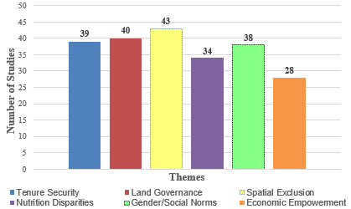

Source: Authors’ Construct (2025)
- Discussion and Policy Implications
  - Synthesis of Gendered Spatial Dispossession
This review clarifies that the outcome of spatial dislocation and the lack of attention given to vulnerable women as a consequence of land-use change in sub-Saharan Africa has been widespread.
Tenure insecurity and the role of spatial exclusion as factors that characterize the loss of access to productive land resources, food provisioning capacity resources, or other means of living for women were recognized as dominant factors in the 44 studies. This indicates that the vulnerability of women not only results from the outcome of urbanization but reflects the nature of the land-governing structure that functions in a gender-blind or patriarchal manner (Hovorka 2006; Mutopo 2011).
Spatial exclusion emerged as the theme most commonly coded (98%), indicating that women are systematically excluded from agricultural land and vending sites close to the peripheries of cities. This happens due to the development of infrastructure, land grabbing, and zoning imposed in the absence of spatial planning inclusion procedures (Owusu Twum et al. 2020; Bachange 2020; Wudil et al. 2022; Bhanye 2023).
"Dispossession as a concept related to the land rights of women refers to the loss of access, management, and ownership through legal systems and patriarchal norms (Agarwal 1994)". This represents the core reason for the “feminisation of poverty” (Chant 2006), and the inflation of large-scale land acquisition significantly affects the loss of traditional land-use rights. This lack of bargaining power due to the lack of undivided property can also signify the type of silent “dispossession” felt internally (Sen 1990).
Land degradation remains a critical concern across sub-Saharan Africa, with approximately 25% of the continent affected and an estimated 3 million hectares lost annually (World Bank, 2016). This deterioration is driven by climate change and unsustainable agricultural practices (Atube et al., 2021). Concurrently, processes of urbanisation and the expansion of commercial monocultures are displacing landowners - particularly women from marginalized groups - due to insecure land tenure systems (Lanz, 2022). Despite their central role in agricultural production, contributing over 50% of the labour force, women hold disproportionately small shares of agricultural land. Their dispossession is often subtle and systemic, reflecting entrenched gendered inequalities in land access and ownership (Doss, 2014). These dynamics are further illustrated in Table 6.
Analysis was conducted in a two-fold manner: first for the females who own the land, as well as the total. From the lowest percentage of 15.4% of the female agricultural land owners, 7% of the total percentage (1.1% of the total ownership) held less than 10% of the land. 76.8% (11.8% of the total ownership) held between 10 and 20% of the land; 8.4% (1.3% of the total ownership) between 20 and 30%, 7.6% (1.2% of the total ownership) between 30 and 40% of the land; and 0.3% (0.04% of the total ownership) between 50 and 60% of the land. This marginalisation among the female farmers indicates a serious concern that can form a negative factor in the fight against food insecurity.

Table 6: Distribution of Agricultural Holders by Gender in Sub-Saharan Africa
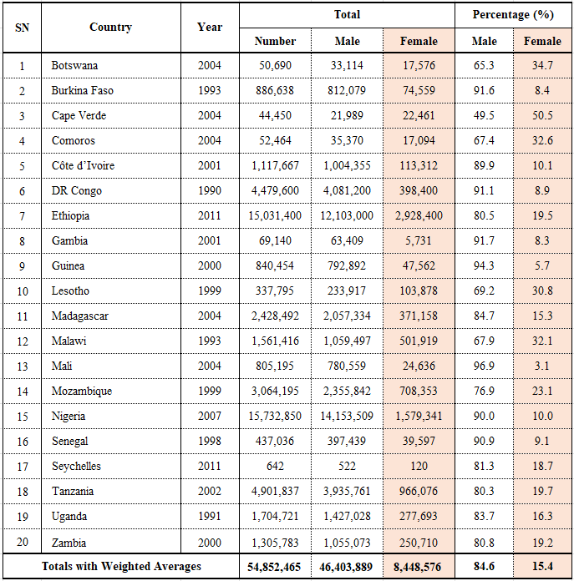Source: FAO Gender and Land Rights Database (2015)
  - Interconnected Structural Inequities
The findings indicate that insecure land tenure and weak land governance are key drivers of female food insecurity. In 88% of the reviewed studies, women’s land claims were undermined by cultural norms, lack of formal documentation, and displacement during land formalization processes. These dynamics are compounded by entrenched patriarchal structures, which persist despite ostensibly gender-neutral land policies (Doss et al., 2014; Arisunta, 2015). The systemic failure to recognize women’s land rights directly impacts their health and food security. Evidence from Ghana, Kenya, and Zimbabwe further reveals that titling schemes and spatial development plans routinely exclude women’s informal land claims, particularly in peri-urban contexts (Addo et al., 2024; Bonye et al., 2021).

  - Underreported Links Between Land and Nutrition
Despite the finding that 77% of the studies documented the existence of disparities in nutritional access, very few studies critically examined the nutritional aspect, especially the aspects of intrahousehold food distribution and children's diets. Only some studies examined how the loss of land can become the source of nutritional inequality, specifically in female-headed households (Korth et al. 2014; Mubiru et al. 2024). Additionally, very little information can be found about the influence of the loss of land on the control of the production and distribution of food by women, when the fact has been acknowledged that the greater control of the aforementioned has been shown to improve nutritional status (FAO 2011).This review confirms the plea made by feminist scholars of the food system for the inclusion of spatial plans concerned with nutritional aspects among the plans involved in the development of cities as recommended by several sources (Crush & Frayne, 2011; Haysom G. 2021).
  - Gaps in Spatial Evidence and Mapping
Although a few studies employed participatory GIS and remote sensing to track land-use change, the lack of gender-disaggregated spatial data remains a major barrier to evidence-based policy. Most planning agencies do not collect or map data on gendered patterns of land access, displacement, or food provisioning. As a result, women’s spatial experiences remain invisible in urban master plans and spatial justice assessments. There is a strong case for integrating feminist GIS methodologies (Kwan 2002; Elwood, 2006), participatory community mapping, and ground-truthing into land-use monitoring systems. Tools like household-level land tenure mapping, market access heatmaps, and food security overlays can enable more inclusive planning.
  - Policy and Planning Implications
To mitigate the gendered impacts of urban land-use change, the following policy pathways are recommended:
Strengthen Legal Tenure Protections: Governments should expand access to formal land rights for women through joint titling, legal aid services, and gender-sensitive adjudication, particularly in urbanising rural zones.
Institutionalise Gender in Urban Planning: National and municipal development frameworks should require gender impact assessments for rezoning, urban redevelopment, and infrastructure projects. Representation of women on local land boards and planning councils must be institutionalised.
Protect the peri-urban agricultural zones: Urban authorities must establish the concept of a greenbelt as a zone that protects the land used for subsistence agriculture and food vending by the female population. The greenbelt must be included in the urban land-use plan.
Empowering Women Food Entrepreneurs: Efforts should focus on the informal food economy because the main players are women. Land allocation in urban areas should focus on allocating as much land as possible for the space of food trade and food production.
Invest in Spatial Data Systems: Develop a gender-disaggregated spatial data infrastructure that enables planners to visualise how land-use change affects different population groups. This includes using participatory GIS, community-based enumeration, and satellite-linked tenure tracking.
  - Research Implications
This review highlights the need for future research to expand longitudinal studies that link land-use change with long-term nutrition and livelihood outcomes for women, develop intersectional frameworks that explore how age, class, marital status, and migration interact with gendered land dispossession, and integrate quantitative spatial analysis with qualitative storytelling to represent women’s experiences more holistically in land-use change research.
- Conclusion and Future Research Directions
  - Conclusion
This systematic review has demonstrated that urban land-use change in sub-Saharan Africa is not a gender-neutral process. Rather, it is a deeply political and spatially exclusionary phenomenon that disproportionately undermines women's access to land, economic security, and food systems. Drawing on the 44 high-quality studies, the review identified six interlinked themes, tenure security, land governance, spatial exclusion, nutrition disparities, gender norms, and economic empowerment, that collectively structure a system of ‘invisible dispossession’.
As a result of their lack of informal access to land resources, their role as non-monetary food producers, as well as their limited involvement in the governance of the resource, women are rendered vulnerable to the effects of peri-urban development. This vulnerability can be attributed to limited livelihood opportunities and access to healthy food. The implication here is that land use change in urban areas cannot be planned for, executed, and assessed without incorporating the gender dimension. The consequences of disregarding the nexus between the management of land and the food security of women are already apparent, as it can only continue to widen the existing inequality in sustainable development goals such as SDG 2: Zero Hunger, SDG 5: Gender Equality, and SDG 11: Sustainable Cities and Communities.
This study does not explicitly engage with feminist GIS, intersectionality, or participatory planning frameworks, which could offer deeper insights into the spatial and socio-political dimensions of land dispossession. While the review foregrounds gendered tenure insecurity, it does not fully account for how overlapping identities - such as age, class, or ethnicity - interact with spatial governance. Future research could integrate these approaches to better capture the lived experiences of marginalized women and to inform more inclusive land-use planning and policy design.
  - Future Research Directions
This review identifies numerous important gaps and opportunities for scholarship and practice in this field:
Longitudinal Research Relating Land Loss to Nutrition
Future studies should use both qualitative and longitudinal designs to establish how transitions in land use influence food security at the household level, specifically female-headed households.
Intersectional Approaches to Dispossession
Research should instead focus more on understanding the relationship between gender and other aspects such as age, marital status, class, immigration status, and disabilities. Most studies have been conducted based exclusively on the aspect of gender without intersectional approaches.
Participatory and Feminist Spatial Methods
A potential synergy between the concepts of feminist GIS mapping and remote sensing truth could empower the visualization of the exclusion patterns made invisible.
Comparative Urban Studies Across Sub-Regions
Such comparative studies are required to identify the patterns across East, West, Central, and Southern Africa. This will generate a body of knowledge that provides input for urban land reform and management of the food systems.
Policy and Institutional Ethnographies
Further ethnographic research should be conducted to disentangle the ways in which land use decisions are made and negotiated. This would reveal more information about the informal processes that currently exist at the planning departments and traditional councils.
Measurement of Empowerment and Resilience
New indicators must be created to monitor the empowerment and resilience of female individuals affected by the process of dispossession. These could include access to collective spaces, participation in governance, and food system autonomy.
Disclaimer (Artificial intelligence)
Authors hereby declare that NO generative AI technologies such as Large Language Models (ChatGPT, COPILOT, etc.) and text-to-image generators have been used during the writing or editing of this manuscript.

REFERENCES
Abebe, Mekonen Getachew. "Impacts of urbanization on food security in Ethiopia. A review with empirical evidence." Journal of Agriculture and Food Research 15 (2024): 100997. https://doi.org/10.1016/j.jafr.2024.100997
Addo, Phyllis, M. Djekic-Ivankovic, A. Abdu, P. Boadi, O. Eyo, M. Y. Baguignan, A. M. Atakoun et al. "Gender Role in Food Rights and Sovereignty in West Africa: A Rapid Review." African Journal of Food, Agriculture, Nutrition and Development 24, no. 10 (2024): 24725-24773. https://doi.org/10.22004/ag.econ.348078
Agarwal, B. (1994). Gender and command over property: A critical gap in economic analysis and policy in South Asia. World Development, 22(10), 1455–1478. https://doi.org/10.1016/0305-750X(94)90031-0
Alemu, Gashaw Tenna. "Women's Land Use Right Policy and Household Food Security in Ethiopia." Review, International Journal of African and Asian Studies 12 (2015): 56-65.
Ali, Daniel Ayalew, Klaus Deininger, and Markus Goldstein. "Environmental and gender impacts of land tenure regularization in Africa." World Bank Policy Research Working Paper No 5765 (2011). https://doi.org/10.1016/j.jdeveco.2013.12.009
Arisunta, Caroline. "Women Land Rights and HIV/AIDS in Zimbabwe." AIDS in Zimbabwe (August 14, 2015) (2015). https://papers.ssrn.com/sol3/papers.cfm?abstract_id=2644216
Atube, F., Malinga, G.M., Nyeko, M. et al. Determinants of smallholder farmers’ adaptation strategies to the effects of climate change: Evidence from northern Uganda. Agric & Food Secur 10, 6 (2021). https://doi.org/10.1186/s40066-020-00279-1
Ayambire, R. A., Amponsah, O., Peprah, C., & Takyi, S. A. (2019). A review of practices for sustaining urban and peri-urban agriculture: Implications for land use planning in rapidly urbanising Ghanaian cities. Land Use Policy, 84, 260-277. https://doi.org/10.1016/j.landusepol.2019.03.004
Bachange, Enchaw Gabriel. "Cultivating gender insensitive land tenure reforms and harvesting food insecurity in cameroon, sub-saharan africa." African Journal of Land Policy and Geospatial Sciences 3, no. 1 (2020): 67-79. https://doi.org/10.22004/ag.econ.334233
Battersby, Jane. "Hungry cities: a critical review of urban food security research in sub‐Saharan African cities." Geography Compass 7, no. 7 (2013): 452-463. https://doi.org/10.1111/gec3.12053
Bhanye, Johannes. "‘Emerging forms of spatialised and socialised authority’among ‘tenure-insecure peri-urbanites’ in African peri-urban spaces." Pan-African Conversations 1, no. 2 (2023): 26-63. https://www.jstor.org/stable/48794427
Boneya, Dube Jara, Ahmed Ali Ahmed, and Alemayehu Worku Yalew. "The effect of gender on food insecurity among HIV-infected people receiving anti-retroviral therapy: a systematic review and meta-analysis." PloS one 14, no. 1 (2019): e0209903. DOI: 10.1371/journal.pone.0209903
BORRAS JR, S.M. and FRANCO, J.C. (2012), Global Land Grabbing and Trajectories of Agrarian Change: A Preliminary Analysis. Journal of Agrarian Change, 12: 34-59. https://doi.org/10.1111/j.1471-0366.2011.00339.x
Chambers, Robert & Conway, Gordon. (1992). Sustainable rural livelihoods: practical concepts for the 21st century. IDS Discussion Paper. 296. https://opendocs.ids.ac.uk/articles/report/Sustainable_rural_livelihoods_practical_concepts_for_the_21st_century/26473510/1
Chant, S. (2006) Re-Thinking the “Feminization of Poverty” in Relation to Aggregate Gender Indices. Journal of Human Development, 7, 2.
http://personal.lse.ac.uk/chant/chantpdfs/Chant_JHD_PDF.pdf
https://doi.org/10.1080/14649880600768538
Cheryl Doss & Ruth Meinzen-Dick & Allan Bomuhangi, 2014. "Who Owns the Land? Perspectives from Rural Ugandans and Implications for Large-Scale Land Acquisitions," Feminist Economics, Taylor & Francis Journals, vol. 20(1), pages 76-100, January.
Chigbu, Uchendu Eugene, Gaynor Paradza, and Walter Dachaga. 2019. “Differentiations in Women’s Land Tenure Experiences: Implications for Women’s Land Access and Tenure Security in Sub-Saharan Africa.” Land 8 (2): 22. https://doi.org/10.3390/land8020022
Chop, Elisabeth, Avani Duggaraju, Angela Malley, Virginia Burke, Stephanie Caldas, Ping Teresa Yeh, Manjulaa Narasimhan, Avni Amin, and Caitlin E. Kennedy. "Food insecurity, sexual risk behavior, and adherence to antiretroviral therapy among women living with HIV: a systematic review." Health care for women international 38, no. 9 (2017): 927-944. DOI: 10.1080/07399332.2017.1337774
Cofie, Evelyn N. K. 2015. Effects of Urbanization on Access to Livelihood Resources: Experiences of Farm Families in the Ga West Municipality, Ghana. University of Ghana, MPhil thesis. http://ugspace.ug.edu.gh/handle/123456789/22613
Cook, Brian, Ann Trevenen-Jones, and Bhavna Sivasubramanian. "Nutritional, economic, social, and governance implications of traditional food markets for vulnerable populations in sub-Saharan Africa: a systematic narrative review." Frontiers in Sustainable Food Systems 8 (2024): 1382383. https://doi.org/10.3389/fsufs.2024.1382383
Crenshaw, Kimberle (1989) "Demarginalizing the Intersection of Race and Sex: A Black Feminist Critique of Antidiscrimination Doctrine, Feminist Theory and Antiracist Politics," University of Chicago Legal Forum: Vol. 1989, Article 8.
Available at: https://chicagounbound.uchicago.edu/uclf/vol1989/iss1/8
Crush, J. S., & Frayne, G. B. (2011). Urban food insecurity and the new international food security agenda. Development Southern Africa, 28(4), 527–544. https://doi.org/10.1080/0376835X.2011.605571
Danso, George K., Olufunke O. Cofie, L. Annang, Emmanuel Obuobie, and Bernard N. Keraita. "Gender and urban agriculture: the case of Accra, Ghana." (2004). https://hdl.handle.net/10568/38055
Davies, Julia, Corrie Hannah, Zack Guido, Andrew Zimmer, Laura McCann, Jane Battersby, and Tom Evans. "Barriers to urban agriculture in Sub-Saharan Africa." Food Policy 103 (2021): 101999.
de Bruin, Sophie, Just Dengerink, and Jasper van Vliet. "Urbanisation as driver of food system transformation and opportunities for rural livelihoods." Food Security 13, no. 4 (2021): 781-798. 10.1007/s12571-021-01182-8
Deka, M. (2024). Women’s Land Rights in Africa: Societal Demands and Challenges. International Journal of Fundamental and Multidisciplinary Research, 5(5), 28721. https://www.ijfmr.com/papers/2024/5/28721.pdf
Djurfeldt, Agnes Andersson. "Gendered land rights, legal reform and social norms in the context of land fragmentation-A review of the literature for Kenya, Rwanda and Uganda." Land Use Policy 90 (2020): 104305. https://doi.org/10.1016/j.landusepol.2019.104305
Domenech, Laia. "The impact of irrigation on nutrition, health, and gender: A review paper with insights for Africa south of the Sahara." (2013). https://doi.org/10.2139/SSRN.2249812
Doss, Cheryl, and Ruth Meinzen-Dick. "Land tenure security for women: A conceptual framework." Land Use Policy 99 (2020): 105080. https://doi.org/10.1016/j.landusepol.2020.105080
Doss, Cheryl, Chiara Kovarik, Amber Peterman, Agnes R. Quisumbing, and Mara van den Bold. "Gender inequalities in ownership and control of land in Africa: Myths versus reality." (2015). 10.1111/agec.12171
Doss, Cheryl, Gale Summerfield, and Dzodzi Tsikata. "Land, gender, and food security." Feminist economics 20, no. 1 (2014): 1-23. 10.1080/13545701.2014.895021
Doss, Cheryl. (2014). If Women Hold Up Half the Sky, How Much of the World’s Food Do They Produce?. 10.1007/978-94-017-8616-4_4
Elwood, Sarah. 2006. “Negotiating Knowledge Production: The Everyday Inclusions, Exclusions, and Contradictions of Participatory GIS Research∗.” The Professional Geographer 58 (2): 197–208. doi:10.1111/j.1467-9272.2006.00526.x.
FAO. 2011. The Role of Women in Agriculture. Rome: Food and Agriculture Organization of the United Nations. https://doi.org/10.18356/ca0215ed-en
Feminist Africa Collective. (2024). Rethinking African Feminisms in the “New” Normal. Feminist Africa, 5(2). https://feministafrica.net/wp-content/uploads/2024/08/FA-Volume-5-Issue-2.pdf
Francis, Adarkwah & Annan Twumasi, Stephen & Anyamesem-Poku, Anthony & Santiago, Prince & Sanful, Peter. (2018). Real Estate Development and Land Grabbing in Ghana: A Review of Impact and Policy Responses. 119-126. https://doi.org/10.12691/jfs-6-3-4
Gyapong, Adwoa Yeboah. 2021. “Commodification of Family Lands and the Changing Dynamics of Access in Ghana.” Third World Quarterly. https://doi.org/10.1080/01436597.2021.1880889
Haysom G. (2021). Integrating Food Sensitive Planning and Urban Design into Urban Governance Actions. Urban forum (Johannesburg, South Africa), 32(3), 289–310. https://doi.org/10.1007/s12132-021-09417-9
Heynen, Nik, Maria Kaika, and Erik Swyngedouw, eds. 2006. In the Nature of Cities: Urban Political Ecology and the Politics of Urban Metabolism. London: Routledge. https://doi.org/10.4324/9780203027523
HLPE. 2024. Strengthening urban and peri-urban food systems to achieve food security and nutrition, in the context of urbanization and rural transformation. Rome, CFS HLPE-FSN. HLPE-FSN Report- Strengthening urban and peri-urban food systems | UN-Nutrition: the United Nations inter-agency coordination mechanism for nutrition.
Holt Giménez, Eric, and Annie Shattuck. 2011. “Food Crises, Food Regimes and Food Movements: Rumblings of Reform or Tides of Transformation?” The Journal of Peasant Studies 38 (1): 109–44. doi:10.1080/03066150.2010.538578.
Hovorka, Alice J., and Diana Lee-Smith. "Gendering the Urban Agriculture Agenda¹." Cities farming for the future: Urban agriculture for green and productive cities (2006): 126. https://Gendering the Urban Agriculture Agenda
Jarzebski, Marcin Pawel, Abubakari Ahmed, Yaw Agyeman Boafo, Boubacar Siddighi Balde, Linda Chinangwa, Osamu Saito, Graham Von Maltitz, and Alexandros Gasparatos. "Food security impacts of industrial crop production in sub-Saharan Africa: a systematic review of the impact mechanisms." Food Security 12, no. 1 (2020): 105-135. https://doi.org/10.1007/s12571-019-00988-x
Karg, H., and Pay Drechsel. Atlas of West African urban food systems: examples from Ghana and Burkina Faso. International Water Management Institute (IWMI). CGIAR Research Program on Water, Land and Ecosystems (WLE)., 2018. doi: 10.5337/2018.224
Khumalo, Nolwazi Z., Melusi Sibanda, and Lelethu Mdoda. "Implications of a climate-smart approach to food and income security for urban Sub-Saharan Africa: A systematic review." Sustainability 16, no. 5 (2024): 1882. DOI: 10.3390/su16051882
Kiribou, Razak, Bobe Bedadi, Kangbéni Dimobe, Julius Ndemere, Tiga Neya, Valentin Ouedraogo, and Sintayehu W. Dejene. "Urban farming system and food security in sub‐Saharan Africa: Analysis of the current status and challenges." Urban Agriculture & Regional Food Systems 9, no. 1 (2024): e70007. https://doi.org/10.1002/uar2.70007
Korth, Marcel, Ruth Stewart, Laurenz Langer, Nolizwe Madinga, Natalie Rebelo Da Silva, Hazel Zaranyika, Carina Van Rooyen, and Thea De Wet. "What are the impacts of urban agriculture programs on food security in low and middle-income countries: a systematic review." Environmental Evidence 3, no. 1 (2014): 21. 10.1186/2047-2382-3-21
Kwan, Mei-Po. 2002. “Feminist Visualization: Re-Envisioning GIS as a Method in Feminist Geographic Research.” Annals of the Association of American Geographers 92 (4): 645–61. doi:10.1111/1467-8306.00309.
Lanz, Kristina. 2022. Large-Scale Land Acquisition in Ghana: Institutional Change, Gender and Power. Abingdon, UK: Routledge. https://doi.org/10.4324/9781003212768
Lawanson, T., Akaateba, M., & Unuigboje, R. (2023). Gender-Informed Mobility Planning in African Cities. VREF. https://vref.se/wp-content/uploads/2024/01/Gender-informed-mobility-planning-governance-and-policy-in-African-cities-status-barriers-and-ways-forward.-Lawanson-T.-VREF.pdf
Lawhon, Mary & Ernstson, Henrik & Silver, Jonathan. (2013). Provincializing Urban Political Ecology: Towards a Situated UPE Through African Urbanism. Antipode. 46. 10.1111/anti.12051. 10.1111/anti.12051
Levien, Michael. "Gender and land dispossession: a comparative analysis." In Gender and generation in southeast Asian agrarian transformations, pp. 9-32. Routledge, 2019. https://doi.org/10.1080/03066150.2017.1367291
LUDI. (2020). Gender Perspective in Urban Planning and Design. Global Future Cities Programme. https://www.globalfuturecities.org/sites/default/files/2020-10/Gender%20Discussion%20Report_LUDI.pdf
Maina, G. N., Chikowero, N., & Abdallah, L. (2024). Gender Dynamics in African Land Redistribution. In Land and Livelihoods in Africa (pp. 211–228). Springer. https://link.springer.com/chapter/10.1007/978-3-031-61745-4_11
Masuku, Mfundo Mandla, Zinhle Mthembu, and Victor H. Mlambo. "Gendered effects of land access and ownership on food security in rural settings in South Africa." Frontiers in sustainable food systems 7 (2023): 1158946. 10.3389/fsufs.2023.1158946
McNicoll, Kathryn. "Women feeding cities: Mainstreaming gender in urban agriculture and food security." (2011): 133-134. https://doi.org/10.1080/09614524.2011.530234
Mixed Methods Appraisal Tool (MMAT), version 2018. Canadian Institutes of Health Research.
Moser, Caroline. Gender planning and development: Theory, practice and training. Routledge, 2012. https://www.taylorfrancis.com/books/mono/10.4324/9780203411940/gender-planning-development-caroline-moser
Mougeot, Luc JA, ed. Agropolis: the social, political and environmental dimensions of urban agriculture. Routledge, 2010. https://doi.org/10.4324/9781849775892
Mubiru, Moses Batanda, Said Nuhu, Wilbard Kombe, and Tatu Mtwangi Limbumba. "Digesting how the gender of household heads determines housing location choices in Sub-Saharan African cities: a review." Gender, Place & Culture 31, no. 11 (2023): 1583-1605. https://doi.org/10.1080/0966369X.2023.2233708
Mutopo, Patience. 2011. “Women’s Struggles to Access and Control Land and Livelihoods after Fast Track Land Reform in Mwenezi District, Zimbabwe.” The Journal of Peasant Studies 38 (5): 1021–46. doi:10.1080/03066150.2011.635787.
Nchanji, Eileen Bogweh, Takemore Chagomoka, Imogen Bellwood-Howard, Axel Drescher, Nikolaus Schareika, and Johannes Schlesinger. "Land tenure, food security, gender and urbanization in Northern Ghana." Land use policy 132 (2023): 106834. https://doi.org/10.1016/j.landusepol.2023.106834
Negesse, Ayenew, Dube Jara, Habtamu Temesgen, Getenet Dessie, Temesgen Getaneh, Henok Mulugeta, Zeleke Abebaw, Tesfahun Taddege, Fasil Wagnew, and Yilkal Negesse. "The impact of being of the female gender for household head on the prevalence of food insecurity in Ethiopia: a systematic-review and meta-analysis." Public Health Reviews 41, no. 1 (2020): 15. 10.1186/s40985-020-00131-8
Ngcamu, Bethuel Sibongiseni. "The effects of urbanisation on food security in Africa: An overview and synthesis of the literature." Environmental & Socio-Economic Studies 10, no. 2 (2022): 40-48. DOI: 10.2478/environ-2022-0010
Nightingale, A. J. (2011). Bounding difference: Intersectionality and the material production of gender, caste, class and environment in Nepal. Geoforum, 42(2), 153-162. https://doi.org/10.1016/j.geoforum.2010.03.004
Njoh, A. J., Ananga, E. O., Anchang, J. Y., Ayuk-Etang, E. M., & Akiwumi, F. A. (2016). Africa’s Triple Heritage, Land Commodification and Women’s Access to Land: Lessons from Cameroon, Kenya and Sierra Leone. Journal of Asian and African Studies, 52(6), 760-779. https://doi.org/10.1177/0021909615612121 (Original work published 2017)
Nyamura, K. Gemtessa, and Bongani Ngwenya. "Exploring the consequences of land expropriation on the food security of Peri-Urban Indigenous Communities in Addis Ababa." Int. J. Multidiscip. Res 6, no. 2 (2024). https://doi.org/gtq3dv
Odeny, M. (2013, April). Improving Access to Land and strengthening Women’s land rights in Africa. In Annual World Bank conference on land and poverty’, The World Bank, Washington, DC. (PDF) Improving Access to Land and strengthening Women's land rights in Africa
Okoye, Victoria. 2020. Street Vendor Exclusion in “Modern” Market Planning: A Case Study from Kumasi, Ghana. WIEGO Resource Document No. 15. WIEGO. https://www.Street Vendor Exclusion in “Modern” Market Planning: A Case Study from Kumasi, Ghana.
Owusu Twum, Kwaku, Kwabena Asiama, John Ayer, and Cosmas Yaw Asante. 2020. “Gender, Land and Food Access in Ghana’s Suburban Cities: A Case of the Adenta Municipality.” Land 9, no. 11: 427. https://doi.org/10.3390/land9110427.
Oxfam Africa. (2024). Transforming Land Rights for African Women and Men: Civil Society’s Clarion Call to Action. https://africa.oxfam.org/latest/blogs/transforming-land-rights-african-women-and-men-civil-societys-clarion-call-action
Page M J, McKenzie J E, Bossuyt P M, Boutron I, Hoffmann T C, Mulrow C D et al. The PRISMA 2020 statement: an updated guideline for reporting systematic reviews BMJ 2021; 372 :n71. https://doi.org/10.1136/bmj.n71
Patel, Raj. 2009. “Food Sovereignty.” Journal of Peasant Studies 36 (3): 663–706. https://doi.org/10.1080/03066150903143079
Quan, Julian, and Geoffrey Payne. Secure land rights for all. The United Nations Human Settlements Programme, UN-HABITAT,, 2008. https://Secure land rights for all.
Razavi, Shahra, and Carol Miller. 1995. From WID to GAD: Conceptual Shifts in the Women and Development Discourse. Occasional Paper No. 1. Geneva: UNRISD. From WID to GAD:
Rocheleau, Dianne, Barbara Thomas-Slayter, and Esther Wangari. Feminist political ecology: Global issues and local experience. Routledge, 2013. https://api.taylorfrancis.com/content/books/mono/download?identifierName=doi&identifierValue=10.4324/9780203352205&type=googlepdf
RRI. 2017. “The Effects of Large-scale Land Acquisitions on Women.” Rights + Resources. (Ghana, Ethiopia examples of women losing land access and compensation) The Effects of Large-scale Land Acquisitions on Women - Rights + Resources - Supporting Forest Tenure, Policy, and Market Reforms
Sakketa, Tekalign Gutu. "Urbanisation and rural development in sub-Saharan Africa: A review of pathways and impacts." Research in Globalization 6 (2023): 100133. https://doi.org/10.1016/j.resglo.2023.100133
Scoones, Ian. 1998. “Sustainable Rural Livelihoods: A Framework for Analysis.” IDS Working Paper No. 72. Brighton: Institute of Development Studies. https://opendocs.ids.ac.uk/opendocs/handle
Sen, A. (1990) Gender and Cooperative Conflict. In: Tinker, I., Ed., Persistent Inequality, Oxford University Press Oxford, 123-148. https://www.scirp.org/journal/paperinformation?paperid=64419
Siegner, Alana, Jennifer Sowerwine, and Charisma Acey. "Does urban agriculture improve food security? Examining the nexus of food access and distribution of urban produced foods in the United States: A systematic review." Sustainability 10, no. 9 (2018): 2988. https://doi.org/10.3390/su10092988
Spire, Amandine & Armelle, Choplin. (2017). Street Vendors Facing Urban Beautification in Accra (Ghana): Eviction, Relocation and Formalization. Articulo - Journal of Urban Research. 2018. https://doi.org/10.4000/articulo.3443
Stewart, Ruth, Marcel Korth, Laurenz Langer, Shannon Rafferty, Natalie Rebelo Da Silva, and Carina Van Rooyen. "What are the impacts of urban agriculture programs on food security in low and middle-income countries?." Environmental Evidence 2, no. 1 (2013): 7.
Tacoli, Cecilia, and Bill Vorley. 2015. Reframing the Debate on Urbanization, Rural Transformation and Food Security. London: IIED. Reframing the debate on urbanisation, rural transformation and food security | IIED Publications Library
Tantoh, Henry Bikwibili, Tracey TJM McKay, Felix Ekwabena Donkor, and Mulala Danny Simatele. "Gender roles, implications for water, land, and food security in a changing climate: a systematic review." Frontiers in Sustainable Food Systems 5 (2021): 707835. https://doi.org/10.3389/fsufs.2021.707835
Thompson, Heather E., Lea Berrang-Ford, and James D. Ford. "Climate change and food security in sub-Saharan Africa: a systematic literature review." Sustainability 2, no. 8 (2010): 2719-2733. https://doi.org/10.3390/su2082719
Titz, Alexandra, and Sosten S. Chiotha. "Pathways for sustainable and inclusive cities in Southern and Eastern Africa through urban green infrastructure?." Sustainability 11, no. 10 (2019): 2729. https://doi.org/10.3390/su11102729
Twum, Kwaku Owusu, Kwabena Asiama, John Ayer, and Cosmas Yaw Asante. "Gender, land and food access in ghana’s suburban cities: A case of the adenta municipality." Land 9, no. 11 (2020): 427.
UN-Habitat. 2022. World Cities Report 2022: Envisaging the Future of Cities. Nairobi: United Nations Human Settlements Programme. World Cities Report 2022: Envisaging the Future of Cities | UN-Habitat
VanVolkenburg, Heather, Isabelle Vandeplas, Katim Touré, Safiétou Sanfo, Fatoumata Lamarana Baldé, and Liette Vasseur. "Do COVID-19 and food insecurity influence existing inequalities between women and men in Africa?." International journal of environmental research and public health 19, no. 4 (2022): 2065. doi: 10.3390/ijerph19042065.
Vercillo, Siera, Chris Huggins, and Logan Cochrane. "How is gender investigated in African climate change research? A systematic review of the literature." Ambio 51, no. 4 (2022): 1045-1062. 10.1007/s13280-021-01631-w
Watson, Vanessa. (2013). African urban fantasies: Dreams or nightmares?. Environment and Urbanization. 26. 215-231. 10.1177/0956247813513705.
World Bank. 2016. “Africa’s Bold and Ambitious Endeavor: Restoring 100 M Hectares of Land by 2030.” World Bank, November 14, 2016. Africa’s Bold and Ambitious Endeavor: Restoring 100M Hectares of Land by 2030
Wudil, Abdulazeez Hudu, Muhammad Usman, Joanna Rosak-Szyrocka, Ladislav Pilař, and Mortala Boye. "Reversing years for global food security: A review of the food security situation in Sub-Saharan Africa (SSA)." International Journal of environmental research and Public Health 19, no. 22 (2022): 14836. DOI: 10.3390/ijerph192214836
Ziem Bonye, Samuel, Gordon Yenglier Yiridomoh, and Emmanuel K. Derbile. "Urban expansion and agricultural land use change in Ghana: Implications for peri-urban farmer household food security in Wa Municipality." International Journal of Urban Sustainable Development 13, no. 2 (2021): 383-399. https://doi.org/10.1080/19463138.2021.1915790
Zoomers, Annelies. 2010. “Globalisation and the Foreignisation of Space: Seven Processes Driving the Current Global Land Grab.” The Journal of Peasant Studies 37 (2): 429–47. doi:10.1080/03066151003595325.

