Perceptions and Determinants of Credit Service Utilization among Residents: A Case Study of Kratie Province, Cambodia

.
ABSTRACT

Aims: This study examined the perceptions and factors that determine the use of credit services by 111 farming households in Kampong Cham commune, Sambour district, Kratie province, Cambodia.
Method: Data collected from four villages (Ampil Teuk, Samphin, Ajen, and Tansong Paek) showed that respondents had moderate understanding of credit services, with the strongest understanding of benefits and trust in financial institutions, but little understanding of credit terms, repayment terms, and associated risks. The main factors affecting the decision to borrow included family encouragement, lack of personal funds, flexible repayment terms, and ease of applying for credit, while interest rates and repayment terms had a lesser influence. Common problems included difficulty understanding credit contracts, insufficient access to financial data, and poor repayment plan design.
Results: The results of statistical analysis using one-way ANOVA showed that there were statistically significant differences in understanding and experience between income levels and villages, while occupation, education level, and age did not show statistically significant differences. However, gender showed statistically significant differences in understanding and challenges. The reliability of the research instrument was high (Cronbach’s α value between 0.81 and 0.90; overall α value = 0.86).
Conclusion: The results of the study highlight the need to implement specific financial education programs to increase understanding of credit terms, repayment management, and risk awareness, as well as to promote credit services that are more dignified and flexible to encourage responsible borrowing and strengthen financial resource capacity in rural Cambodia.

Keywords: Financial literacy; credit service use; borrowing behavior; rural households; socioeconomic factors; microfinance; Cambodia

1. INTRODUCTION

Cambodia is a developing country with a growing but weak economy, where the financial sector has become a key driver for sustainable development and poverty reduction (Cambodia Development Resources Institute [CDRI], 2025). Over the past two decades, access to financial services has improved significantly, thanks to the rapid growth of microfinance institutions (MFIs), which provide credit, savings, and small investment opportunities to people and small enterprises, especially in rural areas (Taiwo et al., 2016; Zhang et al., 2024). These institutions play a key role in providing resources to expand businesses, develop agriculture, and increase household incomes, as well as helping rural communities to cope with external challenges such as epidemics, economic downturns, and natural disasters (Anurag et al., 2024). Microfinance has become a key tool for economic growth, inclusion, and social development in Cambodia, helping thousands of ethnic families move from subsistence livelihoods to small enterprises (Chantha et al., 2024). Despite these achievements, the financial well-being of many rural households remains weak due to limited understanding of credit management and repayment terms (Kyeyune & Ntayi, 2025). Rapid credit growth has not always been matched by high levels of financial literacy. This has led to borrowers misusing loans, not planning how to pay them back, and getting into more debt (Transparency International Cambodia, 2021). Financial literacy, which includes the knowledge, attitudes, and behaviors necessary for effective financial decision-making, is a key factor in personal and national economic stability (Katnic et al., 2024). Financially literate individuals are better able to budget, manage savings, assess borrowing risks, and avoid over-indebtedness (Lusardi & Mitchell, 2014; Uy et al., 2024). At the community level, improving financial literacy can foster participation in the formal financial system and increase trust, reducing reliance on illegal moneylenders, many of whom charge high interest rates (Das, 2024). Previous studies have shown a strong relationship between financial literacy, educational level, household income, and social capital (Chakrabarty, 2012; Zhao & Li, 2021). These results suggest that the ability to make effective borrowing decisions depends not only on access to financial institutions but also on personal knowledge, social environment, and confidence in repayment ability. Recognizing this, researchers and policymakers have focused on developing specific financial education programs, community training activities, and the practice of providing credit in a dignified manner to ensure effective financial outcomes and support sustainable economic development (UNCDF, 2020; MEF, 2022; Zeqiraj et al., 2022). In Cambodia, especially in Kratie province, low financial literacy remains a major obstacle to effective use of credit services (Uy & Flores, 2024). Many clients do not fully understand the term “credit,” interest rates, and repayment schedules, while some use the borrowed money for purposes other than the original purpose (Bucks & Pence, 2008). These behaviors not only reduce the value of credit services but also significantly increase the risk of chronic debt for rural households. Therefore, this study, titled “Perceptions and Factors Determining the Use of Credit Services by Citizens: A Case Study of Kampong Cham Commune, Sambour District, Kratie Province,” aims to assess citizens’ perceptions of credit services, the factors that motivate them to use these services, and the barriers they face. This study aims to measure the level of rural households' awareness towards credit services, identify key socio-economic, and institutional factors that affect their borrowing decisions, and understand the challenges they face and their coping strategies.

2. methods

2.1 Study Area
Kampong Cham Commune is one of the five administrative communes of Sambour District, Kratie Province, Cambodia. It is bordered by Sok Chet Commune of Kampong Thom Province to the west, Boeung Char and Sambour Communes to the east and north, and Vathanak Commune to the south. The commune has seven villages, but this study focused on only four villages: Ampil Teuk, Samphin, Ajen, and Tansong Paek, which are areas with widespread access to credit services. These areas were selected to represent the different geographical and socio-economic conditions in the commune. The study was conducted over a six-month period, from January to June 2025.
2.2 Research Design
A quantitative research design was applied to examine perceptions, influencing factors, and challenges related to credit service use among rural households. The quantitative approach was selected to enable objective measurement and statistical analysis of household responses, ensuring reliability and comparability across demographic groups.
2.3 Population and Sampling
According to the Population Change Report (2025), Kampong Cham Commune comprises 1,553 households, of which 1,150 were identified as credit users. These 1,150 households constituted the population frame for the study.
n =
N
1 + N (e)²

where:
n = required sample size,
N = total population (1,150 households),
e = margin of error (0.09 or 9%).
Applying this formula, the calculated sample size was 111 households, which were proportionally distributed across the four selected villages.
List 1: Sample list from different villages
Commune | Village | Total Number of Families | Families Interviewed
Kampong Cham | Ampil Teuk | 209 | 20
Kampong Cham | Samphin | 187 | 18
Kampong Cham | Ajen | 405 | 39
Kampong Cham | Tansong Paek | 349 | 34
Total | 4 villages | 1,150 | 111
This proportional allocation ensured adequate representation of each village and reflected the diversity of economic and social backgrounds among households.
2.4 Sampling Technique
A non-probability snowball sampling technique was employed to select respondents. This approach was particularly appropriate for the present study because households that currently used or had previously used credit services been not systematically listed in official databases, making probability sampling impractical. Snowball sampling enabled the identification of such households through community-based social networks, which are often the primary channels through which financial information circulates in rural areas. The selection process began with key informants recommended by the village head, who possessed direct knowledge of local credit users. These initial participants then referred other individuals who met the study’s inclusion criteria. The process continued iteratively until the target sample size was achieved. Although non-probability sampling may limit the generalizability of findings to a wider population, it was the most effective method for capturing the dynamics of credit use and financial behavior within socially interconnected rural communities. Furthermore, the use of robust statistical analyses, including ANOVA and reliability testing, helped to strengthen the validity of the findings and support cautious inferences regarding causal relationships and policy implications.
2.5 Data Collection Methods
2.5.1 Primary Data
Primary data were collected through structured face-to-face interviews with the 111 sampled households. A pre-tested questionnaire was used to ensure clarity and consistency. The questionnaire included sections on (1) demographic information, (2) awareness and understanding of credit services, (3) determinants influencing borrowing decisions, and (4) challenges and response strategies in credit utilization. Prior to data collection, permission was obtained from local authorities, and all participants provided verbal consent to participate in the study.
2.5.2 Secondary Data
Secondary data were gathered from commune administrative records, government statistical reports, and relevant online publications. These sources were used to supplement and contextualize the primary data collected from respondents.
2.6 Data Analysis
All data, which came from 111 respondents, underwent a systematic process — it was encoded, tabulated, and analyzed using both Microsoft Excel and the Statistical Package for the Social Sciences (SPSS). We relied on descriptive statistics (such as frequencies, means, and standard deviations) to clearly outline the sociodemographic profile of the participants and their existing understanding of credit services. To identify statistically significant differences between key groups, we ran one-way analysis of variance (ANOVA) across variables such as gender, income, occupation, education, and village location. Importantly, the internal reliability of our survey was confirmed by a Cronbach’s Alpha score of over 0.70, which is considered highly acceptable for social science work. While the core of the study was quantitative, we intentionally incorporated qualitative interpretations in the results phase. We used observations and open-ended responses to provide a rich contextual understanding that supported the figures, giving us a deeper understanding of the views and behaviors of rural households, which ultimately informed the study’s policy recommendations.
3. results and discussion
3.1 Socio-Demographic Characteristics of Respondents
The socio-demographic profile in Kampong Cham commune shows some distinct patterns. The sample is overwhelmingly female (76%) compared to just 24% male, with over half of respondents (55%) in the prime working age group of 31 to 45 years. Education levels are predictably low. 73% of samples have completed only primary school, and tertiary education completion is minimal. In terms of economy, the community's dependence on land is clear, as 79% rely on agriculture as their primary occupation, surpassing traders (12%) and civil servants (7%). This focus on agriculture translates into a low-income reality: a staggering 68% of households report earning less than $200 per month. Not surprisingly, spending patterns closely mirrored these low incomes, revealing a fundamental constraint: most households have very little capacity for meaningful savings.
Table 1. Socio-demographic characteristics of respondents (n = 111).
Variables | Categories | Ampil Teuk | Samphin | Ajen | Tansong Thleak | Total (n) | Total (%)
Gender | Female | 20 (100%) | 15 (83%) | 30 (77%) | 19 (56%) | 84 | 76%
 | Male | 0 (0%) | 3 (17%) | 9 (23%) | 15 (44%) | 27 | 24%
Age (Years) | 20–30 | 4 (20%) | 1 (6%) | 10 (26%) | 4 (12%) | 19 | 17%
 | 31–45 | 11 (55%) | 10 (56%) | 16 (41%) | 24 (71%) | 61 | 55%
 | 46–55 | 3 (15%) | 5 (28%) | 7 (18%) | 6 (18%) | 21 | 19%
 | 56+ | 2 (10%) | 2 (11%) | 6 (15%) | 0 (0%) | 10 | 9%
Education Level | No Schooling | 0 (0%) | 0 (0%) | 2 (5%) | 0 (0%) | 2 | 2%
 | Primary | 16 (80%) | 11 (61%) | 30 (77%) | 24 (71%) | 81 | 73%
 | Lower Secondary | 4 (20%) | 7 (39%) | 4 (10%) | 9 (26%) | 24 | 22%
 | Upper Secondary | 0 (0%) | 0 (0%) | 2 (5%) | 1 (3%) | 3 | 3%
 | Bachelor Degree | 0 (0%) | 0 (0%) | 1 (3%) | 0 (0%) | 1 | 1%
Occupation | Farming | 18 (90%) | 14 (78%) | 24 (62%) | 32 (94%) | 88 | 79%
 | Business | 1 (5%) | 1 (6%) | 10 (26%) | 1 (3%) | 13 | 12%
 | Government | 1 (5%) | 2 (11%) | 4 (10%) | 1 (3%) | 8 | 7%
 | Worker | 0 (0%) | 1 (6%) | 1 (3%) | 0 (0%) | 2 | 2%
Monthly Income (USD) | < 200 | 11 (55%) | 18 (100%) | 18 (46%) | 28 (82%) | 75 | 68%
 | 201–300 | 8 (40%) | 0 (0%) | 10 (26%) | 3 (9%) | 21 | 19%
 | 301–400 | 1 (5%) | 0 (0%) | 3 (8%) | 0 (0%) | 4 | 4%
 | > 401 | 0 (0%) | 0 (0%) | 8 (21%) | 3 (9%) | 11 | 10%
Monthly Expenditure (USD) | < 200 | 20 (100%) | 9 (50%) | 20 (51%) | 27 (79%) | 76 | 68%
 | 201–300 | 0 (0%) | 9 (50%) | 13 (33%) | 4 (12%) | 26 | 23%
 | 301–400 | 0 (0%) | 0 (0%) | 2 (5%) | 0 (0%) | 2 | 2%
 | > 401 | 0 (0%) | 0 (0%) | 4 (10%) | 3 (9%) | 7 | 6%

3.2 Types of Financial Institutions Used by Respondents
Fig. 1 shows the types of financial institutions that people use most frequently for loans. The results show that LOLC is the credit institution with the largest number of clients, accounting for 40% of all borrowers, followed by AMK (23%), while ACLEDA, Mohanokor, Prasac and Woori have lower service rates, ranging from 8–11%. The results show that LOLC and AMK have the highest service coverage and borrower selection in Kampong Cham commune. This popularity may be due to their flexible loan terms, convenient branch locations, and customer trust built through a long history of providing services in rural Cambodia. While institutions such as Prasac, Mohanokor and Woori have fewer clients, this may be due to strict collateral requirements or lack of access to rural communities. Overall, these results indicate that the microfinance sector in Kampong Cham commune is concentrated in a few large institutions, which indicates a lack of diversity in credit sources and may lead to market dominance by LOLC and AMK institutions. Such a narrow institutional focus could affect borrower behavior, competitive interest rates, and ease of access to credit for people in different villages.
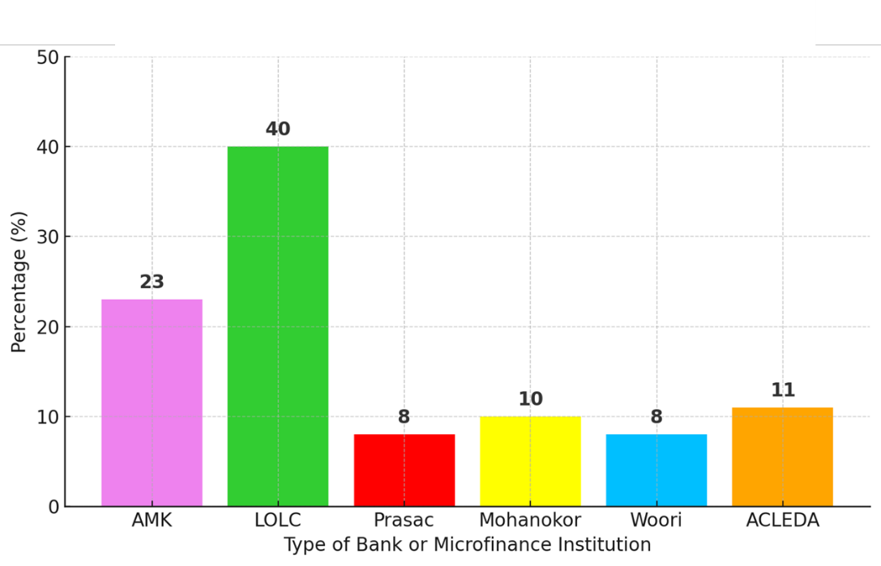
Fig. 1. Percentage distribution of respondents according to the financial institutions they used for credit services in Kampong Cham Commune, Sambour District, Kratie Province. LOLC accounted for the largest proportion (40%) of borrowers, followed by AMK (23%), ACLEDA (11%), Mohanokor (10%), Prasac (8%), and Woori (8%).
3. 2 General Awareness and Understanding of Credit Services
Table 2 summarizes respondents’ understanding and perceptions of credit services. Overall, respondents showed moderate understanding of most items (mean values ranged from 3.0 to 3.6 on a 5-point scale). Understanding of the benefits of borrowing (M = 3.64) and trust in credit institutions (M = 3.58) had the highest scores, while understanding of loan terms and repayments was lower (M = 2.98–3.03). Respondents still showed moderate satisfaction with credit services, including customer service (M = 3.48) and the speed of the credit application process (M = 3.50). These results indicate that rural borrowers have a moderate but incomplete understanding of financial tasks and the credit system.
Table 2. Awareness and understanding of credit services among respondents.
Code | Description | Sum | Max | Min | Mean | SD
Q4 | How well do you understand the terms and conditions of borrowing money from credit institutions? | 331 | 4 | 1 | 2.98 | 0.72
Q5 | Do you understand the process of refunds or repayments related to credit services? | 336 | 4 | 1 | 3.03 | 0.72
Q6 | How well do you understand the interest payments charged on credit services? | 352 | 5 | 1 | 3.17 | 0.73
Q7 | How much do you understand the consequences of borrowing without a proper plan? | 404 | 5 | 1 | 3.64 | 0.74
Q8 | How much do you understand the benefits of using credit services? | 366 | 5 | 1 | 3.30 | 0.73
Q9 | How much do you understand the disadvantages or risks of using credit services? | 368 | 5 | 1 | 3.32 | 0.72
Q11 | Do you trust the information provided about credit terms and conditions? | 397 | 5 | 1 | 3.58 | 0.73
Q12 | Do you trust credit institutions to provide fair and transparent credit services? | 401 | 5 | 1 | 3.61 | 0.74
Q14 | Do you believe that using credit services is beneficial to your financial situation? | 386 | 5 | 2 | 3.48 | 0.75
Q15 | Are you satisfied with the customer service provided by the credit institution? | 377 | 4 | 2 | 3.40 | 0.74
Q16 | Are you satisfied with the information provided about borrowing and repayment? | 388 | 5 | 2 | 3.50 | 0.75
Q17 | Are you satisfied with the speed of the loan approval and disbursement process? | 393 | 5 | 1 | 3.54 | 0.75

3.3 Factors Influencing Borrowing Decisions
Table 3 shows the factors that influence households’ decision to use credit services. The results show that family influence (M = 3.75) and lack of funds (M = 3.68) are the most important factors that motivate borrowing. Institutional factors also play an important role. Respondents value the flexibility of loan terms (M = 3.65), the ease of loan application procedures (M = 3.63), and trust in the credit institution (M = 3.54). In contrast, financial factors such as interest rates (M = 3.34) and repayment terms (M = 3.37) have a minor impact. Overall, these results suggest that socio-economic needs and ease of access to credit are the main factors driving rural households’ borrowing decisions, rather than strong considerations of financial terms or the cost of the loan.
Table 3. Factors influencing household borrowing decisions.
Code | Description | Sum | Max | Min | Mean | SD
Q1 | Did low interest rates motivate your decision to use credit services? | 393 | 5 | 1 | 3.54 | 0.75
Q2 | Does easy access to borrowing influence your decision to use credit services? | 368 | 4 | 1 | 3.32 | 0.76
Q3 | Did detailed explanations about credit services influence your decision to use them? | 373 | 5 | 1 | 3.36 | 0.78
Q4 | Does the lack of personal capital influence your decision to borrow money? | 409 | 5 | 1 | 3.68 | 0.79
Q5 | Does your family influence your decision to use credit services? | 416 | 5 | 1 | 3.75 | 0.78
Q6 | Does the use of credit have an impact on your daily living expenses? | 332 | 5 | 1 | 2.99 | 0.77
Q7 | Does the widespread use of credit services in your community influence your decision to borrow? | 392 | 5 | 1 | 3.53 | 0.52
Q8 | Is sharing experiences about credit services with neighbors effective in influencing your decision? | 393 | 4 | 1 | 3.54 | 0.48
Q9 | Are you confident in your ability to repay borrowed money? | 402 | 5 | 1 | 3.62 | 0.49
Q10 | Do you trust credit institutions? | 393 | 5 | 1 | 3.54 | 0.50
Q11 | Do you believe that borrowing money is related to your understanding of credit services? | 381 | 5 | 1 | 3.43 | 0.52
Q13 | How easy is it to apply for a loan, and how much does this influence your borrowing decision? | 381 | 4 | 1 | 3.43 | 0.53
Q14 | How much does the interest rate set by the credit institution influence your borrowing decision? | 371 | 5 | 1 | 3.34 | 0.54
Q15 | How much do the repayment terms (e.g., duration and repayment capacity) influence your borrowing decision? | 374 | 4 | 1 | 3.37 | 0.55
Q16 | How much do document or collateral requirements influence your borrowing decision? | 402 | 4 | 1 | 3.62 | 0.57
Q17 | How much does the credit policy of the institution influence your borrowing decision? | 390 | 5 | 1 | 3.51 | 0.58
Q18 | How much do flexible credit terms (e.g., problem relief or rescheduling) influence your borrowing decision? | 405 | 5 | 1 | 3.65 | 0.60
Q19 | How much do the overall loan application terms influence your decision to borrow? | 388 | 4 | 1 | 3.50 | 0.62
Q20 | Does the ease of the loan process affect your borrowing decision? | 403 | 4 | 1 | 3.63 | 0.64

3. 4 Challenges in Credit Use and Response Strategies
Table 4 summarizes challenges faced during credit use and strategies employed by respondents. Mostly, respondents found loan terms and contracts very difficult to understand (M = 3.05–3.16) and cited limited access to information (M = 2.94) as a major obstacle. However, many reported consulting families before borrowing (M = 3.80) and raising additional income to repay debts (M = 3.41). These findings suggest that while borrowers face comprehension barriers, they employ informal strategies such as family consultation and supplementary income generation to manage repayment.
Table 4. Challenges and response strategies in credit service utilization.
Code | Description | Sum | Max | Min | Mean | SD
Q1 | Do you find it easy to understand the terms and conditions of a loan? | 351 | 5 | 1 | 3.16 | 0.69
Q2 | Do you find it easy to understand credit contracts? | 339 | 4 | 1 | 3.05 | 0.62
Q3 | Does the lack of information about credit services make it easier for you to decide to use them? | 326 | 4 | 1 | 2.94 | 0.64
Q4 | Are high interest rates convenient or acceptable for you? | 394 | 5 | 1 | 3.55 | 0.50
Q5 | Are the documentation requirements easy to meet when applying for credit? | 387 | 5 | 1 | 3.49 | 0.51
Q6 | Is it easy for you to make loan payments when your income is low or unstable? | 397 | 5 | 1 | 3.58 | 0.52
Q9 | Have you made a monthly repayment plan to ensure timely loan payments? | 350 | 4 | 1 | 3.15 | 0.52
Q10 | Did you consult with family members before deciding to borrow money? | 422 | 5 | 1 | 3.80 | 0.52
Q11 | Have you sought information from other credit institutions before borrowing? | 387 | 4 | 1 | 3.49 | 0.52
Q12 | Have you tried to raise additional income to support your loan repayments? | 379 | 5 | 1 | 3.41 | 0.53
Q13 | Have you avoided borrowing money when you were not sure about your repayment ability? | 360 | 5 | 1 | 3.24 | 0.48
Q15 | How effective are these actions or solutions in helping you manage your loans? | 379 | 5 | 1 | 3.41 | 0.59

3.5 Comparison of Group Means
The analysis of variance (ANOVA) followed by Tukey’s HSD test revealed distinct patterns of understanding, influencing factors, and challenges toward credit service utilization across different socio-demographic groups (Figure 2). Occupation showed no significant difference in understanding (p > 0.05), although government employees exhibited slightly higher mean scores than agricultural workers and laborers. In contrast, for influencing factors, workers demonstrated significantly higher scores compared to other occupations (p < 0.05), indicating a stronger perception of external influences on their decision to use credit services. Similar trends were observed in challenges, where agricultural workers and laborers expressed higher perceived difficulties than business owners and government workers. Income level significantly affected all three aspects (p < 0.05). Respondents earning between USD 200–300 reported the highest understanding and awareness of credit services, while those earning less than USD 200 had lower comprehension and greater perceived challenges. For gender, female respondents had slightly higher mean scores in understanding and challenges than males, although differences were not statistically significant (p > 0.05). Regarding cultural level, no significant variation was found among educational groups (p > 0.05). However, participants with a bachelor’s degree tended to exhibit greater understanding and awareness compared to those with only elementary education. Age did not significantly influence understanding, influencing factors, or challenges (p > 0.05), suggesting relatively consistent perceptions across age cohorts. Conversely, residence demonstrated a pronounced effect across all dimensions (p < 0.001). Respondents from Ampil Teuk and Ajen villages displayed higher levels of understanding and more positive attitudes toward credit service use compared to those from Sampin and Tansong Thleak, who expressed greater challenges and lower awareness.
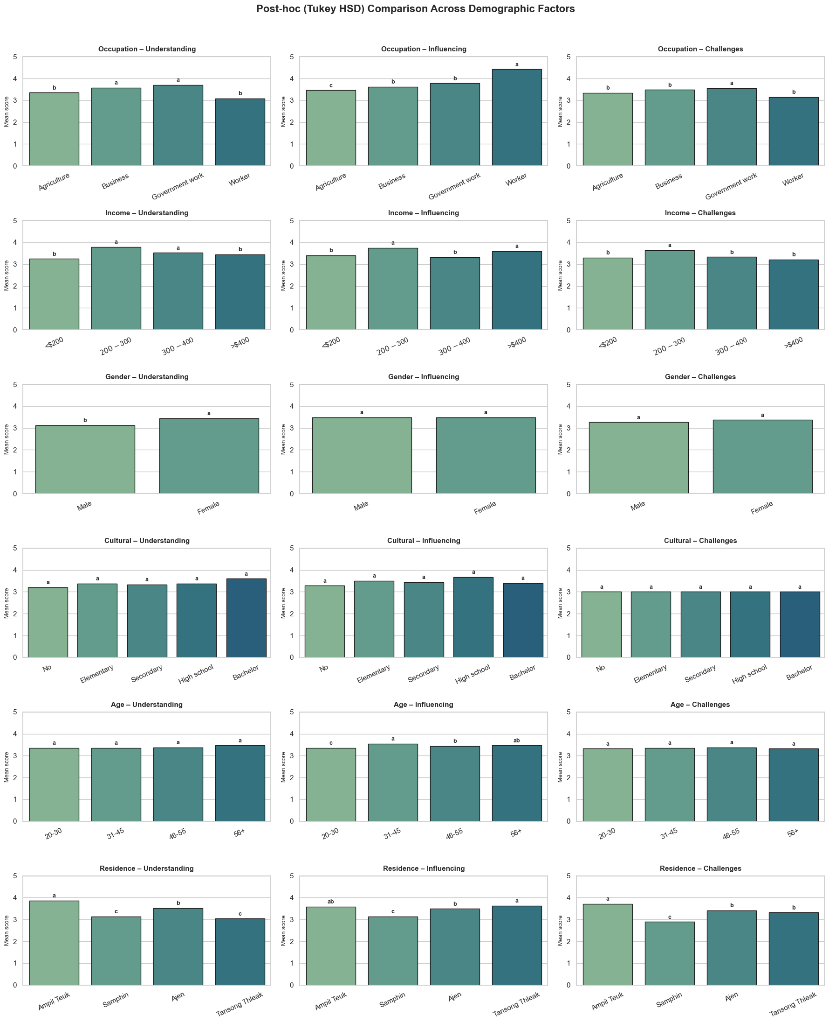
Fig. 2. Post-hoc (Tukey HSD) comparison of respondents’ mean scores for Understanding, Influencing Factors, and Challenges toward credit service utilization across six demographic factors: Occupation, Income, Gender, Cultural Level, Age, and Residence in Kratie Province, Cambodia. Bars represent mean values, and different letters above bars indicate statistically significant differences among categories within each demographic factor (p < 0.05). Error bars represent the standard deviation of simulated group data.
3.6 Reliability of Research Instrument
Table 5 presents the results of the reliability test using Cronbach’s Alpha, which showed high internal consistency across all components of the questionnaire. The coefficient values were α = 0.88 for awareness and understanding, α = 0.90 for influencing factors, and α = 0.81 for challenges and response strategies. The overall reliability of the instrument was α = 0.86, confirming that the questionnaire demonstrated strong statistical reliability for use in social science research.
Table 5. Reliability statistics of the research instrument.
Variable | Number of Items | Cronbach’s Alpha (α)
Variable 1: General understanding of credit service use | 12 | 0.88
Variable 2: Factors influencing credit service use | 19 | 0.90
Variable 3: Challenges and response strategies | 12 | 0.81
Overall (Average) | 14.33 | 0.86

This study examined the perspectives and factors determining the use of loan repayment services by citizens in Kampong Cham village, Sambo district, Kratié province. The results showed that the majority of respondents were between 31 and 45 years old (58%), which is the most economically active group and the one with primary responsibility for managing household income. Rice farming remains the main occupation (79%), especially in villages located on islands and upland areas, highlighting the agricultural nature of the commune's economy. The level of education remains low, with approximately 73% of respondents having only completed primary school. Similarly, many families have an income below $200 per month (68%), indicating limited financial capacity and a reliance on loans to sustain their livelihoods and address urgent financial problems.
The results revealed that the majority of respondents had an average understanding of loan services, particularly regarding the benefits of borrowing and trust in financial institutions. However, their understanding of contract terms and repayment schedules remained limited. This finding is consistent with studies by the World Bank (2020) and Banciu et al. (2022), which reported that despite the expansion of digital financial services and credit institutions in Cambodia, the financial literacy of rural citizens remains low. According to studies by Lusardi and Mitchell (2014) and OECD/UNCDF (2020), financial literacy—especially the ability to manage income, calculate interest, and follow repayment schedules—is a crucial factor for maintaining household financial stability. The limited understanding found in this study suggests that many borrowers may enter into loan agreements without fully grasping the implications of interest rates and repayment schedules, potentially leading to financial difficulties and economic stress. Nguyen and Nguyen (2023) found that in rural Vietnam, limited financial literacy significantly restricts access to formal credit and increases household vulnerability to over-indebtedness. Their findings parallel the present study, showing that knowledge gaps in understanding credit terms often lead borrowers to rely on informal advice or word-of-mouth recommendations rather than professional financial guidance. Similarly, the OECD (2023) report emphasized that improving financial literacy and inclusion builds household financial resilience, particularly in developing rural economies where access to traditional banking services remains limited.
Regarding factors influencing borrowing decisions, the results showed that family influence, a lack of banking resources, the flexibility of loan terms, and the convenience of the borrowing process were the most significant factors. This result aligns with Chakrabarty (2012), who stated that education level, household income, and social environment strongly influence borrowing behavior. Similarly, CGAP (2018) showed that word-of-mouth and community trust networks play a crucial role in encouraging people to use formal or informal credit services. The results of this study confirm that borrowing decisions in rural Cambodia are not driven solely by financial needs but also involve social and relational factors, particularly consultations with family and friends.
Moreover, findings from other South Asian contexts support this argument. Rahman and Khan (2024) reported that microcredit participation and repayment behavior in rural South Asia are influenced not only by income and collateral availability but also by social cohesion and borrower–lender trust. Their results mirror those of the present study, highlighting the strong role of community-based networks in shaping household credit behavior. This reinforces the importance of social capital as a determinant of both borrowing decisions and repayment discipline in developing rural financial systems.
The rise of digital credit platforms, such as mobile loan apps and e-wallet credit services, has made accessing credit procedures increasingly easier in Cambodia (CRDF, 2021; Sophal et al., 2020). Although this technology offers convenience, there are financial risks if borrowing is done without sufficient understanding or proper oversight. Therefore, the need for consumer protection and education on responsible credit use is a critical issue.
The results also highlighted several major problems in using loan services. Many respondents reported difficulties in understanding contracts and repayment terms, a lack of clear information, and high interest rates. These problems are consistent with UNCDF (2020), which reported that rural populations still face challenges in accessing affordable and fair credit services. This finding also aligns with studies by Linda et al. (2021) and the Financial Consumer Affairs Department (2023), which pointed to issues such as a lack of information disclosure, the absence of complaint handling systems, and illegal debt collection practices. These findings indicate that many rural citizens are facing "unfair credit" due to an information asymmetry between lenders and borrowers.
In summary, the study's results show that although access to credit in Kampong Cham commune has improved, financial literacy, fairness, and institutional accountability remain significant obstacles to the effective and equitable use of credit services. Strengthening financial education, making loan documents easier to understand, and promoting the integrity of financial institutions could help reduce credit problems and enhance rural financial security. Strengthening regulations and integrating financial education into community development programs, as guided by the MEF (2022) and UNCDF (2020), will help build a more inclusive and sustainable financial system in Cambodia.

5. Conclusion

This study investigated perceptions and determinants of credit utilization among people in Kampong Cham commune, Sambour district, Kratie province, Cambodia. Findings revealed that the majority of respondents were middle-aged, mostly engaged in agriculture, and had low levels of education and income, all of which significantly influenced their borrowing behavior. Despite increased access to credit through traditional microfinance institutions and new digital platforms, rural borrowers still had limited understanding of loan terms, repayment terms, and financial management.
The analysis revealed that family influence, lack of capital, and ease of access were the main factors driving credit utilization, while interest rates and repayment terms played a less important role. These results suggest that borrowing decisions in rural communities are driven by social and livelihood needs rather than financial strategies. Although respondents expressed moderate levels of trust and satisfaction with credit institutions, many still encountered difficulties such as misunderstandings about loan contracts, limited access to reliable information, and exposure to high interest rates.
Reliability analysis confirmed that the research instrument produced consistent and valid measurements of perceptions, influencing factors, and challenges. Results from one-way ANOVA tests showed that income level and village of residence had significant effects on perceptions, motivations, and experiences related to credit use. These findings highlight the importance of developing financial education programs that are tailored to local contexts and income levels.
Overall, the results of this study clearly show that improving financial literacy, strengthening consumer protection, and ensuring integrity in credit transactions are essential to promoting responsible lending and sustainable rural development in Cambodia. State authorities, financial institutions, and educational organizations should work together to integrate financial education into community development programs, make loan documents easy to understand, and establish effective customer support and complaint handling systems.

Consent
As per international standards or university standards, Participants’ written consent has been collected and preserved by the author(s).

DISCLAIMER (ARTIFICIAL INTELLIGENCE)
Authors hereby declare that NO generative AI technologies such as Large Language Models (ChatGPT, COPILOT, etc.) and text-to-image generators have been used during the writing or editing of this manuscript.

References
Anurag, S. P., Budhiraj, S. P., Vijay, S. P. (2024). Examine the role of microfinance institutions in reducing poverty and promoting economic development. Journal of Xidian University, 1(1), 236‒246. https://doi.org/10.5281/zenodo.11488827
Banciu, D., Arulanandam, B. V., Munhenga, T. & Ivascu, L. (2022). Digital financial literacy and microfinancing among underprivileged communities in Cambodia. Romanian Journal of Information and Automatic Control, 32(4), 77‒92.
Bucks, B., & Pence, K. (2008). Do borrowers know their mortgage terms? Journal of Urban Economics, 64(2), 218–233. https://doi.org/10.1016/j.jue.2008.07.005
Cambodia Development Resource Institute. (2025). Cambodia’s new growth strategy—an assessment of medium and long-term growth for resilient, inclusive, and sustainable development. CDRI.
Chakrabarty, K. C. (2012). Financial literacy and credit usage in low-income households. Reserve Bank of India Bulletin.
Chantha, kong, Seng, S., Ratha, P., & Sovanvatthana, K. (2024). Microfinance institutions performance and economic growth in Cambodia: An advanced econometric analysis. Economics and Business Journal (ECBIS), 2(5), 447–462. https://doi.org/10.47353/ecbis.v2i5.158
Das, S. (2024). Financial Literacy and Education in Enhancing Financial Inclusion and Poverty Alleviation. In N. Mansour, S. Baral, & V. Garg (Eds.), E-Financial Strategies for Advancing Sustainable Development: Fostering Financial Inclusion and Alleviating Poverty (pp. 127–144). Springer Nature Switzerland. https://doi.org/10.1007/978-3-031-67523-2_8
Financial Consumer Affairs Unit. (2023). Consumer protection and loan fairness report. National Bank of Cambodia.
Katnic, I., Katnic, M., Orlandic, M., Radunovic, M., & Mugosa, I. (2024). Understanding the Role of Financial Literacy in Enhancing Economic Stability and Resilience in Montenegro: A Data-Driven Approach. Sustainability, 16(24), 11065. https://doi.org/10.3390/su162411065
Kyeyune, G. N., & Ntayi, J. M. (2025). Empowering rural communities: the role of financial literacy and management in sustainable development. Frontiers in Human Dynamics, 6, 2024. https://doi.org/10.3389/fhumd.2024.1424126
Linda, Y. T., Jeffrey, C., Chao, Y. & Linda, C. L. (2021). Training pack Cambodia. Research Centre for Sustainable Hong Kong.
Lusardi, A., & Mitchell, O. S. (2014). The economic importance of financial literacy: Theory and evidence. Journal of Economic Literature, 52(1), 5–44. https://doi.org/10.1257/jel.52.1.5
Nguyen, T. T., & Nguyen, H. T. (2023). Financial literacy and credit access among rural households in Vietnam. Journal of Asian Economics, 85, 102613.
OECD (2023). Financial Literacy and Inclusion: Building Financial Resilience in Developing Economies. OECD Publishing.
OECD/UNCDF (2020). Blended finance in the least developed countries 2020: Supporting a resilient COID-19 recovery. OECD Publishing. https://doi.org/10.1787/57620d04-en.
Rahman, M. M., & Khan, S. A. (2024). Determinants of microcredit participation and repayment behavior in rural South Asia. Development in Practice, 34(3), 451–463.
Sophal, C., Chansovy, N. & Metta, H. (2020). Digital challenges and opportunities for agribusiness enterprises in Cambodia: Implications for the Cambodian economics. Centre for Policy Studies (CPS).
Taiwo, J. N., Agwu, E., & Benson, K. N. (2016). The role of microfinance institutions in financing small businesses. Journal of Internet Banking and Commerce, 21(1), 1‒20. https://ssrn.com/abstract=3122480
Transparency International Cambodia. (2021). Access to financial services and consumer protection in Cambodia. Transparency International Cambodia.
Uy, J. C. & Flores, E. P. (2024). Financial literacy awareness and practices among village savings group in Cambodia. Journal of Accounting, Finacne, Economics, and Social Sciences, 9(2), 1‒14. https://doi.org/10.62458/jafess921
Yamane, T. (1967). An introductory analysis (3rd ed.). Harper & Row.
Yamane, T. (1973). An introductory analysis (3rd ed.). Harper International.
Zeqiraj, V., Sohag, K., & Hammoudeh, S. (2022). Financial inclusion in developing countries: Do quality institutions matter? Journal of International Financial Markets, Institutions and Money, 81, 101677. https://doi.org/10.1016/j.intfin.2022.101677
Zhang, W., Xia, X., Zhu, Y., Zhao, S., & Zhou, Z. (2024). Rural financial institutions, access to credit and production inputs of rural households. Finance Research Letters, 70, 106298.
Zhao, J., & Li, T. (2021). Social capital, financial literacy, and rural household entrepreneurship: A mediating effect analysis. Frontiers in Psychology, 12, 2021. https://doi.org/10.3389/fpsyg.2021.724605

