Epistemic Beliefs on Learning, Knowledge and Intelligence among Filipino Students and Working Adults: A Descriptive Comparison

.
ABSTRACT

This descriptive study compared students and working adults on their epistemic beliefs about learning, knowledge, and intelligence. A total of 39 Filipino respondents participated in an online survey, comprising 19 students (college, master’s, and secondary levels) and 20 employed individuals. Using a researcher-adapted survey based on Schommer’s (1990) framework of epistemological beliefs, the study gathered both quantitative and qualitative data to identify patterns in how each group conceptualizes intelligence, approaches learning, and perceives knowledge. Descriptive statistics revealed that while both groups acknowledged intelligence as multifaceted and effort-based, students tended to associate it with innate ability, prestige, and academic success, reflecting a more fixed mindset. In contrast, however, employed individuals demonstrated growth-oriented and pragmatic beliefs, emphasizing adaptability, effort, and real-world application of knowledge. These findings suggest that epistemological beliefs evolve with life experience and environmental context, academic or professional, shaping how individuals define intelligence and approach lifelong learning. Furthermore, these insights underscore the need for educational systems to cultivate growth mindsets, epistemic autonomy, and diverse conceptions of intelligence among learners to prepare them for dynamic real-world learning environments.

Keywords: epistemological beliefs; learning; knowledge; intelligence

1. INTRODUCTION
Learning is more than the accumulation of facts or information; it involves how individuals think about knowledge, construct meaning, and approach the learning process itself. These personal perspectives, known as epistemological beliefs, shape how learners interpret experiences, solve problems, and apply knowledge in various contexts (Schommer, 1990). In educational settings, such beliefs play a central role in influencing student motivation, persistence, and engagement in deeper learning (Bendixen & Rule, 2004). On one hand, learners who view knowledge as evolving and complex tend to value effort and reflection, while on the other hand, those with more naïve beliefs see learning as the passive reception of fixed truths (Schommer, 1994; Hofer & Pintrich, 1997). Understanding these beliefs, then, is essential for educators, as they determine how individuals learn, process information, and respond to different instructional strategies.
Schommer’s (1990) multidimensional framework conceptualizes epistemological beliefs along several dimensions: certainty, simplicity, source of knowledge, and the speed and control of learning. Building on this model, subsequent studies have shown that epistemic beliefs may influence academic achievement, self-regulation, and motivation (Muis, 2007; Greene et al., 2010). Letina (2022) found that teachers’ epistemological orientations may have shaped their preference for traditional or constructivist teaching approaches, while Guo et al. (2022) demonstrated that reflective thinking may correlate with more sophisticated epistemic beliefs. Similarly, Shirzad et al. (2022) found that epistemic beliefs and self-efficacy may jointly predict students’ use of language learning strategies. Collectively, these findings suggest that epistemological beliefs act as cognitive filters or worldviews that guide how individuals perceive and engage with learning.
Beyond academic settings, epistemological beliefs may also influence how adults learn in professional environments. Bauer et al. (2004) found that workplace learning is shaped by more pragmatic and experience-based conceptions of knowledge, suggesting that epistemic beliefs evolve as individuals transition from school to work. While many studies have examined epistemic beliefs among students, few have compared them with those of working adults, particularly in Southeast Asian or Philippine contexts. This represents a theoretical and empirical gap, as transitions from formal schooling to professional environments may reveal how epistemic cognition matures over time with the accumulation of more lived experiences.
Addressing this gap, the present study compares the epistemological beliefs of students and working adults. It is grounded in the premise that beliefs about learning and intelligence are not fixed but dynamic, changing with life experiences and environmental demands. Students, who typically learn in structured academic systems, may exhibit more performance-oriented and fixed beliefs, whereas working adults, exposed to real-world problem-solving, may demonstrate growth-oriented and pragmatic perspectives. Investigating these distinctions provides a clearer understanding of how beliefs about knowledge, learning, and intelligence develop across life stages.
Therefore, this study aims to examine whether there are significant differences in beliefs about learning, knowledge, and intelligence between students and working adults. Specifically, it explores how these two groups conceptualize the nature of knowledge, the processes of learning, and the liquidity or relativity of intelligence. By identifying these patterns, the study seeks to contribute to the growing discourse on epistemological development and to inform educational and workplace strategies that promote adaptive and lifelong learning.

2. methodS
This study employed a descriptive-comparative research design to examine potential differences in epistemological beliefs between students and working adults. The research sought to identify how these two groups conceptualize learning, knowledge, and intelligence, and whether their beliefs differ based on their educational and professional contexts. A descriptive approach was chosen to allow a systematic analysis of participants’ self-reported beliefs without manipulating any variables.
A total of 39 respondents participated in the study. The participants were drawn from diverse educational and occupational backgrounds and were selected randomly, regardless of gender, socio-economic status, degree program, or current employment designation. The distribution of respondents is presented in Table 1.
Table 1. Distribution of Respondents by Educational/Occupational Status
Category | Number of Respondents
Employed and no longer studying | 20
Master’s students | 3
College students | 14
Senior High School students (Grade 11–12) | 1
Junior High School students (Grade 7–10) | 1
Total | 39
For purposes of analysis, the respondents were divided into two main categories. Group 1 (Students) consisted of 19 participants, including college students, master’s students, one senior high school student, and one junior high school student. Group 2 (Employed) included 20 individuals who were currently employed and no longer enrolled in formal education. This classification enabled a meaningful comparison between individuals who remain in structured academic environments and those who have transitioned to professional learning contexts.

Data were collected using a survey questionnaire online, adapted from Schommer’s (1990) framework of epistemological beliefs. The questionnaire contained closed-ended items designed to capture participants’ beliefs about learning, knowledge, and intelligence. The closed-ended questions were primarily descriptive and utilized a true or false type to determine participants’ agreement with statements related to epistemic beliefs.The survey was distributed electronically through Google Forms to facilitate efficient and accessible data collection. Respondents participated voluntarily, and confidentiality was maintained throughout the process.

Data gathered from the survey were analyzed using descriptive statistics to summarize and compare the beliefs of students and working adults. Percentages were computed to identify general patterns and variations in epistemological beliefs across the two groups. Together, these analyses provided a balanced interpretation of how epistemological beliefs differ between individuals in academic and professional learning contexts.

3. results and discussion

This study analyzed data from two groups: students (n = 19) and employed individuals (n = 20), having a minuscule sample size of 39 participants. Both groups completed parallel surveys exploring their beliefs about intelligence, learning, and knowledge. To guide comparison, two composite measures were constructed: the Growth/Patience Index, which assessed beliefs that learning requires sustained effort and time, and the Epistemic Autonomy Index, which measured the belief that individuals should question information and adapt their understanding when presented with new evidence.
Results showed that Group 2 (employed respondents) scored higher on both measures. On the Growth/Patience Index, employed participants averaged 3.87, compared with 3.51 among students, indicating stronger endorsement of persistence as essential for learning. On the Epistemic Autonomy Index, employed respondents also scored higher (3.48 vs. 3.13), reflecting greater openness to inquiry and intellectual flexibility. These differences may reflect workplace contexts, where adaptability, feedback, and problem-solving are necessary for success.
In contrast, Group 1 (students) tended to associate intelligence with innate ability and social prestige. Nearly half (47%) viewed fluency in English or another foreign language as a sign of intelligence, compared with only 25% of employed respondents.
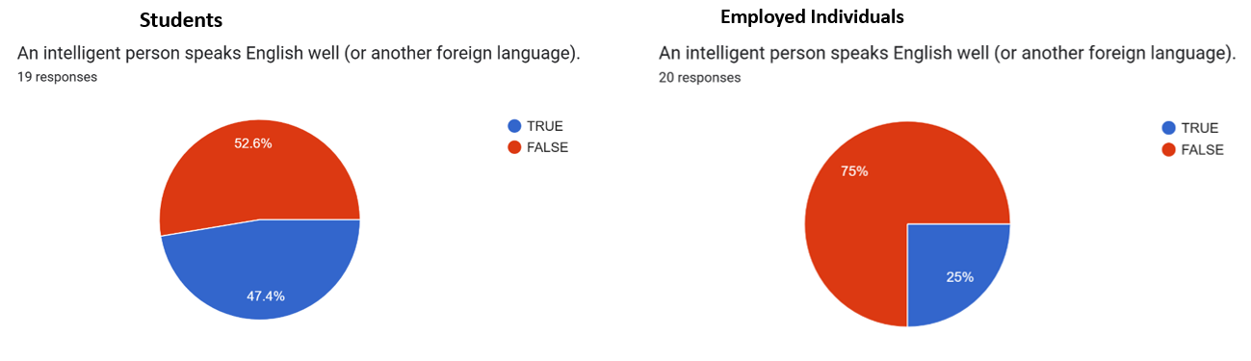
Figure 1. Fluency in Foreign Language as Intelligence

Similarly, 16% of students linked intelligence to attending a prestigious school, while just 5% of employed individuals did the same.
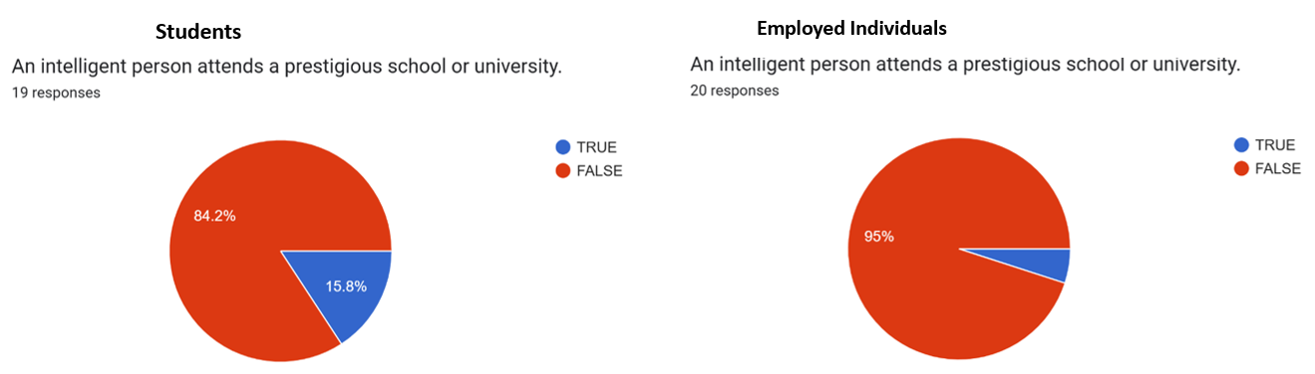
Figure 2. Intelligent People Attend Prestigious Schools

About 32% of students agreed that intelligent individuals require less study to learn, whereas only 10% of employed respondents shared this view. These beliefs reflect a fixed mindset, the assumption that intelligence is a natural gift rather than something developed through effort. Such perspectives can reduce motivation, as students may interpret difficulty as evidence of limited ability rather than a normal part of learning.
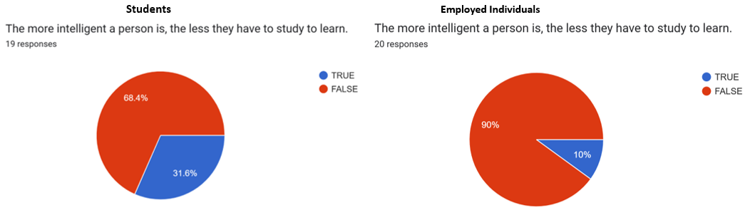
Figure 3. Intelligent People Require Less Study to Learn

Conversely, employed respondents more often valued practical skills and demonstrated competence. For example, 70% associated mathematical ability with intelligence (compared with 42% of students), and 40% connected intelligence to high job positions (versus 21% of students). This suggests a more pragmatic orientation, where intelligence is viewed through tangible outcomes such as problem-solving and performance at work.
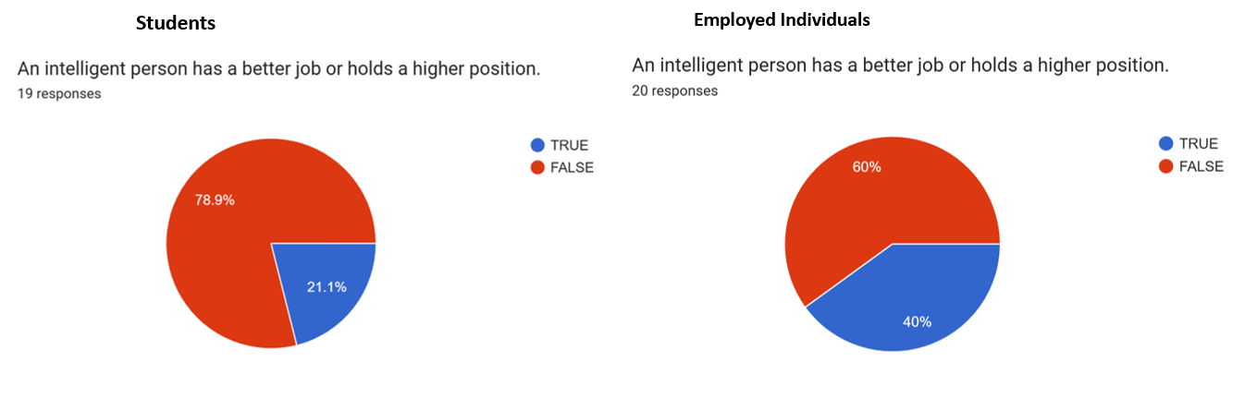
Figure 4. An Intelligent Person has a Better Job

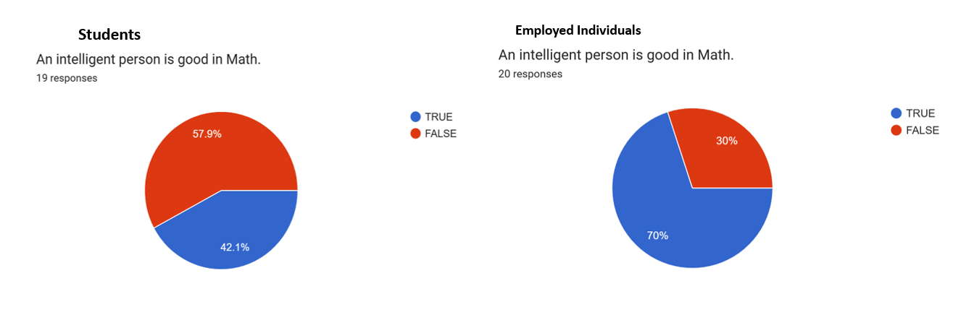
Figure 5. An Intelligent Person is Good at Mathematics

These findings align with major theories of learning and cognition. The students’ emphasis on natural ability reflects fixed mindset theory (Dweck, 2006), which associates such beliefs with performance goals and reduced resilience in the face of challenges. In contrast, employed participants’ higher Growth/Patience and Epistemic Autonomy scores correspond to mastery goals, a focus on improvement and sustained effort. Their openness to revising beliefs mirrors the principles of epistemic cognition, which frame knowledge as evolving and context-dependent (Hofer & Pintrich, 1997).
The contrast between “fast learning” and “effortful learning” is also notable. Many students appeared to embrace what could be called a fast-learning fatalism, which is the idea that those who truly understand do so immediately. This belief can discourage persistence, as difficulty becomes equated with failure. From the lens of expectancy-value theory (Eccles & Wigfield, 2002), this mindset lowers perceived competence, reducing effort and engagement. By comparison, employed individuals’ belief that learning takes time and practice supports motivation and long-term persistence, aligning with growth-oriented perspectives.
Despite these clear patterns, internal contradictions emerged within both groups. Students often affirmed that learning requires time and effort, but simultaneously believed that intelligent people need less study. Employed respondents, while endorsing persistence, also associated intelligence with occupational success and high performance. These inconsistencies suggest that epistemological beliefs are multidimensional and context-dependent, shifting according to experiences and social expectations.
A particularly meaningful dimension of these results involves cultural and societal narratives. The stronger association among students between intelligence and fluency in English reflects the enduring influence of colonial and structural forces in Philippine education, where English proficiency has long been tied to academic success and intellectual status (Bernardo, 2004). Such beliefs reveal how societal hierarchies can shape perceptions of intelligence, linking it with privilege rather than effort. On the other hand, employed participants’ responses suggest that real-world experiences, where success depends on adaptability, collaboration, and applied skill, gradually reframe intelligence as effort-based rather than inherited or status-driven. This shift underscores how contextual realities can reshape epistemic beliefs over time.
The results also resonate with Gardner’s (1983) Multiple Intelligences Theory, which posits that intelligence extends beyond linguistic and logical abilities to include creativity, kinesthetic ability, and interpersonal awareness. Both students and employed respondents acknowledged this broader view, recognizing excellence in sports, the arts, and practical domains as forms of intelligence. However, the lingering belief that “intelligent people learn quickly” suggests that traditional notions of cognitive speed still persist. This coexistence of progressive and traditional ideas reveals the complexity of epistemological beliefs, where openness to multiple intelligences can exist alongside fixed views about ability.
The findings carry several implications for both educational and professional settings. Among students, fixed and speed-based beliefs may undermine confidence and resilience when faced with difficulty. Educators can counter this by explicitly teaching about the growth process in learning: normalizing struggle, valuing persistence, and assessing progress alongside performance. For working adults, growth-oriented beliefs appear to foster adaptability and perseverance, yet training programs should also be mindful of the pressure to equate intelligence with occupational success, which can create undue stress and performance anxiety.
More broadly, the results demonstrate that educational and workplace environments play crucial roles in shaping epistemological beliefs. The transition from school to work appears to promote more flexible, pragmatic conceptions of learning and intelligence. Classrooms that emphasize practice, reflection, and diverse forms of intelligence can help students develop similar perspectives earlier. Likewise, workplaces that encourage questioning, collaboration, and continuous learning can reinforce epistemic autonomy.
4. Conclusions

This study examined the epistemological beliefs of college students and employed individuals, exploring how they perceive intelligence, learning, and knowledge. The findings revealed both convergence and contrast in their perspectives. While students tended to view intelligence as tied to innate talent, academic achievement, and social prestige, reflecting elements of a fixed mindset, employed individuals emphasized persistence, adaptability, and the practical application of knowledge, aligning more closely with growth-oriented and experience-based views. These distinctions suggest that beliefs about learning and intelligence evolve alongside life experience and environmental demands. The transition from academic settings to professional environments appears to foster greater epistemic autonomy, as individuals learn to value effort, reflection, and adaptability as essential to success.
The results carry significant implications for educational and professional practice. For educators, the findings highlight the importance of cultivating growth mindsets within the classroom. Teachers can normalize struggle, encourage persistence, and provide feedback that values effort and improvement rather than innate ability or speed. Integrating principles of multiple intelligences into teaching practice may also help students recognize and develop diverse strengths beyond traditional academic skills. Moreover, promoting epistemic autonomy through inquiry-based learning can empower students to question assumptions, evaluate evidence, and adapt their understanding as new knowledge emerges. By embedding these principles into the curriculum, schools can create learning environments that nurture resilience, curiosity, and self-directed learning.
In professional contexts, organizations and trainers are encouraged to foster workplace cultures that value continuous learning and reflection. Encouraging employees to seek feedback, question assumptions, and apply new insights to real-world challenges reinforces the belief that intelligence develops through practice and adaptability. At the same time, employers should balance performance expectations with opportunities for growth, ensuring that success is measured not only by results but also by improvement, collaboration, and innovation. Such practices sustain motivation and reinforce the view of intelligence as dynamic and multifaceted.
Beyond classrooms and workplaces, these findings also carry implications for policymakers and curriculum developers. Educational frameworks should intentionally address linguistic and cultural biases that equate intelligence with privilege, particularly the persistent notion that English fluency signifies superior intellect. Promoting multilingual competence and valuing local knowledge can help dismantle colonial narratives that continue to shape perceptions of intelligence in Philippine education. Policies that embed the teaching of learning mindsets, self-regulation, and epistemic humility can also prepare students for lifelong learning and adaptive thinking in a rapidly changing world.
Finally, the study invites further research, with a larger population or sample size, into how epistemological beliefs evolve over time. Future studies may expand the sample size, include varied professions, or adopt longitudinal and mixed-method approaches to capture how beliefs about knowledge and learning transform through different life stages. Such research would deepen understanding of the relationship between context, experience, and cognition.
In essence, this study underscores that both educational and professional environments play crucial roles in shaping how people define and experience learning. By consciously fostering beliefs that value effort, patience, and openness to new ideas, educators and employers alike can cultivate more resilient, reflective, and inclusive learners, individuals who view intelligence not as a fixed trait but as a lifelong process of growth.
Consent
As per international standards or university standards, Participants’ written consent and parental written consent for minor participants has been collected and preserved by the author(s).

DISCLAIMER (ARTIFICIAL INTELLIGENCE)
Option 1:
The author hereby declares that NO generative AI technologies such as Large Language Models (ChatGPT, COPILOT, etc.) and text-to-image generators have been used during the writing or editing of this manuscript.

References

Bauer, J., Festner, D., Gruber, H., Harteis, C., & Heid, H. (2004). The effects of epistemological beliefs on workplace learning. Journal of Workplace Learning, 16(5), 284–292. https://doi.org/10.1108/13665620410545561
Bendixen, L. D., & Rule, D. C. (2004). An integrative approach to personal epistemology: A guiding model. Educational Psychologist, 39(1), 69–80. https://doi.org/10.1207/s15326985ep3901_7
Bernardo, A. B. I. (2004). McKinley’s questionable bequest: Over 100 years of English in Philippine education. World Englishes, 23(1), 17–31. https://doi.org/10.1111/j.1467-971X.2004.00332.x
Dweck, C. S. (2006). Mindset: The new psychology of success. Random House.
Eccles, J. S., & Wigfield, A. (2002). Motivational beliefs, values, and goals. Annual Review of Psychology, 53(1), 109–132. https://doi.org/10.1146/annurev.psych.53.100901.135153
Gardner, H. (1983). Frames of mind: The theory of multiple intelligences. Basic Books.
Greene, J. A., Azevedo, R., & Torney-Purta, J. (2010). Modeling epistemic and ontological cognition: Philosophical perspectives and methodological directions. Educational Psychologist, 45(1), 38–58. https://doi.org/10.1080/00461520903433554
Guo, X., Hao, X., Deng, W., Ji, X., Xiang, S., & Hu, W. (2022). The relationship between epistemological beliefs, reflective thinking, and science identity: A structural equation modeling analysis. International Journal of STEM Education, 9(1), 1–17. https://doi.org/10.1186/s40594-022-00355-x
Hofer, B. K., & Pintrich, P. R. (1997). The development of epistemological theories: Beliefs about knowledge and knowing and their relation to learning. Review of Educational Research, 67(1), 88–140. https://doi.org/10.3102/00346543067001088
Letina, A. (2022). Teachers’ epistemological beliefs and inclination towards traditional or constructivist teaching. International Journal of Research in Education and Science, 8(1), 135–153. https://doi.org/10.46328/ijres.1717
Muis, K. R. (2007). The role of epistemic beliefs in self-regulated learning. Educational Psychologist, 42(3), 173–190. https://doi.org/10.1080/00461520701416306
Schommer, M. (1990). Effects of beliefs about the nature of knowledge on comprehension. Journal of Educational Psychology, 82(3), 498–504. https://doi.org/10.1037/0022-0663.82.3.498
Schommer, M. (1994). Synthesizing epistemological belief research: Tentative understandings and provocative confusions. Educational Psychology Review, 6(4), 293–319. https://doi.org/10.1007/BF02213418
Shirzad, S., Barjesteh, H., Dehqan, M., & Zare, M. (2022). Epistemic beliefs and learners’ self-efficacy as predictors of language learning strategies: Toward testing a model. Frontiers in Psychology, 13, 867560. https://doi.org/10.3389/fpsyg.2022.867560

