Classroom presentation by students: A pedagogical approach to enhancing students' English-speaking skills among Grade eleven learners
ABSTRACT
Aims: The study investigated the effectiveness of presentations as a pedagogical strategy to enhance students’ English-speaking skills in a Bhutanese higher secondary school.

Study design: Guided by Kurt Lewin’s cyclical action research model of planning, observing, and reflecting, the study adopted a one-group pre-test-post-test quasi-experimental design over nine weeks.

Place and Duration of Study: Participants included eleventh-grade students (N = 26; 13 male and 13 female), aged 16-18, selected through convenience sampling. The participants were selected using a convenience sampling technique, which involves choosing a sample that is easily accessible to the researcher. This approach was practical because, as their English language teacher, I had regular and direct access to the students, facilitating the implementation and monitoring of the intervention over time.

Methodology: Data were collected using a mixed-method approach: (a) quantitative assessment of students` presentations across five rounds (baseline and four intervention cycles) using a nine-criteria rubric (fluency, pronunciation, grammar accuracy, vocabulary, organization, message clarity, confidence, audience engagement, and audibility), and (b) qualitative reflections from open-ended surveys analysed through word cloud visualization.

Results: Quantitative results showed significant improvement in students’ performance, with mean scores increasing from 27.8 at baseline to 34.6 in the final round, confirmed by a paired-samples t-test, t(25) = -19.84, p < 0.001. Students demonstrated steady progress in fluency, pronunciation, confidence, and audience engagement, through gains varied across individuals. Qualitative findings revealed that students perceived classroom presentations as effective for improving speaking skills, building confidence, organizing ideas, and reducing hesitation, while valuing teacher feedback as essential for targeted improvement. The iterative cycle of presentation, feedback, and re-presentation, emerged as central to skill development.

Conclusion: Overall, the study highlights the transformative potential of classroom presentations in fostering both linguistic and paralinguistic competence. It recommends incorporating structured presentation tasks and standardized speaking assessments into Bhutanese English curricula to promote sustained language growth. Additionally, teacher-training programs could emphasize strategies for facilitating effective student presentations and providing constructive-feedback, equipping educators with the skills to foster fluency, confidence, and communicative competence.

Keywords: Classroom presentation, speaking skills, Bhutanese students, Grade eleven learners

1. INTRODUCTION

Proficiency in English, particularly listening and speaking, has become increasingly vital for academic success, career prospects, and cross-cultural communication worldwide (Al-khreshheh, 2024; Wei, 2025). As English is the lingua franca of the world (El-Dakhs & Mitchell, 2011), it is instituted as one of the main mediums of instruction in Bhutanese schools and universities ever since Bhutan started the modern education system in the early 1960s (Tshering, 2020). Beginning from their first year of formal education at the age of five or six, Bhutanese children learn all subjects in English, with the exception of Dzongkha, the national language (Sherab, 2013; Tshering, 2020). The English curriculum in Bhutan places strong emphasis on the development of the four essential language skills: listening, speaking, reading, and writing (Choeda et al., 2020). Beyond the educational system, English also functions as a widely used official language across the country, playing a vital role in everyday communication, both spoken and written (Tshering, 2020).

However, a recent study by Choeda et al. (2020) found that the communicative competence of Bhutanese secondary students in general is below the standard set in the “Silken Knot” (Centre for Educational Research and Development, 2002). The study found that the majority of the students have poor vocabulary, lack the ability to express and are weak at grammar, both in spoken and written communication. Evidence from teacher interviews, student surveys, and classroom observations reveals that students are generally more fluent and comfortable speaking in classroom interactions, even during English lessons, and when they do attempt to communicate in English, their responses are often short, vague, hesitant, or delivered in a reading tone rather than a natural speaking tone (Choeda et al., 2020). This situation has been attributed to factors such as students’ preference for local dialects, lack of reading habit, shyness and fear of ridicule, and inadequate role modelling by teachers who themselves frequently use Dzongkha or local languages in school (Choeda et al., 2020).

In the school where I work and where the study took place, similar situations persist. Although no formal data has been collected, based on years of classroom experience, I have observed that many students avoid speaking English during group discussions or class interactions, even in English lessons. Those who do participate tend to speak briefly and with hesitation. Their responses are often limited or unclear. Despite various school initiatives such as debates, extempore speeches, and compulsory English-speaking activities, the expected level of fluency, confidence, and participation in English remains low. This is a significant concern. It highlights the need for practical and context-specific classroom interventions that can encourage students to use English more confidently and meaningfully.

One factor contributing to low proficiency in speaking among Bhutanese students, like what Gyeltshen and Chalermnirundon (2018) pointed out, is the persistence of traditional, teacher-centred instructional methods, where teachers dominate classroom talk, while students remain passive listeners, resulting in minimal interaction and communication practice. The emphasis in such classrooms is often on preparing students for written examinations, thereby neglecting the development of oral skills (Gyeltshen & Chalermnirundon, 2018). The absence of a standardized English-speaking assessment in the Bhutanese education system also leads to the neglect of speaking competence (Tshomo & Sherub, 2017). Additionally, the lack of English-speaking culture, both at home and school, further hampers students’ oral proficiency (Om, 2018). Singye (2018) argued that students should be given sufficient opportunities to interact in English through regular practice in the classroom. Nevertheless, there is no empirical evidence regarding their implementations and outcomes in Bhutanese schools. Following this, the present study examined the effectiveness of classroom presentations as a pedagogical practice to enhance students’ speaking skills in English in Shari Higher Secondary School, adopting Lewin’s (1946) action research framework.

  - Objective of the Study
This Action Research (AR) was carried out to meet the following objectives:
- To improve students’ English-speaking skills by enhancing their pronunciation, vocabulary and confidence.
- To promote student engagement and participation in English language learning.
- To provide insights for teachers on implementing presentation-based strategies to support language learning.

  - Research Questions
Based on the background of the study, the following research questions were formulated:
- How do classroom presentations improve students` English-speaking skills by enhancing pronunciation, vocabulary and confidence?
- How do students perceive classroom presentations as a learning method?

- Significance of the Study
The result of this study might potentially contribute to improving English language pedagogy in Bhutanese classrooms by highlighting classroom presentations as a practical, learner-centred approach for developing oral proficiency. Moreover, the results can serve as a reference for teachers seeking effective strategies to reduce students’ passivity in English lessons and shift the focus from rote preparation for examinations to communicative language use. Incorporating such strategies into professional development initiatives can help teachers move away from lecture-dominated lessons toward more participatory, student-centred approaches. Ultimately, the insights gained from this study can serve as a valuable reference for curriculum designers, teacher educators, and policymakers working to strengthen the overall quality and effectiveness of English language competence and holistic education among Bhutanese learners.

3. Literature Review
Student-led classroom presentations - where students prepare and deliver oral presentations on a given topic for some time in front of peers and the subject teacher – have gained increased attention in language learning as a valuable pedagogical approach to enhance English speaking skills among students (Al-khreshheh, 2024; Howard et al., 2019; Ivkovi, 2014; Puspitasari, 2016). As Ivkovi (2014) posits, oral presentations require students to engage in complex communicative tasks such as organizing ideas coherently, applying appropriate linguistic structures, and adapting discourse to audience needs, which collectively enhance their readiness for academic and professional environments. The extant literature suggests that classroom presentations are grounded in active learning pedagogy (Puspitasari, 2016). The presentation-based activities in language instruction promote active learning by engaging students in authentic communication tasks, such as structuring and delivering speeches, which enhance their language proficiency (Darasawanng & Reinders, 2016; Puspitasari, 2016). Unlike traditional methods, these activities encourage students to express complex ideas rather than rely on memorised phrases, fostering deeper linguistic engagement through careful vocabulary choice, voice modulation, and interaction with audiences (Howard et al., 2019; Willis & Willis, 2007). Thus, presentations are seen as a vital component of modern language teaching, supporting meaningful and comprehensive language use.

Empirical studies from diverse English as a Foreign Language (EFL) settings report positive effects of presentation-based activities on language acquisition and communication skills (Al-khreshheh, 2024; Nguyen, 2022; Salainti & Wijayanti, 2024; Sirisrimangkorn, 2021; Zannrni, 2022). For instance, Al-khreshheh (2024) investigated the efficacy of presentation-based activities on improving the speaking proficiency of Saudi English as a Foreign Language (EFL) students. Using the quasi-experimental design, it measured progress through pre- and post-tests. The study found that students in the experimental group demonstrated significant improvements in fluency, coherence, vocabulary, grammar, pronunciation, content delivery, and interaction skills. The gains were largely attributed to increased self-confidence developed through presentation tasks. The study concluded that integrating presentation-driven, practical activities into EFL curricula enhances genuine language mastery and provides useful insights for teachers and policymakers. Engaging students in presentation activities fosters a supportive environment where students can practice and refine their language abilities.
Additionally, Salainti and Wijayanti (2024) conducted a study to investigate the impact of presentation techniques in elevating English-speaking skills among university-level EFL learners. The results indicated that students regarded presentation techniques as substantially advantageous for the enhancement of their speaking skills, as well as for promoting increased engagement and confidence during oral communication endeavours. According to Zannrni’s (2022) study, 74.5% of participants agreed that classroom presentations helped improve their pronunciation. Besides this, more than 60% of the participants reported that presentations enhanced various other skills, including their ability to respond appropriately, expand their vocabulary, improve debating skills, explain different concepts and ideas, and use common phrases and expressions effectively. More importantly, participants noted that classroom presentations provided valuable opportunities to practice speaking, drew attention to mispronounced words and phrases, and encouraged the revision of challenging words and grammatical structures.

Furthermore, Nguyen (2022) explored the benefits of using oral presentations as an interactive teaching tool in non-English major classrooms. The study found that when students gave presentations, they showed improvements such as increased confidence, better pronunciation and speech accuracy, expanded vocabulary usage, and enhanced development of other language and soft skills. According to Sirisrimangkorn (2021), giving classroom presentations through project-based learning significantly improved Thai undergraduate students’ speaking skills. Students also felt that presentations helped them practice integrative skills (speaking, listening, reading, and writing) and build confidence in authentic English-speaking contexts. The researcher concluded that project-based learning using presentations should be considered and implemented to improve learners’ language learning and skills since it bridges the use of English in class and in an authentic context.

4. Research Methodology
4.1 Research Design
This study used a one-group pre-test-posttest research design. A one-group pre-test-posttest design is a quasi-experimental research design in which the same dependent variable is measured in one group of participants before (pre-test) and after (post-test) an intervention is administered (Stratton, 2019). This type of research design is commonly used when random assignment or a concurrent control group is not feasible (Capili & Anastasi, 2024); it allows investigators to measure within-participant change associated with an intervention Stratton, 2019.

The intervention and its evaluation were situated within the foundational model of Kurt Lewin (1946) as depicted in Figure 1. Lewin emphasized that action research (AR) is cyclical in nature, involving phases of planning, acting, observing, and reflecting, which together enable continuous refinement of strategies based on observed outcomes and reflective insights. The intervention was implemented over a nine-week period, spanning from August to September 2025. This duration helped minimize external factors that could confound results while still allowing sufficient time for the interventions to be introduced, practiced, and evaluated.

During the intervention cycles, the study collected quantitative data through pre-and post-assessments to measure changes in performance, alongside qualitative data through students’ open-ended survey reflections to capture students’ perceptions of the classroom presentation intervention. This mixed-method approach aligns with established principles of methodological triangulation, which help to enhance the credibility and validity of findings (Carter et al., 2014).

Figure 1 Kurt Lewin’s (1946) cyclical process of planning, acting, observing, and reflecting.

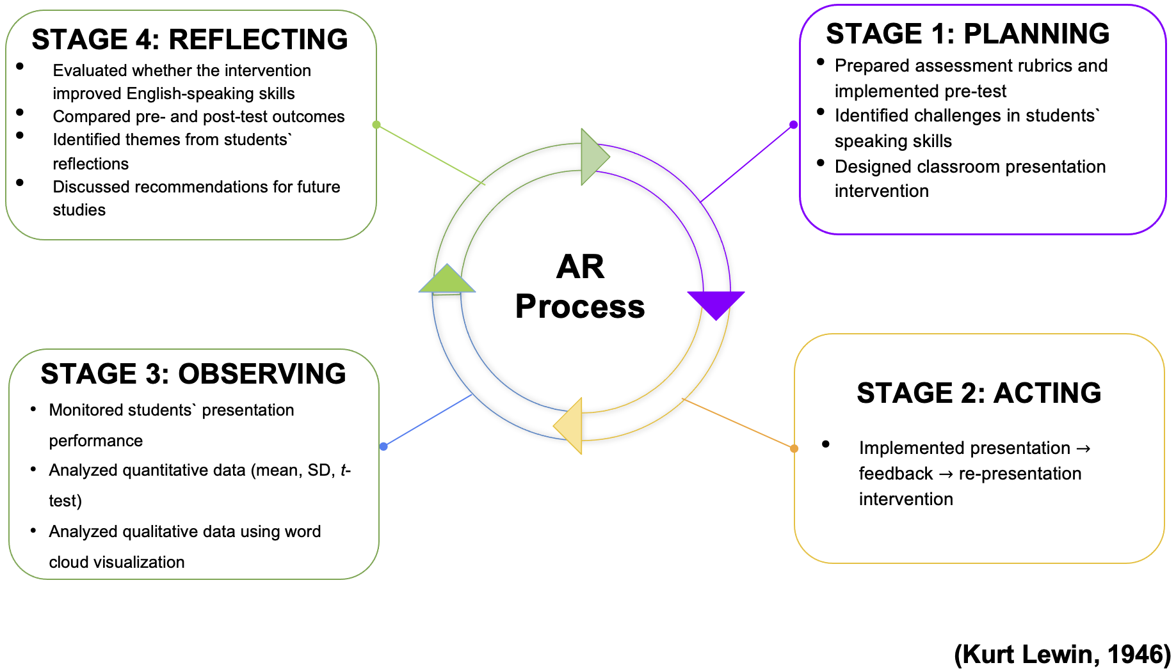

For analysis, quantitative data from the pre- and post-intervention assessments were statistically examined to determine differences in student performances before and after the intervention. Descriptive statistics (mean and standard deviation) provided an overview of changes, while an inferential test (i.e., paired-sample t-test) was used to evaluate whether the observed differences between pre-intervention and post-intervention performance scores were statistically significant. As detailed under result section, prior to conducting the t-test, the necessary assumptions were verified. The normality of the data was checked using the Shapiro-Wilk test. Additionally, potential outliers were checked through boxplot (see Figure 2) to ensure no extreme values distorted the results. The qualitative data obtained from the students’ open-ended reflections were analyzed using word cloud visualization to identify recurring themes and patterns.

4.2 Participants and Sampling
The study took place in an eleventh-grade classroom at a school where the teacher-researcher is currently teaching English. The participants in the study included one section students of two sections at the school. The sample consisted of 26 grade eleven students, including 13 girls and 13 boys, ranging in age from 16 to 18 years. The participants were selected using a convenience sampling technique, which involves choosing a sample that is easily accessible to the researcher. This approach was practical because, as their English language teacher, I had regular and direct access to the students, facilitating the implementation and monitoring of the intervention over time. The selected class represents a typical group of students, with diverse linguistic backgrounds, including Dzongkha, Sharchopkha, Lhotshamkha, Khengkha, and other regional dialects.

4.3. Instrument
4.3.1 Observation Rubric
To assess students’ English-speaking skills, an observation rubric (Appendix 1) was developed. The rubric consisted of nine criteria: fluency, pronunciation, grammar accuracy, use of vocabulary, organization of ideas, message clarity, confidence and poise, audience engagement, and audibility. Each criterion was scored on a scale from 1 (Fair) to 4 (Excellent), giving a maximum possible score of 36 per presentation. This rubric provided a structured and systematic way to assess students’ speaking performance across multiple rounds of classroom presentations.

4.3.2 Reflection Survey
To gain a comprehensive understanding of students’ perceptions of classroom presentations, an open-ended survey (Appendix 2) was developed. The survey was designed to explore students’ perceptions of the effectiveness of presentations in enhancing their English-speaking skills at the end of the classroom presentation interventions.

- Intervention
The intervention of this study was guided by Kurt Lewin’s (1946) model, which follows the cyclical process of planning, acting, observing, and reflecting. The intervention was carried out for 6 weeks, integrated into the regular English classes.

Planning Phase: Baseline Data Collection
The study began by identifying existing challenges in students’ speaking skills. Initially, students were asked to deliver baseline presentations on selected English topics in small groups, before any intervention was implemented. Their presentations were assessed using rubrics highlighted in the instrument section. The results of the baseline presentations are shown in Table 1. This baseline assessment served two purposes: (1) to establish students’ initial proficiency in English speaking, and (2) to identify specific areas for growth and to measure improvement. Before the presentations, the assessment criteria were discussed with the students, and the rubrics were shared to guide their preparations.

Table 1 depicts the baseline assessment of the first presentation done by the students. The assessment result indicates that while students can structure ideas and project their voices effectively, they face significant challenges with fluency, pronunciation, confidence, and audience engagement. The rubric data shows that most students scored between 24 – 30, indicating average to moderately good performance in speaking skills. None of the students achieved very high scores (36), which shows that there is ample room for improvement across all nine criteria. In terms of strengths, almost all students consistently scored 3 (Very Good) for audibility, suggesting that they were able to project their voices clearly and were generally audible to their audience. Similarly, the majority of the students scored 2 (Good) in organization of ideas and message clarity, suggesting that students could present ideas in a sequence and convey their main points with a reasonable degree of clarity, even though other language aspects were weaker.

Table 1 Baseline Assessment Presentation
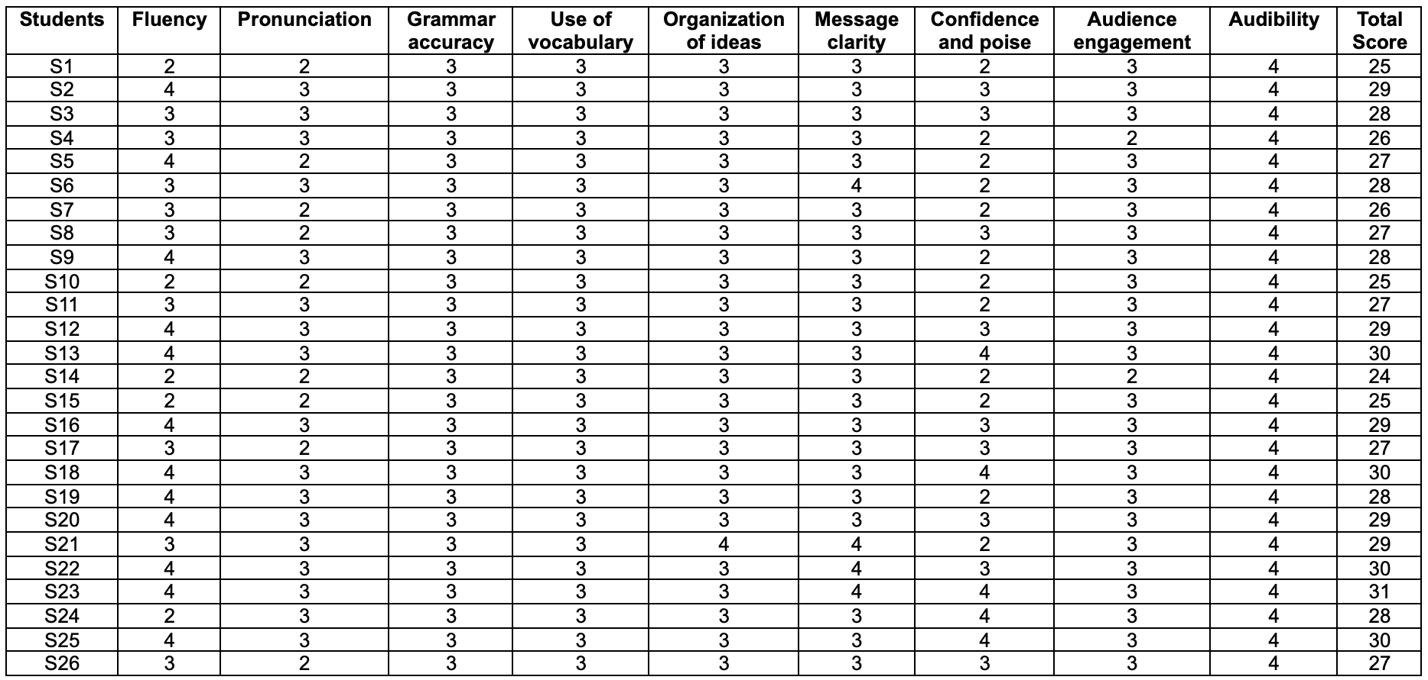

However, the data also highlighted several areas of weakness. Fluency was one of the most common challenges, with a number of students receiving low scores due to frequent pauses and hesitation in speaking. Pronunciation was another problematic area, as many students scored only in the average to good range, indicating that articulation and clarity were inconsistent and at times difficult to understand. Confidence and poise presented a further weakness, with many students demonstrating nervousness, limited eye contact, and restricted use of body language. Additionally, many presented through rote learning that affected effective audience engagement. Audience engagement was also limited, as the majority of students struggled to capture and maintain the attention of their listeners through voice modulation or interactive techniques.

Taken together, the results justify the need for iterative intervention cycles (Presentation-Feedback-Re-presentation cycles) to help them progressively improve their English-speaking skills. The teacher-researcher provided verbal feedback to each student during the first presentation, as shown below in Table 2. The feedback ensured that each student had a clear focus for improvement in their speaking practice. Following this, students were then tasked with preparing a second round of presentation, explicitly integrating the feedback they had received. This process constituted the planning phase of the AR cycle, laying the foundation for the subsequent Acting, Observing, and Reflecting Phases.

Table 2 summarizes feedback provided to students during the first presentations, highlighting areas strength and those needing improvement across nine criteria. Students generally struggled with fluency, pronunciation, grammar, and confidence, often hesitating, mispronouncing words, or relying heavily on notes. Vocabulary usage and organization of ideas were moderate, with some repetition and unclear sequencing. Audience engagement varied, with some presenters reading from slides while others attempted interaction, and audibility was mostly adequate but inconsistent. The feedback provided specific, practical strategies for improvement, such as practicing key points aloud, breaking down difficult words, simplifying sentences, using new vocabulary, structuring presentations clearly, maintaining eye contact, and projecting their voice effectively. Overall, the feedback aimed to help students enhance clarity, confidence, and engagement in future presentations.

Table 2 Feedback on first presentation
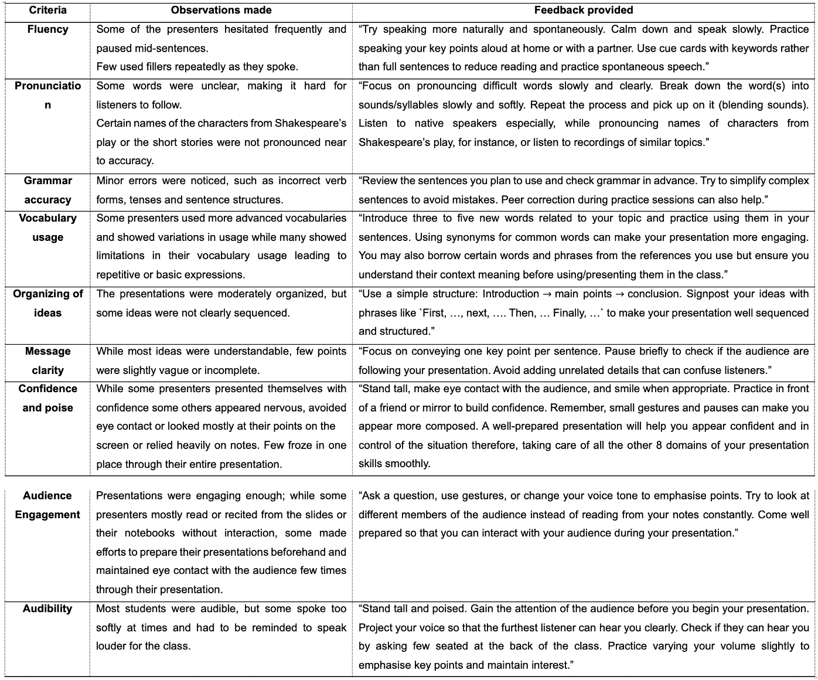
Acting Phase: Intervention and Data Collection
Following the baseline assessment, students engaged in a second round of presentations, explicitly integrating the feedback they had received in their initial presentation. For this round, students were assigned different topics across various genres, covering both language and literature components, such as short stories, drama, letter writing, and report writing. This variety ensured that students practiced speaking in different contexts, prompting both linguistic competence and literary understanding. Simultaneously, at the end of each presentation, students again received immediate verbal feedback from the teacher-researcher, guided by the nine rubric criteria mentioned above. Students have been familiarized with the rubrics by sharing a soft copy of them through the class Telegram page before the start of the interventions.
The feedback highlighted acknowledgement of what the student had done well and provided targeted suggestions for what could be improved in the subsequent presentations. For example:

- Presenters who heavily relied on their notes or the PPT on screen were advised to prepare their portion of the presentation and practice in front of a mirror or a friend. They were informed to use keywords from their notebooks/journals as they speak. They were also recommended to calm themselves by taking a few seconds to breathe before staring.
- For those lacking confidence, similar feedback on preparation and more practice on their presentation had been recommended. Another strategy the teacher-researcher used to help improve their confidence was by acknowledging their improvements through their series of presentations by showing them the comparative study findings from the rating sheets just before they begin presenting or video recording them (after seeking their consent) and showing them the videos to study both their strengths and flaws and also to show them their improvements through comparative study of the series of videos recorded for them to see. This strategy helped a few students boost their confidence as they spoke. Presenter A (a boy) and presenter B (a girl) have shown their areas of improvement in confidence and poise from poor - 2 scores in their pre-tests to excellent – 4 scores in their final intervention.
- Those who lacked fluency were also recommended to take more time to prepare and practice their presentation in front of the mirror or a peer with whom they feel comfortable. Suggestion for use of cue cards have been given as a way to bounce back into speaking when they falter as they speak. Taking small pauses was suggested to improve their fluency and spontaneity as they speak. The teacher-researcher gave them a demonstration to show how this could be done easily and made them practice a few times and then reminded them to use it when needed during presentations when they get nervous.
- For those who faltered in their pronunciation, the errors were pointed out to them after class or during class, depending on their comfort space and then couched by the teacher researcher using sounds and blending methods/ breaking the word into syllables and then blending them as per their learning abilities. They are also suggested to listen to the teacher with care, in the class, when names of characters in a story or play which is not Bhutanese, and also to listen to recommended audio dictionary sources. For instance, names of characters from Shakespeare’s ‘Merchant of Venice’, such as ‘Selario’, ‘Bassanio’, ‘Lancellot’, ‘Gratianio’ ‘Baudelaire’ or places such as ‘Venice’ or ‘Padua’ were hardly pronounced correctly by many. Words like ‘chevalier’, ‘monsieur’, ‘signore’, and other French and Italian terms and names needed proper guidance and resources to have them pronounced correctly. As the teacher-researcher (myself) has some background to the French language with Certificat d’études de Intermédiaire Supérieur at the Institute of Richelieu, Lausanne, Switzerland, I was able to help them with the correct pronunciation of those names and words. Words such as ‘disdain’, ‘lament’, ‘lead casket’, ‘pound’, etc, needed repeated correction from the teacher researcher for many presenters.
- For the few who did couldn’t engage their audience properly as they presented were asked to try seeking interaction with the audience through questions or gauging their attention through eye contact, using gestures and facial expressions, varying the voice tone as they spoke to hold the attention of the audience.

Following the second round of presentations, students engaged in three additional rounds of presentations, with each round following the same structured process of constructive feedback for improvement. Each new round focused on applying feedback from previous presentations on the nine criteria contributing to enhanced speaking skills, allowing students to internalize feedback, practice improvement strategies, and gradually enhance their speaking skills.

In total, four rounds of presentations were conducted after the initial baseline assessment presentation. Table 3 to 6 present the data collected during each round of presentations. These data not only helped teacher-researcher to track students’ growth over time but also to identify persistent weaknesses that required targeted interventions.
To gain a comprehensive understanding of students’ perceptions, an open-ended survey was administered at the end of the fifth round of classroom presentations. The survey focused on exploring how classroom presentations contributed to their learning process, particularly in improving English-speaking skills, difficulties they faced during preparation and delivery, and the types of support, strategies, or resources that could help them prepare more effectively and present with greater confidence. The collected responses were then analysed by conducting word cloud analysis.

Observing Phase: Data Analysis and Interpretation
8. 1 Quantitative Data Analysis and Interpretation.
The longitudinal data from the five rounds of classroom presentations, including the baseline presentation (Table1) and four subsequent rounds of presentations (Table 3-6), provide clear evidence of gradual and measurable improvement in students’ English-speaking skills. It demonstrates the effectiveness of classroom presentations as a pedagogical practice to enhance speaking skills, particularly when combined with structured feedback and iterative opportunities for practice. The structured cycle of presentation, feedback, and re-presentation appears to have been instrumental in enabling students to internalize feedback, practice targeted strategies, and consolidate their oral communication abilities.

Between the first round and the fifth round of presentations, students showed notable improvement across almost all nine assessment criteria. At the baseline stage (Table 1), students generally performed at a “Good” to “Very Good” (scores 2-3) in key areas such as fluency, pronunciation, confidence, and audience engagement, while showing relative strength in audibility and organization of ideas. In the second round (Table 3), the majority of students were rated as “Very Good” (3) in fluency, grammar accuracy, and vocabulary use, while weaknesses persisted in confidence and poise (scores of 2 for many students) and audience engagement (with several students scoring only 2). By the fifth round (Table 6), most students consistently reached “Excellent” (4) levels across fluency, pronunciation, organization of ideas, and confidence. Minor fluctuations in individual performance were observed in a few students, but the overall trajectory was upward.

A clear example of progression is evident in student S1. At the baseline assessment, S1 scored “Good” (2) in fluency, pronunciation, and confidence, while achieving “Very Good” (3) in the other criteria. By the third round of presentations, S1 improved to “Good” in fluency and pronunciation, and “Excellent” (4) in organization of ideas, message clarity, and confidence and poise, showing that feedback on pauses, articulation, and audience engagement had been applied. By the fifth round, S1 achieved “Very Good” in fluency, pronunciation, grammar accuracy, organization of ideas, message clarity, confidence, and audience engagement, and maintained strong audibility. This progression exemplifies how the iterative practice and a constructive feedback loop can produce cumulative improvements across multiple dimensions of speaking skills.

The consolidated results of students’ performance across the five rounds of interventions, including the baseline assessment presentation (i.e., round 1), are shown in Table 7. Analysis of students` scores across the five presentation rounds shows clear progress over time. The mean total score at the baseline was 27.8 (SD = 1.8), with scores ranging from 25 to 31. After the second round, the mean remained the same 27.6 (SD = 1.9), indicating little fluctuation. By the third round, the mean increased to 30.1 (SD = 2.7), showing noticeable improvement after repeated feedback cycles. The fourth round mean slightly decreased to 29.6 (SD = 3.5), while the fifth round demonstrated substantial growth with a mean of 34.6 (SD = 1.1), with scores ranging from 32 to 36. The reduced standard deviation in the fifth round suggests that students’ performance became more consistent, with most students approaching the maximum possible score. On average, students improved by 6.8 points from baseline to the fifth round. This highlights the cumulative effect of iterative presentations combined with structured feedback on enhancing speaking skills.

In terms of fluency and pronunciation, the ratings got stricter as the interventions proceeded. The ratings were not only based on the correct sounds but also on the frequency of errors. Likewise, for fluency, the ratings were based not only on fluency or flow but also on frequency of flaws in their spontaneity and intonation. Therefore, some presenters who scored lower in their final intervention than their previous ratings have a few evidences of their lack of mindful use of language despite their ability to use them correctly.

Table 3 presents the second-round of presentation scores of student participants across the nine assessment criteria. Total scores range from 24 to 31, indicating moderate to high performance overall. Most students consistently scored “Very Good” (3) across criteria, reflecting satisfactory performance, while fluency, confidence, and audience engagement showed slightly more variation. A few students achieved higher scores (30-31), demonstrating strong presentation skills, particularly in confidence and message clarity. Overall, the data suggest that while most students performed steadily across all aspects, targeted improvements in fluency and confidence could further enhance presentation quality.

Table 3 Second round presentation scores
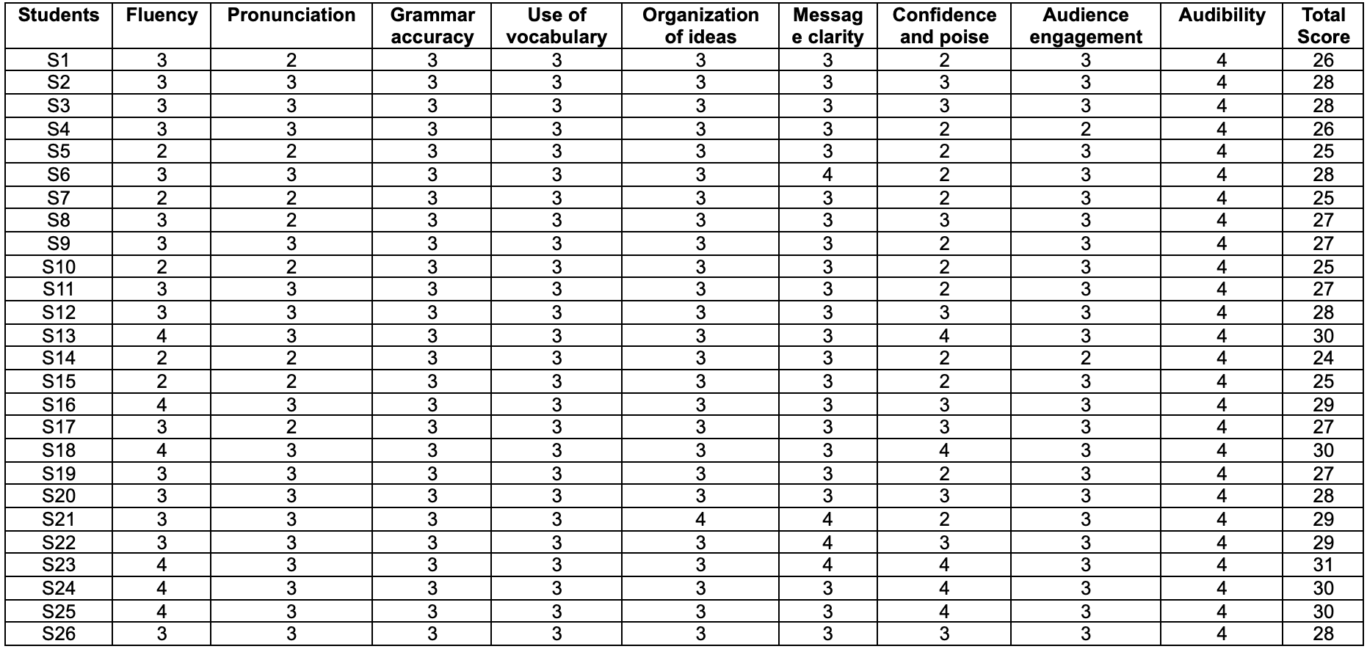

Table 4 shows the third-round presentation scores across nine assessment criteria. Total scores range from 25 to 35, indicating overall improvement compared to the second round. Most students scored consistently high in grammar accuracy, vocabulary use, message clarity, and audibility, while fluency, confidence, and audience engagement still showed some variation. Several students achieved very high scores (33-35), reflecting strong presentation skills, particularly in confidence, message clarity, and organization of ideas. Overall, the data suggest that students` presentation performance improved in the third round, with noticeable gains in organization, clarity, and confidence, though a few students still require support in fluency and confidence.

Table 4 Third round presentation scores
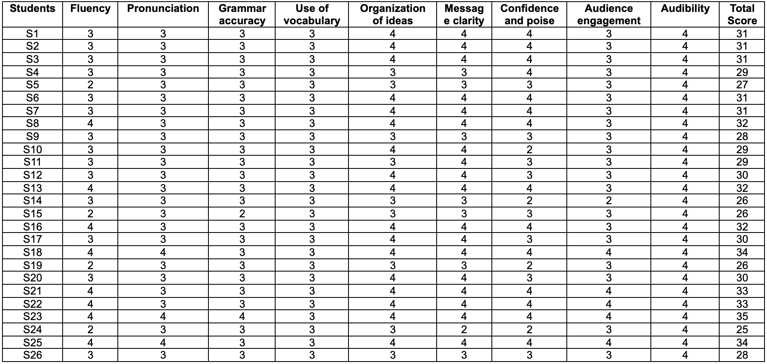
Table 5 presents the fourth-round presentation scores across nine assessment criteria. Total scores range from 24 to 36, indicating continued improvement and a wider spread of performance compared to earlier rounds. Most students consistently scored high in audibility, message clarity, and confidence, while fluency, organization of ideas, and pronunciation showed more variation. Several students achieved very high scores (35-36), demonstrating strong overall presentation skills, particularly in confidence, clarity, vocabulary, and audience engagement. Overall, the data suggest that by the fourth round, students` presentation skills had improved markedly, with noticeable gains in confidence, clarity, and audience engagement, though a few students still need support in fluency and organization.

Table 5 Fourth round presentation scores
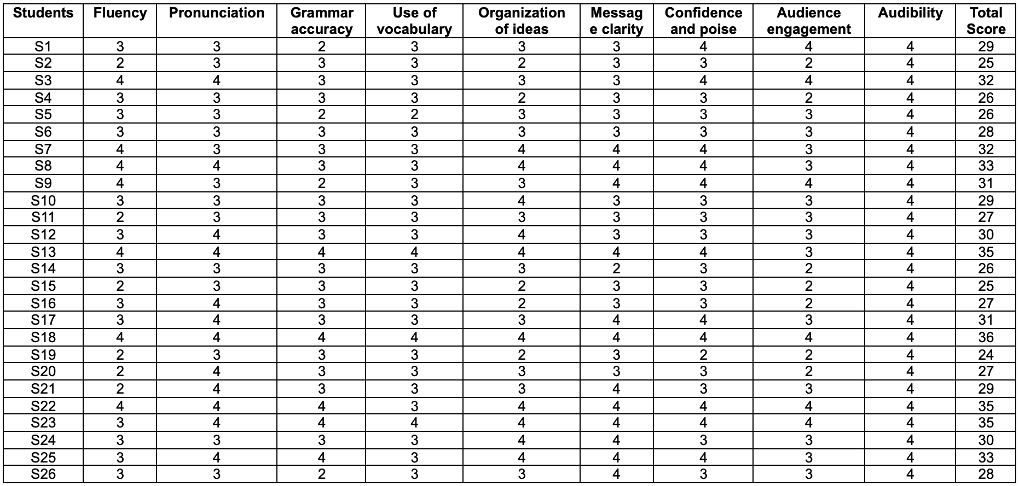

Table 6 presents the last-round presentation scores across nine assessment criteria. Total scores range from 32-36, indicating strong overall performance and marked improvement compared to previous rounds. Most students consistently scored “Excellent” (4) in message clarity, confidence, audibility, and organization of ideas, reflecting high-level presentation skills. Fluency, pronunciation, and vocabulary showed minor variations, but overall consistency improved across all criteria. Several students achieved perfect or near^perfect scores (36), demonstrating mastery in presentation skills. Overall, the data suggest that by the fifth round, students` presentation abilities had substantially improved, with most achieving high competence in clarity, confidence, audience engagement, and organization.

Table 6 Fifth round presentation scores
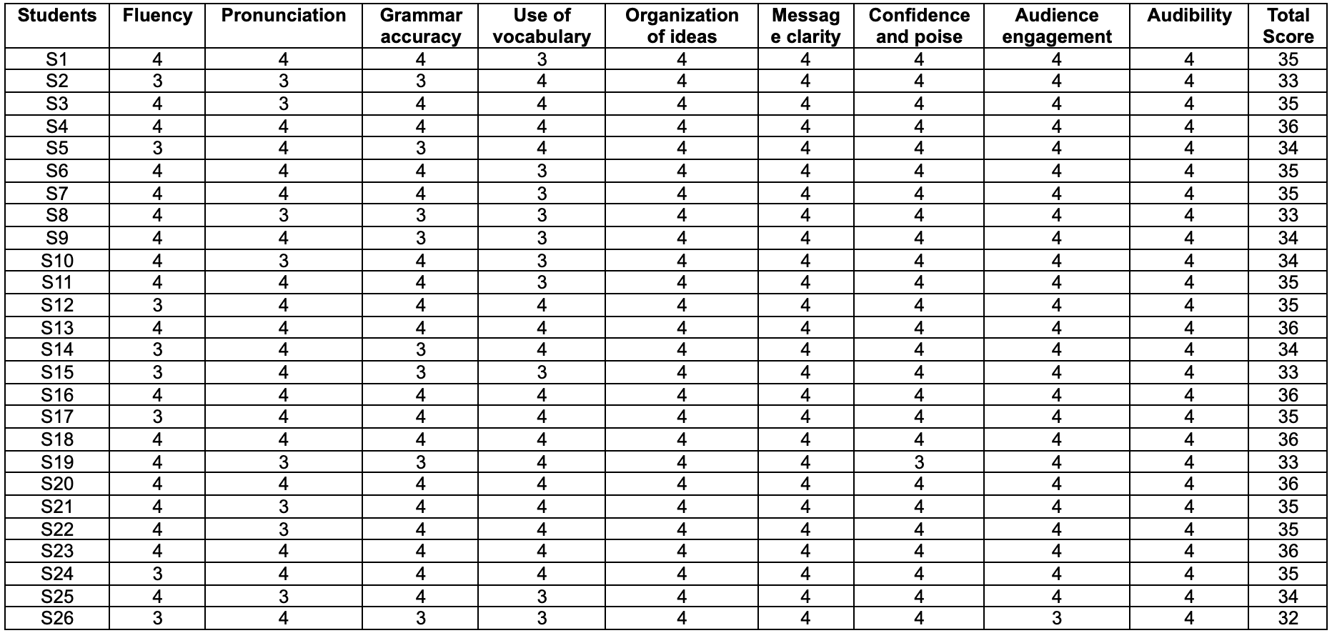

Table 7 shows the mean (M) and standard deviation (SD) of scores across five rounds of presentations. The mean scores gradually increased from Round 1 (M = 27.8, SD = 1.83) to Round 5 (M = 34.6, SD = 1.1) indicating an overall improvement or growth across the rounds. The SD suggest some variability in scores, with Round 4 showing the highest variability (SD = 3.5). The last column presents the mean difference between Round 1 and Round 5, which is 6.8, showing the average change in scores between these two rounds.

Table 7 Consolidated results of students` performance across the five rounds of presentations
.
Round 1 |  | Round 2 |  | Round 3 |  | Round 4 |  | Round 5 |  | Round 1 and Round 5 Mean Difference
M | SD | M | SD | M | SD | M | SD | M | SD | Round 1 and Round 5 Mean Difference
27.8 | 1.83 | 27.6 | 1.9 | 30.1 | 2.7 | 29.6 | 3.5 | 34.6 | 1.1 | 6.8

A paired-samples t-test comparing students’ baseline (Round 1) and fifth-round total scores was conducted to examine whether the improvement was statistically significant. Prior to conducting the t-test, the necessary assumptions were verified. The normality of the difference scores was checked using the Shapiro-Wilk test. Result indicated that the difference scores were normally distributed (W =0.94, p = 0.13), suggesting that the assumption of normality for the paired-sample t-test was met. Additionally, potential outliers were checked through boxplot to ensure no extreme values distorted the results. The boxplot depicted in Figure 2 shows no outliers beyond the whiskers (whiskers extend from 4-10), indicating that the data are fairly uniform and there are no unusually large or small differences.

Figure 2 Boxplot of difference scores
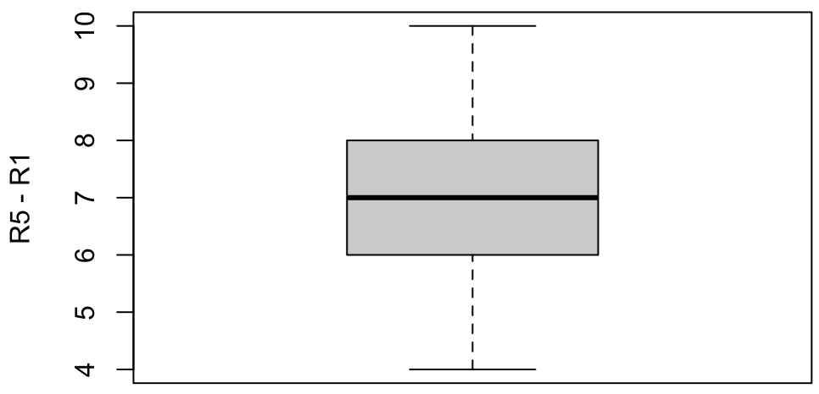
The result of paired-sample t-test between R1 and R5 scores also showed a t(25) = 19.84, p < 0.001, indicating a highly significant increase in speaking performance following the iterative presentation cycles. This confirms that the intervention, consisting of repeated presentations with targeted feedback, had a statistically significant effect on enhancing students’ overall English-speaking skills.

8.2 Qualitative Data Analysis and Interpretation
To gain rich, qualitative insights into students’ perceptions, experiences, and challenges with the classroom observation, an open-ended survey was administered at the end of the of the fifth round of classroom presentations. The survey focused on exploring how classroom presentations contributed to their learning process, particularly in improving English-speaking skills.

When asked how effective classroom presentations are in helping them learn and improve their English-speaking skills through an open-ended survey, students responded overwhelmingly positively. As depicted in the word cloud (Figure 3), frequently recurring bigrams such as speaking skills, presentations are effective, help us, build confidence, practice speaking, and boosts confidence, indicate that students perceived presentations as a valuable platform for practicing and refining their English. The emphasis on confidence, public speaking, improving English speaking, and fluency further shows that presentations not only enhanced their language skills but also helped them overcome fear and hesitation when speaking in front of others. Moreover, students highlighted that classroom presentations provided opportunities to express ideas, deliver effectively, gain fluency, and learn from classmates. This suggests that, beyond language development, presentation fostered peer learning, critical thinking, and audience engagement, thereby contributing to a more holistic improvement in their communication and interpersonal skills.

Figure 3 Students’ views on the effectiveness of classroom presentations in helping English-speaking skills.
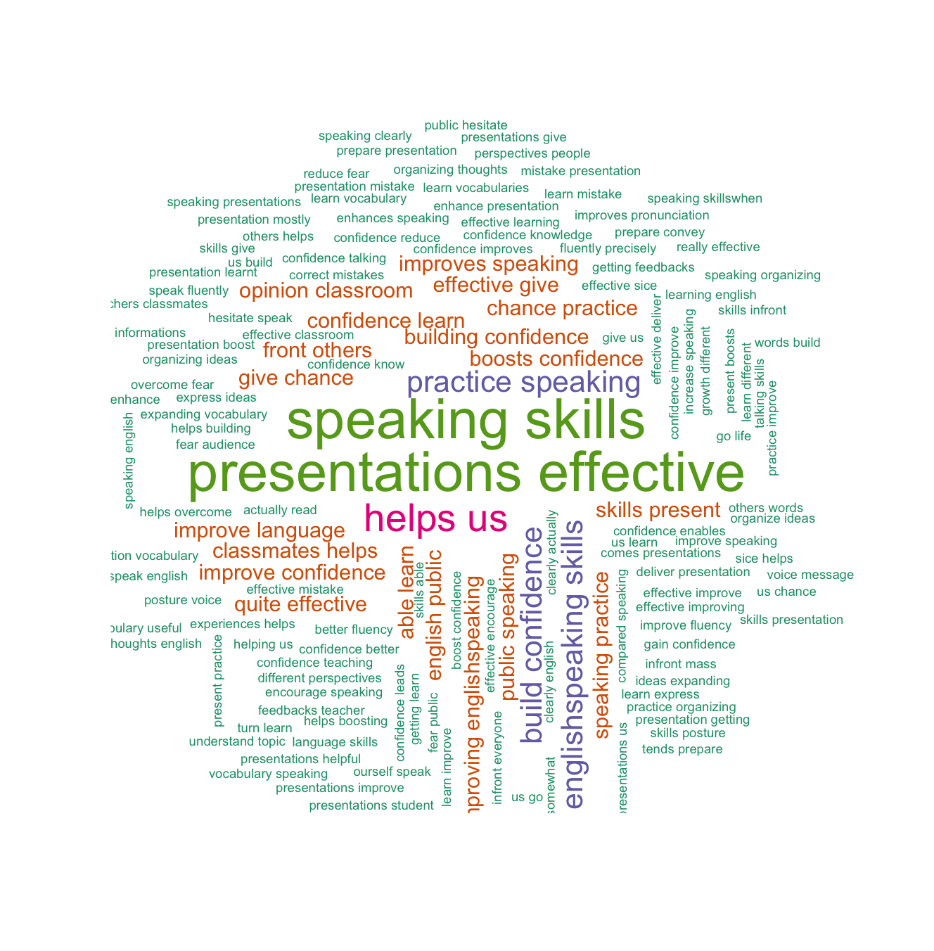
When asked what changes they had noticed in their speaking ability since beginning classroom presentations, students responded with a range of positive improvements (Figure 4). The most prominent changes centre around fluency, confidence, and improved vocabulary. The regular practice of presenting has helped them speak more clearly, and fluently, with less hesitation, moving away from feeling shy or nervous talking to becoming confident presenters. Moreover, many students feel they have improved vocabulary, are able to organise sentences and express ideas better, and are actively noticing and correcting both grammar mistakes and pronunciation errors, ultimately leading to a more comfortable and polished speaking ability.

Figure 4 Students’ views on changes in their speaking skills.

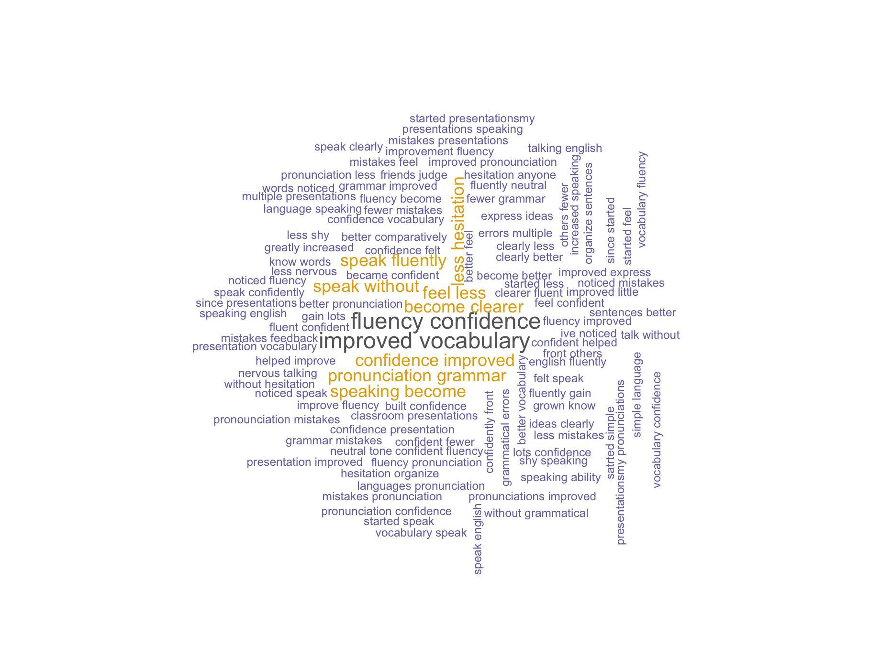
When asked in what ways classroom presentations differ from other speaking activities in helping them learn English-speaking, students responded with several insightful perspectives. From the word cloud (Figure 5), it is clear that classroom presentation was perceived as structured and purposeful activities compared to other speaking practices. Prominent phrases such as classroom presentations, different speaking activities, and organizing ideas, show that students considered presentations to provide a distinct platform where they could systematically prepare, express, and refine their thoughts in English.

Students emphasised that presentations help them organize ideas, practice public speaking, and build confidence in front of a crowd, skills that are not often emphasised in informal speaking activities. Words like boost confidence, confidence crowd, and helps us learn, suggest that the act of presenting to peers and teachers simulates real-life communication scenarios, encouraging them to overcome hesitation and nervousness while improving fluency. In addition, phrases such as grammar, pronunciation practice, and researching skills, indicate that students valued the academic rigor of presentations, which required preparation, accuracy, and clarity in communication.

Figure 5 Students’ views on how classroom presentations differ from other speaking activities.

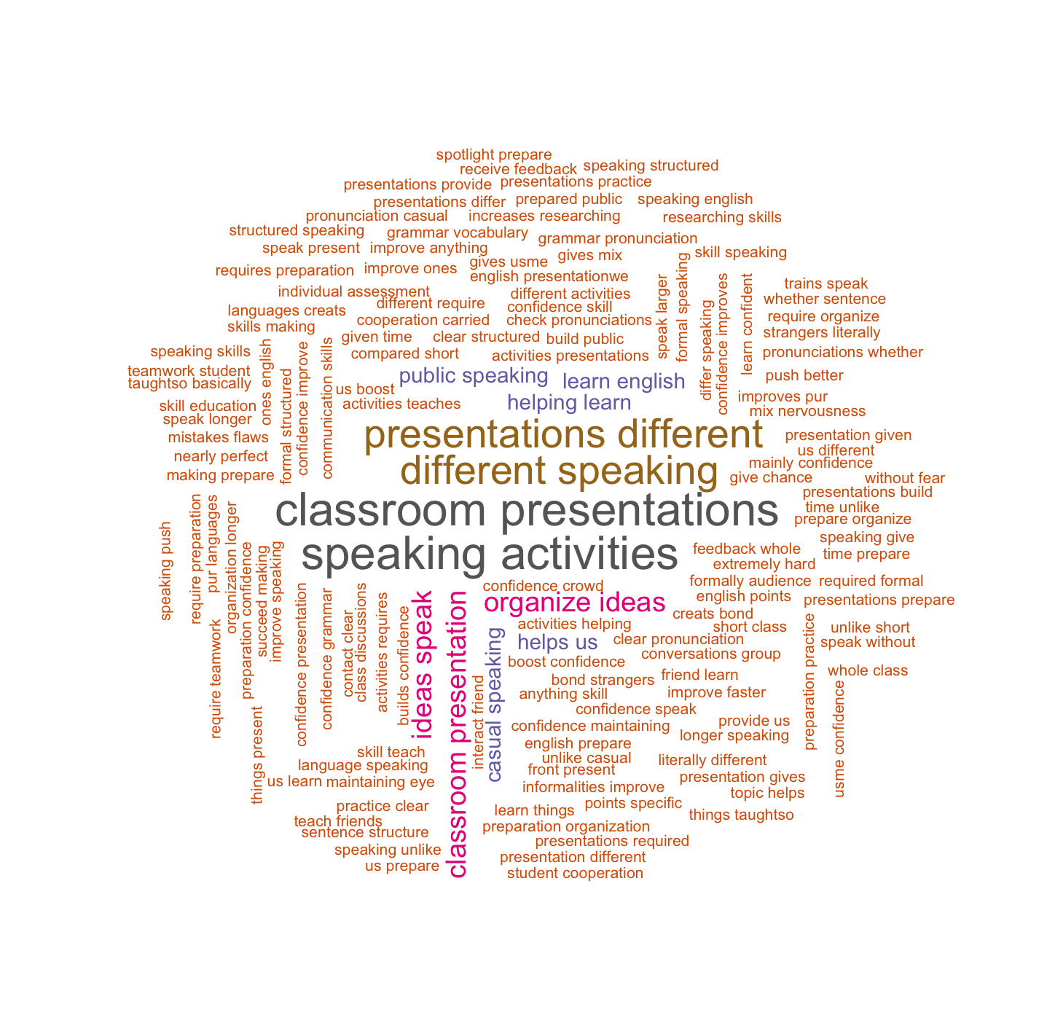
When asked whether the feedback provided by the teacher after each presentation helped them define, address, or improve their challenges, students responded with a range of reflections that highlighted the importance of teacher feedback in their learning journey. The most frequent phrases from the word cloud (Figure 6), such as next presentation, feedback helps, and helped improve, suggest that students found feedback to be directly useful for preparing and performing better in their following presentations. Key areas highlighted include pronunciation, grammar, and sentence structure, which indicates that students recognised feedback as essential for correcting specific language-related mistakes. Phrases such as identify mistakes, clearly shows, and mistakes made reflect that teacher feedback helped them notice errors they might have overlooked. Additionally, students associated feedback with building confidence, overcoming challenges, and overcoming issues such as low confidence, fluency, and word choice. This shows that they saw feedback as not just correcting errors but also supporting personal growth and communication skills.

Overall, the word cloud interpretation indicates that students considered teacher feedback highly effective, as it guided them to improve their weaknesses and motivated them to perform better in the next presentation.
Figure 6 Students’ views on the effectiveness of feedback provided after each classroom presentation.

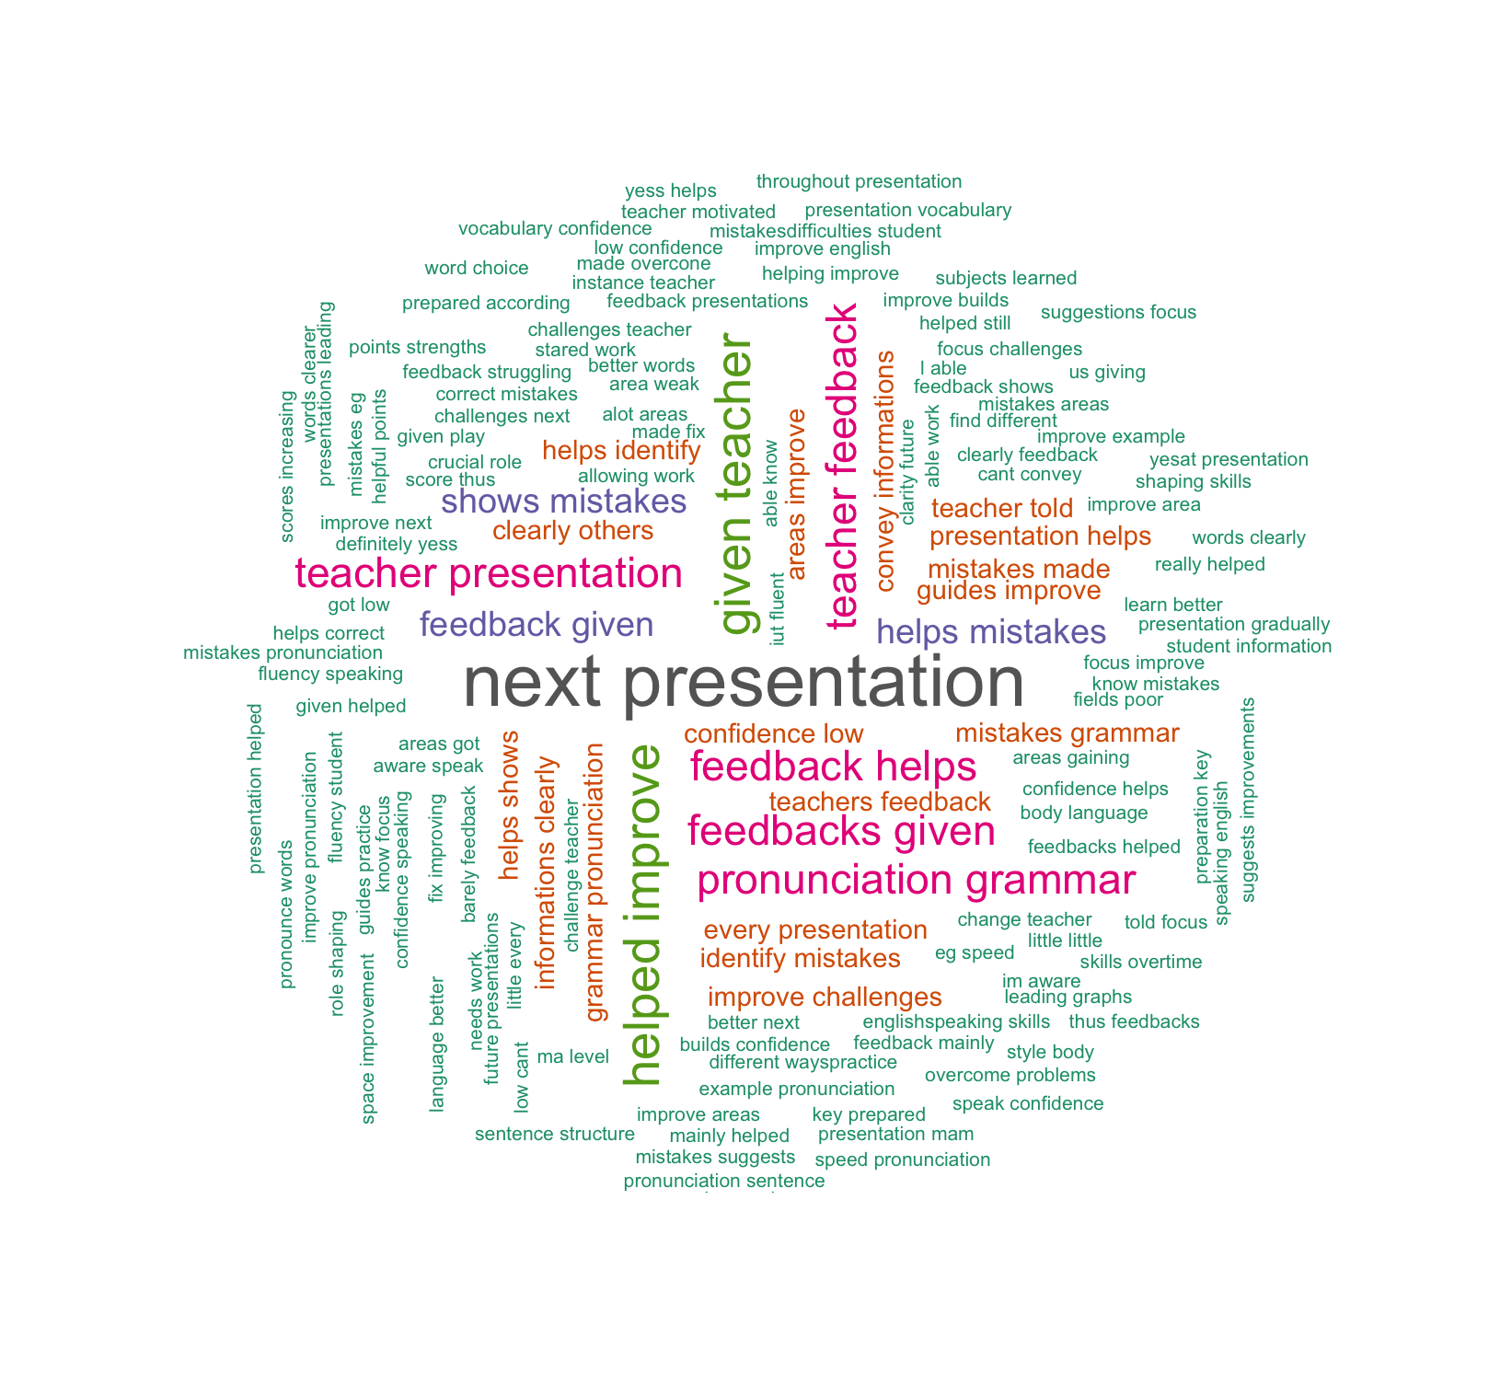
Reflecting Phase: Discussion of the findings
The findings of this study provide compelling evidence that classroom presentations, when implemented through an iterative cycle of practice, structured feedback, and re-presentation, significantly enhance students’ English-speaking skills. The longitudinal data from the five rounds of classroom presentations, including the baseline and four subsequent intervention rounds, provide strong evidence of students’ progressive improvement in their English-speaking skills. The progress of improvements in students’ presentations was, in most cases, slow but never absent. The structured cycle of presentation, feedback, and re-presentation appears to have been instrumental in enabling students to internalize feedback, practice targeted strategies, and consolidate their oral communication abilities. Between the second and the fifth round of presentations, students showed notable improvement across almost all nine assessment criteria.

In the second round, the majority of the students were rated as “Good” in fluency, grammar accuracy, and vocabulary use, while weakness persisted in confidence and poise and audience engagement. By the fifth round, most students consistently reached “Excellent” levels across fluency, pronunciation, organization, and confidence. Beyond test scores, student perceptions through the open-ended survey add a qualitative depth to our interpretation. Students, overwhelmingly, viewed classroom presentations as effective, emphasizing gains in confidence, fluency, vocabulary, and ability to organize and express ideas. Many described overcoming fear and hesitation, and noticed they were more mindful of grammar and pronunciation in real time.

In the literature on public speaking pedagogy, feedback is widely regarded as important. For instance, Chollet et al.’s (2015) study has shown that immediate non-verbal or visual feedback sharpen awareness of delivery issues and accelerate improvement. Additionally, meta-analyses and reviews have concluded that well-targeted corrective feedback, particularly immediate and actionable guidance, produces moderate-to-large improvements in skill acquisition and performance (Wisniewski et al., 2020). Heideman and Laury`s (2021) ultra-short presentation approach also supports the notion that quick, repeated speaking tasks with focused feedback can incrementally improve public speaking skills.

In the present study, the iterative cycle of presentation, feedback, and re-presentation allowed students to internalize corrections and refine their skills progressively. The responses from the students to the open-ended reflection survey indicate that the repeated practice and constructive feedback loop had a cumulative impact on both linguistic and paralinguistic aspects of presentation. Linguistically, phrases such as improved vocabulary, grammar mistakes, correct mistakes, learn mistakes, learning vocabulary, organizing thoughts, and express ideas, indicate that students progressively refined their language accuracy, lexical resources, sentence construction, and clarity of ideas through iterative practice and feedback. Beyond linguistic gains, phrases like gain confidence, better fluency, effective delivery, less hesitation, less shy, less nervous talking, posture voice, confidence improve, overcome fear, and fear audience reflect improvements in students’ voice modulation, delivery style, body language, and overall confidence, which allowed them to present more comfortably and engage their audience more effectively in later presentations.

This study supports the prior empirical work showing that presentation-based activities reliably support English speaking-skill development (Al-khresheh, 2024). Al-khresheh’s study, conducted with Saudi English learners using a quasi-experimental design, found that students who engaged in presentation-driven tasks demonstrated significant improvements in multiple dimensions of speaking ability. Specifically, participants showed enhanced fluency and coherence, enriched lexical resources, heightened grammatical range with greater accuracy, clearer pronunciation, and more compelling content delivery. Beyond linguistic gains, students also displayed enhanced engagement and interaction skills, alongside increased self-confidence, an essential factor in effective language learning. Such evidence underscores the pedagogical value of incorporating interactive, presentation-based tasks in EFL classrooms to foster both linguistic proficiency and communicative competence (Al-khresheh, 2024).

10. Conclusion
In conclusion, the findings of this study underscore the importance of integrating classroom presentation and feedback mechanisms into EFL curricula to support comprehensive language development. Although the students` progress was observed to be gradual and uneven, the overall improvement in their English-speaking skills within the teacher-researcher’s school context underscore the transformative potential of such practices. These results serve as a strong call to reimagine and innovate existing educational methodologies. It is therefore recommended that teachers across all levels incorporate classroom presentation as a regular component of assignments and assessments. Such practices not only enhance linguistic accuracy but also contribute significantly to the development of fluency, confidence, and communicative competence in learners (Al-khresheh, 2024). Furthermore, the establishment of standardized English-speaking assessments within the Bhutanese education system is strongly recommended, as this would provide students with opportunities to strengthen their speaking competence. Additionally, teacher-training programs could emphasize strategies for facilitating effective student presentations and providing constructive-feedback, equipping educators with the skills to foster fluency, confidence, and communicative competence.

11. Limitations of the Study
As an action research study, the findings provide robust insights into the local classroom context; however, caution is needed when generalizing beyond this setting. While the results are meaningful for understanding how classroom presentations influence oral skills in this particular group (N = 26) of students, larger-scale quasi-experimental studies or multi-site investigations would be necessary to test the external validity of these findings. Additionally, the nine-week duration of this study allowed the teacher-researcher to collect clear short-term longitudinal evidence of improvement across linguistic and paralinguistic aspects of students` oral skills. Nonetheless, a longer follow-up period would be valuable in determining whether these gains, particularly in areas such as grammar and vocabulary, are retained and continue to develop over time. Second language acquisition research suggests that structural and lexical features often require extended and distributed practice to consolidate fully (He & Suzuki, 2023).

Ethical Approval and Consent:
At the outset, permission to conduct the study was sought from the school principal. Verbal and written consent was also obtained from the student participants to ensure ethical compliance.

Disclaimer (Artificial intelligence)
Option 1:
Author(s) hereby declare that NO generative AI technologies such as Large Language Models (ChatGPT, COPILOT, etc.) and text-to-image generators have been used during the writing or editing of this manuscript.
Option 2:
Author(s) hereby declare that generative AI technologies such as Large Language Models, etc. have been used during the writing or editing of manuscripts. This explanation will include the name, version, model, and source of the generative AI technology and as well as all input prompts provided to the generative AI technology
Details of the AI usage are given below:
1.
2.
3.

References
Al-Khresheh, M. H. (2024). The role of presentation-based activities in enhancing speaking proficiency among Saudi EFL students: A quasi-experimental study. Acta Psychologica, 243, 104159. https://doi.org/10.1016/j.actpsy.2024.104159
Capili, B., & Anastasi, J. K. (2024). An introduction to types of Quasi-Experimental Designs. AJN American Journal of Nursing, 124(11), 50–52. https://doi.org/10.1097/01.naj.0001081740.74815.20
Carter, N., Bryant-Lukosius, D., DiCenso, A., Blythe, J., & Neville, A. J. (2014). The use of triangulation in qualitative research. Oncology Nursing Forum, 41(5), 545–547. https://doi.org/10.1188/14.onf.545-547
Centre for Educational Research and Development. (2002). The silken knot. Department of Education, Thimphu, Bhutan. https://www.pce.edu.bt/wp-content/uploads/2019/07/The-Silken-Knot.pdf
Choeda, C., Gyeltshen, T., Daker, S., Gyeltshen, S., Wangmo, W., & Letho, D. (2020). Communicative competence of secondary school students of Bhutan. Journal of Humanities and Education Development, 2(1), 12–25. https://doi.org/10.22161/jhed.2.1.3
Chollet, M., Wörtwein, T., Morency, L. P., Shapiro, A., & Scherer, S. (2015, September). Exploring feedback strategies to improve public speaking: an interactive virtual audience framework. In Proceedings of the 2015 ACM international joint conference on pervasive and ubiquitous computing (pp. 1143-1154).
Darasawang, P., & Reinders, H. (Eds.). (2016). Innovation in language learning and teaching: The case of Thailand. Springer.
El-Dakhs, D., & Mitchell, A. (2011). Spelling errors among EFL high school graduates. In the 4th Annual KSAALT Conference, a paper presented in Al Khobar, Prince Mohammed Bin Fahad University.
He, J., & Suzuki, Y. (2023). Distribution of grammar learning through writing tasks: A potential role of proficiency. International Journal of Applied Linguistics, 34(1), 367–382. https://doi.org/10.1111/ijal.12498
Heideman, P. D., & Laury, J. E. (2021). Ultra-Short Presentations with Immediate in-Class Public Feedback to Enhance Skill Development with Low Class Time and Instructor Time. College Teaching, 70(2), 196–205. https://doi.org/10.1080/87567555.2021.1913395
Howard, J., Tolosa, C., Biebricher, C., & East, M. (2019). Shifting conceptualisations of foreign language teaching in New Zealand: students’ _journeys towards developing intercultural capability. Language and Intercultural Communication, 19(6), 555–569. https://doi.org/10.1080/14708477.2019.1601201

Nguyen, T. H. (2019). Oral presentation strategy for enhancing English speaking proficiency to non-English major. Scientific Journal of Tra Vinh University, 1(2), 40–48. https://doi.org/10.35382/18594816.1.2.2019.154
Om, G. (2018). The use of group investigation technique to enhance the English speaking skills of grade six Bhutanese students (Doctoral dissertation, Rangsit University).
Puspitasari, E. (2016). Classroom activities in content and language integrated learning. Journal of Foreign Language Teaching and Learning, 1(2), 1–13. https://doi.org/ 10.18196/ftl.129
Salainti, E., & Wijayanti, L. M. (2024). Enhancing English Speaking Skills through PowerPoint Presentation Techniques: A Study of EFL Learners. AL-MIKRAJ Jurnal Studi Islam Dan Humaniora (E-ISSN 2745-4584), 5(01), 772–786. https://doi.org/10.37680/almikraj.v5i01.6167
Sherab, K. (2013). Gross National Happiness education in Bhutanese schools: Understanding the experiences and efficacy beliefs of principals and teachers. A thesis submitted in fulfilment of the requirements for the degree of Doctor of Philosophy, University of New England, Armidale, Australia.
Sirisrimangkorn, L. (2021). Improving EFL Undergraduate learners’ speaking skills through Project-Based Learning using Presentation. Advances in Language and Literary Studies, 12(3), 65. https://doi.org/10.7575/aiac.alls.v.12n.3.p.65
Stratton, S. J. (2019). Quasi-experimental design (pre-test and post-test studies) in prehospital and disaster research. Prehospital and Disaster Medicine, 34(6), 573–574. https://doi.org/10.1017/s1049023x19005053

Tshering, K. (2020). The status and role of English as a language of administration in Bhutan. Journal of World Englishes and Educational Practices, 2(4), 31–43. https://doi.org/10.32996/jweep.2020.2.4.4
Tshomo, T., & Sherub, K. (2017). Bhutanese teachers’ and students’ perceptions on using literary texts as English as a Second Language. Rabsel - The CERD Educational Journal, 18(1), 26-42.
Wei, X. (2025). The Effectiveness of Flipped Classroom in improving English Communication skills: A focus on listening and speaking. Advances in Social Behavior Research, 14(1), 84–88. https://doi.org/10.54254/2753-7102/2025.20434
Willis, D., & Willis, J. (2007). Doing task-based teaching. Oxford: Oxford University Press.
Wisniewski, B., Zierer, K., & Hattie, J. (2020). The Power of Feedback Revisited: A Meta-Analysis of Educational Feedback Research. Frontiers in Psychology, 10. https://doi.org/10.3389/fpsyg.2019.03087
Zannrni, I. M. (2022). The Role of Students’ Classroom Presentations in Developing their Speaking Skills. Cihan University-Erbil Journal of Humanities and Social Sciences, 6(1), 87–91. https://doi.org/10.24086/cuejhss.v6n1y2022.pp87-91

Appendix 1

Rubric for Evaluating Students' Speaking Skills through Classroom Presentations

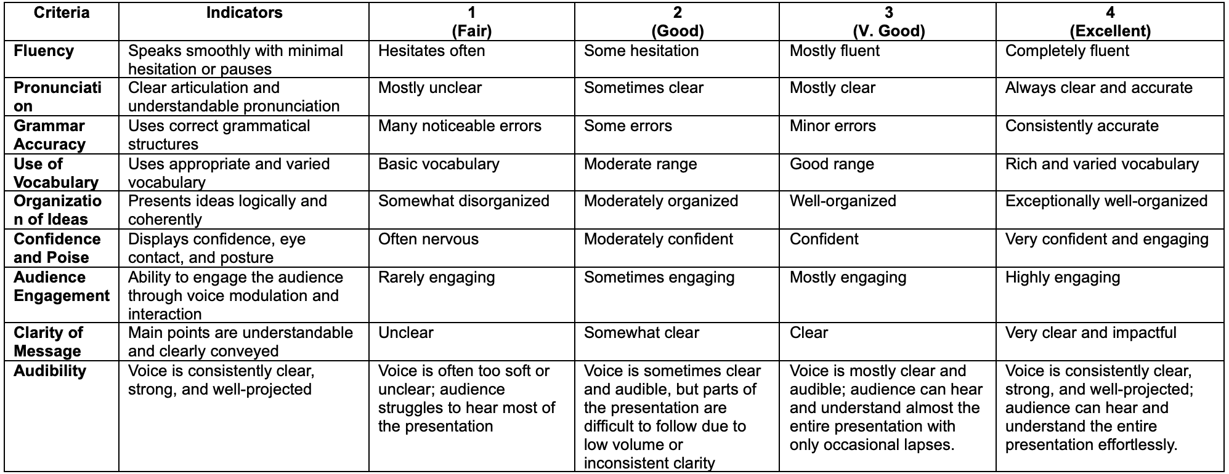

Appendix 2

Open-Ended Survey Questionnaire: Perception of Classroom Presentations as a Learning Method
- In your opinion, how effective are classroom presentations in helping you learn and improve your English-speaking skills? Please explain.
- What changes (if any) have you noticed in your speaking ability since you started doing presentations in class?
- In what ways do you think classroom presentations are different from other speaking activities in helping you learn English?
- Did the feedback given by the teacher after each presentation help you define and address or improve your challenges? Briefly narrate/How

