Harnessing Artificial Intelligence for Microplastic Pollution Control in Lakes: Detection, Prediction and Removal

ABSTRACT

Microplastic (MP) contamination in freshwater systems has become a pressing global concern. Lakes, as relatively closed aquatic environments, act as long-term sinks for microplastics and serve as critical indicators of human-induced environmental change. Traditional monitoring and removal methods are limited by labor intensity, cost, and the inability to provide real-time data. Recent advancements in artificial intelligence (AI) are revolutionizing how microplastic pollution in lakes is detected, modeled, and mitigated. AI enables automated identification, classification, and prediction of microplastic behavior using tools such as computer vision, remote sensing, and machine learning algorithms. This review synthesizes current research on AI’s role in addressing lake-based microplastic pollution, including detection and characterization methods, predictive modeling of microplastic fate and transport, and AI-assisted removal systems. It also identifies challenges, such as data scarcity, model generalization, and hardware efficiency, and outlines future directions for integrating AI-driven solutions into environmental monitoring frameworks. The findings highlight AI’s transformative potential for achieving sustainable microplastic management in freshwater ecosystems.

Keywords: Microplastics; Artificial Intelligence; Machine Learning; Computer Vision; Lakes; Environmental Monitoring; Waste Interception; Microplastic Pollution Control

1. INTRODUCTION

Microplastic pollution has emerged as one of the most pervasive environmental threats of the 21st century. Defined as plastic fragments smaller than 5 mm, microplastics (MPs) originate from both primary sources, such as microbeads in cosmetics, and secondary sources, such as the degradation of larger plastic waste (Andrady, 2017; Yang et al., 2025). Lakes, due to their relatively enclosed nature, often accumulate microplastics at concentrations higher than those found in rivers or oceans (Jin et al., 2024). This accumulation poses ecological risks to aquatic organisms and can lead to the bioaccumulation of synthetic particles in food webs, ultimately affecting human health (Yang et al., 2025).

Traditional monitoring of microplastics involves manual sampling, filtration, and microscopic identification—a time-consuming and labor-intensive process that limits spatial and temporal coverage. Furthermore, physical and chemical removal strategies, such as filtration and coagulation, often lack scalability and can introduce secondary pollution. The need for efficient, accurate, and automated solutions has led to a growing interest in artificial intelligence (AI) technologies (Guo et al., 2022; Yang et al., 2025).

AI, encompassing machine learning (ML), deep learning (DL), and computer vision, is revolutionizing environmental science by enhancing data acquisition, analysis, and decision-making processes (Rolnick et al., 2022). In the context of microplastic pollution, AI enables the automatic detection and classification of particles, predicts their transport dynamics, and optimizes remediation systems. These capabilities address key limitations of conventional methods by offering real-time, high-resolution, and large-scale monitoring potential. For instance, AI-assisted digital imaging and drone-based detection systems are being developed to identify plastics on lake surfaces and within the water column, reducing reliance on laboratory-based analysis (Wang et al., 2024).

In this review, we examine how AI applications are reshaping microplastic pollution control in lakes. We first discuss the sources, distribution, and ecological effects of microplastics in lacustrine systems. Next, we explore AI’s growing role in detection, monitoring, and predictive modeling. We then evaluate its applications in active removal and remediation efforts, before concluding with an assessment of current challenges and future research directions. This literature-based synthesis aims to provide an integrated understanding of how AI can support freshwater sustainability and enhance global pollution control efforts.

2. MICROPLASTIC POLLUTION IN LAKES: AN OVERVIEW

Microplastic pollution has emerged as a pervasive and complex environmental issue in freshwater ecosystems worldwide. Numerous reviews emphasize that microplastic pollution is now recognized as a globally pervasive and multidimensional environmental threat across freshwater ecosystems, driven by diverse sources, long-term persistence, and complex interactions with biological and physicochemical processes (Horton et al., 2017; da Costa et al., 2016). Lakes, which serve as critical reservoirs for drinking water, recreation, and biodiversity, are increasingly recognized as major sinks for microplastics originating from diverse anthropogenic activities. Due to their semi-enclosed hydrological nature, lakes tend to accumulate and retain plastic particles for extended periods, allowing for interactions with sediments, aquatic organisms, and pollutants. The dynamics of microplastic input, transport, and fate within lake systems are influenced by both environmental and human factors, including land use, hydrology, and waste management practices. Understanding the sources, distribution patterns, and ecological implications of microplastics in lakes is therefore essential for developing data-driven monitoring and remediation strategies. This section reviews current knowledge on the pathways through which microplastics enter lake environments, their spatial distribution characteristics, and the key environmental processes governing their persistence and movement.

2.1 Sources and Distribution

Microplastics enter lakes through multiple pathways, including wastewater effluents, surface runoff, atmospheric deposition, and direct littering (Yang et al., 2025) (Fig. 1). Urban areas contribute heavily via stormwater systems, while rural catchments introduce microplastics through agricultural runoff containing synthetic fibers and plastic mulch residues (Horton et al., 2017). Atmospheric fallout also plays a significant role—recent studies have detected microplastic particles even in remote mountain lakes, underscoring the global reach of airborne transport (Allen et al., 2019).

Globally, plastic production exceeded 400 million tonnes in 2022, and an estimated 3.1–3.4 million tonnes of microplastics enter aquatic environments annually through wastewater, tire wear, textiles, industrial pellets, and surface runoff (UNEP, 2023). Major hotspots include regions with dense urbanization, intensive industrial activity, and high wastewater discharge, such as East Asia, North America, and parts of Western Europe. International assessments further highlight that freshwater lakes located downstream of densely populated catchments—such as the Great Lakes, Lake Victoria, and lakes in eastern China—exhibit disproportionately high microplastic loads due to hydrological connectivity and limited flushing capacity (Chen et al., 2024).

Once microplastics enter a lake, hydrodynamic processes and particle properties determine their spatial distribution. Density differences among polymers influence whether particles remain suspended or settle into sediments. Biofilm formation can further alter buoyancy and degradation rates, complicating modeling efforts (Kooi et al., 2017). Sediments often serve as long-term sinks for microplastics, while resuspension events caused by wind or bioturbation can redistribute particles throughout the water column (Mi et al., 2008). Notably, the highest microplastic concentrations are often found near shorelines and inflow points. For example, Lake Geneva in Switzerland and Lake Taihu in China both exhibit dense accumulations of plastic debris near urban and industrial regions (Yang et al., 2020; Jian et al., 2020; Liu et al., 2022). These localized hotspots indicate the influence of anthropogenic activities and hydrological connectivity on pollution distribution. Recent global assessments reveal that lake microplastic concentrations are strongly associated with regional development levels, watershed land use intensity, and hydrological connectivity, with higher loads occurring in densely populated regions (Chen et al., 2024). Similar patterns have been reported across Chinese lake ecosystems, where urbanization and industrial discharge are the primary drivers of microplastic accumulation (Cai et al., 2022).

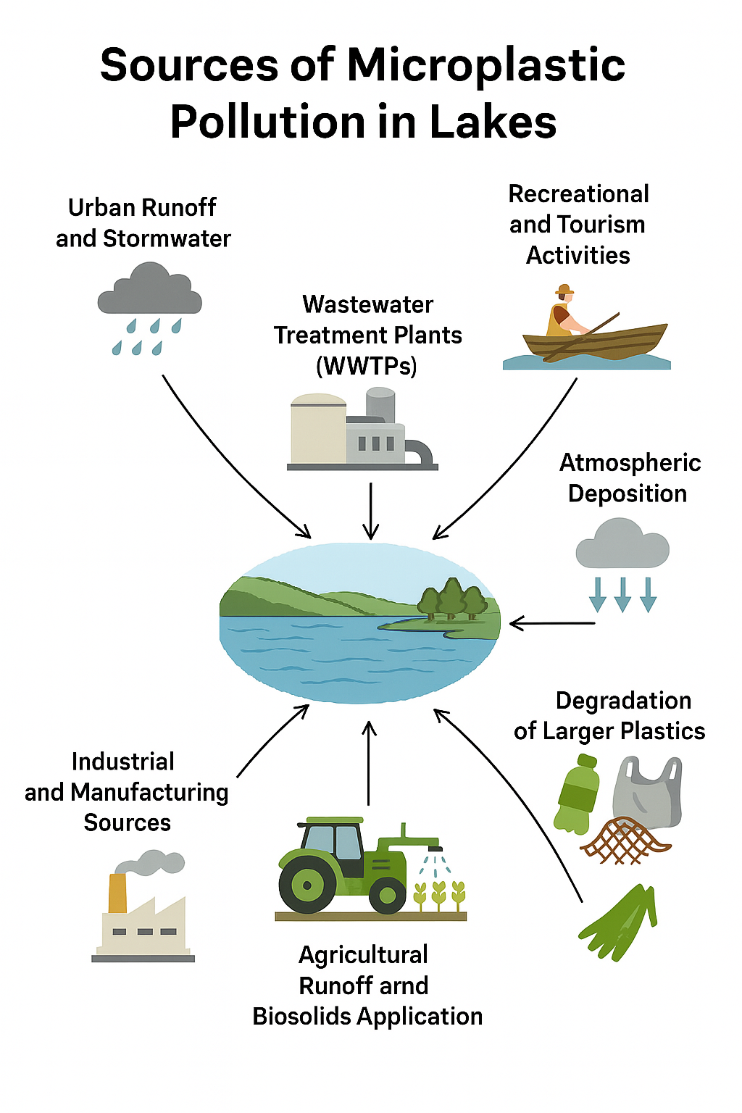

Fig. 1. Sources of Microplastic Pollution in Lakes (Yang et al., 2025)

2.2 Ecological and Human Health Impacts

Microplastics pose significant ecological risks to freshwater ecosystems. Zooplankton, fish, and benthic organisms can ingest plastic particles, leading to reduced feeding efficiency, impaired growth, and physiological stress (Wright et al., 2013; Yang et al., 2025). MPs also act as vectors for hydrophobic pollutants and pathogenic microorganisms, concentrating toxic compounds on their surfaces and facilitating their transfer through food webs (Rochman et al., 2019). Field investigations across the Great Lakes, including Lake Ontario, have confirmed the presence of microplastics in the gastrointestinal tracts of multiple fish species, indicating widespread exposure in aquatic food webs (Munno et al., 2022).

From a human health perspective, microplastics in drinking water sources raise growing concerns. Although the toxicological effects of microplastic ingestion are still under investigation, there is evidence suggesting inflammatory responses and potential cellular damage (Cai et al., 2025). As lakes serve as both ecological habitats and water supply reservoirs, understanding and mitigating microplastic contamination is essential for ecosystem and public health protection.

2.3 Monitoring Challenges

Monitoring microplastic pollution in lakes faces several methodological challenges. Manual sampling provides limited spatial coverage and may not capture temporal variability. Analytical techniques such as Fourier-transform infrared (FTIR) spectroscopy and Raman spectroscopy are precise but require expensive instrumentation and expert interpretation (Primpke et al., 2018). Additionally, the detection of nanoplastics (<1 µm) remains particularly difficult, given their small size and complex interactions with natural organic matter.

These limitations have motivated the integration of automated sensing and AI-based analysis. The combination of AI algorithms with optical and spectroscopic technologies can drastically improve the speed, accuracy, and scalability of microplastic monitoring (Wang et al., 2024). As the next sections show, AI provides tools not only for enhanced detection but also for modeling and removal, bridging a major gap between data generation and environmental management.

3. AI FOR MICROPLASTIC DETECTION AND MONITORING

AI is revolutionizing the control of microplastic pollution in lakes by enabling more accurate and efficient monitoring, modeling, and removal. Unlike traditional, labor-intensive methods that rely on manual sampling and laboratory analysis, AI-driven systems provide real-time data acquisition and automated interpretation. This innovation dramatically enhances spatial coverage and temporal resolution, allowing environmental managers to target remediation strategies more effectively (Jin et al., 2024).

3.1 Real-Time In-Situ Analysis

AI-assisted imaging technologies are transforming microplastic detection by automating particle recognition in natural water samples. One of the most promising developments is AI-assisted digital holographic microscopy (nano-DIHM), which captures high-resolution 3D holographic images of particles suspended in water. Deep learning models then classify these particles by shape, size, and refractive index (Fig. 2). In a recent application at Lake Ontario, nano-DIHM enabled real-time detection and classification of both microplastics (MPs) and nanoplastics (NPs), eliminating the need for laborious manual sorting and microscopic validation (Wang et al., 2023).

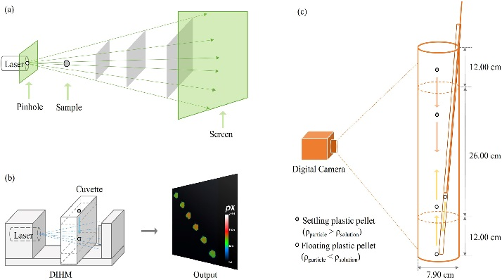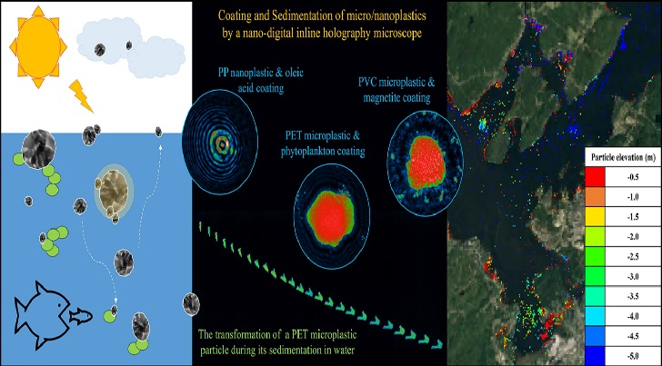

Fig. 2. A schematic of the principle of a nano-DIHM and coating/sedimentation of micro/nanoplastics by a nano-DIHM (Wang et al., 2023)

Nano-DIHM systems integrated with AI not only quantify microplastic concentrations but also provide continuous temporal data, crucial for understanding dynamic pollution events such as stormwater inflows or seasonal variations. These tools demonstrate the transition from static, sample-based measurements to continuous, in situ monitoring.

Beyond holographic microscopy, AI-assisted imaging pipelines are increasingly recognized for their cost-effectiveness and scalability. Data-driven AI detection systems provide economically viable pathways for high-throughput microplastic identification in environmental samples (Latwal et al., 2024).

Recent advances in digital in-line holographic microscopy equipped with AI-driven classification algorithms have further enhanced real-time microplastic detection in complex aquatic matrices, enabling rapid analysis without extensive sample preparation (Rarima & Veerasingam, 2025).

3.2 Computer Vision for Surface and Underwater Debris

Surface and subsurface plastic debris detection has advanced significantly through the use of AI-powered computer vision. Drones, autonomous surface vehicles (ASVs), and underwater robots equipped with high-resolution cameras can scan large areas of lakes. AI models such as YOLO (You Only Look Once) and Faster R-CNN (Region-Based Convolutional Neural Network) process video feeds in real time to identify and track floating and submerged plastics (Fig. 3). These systems can differentiate between plastics, organic matter, and other debris with high accuracy (Guo et al., 2022; Qiao et al., 2021).

For instance, drones using YOLOv8 algorithms achieved over 90% detection accuracy in identifying floating plastics in small lakes and reservoirs (Song et al., 2025). The combination of aerial and underwater imaging provides comprehensive spatial coverage, overcoming the limitations of traditional point-sampling methods. Moreover, AI-based tracking allows scientists to analyze drift patterns and predict accumulation zones, informing cleanup operations.
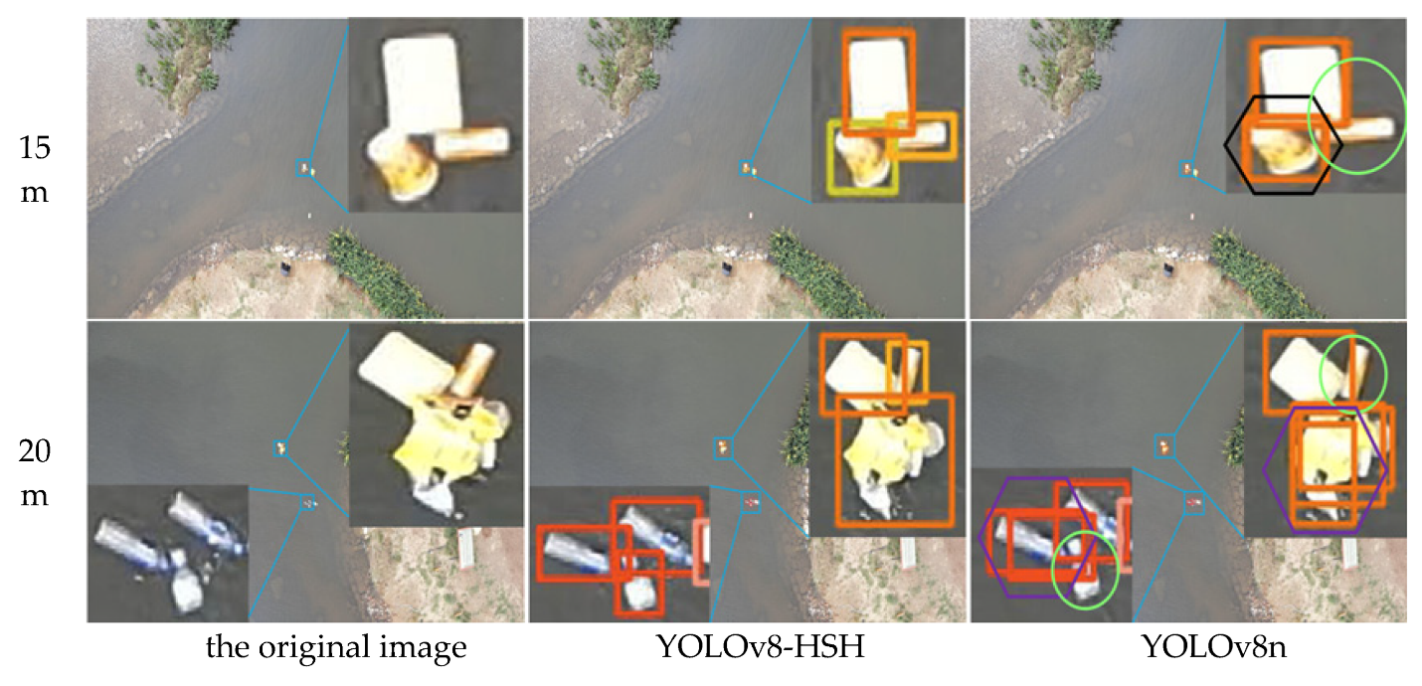

Fig. 3. Aerial surface floating object detection and classification recognition by YOLOv8 Model (Song et al., 2025)

3.3 Spectral Image Analysis

Spectral imaging techniques such as Raman spectroscopy, Fourier-transform infrared (FTIR) spectroscopy, and hyperspectral imaging (HSI) are the gold standards for identifying polymer types. However, manual analysis of spectral data is complex and time-consuming. AI algorithms — particularly convolutional neural networks (CNNs) and support vector machines (SVMs) — can automate spectral interpretation, drastically reducing analysis time while maintaining high precision (da Costa et al., 2021; Wang et al., 2021).

For example, studies using hyperspectral imaging (HSI) coupled with supervised machine-learning models have demonstrated the ability to accurately distinguish between polyethylene (PE), polypropylene (PP), and polystyrene (PS) particles—even when biofouled or embedded in complex matrices—and workflows using HSI or FTIR with AI classification now enable polymer identification of microplastics in mixed sediment or soil samples without extensive chemical pre-treatment (Xu et al., 2023). AI-driven spectroscopic workflows are rapidly evolving. Generative AI models have recently demonstrated the capacity to enhance spectral interpretation, compensate for noise, and improve polymer classification accuracy, even for weathered microplastics (Zhao et al., 2024). Complementarily, SERS-based microplastic detection systems integrated with AI algorithms achieve exceptionally high sensitivity for polymer fingerprinting in environmental samples (Kumar et al., 2025).

3.4 Integration with Remote Sensing and IoT Networks

The future of microplastic monitoring lies in the convergence of AI, remote sensing, and Internet of Things (IoT) technologies. Satellite and UAV imagery, combined with machine learning algorithms, can map surface debris fields in large lakes such as Lake Victoria and the Great Lakes. IoT-based sensor networks can continuously collect water quality data — turbidity, temperature, pH, and flow — that feed into AI models predicting microplastic fluxes (Rolnick et al., 2022). These connected systems enable near-real-time environmental intelligence, providing decision-makers with dynamic pollution maps. At broader spatial scales, AI-enhanced remote sensing frameworks have been successfully applied to map microplastic pollution across major aquatic ecosystems worldwide, demonstrating the feasibility of large-scale hotspot identification (Solayman et al., 2025). AI-based integration also facilitates early warning systems for plastic discharge events, enhancing rapid response capacity.

In practical terms, implementing interconnected AI–remote sensing–IoT systems in large lake environments requires balancing data resolution, cost, and maintenance demands. High-resolution satellite imagery is increasingly accessible, but cloud cover, atmospheric correction, and limited spectral bands can reduce accuracy for detecting small plastic debris. UAV-based imaging provides superior spatial detail but requires frequent flights and skilled operation. IoT sensor networks offer continuous in situ measurements, yet long-term deployment in large systems such as the Great Lakes or Lake Victoria must contend with sensor fouling, power limitations, and variable connectivity. Despite these challenges, hybrid monitoring frameworks—where satellites provide basin-scale context, UAVs refine hotspot identification, and IoT sensors supply real-time water-quality data—are becoming technologically and economically feasible as hardware costs decline and AI-driven data fusion methods improve (Rolnick et al., 2022; Solayman et al., 2025).

Together, these technologies demonstrate how AI is transforming microplastic monitoring from isolated observations into an integrated, data-rich ecosystem. The next section examines how these data streams feed into predictive modeling frameworks capable of simulating the movement, fate, and environmental behavior of microplastics in lake systems. Figure 4 illustrates this continuum, showing how AI technologies contribute to each stage of the microplastic control cycle — from detection and data acquisition, through prediction of environmental behavior, to removal via autonomous systems.
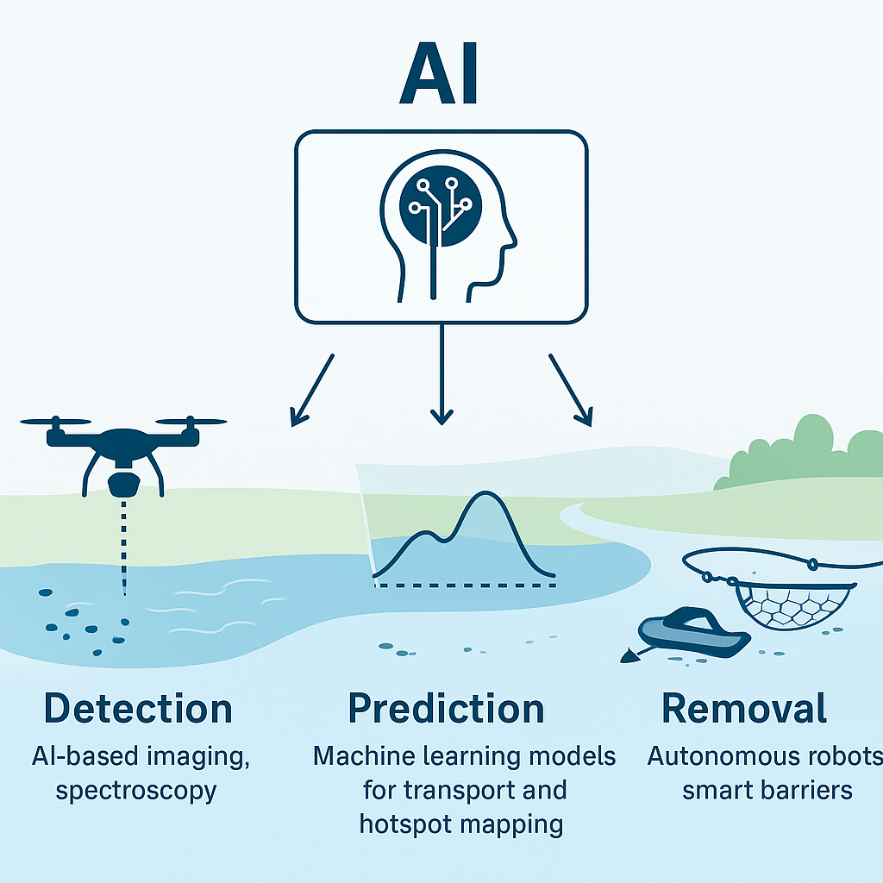

Fig. 4. Conceptual framework showing applications of AI across the microplastic pollution control cycle in lake ecosystems, including detection, prediction and removal.

4. AI FOR PREDICTING MICROPLASTIC FATE AND TRANSPORT

Building upon AI-driven detection and monitoring frameworks, predictive modeling serves as the next critical application area. By integrating environmental, hydrodynamic, and remote-sensing data, AI algorithms can simulate microplastic movement, identify pollution hotspots, and inform targeted mitigation strategies.

4.1 Mapping Pollution Hotspots

Machine learning models can process vast datasets from in situ sensors, hydrological measurements, and satellite observations to identify regions of high microplastic accumulation. The ability of ML algorithms to integrate heterogeneous datasets—combining remote-sensing indicators, hydrodynamic variables, and land-use metrics—has been demonstrated across multiple environmental domains, including plastic pollution mapping, where Random Forest and gradient-boosting models successfully predict spatial distribution patterns from complex predictors (Li et al., 2025; Zhang et al., 2023). Using supervised learning techniques, models such as Random Forest, Gradient Boosting, and Artificial Neural Networks (ANNs) can relate microplastic concentrations to environmental parameters like current velocity, wind direction, and land use.

For example, a study in Lake Taihu, China applied an AI model to integrate hydrodynamic and meteorological data, producing accurate pollution maps that pinpointed accumulation zones near industrial inflows. Such insights allow for targeted deployment of cleanup operations and the strategic placement of interception devices (Qiu et al., 2023; Zhang et al., 2023).

4.2 Predictive Modeling of Transport and Deposition

AI enables scientists to simulate the fate and transport of microplastics under varying environmental conditions. Hybrid models that combine physics-based hydrodynamic simulations with machine learning algorithms are particularly effective. For instance, Long Short-Term Memory (LSTM) networks — a form of recurrent neural network — can learn temporal patterns in pollution data and forecast future concentration levels based on inflow and meteorological variables (Wang et al., 2024).

Recent advances in predictive modeling highlight how machine-learning approaches can characterize adsorption dynamics, aggregation behavior, and transport pathways of microplastics in freshwater environments (Godasiaei, 2025). These physics-informed AI models significantly improve scenario-based assessments of microplastic fate under varying hydrodynamic and meteorological conditions.

4.3 Coupling AI with Hydrodynamic and Climate Models
The integration of AI with conventional hydrodynamic models, such as Delft3D or MIKE 21, can significantly enhance prediction accuracy in complex aquatic environments. These hybrid systems allow AI to calibrate and optimize model parameters automatically, reducing uncertainty in simulations of microplastic transport and distribution (Salikova et al., 2025). Additionally, climate-informed AI models can evaluate how long-term variations in temperature, precipitation, and wind patterns influence microplastic fate, providing insights into future environmental scenarios. This approach aligns microplastic research with broader climate adaptation frameworks, supporting proactive environmental management and mitigation strategies (Senathirajah & Pattiaratchi, 2025).

5. AI-ASSISTED MICROPLASTIC REMOVAL

While AI’s application in detection and prediction is well established, its role in active removal and remediation is rapidly expanding. AI enhances cleanup efficiency, reduces operational costs, and enables autonomous systems to function in complex environments such as lakes with varying turbidity and vegetation cover.

5.1 Autonomous Cleanup Robots

AI-powered autonomous robots are being deployed to identify and collect floating debris in real time. A notable example is Clearbot, a self-navigating robot equipped with computer vision that recognizes and retrieves floating plastics (Microsoft, 2022; Green, 2022; Martin, 2024; Chandrasekaran, et al., 2025). The system’s onboard AI allows it to learn and optimize collection routes based on debris density and water conditions. Similar technologies can be adapted for freshwater lakes, where smaller-scale autonomous surface vehicles (ASVs) can continuously patrol and clean pollution hotspots (Fig. 5).

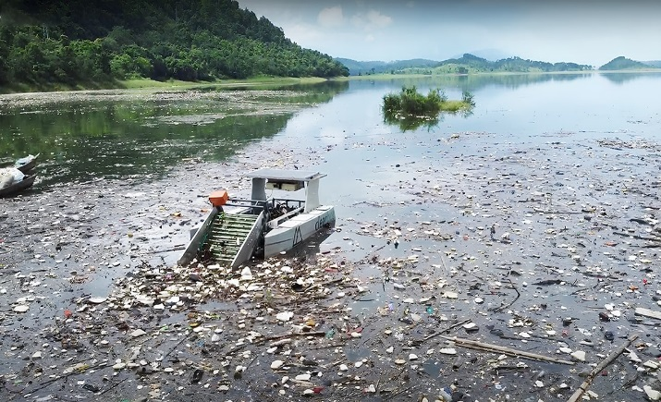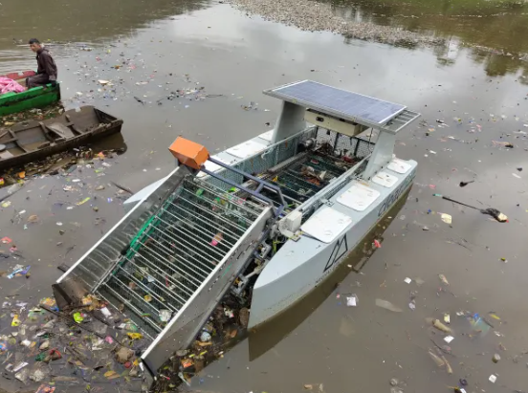

Fig. 5. Clearbot: a self-navigating robot equipped with computer vision that recognizes and retrieves floating plastics in Lake

These systems not only collect waste but also upload georeferenced data to cloud servers, contributing to large-scale pollution mapping efforts. Over time, machine learning improves route optimization and collection efficiency, demonstrating a feedback loop between AI-based detection and removal.

5.2 AI-Assisted Waste Sorting and Interception Systems

AI-supported automation is enhancing waste collection at river inflows, which are critical control points for lake pollution. For example, a floating robot concept described by Ahmad & Jamal (2025) uses vision-based AI to detect plastic debris on the water surface and selectively collect synthetics.

Interception devices equipped with vision-based AI are already being piloted in several European rivers feeding into major lakes. The River Cleaning project in Italy has introduced a network of smart floating barriers equipped with sensors and AI-driven image recognition to differentiate plastics from natural debris. The system enables selective collection, reduces manual sorting requirements, and provides real-time monitoring data to inform local authorities (River Cleaning, 2025). Such AI-based interception approaches could be extended to lakeside waste-management infrastructure to prevent secondary plastic pollution and enhance resource recovery (Fig. 6).

A recent review synthesizing global advances in microplastic detection and interception emphasizes the critical role of AI-guided collection systems, including autonomous robots, adaptive vision-based sorters, and smart floating barriers, in enabling efficient removal strategies across diverse aquatic environments (Song et al., 2025).

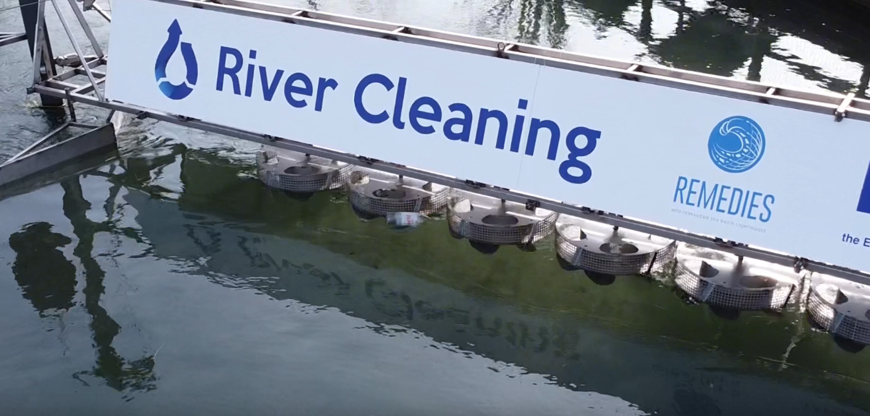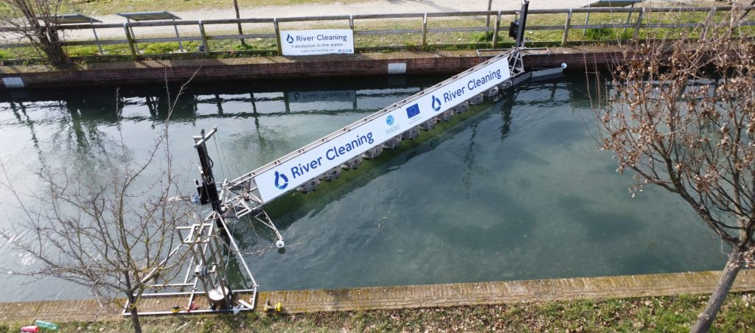

Fig. 6. Smart floating barriers equipped with sensors and AI-driven image recognition to differentiate plastics from natural debris

5.3 AI-Optimized Filtration Systems

AI is also used to optimize microplastic filtration systems in wastewater treatment plants and in-lake filtering devices. Machine learning models can adjust operational parameters — such as flow rate, filter pore size, and backwashing intervals — to maximize microplastic removal efficiency while minimizing energy consumption (Zamfir et al., 2025).

These adaptive control systems learn from sensor feedback to maintain high performance under fluctuating water quality conditions. In pilot installations, AI-optimized filtration achieved up to a 30% improvement in removal rates compared with static systems (Guo et al., 2022). Such intelligent filtration networks could form the backbone of future lake restoration efforts, particularly in densely populated or industrial regions.

6. CHALLENGES AND LIMITATIONS

Despite the promising applications of AI in microplastic detection, modeling, and removal, several critical challenges hinder widespread adoption and operational maturity.

6.1 Data Limitations and Standardization

A major constraint is the lack of standardized, high-quality datasets for training AI models. Microplastic datasets vary widely in sampling methodology, particle size classification, and polymer identification protocols (Primpke et al., 2018). This inconsistency reduces cross-study comparability and impedes the development of generalized models. Moreover, most datasets focus on specific regions or conditions, leading to biases in model training.

Creating global open-access databases with standardized imaging, spectral, and environmental metadata would greatly enhance model robustness and transferability. Integrating such databases with cloud-based AI frameworks could democratize access to advanced analysis tools, especially for developing regions.

6.2 Computational and Hardware Constraints

Implementing deep learning in environmental monitoring requires considerable computational resources. Many freshwater ecosystems are located in remote or low-infrastructure regions, limiting the feasibility of deploying energy-intensive hardware. To address this, recent research advocates for lightweight neural architectures and edge AI — systems capable of performing inference directly on embedded sensors or mobile robots without constant cloud connectivity (Jin et al., 2022).

However, achieving high performance under constrained hardware remains challenging. Efficient model compression, pruning, and quantization techniques must be further developed to ensure scalability of real-time applications in remote lakes.

6.3 Distinguishing Plastics from Natural Particles

Distinguishing microplastics from natural materials such as organic detritus, algae, and mineral fragments remains one of AI’s most persistent challenges (Wang et al., 2024). Variations in particle morphology and spectral signatures due to weathering or biofouling can cause misclassification. Models trained in controlled laboratory conditions often perform poorly when applied to complex field samples.

Multimodal learning — combining spectral, morphological, and contextual features — may improve accuracy. Recent advances in multimodal learning demonstrate that integrating spectral signatures with morphological descriptors and contextual environmental information significantly improves polymer classification accuracy. For example, multimodal neural networks combining Raman spectra with particle-shape metrics have achieved higher precision in distinguishing weathered or biofouled microplastics compared with single-modality models (Zhao et al., 2024; Guo et al., 2024).

6.4 Algorithmic Bias and Model Generalization

AI models trained on limited datasets are vulnerable to overfitting, where the model performs well on known data but poorly on unseen environments. This is particularly problematic in lakes that exhibit high spatial and temporal variability. Transfer learning, domain adaptation, and ensemble modeling approaches can help overcome these issues but require additional research and computational investment (Barman et al., 2023).

6.5 Governance and Ethical Considerations

Beyond technical hurdles, AI adoption in environmental monitoring raises policy, privacy, and governance concerns. Drone-based imaging and autonomous monitoring may inadvertently capture private property or human activity, leading to data governance challenges. Furthermore, unequal access to AI technologies risks widening the gap between well-funded and resource-limited regions, potentially creating disparities in environmental management capacities.

Establishing transparent ethical frameworks and data-sharing standards will be essential for ensuring equitable and responsible deployment of AI systems.

7. FUTURE DIRECTIONS

Despite current challenges, the future of AI-driven microplastic pollution control in lakes appears highly promising. Ongoing advances in machine learning, robotics, and sensor technologies are paving the way for more sophisticated, sustainable, and scalable solutions.

7.1 Integration of AI with Autonomous and Robotic Systems

The integration of AI with autonomous surface vehicles (ASVs) and autonomous underwater vehicles (AUVs) is enabling fully automated lake monitoring and remediation. These AI-enabled systems can operate continuously, collecting water samples, capturing high-resolution images, and performing in situ analyses, thereby improving the efficiency and comprehensiveness of ecological assessments (Homicki, 2025). Swarm robotics, which involves multiple small robots operating cooperatively, can enhance spatial coverage, redundancy, and resilience in dynamic lake environments (Isler, 2012). Additionally, AI-optimized control algorithms can coordinate multi-robot networks, enabling energy-efficient navigation and adaptive task allocation based on real-time pollution and environmental data (Kroeger, 2025). Together, these technologies pave the way for adaptive, scalable, and continuous environmental monitoring, providing critical insights for lake restoration and pollution mitigation efforts.

7.2 Development of Real-Time, Cloud-Connected Monitoring Networks

The deployment of IoT-enabled sensors connected to cloud-based AI platforms will allow for real-time pollution tracking. This AI–IoT convergence facilitates continuous data flow between sensors, drones, and control centers, supporting rapid decision-making. Such frameworks could integrate predictive models that automatically trigger cleanup operations when threshold concentrations of microplastics are detected (Rolnick et al., 2022).

7.3 AI-Enhanced Bioremediation and Material Innovation

An emerging research direction involves combining AI with biotechnological methods to accelerate microplastic degradation. AI models can predict microbial activity and enzymatic efficiency, guiding the design of synthetic microbes or bioengineered enzymes that specifically target plastic polymers (Wei & Zimmermann, 2017). In material science, machine learning is increasingly used to design biodegradable plastics with minimal environmental persistence, thereby addressing the issue at its source.

7.4 Citizen Science and Participatory Monitoring

AI tools integrated into smartphone applications can empower citizens to contribute to data collection through image-based observations of plastic debris. Participatory platforms using crowd-sourced data, validated through AI algorithms, can dramatically expand spatial coverage at minimal cost (Song et al., 2025). This approach enhances public engagement while providing valuable datasets for training and validation.

7.5 Hybrid Modeling and Interdisciplinary Integration

Future research should promote hybrid models that combine physical, chemical, and biological knowledge with data-driven AI methods. These models can better capture the multifactorial dynamics of microplastic transport, aggregation, and degradation. Interdisciplinary collaboration among ecologists, computer scientists, engineers, and policymakers will be essential to translate these technological innovations into actionable management strategies.

8. CONCLUSION

AI is reshaping how scientists and policymakers address the challenge of microplastic pollution in lake ecosystems. By integrating computer vision, deep learning, and sensor-based technologies, AI enables real-time detection, accurate classification, and predictive modeling of microplastic behavior. Autonomous systems and AI-optimized filtration technologies further extend its utility to active removal and remediation efforts.

Despite persistent challenges — including data standardization, computational costs, and algorithmic bias — the trajectory of research clearly points toward greater automation, accuracy, and accessibility in pollution control. The convergence of AI with robotics, IoT, and biotechnology represents a paradigm shift in freshwater environmental management.

Ultimately, the successful deployment of AI-driven systems in lakes will depend not only on technological progress but also on interdisciplinary collaboration and responsible governance. As the world seeks to safeguard freshwater resources against the mounting tide of plastic pollution, AI stands as one of the most powerful and promising tools for a cleaner and more sustainable future.

COMPETING INTERESTS DISCLAIMER:

Authors have declared that they have no known competing financial interests OR non-financial interests OR personal relationships that could have appeared to influence the work reported in this paper.

Disclaimer (Artificial intelligence):

Author(s) hereby declare that NO generative AI technologies such as Large Language Models (ChatGPT, COPILOT, etc.) and text-to-image generators have been used during the writing or editing of this manuscript.

REFERENCES

- Jian, M., Zhang, Y., Yang, W., Zhou, L., Liu, S., & Xu, E. G. (2020). Occurrence and distribution of microplastics in China's largest freshwater lake system. Chemosphere, 261, 128186. https://doi.org/10.1016/j.chemosphere.2020.128186
- Ahmad, M., & Jamal, T. (2025). Automated river cleaning robot for plastic waste segregation using AI. Journal of Information Systems Engineering & Management, 10(55s). https://www.jisem-journal.com/index.php/journal/article/view/11426
- Allen, S., Allen, D., Phoenix, V. R., Le Roux, G., Jiménez, P. D., Simonneau, A., Binet, S., & Galop, D. (2019). Atmospheric transport and deposition of microplastics in a remote mountain catchment. Nature Geoscience, 12(5), 339–344. https://doi.org/10.1038/s41561-019-0335-5
- Andrady, A. L. (2017). The plastic in microplastics: A review. Marine Pollution Bulletin, 119(1), 12–22. https://doi.org/10.1016/j.marpolbul.2017.01.082
- Barman, P., Sharma, R., & Sharma, A. (2023). Transfer-Ensemble Learning: A novel approach for mapping urban land use/cover of Indian metropolitans. Sustainability, 15(24), 16593. https://doi.org/10.3390/su152416593
- Cai, T., Tang, Z., Gu, T., Tong, K., Wang, X., Chen, H., Zhou, X., Long, Z., Hao, C., Chen, C., & Zeng, R. (2025). Microplastics in drinking water: A review of sources, removal, detection, occurrence, and potential risks. Toxics, 13(9), 782. https://doi.org/10.3390/toxics13090782
- Cai, X., Chen, H., Huang, B., & Lu, J. (2022). Analysis on advances and characteristics of microplastic pollution in China’s lake ecosystems. Ecotoxicology and Environmental Safety, 232, 113254. https://doi.org/10.1016/j.ecoenv.2022.113254
- Chandrasekaran, G., Pragadeswaran, S., & Ragupathi, N. (2025). Autonomous robotic boat for plastic waste collection and marine pollution mitigation. In Proceedings of the 7th International Conference on Inventive Material Science and Applications (ICIMA) (pp. 1–6). IEEE. https://doi.org/10.1109/ICIMA64861.2025.11074018
- Chen, D., Wang, P., Liu, S., Wang, R., Wu, Y., Zhu, A.-X., & Deng, C. (2024). Global patterns of lake microplastic pollution: Insights from regional human development levels. Science of the Total Environment, 954, 176620. https://doi.org/10.1016/j.scitotenv.2024.176620
- da Costa, J. P., Santos, P. S. M., Duarte, A. C., & Rocha-Santos, T. (2016). (Nano)plastics in the environment – sources, fates and effects. Science of the Total Environment, 566–567, Article 24-32. https://doi.org/10.1016/j.scitotenv.2016.05.041
- Godasiaei, S. H. (2025). Predictive modeling of microplastic adsorption in aquatic environments using advanced machine learning models. Science of the Total Environment, 958, 178015. https://doi.org/10.1016/j.scitotenv.2024.178015
- Green Schools Green Future. (2022, November 8). AI-enabled robotic boat cleans up harbours and rivers to keep plastic trash out of the ocean. https://greenschoolsgreenfuture.org/ai-enabled-robotic-boat-cleans-up-harbours-and-rivers-to-keep-plastic-trash-out-of-the-ocean
- Guo, P., Wang, Y., Moghaddamfard, P., Meng, W., Wu, S., & Bao, Y. (2024). Artificial intelligence-empowered collection and characterization of microplastics: A review. Journal of Hazardous Materials, 471, Article 134405. https://doi.org/10.1016/j.jhazmat.2024.134405
- Homichi, C. (2025, August 15). Revolutionizing aquatic monitoring: The autonomous robot making waves. Dartmouth College. https://irving.dartmouth.edu/news/2025/08/revolutionizing-aquatic-monitoring-autonomous-robot-making-waves
- Horton, A. A., Walton, A., Spurgeon, D. J., Lahive, E., & Svendsen, C. (2017). Microplastics in freshwater and terrestrial environments: Evaluating the current understanding to identify the knowledge gaps and future research priorities. Science of the Total Environment, 586, 127–141. https://doi.org/10.1016/j.scitotenv.2017.01.190
- Isler, V. (2012). Robotic sensor networks for environmental monitoring. Proceedings of the Twenty-Sixth AAAI Conference on Artificial Intelligence, 4277–4282. https://cdn.aaai.org/ocs/4277/4277-19438-1-PB.pdf
- Jin, H., Kong, F., Li, X., & Shen, J. (2024). Artificial intelligence in microplastic detection and pollution control. Environmental Research, 262, Article 119812. https://doi.org/10.1016/j.envres.2024.119812
- Kooi, M., van Nes, E. H., Scheffer, M., & Koelmans, A. A. (2017). Ups and downs in the ocean: Modelling the effect of biofouling on the vertical transport of microplastics. Environmental Science & Technology, 51(14), 7963–7971. https://doi.org/10.1021/acs.est.6b04702
- Kroeger, T. (2025, September 3). Specialized AI for scalable and adaptive multi-robot orchestration. Intrinsic AI Blog. https://www.intrinsic.ai/blog/posts/specialized-ai-for-scalable-and-adaptive-multi-robot-orchestration
- Kumar, J., Amulraj, P., Haroon, S. F., Selvasembian, R., Soma, V. R., & Panneerselvam, R. (2025). Trapping tiny pollutants: SERS-driven strategies for microplastics and nanoplastics detection. iScience, 113888. https://doi.org/10.1016/j.isci.2025.113888
- Latwal, M., Arora, S., & Murthy, K. S. R. (2024). Data driven AI detection furnish economic pathways for microplastics. Journal of Contaminant Hydrology, 264, 104365. https://doi.org/10.1016/j.jconhyd.2024.104365
- Li, J., Jiang, Z., Shu, L., Li, X., Wang, C., & Zhang, H. (2025). Machine learning models for forecasting microplastic dynamics in China’s coastal waters. Journal of Hazardous Materials, 494, 138797. https://doi.org/10.1016/j.jhazmat.2025.138797
- Liu, X., Tang, N., Yang, W., & Chang, J. (2022). Microplastics pollution in the soils of various land-use types along Sheshui River basin of Central China. Science of The Total Environment, 806, 150620. https://doi.org/10.1016/j.scitotenv.2021.150620
- Martin, S. (2024, October 17). Waterways wonder: Clearbot autonomously cleans waters with energy-efficient AI. NVIDIA Blog. https://blogs.nvidia.com/blog/clearbot-autonomously-cleans-ai/
- Mi, W., Zhou, Y., Zhu, D., & Yang, W. (2008). The phosphorous chemical behavior in water-sediment systems polluted by sewage of manure and aquaculture. Lakes & Reservoirs: Research & Management, 20(3), 271–276. https://doi.org/10.18307/2008.0302
- Microsoft Hong Kong. (2022, April 29). This AI-enabled robotic boat cleans up harbors and rivers to keep plastic trash out of the ocean. https://news.microsoft.com/en-hk/2022/04/29/this-ai-enabled-robotic-boat-cleans-up-harbors-and-rivers-to-keep-plastic-trash-out-of-the-ocean/
- Munno, K., Helm, P. A., Rochman, C., George, T., & Jackson, D. A. (2022). Microplastic contamination in Great Lakes fish. Conservation Biology, 36(1), e13794. https://doi.org/10.1111/cobi.13794
- Primpke, S., Wirth, M., Lorenz, C., & Gerdts, G. (2018). Reference database design for the automated analysis of microplastic samples based on Fourier transform infrared (FTIR) spectroscopy. Analytical and Bioanalytical Chemistry, 410(21), 5131–5141. https://doi.org/10.1007/s00216-018-1156-x
- Qiao, H., Liu, S., Xu, Q., Liu, S., & Yang, W. (2021). Two-stream convolutional neural network for video action recognition. KSII Transactions on Internet and Information Systems, 15(10), 3668–3684. https://doi.org/10.3837/tiis.2021.10.011
- Qiu, Y., Zhou, S., Zhang, C., Qin, W., Lv, C., & Zou, M. (2023). Identification of potentially contaminated areas of soil microplastic based on machine learning: A case study in Taihu Lake region, China. Science of The Total Environment, 877, Article 162891. https://doi.org/10.1016/j.scitotenv.2023.162891
- Rarima, R., & Veerasingam, S. (2025). Towards cleaner waters: Advancing pollutant detection with artificial intelligence-assisted digital in-line holographic microscopy. Optics and Laser Technology, 192, 113402. https://doi.org/10.1016/j.optlastec.2025.113402
- River Cleaning. (2025). River Cleaning: The Italian technology that’s revolutionizing river cleaning with smart floating barriers. https://rivercleaning.com/2025/05/river-cleaning-the-italian-technology-thats-revolutionizing-river-cleaning-with-smart-floating-barriers
- Rochman, C. M., Brookson, C., Bikker, J., Djuric, N., Earn, A., Bucci, K., ...& Hung, C. (2019). Rethinking microplastics as a diverse contaminant suite. Environmental Toxicology and Chemistry, 38(4), 703–711. https://doi.org/10.1002/etc.4371
- Rolnick, D., Donti, P. L., Kaack, L. H., Kochanski, K., Lacoste, A., Sankaran, K., ... & Bengio, Y. (2022). Tackling climate change with machine learning. ACM Computing Surveys, 55(2), 1–38. https://doi.org/10.1145/3485128
- Salikova, N. S., Rodrigo-Clavero, M.-E., Makeyeva, L. A., Shaimerdenova, Z. M., & Rodrigo-Ilarri, J. (2025). Numerical modeling of the concentration of microplastics in lakes and rivers in Kazakhstan. Hydrology, 12(4), Article 93. https://doi.org/10.3390/hydrology12040093
- Senathirajah, K., & Pattiaratchi, C. (2025). Microplastics in bays: Transport processes and numerical models. Science of The Total Environment, 993, 179995. https://doi.org/10.1016/j.scitotenv.2025.179995
- Solayman, H. M., et al. (2025). Mapping global microplastic pollution: Integrating advanced detection and monitoring in aquatic ecosystems. Marine Pollution Bulletin, 222, 118685. https://doi.org/10.1016/j.marpolbul.2025.118685
- Song, J., Pashazadeh, A., Wu, S., Greene, V. R., Hallee, K. O., Tannehill, A. M., Saxon, T. M., Potter, M., & Beneke, Z. (2025). Advances in microplastic detection and interception: A state-of-the-art review. Cleaner Water, 4(100141), 100141. https://doi.org/10.1016/j.clwat.2025.100141
- Song, L., Deng, H., Han, J., & Gao, X. (2025). Improved aerial surface floating object detection and classification recognition algorithm based on YOLOv8n. Sensors, 25(6), 1938. https://doi.org/10.3390/s25061938
- UNEP. (2023). Turning off the Tap: How the world can end plastic pollution and create a circular economy. United Nations Environment Programme. https://www.unep.org/resources/turning-off-tap-end-plastic-pollution-create-circular-economy
- Wang, Y., Liu, S., Jiang, M., Chen, L., Zeng, J., & Yang, W. (2021). Dense Crowd Counting Based on ResNet. 2021 IEEE 7th International Conference on Cloud Computing and Intelligent Systems (CCIS), 455–459. https://doi.org/10.1109/ccis53392.2021.9754656
- Wang, Z., Pal, D., Pilechi, A., & Ariya, P. A. (2023). Nanoplastics in water: Artificial intelligence-assisted 4D physicochemical characterization and rapid in situ detection. Environmental Science & Technology, 58(20), 8919–8931. https://doi.org/10.1021/acs.est.3c10408
- Wei, R., & Zimmermann, W. (2017). Microbial enzymes for the recycling of recalcitrant petroleum-based plastics: How far are we? Microbial Biotechnology, 10(6), 1308–1322. https://doi.org/10.1111/1751-7915.12710
- Wright, S. L., Thompson, R. C., & Galloway, T. S. (2013). The physical impacts of microplastics on marine organisms: A review. Environmental Pollution, 178, 483–492. https://doi.org/10.1016/j.envpol.2013.02.031
- Xu, L., Chen, Y., Feng, A., Shi, X., Feng, Y., Yang, Y., Wang, Y., Wu, Z., Zou, Z., Ma, W., He, Y., Yang, N., & Feng, J. (2023). Study on detection method of microplastics in farmland soil based on hyperspectral imaging technology. Environmental Research, 232, 116389. https://doi.org/10.1016/j.envres.2023.116389
- Yang, L., Zhang, Y., Kang, S., Wang, Z., & Wu, C. (2020). Microplastics in freshwater sediment: A review on methods, occurrence, and sources. Science of The Total Environment, 754, 141948. https://doi.org/10.1016/j.scitotenv.2020.141948
- Yang, W. (2011). Characteristics of phosphorus forms in sediments and its biological activity evaluation with Potamogeton crispus L. growth. Master’s thesis, Huazhong Agricultural University, China, 24-25. https://doi.org/10.7666/d.y1805505
- Yang, W., Hu, W., Liu, S., Liu, X., Hu, W., Yang, W., & Collins, E. (2025). Harnessing big data analytics for environmental protection: Benefits, current applications, challenges, and future prospects. Global Journal of Engineering and Technology Advances, 24(1), 218–228. https://doi.org/10.30574/gjeta.2025.24.1.0230
- Yang, W., Hu, W., Liu, X., Hu, W., Yang, W., & Collins, E. (2025). Microplastic pollution in lakes: Sources, impact, and solutions. World Journal of Advanced Engineering Technology and Sciences, 16(1), 298–308. https://doi.org/10.30574/wjaets.2025.16.1.1211
- Yang, W., Hu, W., Liu, X., Xin, Y., Hu, W., Yang, W., & Liu, S. (2025). Effects of Potamogeton crispus growth on phosphorus fractions in lake sediments under two nutrient levels. World Journal of Advanced Engineering Technology and Sciences, 15(2), 3050–3061. https://doi.org/10.30574/wjaets.2025.15.2.0870
- Yang, W., Liu, X., Hu, W., Xin, Y., Hu, W., Yang, W., & Liu, S. (2025). Role of Submerged Macrophytes in Restoring Eutrophic Lakes. International Journal of Environment, Agriculture and Biotechnology, 10(5), 172–181. https://doi.org/10.22161/ijeab.105.18
- Yang, W., Mi, W., Zhu, D., Zhou, W., Yang, T., Geng, M., and Hu, W. (2007). Effects of Potamogeton crispus L. on phosphorus forms in different lake sediments. Paper presented at the 3rd Annual Conference of the Environmental Chemistry and Chemical Engineering Professional Committee of Hubei Society of Chemistry and Chemical Engineering, Wuhan, China. 99-101.
- Zamfir, F.-S., Carbureanu, M., & Mihalache, S. F. (2025). Application of machine learning models in optimizing wastewater treatment processes: A review. Applied Sciences, 15(15), Article 8360. https://doi.org/10.3390/app15158360
- Zhang, Y., Zhang, D., & Zhang, Z. (2023). A Critical Review on Artificial Intelligence—Based Microplastics Imaging Technology: Recent Advances, Hot-Spots and Challenges. International Journal of Environmental Research and Public Health, 20(2), 1150. https://doi.org/10.3390/ijerph20021150
- Zhao, B., Richardson, R. E., & You, F. (2024). Advancing microplastic analysis in the era of artificial intelligence: From current applications to the promise of generative AI. Nexus, 1(4), 100043. https://doi.org/10.1016/j.ynexs.2024.100043

