Effectiveness and Optimization of Chlorine Tablets for Total Coliform Removal in Hospital Wastewater Effluent

ABSTRACT
Background: Hospital wastewater contains diverse pathogens and chemical contaminants that pose serious risks to public health and the environment. In Indonesia, conventional treatment systems often fail to meet microbial quality standards, leading to potential secondary pollution. Chlorination is widely used as a disinfection method; however, its practical application using chlorine tablets in hospital wastewater management remains limited. Objective: This study introduces an innovative, low-cost, and context-specific optimization of chlorine tablet dosage and contact time for hospital wastewater disinfection under tropical Indonesian conditions. Methods: A preliminary survey at a hospital in Surakarta showed total coliform levels of 5,400 MPN/100 mL, exceeding the national limit of 3,000 MPN/100 mL (Regulation No. 68/2016). A pretest–posttest batch experiment was conducted using chlorine tablet dosages of 200 g, 400 g, and 600 g, with contact times of 30, 40, and 50 minutes. Parameters measured included total coliform, pH, and temperature to evaluate disinfection efficiency and stability. Results: Total coliform removal efficiencies were 68% (200 g/50 min), 99.87% (400 g/40 min), and 100% (600 g at all durations). Although higher doses enhanced microbial removal, the 600 g treatment inc9reased pH above 8.0, reducing chlorine stability and increasing residual chemical risk. Conclusion: The optimal condition was 400 g of chlorine with a 40-minute contact time, achieving 99.87% total coliform removal while maintaining safe pH levels. This study presents a novel, efficient, and cost-effective chlorination optimization model for hospital wastewater disinfection, supporting sustainable and regulation-compliant wastewater management in developing countries.
Keywords: Chlorine tablet; Total Coliform; Hospital wastewater; Wastewater treatment; Disinfection optimization
- INTRODUCTION
Wastewater generated as a by-product of healthcare services constitutes a significant source of environmental pollution, with the potential to disrupt the ecological balance of surrounding ecosystems. It is commonly classified into three categories: medical wastewater, non-medical wastewater, and hazardous and toxic substances (HTS), each potentially containing toxic chemicals, pathogenic microorganisms, and infectious biological agents. (Ajala et al., 2022) When inadequately treated, these pollutants can infiltrate surface waters, accumulate through the food chain, and contribute to long-term ecological degradation, as well as the proliferation of waterborne diseases, posing serious risks to human health and aquatic ecosystems (Nishmitha et al., 2025)
The assessment of wastewater quality generally involves both physicochemical and microbiological parameters. Physicochemical indicators, including biochemical oxygen demand (BOD), chemical oxygen demand (COD), and total suspended solids (TSS), reflect the levels of organic loading and particulate matter, serving as key indicators for evaluating wastewater treatment performance (Aib et al., 2024) Microbiological parameters, particularly total coliform, are widely used to assess fecal contamination and the potential presence of pathogenic microorganisms. High total coliform counts indicate inadequate disinfection and pose a significant risk to public health and the environment...
Within Indonesia, hospital wastewater effluent quality is regulated under the Ministry of Environment Regulations No. 5/2014 and No. 68/2016, which stipulate a maximum allowable total coliform concentration of 3,000 most probable number (MPN) per 100 mL(Sulistiawati, 2022). Monitoring conducted at a hospital in Surakarta in March 2023 showed that, although BOD, COD, and TSS levels complied with the required standards, the total coliform concentration at the wastewater treatment plant (WWTP) outlet reached 5,400 MPN/100 mL—exceeding the regulatory limit. This indicates deficiencies in the disinfection process and underscores the need for operational improvements (Yan et al., 2020)
Chlorination using calcium hypochlorite [Ca(ClO)₂], commonly known as bleaching powder, is among the most widely applied disinfection methods in hospital WWTPs due to its proven efficiency, operational simplicity, and cost-effectiveness (Romanovski et al., 2024) Its performance, however, depends heavily on two critical parameters: chlorine dosage and contact time. Insufficient dosage or contact time can result in incomplete pathogen inactivation, whereas excessive dosing may leave high residual chlorine levels and generate harmful disinfection by-products (DBPs), such as trihalomethanes (THMs). Therefore, identifying an optimal balance between dosage and contact duration is essential to ensure effective microbial control while minimizing chemical use and potential environmental impacts (Wang et al., 2025)
Optimizing chlorine application aligns with the principles of resource efficiency and green chemistry, enabling hospitals to achieve effective disinfection with minimal chemical consumption, lower operational costs, and reduced environmental risks. This approach supports Sustainable Development Goal (SDG) 6 (Clean Water and Sanitation) and SDG 12 (Responsible Consumption and Production) through improved wastewater management and responsible chemical utilizatio (Shafik, 2025)
This study evaluates the disinfection efficiency of calcium hypochlorite tablets at three dosages (200 g, 400 g, and 600 g) and three contact times (30, 40, and 50 minutes) for reducing total coliform levels in hospital wastewater. It aims to identify the optimal combination of dosage and contact time that meets regulatory standards, ensures chemical safety, and maximizes cost-efficiency. As the first study in Indonesia to assess combined dosage–time effects under real WWTP operating conditions, it integrates microbiological performance, physicochemical parameters, and economic analysis to provide evidence-based recommendations for sustainable and regulation-compliant hospital wastewater disinfection. (Saufi, Arifin and Hamzani, 2024)(Saufi, Arifin and Hamzani, 2024)(Saufi, Arifin and Hamzani, 2024)(Saufi, Arifin and Hamzani, 2024)
- RESEARCH METHODS
  - Study Site and Sample Collection
This research was conducted at a state-owned psychiatric hospital in Central Java, Indonesia. Classified as a Type A healthcare facility, it accommodates 260 inpatient beds and holds advanced-level national accreditation as well as ISO 9001:2015 certification (Wolniak, 2021), demonstrating its commitment to maintaining high standards of healthcare quality and patient safety. The hospital’s Environmental Sanitation Unit plays a strategic role in planning, implementing, and supervising integrated environmental hygiene programs to ensure a clean and regulation-compliant hospital environment in accordance with national standards.
Wastewater samples were collected from two critical points within the hospital’s Wastewater Treatment Plant (WWTP): the inlet (before treatment) and the outlet (after treatment). Sampling was conducted in accordance with the Indonesian National Standard SNI 6989.57:2008 for wastewater sampling and SNI 6989.1:2019 for manual water sampling procedures (Susetyaningsih et al., 2023). Samples were collected in sterile glass bottles and immediately stored in a cool box at 4 ± 2°C to preserve parameter stability. All samples were analyzed within 24 hours to ensure data integrity, particularly for microbiological indicators such as total coliform. Analyses of physicochemical parameters (pH and temperature) and microbiological parameters (total coliform) were performed in the hospital’s Environmental Sanitation Laboratory, which operates under SNI ISO/IEC 17025:2017, certifying the competence and reliability of testing laboratories. (Wijaya et al., 2022),
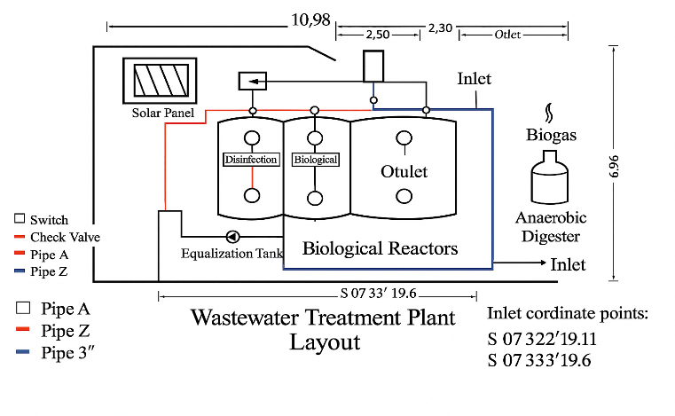
Figure 1. Sampling Locations at the Hospital Wastewater Treatment Plant (WWTP)
This figure illustrates the two primary sampling points used in the study: the inlet, representing untreated hospital wastewater before chlorination, and the outlet, representing treated effluent after chlorination. These sampling points were selected to assess the effectiveness of chlorination in reducing total coliform levels and to observe variations in physicochemical parameters, including pH and temperature, across the treatment stages.
  - Materials and Equipment
This This study utilized standard laboratory equipment, including sterile glass sampling bottles with ground-glass stoppers sterilized by autoclaving, weighted sampling ropes, and a Hanna digital pH meter for measuring pH and temperature. Microbiological analyses were performed using an incubator (maintained at 36–37.5°C), colony counter, sterile pipettes, digital analytical balance, laboratory blender, and EC Compact Dry Plates as the culture medium. All procedures were conducted aseptically using sterile gloves, 70% ethanol, and alcohol swabs to prevent contamination.
The materials used in this study included wastewater samples from the Wastewater Treatment Plant (WWTP), Lactose Broth (LB) and 2% Brilliant Green Lactose Broth (BGLB) culture media, Buffered Peptone Water (BPW), sulfuric acid (H₂SO₄) as a preservative when required, and sterile water for serial dilutions. All experimental procedures strictly followed standardized protocols to ensure the accuracy, reliability, and validity of the analytical results..(Mulyati et al., 2024)
  - Research Procedure

This study aimed to evaluate the disinfection efficiency of calcium hypochlorite [Ca(ClO)₂] in treating hospital wastewater by applying chlorine tablets at dosages of 200 g, 400 g, and 600 g, with contact times of 30, 40, and 50 minutes. The selected dosage and contact time ranges were determined based on preliminary trials and supported by previous studies on chlorine-based disinfection in healthcare wastewater systems. These ranges are operationally feasible for medium-scale wastewater treatment plants in Indonesia, where contact times of 30–60 minutes and dosages below 1,000 g have been demonstrated to effectively reduce microbial contamination while minimizing chemical use. The treatment parameters were also aligned with World Health Organization (WHO) disinfection guidelines and the operational constraints of Indonesian hospitals.

Wastewater samples were collected from the inlet and outlet of the hospital’s Wastewater Treatment Plant (WWTP) to assess pre- and post-treatment conditions. Each dosage–contact time combination was replicated three times to ensure data reliability. pH and temperature were measured before and after chlorine application to evaluate changes in physicochemical characteristics. Microbiological analysis was performed using the Most Probable Number (MPN) method to determine total coliform counts as an indicator of biological contamination. The results were compared with the effluent quality standard specified in the Indonesian Ministry of Environment and Forestry Regulation No. 68/2016, which sets a maximum permissible limit of 3,000 MPN/100 mL (Azwarudin et al., 2023)
  - Total Coliform Testing and Data Analysis
    - Total Coliform Testing
The analysis of total coliform was performed using the Most Probable Number (MPN) method, employing a three-tube serial dilution technique in accordance with standard environmental microbiology protocols. The procedure began with a presumptive test, in which wastewater samples were inoculated into Lactose Broth (LB) medium and incubated for 24–48 hours to observe gas formation in Durham tubes and turbidity, which indicated presumptive positive results. Tubes showing positive reactions were then subjected to a confirmatory test using 2% Brilliant Green Lactose Broth (BGLB) medium and incubated at 36 ± 1°C for 48 hours. The presence of gas in the confirmatory stage confirmed the occurrence of coliform bacteria. The final MPN value was calculated based on the number of positive tubes obtained (Yannawar, 2022)
    - MPN Calculation
Total coliform levels were determined based on the number of positive tubes obtained across three serial dilutions (10⁰, 10⁻¹, and 10⁻²). The corresponding Most Probable Number (MPN) values were derived from the standard MPN table and calculated using the following equation: (Senthilkumar et al., 2021)
$$\text{MPN/100 mL}=(\text{MPN table value})×\frac{1}{\text{middle dilution factor}}$$
The MPN table value is obtained from the standard MPN table based on the combination of positive tubes at each dilution level, while the constant 1 serves as a conversion factor to express the result per 100 mL of the sample. The middle dilution factor represents the dilution level positioned in the middle of the series—for example, among dilutions of 10⁰, 10⁻¹, and 10⁻², the middle dilution factor is 10⁻¹. .
    - Experimental Design
This study employed a pretest–posttest experimental design without a control group. Chlorine tablets were applied at three dosage levels (200 g, 400 g, and 600 g) and three contact times (30, 40, and 50 minutes). Each dosage–contact time combination was replicated three times to ensure the reliability and reproducibility of the data. In total, nine inlet (pre-treatment) samples and twenty-seven outlet (post-treatment) samples were analyzed, corresponding to the nine dosage–contact time combinations. Total Coliform concentrations were determined using the Most Probable Number (MPN) method to evaluate disinfection performance, and the results were compared across treatment variations to assess the reduction efficiency. (Mulyati et al., 2024)(Ge et al., 2025)
    - Data Analysis
The MPN results were analyzed using both descriptive and inferential statistical approaches. Descriptive statistics, including mean values, standard deviations, and percentage reductions of Total Coliform, were calculated to summarize disinfection outcomes. Inferential analysis was performed using one-way and two-way ANOVA to evaluate the effects of chlorine dosage, contact time, and their interaction on microbial reduction efficiency. When significant differences were detected, Tukey’s HSD post hoc test was applied to identify specific group variations. The results were presented in tabular form, graphical illustrations, and effectiveness curves. Cost-effectiveness analysis was conducted by calculating chlorine consumption per cubic meter for each treatment condition, with the optimal dosage determined based on the greatest statistically significant microbial reduction, compliance with regulatory standards (≤3,000 MPN/100 mL), and minimal chemical usage. Additionally, a breakpoint chlorination curve was developed to determine the saturation threshold, thereby providing a basis for efficient and sustainable chlorine dosing in hospital wastewater treatment (Harahap et al., 2021)
- Result
  - Layout Design and Performance of the Hospital Wastewater Treatment Plant (WWTP)

The hospital Wastewater Treatment Plant (WWTP) was designed and operated as an integrated system comprising a sequence of interconnected treatment units, namely the inlet channel, equalization tank, anaerobic digester, biological reactors, and disinfection unit (Table 1). Each component performed a distinct yet interdependent function, ensuring the effective and continuous treatment of hospital effluent.

Raw wastewater was initially directed through the inlet channel at designated coordinates (S 07°32′19.11″ and S 07°33′19.6″), which ensured uniform flow distribution and prevented hydraulic turbulence. The equalization tank moderated fluctuations in hydraulic load and pollutant concentration, thereby minimizing shock loading and enhancing the performance of subsequent treatment processes. Within the anaerobic digester, organic matter underwent microbial decomposition under oxygen-limited conditions, producing biogas that was subsequently captured and utilized as a renewable energy source.

The biological reactors incorporated both aerobic and anaerobic zones to facilitate the sequential biodegradation of organic compounds and promote nutrient removal. Following biological treatment, effluent passed through the disinfection unit, where chlorine tablets were applied via an adjustable dosing mechanism to achieve optimal pathogen inactivation prior to discharge.

To support sustainability, the system integrated solar-powered modules coupled with automated process control units, which provided real-time operational monitoring and contributed to reducing the facility’s carbon footprint. The hydraulic system was reinforced with a color-coded piping network (Pipes A, Z, and 3″), engineered to maintain balanced hydraulic flow and efficient water conveyance. Check valves were strategically positioned at key pipeline junctions to prevent backflow and cross-contamination, ensuring both process reliability and operational safety.

The integrated WWTP configuration demonstrated high operational efficiency and consistent compliance with national effluent discharge standards. Its design exemplifies a sustainable approach to hospital wastewater management by optimizing treatment performance, enabling energy recovery, and promoting low-carbon operation...

Table 1. Layout design, functions, and performance contributions of the WWTP components
Component | Function | Design Features | Performance Contribution
Inlet Channel | Directs raw wastewater into the treatment system. | Connected to inlet coordinates (S 07° 32′ 19.11″ and S 07° 33′ 19.6″). | Ensures proper entry and distribution of influent wastewater.
Equalization Tank | Homogenizes flow and equalizes pollutant load fluctuations. | Equipped with flow distribution control. | Prevents shock loading and enhances downstream treatment efficiency.
Anaerobic Digester | Facilitates anaerobic decomposition and produces biogas. | Connected to biogas capture unit. | Reduces organic load and generates renewable energy.
Biological Reactors | Supports aerobic and anaerobic biological degradation of organic matter. | Divided into aerobic and anaerobic zones. | Removes biodegradable organic matter and nutrients.
Disinfection Unit | Inactivates pathogenic microorganisms using chlorine tablets. | Chlorine tablet dosing system with adjustable dosage. | Ensures microbial safety of effluent before discharge.
Solar Panel System | Provides renewable energy for control and monitoring systems. | Integrated with system automation. | Reduces operational carbon footprint and supports sustainability.
Pipe A | Transports treated/untreated water between units as part of main flow. | Indicated in layout diagram as red pipeline. | Maintains continuous and efficient water transport.
Pipe Z | Secondary transport line for optimized water routing. | Indicated in layout diagram as blue pipeline. | Optimizes hydraulic efficiency in treatment process.
Pipe 3″ | Additional high-capacity transport for wastewater flow. | Indicated in layout diagram as black pipeline. | Supports peak flow handling and hydraulic balance.
Check Valves | Prevents backflow to maintain unidirectional water movement. | Positioned between critical pipeline connections. | Prevents contamination and maintains system integrity.
  - Physicochemical Parameters (pH and Temperature)

Monitoring of physicochemical parameters was conducted to establish baseline conditions of the hospital wastewater prior to chlorination. Measurements of pH and temperature were taken over three consecutive days, with three sampling intervals each morning (Table 2). The results indicated that the pH values of the untreated wastewater ranged from 6.9 to 7.4, remaining close to neutral conditions. Meanwhile, the temperature varied slightly between 28.3 °C and 28.7 °C, reflecting stable environmental conditions within the wastewater treatment system.

After chlorination, the pH values of the treated effluent remained within the regulatory range of 6–9, and the temperature stayed below the national maximum limit of 30 °C, demonstrating compliance with effluent quality standards. These findings confirm that the chlorination process did not significantly alter the physicochemical characteristics of the wastewater. The recorded baseline values were subsequently used as reference parameters for assessing the disinfection performance and the effect of chlorine dosage and contact time on Total Coliform removal efficiency.

Table 2. Daily monitoring of pH and temperature variations in hospital wastewater prior to and after chlorination treatment
Date | Time | pH | Temperature (°C)
23-Apr-25 | 08:28 WIB | 6.9 | 28.4
 | 08:38 WIB | 7.2 | 28.5
 | 08:48 WIB | 7.1 | 28.5
24-Apr-25 | 08:28 WIB | 7.1 | 28.3
 | 08:38 WIB | 6.9 | 28.5
 | 08:48 WIB | 7.3 | 28.6
25-Apr-25 | 08:28 WIB | 7.2 | 28.3
 | 08:38 WIB | 7.1 | 28.7
 | 08:48 WIB | 7.4 | 28.5
  - Microbiological Parameter (Total Coliform)

Total Coliform concentrations in the hospital wastewater were monitored to evaluate the disinfection performance of chlorine tablet application under varying dosage levels. Measurements were conducted over three consecutive days, encompassing pre- and post-treatment conditions (Table 3). Prior to chlorination, Total Coliform concentrations consistently exceeded 3,000 MPN/100 mL, surpassing the national regulatory limit for effluent discharge. These elevated baseline values reflected the high microbial load characteristic of untreated hospital wastewater. After chlorination, a clear dose–response relationship was observed between chlorine dosage and Total Coliform reduction. At a dosage of 200 g, microbial counts decreased substantially to a range of 1,800–950 MPN/100 mL, indicating partial disinfection but remaining slightly above the permissible threshold. Increasing the dose to 400 g produced markedly improved outcomes, with Total Coliform levels reduced to 550–4 MPN/100 mL, successfully meeting the regulatory standard. The highest dosage of 600 g achieved complete microbial elimination (0 MPN/100 mL) in all replicates, demonstrating optimal disinfection efficiency.

These findings confirm that higher chlorine doses significantly enhanced microbial inactivation, aligning with the typical kinetics of chlorine-based disinfection. The 600 g dosage effectively met and exceeded national effluent quality requirements (≤ 3,000 MPN/100 mL), highlighting its suitability for safe and sustainable hospital wastewater management.standards

Table 3. Baseline and post‑treatment Total Coliform levels in hospital wastewater effluent
Date | Time | Condition | Chlorine Dose (g) | Total Coliform (MPN/100 mL) | Standard Limit (MPN/100 mL)
23-Apr-25 | 08:28 | Before Chlorination | – | >3000 | 3000
23-Apr-25 | 08:38 | Before Chlorination | – | >3000 | 3000
23-Apr-25 | 08:48 | Before Chlorination | – | >3000 | 3000
24-Apr-25 | 08:28 | Before Chlorination | – | >3000 | 3000
24-Apr-25 | 08:38 | Before Chlorination | – | >3000 | 3000
24-Apr-25 | 08:48 | Before Chlorination | – | >3000 | 3000
25-Apr-25 | 08:28 | Before Chlorination | – | >3000 | 3000
25-Apr-25 | 08:38 | Before Chlorination | – | >3000 | 3000
25-Apr-25 | 08:48 | Before Chlorination | – | >3000 | 3000
23-Apr-25 | 08:30 | After Chlorination | 200 | 1800 | 3000
23-Apr-25 | 08:40 | After Chlorination | 200 | 1420 | 3000
23-Apr-25 | 08:50 | After Chlorination | 200 | 950 | 3000
24-Apr-25 | 08:30 | After Chlorination | 400 | 550 | 3000
24-Apr-25 | 08:40 | After Chlorination | 400 | 120 | 3000
24-Apr-25 | 08:50 | After Chlorination | 400 | 4 | 3000
25-Apr-25 | 08:30 | After Chlorination | 600 | 0 | 3000
25-Apr-25 | 08:40 | After Chlorination | 600 | 0 | 3000
25-Apr-25 | 08:50 | After Chlorination | 600 | 0 | 3000

- DISCUSSION
  - Layout Design and Performance of the Hospital Wastewater Treatment Plant (WWTP)
The layout design of a hospital Wastewater Treatment Plant (WWTP) represents a critical element in ensuring the effective management of hospital wastewater and adherence to environmental regulations (Fallah et al., 2025). As shown in Figure 1, the IPAL system adopts a compact yet functionally comprehensive configuration, comprising one equalization tank, three sequential biological reactors—including a dedicated disinfection unit—and an integrated anaerobic digester for sludge stabilization and biogas production. The hydraulic network incorporates three dedicated pipelines (Pipes A, Z, and 3″) that facilitate unidirectional flow from the inlet to the outlet, with strategically positioned check valves and switches enabling precise hydraulic regulation and preventing backflow. The integration of a photovoltaic solar panel for auxiliary power and a biogas recovery system from the anaerobic digester reflects a deliberate alignment with renewable energy adoption and circular economy principles, thereby enhancing the facility’s sustainability profile.
The system supports a stepwise treatment process, optimizing hydraulic retention time and operational stability. However, a semantic inconsistency in the geospatial data is noted, as both GPS coordinates are labeled as “inlet,” when one clearly corresponds to the outlet. This discrepancy warrants correction to ensure accurate process mapping and regulatory documentation. Given that treated effluent is discharged into a natural water body, compliance with the effluent quality standards mandated by the Indonesian Ministry of Environment and Forestry Regulation No. 68/2016 is imperative (Fallah et al., 2025). Technical validation remains essential, particularly regarding the efficiency of biological treatment stages, the reliability of the disinfection unit, and the adequacy of sludge handling systems.
Operational efficiency is determined not only by the physical and hydraulic design but also by key chemical parameters, notably pH and temperature, which significantly influence microbial inactivation during chlorination. In this study, the application of chlorine tablets at three dosage levels (200 g, 400 g, and 600 g) produced consistent and measurable changes in the physicochemical characteristics of the wastewater over a three-day monitoring period (Fallah et al., 2025). A steady increase in pH was observed in all treatment groups, from initial values of 6.9–7.4 to final values of 7.2–8.1, correlating with higher chlorine dosages and extended contact times. This increase in alkalinity can be attributed to the dissociation of calcium hypochlorite [Ca(ClO)₂], which yields calcium hydroxide (Ca(OH)₂) and hypochlorite ions (OCl⁻).
From a disinfection chemistry standpoint, maximum antimicrobial efficacy is achieved when hypochlorous acid (HOCl) which is approximately 80–100 times more potent than hypochlorite ion (OCl⁻)—predominates. This condition occurs optimally within the pH range of 6.5–7.5 (Coaguila‐Llerena et al., 2024) Beyond pH 7.5, the equilibrium progressively shifts toward OCl⁻, thereby diminishing the overall biocidal effectiveness of chlorine. Meanwhile, the wastewater temperature exhibited only a slight increase from 28.3–28.7 °C at the inlet to 28.8–29.3 °C at the outlet, remaining within the optimal thermal range that supports oxidation kinetics and biological stability.
Statistical analysis revealed a strong positive correlation between contact time and pH (R² > 0.97), as described by the regression model pH = 0.025x + 6.28 for the 400 g chlorine dosage (Fallah et al., 2025). Although temperature exhibited a similar upward trend, its variation was less pronounced, suggesting that pH serves as a more sensitive indicator of chlorine–wastewater interactions. Based on these observations, a chlorine dosage of 400 g with a contact time of 40–50 minutes was determined to represent the optimal operating condition, achieving an effective balance between microbial inactivation efficiency, chemical consumption, and environmental sustainability. This configuration is consistent with predictive and sustainable disinfection frameworks for hospital wastewater management (Titaley et al., 2020) (Fallah et al., 2025)
Table 4. Optimized Design and Operational Performance of a Hospital Wastewater Treatment Plant (WWTP) to Comply with Effluent Standards in Indonesia
Parameter | Description
System Components | One equalization tank, three sequential biological reactors (including disinfection unit), anaerobic digester for sludge stabilization and biogas production
Flow Configuration | Unidirectional flow via three pipelines (Pipes A, Z, and 3″) with check valves and switches to control flow and prevent backflow
Renewable Energy Integration | Photovoltaic solar panel for auxiliary power; biogas recovery system from anaerobic digester
Effluent Discharge Compliance | Must comply with Indonesian Ministry of Environment and Forestry Regulation No. 68/2016
Key Design Features | Compact footprint, stepwise treatment process, optimized hydraulic retention time
Operational Variables Monitored | pH, temperature, chlorine dosage, and contact time
Chemical Effects Observed | pH increased from 6.9–7.4 to 7.2–8.1 due to calcium hypochlorite dissociation; temperature rose from 28.3–28.7 °C to 28.8–29.3 °C
Optimal Disinfection Condition | 400 g chlorine dosage with 40–50 min contact time, balancing disinfection efficacy and environmental sustainability
The WWTP design complies with the Ministry of Environment and Forestry Regulations No. 68/2016 and No. 5/2021, fulfilling key principles such as proper treatment sequencing, wastewater–stormwater separation, and inclusion of required units. However, full compliance must be confirmed through verification of design parameters and laboratory analyses of effluent quality (Rosari and Purwanti, 2020)
  - Statistical Analysis of Wastewater Physical Parameters Based on ANOVA and t-Test
The ANOVA test for outlet pH revealed a statistically significant difference among the three chlorine tablet dosage groups (200 g, 400 g, and 600 g), with an F-value of 5.868 and a p-value of 0.0387 (p < 0.05). This indicates that increasing chlorine dosages have a meaningful effect on pH levels following the disinfection process. These results align with empirical observations that higher chlorine dosages lead to greater increases in pH, due to the formation of alkaline compounds resulting from the dissociation of calcium hypochlorite. (Connelly, 2021)
In contrast, the ANOVA results for outlet temperature yielded a p-value of 0.7703—well above the significance threshold (p > 0.05)—with a correspondingly low F-value of 0.273. This suggests that there were no statistically significant differences in temperature across the chlorine dosage groups. Although minor temperature fluctuations were observed during treatment, they were not substantial enough to be considered statistically significant, indicating that temperature remained relatively stable and was not highly sensitive to chlorine dosage variations under the conditions of this experiment. Subsequently, independent-sample t-tests were conducted to assess pairwise differences in outlet pH and temperature between dosage groups. For outlet pH, the comparisons between 200 g and 400 g (p = 0.3046) and between 400 g and 600 g (p = 0.1194) did not yield statistically significant results. A similar pattern was observed for outlet temperature, where the comparisons between 200 g and 400 g (p = 1.000) and between 400 g and 600 g (p = 0.5734) also showed no significant differences. Overall, these findings confirm that pH is more responsive to chlorine dosage variation than temperature, both in terms of observed trends and statistical outcomes. While overall differences in pH across all groups were statistically significant (based on ANOVA), the pairwise comparisons using t-tests revealed that the magnitude of change between individual dosage levels was not sufficient to reach statistical significance. Therefore, disinfection process control strategies should prioritize dosage adjustment and continuous pH monitoring as the primary indicators of effectiveness, while temperature may be maintained as a secondary parameter to ensure system stability within the wastewater treatment plant. (Mompremier et al., 2024).
Table 5. One-Way ANOVA Results for Outlet pH and Temperature,
Parameter | F-Value | p-Value | Sig (p < 0.05) | Interpretation
Outlet pH | 5.868 | 0.0387 | Significant | Chlorine dosage significantly affected outlet pH levels.
Outlet Temperature | 0.273 | 0.7703 | Not significant | No significant temperature differences among dosage groups.
Note: One-way ANOVA was performed to evaluate the effect of chlorine dosage (200 g, 400 g, 600 g) on outlet pH and temperature. A p-value < 0.05 indicates statistically significant variation among treatment groups. Results confirm that chlorine dosage significantly influenced pH but not temperature, aligning with observed chemical dissociation of calcium hypochlorite [Ca(ClO)₂] in hospital wastewater.
This table displays the Pearson correlation coefficients between chlorine dosage, inlet and outlet pH, and inlet and outlet temperature. The results indicate the strength and direction of linear relationships among these operational parameters within the hospital wastewater treatment plant (WWTP) system.
Table 6. Pearson Correlation Matrix between Chlorine Dosage, pH, and Wastewater Temperature in the Hospital WWTP System (Azuma and Hayashi, 2021)
Variable | Chlorine Dosage | Inlet pH | Inlet Temp (°C) | Outlet pH | Outlet Temp (°C)
Chlorine Dosage | 1.00 | 0.44 | 0.11 | 0.80 | 0.25
Inlet pH | 0.44 | 1.00 | 0.15 | 0.67 | 0.70
Inlet Temperature | 0.11 | 0.15 | 1.00 | 0.50 | 0.70
Outlet pH | 0.80 | 0.67 | 0.50 | 1.00 | 0.74
Outlet Temperature | 0.25 | 0.70 | 0.70 | 0.74 | 1.00
Note: Pearson correlation coefficients (r) range from −1 to +1. Strong correlations were observed between chlorine dosage and outlet pH (r = 0.80) and between outlet pH and outlet temperature (r = 0.74)) (Rolbiecki et al., 2022)
The correlation analysis showed that increasing chlorine dosage consistently elevated outlet pH due to the dissociation of calcium hypochlorite [Ca(ClO)₂], which releases hydroxide ions (OH⁻) and increases alkalinity. Although this rise in pH supports microbial reduction, excessively high pH may reduce HOCl activity and increase the risk of disinfection by-products(Trautmann et al., 2021).
The study revealed a weak correlation between chlorine dosage and outlet temperature (r = 0.25), indicating that temperature variations were primarily influenced by external factors rather than treatment parameters. Nevertheless, the temperature remained within the optimal operational range (28.8–29.3 °C), supporting stable system performance. A moderate correlation between inlet and outlet pH (r = 0.67) underscores the influence of influent quality on treatment outcomes, while strong correlations between inlet and outlet temperatures (r = 0.70) and between outlet temperature and pH (r = 0.74) suggest consistent thermal conditions and mild exothermic effects during chlorination. Overall, chlorine dosage was identified as the most influential factor affecting outlet pH, a key determinant of disinfection efficiency. The measured pH (7.2–8.1) and temperature (28.8–29.3 °C) complied with national effluent standards (Regulation No. 68/2016), confirming environmental safety. The optimal dosage of 400 g calcium hypochlorite with a 40–50 minute contact time effectively reduced Total Coliform levels, providing a practical and sustainable disinfection strategy for small to medium-sized hospitals. Higher dosages (e.g., 600 g), however, may raise pH and increase the potential for trihalomethane (THM) formation, underscoring the importance of maintaining balanced dosing and continuous pH monitoring to ensure effective and safe wastewater treatmen (Azuma and Hayashi, 2021)
The results of this study indicate that maintaining pH within a slightly acidic to neutral range can optimize chlorine performance during disinfection. Although the applied 400 g dosage of calcium hypochlorite produced an effluent pH of 7.2–8.1—meeting regulatory standards and effectively reducing total coliform levels—further adjustment of pH toward a mildly acidic condition could enhance the formation of hypochlorous acid (HOCl) and improve overall disinfection efficiency. Such control may also minimize the formation of undesirable by-products, including trihalomethanes (THMs). Integrating pH regulation into the disinfection process is therefore recommended to strengthen treatment performance and promote more sustainable wastewater management practices (Marin et al., 2020)

  - Changes in pH and Temperature of Wastewater Following Multi-Stage Chlorination

The analysis demonstrated that variations in calcium hypochlorite tablet dosage significantly influenced the reduction of Total Coliform levels. The ANOVA test produced an F-value of 18.977 with a p-value of 0.0025 (p < 0.05), confirming a statistically significant difference in microbial counts among the three dosage groups (200 g, 400 g, and 600 g). Further t-tests showed significant differences between the 200 g and 400 g treatments (t = 3.928; p = 0.0171) and between 200 g and 600 g (t = 5.654; p = 0.0048) (Azuma and Hayashi, 2021)

In contrast, the increase from 400 g to 600 g did not produce a statistically significant difference (p = 0.2475), indicating that 400 g represents the most effective and practical dosage. Linear regression analysis revealed a strong negative correlation between chlorine dosage and Total Coliform concentration, described by the equation Total Coliform = 1928.22 – 3.475 × Chlorine Dose with an R² value of 0.749. This means that approximately 74.9% of the variation in bacterial counts can be explained by changes in chlorine dosage.

The trend showed that higher chlorine doses progressively lowered coliform levels, achieving complete elimination at 600 g. However, increasing the dosage beyond 400 g provided minimal additional benefit and may cause negative effects such as elevated pH, increased residual chlorine, and the potential formation of disinfection by-products. Thus, maintaining optimal dosing and continuous pH monitoring are essential for achieving effective and environmentally safe disinfection in hospital wastewater treatment(Kumari and Gupta, 2022)

The relationship between chlorine dosage and the corresponding reduction in Total Coliform levels is illustrated in Figure 2, which demonstrates the negative correlation and the diminishing returns at higher dosage levels.
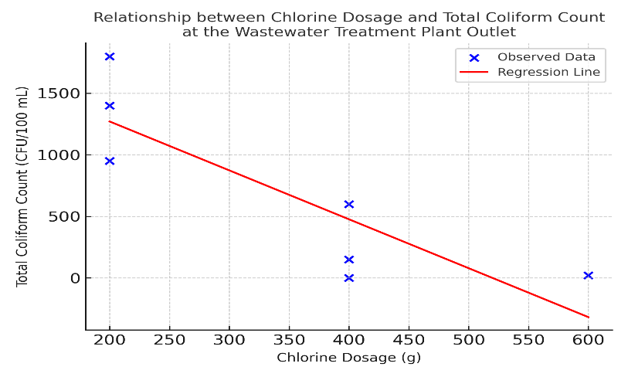
Figure 2. Relationship between Chlorine Dosage and Total Coliform Count at the Wastewater Treatment Plant Outlet.
The linear regression analysis between calcium hypochlorite dosage and Total Coliform concentration at the wastewater treatment plant outlet confirmed a statistically significant inverse relationship. The data showed a consistent declining trend, where increasing the chlorine dosage from 200 g to 600 g resulted in a substantial reduction of bacterial counts, culminating in complete elimination (0 CFU/100 mL) at the highest dosage. The derived regression equation, Total Coliform = 1928.22 − 3.475 × Chlorine Dose, indicates that for every additional gram of chlorine applied, the bacterial load is predicted to decrease by approximately 3.48 CFU/100 mL. The coefficient of determination (R² = 0.749) supports this finding, suggesting that 74.9% of the variation in Total Coliform levels can be explained by differences in chlorine dosage. These results highlight chlorine dosage as the dominant factor governing disinfection efficiency within the hospital wastewater treatment system. (Suwannasin et al., 2024)
The regression analysis showed that chlorine dosages between 400 and 600 grams were highly effective in achieving the national discharge standard for Total Coliform (<3000 CFU/100 mL). A dosage of 600 grams achieved complete microbial elimination, providing a wide operational safety margin. However, increasing the dosage beyond this statistically optimal range should be approached with caution due to potential chemical and environmental risks, including elevated effluent pH and the possible formation of harmful disinfection by-products such as trihalomethanes (THMs). The regression model provides strong empirical evidence of chlorination efficiency and establishes a scientific basis for optimizing hospital wastewater treatment processes to ensure both disinfection effectiveness and environmental sustainability (Saufi, Arifin and Hamzani, 2024). Building upon the regression results, a Pearson correlation analysis was conducted to validate the consistency and magnitude of the association between chlorine dosage and Total Coliform reduction, as summarized in Table 7.
Table 7. Pearson Correlation between Chlorine Dosage and Total Coliform Count in Hospital WWTP Effluent
Variable | Chlorine_Dosage | Total_Coliform_Outlet
Chlorine_Dosage | 1 | -0,923
otal_Coliform_Outlet | -0.923 | 1
Note: The negative Pearson correlation coefficient (r = −0.923) indicates a strong inverse relationship between chlorine dosage and Total Coliform concentration. This means that higher chlorine application consistently results in lower microbial counts in hospital wastewater effluent, confirming the strong disinfecting efficiency of chlorination under the tested conditions.
The Pearson correlation coefficient of −0.923 indicates a very strong negative relationship between chlorine dosage and Total Coliform concentration, meaning that higher chlorine doses consistently result in lower microbial contamination in hospital wastewater effluent. This finding supports the statistical analyses showing significant differences between lower (200 g) and higher (400–600 g) dosages. Based on these results, a 400-gram dosage is identified as the optimal level, as it effectively reduces Total Coliform counts to meet discharge standards while minimizing excessive chemical use. The variation in required dosage compared to other wastewater types reflects the higher microbial and chemical load typically found in hospital effluent, which demands a stronger disinfection approach to ensure equivalent levels of safety and compliance.(Mulyati et al., 2024). Moreover, the effectiveness of disinfection is influenced by multiple interrelated factors, including treatment scale, wastewater volume, system design, contact time, and environmental conditions such as pH and temperature. Methodological variations also contribute to differences in performance outcomes. While laboratory-scale studies typically focus on identifying the minimum effective dosage under controlled conditions, full-scale treatment systems are designed to achieve maximum disinfection efficiency with a broader safety margin, ensuring stable effluent quality under variable and real-world operating environments (Temesgen et al., 2023)
A related assessment demonstrated that administering 1–2 chlorine tablets (equivalent to 200–400 mg) effectively reduced Total Coliform levels by up to 99.9% in hospital wastewater effluent, achieving compliance with microbiological discharge standards (<3,000 MPN/100 mL). However, the treatment showed minimal effect on ammonia removal, with concentrations only partially reduced (approximately 31.8–72.8%) and remaining above the permissible limit of 10 mg/L. These results indicate that while chlorination is highly effective for microbial disinfection, it is less efficient in addressing chemical contaminants such as ammonia. Therefore, the integration of complementary treatment technologies—such as advanced oxidation processes, biological nitrification, or enhanced aeration—is essential to achieve comprehensive effluent quality and regulatory compliance. This highlights both the strengths and limitations of chlorination and underscores the importance of context-specific and integrated treatment strategies in hospital wastewater management (Saufi, Arifin and Hamzani, 2024)
  - Breakpoint Chlorination and Cost-Efficiency Analysis
Breakpoint chlorination analysis was conducted to identify the optimal chlorine dosage that achieves maximum disinfection efficiency against Total Coliform in hospital wastewater. The resulting curve shows that increasing the chlorine dosage from 200 g to 400 g leads to a substantial reduction in Total Coliform counts, achieving removal efficiencies greater than 99%. However, further increasing the dosage to 600 g provides no significant additional benefit, indicating that the breakpoint—where all oxidizable substances such as ammonia and organic matter have been completely reacted—has been reached at 400 g. Beyond this point, excess chlorine contributes only to the accumulation of free residual chlorine without improving disinfection effectiveness (Li et al., 2023)
Accordingly, a dosage of 400 g is considered optimal, balancing microbiological effectiveness with efficient chemical use. To complement this finding, a cost-efficiency simulation was conducted to assess its practical applicability, assuming a calcium hypochlorite tablet price of IDR 50 per gram and a treatment volume of 1 m³.
The analysis showed that disinfection efficiency increased progressively with higher chlorine dosages, although the economic return declined at elevated concentrations. A dosage of 200 g, with an estimated cost of IDR 10,000 per m³, achieved approximately 68% Total Coliform removal, indicating partial yet inadequate disinfection. Increasing the dosage to 400 g improved removal efficiency to 99.87% at a cost of IDR 20,000 per m³, representing an optimal balance between microbial elimination and chemical expenditure. Further increasing the dosage to 600 g raised the cost to IDR 30,000 per m³ but provided only a marginal efficiency gain of 0.13%, exceeding the practical threshold for cost-effective operation. These findings confirm that the 400 g dosage not only satisfies the national effluent quality standard for hospital wastewater (≤3,000 MPN/100 mL) but also represents the most rational and sustainable option in terms of both cost and environmental performance. The cost-efficiency curve illustrates that increasing the chlorine dosage beyond this level yields no substantial disinfection advantage while imposing additional economic and ecological burdens, making it unsuitable for routine wastewater treatment operations..(Mugwili et al., 2023). The relationship between chlorine dosage and removal efficiency is illustrated in Figure 3, which presents the breakpoint chlorination curve showing the trend between increasing chlorine concentration and Total Coliform reduction..
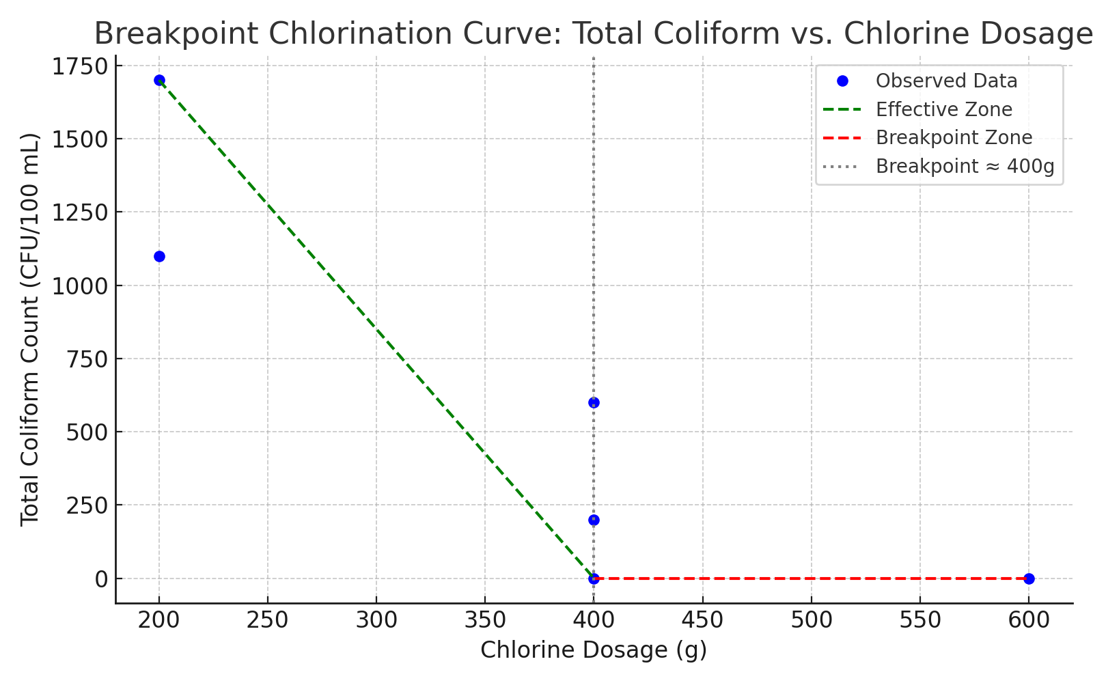
Figure 3. Breakpoint chlorination curve illustrating the relationship between chlorine dosage and Total Coliform reduction.
These findings are consistent with the preceding breakpoint chlorination analysis, confirming that the 400 g dosage not only represents the microbiological disinfection threshold but also serves as the most cost-efficient option for hospital wastewater treatment.
To further analyze the economic implications of dosage optimization, Figure 4 presents the cost-efficiency relationship between chlorine dosage and Total Coliform reduction effectiveness.
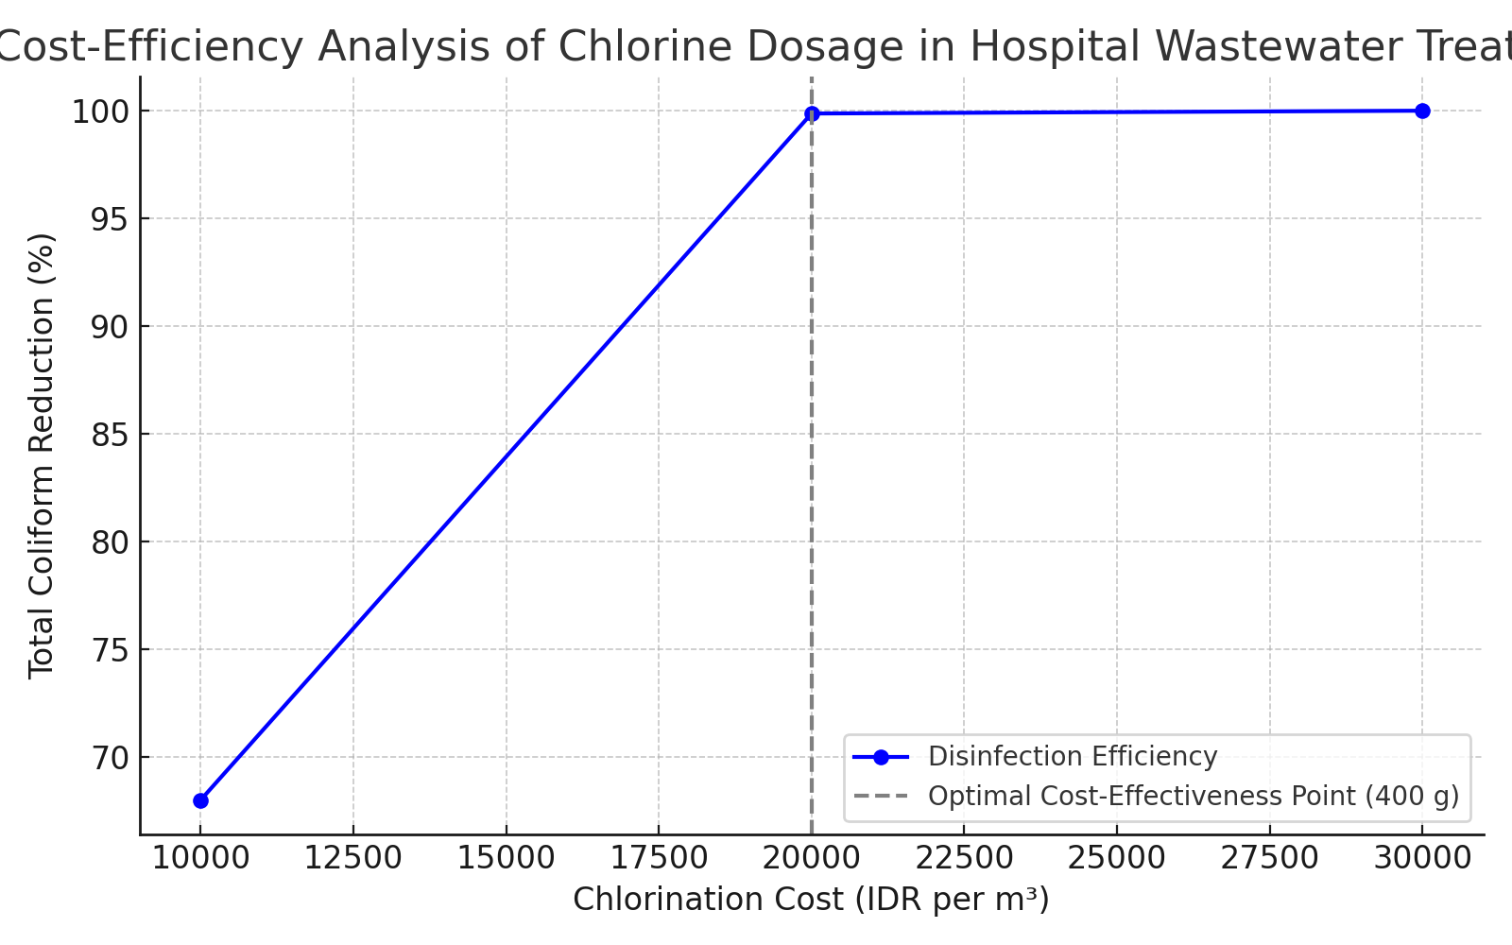
Figure 4. Cost-efficiency analysis of chlorination based on chlorine dosage and Total Coliform reduction effectiveness.
The cost-efficiency analysis of chlorine dosage in hospital wastewater treatment demonstrates a strong and consistent relationship between chlorine application cost and microbial disinfection performance. As the dosage increases from 200 g to 400 g, Total Coliform removal efficiency rises sharply, reaching nearly complete elimination. This optimal point, corresponding to an operational cost of approximately IDR 20,000 per cubic meter, represents the most effective balance between disinfection performance and financial expenditure. At this level, most oxidizable compounds such as ammonia and organic matter are likely fully reacted, resulting in maximum microbial inactivation. Beyond this point, additional increases in chlorine dosage such as up to 600 g, equivalent to a cost of around IDR 30,000 per cubic meter—do not produce meaningful further reductions in Total Coliform concentration. The plateau observed in efficiency indicates that the breakpoint chlorination threshold has been reached, and any excess chlorine remains as free residuals, offering no additional sanitary benefit while increasing chemical consumption and operational costs. Technically, this represents an inefficient use of disinfectant, and economically, it reduces the overall cost-effectiveness of the treatment process.(Rosende et al., 2020) Therefore, the 400 g chlorine dosage serves a dual function: it represents the microbiological breakpoint required to ensure compliance with national effluent standards and simultaneously serves as the economic optimum for hospital wastewater treatment. This dosage provides effective microbial control while minimizing chemical waste and supporting sustainable operational practices. These results emphasize the importance of integrating microbiological performance with cost-efficiency considerations in wastewater treatment systems, particularly within institutional facilities such as hospitals, where long-term sustainability and environmental compliance are essential..(Pariente et al., 2022)
- CONCLUSION

This study presents a comprehensive evaluation of chlorination performance in hospital wastewater treatment, establishing the optimal balance between microbial control, physicochemical stability, and environmental safety. Variations in chlorine tablet dosage and contact time significantly affected Total Coliform reduction, with statistical analyses confirming that 74.9% of the variation in bacterial levels was explained by chlorine dosage, exhibiting a strong inverse correlation (r = –0.923). Incremental increases in dosage from 200 g to 600 g resulted in substantial microbial reductions, with 400 g identified as the most efficient and practical dosage.

Chlorine dosage had a significant effect on pH (p < 0.05), while temperature remained relatively stable and statistically non-significant across treatments. Maintaining pH within the range of 6.5–7.5 is essential to sustain disinfection efficiency and minimize the risk of forming disinfection by-products such as trihalomethanes (THMs). All recorded pH (7.2–8.1) and temperature (28.8–29.3 °C) values complied with national discharge standards, confirming that the treated effluent met environmental safety requirements.

From a technical and operational perspective, a 400 g chlorine dosage with a 40–50 minute contact time is recommended as the most effective and sustainable disinfection strategy. Although higher dosages such as 600 g achieved complete microbial elimination, they provided no additional benefit and may increase the potential for THM formation. Continuous monitoring of key parameters—pH, temperature, chlorine dosage, and Total Coliform—together with adequate operator training, is crucial for consistent process optimization. Future research should focus on assessing THM formation potential, residual chlorine behavior, and long-term cost–benefit performance to enhance the safety, efficiency, and sustainability of hospital wastewater disinfection practices..

Disclaimer (Artificial Intelligence)
In accordance with the Code of Conduct and Publication Ethics of Science Domain International (SDI) and COPE guidelines, the authors declare that ChatGPT (GPT-5, OpenAI) was used only for language editing and improving clarity and academic style. The AI tool was not used to generate or analyze data or draw scientific conclusions. All research design, analysis, and interpretation were performed by the authors, who retain full responsibility for the originality and integrity of this work.
REFERENCE
Aib, H. et al. (2024) ‘Evaluating the efficiency of wastewater treatment plants in the Northern Hungarian Plains using physicochemical and microbiological parameters’, Water, 16(24), p. 3590. https://doi.org/10.3390/w16243590
Ajala, O.J. et al. (2022) ‘A review of emerging micro pollutants in hospital wastewater: environmental fate and remediation options’, Results in Engineering, 16, p. 100671. https://doi.org/10.1016/j.rineng.2022.100671
Azuma, T. and Hayashi, T. (2021) ‘On-site chlorination responsible for effective disinfection of wastewater from hospital’, Science of The Total Environment, 776, p. 145951. https://doi.org/10.1016/j.scitotenv.2021.145951
Azwarudin, A. et al. (2023) ‘Suitable technology for a household scale workshop systems for the treatment of wastewater’, Jurnal Pijar MIPA, 18(3), pp. 430–435. https://doi.org/10.29303/jpm.v18i3.4927
Coaguila Llerena, H. et al. (2024) ‘Calcium hypochlorite cytotoxicity mechanism in fibroblasts and effect on osteoblast mineralization’, International Endodontic Journal, 57(1), pp. 64–77. https://doi.org/10.1111/iej.13983
Connelly, L.M. (2021) ‘Introduction to analysis of variance (ANOVA)’, Medsurg Nursing, 30(3), pp. 218–221. https://doi.org/10.62116/MSJ.2021.30.3.218
Fallah, N. et al. (2025) ‘Chemical disinfection of secondary municipal wastewater effluents: optimizing CT dose and tailing effects through high-intensity mixing’, Water Environment Research, 97(4), p. e70066. https://doi.org/10.1002/wer.70066
Ge, B. et al. (2025) ‘Independent laboratory validation of a Salmonella loop-mediated isothermal amplification assay in 27 human and animal food matrices of 9 ISO food categories’, Food Microbiology, p. 104821. https://doi.org/10.1016/j.fm.2025.104821
Harahap, J. et al. (2021) ‘A review: Domestic wastewater management system in Indonesia’, IOP Conference Series: Earth and Environmental Science, 739, p. 012031. https://doi.org/10.1088/1755-1315/739/1/012031
Kumari, M. and Gupta, S.K. (2022) ‘Occurrence and exposure to trihalomethanes in drinking water: a systematic review and meta-analysis’, Exposure and Health, 14(4), pp. 915–939. https://doi.org/10.1007/s12403-022-00467-3
Li, Q. et al. (2023) ‘Chlorine-mediated electrochemical advanced oxidation process for ammonia removal: mechanisms, characteristics and expectation’, Science of The Total Environment, 896, p. 165169. https://doi.org/10.1016/j.scitotenv.2023.165169
Mompremier, R. et al. (2024) ‘Study of the combined effect of temperature and free chlorine concentration on the chlorine bulk decay coefficient in water supply systems’, Water Supply, 24(12), pp. 4046–4056. https://doi.org/10.2166/ws.2024.255
Mugwili, M.E. et al. (2023) ‘A pilot study on the removal of ammonia from aqueous solution using the integration of struvite synthesis and breakpoint chlorination’, Advances in Environmental Technology, 9(2), pp. 85–97. https://doi.org/10.22104/aet.2023.5912.1623
Mulyati, T.A. et al. (2024) ‘Identification of pathogenic bacteria in liquid waste from “X” Hospital in Kediri City’, Ad Dawaa’ Journal of Pharmaceutical Sciences, 7(2), pp. 109–116. https://doi.org/10.24252/djps.v7i2.50196
Nishmitha, P.S. et al. (2025) ‘Understanding emerging contaminants in water and wastewater: a comprehensive review on detection, impacts, and solutions’, Journal of Hazardous Materials Advances, p. 100755. https://doi.org/10.1016/j.hazadv.2025.100755
Pariente, M.I. et al. (2022) ‘Critical review of technologies for the on-site treatment of hospital wastewater: from conventional to combined advanced processes’, Journal of Environmental Management, 320, p. 115769. https://doi.org/10.1016/j.jenvman.2022.115769
Rolbiecki, D. et al. (2022) ‘The impact of chlorine disinfection of hospital wastewater on clonal similarity and ESBL production in selected bacteria of the family Enterobacteriaceae’, International Journal of Environmental Research and Public Health, 19(21), p. 13868. https://doi.org/10.3390/ijerph192113868
Romanovski, V. et al. (2024) ‘Comparative analysis of the disinfection efficiency of steel and polymer surfaces with aqueous solutions of ozone and sodium hypochlorite’, Water, 16(5), p. 793. https://doi.org/10.3390/w16050793
Rosari, N.L. and Purwanti, I.F. (2020) ‘Design of sewerage system and wastewater treatment plant in Asemrowo, Surabaya, Indonesia’, IOP Conference Series: Earth and Environmental Science, p. 012021. https://doi.org/10.1088/1755-1315/506/1/012021
Rosende, M. et al. (2020) ‘Cost-effectiveness analysis of chlorine-based and alternative disinfection systems for pool waters’, Journal of Environmental Engineering, 146(1), p. 04019094. https://doi.org/10.1061/(ASCE)EE.1943-7870.0001610
Saufi, Y., Arifin, A. and Hamzani, S. (2024) ‘The impact of chlorine tablets on ammonia and MPA coliform parameters in the effluent of the sewage treatment plant at Banjarmasin Surgical Special Hospital Emergency 2023’, Global Health & Environmental Perspectives, 1(2), pp. 101–106. https://doi.org/10.61848/ghep.v1i2
Senthilkumar, M. et al. (2021) ‘Enumeration of Rhizobia: Most Probable Number (MPN) Technique’, in Rhizobia. Springer, pp. 9–17. https://doi.org/10.1007/978-1-0716-1080-0_2
Shafik, W. (2025) ‘SDG 6: Clean Water and Sanitation—Smart Water Management’, in Factoring Technology in Global Sustainability: A Focus on the Sustainable Development Goals. Springer, pp. 223–248. https://doi.org/10.1088/1755-1315/506/1/012021
Stevens, M., Ashbolt, N. and Cunliffe, D. (2003) ‘Review of coliforms as microbial indicators of drinking water quality’, NHMRC, Biotext Pty Ltd, Canberra. ISBN 1864961651.
Sulistiawati, L.Y. (2022) ‘Challenges in marine plastic pollution regulation in Indonesia’, Asia Pacific Journal of Environmental Law, 25(1), pp. 100–118. https://doi.org/10.4337/apjel.2022.01.05
Susetyaningsih, R. et al. (2023) ‘Water quality assessment to improve the ecological function of waters: the South Coast of the Yogyakarta Shrimp Farming Area’, Journal of Water and Land Development. https://doi.org/10.24425/jwld.2023.147244
Suwannasin, S. et al. (2024) ‘Reduction and regrowth of total coliform bacteria, fecal coliform bacteria, and E. coli after chlorine and peracetic acid disinfection in hospital effluent’, ScienceAsia, 50(1), p. 2024026. https://doi.org/10.2306/scienceasia1513-1874.2024.026
Temesgen, G. et al. (2023) ‘Evaluation of chlorination efficiency on improving microbiological and physicochemical parameters in water samples available in Sheble Berenta district Amhara region, Ethiopia’, Applied Water Science, 13(5), p. 120. https://doi.org/10.1007/s13201-023-01922-5
Titaley, C.R. et al. (2020) ‘Health care–seeking behavior of children with acute respiratory infection symptoms: analysis of the 2012 and 2017 Indonesia Demographic and Health Surveys’, Asia Pacific Journal of Public Health, 32(6–7), pp. 310–319. https://doi.org/10.1177/1010539520944716
Trautmann, E. et al. (2021) ‘Hydrogen peroxide versus sodium hypochlorite: all a matter of pH?’, Journal of Endodontics, 47(2), pp. 297–302. https://doi.org/10.1016/j.joen.2020.10.016
Wang, Y. et al. (2025) ‘Mechanism and risk control of chlorine-resistant bacteria in drinking water supply systems: a comprehensive bibliometric analysis’, Water, 17(7), p. 956. https://doi.org/10.3390/w17070956
Yan, S. et al. (2020) ‘Guidelines for hospital wastewater discharge’, in Current Developments in Biotechnology and Bioengineering. Elsevier, pp. 571–597. https://doi.org/10.1016/B978-0-12-819722-6.00016-X
Yannawar, V.B. (2022) ‘Most probable number (MPN) Coliform test to detect the presence of coliform from Godavari River water of Nanded city, Maharashtra, India’, Indian Journal of Applied & Pure Biology, 37(2), pp. 478–487. https://doi.org/10.47422/ijapb.v37i2.23
Zhu, G. et al. (2021) ‘Multi-linear regression model for chlorine consumption by waters’, Environmental Engineering Research, 26(4), p. 200402. https://doi.org/10.4491/eer.2020.402
.

