Sedimentation rates and its impact on juvenile coral density and survival on reefs of Unguja Island, Zanzibar, Tanzania

ABSTRACT

Sedimentation can hinder coral recruitment and early survival, but its variation across Zanzibar reefs is poorly quantified for restoration planning. We assessed the temporal and spatial variability of sedimentation rates at three reef sites on Unguja Island, Zanzibar (Chumbe, Changuu, and Mnemba reefs), and their relationships with juvenile coral density and juvenile coral survival, during five seasonal periods in 2011–2012 using sediment traps and repeat juvenile coral surveys. During the study period, sedimentation rates at Chumbe ranged from 0.97 mg cm⁻² day⁻¹ in November 2011-January 2012 and 9.07 mg cm⁻² day⁻¹ in May-July 2011, from 1.69 mg cm⁻² day⁻¹ in May-July 2011 to 5.47 mg cm⁻² day⁻¹ in February-April 2011 at Changuu, and from 0.7 mg cm⁻² day⁻¹ in September-November 2011 to 1.4022 mg cm⁻² day⁻¹ in November 2011-January 2012 at Mnemba. On average, sedimentation rates were higher at Chumbe reef (4.67 mg cm⁻² day⁻¹) relative to Changuu (3.67 mg cm⁻² day-¹) and were lowest at Mnemba reef (1.22 mg cm⁻² day⁻¹). Sedimentation rates were highest and lowest on reef slopes and crests, respectively. High sedimentation rates at Chumbe were observed from May-July 2011, and low rates were measured from November 2011 to May 2012. At Changuu, high sedimentation rates were recorded between January and May 2012 and a low rate between May and October 2011. At Mnemba, high sedimentation rates were recorded between January 2012 and May 2012, and low rates were recorded between July 2011 and November 2011. There were no relationships between sedimentation rates, juvenile coral densities, and survival in reef sites. The results suggest that sedimentation was low and did not negatively impact juvenile coral densities or survival. Furthermore, the May-July period is not suitable for coral transplants at Chumbe, as is February-May at Changuu reef. The findings provide actionable guidance for scheduling reef restoration.

Keywords: Sedimentation rates, juvenile corals, reefs, Unguja Island, Zanzibar, Tanzania.

1. INTRODUCTION
The increasingly growing human population along the coasts threatens coral reefs globally (Sauter et al., 2021; Sing Wong et al., 2022). These threats include increased sediment input into coastal waters. Sediments mainly result from changes in land-use practices (McLaughlin et al., 2003; Mameno et al., 2025), such as increased agricultural activities (MacManus, 1988; McCulloch et al., 2003; Neumann et al., 2025), coastal constructions (Brown, 1987), drilling and mining (Dodge and Vaisnys, 1977; Rogers, 1990, Dollar and Grigg, 2004; Cunning et al., 2019; Bhuyan et al., 2025), dredging and dumping of both liquid and solid wastes into the ocean (Rogers, 1990, Cole et al., 1993; Carreiro-Silva et al., 2022). These activities are intended to meet demands for nutrition, habitat, economy and sanitation, respectively. Additionally, beach erosion caused by powerful waves may significantly contribute to sediment resuspension, particularly on nearshore reefs, such as those found in Zanzibar (Muzuka et al., 2010). Such sediment load and resuspension in coastal waters may lead to sedimentation and turbidity stress on corals in adjacent coral reefs (Gove et al., 2023; Tuttle and Donahue, 2022; Ussi et al., 2024).

Corals are sensitive to small changes in environmental conditions, due to their narrow physiological tolerance ranges (Endean, 1976; Pearson, 1981; Pastorok and Bilyard, 1985; Martell and Donner, 2025). Thus, slight variations in sedimentation rates outside these narrow tolerance ranges could be critical to coral growth, survival, and reef development (Roy and Smith, 1971; Gleason, 1998; Tuttle and Donahue, 2022; Lock et al., 2024; Good et al., 2025). Corals have different tolerance limits to sedimentation (Rogers, 1990; Fabricius, 2005; Minton et al., 2022). They remove sediment particles from their coral polyps using their tentacles (Fähse et al., 2023). Sediment removal, however, is an energy consuming process (Tuttle and Donahue, 2022; Zweifler et al., 2024). Thus, corals may fail to thrive when sediments accumulate on them faster than they can be removed (Victor et al., 2006). This situation partly explains why coral reefs are rarely found in areas adjacent to large river mouths and along sediment-laden coastal stretches (Spalding et al., 2001; Muzuka et al., 2010; Isacksson et al., 2019; Santana et al., 2023; Samperiz et al., 2025; Dehm et al., 2025).

Several studies have demonstrated that sediment loads impact corals and other reef organisms (e.g., Roy and Smith, 1971; Dodge and Vaisnys, 1977; Rogers, 1990; Humphrey et al., 2008; Mejia-Echeverry et al., 2018; Tuttle and Donahue, 2022; Bhuyan et al., 2025). Suspended sediment loads block light penetration to corals through light scattering and absorption (Woolfe and Larcombe, 1999; Lin et al., 2024; Lock et al., 2024). Extreme sedimentation smothers reef bottoms and clogs corals, preventing feeding and respiration (Babcock, 1991; Rogers and Ramos-Scharrón, 2022). Such physical characteristics of sediment loads have several biological consequences (Rogers, 1990; Good et al., 2025). Light hindrance reduces coral productivity as little food becomes available to corals from their endosymbiotic dinoflagellates (Woolfe and Larcombe, 1999). Smothering decreases the amount of available substratum for coral larval settlement (Rogers et al., 1984; Serrano et al., 2024), thereby reducing coral recruitment success (Sammarco, 1980; Wallace, 1985; Rogers and Ramos-Scharrón, 2022). Clogging of the corals' feeding and respiratory apparatuses causes physiological stress (Fabricius, 2005). The stress may lead to a change in energy allocation, such that more energy is directed towards propelling sediments away from the coral polyps, rather than being allocated towards growth and reproduction (Rogers, 1990; Rogers, 1983; Tuttle and Donahue, 2022; Ashey et al., 2024). Additionally, the physiological stress induced by sedimentation on corals makes them vulnerable to other threats such as competition, predation, bleaching, and disease (Carlson et al., 2022; Page et al., 2023).

In Zanzibar, studies of sedimentation rates on corals are limited to a few reef sites and have primarily focused on their impact on adult coral populations (e.g., Nzali et al., 1998; Muhando, 2003; Muzuka et al., 2010; Bravo et al., 20021). Information on temporal variability in sedimentation rates among reef habitats and their effects on the densities and survival of juvenile corals is limited. Such information is crucial for understanding sedimentation patterns on Zanzibar's reefs. Information on sedimentation patterns is required to set reef management strategies that include coral recolonization options, such as larval settlement enhancement and coral-fragment transplantation (Muhando, 2003). This study investigated the temporal and spatial variability in sedimentation rates at three reef sites over three-month intervals, from January 2011 to May 2012. Sedimentation rates were associated with juvenile coral densities and survival.

2. material and methods
2.1 Study sites
The study was carried out on three reef sites in Unguja Island: Chumbe, Changuu, and Mnemba (Fig.1a). While Chumbe reef is located on the western side of the Chumbe Island Coral Park, Changuu reef is situated on the eastern side of Changuu Island. Mnemba reef is located on the west side of Mnemba Island. Chumbe reef experiences rough sea conditions during the southeast monsoon (SEM) (April to September), while Changuu and Mnemba reefs become exposed to strong winds during the northeast monsoon (NEM) (October to March) (Painter, 2020). Changuu reef is located near sediment discharge points, such as the Zanzibar municipal dumping site at Maruhubi and the sewage outlets at Mizingani and Kinazini from Zanzibar municipal. Chumbe and Mnemba reefs are not located near sediment discharging points. All sites experience reversing tidal currents, with strong and long-lasting northward currents (Mwaipopo, 1990; Painter, 2020). Unlike Mnemba, Chumbe and Changuu reefs have well defined reef slopes, crests and flats. Fine sand and silt form the primary substrate at the end of reef slopes in all sites. Chumbe reef is close to the main traffic of Zanzibar-Dar es Salaam ferries, whereas Changuu and Mnemba reefs are not. Chumbe experiences relatively rough weather during the SEM period and calm conditions during the NEM period. Changuu and Mnemba reefs experience rough weather during NEM and relatively calm weather during SEM.

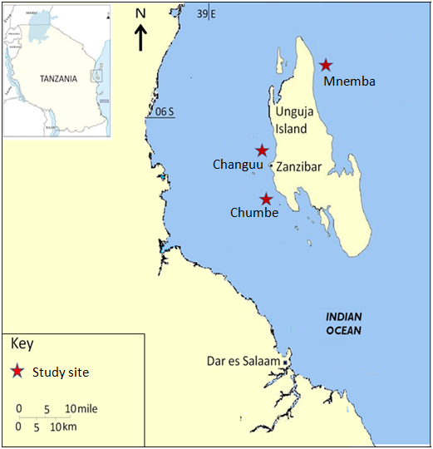
Figure 1a: Map showing the location of study sites; Chumbe, Changuu and Mnemba. Chumbe ( 06° 16′ 38.57″ S, 39° 10′ 31.06″ E), Changuu (06° 07′ 07.06″ S, 39° 09′ 59.74″ E) and Mnemba (05° 48′ 58.71″ S, 39° 22′ 59.20″ E).

2.2 Field methods
2.2.1 Sampling design
Two sampling plots (plot one and plot two - 50 m x 75 m, each) were established at each site (Fig. 1b.). Each plot was intended to be a replicate of the other, covering all available reef habitats (reef flat, reef slope and reef crest), and were located about 300m apart. Six-2m x 2m permanent quadrats were established on each plot; two quadrats in each habitat. The quadrats were placed on substrates suitable for coral recruitment, with at least 50% coverage of hard substrates available for coral recruits. The replicates plots were intended to provide an authentic replication for within-site replicates, ensuring that site means and confidence intervals were not based on a single location. This was important to strengthen inference and reduce the chance that a local anomaly drives a site's results. Additionally, the two plots within each sampling site was for comparison to capture fine-scale heterogeneity to reveal the extent of small scale variation within a site.

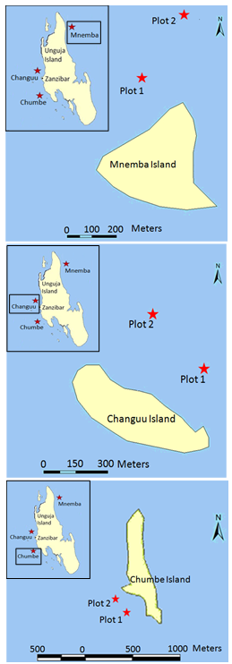

Figure 1b: Map showing location of sampling plots at Chumbe, Changuu and Mnemba reefs.

2.2.2 Sedimentation rates measurement
Sedimentation rates were determined at 90-day intervals from January 2011 to May 2012, using the method described by English et al. (1994). Twelve sediment traps (four traps per habitat) were deployed in the field at each sampling plot. The traps were 10.9cm high and 5.3cm in diameter, constructed from a PVC pipe (Plate 1). The sampling traps were tightly secured using cable ties to steel bars; the tops of the pipes were established 20cm above the sea bottom to avoid resuspension of sediments. The sediments were retrieved in April 2011, July 2011, November 2011, January 2012, and May 2012 from all sites, except for Mnemba, where the April 2011 data could not be retrieved due to strong winds in February 2011. The retrieved sediments were brought to the laboratory. The traps were cleaned and redeployed in the field soon after sediment retrieval on the same day. In the laboratory, samples were filtered using Whatman filter paper number 2 in a Buchner funnel. To remove salts from the sediments, the filtrate was rinsed by gently flowing approximately 200 mL of distilled water through the funnel. The sediment containing filter paper was then dried in the oven at 60 °C to a constant weight. The sedimentation rate was considered as the predictor variable, which was computed in milligram per centimeter sqaure per day (mg cm⁻² day⁻¹) (Gardner, 1980; Storlazzi et al., 2011) as:

$$Sedimentation rate=\frac{Sediment dry weight }{Area of jar opening \left({πr}^{2}\right)in {cm}^{2} x deployment days }$$

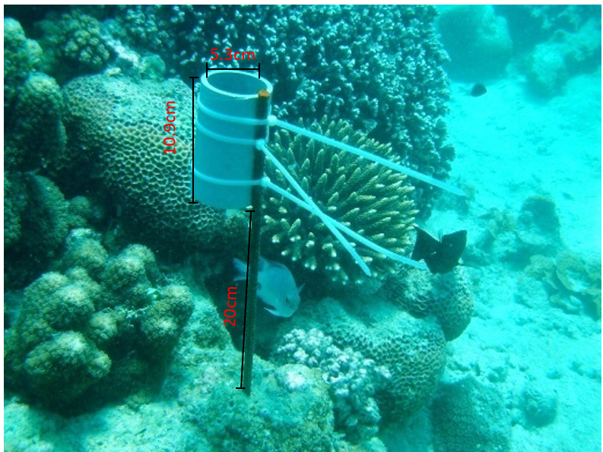

Plate 1: Sediment trap set up

2.2.3 Assessment of juvenile coral densities and survival
Juvenile corals were defined as colonies with a canopy diameter of < 10 cm, distinguishable from microscopic coral spat (Bak and Engel, 1979). The same six permanent quadrats per station (two in each reef habitat) used to assess sedimentation rates were used to monitor juvenile corals. Within 2m × 2m quadrats, juveniles were identified to genus level, mapped for relocation, and monitored across sampling periods. Sampling was conducted in three month interval from April 2011 to May 2012. Juvenile coral density was expressed as individuals per square meter. Mortality was recorded when previously observed juveniles were absent or overgrown by algae (Plate 2). Survival rates were calculated as the proportion of juveniles persisting between sampling periods. For the relationship between juvenile coral density and sedimentation rates, data from April 2011, November 2011, and May 2012 were used for the Chumbe and Changuu reef sites, while data from November 2011 and May 2012 were used for Mnemba. This was due to the lack of data for Mnemba in April 2011. The November 2011 and May 2012 data were used for all reef sites. Juvenile coral density and survival rates were considered as response variables in this study. Due to differences in the magnitude of the predictor variable among sites, the relationships between sedimentation rates and juveniles' densities and survival were determined independently for each site.

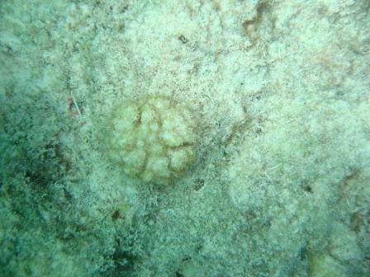

Plate 2: Juvenile coral covered with algae

2.3 Data analyses
Analysis of variance (ANOVA) was used to test for variations in mean sedimentation rates among sampling plots, reef habitats, seasons, and sites. The Hartley test was used to test for the validity of running parametric tests. Data that did not meet the parametric assumptions were either log- or square-root-transformed. Simple regression models (GLMs) were used to determine whether sedimentation rates were associated with the dependent variables: recruitment and post-recruitment survival rates of juvenile corals. Additionally, ANOVA (F-test) was used to test the significance of the regression slopes. All GLM analyses were performed using Statistica 7 software.

3. results
3.1 Sedimentation rates across sites, habitats, and temporal patterns
At Chumbe, sedimentation rates (mg cm⁻² day⁻¹) ranged from 0.97 during November 2011 -January 2012 to 9.07 during May - July 2011 (Fig. 2), with a site average of 4.67 mg cm⁻² day⁻¹. The overall minimum and maximum observed at Chumbe were 0.19 and 16.14 mg cm⁻² day⁻¹, respectively. At Changuu, rates varied from 1.69 mg cm⁻² day⁻¹ in May - July 2011 to 5.47 mg cm⁻² day⁻¹ in February-April 201, with a site mean of 3.66 mg cm⁻² day⁻¹ and an overall range of 0.64 - 8.75 mg cm⁻² day⁻¹. At Mnemba, sedimentation spanned 0.70 mg cm⁻² day⁻¹ in September - November 2011 to 1.64 mg cm⁻² day⁻¹ in February - May 2012, with a site mean of 1.22 mg cm⁻² day⁻¹, and a total range of 0.10 - 3.60 mg cm⁻² day⁻¹. Plot level comparisons within sites showed no significant differences between sampling plots in all sites (Fig. 3), hence data were aggregated at the site level. Among reefs, Chumbe exhibited significantly the highest sedimentation (4.67mg cm⁻² day⁻¹), group sizes were n = 60 per site (total N = 180), (ANOVA: F = 203.271, df = 2, P < .001), followed by Changuu (3.66 mg cm⁻² day⁻¹), whereas Mnemba had the lowest (1.22 mg cm⁻² day⁻¹).

Figure 2: Mean sedimentation rates in month intervals among sites. Error bars denote 0.95 confidence intervals.

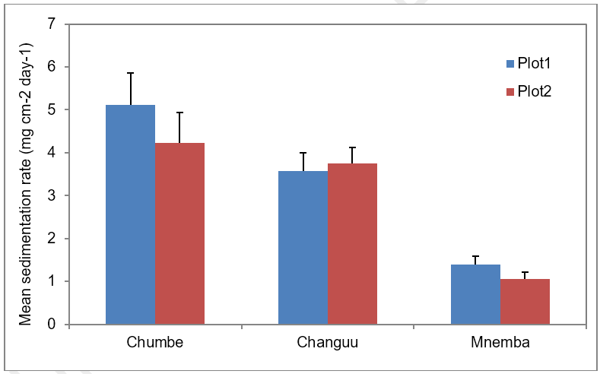

Figure 3: Mean sedimentation rates at sampling plots. Error bars denote standard deviation of the mean.

Across sites, sedimentation was highest on reef slopes and lowest on reef crests (Fig. 4). Within-site habitat effects were significant at all reefs, group sizes were n = 20 per habitat per site (total N =180): Chumbe (ANOVA: F = 272.956, df = 2, P < .001), Changuu (ANOVA: F = 50.5471, df = 2, P < .001), and Mnemba (ANOVA: F = 123.1607, df = 2, P < .001), with markedly greater among-habitat variation at Chumbe relative to Changuu and Mnemba.

Figure 4. Mean sedimentation rates at reef habitats. Error bars denote 0.95 confidence intervals.

Sedimentation varied through time at all sites (Fig. 2). At Chumbe, rates were significantly higher in May-July than during other sampling periods, group sizes were n = 24 for May – July and n = 36 for August - April per site (total N = 60): (ANOVA: F = 162.428, df = 4, P < .001). At Changuu, significantly elevated rates occurred from February to May, compared with other periods, group sizes were n = 24 for February - May and n = 36 for June - April per site (total N = 60): (ANOVA: F = 31.6894, df = 4, P < .001). At Mnemba, sedimentation was significantly higher during January - May than at other times, group sizes were n = 24 for January - May and n = 36 for June - April per site (total N = 60) (ANOVA: F = 20.3079, df = 3, P < .001).

3.2 Juvenile coral abundance, density, and seasonality
Across the 864 m² surveyed, 10,932 juvenile corals were recorded, spanning 13 families and 38 genera. Site-level contributions were disproportionately distributed, with Changuu accounting for 43% of the records, Chumbe for 30%, and Mnemba for 27%. Mean juvenile density (individuals m⁻² ± SE) differed significantly among sites, being highest at Changuu (16.4 ± 1.3), intermediate at Chumbe (12.2 ± 0.6), and lowest at Mnemba (10.3 ± 0.8), group sizes were n = 60 per site (total N = 180), (ANOVA: F = 14.671, df = 2, P < .001). Observed density ranges were 4.8 - 25.5 m⁻² at Chumbe, 3.8 - 49.0 m⁻² at Changuu, and 1.75 - 30.25 m⁻² at Mnemba. No significant plot-level effects were detected within sites; therefore, plot data were pooled for site-level inference.

At Chumbe, juvenile density did not vary among habitats, reef slope (10.4 m⁻²), reef crest (11.7 m⁻²), and reef flat (11.6 m⁻²) (Fig. 4). By contrast, significant habitat effects were evident at Changuu (ANOVA: F = 6.255, df = 2, P = .003) and Mnemba (ANOVA: F = 10.683, df = 2, P < .001), group sizes were n = 20 per habitat per site (total N =180). At Changuu, densities were low on the reef slope (11.6 m⁻²) relative to the reef flat (18.6 m⁻²) and reef crest (19.2 m⁻²). At Mnemba, densities were lowest on the reef flat (6.7 m⁻²) compared with the reef crest (10.7 m⁻²) and reef slope (13.4 m⁻²)

There was no significant inter-plot seasonal variation detected within sites (ANOVA: F = 0.182, df = 2, P = .83). When habitat data were pooled, seasonal differences between the Southeast Monsoon (SEM) and Northeast Monsoon (NEM) were also non-significant across all sites (ANOVA: F = 0.321, df = 2, P = 0.72), although modest site-specific shifts were apparent. Mean densities (individuals m⁻²) at Changuu were 17.73 (SEM) and 15.52 (NEM); at Mnemba, 10.38 (SEM) and 10.20 (NEM); and at Chumbe, 10.98 (SEM) and 11.42 (NEM). At the habitat level, no significant seasonal effect was detected within sites (ANOVA: F = 1.099, df = 4, P = .36). Nevertheless, non-significant trends indicated higher densities on reef flats and reef crests during SEM at Changuu, as well as higher densities on reef flats during SEM and on reef slopes during NEM at Mnemba.

3.3 Relationships between sedimentation and juvenile coral density and survival
There was a weak negative relationship between sedimentation and juvenile coral recruitment density at Chumbe and Changuu reefs (Fig. 5). The relationships were not statistically significant, with only 2% and 3% of the change in juvenile coral density accounted for by the change in sedimentation at the former and latter reef sites, respectively. By contrast, juvenile coral recruitment density at Mnemba was significantly positively related to sedimentation (ANOVA; F = 8.0063, P = .009). However, the relationship was weak, in which only 27% (Fig. 5c) of the change in juvenile coral densities accounted for the explained change in sedimentation. Additionally, sedimentation was not related to the survival of juvenile corals at Chumbe reef, whereas sedimentation was positively associated with survival at Changuu and Mnemba reefs. The relationship was not statistically significant in either reef.

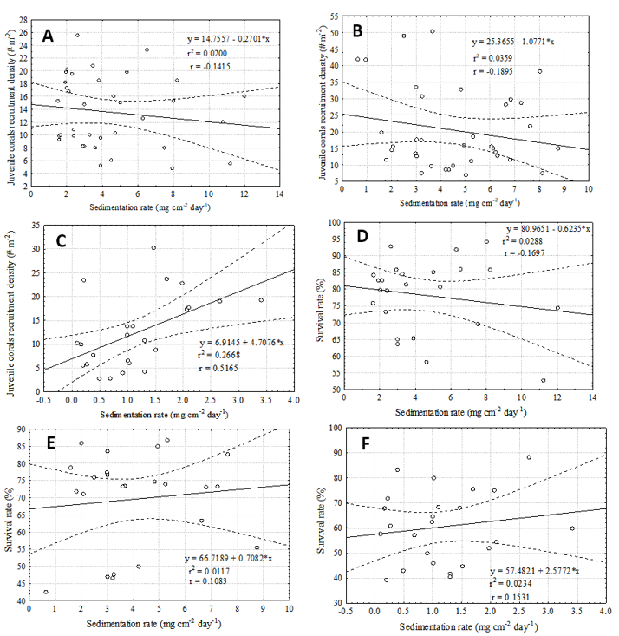
Figure 5: Regression analysis between sedimentation rates and juvenile coral recruitment density at Chumbe reef (A), Changuu reef (B) and Mnemba reef (C); and between sedimentation rates and post- recruitment survival of juvenile coral at Chumbe reef (D), Changuu reef (E) and Mnemba reef (F). Doted lines denote 0.95 confidence intervals.

4. discussion
Sedimentation dynamics within reef sites appear to be driven by monsoon wind regimes. At Chumbe, elevated sedimentation occurred from May to July (Fig. 2), coinciding with exposure to the Southeast Monsoon (SEM) due to the reef's orientation relative to prevailing winds. The results suggest that the bulk of the sedimentary material comprised reef-derived carbonate particles rather than terrestrial sediments. At Changuu and Mnemba, peak sedimentation occurred between February and May, when these reefs are exposed to the Northeast Monsoon (NEM) winds. The concurrence of higher sedimentation with stronger winds indicates that wind-driven waves promote the resuspension of carbonate sediments, thereby enhancing trap loads and driving monthly variability. The sedimentation pattern at Chumbe aligns with earlier observations by Muhando (2003) and Muzuka et al. (2010). Similarly, the patterns documented at Changuu and Mnemba mirror findings from Bawe reef in Zanzibar reported by Muhando (2003) and Muzuka et al. (2010). The possible reason could be because the trap-exposed flanks at Bawe, Changuu, and Mnemba all face NEM conditions. Collectively, these trends suggest that the locally calmer seasons, from November to May at Chumbe and from May to November at Changuu and Mnemba, are operationally favorable for coral transplantation and larval settlement, both due to improved accessibility and more conducive growth conditions.

Contrary to expectations, sedimentation rates were not highest at Changuu, despite its proximity to potential terrestrial inputs from the Maruhubi dumpsite and sewage outfalls at Mizingani and Kinazini. Instead, Chumbe exhibited the highest rates, followed by Changuu and Mnemba. A plausible explanation could be that mangrove stands at Maruhubi and adjacent seagrass meadows act as sediment filters, trapping a substantial fraction of land-derived material before it reaches Changuu reef. It is important to note that the measured sediments integrated both terrestrially derived and reef-derived (carbonate) sediments, which were not discriminated in this study. Consequently, terrestrial inputs may indeed have been relatively higher at Changuu, whereas carbonate resuspension driven by hydrodynamics may have been strongest at Chumbe. In general, terrestrial particles are finer than the typically coarse-grained carbonate reef sediments and are therefore more difficult for coral polyps to expel, potentially impairing polyp function.

Another factor likely shaping the observed patterns is the predominantly northward flow of ocean currents in the Zanzibar Channel (Shaghude et al., 2002; Muzuka et al., 2010), which can influence circulation between Unguja Island and the offshore islets adjacent to Zanzibar Town, particularly near Chapwani, Snake, and Changuu. Such currents may disperse suspended material northward, diverting sediments away from Changuu reef. Additionally, Bergman (1970) reported that Southeast Monsoon (SEM) winds are substantially stronger than those of the Northeast Monsoon (NEM). Accordingly, the elevated sedimentation at Chumbe is most plausibly attributable to intensified resuspension of bottom carbonate sediments under SEM forcing, in contrast to the weaker NEM driven hydrodynamics affecting Changuu and Mnemba.

In this study, sedimentation rates were consistently higher on reef slopes across sites (Fig. 4). The observed pattern plausibly attributable to enhanced resuspension driven by wave breaking and subsequent downslope transport of particulates. Notably, juvenile coral survival at Chumbe and Mnemba was greater on reef slopes than on reef crests or reef flats. Corals are known to actively clear settled particles using ciliary mucus transport and tentacular manipulation (Victor et al., 2006; Rogers and Ramos-Scharrón, 2022), and the hydrodynamic context is critical, as flow velocities are typically higher on reef slopes than in other habitats (Larcombe et al., 1995; Ashey et al., 2024). The elevated survivorship on slopes is therefore likely linked to stronger near-bed currents that limit net particle deposition on coral surfaces, thereby reducing sediment related stress and improving post settlement survival.

Although mean sedimentation at Chumbe and Changuu was approximately four and three-fold higher than at Mnemba, respectively, rates at all three sites remained below the lethal threshold of 10 mg cm⁻² day⁻¹ proposed by Rogers (1990). Sedimentation showed no detectable association with juvenile coral density or survival at Chumbe and Changuu (Fig. 5), and only weak positive relationships with both dependent variables at Mnemba. Collectively, these patterns indicate that sedimentation levels during the study were generally insufficient to constrain juvenile coral density or survival across sites. However, the May - July peak at Chumbe (Fig. 2) approached the lethal threshold, suggesting that occasional events at this site may intermittently reach levels detrimental to corals. Accordingly, coral transplantation or nursery activities at Chumbe should be avoided during the May-July period, as it appears operationally unsuitable due to the elevated risk of near-threshold sedimentation.
Placing these 2011–2012 results in today's context, the monsoon framework that likely drove most sediment resuspension (SEM ~ April-September; NEM ~ October–March) and the predominantly northward Zanzibar Channel flow (Mwaipopo, 1990; Painter, 2020), remain the first-order physical controls. The observed pattern that higher sedimentation rates occur when each site is exposed to its "windward" season broadly persists (NEMC, 2024). However, reef condition and human pressures have changed significantly since the original study. Multiple mass-bleaching episodes (notably 2016 and the 2023–2024 global event) have been documented around Unguja, including at Chumbe and Mnemba, altering coral cover and taxa most prone to sediment stress (Ussi et al., 2019). Such community changes can modify how easily bottom carbonate sediments are generated and resuspended. Management has also improved. Mnemba Island Marine Conservation Area and long-standing protection at Chumbe continued. At the same time, broader governance and financing for marine conservation have expanded, factors that can minimize local stressors but do not eliminate climate-driven extremes (Yahya, 22021). Given these updates, it is reasonable to expect the study's seasonal ranking of sedimentation risk (e.g., SEM-exposed Chumbe peaking in May–July; NEM-exposed Changuu/Mnemba peaking in February-March) to still be directionally valid, yet with higher variability and occasional spikes tied to stronger heatwaves and storminess that now occur on top of the monsoon winds. Consequently, the current restoration planning should still be guided by these findings, avoiding high-exposure months, and be linked with real-time thermal stress and wind forecasts, as well as site checks of post-bleaching substrate condition (rubble vs. consolidated framework), which strongly influences resuspension potential and trap loads (Ussi et al, 2024).
4. Conclusion
Sedimentation dynamics across the three reefs on Unguja Island were seasonally structured and site-specific. Chumbe exhibited pronounced elevations from May to July, whereas Changuu and Mnemba peaked from February to May. Mnemba was relatively stable throughout the year, aside from a minimum in September-November. Across sites, absolute sedimentation followed the gradient Chumbe > Changuu > Mnemba, and was consistently highest on reef slopes. Importantly, observed rates remained below the putative lethal threshold of 10 mg cm⁻² day⁻¹ and were not associated with significant reductions in juvenile coral density or survival. From a management perspective, these patterns indicate that periods of elevated sedimentation are operationally suboptimal for restoration activities. Specifically, coral growth and out-planting at Chumbe should be avoided during the May-July period, while comparable activities at Changuu should be avoided during the February-May interval. Conversely, windows characterized by lower background loads offer more favorable conditions for transplantation and early post-settlement performance.

AcknowledgEments
The authors would like to thank the management of Institute of Marine Sciences (IMS) of the University of Dar es Salaam (UDSM), Zanzibar, Tanzania for providing a PhD Scholarship that made this study possible. This research was sponsored by Sida Bilateral Marine Sciences Program at IMS.

Authors’ Contributions
AU: Conceptualization, Investigation, Data curation, Formal analysis, Methodology, Writing – original draft. CM: Conceptualization, Methodology, Writing – review & editing. All authors read and approved the final manuscript.

Disclaimer (Artificial intelligence)
Author(s) hereby declare that NO generative AI technologies such as Large Language Models (ChatGPT, COPILOT, etc.) and text-to-image generators have been used during the writing or editing of this manuscript.

References
Ashey, J., McKelvie, H., Freeman, J., Shpilker, P., Zane, L. H., Becker, D. M., ... & Putnam, H. M. (2024). Characterizing transcriptomic responses to sediment stress across location and morphology in reef-building corals. PeerJ, 12, e16654. https://doi.org/10.7717/peerj.16654.
Babcock, R. (1991). Comparative demography of three species of scleractinian corals using age and size dependent classifications. Ecological Monographs, 61: 225-244. https://doi.org/10.2307/2937107.
Bak, R. P. M., & Engel, M. S. (1979). Distribution, abundance and survival of juvenile hermatypic corals (Scleractinia) and the importance of life history strategies in the parent coral community. Marine Biology, 54(4): 341-352. https://doi.org/10.1007/BF00395440.
Bhuyan, M. S., Jenzri, M., & Adikari, D. (2025). Impacts of sedimentation on coral health and reef ecosystems: A comprehensive review. Marine Pollution Bulletin, 221, 118480. https://doi.org/10.1016/j.marpolbul.2025.118480.
Bourke, L., Selig, E., & Spalding, M. (2002). Reefs at risk in Southeast Asia. World Resources Institute, Cambridge, 72pp.
Bravo, H., Cannicci, S., Huyghe, F., Leermakers, M., Sheikh, M. A., & Kochzius, M. (2021). Ecological health of coral reefs in Zanzibar. Regional Studies in Marine Science, 48, 102014. https://doi.org/10.1016/j.rsma.2021.102014.
Brown, B. E. (1987). Worldwide death of corals – natural cyclical events or man-made pollution. Marine Pollution Bulletin, 18: 9-13. https://doi.org/10.1016/0025-326X(87)90649-7.
Carlson, R. R., Li, J., Crowder, L. B., & Asner, G. P. (2022). Large-scale effects of turbidity on coral bleaching in the Hawaiian islands. Frontiers in Marine Science, 9, 969472. https://doi.org/10.3389/fmars.2022.969472.
Carreiro-Silva, M., Martins, I., Riou, V., Raimundo, J., Caetano, M., Bettencourt, R., ... & Colaco, A. (2022). Mechanical and toxicological effects of deep-sea mining sediment plumes on a habitat-forming cold-water octocoral. Frontiers in Marine Science, 9, 915650. https://doi.org/10.3389/fmars.2022.915650.
Cole, J. J., Peirls, B. L., Caraco, N. F., & Pace, M. L. (1993). Nitrogen loading of rivers as a human driven process. In: McDonnell, M. J. and Pickett, S. T. A. (Eds), Humans as Components of Ecosystems: The Ecology of Subtle Human Effects and Populated Areas, 141–157 pp. https://doi.org/10.1007/978-1-4612-0905-8_12.
Cunning, R., Silverstein, R. N., Barnes, B. B., & Baker, A. C. (2019). Extensive coral mortality and critical habitat loss following dredging and their association with remotely-sensed sediment plumes. Marine Pollution Bulletin, 145, 185-199. https://doi.org/10.1016/j.marpolbul.2019.05.027.
Dehm, J., Ford, A., Singh, A., & Lal, M. (2025). Influence of urbanization-driven water quality on reef substrate composition along Suva, Fiji, one of the Pacific Islands most urbanized reefs. Frontiers in Marine Science, 12, 1659324. https://doi.org/10.3389/fmars.2025.1659324.
Dodge, R. E., & Vaisnys, J. R. (1977). Coral populations and growth pattern: responses to sedimentation and turbidity associated with dredging. Journal of Marine Research, 35: 715-730.
Dollar, S. J., & Grigg, R. W. (2004). Anthropogenic and natural stresses on selected coral reefs in Hawaii: a multidecade synthesis of impact and recovery. Pacific Science, 58(2): 281-304. 10.1353/psc.2004.0016.
Endean, R. (1976). Destruction and recovery of coral reef communities. In: Jones, O. A., Endean, R. (eds), Biology and Geology of Coral Reefs, Vol. 3, Biol. 2. Academic Press, London, 215-254.
English, S., Wilkinson, C., & Baker, V. (1994). Survey Manual for Tropical Marine Resources, 2nd Edition. Australian Institute of Marine Science, Townsville. 368pp.
Fabricius, K. E. (2005). Effects of terrestrial run-off on the ecology of corals and coral reefs: review and synthesis. Marine Pollution Bulletin, 50: 125-146. https://doi.org/10.1016/j.marpolbul.2004.11.028.
Fähse, M., Orejas, C., Titschack, J., Försterra, G., Richter, C., & Laudien, J. (2023). Ecophysiological and behavioural response of juveniles of the Chilean cold-water coral Caryophyllia (Caryophyllia) huinayensis to increasing sediment loads. Scientific reports, 13(1), 21538. https://doi.org/10.1038/s41598-023-47116-6.
Gardner, W. D. (1980). Field assessment of sediment traps. Journal of Marine Research, 38(1), 41–52. https://elischolar.library.yale.edu/journal_of_marine_research/1498.
Gleason, D. F. (1998). Sedimentation and distributions of green and brown morphs of the Caribbean coral Porites asteroides (Lamarck). Journal of Experimental Marine Biology and Ecology, 230: 73-89. https://doi.org/10.1016/S0022-0981(98)00084-7.
Good, A. M., Epps, A., Coberly, M., Rodgers, K. S., Prouty, N. G., Storlazzi, C. D., & Bahr, K. D. (2025). Impact of warming and suspended terrigenous sediment on the Hawaiian reef coral Montipora capitata. Coral Reefs, 1-17. https://doi.org/10.1007/s00338-025-02752-4.
Gove, J. M., Williams, G. J., Lecky, J., Brown, E., Conklin, E., Counsell, C., ... & Asner, G. P. (2023). Coral reefs benefit from reduced land–sea impacts under ocean warming. Nature, 621(7979), 536-542.https://doi.org/10.1038/s41586-023-06394-w.
Humphrey, C., Weber, M., Lott, C., Cooper, T., & Fabricius, K. (2008). Effects of suspended sediments, dissolved inorganic nutrients and salinity on fertilization and embryo development in the coral Acropora millepora (Ehrenberg, 1834). Coral Reefs, 27(4): 837-850. https://doi.org/10.1007/s00338-008-0408-1.
Isacksson, P. S., de Farias, E. G. G., Dias, F. J., de Farias, R. N., Machado, A., de Assis Esteves, F., & Molisani, M. M. (2019). Small river basin and estuarine sediment fluxes: The magnitude necessary for coastal dispersion and siltation effects on a coral reef. International Journal of Sediment Research, 34(6), 591-599. https://doi.org/10.1016/j.ijsrc.2019.04.002.
Larcombe, P., Ridd, V. P., Prytz, A., & Wilson, B. (1995). Factors controlling suspended sediments on inner-shelf coral reef. Coral Reefs, 14: 163-171. https://doi.org/10.1007/BF00367235.
Lin, Q., Feng, Z., Wang, Y., Wang, X., Bian, Z., Zhang, F., ... & Wang, Y. P. (2024). Light attenuation parameterization in a highly turbid mega estuary and its impact on the coastal planktonic ecosystem. Frontiers in Marine Science, 11, 1486261. https://doi.org/10.3389/fmars.2024.1486261.
Lock, C., Gabriel, M. M., & Bentlage, B. (2024). Transcriptomic signatures across a critical sedimentation threshold in a major reef-building coral. Frontiers in Physiology, 15, 1303681.https://doi.org/10.3389/fphys.2024.1303681.
MacManus, J. W. (1988). Coral reefs of the ASEAN region: status and management. Ambio, 17: 189-193.
Mameno, K., Kubo, T., Tsuge, T., & Yamano, H. (2025). Reducing red-soil runoff from farmland provides heterogeneous economic benefits through coastal ecosystems. Ecological Economics, 230, 108527. https://doi.org/10.1016/j.ecolecon.2025.108527.
Martell, H. A., & Donner, S. D. (2025). Headwinds to Understanding Stress Response Physiology: A Systematic Review Reveals Mismatch between Real and Simulated Marine Heatwaves on Coral Reefs. Climate Change Ecology, 100094.https://doi.org/10.1016/j.ecochg.2025.100094.
Mbezi, J., Mango, J., Lubida, A., Valerian, R., & Kato, L. (2024). Exploring shoreline changes and their implications in coastal communities using GIS and remote sensing techniques: The case of eastern beaches of Unguja island, Tanzania. Regional Studies in Marine Science, 75, 103566. https://doi.org/10.1016/j.rsma.2024.103566.
McCulloch, M., Fallon, S., Wyndham, T., Hendey, J., Lough, J., & Barnes, D. (2003). Coral record of increased sediment flux to the inner Great Barrier Reef since European settlement. Nature, 421: 727–730. https://doi.org/10.1038/nature01361.
McLaughlin, C. J., Smith, C. A., Buddemeier, R. W., Bartley, J. D., & Maxwell, B. A. (2003). Rivers, runoff, and reefs. Global and Planetary Change, 39: 191–199. https://doi.org/10.1016/S0921-8181(03)00024-9.
Mejia-Echeverry, D., Chaparro, M. A., Duque-Trujillo, J. F., & Restrepo, J. D. (2018). An environmental magnetism approach to assess impacts of land-derived sediment disturbances on coral reef ecosystems (Cartagena, Colombia). Marine pollution bulletin, 131, 441-452. https://doi.org/10.1016/j.marpolbul.2018.04.030.
Minton, D., Burdick, D., & Brown, V. (2022). Changes in coral reef community structure along a sediment gradient in Fouha Bay, Guam. Marine Pollution Bulletin, 181, 113816. https://doi.org/10.1016/j.marpolbul.2022.113816.
Muhando, C. A. (2003). Enhanced coral larval settlement and coral transplantation as means of promoting coral replenishment in Tanzania. Ph.D thesis, University of Dar es Salaam. 285pp.
Muzuka, A. N., Dubi, A. M., Muhando, C. A., & Shaghude, Y. W. (2010). Impact of hydrographic parameters and seasonal variation in sediment fluxes on coral status at Chumbe and Bawe reefs, Zanzibar, Tanzania. Estuarine, Coastal and Shelf Science, 30: 1-8. https://doi.org/10.1016/j.ecss.2010.05.007.
Mwaipopo, O. U. (1990). Oceanographic study for Unguja and Mnemba Islands. In: Ngoile, M.A.K. ed. Ecological Baseline Surveys of Coral Reefs and Intertidal Zones around Mnemba Island and Zanzibar Town. Zanzibar Environmental Study Series no. 8.

NEMC (2024). State of the Coast for mainland Tanzania. National Environment Management Council (NEMC). Dodoma, Tanzania. pp. xxxiv + 293p
Neumann, K., John, C., Atger, T., Punu, T., Hollarsmith, J. A., & Burkepile, D. E. (2025). Land use shapes riverine nutrient and sediment concentrations on Moorea, French Polynesia. Scientific Reports, 15(1), 27948. https://doi.org/10.1038/s41598-025-13425-1.
Nzali, M., Johnstone, R. W., & Mgaya, Y. D. (1998). Factors affecting scleractinian coral recruitment on a nearshore reef in Tanzania. Ambio, 27: 717-722. https://www.jstor.org/stable/4314820.
Page, C. E., Leggat, W., Egan, S., & Ainsworth, T. D. (2023). A coral disease outbreak highlights vulnerability of remote high-latitude lagoons to global and local stressors. iScience 26: 106205. https://doi.org/10.1016/j.isci.2023.106205.
Painter, S. C. (2020). The biogeochemistry and oceanography of the East African Coastal Current. Progress in Oceanography, 186, 102374. https://doi.org/10.1016/j.pocean.2020.102374
Pastorok, R. A., & Bilyard, G. R. (1985). Effects of sewage pollution and coral reefs communities. Marine Ecology Progress Series, 21: 175-189.
Pearson, R. G. (1981). Recovery and recolonization of coral reefs. Marine Ecology Progress Series, 4: 105-122. https://www.jstor.org/stable/24812966.
Rogers, C. S. (1983). Sub lethal and lethal effects of sediments applied to common Caribbean reef corals in the field. Marine Pollution Bulletin, 14: 378-382. https://doi.org/10.1016/0025-326X(83)90602-1.
Rogers, C. S. (1990). Responses of coral reefs and reefs organisms to sedimentation. Marine Ecology Progress Series, 62: 105-202.
Rogers, C. S., & Ramos-Scharrón, C. E. (2022). Assessing effects of sediment delivery to coral reefs: A Caribbean watershed perspective. Frontiers in Marine Science, 8, 773968. https://doi.org/10.3389/fmars.2021.773968.
Rogers, C. S., Fitz III, H. C., Gilnack, M., Beets, J., & Hardin, J. (1984). Scleractinian coral recruitment patterns at Salt River Submarine Canyon, St. Croix, US Virgin Islands. Coral Reefs, 3(2): 69-76. https://doi.org/10.1007/BF00263756.
Roy, K. J., & Smith, S. V. (1971). Sedimentation and coral reef development in turbid water: Fanning Lagoon. Pacific Science, 25(2): 234-245. http://hdl.handle.net/10125/4240.
Sammarco, P. W. (1980). Diadema and its relationship to coral spat mortality: grazing, competition and biological disturbance. Journal of Experimental Marine Biology and Ecology, 45: 245-272. https://doi.org/10.1016/0022-0981(80)90061-1.
Samperiz, A., Sosdian, S., Hendy, E., Johnson, K., John, E. H., Jupiter, S. D., & Albert, S. (2025). Coastal seawater turbidity and thermal stress control growth of reef-building Porites spp. corals in Fiji. Scientific Reports, 15(1), 17172. https://doi.org/10.1038/s41598-025-02283-6.
Santana, E. F., Mies, M., Longo, G. O., Menezes, R., Aued, A. W., Luza, A. L., ... & Francini-Filho, R. B. (2023). Turbidity shapes shallow Southwestern Atlantic benthic reef communities. Marine Environmental Research, 183, 105807. https://doi.org/10.1016/j.marenvres.2022.105807.
Serrano, X. M., Rosales, S. M., Miller, M. W., Palacio-Castro, A. M., Williamson, O. M., Gomez, A., & Baker, A. C. (2024). Sediment source and dose influence the larval performance of the threatened coral Orbicella faveolata. PloS one, 19(6), e0292474. doi: 10.1371/journal.pone.0292474.
Shaghude, Y. W., Wannas, K. O., & Mahongo, S. B. (2002). Biogenic assemblage and hydrodynamic settings of the tidally dominated reef platform sediments of the Zanzibar Channel. Western Indian Ocean Journal of Marine Science, 1: 107-116.
Sing Wong, A., Vrontos, S., & Taylor, M. L. (2022). An assessment of people living by coral reefs over space and time. Global Change Biology, 28(23), 7139-7153. https://doi.org/10.1111/gcb.16391.
Souter, D., Planes, S., Wicquart, J., Logan, M., Obura, D., & Staub, F. (eds.) (2021). Status of coral reefs of the world: 2020: summary for policymakers. Global Coral Reef Monitoring Network (GCRMN) and International Coral Reef Initiative (ICRI). Recuperado de:https://bvearmb.do/handle/123456789/3191.
Spalding, M. D., Ravilious, C., & Green, E. P. (2001). World Atlas of Coral Reefs. University of California Press, Berkeley, USA. 424 pp.
Storlazzi, C. D., Field, M. E., & Bothner, M. H. (2011). The use (and misuse) of sediment traps in coral reef environments: Theory, observations, and suggested protocols. Coral Reefs, (30) 23–38. https://doi.org/10.1007/s00338-010-0705-3.
Tuttle, L. J., & Donahue, M. J. (2022). Effects of sediment exposure on corals: a systematic review of experimental studies. Environmental Evidence, 11(1), 4. doi: 10.1186/s13750-022-00256-0.
Ussi, A. M., Mohammed, M., Muhando, C. A., & Yahya, S. A. S. (2019). Ecological impact of thermal stress in reefs of Zanzibar following the 2016 elevated higher sea surface temperatures. In Climate change and coastal resources in Tanzania: studies on socio-ecological systems' Vulnerability, resilience and governance (pp. 93-115). Cham: Springer International Publishing. https://doi.org/10.1007/978-3-030-04897-6_6.

Ussi, A. M., Mohammed, M. S., Rashid, R. J., Sheikh, M. A., Staehr, P. A., Muhando, C. A., ... & Dahl, K. (2024). Status and long-term changes of coral reefs around Zanzibar. Frontiers in Marine Science, 11, 1334235. https://doi.org/10.3389/fmars.2024.1334235.
Victor, S., Neth, L., Golbuu, Y., Wolanski, E., & Richmond, R. H. (2006). Sedimentation on mangroves and coral reefs in a wet tropical island, Pohnpei, Micronesia. Estuarine and Shelf Science, 66: 409-416. https://doi.org/10.1016/j.ecss.2005.07.025.
Wallace, C. C. (1985). Seasonal peaks and annual fluctuations in recruitment of juvenile scleractinian corals. Marine Ecology Progress Series, 21: 289-298.
Wilkinson, C. R. (1997). Global change and coral reefs: impacts on reefs, economies and human cultures. Global Change Biology, 2: 547-558. https://doi.org/10.1111/j.1365-2486.1996.tb00066.x.
Woolfe, K. J., & Larcombe, P. (1999). Terrigenous sedimentation and coral growth: a conceptual framework. Marine Geology, 155: 331-345. https://doi.org/10.1016/S0025-3227(98)00131-5.
Yahya, S. 2021. Marine & Coastal Areas under Protection: United Republic of Tanzania: Zanzibar, p. 203–214, In: UNEP-Nairobi Convention and WIOMSA. 2021. Western Indian Ocean Marine Protected Areas Outlook: Towards achievement of the Global Biodiversity Framework Targets. UNEP and WIOMSA, Nairobi, Kenya, 298 pp.

Zweifler, A., Browne, N. K., Levy, O., Hovey, R., & O'Leary, M. (2024). Acropora tenuis energy acquisition along a natural turbidity gradient. Frontiers in Marine Science, 11, 1288296. https://doi.org/10.3389/fmars.2024.1288296.
Zweifler, A., Dee, S., & Browne, N. K. (2024). Resilience of turbid coral communities to marine heatwave. Coral Reefs, 43(5), 1303-1315. https://doi.org/10.1007/s00338-024-02538-0.

