Price Risk Management through NCDEX Futures: Evidence from the Indian Coriander Market

Abstract:
Aim: This study explores the effectiveness of NCDEX futures contracts in reducing price risks for coriander crops (stakeholders). NCDEX (National Commodity and Derivatives Exchange) offers futures contracts to manage risks, hedging practices, and price discovery mechanisms.
Study Design:Non-probability and purposive sampling techniques are used for the study area, sample size selection, and selection of stakeholders as they are selected based on language, time duration, some telephonic interviews, etc, and convenience sampling is used for the preparation of the questionnaire through Google form .Analysis the all phases using technical indicators like Candle stick chart, Bollinger bands, %B, ADX-Average Directional Index,Moving Average Exponential (EMA) and Relative Strength Index (RSI),MACD- Moving Average Convergence and Divergence,CCI-Commodity Channel Index,and Stochastic RSIprovides more valuable insights for anticipating future trends. Econometric models like VAR (Vector Auto-Regression) was used especially in monthly prices of Coriander crop.
Methodology:
In this study, data was collected from primary and secondary sources such as farmers in major coriander cultivating areas, and NCDEX data respectively.The research is conducted incoriander-producing regions such as Rajasthan, Madhya Pradesh, Gujarat, Andhra Pradesh, and Assam. Hence, purposively the regions have been selected to know their perception towards coriander crop, some important information gathered for my research.The total sample size is 300 .
Findings and Results:
Price volatility is a significant challenge for coriander farmers and traders due to seasonal production patterns, unpredictable weather, and fluctuations in demand. The study found key barriers, along with scarce resources like awareness, infrastructure, and less number of participants in cultivation. This research includes suggestions to improve the adoption of future contracts, focus on policy support, quality education, and enhanced market access.Over the last 10 years, Madhya Pradesh and Rajasthan have remained the top producers of coriander, with consistent growth in both area and production because of favorable conditions and better farming practices. India consistently contributes over 60% of the global coriander production, Turkey remains the 2nd largest producer. The ‘r’ value is 0.924428969, ‘p’ value is 0.00013, so there is a significant relation between Area’ (thousand hectares) and ‘Production’ (thousand metric tons). ‘t-value’ is 6.856, which indicates that the observed correlation is very far from expected under the null hypothesis. The F- value is 0.0000529183 so there is a significant impact of the Production in thousand metric tons and Productivity in kg/ha. The adjusted R-square value is 86.892; therefore, 87 % of this variance of the dependent variable is explained by the independent variable, it has a positive impact on output. So there is a linear relationship betweenProduction in thousand metric tons and Productivity in kg/ha.
Policy Recommendations: Strengthen farmer awareness &particiation in future markets, improve market infrastructure at spot market, enhance contract design and delivery mehanisams,strengthen price discovery & transparency, facilitate PPP (public-private –partnership) in commodity markets, and policy support for FPO- based collective hedging.
Keywords: Coriander, NCDEX, Future Contracts, Price Risk Management, Agricultural Markets.
1. Introduction
Coriander (commonly known as 'Dhaniya') is one of the earliest spices known to humanity and is a widely cultivated crop worldwide. Its native is Mediterranean region, and commercially producing countries like India, Morocco, Russia, and the USA. India is the largest producer (70-80%), consumer, and exporter of coriander seeds, it is growing in states like Rajasthan, Madhya Pradesh, Gujarat, Andhra Pradesh, and Assam. Rajasthan alone contributes 58% (5 to 6 lakh tonnes) of the total country production, particularly Churu, Bikaner, Jodhpur, and Nagpur. The crop is sustained as a tropical, rabi season plant, it requires frost-free conditions during flowering and seed-setting stages. Most Indians consume crops domestically, and also contribute majorly to global trade, with exports to the Middle East, Southeast Asia, the USA, UK, UAE, Malaysia, and Europe. The global trade of crops is 1.5 to 2 million tonnes annually, with India leading the market alongside Turkey, Egypt, and China, production fluctuates between 1.1 to 1.4 million tonnes annually in India and plays a crucial role in the global spice industry.
The decline of the export orientation of coriander (-25% change) along with an increase in imports (10,000 metric tones) were driven by poor phytosanitary standards in (APMCs) Agricultural Produce Market Committees and dumping of this commodity in domestic markets.(Mohanakumaret al.,2023).Ethnobotanical studies play a crucial role in understanding the traditional uses and purposes of coriander by local populations, as well as identifying the varieties currently cultivated by producers. This aim is to preserve and return this valuable knowledge to the people, ensuring its recognition and use by future generations.(Póvoaet al.,2024).
Importance of the study:
The study explains how NCDEX futures contracts help in minimizing price risk in the Coriander market. It provides empirical evidence for supporting better hedging practices. The key findings are very much helping for policymakers, traders, and farmers to enhance market transparency and efficiency. This topic is highly relevant to agricultural economics and risk management, especially in emerging fields like Indian markets. NCDEX futures contracts for spices enhance price transparency, reduce gaps in the information, and strengthen the exporters' and importers' negotiation power. Exporters are benefited by locking the prices and they can quote at competitive rates along with secure contracts. While importers can track prices and trends with verified forward rates. This platform also enables hedging practices to manage price risks by exposing the physical markets. Over the past decades, coriander exports have risen steadily. India remains one of the largest exporters of coriander seeds globally, catering to countries in the Middle East Europe, and Asia. Challenges faced are climate change, market volatility (price fluctuations), and soil fertility issues (decline in yield).Overall trends are a shift in leadership led to Madhya Pradesh overtaking Rajasthan in percentage share over the years, the adoption of high-yielding seeds and modern agricultural practices has improved production in some regions, and increased domestic and global demand for coriander seeds and powder.
2. Review of Literature
Aggarwal et al., (2018), explores the impact of futures markets varies across commodities, with spatial dispersion playing a significant role in coriander. These markets have increasingly integrated with futures-relevant markets through enhanced information flows, leading to a closer alignment of prices and improved market efficiency.
Sahu et al., (2019), highlights the price discovery is a critical function of the commodity market, helping to manage price volatility and protect the interests of both farmers and consumers. The growing production and export of major spices from India are increasingly important, enhancing the country’s markets and contributing substantially to its foreign currency reserves.
Kalaiarasi et al., (2023), provides the outbreak of the coronavirus had an unprecedented impact on global financial markets, causing significant disruptions. The Indian financial market responded with heightened volatility, mirroring international trends. Amid this turbulence, coriander experienced considerable instability, highlighting the broader challenges faced by agricultural commodities during the pandemic.
Dey et al., (2019), explored that commodity futures and forward markets have evolved with a market-oriented approach. Recent structural advancements in India have imported exchange performance, boosting trading efficiency and market dynamics.
Rout, B. S. (2018), adds valuable insights by understanding market patterns is essential for hedgers to manage price risks and for speculators to earn premiums. John Maynard Keynes, known for Keynesian Economics, analyzed speculations in commodity markets, introducing ‘normal backwardations’ where future prices often exceed expected future spot prices, benefiting producers who hedge against price declines.
Joshi, A. (2022),noted that the pricing of goods and services, particularly in the agricultural sectors, is influenced by various factors, either individually or in combination. It is vulnerable to price risk due to a lack of product standardization, organized markets, storage, marketing, and knowledge about pricing.
Palaniappan Shanmugam, V., & Armah, P. ( 2017), revealed the futures markets are essential for price discovery and risk management in agriculture, they enable producers, traders, and processors to hedge against price fluctuations, stabilizing income and enhancing market efficiency.
Mohanakumar et al., (2023), concluded that the decline of the export orientation of coriander (-25% change) along with an increase in imports (10,000 metric tones) were driven by poor phytosanitary standards in (APMCs) Agricultural Produce Market Committees and dumping of this commodity in domestic markets.
Póvoa et al., (2024), provides ethnobotanical studies play a crucial role in understanding the traditional uses and purposes of coriander by local populations, as well as identifying the varieties currently cultivated by producers. This aim is to preserve and return this valuable knowledge to the people, ensuring its recognition and use by future generations.
Pullaykkodi, S., & Acharya, R. H. (2025), found that Indian agricultural commodity prices don’t consistently adjusted faster to the new information, even after some market reforms. Market changes in the micro structural category not significantly improved market quality or efficiency.
Baishnab, K., & Singh, P. K. (2025), concluded that after COVID-19 trade suspension , five out of 13 agricultural commodities showed a reversal in the leading and lagging relation, futures no longer consistently led spot prices in the short run period.
Alawode, A., & Chiamaka, O. T.( 2023), provides financial derivatives like futures, options, swap are generally improve market liquidity, depth, and price forecasting, helping stakeholders in hedging agricultural risks.
Meena, M. D., et al., (2025), found that adulterated samples were reduced linalool it is key Coriander marker, poorer physical qualities like darker, brownish seeds, and these are correlated strongly with lower market prices.
Datta, A., & Bharodia, C. (2025), explored seed quality like germination percentage rate, purity, performance and others like brand reputation, price, annual income of the farmers, and area of cultivation , all the factors are most significantly influencing on the Coriander seed purchasing behavior.
Baishnab, K., & Singh, P. K. (2025), provides major problems faced by industry are price fluctuations in the raw material, variability, in procurement of raw material, technological advancements, grinding issues, consumer preferences and moisture sensitivity.
3. Material and methods:
This includes the design of the study and the methods to do research work and analysis. Location, sampling design, method of data collection, and the tools used for analyzing the data are explained here. The methodology used in the research is both qualitative and quantitative method. Sampling design study area: The research is conducted incoriander-producing regions such as Rajasthan, Madhya Pradesh, Gujarat, Andhra Pradesh, and Assam. Hence, purposively the regions have been selected to know their perception towards coriander crop, some important information gathered for my research.Sample unit and size: The total sample size is 300 and the targeted respondents(stakeholders) were the producers(Farmers), traders, and processors in coriander cultivating regions of India. Purposively the sample size was distributed among all.
Data source: Primary and secondary data are collected to research market dynamics (seasonal production and export demand drive price fluctuations), the role of NCDEX futures, and challenges. Primary data is used for the analysis where the data is collected through Google form questionnaires, by circulating among the stakeholders. For the collection of data were collected based on the objective of the research. The questionnaire is grouped into well structure to capture all the necessary information required for my research.Method of data collection: Primary data is collected through structured questionnaires using Google Forms, which mostly have close-ended questions. It will be done through circulation among thestakeholders. Secondary data is collected through research papers, journals, and websites of NCDEX, money control, investing.com, and the Ministry of Agriculture & Farmers Welfare.Sampling technique: Non-probability and purposive sampling techniques are used for the study area, sample size selection, and selection of stakeholders as they are selected based on language, time duration, some telephonic interviews, etc, and convenience sampling is used for the preparation of the questionnaire through Google form as it is easy to circulate among large customers, so the non-probability sampling technique is chosen. Statistical designing: Descriptive statistics are used to analyze the statistical facts and patterns in the collected data, using this data on the profile of stakeholders and technical information on crops was presented in the form of charts and tables. Statistical tools such as Correlation and Regression analysis were performed using advanced Excel.
4. Results and Discussions:

Perceptions of market infrastructure facilities by coriander farmers:
Table 1: Perceptions of market infrastructure facilities by coriander farmers
Particulars | Good | % | Average | % | Bad | % | Not available | % | Total respondents | %
Storage facilities like cold storage and warehouses | 89 | 29.66 | 137 | 45.66 | 34 | 11.33 | 40 | 13.33 | 300 | 100
Processing units (cleaning, grading, and packaging) | 78 | 26 | 148 | 49.33 | 36 | 12 | 38 | 12.66 | 300 | 100
Market access like APMCs, and e-NAM | 70 | 23.33 | 159 | 53 | 30 | 10 | 41 | 13.66 | 300 | 100
Transport | 41 | 13.66 | 121 | 40.33 | 59 | 19.66 | 79 | 26.33 | 300 | 100
Government supportlike subsidies and price support schemes | 180 | 60 | 60 | 20 | 26 | 8.66 | 34 | 11.33 | 300 | 100
Exports like testing labs, marketing, and certification | 60 | 20 | 175 | 58.33 | 55 | 18.33 | 10 | 3.33 | 300 | 100

Source: Data collection by author.
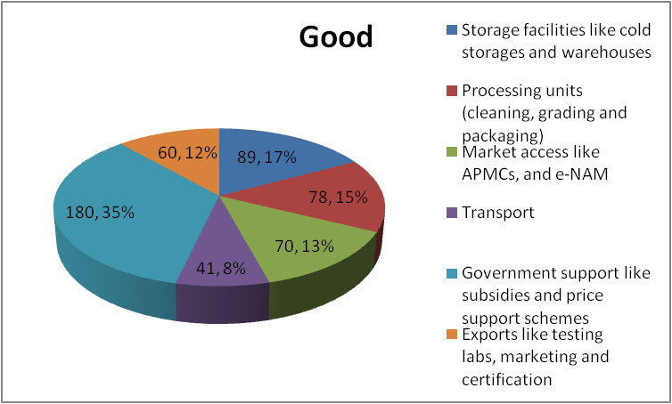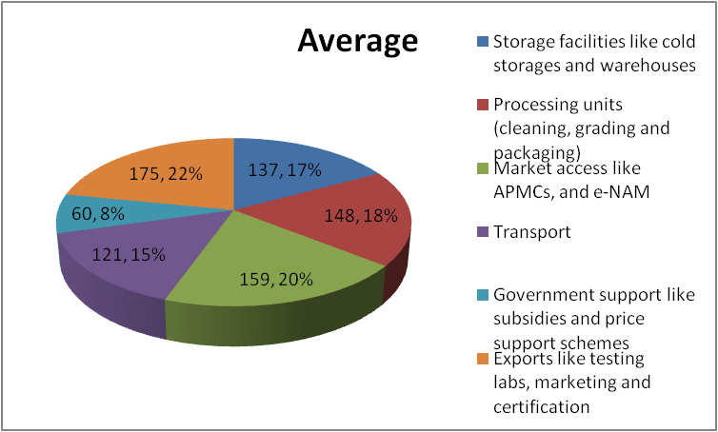
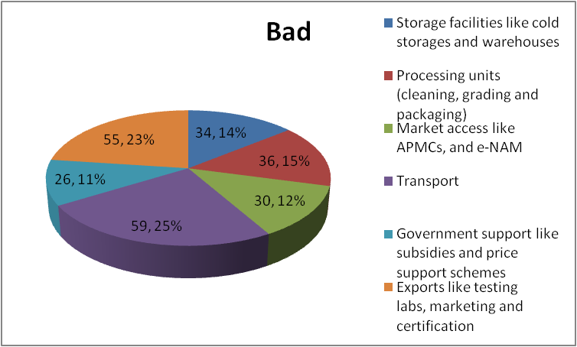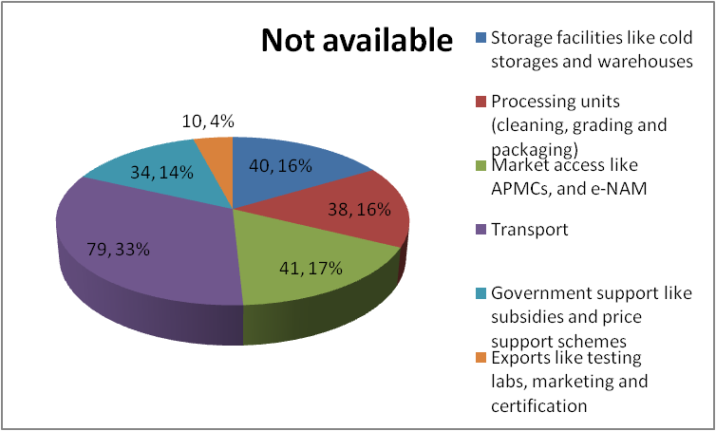
Figure 1: Pie-chart showing the Perceptions of market infrastructure facilities by coriander farmers
Source: primary data collection by author
Perceptions of market infrastructure facilities by coriander farmersare as follows, the highest number of respondents (137) under the category ‘average' because of storage facilities like cold storage and warehouses chosen (45.66%),and the lowest respondents (34) are due to bad (low) facilities11.33%.For processing units (cleaning, grading, and packaging) the highest number of respondents was chosen as 'average' 148 (49.33%), and the lowest number of respondents (36)were chosen as low (bad) facilities (12%).The highest respondents (159) under the category 'average' (53%) were chosen due to market access like APMCs, and e-NAM, and the lowest respondents (30) were chosen as low (bad) facilities (10%).The highest number of respondents (121) under the category 'average' (40.33%) were chosen due to transportation facilities, and the lowest number of respondents (59) were chosen as low (bad) facilities (19.66%).The highest number of respondents (180) under the category 'good' (60%) were chosen due toGovernment support like subsidies and price support schemes, and the lowest number of respondents (26) were chosen as low (bad) facilities (8.66%).The highest number of respondents (175) under the category 'average' (58.33%) were chosen due to exports like testing labs, marketing, and certification, and the lowest number of respondents (10) were chosen as facilities are not available (3.33%).
Problems faced by farmers during cultivation:
Problems | Respondents | Percentage (%)
Weather-related | 39 | 13.00
Soil related | 35 | 11.66
Pest and Disease infestation | 80 | 26.66
Irrigation challenges | 25 | 8.33
Seed quality and availability | 15 | 5.00
Market and Price fluctuations | 45 | 15.00
Post-harvest issues | 19 | 6.33
Input costs and availability | 10 | 3.33
Lack of knowledge and Extension services | 12 | 4.00
Environmental issues | 10 | 3.33
Policy and Infrastructure | 10 | 3.33
Table 2: Problems faced by farmers during cultivation
Source: Data collection by author
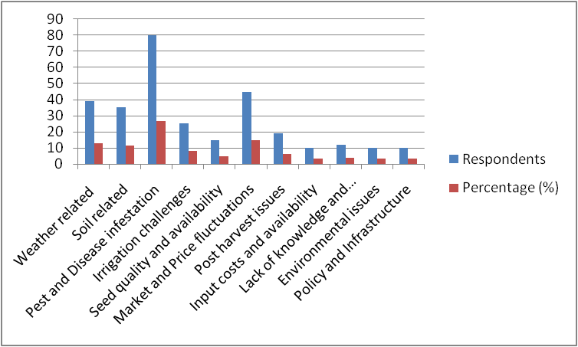
Figure 2: Graph showing the Problems faced by farmers during cultivation
Source: primary data collection by author
Problems faced by farmers during cultivation, among all the respondents Highest respondents 80(26.66%) chosen due to‘Pest and Disease infestation', and the lowest respondents 10(3.33) were chosen due to input costs and availability, environmental issues, and policy and Infrastructure.
Types of distribution channels to sell produce by coriander farmers in India:
Channels | Respondents | Percentage (%)
Wholesale markets (Mandis) | 228 | 76
Retail (Local stores) | 33 | 11
Direct sale (Farm gate) | 15 | 5
Exports | 18 | 6
Institutional buyers(Hotels/ Food processors) | 6 | 2
Table 3: Types of distribution channels to sell produce by coriander farmers in India
Source: Data collection by author
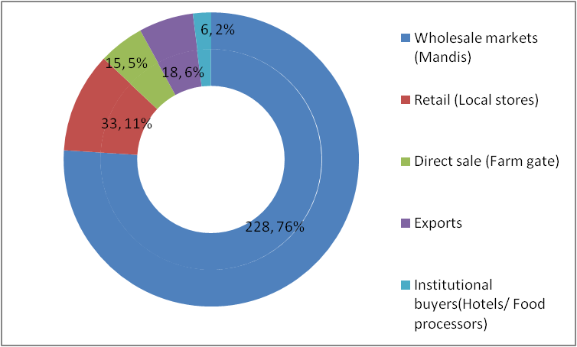
Figure 3: Pie-chart showing the Types of distribution channels to sell produce by coriander farmers in India
Source: primary data collection by author
Types of distribution channels to sell produce by coriander farmers in India, among all the respondents Highest respondents 228(76%) chose channel wholesale markets (Mandis), and the lowest respondents 6(2%) chose channel as institutional buyers(Hotels/ Food processors).
Problems faced in APMC-Agricultural Produce Market Committees:
Problems | Respondents | Percentage (%)
Middlemen exploitation | 138 | 46
Price volatility | 81 | 27
Storage issues | 45 | 15
Market monopoly | 27 | 9
High transportation costs | 9 | 3
Table 4: Problems faced in APMC-Agricultural Produce Market Committees
Source: Data collection by author
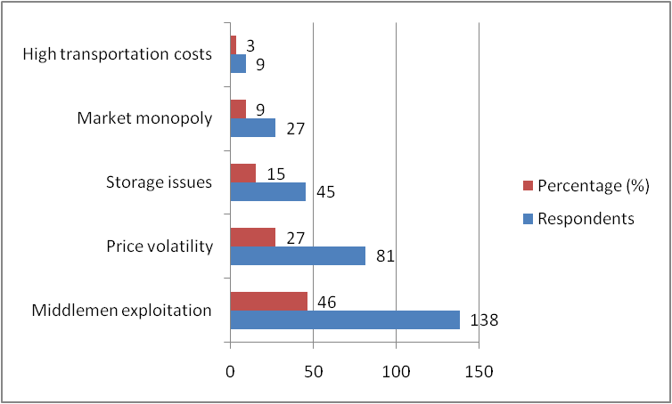
Figure 4: Graph showing the Problems faced in APMC-Agricultural Produce Market Committees
Source: primary data collection by author
Problems faced in APMC-Agricultural Produce Market Committees, among all the respondents Highest respondents 138(46%) due to middlemen exploitation, and the lowest respondents 9(3%) were chosen due to high transportation costs.
Area, Production, Productivity, and Percentage share of Coriander crop in India(2015-2024):
Year | Area  (thousand hectares) | Production (thousand metric tons) | Productivity (kg/ha) | Major percentage share
2014-15 | 560 | 462 | 825 | Rajasthan-52%  Madhya Pradesh-33%
2015-16 | 580 | 480 | 828 | Rajasthan-50%  Madhya Pradesh-35%
2016-17 | 590 | 495 | 840 | Rajasthan-48%  Madhya Pradesh-37%
2017-18 | 620 | 710 | 1145 | Rajasthan-45%  Madhya Pradesh-40%
2018-19 | 645 | 784 | 1215 | Rajasthan-42%  Madhya Pradesh-43%
2019-20 | 660 | 800 | 1212 | Rajasthan-40%  Madhya Pradesh-45%
2020-21 | 685 | 820 | 1197 | Rajasthan-38%  Madhya Pradesh-47%
2021-22 | 700 | 840 | 1200 | Rajasthan-35%  Madhya Pradesh-50%
2022-23 | 720 | 847 | 1176 | Rajasthan-30%  Madhya Pradesh-55%
2023-24 | 583.294 | 791.273 | 1356 | Rajasthan-13.6%  Gujarat-21.7  Madhya Pradesh-54.7%
Table 5: Area, Production, Productivity, and Percentage share of Coriander crop in India(2015-2024)
Source: Secondary data-Ministry of Agriculture & Farmers Welfare- Agriculture statistics at a glance, &National Horticulture Board (NHB)- Horticultural statistics at a glance.
From the above data Rajasthan dominated traditionally in coriander production until recent years, contributing a significant percentage share. However, Madhya Pradesh has emerged as the largest producer due to its increasing cultivation area, better farming practices, and favorable climatic conditions. Gujarat has also consistently ranked as one of the top producers. Fluctuations in production due to changes in rainfall patterns(e.g., excessive rainfall or drought), pests and diseases affecting crops, and market prices influencing farmers' decisions to grow coriander. The area under coriander cultivation has generally increased in states like Madhya Pradesh and Gujarat, as farmers shift towards cash crops.
Over the past decades, coriander exports have risen steadily. India remains one of the largest exporters of coriander seeds globally, catering to countries in the Middle East Europe, and Asia. Challenges faced are climate change, market volatility (price fluctuations), andsoil fertility issues(decline in yield).Overall trends are a shift in leadership led to Madhya Pradesh overtaking Rajasthan in percentage share over the years, the adoption of high-yielding seeds and modern agricultural practices has improved production in some regions, and increased domestic and global demand for coriander seeds and powder.
Area, Production, and Productivity of coriander crop in different states of India (2015-24):
Andhra Pradesh:
Year | Area (ha) | Production (MT) | Productivity (kg/ha)
2015 | 40,180 | 51,000 | 1270
2016 | 25,000 | 31,250 | 1250
2017 | 15,000 | 19,000 | 1267
2018 | 10,000 | 12,500 | 1250
2019 | 5,000 | 6,300 | 1260
2020 | 2,000 | 2,600 | 1300
2021 | 747 | 975 | 1350
2022 | 3,500 | 4,500 | 1285
2023 | 6,784 | 7,300 | 1076
2024 | 2,784 | 3,000 | 1078
Table 6: Area, Production, and Productivity of coriander crop in Andhra Pradesh of India (2015-24)
Source: Directorate of Economics and Statistics, Govt. of India.

Year | State | Area (ha) | Production (MT) | Productivity (kg/ha)
2014-15 | Madhya Pradesh | 2,70,000 | 4,00,000 | 1480
 | Rajasthan | 2,10,000 | 3,00,000 | 1430
 | Gujarat | 1,10,000 | 1,30,000 | 1180
2015-16 | Madhya Pradesh | 2,80,000 | 4,10,000 | 1464
 | Rajasthan | 2,20,000 | 3,10,000 | 1409
 | Gujarat | 1,15,000 | 1,35,000 | 1174
2016-17 | Madhya Pradesh | 2,90,000 | 4,20,000 | 1448
 | Rajasthan | 2,25,000 | 3,15,000 | 1400
 | Gujarat | 1,20,000 | 1,40,000 | 1167
2017-18 | Madhya Pradesh | 2,95,000 | 4,25,000 | 1441
 | Rajasthan | 2,30,000 | 3,20,000 | 1391
 | Gujarat | 1,25,000 | 1,45,000 | 1160
2018-19 | Madhya Pradesh | 3,00,000 | 4,30,000 | 1433
 | Rajasthan | 2,35,000 | 3,25,000 | 1383
 | Gujarat | 1,30,000 | 1,50,000 | 1154
2019-20 | Madhya Pradesh | 3,05,000 | 4,35,000 | 1426
 | Rajasthan | 2,40,000 | 3,30,000 | 1375
 | Gujarat | 1,35,000 | 1,55,000 | 1148
2020-21 | Madhya Pradesh | 3,10,000 | 4,40,000 | 1419
 | Rajasthan | 2,45,000 | 3,35,000 | 1367
 | Gujarat | 1,40,000 | 1,60,000 | 1143
2021-22 | Madhya Pradesh | 3,15,000 | 4,45,000 | 1413
 | Rajasthan | 2,50,000 | 3,40,000 | 1360
 | Gujarat | 1,45,000 | 1,65,000 | 1138
2022-23 | Madhya Pradesh | 3,20,000 | 4,50,000 | 1406
 | Rajasthan | 2,55,000 | 3,45,000 | 1353
 | Gujarat | 1,50,000 | 1,70,000 | 1133
2023-24 | Madhya Pradesh | 3,00,000 | 4,20,000 | 1400
 | Rajasthan | 2,30,000 | 3,30,000 | 1435
 | Gujarat | 1,20,000 | 1,45,000 | 1208
Table 7: Area, Production, and Productivity of coriander crop in different states of India (2015-24)
Source: Directorate of Economics and Statistics, Govt. of India.
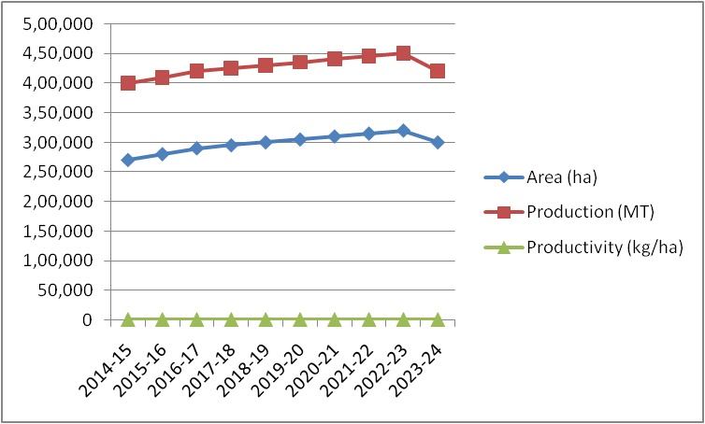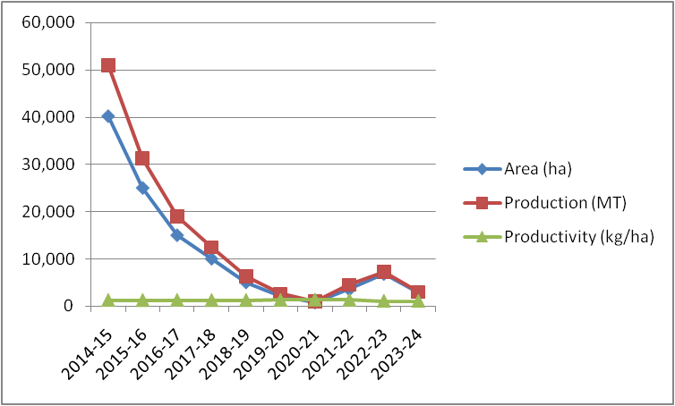Andhra Pradesh Madhya Pradesh
RajasthanGujarat
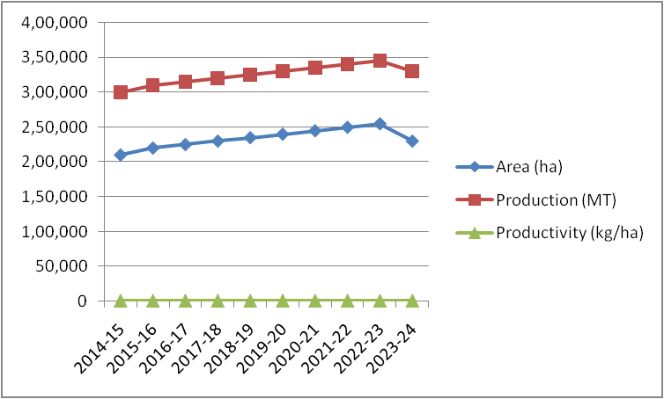
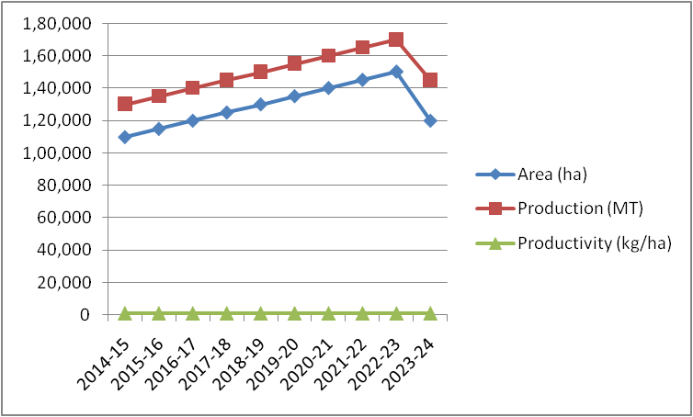Figure 5: Graph showing the Area, Production, and Productivity of coriander crop in different states of India (2015-24)
Source: Directorate of Economics and Statistics, Govt. of India.
2014-24, coriander in Andhra Pradesh rose in 2015 with 40,180 hectares and 51,000 MT productions. Later a sharp decline in 2021 with 747 hectares due to market and weather challenges. In 2023, with 6784 hectares and 7300 MT production showed good recovery, but the next year again declined to 2784 hectares. Productivity remains constant at 1200 to 1300 kg/ha, which indicates stable farming practices. Over the last 10 years, Madhya Pradesh and Rajasthan have remained the top producers of coriander, with consistent growth in both area and production because of favorable conditions and better farming practices. Gujarat has shown steady growth, but productivity remains lower due to water scarcity. Overall Madhya Pradesh and Rajasthan dominate in all categories, but Andhra Pradesh needs more stability in growth recovery.
Area, Production, Productivity, and Percentage share of Coriander crop on a global scale (2015-2024):
Year | Area  (thousand hectares) | Production (thousand metric tones) | Productivity (kg/ha) | Remarks
2014-15 | 1220 | 1860 | 1525 | Mexico & Turkey emerging
2015-16 | 1240 | 1880 | 1516 | Stable production trends
2016-17 | 1260 | 1910 | 1516 | Yield improvement in India
2017-18 | 1290 | 2000 | 1550 | Notable growth in Turkey
2018-19 | 1310 | 2200 | 1679 | High demand in global mark
2019-20 | 1320 | 2250 | 1705 | Mexico contributing significantly
2020-21 | 1380 | 2500 | 1812 | Consistent yield improvement
2021-22 | 1400 | 2910 | 2078 | Record growth driven by India
2022-23 | 1100 | 2950 | 2680 | India's 64 % share
2023-24 | 1150(projected) | 3000(projected) | 2700(projected) | Expected growth due to rising global demand and improved cultivation practices.
Table 8: Area, Production, Productivity, and Percentage share of Coriander crop on a global scale (2015-2024)
Source: Secondary data- Commodity board & Indiastat.com.
The global value of the coriander market is $4.51 billion and it will reach $17.2 billion by 2031, growing a compound growth rate (CAGR) of 10.1% from 2024 to 2031. India consistently contributes over 60% of the global coriander production, Turkey remains the 2nd largest producer, but its output is significantly lower than India’s.Mexico holds the third position but with an even smaller share. Overall production has seen steady growth, except for minor declines in 2018 to 2022 likely due to climatic or market factors.
Export value:it is $193.90 million, making a 24.22% increase from the previous year.As of 2024, the global coriander seed export market has notable trends.Top exporting countries:
Country | Export value (USD) | Share of Global Exports
India | $95.93 | 49.47%
Italy | $27.54 | 14.20%
Bulgaria | $15.51 | 8.00%
Morocco | $10.87 | 5.61%
UAE | $5.25 | 2.71%
Spain | $4.70 | 2.42%
Canada | $3.94 | 2.03%
Egypt | $3.45 | 1.78%
Poland | $3.41 | 1.76%
Argentina | $3.14 | 1.62%
Table 9: Export value and Percentage share of Coriander crop on a global scale (2015-2024)
Source: Secondary data-CBI-Centre for Promotion of Imports from developing countries-Ministry of Foreign Affairs.
India remains the dominant exporter, contributing nearly half of the global supply. Export growth: Between 2023-24 the world exported 7373 shipments of coriander seeds, at a 25% growth compared to the preceding 12 months.
Import trends:India 27%, US 21%, Pakistan 11%. Collectively, these countries accounted for 59% of the world's total coriander seed imports.
Major Indian trading centers:The major markets are located in Rajasthan and Madhya Pradesh. The three largest markets are Kota, Ramganj mandi, and Baran in Rajasthan.
Spot markets: Rajasthan: Ramganj mandi, and Baran; MP: Neemuch, Kumbhraj; TN: Thiruchirappilly, Virudhunagar; Gujarat: Rajkot; AP: Guntur, Varavakonda, Nandyal.
Futures markets: NCDEX.
LIST 1. Cost of production of coriander:

A. | Cost
Income (1.25 Ton per ha @ Rs. 50000 per Ton) | 62500
B.
Cost of Production
Land Preparation Cost | 5000
Seed Cost | 2500
Input Cost | 3750
Sowing cost | 1250
Irrigation cost | 3750
Weeding Cost | 10000
Harvesting Cost | 7500
Packing and Transportation Cost | 12  50
Total Cost of Production | 35000

Flow CHART 1. Flow chart of coriander market

Table 10: Cost of production of coriander India vs. world
Region/ Country | Cost of production(hectare) | Key factors influencing cost | Yield(hectare)
India (Rajasthan) | 25,000 to 30,000 | Moderate to high labor costs, irrigation costs, fertilizer, and pesticide use. | 500-600 kg
India (Madhya Pradesh) | 22,000 to 28,000 | Labor costs for sowing, weeding, and harvesting, water depended irrigation on fertilizer use for soil fertility. | 400-500 kg
India (Gujarat) | 20,000 to 25,000 | Low irrigation costs due to an extensive network, efficient labor management, and proximity to the spice market reduce transport costs. | 500-700 kg
India (Tamil Nadu) | 22,000 to 28,000 | Favorable weather reduces irrigation costs, high labor costs in harvesting, and fertilizers used for diseases. | 300-500 kg
China | $300 to $500 | Low labor costs, favorable climate reducing need for irrigation, low input cost due to fertile soil. | 5-6 tons
Turkey | $350 to $550 | Moderate labor costs,irrigation costs vary, and favorable climate. | 5-6 tons
Egypt | $200 to $400 | With low labor costs, rain-fed agriculture reduces irrigation costs, a favorable climate, and fertile soil. | 5-6 tons
US(California) | $2000 to $3000 | High labor costs due to mechanization and wage rates, high water costs due to irrigation,and technological inputs. | 1-2 tons
Morocco | $500 to $700 | Low labor costs, rain-fed agriculture reduces irrigation costs, and fertile soil with minimal input requirement. | 4-5 tons
Source: Primary data collected by author in Andhra Pradesh. Secondary data: Ministry of Agriculture & Farmers Welfare (India), Spices Board, FAO (Food and Agriculture Organization), ITC (International Trade Centre), and World Bank Agriculture & Rural Development.
Spot prices of corianderlast 3 years (2022-25 January):
Date | Price | Open | High | Low | Vol. | Change %
01-01-2025 | 8,204.00 | 8,110.00 | 8,694.00 | 7,244.00 | 55.16K | 1.23%
01-12-2024 | 8,104.00 | 7,838.00 | 8,192.00 | 7,320.00 | 55.51K | 3.74%
01-11-2024 | 7,812.00 | 7,172.00 | 8,080.00 | 6,800.00 | 84.79K | 8.32%
01-10-2024 | 7,212.00 | 7,460.00 |  | 7,060.00 | 52.44K | -3.01%
01-09-2024 | 7,436.00 | 6,950.00 | 7,546.00 | 6,610.00 | 60.18K | 7.05%
01-08-2024 | 6,946.00 | 7,300.00 | 7,326.00 | 6,636.00 | 59.79K | -4.25%
01-07-2024 | 7,254.00 | 7,362.00 | 7,400.00 | 7,092.00 | 59.17K | -1.71%
01-06-2024 | 7,380.00 | 7,412.00 | 7,638.00 | 7,186.00 | 3.87K | -0.57%
01-05-2024 | 7,422.00 | 7,430.00 | 7,830.00 | 7,104.00 | 74.70K | -0.11%
01-04-2024 | 7,430.00 | 7,620.00 | 7,960.00 | 7,154.00 | 51.97K | -2.34%
01-03-2024 | 7,608.00 | 8,030.00 | 8,414.00 | 7,598.00 | 56.97K | -4.90%
01-02-2024 | 8,000.00 | 7,730.00 | 8,178.00 | 7,460.00 | 49.06K | 3.57%
01-01-2024 | 7,724.00 | 7,202.00 | 8,156.00 | 6,722.00 | 51.45K | 6.63%
01-12-2023 | 7,244.00 | 8,220.00 | 8,294.00 | 7,034.00 | 56.33K | -12.07%
01-11-2023 | 8,238.00 | 7,228.00 | 8,462.00 | 7,220.00 | 85.60K | 13.94%
01-10-2023 | 7,230.00 | 6,772.00 | 7,426.00 | 6,414.00 | 77.30K | 6.17%
01-09-2023 | 6,810.00 | 7,054.00 | 7,250.00 | 6,650.00 | 76.92K | -3.70%
01-08-2023 | 7,072.00 | 7,800.00 | 7,828.00 | 6,900.00 | 85.15K | -9.50%
01-07-2023 | 7,814.00 | 6,752.00 | 8,068.00 | 6,602.00 | 115.28K | 16.98%
01-06-2023 | 6,680.00 | 6,414.00 | 6,720.00 | 5,880.00 | 79.90K | 4.51%
01-05-2023 | 6,392.00 | 6,530.00 | 6,950.00 | 6,262.00 | 58.51K | -1.81%
01-04-2023 | 6,510.00 | 6,602.00 | 6,900.00 | 6,212.00 | 34.19K | -2.54%
01-03-2023 | 6,680.00 | 7,292.00 | 7,300.00 | 6,620.00 | 54.25K | -8.52%
01-02-2023 | 7,302.00 | 7,900.00 | 7,968.00 | 6,768.00 | 38.79K | -6.89%
01-01-2023 | 7,842.00 | 8,018.00 | 8,500.00 | 7,300.00 | 38.60K | -3.26%
01-12-2022 | 8,106.00 | 9,750.00 | 9,940.00 | 7,760.00 | 40.47K | -16.19%
01-11-2022 | 9,672.00 | 10,800.00 | 11,520.00 | 9,426.00 | 41.44K | -12.09%
01-10-2022 | 11,002.00 | 10,900.00 | 12,142.00 | 10,588.00 | 40.26K | 0.24%
01-09-2022 | 10,976.00 | 11,394.00 | 11,820.00 | 10,422.00 | 58.73K | -3.36%
01-08-2022 | 11,358.00 | 11,930.00 | 11,964.00 | 10,984.00 | 53.90K | -3.81%
01-07-2022 | 11,808.00 | 11,304.00 | 12,618.00 | 11,276.00 | 52.90K | 4.09%
01-06-2022 | 11,344.00 | 11,176.00 | 11,566.00 | 10,774.00 | 42.69K | 1.49%
01-05-2022 | 11,178.00 | 12,170.00 | 12,350.00 | 10,810.00 | 60.35K | -8.23%
01-04-2022 | 12,180.00 | 11,170.00 | 13,298.00 | 11,160.00 | 78.21K | 8.79%
01-03-2022 | 11,196.00 | 10,790.00 | 11,268.00 | 10,210.00 | 82.04K | 2.70%
01-02-2022 | 10,902.00 | 10,130.00 | 11,300.00 | 9,780.00 | 120.03K | 7.94%
01-01-2022 | 10,100.00 | 8,870.00 | 10,398.00 | 8,868.00 | 49.92K | 14.80%

Table 11: Spot prices of corianderlast 3 years (2022-25 January)
Source:https://in.investing.com/commodities/ncdex-coriander-futures-historical data.(secondary data).

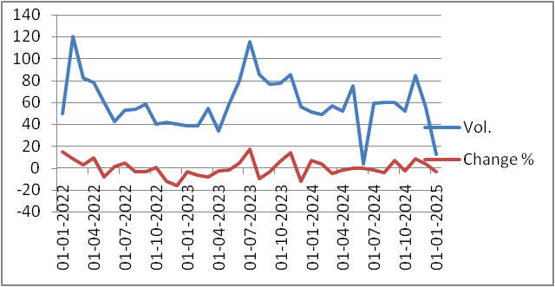
Figures 6: Spot prices of coriander last 3 years (2022-25 January)
Source: Table 11- secondary data.
Analyzing the historical performance of coriander futures over the past three years provides valuable insights into market trends and price volatility. Below is a summary of the annual average prices, along with the highest and lowest recorded prices for each year.
2022: Average price-₹7200 per quintal; Highest price-₹8000; Lowest price-₹6500.
2023: Average price-₹7500 per quintal; Highest price-₹8200; Lowest price-₹6800.
2024: Average price-₹7800 per quintal; Highest price-₹8400; Lowest price-₹7000.
Key observations:2022 marked a steady base for the market, with prices fluctuating within a range of ₹6500 to ₹8000 per quintal. Factors like local crop conditions and global spice demands shaped the price movements. In 2023, the market saw an upward shift with the average price reaching ₹7500, the peak at ₹8200 indicated a surge in demand, while the bottom at ₹6800 highlighted the underlying volatility from supply chain disruptions. 2024’s figures suggest a gradual increase in the price levels, signaling consistent market growth, the highest recorded price of ₹8400 marked a sustained interest in coriander, possibly due to stronger domestic and export demand.
Gradual price increase clear upward trend can be seen from 2022 to 2024, with prices growing at an average rate of 300 per quintal annually, this could be attributed to factors like inflation, improved demand, and tightening supply.
Fluctuations and Volatility:-The market exhibited year-on-year price volatility, with fluctuations of about ₹1000 to₹1500. These price variations are common in commodity markets, influenced by weather conditions, crop yields, and consumer demand.
External market influence market trends, economic policies, and even climate events like droughts or excessive rainfall can have an immediate impact on coriander's pricing, the price spikes reflect these external pressures.
Price discovery- Technical analysis:
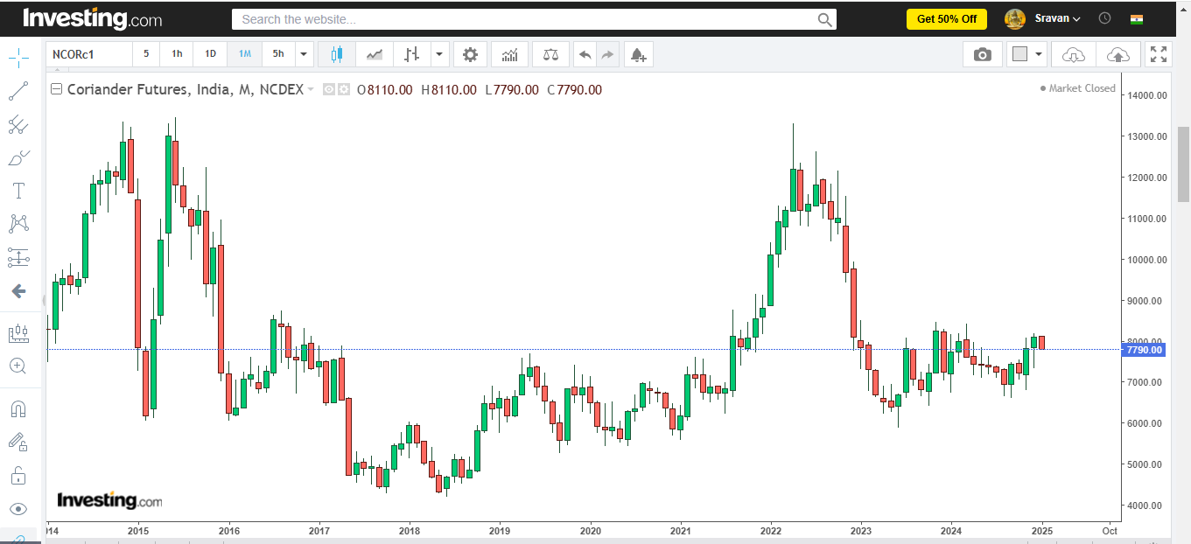
Figure7: Candlestick chart for coriander from jan1- 2015 to jan1-2025
Source: https://in.investing.com/commodities/ncdex-coriander-futures-historical data.(secondary data).
Market analysis trends:2015-17corianderprices significantly declined, dropping by 50% to around ₹4000 per quintal. 2017-2024, prices fluctuated, averaging ₹103/kg in FY 2024 due to supply-demand imbalances, including increased international production and domestic shifts. Key influences are global supply (large coriander crops from Syria and Russia led to oversupply, dampening export demand. Shift in cultivation (cumin). Candlestick charts, which show daily price movements (open, high, low, close) are ideal for market trends over time.
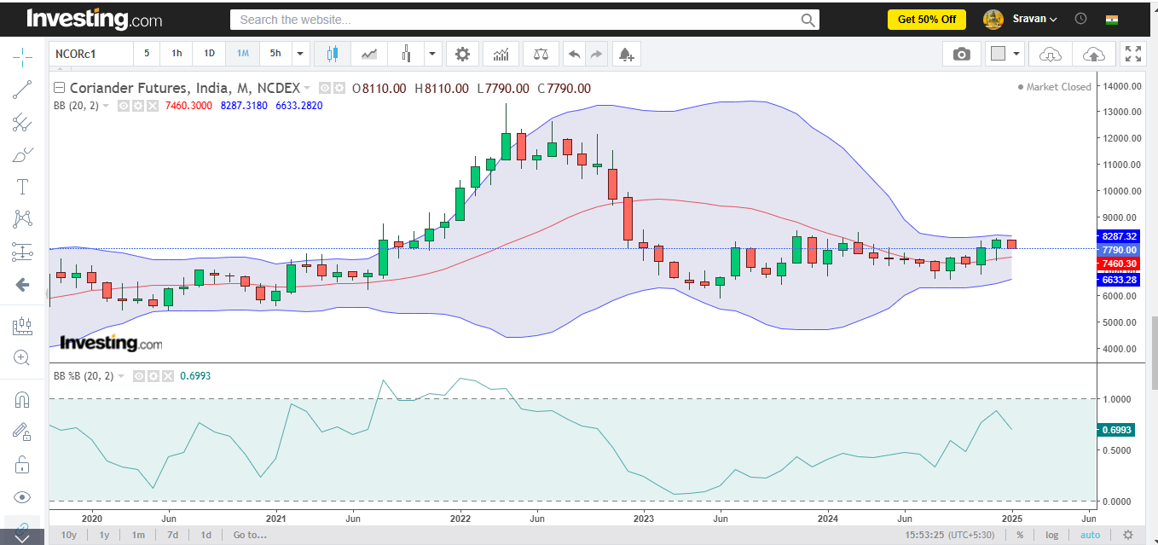
Figure8: Bollinger bands, %B for coriander from jan1- 2015 to jan1-2025.
Source:https://in.investing.com/commodities/ncdex-coriander-futures-historical data.(secondary data).
2015-17: Prices broke below the lower Bollinger Band frequently, signaling oversold conditions. %B stayed near ‘0’, reflecting strong selling pressure. 2018-2021, moderate volatility with prices staying mostly within the bands. %B hovered around 0.5, indicating consolidation phases with occasional spikes. 2022-24, high volatility as prices touched both upper and lower bands due to global supply shifts and reduced cultivation in India. %B >1 during price surges (export demand), %B<0 during oversupply periods.
.
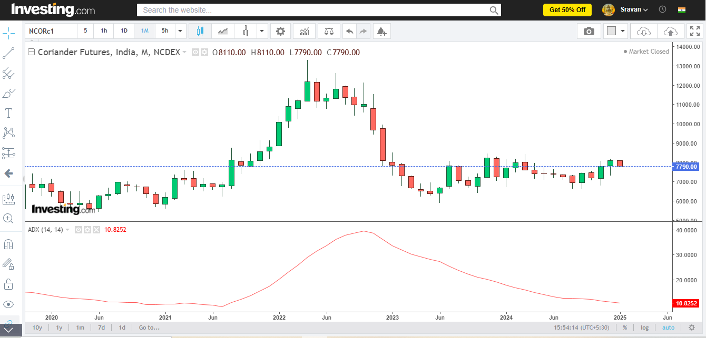
Figure 9: ADX-Average Directional Index for Coriander from jan1- 2015 to jan1-2025
Source:https://in.investing.com/commodities/ncdex-coriander-futures-historical data.(secondary data).
The ADX measures trend strength on a Scale of 0-100. 0-25- weak or no trend; 25-50-strong
Trend; 50+ is a very strong trend (rarely observed). In 2015-17 (strong downtrend), a strong bearish trend as prices halved. Clear directionality driven by oversupply and falling demand. 2018-21 (range-bound market), ADX < 25, most of the time, indicating weak or no clear trend. Prices oscillated within a range due to stable market conditions. 2022-24 (volatility and trend resurgence), ADX spiked above 25 during sharp price movements caused by export demand or supply shocks. Short-term trends alternated with consolidation phases (ADX < 20).
.
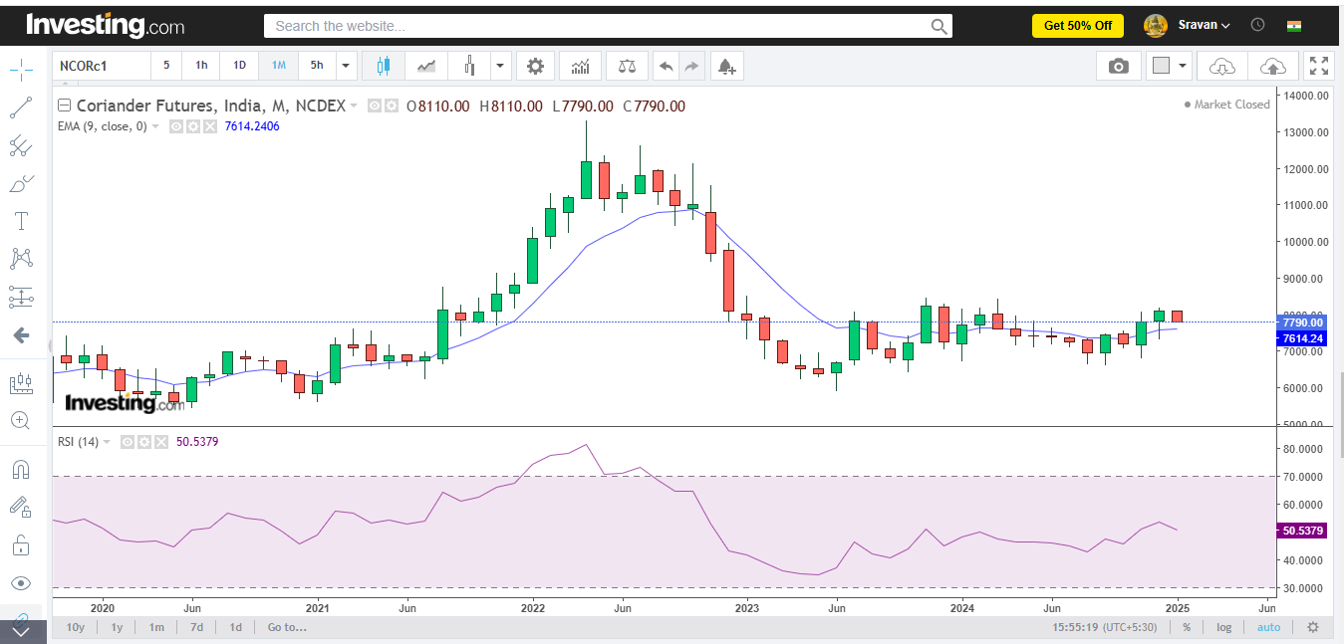
Figure10: Moving Average Exponential (EMA) and Relative Strength Index (RSI), for coriander from jan1- 2015 to jan1-2025
Source:https://in.investing.com/commodities/ncdex-coriander-futures-historical data. (secondary data).
EMA-2015-17(downtrend), short-term EMA (e.g., 20-day) stayed below long-term EMA (e.g., 50-day), signaling a persistent bearish trend. Prices consistently traded below both EMA’s, reflecting strong selling pressure. 2018-21(consolidation), short- and long-term EMA's converged frequently, indicating a range-bound market with no strong direction. Crossovers lacked momentum, showing indecision in price movements. 2022-24 (volatility), short-term EMA often crossed the long-term EMA, reflecting sharp price swings. Bullish trends emerged during export-driven price surges, while corrections quickly reversed trends.
RSI Identifies momentum and potential turning points; above 70- overbought (price likely drop). Below 30- oversold (price likely rises).2015-20 (pre-pandemic, relatively stable agricultural cycles), moderate fluctuations driven by climatic conditions and domestic demand. RSI trends:- overbought (>70) years with below-average monsoons (e.g., 2015, 2019). Oversold (<30):-periods of bumper harvest or reduced exports (e.g., 2017).2020-22 (disruptions from COVID-19 impacting supply chains and demand). Oversold:with reduced trading activity due to lockdown, overbought: supply shortages and inflation-driven price hikes. 2023-25 (post-pandemic recovery and stabilization of coriander prices).RSI is closer to neutral (40-60) as price fluctuations stabilize.
.
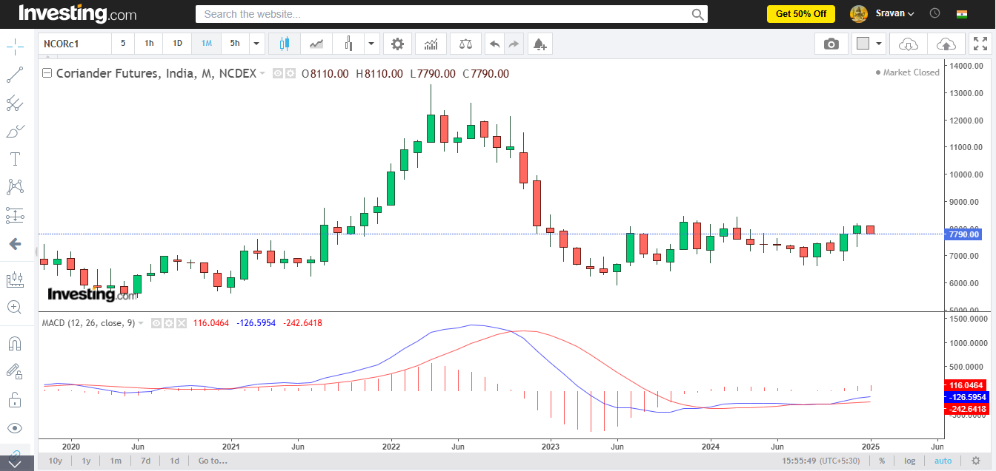
Figure 11: MACD- Moving Average Convergence and Divergence for Coriander from jan1- 2015 to jan1-2025
Source:https://in.investing.com/commodities/ncdex-coriander-futures-historical data. (secondary data).
The MACD is a trend-following momentum indicator that shows the relationship between two EMAs; the MACD line (difference between 12, and 26 days of EMAs) & Signal line (9-day EMA of the MACD line). The histogram is the difference between the MACD line and signal line, indicating momentum strength. 2015-17 (Bearish phase), the MACD line below the signal line, indicates a strong downtrend as coriander prices declined. A negative histogram indicated strong selling pressure and short-term bullish crossovers due to supply issues. 2018-21 (Consolidation phase), the MACD and signal line frequently crossed, signaling indecision and a lack of clear direction. A small histogram indicates balanced supply and demand, and rarely bullish or bearish spikes indicate without clear trend. 2022-24 (Volatile phase), export demand causes MACD to move above the signal line, indicating bullish momentum with a positive histogram. Large histogram swings due to MACD shifts.
.
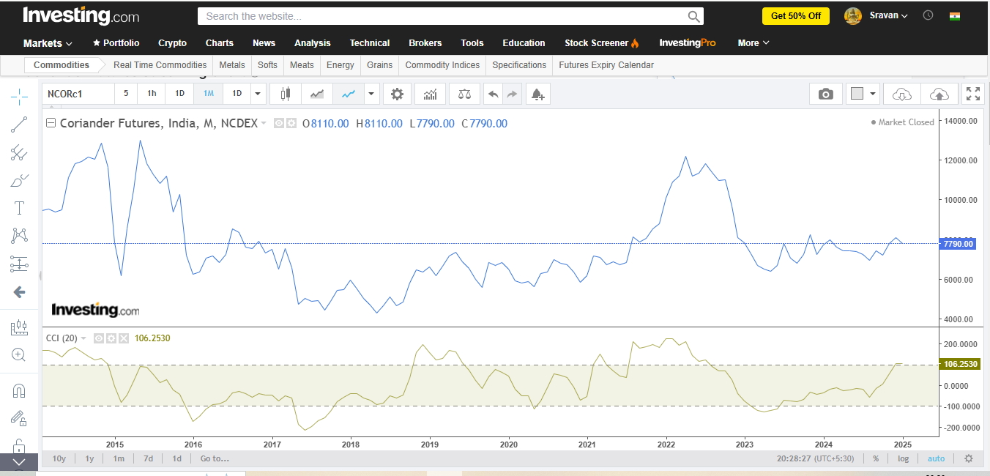
Figure 12: CCI-Commodity Channel Index for coriander from jan1- 2015 to jan1-2025
Source:https://in.investing.com/commodities/ncdex-coriander-futures-historical data. (secondary data).
CCI identifies cyclical trends and over-bought or sold conditions, with values typically from -100 to +100. CCI >100 (overbought i.e. price likely to correct downward), CCI < -100 (oversold i.e. price likely to rise.). 2015-17 (downtrend with oversold conditions), CCI indicates short-lived in the bearish market. 2018-21 (consolidation phase), the market lacked a clear trend, and CCI varied between -100 to +100. 2022-24 (volatility and price shifts), price shifts due to global demand and supply shocks.
.
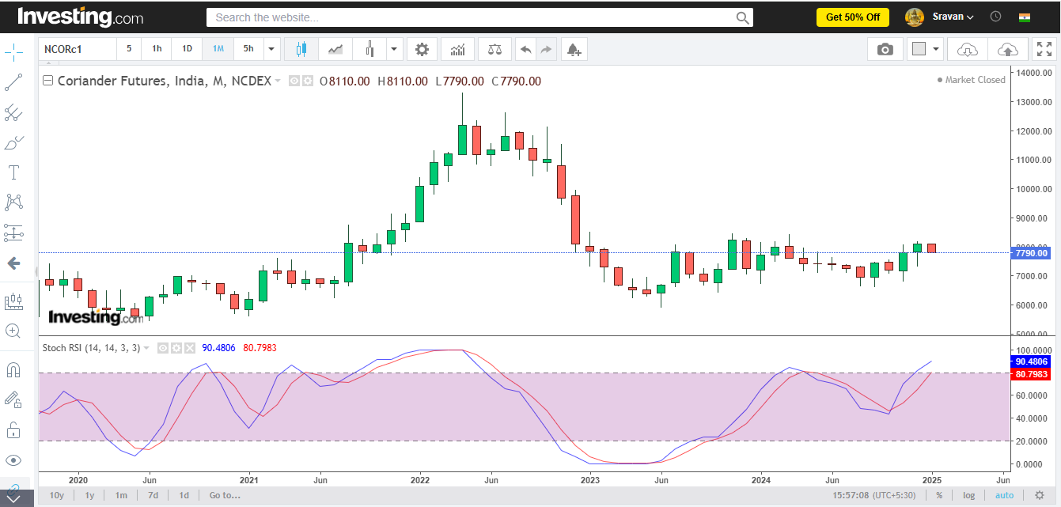
Figure 13: Stochastic RSIfor coriander from jan1- 2015 to jan1-2025
Source:https://in.investing.com/commodities/ncdex-coriander-futures-historical data. (secondary data).
Stochastic RSI is a momentum oscillator that measures the level of the RSI to its range in a certain period, it provides more sensitive signals than regular RSI, and it indicates overbought and oversold conditions. It ranges between 0 to 1. Above 0.8 indicates overbought and potential for risk. Below 0.2 indicates oversold and potential for a price rebound, and between 0.2 to 0.8 indicates a neutral zone i.e. lack of clear trend. 2015-17 (Bearish phase), the stochastic RSI indicated oversold conditions regularly, but due to a strong downtrend, price reversals were lacking. 2018-21 (Consolidation), a neutral market phase with a stochastic RSI varies between 0.2 and 0.8, indicates no clear trend, and shows stable prices. 2022-24 (Sharp price movements), a volatile period with the stochastic RSI entering overbought and oversold conditions most repeatedly, affects price movements globally with an imbalance of demand and supply.
Combination of all Technical charts:
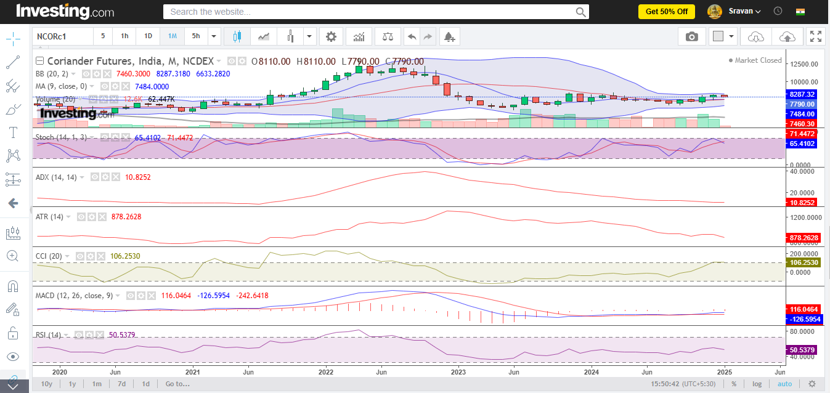
Figure 14: Combination of all Technical charts Source:https://in.investing.com/commodities/ncdex-coriander-futures-historical data. (secondary data).
Over the past decade, the coriander crop market has faced significant changes, moving through time with oversupply, consolidation, and volatility. Analysis the all phases using technical indicators like Candle stick chart, Bollinger bands, %B, ADX-Average Directional Index,Moving Average Exponential (EMA) and Relative Strength Index (RSI),MACD- Moving Average Convergence and Divergence,CCI-Commodity Channel Index,and Stochastic RSIprovides more valuable insights for anticipating future trends. The volatility seen in recent years suggests that global factors like weather disruptions, trade policies, and shifts in demand will play constantly and shape the prices of coriander in upcoming years.
Correlation:
Objective: To analyze the relationship between a dependent variable and an independent variable (output & input) or ‘Area’ (thousand hectares) and ‘Production’ (thousand metric tons)of Coriander crops on a global scale (2015-2024).
Data nature:
S.no. | Output (DV or Variable-1) | Input (IDV or Variable-2)
Pearson correlation | Metric | Metric
Example | Area  (thousand hectares) | Production (thousand metric tons)
Source: Table-8: Author’s computation. Secondary data- Commodity board & Indiastat.com.
Hypothesis:
Ho (Null hypothesis): There is no significant relation between variable 1 and variable 2, orArea’ (thousand hectares) and ‘Production’ (thousand metric tons).
H1 (Alternate hypothesis): There is a significant relation between variable 1 & variable 2, orArea’ (thousand hectares) and ‘Production’ (thousand metric tons).
Statistical Interpretation:
Particulars | Area  (thousand hectares) | Production (thousand metric tons)
Area  (thousand hectares) | 1
Production (thousand metric tons) | 0.924428969 | 1
r - Value=0.924428969; Degrees of freedom= n-2 = 10-2=8;
t = r x √ n-2/ √1-r^2=6.856; p = TDIST(r, n-2, 2) = 0.00013
Here p value =0.00013, which is not more than 0.05 (0.00013 <0.05), at the 95% level of significance value, so accept the H1 and reject the Ho and there is a significant relation between variable 1 & variable 2, or Area’ (thousand hectares) and ‘Production’ (thousand metric tons). ‘t-value’ is 6.856, which indicates that the observed correlation is very far from expected under the null hypothesis.
Managerial decision-making:
r = 0.924428969therefore, there is a highly positive correlation (close to +1) between variable 1 & variable 2 and a statistically significant linear relationship between them.So increase in the area of coriander crops leads to higher production, keeping other factors constant like soil fertility, weather, and inputs.
Regression:
Objective: To assess the impact of the dependent variable (Production in thousand metric tons)on the independent variable (Productivity in kg/ha)of the Coriander crop in India (2015-2024).
Data nature:
S.no. | Output(DV or Variable-1) | Input(IDV or Variable-2)
Simple regression | Metric | Metric
Example | Production in thousand metric tons | Productivity in kg/ha
Data:Source: Table-5: Author’s computation. Secondary data- Ministry of Agriculture & Farmers Welfare- Agriculture statistics at a glance, & National Horticulture Board (NHB)- Horticultural statistics at a glance.
Hypothesis:
Ho (Null hypothesis):There is no significant impact of the dependent variable on the independent variable (output & input) or Production in thousand metric tons and Productivity in kg/ha.
H1 (Alternate hypothesis):There is a significant impact of the dependent variable on the independent variable (output & input) or Production in thousand metric tons and Productivity in kg/ha.
Statistical interpretation:
The F- Value of 0.0000529183< table value of 0.05 at the 95% significance level (0.00005 < 0.05), therefore reject the Ho and accept the H1, and There is a significant impact of the dependent variable on the independent variable (output & input) or Production in thousand metric tons and Productivity in kg/ha.
Managerial decision making: The adjusted R-square value is86.892; therefore, 87 % of this variance of the dependent variable is explained by the independent variable. Y=a+bx; coefficients a, b (alpha, beta) show positive value so, it has a positive impact on output. So there is a linear relationship betweenProduction in thousand metric tons and Productivity in kg/ha.It implies the predictors explain a large proportion of the variability in production or productivity.
Econometric models- VAR (Vector Auto-Regression)
Objective:
In this research VAR model was used to capture the inter relationship between multiple series variables. It gives all variables as endogenous meaning, each variable was explained by it’s own past as well as by using past values of other variables in the crop.
Data: Source: Data was calculated using source table 11 in this research here are the sequential steps for VAR model:
Y1= Price of this month.
Yi-1, i-2, i-3= Price of next month (Lead or Lag).

Year | Price | Lag1 | Lag2 | Lag3
01-01-2025 | 8,204.00
01-12-2024 | 8,104.00 | 8,204.00
01-11-2024 | 7,812.00 | 8,104.00 | 8,204.00
01-10-2024 | 7,212.00 | 7,812.00 | 8,104.00 | 8,204.00
01-09-2024 | 7,436.00 | 7,212.00 | 7,812.00 | 8,104.00
01-08-2024 | 6,946.00 | 7,436.00 | 7,212.00 | 7,812.00
01-07-2024 | 7,254.00 | 6,946.00 | 7,436.00 | 7,212.00
01-06-2024 | 7,380.00 | 7,254.00 | 6,946.00 | 7,436.00
01-05-2024 | 7,422.00 | 7,380.00 | 7,254.00 | 6,946.00
01-04-2024 | 7,430.00 | 7,422.00 | 7,380.00 | 7,254.00
01-03-2024 | 7,608.00 | 7,430.00 | 7,422.00 | 7,380.00
01-02-2024 | 8,000.00 | 7,608.00 | 7,430.00 | 7,422.00
01-01-2024 | 7,724.00 | 8,000.00 | 7,608.00 | 7,430.00
01-12-2023 | 7,244.00 | 7,724.00 | 8,000.00 | 7,608.00
01-11-2023 | 8,238.00 | 7,244.00 | 7,724.00 | 8,000.00
01-10-2023 | 7,230.00 | 8,238.00 | 7,244.00 | 7,724.00
01-09-2023 | 6,810.00 | 7,230.00 | 8,238.00 | 7,244.00
01-08-2023 | 7,072.00 | 6,810.00 | 7,230.00 | 8,238.00
01-07-2023 | 7,814.00 | 7,072.00 | 6,810.00 | 7,230.00
01-06-2023 | 6,680.00 | 7,814.00 | 7,072.00 | 6,810.00
01-05-2023 | 6,392.00 | 6,680.00 | 7,814.00 | 7,072.00
01-04-2023 | 6,510.00 | 6,392.00 | 6,680.00 | 7,814.00
01-03-2023 | 6,680.00 | 6,510.00 | 6,392.00 | 6,680.00
01-02-2023 | 7,302.00 | 6,680.00 | 6,510.00 | 6,392.00
01-01-2023 | 7,842.00 | 7,302.00 | 6,680.00 | 6,510.00
01-12-2022 | 8,106.00 | 7,842.00 | 7,302.00 | 6,680.00
01-11-2022 | 9,672.00 | 8,106.00 | 7,842.00 | 7,302.00
01-10-2022 | 11,002.00 | 9,672.00 | 8,106.00 | 7,842.00
01-09-2022 | 10,976.00 | 11,002.00 | 9,672.00 | 8,106.00
01-08-2022 | 11,358.00 | 10,976.00 | 11,002.00 | 9,672.00
01-07-2022 | 11,808.00 | 11,358.00 | 10,976.00 | 11,002.00
01-06-2022 | 11,344.00 | 11,808.00 | 11,358.00 | 10,976.00
01-05-2022 | 11,178.00 | 11,344.00 | 11,808.00 | 11,358.00
01-04-2022 | 12,180.00 | 11,178.00 | 11,344.00 | 11,808.00
01-03-2022 | 11,196.00 | 12,180.00 | 11,178.00 | 11,344.00
01-02-2022 | 10,902.00 | 11,196.00 | 12,180.00 | 11,178.00
01-01-2022 | 10,100.00 | 10,902.00 | 11,196.00 | 12,180.00
 | Y1 | Yi-1 | Yi-2 | Yi-3
Table-12: VAR model was used to capture the inter relationship between multiple series variables
Source: https://in.investing.com/commodities/ncdex-coriander-futures-historical data.(secondary data).
Hypothesis:
Ho (Null hypothesis):There is no significant impact of the dependent variable on the independent variable (output & input)
H1 (Alternate hypothesis):There is a significant impact of the dependent variable on the independent variable (output & input)
Statistical interpretation:
In this research calculated three VAR models using MS- excel , below are the models to find best one in all.
Model VAR-1
R square : 0.8859
Adjusted R Square : 0.8746
F-statistic is highly significant (p < 0.00000000000003)
Variable | Significant | Explanation
Intercept | Not significant | Constant has no major effect
Lag 1(x1) | Significant(p=0.000046) | Current price strongly depends on last day price
Lag 2(x2) | Not significant(p=0.944) | 2nd day lag has no meaningful effect
Lag 3(x3) | Not significant(p=0.68) | 3rd day lag is not important

Conclusion: Overall model is strong, but only lag 1 is useful, lag2 and lag3 are unnecessary.
Model VAR-2:
R square : 0.8847
Adjusted R Square : 0.8775
F-statistic is significant (p < 0.00000000000000097)
Variable | Significant | Explanation
Intercept | Not significant | Constant has no major effect
Lag 1(x1) | Significant(p=0.00000195) | price depends heavily on last day price
Lag 2(x2) | Not significant(p=0.59) | No influence
only lag 1 is useful or matters , lag2 is unnecessary or needed.
Model VAR-3:

R square : 0.8836
Adjusted R Square : 0.8801
F-statistic is extremely significant (p < 0.000000000000000019)
Variable | Significant | Explanation
Intercept | Not significant | Constant has no major effect
Lag 1(x1) | Significant(p=0.000000000000000019) | price depends heavily on last day price

lag 1 explains the price very well. Model is clean and fully significant, fit is almost equal to VAR- 2 and VAR-3 .
Selection of best model:
Model | Adjusted R Square | Significant Lags | Best selection
VAR-3 | 0.8746 | Only Lag 1 | Not needed
VAR-2 | 0.8775 | Only Lag 1 | Extra Lag is unnecessary
VAR-1 | 0.8801 | Only Lag 1 | Best Model

So best model is VAR-1, because of highest Adjusted R Square, only 1 lag needed, model is simple and robust and no insignificant parameters.
To identify the price dynamics of the Coriander spot market, VAR-1, VAR-2, VAR-3 models were estimated using monthly data. The VAR-1 model produced the best results with an Adjusted R Square of 0.8801, which was higher than VAR-2(0.8775) and VAR-3(0.8746). In all the models, only the first lag price was statistically significant, while the 2nd and 3rd lag were insignificant ( p is greater than 0.90).
Therefore, Coriander price dynamics follow a first order autoregressive process (VAR-1), here
Pt= α + βPt-1 + €t, the coefficients are positive and highly significant (t=16.065), it indicating strong price persistence. This refers that current price of Coriander crop depends primarily on the previous period price, it suggests that slow adjustment and high memory in the price series.
Conclusion
NCDEX futures contracts for spices enhance price transparency, reduce gaps in the information, and strengthen the exporters' and importers' negotiation power. Exporters are benefited by locking the prices and they can quote at competitive rates along with secure contracts. While importers can track prices and trends with verified forward rates. This platform also enables hedging practices to manage price risks by exposing the physical markets. However, standardized contract terms may not be match always with requirements of individual market.Key influences are global supply (large coriander crops from Syria and Russia led to oversupply, dampening export demand. Shift in cultivation (cumin).
Disclaimer (Artificial intelligence)
Option 1:
Author(s) hereby declare that NO generative AI technologies such as Large Language Models (ChatGPT, COPILOT, etc.) and text-to-image generators have been used during the writing or editing of this manuscript.
References
Aggarwal, N., Jain, S., & Narayanan, S. (2018). How do commodity derivatives markets impact farmers’ welfare? The Indian experience.
Alawode, A., & Chiamaka, O. T. Evaluating financial derivatives in agricultural risk management: implications for market stability and price transmission. International Journal Of Engineering Technology Research & Management (IJETRM). 2023Dec21, 7(12), 410-26.
Baishnab, K., & Singh, P. K. (2025). Impact of COVID-19 trade suspension on price discovery in FPO-traded agri-derivatives. Journal of Modelling in Management, 20(2), 537-563.
Commodity board: https://www.commerce.gov.in/useful-links/commodity-boards/.
Coriander Futures Historical Prices 2015-2024: https://in.investing.com/commodities/ncdex-coriander-futures-historical-data.
Datta, A., & Bharodia, C. (2025). Farmer's Purchasing Behavior Towards Coriander Seeds in Junagadh District, Gujarat, India. Asian Journal of Agricultural and Horticultural Research, 12(4), 35-40.
Dey, K., Gandhi, V. P., & Debnath, K. (2019). Farmers’ Participation in India’s Futures Markets: Potential, Experience, and Constraints.
Directorate of Economics and Statistics, Govt. of India 2015-24: https://desagri.gov.in/en/.
FAO (Food and Agriculture Organization): https://www.fao.org/home/en
Indiastat.com: https://www.indiastat.com/.
ITC (International Trade Centre): https://www.intracen.org/
Joshi, A. University of Agricultural Sciences, Bangalore.
Kalaiarasi, D., Rohini, A., Venkatesa, P. N., Shivakumar, K. M., Pangayar, S. R., & Chandra, S. K. (2023). Price patterns in agricultural futures markets: a GARCH model approach.
Meena, M. D., Saxena, S. N., Lal, S., Kumar, S., Meena, S. S., Sharma, Y. K., ... & Mahatma, M. K. (2025). Detection of adulteration in coriander seeds using essential oil profiling through GCMS and its correlation with physical quality and market price. Applied Food Research, 101053.
Mohanakumar, S., Joseph, K. J., & Kumar, P. (2023). Production Structure and Market Dynamics of Seed Spices: A Study of Cumin and Coriander in Rajasthan.
National Horticulture Board (NHB)- Horticultural statistics at a glance 2015-24: https://nhb.gov.in/Statistics.aspx?enc=WkegdyuHokljEtehnJoq0KWLU79sOQCy+W4MfOk01GFOWQSEvtp9tNHHoiv3p49g.
Palaniappan Shanmugam, V., & Armah, P. (2017). A New Look at the Efficiency & Volatility of Indian Agricultural Commodity Futures Markets. Paul, A New Look at the Efficiency & Volatility of Indian Agricultural Commodity Futures Markets (May 26, 2017).
Póvoa, O., Farinha, N., Lopes, V., Machado, A. M., &Figueiredo, A. C. (2024). Coriander (Coriandrum sativum L.) from Alentejo (South Portugal)—Ethnobotany and Potential Industrial Use. Foods, 13(6), 929.
Pullaykkodi, S., & Acharya, R. H. (2025). Speed of price adjustment toward market efficiency of Indian agricultural commodity market: a market microstructure analysis of market quality. Journal of Agribusiness in Developing and Emerging Economies, 15(2), 426-444.
Rout, B. S. (2018). Performance of commodity derivatives market in India (Doctoral dissertation, Department of Banking Technology, Pondicherry University).
Sahu, P. K., Dey, S., Sinha, K., Singh, H., &Narsimaiaha, L. (2019). Cointegration and price discovery mechanism of major spices in India. American Journal of Applied Mathematics and Statistics, 7(1), 18-24.
Sharwani, M. K. S. (2025). An Economic Analysis of Srivari Spices and Foods limited, Hyderabad: A case study (Doctoral dissertation, Mahatma Phule Krishi Vidyapeeth).
Spices board: https://www.indianspices.com/.
World Bank agriculture & rural development: https://www.worldbank.org/en/programs/knowledge-for-change/brief/agriculture-and-rural-development.

