Short Research Article

Microleakage Evaluation of Two Different Fabricated Composite Inlays: An In Vitro Study
Abstract

The clinical longevity of tooth-coloured restorations, whether direct or indirect, mainly depends on the strength of the restoration, marginal fit, and its bond strength to the tooth structures. This in vitro study investigates the extent of microleakage in composite inlays fabricated using two different indirect techniques: conventional manual fabrication and advanced 3D printing. Twenty multirooted extracted human teeth were prepared with standardised inlay cavities and divided into two groups. The samples were randomly divided into groups of indirect restorations fabricated using a conventional technique and 3D printing. Group 1 restorations were made using conventional impressions and layered composite resin, while Group 2 employed digital scanning and additive manufacturing (AM) to produce inlays. All restorations were cemented using self-adhesive resin cement and evaluated under a stereomicroscope following dye penetration with 1% methylene blue. The study revealed significantly lower vertical and angular microleakage in the 3D printed group, indicating superior marginal adaptation. These results highlight the clinical potential of 3D printed composite restorations in reducing polymerisation shrinkage and enhancing marginal integrity. The findings underscore the evolving role of digital and additive technologies in restorative dentistry, promising improved accuracy, efficiency, and patient outcomes. Dentistry is currently witnessing the beginnings of the additive age, where promising processes are developing in parallel. It is still uncertain which of these processes will ultimately prevail.
Keywords – additive manufacturing, inlay, hybrid composite, indirect restoration, 3D printing, marginal integrity

Introduction
The Global Burden of Disease 2015 study concluded that oral health has not improved in the last 25 years: the age-standardised prevalence rate of untreated caries in primary teeth was 7.8% (573 million children), and 126 million children worldwide had incident cases of caries in primary teeth in 2015. Dental caries, according to the WHO, remains the most frequent chronic disease in early childhood in most communities around the world, having a negative impact on the quality of life of both the child and their family, and is considered a public health problem (Ortiz-Ruiz et al., 2020; McGrath, 2022). The clinical longevity of tooth-coloured restorations, whether direct or indirect, mainly depends on the strength of the restoration, marginal fit, and its bond strength to the tooth structures. The clinical success of indirect restoration depends on various factors. Polymerisation shrinkage remains a major disadvantage of composite resin fillings, which causes stress to the filling material and to the restored surfaces and may lead to marginal leakage, discolouration and sensitivity¹. Volumetric shrinkage values between 1.08% and 4.68% are reported¹. Polymerisation shrinkage in resin composites generates stress at the interface between the composite restoration and the tooth substance, resulting in marginal gap formation and microleakage². Indirect restorations have been touted as a possible way to minimise this drawback³. (Abbasi et al). Indirect restorations play a significant role in control of polymerisation shrinkage, secondary polymerisation, enabling improved control over contacts and contours, physical properties and esthetics.
Computer-aided design-computer-aided manufacturing (CAD-CAM) can be subtractive (milling) or additive (three-dimensional (3D) printing). Nowadays, computer-aided design/computer-aided manufacturing (CAD/CAM), here indicated as CAD/CAM technology (CCT), is widely used since digital impression is more comfortable for patients (mainly vulnerable ageing population or younger ones) (Barenghi et al., 2019). 3D printing is also known as rapid prototyping or solid free form fabrication. 3D Printing is a disruptive technology for healthcare and provides significant research and development avenues (Javaid et al., 2022). 3D printing systems presented some advantages over milling as the production of complex geometries, less waste material, lower cost, higher accuracy, and faster production⁴.
Indirect 3D printed restorations are a viable option for fabricating dental restorations. With this technique, systemic errors in the fabrication of restoration, such as shrinkage, can be compensated during the CAD process⁵. This technique also allows clinicians to optimise the roughness of the restoration’s bonding surface and the use of existing photocurable, chemically curable or dual curable restorative material for indirect restorations. It also provides good reproducibility, minimising human errors and techniques that reduce workload in large defects⁶.
The study aimed to evaluate the microleakage of indirect and 3D printed composite inlays using conventional and digital impression techniques to compare two kinds of composite materials and techniques, along with evaluation of microleakage.

Methodology
Multirooted teeth, which had been extracted, were obtained from the Department of Oral and Maxillofacial Surgery, DAPM RV Dental College. Teeth have grossly decayed surfaces were eliminated. Inlay cavities were prepared on 20 extracted multirooted teeth. The samples were divided into two groups. The samples were randomly divided into groups of indirect restorations fabricated using a conventional technique and 3D printing.
Cavity Preparation
Group 1 Conventional Restoration
To produce an indirect composite restoration, inlay cavity preparation was done. Polyvinyl silicone impressions were taken, and die stone models of the samples were obtained. A micro-ceramic indirect composite resin was used for restoration. Composite layering was done after the application of the spacer. The filled samples were cured.
Fig. .1 Conventional Restoration of teeth
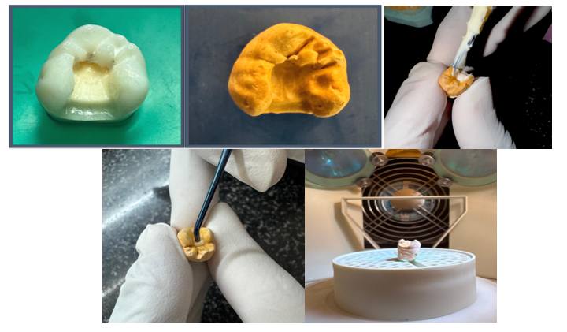

Group 2: 3D-Printed restoration
Similar to group 1 samples, inlay cavities were prepared. The samples were scanned using extra-oral digital scanners. 3D printed models and restorations were obtained. The samples were cemented using light-cure resin cements.
Fig. .2 3D printed restoration of teeth
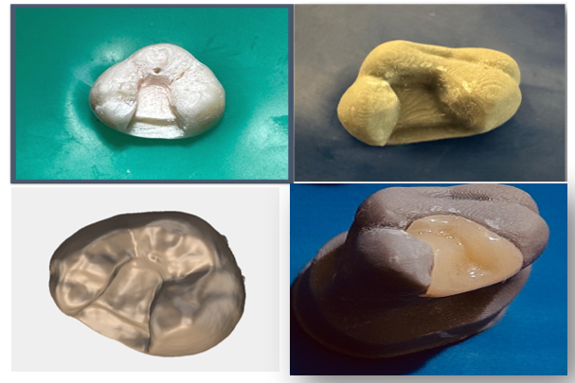

Stereomicroscope Image
After obtaining the laboratory-prepared inlays, the restorations were cemented using self-adhesive resin cement. The specimens were coated with a single layer of varnish. The specimens were immersed in 1% methylene blue dye for 24 hrs. The specimens were sectioned mesiodistally. The specimens were observed under stereomicroscopy at a magnification 20x. Dye penetration was observed along two planes. Firstly, a vertical line is drawn parallel to the axial wall, and a horizontal line is drawn at the tooth-restoration interface at the gingival seat.
Fig. .3 Stereomicroscopic Images

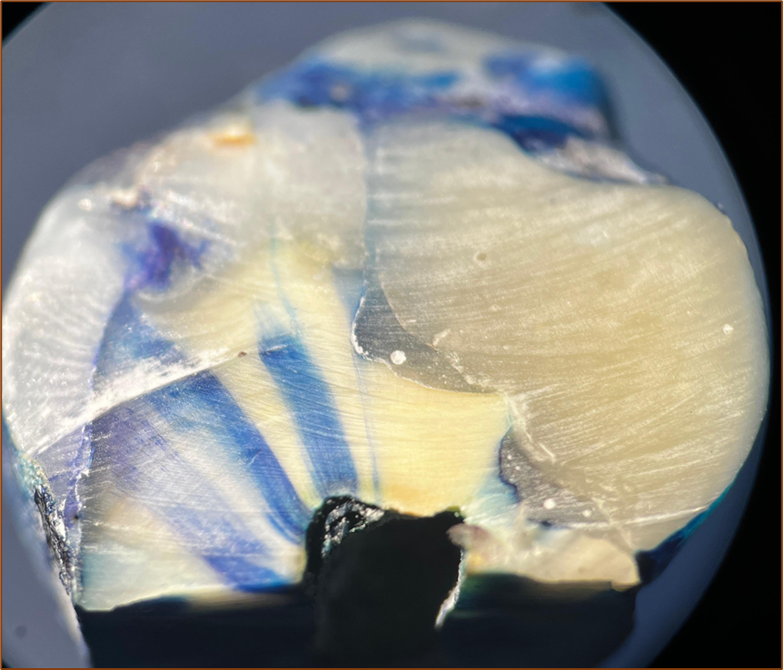
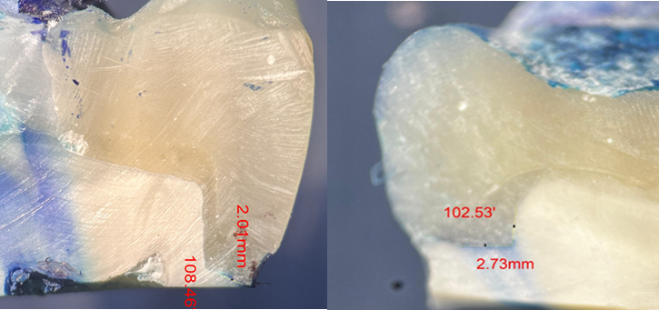

Table 1: Direction and measurements of teeth

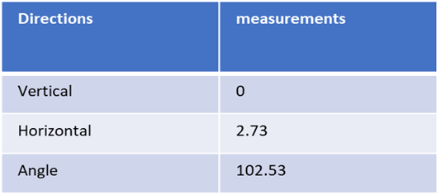
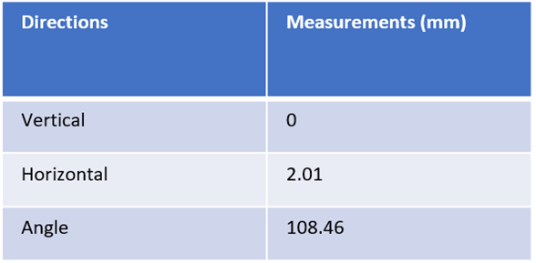

Results
Table 2. Morphometric analyses of length and area of dye penetration
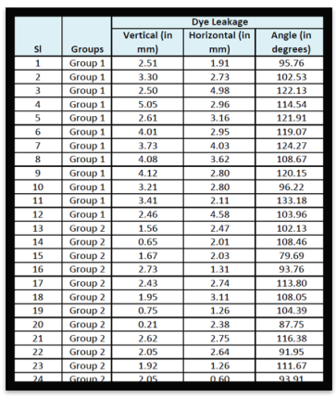
Statistical Analysis
The difference in the mean vertical length of dye leakage was statistically significant between the 2 groups at p<0.001. The analysis demonstrates that Group 2 has a significantly lower mean vertical length of dye leakage compared to Group 1.
The difference in the mean vertical length of dye leakage was statistically significant between the 2 groups at p<0.001. The analysis demonstrates that Group 2 has a significantly lower mean vertical length of dye leakage compared to Group 1.

Table 3 Comparison of mean vertical length of dye leakage
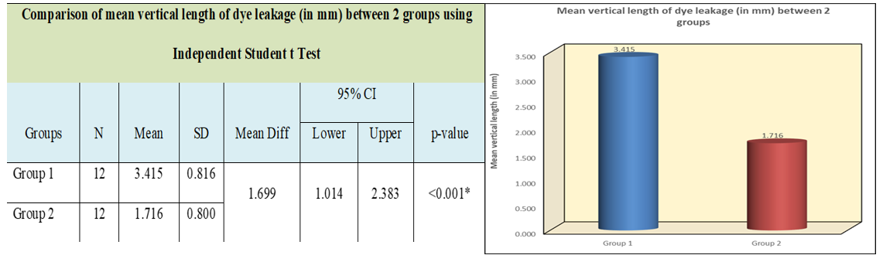
2 has a significantly lesser mean vertical length of dye leakage compared to Group 1.
Table 4 Comparison of the mean horizontal length of dye leakage
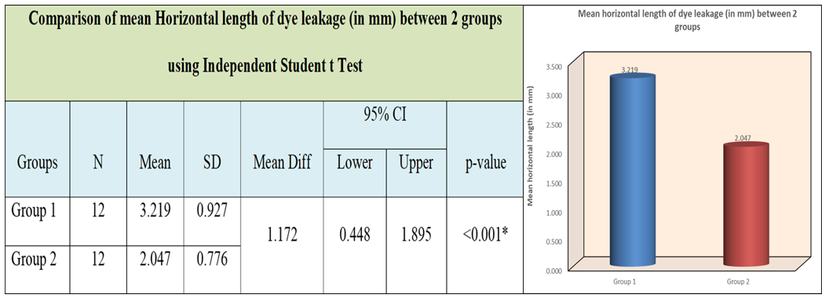
The difference in the mean angle of dye leakage was statistically significant between the 2 groups at p=0.01. The analysis demonstrates that Group 2 has a significantly lower mean angle of dye leakage compared to Group 1
Table 5 Comparison of the mean angle of dye leakage
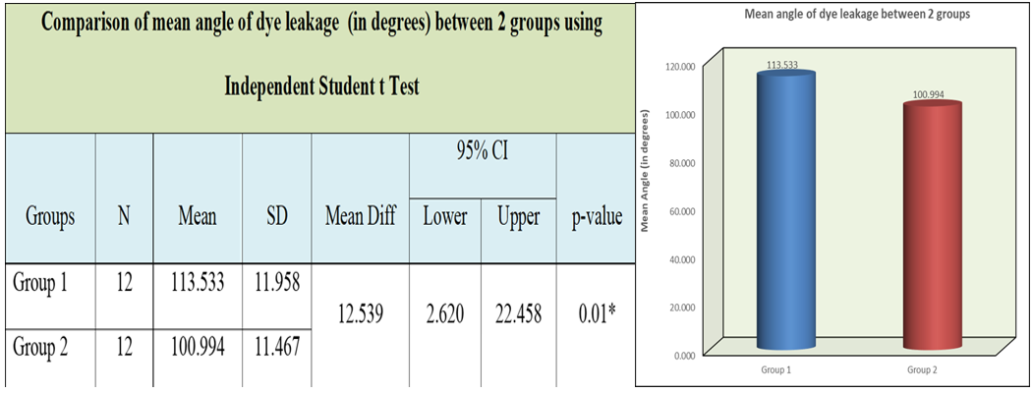

Discussion
In the present study, marginal leakage was evaluated along the axial wall, the gingival seat and also the axial-gingival line angle of the tooth restoration margin. Dye penetration is noted in all the specimens. Microleakage was observed more along the gingival seat (horizontal dimension) when compared to the axial wall. Ceramic hybrid resins were used in groups 1 and 2.
“Microleakage” is defined as the passage of bacteria and their toxins between restoration margins and tooth preparation walls.” In manual technique, polymerisation shrinkage refers to the volumetric decrease, leading to potential issues like marginal gaps, stress on the tooth structure, and post-operative sensitivity due to the shrinkage forces generated during the curing process⁷. Shrinkage is caused due to high stresses in the cavity wall influencing the C-factor, light activation protocols, filling technique, micro tensile bond strength⁸ (A.D. Loguercio et al.) and visco-elastic behaviour⁹(R.R Braga et al). The present study reveals that the microleakage is significantly less for 3D printed resins as they are photopolymerized, which results in minimal polymerisation shrinkage. This is attributed to the Stereolithography (SLA) or digital light processing (DLP) mechanism used in 3D printing technology. Liquid resin is layered with a focused UV laser beam, creating a highly accurate, detailed dental restoration based on a digital design. This aids in obtaining restoration with intricate geometries and a precise fit within the patient's mouth. Polymer shrinkage decreases with an increase in the inorganic filler content. Thus, the higher the inorganic filler content, the lower the polymerisation shrinkage. The 3D printing technology comparatively resolved the contradiction between a higher double-bond conversion rate and lower polymerisation shrinkage. It might have great potential to reduce the incidence of marginal leakage in caries restorative procedures¹⁰ (M. Zhao et al.). Another crucial aspect is the margin adaptation that can affect the clinical success of the printed restoration.AM indirect restorations have better margin adaptation than subtractive-manufactured restorations ^{11,12}In the study group, 2 had lower microleakage resulting in favourable adaptation. The present study has strengths, including the use of stable and precise printing technology, as well as the comparison between materials with similar characteristics and clinical applications, which differ in their composition and energy source for conversion; however, further studies are necessary to evaluate the potential of 3D printed restorations to their fullest.
Conclusion
3D printing already has diverse applications, and holds a great deal of promise to make possible many new and exciting treatments and approaches to fabricate dental restorations. Digital manufacturing will change the face of dentistry in the near future in terms of treatment time and simplicity. While both additive and subtractive techniques can be used to produce restorations with adequate marginal fit, errors can arise depending on the CAD system used and the clinician's expertise. Application intertwined with improved skill, considering patient comfort and demand, must be focused. Moving forward, several key trends are anticipated to emerge in the field of 3D printing technology for polymer composites, profoundly impacting the design, preparation, and practical production applications of these materials. These trends will set new standards for performance, sustainability, and efficiency.
Dentistry is currently witnessing the beginnings of the additive age, where promising processes are developing in parallel. It is still uncertain which of these processes will ultimately prevail

Disclaimer (Artificial intelligence)

Option 1:

Author(s) hereby declare that NO generative AI technologies such as Large Language Models (ChatGPT, COPILOT, etc.) and text-to-image generators have been used during the writing or editing of this manuscript.

Option 2:

Author(s) hereby declare that generative AI technologies such as Large Language Models, etc. have been used during the writing or editing of manuscripts. This explanation will include the name, version, model, and source of the generative AI technology and as well as all input prompts provided to the generative AI technology

Details of the AI usage are given below:
1.
2.
3.

REFERENCES
1. Susila AV. Role of Composition on Polymerization Shrinkage and Shrinkage Stress in Dental Composites. J Oper Dent Endod 2021;6(1):31–44
2.Battancs, E.; Sáry, T.; Molnár, J.; Braunitzer, G.; Skolnikovics, M.; Schindler, Á.; Szabó, P.B.; Garoushi, S.; Fráter, M. Polymers 2022, 14, 3463
3. Abbasi M, Moradi Z, Mirzaei M, Kharazifard MJ, Rezaei S. Polymerization Shrinkage of Five Bulk-Fill Composite Resins in Comparison with a Conventional Composite Resin. J Dent (Tehran). 2018 Nov;15(6):365-374. PMID: 30842797; PMCID: PMC6399456.
4. Bilgin MS, Baytaroğlu EN, Erdem A, Dilber E. A review of computer-aided design/computer-aided manufacture techniques for removable denture fabrication. Eur J Dent. 2016 Apr-Jun;10(2):286-291. doi: 10.4103/1305-7456.178304. PMID: 27095912; PMCID: PMC4813451.
5. Balestra, D.; Lowther, M.; Goracci, C.; Mandurino, M.; Cortili, S.; Paolone, G.; Louca, C.; Vichi, A. 3D Printed Materials for Permanent Restorations in Indirect Restorative and Prosthetic Dentistry: A Critical Review of the Literature. Materials 2024, 17, 1380. https://doi.org/10.3390/ma17061380
6. Alshargawi, Waleed & Tawhari, Feras & Aladwani, Ameerah & Hassanein, Zyad & Fageeh, Sahar & Almeshrf, Ahmed & Alamani, Saud & Neyaz, Aymen & Albalbisi, Asraa & Alsadiq, Belal & Alasmari, Abdulrahman. (2024). The effectiveness of direct versus indirect restoration techniques following canal therapy. International Journal Of Community Medicine And Public Health. 11. 10.18203/2394-6040.ijcmph20242686.
7. Schneider LF, Cavalcante LM, Silikas N. Shrinkage Stresses Generated during Resin-Composite Applications: A Review. J Dent Biomech. 2010;2010:131630. doi: 10.4061/2010/131630. Epub 2009 Sep 30. PMID: 20948573; PMCID: PMC2951111.
8.Loguercio AD, Reis A, Ballester RY. Polymerization shrinkage: effects of constraint and filling technique in composite restorations. Dent Mater. 2004 Mar;20(3):236-43. doi: 10.1016/S0109-5641(03)00098-8. PMID: 15209228.
9.Braga RR, Ballester RY, Ferracane JL. Factors involved in the development of polymerization shrinkage stress in resin-composites: a systematic review. Dent Mater. 2005;21(10):962-970. doi:10.1016/j.dental.2005.04.018
10.Zhao, Xy & Li, Sb & Gu, Lj & Li, Y. (2013). Detection of Marginal Leakage of Class V Restorations In Vitro by Micro-Computed Tomography. Operative dentistry. 39. 10.2341/12-182-L.
11. Donmez MB, Okutan Y. Marginal gap and fracture resistance of implant-supported 3D-printed definitive composite crowns: An in vitro study. J Dent. 2022;124:104216. doi:10.1016/j.jdent.2022.104216
12. Suksuphan P, Krajangta N, Didron PP, Wasanapiarnpong T, Rakmanee T. Marginal adaptation and fracture resistance of milled and 3D-printed CAD/CAM hybrid dental crown materials with various occlusal thicknesses. J Prosthodont Res. 2024;68(2):326-335. doi:10.2186/jpr.JPR_D_23_00089

13. Ortiz-Ruiz, A. J., Pérez-Guzmán, N., Rubio-Aparicio, M., & Sánchez-Meca, J. (2020). Success rate of proximal tooth-coloured direct restorations in primary teeth at 24 months: a meta-analysis. Scientific Reports, 10(1), 6409.
14. McGrath, C. E., & Bonsor, S. J. (2022). Survival of direct resin composite onlays and indirect tooth-coloured adhesive onlays in posterior teeth: a systematic review. British Dental Journal, 1-7.
15. Barenghi, L., Barenghi, A., Cadeo, C., & Di Blasio, A. (2019). Innovation by computer‐aided design/computer‐aided manufacturing technology: A look at infection prevention in dental settings. BioMed Research International, 2019(1), 6092018.
16. Javaid, M., Haleem, A., Singh, R. P., & Suman, R. (2022). 3D printing applications for healthcare research and development. Global Health Journal, 6(4), 217-226.

