Case report

Surgical Repair of a Radial Artery aneurysm Following Elective Percutaneous Coronary Intervention: A Case Report

Abstract
Background: Transradial approach for percutaneous coronary intervention (PCI) is frequently preferred because it has lower complication rates than femoral access. However, unusual vascular complications, such as radial artery pseudoaneurysms, might arise, requiring diagnostic and treatment challenges.
Case Summary: We present a case of a 68-year-old man who underwent an elective right radial percutaneous coronary intervention (PCI) with a 6 Fr sheath. Following the procedure, he experienced the development of a non-painful, progressively growing pulsatile mass at the site of access ten days later. A duplex ultrasound revealed a saccular pseudoaneurysm measuring 22 × 18 mm, characterized by a 2.5 mm neck and to-and-fro flow patterns. A CT angiography confirmed the presence of a localized pseudoaneurysm without any signs of distal embolization. After a discussion among specialists, Surgical intervention was decided , while maintaining the patency of the radial artery and avoiding any distal ischemia. The patient was discharged the next day and remained asymptomatic with duplex-confirmed thrombosis after 1 and 6 months.
Conclusion: A delayed pulsatile swelling following transradial procedures should lead to the use of duplex imaging. For anatomically appropriate radial pseudoaneurysms, ultrasound-guided thrombin injection is an efficient and minimally invasive treatment option for small sized pseudoaneurysms.For large, symptotic pseudoaneurysm ,Surgical removal is the treatment of choice.
Keywords: radial artery; pseudopseudoaneurysm; percutaneous coronary intervention; transradial access; access-site complication.

Introduction
Percutaneous coronary intervention (PCI) with transradial access has become the preferred technique in several hospitals due to lower bleeding risk, earlier ambulation, and greater patient comfort. Despite its benefits, transradial access is not without risks. Hematomas, arterial occlusion, and pseudoaneurysms are among the most common vascular injuries documented. Radial pseudoaneurysms are extremely rare and frequently go undiagnosed.
Atrue pseudoaneurysm dilates all three layers of the vessel wall: intima, medium, and adventitia. Pseudoaneurysms, on the other hand, are caused by a rupture in the artery wall that is filled with blood from surrounding tissues. True pseudoaneurysms can develop after PCI due to mechanical damage, recurrent puncture, or infection. This article reports a rare example of a genuine radial artery pseudoaneurysm after elective PCI and outlines its clinical implications.

Case Presentation
A 68-year-old male patient known to be hypertensive and dyslipidemic presented with stable angina.Elective coronary angiography was performed and right radial approach was preferred after careful examination of both radial arteries and it was done through the right radial artery using a 6F sheath. It showed a severe stenosis in the proximal left anterior descending artery (LAD ). PCI and stenting to the LAD was performed a the same setting through which heparin at a dose of 5000u IV with an ACT check within 10 minutes . The procedure was successful and the sheath was safely removed after the proceedure and compression was done by a TR band and the site is then monitored frequently for bleeding, swelling, and other signs of complications, with pressure adjusted as needed. The patient was discharged the next day with dual antiplatelet treatment.
Ten days after discharge, the patient noticed a gradually increasing, painless swelling on the volar aspect of his right wrist. He denied experiencing fever, trauma, or neurological problems. The physical examination showed a pulsatile mass with an audible bruit. The distal pulses were intact, and there was no evidence of ischemia or infection.
Doppler Ultrasound revealed a saccular pseudoaneurysm measuring 22 × 18 mm with intact arterial wall layers and laminar flow. CT Angiography was done and revealed a pseudoaneurysm of the radial artery without evidence of thrombosis or distal embolization.

Management

Due to the size and pulsatile nature of the pseudoaneurysm, surgical intervention was considered essential. The procedure was performed under regional anesthesia, during which the pseudoaneurysm was removed, and the radial artery was repaired using end-to-end anastomosis. Intraoperative observations confirmed it was a true pseudoaneurysm with the arterial wall layers intact and no evidence of rupture or infection.

The recovery process post-surgery was uneventful. The patient was discharged on the third day following the surgery, with intact hand function and palpable distal pulsations.
postoperative follow-up after 1 and 3 months with clinical examination and doppler ultrasound showed patent radial artery.

Table 1 : Clinical Features of Reported Radial Artery Pseudoaneurysm Cases
Author | Year | Patient Age/Sex | Presentation | Time to Diagnosis | Symptoms
Cunha et al. | 2023 | 65/M | Pulsatile wrist swelling | 10 days | Bruit, mass
Papadoulas et al. | 2022 | 72/F | Painful forearm lump | 14 days | Pain, swelling
Majumdar et al. | 2016 | 58/M | Expanding wrist hematoma | 7 days | Pain, bruit
Present case | 2025 | 68/M | Painless pulsatile swelling | 10 days | Audible bruit, mass

Table 2: Summary of Reported Radial Artery pseudoaneurysm Cases Post-PCI (imaging and outcomes)
Author | Year | Type | Imaging Used | Management | Outcome
Cunha et al. | 2023 | pseudoaneurysm | Doppler, CT Angio | Surgical | Full recovery
Papadoulas et al. | 2022 | pseudoaneurysm | Doppler | Surgical | Good outcome
Majumdar et al. | 2016 | pseudoaneurysm | Doppler, CT Angio | Surgical | No complications
Present case | 2025 | pseudoaneurysm | Doppler, CT Angio | Surgical | No complications

Table 3: Management Strategies for Radial Artery Pseudoaneurysm
Approach | Indication | Technique | Outcome
Conservative observation | Small, asymptomatic pseudoaneurysm | Clinical monitoring, compression | Often spontaneous resolution
Ultrasound-guided thrombin injection | Moderate-sized pseudoaneurysm with narrow neck | Percutaneous thrombin injection under Doppler | Rapid thrombosis, artery preserved
Surgical excision & repair | Large, symptomatic, or true aneurysm | Excision + end-to-end anastomosis | Definitive treatment, preserved flow

Discussion

Radial artery pseudoaneurysms are uncommon complications that can arise from transradial PCI. The majority of documented cases involve pseudoaneurysms, which are more prevalent due to disruption of the arterial wall during the insertion of sheaths or manipulation of catheters. True pseudoaneurysms, like the one discussed here, are less common and may be attributed to repeated trauma or inflammatory conditions.

Possible causes include mechanical injury from sheath or catheter placement, multiple punctures during various procedures, infections that weaken the arterial wall, and disorders related to connective tissue.

Imaging techniques are essential for diagnosis. Doppler Ultrasound is the primary, non-invasive method that effectively distinguishes between true and pseudoaneurysms. CT Angiography offers detailed anatomical images and aids in surgical preparation.
Management depends on size and symptoms:
- Small, asymptomatic lesions may resolve conservatively.
- Moderate pseudoaneurysms respond well to thrombin injection.
- Large or symptomatic lesions require surgical repair.

An analysis of available cases indicates that the majority of radial artery pseudoaneurysms following PCI are pseudoaneurysms. True aneurysms are infrequently reported and often necessitate surgical intervention. Prompt identification is crucial to avoid complications such as rupture, thrombosis, or ischemia in the distal area.
In our patient, the proximal pseudoaneurysm formed after transradial PCI was successfully treated by surgical excision and end-to-end anastomosis, preserving distal perfusion and hand function.

Conclusion

This case highlights the necessity of post-PCI surveillance, particularly in patients having transradial access. Radial artery pseudoaneurysms, while rare, can cause catastrophic problems if not detected and treated early. When patients appear with forearm masses after catheterization, clinicians should exercise a high level of suspicion.

Figures
Figure 1: Doppler ultrasound showing saccular pseudoaneurysm with preserved arterial wall layers
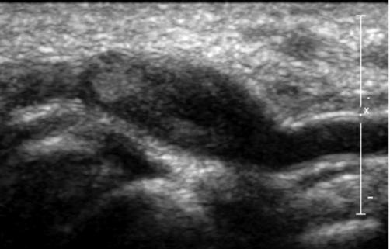

Figure 2: CT angiography confirming pseudoaneurysm morphology and absence of distal ischemia
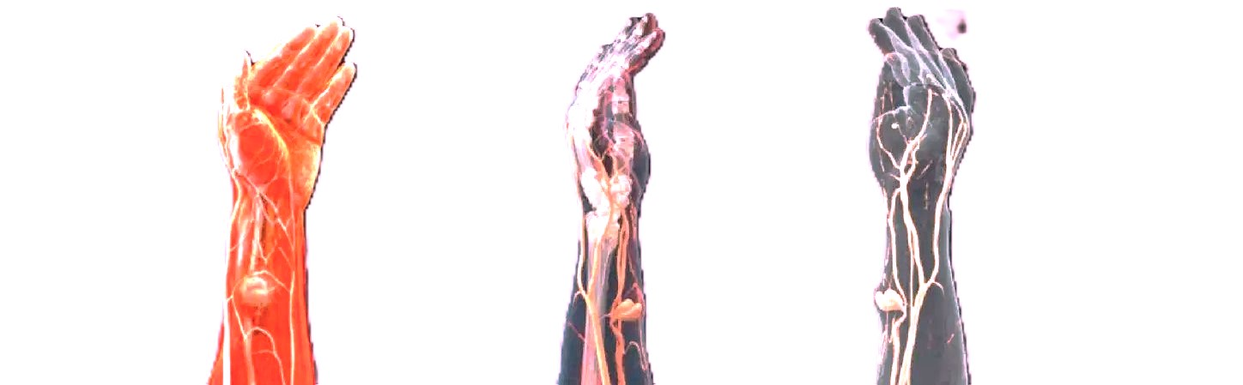

Patient consent and ethics

Written informed consent for publication and use of clinical images was obtained from the patient. Institutional approval was obtained as required by local policy.

Disclaimer (Artificial intelligence)
Author(s) hereby declare that NO generative AI technologies such as Large Language Models (ChatGPT, COPILOT, etc.) and text-to-image generators have been used during the writing or editing of this manuscript.

References
- Cunha R, et al. Pseudoaneurysm of radial artery after coronary angiography. J Surg Case Rep. 2023;2023(8):rjad446.
- Papadoulas SI, et al. Surgical repair of post-catheterization radial pseudoaneurysm. Pan Afr Med J. 2022;41:261.
- Majumdar G, et al. Radial artery pseudoaneurysm following transradial coronary intervention. J Cardiovasc Dis Diagn. 2016;S1:001.
- Kiemeneij F, et al. Radial artery access for coronary procedures: review of complications. Catheter Cardiovasc Interv. 2003;59(3):357–62.
- Bertrand OF, et al. Complications and failure of transradial approach for coronary interventions. JACC Cardiovasc Interv. 2010;3(10):1022–31.
- Corcos T. Distal radial access for coronary angiography and PCI: a state-of-the-art review. Catheter Cardiovasc Interv. 2019;93(4):639–44.
- Tokarek T, et al. Comparison of safety and effectiveness between right and left radial artery approach in PCI. Rev Esp Cardiol. 2022;75(2):119–28.
- Goktay AY, et al. Ultrasound-guided thrombin injection for radial pseudoaneurysm: case report and review. J Ultrasound Med. 2024;43(2):345–50.
- Khandelwal A, et al. Radial artery pseudoaneurysm post-PCI: diagnostic challenges and therapeutic options. Ann Vasc Surg. 2025;84:123–8.
- Sinha SK, et al. True radial artery pseudoaneurysm after transradial PCI: rare complication and surgical management. Indian Heart J. 2023;75(1):85–8.
- Patel T, et al. Management of radial artery pseudoaneurysm after cardiac catheterization: contemporary review. Catheter Cardiovasc Interv. 2022;99(4):E191–7.
- BMJ Case Reports. Radial artery pseudoaneurysm following coronary angiogram: the yin-yang sign. BMJ Case Rep. 2020;12(8):e228723.

