Case report

Suspected Arrhythmogenic Left Ventricular Cardiomyopathy: The Great Imitator Unveiled by Cardiac MRI – A Case Report.

Abstract:
Background: Arrhythmogenic left ventricular cardiomyopathy (ALVC) is a rare and often underdiagnosed subtype of arrhythmogenic cardiomyopathy (ACM), characterized by predominant left ventricular involvement and a high risk of arrhythmias. In contrast to the classic right dominant form, ALVC presents significant diagnostic challenges due to its phenotypic overlap with other cardiomyopathies and the limited availability of genetic testing.
Case Presentation: We report the case of a 55-year-old man with a history of hypertension and active smoking, who presented with progressive dyspnea, syncope, and palpitations. Initial evaluation revealed atrial fibrillation with rapid ventricular response, elevated troponin and BNP levels, and signs of congestive heart failure. Transthoracic echocardiography demonstrated left ventricular hypertrophic cardiomyopathy with severely reduced left ventricular ejection fraction (LVEF 34%) and global longitudinal strain (GLS) of -11.3%. Cardiac magnetic resonance (CMR) imaging showed moderate left ventricular dilation with significant septal hypertrophy, systolic dysfunction (LVEF 33%), and characteristic subepicardial and mid-myocardial late gadolinium enhancement (LGE) involving more than 30% of the myocardial mass, while the right ventricle remained unaffected. Comprehensive workup excluded cardiac sarcoidosis through negative angiotensin-converting enzyme levels, phosphocalcic assessment, salivary gland biopsy, and thoracic CT. Twenty-four-hour Holter monitoring revealed ventricular hyperexcitability with non-sustained ventricular tachycardia episodes and a 22% premature ventricular contraction burden.
Management and Outcome: Given the high risk of sudden cardiac death (SCD), the patient received an implantable cardioverter-defibrillator (ICD) and antiarrhythmic therapy with amiodarone, resulting in a significant reduction of arrhythmia burden, with premature ventricular contractions burden decreasing to 1.3%.
Conclusion: This case highlights the diagnostic complexity of ALVC and emphasizes the importance of multimodal imaging and the systematic exclusion of differential diagnoses. In settings with limited access to genetic testing, comprehensive clinical evaluation remains crucial for early recognition and appropriate risk stratification of this potentially life-threatening condition.

Keywords:
- Arrhythmogenic left ventricular cardiomyopathy
- Cardiac magnetic resonance
- Sudden cardiac death risk
- Implantable cardioverter-defibrillator
- Case report

Introduction:
Arrhythmogenic cardiomyopathy (ACM) is a genetic myocardial disease characterized by fibrofatty replacement, and clinically by ventricular arrhythmias [1]. It is often accompanied by regional or global ventricular dysfunction and represents a leading cause of sudden cardiac death in young individuals and athletes [2]. This condition is strongly linked to mutations in genes encoding desmosomal proteins, resulting in the loss of cardiomyocyte adhesion and disruption of intracellular signaling processes [1]. Initially, it has been described as a condition predominantly affecting the right ventricle (RV), with minor or late involvement of the left ventricle (LV). However, emerging evidence from multiple studies has demonstrated that LV involvement occurs frequently, with reported rates ranging from 16% to 76% of cases [3]. Consequently, this more nuanced understanding has led to the adoption of the term "arrhythmogenic cardiomyopathy", a designation that better captures the full phenotypic spectrum of the disease. As a result, the clinical classification of ACM has been expanded to include three primary phenotypes: the ‘right-dominant’ variant, the biventricular form, with equal involvement of both ventricles, and the ‘left-dominant’ variant, or arrhythmogenic left ventricular cardiomyopathy (ALVC), featuring predominant left ventricular involvement and minimal or no right ventricular abnormalities[4][5]. In 2023, the European Task Force introduced the term “scarring/arrhythmogenic cardiomyopathy” to encompass all phenotypic variants of ACM, regardless of etiology, and to emphasize myocardial scarring the substrate for malignant ventricular arrhythmias and progressive systolic dysfunction as the defining pathological hallmark of the disease[6]. We present a case of ALVC in a patient with symptomatic ventricular arrhythmias and high risk of sudden cardiac death, requiring the placement of an implantable cardioverter-defibrillator. This manuscript highlights the diagnostic challenges of Arrhythmogenic Left Ventricular Cardiomyopathy (ALVC), a rare and often underrecognized variant of arrhythmogenic cardiomyopathy with heterogeneous clinical presentations and considerable overlap with other cardiac conditions. It emphasizes the pivotal role of multimodal imaging particularly cardiac MRI in establishing the diagnosis through characteristic features, systematic exclusion of differential diagnoses, including cardiac sarcoidosis, myocarditis, and dilated cardiomyopathy, along with precise risk stratification. Given the limited number of studies focusing on this left-dominant form, and the frequent lack of access to genetic testing in some settings, a comprehensive clinical, electrocardiographic, and imaging assessment remains essential for early recognition and optimal management. Overall, this report increases awareness of ALVC as a distinct phenotype and provides valuable insights to enhance diagnostic accuracy and patient outcomes. Our paper was written according to the CARE guidelines[7].
Case presentation:

We report the case of a 55-year-old man with a history of hypertension and active smoking, admitted to our department with recently worsened dyspnea at rest, along with two episodes of syncope associated with palpitations occurring one week prior to admission. Additionally, he reported a three-month history of exertional palpitations that resolved completely with rest. The patient had no history of early-onset cardiac disease, and there was no report of premature cardiac illness or sudden cardiac death among first-degree relatives.
Upon admission, his vital signs were stable, with a blood pressure of 120/80 mmHg, tachycardia at 115 beats per minute, tachypnea at 22 breaths per minute, and normal oxygen saturation. The clinical examination revealed signs of congestive left heart failure.
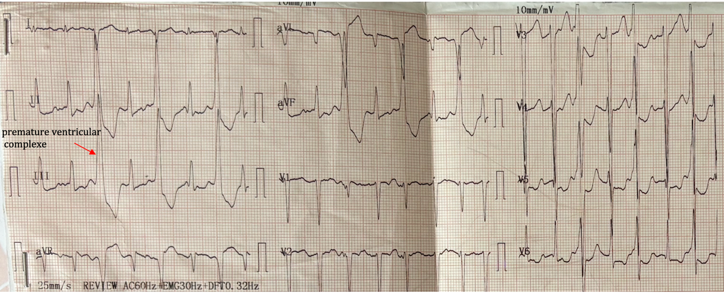
The electrocardiogram (ECG) revealed sinus rhythm with electrical left ventricular hypertrophy and monomorphic premature ventricular complexes (PVCs) in a bigeminy pattern, with a left bundle branch block (LBBB) morphology and a long R-on-T coupling interval. (Fig. 1).

Fig.1- ECG showing a sinus rhythm with electrical left ventricular hypertrophy and monomorphic premature ventricular complexes (PVCs) in a bigeminy pattern, with a left bundle branch block (LBBB) morphology and a long R-on-T coupling interval.

Biologically, troponin levels were elevated at 1.76 ng/mL, and BNP was also increased at 420 pg/mL. Urea and creatinine levels were elevated at 1 mmol/L and 24 mg/dL, respectively, corresponding to an estimated glomerular filtration rate of 29 mL/min/1.73 m². The chronicity assessment showed normal 24-hour proteinuria at 128 mg/24h, along with normal electrolytes levels, A renovesical ultrasound was performed, showing normal kidneys with regular contours and well-defined parenchyma, without any abnormalities.

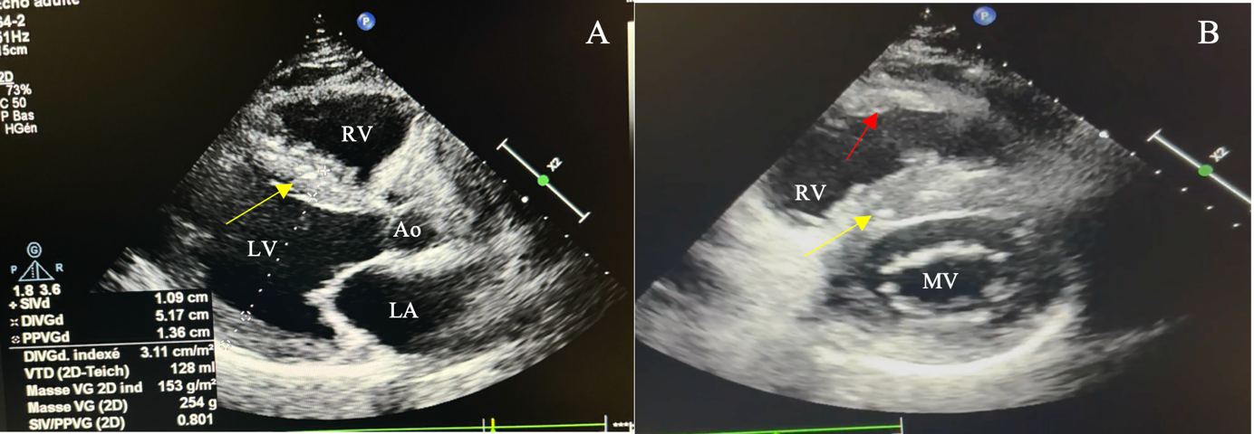
Transthoracic echocardiography (TTE) revealed features of left ventricular hypertrophic cardiomyopathy, with posterior wall thickness of 13 mm, interventricular septal (IVS) thickness of 11 mm, and RV wall thickness of 4 mm. The left ventricle was moderately dilated (end-diastolic volume: 165 mL) with globally reduced wall motion and a severely decreased ejection fraction (LVEF: 34%) as well as a global longitudinal strain (GLS) of –11.3%. The right ventricle showed normal end-diastolic volume (135 mL) and preserved function (TAPSE: 19 mm; fractional area change (FAC): 40%), along with biatrial dilation (Fig. 2)

Fig.2- Two-dimensional echocardiogram: (A) Parasternal long axis view showing a dilated hypertrophic left ventricle (yellow arrow), (B) Parasternal short axis view demonstrating biventricular hypertrophy (hypertrophic right ventricle: red arrow).
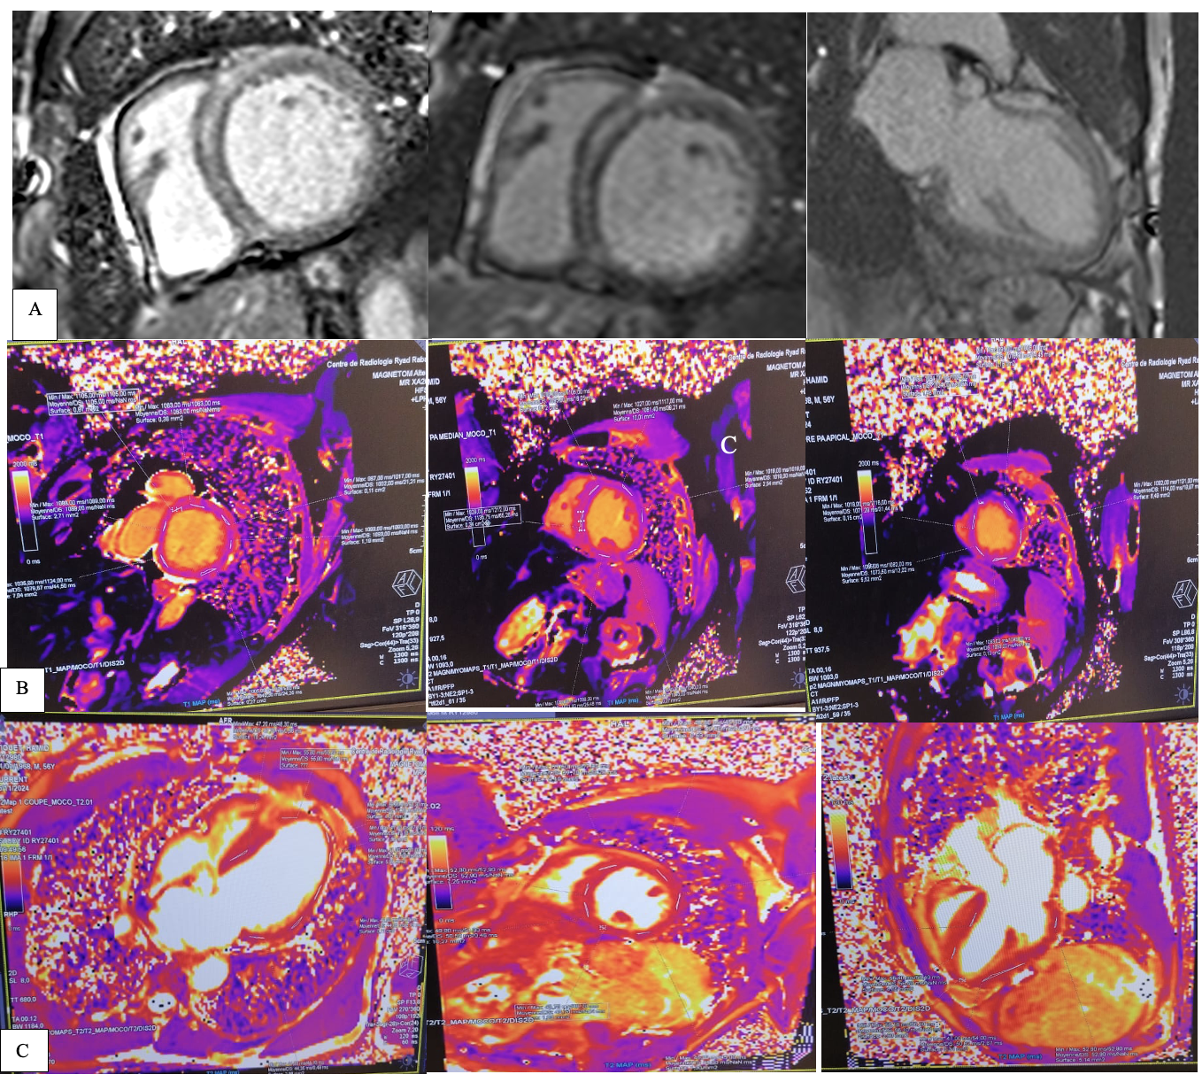
In view of the patient’s reduced renal function, cardiac MRI was chosen over coronary angiography to avoid further renal impairment, rule out CAD, and allow a comprehensive evaluation of myocardial involvement. Accordingly, CMR revealed a moderately dilated left ventricle (end-diastolic volume: 256 mL) with marked hypertrophy measuring 14 mm in the basal anteroseptal and mid-inferoseptal segments. It also demonstrated systolic dysfunction characterized by global kinetic abnormalities, intraventricular asynchrony, and non-systematized regional wall motion abnormalities, with a left ventricular ejection fraction (LVEF) of 33%. In contrast, the right ventricle showed normal wall thickness (4 mm), no segmental or global wall motion abnormalities, a normal end-diastolic volume of 135 mL, and a preserved ejection fraction of 51%. Late gadolinium enhancement (LGE) was detected in a subepicardial and mid-myocardial distribution, involving the basal and mid segments of the anterior, anteroseptal, and inferoseptal walls, and affecting more than 30% of the myocardial mass. The mean indexed left ventricular myocardial mass was 73 g/m². These findings suggest extensive focal fibrosis, which may indicate cardiac sarcoidosis or left-dominant ACM (Fig.3).

Fig.3 - Cardiac magnetic resonance imaging: A: LGE significantly delayed enhancement of the LV basal to mid anterior wall and interventricular septum B: Cardiac MRI demonstrates prolonged T1 mapping values (> 1050 ms), consistent with the presence of late gadolinium enhancement. C: Cardiac MRI showing normal native T2 mapping values, indicating the absence of myocardial edema.

For the etiological workup and to rule out differential diagnoses, measurement of angiotensin-converting enzyme levels, phosphocalcic assessment, salivary gland biopsy, and thoracic CT scan were conducted, all showing no evidence of sarcoidosis. Although genetic testing plays an important role in the diagnosis of ALVC, it remains largely inaccessible in our country.

Lastly, and from a rhythmic standpoint, an initial 24-hour ECG monitoring showed ventricular hyperexcitability, with two non-sustained episodes of ventricular tachycardia (VT) and multiple premature ventricular contractions (PVC) with a PVC burden of 22%. Supraventricular hyperexcitability was also noted, with multiple episodes of supraventricular tachycardia (SVT). One month later, while on amiodarone therapy, the follow-up Holter monitor demonstrated a reduction in the burden of PVCs (1.3% over 36 hours), with occasional PVC couplets but no progression to VT. Additionally, a few supraventricular extrasystoles were also recorded, with no progression to SVT. Given the high risk of sudden cardiac death (SCD), the patient subsequently underwent implantation of an ICD (Fig.4). In our patient, device interrogation revealed that one shock had been appropriately delivered in response to detected arrhythmias, (Fig.5) shows an ECG performed after ICD implantation.

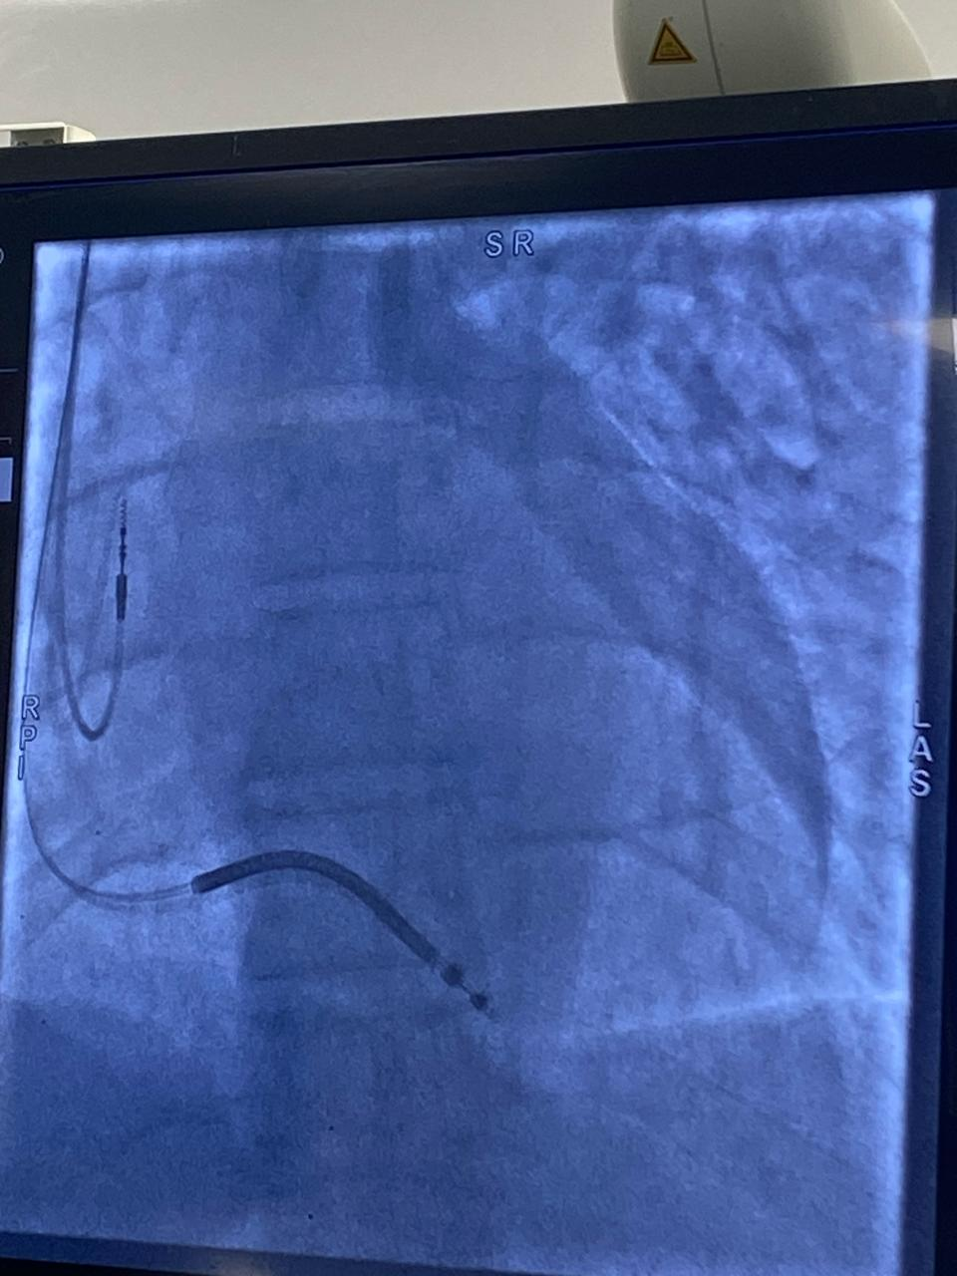
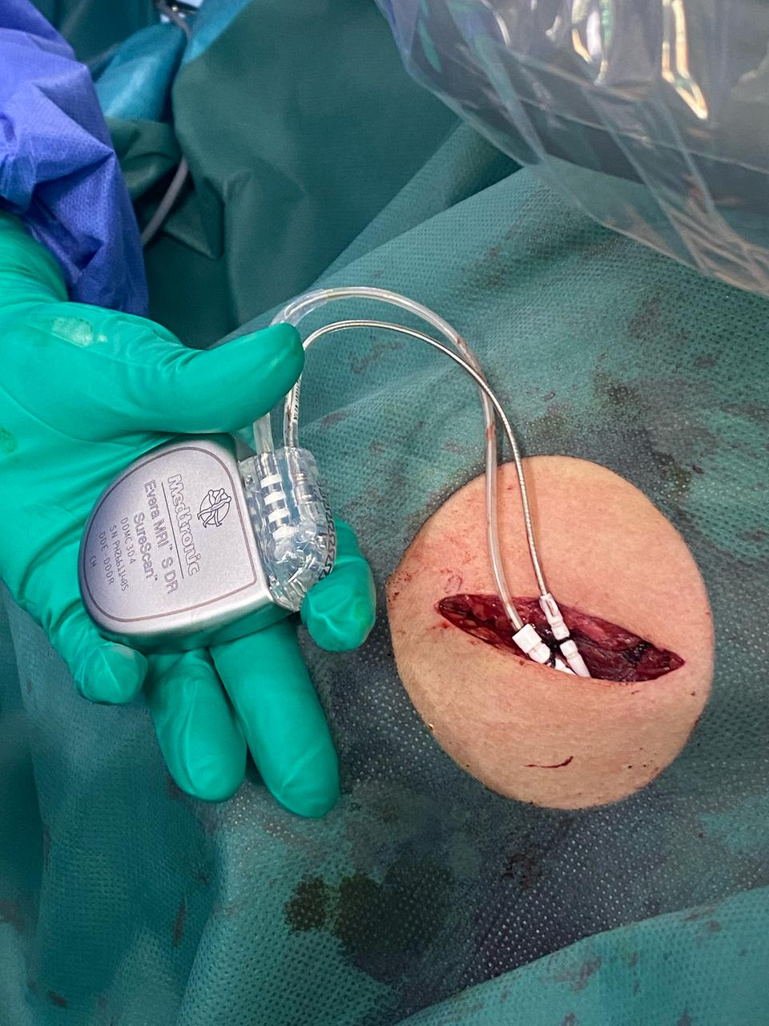

Fig.4 - A: Operative Image Demonstrating ICD Lead and Generator Positioning, B: Fluoroscopy of Defibrillator Electrode Placement

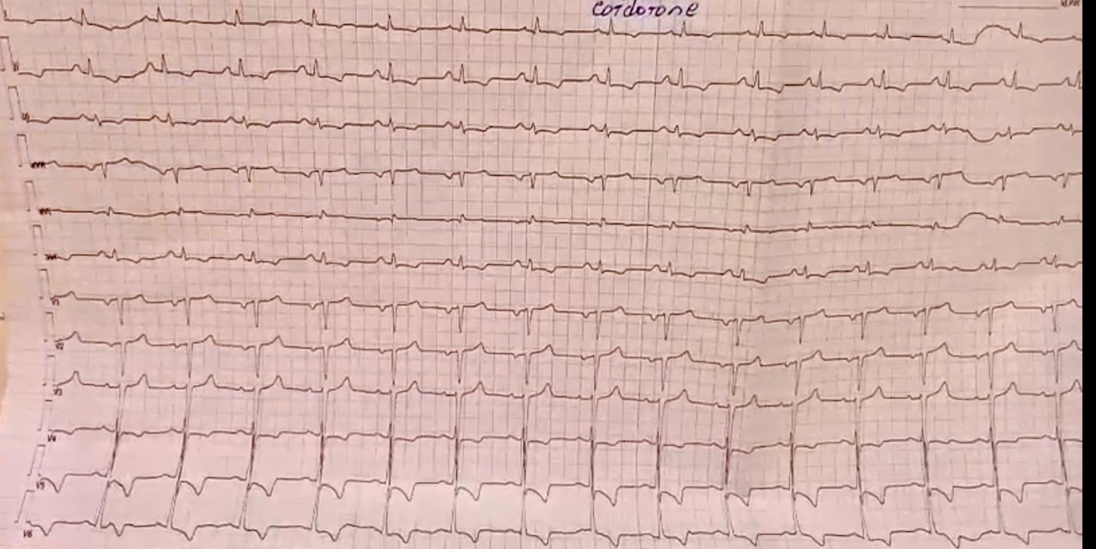

Fig.5- ECG after ICD implantation and antiarrhythmic therapy, showing a sinus rhythm, with electrical left ventricular hypertrophy, inverted T waves in the lateral leads, low QRS voltages in the limb leads, and R-wave attenuation in the anterior leads.

Discussion

Arrhythmogenic cardiomyopathy (ACM) affects approximately 1 in every 2,000 to 5,000 individuals [2], although the true prevalence of arrhythmogenic left ventricular cardiomyopathy (ALVC) is likely underestimated due to diagnostic challenges and limited access to genetic testing. The clinical significance is evident from postmortem studies revealing ACM in up to 20% of sudden cardiac deaths among young individuals [8] and accounting for 10-15% of sudden deaths in athletes [9]. ACM results from pathogenic mutations in genes encoding intercellular junction structural proteins [10], primarily cardiac desmosomal proteins including desmoplakin (DSP), plakophilin (PKP2), desmoglein (DSG2), and desmocollin (DSC2). Mutations in DSP, phospholamban (PLN), and filamin C (FLNC) are most frequently associated with left-sided forms [11].

Classifying cardiomyopathies remains challenging due to their genetic and phenotypic heterogeneity, often resulting in overlapping clinical and imaging features [12]. The 2020 International Consensus introduced the Padua criteria for ACM, integrating structural, histological, and genetic markers [5]. In isolated LV forms, however, genetic confirmation remains crucial given the overlap with other cardiac pathologies [13] [14]. The 2023 European Task Force revised the ACM framework, allowing ALVC diagnosis based on clinical and imaging findings even without RV involvement, and highlighting its high risk of SCD irrespective of etiology or LV function (Table 1). The term “scarring/arrhythmogenic cardiomyopathy” was proposed to better capture the disease’s hallmark nonischemic myocardial fibrosis as the substrate for malignant ventricular arrhythmias. In parallel, the 2023 ESC classification adopted a phenotypic approach, categorizing patients as having dilated or non-dilated LV cardiomyopathy (NDLVC) based on LV volume and function. Unlike the Task Force Criteria, this framework focuses on morphology rather than tissue characterization or arrhythmic risk. These evolving definitions highlight the challenge of a unified classification for cardiomyopathies.

 | Criteria for RV Involvement | Criteria for LV Involvement
I. Morpho-functional ventricular abnormalities | By 2D echocardiogram, CMR or angiography:  Major  • Regional RV akinesia, dyskinesia, or aneurysm plus one of the following:  - global RV dilatation (increase of RV EDV according to the imaging test specific nomograms for age, sex and BSA)  or  - global RV systolic dysfunction (reduction of RV EF according to the imaging test specific nomograms for age and sex)  Minor  • Regional RV akinesia, dyskinesia or aneurysm of RV free wall | By 2D echocardiogram, CMR or angiography:  Minor  • Global LV systolic dysfunction, with or without LV dilatation (increase of LV EDV according to the imaging test specific nomograms for age, sex, and BSA)
II. Structural myocardial abnormalities | By CECMR:  Major  • Fibrous replacement of the myocardium in ≥1 sample, with or without fatty tissue, at histology  By EMB (limited indications):  Major  • Unequivocal RV LGE (confirmed in 2 orthogonal views) in ≥1 RV region(s) (excluding tricuspid valve) | By CECMR:  Major  • “Ring-like” LV LGE (subepicardial or midmyocardial stria pattern) of ≥3 segments (confirmed in 2 orthogonal views) Minor  • LV LGE (subepicardial or midmyocardial stria pattern) of 1 or 2 Bull’s Eye segment(s) (in 2 orthogonal views) of the free wall, septum, or both (excluding patchy, focal or septal junctional LGE)
III. ECG repolarization abnormalities | Major  • Negative T waves in right precordial leads (V1, V2, and V3) or beyond in individuals ≥14-year-old (in the absence of complete RBBB and not preceded by J-point/ST-segment elevation)  Minor  • Negative T waves in leads V1 and V2 in males ≥14-year-old (in the absence of RBBB and not preceded by J-point/ST-segment elevation)  • Negative T waves beyond V3 in the presence of complete RBBB  • Negative T waves beyond V3 in individuals <14-year-old | Minor  • Negative T waves in left precordial leads (V4–V6) (in the absence of complete LBBB)
IV. ECG depolarization abnormalities | Minor  • Epsilon wave (reproducible low-amplitude signals between end of QRS com- plex to onset of the T wave) in the right precordial leads (V1 to V3)  • Terminal activation duration of QRS ≥55 ms measured from the nadir of the S wave to the end of the QRS, including R’, in V1, V2, or V3 (in the absence of complete RBBB) | Minor  • Low QRS voltages (<0.5 mV peak to peak) in all limbs leads in the absence of other causes (e.g., cardiac amyloidosis, obesity, emphysema, or pericardial effusion)
V. Ventricular arrhythmias | Major  • Frequent ventricular extrasystoles (>500 per 24 h), non-sustained or sustained ventricular tachycardia of LBBB morphology with non-inferior axis  Minor  • Frequent ventricular extrasystoles (>500 per 24 h), non-sustained or sustained ventricular tachycardia of LBBB morphology with inferior axis (“RVOT pattern”) • History of cardiac arrest due to ventricular fibrillation or sustained ventricular tachycardia of unknown morphology | Minor  • Frequent (>500 per 24 h) or exercise-induced ventricular extrasystoles with a RBBB morphology or multiple RBBB morphologies (excluding the “fascicular pattern”)  • Non-sustained or sustained ventricular tachycardia with a RBBB morphology (excluding the “fascicular pattern”)  • History of cardiac arrest due to ventricular fibrillation or sustained ventricular tachycardia of unknown morphology
VI. Family history/genetics | Major  - Identification of a pathogenic ACM-gene variant in the patient under evaluation  - ACM confirmed in a first-degree relative who meets diagnostic criteria  - ACM confirmed pathologically at autopsy or surgery in a first-degree relative  Minor  - Identification of a likely-pathogenic ACM-gene variant in the patient under evaluation  - History of ACM in a first-degree relative in whom it is not possible or practical to determine whether the family member meets diagnostic criteria  - ACM confirmed pathologically or by diagnostic criteria in second-degree relative

ACM: arrhythmogenic cardiomyopathy; BSA: body surface area; ECG: electrocardiogram; EDV: end diastolic volume; EF: ejection fraction; LBBB: left bundle branch block; LGE: late gadolinium enhancement; LV: left ventricle; RBBB: right bundle branch block; RV: right ventricle; RVOT: right ventricular outflow tract. Adapted from [15].

Table 1: European Task Force criteria for diagnosis of arrhythmogenic cardiomyopathy[12].

For the diagnosis of ACM, the 2023 European Task Force criteria maintained the six-category structure of the Padua criteria [5], in which LV systolic dysfunction, with or without dilation, is classified as a minor morpho-functional criterion due to its limited specificity [16]. This was observed in our patient, whose CMR showed a mildly dilated, hypokinetic LV with an altered ejection fraction. The characteristic nonischemic LGE pattern subepicardial or mid-myocardial involvement across ≥3 contiguous or discontinuous LV segments represents a major diagnostic criterion [16] [17]. In our patient, with fibrosis affected over 30% of the LV mass. ECG findings further supported LV involvement, including T-wave inversion in leads V4–V6, sparing V1–V3, without complete LBBB, a minor criterion [18], and low QRS voltages in the limb leads (<0.5 mV), reflecting myocardial loss and fibro-fatty replacement, which constitutes a major criterion [10] [19] (Figure 2). Arrhythmic markers, such as PVCs or VT with RBBB morphology indicating a left ventricular origin [20], or a history of cardiac arrest due to VF/VT, were absent, as the patient’s PVCs and VT exhibited LBBB morphology. No family history or genetic criteria were met, although genetic testing is a key component of ALVC diagnosis, access remains limited in our setting.
According to the 2023 European Task Force criteria, the diagnosis of ACM requires at least one criterion major or minor from either the first category (morpho-functional abnormalities) or the second (structural abnormalities), as ACM is primarily a structural heart disease. A definite diagnosis is established when two major, or one major plus two minor, or four minor criteria are fulfilled; a borderline diagnosis requires one major and one minor, or three minor criteria; and a possible diagnosis is made when one major or two minor criteria are met [21]. In our case, following this algorithm, the patient fulfilled two major and two minor criteria, establishing a definite diagnosis of ALVC (Fig.6).

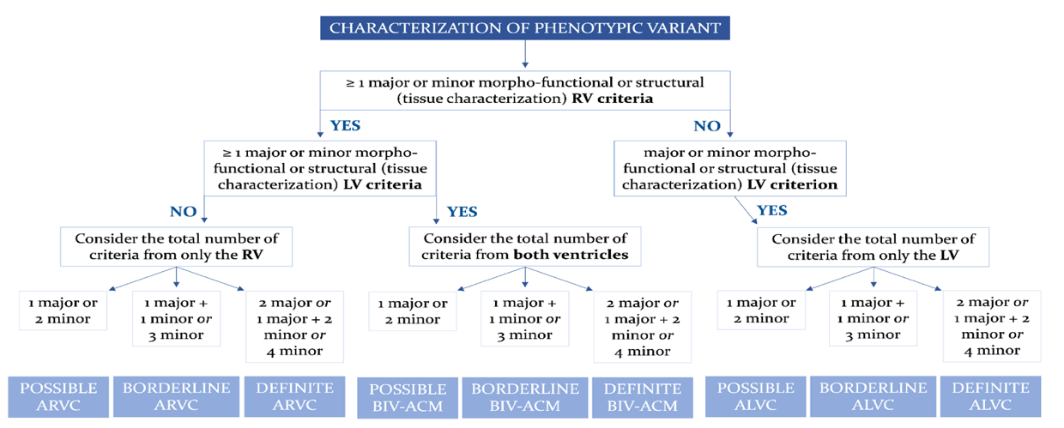

Fig.6- Flowchart for phenotypic characterization of ACM. Adapted from Corrado et al. [15].
ACM: arrhythmogenic cardiomyopathy; ALVC: arrhythmogenic left ventricular cardiomyopathy; ARVC: arrhythmogenic right ventricular cardiomyopathy; BIV-ACM: biventricular arrhythmogenic cardiomyopathy; LV: left ventricle; RV: right ventricle.

Differentiating ALVC from other conditions is challenging due to significant phenotypic overlap with inherited cardiomyopathies, neuromuscular disorders, and acquired myocardial diseases such as dilated cardiomyopathy, myocarditis, and cardiac sarcoidosis. Although both DCM and ALVC may exhibit varying degrees of LV systolic dysfunction and myocardial fibrosis, they represent distinct entities. ALVC lies within the spectrum of non-dilated LV cardiomyopathies (NDLVC), with minimal or absent LV dilation, whereas DCM is defined by global systolic impairment and marked LV dilation [22]. Cardiac MRI plays a pivotal role in distinguishing these two entities as the fibrofatty replacement seen in ALVC occurs early and is more pronounced and directly correlates with left ventricular systolic dysfunction [23], whereas in DCM, fibrosis develops later as a consequence of myocyte contractile dysfunction and eccentric remodeling. Consequently, ventricular arrhythmias often appear early in ALVC, sometimes as the first manifestation, but emerge only in advanced stages of DCM [24]. Advanced CMR techniques, including native T1 mapping and extracellular volume (ECV) quantification, further support the diagnosis of ALVC by revealing interstitial expansion, with prolonged native T1 values consistent with the LGE findings.

Cardiac sarcoidosis, similarly, can mimic ALVC through myocardial fibrosis and ventricular dysfunction, leading to arrhythmias and heart failure, making differential diagnosis challenging. In contrast to ALVC, sarcoidosis often involves infrahisian conduction abnormalities such as atrioventricular and bundle branch blocks resulting from granulomatous infiltration of the basal septum [25]. Although endomyocardial biopsy remains the diagnostic gold standard, CMR plays a crucial role in differentiation, as sarcoidosis typically demonstrates the characteristic “hook sign” (fig.7), with late gadolinium enhancement extending from the septum to the ventricular insertion points and right ventricular free wall[26], a feature absent in our patient. T2-weighted CMR sequences are not routinely recommended for diagnosing ALVC, however, they may be useful in identifying ACM patients presenting with myocarditis-like features, such as chest pain and elevated troponin levels. Complementary 18F-FDG PET imaging further supports the diagnosis by showing focal uptake overlapping the LGE distribution, confirming active myocardial inflammation [27].

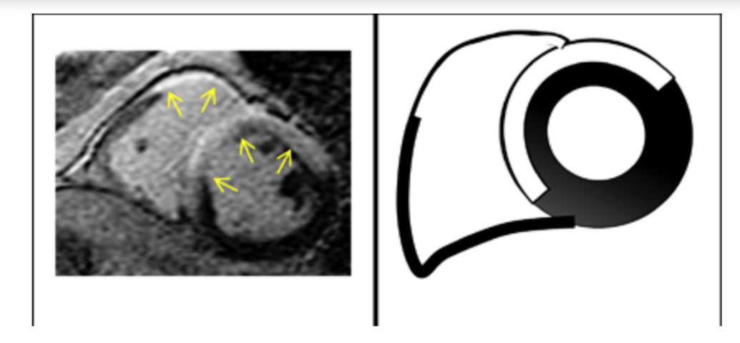

Fig. 7- Intense LGE signals and prominent involvement of insertion points with direct and contiguous extension across the septum into RV (“hook sign”) typical of CS. Arrows indicate areas of edema.[26]

Moreover, isolated left ventricular myocardial scars, often attributed to previous myocarditis, can resemble ALVC and cause ECG abnormalities such as low-amplitude QRS complexes, T-wave inversion, and ventricular arrhythmias, even though they may not be detectable by echocardiography [28] [29]. Although CMR is essential, it cannot reliably differentiate ALVC from post-myocarditis fibrosis patterns. Therefore, genetic testing is recommended in patients presenting with acute myocarditis who exhibit at least one of the following: a family history of cardiomyopathy or sudden cardiac death, a severe clinical presentation regardless of age, or imaging findings (echocardiography or CMR) suggestive of arrhythmogenic cardiomyopathy [30]. These non-ischemic LV scars, especially in athletes, can serve as substrates for life-threatening arrhythmias, underscoring the importance of thorough evaluation, including family history, symptom assessment, and genetic testing for arrhythmogenic cardiomyopathy mutations to differentiate ALVC from myocarditis.

Hypertrophic cardiomyopathy (HCM) may also be considered in the differential diagnosis due to the septal hypertrophy observed in our patient. Nevertheless, in our patient, this finding is more plausibly explained by longstanding hypertension. Although arrhythmias can occur in HCM, they tend to be less pronounced in the early stages of the disease. Moreover, HCM rarely progresses to severe left ventricular systolic dysfunction except in its late, dilated phase, which was not observed in our case. CMR is invaluable for differentiating between these conditions, typically revealing subepicardial or diffuse fibrosis in ALVC, in contrast to the patchy mid-myocardial fibrosis pattern seen in HCM [31].

Individualized risk stratification in patients with ACM is crucial to identify those at high risk of SCD. This assessment relies on the severity of arrhythmic events and the extent of fibrofatty myocardial replacement, assessed via ECG and imaging. However, despite numerous follow-up studies, the prognostic value of individual risk factors remains uncertain due to small sample sizes and methodological variability [32]. Multivariate analyses have identified independent predictors of ventricular arrhythmias, including a history of cardiac arrest or unstable ventricular tachycardia, younger age, and left ventricular involvement with reduced ejection fraction [33]. More recent imaging-based research has shown that left ventricular involvement, particularly in left-dominant variants, is associated with poorer outcomes compared to isolated right ventricular disease or normal cardiac MRI findings [34][35].

Genotype plays a key role in sudden cardiac death (SCD) risk prediction. Variants in PLN, TMEM43, DES, DSP, and LMNA genes are associated with higher arrhythmic event rates, independent of LVEF[17][30]. When available, genotype-specific risk models should be applied [36]. However, in settings with limited access to genetic testing, data on SCD risk stratification in ALVC patients without identified pathogenic variants remain limited. According to the 2019 HRS expert consensus statement on the evaluation, risk stratification, and management of arrhythmogenic cardiomyopathy, ICD implantation for primary prevention is recommended in patients with ACM (other than ARVC) who present with hemodynamically tolerated ventricular tachycardia (VT). It is also indicated in those with an LVEF ≤35%, NYHA class II–III symptoms, and an expected meaningful survival greater than one year[37]. Based on these criteria, our patient met the indication for ICD implantation, which was subsequently performed. The 2023 ESC Guidelines for the management of cardiomyopathies further recommend that primary prevention ICD indications in NDLVC should mirror those for dilated cardiomyopathy (DCM), although the level of supporting evidence is necessarily lower given the overlap between both entities and the limited available data. Given the complexity of risk assessment in ACM, shared decision-making remains essential, weighing individual risk and patient preference [38].

The management of ACM involves clinical management, pharmacological options, catheter ablation, and placement of ICD. Clinical management involves lifestyle modifications advised for all ACM patients due to the strong link between endurance exercise and the increased risk of ventricular arrhythmias [39]. Given the overlap with DCM and available data, and in keeping with the 2022 ESC Guidelines for the management of patients with ventricular arrhythmias and the prevention of sudden cardiac death, the Task Force recommends that primary prevention ICD implantation in NDLVC should be the same as those for DCM but the level of evidence is necessarily lower. Pharmacological therapy may include antiarrhythmic agents such as amiodarone or sotalol, which are considered reasonable options (Class IIb recommendation) in patients with ACM to control arrhythmic symptoms or reduce ICD shocks [37]. Cardio selective β-blockers, such as metoprolol, are also advised, in combination with guideline-directed heart failure therapy in advanced stages with severe systolic dysfunction [38]. Catheter ablation via epicardial approach can address scar-related VT [40], while heart transplantation remains the definitive therapeutic option for end-stage disease [40].
Conclusion:
The primary takeaway lessons from this case report are the diagnostic complexity of ALVC and the need to maintain high clinical suspicion in patients with ventricular arrhythmias and left ventricular dysfunction. Despite the absence of genetic confirmation, our patient's presentation with characteristic subepicardial late gadolinium enhancement (LGE) on CMR and systematic exclusion of differential diagnoses supported the ALVC diagnosis.
The case highlights three key clinical points: the necessity of multimodal imaging including CMR for accurate diagnosis, the importance of excluding phenotypically similar conditions such as sarcoidosis and dilated cardiomyopathy, and the critical role of risk stratification in guiding ICD implantation. In resource-limited settings where genetic testing remains inaccessible, clinicians must rely on comprehensive clinical assessment and advanced imaging to establish diagnosis and implement appropriate management strategies.
Increased awareness of ALVC as a distinct phenotypic variant of arrhythmogenic cardiomyopathy is crucial for early recognition, appropriate risk stratification, and optimal patient outcomes.

Disclaimer (Artificial intelligence)
we hereby declare that NO generative AI technologies such as Large Language Models (ChatGPT, COPILOT, etc.) and text-to-image generators have been used during the writing or editing of this manuscript.

References:
C
C
B
A
B
A

[1] D. Corrado, C. Basso, and D. P. Judge, “Arrhythmogenic cardiomyopathy,” Circ Res, vol. 121, no. 7, pp. 785–802, Sep. 2017, doi: 10.1161/CIRCRESAHA.117.309345

[2] A. W. G. J. Oomen, C. Semsarian, R. Puranik, and R. W. Sy, “Diagnosis of Arrhythmogenic Right Ventricular Cardiomyopathy: Progress and Pitfalls,” Heart Lung Circ, vol. 27, no. 11, pp. 1310–1317, Nov. 2018, https://doi.org/10.1161/CIR.0000000000000682
[3] C. Miles et al., “Sudden Death and Left Ventricular Involvement in Arrhythmogenic Cardiomyopathy,” Circulation, vol. 139, no. 15, p. 1786, Apr. 2019, doi: 10.1161/CIRCULATIONAHA.118.037230
[4] D. Corrado et al., “Arrhythmogenic right ventricular cardiomyopathy: evaluation of the current diagnostic criteria and differential diagnosis,” Eur Heart J, vol. 41, no. 14, p. 1414, Apr. 2019, doi: 10.1093/eurheartj/ehz669
[5] D. Corrado et al., “Diagnosis of arrhythmogenic cardiomyopathy: The Padua criteria,” Int J Cardiol, vol. 319, pp. 106–114, 2020, doi: 10.1016/j.ijcard.2020.06.005
[6] D. Corrado et al., “Scarring/arrhythmogenic cardiomyopathy,” Eur Heart J Suppl, vol. 25, no. Suppl C, pp. C144–C154, May 2023, doi: 10.1093/eurheartjsupp/suad017
[7] D. S. Riley et al., “CARE guidelines for case reports: explanation and elaboration document,” J Clin Epidemiol, vol. 89, pp. 218–235, Sep. 2017, doi: 10.1016/j.jclinepi.2017.04.026
[8] G. Thiene, A. Nava, D. Corrado, L. Rossi, and N. Pennelli, “Right Ventricular Cardiomyopathy and Sudden Death in Young People,” New England Journal of Medicine, vol. 318, no. 3, pp. 129–133, Jan. 1988, doi: 10.1056/NEJM198801213180301
[9] B. J. Maron, T. S. Haas, A. Ahluwalia, C. J. Murphy, and R. F. Garberich, “Demographics and Epidemiology of Sudden Deaths in Young Competitive Athletes: From the United States National Registry,” American Journal of Medicine, vol. 129, no. 11, pp. 1170–1177, Nov. 2016, doi: 10.1016/j.amjmed.2016.02.031
[10] A. Zorzi et al., “Nonischemic Left Ventricular Scar as a Substrate of Life-Threatening Ventricular Arrhythmias and Sudden Cardiac Death in Competitive Athletes,” Circ Arrhythm Electrophysiol, vol. 9, no. 7, p. e004229, Jul. 2016, doi: 10.1161/CIRCEP.116.004229
[11] J. B. Augusto et al., “Dilated cardiomyopathy and arrhythmogenic left ventricular cardiomyopathy: a comprehensive genotype-imaging phenotype study,” Eur Heart J Cardiovasc Imaging, vol. 21, no. 3, pp. 326–336, Mar. 2020, doi: 10.1093/ehjci/jez188
[12] F. Graziano et al., “The 2023 European Task Force Criteria for Diagnosis of Arrhythmogenic Cardiomyopathy: Historical Background and Review of Main Changes,” Rev Cardiovasc Med, vol. 25, no. 9, p. 348, 2024, doi: 10.31083/j.rcm2509348

[13] D. Corrado, C. Basso, and G. Thiene, “Arrhythmogenic right ventricular cardiomyopathy: diagnosis, prognosis, and treatment,” Heart, vol. 83, no. 5, pp. 588–595, May 2000, doi: 10.1136/heart.83.5.588
[14] D. Corrado and C. Basso, “Arrhythmogenic left ventricular cardiomyopathy,” Heart, vol. 108, no. 9, pp. 733–743, May 2022, doi: 10.1136/heartjnl-2020-316944
[15] D. Corrado et al., “Proposed diagnostic criteria for arrhythmogenic cardiomyopathy: European Task Force consensus report,” Int J Cardiol, vol. 395, Jan. 2024, doi: 10.1016/j.ijcard.2023.131447
[16] A. Cipriani et al., “Cardiac magnetic resonance imaging of arrhythmogenic cardiomyopathy: evolving diagnostic perspectives,” Eur Radiol, vol. 33, no. 1, pp. 270–282, Jan. 2023, doi: 10.1007/s00330-022-08958-2
[17] E. D. Smith et al., “Desmoplakin Cardiomyopathy, a Fibrotic and Inflammatory Form of Cardiomyopathy Distinct from Typical Dilated or Arrhythmogenic Right Ventricular Cardiomyopathy,” Circulation, vol. 141, no. 23, pp. 1872–1884, Jun. 2020, doi: 10.1161/CIRCULATIONAHA.119.044934
[18] F. D’Ascenzi et al., “Prevalence and significance of T-wave inversion in children practicing sport: A prospective, 4-year follow-up study,” Int J Cardiol, vol. 279, pp. 100–104, Mar. 2019, doi: 10.1016/j.ijcard.2018.09.069
[19] A. Zorzi et al., “Prevalence and clinical significance of isolated low QRS voltages in young athletes,” Europace, vol. 24, no. 9, pp. 1484–1495, Sep. 2022, doi: 10.1093/europace/euab330
[20] D. Corrado, J. A. Drezner, F. D’Ascenzi, and A. Zorzi, “How to evaluate premature ventricular beats in the athlete: critical review and proposal of a diagnostic algorithm,” Br J Sports Med, vol. 54, no. 19, pp. 1142–1148, Oct. 2020, doi: 10.1136/bjsports-2018-100529
[21] F. Graziano et al., “New Diagnostic Approach to Arrhythmogenic Cardiomyopathy: The Padua Criteria,” Rev Cardiovasc Med, vol. 23, no. 10, p. 335, Oct. 2022, doi: 10.31083/j.rcm2310335
[22] E. Arbelo et al., “2023 ESC Guidelines for the management of cardiomyopathies: Developed by the task force on the management of cardiomyopathies of the European Society of Cardiology (ESC),” Eur Heart J, vol. 44, no. 37, pp. 3503–3626, Oct. 2023, doi: 10.1093/eurheartj/ehad194
[23] D. Segura-Rodríguez et al., “Myocardial fibrosis in arrhythmogenic cardiomyopathy: A genotype-phenotype correlation study,” Eur Heart J Cardiovasc Imaging, vol. 21, no. 4, pp. 378–386, Apr. 2020, doi: 10.1093/ehjci/jez277

[24] M. Merlo, A. Cannatà, M. Gobbo, D. Stolfo, P. M. Elliott, and G. Sinagra, “Evolving concepts in dilated cardiomyopathy,” Eur J Heart Fail, vol. 20, no. 2, pp. 228–239, Feb. 2018, doi: 10.1002/ejhf.1103
[25] B. Philips et al., “Arrhythmogenic right ventricular dysplasia/ cardiomyopathy and cardiac sarcoidosis distinguishing features when the diagnosis is unclear,” Circ Arrhythm Electrophysiol, vol. 7, no. 2, pp. 230–236, 2014, doi: 10.1161/CIRCEP.113.000932
[26] T. Vita et al., “Complementary Value of Cardiac Magnetic Resonance Imaging and Positron Emission Tomography/Computed Tomography in the Assessment of Cardiac Sarcoidosis,” Circ Cardiovasc Imaging, vol. 11, no. 1, p. e007030, Jan. 2018, doi: 10.1161/CIRCIMAGING.117.007030
[27] W. K. Choo, A. R. Denison, D. R. Miller, O. J. Dempsey, D. K. Dawson, and P. A. Broadhurst, “Cardiac sarcoid or arrhythmogenic right ventricular cardiomyopathy: A role for positron emission tomography (PET)?,” Journal of Nuclear Cardiology, vol. 20, no. 3, pp. 479–480, Jun. 2013, doi: 10.1007/s12350-013-9683-5
[28] A. Zorzi et al., “Phenotypic expression is a prerequisite for malignant arrhythmic events and sudden cardiac death in arrhythmogenic right ventricular cardiomyopathy,” EP Europace, vol. 18, no. 7, pp. 1086–1094, Jul. 2016, doi: 10.1093/europace/euv205

[29] R. Vio, A. Zorzi, and D. Corrado, “Myocarditis in the Athlete: Arrhythmogenic Substrates, Clinical Manifestations, Management, and Eligibility Decisions,” J Cardiovasc Transl Res, vol. 13, no. 3, pp. 284–295, Jun. 2020, doi: 10.1007/s12265-020-09996-1
[30] T. E. Verstraelen et al., “Prediction of ventricular arrhythmia in phospholamban p.Arg14del mutation carriers-reaching the frontiers of individual risk prediction,” Eur Heart J, vol. 42, no. 29, pp. 2842–2850, Aug. 2021, doi: 10.1093/eurheartj/ehab294
[31] N. Mewton, C. Y. Liu, P. Croisille, D. Bluemke, and J. A. C. Lima, “Assessment of Myocardial Fibrosis With Cardiovascular Magnetic Resonance,” J Am Coll Cardiol, vol. 57, no. 8, pp. 891–903, Feb. 2011, doi: 10.1016/j.jacc.2010.11.013

[32] A. Zorzi et al., “Arrhythmogenic Right Ventricular Cardiomyopathy: Risk Stratification and Indications for Defibrillator Therapy,” Curr Cardiol Rep, vol. 18, no. 6, pp. 1–11, Jun. 2016, doi: 10.1159/000519231

[33] D. Corrado et al., “Implantable Cardioverter-Defibrillator Therapy for Prevention of Sudden Death in Patients with Arrhythmogenic Right Ventricular Cardiomyopathy/Dysplasia,” Circulation, vol. 108, no. 25, pp. 3084–3091, Dec. 2003, doi: https://doi.org/10.1161/CIRCEP.113.000392
[34] G. D. Aquaro et al., “Prognostic Value of Magnetic Resonance Phenotype in Patients With Arrhythmogenic Right Ventricular Cardiomyopathy,” J Am Coll Cardiol, vol. 75, no. 22, pp. 2753–2765, Jun. 2020, doi: 10.1016/j.jacc.2020.04.023.

[35] Ø. H. Lie et al., “Prediction of Life-Threatening Ventricular Arrhythmia in Patients With Arrhythmogenic Cardiomyopathy: A Primary Prevention Cohort Study,” JACC Cardiovasc Imaging, vol. 11, no. 10, pp. 1377–1386, Oct. 2018, doi: 0.1016/j.jcmg.2018.05.017

[36] A. Mauriello et al., “Arrhythmogenic Left Ventricular Cardiomyopathy: From Diagnosis to Risk Management,” J Clin Med, vol. 13, no. 7, Apr. 2024, doi: 10.3390/jcm13071835
[37] J. A. Towbin et al., “2019 HRS expert consensus statement on evaluation, risk stratification, and management of arrhythmogenic cardiomyopathy,” Heart Rhythm, vol. 16, no. 11, pp. e301–e372, Nov. 2019, doi: 10.1016/j.hrthm.2019.05.007
[38] D. Corrado et al., “Treatment of arrhythmogenic right ventricular cardiomyopathy/dysplasia: an international task force consensus statement,” Eur Heart J, vol. 36, no. 46, pp. 3227–3237, Dec. 2015, doi: 10.1093/eurheartj/ehv162
[39] A. Gasperetti, C. A. James, M. Cerrone, M. Delmar, H. Calkins, and F. Duru, “Arrhythmogenic right ventricular cardiomyopathy and sports activity: from molecular pathways in diseased hearts to new insights into the athletic heart mimicry,” Eur Heart J, vol. 42, no. 13, pp. 1231–1243, Mar. 2021, doi: 10.1093/eurheartj/ehaa821
[40] F. Migliore et al., “Subcutaneous implantable cardioverter defibrillator in patients with arrhythmogenic right ventricular cardiomyopathy: Results from an Italian multicenter registry,” Int J Cardiol, vol. 280, pp. 74–79, Apr. 2019, doi: 10.1016/j.ijcard.2019.01.041

