Original Research Article
Assessment of Cardiovascular function in Periodontitis and Diabetes
Mellitus induced Rats Treated with Black Seed (Nigella sativa) Oil

ABSTRACT
Diabetic periodontitis and diabetes worsen cardiovascular disease, which is a major cause of morbidity and death globally. Although Nigella sativa (NS) oil has anti-inflammatory, antioxidant, and hypoglycemic qualities, little is known about how well it can treat periodontitis and diabetes-related cardiovascular dysfunction. Therefore, the purpose of this study was to examine, in a rat model of diabetes and periodontitis, the effects of intraperitoneal injection of Nigella sativa oil on heart function. Eight groups of six rats each were made from forty-eight Wistar rats as follows: Rats in Group I were fed regular rat chow without restriction (Control). NS oil is in Group II. Diabetes without treatment is in Group III. Group IV: NS oil following the onset of diabetes. Group V is untreated periodontitis. Group VI: administration of NS oil subsequent to induction of periodontitis. Group VIII: NS oil following the introduction of diabetes and periodontitis, and Group VII: diabetes and periodontitis without therapy. The polygraph was used to measure the heart rate, diastolic blood pressure (DBP), systolic blood pressure (SBP), and mean arterial blood pressure (MABP). The results of these measurements were used to calculate the rate pressure product (RPP), pulse pressure (PP), and mean arterial blood pressure (MABP). In order to estimate the quantity of antioxidant enzymes and troponin I, blood samples and heart tissue were obtained. The findings demonstrated a statistically significant decrease in SBP, DBP, MABP, and HR between the treated and control groups. In addition, it was noted that the animals' development of diabetes and periodontitis significantly raised their troponin I levels, an indication of heart injury, but that the effects of N. sativa oil treatment mitigated this effect when compared to the control group. The group with diabetes and periodontitis had higher levels of malondialdehyde, indicating the existence of accelerated lipid peroxidation, and decreased antioxidant activity of glutathione, catalase, and superoxide dismutase. On the other hand, the treatment with N. sativa oil decreased the increased MDA levels, indicating a decrease in lipid peroxidation. Additionally, levels of GSH, CAT, and SOD increased, confirming its potent antioxidant action. The results of this investigation demonstrated that giving Nigella sativa oil to rats with periodontitis and diabetes mellitus ameliorates their cardiovascular dysregulation.

KEYWORDS: Periodontitis, Diabetes Mellitus, Black Seed Oil, Heart

1. INTRODUCTION
Periodontitis (PD) is an infection caused by bacteria that is typified by a destructive inflammatory reaction brought on by the activity of bacteria and their byproducts. The causative agent and the host's immune and inflammatory response interact to cause PD [1]. Diabetes (type 2, DM2) is a chronic illness in which the body either becomes incapable of utilizing insulin efficiently or the pancreas is unable to make enough of it. By 2030, it is projected to impact 439 million people worldwide due to its high prevalence. While diabetes mellitus is becoming more commonplace worldwide and is associated with increased morbidity and mortality, periodontitis, or inflammation of the periodontal tissues, is thought to be the most common dental illness [2]. Diabetes and PD are two of the main illnesses that might cause mortality and disability [3]. Low- and middle-income nations are disproportionately impacted by these conditions [4]. Diabetes patients have PD two to three times more frequently than the overall population. Diabetes has been shown to raise a person's risk of developing periodontitis, and research has shown that having both conditions increases a person's risk of developing cardiovascular dysfunction [5].
Due to their shared inflammatory etiopathogenesis, diabetes and periodontitis have a bidirectional interaction. Diabetes modifies the severity of periodontitis, which may increase an individual's overall inflammatory load and impact the course of diabetes naturally. In addition to causing aberrant cytokine production, inflammatory processes also contribute to oxidative stress [3], which is the extreme imbalance between antioxidant defense and free-radical production that can result in tissue damage [6, 7]. Thus, reactive oxygen species (ROS) are produced at a higher rate as a result of the inflammatory responses. Perhaps the most important factor in explaining the connection between DM2 and periodontitis is oxidative stress.
Due to its increased morbidity and mortality, type 2 diabetes and the cardiovascular risk it carries are on the rise, posing a serious threat to public health and disproportionately affecting underprivileged people [8]. Inducible nitric oxide and other inflammatory markers associated with oxidative stress have been connected to the development of cardiovascular disease (CVD), a term used to describe conditions affecting the heart and blood arteries. Plaque development and progression can increase the risk of clot formation and lower blood flow, which can ischemia organs and tissues downstream [9]. Myocardial infarction (heart attack), heart failure, arrhythmia, abnormalities of the heart valves, and cardiomyopathy are among the major cardiac illnesses [10]. Despite the availability of medications and intense interventional efforts, cardiovascular disease (CVD) remains the top cause of death globally and has done so for the past 20 years [10].
Studies have demonstrated the anti-inflammatory and anti-diabetic properties of natural substances like Nigella sativa, sometimes known as black cumin or black seed. Locally, Nigella sativa (Ranunculaceae) is referred to as kalonji seed. It is an annual plant that is grown all over the world. From a phytochemical perspective, it consists of different phytochemicals, including alkaloids, protein, oil, tannins and saponins [11]. Hepatoprotective effects have been recognized Nigella sativa [12, 13], as well as antidiabetic [14], and antioxidant [12, 15-16].
According to Chen et al. [17], there is a data indicating that merely 1 in 4 persons with diabetes are meeting the American Diabetes Association's (ADA) blood pressure and cholesterol targets to lower their risk of cardiovascular disease. Over the past 15 years, the global health spending on diabetes has tripled [18], with the poorest regions bearing a disproportionate share of the cost of disability and death resulting from failure to fulfill these targets [3]. The primary cause of morbidity and death in diabetics, cardiovascular complications account for a large portion of this expense. The current paradigm of diabetes care mandates the simultaneous and aggressive treatment of multiple cardiovascular risk factors [18]. This scenario suggests that there is a continuous need to research novel, affordable ways to provide antidiabetic medication and lower the cardiovascular risk and problems associated with type 2 diabetes. Treating periodontal disease (PD) is a crucial but frequently disregarded step in the management of type 2 diabetes (T2DM) [19]. Thus, this study was carried out to determine if black seed oil can reduce the cardiovascular issues caused by inducing diabetes mellitus and periodontitis in rats.

2. MATERIALS AND METHODS
2.1 Chemicals and reagents: Nigella sativa oil, Acetonitrile, Saline, Heparin injection trichloroacetic acid, distilled water, formic acid, streptozotocin, formaldehyde, methanol, urethane and chloralhydrate and sodium chloride were obtained from Chemic Laboratory, India. Dichromate, Acetic acid, adrenaline, 2,-thiobarbituric acid, and Ellman's reagent were manufactured by BDH Chemical Company, England. All chemicals and reagents utilized were of analytical-grade.

2.2 Experimental animals
Adult Wistar rats (140-160g), 48 in number, were used in this research. Before the trial started, they were acclimated at the Faculty of Basic Medical Science, University of Lagos, animal house within two weeks. They were kept in wire-mesh cages in a temperature-controlled environment with a 12-hour light and dark cycle, at roughly 29°C +/- 2°C. The animals had unrestricted access to food pellets and water during the trial. The Handbook for the Care and Use of Experimental Animals was followed in the development of the experiment protocols. The study was approved ethically by the University of Lagos's Faculty of Medicine's animal care and use research ethics committee (CMUL/ACUREC/02/20/71).

2.3 Experimental design:
Eight groups of six rats each were created from 48 rats as follows:
Group I (Control) - were given regular rat food at will without any kind of induction.
Group II (NS) - were given NS oil with regular access to water and food
Group III (Diabetes) - were inducted with diabetes with no intervention.
Group IV (DB+NS) - after diabetes induction, 1 ml/kg NS oil was administered
intraperitoneally to the rats.
Group V (PD) - were induced with periodontitis, but not treated.
Group VI (PD+NS) - after periodontitis induction in Group VI rats, NS
oil dosed at 1 ml/kg and administered intraperitoneally.
Group VII (DB+PD) - were induced with diabetes and periodontitis without treatment.
Group VIII (DB+PD+NS) - after diabetes and periodontitis induction, rats were treated with
1ml/kg of NS oil.

2.4 Diabetes and periodontitis induction: The rats were left without food prior to the use of streptozotocin (STZ) for diabetes pathology. STZ was given intraperitoneally (IP) in a dose of 50 mg/kg in freshly prepared buffered solution (pH 4.5). Blood samples were obtained by puncture of tail vein, and was used to measure blood glucose levels 72 hours after the STZ injection.

Ligature-induced periodontitis was achieved by means of a 3/0 silk suture applied subgingivally to rat’s incisor during the period of general anesthesia (30 mg/kg body weight; Chlorahydrate) [20]. The ligature worked as a gingival irritant for 3 weeks, causing cluster formation and the consequential periodontal disease. Animals were observed for 21 days after the ligatures were placed, and daily ligature checks were conducted.

2.5 Nigella sativa Dosage: For 21 days, the treatment groups got 1 milliliter of oil intraperitoneally per kilogram of test animals [21].

2.6 Sample collection: Following the completion of the anticipated exposure and treatment periods, each group of animals was sacrificed by cervical dislocation following an overnight fast [22]. Using a cardiac puncture, blood was drawn into EDTA bottles, and the serum was quickly separated by centrifuging the mixture at 3000 rpm for 10 minutes in order to measure the level of antioxidant enzymes and troponin I.

2.7 BLOOD PRESSURE MEASUREMENT
The Rats were anesthetized using Urethane 1.25g/kg dissolved in 5ml of saline which was injected intraperitoneally.

Cannulation of the Trachea:
The trachea was exposed by splitting the sternohyoid muscles in front of it via the midline. Using blunt dissection, the trachea was freed for a short distance and the wall of the trachea was snipped for about two thirds its diameter, about midway in the neck then the trachea cannula was inserted pointing towards the thorax.

Femoral Vessels:
The inguinal region was felt for the pulsation of the skin overlying the artery. Using scissors and forceps, the femoral artery which is reddish in colour was dissected and exposed then clipped at the proximal end using the bulldog clip. A small incision was made near the distal tie and a cannula was inserted and filled with heparinized saline proximally. The vessel was tied onto the cannula and the clip removed.

Recording of Blood Pressure:

By attaching the artery cannula to a Statham strain gauge pressure transducer, blood pressure was measured. A pressure gauge and the matching deflection on the grass polygraph recording paper were used to calibrate the transducer. To measure the heart rate and blood pressure, the arterial cannula was attached to the transducer. The heart rate was calculated by multiplying the total number of arterial pulses in 30 seconds by 2.

TROPONIN ANALYSIS USING FLUORESCENCE IMMUNOASSAY (Fia)
The assay was done using the Finecare™ FIA Meter Plus machine. It uses LED as the excitation light source. The light from the LED hits the test device which has been inserted in the meter, causing the fluorescence dye in the test device to give off energy. The more energy the fluorescent dye gives off the stronger the signal.

Procedure:
A buffer mixed with the blood plasma sample was added into the test device which was inserted into the Finecare™ FIA Meter Plus machine. The meter measures the concentration of the analyte based on a pre-programmed calibration process and displays the values which was now printed out.

2.8 ANTIOXIDANT TEST ASSAY
The following antioxidant enzymes activities were determined spectrometrically as follows:

2.8.1 Quantification of the Activity of Superoxide Dismutase (SOD)
Assessment of Superoxide Dismutase was done by its ability to inhibit the auto-oxidation of epinephrine determined by the raised level in absorbance at 480nm [6]. The action mixture (3ml) involved 2.95ml 0.05M sodium carbonate buffer pH 10.2, 0.02 ml of liver homogenate and 0.03 ml of epinephrine in 0.005 N HCL were used to initiate the exertion. The reference curved contained 2.95ml buffer,0.03ml of substrate(epinephrine)and 0.02 ml of water. Enzyme activity were determined by measuring the change in absorbance at 480 nm for 5 min.

∑=4020M⁻¹ cm⁻¹

2.8.2 Determination of Catalase activity
It was detected colorimetrically at 620nm and expressed as µmoles of H₂O₂ consumed/min/mg protein at 25⁰C. The reaction mixture (1.5ml) contained 1.0ml of 0.01M phosphate buffer (pH 7.0), 0.1ml of tissue homogenate and 0.4ml of 2M H₂O₂. The reaction was completed when 2.0ml of dichromate-acetic acid reagent (5% potassium dichromate) and glacial acetic acid were mixed in 1:3 ratio and added [6].
∑ = 40M⁻¹ cm⁻¹

2.8.3 Glutathione Determination
The content of glutathione (GSH) in serum as non-protein sulfhydryl was estimated according to the method described by Beutler et al. [24]. To the homogenate 10% TCA was added and centrifuged. 1.0ml of supernatant was treated with 0.5ml of Ellmans reagent (19.8mg of 5,5- dithiobisnitro benzoic acid (DTNB) in 100ml of 0.1% sodium nitrate) and 3.0ml of phosphate buffer (0.2M, pH 8.0). Result was obtained via absorbance reading at 412nm.
∑ = 1.34 x 10⁴ M⁻¹ cm⁻¹

2.8.4 Lipid Peroxidation
Malondialdehyde (MDA) an index of lipid peroxidation was determined using the method of Varshney and Kale [23]. Exactly 1.0 ml of the supernatant was added to 2 ml of (1:1:1 ratio) TCA-TBA- HCl reagent (thiobarbituric acid 0.37%, 0.24N HCl and 15% TCA) tricarboxylic acid- thiobarbituric acid-hydrochloric acid reagent boiled at 100ºC for 15 min and allowed to cool. At 3000rpm for 10min flocculent materials were removed by centrifuging. The supernatant was removed, and the absorbance read at 532nm against a blank. For MDATBA- complex of 1.56 × 10⁵M⁻¹CM⁻¹ MDA was calculated using the molar extinction coefficient

2.9 STATISTICAL ANALYSIS
Results are expressed as Mean ± S.E.M. (standard error of mean). Statistical significance of difference between groups were determined by ANOVA followed by post-hoc Tukey test using GraphPad version 9 Software (Inc. La Jolla, CA 92037 USA). A probability (P) value of less than 0.05 was taken to indicate statistical significance level for all data.

3. RESULTS
3.1 Effect of Nigella Sativa Oil on Systolic Blood Pressure
The effect of Nigella Sativa Oil on Systolic Blood Pressure (SBP) are presented in Figure 1. There was a non-significant increase in SBP in rats induced with DM alone relative to the untreated control group. Also, there was a non- significant decrease in SBP in PD alone induced rats relative to the untreated control group. The SBP of rats administered Nigella Sativa Oil after PD induction was decreased compared to the untreated control group. There was also a non-significant reduction in SBP level in rats administered Nigella Sativa Oil after DM induction when compared to the untreated control group. The SBP level in group of rats co-induced with DM and PD evidently decreased (p< 0.0001) compared to the untreated control group. The figure below also shows a significant decrease (p<0.05) in SBP levels in rats administered Nigella Sativa Oil after co-induction with DM+PD.

100
*
****
SBP (mmHg)
CTRL
NS
DM
DM+NS
PD
PD+NS
DM+PD
DM+PD+NS

80

60

40

20

0

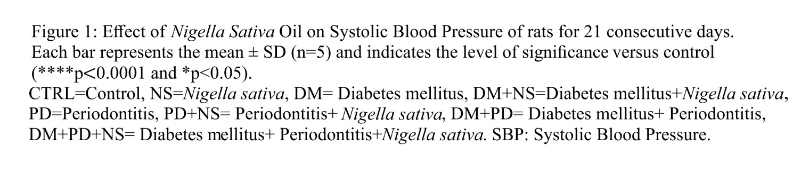
3.2 Effect of Nigella Sativa Oil on Diastolic Blood Pressure
The effect of Nigella Sativa Oil on Diastolic Blood Pressure are presented in Figure 2. Results show an increase in DBP levels in DM induced rats and rats administered Nigella Sativa Oil (DM+NS) following DM induction when compared to the control group. Data also shows a decrease in DBP levels in PD induced rats and rats administered Nigella Sativa Oil following PD induction when compared to the control group. Co-induction with DM and PD decreased (p<0.001) the DBP in rats compared to the control group. In addition, there was a reduction in DBP in rats administered Nigella Sativa Oil following DM and PD co-induction compared to the control group.

80
***
DBP (mmHg)
CTRL
NS
DM
DM+NS
PD
PD+NS
DM+PD
DM+PD+NS

60

40

20

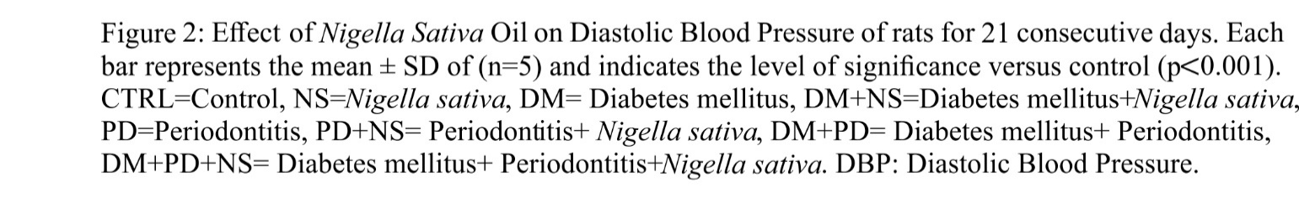

3.3 Effect of Nigella Sativa Oil on Mean Arterial Blood Pressure
Figure 3 depicts the impact of Nigella Sativa Oil on Mean Arterial Blood Pressure in experimental rats. DM and PD alone respectively increased and decreased the MABP relative to the untreated group in the present study. The figure below also shows increased and decreased MABP level in rats administered Nigella Sativa Oil following DM and PD induction respectively compared to the untreated group. Rats co-induced with DM and PD alone had a significant reduction (p<0.001) in MABP when compared with the control group. Also, Nigella Sativa oil administration to rats following co-induction of DM and PD caused substantial decrease (p<0.05) in MABP relative to the control group.

100
*
****
MABP (mmHg)
CTRL
NS
DM
DM+NS
PD
PD+NS
DM+PD
DM+PD+NS

80

60

40

20

0

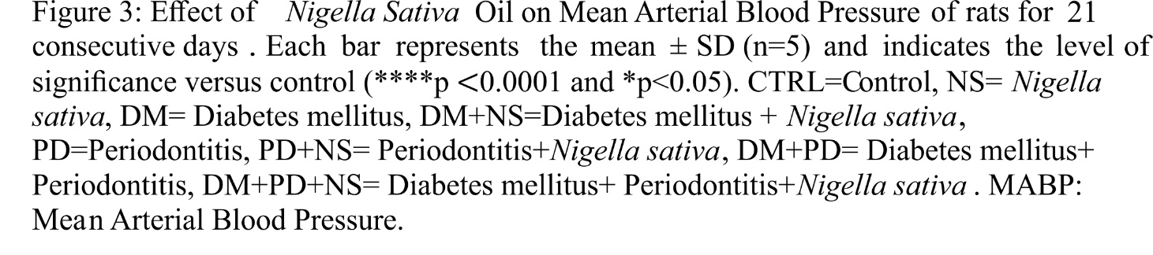
3.4 Effect of Nigella Sativa Oil on Pulse Pressure
How Nigella Sativa Oil affected Pulse Pressure in rats is presented in Figure 4. The induction of DM alone caused in a substantial decrease in pulse pressure relative to the control group. There was also a significant reduction in pulse pressure in rats treated with Nigella Sativa Oil and induced with DM when compared to the untreated group. Similarly, periodontitis resulted in a much significant decrease in pulse pressure in rats compared to the control group. The same trend was noticed in rats administered Nigella Sativa Oil and induced with PD in comparison with the untreated group. In rats co-induced with DM and PD alone, there was a non-significant reduction in pulse pressure compared to the control group. However, administration of Nigella Sativa Oil to rats co-induced with DM and PD caused a significant reduction in pulse pressure relative to the untreated control group.

40
*
*
*
**
***
PP (mmHg)
CTRL
NS
DM
DM+NS
PD
PD+NS
DM+PD
DM+PD+NS

30

20

10

0

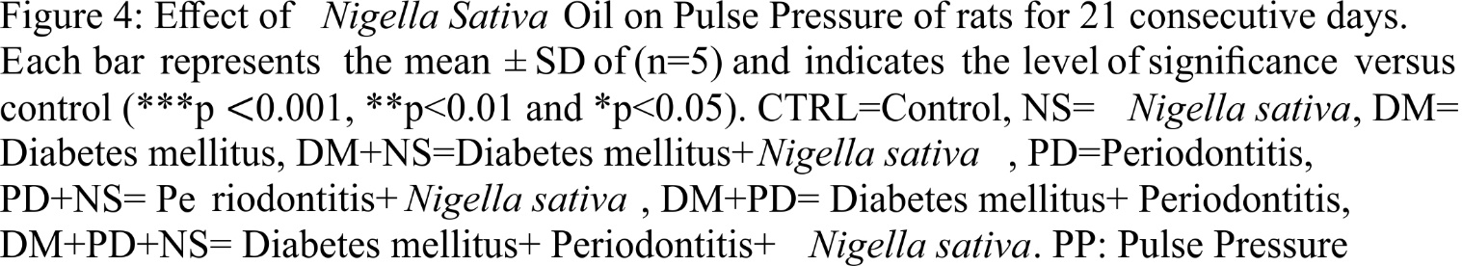

3.5 Effect of Nigella Sativa Oil on Heart Rate
Figure 5 represents the effect of Nigella Sativa Oil on Heart Rate in rats. Induction of rats with DM resulted in elevated heart rate compared to rats in the control group. The same trend was observed in rats administered Nigella Sativa Oil following DM induction as well as in those induced with PD. Treatment of rats with Nigella Sativa Oil following PD induction unaltered the heart rate compared to the control group. There was reduction in heart rate in animals having DM and PD with respect to the control group. The same trend was observed in rats treated with Nigella Sativa Oil after DM and PD induction.

500
HR (bpm)
CTRL
NS
DM
DM+NS
PD
PD+NS
DM+PD
DM+PD+NS

400

300

200

100

0

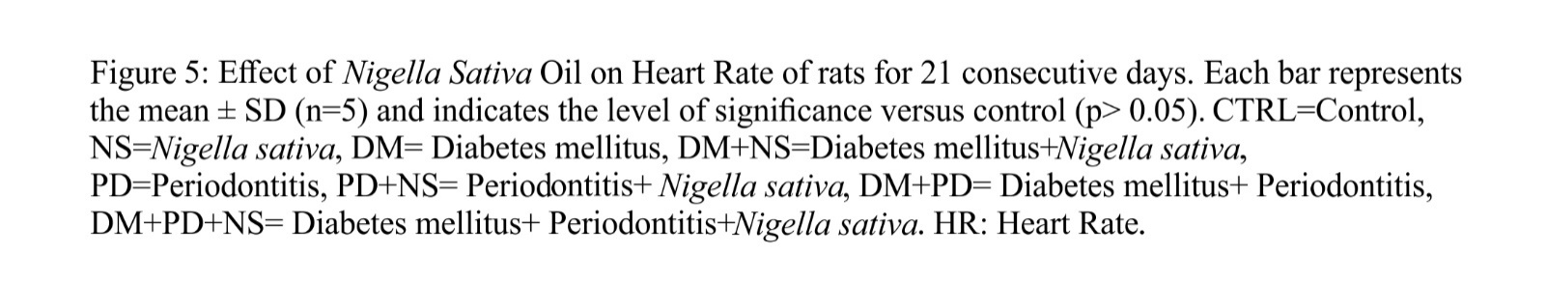

3.6 Effect of Nigella Sativa Oil on Rate Pressure Product
Figure 6 below reveals the effect of Nigella Sativa Oil on rate pressure product in rats. DM induction increased the rate pressure product compared to the control group. In the same vein, Nigella Sativa oil resulted in elevated rate pressure product in DM alone induced rats relative to the control group. However, there was reduction in rate pressure product in rats with periodontitis and in rats treated with Nigella Sativa oil following periodontitis induction in comparison with the control group. Similarly, co-induction of animals with DM and PD resulted in a significant reduction (p<0.001) in rate pressure product compared to control group. There was also a decrease in RPP in animals treated with Nigella Sativa oil following DM and PD co- induction compared to those in the untreated group.

50000
***
Rate pressure product
CTRL
NS
DM
DM+NS
PD
PD+NS
DM+PD
DM+PD+NS

40000

30000

20000

10000

0

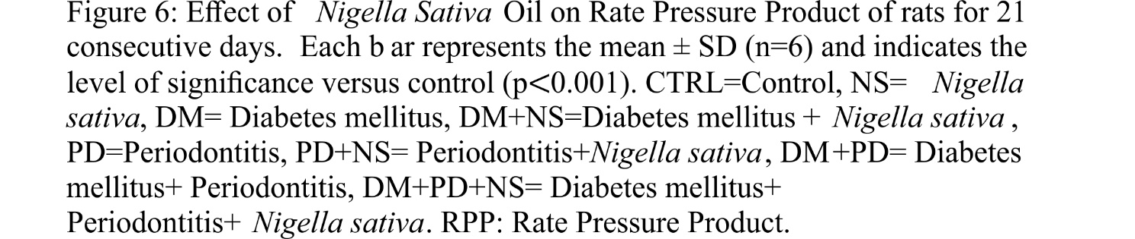
3.7 Effect of Nigella Sativa Oil on Cardiac Tissue Damage

The troponin levels of experimental animals treated with Nigella Sativa Oil are presented in Figures 7. The figure below shows a significant increase (p<0.05) in troponin level in DM induced rats and a non-significant surge in troponin levels in animals administered Nigella Sativa oil after DM induction, relative to the untreated control group. The same trend was seen in rats induced with PD and rats administered Nigella Sativa Oil following PD induction (p<0.01) when compared to the control group. Co-induction of rats with DM and PD resulted in a significant increase (p<0.05) in the level of troponin when compared to rats in the control group. There was also an increase in troponin in rats treated with NS oil after PD and DM induction, when compared to control group, though not significant.

0.10
**
*
*
Troponin I (ng/ml)
CTRL
NS
DM
DM+NS
PD
PD+NS
DM+PD
DM+PD+NS

0.08

0.06

0.04

0.02

0.00

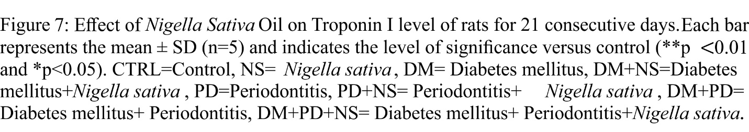

3.8 Effects of Nigella sativa oil on oxidative stress biomarkers in Diabetes mellitus and Periodontitis induced rats

The effects of Nigella sativa oil on SOD and CAT in the Heart of Diabetes mellitus and Periodontitis induced rats is presented in Table 1. There was a significant decrease in the activities of SOD and CAT in the heart of DM induced rats compared to the control. There was an increase in the activities of cardiac SOD and CAT upon administration of NS in rats induced with DM compared to the untreated control group. The table also shows a decrease and increase in the activities of SOD and CAT respectively in rats induced with PD compared to the control group. Administration of PD induced rats with NS resulted in increased activities of cardiac SOD and CAT compared to the hearts of rats in the control group.
Rats co-induced with DM and PD alone had reduced activities of cardiac SOD and CAT compared to the control group. The administration of Nigella Sativa oil to rats following co-induction of DM and PD resulted in an increase in SOD activity relative to the control group. However, Nigella Sativa oil administration to rats following co-induction of DM and PD did not cause an increase in CAT activity when compared to the control group.

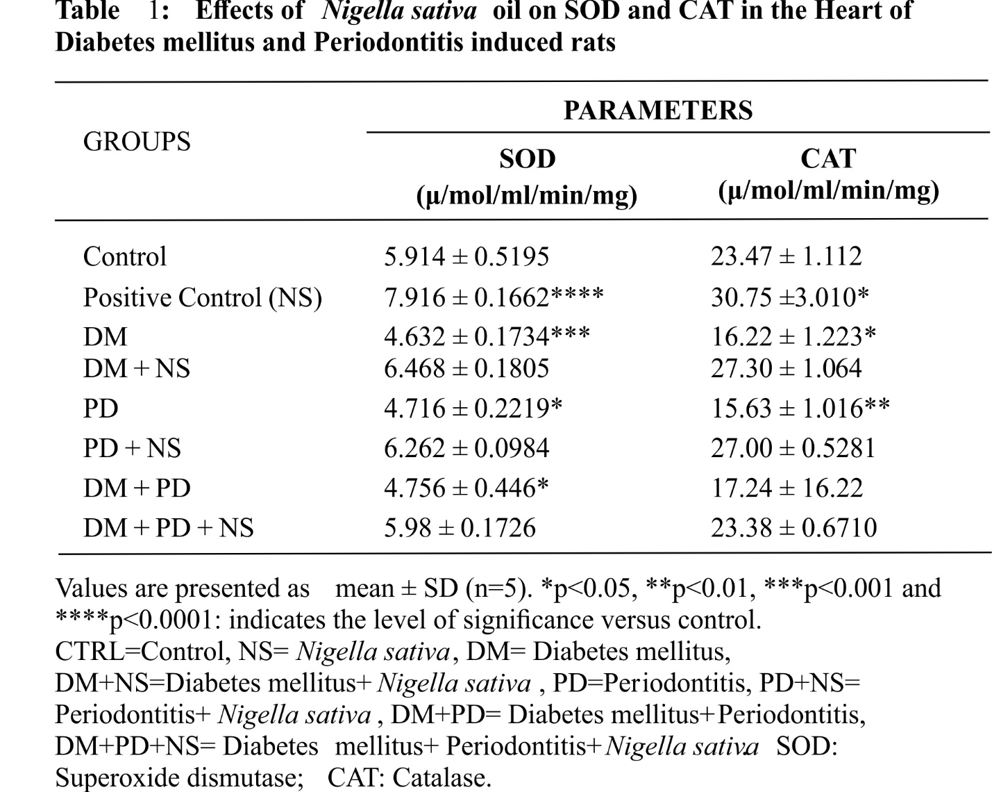

The effects of Nigella sativa oil on GSH and MDA in the Heart of Diabetes mellitus and Periodontitis induced rats is presented in Table 1. There was a decrease in GSH level in the heart of DM induced rats and an increase in cardiac GSH level in rats administered Nigella Sativa oil following DM induction when compared to the control group. Cardiac MDA level in DM induced rats remained unchanged and was reduced in DM induced rats treated with Nigella Sativa oil when compared to the untreated group. There was however a reduction and an increase in GSH and MDA levels respectively in PD induced rats compared to the untreated group. Administration of PD induced rats with Nigella Sativa oil resulted in increased and decreased GSH and MDA levels respectively compared to the control group. The table below also shows a significant decrease in GSH level and an increase in MDA level (though not significant) in rats co-induced with DM and PD relative to the control group. Administration of DM and PD co-induced rats with Nigella Sativa oil resulted in increased and decreased GSH and MDA levels respectively compared to the control group.

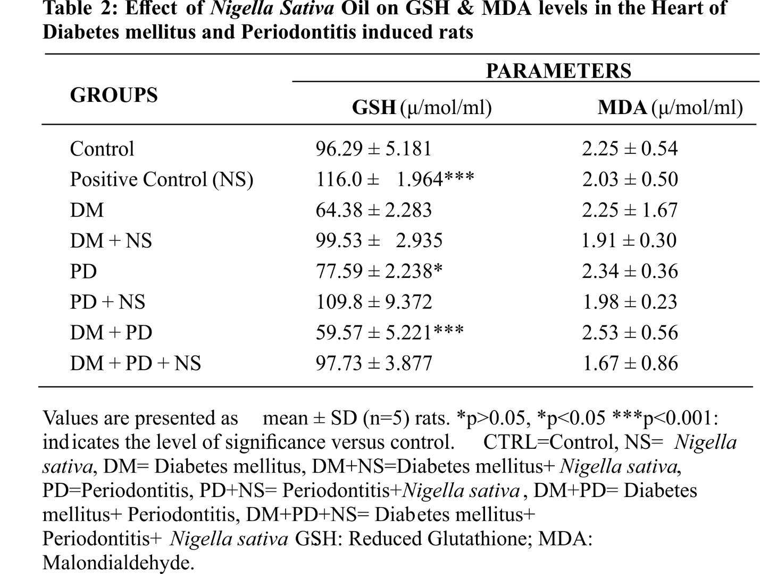

4. DISCUSSION
A significant portion of the global population suffers from diabetes mellitus (DM), which has been linked to an increased risk of cardiovascular dysfunctions [25, 26]. Many of the detrimental effects of diabetes mellitus on the cardiovascular system seem to be accelerated by oxidative stress and inflammation [25]. A long-term inflammatory condition that damages the tooth's supporting tissues is called periodontitis. It is the sixth most prevalent disease in humans, reportedly affecting the majority of people on the planet [26]. According to Avijeeta et al. [28], periodontitis has also been linked to an increased risk of cardiovascular illnesses through mechanisms such bacteraemia, inflammatory reactions, and oxidative stress. For many years, Nigella sativa and its constituents have been utilized to treat a variety of illnesses and to promote good health [15, 29]. Numerous biological activities of Nigella sativa have been reported, including renoprotective, hepatoprotective, analgesic, anti-bacterial, anti-viral, anti-fungal, anti-inflammatory, cardioprotective, antihypertensive, anti-cancer, and anti-diabetic effects [12, 30-31]. Because of these biological characteristics, Nigella sativa is very helpful in the treatment of many illnesses. Thus, this study looked at how Nigella sativa oil affected cardiovascular function in rats who had been induced with diabetes mellitus and periodontitis.
In this investigation, rats with diabetes mellitus showed higher SBP than the control group (Figure 1). The increase in blood sugar levels may have caused hypotension (low blood pressure) and bradycardia (low heart rate) in the group of rats that were induced with diabetes mellitus because of autonomic nervous system dysregulation, which resulted in a decrease in T-wave symmetry [32]. The SBP level was lower after receiving Nigella sativa oil treatment than it was for the control group. The current study's results indicate that PD induction led to a decrease in SBP levels. In PD-induced mice, treatment with Nigella sativa oil corrected these alterations by raising the SBP level, albeit not as much as in the control group. When rats with DM and PD were co-inducted, their SBP levels were pointedly lower than compared to those of the untreated control group. In rats given DM + PD, the injection of Nigella sativa oil markedly elevated the SBP. That being said, the increase was not as great as what was seen in the control rats. In the current investigation, higher DBP was also seen in DM-induced rats as opposed to control rats. The DBP in DM-induced rats was lowered by nigella sativa oil treatment, although not as much as in the untreated group. In rats induced with PD, a reduction in DBP was observed compared to the control group. Treatment of PD induced rats with Nigella sativa oil resulted in increased DBP level, but not as high as the control group. A reduction in DBP was also observed in DM + PD induced rats compared to the control. Nigella sativa oil administration on the other hand increased the DBP in rats co-induced with DM and PD, this was in accordance with the study done by Jaarin et al. [33].
Increased MABP was also observed in rats in which DM was induced compared to the control group. Nigella sativa oil decreased the MABP compared to rats induced with DM alone, but not compared to rats in the control group. The reverse was observed in PD induced rats, as a reduction in MABP was observed relative to the control. Nigella sativa oil treatment reversed this change by increasing the MABP in PD induced rats. A marked reduction in MABP was also observed in rats co-induced with DM + PD when seen in relation to the control. Subsequent treatment with Nigella sativa oil caused significantly increased MABP levels in rats co-induced with DM + PD compared to group 7 in the present study. A significant reduction in PP was also observed in rats induced with DM relative to the control. Nigella sativa oil administration resulted in a further reduction in PP compared to rats in the control group. PD induction in rats also caused a marked decrease in PP compared to rats in the control group. However, Nigella sativa oil treatment increased the PP significantly compared to the control group. In rats co-induced with DM and PD, a reduction in PP was also noticed compared to the control group. Nigella sativa oil treatment further decreased the PP in DM + PD co-induced rats when compared to the untreated control group.
In this study, an increase in heart rate was observed in rats induced with DM as well as in rats induced with PD when compared to rats in the control group. Nigella sativa oil treatment further increased the heart rate in DM induced rats but resulted in no significant change in rats induced with PD, when compared to the untreated group. Co-induction of rats with DM and PD resulted in decreased heart rate, though not significant when compared to the control. Nigella sativa oil administration also further reduced the heart rate in DM + PD induced rats compared to the control group. Since N. sativa oil was able to increase heart rate in Periodontitis + treatment group and Periodontitis + diabetes mellitus + N. sativa oil by bringing its levels up to control indicates that N. sativa oil has heart rate controlling effect which may occur by activating cholinergic mechanisms [34].
Rate Pressure Product (RPP) is an important marker of cardiac function, and high RPP levels indicate a high risk of CVD. In the current study, rate pressure product levels increased in DM- induced rats compared to control rats. Subsequent treatment with Nigella sativa oil decreased the rate pressure product in rats induced with DM, though not as low as the control group. Contrary to the findings observed in DM, PD induction resulted in decreased RPP compared to the control group. Treatment of PD-induced rats with Nigella sativa oil further reduced the level of Nigella sativa oil compared to the control. Additionally, co-induction of DM and PD resulted in a significant reduction in RPP compared to rats in the control group. However, Nigella sativa oil treatment increased the level of RPP in rats co-induced with DM and PD, though not as high as the control group.
In the present study, DM induction induced damage to the heart as seen in the significant increase in troponin I level compared to the control rats. On the other hand, cardiac troponin I levels
decreased in DM induced rats treated with Nigella sativa oil, though they were still higher than those of the control rats. The same trend was observed in PD induced rats and rats treated with Nigella sativa oil following PD induction. Also, our results show a significant increase in cardiac troponin I levels in rats co-induced with DM and PD compared to the control rats. Treatment with Nigella sativa oil resulted in a marked decrease in troponin I level in these rats, showing the role of Nigella sativa in conferring cardio protection. Similar findings were also reported in previous study [34].
In other to further examine the effect of Nigella sativa oil on CVD function, the extent of oxidative
stress, level, and activities of antioxidants in the heart of DM and PD induced rats were assessed. In the present study, rats induced with DM, PD and co-induced with DM and PD had a reduction
in cardiac SOD and CAT activities (Table 1), as well as GSH level (Table 2) relative to the untreated control group. However, treatment with Nigella sativa oil resulted in increased activities
of SOD and CAT, as well as GSH level in the above-mentioned groups when compared to the
control group. The enhancement in the level and activities of GSH, SOD and CAT in the heart of rats induced with DM and PD may be due to the antioxidant activity of Nigella sativa. The results from this study concur with previous work which also report increased activities of SOD, CAT in rats treated with thymoquinone, the most active constituent of Nigella sativa, and preservation of GSH levels, thus inhibiting oxidative stress and damage [12, 35-36]. The prevention of cardiac oxidative damage in the present study reveals the cardioprotective role of Nigella sativa, like previous reports [35, 37]. Free radicals are capable of damaging proteins and inactivating membrane-bound enzymes through Lipid peroxidation. Malondialdehyde (MDA) is a major product of lipid.
In the present study, cardiac MDA levels in rats induced with DM did not differ significantly but increased in rats induced with PD when compared to the control (Table 2). There was also a marked increase in cardiac MDA level in rats co-induced with DM and PD. This could be attributed to oxidative stress induced by DM and PD in the animals. Nigella sativa oil reduced the levels of cardiac malondialdehyde (MDA) in rats induced with DM, PD and co- induced with DM and PD (Table 2). Our results agree with previous studies [16, 38-39].

5. CONCLUSION
The present study showed the ability of Nigella sativa to reverse oxidative, and pathological damages induced by Diabetes mellitus and Periodontitis in the heart of rats due to its antioxidative capacity. Nigella sativa oil mitigated oxidative stress and its consequential cardiovascular dysfunction in periodontitis and diabetes mellitus induced rats. Administration of NS oil caused significant reduction in blood pressure and heart rate, increased troponin levels in heart tissues and improved antioxidant enzymes. The study affirmed the potent antioxidant capacity of Nigella sativa oil giving scientific evidence for its widespread use in traditional medicine.

Disclaimer (Artificial intelligence)
Author(s) hereby declare that NO generative AI technologies such as Large Language Models (ChatGPT, COPILOT, etc) and text-to-image generators have been used during writing or editing of manuscripts.

REFERENCES

- Pedroso JF, Zahra L, Ghadeer A, Maiara AS, Luiz S, Magnus AG, Antonio MFN, Maria ANJ. Influence of Periodontal Disease on cardiovascular markers in Diabetes Mellitus patients. Sci Reports. 2019; 9:16138
- Akhtar MT, Rahman Q, Iqra B, Rana AA, Zoha M, Sadaf Z, Mian AM, Farzana S, Syed N, Hussain S, Mubshara S. Antidiabetic potential of Nigella sativa L seed oil in alloxan-induced diabetic rabbits. Trop J Pharma Res. 2020; 19 (2): 283-289.
- Lachin JM, Nathan DM. Understanding metabolic memory: the prolonged influence of glycemia during the diabetes control and complications trial (dcct) on future risks of complications during the study of the epidemiology of diabetes interventions and complications (edic). Diabetes Care. 2021; 44:2216–24.
- Sanz M, Ceriello A, Buysschaert M, Chapple I, Demmer RT, Graziani F, et al. Scientific evidence on the links between periodontal diseases and diabetes: consensus report and guidelines of the joint workshop on periodontal diseases and diabetes by the international diabetes federation and the European Federation of Periodontology. J Clin Periodontol. 2018: 45:138–49.
- Hannan CJ, Ricks TL, Espinoza L, Weintraub JA. Addressing Oral health inequities, access to care, knowledge, and behaviors. Prev Chronic Dis. 2021; 18:1–5.
- Orororo OC, Asagba SO, Tonukari NJ, Okandeji OJ, Mbanugo JJ. Comparative Assessment of the Antioxidant Properties of Hibiscus sabdarrifa L Anthocyanins and its Aqueous Extract in Cadmium-exposed Rats. Res J Pharma Bio Chem Sci. 2018; 9(3): 836-843
- Orororo OC, Asagba SO. Treatment with Hibiscus sabdarrifa L Anthocyanins Improve Hematological Parameters in Rats Exposed to Cadmium. J Expl Res Pharmaco. 2022; 3:1-10
- Serón C, Olivero P, Flores N, Cruzat B, Ahumada F, Gueyffier F, Marchant I. Diabetes, periodontitis, and cardiovascular disease: towards equity in diabetes care. Front. Public Health. 2023; 11:1270557.
- Libby P. The biology of atherosclerosis comes full circle: lessons for conquering cardiovascular disease. Nature Rev Cardio. 2021: 1-2.
- Libby P, Buring JE, Badimon L, Hansson GK, Deanfield J, Bittencourt MS, Tokgozoglu L, Lewis EF. Atherosclerosis. 2019; 5:56-64.
- Saleh FA, El-Darra N, Raafat K, El Ghazzawi I. Phytochemical Analysis of Nigella sativa L. Utilizing GCMS Exploring its Antimicrobial Effects against Multidrug-Resistant Bacteria. Phcog J. 2018; 10: 99-105.
- Orororo OC, Mordi JC, Opute UA, Efejene IO, Egbune EO, Busari AA, Badmos K, Obadiah CC, Akinshipo WA. Black Seed Oil-induced Amelioration of Renal Dysfunction in a Rat Model of Diabetes Mellitus and Periodontitis. Trop J Nat Prod Res. 2023; 7(7):3524-3531.
- Tuorkey MJ. Therapeutic potential of Nigella sativa oil against cyclophosphamide-induced DNA damage and hepatotoxicity. Nutr and Cancer 2017; 69(3): 498-504.
- Abduallah AM, Rashed AA, Gamaleldeen AK, Sayed SR. The Effect of Nigella sativa Extract (Thymoquinone) on Glucose Insulin Levels and Body Weight of Induced Diabetic Female Rats. Am J life Sci 2017; 5(2): 52-56.
- Busari AA, Orororo OC, Ugbome AO, Efejene IO, Kabir B, Obadiah CC, Akinshipo WA, Egbune EO. Effects of Black Seed Oil on Oxidative Stress Parameters and Gingival Expression of Inducible Nitric Oxide Synthase in Diabetes and Periodontitis-Induced Rats. Afri Sci. 2023; 24; 3: 367-386
- Shahid F, Farooqui Z, Rizwan S, Abidi S, Parwez I, Khan F. Oral administration of Nigella sativa oil ameliorates the effect of cisplatin on brush border membrane enzymes, carbohydrate metabolism and antioxidant system in rat intestine. Exp toxicol pathol 2017; 69(5): 299-306.
- Chen Y, Rolka D, Xie H, Morbidity Saydah S.Mortality Weekly Report (MMWR). Imputed state-level prevalence of achieving goals to prevent complications of diabetes in adults with self-reported diabetes — United States, 2020: 2017–2018.
- International Diabetes Federation. IDF diabetes Atlas 10th edition [Internet]. (2021). Available at: www.diabetesatlas.org
- The American Diabetes Association. 4. Comprehensive medical evaluation and assessment of comorbidities: standards of medical Care in Diabetes—2022. Diabetes Care. 2022; 45:S46–59.
- Hatipoğlu M, Sağlam M, Köseoğlu S, Köksal E, Keleş A, Esen HH. The effectiveness of Crataegus orientalis M Bieber. (Hawthorn) extract administration in preventing alveolar bone loss in rats with experimental periodontitis. PLoS One. 2015; 1;10(6):e0128134.
- Assayed ME. Radioprotective effects of black seed (Nigella sativa) oil against hemopoietic damage and immunosuppression in gamma-irradiated rats. Immunopharmacol. Immunotoxicol. 2010; 1;32(2):284-96.
- Morakinyo AO, Adekunbi DA, Dada KA, Adegoke OA. Testosterone promotes glucose intolerance, lipid disorder and oxidative stress in type 1 diabetic rats. J Basic Clin Physiol Pharmacol. 2014; 1;25(1):13-20.
- Varshney R, Kale RK. Effects of calmodulin antagonists on radiation-induced lipid peroxidation in microsomes. Int J Radiat Biol. 1990; 58(5):733–743.
- Beutler E, Duron O, Kelly BM. Improved method for the determination of blood glutathione. J Lab Clin Med. 1963; 61:882-888.
- Kolakalapudi P, Omar B. Diabetes mellitus and the cardiovascular system. J Endocrino Met. 2015; 5(6):313-320.
- Schofield J, Ho J, Soran H. Cardiovascular risk in type 1 diabetes mellitus. Diabetes Therapy, (2019; 10(3):773-789.
- Kassebaum NJ, Bernabé E, Dahiya M, Bhandari B, Murray CJL, Marcenes W. Global burden of severe periodontitis in 1990-2010: a systematic review and meta- regression. J. Dental Res. 2014; 93(11): 1045-1053.
- Avijeeta A, Jalaluddin M, Jayanti I, Sasmal AR. Periodontitis and Cardiovascular Diseases: The Nexus. J Med Sci Clin Res. 2019; 7:34-43
- Busari AA, Adejare AA, Kelani SO, Imam KO, Awesu AA, Adefila-Sanni I. Comparative pre-and post-treatment effects of Nigella sativa oil on lipid profile and antioxidant enzymes in a rat model of diabetes mellitus. Nig J Med. 2020; 29(3):415-423.
- Saleem U, Sabir S, Ahmad B. How Nigella sativa seeds treat diabetes and ameliorates diabetes complications and safety studies: An overview. J Pharma Res Int. 2016; 6:1-8.
- Farkhondeh T, Samarghandian S, Borji A. An overview on cardioprotective and anti-diabetic effects of thymoquinone. Asian Pacific J. Tropical Med. 2017; 10(9): 849-854.
- Eke PI, Wei L, Thornton‐Evans GO, Borrell LN, Borgnakke WS, Dye B, Genco RJ. Risk indicators for periodontitis in US adults: NHANES 2009 to 2012. J Periodontology, 2016; 87(10): i174-1185.
- Jaarin K, Foong WD, Yeoh MH, Kamarul ZYN, Qodriyah HMS, Azman A, Zuhair JSF, Juliana AH, Kamisah,Y. Mechanisms of the antihypertensive effects of Nigella sativa oil in L-NAME-induced hypertensive rats. Clinics, 2015; 70:751-757.
- Danaei GH, Memar B, Ataee R, Karami M. Protective effect of thymoquinone, the main component of Nigella Sativa, against diazinon cardio-toxicity in rats. Drug Chem Toxico. 2019; 42(6):585-591.
- Ismail M, Al-Naqeep G, Chan KW. Nigella sativa thymoquinone-rich fraction greatly improves plasma antioxidant capacity and expression of antioxidant genes in hypercholesterolemic rats. Free Radical Bio Med. 2010; 48(5):664-672.
- Erşahin M, Toklu HZ, Akakin D, Yuksel M, Yeğen BÇ, Sener G. The effects of Nigella sativa against oxidative injury in a rat model of subarachnoid hemorrhage. Acta neurochirurgica, 2011; 153(2):333-341.
- Nagi MN, Mansour MA. Protective effect of thymoquinone against doxorubicin– induced cardiotoxicity in rats: A possible mechanism of protection. Pharma Res. 2000; 41(3), pp.283-289.
- Sheikh BY, Mohamadin AM. Thymoquinone a potential therapy for cerebral oxidative stress. Asian J Nat Appl Sci. 2012; 1:76-92.
- Desai SD, Saheb SH, Das KK, Haseena S. Effect of Nigella sativa seed powder on MDA and SOD levels in sterptozotocine induced diabetis albino rats. J Pharma Sci Res. 2015; 7(4), p.206.

