Case report
Wandering Spleen with Chronic Torsion and Partial Infarction in a Postpartum Woman: A Case Report

ABSTRACT

Introduction and importance: Wandering spleen (WS) is a rare anatomical anomaly characterized by splenic hypermobility due to ligamentous deficiency. It exhibits a marked predilection for women of reproductive age, often exacerbated by the mechanical and hormonal stress of pregnancy and the postpartum period. WS can lead to life-threatening complications, primarily splenic pedicle torsion and infarction.
Presentation of case: We report the case of a 25-year-old G1P1 woman presenting four months postpartum with a three-month history of intermittent, dull abdominal pain in the left hypochondrium. Physical examination revealed a firm, mobile, non-tender mass. Initial laboratory workup noted mild isolated thrombocytopenia. Contrast-enhanced Computed Tomography (CT) confirmed the diagnosis, revealing an ectopic spleen, partial splenic infarction, and the pathognomonic "whirl sign," indicating chronic torsion of the vascular pedicle.
Clinical discussion: This case underscores the critical need to include WS in the differential diagnosis of abdominal pain in the postpartum setting, where it can mimic more common gynecological pathologies. Due to established partial infarction and significant splenomegaly, splenectomy via open midline laparotomy was performed. Intraoperative findings confirmed the absence of suspensory ligaments and chronic torsion.
Conclusion: This report emphasizes that timely CT imaging is essential for confirming torsion and assessing splenic viability. While splenopexy is preferred for preservation, splenectomy is necessitated by established infarction. High clinical suspicion, even in cases with chronic presentation, and appropriate surgical intervention lead to favorable long-term outcomes, including normalization of hematological indices.

Keywords: Wandering Spleen, Splenic Torsion, Postpartum, Splenectomy, Whirl Sign, Case Report

1. INTRODUCTION

“Wandering spleen (WS), also termed splenoptosis or ectopic spleen, is a rare anatomical condition defined by abnormal splenic hypermobility” [1]. “This condition arises from the absence, maldevelopment, or laxity of the suspensory splenic ligaments (gastrosplenic, splenorenal, splenocolic, and splenophrenic)” [1]. “Its reported incidence is exceptionally low, estimated at less than 0.2% in surgical series, with a marked predilection for two demographic groups: children and women of reproductive age” [2,3].
“The underlying pathophysiology is generally categorized into congenital failure of dorsal mesogastrium fusion during embryogenesis, or acquired ligamentous laxity” [4]. “In women, pregnancy and multiparity are established risk factors, as hormonal shifts and mechanical strain during gestation contribute to the progressive weakening of splenic attachments” [5]. “Lack of proper fixation leaves the spleen mobile, suspended only by an elongated vascular pedicle, rendering it highly susceptible to torsion” [6].
“The clinical presentation of WS is highly variable, ranging from an incidental asymptomatic finding to an acute surgical emergency” [6,7]. “Its rarity and nonspecific features often delay diagnosis and can mimic more common abdominal pathologies” [8]. “Contrast-enhanced computed tomography (CT) remains the gold standard for definitive diagnosis, particularly by revealing the pathognomonic "whirl sign," which denotes the twisting of the splenic pedicle” [9,10]. “Treatment hinges on splenic viability: splenopexy is favored for immunologic preservation, whereas splenectomy is required following established infarction” [11,12].
Herein, we report the case of a young postpartum woman with a wandering spleen complicated by chronic torsion and partial infarction. This report aims to detail the diagnostic complexity, characteristic imaging findings, and pivotal surgical decision-making in this setting. Furthermore, this case underscores the critical need to include WS in the differential diagnosis of abdominal pain among reproductive-age women, especially in the postpartum state.
This case report has been reported in line with the SCARE Criteria.

2. CASE PRESENTATION

A 25-year-old G1P1 woman presented to our surgical outpatient clinic with a three-month history of intermittent, non-acute pain localized to the left hypochondrium (LHC). Symptoms had begun approximately four months postpartum, following an uncomplicated vaginal delivery. The patient characterized the pain as dull, progressively worsening in intensity over three months, and markedly exacerbated by physical activity or exertion.
The patient’s medical history was unremarkable, with no prior surgeries, chronic systemic illnesses, or pertinent family history of hematological or splenic disorders. She reported no constitutional symptoms (denied fever, nausea, vomiting, or weight loss) and no changes in bowel or urinary habits. Her Body Mass Index (BMI) was 20 kg/m2. Physical examination revealed stable vital signs. Abdominal palpation identified a firm, non-tender, mobile mass in the LHC, extending toward the epigastric region. The mass demonstrated mobility with respiration and could be manually displaced, indicating its lack of proper fixation. There were no signs of peritoneal irritation; the remainder of the examination was unremarkable.
Initial laboratory workup revealed mild isolated thrombocytopenia (platelet count: 110×10⁹/L; normal range: 150−400×10⁹/L), suggestive of splenic sequestration. White blood cell count, hemoglobin, liver function tests, and renal function tests were all within normal limits. This finding, combined with the palpable mobile abdominal mass, strongly raised suspicion for a splenic etiology.
Given the clinical suspicion of splenic pathology, a contrast-enhanced computed tomography (CT) scan of the abdomen and pelvis was performed, confirming several key diagnosis features. The spleen was significantly enlarged, measuring approximately 18x 8x10 cm (Splenomegaly), and was ectopically displaced inferiorly and medially into the epigastric region, with the left upper quadrant being empty of splenic tissue. The scan clearly demonstrated the pathognomonic “whirl sign”, represented by the spiral configuration of the splenic vessels and surrounding mesenteric fat, definitively confirming torsion of the elongated splenic vascular pedicle. The splenic parenchyma exhibited heterogeneous post-contrast enhancement, characterized by multiple wedge-shaped areas of low attenuation extending from the periphery to the hilum, consistent with partial splenic infarction due to compromised arterial supply. Remaining abdominal organs were unremarkable, and there was no evidence of free fluid or lymphadenopathy.
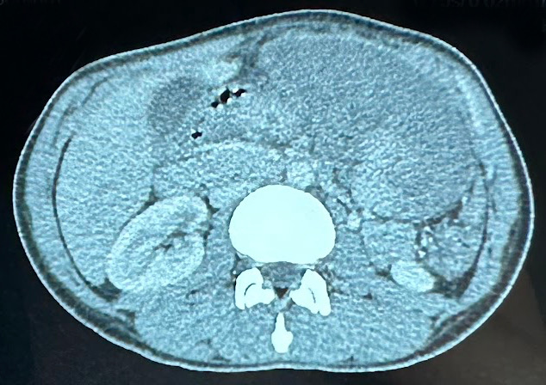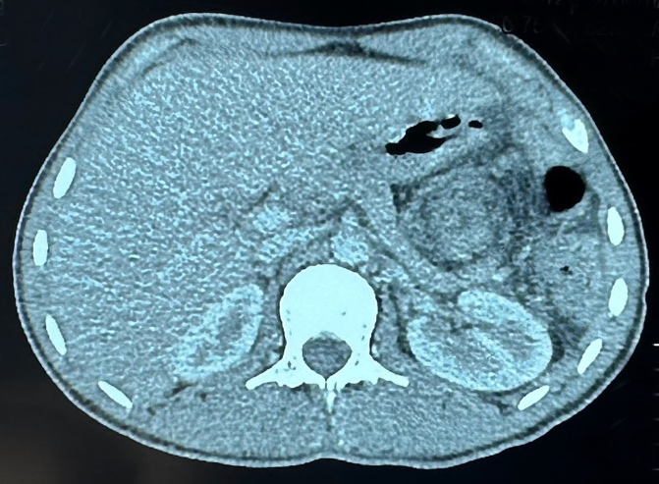
B
A
Figure 1. Contrast-enhanced Computed Tomography (CT) scan findings of Torsed Wandering Spleen
A. Axial view demonstrating the enlarged, ectopic spleen located in the epigastric region.
B. Axial image highlighting the characteristic "whirl sign" (red arrow), confirming torsion of the splenic vascular pedicle.

Based on the clinical presentation, laboratory findings, and the pathognomonic imaging features (ectopic location, whirl sign, and wedge-shaped infarcts), the definitive diagnosis of wandering spleen with chronic torsion of the splenic pedicle and partial splenic infarction was established and surgical intervention was indicated.
The patient was thoroughly counselled regarding the risks of continued observation (e.g., progression to complete infarction or rupture). Given the established infarction, splenopexy (splenic preservation) was deemed inappropriate. Splenectomy was therefore planned and was performed electively 20 days after the diagnostic CT scan, allowing for necessary preoperative optimization.
15 days before surgery, the patient received standard post-splenectomy vaccinations to prevent overwhelming post-splenectomy infection (OPSI): pneumococcal (PCV13 and PPSV23), meningococcal (quadrivalent conjugate), and Haemophilus influenzae type b (Hib) vaccines.
A midline laparotomy was the chosen surgical approach, favored over a laparoscopic technique due to the significant splenomegaly, the necessity for safe manipulation of the congested organ, and the requirement for secure control of the highly torsed vascular pedicle.
Intraoperatively, the spleen was confirmed to be in the epigastric region, markedly enlarged, congested, and showed extensive ischemic (dusky) areas consistent with partial infarction. Complete congenital absence of the gastrosplenic and splenorenal ligaments was noted, with the spleen attached solely by an exceptionally long, highly torsed vascular pedicle (twisted approximately 1080°).
Due to the severe ischemic changes and established partial infarction, the spleen was determined to be non-viable and a complete splenectomy was performed following careful mobilization and individual ligation and division of the splenic artery and vein.
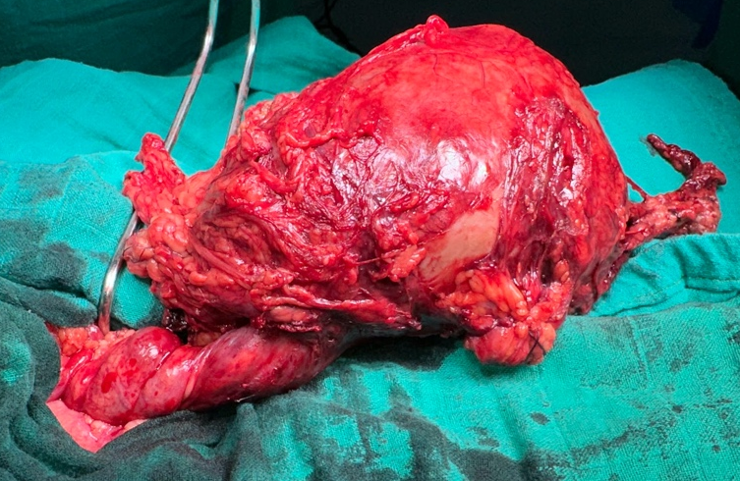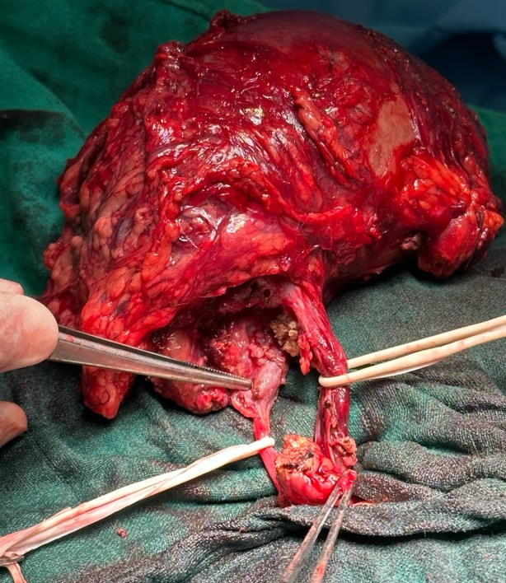
Figure 2. Peroperative view of the wandering spleen showing a twisted pedicle and areas of infarction
Hemostasis was meticulously confirmed before layered closure of the abdominal wall. Estimated Blood Loss was less than 50mL and Operative Time was 60 minutes.
The spleen was sent for histopathological examination.
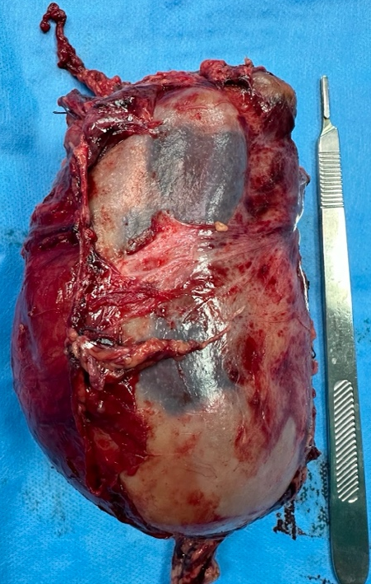
Figure 3. Image of excised spleen
The patient experienced an uncomplicated postoperative recovery. Monitoring included regular vital sign checks, pain management with multimodal analgesia, early mobilization, and prophylactic anticoagulation. Diet was gradually advanced as tolerated and the patient was discharged on postoperative day 5 in stable condition.
The patient received extensive counselling regarding the lifelong increased risk of infection with encapsulated bacteria, the necessity of seeking immediate care for fever, and the need for adherence to the recommended vaccination and potential antibiotic prophylaxis schedules.
Gross examination of the splenectomy specimen confirmed a markedly enlarged spleen with surface discoloration and congestion. Microscopic evaluation corroborated the diagnosis, revealing extensive areas of hemorrhagic infarction with coagulative necrosis, vascular congestion with dilated/thrombosed vessels, and reactive changes in the remaining viable tissue. No malignancy or other pathological processes were identified, confirming the preoperative diagnosis.
The patient was followed regularly in the outpatient clinic. At the three-year follow-up: the patient remains completely asymptomatic, reporting an excellent quality of life and return to full normal activities. Physical examination is unremarkable and laboratory investigations confirm the complete normalization of the platelet count (now within the normal range) and a normal complete blood count.
The patient has maintained compliance with all infection prevention measures and has had no reported infections requiring hospitalization.

3. discussion

Our case, involving a 25-year-old woman presenting four months postpartum, perfectly exemplifies the demographic and the recognized etiologic role of pregnancy [4,5]. The intraoperative finding of complete congenital absence of the gastrosplenic and splenorenal ligaments in our patient suggests that the congenital anomaly was likely unmasked or exacerbated by the physiological stress of pregnancy and childbirth. This anomaly results in the spleen being attached solely by an elongated vascular pedicle [4,6]. This instability predisposes the organ to torsion.
Diagnostic Challenges and Differential Diagnosis in Postpartum Women
The nonspecific and highly variable clinical presentation of Wandering Spleen (WS) often contributes to significant diagnostic delays [1,6,7]. This is strongly illustrated by our patient's three-month history of intermittent pain, which suggests a pattern of chronic, intermittent torsion-detorsion rather than a single acute event. The postpartum status may further confound the diagnosis, with symptoms frequently misattributed to routine recovery or common gastrointestinal complaints. In reproductive-age women presenting with an ectopic abdominal mass and pain, WS must be aggressively distinguished from other common entities such as ovarian torsion or other gynecological pathologies [6,14]. This case highlights the critical need for a high index of suspicion to avoid catastrophic delays.
Pathophysiology of Chronic Torsion and Hematologic Manifestations
Torsion initially compromises venous drainage—leading to splenomegaly and sequestration—before progressively compromising arterial supply and causing infarction [6,7]. In chronic or intermittent torsion, the prolonged vascular congestion and sequestration can lead to hypersplenism, manifesting clinically as the thrombocytopenia observed in our patient. This emphasizes that hematologic changes can serve as a relevant, albeit non-specific, indicator of underlying splenic pathology. While Doppler ultrasound is often the initial screening tool, Contrast-enhanced Computed Tomography (CT) remains the established gold standard for definitive diagnosis and surgical planning [8-10].
Management Considerations: Open vs. Laparoscopic Surgery
Management is strictly dictated by splenic viability [11,12]. While splenopexy (fixation) is preferred for viable spleens, splenectomy is necessary when, as in our case, established infarction, dense vascular thrombosis, or splenic rupture has occurred [11,15]. Due to the significant splenomegaly, chronic torsion (∼1080∘), and irreversible partial infarction confirmed radiologically and macroscopically, an open midline laparotomy was chosen over a laparoscopic approach. This decision was essential for securing vascular control, safely handling the massive, congested organ, and minimizing the risk of rupture—considerations often favoring the open technique in cases of complex torsion or massive splenomegaly.
Long-Term Follow-up and Prognosis
The patient received comprehensive post-splenectomy prophylaxis, including appropriate vaccinations and extensive counselling regarding the lifelong risk of Overwhelming Post-Splenectomy Infection (OPSI) [11]. Our patient's excellent three-year follow-up, characterized by complete symptom resolution and normalization of the platelet count, underscores that a timely diagnosis and appropriate surgical intervention lead to favorable long-term outcomes, even when splenectomy is required.
The clinical lessons highlighted by this report are thus highly relevant. It emphasizes that Wandering Spleen (WS) must be considered in the differential diagnosis of abdominal pain and masses in postpartum women, even when symptoms are chronic or intermittent. Furthermore, it reinforces that Contrast-enhanced CT, particularly the presence of the whirl sign, is essential for confirming torsion and accurately assessing splenic viability. Finally, the case confirms that while management hinges on viability, splenectomy is the required definitive treatment for established infarction, and rigorous post-splenectomy care and patient education are absolutely vital for long-term prognosis.
Strengths and Limitations The primary strength of this report is the comprehensive three-year follow-up, confirming complete symptom resolution and hematological normalization, which is not always available in case reports. However, this study is inherently limited by its nature as a single case report, and its findings cannot be generalized.

4. Conclusion

Wandering spleen (WS) is a rare but critical cause of acute and chronic abdominal pain, especially among women of reproductive age. This case underscores the diagnostic challenge presented by WS in the postpartum period, where symptoms are often initially nonspecific. Contrast-enhanced Computed Tomography (CT) remains vital for early diagnosis, confirmation of pedicle torsion via the "whirl sign," and assessment of splenic viability. While splenic preservation through splenopexy is preferred, splenectomy is the definitive necessity when infarction is established. This report reinforces the need for high clinical suspicion and highlights that timely diagnosis and appropriate surgical intervention lead to favorable long-term outcomes.

Consent

As per international standard or university standard, patient(s) written consent has been collected and preserved by the author(s).

Ethical approval

As per international standard or university standard, written ethical approval has been collected and preserved by the author(s).

ARTIFICIAL INTELLIGENCE (AI) USAGE DECLARATION

Generative AI tools were utilized solely for editing, grammar correction, and stylistic polishing of the manuscript. All authors reviewed, verified, and assume full responsibility for the scientific content and accuracy of the final submission.

References

- Eleiwi M, Atatri Y, Younis O, et al. Wandering Spleen Torsion: A Diagnostic Challenge. Cureus. 2024;16(2):e53552. doi:10.7759/cureus.53552.
- Zouidine I, Tounsi O, Bouktib Y, et al. Wandering Spleen Complicated by Splenic Volvulus: An Unusual Cause of Acute Abdomen. Scholars Journal of Medical Case Reports. 2025;13(4). doi:10.36347/sjmcr.2025.v13i04.044.
- Wandering Spleen with Splenic Torsion: Unusual Cause of Acute Abdomen. Int Med Case Rep J. 2022;15:667-672. doi:10.2147/imcrj.s388271.
- Khan D, Khandwala K, Abbasi SN, et al. Torsion of Wandering Spleen with Infarction. Cureus. 2018;10(8):e3177. doi:10.7759/CUREUS.3177.
- Kim SH, Cho YH, Kim HY. Two cases of splenic infarction due to torsion of wandering spleen requiring laparoscopic splenectomy in adolescent girls. Pediatric Emergency Medicine. 2020;7(1):36-41. doi:10.22470/PEMJ.2019.00136.
- Sawaftah Z, Sawafta O, Rajha HE, et al. Massively Enlarged Wandering Spleen With Torsion and Infarction in a 10-Year-Old: Case Report and Comprehensive Literature Review. Case Rep Pediatr. 2025;2025:9927034. doi:10.1155/crpe/9927034.
- Feroci F, Miranda E, Moraldi L, et al. The torsion of a wandering pelvic spleen: A case report. Cases J. 2008;1:149. doi:10.1186/1757-1626-1-149.
- Cui Q, Xu XY, Li C, et al. Wandering spleen combined with pedicle torsion and splenic infarction: a rare case report and literature review. Front Pediatr. 2024;12:1429490. doi:10.3389/fped.2024.1429490.
- Ectopic splenic torsion-a challenging diagnosis in a resource-limited setting mimicking a gynecologic emergency: a case report. J Surg Case Rep. 2025;2025(4):rjaf182. doi:10.1093/jscr/rjaf182.
- Emergency radiological evaluation of wandering spleen volvulus and infarction: A case report and review of literature. Radiol Case Rep. 2025;20(4):1688-1692. doi:10.1016/j.radcr.2025.01.057.
- Kaur R, Dua A, Dalal AK. Wandering spleen: A rare entity and a diagnostic dilemma. Indian J Radiol Imaging. 2020;30(3):364-367. doi:10.4103/IJRI.IJRI_46_20.
- Wubie AG, Yirga B, Goedert MH. Splenic Infarction Following Torsion of Wandering Spleen Involving Pancreatic Tail Successfully Managed in Resource Limited Setting: a Case Report. J Med Case Rep. 2024;18:1003. doi:10.1186/s13256-024-05003-2.
- Parvaiz A, Chandran S, Karim A, et al. Torted and ruptured wandering spleen presenting as a surgical emergency in pregnancy. Sci World J. 2004;4:1001-1004. doi:10.1100/TSW.2004.208.
- Rowland EA, Rowland P. S2091 A Twisted Tale of Intractable Vomiting: The Wandering Spleen. Am J Gastroenterol. 2023;118(10S):S1451. doi:10.14309/01.ajg.0000958004.08164.44.
- Abdominal Pain Unveiled: Torsion of a Wandering Spleen in a Background of Biliary Stenting. Cureus. 2025;17(3):e84819. doi:10.7759/cureus.84819.

