Laparoscopic Common Bile Duct Exploration Using a Standard Gastroscope and Simple Accessories in a Resource-Limited Setting: A Case Report and Review of Literature

Abstract
Background: Laparoscopic common bile duct exploration (LCBDE) is a recognized treatment for choledocholithiasis. Dedicated choledochoscopes and retrieval accessories facilitate the procedure but may be unavailable in resource-limited centers.
Case Presentation: We report a 51-year-old male with intermittent itching and fever for two years. Imaging showed a distal common bile duct (CBD) stone measuring 1.5 cm with a CBD diameter of 10 mm. LCBDE was performed using a standard upper gastrointestinal gastroscope for intraductal visualization. The stone was retrieved using a Roth net and biopsy forceps. The choledochotomy was closed transversely with interrupted 4-0 PDS sutures without a stent or T-tube. The patient recovered uneventfully and was discharged on postoperative day 2. Follow-up at one month showed no complications.
Conclusion: LCBDE can be safely and effectively performed using a standard gastroscope and simple instruments in selected cases within resource-limited settings. Larger series and longer follow-up are needed to confirm long-term safety and ductal patency.
Keywords: Laparoscopic CBD exploration, Gastroscope, Choledochoscopy, Stone extraction, Minimal access surgery, Resource-limited setting

Introduction
Choledocholithiasis remains a prevalent cause of biliary obstruction and cholangitis. Conventional management options include endoscopic retrograde cholangiopancreatography (ERCP), open exploration, and laparoscopic common bile duct exploration (LCBDE). With the evolution of minimally invasive surgery, single-stage laparoscopic management combining cholecystectomy and bile duct clearance is increasingly favored.
However, access to dedicated choledochoscopes and retrieval devices remains limited in many secondary-level hospitals, particularly in developing regions. In such settings, adapting available endoscopic tools can make definitive management feasible without referring patients to tertiary centers. This report illustrates successful LCBDE using a standard upper GI gastroscope and basic accessories, supplemented with a review of related literature.

Case Presentation
A 51-year-old male presented with intermittent itching and fever for two years. There was no history of jaundice pancreatitis. Liver function tests were normal except for mild elevation of alkaline phosphatase. Contrast-enhanced CT abdomen revealed a 1.5 cm distal CBD stone with a 10 mm ductal diameter.
Under general anesthesia, laparoscopic CBD exploration was performed using the standard four-port cholecystectomy configuration: two 10 mm (umbilical, epigastric) and two 5 mm ports (right mid-clavicular, right anterior axillary lines). The supraduodenal CBD was dissected and exposed. A longitudinal choledochotomy was created at the 11–1 o’clock position.

Operative Technique
The 10 mm epigastric trocar was removed, and a standard upper GI gastroscope (outer diameter 9.8 mm) was introduced directly through the port under laparoscopic guidance into the choledochotomy. The CBD and distal ampulla were visualized clearly, confirming a single distal stone.
Stone retrieval was performed using a Roth net. Biopsy forceps were employed for gentle manipulation and fragmentation when necessary. After extraction, saline irrigation confirmed free flow into the duodenum and no residual fragments.
The choledochotomy was closed transversely with interrupted 4-0 PDS sutures to prevent narrowing. No stent or T-tube was placed. The patient was discharged on postoperative day 2, symptom-free. Follow-up at 1 month revealed no complications and normal liver function. Continued clinical and ultrasonographic monitoring is ongoing at 3, 6, and 12 months.

A step-by-step video demonstration of this laparoscopic CBD exploration using a gastroscope is available on YouTube (NIRANJANA.PB-LAPAROSCOPIC SURGEON): https://www.youtube.com/watch?v=u-MffR_4_9M

Discussion
LCBDE is a well-established single-stage alternative to ERCP plus laparoscopic cholecystectomy. Meta-analyses have shown comparable stone clearance (85–92%) and complication rates, with shorter hospital stay and fewer procedures compared to the two-stage approach.
Traditionally, LCBDE utilizes a dedicated choledochoscope for intraductal visualization. However, such instruments are expensive and often unavailable in small hospitals. Several authors have described alternative visualization methods, including the use of ureteroscopes, cystoscopes, and gastroscopes, demonstrating similar success in selected patients.
In our case, a standard gastroscope provided excellent visualization through a 10 mm dilated duct. The larger diameter, though a limitation in nondilated ducts, permitted stable imaging and safe manipulation. Stone retrieval with a Roth net and biopsy forceps was effective without trauma or mucosal injury.
Recent evidence supports primary duct closure following LCBDE when duct clearance is confirmed. Meta-analyses show equivalent safety to T-tube drainage, with reduced hospital stay and fewer postoperative complications. The absence of bile leak or stricture in our case supports this evidence, though long-term monitoring remains essential.
This approach highlights the adaptability required in low-resource environments. Similar innovations have been reported by Dacruz I et.al(2018), , demonstrating that conventional bronchoscopic equipment can substitute specialized instruments without compromising safety when applied judiciously.
This report represents a single case with short-term follow-up. Conclusions must therefore be interpreted cautiously. Late complications such as stricture or recurrent stones cannot yet be excluded. Continued follow-up and additional case accumulation are ongoing to validate feasibility and outcomes.

Conclusion
Laparoscopic CBD exploration using a standard gastroscope and simple accessories can be performed safely and effectively in selected patients when specialized choledochoscopes are unavailable. This technique represents a practical and low-cost alternative for resource-limited settings, provided adequate ductal diameter, careful manipulation, and thorough follow-up.

Ethical Considerations
Written informed consent was obtained from the patient for publication of this case report and accompanying images.

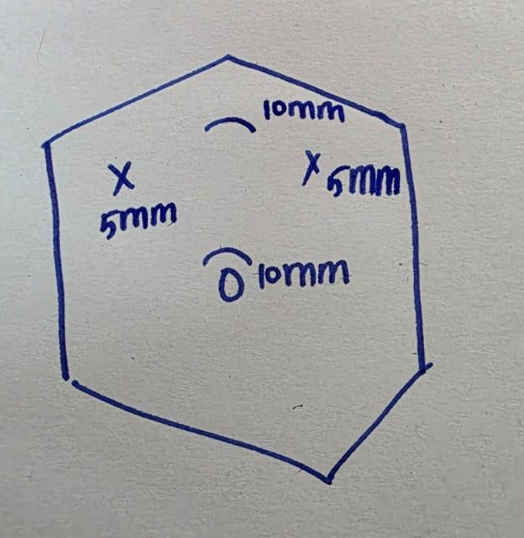
• Figure 1: Port placement schematic for laparoscopic CBD exploration with gastroscope.

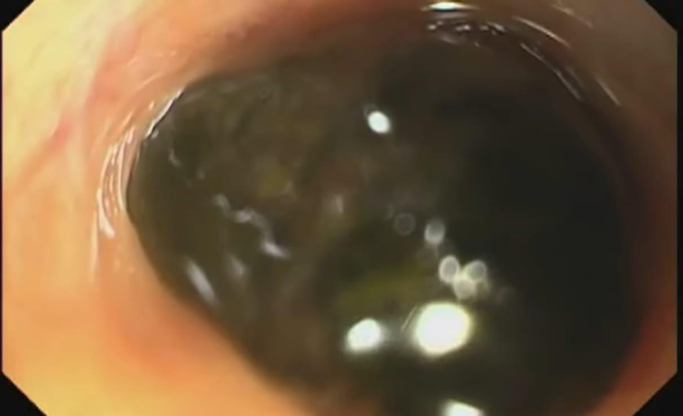
• Figure 2: Intraoperative endoscopic view of distal CBD stone.

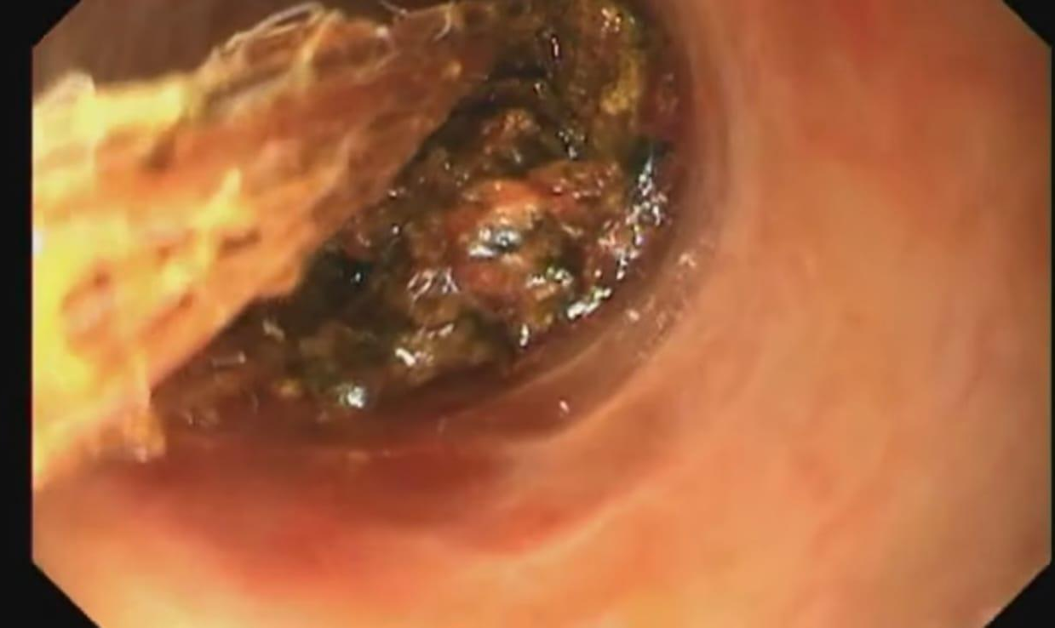
• Figure 3: Stone captured in Roth net after retrieval.

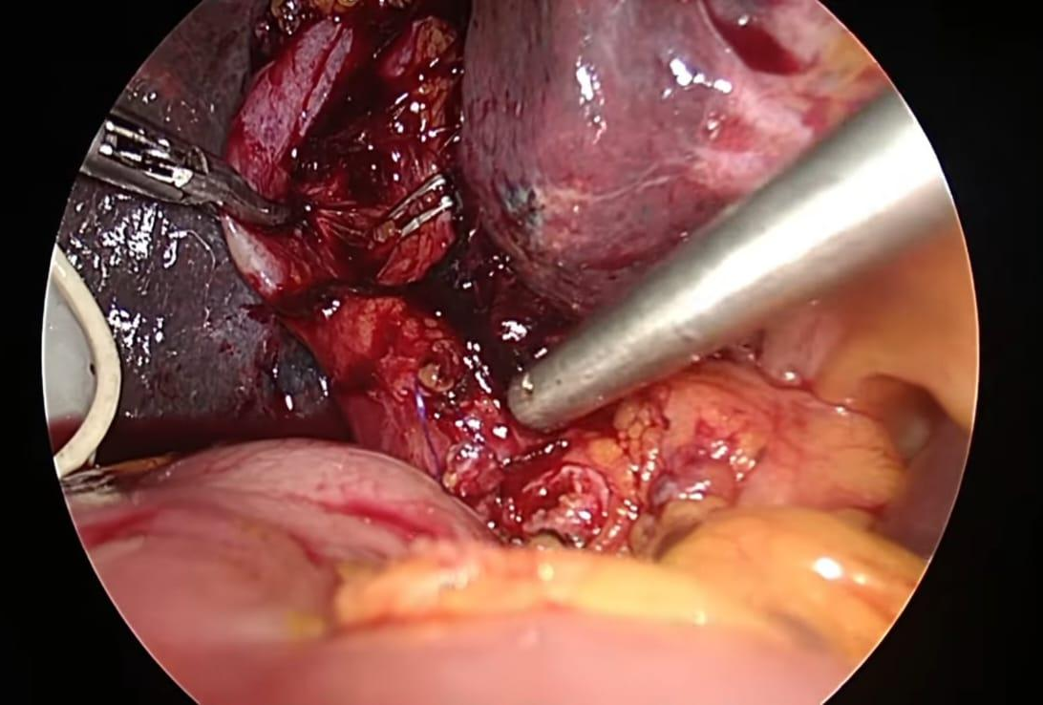

• Figure 4: Transverse closure of choledochotomy with interrupted 4-0 PDS sutures.

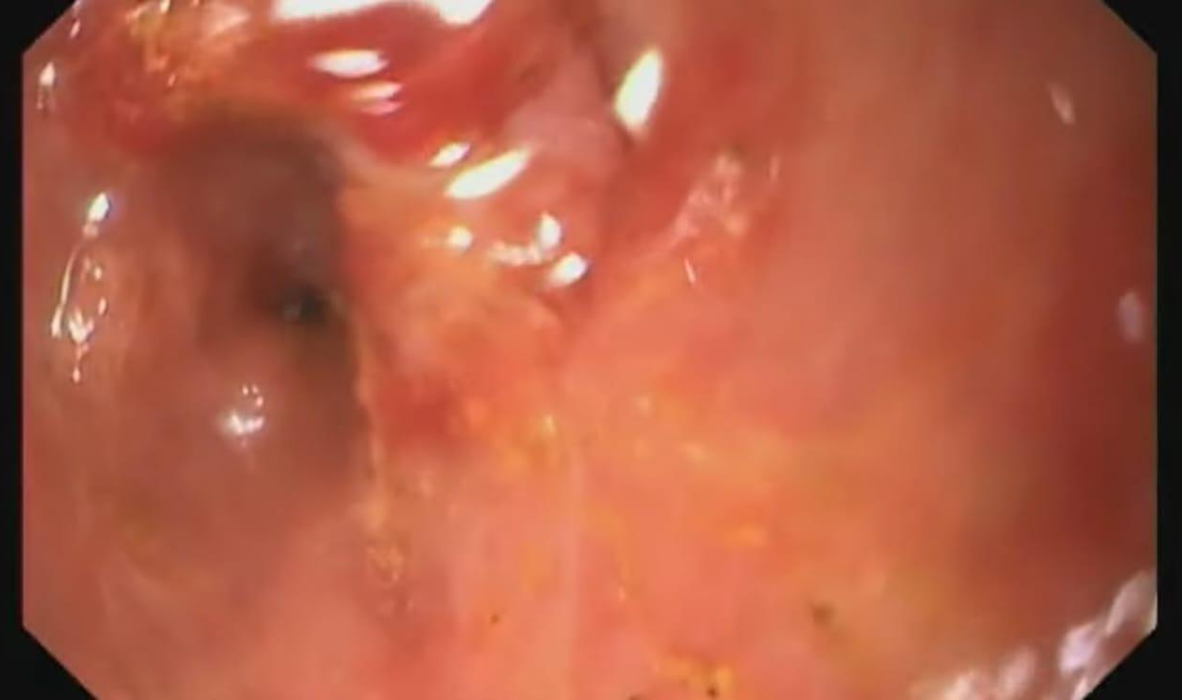A
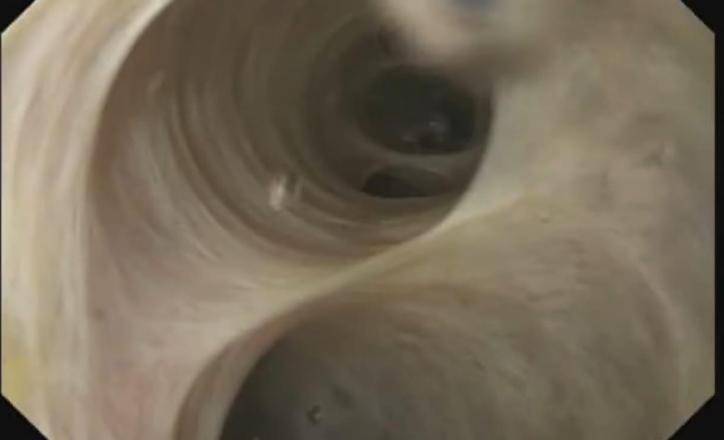B
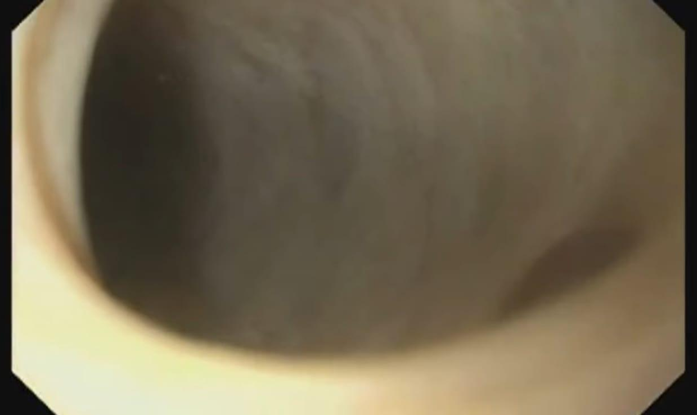C
• Figure 5: CBD(A) and CHD(B,C) after retrieval of distal CBD stone .

Disclaimer (Artificial intelligence)
Option 1:
Author(s) hereby declare that NO generative AI technologies such as Large Language Models (ChatGPT, COPILOT, etc.) and text-to-image generators have been used during the writing or editing of this manuscript.
Option 2:
Author(s) hereby declare that generative AI technologies such as Large Language Models, etc. have been used during the writing or editing of manuscripts. This explanation will include the name, version, model, and source of the generative AI technology and as well as all input prompts provided to the generative AI technology
Details of the AI usage are given below:
1.
2.
3.

References
1.Zhu B, Li D, Li Y, Du T, Guan T, Zhang X, et al. Early versus delayed laparoscopic common bile duct exploration for common bile duct stone-related nonsevere acute cholangitis. Sci Rep. 2015;5:11748. doi:10.1038/srep11748. Full text free: https://www.nature.com/articles/srep11748

2.Dacruz I, Agrawal R, Singh G, Kaman L. Novel technique of laparoscopic common bile duct exploration using a disposable bronchoscope for choledocholithiasis without ductal dilatation. J Minim Access Surg. 2020;16(3):283–6. doi:10.4103/jmas.JMAS_162_18. Full text free: https://pmc.ncbi.nlm.nih.gov/articles/PMC6303829/
3.Dacruz I, Singh G, Kaman L. Laparoscopic common bile duct exploration using a disposable bronchoscope in a post-living donor liver transplant patient with choledocholithiasis. Cureus. 2022;14(11):e31154. doi:10.7759/cureus.31154. Full text free: https://pmc.ncbi.nlm.nih.gov/articles/PMC9750835/
4.Navaratne L, Martinez Isla A. Transductal versus transcystic laparoscopic common bile duct exploration: an institutional review of over four hundred cases. Surg Endosc. 2021;35(8):4370–7. doi:10.1007/s00464-021-08361-7. Abstract free: https://pubmed.ncbi.nlm.nih.gov/33595704/

5.Kouli T, Sreerag K, Ramachandran R, Joseph A, Philip M. Laparoscopic transcystic SpyGlass Discover-assisted common bile duct exploration and clearance: a single-stage, single-session procedure. Cureus. 2024;16(4):e58627. doi:10.7759/cureus.58627. Full text free: https://pmc.ncbi.nlm.nih.gov/articles/PMC11986274/

6.Li Z, Sun J, Li X, Liu J, Zhang J, Wang B, et al. Meta-analysis of single-stage versus two-staged management for concomitant gallstones and common bile duct stones. Ann Surg Treat Res. 2020;98(4):179–88. doi:10.4174/astr.2020.98.4.179. Full text free: https://pmc.ncbi.nlm.nih.gov/articles/PMC7440024/
7.Gurusamy KS, Koti R, Davidson BR. T-tube drainage versus primary closure after laparoscopic common bile duct exploration. Cochrane Database Syst Rev. 2013;2013(6):CD005641. doi:10.1002/14651858.CD005641.pub3
8. Kamande IW, Bradley S, Minford E. Novel use of Ambu® aScope™ 2 for choledochoscopy. Int J Surg 2014; (Suppl 3): S21.

8. Niranjana PB. Laparoscopic Common Bile Duct Exploration Using a Gastroscope – Step-by-Step Video. YouTube. Published [Month Year]. Available at: https://www.youtube.com/watch?v=u-MffR_4_9M

