Case report
When Anatomy Turns Hazardous: Moynihan’s Hump as an Unexpected Challenge in Calot’s Triangle : A Case Report
Abstract:
Moynihan’s or caterpillar hump is a rare anatomical variation of the right hepatic artery (RHA), characterized by a prominent tortuous arterial loop coursing close to the gallbladder, often associated with a short cystic artery. This configuration increases the risk of inadvertent vascular injury during laparoscopic cholecystectomy. We report the case of a woman in her late 40s who presented with acute calculous cholecystitis. She was managed initially with intravenous fluids and antibiotics, followed by an interval laparoscopic cholecystectomy after six weeks. Intraoperatively, a large pulsatile artery running parallel to the cystic duct was identified and confirmed as Moynihan’s hump, with a short cystic artery arising from the distal loop. Careful dissection and controlled clipping allowed safe completion of the procedure without vascular injury. The patient had an uneventful recovery and remained asymptomatic at a 2-month follow-up. This case underscores the importance of preoperative vigilance, meticulous intraoperative dissection, and the achievement of the critical view of safety to avoid potentially catastrophic complications associated with this rare vascular anomaly.
Key words: Moynihan’s hump, Caterpillar hump, Right Hepatic Artery, Laparoscopic Cholecystectomy

Introduction:
Anatomical variations in Calot’s triangle are prevalent and constitute a significant factor in iatrogenic injuries during laparoscopic cholecystectomy, the most commonly performed hepatobiliary surgery globally[1]. One of these variations is Moynihan's hump, which is also called the caterpillar hump. It is a rare and clinically important problem with the right hepatic artery (RHA). In this variation, the RHA takes a winding, often exaggerated path close to the gallbladder. This is often linked to a short cystic artery[2,3]. The incidence of this anomaly is reported to be between 1.3% and 13.3%, but having it makes it much more likely that you will accidentally hurt a blood vessel, bleed, or have ischemic complications while dissecting Calot's triangle[4]. It is difficult to see Moynihan's hump before surgery because standard imaging techniques don't always show arterial variations clearly. Consequently, surgeons must depend on precise intraoperative dissection, comprehensive understanding of anatomical variations, and rigorous compliance with the principles of safe cholecystectomy, including the attainment of the critical view of safety[1,4].
We present this case to emphasize the intraoperative recognition and secure management of Moynihan’s hump during laparoscopic cholecystectomy. The case emphasizes the necessity of vigilance, meticulous dissection, and anatomical awareness to avert potentially disastrous vascular injuries, particularly in emergency or interval cholecystectomy contexts.

Case Presentation:
A patient in her late 40s was admitted to the emergency department with a 2-day history of acute right upper quadrant abdominal pain, fever, and associated non-bilious vomiting. On abdominal examination, there was marked tenderness in the right upper quadrant without any palpable lump. Laboratory investigations revealed marked leukocytosis (21,500 cells/cu mm). A blood culture was sent, and ultrasonography of the abdomen was suggestive of acute calculous cholecystitis. The patient did not give any history of smoking or alcohol intake and had no known comorbidities or any prior history of surgery. The patient was initially resuscitated with intravenous fluids, analgesics, and empirical antibiotics. The patient was discharged 48 hours after following resolution of abdominal pain. Six weeks later, the patient underwent laparoscopic cholecystectomy.
Intraoperatively, during dissection of Calot’s triangle, a large pulsatile artery running parallel to the cystic duct was identified (Figure 1A, 1B). Further careful dissection confirmed a small cystic artery arising from the right hepatic artery, which was separately clipped and divided (Figure 2). After dividing the cystic artery, the cystic duct became clearly identifiable, as it had been running parallel to and partially obscured by the artery. Because the artery was closely guarding the cystic duct, it was dissected and divided first to ensure safe exposure. Following this, the cystic duct was carefully dissected, clipped separately, and divided. The gallbladder was then detached from the liver bed by meticulous dissection along the gallbladder fossa and removed without difficulty. The laparoscopic cholecystectomy was completed without injury to the right hepatic artery. The postoperative course was uneventful, and the patient was discharged the next morning. She remains well at 2-month follow-up.

Discussion:
Moynihan’s hump, also known as the caterpillar hump, is an anatomical variation of the right hepatic artery (RHA), with a reported incidence ranging from 1.3% to 13.3%[5,6]. A recent meta-analysis estimates the incidence to be approximately 1.3% [7].Overall, anatomical variations in the hepatobiliary triangle, involving the cystic artery and biliary tree, are seen in 20% to 50% of individuals[1,7].
This variation arises when the RHA takes a tortuous course, looping either superiorly or inferiorly before giving off a small cystic artery to supply the gallbladder. This loop, resembling the shape of a caterpillar, gives the variation its name. The loop may appear as a single or double curve. When the cystic artery originates from the proximal part of the loop, it has a longer course. More commonly, as in our case, the cystic artery arises from the distal loop and follows a shorter course [2–4].
The etiology behind the formation of Moynihan’s hump remains uncertain. Several theories have been proposed to explain this vascular anomaly. One hypothesis suggests that hepatic cirrhosis can cause structural changes that distort the intrahepatic branches of the hepatic artery, thereby altering its usual course. Another theory proposes that the anomaly may result from complete or partial persistence of the foetal arterial blood supply[8]. Together, these hypotheses highlight the complex developmental and pathological factors that may contribute to this arterial variation.
Preoperative identification of Moynihan’s hump remains challenging. Ultrasonography, although the initial imaging modality for suspected cholecystitis, is limited in its ability to delineate the course of the hepatic artery and frequently fails to visualize the cystic artery. Cross-sectional imaging modalities such as magnetic resonance imaging (MRI) and computed tomography (CT) offer superior characterization of both vascular and biliary anatomy, even in the setting of acute gallbladder inflammation[8,9]. In selected cases, intraoperative cholangiography may be warranted to define the biliary tract anatomy prior to clipping when an associated anomaly is suspected[8]. Additionally, intraoperative venous indocyanine green dye (ICG) or intraoperative ultrasonography serves as a valuable adjunct when uncertainty persists regarding arterial variations [6,10,11].
The primary surgical concern with Moynihan’s hump is the potential for vascular injury during laparoscopic cholecystectomy. This may necessitate conversion to open surgery in up to 1.9% of cases. Although mortality is low (approximately 0.02%), injury to the RHA can lead to right lobe hepatic ischemia, pseudoaneurysm formation, or significant haemorrhage that obscures the operative field [1].
To reduce these risks, adherence to the principles of “safe cholecystectomy” is essential. This includes achieving the “critical view of safety” (CVS), dissecting the lower one-third of the gallbladder from the cystic plate, and ensuring only the cystic artery and cystic duct are entering the gallbladder before clipping. Proper anatomical knowledge, clear exposure, and dissection close to the gallbladder wall are crucial [4,6].

Conclusions:
In conclusion, recognition of Moynihan’s hump is critical during laparoscopic cholecystectomy to prevent vascular injury. A large pulsatile artery in Calot’s triangle should raise suspicion for a tortuous right hepatic artery, and safe dissection with confirmation of the critical view of safety is essential to avoid complications and ensure a successful surgical outcome.

Ethical Approval:

As per international standards or university standards written ethical approval has been collected and preserved by the author(s).
consent: Informed consent was obtained from the patient during the routine preoperative process for participation in research, including specific permission for the use of clinical details and images in a case report/publication

Disclaimer (Artificial intelligence)
Author(s) hereby declare that NO generative AI technologies such as Large Language Models (ChatGPT, COPILOT, etc.) and text-to-image generators have been used during the writing or editing of this manuscript.
References:
1. Martín Pérez JA, Domínguez Rodríguez JA, De Alba Cruz I, Lara Valdés AJ, Sánchez Baltazar AL, Perna Lozada L. Moynihan’s Lump as an unusual variant of right hepatic artery during a laparoscopic cholecystectomy approach. A case report. International Journal of Surgery Case Reports. 2021 Aug;85:106221.
2. Rahate P, Haidar Z, Bangde A, Belsare A, Golchha V, Yadav K. Anatomical classification of catterpillar hump of RHA and its surgical importance (Nagpur classification).
3. Kavitha Kamath B. An anatomical study of Moynihan’s hump of right hepatic artery and its surgical importance. Journal of the Anatomical Society of India. 2016 Aug;65:S65–7.
4. Raghuwanshi DS, Ram M, Khan S, Anand K. Moynihan’s Hump: Our Eyes See What Our Mind Knows. Indian J Surg. 2021 Aug;83(4):1077–8.
5. Dandekar U, Dandekar K, Chavan S. Right Hepatic Artery: A Cadaver Investigation and Its Clinical Significance. Anatomy Research International. 2015 Dec 16;2015:1–6.
6. Meihofer A, Cortez Perez K, Tapia Garcia L, Marcelin N, Masri M. Navigating the Hump: Managing Moynihan’s Hump During a Laparoscopic Cholecystectomy. Cureus [Internet]. 2025 Oct 17 [cited 2025 Nov 17]; Available from: https://www.cureus.com/articles/420395-navigating-the-hump-managing-moynihans-hump-during-a-laparoscopic-cholecystectomy
7. Marano L, Bartoli A, Polom K, Bellochi R, Spaziani A, Castagnoli G. The unwanted third wheel in the Calot’s triangle: Incidence and surgical significance of caterpillar hump of right hepatic artery with a systematic review of the literature. J Min Access Surg. 2019;15(3):185.
8. Uhe I, Ghyas Ghyasi A, Chevallay M, Cherbanyk F. A 56-Year-Old Woman with Acute Cholecystitis and a Moynihan’s Hump, or Caterpillar Configuration, of the Right Hepatic Artery Identified During Laparoscopic Cholecystectomy. Am J Case Rep [Internet]. 2022 Sep 22 [cited 2025 Nov 17];23. Available from: https://www.amjcaserep.com/abstract/index/idArt/936835
9. Sahani D, Mehta A, Blake M, Prasad S, Harris G, Saini S. Preoperative Hepatic Vascular Evaluation with CT and MR Angiography: Implications for Surgery. RadioGraphics. 2004 Sep;24(5):1367–80.
10. Boni L, David G, Mangano A, Dionigi G, Rausei S, Spampatti S, et al. Clinical applications of indocyanine green (ICG) enhanced fluorescence in laparoscopic surgery. Surg Endosc. 2015 Jul;29(7):2046–55.
11. Leigh N, Hammill CW. Liver ultrasound: Normal anatomy and pathologic findings. Surgery Open Science. 2024 Jun;19:178–98.

Figure 1: (A) Intraoperative image showing a short cystic artery originating from the right hepatic artery (RHA), forming a Moynihan’s hump within Calot’s triangle. (B) Schematic diagram illustrating Moynihan’s hump with a short cystic artery running parallel to the cystic duct.
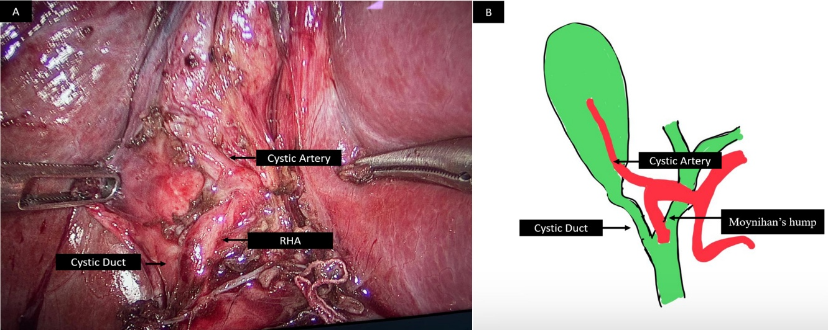

Figure 2: Clipping of the short cystic artery.
