Transanal Specimen Extraction After Laparoscopic Sigmoidectomy for Recurrent Sigmoid Diverticulitis : A Case Report

Abstract
Introduction: Natural orifice specimen extraction (NOSE) has become an important extension of minimally invasive colorectal surgery, enabling removal of the surgical specimen through a natural orifice rather than an abdominal incision. By avoiding a dedicated extraction site, this approach may help reduce postoperative pain, wound-related complications, and the long-term risk of incisional hernias.
Case Presentation: We report the case of a 44-year-old woman with recurrent episodes of uncomplicated sigmoid diverticulitis and a history of multiple abdominal procedures ( two cesarean sections, abdominoplasty, and laparoscopic cholecystectomy). She underwent elective laparoscopic sigmoidectomy with intracorporeal anastomosis and transanal specimen extraction. Intraoperatively, anvil positioning proved to be the most technically demanding step. Her postoperative course was favourable, and she was discharged on postoperative day 5.
Discussion: As minimally invasive colorectal surgery continues to evolve, NOSE techniques provide an alternative to mini-laparotomy for specimen retrieval. Evidence suggests that NOSE offers comparable surgical and functional outcomes to traditional laparoscopy while reducing abdominal wall trauma and translating into lower postoperative pain, surgical site infection and incisional hérnia. These benefits are particularly relevant in patients with previous abdominal operations, who inherently carry a higher risk of wound-related morbidity.
Conclusion: In selected patients with benign colorectal disease, laparoscopic sigmoidectomy with transanal NOSE offers a safe, effective option that may lower wound morbidity and facilitate smoother postoperative recovery.
Keywords: Transanal specimen extraction; laparoscopic sigmoidectomy; diverticulitis; natural orifice surgery; colorectal surgery.
Conclusion:
Transanal NOSE in laparoscopic sigmoidectomy is a safe and effective alternative for selected cases of diverticular disease, offering reduced wound morbidity and faster recovery.
Keywords:
Transanal specimen extraction; laparoscopic sigmoidectomy; diverticulitis; natural orifice surgery; minimally invasive colorectal surgery.
Introduction
“Minimally invasive techniques have reshaped colorectal surgery over recent decades, with laparoscopy now established as a preferred approach in many centers. Although standard laparoscopic colectomy consistently reduces morbidity when compared with open surgery, it still typically requires an abdominal incision for specimen extraction. This incision—regardless of size—can contribute to postoperative pain, wound infection, delayed intestinal recovery, and incisional hernia formation”.¹˒²
The transition toward intracorporeal anastomosis (ICA) has allowed surgeons to minimize bowel manipulation and achieve specimen retrieval through alternative routes or smaller extraction sites.³˒⁴ Within this context, natural orifice specimen extraction (NOSE) was developed to entirely eliminate the need for an abdominal wall incision.⁵˒⁶ The extraction may be performed transanally, transvaginally, or through less frequent transcolonic approaches.⁷
Published data suggest that NOSE is associated with outcomes comparable to conventional laparoscopy, with added benefits in postoperative comfort and cosmetic appearance.⁶˒⁸ Despite its advantages, adoption remains limited, largely due to technical demands and the learning curve associated with these techniques.⁹˒¹⁰
Our surgical unit has progressively incorporated ICA into colorectal practice and has recently expanded its use of NOSE in selected clinical scenarios. This report describes a case of recurrent diverticulitis managed with laparoscopic sigmoidectomy and transanal specimen extraction.

Case Presentation :
A 44-year-old woman with a history of multiple previous abdominal surgeries (two cesarean sections, an abdominoplasty, and a laparoscopic cholecystectomy) presented with recurrent episodes of acute sigmoid diverticulitis. In each episode, computed tomography confirmed the absence of complications, and she was discharged with antibiotic therapy (ciprofloxacin and metronidazole), analgesia, and dietary recommendations. Colonoscopy demonstrated extensive diverticular disease of the sigmoid colon.
Given the persistence of symptoms, an elective laparoscopic sigmoidectomy with intracorporeal anastomosis and transanal specimen extraction was scheduled. The procedure was performed six months after the last acute episode.
Surgical procedure:
A mechanical and antibiotic bowel preparation was performed preoperatively. The patient was placed in the modified lithotomy position. Pneumoperitoneum was established through an infraumbilical incision at a pressure of 12 mmHg, and a 10 mm port was inserted. Four ports were used: a 10 mm port for the laparoscope, a 12 mm operating port in the right lower quadrant, and two 5 mm ports in the right mid-abdomen and left lower quadrant, respectively.

The left colon was mobilized, and the sigmoid colon was resected, preserving the mesentery. The resected segment was placed into an endobag. The rectal stump was marked with silk sutures (Figure 1) and subsequently opened (Figure 2).

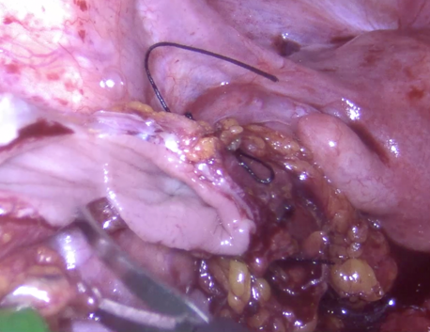
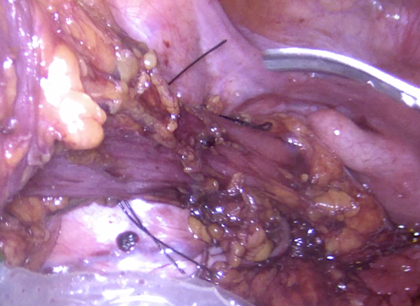

Figure 1 – Rectal marking Figure 2 - Rectal opening

The stump walls were held open using graspers. Resection of the endobag was aided by a clamp introduced through the anal canal into the lumen (Figure 3). The specimen was then retrieved transanally.
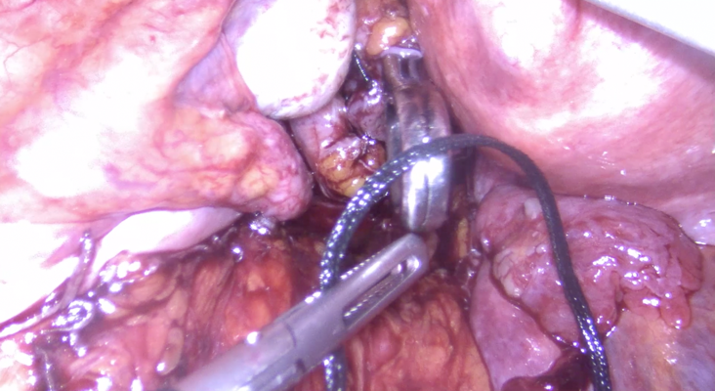
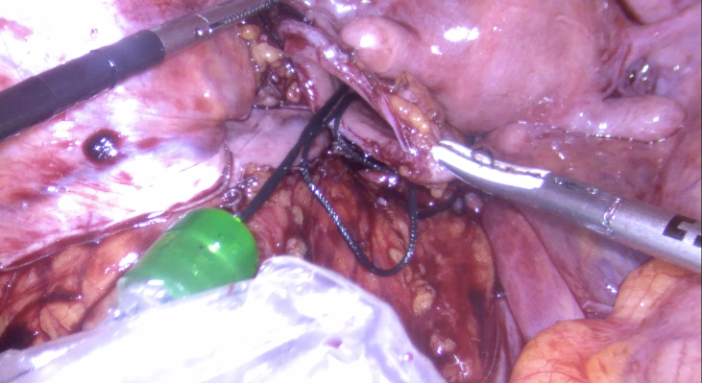

Figure 3 - Resection of the endobag

A 28-mm circular stapler head was introduced through the anus (Figure 4).
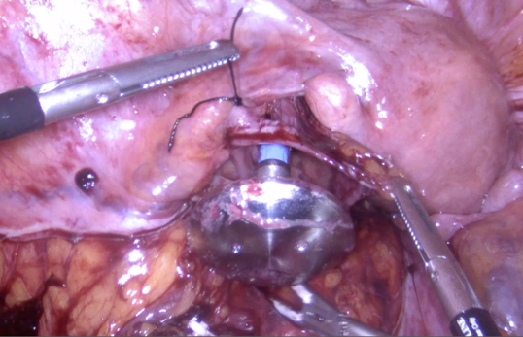

Figure 4- Introduction of 28-mm circular stapler head

The anvil was then inserted into the abdominal cavity, and the shaft was removed. The open rectal stump was closed using a linear stapler and retrieved through the 5-mm port. The anvil was positioned through a small opening in the colic taenia of the proximal colon and exteriorized at the staple line (Figure 5).

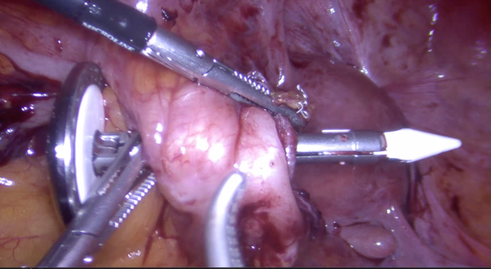

Figura 5 – Anvil position

The open area was subsequently closed with a continuous 2-0 V-Loc™ suture. An intracorporeal, end-to-end mechanical anastomosis was then performed using a CEEA 28 circular stapler. The underwater air-leak test was negative.

The patient had an uneventful postoperative recovery, resumed oral intake within 24 hours, and was discharged on postoperative day 5.

Discussion
With the evolution of minimally invasive colorectal surgery, specimen extraction through natural orifices (NOSE) has emerged as a safe and feasible alternative to traditional mini-laparotomy. The transanal route avoids additional abdominal wall incisions, thereby reducing postoperative pain, wound infection, and the long-term risk of incisional hernia.
Even relatively small extraction sites created during conventional laparoscopic colectomy can lead to complications. Port-site hernias occur in approximately 1.5–2.9% of elective laparoscopic colon procedures,¹³˒¹⁴ and incisional hernia rates after laparoscopic colorectal surgery can reach nearly 8.5% at 4-year follow-up.¹⁵ Avoiding a new fascial incision may therefore be particularly advantageous in patients with previous abdominal surgeries, who already face increased risks due to tissue scarring and weakened fascial planes.
NOSE techniques have been used effectively in both benign and malignant colorectal conditions, with evidence indicating oncologic outcomes comparable to standard laparoscopy.¹⁶ Among female patients, transvaginal extraction is often considered for larger specimens, whereas transanal retrieval is better suited for smaller segments.¹⁷ Despite the need to temporarily open the rectal stump during transanal extraction, meticulous operative technique generally allows contamination to be minimized.
As with other advanced minimally invasive procedures, NOSE requires experience and familiarity with specific technical steps. In this case, positioning the anvil proved the most time-consuming aspect, an experience consistent with published reports.
Surgical site infection (SSI) remains a persistent concern in colorectal surgery, with reported rates ranging from 14% to 26%.²¹ Minimally invasive techniques have helped mitigate this risk, and available comparative studies indicate that employing a NOSE strategy does not increase SSI rates relative to standard extraction.²²˒²³
In the present case, the patient benefited from the absence of an extraction incision, particularly given her previous surgeries. Her recovery was uneventful, with minimal pain and early return to normal activity, supporting growing evidence that NOSE can offer meaningful reductions in wound morbidity while maintaining operative safety.

Conclusion

Laparoscopic sigmoidectomy with transanal specimen extraction is a safe and effective approach that combines the advantages of minimally invasive surgery with complete avoidance of an abdominal extraction site. In selected patients with recurrent diverticulitis, this technique offers excellent outcomes with reduced wound morbidity, faster recovery, and improved cosmetic results.

Declarations

consent

The patient provided written informed consent for publication of this case and all accompanying images.

The authors declare no conflicts of interest.

No external funding was received.

Generative artificial intelligence tools were used exclusively for language revision and standardization of structure. All clinical content, interpretations, and conclusions were produced by the authors.

– Technology: ChatGPT (OpenAI), GPT-5.1, web version

– Access: Official OpenAI platform

References
- Selznick, S., Levy, J., Bogdan, R. M., Hawel, J., Elnahas, A., Alkhamesi, N. A., & Schlachta, C. M. (2023). Laparoscopic right colectomies with intracorporeal compared to extracorporeal anastomotic techniques are associated with reduced post-operative incisional hernias. Surgical Endoscopy, 37(7), 5500-5508. doi: 10.1007/s00464-022-09585-0
- Zattoni D, Popeskou GS, Christoforidis D. Left colon resection with transrectal specimen extraction: current status. Tech Coloproctol. 2018;22:411–23. doi:10.1007/s10151-018-1806-1
- Wolthuis AM, de Buck van Overstraeten A, D’Hoore A. Laparoscopic natural orifice specimen extraction colectomy: a systematic review. World J Gastroenterol. 2014;20:12981–92. doi:10.3748/wjg.v20.i36.12981
- Pham TD, Larach T, Othman B, Rajkomar A, Heriot AG, Warrier SK, et al. Robotic natural orifice specimen extraction surgery for anterior resection. Ann Coloproctol. 2023;39:526–30. doi:10.3393/ac.2022.00458.0065
- Lacy, A. M., García-Valdecasas, J. C., Delgado, S., Castells, A., Taurá, P., Piqué, J. M., & Visa, J. (2002). Laparoscopy-assisted colectomy versus open colectomy for treatment of non-metastatic colon cancer: a randomised trial. The Lancet, 359(9325), 2224-2229. https://www.thelancet.com/journals/lancet/article/PIIS0140673602092905/abstract
- Wolthuis AM, Van Geluwe B, Fieuws S, Penninckx F, D’Hoore A. Laparoscopic sigmoid resection with transrectal specimen extraction: a systematic review. Colorectal Dis. 2012;14(10):1183–8. doi:10.1111/j.1463-1318.2011.02869.x
- Ma B, Huang XZ, Gao P, et al. Laparoscopic resection with natural orifice specimen extraction versus conventional laparoscopic resection for colorectal disease: a meta-analysis. Int J Colorectal Dis. 2015;30(11):1479–88. doi: 10.1007/s00384-015-2337-0
- Wang S, Tang J, Sun W, et al. Natural orifice specimen extraction surgery versus conventional laparoscopy for colorectal cancer: a meta-analysis of efficacy and long-term oncologic outcomes. Int J Surg. 2022;97:106196. doi:10.1016/j.ijsu.2021.106196
- Li Z, Zhou Y, Zhang Y, et al. Long-term oncologic outcomes of natural orifice specimen extraction surgery (NOSES) for rectal cancer. BMC Surg. 2022;22(1):185. doi:10.1186/s12893-022-01691-6
- Zhang, M., Liu, Z., & Wang, X. (2022). Is natural orifice specimen extraction surgery the future direction of minimally invasive colorectal surgery?. Surgery Open Science, 10, 106-110. DOI: 10.1016/j.sopen.2022.08.001
- Rollins, K. E., Javanmard-Emamghissi, H., Acheson, A. G., & Lobo, D. N. (2019). The role of oral antibiotic preparation in elective colorectal surgery: a meta-analysis. Annals of surgery, 270(1), 43-58. DOI: 10.1097/SLA.0000000000003145
- Irani, J. L., Hedrick, T. L., Miller, T. E., Lee, L., Steinhagen, E., Shogan, B. D., ... & Paquette, I. M. (2023). Clinical practice guidelines for enhanced recovery after colon and rectal surgery from the American Society of Colon and Rectal Surgeons and the Society of American Gastrointestinal and Endoscopic Surgeons. Diseases of the Colon & Rectum, 66(1), 15-40.DOI: 10.1097/DCR.0000000000002650
- Taylor, G. W., Jayne, D. G., Brown, S. R., Thorpe, H., Brown, J. M., Dewberry, S. C., ... & Guillou, P. J. (2010). Adhesions and incisional hernias following laparoscopic versus open surgery for colorectal cancer in the CLASICC trial. Journal of British Surgery, 97(1), 70-78. DOI: 10.1002/bjs.6742
- Owens, M., Barry, M., Janjua, A. Z., & Winter, D. C. (2011). A systematic review of laparoscopic port site hernias in gastrointestinal surgery. The surgeon, 9(4), 218-224. DOI: 10.1016/j.surge.2011.01.003
- Fukuoka, H., Watanabe, J., Masanori, O., Suwa, Y., Suwa, H., Ishibe, A., ... & Endo, I. (2021). The risk factors for incisional hernia after laparoscopic colorectal surgery: a multicenter retrospective study at Yokohama Clinical Oncology Group. Surgical Endoscopy, 35(7), 3471-3478. DOI: 10.1007/s00464-020-07794-z
- Liu RJ, Zhang CD, Fan YC, Pei JP, Zhang C, Dai DQ. Safety and oncologic outcomes of laparoscopic NOSE surgery compared with conventional laparoscopy for colorectal disease: a meta-analysis. Front Oncol. 2019;9:597. doi:10.3389/fonc.2019.00597
- Gundogan, E., Aktas, A., Kayaalp, C., Gonultas, F., & Sumer, F. (2017). Two cases of laparoscopic total colectomy with natural orifice specimen extraction and review of the literature. Videosurgery and Other Miniinvasive Techniques, 12(3), 291-296. DOI: 10.5114/wiitm.2017.69227
- Yagci MA, Kayaalp C, Novruzov NH. Intracorporeal mesenteric division of the colon may make the specimen more suitable for natural orifice extraction. J Laparoendosc Adv Surg Tech A. 2014;24:484–6. doi:10.1089/lap.2014.0116
- Wolthuis AM, De Buck Van Overstraeten A, D’Hoore A. Laparoscopic NOSE colectomy with camera sleeve: an evolving technique. Colorectal Dis. 2015;17:O123–5. doi:10.1111/codi.12929
- Pellino G, Frasson M, García-Granero A, Granero-Castro P, Ramos Rodríguez JL, Flor-Lorente B, et al. Predictors of complications and mortality following left colectomy with primary stapled anastomosis for cancer: results of a multicentric study with 1111 patients. Colorectal Dis. 2018;20(11):986–95. doi: 10.1111/codi.14309
- Guzman-Pruneda FA, Husain SG, Jones CD, Beal EW, Porter E, Grove M, et al. Compliance with preoperative care measures reduces surgical site infection after colorectal operation. J Surg Oncol. 2019;119:497–502. doi:10.1002/jso.25346
- Caroff DA, Chan C, Kleinman K, Calderwood MS, Wolf R, Wick EC, et al. Association of open versus laparoscopic approach with risk of surgical site infection after colon surgery. JAMA Netw Open. 2019;2:e1913570. doi:10.1001/jamanetworkopen.2019.13570
- Bu J, Li N, He S, Deng HY, Wen J, Yuan HJ, et al. Effect of laparoscopic colorectal cancer surgery with NOSE on patient recovery and prognosis. Minim Invasive Ther Allied Technol. 2022;31:230–7. doi:10.1080/13645706.2020.1799410

