Case report
Anteriorly Located Rib Osteoblastoma: Case Report

Abstract:
Rib osteoblastoma is a rare benign osteogenic tumor that has the potential to transform into a malignant form.
Case presentation:
This case report describes a 20-year-old female patient who presented with a hard, tender swelling on the left side of her chest wall. Her primary complaint was persistent chest pain. A chest computed tomography (CT) scan showed a well-defined, destructive bony lesion situated at the anterior aspect of the left third rib. An ultrasound-guided true-cut needle biopsy proved challenging and inconclusive; however, it suggested the possibility of osteosarcoma. A fluorodeoxyglucose-positron emission tomography-computed tomography (FDG-PET CT) scan showed that the tumor was metabolically active, with a maximum standardized uptake value (SUV max) of 6.8. The patient then underwent tumor resection and experienced an uneventful postoperative recovery. Histopathological examination confirmed the diagnosis of rib osteoblastoma. Six months after the surgery, a follow-up chest CT scan showed no evidence of recurrence.
Conclusion:
Rib osteoblastoma is a rare benign bone tumor that can exhibit metabolic activity on FDG-PET CT scan. It should be included in the differential diagnosis of tumors located in the anterior or posterior regions of the ribs. A radical surgical approach is essential for accurate diagnosis and effective treatment.
Key words: Anterior, Rib, Osteoblastoma, CT scan
Introduction:
Benign osteoblastoma is a term that was introduced by Lichtenstein in the 1950s. Initially, it was considered a separate pathological entity distinct from osteoid osteoma (Lichtenstein, 1956). Osteoblastoma is a rare type of osteogenic tumors, accounting for about 1% of all bone tumors. It has the potential to transform into a malignant form (Berry et al., 2008; Galgano et al., 2016). This tumor can affect any bone in the body, but it most frequently occurs in the posterior elements of the vertebral column, long bones, and the sacrum. Rib osteoblastoma is particularly uncommon, with a reported incidence of less than 5% in the literature (Berry et al., 2008). All documented cases have been found in the posterior or posterolateral regions of the ribs. This tumor exhibits non-specific radiological features (Galgano et al., 2016; Ye et al., 2012), making the differential diagnosis for this lesion include both benign and malignant conditions. This case report describes a rib osteoblastoma located in the anterior portion of the left third rib, which is an unusual location for such a tumor.
Case Presentation:
A 20-year-old female presented to our department with a two-year history of atypical pain in the left anterior chest. Initially, the pain was attributed to a musculoskeletal cause. It was persistent but partially alleviated by non-steroidal anti-inflammatory medications. The patient denied any previous trauma, and her medical history was otherwise unremarkable. However, over the past few months, the pain significantly increased in intensity, prompting her to seek medical advice. During the physical examination, a very tender, hard swelling was noted at the anterior aspect of the left third rib. The chest examination did not reveal any abnormal findings, and her laboratory test results were all within normal ranges.
A multi-slice chest computed tomography (CT) scan showed a well-defined, destructive intra-medullary bony lesion located at the anterior aspect of the left third rib, measuring approximately 6.1 x 3.3 cm (Fig. 1A, 1B). This lesion indented the underlying costal pleura but showed no pulmonary extension, with the radiologist concluding that it appeared benign. An ultrasound (US)-guided true-cut needle biopsy was attempted, but the procedure was challenging and inconclusive. Nonetheless, it revealed a highly atypical spindle cell neoplasm suggestive of osteosarcoma. A whole-body positron emission tomography-computed tomography (PET-CT) scan was performed, indicating that the bony lesion was metabolically active with increased fluorodeoxyglucose (FDG) uptake. The maximum standardized uptake value (SUV max) measured 6.8 (Fig. 1C). No distant metastasis was observed.
The lesion was surgically excised completely with safety margins. The defect in the anterior chest wall was repaired using polypropylene mesh and bone cement, creating artificial ribs (Fig. 1D). The post-operative recovery was uneventful, and the patient was discharged on the fifth post-operative day.
Histopathological examination indicated a benign tumor composed of interconnected trabeculae of woven bone, bordered by plump osteoblasts and numerous osteoclast-like multinucleated giant cells. Intervening highly vascularized loose connective tissue exhibited variable-sized, thin-walled vascular channels filled with red blood cells (RBCs) (Fig.2A). A sclerotic rim separates the lesion from the surrounding medullary bone marrow (Fig. 2B). There was no observed evidence of malignant changes, necrosis, or granulomatous reaction. Based on these findings, the final diagnosis was osteoblastoma of the rib.
Discussion:
Rib osteoblastoma is a rare eminently benign bone tumor (Berry et al., 2008). In our instance, it was situated on the anterior aspect of the rib, which is an unusual location that, to our knowledge, has not previously been reported. The age of our patient aligns with the peak incidence noted in the literature (Tugcu et al., 2008); however, our patient is female, while osteoblastoma typically shows a male predominance. It is important to highlight that determining sex distribution in cases of rib osteoblastoma can be challenging due to the tumor's rarity (Galgano et al., 2016).
Radiologically, osteoblastoma can be found in various locations, such as intramedullary, intracortical, or periosteal sites, and it often presents with a non-specific appearance (Shaikh et al., 1999). In this case, the osteoblastoma was identified as an intramedullary bony lesion with non-specific radiological features, making it improbable to achieve a definitive preoperative diagnosis. The inconclusive results from the ultrasound-guided true cut biopsy further complicated the situation. As a result, we opted for a whole-body PET-CT scan. Interestingly, the bone lesion demonstrated increased FDG uptake, with a maximum standardized uptake value (SUV) of 6.8. FDG-PET is an imaging technique commonly used for staging malignant tumors, as it detects increased glucose accumulation and metabolism in cancer cells. Some benign bone tumors, like osteoblastoma, can show FDG uptake. Previous researchers reported a significant overlap in the SUVs of benign and malignant bone lesions (Kole et al., 1998).
The maximum SUV reported in our case aligns with the ranges indicated in earlier studies on osteoblastoma, which suggested that increased 18F-FDG uptake is not related to the tumor's location (Kole et al., 1998; Jeong et al., 2011). Currently, it remains unclear which specific cells are responsible for the observed FDG uptake in osteoblastoma. We hypothesize that activated osteoblasts, along with other active cells such as osteoclast-like multinucleated giant cells, may contribute to the positive FDG imaging. A prior study highlighted the significant accumulation of FDG in particular benign bone lesions, especially those containing histiocytic or giant cells (Aoki et al., 2001).
Considering the tumor's location and the diagnostic dilemma, we were surprised to receive a diagnosis of rib osteoblastoma following surgery. The standard treatment for a solitary rib tumor is radical surgery, which is essential for obtaining an accurate diagnosis and preventing local destruction and recurrence. Rib osteoblastoma is generally associated with a favorable prognosis; however, it can recur (Jackson 1978). The incidence of recurrence in osteoblastoma cases varies between 10 to 50% according to the behavioral spectrum of the osteoblastoma, from conventional to highly aggressive tumors, respectively. Recurrence can happen as late as 5 to 10 years after surgical resection (Galgano et al., 2016). This potential for recurrence necessitates long-term follow-up. A chest CT scan performed six months postoperatively showed no signs of recurrence (Fig. 1D).
In fact, we believe that the diagnostic challenges in this case, including the unusual location, non-specific radiological features, uncertainty about the biopsy in addition to increased FDG uptake by the tumor, are especially important and pertinent for practitioners from other specialties who may encounter osteoblastoma.

Conclusion:
Rib osteoblastoma is a rare benign bone tumor that can exhibit metabolic activity on FDG-PET CT scan. It should be included in the differential diagnosis of tumors located in the anterior or posterior regions of the ribs. A radical surgical approach is essential for accurate diagnosis and effective treatment.

Abbreviations list:
CT computed tomography
FDG fluorodeoxyglucose
PET-CT positron emission tomography-computed tomography
SUV max maximum standardized uptake value
RBCs red blood cells
US ultrasound
Declaration of competing interest:
We have no conflict of interest to disclose.
Authorship contribution statement
- Amr A Abdelwahab: Performed surgery, edited the manuscript, and followed up with the patient
- Amro R. Serag: Assisted in surgery, wrote, and edited the manuscript
Patient consent:
We obtained written informed consent from the patient for publication of this case report and its accompanying images. Upon request, a copy of this written consent is available for review.
Disclaimer (Artificial intelligence)
Author(s) hereby declare that generative AI technologies such as Large Language Models, etc. have been used during the writing or editing of manuscripts. This explanation will include the name, version, model, and source of the generative AI technology and as well as all input prompts provided to the generative AI technology
Details of the AI usage are given below:
Grammarly, which is an AI assistant, was used for some grammar and language correction.
References:
- Aoki J., Watanabe H., Shinozaki T., Takagishi K., Ishijima H., Oya N., et al. (2001). FDG PET of primary benign and malignant bone tumors standardized uptake value in 52 lesions. Radiology, 219(3):774-7 DOI:10.1148/radiology.219.3.r01ma08774
- Berry M, Mankin H, Gebhardt M, Rosenberg A, Hornicek F. (2008) Osteoblastoma: a 30-year study of 99 cases. Journal of Surgical Oncology, 98:179–83. DOI: org/10.1002/jso.21105
- Galgano MA, Goulart CR, Iwenofu H, Chin LS, Lavelle W and Mendel E. (2016). Osteoblastoma of the spine: a comprehensive review. Neurosurgical Focus, 41;1-8. DOI:10.3171/2016.5.FOCUS16122.
- Jackson RP. (1978). Recurrent osteoblastoma: a review. Clinical Orthopedics and Related Research, 131:229-233. PMID: 657629
- Jeong YJ, Sohn MH, Lim ST, et al. (2011). Osteoblastoma in the nasal cavity: F-18 FDG PET/CT and Tc-99m MDP 3-phase bone scan findings with pathologic correlation. Clinical Nuclear Medicine, 36:214–217. DOI: 10.1097/RLU.0b013e318208f2f9.
- Kole AC, Nieweg OE, Hoekstra HJ, van Horn JR, Koops HS, Vaalburg W. (1998). Fluorine-18-fluorodeoxyglucose assessment of glucose metabolism in bone tumors. Journal of Nuclear Medicine, 39:810–815. PMID: 9591581
- Lichtenstein L. (1956). Benign osteoblastoma: a category of osteoid- and bone-forming tumors other than classical osteoid osteoma, which may be mistaken for giant cell tumor or osteogenic sarcoma. Cancer, 9:1044–1052
DOI: 10.1002/1097-0142(195609/10)9:5<1044::aid-cncr2820090523>3.0.co;2-o
- Shaikh MI, Saifuddin A, Pringle J, Natali C, Sherazi Z. (1999). Spinal osteoblastoma: CT and MR imaging with pathological correlation. Skeletal Radiology, 28:33-40 DOI:10.1007/s002560050469 - Pubmed 10.
- Tugcu B, Gunaldi O, Gunes M, Tanriverdi O, Bilgic B. (2008). Osteoblastoma of the temporal bone: a case report. Minimally Invasive Neurosurgery, 51:310–2. PMID: 18855299 DOI: 10.1055/s-0028-1083816
- Ye J, Liu L, Wu J, Wang S. (2012). Osteoblastoma of the rib with CT and MR imaging: A case report and literature review. World Journal of Surgical Oncology, 10; 49 DOI: 10.1186/1477-7819-10-49

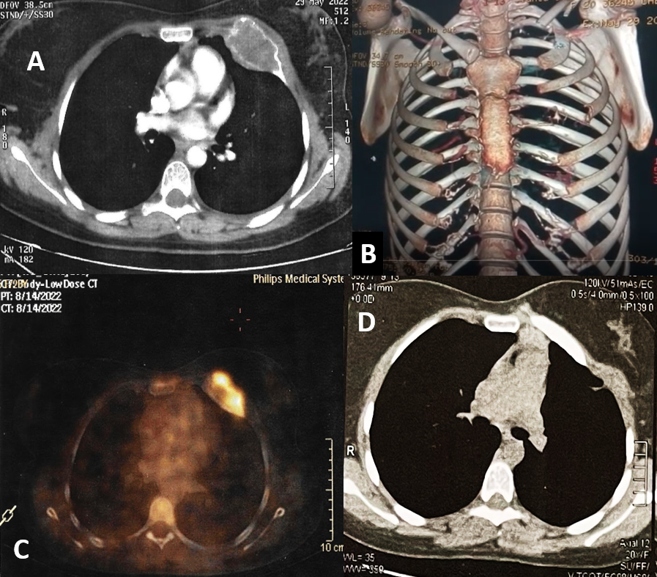
Fig 1: (A) CT chest with contrast shows a well-defined osteolytic, expansile, intramedullary bony lesion situated at the anterior aspect of the left third rib, with intact cortical bone. The lesion measures approximately 6.1 x 3.3 cm. (B) A 3D reconstruction of the bony chest wall showing destruction of the anterior portion of the left third rib.
(C) A whole-body positron emission tomography (PET-CT) scan shows that this bony lesion is metabolically active, exhibiting increased fluorodeoxyglucose (FDG) uptake. The maximum standardized uptake value (SUV max) was recorded at 6.8. (D) CT chest, 6 months postoperatively, shows no evidence of recurrence with good outcome regarding the reconstruction of the chest wall with artificial rib.

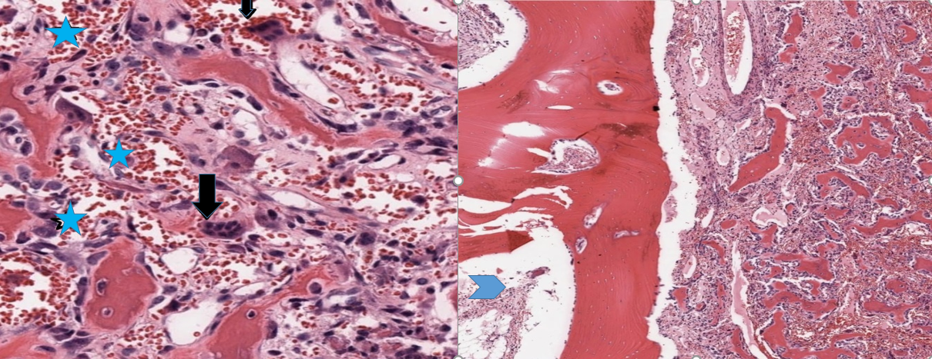
A B
Fig 2: (A) Histopathology image shows osteoblastoma; irregular trabeculae of woven bone rimmed by osteoblasts and scattered multinucleated osteoclasts [black arrows], surrounded by loose fibrovascular stroma with many vascular spaces filled with RBCs [baby blue asterisks] [H&E x 400]. (B) Histopathology image shows osteoblastoma, the tumor is seen sharply demarcated from adjacent cancellous rib bone (Baby blue arrow head) [to the left] [H&E x40].

