Case report

Scapular Osteochondroma in an Adolescent: A Case Report

Abstract :
Introduction:
Osteochondromas are the most common benign bone tumors, but their scapular location, particularly on the anterior surface, remains exceptional. They may reveal themselves through unusual clinical or radiological presentation.

Observation :

We report the case of a 13-year-old boy who presented with a progressive right shoulder deformity and lateral displacement of the scapula. Imaging revealed a large osteochondroma measuring 63 mm, arising from the anterior surface of the right scapula. The patient underwent complete en bloc resection of the lesion performed in the lateral decubitus position. The scapula, displaced laterally by the mass, was repositioned after excision. Postoperatively, a compressive Elastoplast dressing and shoulder sling immobilization for three weeks were applied. No physiotherapy was required, and spontaneous shoulder mobilization resumed gradually after immobilization. Histopathological analysis confirmed a benign osteochondroma. At nine-month follow-up, the patient showed complete functional recovery and resolution of the deformity.

Conclusion :
Scapular osteochondromas are uncommon lesions that should be considered in the differential diagnosis of unexplained thoracic or scapular deformities, particularly in adolescents. Complete surgical excision usually provides excellent functional and cosmetic outcomes, with minimal risk of recurrence when resection is thorough.
Keywords: Osteochondroma, Scapula, Shoulder deformity, Adolescent, Case report.

Introduction
Osteochondroma is the most common benign bone tumor, accounting for approximately 35 to 50% of benign bone tumors [1,2]. It results from a disorder of endochondral ossification, leading to a bony growth covered by a cartilaginous cap and continuous with the cortex and medulla of the supporting bone [3,4]. Scapular localization remains rare, accounting for only 3 to 5% of cases, although it is the most common among flat bones [5,6]. Involvement of the anterior aspect of the scapula remains exceptional and may manifest as deformity, scapulothoracic impingement, or snapping scapula syndrome [7,8]. These forms, which are often clinically misleading, require rigorous radiological evaluation to confirm the diagnosis and rule out any malignant transformation [11–13].
Translated with DeepL.com (free version)We report the case of a large osteochondroma arising from the anterior surface of the right scapula in an adolescent, successfully managed by complete surgical excision with an excellent functional and aesthetic outcome.

Case presentation
A 13-year-old boy with no significant medical history presented with a progressive deformity of the right shoulder that had been developing over two years.
Clinical examination: Physical assessment revealed shoulder asymmetry with posterior displacement of the right scapula. A snapping scapula phenomenon was observed, associated with pain during shoulder movements, resulting in partial limitation of function.
Imaging: Standard radiographs of the right shoulder demonstrated an ill-defined scapular opacity, prompting further evaluation by computed tomography (CT). CT scan with three-dimensional reconstruction revealed a large, well-circumscribed, sessile osteocartilaginous mass arising from the anterior surface of the right scapula, measuring approximately 63 mm in its greatest dimension, and exerting a compressive mass effect on the thoracic cage.
Surgical management: After multidisciplinary discussion and informed consent from the patient’s family, surgical excision was indicated. The patient was positioned in the left lateral decubitus position, and an incision was made along the lateral border of the scapula. Dissection was carried out beneath the teres major muscle, revealing a lesion arising from the anterior surface of the scapula at its lateral aspect. Complete en bloc resection of the mass was performed flush with the bone surface, including the underlying periosteum. A compressive dressing was applied to reposition the scapula against the thoracic cage, and postoperative immobilization was maintained with a shoulder sling for three weeks. No physiotherapy was prescribed. After the immobilization period, the patient gradually regained full shoulder mobility spontaneously.
Outcome: The postoperative course was uneventful. At nine months’ follow-up, clinical examination and CT imaging showed no residual deformity or recurrence, confirming full functional recovery and satisfactory aesthetic results.

Discussion

Osteochondroma is the most common benign bone tumor, accounting for approximately 20 to 50% of all benign bone tumors and 10 to 15% of all bone tumors [1,2]. It is a bony growth covered by a cartilaginous cap, continuous with the cortex and medullary canal of the supporting bone [3,4]. It usually develops during the endochondral growth period and stops growing when the growth plate closes.

Osteochondromas are most commonly found in the metaphyses of long bones (distal femur, proximal tibia, proximal humerus), while locations on flat bones remain rare. The scapula accounts for approximately 3 to 5% of all osteochondromas, but it is the most frequently affected site among flat bones [5,6]. Lesions can develop on the anterior or posterior surface. Anterior forms are more common and can lead to scapulothoracic impingement, bursitis, snapping scapula syndrome, or chest wall deformity [7,8]. Posterior forms, which are more rare, often manifest as dorsal swelling or cosmetic discomfort [9,10].

The diagnosis is primarily radiological. Standard X-rays show a sessile or pedunculated bone mass, continuous with the cortex and medulla of the scapula. CT scans, particularly three-dimensional reconstructions, allow for better analysis of the contours, the base of implantation, and its relationship to the rib cage [11,12]. Magnetic resonance imaging (MRI) is indicated when malignant degeneration is suspected or to assess the thickness of the cartilage cap [13,14].

The differential diagnosis includes benign and malignant cartilage tumors, particularly secondary chondrosarcoma and periosteal osteosarcoma. Certain signs should raise suspicion of malignant transformation: recent pain, rapid growth after skeletal maturity, blurred contours, cortical rupture, periosteal reaction, or thickening of the cartilage cap (> 2 cm in adults, > 3 cm in children) [3,14]. The risk of sarcomatous degeneration is low, estimated at between 1 and 2% in solitary forms, but it can reach 10 to 20% in multiple exostosis [5,15]. In our observation, the absence of pain, the stable progression, and the regular radiological appearance with a thin cap confirmed the benign nature of the lesion.

Treatment is based on complete surgical resection in symptomatic, cosmetically bothersome, or suspected malignant forms. Excision must be monobloc, removing the cartilaginous cap and periosteum to prevent recurrence [6,9,10]. Postoperative outcomes are generally straightforward, with rapid recovery and low recurrence rates. Minimally invasive or endoscopic techniques are being developed, particularly for anterior lesions, offering excellent functional and cosmetic results [5,7,9]. In our case, complete excision resulted in full functional recovery and no recurrence was noted at nine months, which is consistent with the results reported in the recent literature [6,9,15].

Thus, scapular osteochondroma remains a rare but benign tumor with an excellent prognosis after surgical treatment. A thorough radiological evaluation allows the diagnosis to be confirmed, malignant transformation to be ruled out, and the surgical strategy to be guided. This case illustrates the importance of considering this benign entity in the differential diagnosis of scapular masses in children and adolescents.

Table 1. Comparison of Recently Reported Cases of Scapular Osteochondroma
Author / Year | Age / Sex | Scapular Surface | Clinical Presentation | Surgical Technique | Outcome / Follow-up
Shahid et al., 2021 | 18 y / M | Dorsal | Painless mass, cosmetic deformity | Open excision | Complete recovery, no recurrence (12 mo)
Segura Sánchez et al., 2021 | 10 y / F | Anterior | Snapping scapula, shoulder pain | Open resection | Full functional recovery
Ngongang et al., 2019 | 22 y / M | Anterior | Chest wall deformity | En-bloc resection | Excellent functional result
Alatassi et al., 2018 | 17 y / M | Anterior | Winging scapula, shoulder pain | Endoscopic resection | Excellent cosmetic and functional outcome
Nekkanti et al., 2018 | 21 y / M | Dorsal | Painful mass over scapula | Open resection | Uneventful recovery, no recurrence
Vaishya et al., 2014 | 25 y / M | Anterior | Snapping scapula syndrome | Endoscopic resection | No recurrence, good functional result
Karabila et al., 2015 | 24 y / M | Dorsal | Scapular deformity | En-bloc resection | Excellent outcome (10 mo)

Conclusion
Scapular osteochondroma is an uncommon manifestation of a common benign bone tumor that should be included in the differential diagnosis of scapular or shoulder deformities, particularly in young patients. Advances in imaging, especially CT and MRI, have improved diagnostic precision by demonstrating cortical continuity and evaluating the cartilage cap to rule out malignant transformation [11–13]. Although usually asymptomatic, lesions may produce pain, snapping, or cosmetic deformity depending on their location. Surgical excision remains the treatment of choice in symptomatic cases, ensuring complete removal of the cartilage cap and periosteum to prevent recurrence [5–10,14,15]. Recent reports confirm that postoperative recovery is rapid, functional outcomes are excellent, and recurrence is exceedingly rare when resection is complete [2,7,9,12]. This case supports the favorable prognosis of scapular osteochondroma and highlights the importance of early recognition and appropriate surgical management for optimal functional and aesthetic results.

Competing Interests
The authors declare that they have no competing interests.

Consent
Written informed consent was obtained from the patient’s parents for publication of this case report and the accompanying images. A copy of the signed consent form is available for review by the Editor-in-Chief of this journal upon request.

Ethical Approval
Ethical approval was not required for this single case report, as per the institutional policy of the Centre Hospitalier Universitaire Mohammed VI, Tanger, provided that informed consent for publication was obtained.
Disclaimer (Artificial intelligence)

Author(s) hereby declare that generative AI technologies such as Large Language Models, etc. have been used during the writing or editing of manuscripts. This explanation will include the name, version, model, and source of the generative AI technology and as well as all input prompts provided to the generative AI technology

Details of the AI usage are given below:
1. Generative AI technology (ChatGPT, GPT-5, OpenAI) was used ONLY to assist in language editing . The authors reviewed, verified, and approved all content, ensuring the accuracy and integrity of the scientific information presented.

References
- Alabdullrahman LW, Byerly DW. Osteochondroma. StatPearls Publishing, Treasure Island (FL); 2022.
- Tepelenis K, Papathanakos G, Kitsouli A, et al. Osteochondromas: an updated review of epidemiology, pathogenesis, clinical presentation, radiological features and treatment options. In Vivo. 2021;35:681–691. doi:10.21873/invivo.12308.
- Hakim DN, Pelly T, Kulendran M, Caris JA. Benign tumours of the bone: a review. J Bone Oncol. 2015;4:37–41. doi:10.1016/j.jbo.2015.02.001.
- de Souza AM, Bispo Júnior RZ. Osteochondroma: ignore or investigate? Rev Bras Ortop. 2014;49:555–564. doi:10.1016/j.rboe.2013.10.002.
- Shahid O, Shahid M, Shaik L, Masud M, Ranjha S. Rare case of osteochondroma on the dorsal aspect of the scapula. Cureus. 2021;13:e17051. doi:10.7759/cureus.17051.
- Segura Sánchez D, Pino Almero L, Mínguez Rey MF. A solitary osteochondroma of the scapula: uncommon location for a common tumor. Arch Argent Pediatr. 2021;119:e562–566. doi:10.5546/aap.2021.e562.
- Nekkanti S, Moogali A, Meka A, Nair M. An unusual presentation of osteochondroma on the dorsal surface of the scapula: a review of two patients. J Orthop Case Rep. 2018;8:38–41. doi:10.13107/jocr.2250-0685.1098.
- Alatassi R, Koaban S, Almugebel I, Alshehri A. Scapular osteochondroma with winging: a case report. Int J Surg Case Rep. 2018;45:138–142. doi:10.1016/j.ijscr.2018.03.034.
- Ngongang FO, Fodjeu G, Fon AC, et al. Surgical treatment of a rare case of scapula osteochondroma in a resource-limited setting: a case report. Int J Surg Case Rep. 2019;61:130–134. doi:10.1016/j.ijscr.2019.07.015.
- Matthewson G, Singh M, Thompson S. Large osteochondroma of the scapula in a 2-year-old. J Pediatr Surg Case Rep. 2019;42:12–16. doi:10.1016/j.epsc.2018.12.010.
- Douis H, Saifuddin A. The imaging of cartilaginous bone tumours. I. Benign lesions. Skeletal Radiol. 2012;41:1195–1212. doi:10.1007/s00256-012-1427-0.
- Murphey MD, Choi JJ, Kransdorf MJ, Flemming DJ, Gannon FH. Imaging of osteochondroma: variants and complications with radiologic-pathologic correlation. Radiographics. 2000;20:1407–1434. doi:10.1148/radiographics.20.5.g00se171407.
- Tittal P, Pawar I, Kapoor SK. Pseudo-winging of scapula due to benign lesions of ventral surface of scapula – two unusual causes. J Clin Orthop Trauma. 2015;6:30–35. doi:10.1016/j.jcot.2014.10.002.
- Vaishya R, Dhakal S, Vaish A. A solitary osteochondroma of the scapula. BMJ Case Rep. 2014;2014:bcr2013202273. doi:10.1136/bcr-2013-202273.
- Karabila MA, Otmani L, Azouz M, et al. Ostéochondrome volumineux de l’omoplate: à propos d’un cas. Pan Afr Med J. 2015;22:360. doi:10.11604/pamj.2015.22.360.8305.

Fig 1 : Massive Osteochondral Lesion of the Scapula

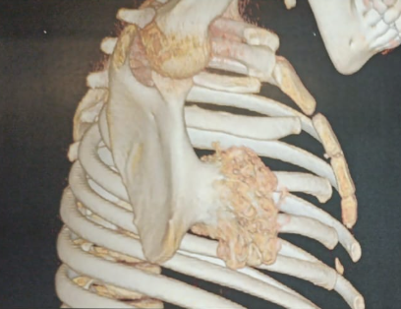

Fig 2 : Surgical Specimen of Bony/Tumoral Mass
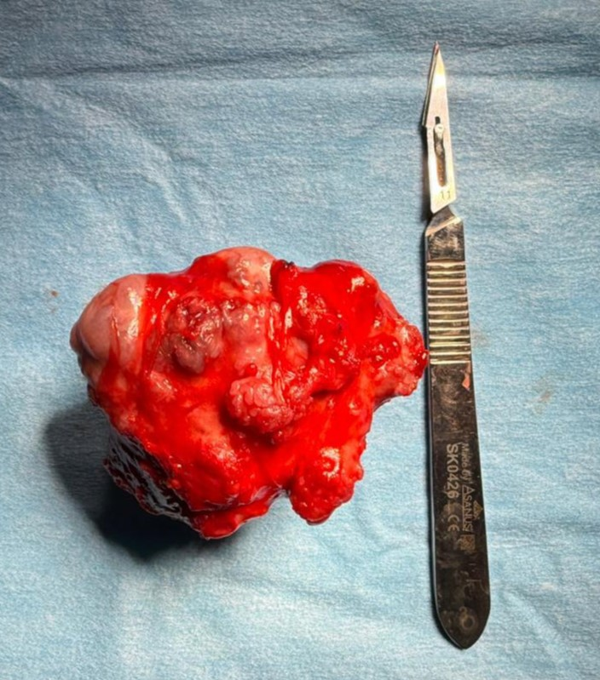

Fig 3 : Post-Operative View of Shoulder Girdle after Tumor Resection
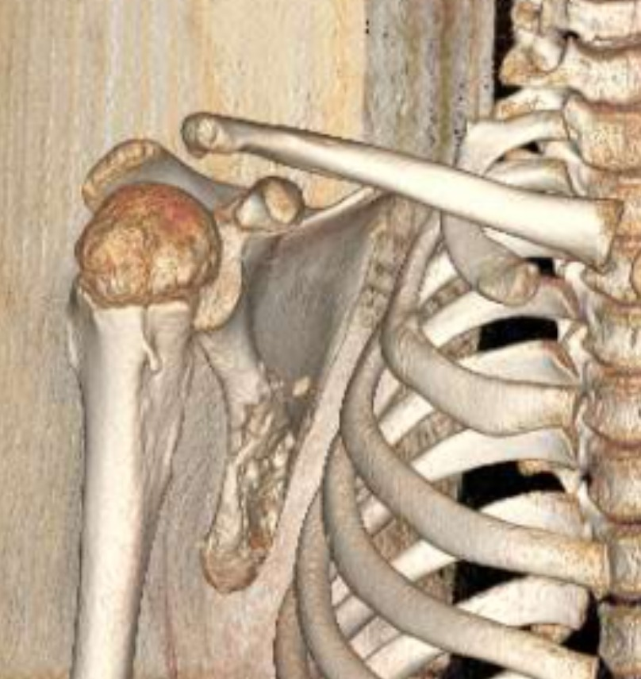

Fig 4 : Post-Operative Clinical Image: Back and Shoulder Assessment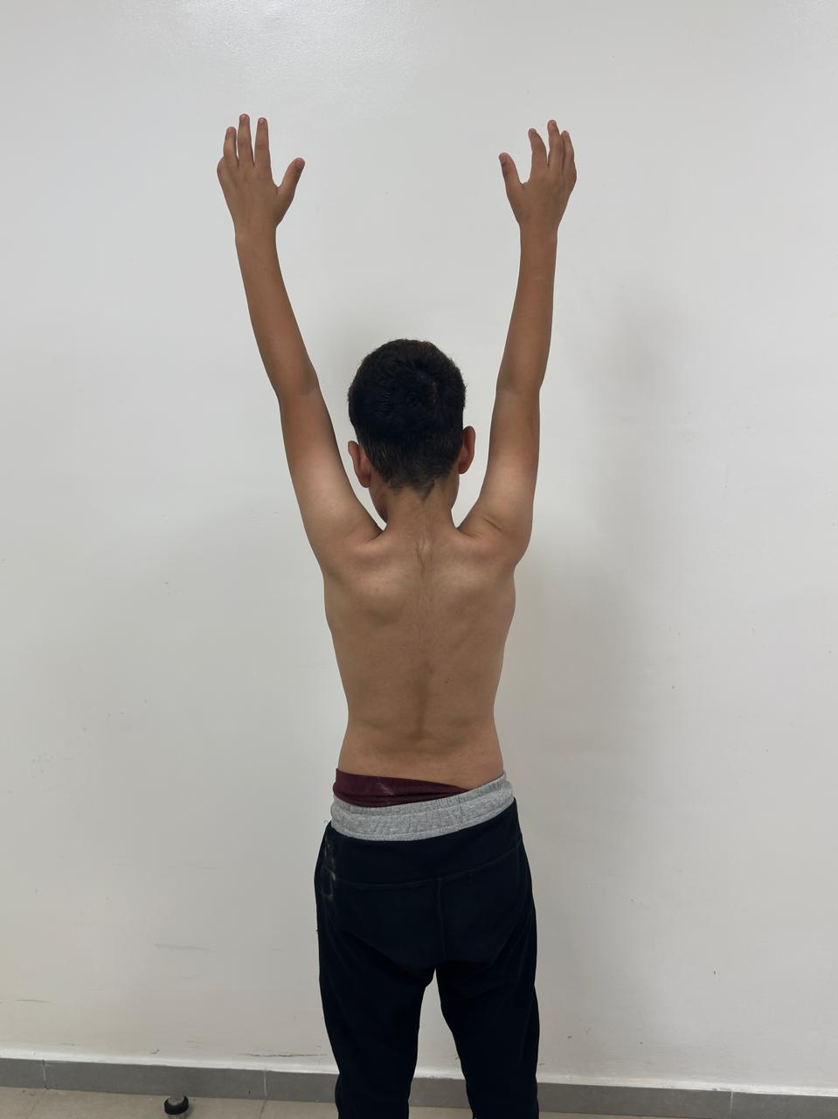

Fig 5 : Post-Operative Assessment of Shoulder Range of Motion (Anterior View)
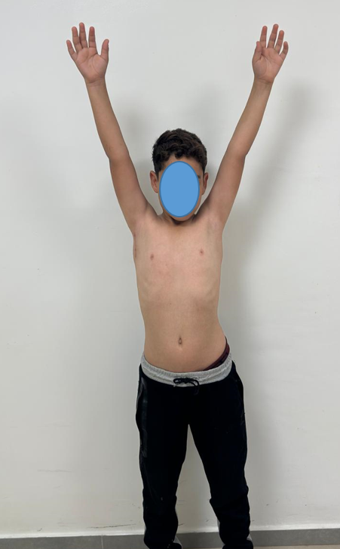
Fig 6 : Pre-Operative Clinical Assessment of Posterior Torso
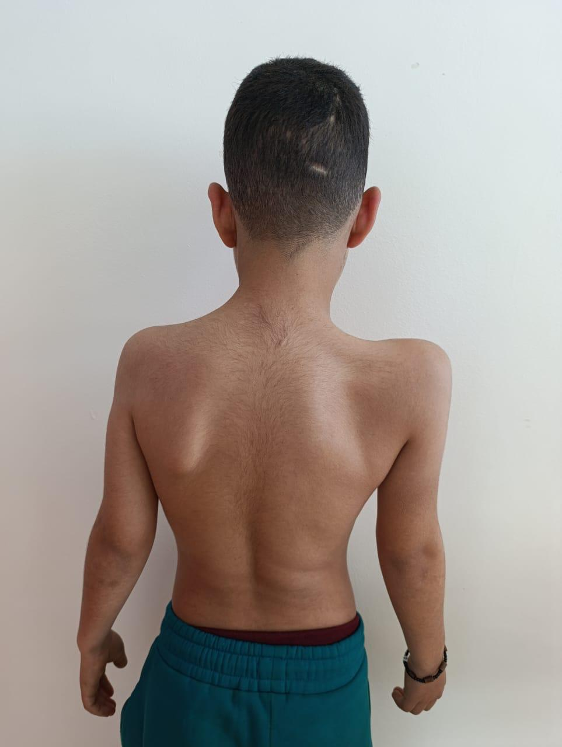
Fig 7 Pre-Operative Clinical Assessment of Anterior Torso
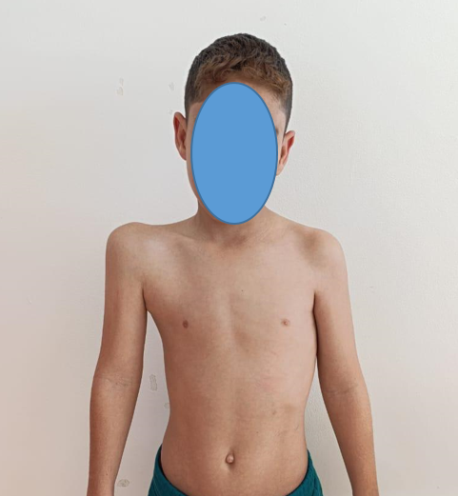
Fig 8 : CT Scan with Lung Window: Scapular Tumor
