Case report

One Hernia, Two Diagnoses: Amyand’s and Richter’s Hernia Revealed Intraoperatively

ABSTRACT

Introduction: Amyand’s hernia and Richter’s hernia are rare entities. Hernia recurrence is a common complication post hernia repair. The coexistence of both hernias in recurrent inguinal hernia is a rare encounter, creating unique challenges in surgical management.
Case Presentation: We present a case of 69-year-old gentleman who presented with obstructed recurrent right inguinal hernia. Initial inguinal exploration was unsuccessful due to distorted anatomy hence converted to midline laparotomy. Intraoperatively revealed Amyand’s and Richter’s hernia. We proceeded with appendicectomy, bowel resuscitation and hernia repair. Patient discharged well without post-operative complication.
Discussion: The coexistence of dual pathologies in recurrent inguinal hernia is exceptionally rare. The management can be challenging depends on the clinical assessment of appendix and bowel viability intraoperatively.
Conclusion: This case illustrates the extremely uncommon case of combined hernias. It emphasizes the importance of maintaining intraoperative vigilance to identify any coexisting pathologies and highlights the significance of individualized planning and prompt surgical intervention especially in recurrent and complex hernias.

Keywords: Amyand’s hernia; Richter’s hernia; recurrent inguinal hernia

1. INTRODUCTION

Inguinal hernia is among the most prevalent conditions we encountered in general surgical practice. But the presence of unusual contents within the sac is an uncommon phenomenon that poses significant diagnostic and management difficulties.

Amyand’s hernia was discovered in 1735 when Claudius Amyand found an appendix in the inguinal hernia sac where he performed the first appendicectomy during hernia repair. It has an incidence of approximately 1% among all inguinal hernias. Acute appendicitis occurring in 0.08% to 0.13% of the cases and constitutes just 0.1% of total incidents of appendicitis [1, 2]. Amyand’s hernia is reported in all ages but more frequent in pediatric population due to the presence of patent processus vaginalis [3]. It usually occurs at the right side, probably due to the normal anatomical location of appendix. Literature shows that men population account for over 90% of cases [4].

Fifty years later, the eponym ‘Richter’s hernia’ was established where August Gottlieb Richter, a German surgeon defined and described this hernia as part of bowel circumference trapped and strangulated at the hernia orifice in 1785. However the earliest discovery credited to Fabricius Hildanus in 1598, which was two centuries earlier where he witnessed a perforated Richter’s hernia in a 63 year old lady. It typically occurs in elderly aged between 60 and 80 years. However, there have been reported instances in infants as well. In terms of anatomical distribution, this hernia more commonly seen in femoral canal, inguinal canal being the secondary, less common in abdominal wall defects. Richter’s hernia more prevalent in female population, which might be due to the fact that femoral hernia is more commonly happens in women compared to men. [5,6,7].

Here, we present a case of simultaneous occurrence of Amyand’s and Richter’s hernia that discovered intraoperatively during hernia repair, highlighting the importance of vigilance in surgical decision making.

2. CASE PRESENTATION

A 69-year-old gentleman with underlying diabetes, hypertension, and a previous history of right inguinal hernia repair presented with three days history of lower abdominal pain, vomiting and loose stool. On examination, there was an irreducible right inguinoscrotal swelling. Otherwise there was no sign of systemic sepsis. Laboratory tests showed mild leucocytosis, while abdominal radiograph suggested small bowel obstruction.

Patient was diagnosed as obstructed right inguinal hernia and posted for right open hernioplasty. Appendix was found within the hernia sac during inguinal exploration. However, the surgery was converted to midline laparotomy due to distorted anatomy, which confirmed Amyand’s hernia with the appendix herniating through the deep inguinal ring. Additionally, a Richter’s hernia was noted, with a segment of small bowel partially entrapped at the anti-mesenteric border near the hernia orifice. The involved bowel showed contusion but viable mucosa.

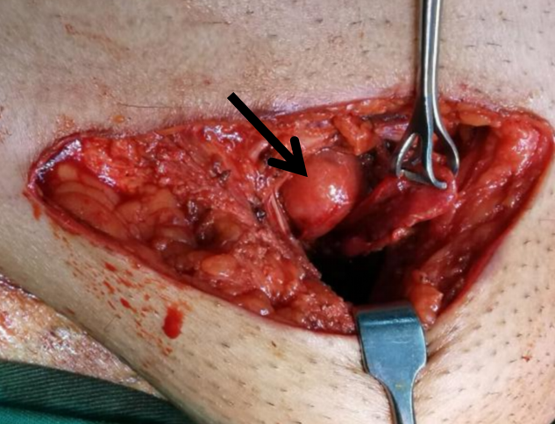

Figure1: Tip of appendix identified from inguinal incision

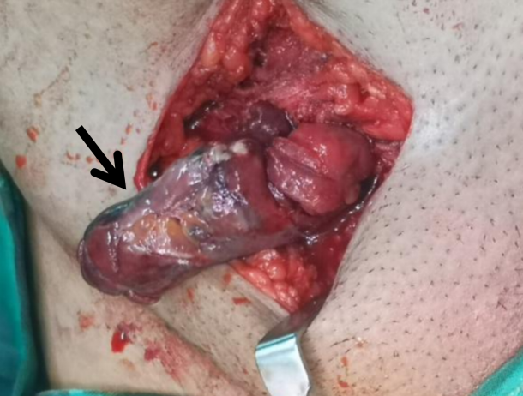

Figure 2: Inflamed appendix with surrounding slough.

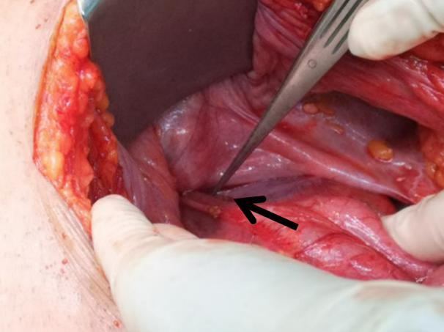

Figure 3: Base of appendix at deep ring from laparotomy incision.

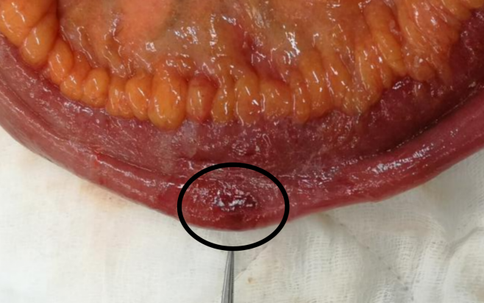
Figure 4: Segment of small bowel partially entrapped at the anti-mesenteric border near the hernia upon removal.
Surgical management consisted of appendicectomy, bowel resuscitation with warm saline packing of small bowel and oxygenation, hernia repair without the need for bowel resection. The postoperative course was uneventful and patient discharged well on day six postoperatively. At two-week follow-up, he remained well with no wound complications.

- DISCUSSION

Both Amyand’s hernia and Richter’s hernia are less known entities. The coexistence of dual pathologies in a recurrent inguinal hernia is uncommonly rare. Preoperative imaging such as ultrasonography or computed tomography may help in diagnosis but it is not routinely performed in emergency setting as in our case where clinical findings suggestive of obstructed hernia.

Amyand’s hernia termed when normal or inflamed appendix found within an inguinal hernia sac [8]. From an etiopathogenic point of view, Mathur et al. (2023) and Oguzkutt et al. (2001) reported the presence of fibrous connections between the appendix and testes with patent processus vaginalis promote the the herniation of appendix through the inguinal canal [9,10]. However this is more common in pediatric population whereas for adult, increase in intra-abdominal pressure with large hernia defect and mobile caecum can be the one of the leading cause. Amyand’s hernia usually an incidental finding during hernia repair surgery. Literature documented around 0.1% of the cases were complicated with appendiceal perforation, leading to significant increase in mortality rate ranging from 15-30% due to severe abdominal sepsis [11]. Management remains debated, but appendicectomy is generally performed when appendiceal inflammation or future diagnostic uncertainty is anticipated. Losanoff JE and Basson MD introduced a classification system with four categories based on the appendix condition with or without the presence of sepsis, which helps in the management of Amyand’s hernia [12]. In this particular case, the appendix was inflamed without intra-abdominal sepsis hence classified as Type 2 Amyand’s hernia. Appendicectomy was performed and hernia repair was done without mesh repair in view of risk of surgical site infection.

Whereas for Richter’s hernia, it is characterized by strangulation and herniation of part of the bowel wall particularly the anti-mesenteric border through the fascial defect. Terminal ileum most commonly involved in Richter’s hernia [5]. The lumen remains patent hence patient rarely present with obstructive symptoms. Eventually the bowels progress into ischemia, gangrene or perforation. The management of Richter’s hernia requires timely surgical intervention either reduction with mesh repair or resection, based on bowel viability [13]. In the case of bowel ischemia, necrosis or perforation, laparotomy and bowel resection is mandatory. Late presentation and delayed management significant increase the morbidity and mortality, highlighting the importance of early diagnosis and prompt intervention. In this particular case, the bowel was contused but viable. Bowel resuscitation was performed without the need for resection, which improved the long-term outcome for the patient.

Hernia recurrence is a common and late complication after inguinal hernia repair with incidence rate of 12% to 13% [14]. Technical factors such as inadequate mesh size, usage of short term absorbable suture in mesh fixation, failure of tension- free repair and patient factors including female, obesity, smoking and previous direct inguinal hernia increase the risk of recurrence [15, 16]. Recurrent hernia increase the complexity of future surgery hence preoperative planning is significant to prevent morbidity. The management of recurrent inguinal hernia depends on the previous repair technique. Posterior approach should be considered if expertise available following a failed anterior approach and vice versa [17] . Open method is recommended in incarcerated, strangulated or obstructed hernia due to the possibility of bowel resection.

To our knowledge, there were very few reports described the simultaneous occurrence of Amyand’s and Richter’s hernia, making intraoperative recognition crucial [18]. This is the first case report presenting a rare case of combined hernias in recurrent inguinal hernia. In our case, distorted anatomy prompted conversion to laparotomy, ensuring accurate diagnosis and safe management. This case highlights the importance of maintaining intraoperative vigilance to identify any coexisting pathologies especially in the case of complex and recurrent hernia. Tailored management which includes appendicectomy and bowel assessment without unnecessary resection optimizes patient outcomes.

4. Conclusion

The coexistance of Amyand’s and Richter’s hernia within a recurrent inguinal hernia is exceptionally uncommon yet clinically significant. Preoperative planning and intraoperative adaptability during hernia surgery is important to ensure optimal outcomes. This case demonstrated a vigilant exploration and tailored management in recurrent hernia with dual pathologies.

Consent

As per international standard, the patient’s written consent was obtained and preserved by author.

Ethical approval

Not applicable.

Disclaimer (Artificial intelligence)
Option 1:
Author(s) hereby declare that NO generative AI technologies such as Large Language Models (ChatGPT, COPILOT, etc.) and text-to-image generators have been used during the writing or editing of this manuscript.

References

1.Faiz, N., Ahmad, N., & Singh, R. (2016). Case series on different presentations of Amyand's hernia. Archives of International Surgery, 6(3), 176.
2.Khalid, H., Khan, N. A., & Aziz, M. A. (2021). Amyand's hernia a case report. International journal of surgery case reports, 86, 106332.
3.Ivanschuk, G., Cesmebasi, A., Sorenson, E. P., Blaak, C., Loukas, M., & Tubbs, S. R. (2014). Amyand's hernia: a review. Medical science monitor : international medical journal of experimental and clinical research, 20, 140–146.
4.Călin M, Costache M, Ilie V, Călin A, Dăscălescu D, Dinu D, et al. Amyand’s hernia: case series and literature review. Romanian Journal of Experimental Surgery. 2024;11(1):7–11
5.Skandalakis, P. N., Zoras, O., Skandalakis, J. E., & Mirilas, P. (2006). Richter hernia: surgical anatomy and technique of repair. The American surgeon, 72(2), 180–184.
6.Steinke, W., & Zellweger, R. (2000). Richter's hernia and Sir Frederick Treves: an original clinical experience, review, and historical overview. Annals of surgery, 232(5), 710–718.
7. Katragadda, K., DeStefano, L. M., & Khan, M. F. (2019). A case of Richter hernia: a rare entity. ACS Case Rev Surg, 2(3), 5-7.
8.Michalinos, A., Moris, D., & Vernadakis, S. (2014). Amyand’s hernia: A review. American Journal of Surgery, 207(6), 989–995.
- Mathur, P., Mittal, P., & Kumar, A. (2023). Amyand's Hernia: Appendix in Hernia or Hernial Appendicitis?. Journal of Indian Association of Pediatric Surgeons, 28(3), 206–211
- Oguzkurt, P., Kayaselçuk, F., Oz, S., Arda, I. S., & Oguzkurt, L. (2001). Sliding appendiceal inguinal hernia with a congenital fibrovascular band connecting the appendix vermiformis to the right testis. Hernia : the journal of hernias and abdominal wall surgery, 5(3), 156–157.
11.Morales-Cárdenas, A., Ploneda-Valencia, C. F., Sainz-Escárrega, V. H., Hernández-Campos, A. C., Navarro-Muñiz, E., López-Lizarraga, C. R., et al. (2015). Amyand hernia: Case report and review of the literature. Annals of Medicine and Surgery, 4(2), 113–115. 12.Losanoff, J. E., & Basson, M. D. (2007). Amyand hernia: what lies beneath--a proposed classification scheme to determine management. The American surgeon, 73(12), 1288–1290.
13.Al-Jawad, M., Alnasser, S., Lbabidi, N. A., Sheikh, A., Diarbakerly, B., & Kawas, A. (2024). Prevascular Richter’s hernia: A rare and challenging presentation of a potentially life-threatening condition: A rare case report. International Journal of Surgery Case Reports, 121, 110024.
- Niebuhr, H., & Köckerling, F. (2017). Surgical risk factors for recurrence in inguinal hernia repair - a review of the literature. Innovative surgical sciences, 2(2), 53–59.
- Burcharth J. (2014). The epidemiology and risk factors for recurrence after inguinal hernia surgery. Danish medical journal, 61(5), B4846.
- Gopal, S., & Warrier, A. B. (2013). Recurrence after groin hernia repair—revisited. International Journal of Surgery, 11(5), 374–377.
- Kumar, H. R. (2025). Current Approaches to the Management of Recurrent Inguinal Hernias: A Review. Medical Science: Recent Advances and Applications Vol. 11, 56-66.
18.Bori, A. K., Tebisso, A. D., Kahsay, A. B., & Goshu, E. M. (2024). A case report on rarer case of triple combined hernia: Management, challenges, and insights. International journal of surgery case reports, 122, 110051.

