Case report
Ammonium Bi-Urates in the Urine of a 10-Year-Old Boy: A Case Report from a Tertiary Care Hospital
Abstract
Background:
Ammonium bi-urate crystals are rarely seen on routine urine microscopy, particularly in older children. “These crystals may appear in condition like dehydration or mild infection when urinary chemistry changes. Timely identification helps clinicians prevent later stone development
Case report:
A 10-year-old boy presented with low-grade fever (100.2°F) and mild dehydration, but no urinary symptoms. Urine microscopy revealed numerous refractile, brownish-yellow “thorn-apple” crystals at near-neutral pH, which is consistent with ammonium bi-urate. The urine culture was sterile, and renal function test results were normal. He was advised to increase oral fluids, and on review after three months, the crystals had completely disappeared.
Discussion:
Ammonium bi-urate crystalluria occurs when the urinary ammonia and urate concentrations increase under near-neutral pH conditions. Transient metabolic stress or reduced fluid intake can precipitate such crystals even in the absence of infection. Although historically observed in regions with a high prevalence of bladder stones and low phosphate diets, sporadic cases may occur in otherwise healthy children. Early recognition and hydration remain key to preventing stone disease progression.
Conclusion:
This manuscript highlights a rarely documented occurrence of ammonium bi-urate crystalluria in an older child, an observation with important diagnostic and preventive implications. Awareness of such cases can guide clinicians toward intervention through simple measures like hydration. It can also save excessive use of antibiotics specially in the absence of infection.
Keywords:
Ammonium bi-urate crystals, crystalluria, dehydration, lithogenic risk, pediatric urine microscopy, thorn-apple crystals
Introduction
Crystalluria means the presence of crystals in urine sediment and is a frequent finding during routine microscopic examination. While most crystals are physiologic but few may indicate or predispose to urolithiasis or systemic metabolic abnormalities¹⁻².
Pediatric urolithiasis (PU) is a rare condition accounting for 1–3% of all urolithiasis cases Despite a low prevalence of 2–3% with recurrence rates is up to 50 % ³. Because stones in children can recur and occasionally damage the kidneys, pediatric urolithiasis need careful follow-up” ⁴.
Ammonium urate and ammonium bi-urate crystals are rarely seen nowadays, particularly beyond infancy ⁵⁻⁶. They are typically associated with dehydration, urinary tract infections, metabolic acidosis, or diets rich in purines ⁷. These crystals are more frequently encountered in resource-limited regions or in areas endemic for bladder stones ⁸.
Ammonium bi-urate crystals have a distinctive “thorn-apple” morphology and are less soluble at neutral or slightly alkaline urinary pH levels. Recognition of these crystals is crucial because their persistence may precede the formation of ammonium urate stones ⁶. Here, we report a case of incidental detection of ammonium bi-urate crystals in an older child during evaluation for febrile illness, emphasizing the importance of hydration and monitoring.
Case Report
A 10-year-old male child presented to the outpatient department of the Raipur Institute of Medical Sciences, a tertiary care hospital Raipur, Chhattisgarh, India, with a history of low-grade fever (100.2°F) lasting for four days. There were no associated urinary symptoms, such as dysuria, hematuria, flank pain, urgency, or frequency. The child’s appetite was slightly reduced during the febrile episode, and the parents reported a mild decrease in oral fluid intake. There was no history of gastroenteritis, vomiting, or recent illness, and no prior episodes suggestive of ureteric or metabolic disease. His medical history was unremarkable, with normal growth and development, and no history of nephrolithiasis or recurrent urinary tract infections. The child was not on any medications at the time of presentation.
On general physical examination, the patient appeared well nourished but mildly dehydrated. At the time of examination, he was afebrile, and vital signs were within normal limits for age. Systemic examination revealed a soft, nontender abdomen without organomegaly or costovertebral angle tenderness. The results of cardiovascular, respiratory, and neurological examinations were unremarkable.
Table 1. Laboratory Investigations
Test | Result | Interpretation
Urine (Gross Examination) | Turbid, yellowish appearance | Suggestive of concentrated urine; possible mild dehydration
Urine dipstick | pH ≈ 6.5; no protein, no blood, nitrite/leukocyte esterase negative | Near-neutral urine
Urine (Microscopy Examination) | Numerous thorn-apple shaped ammonium bi-urate crystals, refractile, brownish-yellow; no casts or bacteria | Characteristic morphology
Urine culture | Sterile | Rules out infection
Serum creatinine, BUN | Normal | Normal renal function
Serum uric acid | Normal | No hyperuricemia
Spot urine uric acid: creatinine ratio | Normal | No hyperuricosuria
Electrolytes (Na⁺, K⁺, Cl⁻) | Normal | Balanced status
CBC | Mild neutrophilic leukocytosis | Suggests inflammatory response
CRP | 47.84 mg/L (elevated) | Confirms systemic inflammation
Widal test, MP smear, Dengue NS1/IgM | Negative | No evidence of enteric fever, malaria, or dengue
Ultrasound KUB | No stones or hydronephrosis | Normal study

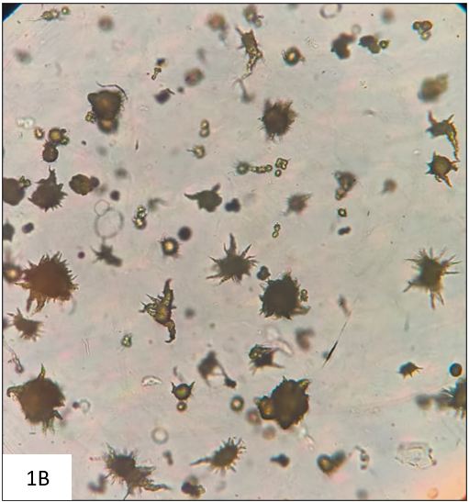
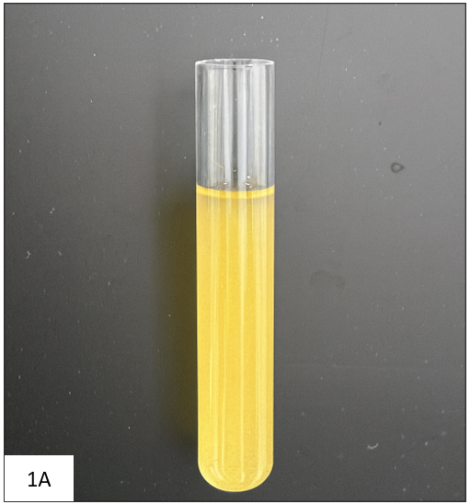

Figure 1: (A) Turbid yellowish urine sample, indicating concentration. (B) Unstained wet mount (×40) showing numerous refractile “thorn-apple” shaped ammonium bi-urate crystals.

Management and Outcome
The patient was managed conservatively with emphasis on correcting mild dehydration and optimizing dietary intake. His parents were advised to increase daily fluid intake to approximately 1.5–2 liters per day. Regular follow-up was advised with repeat urinalysis every four–six weeks to monitor for persistence or recurrence of crystalluria. At the 3-month follow-up visit, urine microscopy revealed complete resolution of the ammonium bi-urate crystals, and the urine appeared clear. The patient remained asymptomatic with normal renal function parameters and no new clinical concerns.
Discussion
Ammonium bi-urate crystalluria is an uncommon finding in pediatric urine microscopy and is rarely observed in routine practice. Formation of these crystals is influenced by urate level, urinary pH, and ammonia. Short periods of fever or dehydration can change these factors and cause crystal appearance. While urease-producing infections are known to cause ammonium urate precipitation, the sterile urine culture in this case excluded the infection. In this case, the findings point to brief dehydration during the fever episode as the cause. Temporary shifts in urinary chemistry likely led to crystal formation.
Clinical Relevance
Crystalluria often precedes stone formation. In children, ammonium urate stones have been described after episodes of gastroenteritis or severe dehydration ⁹. Our case differs in that it demonstrated crystalluria during a mild febrile illness without overt dehydration or infection and with spontaneous resolution upon hydration.
Differential Diagnosis
The differential diagnosis of crystalline deposits by urine microscopy includes uric acid, sodium or potassium urate, calcium oxalate, and phosphate crystals. However, these morphological differences are typically observed in more acidic or alkaline environments. The absence of triple phosphate crystals and negative urine culture excluded infection-related crystalluria in this case.
Comparison with Literature
Recent studies reaffirm that ammonium urate and ammonium bi-urate crystals, though rare in children, may occur transiently during dehydration or febrile illnesses. Bhattacharjee et al. (2021)⁶ reported pediatric cases with “thorn-apple” crystals, while Ban et al. (2022) ⁹ described ammonium acid urate stones linked to viral gastroenteritis and dehydration. Letavernier et al. (2022) ² and Lee et al. (2022) ⁶ emphasized the diagnostic value of detailed morphological and solubility analysis in identifying such rare crystals. These findings support the present observation that timely hydration ensures complete resolution and prevents lithogenic progression.
Limitations
This case report had certain limitations that should be acknowledged. Since this report covers only one child, the results can’t be applied to all cases. Larger studies or multicenter case series are needed to better understand the prevalence, underlying metabolic factors, and clinical implications of ammonium bi-urate crystalluria in children, especially in the context of transient dehydration or febrile illnesses.
Conclusion
Ammonium bi-urate crystals, though rare in older children, may appear transiently during febrile or dehydrating illnesses. Once identified, such crystals should lead clinicians to check the child’s hydration, diet, and urine pH. With timely conservative management, recurrence and progression to stone disease can be prevented. Awareness among clinicians and laboratory professionals ensures an appropriate evaluation.
Disclosure: The authors declare no conflict of interest. No funding was received for this study.
Funding: None
Acknowledgments: None
​References
1. JM B, B A. From crystalluria to kidney stones, some physicochemical aspects of calcium nephrolithiasis. World J Nephrol [Internet]. 2014 [cited 2025 Nov 5];3(4):256. Available from: https://pubmed.ncbi.nlm.nih.gov/25374820/
2. Letavernier E, Bazin D, Daudon M. Description of Stone Morphology and Crystalluria Improve Diagnosis and Care of Kidney Stone Formers. Healthcare 2023, Vol 11, Page 2 [Internet]. 2022 Dec 20 [cited 2025 Oct 26];11(1):2. Available from: https://www.mdpi.com/2227-9032/11/1/2/htm.
3. Pecoraro L, Zuccato A, Vitella R, Pietrobelli A, Piacentini G, Brugnara M. Pediatric Nephrolithiasis: A Changing Landscape Through Time and Space. Medicina 2024, Vol 60, Page 1993 [Internet]. 2024 Dec 2 [cited 2025 Oct 26];60(12):1993. Available from: https://www.mdpi.com/1648-9144/60/12/1993/htm.
4. Hen S, Ma X, Guo L, Zhang J, Li H. The global, regional, and national burden of pediatric stone disease. Front Pediatr. 2025;13:1529407. Available from: https://www.frontiersin.org/articles/10.3389/fped.2025.1529407/
5. Bhattacharjee Junior Resident K, Kumar Singh Assistant Professor V, Bhattacharjee K, Kumar Singh V, Belurkar S. Unexpected crystalluria: Report of three cases. International Journal of Clinical and Diagnostic Pathology [Internet]. 2021 Apr 1 [cited 2025 Nov 5];4(2):70–2. Available from: https://www.patholjournal.com/archives/2021.v4.i2.359/unexpected-crystalluria-report-of-three-cases.
6. Lee AJ, Yoo EH, Bae YC, Jung SB, Jeon CH. Differential identification of urine crystals with morphologic characteristics and solubility test. J Clin Lab Anal [Internet]. 2022 Nov 1 [cited 2025 Nov 5];36(11). Available from: https://pubmed.ncbi.nlm.nih.gov/36164743/.
7. Allam EAH. Urolithiasis unveiled: pathophysiology, stone dynamics, types, and inhibitory mechanisms: a review. African Journal of Urology 2024 30:1 [Internet]. 2024 Jul 23 [cited 2025 Nov 5];30(1):1–12. Available from: https://afju.springeropen.com/articles/10.1186/s12301-024-00436-z.
8. Pecoraro L, Zuccato A, Vitella R, Pietrobelli A, Piacentini G, Brugnara M. Pediatric Nephrolithiasis: A Changing Landscape Through Time and Space. Medicina 2024, Vol 60, Page 1993 [Internet]. 2024 Dec 2 [cited 2025 Nov 5];60(12):1993. Available from: https://www.mdpi.com/1648-9144/60/12/1993/htm.
9. Ban H, Miura K, Tomoeda R, Hirai K, Hattori M. Acute kidney injury due to ammonium acid urate stones in a patient with adenovirus gastroenteritis: a case report. BMC Urology 2022 22:1 [Internet]. 2022 Jan 15 [cited 2025 Nov 5];22(1):1–4. Available from: https://bmcurol.biomedcentral.com/articles/10.1186/s12894-022-00954-4.

Disclaimer (Artificial Intelligence Use)
Author(s) hereby declare that generative AI technology was used only for language refinement, grammar correction, and reference formatting during manuscript preparation. The scientific content, data interpretation, and conclusions are entirely the authors’ own work.
Details of AI usage:
- Tool: ChatGPT (GPT-5, OpenAI)
- Purpose: To improve clarity, grammar, and consistency of the text; to format references in Vancouver style.
- Prompts provided: Limited to linguistic and formatting assistance; no prompts were used to generate research content or results.

