A case report of atrial myxoma with obstructive shock Presentation
Abstract
Learning Objectives :
-explore the clinical presentation and diagnosis of cardiac myxoma
-find out the potential complications of cardiac myxoma, such as embolic events and heart failure
-Understanding the role of echocardiography in the diagnosis and management of cardiac myxoma.
Background:
Cardiac myxoma, an uncommon tumor forming in the heart, tends to occur in the left atrium and is generally non-cancerous in nature. The composition, size, and position of the tumor can lead to a range of varied signs and symptoms. These symptoms can range from barely noticeable to severe and may include heart ailments, pulmonary hypertension, and even strokes. The usual course of treatment involves surgical removal of the tumor to resolve the issue.
CASE PRESENTATION :
This manuscript presents a case report of a 33-year-old male patient who presented with sudden dyspnea and was diagnosed with an extraordinarily large left atrial myxoma causing cardiogenic shock. Despite plans for surgery, the patient's condition rapidly deteriorated and he eventually died due to persistent intracardiac obstruction. The article discusses the rarity of primary tumors in the heart, with myxoma being the most prevalent, and the non-specific symptoms that can manifest in a variety of ways, including cardiac, embolic, and systemic symptoms. The importance of echocardiography in diagnosing cardiac tumors and the potential complications of atrial myxomas, including mitral valve obstruction, congestive heart failure, and sudden death, are also discussed.
CONCLUSION :
The presence of a giant left atrial myxoma, although benign, can cause severe symptoms and even be life-threatening. Diagnosis is made through echocardiography, and surgical removal of the tumor is the recommended treatment, which should be performed promptly upon diagnosis.
Keywords :
Cardiac mass , Myxoma, Cardiogenic shock

INTRODUCTION :
The frequency of primary tumors in the heart is rare, with a range of 0.0017% to 0.19% annually. (1) Benign tumors comprise approximately 75% of primary cardiac tumors, with myxoma being the most prevalent, accounting for 50% of cases. (2) The clinical presentation of myxoma is determined by the tumor's size, location, and architecture, with symptoms ranging from unnoticeable to severe, including stroke, heart failure, and pulmonary hypertension due to impaired left ventricular filling. We present a unique case of cardiogenic shock caused by an extraordinarily large left atrial myxoma.
CASE PRESENTATION :
In this case report, we detail the medical history of a 33-year-old male patient who has long-standing issues with exertional dyspnea that have gone untreated. The patient arrived at the emergency department with a sudden onset of severe dyspnea, despite having no previous medical concerns. Upon physical examination, the patient was found to be in poor overall condition, displaying paleness and normotensive afebrile symptoms, with a pulse rate of 100 bpm, and an oxygen saturation level of 90%. An external jugular vein distension and soft hepatomegaly indicated an increase in central venous pressure. Cardiac auscultation revealed a diastolic rumble, while pulmonary auscultation showed symmetrical bilateral diffuse crackles.
The patient's electrocardiogram revealed atrial fibrillation and a ventricular rate of 100 beats per minute.
Upon conducting an echocardiography, it was discovered that there was an abnormally large, immobile mass situated within the left atrium, attached to the interatrial septum and the posterior mitral valve leaflet within a dilated atrium (figure 1). Figure 2 displays the impact of compromised mitral valve functions, leading to an extreme functional mitral valve stenosis. This results in a mean transmitral gradient of 13 mmHg and pulmonary hypertension, where the systolic pulmonary arterial pressure is 110 mmHg. The left ventricular systolic function and geometry remain unaltered, while the basal right ventricular diameter measures at 4.4 cm.
A diagnosis of probable left atrial myxoma was made.
As plans were being made for the patient to undergo surgery, the patient's medical condition began to deteriorate rapidly. His limbs became cold and he became hypotensive, while his EKG showed a rapid atrial fibrillation with a rate of 140 bpm. The Transesophageal echocardiogram (TEE) revealed an increase in mean mitral gradient, reaching 21 mmHg (figure 3). To address his condition, the patient was intubated and vasopressors were initiated. His laboratory tests showed acute kidney injury, lactic acidosis, as well as elevated levels of transaminases and B-type natriuretic peptide. Unfortunately, the patient went into cardiac arrest and all attempts at resuscitation proved futile. The patient’s death was presumably due to persistent intracardiac obstruction .
Discussion :

The exact origin of most cases of atrial myxomas remains inadequately understood, despite being mostly sporadic in nature. Autosomal dominant inheritance is attributed to familial atrial myxomas. The majority of patients, roughly 75%, exhibit the presence of a tumor in the left atrium, with the right atrium accounting for 23% of cases and the ventricles representing only 2% of cases. It is an infrequent occurrence for myxoma to manifest in multiple cavities. (3) This data is supported by research.
The signs and symptoms of myxomas are typically non-specific and can manifest in a variety of ways, including cardiac (67%), embolic (29%), and systemic (34%) symptoms, and in rare cases, sudden cardiac death.(4)
The size, location, and nature of the tumor dictate the clinical symptoms.(5)
The most vital imaging technique used to diagnose cardiac tumors is echocardiography. The tumor myxoma frequently displays varying echogenicity, with intermittent calcifications. A myxoma situated in the left atrium and originating from the atrial septum are distinct indicators for a diagnosis. These characteristics are beneficial in differentiating myxoma from other cardiac masses. In the majority of cases, myxomas can be diagnosed with a transthoracic echocardiogram. However, if the results are not optimal, a transesophageal echocardiogram should be conducted. (6)
It's commonly observed that embolic events tend to have a greater impact on cerebral arteries, with retinal arteries also being affected. Additionally, there have been reports of embolization affecting visceral, renal, or coronary arteries, which can impact approximately 29% of all patients (7).
When there is an atrial myxoma, the mitral valve can become obstructed, which has significant hemodynamic implications. This obstruction often leads to the development of congestive heart failure, pulmonary hypertension, syncope, and in some cases, sudden death. According to clinicopathologic correlations, mitral stenosis was observed when the tumor diameter was greater than 5 centimeters .(8)
During the presence of cardiac myxomas, the most dreaded complication is sudden cardiac death. This unfortunate event may happen to as much as 15% of the patients and is typically triggered by either massive cerebral, coronary, or systemic embolization, or the sudden blockage of blood flow at the mitral or tricuspid valves.(9) It is important to note that these complications may lead to abrupt and severe consequences.
The detection of left atrial myxoma is an immediate indication for surgical removal. Surgical intervention has a periprocedural mortality rate of under 3%,(10) and resected myxomas have a positive prognosis in both the short and long term.

CONCLUSION :
Giant left atrial myxoma although a benign mass, can induce dramatic symptoms and be lifethreatening. Echocardiography is the diagsnotic modality of choice in patients with suspected cardiac masses. The treatment is based on surgical removal of the tumor, wich should be realized as soon as the diagnosis is made.
Consent :
informed written consent has been obtained
REFERENCES :
- Butany J, Nair V, Naseemuddin A, Nair GM, Catton C, Yau T. Cardiac tumours: diagnosis and management. Lancet Oncol. 2005;6:219-28.
- Ren DY, Fuller ND, Gilbert SA, Zhang Y. Cardiac Tumors: Clinical Perspective and Therapeutic Considerations. Current Drug Targets. 2016 Jul 3; [PubMed] [Google Scholar]
- El Sabbagh A, Al-Hijji MA, Thaden JJ, et al. Cardiac Myxoma: The Great Mimicker. JACC Cardiovasc Imaging. 2017;10:203-6
- Spartalis M, Tzatzaki E, Spartalis E, et al. Atrial Myxoma Mimicking Mitral Stenosis. Cardiol Res. 2017;8:128-30
- Děrgel M, Gofus J, Smolák P, et al. Surgical treatment of primary cardiac tumors: 20-year single center experience. Kardiochir Torakochirurgia Pol 2022; 19(1): 36–40.
- Rashidi N, Montazeri M, Montazeri M. Large Left Atrial MyxomaCausing Mitral Valve Obstruction: A Rare Cause of Syncope. J Cardiovasc Echogr. 2014;24:125-7.
- eynen K. Cardiac myxomas. N Eng J Med. 1995;333(24):1610–7, http:// dx.doi.org/10.1056/NEJM199512143332407
- Pucci A, Gagliardotto P, Zanini C, Pansini S, di Summa M, Mollo F.Histopathologic and clinical characterization of cardiac myxoma: review of 53 cases from a single institution. Am Heart J. 2000;140(1):134–8, http://dx.doi.org/10.1067/mhj.2000.107176
- Mustajab H, Ramy A, Mohammed F, et al. Atrial myxoma, a rare cause of sudden cardiac death: a case report and review of literature. Cureus 2020; 12(1): 6704.

10 Agnieszka M. Łebek-Szatańska a, Zbigniew L. Łebek b, et al. A large tumour of the left atrium

– A 10-year follow-up . Hellenic Journal of Cardiology November–December 2016, Pages 441-444

Figures :

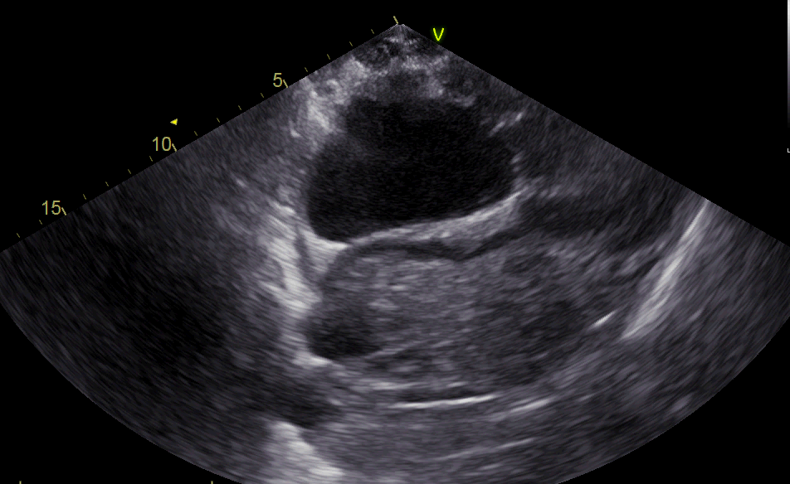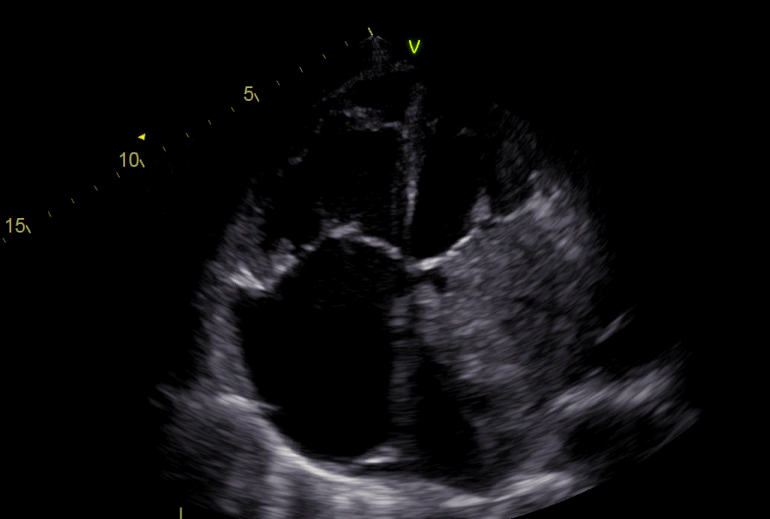
FIGURE 1 : TTE four chamber and two chamber views showing enormous mass in the left atrium

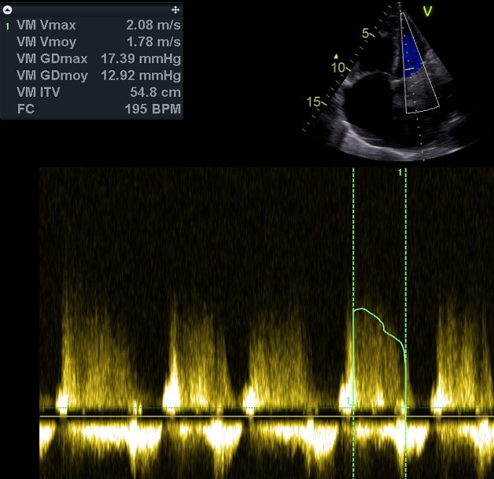
Figure 2 : CW showing obstructive Mitral valve with high gradient 13mmhg

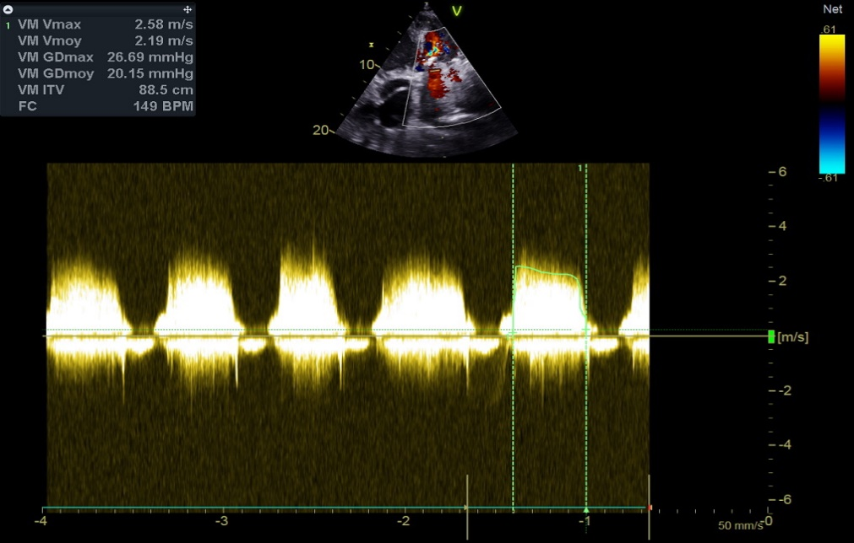
Figure 3 : CW showing obstructivre Mitral valve with high gradient

