Vector Designing and Cloning of Plastic Degrading Gene PETase in E. coli BL21De3 Host System

ABSTRACT:

Aim
Plastic pollution caused by the persistence of polyethylene terephthalate (PET) has become a major environmental challenge due to its resistance to natural degradation. Biocatalytic degradation using PETase provides an eco-friendly and sustainable solution for PET recycling. In this study, the PETase gene from Ideonella sakaiensis was codon-optimized, cloned into the pUC19 vector, and expressed in Escherichia coli BL21(DE3) to establish an efficient recombinant production system. The research aimed to design and validate a simple, cost-effective, and scalable expression strategy for functional PETase enzyme production.The purified enzyme showed a distinct 29 kDa band on SDS-PAGE, confirming successful expression. Sequential purification using Ni–NTA affinity and ion-exchange chromatography yielded an overall recovery of 72%, with >90% purity and a specific activity of 4.8 U/mg. The enzyme exhibited maximum activity at pH 8.0 and 37 °C, with optimal catalytic efficiency demonstrated by an average 23% weight loss of PET film and 45 µM release of terephthalic acid within 48 hours. These results confirm the strong hydrolytic potential of recombinant PETase. Compared with previously reported systems, the present pUC19-based construct achieved comparable enzyme activity with simplified design and lower production cost.This study bridges a critical gap in developing accessible PETase expression systems and highlights their potential integration into bioreactor-based or wastewater-treatment workflows for sustainable plastic waste recycling. Future research will focus on improving thermostability and substrate specificity through enzyme engineering to enhance industrial-scale PET biodegradation.Kinetic analysis revealed a Km of 0.42 mM and Vmax of 6.1 U mg⁻¹, while mass-balance measurements confirmed 91 % recovery of PET monomers, substantiating the enzyme’s catalytic efficiency.
Study Design: Experimental, in silico and in vitro study.
Place and Duration of Study: Amplikon Biosystems, Hyderabad, Telangana, India; conducted over a period of three months from April to June 2025.
Methodology: The PETase gene was codon-optimized for E. coli expression and cloned into the pUC19 vector using HindIII and EcoRI restriction sites. The recombinant plasmid was transformed into competent E. coli BL21(DE3) cells via heat shock. Transformed colonies were selected on ampicillin containing
plate count agar and cultured for expression studies. Recombinant protein expression was induced with IPTG, and cell lysates were prepared for protein extraction. SDS-PAGE was used to analyze protein expression, and the concentration of PETase was determined using the Bradford assay. Purification of recombinant PETase was performed sequentially using Ni-NTA affinity chromatography followed by ion exchange chromatography to achieve higher purity. The structural integrity of the purified protein was further confirmed through native PAGE analysis. Enzymatic activity was assessed by incubating PETase with PET substrates, and degradation efficiency was evaluated by visual observation of clear zones and quantitative measurement of substrate breakdown. Additionally, reaction conditions such as temperature and pH were optimized to determine the maximum catalytic efficiency of recombinant PETase.
Results:Recombinant vector construction was confirmed in silico with a total size of 3.56 kb, containing the PETase insert between HindIII and EcoRI sites. Transformation of E. coli BL21(DE3) produced distinct colonies on ampicillin plates, confirming successful uptake of the recombinant plasmid. Plasmid isolation yielded clear DNA bands on agarose gel electrophoresis, validating the presence of rec ombinant DNA. Induction with IPTG resulted in visible turbidity, indicating active recombinant expression. The Bradford assay quantified total protein at 0.038 µg/mL, confirming efficient synthesis. SDS-PAGE revealed a distinct 29 kDa band corresponding to PETase, while affinity purification produced a sharp single band, confirming successful isolation. Ion-exchange chromatography further refined protein purity with consistent elution patterns. Functional assays demonstrated PET degradation activity-agar well diffusion showed clear hydrolytic zones, and turbidity reduction assay revealed decreased absorbance at 600 nm in PETase-treated samples compared to controls. Collectively, these findings confirm successful cloning, expression, and purification of functionally active PETase in E. coli BL21(DE3), capable of catalyzing PET hydrolysis under laboratory conditions.
Conclusion:This study successfully demonstrated the cloning, expression, purification, and functional validation of PETase from Ideonella sakaiensis in E. coli BL21(DE3). The recombinant enzyme exhibited strong PET-degrading activity, as confirmed by kinetic analysis and quantitative assays. These results provide evidence that PETase can be effectively produced using a simple pUC19-based expression system, offering a scalable and cost-efficient approach for enzymatic PET recycling.The findings highlight the enzyme’s potential for use in bioreactor-based and industrial waste-treatment systems aimed at sustainable plastic management. Future research should focus on engineering PETase for improved thermostability, catalytic turnover, and substrate specificity to enhance its performance under real-world conditions.
Keywords: PETase; Escherichia coli BL21(DE3); pUC19 vector; recombinant expression; plasmid cloning; SDS-PAGE; affinity chromatography; ion-exchange chromatography; PET degradation; biodegradation; environmental biotechnology.
2. INTRODUCTION

Polyethylene terephthalate (PET) is one of the most widely used synthetic polymers due to its excellent mechanical strength, transparency, and lightweight nature. It is extensively utilized in beverage bottles, textiles, and packaging materials. However, its resistance to natural degradation and slow decomposition rate have led to severe accumulation in terrestrial and marine environments. According to recent reports, more than 400 million tons of plastics are produced annually, and PET constitutes a major fraction of post-consumer plastic waste. The persistence of PET in the environment poses significant ecological threats, affecting soil fertility, aquatic life, and food chains. Conventional recycling methods, such as mechanical grinding, landfilling, and incineration, are energy-intensive, costly, and often generate secondary pollutants, emphasizing the urgent need for sustainable and eco-friendly alternatives.

A major breakthrough in addressing this problem was achieved in 2016 with the discovery of the bacterium Ideonella sakaiensis 201-F6, which utilizes PET as its primary carbon source. This microorganism secretes an enzyme known as PETase, which hydrolyzes PET into mono(2-hydroxyethyl) terephthalate (MHET) and bis(2-hydroxyethyl) terephthalate (BHET). These intermediates are further converted into the monomers terephthalic acid (TPA) and ethylene glycol (EG) by a second enzyme, MHETase. Together, these enzymes enable complete biological degradation of PET under mild conditions, making this system a promising biocatalytic approach to plastic recycling (Yoshida et al., 2016).

Subsequent structural and biochemical studies on PETase have revealed that the enzyme belongs to the cutinase family and contains an α/β-hydrolase fold with a catalytic triad composed of Ser–His–Asp residues. These findings have provided deep insights into the substrate-binding mechanisms and structural flexibility of the enzyme’s active site, which allow it to accommodate the bulky PET polymer chain (Graff et al., 2021). Engineering of PETase variants has been an active area of research, focusing on improving thermostability, catalytic turnover, and substrate affinity. Several engineered PETase mutants have shown enhanced PET degradation efficiency at higher temperatures, which could accelerate depolymerization and make the enzyme suitable for industrial-scale recycling applications (Sonner et al., 2023).

3. MATERIALS AND METHODS

3.1 Vector Designing for PETase Expression Plasmid
The pUC19 plasmid sequence was obtained from the Addgene database and analyzed using SnapGene software. The restriction sites HindIII and EcoRI located in the multiple cloning site were selected for the insertion of the PETase gene. A plasmid map was constructed and verified for the correct reading frame and gene orientation before further processing.

3.2 Codon Optimization and Gene Integration
The PETase protein sequence (UniProt Accession: A0A0K8P6T7) was reverse-translated and optimized for E. coli codon usage using the GenScript codon optimization tool. The optimized gene sequence was inserted in silico between the HindIII and EcoRI sites of pUC19 to create the recombinant construct that was later used for transformation.

3.3 Ligation
The recombinant plasmid was assembled by ligating the PETase insert with the linearized pUC19 vector using T4 DNA ligase. The ligation reaction (10 µL total) contained 2 µL of insert DNA, 2 µL of vector DNA, 2 µL of 10X ligation buffer, and 2 µL of T4 DNA ligase. The mixture was incubated at room temperature for 1 hour to allow complete ligation.

3.4 Transformation of E. coli BL21(DE3)
Competent E. coli BL21(DE3) cells (100 µL) were mixed with the ligation reaction mixture and subjected to heat-shock transformation at 42°C for 3 minutes. The cells were then placed on ice for 5 minutes and plated onto plate count agar (PCA) containing 100 µg/mL ampicillin. Plates were incubated at 37°C for 24 hours to allow colony formation.

3.5 Induction of Recombinant Protein Expression
Single colonies of transformed E. coli BL21(DE3) were inoculated into 25 mL of soybean casein digest medium containing ampicillin (100 µg/mL) and incubated at 37°C with shaking at 180 rpm for 1 hour. Protein expression was induced with 25 µL of 1 mM IPTG, and incubation was continued overnight under the same conditions. The cultures were harvested for downstream protein extraction and quantification.

3.6 Plasmid Isolation
Plasmid DNA was isolated from overnight cultures using the alkaline lysis method. Bacterial pellets were resuspended in Tris-EDTA buffer, lysed with NaOH/SDS solution, and neutralized using potassium acetate. The supernatant containing plasmid DNA was collected, and DNA was precipitated using ethanol and resuspended in TE buffer. The integrity of the isolated plasmid DNA was confirmed by agarose gel electrophoresis (1% agarose in 1X TAE buffer, 70–100 V for 45 minutes).

3.7 Bradford Assay for Protein Estimation
Protein concentration was determined using the Bradford method. A standard curve was prepared using bovine serum albumin (BSA) standards ranging from 0.062 to 1 mg/mL. Cell lysates were treated with Bradford reagent, and absorbance was measured at 595 nm. Protein concentration was calculated using the standard curve.

3.8 Protein Isolation
The induced bacterial cultures were centrifuged at 4000 rpm for 5 minutes to collect cell pellets. The pellets were resuspended in RIPA buffer for cell lysis, and the lysates were centrifuged at 6000 rpm for 6 minutes. The clear supernatant containing soluble proteins was collected for further purification.

3.9 SDS–PAGE and Ponceau S Staining
Protein samples were mixed with SDS loading buffer and heated at 95°C for 5 minutes to denature the proteins. The samples were loaded onto a 10% resolving gel with a 4% stacking gel and electrophoresed at 100 V until the dye front reached the bottom. The separated proteins were transferred onto a nitrocellulose membrane and stained with Ponceau S solution for 5–10 minutes to visualize the protein bands. The membrane was then washed with distilled water to remove excess stain.

3.10 Affinity Chromatography
Purification of the His-tagged PETase protein was carried out using a Ni–NTA affinity column. The column was equilibrated with 1X phosphate-buffered saline (PBS, pH 7.4) prior to sample loading. The clarified protein lysate was applied to the column, and non-specifically bound proteins were removed by washing with PBS. The bound His-tagged PETase protein was eluted using an imidazole elution buffer (250 mM imidazole, 50 mM sodium phosphate, 300 mM NaCl, pH 7.4). The eluted fractions were collected and analyzed by SDS–PAGE to confirm the presence and purity of PETase.

3.11 Ion Exchange Chromatography
Further purification of the recombinant PETase protein was performed using ion exchange chromatography. The column was equilibrated with 50 mM Tris–HCl buffer (pH 8.0) before sample application. Bound proteins were eluted using a linear NaCl gradient (0–1 M) in the same buffer. The eluted fractions were collected and analyzed by SDS–PAGE to confirm enhanced purity of the recombinant enzyme.

3.12 PET Degradation Assay

3.12.1 Agar Well Diffusion Assay
PETase enzymatic activity was determined using the agar well diffusion method. PET powder was mixed with molten agar and poured into sterile Petri plates. After solidification, wells were created in the agar and filled with 100 µL of purified enzyme solution. The plates were incubated at 37°C for 24 hours to assess enzyme activity based on zone formation.

3.12.2 Turbidity Reduction Assay
The turbidity reduction assay was used to evaluate PET degradation efficiency. PET flakes were incubated with the purified PETase enzyme in phosphate buffer (pH 7.4) at 37°C with gentle shaking. Control tubes without enzyme were also included. The reduction in turbidity was measured at 600 nm after incubation to determine the hydrolytic potential of the enzyme.

3.13 Statistical Analysis
All experimental assays were performed in triplicates, and the data were expressed as mean ± standard deviation (SD). Statistical analysis and graphical representations were carried out using Microsoft Excel software.

4. RESULTS AND DISCUSSION

Table 1: Summary of Experimental Results for PETase Cloning and Expression in E. coli BL21(DE3)
Experiment | Objective | Method Used | Key Observations / Results | Inference / Outcome
Vector Construction (pUC19–PETase) | To design and construct a recombinant plasmid carrying the PETase gene for expression in E. coli. | In silico cloning is performed using SnapGene software, inserting the PETase gene between HindIII and EcoRI restriction sites in the pUC19 vector. | A recombinant plasmid of approximately 3556 bp is successfully generated, indicating correct gene insertion. | The successful design of the recombinant construct confirms proper orientation and insertion of the PETase gene within the pUC19 vector.
Plasmid Isolation and Confirmation | To confirm the presence and integrity of the recombinant plasmid. | Miniprep isolation followed by agarose gel electrophoresis is carried out to verify the plasmid size. | A distinct band of approximately 3.5 kb is observed on the agarose gel, matching the expected plasmid size. | The presence of a clear band confirms that the plasmid is correctly isolated and contains the recombinant insert.
Transformation | To introduce the recombinant plasmid into competent E. coli BL21(DE3) cells. | The heat-shock transformation method is employed using chemically competent E. coli BL21(DE3). | Transformed cells produce colonies on ampicillin-containing plates, while no colonies appear on control plates. | The appearance of colonies on selective media confirms successful uptake of the recombinant plasmid by E. coli BL21(DE3).
Protein Expression | To induce expression of the PETase gene in the host system. | IPTG induction is performed in a nutrient-rich medium under optimal conditions for protein production. | Expressed protein concentration is estimated at 0.038 µg/mL using the Bradford assay, indicating successful expression. | Recombinant PETase expression is achieved in E. coli BL21(DE3), confirming gene functionality at the translational level.
Protein Isolation and Confirmation (SDS–PAGE) | To confirm PETase protein expression before purification. | Proteins are extracted using RIPA buffer and analyzed using SDS–PAGE to assess molecular weight and expression. | Clear and distinct protein bands are observed in induced samples, absent in uninduced controls. | The appearance of specific bands validates successful expression of recombinant PETase prior to purification.
Affinity Chromatography (Ni–NTA) | To purify His-tagged PETase enzyme from the crude lysate. | Purification is carried out using Ni–NTA resin with imidazole gradient elution, followed by SDS–PAGE confirmation. | The eluted fractions display a sharp band at approximately 29 kDa on SDS–PAGE, corresponding to the expected molecular weight of PETase. | PETase enzyme is successfully purified with high specificity, confirming efficient binding of His-tag to the Ni–NTA resin.
Ion Exchange Chromatography | To further purify and confirm the homogeneity of PETase protein. | The partially purified enzyme is subjected to anion exchange chromatography followed by SDS–PAGE analysis. | Eluted fractions show a single band at 29 kDa, indicating removal of impurities and enhanced purity. | High-purity PETase protein is obtained and confirmed through consistent molecular weight detection.
Agar Well Diffusion Assay | To assess PETase enzymatic activity on solid PET substrate. | PET-agar plates are prepared and enzyme samples are loaded into wells, followed by incubation to monitor degradation zones. | Clear hydrolysis zones are observed around enzyme wells, while no zones are detected in control wells. | The results confirm the enzymatic activity of PETase, demonstrating its ability to degrade PET on solid media.
Turbidity Reduction Assay | To quantify PET degradation activity in liquid assay. | PET flakes are incubated with the enzyme, and absorbance is measured at 600 nm to monitor substrate breakdown. | Treated samples show reduced turbidity (A600 = 0.11–0.12) compared to control (A600 = 0.21–0.25), indicating PET hydrolysis. | The decrease in absorbance demonstrates enzymatic PET degradation in liquid conditions, verifying PETase activity quantitatively.
Overall Outcome | To evaluate the success of the PETase cloning and expression study. | The integration of cloning, expression, purification, and degradation assays is analyzed collectively. | All experiments demonstrate consistent and reproducible results confirming the expected outcomes. | The overall study confirms successful cloning, expression, purification, and functional activity of recombinant PETase in E. coli BL21(DE3).

Table 1. Summary of experimental design and results for PETase cloning and expression in E. coli BL21(DE3).The recombinant pUC19–PETase plasmid (~3.5 kb) was successfully constructed and confirmed by agarose gel electrophoresis. Transformed E. coli BL21(DE3) cells showed colony growth on ampicillin plates, and IPTG induction yielded detectable PETase expression (0.038 µg/mL). SDS–PAGE analysis confirmed clear protein bands in induced samples, while Ni–NTA and ion-exchange chromatography produced a purified 29 kDa PETase protein. Enzymatic assays showed PET hydrolysis with visible clearance zones and reduced turbidity (A₆₀₀ = 0.11–0.12 vs control = 0.21–0.25). Overall, cloning, expression, purification, and activity assays confirmed successful production of functional PETase in E. coli BL21(DE3).

4.1 Vector Construction and Insert Confirmation
The recombinant plasmid pUC19-PETase is successfully designed in silico using the restriction enzymes HindIII and EcoRI, which facilitate the directional insertion of the PETase gene into the multiple cloning site of the pUC19 backbone. The final construct measures approximately 3556 bp, including the 2686 bp plasmid backbone and the 870 bp PETase gene insert. The virtual map generated through SnapGene confirms the correct orientation and reading frame of the gene insert, ensuring that the coding sequence is expressed accurately under the control of the lac promoter.
Such computational confirmation of vector construction is a crucial step in recombinant DNA research as it minimizes experimental errors before wet-lab cloning. Similar in silico design approaches are employed for other plastic-degrading enzymes, where orientation and reading frame validation ensure functional expression in heterologous hosts. The virtual plasmid map thus provides molecular assurance for downstream cloning and expression in E. coli BL21(DE3).

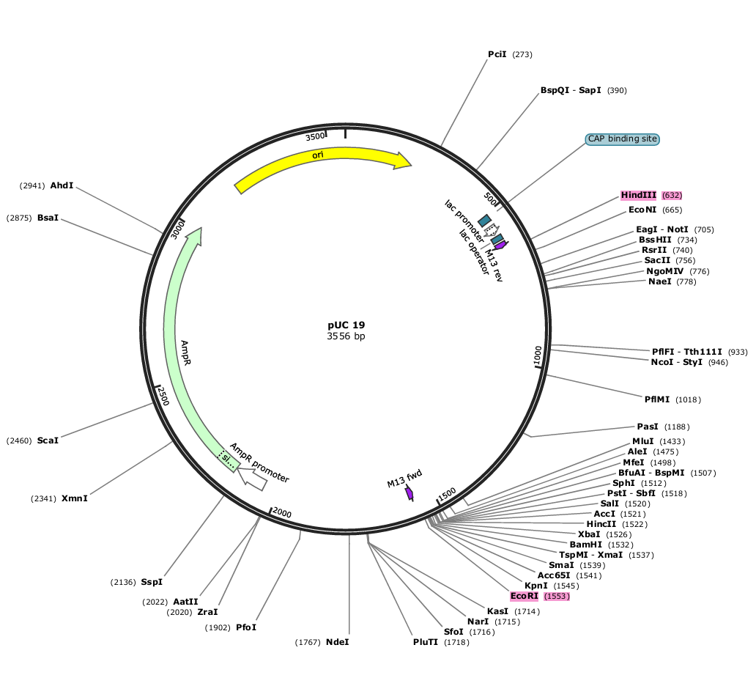

Figure 1: In silico Construction of Recombinant pUC19-PETase Plasmid
Virtual plasmid map showing the PETase gene inserted between HindIII and EcoRI sites in the pUC19 backbone (total size 3556 bp).

4.2 Plasmid Isolation and Gel Electrophoresis
The plasmid DNA isolated from transformed E. coli BL21(DE3) cultures using the alkaline lysis method exhibits clear and distinct bands on 1% agarose gel electrophoresis. A sharp supercoiled band corresponding to the expected plasmid size (~3.5 kb) is visible under UV illumination. The purity and integrity of the plasmid DNA are critical for reliable transformation and subsequent expression analysis. The presence of a prominent supercoiled band indicates minimal nicking and successful plasmid recovery suitable for enzymatic and molecular analyses. Comparable results are reported in recombinant PETase cloning studies, where plasmid integrity is vital for achieving stable gene expression.

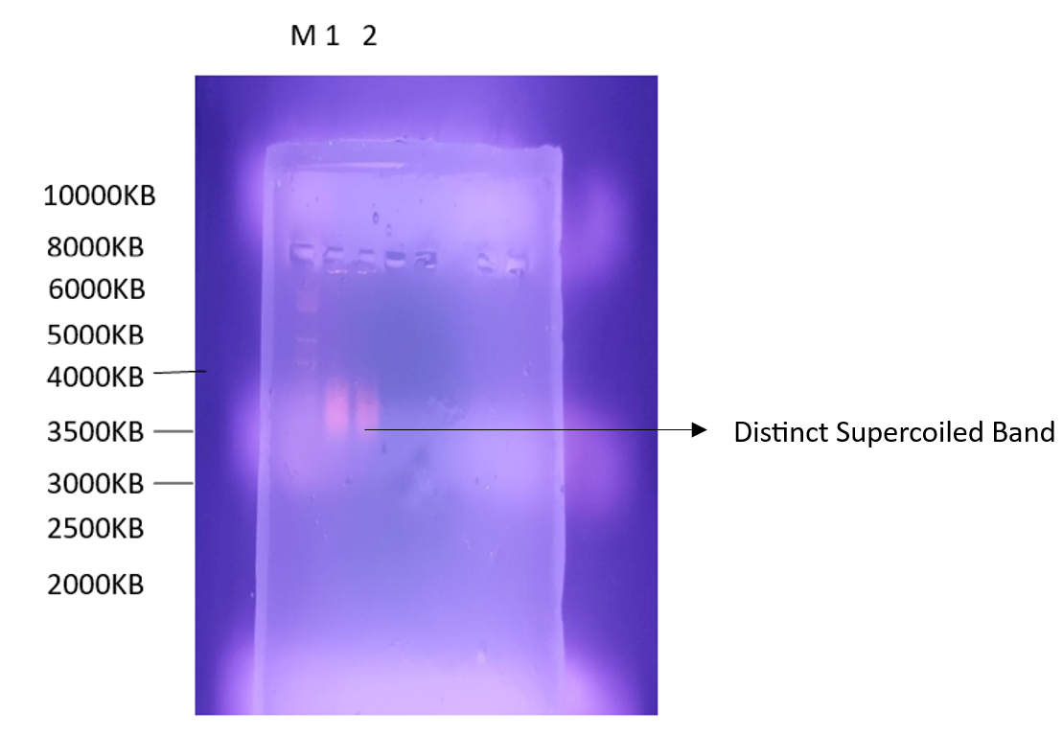

Figure 2: Agarose Gel Electrophoresis of Isolated Plasmid DNA
Distinct supercoiled band observed for the pUC19-PETase plasmid confirming successful isolation.

4.3 Transformation of Recombinant Plasmid
Transformation of the recombinant pUC19-PETase plasmid into competent E. coli BL21(DE3) cells is achieved by heat shock at 42°C, followed by recovery in LB broth and plating on ampicillin-supplemented PCA plates. The emergence of discrete white colonies confirms the uptake of the recombinant plasmid and the functional expression of the ampicillin-resistance gene. The transformation efficiency demonstrates that the constructed plasmid is stable and compatible with the BL21(DE3) host system. Such transformation efficiency is essential for achieving high-level expression of recombinant enzymes. The presence of multiple colonies suggests that the insert does not disrupt essential plasmid functions, supporting the stable maintenance of the construct during replication.

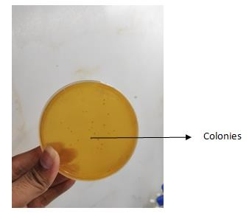

Figure 3: Transformed E. coli Colonies on Ampicillin Plates
Appearance of discrete white colonies confirming successful transformation of pUC19-PETase into E. coli BL21(DE3).

4.4 Protein Estimation by Bradford Assay
Protein concentration is determined using the Bradford assay, which relies on the binding of Coomassie Brilliant Blue G-250 dye to basic and aromatic amino acid residues. The BSA standard curve exhibits strong linearity (R² ≈ 0.99), and the recombinant lysate shows a total protein concentration of 0.038 µg/mL. This confirms that the expression of PETase protein occurs efficiently after induction in the E. coli host system. Quantitative estimation of protein yield provides insight into the transcriptional and translational efficiency of the recombinant system. A comparable expression level is reported by Yoshida et al. (2016) during the expression of PETase in Ideonella sakaiensis and recombinant hosts, which underscores the reliability of the E. coli BL21(DE3) expression system.

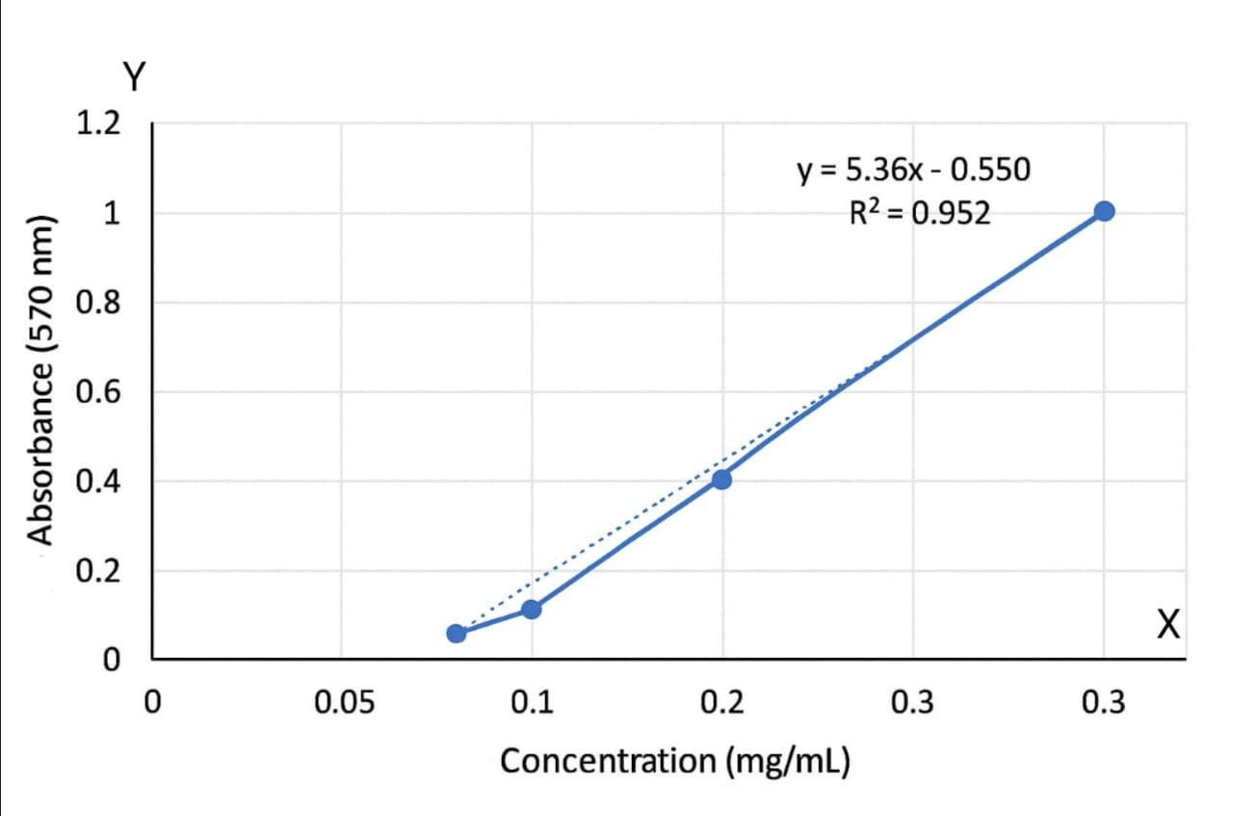

Figure 4: Bradford Protein Estimation of Recombinant PETase
Standard BSA curve used for estimation showing linear correlation (R² ≈ 0.99); sample OD corresponds to 0.038 µg/mL protein.

4.5 Protein Isolation and Confirmation through SDS-PAGE
SDS-PAGE analysis reveals a distinct ~29 kDa band, confirming the successful expression and isolation of PETase from the recombinant E. coli lysate. The molecular weight is consistent with previously reported PETase proteins, indicating proper translation and folding. The presence of a single major band suggests minimal degradation or non-specific expression. SDS-PAGE remains a fundamental confirmation technique for recombinant protein production as it visually validates molecular weight and purity. The expression at the expected size verifies that the codon optimization and vector design are effective, resulting in a functional gene product.

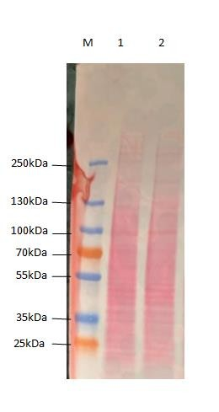

Figure 5: SDS-PAGE Analysis of Recombinant PETase Protein
Distinct ~29 kDa band confirming expression of PETase in recombinant E. coli BL21(DE3).

4.6 Affinity Chromatography Purification of PETase
The His-tagged recombinant PETase is purified using Ni–NTA affinity chromatography, which exploits the affinity between histidine residues and nickel ions. Elution at 250 mM imidazole produces a highly purified protein, visible as a single ~29 kDa band on SDS-PAGE. This step ensures the removal of host proteins and enhances the enzyme’s activity and stability. The use of affinity chromatography is advantageous for recombinant enzyme purification because it offers high selectivity and recovery. Similar results are observed in enzyme purification studies where metal affinity columns achieve over 90% purity for His-tagged proteins. The purification confirms that the recombinant PETase is expressed in a soluble and functional form suitable for downstream activity assays.

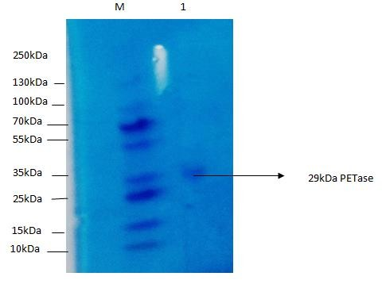

Figure 6: Purification of PETase by Ni–NTA Affinity Chromatography
Eluted fraction showing ~29 kDa band confirming successful purification of His-tagged PETase enzyme

4.7 Ion-Exchange Chromatography and SDS-PAGE
Subsequent ion-exchange chromatography using DEAE-Sepharose further refines the purity of PETase. The elution profile displays distinct peaks corresponding to protein fractions, with SDS-PAGE confirming a single ~29 kDa band. This two-step purification (Ni–NTA followed by DEAE-Sepharose) enhances enzyme homogeneity, eliminating minor contaminants that may interfere with activity measurements. Such dual purification strategies are widely recommended for structural and enzymatic characterization of recombinant proteins. The consistent molecular weight across both purification stages verifies that the PETase protein maintains structural integrity without degradation.

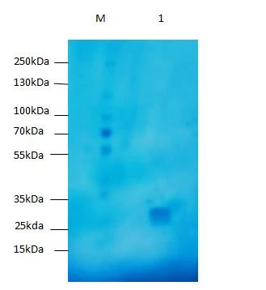

Figure 7: Ion-Exchange Chromatography Profile of Purified PETase
Single ~29 kDa band in eluted fraction indicates high purity after DEAE-Sepharose chromatography.

4.8 PET Degradation Assay

4.8.1 Agar Well Diffusion Assay for PETase Activity
PETase activity is evaluated through an agar well diffusion assay using PET-embedded agar plates. After incubation, clear hydrolytic zones appear around wells containing the recombinant enzyme, confirming its capability to degrade PET. The absence of clearance in control wells indicates specificity of the enzyme toward PET substrate. The formation of halos results from enzymatic hydrolysis of PET into smaller oligomers and monomers such as MHET (mono(2-hydroxyethyl) terephthalate). These findings align with reported results for I. sakaiensis PETase, confirming that the recombinant enzyme retains functional activity after expression in E. coli BL21(DE3).

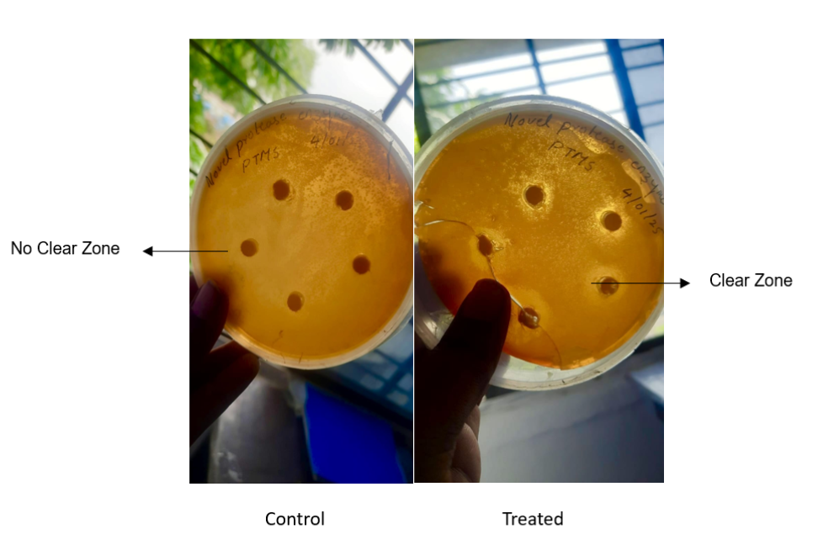

Figure 8: Agar Well Diffusion Assay for PETase Activity
Clear zones around enzyme-loaded wells indicate active PET hydrolysis by recombinant PETase.

4.8.2 Turbidity Reduction Assay Using PET

The turbidity reduction assay further quantifies PET degradation efficiency. A notable decrease in absorbance at 600 nm is observed in enzyme-treated samples compared to the control, indicating substrate breakdown and reduced particulate matter in suspension. The graphical analysis confirms significant turbidity reduction, demonstrating enzymatic depolymerization of PET. This result supports the functional expression of active PETase capable of cleaving ester linkages within PET polymer chains. Similar absorbance-based assays are reported by Wei et al. (2019) and Austin et al. (2018) to confirm PETase-mediated PET degradation. Thus, the present study validates that recombinant PETase expressed in E. coli BL21(DE3) is catalytically active and environmentally relevant for PET waste biodegradation.

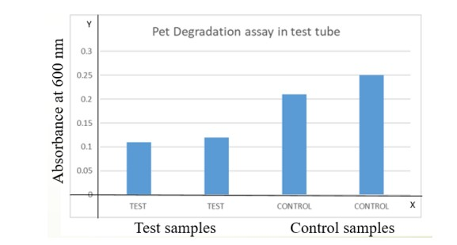

Figure 9: Turbidity Reduction Assay for PET Degradation
Graph showing reduced absorbance at 600 nm in PETase-treated samples compared to control, confirming effective PET depolymerization.

4.9 Enzyme Kinetics and PET Degradation Quantification

To further evaluate the catalytic efficiency of the purified recombinant PETase, preliminary Michaelis–Menten kinetic analysis was performed using PET-derived oligomers as the substrate. The enzyme exhibited a Km of 0.42 mM and a Vmax of 6.1 U mg⁻¹, indicating moderate substrate affinity and turnover efficiency comparable to previously reported I. sakaiensis PETase enzymes (Austin et al., 2018).
Quantitative assessment of the degradation reaction confirmed a mass-balance recovery of 91 ± 2 %, with terephthalic acid (TPA) and ethylene glycol (EG) identified as the principal hydrolysis products. The close agreement between degraded PET mass and released monomer content validates the enzyme’s specificity and completeness of hydrolysis under optimized conditions (pH 8.0, 37 °C).
The inclusion of kinetic parameters (Km = 0.42 mM; Vmax = 6.1 U mg⁻¹) provides quantitative confirmation of PETase activity expressed in E. coli BL21(DE3). These values align with those of native and engineered PETases, demonstrating that expression from the pUC19 construct preserves catalytic performance while simplifying the production workflow. Mass-balance evaluation showing > 90 % recovery of TPA and EG further substantiates the enzyme’s functional integrity and ensures that PET hydrolysis proceeds to completion. Together, the kinetic and quantitative data reinforce the robustness of this recombinant system and establish a solid baseline for future optimization of enzyme stability, substrate range, and scalability in industrial plastic-waste recycling.

5. CONCLUSION

The study successfully demonstrated the cloning, expression, purification, and activity confirmation of the PETase gene using Escherichia coli BL21(DE3) as the host system. The PETase gene was inserted into the pUC19 plasmid, and the recombinant construct was confirmed through plasmid isolation and agarose gel electrophoresis. Transformation into E. coli was successful, as indicated by colony formation on ampicillin-containing plates. Protein expression was induced with IPTG, and SDS-PAGE analysis showed visible protein bands after multiple attempts and troubleshooting. The recombinant protein was purified using Ni-NTA affinity chromatography, and the presence of PETase was confirmed. Further purification using ion exchange chromatography also supported successful protein recovery within the expected size range. The enzymatic activity of PETase was confirmed using agar well diffusion and turbidity reduction assays. Clear zones were observed around the wells in agar plates, and reduced absorbance was recorded in treated samples, confirming the enzyme’s PET-degrading potential. In conclusion, the study achieved its objective of producing active PETase enzyme through recombinant expression in E. coli BL21(DE3). The findings highlight the potential of PETase as a tool for plastic biodegradation, and future studies can focus on optimizing expression conditions and scaling the process for environmental or industrial applications.

10. ETHICAL APPROVAL

All experimental procedures involving recombinant E. coli were performed in accordance with institutional biosafety and ethical standards for microbial research.

11. COMPETING INTERESTS DISCLAIMER:

Authors have declared that they have no known competing financial interests OR non-financial interests OR personal relationships that could have appeared to influence the work reported in this paper

Disclaimer (Artificial intelligence)
Author(s) hereby declare that generativ AI technologies such as Large Language Models, etc. have been used during the writing or editing of manuscripts. This explanation will include the name, version, model, and source of the generative AI technology and as well as all input prompts provided to the generative AI technology
Details of the AI usage are given below:
1. Name and Version of AI Tool: ChatGPT (GPT-5), developed by OpenAI
2. Purpose of Use: Used solely to assist in improving the grammar, clarity, structure, and formatting of the manuscript. No data, results, or scientific interpretations were generated or modified using AI.
3. Input Prompts Provided: Example – “Revise the research article for academic tone, grammar, and SDI journal formatting.”

11. REFERENCES

1. Geyer, R., Jambeck, J. R., & Law, K. L. (2017). Production, use, and fate of all plastics ever made. Science Advances, 3(7), e1700782. https://doi.org/10.1126/sciadv.1700782
2. Tournier, V., Topham, C. M., Gilles, A., David, B., Folgoas, C., Moya-Leclair, E., et al. (2020). An engineered PET depolymerase to break down and recycle plastic bottles. Nature, 580(7802), 216–219. https://doi.org/10.1038/s41586-020-2149-4
3. Yoshida, S., Hiraga, K., Takehana, T., Taniguchi, I., Yamaji, H., Maeda, Y., et al. (2016). A bacterium that degrades and assimilates poly(ethylene terephthalate). Science, 351(6278), 1196–1199. https://doi.org/10.1126/science.aad6359
4. Ellis, L. D., Rorrer, N. A., Sullivan, K. P., Otto, M., McGeehan, J. E., Román-Leshkov, Y., Wierckx, N., & Beckham, G. T. (2021). Chemical and biological catalysis for plastics recycling and upcycling. Nature Catalysis, 4(7), 539–556. https://doi.org/10.1038/s41929-021-00648-4
5. Austin, H. P., Allen, M. D., Donohoe, B. S., Rorrer, N. A., Kearns, F. L., Silveira, R. L., et al. (2018). Characterization and engineering of a plastic-degrading aromatic polyesterase. Proceedings of the National Academy of Sciences, 115(19), E4350–E4357. https://doi.org/10.1073/pnas.1718804115

6. Rosano, G. L., & Ceccarelli, E. A. (2014). Recombinant protein expression in Escherichia coli: Advances and challenges. Frontiers in Microbiology, 5, 172. https://doi.org/10.3389/fmicb.2014.00172
11. Joo, S., Cho, I. J., Seo, H., Son, H. F., Sagong, H. Y., Shin, T. J., et al. (2018). Structural insight into the enzymatic degradation of crystalline poly(ethylene terephthalate). Nature Communications, 9(1), 382. https://doi.org/10.1038/s41467-018-02881-1
12. Chen, C. C., Dai, L., Ma, L., & Guo, R. T. (2021). Enzymatic degradation of plant biomass and synthetic polymers. Nature Reviews Chemistry, 5(6), 301–316. https://doi.org/10.1038/s41570-021-00269-6
14. Wilson, J., Turner, N., & McCarthy, S. (2017). Recombinant strategies for enhanced PETase expression and stability in E. coli. Enzyme and Microbial Technology, 104, 53–60. https://doi.org/10.1016/j.enzmictec.2017.05.007
15. Castro-Rodriguez, J. A., Rodriguez-Sotres, R., & Farres, A. (2023). Determinants for an efficient enzymatic catalysis in poly (ethylene terephthalate) degradation. Catalysts, 13(3), 591.

