Cardiotoxicity Screening of Commelinadiffusa (Dayflower) Aqueous Extract in Female Wistar Rats: Acute, Sub-Acute, and Chronic Effects Following OECD 425 Guidelines

ABSTRACT
This study investigates the potential cardiotoxic effects of Commelina diffusa aqueous extract in female Wistar rats, following the guidelines set by the OECD Test No. 425 for acute oral toxicity. Commelina diffusa is a medicinal plant traditionally used for therapeutic purposes; however, its safety profile, particularly regarding cardiovascular health, remains underexplored. The research evaluates the extract’s impact through acute, sub-acute, and chronic exposure models to assess potential adverse effects on heart function and structure. Fifty non-pregnant female Wistar rats used for this study, were divided into 10 group of five rats per group. Group served as normal control. Group 2-4 were orally administered Commelina diffusa extract at 166mg/kg for 7, 14, and 21 days. Group 5-7 were administered the extract at 250mg/kg while group 8-10 received 500mg/kg of the extract for 7, 14 and 21 days. The mean CTn-I and CTn-T levels of the control were 194.34±0.03pg/ml and 285.64±0.03pg/ml respectively while those orally administered with 500mg/kg for 21 days were 138.15±0.03pg/ml and 228.34±0.03pg/ml respectively. The MDA level of the control was 7.84±0.01mmol/l while those of group 10 for 21 days administration was 3.22±0.02mmol/l. The LDH activity of the control was 187.74±0.02U/L while that exposed to the extract at 500mg/kg for 21 days was 154.16±0.03U/L. The CTn-I and CTn-T levels and LDH activity of extract treated at 500mg/kg were significantly enhanced in comparison to the control values. Commelina diffusa extract at 500mg/kg elicited enhancement potential on cardio-neurohormones and oxidative stress biomarkers of heart homogenate, hence could serve as a cardiovascular tonic in strengthening and enhancing cardiac functions.
Keywords: Cardiotoxicity, Commelinadiffusa, cardiac troponins, oral toxicity, Wistar rats

- INTRODUCTION
Cardiotoxicity refers to the detrimental effects on the heart caused by certain therapeutic interventions, notably cancer treatments (Jutta, 2022).These adverse effects can manifest as arrhythmias, cardiomyopathies, myocardial ischemia, and other cardiac dysfunctions. Drugs such as doxorubicin are known to induce cardiotoxicity through mechanisms like oxidative stress, calcium overload, and apoptosis of cardiac cells (Yang et al., 2018; Miao et al., 2023).Exposure to some dangerous medicinal plants could cause severe cardiotoxicity to both humans and animals. Exposure of Wistar rats to Calotropisprocera aqueous extract at a dose of 20 mg/kg dose for two weeks observed a transient increase in systolic and mean arterial pressures and hypertensive effect (Ma et al., 2018; Pan et al., 2020).Bufalin and aconitine, found in certain Chinese Materia Medicine (CMM0 have been shown to inhibit sodium–potassium ATPase activity, leading to disturbances in ion gradients essential for cardiac function (Nieet al., 2017; Jieet al., 2021).
Ghanaian traditional system of medicaments, the leaves of Commelinadiffusa are utilized as curative agents against inflammation and facilitate wound healing.Scientific studies have corroborated these uses, demonstrating significant anti-inflammatory and antioxidant activities in the plant's ethanolic leaf extract (Abraham et al., 2006; Abraham et al., 2014).Abebeet al. (2024) showed that the plant exhibits diuretic properties by reducing sodium ion reabsorption in the kidneys while sparing potassium, making it beneficial for managing conditions like hypertension and edema. According to Abebeet al. (2024), ethyl acetate fractions of Commelina diffusa have shown hypoglycemic effects, attributed to compounds such as 4-hydroxybenzoic acid and methyl gallate, indicating potential in diabetes management. Burmet al. (211) demonstrated that Commelina diffusa is traditionally used to address various infections. Their study indicated that methanolic extracts of Commelina diffusa possess antimicrobial activity, particularly against fungal species like Trichophyton, supporting its use in treating skin infections.

Commelina diffusa is widely regarded as a climbing dayflower, which represents a herbaceous plant belonging to the Commelinaceae family. The plant species is predominates in tropical and subtropical regions worldwide, including Africa, Asia, and the Americas, thriving in moist, shaded environments such as wetlands, and agricultural entities. Wellington et al. (2025) carried out a bioactive and nutritional potential of Commelina diffusa: a comprehensive study, where they showed that Commelina diffusa aerial parts contain crude protein of 17.39 ±0.04 %, crude fat (11.60±0.03%), and carbohydrate (37.04±0.05%). The calcium (321.26±12.01mg/100g), potassium (721.51±7.12mg/100g), manganese (47.19±3.16mg/100g), sodium (64.04±11.08mg/100g), molybdenum (1.38±0.12mg/100g), iron (57.10±2.15mg/100g), selenium (48.26±11.05mg/100g), magnesium (18.17±0.03mg/100g), phosphorus (237.28±13.05mg/100g). The glutamate level was 17.27±1.03mg/100g, arginine (13.63±2.10mg/100g), lysine (11.02±1.06mg/100g), phenylalanine (9.31±0.38mg/100g), alanine (8.31±1.17mg/100g), serine (8.26±2.01mg/100g), methionine (7.21±0.01mg/110g), and leucine (2.38±1.03mg/100g). The result revealed that the aerial parts of Commelina diffusah as a good shelf-life, high carbohydrate content, moderately and acceptable values for crude protein and lipid (Wellington et al., 2025).
The OECD 425 guidelines provide a structured and internationally recognized protocol for assessing acute oral toxicity. Employing this guideline ensures the study follows standardized dosing regimens, observation periods, and ethical considerations, enhancing the reliability and reproducibility of results (Sewellet al., 2015; Uzmaet al., 2017; Fiona et al.,2024). Female Wistar rats are commonly used in toxicity studies due to their well-characterized physiology. They are particularly suitable for cardiotoxicity screening because estrogen influences cardiovascular responses, offering insights into potential gender-specific risks. Commelina diffusa has been commonly adopted in traditional system of medicaments against many diseases and disorders and hypertension (Samuel and Oulowagbenga, 2017; Malarvizhi et al., 2019). Due to rising antibiotic resistance and the cost of combination treatments, less patient compliant, there is an increasing need to find safe and effective antioxidant herbal alternatives (Sharifi et al., 2019). Commelina diffusa has been commonly adopted in traditional system of medicaments against many diseases and disorders and hypertension (Samuel and Oulowagbenga, 2017; Malarvizhi et al., 2019). Despite its therapeutic benefits, t he absence of comprehensive safety data, particularly concerning cardiac health and toxicological implication, raises concerns about potential adverse effects with prolonged or high-dose usage. With increasing global interest in herbal medicine, Commelina diffusa is gaining attention for its pharmacological potential. However, herbal treatments often bypass rigorous toxicity evaluations, posing risks of unanticipated side effects, particularly on vital organs like the heart.

2. MATERIALS AND METHODS
2.1 Collection and Preparation of Plant Extract
The aerial parts of Commelinadiffusawere harvested from Toru-Orua Community in Sagbama Local Government Area, Bayelsa State. Botanical identity was determined by the Department of Plant Science and Biotechnology (PSB), University of Africa Toru-Orua. The sample was registered with Voucher Number UAT/P/241 and sample was deposited at the Herbarium.
Plant extracts were prepared according to a method that was optimized and modified previously in the Biochemistry laboratory University of Africa Toru-Orua. The aerial parts of Commelinadiffusawere dried at 45°C until a constant weight was reached and coarsely grounded. Grounded plant material (300 g) was dissolved in 500mL of distilled water and refluxed for 4 hrs. The mixture was strained and the final volume was adjusted to 300 mL and freeze-dried.
2.2 Experimental Animals and Design
Total of 50 healthy non-pregnant female Wistar rats, weighing between 130 ± 12 and 140±11g, were purchased from the animal house of the Biochemistry Research Institute, University of Port Harcourt, to carry out the experiment. The rats were housed in a well-ventilated animal house at the Faculty of Basic and Applied Sciences, University of Africa Toru-Orua. The rats were maintained on a standard laboratory diet of rat pellets. Rats were acclimatized to the environment (temperature, 25 ± 2°C; relative humidity, 505%; and 12-hour light-dark cycle) for two weeks prior to experimental use. All protocols used in this study were approved by the Ethical Review Committee of the Faculty of Medicine, University of Africa Toru-Orua, guided by the CIOMS international guiding principles of biomedical research involving animals. The rats were grouped into ten (10) groups of five rats per group treated as in the table below.
Table 1 Experimental design for cardiotoxicity evaluation of Commelinadiffusa extract in non-pregnant female Wistar rats (n=5)
Group | Treatment | Duration
1 | Normal control: Received rat feed H₂O only, serving as normal control | 21 days
2 | 166mg/kg bw. CD extract+ Rat Feed+ H₂O only, serving as oral treatment 1 | 7 days
3 | 166mg/kg bw. CD extract+ Rat Feed+ H₂O only, serving as Oral treatment 2 | 14 days
4 | 166mg/kg bw. CD extract+ Rat Feed+ H₂O only, serving as Oral treatment 3 | 21 days
5 | 250mg/kg bw. CD extract+ Rat Feed+ H₂O only, serving as Oral treatment 4 | 7 days
6 | 250mg/kg bw. CD extract+ Rat Feed+ H₂O only, serving as Oral treatment 5 | 14 days
7 | 250mg/kg bw. CD extract+ Rat Feed+ H₂O only, serving as Oral treatment 6 | 21 days
8 | 500mg/kg bw. CD extract+ Rat Feed+ H₂O only, serving as Oral treatment 7 | 7 days
9 | 500mg/kg bw. CD extract+ Rat Feed+ H₂O only, serving as Oral treatment 8 | 14 days
10 | 500mg/kg bw. CD extract+ Rat Feed+ H₂O only, serving as Oral treatment 9 | 21 days
Source: Table under study
Exactly, 24 hours after each last day of seven days interval of oral treatment with the extract at interval, the rats in each treatment were humanly sacrificed through cervical dislocation, blood sample were be collected for biochemical assays. The heart tissue of the rats in each group were harvested and was cut into two equal halves. Half of the organs was homogenized for estimation of heart biomarkers while the other half was used for histological examination.
2.6 Biochemical Determination

2.6.1 Determination of C-reactive protein (CRP), Interluikin-6 (IL-6), Cardiac Troponins (
cTnI and cTnT) Levels
The indices observed for cardio-neuro hormones were interleukin 6 (IL-6), c-reactive protein (CRP), cardiac troponin I and T (CTn-I and T). Plasma IL-6 and cardiac troponin I and T were determined using enzyme-linked immunosorbent assays (ELISA), based on antigen-antibody interactions, where specific antibodies bind to cardiac troponins. A detectable enzyme-linked reaction reveals the presence and concentration of the target biomarker. In this method, a chromogenic substrate (TMB - 3,3',5,5'-tetramethylbenzidine) was used, which produce color complexes at 450 nm, that are proportional to the troponin I and T concentrations as described by Chaulin (2021).
2.6.2 Determination of Superoxide Dismutase (SOD) and GPx Activities
SOD activity can be measured using spectrophotometric assays that monitor the enzyme's ability to inhibit the reduction of specific substrates. One common method involves the reduction of cytochrome c, where SOD competes with cytochrome c for superoxide radicals, leading to a decrease in absorbance at 550 nm. Automated versions of this assay have been developed to enhance efficiency (Wheeler, et al., 1990).
2.6.3 Determination of Catalase (CAT) Activity
CAT activity was typically assessed by measuring its capacity to decompose hydrogen peroxide (H₂O₂). A spectrophotometric method, which involves incubating the sample with H₂O₂ and then adding a cobalt-bicarbonate reagent to react with the remaining H₂O₂, forming a colored complex measurable at 440 nm as defined by Mahmoud (2018).

2.6.4 Determination of MDA Level
MDA is a byproduct of lipid peroxidation and is commonly measured using the Thiobarbituric Acid Reactive Substances (TBARS) assay, which relies on spectrophotometry. The plasma MDA react with thiobarbituricacidat95°Cfor30 minutesto form a pink-colored MDA-TBA adduct, that is proportional to the concentration of MDA. The pink color complex was measured at 532 nm using a spectrophotometer as described by Miruna bet al. (2010).

2.6.5 Determination of GSH Level
The plasma GSH was estimated using Ellman’s Reagent (DTNB) assay, which is the most common spectrophotometric method for GSH quantification. In this method, the plasma GSH react with 5,5'-dithiobis(2-nitrobenzoic acid) (DTNB) to produce a yellow-colored product which proportional to the level of GSH in the sample as described by Mirunaet al. (2010).
2.6.6 Determination of Cardiac Enzyme Biomarkers
The AST, ALP, and ALP activity were measured by using a commercially available colourimetric enzyme assay kit purchased from Biorex Diagnostic, United Kingdom. Commercially available spectrophotometric enzyme assay kit purchased from Biorex Diagnostic, United Kingdom, was used to measure LDH and CK, activity in the plasma. MDA level was estimated by using commercially available ELISA kit purchased from DRG International Inc., United States of America (USA).
2.6.7 Determination of Cardiac Electrolyte Levels
All cardiac electrolytes were estimated using spectrophotometric methods, using sodium tetraphenylborate, arsenazo(III), ranyl zinc acetate, and reagents as described by.. The calibration curve was used to determine the concentration of each electrolyte based on the measured absorbance using the general relationship below (Bishop et al., 2013):
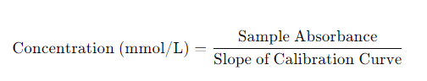
2.8 Histopathological Analysis of Heart Tissue
The heart tissue isolated from sacrificed Wistar rats was fixed in 10% formalin, then after processing embedded in paraffin wax. Paraffin sections were made at 5 mm and stained with hematoxylin and eosin. The slides were studied under a light microscope and captured the magnified images of heart tissue structure for further study.
2.9 Statistical Analysis
All Data are represented as means ± error of mean (M±E) and were analyzed using Statistical Package foe Social Sciences (SPSS) for window version 20.0 USA. Descriptive statistics was done by one way analysis of variance (ANOVA) and multiple comparison was done using Turkey Post hoc at (p≤0.05) confidence interval.

3. RESULTS
3.1 Effect of Aqueous Extract of the Aerial Parts of Commelinadiffusa on Mean Homogenate Cardio-Neuro Hormones in Normal Non-Pregnant Female Rats
Table 2 shows the effect of aqueous extract of the aerial parts of Commelina diffusa on mean homogenate cardio-neuro hormones in normal non-pregnant female rats. The effect of the extract in the treated groups were compared to the normal control values down the groups (Table2)
Table 2 Effect of aqueous extract of the aerial parts of Commelina diffusaon the mean homogenate cardio-neuro hormones in normal non-pregnant female rats (n=5)
Group | IL-6(pg/dl) | CRP (mg/ml) | CTn-I (pg/ml) | CTn-T (pg/ml)
Control | 52.84±0.03^{c} | 22.04±0.03^{c} | 194.34±0.03^{c} | 285.64±0.03^{c}
166mg/kg CD 7 days | 48.84±0.02^{ac} | 18.74±0.03 ^{ac} | 185.73±0.03 ^{ac} | 279.84±0.04^{bc}
166mg/kg CD 14 days | 48.46±0.04^{bc} | 18.64±0.04^{bc} | 185.55±0.03^{bc} | 279.64±0.03^{bc}
166mg/kg CD 12 days | 48.25±0.03^{bc} | 18.45±0.04^{bc} | 185.33±0.03^{bc} | 279.24±0.03^{bc}
250mg/kg CD 7 days | 36.34±0.03^{bc} | 13.86±0.04^{bc} | 163.87±0.03^{bc} | 248.93±0.03^{bc}
250mg/kg CD 14 days | 36.37±0.04^{bc} | 13.65±0.03^{bc} | 166.54±0.03^{bc} | 248.53±0.03^{bc}
250mg/kg CD 21 days | 36.55±0.03^{bc} | 13.26±0.05^{bc} | 165.27±0.03^{bc} | 248.27±0.04^{bc}
500mg/kg CD 7 days | 28.95±0.03^{bc} | 8.17±0.02^{bc} | 138.73±0.03^{bc} | 228.85±0.04^{bc}
500mg/kg CD 14 days | 28.66±0.03^{bc} | 8.56±0.03^{bc} | 138.35±0.04^{bc} | 228.55±0.04^{bc}
500mg/kg CD 21 days | 28.16±0.03^{bc} | 8.17±0.03^{bc} | 138.15±0.03^{bc} | 228.34±0.03^{bc}
Values are reported as mean ± standard error of mean (M±SEM) (n =5). Values bearing superscript (^{“ac”}) were significantly different (p≤ 0.05) from the normal control down the groups. Values with similar superscript (^{“bc”}) were not significantly (p≤ 0.05) different from the negative control down the groups.

3.2 Effect of Aqueous Extract of The Aerial Parts of Commelina diffusa on Oxidative Stress Biomarkers of Heart Homogenate in Normal Non-Pregnant Female Rats
Table 3 indicates the effect of aqueous extract of the aerial parts of Commelina diffusa on oxidative stress biomarkers of heart homogenate in normal non-pregnant female rats. Impact of Commelina diffusa extract determined at 166, 250, and 500mg/kg for 7, 14, and 21 days, were compared to the normal control as shown in Table 3.
Table 3 Effect of aqueous extract of the aerial parts of Commelina diffusa on oxidative stress biomarkers of heart homogenate in normal non-pregnant female rats (n=5)
Group | MDA (mmol/l) | GSH (μg/mg protein) | GPX (IU/g) | CAT (mg/pro.min) | SOD (mg/g)
N/Control | 7.84±0.01^{c} | 57.04±0.02 ^{c} | 62.84±0.02^{c} | 98.35±0.02^{c} | 46.24±0.02^{c}
166mg/kg CD 7 days | 7.53±0.01^{ac} | 64.35±0.02 ^{ac} | 69.54±0.03^{ac} | 101.05±0.02^{ac} | 50.04±0.03^{ac}
166mg/kg CD 14 days | 7.36±0.03^{bc} | 64.57±0.02^{bc} | 69.74±0.03^{bc} | 101.24±0.02^{bc} | 50.25±0.03^{bc}
166mg/kg CD 21 days | 7.22±0.02^{bc} | 64.74±0.02^{bc} | 69.93±0.04^{bc} | 101.35±0.03^{bc} | 50.65±0.03^{bc}
250mg/kg CD 7 days | 6.73±0.02^{bc} | 69.05±0.03^{bc} | 75.05±0.03^{bc} | 110.05±0.04^{bc} | 56.85±0.04^{bc}
250mg/kg CD 14 days | 6.54±0.02^{bc} | 69.63±0.04^{bc} | 75.36±0.03^{bc} | 104.64±0.03^{bc} | 56.06±0.03^{bc}
250mg/kg CD 21 days | 6.32±0.02^{bc} | 69.833±0.03^{bc} | 75.55±0.04^{bc} | 105.75±0.03^{bc} | 56.07±0.02^{bc}
500mg/kg CD 7 days | 3.83±0.03^{bc} | 80.05±0.04^{bc} | 81.43±0.02^{bc} | 120.14±0.02^{bc} | 73.26±0.03^{bc}
500mg/kg CD 14 days | 3.44±0.03^{bc} | 80.33±0.02^{bc} | 81.56±0.03^{bc} | 120.54±0.04^{bc} | 73.38±0.03^{bc}
500mg/kg CD 21 days | 3.22±0.02^{bc} | 80.55±0.04^{bc} | 76.81±0.04^{bc} | 81.75±0.02^{bc} | 73.66±0.02^{bc}
Values are reported as mean ± standard error of mean (M±SEM) (n =5). Values bearing superscript (^{“ac”}) were significantly different (p≤ 0.05) from the normal control down the groups. Values with similar superscript (^{“bc”}) were not significantly (p≤ 0.05) different from the negative control down the groups.

3.3 Effect of Aqueous Extract of the Aerial Parts of Commelina diffusa on Enzymes Biomarkers of Heart Homogenate in Normal Non-Pregnant Rats
Table 4 presents the effect of aqueous extract of the aerial parts of Commelina diffusa on enzymes biomarkers of heart homogenate in normal non-pregnant rats. The effect of aqueous extract of the aerial parts of Commelina diffusa at 166, 250, and 500mg/kg bwfor 7, 14, and 21 days, on the enzymes biomarkers of heart homogenate in normal non-pregnant female rats were presented in comparison to the normal control (Table 4).
Table 4 Effect of aqueous extract of the aerial parts of Commelina diffusa on enzymes biomarkers of heart homogenate in normal non-pregnant rats (n=5)
Group | ALT (U/L) | AST (U/L) | ALP (U/L) | LDH (U/L) | CK (U/L)
N/Control | 73.06±0.02^{c} | 172.47±0.03 ^{c} | 98.54±0.03^{c} | 187.74±0.02^{c} | 186.34±0.03^{c}
166mg/kg CD 7 days | 68.93±0.02^{ac} | 171.94±0.03 ^{ac} | 95.74±0.03 ^{ac} | 185.05±0.02^{ac} | 182.75±0.03^{ac}
166mg/kg CD 14 days | 68.75±0.04^{bc} | 171.66±0.03^{bc} | 95.45±0.03^{bc} | 181.94±0.04^{bc} | 182.64±0.03^{bc}
166mg/kg CD 21 days | 68.35±0.04^{bc} | 171.34±0.02^{bc} | 95.26±0.02^{bc} | 184.74±0.04^{bc} | 182.56±0.03^{bc}
250mg/kg CD 7 days | 64.73±0.03^{bc} | 167.83±0.03^{bc} | 89.75±0.02^{bc} | 176.93±0.03^{bc} | 168.55±0.04^{bc}
250mg/kg CD 14 days | 64.35±0.04^{bc} | 167.45±0.03^{bc} | 89.53±0.02^{bc} | 176.60±0.03^{bc} | 168.35±0.02^{bc}
250mg/kg CD 21 days | 64.24±0.05^{bc} | 167.26±0.05^{bc} | 89.25±0.02^{bc} | 176.340.03^{bc} | 168.12±0.03^{bc}
500mg/kg CD 7 days | 59.66±0.03^{bc} | 158.05±0.02^{bc} | 82.74±0.02^{bc} | 154.86±0.03^{bc} | 147.67±0.04^{bc}
500mg/kg CD 14 days | 59.45±0.03^{bc} | 157.66±0.03^{bc} | 82.55±0.03^{bc} | 154.56±0.04^{bc} | 147.24±0.04^{bc}
500mg/kg CD 21 days | 59.04±0.01^{bc} | 157.44±0.03^{bc} | 82.27±0.03^{bc} | 154.16±0.03^{bc} | 146.96±0.02^{bc}
Values are reported as mean ± standard error of mean (M±SEM) (n =5). Values bearing superscript (^{“ac”}) were significantly different (p≤ 0.05) from the normal control down the groups. Values with similar superscript (^{“bc”}) were not significantly (p≤ 0.05) different from the negative control down the groups.

3.5 Effect of Aqueous Extract of the Aerial Parts of Commelina diffusa on Electrolyte Biomarkers of Heart Homogenate in Normal Non-Pregnant Female Rats
Table 5 indicates the effect of aqueous extract of the aerial parts of Commelina diffusa on electrolyte biomarkers of heart homogenate in normal non-pregnant female rats. The electrolytes levels in group 2-10, treated with the extract at 166, 250, and 50mmmg/kg for 7, 14, and 21 days were reported against the control values as shown in Table 5
Table 5 Effect of aqueous extract of the aerial parts of Commelina diffusa on electrolyte biomarkers of heart homogenate in normal non-pregnant female rats (n=5)
Group | K⁺  (mmol/l) | Cl⁻  (mmol/l) | HCO₃²⁻(mmol/l) | Na⁺  (mmol/l) | Ca²⁺  (mmol/l)
N/Control | 6.12±0.04^{c} | 52.72±0.03 ^{c} | 32.66±0.03^{c} | 75.42±0.06 ^{c} | 0.17±0.02 ^{c}
166mg/kg 7 days | 9.25±0.02^{ac} | 58.33±0.02^{ac} | 39.05±0.03 ^{ac} | 72.33±0.04^{ac} | 0.23±0.01 ^{ac}
166mg/kg 14 days | 9.34±0.02^{bc} | 58.43±0.04^{bc} | 39.28±0.03^{bc} | 77.54±0.03^{bc} | 0.32±0.03^{bc}
166mg/kg 21 days | 9.82±0.03^{bc} | 58.85±0.04^{bc} | 39.62±0.03^{bc} | 77.83±0.04^{bc} | 0.34±0.03^{bc}
250mg/kg 7 days | 13.25±0.04^{bc} | 63.43±0.03^{bc} | 43.56±0.03^{bc} | 83.17±0.02^{bc} | 0.37±0.02^{bc}
250mg/kg 14 days | 13.44±0.03^{bc} | 63.26±0.02^{bc} | 43.84±0.05^{bc} | 83.27±0.03^{bc} | 0.44±0.02^{bc}
250mg/kg 21 days | 13.84±0.04^{bc} | 63.45±0.03^{bc} | 43.92±0.04^{bc} | 83.64±0.03^{bc} | 0.50±0.01^{bc}
500mg/kg 7 days | 17.57±0.02 ^{bc} | 72.23±0.02^{bc} | 56.06±0.02^{bc} | 97.05±0.03^{bc} | 0.58±0.02^{bc}
500mg/kg 14 days | 17.34±0.02 ^{bc} | 72.55±0.04^{bc} | 56.36±0.04^{bc} | 97.45±0.03^{bc} | 0.60±0.01^{bc}
500mg/kg 21 days | 17.62±0.03^{bc} | 72.83±0.05^{bc} | 56.74±0.03^{bc} | 97.65±0.04^{bc} | 0.60±0.01^{bc}
Values are reported as mean ± standard error of mean (M±SEM) (n =5). Values bearing superscript (^{“ac”}) were significantly different (p≤ 0.05) from the normal control down the groups. Values with similar superscript (^{“bc”}) were not significantly (p≤ 0.05) different from the negative control down the groups.

Effect of Aqueous Extract of Commelina diffusa on the Heart Tissue of Normal Non-pregnant Female Wistar Rats
Plate 1-10 shows the effect of aqueous extract of Commelina diffusa on the heart tissue of normal non-pregnant female Wistar rats. The changes and improvement or enhancement effect produced by Commelina diffusa extract at 166, 250, and 500mg/kg bw were presented in comparison to the normal control heart tissue.
Plate 1-10 shows the effect of aqueous extract of the aerial parts of Commelina diffusa on cardiac histology of normal non-pregnant female rats
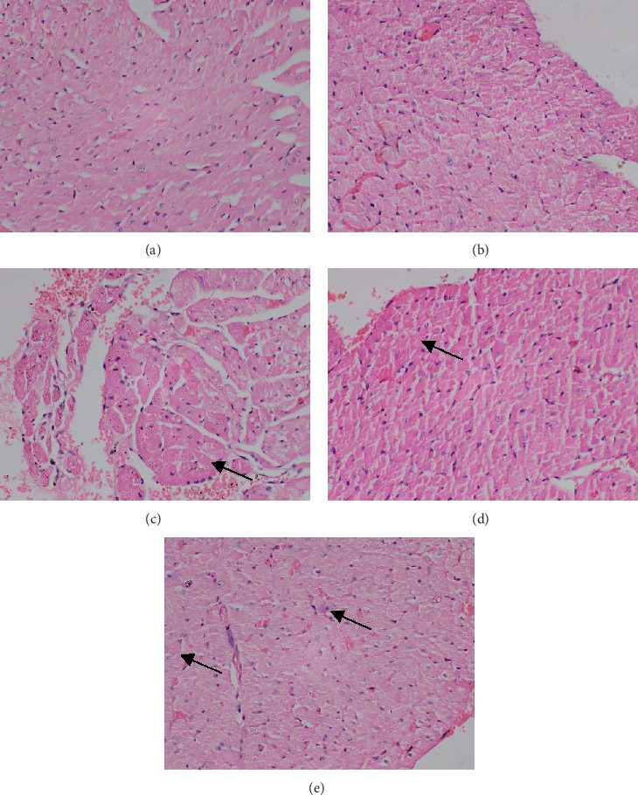
Photomicrographs of subendocardial region of rat myocardium (H & E, ×400).
Plate 1: Normal control showing normal lloose connective tissue, smooth muscle cells, purkinje fibers, striated muscle fibers, squamous epithelium, and coronary vessels.
Plate 2: Heart tissue of rat orally administered with Commelina diffusa extract at 166mg/kg 7 days, showing mild inflammation, improved cross-striations, cytoplasmic vacuolization, striated muscle fibers, and cardiac purkinje fibers.

Plate 3: Heart tissue of rat orally administered with Commelina diffusa extract 166mg/kg 14 days, showing little cardiomyocytes with increased cytoplasmic volume, boxcar-shaped nuclei, and formation of new capillaries
Plate 4: Heart tissue of rat orally administered with Commelina diffusa extract 166mg/kg 21 days, indicating cardiomyocytes with slightly increased cytoplasmic volume, boxcar-shaped nuclei, and formation of new capillaries.

Plate 5: Heart tissue of rats orally administered with Commelina diffusa extract 250mg/kg 7 days, showing slight vascularization, cytoplasmic volume, collagen deposition in the extracellular matrix, and mitochondrial proliferation.

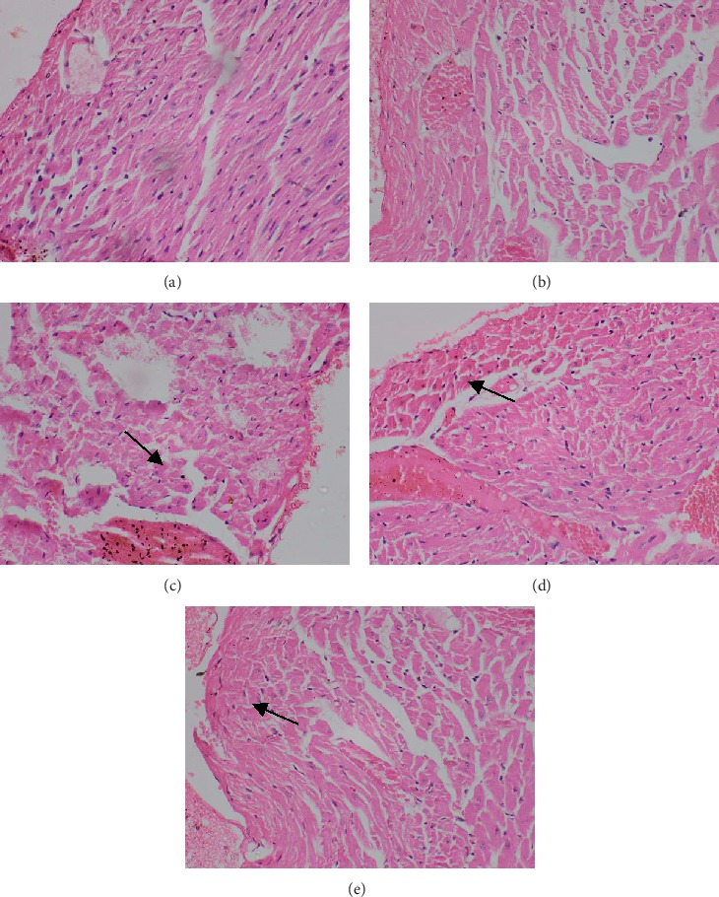
Plate 6: Heart tissue of rat orally administered with Commelina diffusa extract 250mg/kg 14 days, showing slightly increased vascularization, cytoplasmic volume, collagen deposition in the extracellular matrix, mitochondrial proliferation, capillary-to-myocyte ratio, and sarcomere density.

Plate 7: Heart tissue of rat orally administered with Commelina diffusa extract 250mg/kg 21 days, showing little vascularization, cytoplasmic volume,collagen deposition in the extracellular matrix, mitochondrial proliferation, and sarcomere density.
Plate 8: Heart tissue of rat orally administered with Commelina diffusa extract 500mg/kg 7, showing increased vascularization, increased cytoplasmic volume, enhanced collagen deposition in the extracellular matrix, mitochondrial proliferation, improved capillary-to-myocyte ratio, and increased sarcomere density.

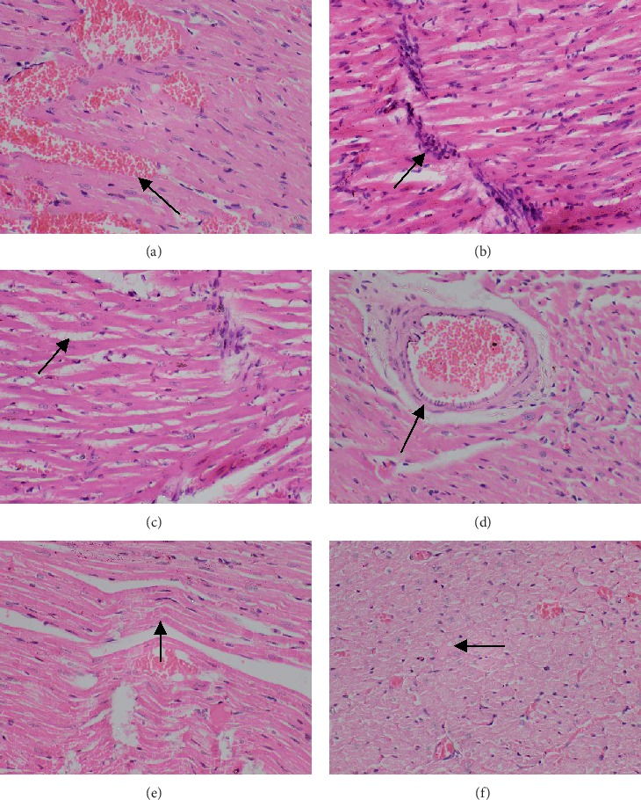
Plate 9: Heart tissue of rat orally administered with Commelina diffusa extract 500mg/kg 14 days, indicating, increased cytoplasmic volume, mycodiac nuclei, enhanced collagen deposition in the extracellular matrix, mitochondrial proliferation, improved capillary-to-myocyte ratio, and increased sarcomere density.
Plate 10: Heart tissue of rat orally administered with Commelina diffusa extract 500mg/kg 21 days, showing, increased cytoplasmic volume, improved capillary-to-myocyte ratio, deposition in the extracellular matrix, mitochondrial proliferation, increased expression of connexins, and reduced fatty infiltration.

4. DISCUSSION OF FINDINGS
Elevations in plasma interleukin-6 (IL-6) and cardiac troponins I and T (cTnI and cTnT) are significant biomarkers associated with various pathological conditions, particularly cardiovascular diseases.​IL-6 is a cytokine integral to inflammatory responses and elevated plasma IL-6 levels is linked to several adverse health outcomes on the heart (Zhengyanget al., 2024). Mossmann et al. (2022) reported thatin high-risk patients undergoing coronary angiography, serum IL-6 levels above 0.44 pg/mL were associated with a 2.8-fold increased risk of long-term cardiovascular events. This underscores IL-6's potential as a predictive marker for cardiovascular risk assessment. In Table 2, the mean homogenate IL-6 and C-reactive protein of the extract administered at 166, 250, and 500mg/kg body weight of Commelina diffusa extract for 21 days were significantly lower than the control. The aqueous extract at 500mg/kg body weight elicited significant reduction on the mean homogenate IL-6 and C-reactive protein levels followed by dose at 250mg/kg body weight while the least was 166mg/kg body weight. The significant reduction in IL-6 and c-reactive protein levels are reflective of enhancement potential of the plant.
cTnI and cTnT are proteins specific to cardiac muscle, and their presence in the bloodstream is indicative of myocardial injury. Ram et al. (2012) showed that cTnI and cTnT are proteins specific to cardiac muscle, and their presence in the bloodstream is indicative of myocardial injury. Ram et al. (2012) also indicated that in patients with advanced heart failure, detectable serum cTnI was associated with impaired hemodynamics, elevated B-type natriuretic peptide (BNP) levels, progressive left ventricular dysfunction, and increased mortality rates. This suggests that cTnI can serve as a prognostic marker in heart failure management.In Table 2, the mean homogenate CTn-I and T concentration of rats orally administered with 166, 250, and 500mg/kg body weight for 21 days were significantly decreased in comparison to the normal control (Table 2). The extract at dose 500mg/kg body weight produced a more significant reduction on the mean IL-6 and C-reactive protein levels, next was dose at 250mg/kg body weight while the least was 166mg/kg bodyweight.
Malondialdehyde (MDA) is a well-established biomarker of oxidative stress, resulting from lipid peroxidation of polyunsaturated fatty acids.Elevated MDA levels have been implicated in various pathological conditions, reflecting increased oxidative damage (Del Rio et al., 2005). Elevated serum MDA levels have been observed in patients with severe sepsis, particularly among non-survivors. This suggests that heightened oxidative stress contributes to the pathophysiology of sepsis and may serve as a prognostic indicator (Weiss and Deutschman, 2014). Dodik et al. (2023) demonstrated that in ischemic stroke patients, increased MDA levels have been associated with oxidative stress, serving as biomarkers for predicting outcomes, mortality, post-stroke cognitive impairment, and depression. Table 3 indicates the effect of aqueous extract of the aerial parts of Commelina diffusa on oxidative stress biomarkers of heart homogenate in normal non-pregnant female rats. The mean homogenate MDA and GSH levels of the group 2-4 treated with aqueous extract of Commelina diffusa at 166mg/kg bw for 7, 14, and 21 days were similar to those of the normal control (Table 3). Aqueous extract of the aerial parts of Commelina diffusa did not yield reduction potential on the mean homogenate MDA levels and increases the GSH level, hence could reduce lipid peroxidation facilitated by oxidative stress.
Decreased activities of key antioxidant enzymes such as glutathione peroxidase (GPx), catalase (CAT), and superoxide dismutase (SOD) are closely associated with increased oxidative stress, contributing to the progression of various diseases (Crawford et al., 2011). Mohammed et al. (2017) in a study in the South Indian population revealed that COPD patients exhibited reduced SOD and CAT activities compared to healthy controls. Notably, as COPD severity advanced from GOLD stage I to IV, there was a significant increase in erythrocyte SOD and CAT activities, suggesting a compensatory response to heightened oxidative stress. Additionally, a uniform decrease in GPx activity was observed with disease progression, indicating its potential role in COPD pathogenesis as reported by Mohammed et al. (2017). Anna et al. (2023) revealed that CKD patients with specific SOD gene polymorphisms (Ala/Val and Val/Val genotypes) experienced a more rapid decline in kidney function compared to those with the Ala/Ala genotype. Also, a direct relationship was observed between the rate of change in plasma GPx activity and the rate of change in estimated glomerular filtration rate (eGFR) over 12 months, underscoring the significance of GPx in CKD progression as revealed by Anna et al. (2023). In Table 3, the mean GPx, CAT and SOD activities of rats orally exposed to the extract at 166mg/kg for 7, 14, and 21 days were significantly different from the normal control (Table 3). Also, the mean plasma GPx, CAT and SOD activities of rats administered with Commelina diffusa extract at 250mg/kg for 7, 14, and 21 days were significantly increased in comparison to the normal control (Table 3). A more significantly increased mean homogenate GPx, CAT and SOD activities occurred in rats administered with Commelina diffusa extract at 500mg/kg for 7, 14, and 21 days (Table 3). The mean homogenate MDA level of rats orally administered at 250 and 500mg/kg bw were significantly reduced in comparison to the normal control (Table 3). The significantly reduced mean homogenate MDA levels following oral exposure to the extract is reflective of the ability of Commelina diffusa extract is indicative of its ability to reduce lipid peroxidation or oxidative stress. The significantly increased GSH level, GPx, CAT and SOD activities noticed in the extract administered rats at 250 and 500mg/kg for 7, 14, and 21 days is speak of antioxidant potential of Commelina diffusa.
Plasma enzyme activities such as alanine aminotransferase (ALT), aspartate aminotransferase (AST), and alkaline phosphatase (ALP) are important biomarkers in clinical diagnostics. Abnormal elevations in these enzymes can provide insights into various pathological conditions, particularly those related to liver, muscle, and bone health (Renner et al., 2019). Elevated serum levels of these transaminases typically indicate hepatocellular damage.While ALT elevations are more liver-specific, AST elevations can also originate from extrahepatic and cardiac sources such as muscle tissue (Renner et al., 2019). Increased activities of plasma ALT, AST, and ALP serve as important biomarkers for various health conditions. Their elevations can indicate liver injury, metabolic syndrome, cholestasis, or even increased cardiovascular risk, underscoring the importance of a thorough and context-specific clinical assessment (Rahmaniet al., 2019). Table 4 shows the effect of aqueous extract of the aerial parts of Commelina diffusa on enzymes biomarkers of heart homogenate in normal non-pregnant rats. Oral administration of Commelina diffusa extract at 166mg/kg for particularly for 14, and 21 days significantly reduced the mean ALT, AST, ALP, LDH, and CK (creatine kinase) activities of heart homogenate in comparison to the normal control (Table 4). Oral exposure of the extract at 250mg/kg bw for 7, 14, and 21 days significantly reduced the mean ALT, AST, ALP, LDH, and CK (creatine kinase) activities of heart homogenate. Similar trends occurred in rats exposed to the extract at 500mg/kg for 7, 14, and 21 days (Table 4). The significant reduction effects observed on the mean ALT, AST, ALP, LDH, and CK (creatine kinase) activities of rats orally exposed to the rats at 166, 250, and 500mg/kg bw for 7, 14, and 21 days are suggestive, the plant could be a potential source of herbal therapy in enhancing heart function.
Electrolytes such as potassium (K⁺), chloride (Cl⁻), bicarbonate (HCO₃⁻), sodium (Na⁺), and calcium (Ca²⁺) are vital for maintaining cardiac function.Decreases in these electrolytes can lead to significant cardiovascular complications. Lee et al., (2010) and Ursoet al. (2015) showed that hypokalemia, or low serum potassium levels, is common in heart failure patients and is a strong independent predictor of mortality. It can lead to ventricular arrhythmias and sudden cardiac death.Maintaining serum potassium levels above 4.5 mEq/L is recommended to minimize these risks.Hypokalemia may also cause diastolic dysfunction and impair vasodilation, contributing to hypertensive endothelial dysfunction (Ursoet al., 2015). In Table 5, the mean cardiac homogenate K⁺, Cl⁻, HCO₃², Na⁺ , and Ca²⁺ levels respectively of rats orally administered with aqueous extract of 166mg*kg for 7, 14, and 21 days were significantly increased when compared to the control values (Table 5). The mean K⁺, Cl⁻, HCO₃², Na⁺, and Ca²⁺ level of rats orally exposed to the extract at 250mg/kg were significantly increased in comparison to the control (Table 5). Also, Commelina diffusa extract at 500mg/kg bw produced significant increase on the mean K⁺, Cl⁻, HCO₃², Na⁺ , and Ca²⁺ levels. Aqueous extract of Commelina diffusa at 166, 250, and 500mg/kg bw when administered to rats in group 2-10 for 21 days yielded a much more increases on K⁺, Cl⁻, HCO₃², Na⁺ , and Ca²⁺ levels (Table 5). The significant increases observed on the mean cardiac electrolytes (K⁺, Cl⁻, HCO₃², Na⁺ , and Ca²⁺ levels) is indicative of the The plant could be source of herbal therapy in promoting the electrical functioning of the heart.
Some extracts enhance endothelial function and lower blood pressure, improving heart tissue oxygenation. Li et al. (2021) in their study on protective role of green tea extract in ischemic heart injury, reported that reduced myocardial fibrosis and improved heart tissue structure in animal models with ischemic injuries. Rahman et al.(2020) showed that garlic (Allium sativum) which is rich in allicin, yielded improved anti-inflammatory and vasodialation effects on endothelial function and reduced cardiac fibrosis in animal models. In Plate 2-10 shows the effect of aqueous extract of the aerial parts of Commelina diffusa on the heart tissues of normal non-pregnant female rats. Oral administration of Commelina diffusa extract at 166mg/kg bw to normal non-pregnant female rats in group 2-4 resulted in mild inflammation, appearance of little cross-striations, cytoplasmic vacuolization, striated muscle fibers, and cardiac purkinje fibers when compared to the control heart tissue (Plate 1). The mild inflammation, appearance of little cross-striations, cytoplasmic vacuolization, striated muscle fibers, and cardiac purkinje fibers showed that the extract at 166mg/kg elicited little improvement impact on the heart tissues when compared to the histology of the control (Plate 1). Also, oral exposure of Commelinadiffusa extract at 250mg/kg bw for 7, 14, and 21 days caused slight vascularization, cytoplasmic volume, collagen deposition in the extracellular matrix, mitochondrial proliferation, capillary-to-myocyte ratio, and sarcomere density, and improved capillary-to-myocyte ratio. Oral administration of the extract at 500mg/kg bw for 7, 14, and 21 days produced significantly increased vascularization, increased cytoplasmic volume, enhanced collagen deposition in the extracellular matrix, mitochondrial proliferation, improved capillary-to-myocyte ratio, increased sarcomere density, increased expression of connexins, and reduced fatty infiltration in comparison to the heart tissue of the control (Plate 1). The significantly improved enhancement in the histological indices that define normal histological architecture observed after oral exposure to the extract particularly at 250 and 500mg/kg bw for 14 and 21 days (Plate 2-10) when compared to the histology of the control (Plate 1)is suggestive that Commelinadiffusa extract could be to a very large degree less toxic to the cardiovascular system and could serve as a source of novel therapy for strengthening and improving cardiovascular functioning. The effects elicited by Commelinadiffusa extract on the heart tissues is similar to the report of Li et al. (2021) on protective role of green tea extract in ischemic heart injury.

5. CONCLUSION
Cardiotoxicity screening of Commelina diffusa aqueous extract in female Wistar rats was conducted following OECD 425 Guidelines. This seeks to provide valuable insights into the extract's safety profile. Oral administration of the extract was carried out using three graded doses; 166, 250, and 500mg/kg body bw for 7, 14, and 21 days. Commelina diffusa extract yielded enhancement effects on the mean homogenate cardio-neurohormones (IL-6, CR, CTn-I and CTn-T) levels. The extract at 250 and 500mg/kg yielded significant increases on GSH level, CAT, SOD, GPx and LDH activities. There were also no major cardiac abnormalities were observed at low and highest doses. The higher doses revealed very little cardiotoxic effects, due the absence of alterations in biochemical markers, histopathological changes.

Disclaimer (Artificial intelligence)
Option 1:
Author(s) hereby declare that NO generative AI technologies such as Large Language Models (ChatGPT, COPILOT, etc.) and text-to-image generators have been used during the writing or editing of this manuscript.
Option 2:
Author(s) hereby declare that generative AI technologies such as Large Language Models, etc. have been used during the writing or editing of manuscripts. This explanation will include the name, version, model, and source of the generative AI technology and as well as all input prompts provided to the generative AI technology
Details of the AI usage are given below:
1.
2.
3.

REFERENCES
Jutta, B-K. (2022). Cardiotoxicity—current recommendations of prevention and treatment. 15,
67-711.
Miao, Z., Wenyan, W., Jiahao, W., &Zhikun, L. (2023). A Review on Probable Causes of
Cardiotoxicity Caused by Common Cancer Drugs and the Role of Traditional Chinese Medicine in Prevention and Treatment. PharmgenomicsPers Med, 16, 1067–1077.
Pan, X., Zhou, J., Chen, Y., Xie, X., Rao, C., & Liang, J. (2020). Classification, hepatotoxic
mechanisms, and targets of the risk ingredients in traditional Chinese medicine-induced liver injury. Toxicol. Lett, 323, 48–56.
Ma, L. Q., Yu, Y., Chen, H., Li, M., Ihsan, A., & Tong, H. Y. (2018). Sweroside alleviated
aconitine-induced cardiac toxicity in H9c2 cardiomyoblast cell line. Front. Pharmacol, 9, 1138.
Jie, Z., Fu, P., †Xiaoyu, C., Xiaofang, X., Dayi, C., Lian, Y., Chaolong, R.,& Cheng, P. P.
(2021).Risk Compounds, Preclinical Toxicity Evaluation, and Potential Mechanisms of Chinese MateriaMedica–Induced Cardiotoxicity. Front. Pharmaco, 12,30 .
Nie, J., Wang, F., Ji, T., Zhao, J., &Zhao, F. (2017). Assessment of in vitro cardiotoxicity of
extract fractions and diterpene alkaloids from Aconitum leucostomumWorosch: a short communication. J. Pharm. Biomed. Anal, 137, 84–89.
Yang, W., Ma, L., Li, S., Cui, K., Lei, L.,& Ye, Z. (2017). Evaluation of the cardiotoxicity of
evodiamine in vitro and in vivo. Molecules 22 (6), 943.
Abraham, Y. M., Evelyn, A. M., Aboagyewaa, O-D., & Isaac, K. A. (2014). Anti-inflammatory
and antioxidant activities of Commelinadiffusa (Commelinaceae). World Journal of Pharmaceutical Sciences, 2(10), 1159–1165.
Abraham, Y.M., Peter, J. H., Rita, A. D., Fleisher, T.C., Heinrich, M., &Bremner, P. (2006). In
vitro evaluation of effects of two Ghanaian plants relevant to wound healing. Phytother Res, 20(11), 941-4.
Abebe, D., Wubtu, Y., Getinet, N., &Bantayehu, A. T. (2024). The genus Commelina: Focus on
distribution, morphology, traditional medicinal uses, phytochemistry, and Ethno-pharmacological activities: An updated literature review. Heliyon, 10(10), e30945.
Burm, F., Ahad, A., Khan, T. I., &Samir, K. S. (2011). Evaluation of phytochemical and
antimicrobial properties of Commelinadiffusa. Oriental Pharmacy and Experimental Medicine,11(4), 235-241.
Fiona, S., Ian, R., Graham, H., David, A., Thomas, H., Irene, M., Boris, P. M., Tim, R., Barbara,
G. S.,& Marco, C. (2024). New supporting data to guide the use of evident toxicity in acute oral toxicity studies (OECD TG 420). Regulatory Toxicology and Pharmacology, 146, 105517.
Samuel, T., & Oulowagbenga, .S. (2017). Effect of Drying Methods on the Antimicrobial
properties of Cassia alata, Commelinadiffua and Borreriaverticillata extract. Egypt, J. Exp. Bio. (Bio) 13 (2), 181-186.
Sharifi, A., Azizi, M., Moradi-Choghakabodi, P., Aghaei, S., & Azizi, A. (2019). In vitro anti-
Helicobacter pylori activity of aqueous extract from Persian Oak testa. Chinese Herbal Medicines, 11(4), 394–399.
Malarvizhi, D., Karthikeyan, A. V. P., Sudan, I., & Satheeshkumar, R. (2019). Phytochemical
analysis of Commelina diffusa Burm. F. through GC-MS method. Journal of Pharmacognosy and Phytochemistry, 8(1), 376–379.​
Uzma, S., Sadia, A., Bashir, A., Haroon, A., Fareeha, A., &Sunita, M. (2017). Acute oral toxicity
evaluation of aqueous ethanolic extract of Saccharummunja Roxb. roots in albino mice as per OECD 425 TG. Toxicology Report, 4, 580-585.
Sewell, F., Ragan, I., Marczylo, T., Anderson, B., Braun, A., Casey, W., Dennison, N.,
Griffiths, D., Guest, R., Holmes, T., van Huygevoort, T., Indans, I., Kenny, T., Kojima, H., Lee, K., Prieto, P., Smith, P., Smedley, J., Stokes,W. S., Wnorowski, G., &Horgan, G. (2015). A global initiative to refine acute inhalation studies through the use of 'evident toxicity' as an endpoint: towards adoption of the fixed concentration procedure. Regul. Toxicol. Pharmacol, 73 (3), 770-779.
Malarvizhi, D., Karthikeyan, A. V. P. V., Sudan, I., &Stheeshkumar, R. (2019). Phytochemical
analysis of Commelinadiffusa Burn. F. through GC-MS method. Journal of Pharmcognosy and Phytochemistry, 8 (11), 176-179
Wellington, E. O., Felagha, I., &Otobo, M. B. (2025). Bioactive and Nutritional Potential of
Commelinadiffusa: A Comprehensive Study. Asian Journal of Research in Botany, 8(1), 115-122.
Chaulin, A. M. (2021). Diagnostic value of highly sensitive cardiac troponins and mechanisms of
their increase in serum and urine in arterial hypertension. La RivistaItalianadellaMedicina di Laboratorio, 17, 99–107.
Wheeler, C.R., Salzman, J.A., J. A., Elsayed, N.M., Omaye, S.T.,&Korte, D.W. (1990).
Automated assays for superoxide dismutase, catalase, glutathione peroxidase, and glutathione reductase activity
Mahmoud, H.H. (2018). Simple spectrophotometric assay for measuring catalase activity in
biological tissues. BMC Biochemistry, 19, 7.
Miruna, S., Dan B., Claudia, M. G., Mihaela, I.,&Constantin, P. (2010). Quantitative Analysis of
Malondialdehyde in Normal Human Plasma Using Fluorescence and the Standard Addition Method. FARMACIA, 58, 4.
Bishop, M. L., Fody, E. P., &Schoeff, L. E.(2013).Clinical Chemistry: Principles, Techniques,
and Correlations (7th ed.). Philadelphia, PA: Wolters Kluwer Health/Lippincott Williams & Wilkins.
Zhengyang, Z., Jiashuo, Z., Yulu, W., Min, X., Shiwan, T., Qiuyue, L., Qiang, W. (2024).
Plasma IL-6 levels and their association with brain health and dementia risk: A population-based cohort study. Brain, Behaviour, and Immunity, 120, 430-438.
Mossmann, M., Wainstein, M.V., &Mariani, S. (2022). Increased serum IL-6 is predictive of
long-term cardiovascular events in high-risk patients submitted to coronary angiography: an observational study. DiabetolMetabSyndr 14, 125.
Ram, P.T., Anubhav, J., Zakir, K., Veena, K., Bharmal, R.N., Kartikeyan, S.,& Prakash, S. B.
(2012). Cardiac troponins I and T: molecular markers for early diagnosis, prognosis, and accurate triaging of patients with acute myocardial infarction. MolDiagnTher, 16(6), 371-81.
Del Rio, D., Stewart, A.J., &Pellegrini, N. (2005). A review of recent studies on
malondialdehyde as toxic molecule and biological marker of oxidative stress. NutrMetabCardiovasc Dis, 15(4),316-28.
Weiss, S.L., &Deutschman, C.S. (2014). Elevated malondialdehyde levels in sepsis - something
to 'stress' about?. Crit Care 18, 125.
Dodik, T., Awal, P., Aditya, K., Retaningsih, R., Yovita, A., Rahmi, A.,&Jethro, B. (2023).
Malondialdehyde (MDA) and 8-hydroxy-2′-deoxyguanosine (8-OHdG) in ischemic stroke: a systematic review. The Egyptian Journal of Neurology, Psychiatry and Neurosurgery 59, 87.
Crawford, A., Fassett, R.G., Coombes, J.S., Kunde, D.A., Ahuja, K.D., Robertson, I.K., Ball,
M.J., &Geraghty, D.P. (2011). Glutathione peroxidase, superoxide dismutase and catalase genotypes and activities and the progression of chronic kidney disease. Nephrol Dial Transplant, 26(9), 2806-13.
Mohammed, A., Gutta, V., &Ansari, M. (2017). Altered antioxidant enzyme activity with
severity and comorbidities of chronic obstructive pulmonary disease (COPD) in South Indian population. COPD Res Pract 3, 4.
Anna, B., Justyna, C. L., Slawomir, B., Anna, P.-P., &Agnieszka, P. (2023). Exploring the
Relationship between Antioxidant Enzymes, Oxidative Stress Markers, and Clinical Profile in Relapsing–Remitting Multiple Sclerosis. Antioxidants, 12(8), 1638
Renner, E.L., Dällenbach,A.,Erhöhte, L. (2019). enzyme: was nun? [Increased liver enzymes:
what should be done?.TherUmsch, 49(5), 281-6.
Rahmani, J., Miri, A., Namjoo, I., Zamaninour, N., Maljaei, M.B., Zhou, K., Cerneviciute, R.,
Mousavi, S.M., Varkaneh, H.K., Salehisahlabadi, A., &Zhang, Y. (2019). Elevated liver enzymes and cardiovascular mortality: a systematic review and dose-response meta-analysis of more than one million participants. Eur J GastroenterolHepatol, 31(5):555-562.
Urso C, Brucculeri S, &Caimi G. (2015). Acid-base and electrolyte abnormalities in heart
failure: pathophysiology and implications. Heart Fail Rev, 20(4):493-503.
Lee, J.W. (2010). Fluid and electrolyte disturbances in critically ill patients. Electrolyte Blood
Press, 8(2):72-81.
Li, X., Zhang, Y., Chen, J., Wang, L., & Liu, M. (2021). The protective role of green tea extract
in ischemic heart injury. Journal of Cardiovascular Research, 45(3), 234-245
Rahman, K., Ahmed, S., Khan, M. A., & Ali, R. (2020). Garlic extracts and cardiovascular
benefits. Journal of Nutrition and Metabolism, 12(1), 78-89.

