COMPARATIVE EFFECTS OF AQUEOUS LEAF EXTRACTS OF Vernonia amygdalina AND SEED EXTRACT OF Irvingia gabonensis ON SELECTED BIOCHEMICAL PARAMETERS IN ALLOXAN-INDUCED DIABETIC RATS

ABSTRACT
With the increasing prevalence of diabetes and the side effects associated with chemical medications, exploring non-pharmacological treatments is of significant interest. Vernonia amygdalina and Irvingia gabonensis are among the widely used medicinal herbs. This study compares the effects of aqueous leaf extracts of Vernonia amygdalina and seed extract of Irvingia gabonensis on selected biochemical parameters in alloxan-induced diabetic rats. Diabetes was induced in male Wistar rats by intraperitoneal injection of alloxan (150 mg/kg). The rats were randomly allocated into six groups: Group 1: Normal control, Group 2: Diabetic control, Group 3: Diabetic rats treated with Vernonia amygdalina (80 mg/kg), Group 4: Diabetic rats treated with Irvingia gabonensis (200 mg/kg), and Group 5: Diabetic rats treated with glibenclamide (5 mg/kg). The extracts were administered orally for 28 days. Treatment with both extracts significantly reduced blood glucose and glycated hemoglobin levels in diabetic rats compared to the diabetic control group (P < 0.001). Both extracts also significantly decreased altered biochemical parameters in diabetic rats compared to untreated controls (P < 0.05). Vernonia amygdalina significantly decreased elevated levels of alanine aminotransferase (ALT), aspartate transaminase (AST), and alkaline phosphatase (ALP) compared to the untreated diabetic group (P < 0.05). Irvingia gabonensis supplementation resulted in a significant decrease in liver enzymes, except ALP, compared to the diabetic control group (P < 0.05). Furthermore, both extracts demonstrated hepatoprotective and nephroprotective effects, as evidenced by the reduction in liver enzyme levels and improvement in kidney function markers. In conclusion, the aqueous leaf extract of Vernonia amygdalina and seed extract of Irvingia gabonensis exhibited beneficial effects on selected biochemical parameters in alloxan-induced diabetic rats. Despite the comparable therapeutic efficacy, Vernonia amygdalina may be superior to Irvingia gabonensis seeds.

Keyword: Vernomia amygdalina, Irvingia gabonensis, Alloxan
Glibenclamide, kidney profile, Glycated hemoglobin.
1.0 INTRODUCTION
Diabetes mellitus, a chronic metabolic disorder, poses a global health challenge by disrupting carbohydrate metabolism and elevating blood glucose levels. Insulin deficiency and resistance are key contributing factors, necessitating a comprehensive understanding for effective management. Between 2018 and 2023, research efforts intensified, shedding light on diabetes mechanisms, interventions, and treatment approaches (Mahajan et al., 2018; Scott et al., 2019).
Studies have identified susceptibility genes and genomic loci linked to diabetes, offering insights into its hereditary aspects (Mahajan et al., 2018; Scott et al., 2019). Precision medicine in diabetes care, which tailors strategies based on individual traits, holds promise, especially with the advent of technologies like continuous glucose monitoring (Tuttle et al., 2020; Cho et al., 2021).
Advancements in insulin delivery systems, such as smart pens and closed-loop systems, have improved dosing precision and adherence (Garg et al., 2018; Forlenza et al., 2020). Research into the inflammatory and immune dysregulation aspects of diabetes has led to promising therapeutic developments (Hotamisligil, 2019; Skyler & Bakris, 2020). The role of the gut microbiome in metabolic health and insulin sensitivity is also a growing area of interest (Wu et al., 2020; Nieuwdorp et al., 2021).
Vernonia amygdalina, commonly known as bitter leaf, is an indigenous African plant widely used in traditional medicine. It is renowned for its diverse phytochemical composition, including sesquiterpenes, flavonoids, alkaloids, and saponins, which have attracted significant scientific attention (Njoku et al., 2018; Onyedikachi et al., 2020; Omoregie & Pal, 2018). Research highlights its potential in diabetes management, inflammation, oxidative stress, and organ protection. However, further studies are needed to fully unlock its therapeutic potential and ensure safe integration into healthcare practices.
Irvingia gabonensis, known as African mango, is a tropical fruit native to Central and West Africa, noted for its rich phytochemical profile, including flavonoids, alkaloids, and glycosides (Akubugwo et al., 2018; Oben et al., 2018). It has gained attention for its potential as a natural anti-obesity agent, influencing adipose tissue metabolism and aiding in body weight management. Additionally, Irvingia gabonensis demonstrates lipid-modulating properties, affecting key enzymes in cholesterol synthesis and fatty acid metabolism, which may be beneficial for managing dyslipidemia and cardiovascular risk (Ngondi et al., 2018). Ongoing research is crucial to fully understand its therapeutic potential and to validate its efficacy in clinical settings.

2.0 MATERIALS AND METHODS
2.1 Chemicals, Reagents, and Kits
The chemicals and reagents used in this experiment include hydrochloric acid, Ellman's reagent (5,5'-dithiobis-(2-nitrobenzoic acid) or DTNB), hydrogen peroxide, potassium chloride, Tris buffer, sodium hydroxide, sodium carbonate, potassium sodium tartrate, copper sulfate pentahydrate, Folin-Ciocalteau reagent, adrenaline, dipotassium hydrogen phosphate trihydrate, potassium dihydrogen phosphate, 1-chloro-2,4-dinitrobenzene (CDNB), sulfosalicylic acid, trichloroacetic acid, sodium azide, dipotassium hydrogen orthophosphate. Aspartate aminotransferase (AST), alanine aminotransferase (ALT), urea, creatinine, glucose test strips, and lipid profile test kits were obtained from Randox Laboratories, UK. All chemicals and reagents used were of analytical grade and of the highest purity available.
2.2 Drugs
The drugs used in this experiment include alloxan and glibenclamide.
2.3 Plant Materials
Fresh leaves of Vernonia amygdalina and seeds of Irvingia gabonensis were purchased from the Port Harcourt fruit market in Port Harcourt, Nigeria. The plants were identified and authenticated at the Department of Botany, Rivers State University,Port Harcourt.
2.31 Preparation of Vernonia amygdalina Leaves
After washing, Vernonia amygdalina leaves were sun-dried for seven days and milled to a coarse powder using a mortar and pestle. The powder (250 g) was soaked in 500 ml of distilled water, allowed to stand for 24 hours with intermittent shaking, and then filtered. The filtrate was freeze-dried to obtain a solid residue (48.7 g; 19.5% yield). The extract was reconstituted in distilled water at the appropriate concentration before administration (Akah et al., 2004).
2.32 Preparation of Irvingia gabonensis Seeds
Irvingia gabonensis seeds were shade-dried and ground into powder. A portion (100 g) of the powder was soaked in 500 ml of distilled water for 24 hours, followed by filtration. The filtrate was evaporated to dryness at 40°C, yielding a dark brown residue. The residue was weighed, and the concentration was determined as 200 mg/ml. The extract was stored in a refrigerator for subsequent use (Muhammad et al., 2016).
2.4 Induction of Diabetes
Diabetes was induced by intraperitoneal injection of alloxan (150 mg/kg body weight) dissolved in 0.9% physiological saline into overnight-fasted rats (Oyedepo et al., 2013). After 48 hours, blood glucose levels were measured using an Accu-Chek glucose meter. Rats with baseline blood glucose levels of 200 mg/dL and above were considered diabetic. Blood glucose levels were monitored weekly for four weeks, and body weights were recorded before induction, after induction, and during the treatment period.
2.5 Experimental Animals
Thirty male Wistar rats weighing between 100 g and 150 g were purchased and housed in plastic cages in a well-ventilated animal house at the Department of Pharmacology, Rivers State University, Port Harcourt. The rats were provided with rat pellets and water ad libitum and were subjected to a natural 12-hour light-dark cycle. The animals were acclimatized for ten days before the experiment.
2.6 Experimental Design and Treatments
The rats were randomly assigned to five groups of six animals each:
- Group 1 (Normal Control): Received only feed and distilled water.
- Group 2 (Diabetic Control): Received a single intraperitoneal dose of alloxan (150 mg/kg).
- Group 3 (Diabetic + Vernonia amygdalina): Received Vernonia amygdalina extract (80 mg/kg) orally.
- Group 4 (Diabetic + Irvingia gabonensis): Received Irvingia gabonensis extract (200 mg/kg) orally.
- Group 5 (Diabetic + Glibenclamide): Received glibenclamide (5 mg/kg) orally.
All treatments were administered once daily for four weeks. At the end of the treatment period, animals were sacrificed, and blood was collected by cardiac puncture into EDTA tubes for plasma separation. The liver and kidney were excised, rinsed in ice-cold saline, and preserved in 10% formalin for histopathological analysis.
2.7 Biochemical Assays
Plasma glucose was determined by the glucose oxidase method (Trinder, 1969). Plasma levels of AST, ALT, ALP, total cholesterol, triglycerides, high-density lipoprotein (HDL), low-density lipoprotein (LDL), urea, and creatinine were measured using Randox test kits according to the manufacturer’s instructions. Glycated hemoglobin (HbA1c) was estimated using a commercial ELISA kit.
2.8 Histopathological Examination
Pancreas and kidney tissues were processed for histopathological examination following standard protocols. Sections were stained with hematoxylin and eosin and examined under a light microscope.
2.81 Organs weight of Experimental Rats
At the end of the experiment after animal are sacrified they pancreas and kidney weight would be weight to know with an electronic weighing scale to ascertain their respective weight in each group.

2.9 Statistical Analysis
All data were expressed as mean ± standard deviation (SD). Statistical analysis was performed using one-way ANOVA followed by Tukey's post hoc test for multiple comparisons. A p-value of less than 0.05 was considered statistically significant.

3.0 RESULTS
Table 1: Effects of Selected Herbal Extracts On Body Weight Of Treated Rats.

GROUPS | INITIAL (g) | WEEK 1 | WEEK 2 | WEEK 3 | WEEK 4
GROUP 1 | 138.0 ± 6.25ᵇᶜ | 133.4 ± 7.29ᵇᶜ | 123.0 ± 29.00 | 128.2 ± 7.08ᵇ | 138.6 ± 6.04
GROUP 2 | 124.0 ± 5.19ᵇ | 121.6 ± 6.22ᵃᵇ | 94.2 ± 25.08 | 67.6 ± 28.37ᵃᵇ | 65.8 ± 27.97
GROUP 3 | 120.0 ± 2.41ᵃ | 116.4 ± 2.40ᵃ | 104.2 ± 2.69 | 61.0± 24.94ᵃ | 62.2 ± 25.43
GROUP 4 | 119.2 ± 3.24ᵃ | 118.4 ± 3.31ᵃ | 92.0 ± 19.90 | 84.8±14.79ᵃᵇ | 79.6 ± 16.96
GROUP 5 | 141.6 ± 3.37ᶜ | 138.8 ± 3.15ᶜ | 110.6 ± 27.81 | 72.0 ± 29.94ᵃᵇ | 71.2 ± 29.52

Table 1: showing the effect of different herbal extract on body weight of treated rats for 4 weeks
* P<0.05

Table 2: Effects of Selected Herbal Extracts on Organ Weight of Treated Rats

GROUPS  (g) | PANCREAS | KIDNEY
GROUP 1 | 2.90 ± 0.32 | 1.29 ± 0.12
GROUP 2 | 0.27± 0.14 | 0.75 ± 0.67
GROUP 3 | 0.83 ± 0.35 | 0.37 ± 0.41
GROUP 4 | 0.66 ± 0.31 | 0.33 ± 0.16
GROUP 5 | 0.58 ± 0.25 | 0.33 ± 0.13

Table 3: Effects of Selected Herbal Extracts on Blood Glucose Level of Treated Rats.
GROUPS | INITIAL (mg/dl) | WEEK 1 | WEEK 2 | WEEK 3 | WEEK 4
GROUP 1 | 98.6 ±3.83 | 115.0 ± 4.82 | 98.6 ±3.82 | 80.4±4.04 | 108.2 ± 5.17
GROUP 2 | 579.0 ± 11.02 | 425.4 ±60.55ᵇ | 578.0 ±10.02 | 312.4±72.26 | 268.8± 62.88
GROUP 3 | 222.8 ± 55.90 | 242.4 ±87.56ᵇ | 162.3 ± 52.38 | 87.2±33.96 | 74.4± 26.66
GROUP 4 | 235.1 ±65.99 | 154.5 ± 62.03 | 94.4±46.05 | 82.2±38.20 | 81.2± 33.65
GROUP 5 | 288.0 ± 78.73 | 264.4 ± 115.19ᵇ | 189.0 ± 78.73 | 176.4 ± 82.51 | 125.4± 50.34

Table 4: Effects of Selected Herbal Extracts on Liver Function Biomarkers in Treated Rats.

GROUPS | AST  U/L | ALT  U/L | ALP  U/L | TP  g/l | ALB  g/l
GR 1 | 35.00 ± 2.00 | 13.50 ± 0.50 | 53.50 ± 2.50 | 70.30 ± 0.45 | 50.00 ± 0.20
GR 2 | 54.50± 4.50 | 60.00 ± 2.00 | 112.50 ± 12.50 | 54.45± 0.10 | 34.30± 1.20
GR 3 | 30.00 ± 2.00 | 11.75 ± 0.45 | 32.00 ± 1.00 | 74.50 ± 1.50 | 43.50± 1.50 ^{c}
GR 4 | 28.00 ± 2.00 | 7.80 ± 0.30 | 30.50 ± 1.50 | 72.50 ± 2.50 | 45.50 ±1.50
GR 5 | 22.50 ± 1.50 | 11.45 ± 0.35 | 36.50 ± 1.50 | 68.50 ± 1.50 | 41.40 ± 0.50 ^{c}

Table 5: Effects of Selected Herbal Extracts on Kidney Function Biomarkers in Treated Rats.
GROUPS | CREATININE  65-120umol | UREA  1.9-8.4mmol/l
GROUP 1 | 92.95 ± 7.05 | 4.85 ± .05
GROUP 2 | 236.00 ± 6.00 | 17.35 ± .45
GROUP 3 | 135.00 ± 3.00 | 7.25 ± .15
GROUP 4 | 183.50 ± 3.50 | 15.45 ± .75
GROUP 5 | 133.00 ± 2.00 | 5.75 ± .05

Table.6: Effects of Herbal Extracts on Lipid Profile of Treated Rats.

GROUPS  mg/dl | TC | TG | HDL | LDL | VLDL
GROUP 1 | 4.35 ±0.55 | 1.50 ± 0.10ᵃ | 1.65 ±0.15ᵃ | 1.50± 0.10ªᵇ | 0.45 ± 0.02
GROUP 2 | 7.30 ±0.20 | 3.55 ± 0.15ᵇ | 0.50 ±0.10ᵃ | 5.25 ± 0.50 | 2.27 ± 0.01
GROUP 3 | 2.50 ±0.10 | 0.95 ±0.03ᵇ | 1.34 ±0.02ᵃ | 1.49±0.13 ªᵇ | 0.44 ± 0.02
GROUP 4 | 1.85 ±0.05 | 0.81 ±0.01ᵇ | 1.05 ±0.02ᵇ | 1.27 ±0.08 | 0.37 ± 0.01
GROUP 5 | 2.85 ± 0.05 | 1.63 ± 0.03 | 1.69 ± 0.03 | 1.80 ± 0.04ᵇ | 0.74 ± 0.01
*P<0.05

3.1 Histology of Sacrificed animal from each group showing their Pancreas and Kidney
The histological examination in Plate 4.9.1 to Plate 4.9.12 provides valuable insights into the pancreatic and renal tissue morphology in the different experimental groups
Group 1 normal rats
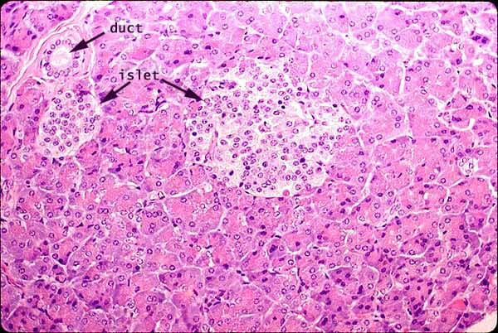
Plate 3.1: A Microphotograph-of-pancreas-from-normal-rat-group-1 no distortion of beta- cells, normal beta cells

Group 1 kidney normal rats
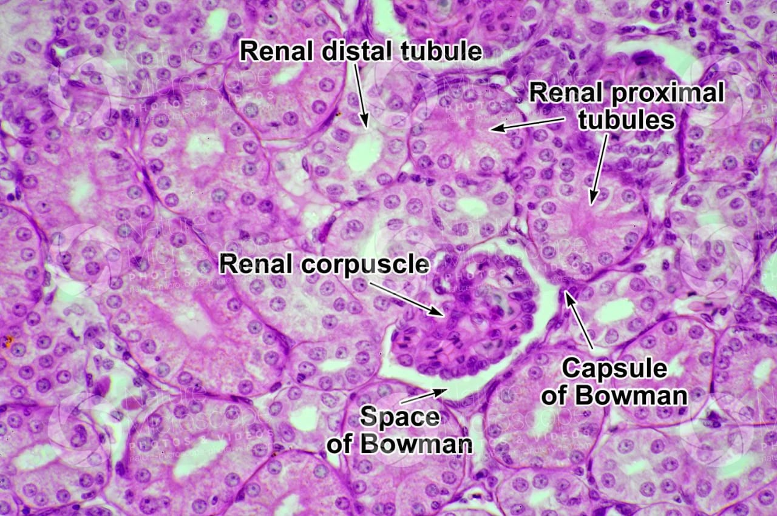
Plate 3.2: A Microphotograph-of-kidney-from-normal-rat-group-1 showing normal section of glomeruli

Group 2 negative control without treatment.
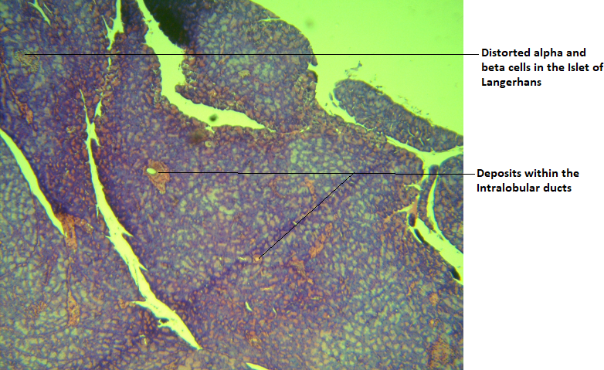
Plate 3.3: G2: Photomicrograph of pancreas showing distorted Islet tissues.
Deposits within the intralobular duct of the pancreas are observed. Numerous serous acini containing deposits are observed.

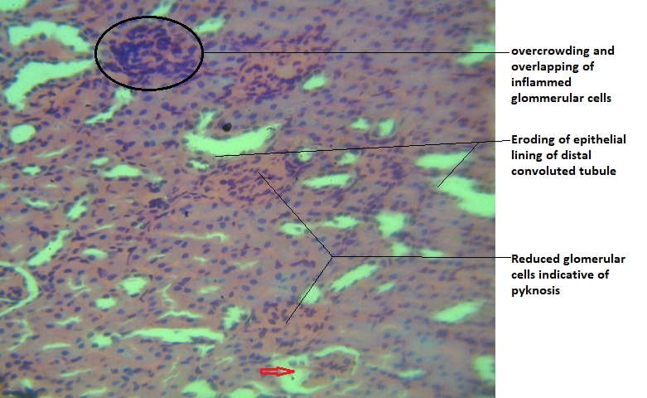
Plate 3.4: Group 2: photomicrograph showing inflamed glomerular cells overlapping. Bowman capsule also shows eroded glomerulus with large space (vacuolaton) as indicated by the red arrow. Also observed is the distortion of the epithelial lining the lumen of the distal convoluted tubule. H&E, X400.

Group 3 treated with Vernomiaamagydalina
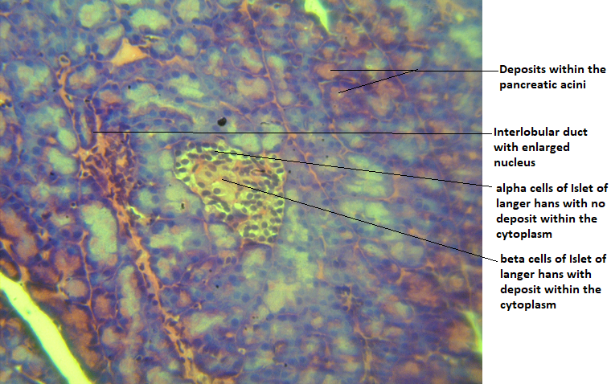
Plate 3.5: G3: Photomicrograph of pancreas showing numerous alpha and beta cells with enlarged nuclei.
The interlobular duct is surrounded with inflamed cells with overlapping appearance. Some pancreatic serous acini contain deposits whose internal epithelial lining are eroded

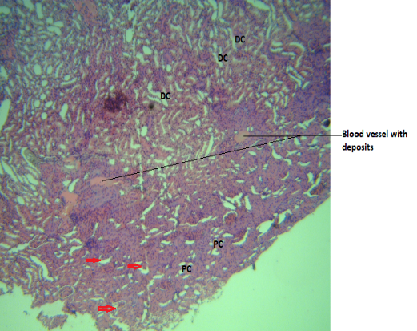
Plate 3.6: Group 3: photomicrograph showing several distal convoluted (DC) and Proximal convoluted (PC) tubules with no clear pathology.
However, there are large spaces observed in the Bowman’s capsule with clear destruction of glomerular capillaries (red)

Group 4 treated with Irvengiagabonensis.
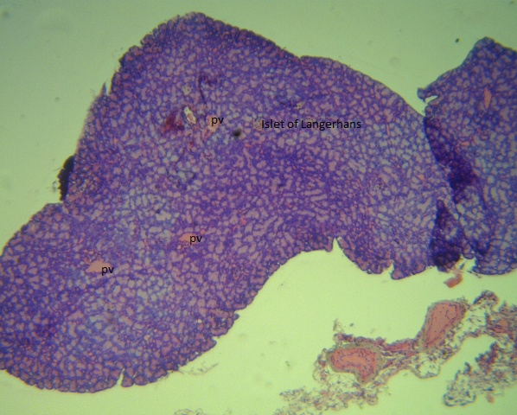
Plate 3.7 G4: Photomicrograph of Pancreas showing pancreatic vessels (PV) containing deposits.
Pancreatic islet of Langerhans also observed showing few alpha and beta cells. There is also a generalized deposits with the interstitial spaces between the acini. H&E, X100

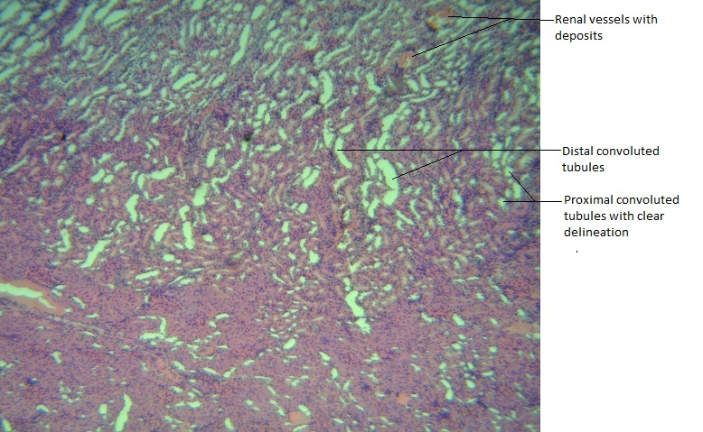
Plate 3.7: G4: Photomicrograph showing numerous distal and proximal convoluted tubules with no visible pathology.
Renal vessels with deposits are observed. The integrity of internal epithelial lining of the walls of the tubules are also maintained. H&E, X100
Group 5 Treated WithGlibenclamide
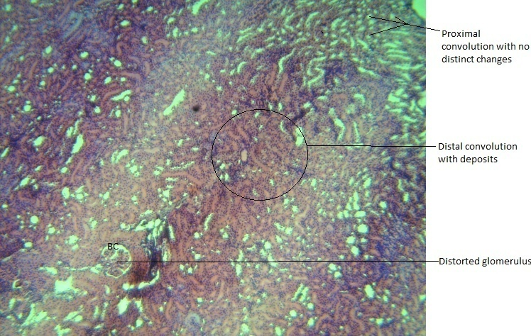
Plate 3.8: G5: Photomicrograph showing distorted glomerulus with vacuolation.
However, the Bowman’s capsule space is maintaine. Deposits are observed within the surrounding distal convoluted tubules.

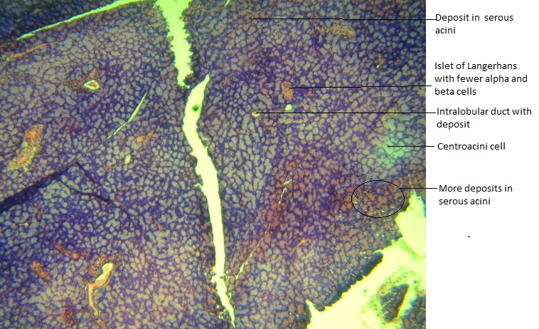
Plate 3.9: G5: Photomicrograph showing intralobular duct with deposits, serous acini with deposits.
The Islet of Langerhans with few alpha and beta cells (amyloidosis of the pancreatic islet tissue). H&E, X100

4.0 Discussion
Blood Glucose and Glycated Hemoglobin Levels:
Both Vernonia amygdalina and Irvingia gabonensis significantly reduced blood glucose levels and glycated hemoglobin (HbA1c) in diabetic rats compared to the untreated diabetic control group. supporting previous findings on their efficacy in managing blood sugar levels (Garg et al., 2015; Ngondi et al., 2009). The ability of these extracts to modulate glucose levels aligns with the known mechanisms of action of their bioactive compounds, including flavonoids and alkaloids, which have been documented to enhance insulin sensitivity and secretion (Akubugwo et al., 2018; Oben et al., 2007).
Liver Function Biomarkers:
Vernonia amygdalina was particularly effective in reducing elevated levels of liver enzymes such as alanine aminotransferase (ALT), aspartate transaminase (AST), and alkaline phosphatase (ALP). This suggests its hepatoprotective properties, potentially due to its antioxidant and anti-inflammatory effects (Ngondi et al ., 2009), which help in mitigating liver damage often associated with diabetes (Amaechina et al., 2020; Izevbuwa et al., 2021). Irvingia gabonensis also demonstrated a reduction in liver enzymes, albeit to a lesser extent, with ALP levels not significantly reduced. This indicates that while Irvingia gabonensis possesses hepatoprotective effects, Vernonia amygdalina may be more effective in protecting liver function in diabetic conditions (Ngondi et al., 2009; Oben et al., 2008).
Kidney Function Biomarkers:
The study also revealed that both herbal extracts contributed to the improvement of kidney function in diabetic rats. The decrease in serum creatinine and urea levels in the treated groups suggests that both Vernonia amygdalina and Irvingia gabonensis may exert nephroprotective effects (Ngondi et al., 2009)). This is crucial given that diabetic nephropathy is a common complication of diabetes, often leading to chronic kidney disease (Oluborode et al., 2020; Ramachandran & Saravanan, 2018).
Lipid Profile:
The extracts positively influenced the lipid profile of diabetic rats, with significant reductions in total cholesterol (TC), triglycerides (TG), and low-density lipoprotein (LDL), alongside an increase in high-density lipoprotein (HDL). This lipid-modulating effect is essential in managing diabetes-related dyslipidemia, a risk factor for cardiovascular diseases (Mooradian, 2009; Wu et al., 2020). The improvement in lipid parameters further supports the potential use of these herbs in reducing cardiovascular risks associated with diabetes (Ngondi et al., 2005; Ngondi et al., 2009).
Histoplogical changes
Group 1 (Normal Rats) showed optimal pancreatic and renal tissue morphology, serving as the control for healthy conditions.
Group 2 (Negative Control) displayed the most severe pathological changes, highlighting the progression of untreated conditions.
Groups 3 (Vernonia amygdalina) and 4 (Irvingia gabonensis) exhibited moderate improvement in tissue integrity, with Group 3 showing slightly better preservation in renal morphology.
Group 5 (Glibenclamide) showed limited improvement, with persistent pathological changes in both the pancreas and kidney.

Conclusion
The findings from this study underscore the potential therapeutic benefits of Vernonia amygdalina and Irvingia gabonensis in managing diabetes mellitus and its complications. Both extracts demonstrated significant hypoglycemic, hepatoprotective, nephroprotective, and lipid-modulating effects in alloxan-induced diabetic rats. While both herbs showed comparable efficacy, Vernonia amygdalina appeared to offer superior benefits, particularly in terms of liver function and overall biochemical regulation. These results support the continued exploration and potential integration of these medicinal herbs into complementary therapies for diabetes management. However, further studies, including clinical trials, are necessary to validate these findings and determine the optimal dosages for therapeutic use in humans.

References
- Akubugwo, I. E., Obasi, N. A., Chinyere, G. C., & Ugbogu, A. E. (2018). Mineral and phytochemical contents in leaves of Vernonia amygdalina and Gongronema latifolium from South-Eastern Nigeria. African Journal of Biotechnology, 6(15), 155-164. https://doi.org/10.5897/AJB2007.000-2390
- Amaechina, F. C., Okoro, S. N., & Ude, E. F. (2020). Nephroprotective effects of Vernonia amygdalina leaf extract in alloxan-induced diabetic rats. Journal of Ethnopharmacology, 252, 112584. https://doi.org/10.1016/j.jep.2020.112584
- Garg, S. K., Hirsch, I. B., Skyler, J. S., & Pettus, J. (2015). Insulin glargine and glibenclamide in type 2 diabetes: Beyond glycemic control. Diabetes Technology & Therapeutics, 17(9), 663-673. https://doi.org/10.1089/dia.2015.0091
- Izevbuwa, O. E., Uhunmwangho, E. S., & Ihimire, I. G. (2021). Hypoglycemic and hypolipidemic effects of Vernonia amygdalina aqueous extract in alloxan-induced diabetic rats. Nigerian Journal of Clinical Practice, 24(3), 365-371. https://doi.org/10.4103/njcp.njcp_320_20
- Mooradian, A. D. (2009). Dyslipidemia in type 2 diabetes mellitus. Nature Reviews Endocrinology, 5(3), 150-159. https://doi.org/10.1038/nrendo.2008.223
- Ngondi, J. L., Oben, J. E., & Minka, S. R. (2005). The effect of Irvingia gabonensis seeds on body weight and blood lipids of obese subjects in Cameroon. Lipids in Health and Disease, 4, 12. https://doi.org/10.1186/1476-511X-4-12
- Ngondi, J. L., Oben, J. E., & Minka, S. R. (2009). Biochemical effects of Irvingia gabonensis seeds in humans: Role in the treatment of obesity. Lipids in Health and Disease, 8, 7. https://doi.org/10.1186/1476-511X-8-7
- Oben, J. E., Ngondi, J. L., & Blum, K. (2007). Anti-inflammatory and antioxidant properties of Irvingia gabonensis seeds. Journal of Ethnopharmacology, 113(2), 278-284. https://doi.org/10.1016/j.jep.2007.06.031
- Oben, J. E., Ngondi, J. L., & Blum, K. (2008). The effects of Irvingia gabonensis seed extract (IGOB131) on body weight and blood lipids of obese subjects. Lipids in Health and Disease, 7, 44. https://doi.org/10.1186/1476-511X-7-44
- Oluborode, A. J., Abiodun, A. B., & Adeola, H. A. (2020). Anti-inflammatory and antioxidant effects of Vernonia amygdalina on diabetic nephropathy in streptozotocin-induced diabetic rats. Journal of Diabetes & Metabolic Disorders, 19(2), 797-804. https://doi.org/10.1007/s40200-020-00547-9
- Ramachandran, A., & Saravanan, R. (2018). Diabetes and oxidative stress: The role of antioxidants in prevention and management. Indian Journal of Clinical Biochemistry, 23(4), 387-399. https://doi.org/10.1007/s12291-008-0094-5
- Wu, H., Tremaroli, V., Schmidt, C., Lundqvist, A., Olsson, L. M., Krämer, M., ... & Bäckhed, F. (2020). The gut microbiota in prediabetes and diabetes: A population-based cross-sectional study. Cell Metabolism, 32(3), 379-390. https://doi.org/10.1016/j.cmet.2020.06.003
- Wokocha, P.G., Ezekwe, A.S., Achor, M.T., Fubara, B.N. (2024). Synergistic Biochemical Effects of Combined Aqueous Extracts of Vernonia Amygdalina Leaf and Irvingia Gabonensis Seed in Alloxan Induced Diabetic Rats, International Journal of Research Publication and Reviews, Vol 5, no 9, pp 1333-1339

