Original Research Article

Assessment of Agricultural Practices and Socio-Economic Challenges in Urban Market Gardening: A Case Study of Yopougon, Ivory Coast

.
ABSTRACT

Urban and peri-urban agriculture is a fundamental pillar of food security and local economic development in Côte d'Ivoire, particularly in the municipality of Yopougon, where market gardening plays a central role despite significant land, technical, and health constraints. This study aimed to identify the main market gardening production sites, characterize cultivation practices, and assess the associated socio-economic and health challenges. A comprehensive survey was conducted with 132 producers and 88 traders spread across 18 sites covering eight areas of Yopougon. Data were collected using structured questionnaires, direct observation, and advanced statistical tools, including Principal Component Analysis (PCA) for the multidimensional exploration of variables and Analysis of Variance (ANOVA) for comparing means between groups. The results show a predominance of women (56.06%), mostly married (93.18%), with low levels of education, cultivating small plots (100 to 500 m²) with a workforce comprised primarily of family members. Access to land remains precarious, characterized by squatting (37.88%) and renting (32.58%), while irrigation remains mainly manual (88.63%). Fertilization and pesticide use practices, relying on the intensive use of chemical inputs (100%), expose producers and consumers to significant health risks. The observed monthly incomes (25,000 to 40,000 FCFA) reflect limited profitability given the arduous nature of the work. The study recommends the implementation of integrated local policies focused on land tenure security, strengthening technical capacities, and promoting sustainable, resilient, and economically viable urban agriculture.

Keywords: Urban agriculture, farming practices, food safety, Yopougon, Ivory Coast.

1. INTRODUCTION

In a context marked by rapid urbanization and sustained population growth, major cities in sub-Saharan Africa face significant challenges related to food security and the livelihoods of their populations (Bâ & Cantoreggi, 2018; Giller et al., 2021). In Abidjan, and more specifically in the Yopougon district, market gardening plays a strategic role in the supply of fresh vegetables, but it continues to face numerous structural constraints that compromise its sustainability (Giller et al., 2021). Land instability, fueled by informal land occupation and recurring evictions, weakens farms and limits agricultural investment. At the same time, the intensive use of chemical inputs and irrigation water of uncertain quality increases health risks, affecting the health of producers and the safety of consumers (Kuyah et al., 2021; Nordey et al., 2017). In addition to these constraints, there is a lack of technical training among stakeholders, insufficient institutional support, informal marketing channels, and precarious working conditions. These combined factors hinder the professionalization of the sector and compromise its socio-economic and environmental sustainability (Bâ & Cantoreggi, 2018; Nordey et al., 2017; Kuyah et al., 2021). Faced with these challenges, a systemic and integrated approach is essential to better understand the interactions between farming practices, socio-economic conditions, and health risks, while also identifying relevant levers for action (Kuyah et al., 2021; Nordey et al., 2017). It is within this framework that the present study aims to identify and characterize the main market gardening sites in Yopougon, to assess cultivation practices, producer profiles, land access methods, irrigation systems, and marketing channels, as well as to analyze the associated health and environmental risks. The ultimate goal is to propose technical and institutional recommendations for sustainable, secure, and resilient urban agriculture in the face of increasing land and health pressures.
2. material and methods
  - Study Site
The study was driving in the autonomous district of Abidjan, within the municipality of Yopougon, located between the forest classified as Banco and the Ébrié Lagoon, to the west of the geographical area North Abidjan. This municipality, slightly located off-center, at coordinates Geographic coordinates: 5°20'56" North latitude and 4°00'42" West longitude, covers a It covers an area of 16,420 hectares (164.2 km²), has an altitude ranging from 40 to 132 meters , and is home to 1,571,065 inhabitants. a density of 9,568 inhabitants/km², the study focuses on eight market gardening production areas: Adiopodoumé, Niangon -Adjamé, Niangon-Attié, Yopougon-Koweït, Yopougon -Santé, Yopougon-Séminaire, Béago - Village and Niangon -Sud/Lokoa Bité.
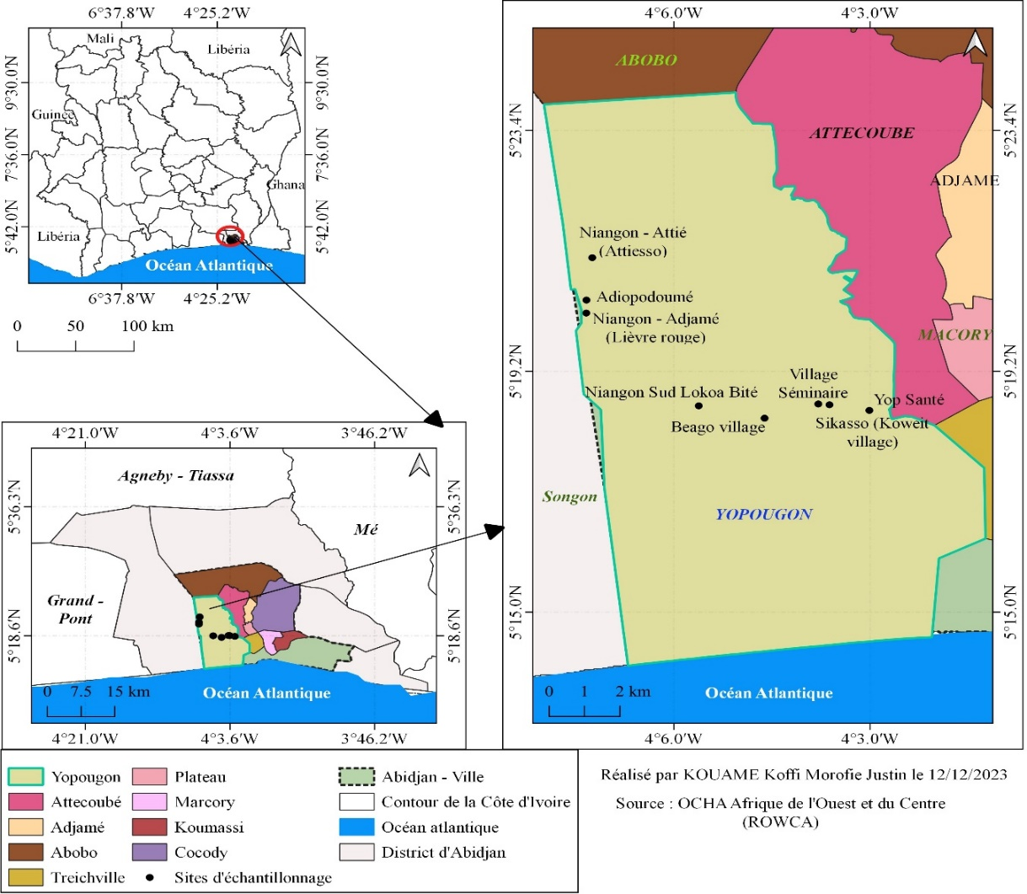
Fig.1. market gardening production areas in the municipality of Yopougon – Abidjan
  - Study Material
An investigation has been carried out between November 2022 and August 2024 among vegetable producers and traders, using structured questionnaires, semi - direct interviews and direct observations on the plots, in order to collect detailed data on cultivation practices, socio- economic conditions and marketing methods.
  - Sampling Collection
For this study, a sample exhaustive made up of 132 market gardeners and 88 traders, was mobilized in order to guarantee a representativeness optimal production and marketing dynamics in the municipality of Yopougon. Data collection combined several approaches methodological additional information : structured questionnaires to obtain information standardized on the characteristics sociodemographic factors , land acquisition methods , fertilization and irrigation systems , phytosanitary practices , incomes and constraints perceived ; semi- structured interviews allowing the collection of information qualitative In-depth research on management strategies and stakeholder perceptions; and direct observations on the plots , intended to validate and supplement the reported data . This methodological triangulation helped to reduce bias. related to self-declaration and obtaining a comprehensive and reliable overview of farming practices, socio- economic conditions, and dynamics commercial.
  - Statistical data processing
The data has summer processed using XLSTAT software version 2025, incorporating descriptive statistics, a analysis of variance (ANOVA) and Duncan's post-hoc test at the 5% significance level in order to to assess the significance of the differences between the means of the parameters studied. The associations between qualitative variables, such as gender and specialization cultural, have summer examined using the Chi-square test. Furthermore, a Analysis in Components Principal (PCA) carried out to analyze the spatial structuring and traceability of marketing channels.

3. Results and discussion

3.1.1. Identification of Market Gardening Production Sites

At the end from a survey conducted in the municipality of Yopougon, eight potential market gardening areas have summer identified, distributed across eighteen production sites comprising a total of one hundred and sixty plots cultivated by one hundred and thirty -two market gardeners. The identified areas include Adiopodoumé (KM17), Niangon -Adjamé (Lièvre-Rouge), Niangon-Attié (Attiesso), Yopougon-Koweït (Assikasso), Yopougon -Santé, Yopougon-Séminaire, Béago -Village and Niangon -Sud
(Lokoa Bité). The majority of these areas are located in low-lying areas, particularly near the Ébrié Lagoon, along the watercourses water, near major outlets and storage areas garbage households, as well as in non -building zones or on slopes.

3.1. 2. Characteristics sociodemographic characteristics of operators
socio-demographic analysis of market garden producers shows a predominance female, with 56.06% women, predominantly aged 26 to 50 (8.82%) and married (93.18%), highlighting the central role of women and family in the activity market gardening. However, the weak level education, particularly among women of which 46% are illiteracy constitutes a factor​ limiting professionalization and the adoption of improved agricultural practices. Out of 132 producers of those surveyed, 56.82% are of [nationality]. Ivorian, while that a significant proportion is of origin foreign, mainly Burkinabe (38%). Finally, market gardening represents the main, or even only, source of income for 95.45% of operators, confirming the importance economic of this activity for household subsistence and security local food.

Table 1. Distribution Sociodemographic data of market gardeners in Yopougon according to gender , age group and marital status

Producer characteristics​ | Number of employees (n=132) | Percentage (%)
Sex
Men | 58 | 43.94
Women | 74 | 56.06
Age group ( Years )
From 26 to 50 | 108 | 81.82
From 51 to 72 | 24 | 18.18
Marital status
Married | 123 | 93.18
Bachelor | 7 | 5.30
Widower​​​ | 2 | 1.52

Table 2. Distribution of vegetable producers according to nationality, experience and activity main

Producer characteristics​ | Number of employees (n=132) | Percentage (%)
Nationality
Ivorian | 75 | 56.82
Foreigner | 57 | 43.18
Number of years experience
Less than 5 years | 8 | 6.06
Between 5 and 10 years old | 38 | 28.79
More than 10 years | 86 | 65.15
Activity main
Yes | 126 | 95.45
No | 6 | 4.55

3.1. 3. Characteristics sociodemographic data of female traders

Table 3 shows the sale of vegetables and fruits at market garden sites in Yopougon East exclusively provided by women (100%). Among them, 47.73% have never been 52.27% were enrolled in school, while 52.27% have follow up a education formal. The grand The majority of female saleswomen, 89.77 %, are between 17 and 35 years old, compared to 10.23% who are over 35. Among women with formal education, 13.63% have reached the first cycle of secondary education and 10.23% the second cycle. The data reveal Also noteworthy is the predominance of Ivorian women, representing 90.91% of the workforce, compared to 9.09% foreign women. originating from the sub- region.

Table 3. Distribution Sociodemographics of fruit and vegetable vendors in Yopougon

Characteristics of female shopkeepers | Number of employees (n=88) | Percentage (%)
Men | 0 | 0
Women | 88 | 100
Age group ( Years )
From 17 to 35 | 79 | 89.77
From 36 to 50 | 9 | 10.23
Nationality
Ivorian | 80 | 90.91
Non- Ivorian | 8 | 9.09
Level study
Not enrolled in school | 42 | 47.73
Primary school (grades 1-5) | 25 | 28.41
Secondary (6th grade – 12th grade ) | 21 | 23.86

3.1.4. Characterization of market gardening operations in Yopougon

Agriculture urban area in Yopougon East dominated by small plots (100-500 m²), representing 75.76% of farms. Access to land depends on several modes: the squat or the occupation anarchic (37.88%), rental (32.58%), and inheritance (21.21%). Labor East mostly Family (84.85%). The activity East faced with conflicts land and to a instability due to evictions.

Fig 2. Distribution of areas cultivated by market gardeners

Table 4. Methods of land acquisition and types of farming

Land acquisition and development​ | Distribution
Land acquisition and development​ | Effective |  | Percentage (%)
Property land (n=8)  Private entities (companies, individuals, religious groups)  Community villager  Family | 3  3  2 | N=8 | 35  35  25
Access method (n=132)  Squatting or anarchic occupation  Legacy  Rental  Loan  Workforce​  Family  Mutual aid  Daily | 50  28  43  11  112  13  7 | N=132  N=132 | 37.88​  21.21  32.58  8.33  84.85  9.85  5.3

3.1.5. Farm typologies

The investigation into the market garden sites of Yopougon revealed a distribution gendered marked by cultures: men practice a crop diversity with lettuce (30.30%), cucumber (25%), chili pepper (15.91%) and other produce (13.64% each), while women focus on leafy vegetables – spinach , sweet potato leaves , sorghum and dah (54.55% each) – with a very small share of lettuce (1.52%) and no fruit vegetable crops . The Chi-square test (Chi² = 12.8; ddl = 8; p = 0.0188) puts in evidence a significant association between sex and type of culture, confirming a specialization cultural according to gender.

Table 5. Distribution of vegetable types cultivated
Type of vegetables | Scientific name | Family | French name | Frequency
 |  |  |  | Man | Women | Total %
Vegetables leaves | Lactuca sativa L.  Spinacia oleracea  Matembele  Sorghum bicolor L.  Hibiscus sabdariffa | Compositae  Amaranthaceae  Convolvulaceae  Poaceae  Malvaceae | Lettuce  Spinach  Potato leaves​  Sorghum  Already | 40(30.30)  18(13.64)  18(13.64)  18(13.64)  18(13.64) | 2(1.52)  72(54.55)  72(54.55)  72(54.55)  72(54.55) | 31.82  68.18  68.18  68.18  68.18
Fruit vegetables | Capsicum frutescens L.  Cucumissativus L.  Lycopersicon esculentum Mill.  Solanum melongena L. | Solanaceae  Cucurbitaceae  Solanaceae  Solanaceae | Pepper  Cucumber  Tomato  Eggplant | 21(15.91)  33(25)  12(9.09)  18(13.64) | -  -  -  - | 15.91  25  9.09  13.64

3.1.6. Farming practices and pest management

Farming systems vary​ depending on the site. Irrigation is mainly carried out using cisterns (88.63%) and wells (9.10%), with a draining manual. The tools used are mostly traditional. Market gardening in Yopougon is a conventional system, using intensively fertilizers​ Minerals and poultry manure (nearly 100% utilization). Control against pests​ East exclusively chemical, with 100% of producers using pesticides. The dosage is often approximate and adherence to deadlines Before harvest is variable. Pesticide packaging is mostly discarded at production sites (94.70%). Furthermore, 97.73 % of market gardeners do not comply with adequate protective measures. during the preparation and application of pesticides.

Table 6. Water Sources irrigation and sowing practices in market gardening

Cultivation practices of market gardeners | Number of employees (n=132) | Percentage (%)
Source of crop supply
Watercourse​ | 3 | 2.27
Ceanes | 117 | 88.63
Well | 12 | 9.10
Sowing method
Indirect sowing ( nursery ) | 50 | 37.88
Direct seeding | 82 | 62.12

Table 7. Product Usage System plant protection products

Treatment Plant protection | Distribution | Number of employees (n= 132) | Percentage (%)
Application methods | Spraying ( backpack sprayer ) | 132 | 100%
Measuring instruments | Caps | 119 | 90.15%
 | Bottles | 13 | 9.85%
Suppliers (place of purchase ) | Plant protection product shops | 19 | 14.39%
 | Market retailers​ local | 113 | 85.61%
Pesticide storage | Shops ( home ) | 89 | 67.42%
 | Under a shelter (in the field) | 43 | 32.58%

Fig 3. Rate use of Personal Protective Equipment (PPE) by producers

3.1.7. Marketing and revenue
The producers finance their Self -funded activities. Sales are primarily conducted at production sites (97.4%). Revenue monthly averages are between 40,000 and 79,000 FCFA for the majority of producers (51.52%).
Table 8. Distribution of income among market gardeners in Yopougon

Income annual (FCFA) | Number of producers | Percentage (%) | Income monthly average (FCFA) | Income annual average (FCFA)
< 300,000 | 25 | 18.94 | 15,000 | 288,000
[300,000, 500,000[ | 36 | 27.27 | 25,000 | 468,000
[500,000, 1,000,000[ | 68 | 51.52 | 40,000 | 948,000
≥ 1,000,000 | 3 | 2.27 | 80,000 | 1,320,000
Total | 132 | 100 | 160,000 | 1,848,000

3.1.8. Health impact of the activity market gardening on the health of producers in Yopougon

The analysis of health risks among market gardeners in Yopougon reveals high exposure linked to intense physical labor, rudimentary tools, wastewater, and chemicals. All suffer from general fatigue (100%) and muscle pain (100%), followed by injuries (54.55%), malaria (95.45%), colds (75.76%), stomach aches (39.39%), coughs (33.33%), dyspnea (31.82%), headaches (28.03%), and athlete's foot (15.91%). Fatigue, identified as a trigger for other ailments, underscores the urgent need to improve working conditions, ensure the provision of protective equipment, and strengthen awareness of good hygiene and safety practices.

Fig 4. Frequency of practices at risk of contamination in vegetable production

3.2. DISCUSSION

The survey conducted in Yopougon identified eight market gardening areas spread across eighteen sites, located primarily in low-lying areas and near waterways. This distribution highlights the dependence of urban market gardening on water and land availability, but also its high vulnerability to the risk of wastewater contamination. This vulnerability is confirmed by widespread microbial contamination of vegetables, although heavy metal concentrations remain low (Coulibaly et al., 2023; Kouame et al., 2025). These findings corroborate observations made in other African cities such as Niamey and Accra, where inadequate water quality management remains a major challenge (Pires et al., 2020; Osafo et al., 2022). Manual irrigation practices, the use of mineral fertilizers, poultry manure and pesticides without rigorous dosage increase health risks for producers (fatigue, injuries, poisoning) and promote product contamination (Kouame et al., 2025).
The production system remains essentially family-based, dominated by a largely uneducated female workforce and a high proportion of Burkinabé producers. This configuration fosters social cohesion and the resilience of urban communities, but limits professionalization and the adoption of technological innovations (Qiu & Zhao, 2023 ; Drottberger et al., 2021). Men practice crop diversification (lettuce 30.30%, cucumber 25%, chili pepper 15.91%), while women specialize in leafy vegetables (54.55%), reflecting disparities in access to productive resources (Diekmann et al., 2020). Marketing, carried out almost exclusively by young, poorly educated women, is a lever for empowerment, although it remains fragile due to limited access to training and good hygiene practices (Angoua et al., 2018; Strike et al., 2025).
The sustainability of urban market gardening in Yopougon thus depends on several factors: land tenure security, improved hygiene practices, strengthened technical capacities, and enhanced institutional support (Diekmann et al., 2020; Drottberger et al., 2021). Land insecurity, insufficient supervision, limited market access, and gender inequalities constitute major obstacles to the professionalization of the sector. In this context, the introduction of water-efficient irrigation technologies, the development of training programs on input management, and the promotion of agroecological practices are essential to reduce the vulnerability of producers and improve the sanitary quality of produce (Agodzo et al., 2023).
The central role of women in production and marketing necessitates the implementation of empowerment policies focused on access to training, credit, and land. Their involvement in local water governance and resource management, as demonstrated in Abidjan and other African cities, is crucial for improving sanitation and reducing health risks (Osafo et al., 2022).
Ultimately, urban market gardening in Yopougon illustrates the complexity of urban food systems in West Africa, at the intersection of health, economic, social, and environmental issues. Its sustainability requires an integrated, inclusive, and innovative approach, based on land tenure security, continuous training, women's empowerment, and participatory resource governance (Saad et al., 2017; Angoua et al., 2018).

4. Conclusion

The study shows that market gardening urban in Yopougon, although essential for income and security household food, remains a fragile activity, characterized due to the small size of the plots, the insecurity land, the weak level producer instruction and usage​ Intensive pesticide use without adequate protection. This situation increases health risks for producers and consumers and hinders the adoption of sustainable practices. To do so to ensure durability, it is necessary to secure access to land, to strengthen technical support and training (particularly for women), promoting agroecological practices, improving storage and marketing infrastructure, and putting in place in work of public policies integrated in order to make this a real sector pillar of security food and resilience economic urban.

Disclaimer (Artificial intelligence)
Author(s) hereby declare that NO generative AI technologies such as Large Language Models (ChatGPT, COPILOT, etc.) and text-to-image generators have been used during the writing or editing of this manuscript.

References

- Agodzo, SK, Bessah, E., & Nyatuame, M. (2023). A review of Ghana's water resources in a changing climate and under anthropogenic pressures. Frontiers in Water, 4, 973825.
- Angoua, E., Dongo, K., Templeton, M., Zinsstag, J., & Bonfoh, B. (2018). Barriers to access improved water and sanitation in poor peri-urban settlements of abidjan, côte d’ivoire. Plos One, 13(8), e0202928.
- Bâ, A., & Cantoreggi, N. (2018). Urban and peri-urban agriculture (UPA) and the economy of agro-urban households in Dakar (Senegal). International Journal of Environment, Agriculture and Biotechnology, 3, 195-207.
- Coulibaly, AE, Pakora, GA, Elisée Amari, LNDG, Berenger Ako, AA, & Djaman, JA (2023). Survey on the use of plant protection products in vegetable crops in the District of Abidjan, Côte d'Ivoire. Scientific Review European, ESJ, 19 (12), 114.
- Diekmann, LO, Gray, LC and Thai, CL (2020). More than food: The social benefits of localized urban food systems. Frontiers in Sustainable Food Systems, 4, 534219.
- Drottberger, A., Melin, M. and Lundgren, L. (2021). Alternative food networks in the food system transition: values, motivation and capacity building among young Swedish market gardeners. Sustainability, 13, 4502.
- Giller, K., Delaune, T., Silva, J., Van Wijk, M., Hammond, J., Descheemaeker, K., Van De Ven, G., Schut, A., Taulya, G., Chikowo, R., & Andersson, J. (2021). Small farms and development in sub-Saharan Africa: farming for food, for income or for lack of better options? Food Security, 13, 1431-1454.
- Kouame, KMJ, Kadjo, AC, Kouame, KA, Hamian, EL, Dago, S., Ouattara, MM and Akaki, KD (2025). Evaluation of the current sanitary quality of market garden produce in the commune of Yopougon. European Journal of Nutrition and Food Safety, 17 (3), pp-144.
- Kuyah, S., Sileshi, G., Nkurunziza, L., Chirinda, N., Ndayisaba, P., Dimobe, K., and Öborn, I. (2021). Innovative agronomic practices for sustainable intensification in sub-Saharan Africa. A review. Agronomy for Sustainable Development, 41.
- Nordey, T., Basset-Mens, C., Bon, H., Martin, T., Delétré, E., Simon, S., Parrot, L., Despretz, H., Huat, J., Biard, Y., Dubois, T. and Malézieux, É. (2017). Protected vegetable crops in sub-Saharan Africa: limits and perspectives for smallholder farmers. A review. Agronomy for Sustainable Development, 37.
- Osafo, R., Balali, G., Amissah -Reynolds, P., Gyapong, F., Addy, R., Nyarko, A., ... & Wiafe, P. (2022). Microbial and parasitic contamination of vegetables in developing countries and their food safety guidelines. Journal of Food Quality, 2022, 1-24.
- Pires, S.M., Thomsen, S.T., Nauta, M., Poulsen, M., & Jakobsen, L.S. (2020). Implications of the transition to healthy and sustainable diets for food security. Food and Nutrition Bulletin, 41 (2_suppl), 104S-124S.
- Qiu, J., & Zhao, H. (2023). Understanding Multiple Ecosystem Services of Urban Agriculture Across Scales: FOR390/FR461, 2/2023. Rev., 2023 (1).
- Saad, D., Byrne, D., and Drechsel, P. (2017). Social perspectives on the effective management of physico-chemical wastewater treatment and resource recovery, 253.
- Strike, W., Faleye, T. O., Lubega, B., Rockward, A., Torabi, S., Noble, A., ... & Berry, S. (2025). Implementing Wastewater-Based Epidemiology for Long-Read Metagenomic Sequencing of Antimicrobial Resistance in Kampala, Uganda. Microorganisms, 13(6), 1240.

