Molecular Detection of bla_{CTX-M-G1,} bla_{VIM} bla_{IMP} and mcr Genes in Extended Spectrum β-Lactamase Bacilli Isolated at Schiphra Protestant Hospital, Ouagadougou, Burkina Faso
ABSTRACT
Background and Aim : Infectious diseases nowadays are caused by multidrug-resistant bacteria, making their management both difficult and costly. In Gram-negative bacilli, several enzymes particularly ESBLs and carbapenemases allow to counteract the antibiotic effect of nearly all β-lactams. This leads to a dilemma for clinicians who increasingly include last-resort drugs in therapeutic options. The objective of this study is to focus attention on the precarious situation of antibiotic drugs, even those considered last-resort like colistin. It aims precisely to characterize the blaCTX-M-G1, blaIPM, blaVIM genes and the mcr gene in Gram-negative bacilli producing ESBL.
Methodology: A total of 60 strains of Gram-negative bacilli isolated from clinical samplesbetween December 2022 and March 2023 at Shiphra Hospital in Ouagadougou were first subjected to sensitivity test against β-lactamantibiotics using disc diffusion method . Then a synergy test was performed for the phenotypic detection of ESBL producers . Finally, a conventional PCR was performed for isolation of the targeted resistance genes. Results: Of the 60 strains studied, the sensitivity test showed that 86.67% and 88.33% were respectively resistant to ceftazidime and cefotaxime. However, most of isolates were found sensitive to carbapenem drugs. There were 76.67% and 83.33% for meropenem and imipenem respectively. The synergy test revealed that 76.67% of our strains produced ESBLs. Electrophoresis of PCR products revealed 89.13% of strains carrying at least one of the resistance genes studied. All these strains harbored the CTX-M-G1 gene while 6.52% carried also the VIM gene. The IMP genes and the mcr genes were not detected. Conclusion : This study showed that several Gram-negative bacilli harbor resistance genes against last-resort antibiotics at the Schiphra Protestant Hospital. The results obtained raise the need to regulate the use of antibiotics in order to prevent the emergence of multidrug-resistant bacteria.
Keywords : Gram-negative bacilli, ESBL, Muitiplex PCR, CTX-M-1, IMP, VIM, mcr

INTRODUCTION
Gram-negative bacteria are the most involved in infectious diseases. Recognized as multidrug-resistant bacteria, they are often responsibles of high risk of morbidity elevated healthcare costs, and extended hospital stays in.intensive care units (Wang and al., 2022 ; Oliveira and Reygaert, 2023) . In USA Liversi and colleagues reported a variation in incidence of 0.3 to 2.93 infections per 100,000 person-years (Liversi and al., 2018).. In Europe, about 25,000 people die each year from infections caused by multidrug-resistant bacteria (Oliveira and Reygaert, 2023). In sub-Saharan Africa, the mortality rate linked to antimicrobial resistance is estimated at 27.3 deaths per year per 100,000 inhabitants (Da et al., 2023 Many studies on the subject reports that a high proportion of Gram-negative bacilli strains isolated in infections possess significant resilience against multiple classes of antibiotics. Through the production of ESBLs and carbapenemases, they counteract the inhibitory effectiveness of third-generation cephalosporins and carbapenems (Nabti and al., 2020; Qamar and al., 2025). CTX-M (cefotaximase-Munich) type enzymes have emerged as the predominant type of extended-spectrum β-lactamases produced by clinical isolates of Enterobacteriaceae worldwide (Zhuo and al., 2013). This would be the first enzyme that hydrolyzes extended-spectrum cephalosporins at a clinically significant level (Davies and al., 2010). In West Africa, extensive studies on ESBLs including CTX-M types, have already been conducted in several countries such as Benin, Nigeria and Senegal (Ahoyo and al., 2007; Yushsha’u and al., 2007; Harrois and al., 2013). In Burkina Faso, although fairly recent, the description of ESBLs genes, is very abundante on Gram negative bacilli isolated from hospital Centers (Mètuor Dabiré and al., 2014 ; Zongo and al., 2015 ; Dembélé and al.,2020) and from environment (Muhigwa and al., 2023)
Metallo-β-lactamases (MBLs), initially encoded by chromosomes, have a broad substrate spectrum ; Metallo-β-lactamases such as VIM (Verona integron-encoded metallo-β-lactamase) and IMP (Imipenemase) are responsible for the hydrolysis of various β-lactams, except monobactam (aztreonam) (Palzkill and al., 2013; Ghamgosha and al., 2015). In Burkina Faso, resistance through production of carbapenemases is increasingly being reported (Kaboré and al., 2021; Ouédraogo and al.,2023. Ouattara and al., 2023).
Due to these resistances, molecules such as colistin despite their toxicity are used as a last resort treatment option for serious human infections caused by Gram-negative bacilli . However, resistances to colistin have been reported in recent years (Liu and al ., 2016). To date, ten slightly different variants of the mcr gene (mcr-1 to mcr-10) have been identified in different bacteria isolated from animals, food, humans and the environment. In Burkina Faso, the mcr gene and mainly the mcr-5 gene has been detected in hospital effluents (Melina and al.,2023) . The aim of this work was to contribute like previous studies, to the alert and decision-making on bacterial multiresistance by providing scientific data on the genes responsible for resistance to β-lactams, antibiotics with lower toxicity and more accessible in low-income countries and simultaneously focusing attention on resistances to colistin in Gram-negative bacilli

MATERIALS AND METHODS
Isolation and identification of bacterial strains
This was a prospective study carried on a period of 4 months from December 2022 to March 2023 during which 112 biological samples were analyzed. For the isolation and identification of bacterial strains, the samples consisting of urine, pus, ascitic fluid, and stools were incubated in appropriate media. The identification of bacterial strains was essentially based on biochemical characteristics revealed by chromogenic culture media or by the API20 E (bioMérieux France) gallery if required
Antimicrobial Susceptibility Testing
Antimicrobial susceptibility testing was realized using disc diffusion method in accordance with the recommendations of CA-SFM/EUCAST (CA-SFM, 2023) . A bacterial suspension with turbidity equivalent to 0.5 McFarland was prepared from each isolate in isotonic saline and plated on Mueller-Hinton agar. β-lactams such as Amoxicillin + clavulanic acid (AUG 30μg), Meropenem (MEM 10μg), Cefotaxime (CTX 30μg), Ceftazidime (CAZ 30μg) and Imipenem (IMI 10μg) were used for strains susceptibility Testing. After incubation (37°C for 18-24 hours), strains were classified as susceptible (S), intermediate (I) and resistant (R) using critical inhibition diameter limits (CLSI, 2009; Kaboré and al., 2022). All these antiiotics discs were provided by liofilchem srl, Italy.
Double disc synergy test
The double disc synergy test was used for phenotypical detection of bacterial strains producing ESBL. For this purpose, a bacterial suspension that turbidity equivalent to Mac Farland 0.5 was used to inoculate the Muller-Hinton agar medium in a Petri dish. Third-generation cephalosporin or Aztreonam disks were placed on either side of an amoxicillin + clavulanic acid disk, observing a center-to-center distance of 1.5 to 2 cm (Figure1). The production of ESBL is objectified by a characteristic image called a "Champagne cork" (potentiating effect of clavulanic acid) observed between clavulanic acid and third-generation cephalosporins (Jarlier and al.,1988; Kaur and al., 2013)
Figure 1: Antibiogram on Mueller-Hinton agar plate of E. coli (LA-05) isolated from ascitic fluid
¥= Arrangement of antibiotics discs in the synergy test ( CTX : cefotaxim, CAZ : ceftazidim, AUG : amoxicillin+ clavulanic acid).
Molecular characterization of antibacterial resistance genes
DNA extraction
DNA extraction from the bacterial strains studied was performed using the boiling method (Ribeiro and al., 2016). For each bacterial strain, an isolated colony from a young culture on MH agar plate was taken and suspended in 200 μL of distilled water previously aliquoted in labeled Eppendorf tube . This suspension was immersed in a water bath at 100 ° C for 15 min allowing bacterial lysis and release of the genetic material. The suspension was immediatly placed into ice bath for 15 minutes and then centrifuged at 12000g for 10 min. The supernatant obtained containing the released DNA was transferred to a new Eppendorf tubes. The DNA concentration was then determined using the Nanodrop spectrophotometer
PCR conditions
Multiplex PCRs were performed for the mcr and IMP genes. A volume of 25 μL reaction mixture was prepared for each gene type, composed of. 4 μL of 5X Firepol® Master Mix, 0.5 μL of sense primer and 0.5 μL of antisense primer (inqaba biotecTM) of each gene, 2 μL of bacterial DNA. ; Reactional volume was completed to 25 μL with PCR water. The VIM gene and CTX-M-G1 gene were for each,isolated by single PCR with a final reaction volume of 25 μL consisting to 4 μL of the master mix, 0.5 μL for each of the primers, 2 μL of bacterial DNA and 18 μL of PCR water.
PCR reactions were performed using the GeneAmp PCR System 9700 thermal cycler (Applied Biosystems, California, USA). The amplification programs used and the primer sequences of the different genes are listed in Table 1 and Table 2
Table 1: Temperature cycles according to gene
Gene  Steps | CTX-M-G1 | mcr | VIM | IMP
Initial denaturation | 94°C/5 min | 94°C/15 min | 94°C/15 min | 94°C/15 min
Denaturation | 94°C/30s | 94°C/30s | 94°C/30s | 94°C/30s
Hybridization | 63°C/30s | 55°C/45s | 56°C/1 min | 56°C/ 1 min
Elongation | 72°C /30s | 72°C /1 min | 72°C /1 min | 72°C / 1 min
Final elongation | 72°C /7mn | 72°C /10 mins | 72°C /10 min | 72°C /10 min
Number of cycles | 35 | 35 | 35 | 35
References | Kim and al., 2009) | Rebelo and al., 2018) | Ssekatawa, and al., 2021)

Table 2: Nucleotide sequences of the different primers used and sizes of the expected bands
Genes sought | Primers | Sequences (5'-3') | Size (pb) | References
CTX-M-G1 | CTX-M-1 | F- 5' TCCAGAATAAGGAATCCCATGG-3'  R- 5' TGCTTTACCCAGCGTCAGAT-3' | 621 | Kim and al., 2009)
mcr | Mcr-1 | F- 5'AGTCCGTTTGTTCTTGTGGC-3'  R- 5'AGATCCTTGGTCTCGGCTTG-3' | 320 | Rebelo and al., 2018)
mcr | Mcr-2 | F- 5'CAAGTGTGTTGGTCGCAGTT-3'  R- 5'TCTAGCCCGACAAGCATACC-3' | 715 | Rebelo and al., 2018)
VIM | VIM | F - 5 GATGGTGTTTGGTCGCATA -3'  R - 5' CGAATGCGCAGCACCAG -3' | 390 | Ssekatawa, and al., 2021)
IMP | IMP-1 | F- 5' TGAGCAAGTTATCTGTATTC -3'  R- 5' TTAGTTGCTTGGTTTTGATG -3' | 139 | Ssekatawa, and al., 2021)
IMP | IMP-2 | F- 5' GGCAGTCGCCCTAAAACAAA -3'  R- 5' TAGTTACTTGGCTGTGATGG -3' | 139 | Ssekatawa, and al., 2021)

Agarose gel electrophoresis in molecular testing
PCR products were separated by agarose gel electrophoresis (1.5%). To do this, 1.5g of agarose was dissolved in 100mL of a 1.5X Tris-Acetate-EDTA solution, the whole heated in the microwave r 2 minutes for homogenization. Then, a volume of 5μL of ethidium bromide (BET) was added. The gel was poured, before solidification, into an electrophoresis tank with the comb well positioned for opening the sample wells. A negative quality control has always been used for each PCR operation. The 100 bp molecular weight marker was used to assess the expected sizes of the bands. Migration was carried out for 35 minutes under a voltage of 100V. The migration products obtained were visualized under UV light with the trans-illuminator (E-Box Vilber) and the photos were recorded.
Statistical analysis
The collected data were entered into Excel 2016. Antibiotic resistance rates were calculated using the formula P= 100n/N (with n the number of antibiotic-resistant strains and N the total number of strains studied). The same formula was used to calculate the prevalence of each gene as well as the prevalences of gene co-existence.

RESULTS
Sociodemographic characteristics of infected patients
At the end of the study, 53.57% of the analyzed clinical samples contained bacterial strains responsible for infections in the source patients. The people most infected are 60 years old and are mostly male (Figure 2).

Figure 2: Histogram presenting the spread of infected patients according sex and age
In the 40-60 age group, the most infected subjects are found among females, whereas in the 20-40 age group, there are as many men as women.
Distribution of bacterial species collected according to clinicalsamples
Among the samples analyzed, urines and stools were the most represented samples analysed. They constituted also the largest sources of resistant bacterial strains. Proportions of bacterial species idnenfified from clinically relevant isolates are recorded in table 3.
Table 3: Distribution(%) of bacterial species according clinical samples
Samples  Strains |  | Urine | Stools | Pus | Ascites fluid | Total(%)
Enterobacteria  N= 56 (93.33%) | Escherichia coli | (n = 38)  63.33 | (n = 1)  1.67 | (n = 3)  5 | (n = 1)  1.67 | (n = 43)  71.67
Enterobacteria  N= 56 (93.33%) | Klebsiella pneumoniae | (n = 9)  25 | (n = 0)  0 | (n = 0)  0 | (n = 0)  0 | (n = 9)  15
Enterobacteria  N= 56 (93.33%) | Shigella sp. | (n = 0)  0 | (n = 2)  33.33 | (n = 0)  0 | (n = 0)  0 | (n = 2)  33.33
Enterobacteria  N= 56 (93.33%) | Salmonella sp. | (n = 0)  0 | (n = 1)  1.67 | (n = 0)  0 | (n = 0)  0 | (n = 1)  1.67
Enterobacteria  N= 56 (93.33%) | Morganella sp | (n =1)  1.67 | (n = 0)  0 | (n = 0)  0 | (n = 0)  0 | (n =1)  1.67
Non-fermenting Gram-negative bacilli  N= 4 (6.67%) | Acinetobacter baumanii | (n = 3)  5 | (n = 0)  0 | (n = 0)  0 | (n = 0)  0 | (n = 3)  5
Non-fermenting Gram-negative bacilli  N= 4 (6.67%) | Pseudomonas aeruginosa | (n = 1)  1.67 | (n = 0)  0 | (n = 0)  0 | (n = 0)  0 | (n = 1)  1.67
Total(%) |  | (n = 52)  86.67 | (n = 4)  6.67 | (n = 3)  5 | (n = 1)  1.67 | (n = 60)  100

In urines samples, Escherichia coli was the majority species with a proportion of 73.07% followed by Klebsiella pneumoniae (17.31%), Acinetobacter baumanii (5.77%), Morganella sp and Pseudomonas aeruginosa finishing with respectively 1.92%. For stools samples, the most represented species were Shigella sp (50%), Escherichia coli (25%) and Salmonella sp (25%).
Finally, the bacterial strains collected during this study are mostly strains of enterobacteria (93.33%) compared to 6.47% non-fermenting Gram-negative bacilli.
Antibiogram of bacterial strains Our study, revealed that most proportions of strains were resistant to cephalosporins and sensitive to carbapenems. Indeed, we have observed high proportions of resistant strains whith cefotaxime (88.33%) and . ceftazidime (86.67%). However, high proportions of sensitivity were observed whith meropenem (76.67%) and imipenem (83.33%) (Figure 3 ). Phenotipicaly, antibacterial susceptibility of Colistin was not tested. This antiotic was not used during biological analysis in the laboratory of Shiphra hospital center.

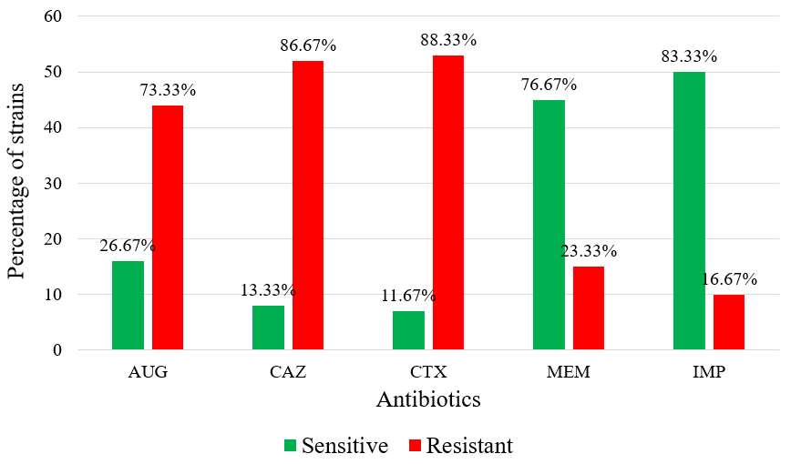
Figure 3 : Histogram of proportions of strains resistant to the antibiotics used
Some bacterial strains (81.67%) showed associeted resistances to both cefotaxime and ceftazidime.
Proportion of bacterial strains producing ESBLOf all bacterial strains tested, 76.67% were broad-spectrum β-lactamases producers. (Figure 4 ). Among these strains, enterobacteria represented 71.67% compared to 5% for non-fermentative Gram-negative bacteria. Among enterobacteria, E. coli was largely represented with a proportion of 73.91% followed by Klebsiella pneumoniae with 15.21%.
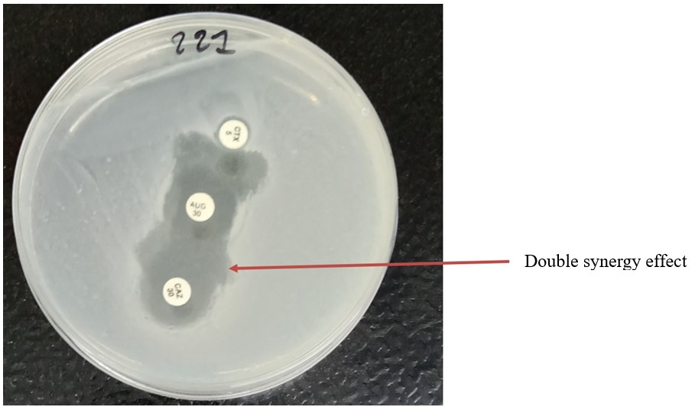
Figure 4: Bacterial strainproducing broad-spectrum β-lactamases (E. Coli 221Uro )
Legend : image of champagne cork observed between amoxicillin + clavulanic acid (AUG) and ceftazidime (CAZ) or cefotaxime (CTX) with E. coli isolated in urine sample
Isolation of resistance genes
Electrophoretic migration of PCR products revealed amplicons around 621 bp (Figure 5 ) and 390 bp corresponding to the genes CTX-M-G1 and VIM (Figure 6), respectively. The genes mcr1 (320bp), mcr2 (715bp), IMP1 and 2 (139 bp) were not detected.
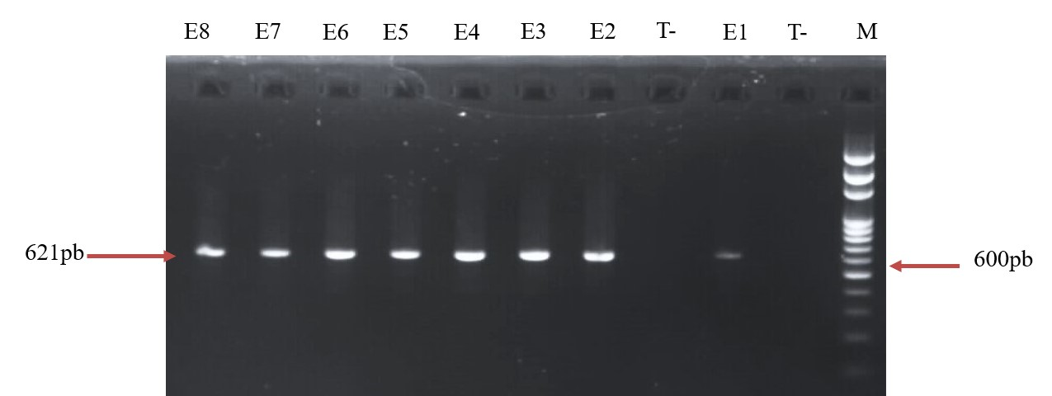
Figure 5: Electrophoretic profile of CTX-M-G1 gene amplicons
Legend: M1: Molecular weight marker (100 bp DNA Ladder); T-: Negative control; Numbers E1 – E8 represent samples: E1 = 20 P*; E2 = 23 P; E3 = 350 Uro**; E4 = 362 Uro; E5 = 3149 Uro; E6 = 3361 Uro; E7 = 3387 Uro; E8 = 3443 Uro.
20 P* : Number assigned to a pus sample
350 Uro ** : Number assigned to a urine sample

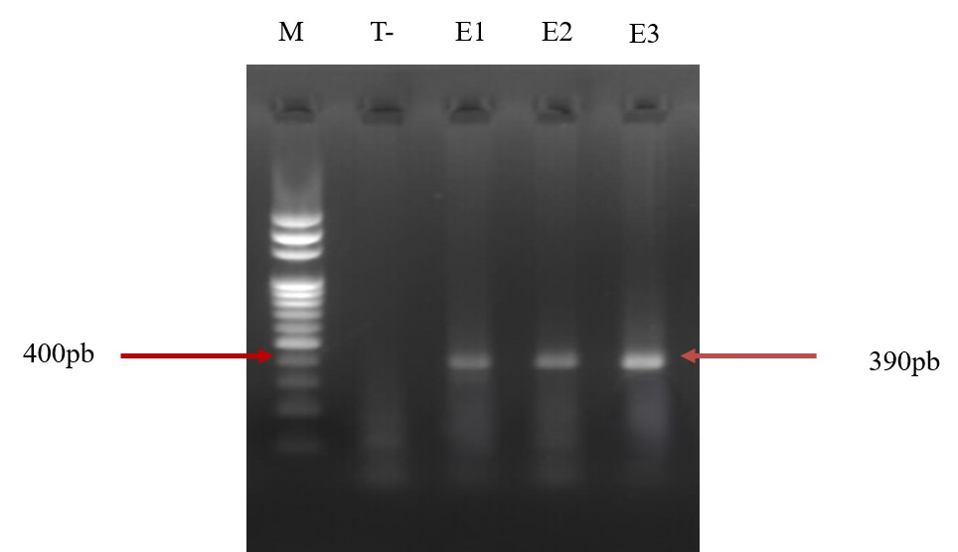
Figure 6:Electrophoretic profile of VIM gene amplicons
Legend: M1: Molecular weight marker (100 bp DNA Ladder); T-: Negative control; Numbers E1 – E3 represent samples: E1 = 228 Uro; E2 = 2532 Uro; E3 = 3149 Uro.
Frequencies of isolated genes
Electrophoretic migration revealed that 89.13% of bacterial strains were found harbored at least one of the genes sought among the strains producing ESBL. The CTX-M-G1 gene was isolated from 89.13% of strains and the VIM gene was isolated from 6.52%. All strains carrying the VIM gene also harbored the CTX-M-G1 gene. In our experimental conditions mcr and IMP genes were not found. Among the strains producing the CTX-M-G1 gene, most proportion corresponded to Escherichia coli (73.17%), Klebsiella pneumoniae (14.63%), Acinetobacter baumanii ( 4.88% ) and 2.43% for each of Citrobacter sp, Pseudomonas aeruginosa and Morganella sp. Regarding the VIM gene, a proportion of 2.43% was found for each of Klebsiella pneumoniae, Acinetobacter baumanii and Pseudomonas aeruginosa.
DISCUSSION
The results of our study showed that males over 60 years old are the most likely to have urinary infections. Urogenital infections, more frequently described in adults, are associated with predisposing anatomical and pathological factors such as urethral or ureteral strictures, prostate adenomas, and with invasive treatments related to these conditions in elderly persons (Davison and al., 2000 ; Zongo and al., 2016). Urines samples represented the most source providing resistant bacterial strains, of which Escherichia coli was the majority species with a proportion of 73.07% followed by Klebsiella pneumoniae (17.31%). In Burkina faso, a study conduced by Ky/Ba and collaborators in 2024 reported that Escherichia coli and Klesiella pneumoniae represented the most bacterial species responsible of urinary stract infectious whith proportions respectively 39.3% and 36.4% of bactérial strains studied (Ky/Ba and al., 2024).
In stools, the species represented were Shigella sp (50%), Escherichia coli (25%) and Salmonella sp (25%) and were isolated in children under two years. Other studies have also reported the same trends. In Cameroon, proportions of 66.6%, 15.5% and 2.22% were reported respectively for Escherichia coli, Salmonella Spp. 15.5% and Shigella Spp in cases of diarrhea (Ateudjieu et al., 2018). In Burkina Faso, bacteriological analysis of stools are focused on specific pathogens like Salmonella, enteropathogenic Escherichia coli, Sigella… that are responsible of infectious diarrhea for chidren that conduces freqently to antibiotics use without prescription (Dembele and al., 2016)
Enterobacteria were the most widely encountered with a proportion of 93.33% in our study. Among them, Escherichia coli was represented in the majority with a proportion of 71.67% followed by Klebsiella pneumoniae with 15%. These same trends had been reported in Burkina in 2015 and in Togo in 2017, but with slightly lower prevalences in bacterial species (Zongo, and al., 2015; Toudji, and al., 2017). Among Gram-negative bacilli, enterobacteria are frequently isolated in bacteriology laboratories, with E. coli and Klebsiella spp being the most commonly encountered species. (Zongo, et al., 2015).
IN our stufy, the antibiotic susceptibility testing showed high proportions of strains resistant to cephalosporins with 86.67% for ceftazidime and 88.33% for cefotaxime. Molecular characterization revealed that high proportions (89.13%) of our bacterial strains carried the CTX-M-G1 gene. A prevalence of 88.9% for CTX-M-G1 was reported in Algeria (Souna et al., 2022), while Zeynudin and colleagues found that 95.8% of their isolates carried CTX-M in Ethiopia (Zeynudin et al., 2018). CTX-M enzymes efficiently hydrolyze third-generation cephalosporins, particularly cefotaxime, and this corroborates our results. In Burkina Faso, Cefotaxime, Ceftriaxone, and Ceftazidime are the most commonly used β-lactams for the treatment (even presumptive) of infectious diseases, which may explain the selection of resistant mutants among clinical isolates. Furthermore, in this contry, data from studies focusing specifically on CTX-M-G1 remain limited. The screening of CTX-M-G1 genes is a topic worthy of interest because this group contains the CTX-M-15 gene, known to spread rapidly and being associated with other resistance genes, leading to the emergence of multidrug-resistant bacteria (Strahilevitz and al., 2009).
In low-income countries, faced with infections caused by multidrug-resistant bacteria, empiric antibiotic therapy increasingly includes antibiotic molecules from the 'watch' and 'reserve' categories of the WHO's AWaRe classification. It is well established that resistance to third-generation cephalosporins has explained the frequent prescriptions of carbapenems, leading to the emergence of resistance against the latter(Oliveira et Reygaert, 2023). Our study did not find all the targeted carbapenemase genes. However, 2,43% of isolates harbored bla_{VIM} gene and all isolates harboring the VIM gene also carried the CTX-M gene, These molecular results are consistent with the observations on the antibiograms at the Petri dish level, showing low proportions of bacterial strains resistant to Imipenem and Meropenem. However, it should be noted that blaVIM confers on bacteria the ability to hydrolyze penicillins, cephalosporins, cephamycins, and carbapenems (Bonnin an al., 2025). Therapeutic failures with these latest minimally harmful molecules have led to the increasingly frequent prescription of potentially toxic antibiotics such as colistin in both hospital and community settings.
The mcr gene was not detected under the conditions of our study. However, a metagenomic study of hospital, river and domestic wastewater from Burkina Faso, Benin and Finland found traces of the presence of these genes in these three countries, mcr-5 variant being the most frequently encountered (Melina et al., 2023). Other studies have also reported low proportions of the mcr-1 gene (0.7%) and mcr-2 gene (1.5%) particularly in China. Initially detected in animals, the mcr gene would be transmitted to humans by the consumption of animals infected by carrier bacteria (Zhang et al. 2018)

CONCLUSION
This study, like all previous ones, has identified in bacterial strains, resistance genes to third-generation cephalosporins (C3G) and carbapenems which are antibiotics of primary importance in therapeutic regimens. The high proportion of host strains highlights the significance of their impact on population health and the challenges they pose to clinicians in choosing therapeutic options. The increasing use of colistin despite its potential toxicity appears illusory, as resistance to this antibiotic has already been described. To resolve this perilous situation, relevant drug policies must enforce rigorous management of antibiotics in both hospital settings and the community, drawing inspiration from the WHO's AwaRe approach. Substantial resources are also needed to enable reliable identification of bacteria hosting ESBLs, carbapenemases and clinical categories of colistin. Finally, coordinated surveillance of multidrug-resistant bacterial strains through the One Health approach is essential.
Study Limitations
In conducting this study, we were limited in determining the MICs of the antibiotics tested due to laboratory logistical constraints. This did not allow us to classify the bacterial strains by clinical categories for colistin.
Disclaimer (Artificial intelligence)
Author(s) hereby declare that NO generative AI technologies such as Large Language Models (ChatGPT, COPILOT, etc.) and text-to-image generators have been used during the writing or editing of this manuscript.

References
Ahoyo A.T., Baba-Moussa, L., Anago, A.E., Avogbe, P., Missihoun, T.D., Loko, F., Prévost, G., Sanni, A.,
Dramane, K. (2007). Incidence of infections dues to Escherichia coli strains producing extended spectrum betalactamase, in the Zou/Collines Hospital Centre (CHDZ/C) in Benin. Médecine et Maladies Infectieuses. 37(11), 746-752
Ateudjieu, J., Bita’a, L.B, Guenou, E., Chebe, A.N., Chukuwchindun, B.A., Koukoum, A.P.G.,
Bisseck, A.C.Z.K. (2018). Profile and antibiosensitivity of pathogenic bacteria associated with diarrhea in patients consulting at the Regional Annex Hospital of Kousseri, Far North Cameroon. Pan Afr. Med. J., vol. 29. Doi : 10.11604/pamj.2018.29.170.14296.
Bonnin, R.A., Jousset, A.B., Jacquemin; A., Emeraud, C., Girlich, D., Naas, T., Dortet
L. (2025).Genetic diversity,biochemical properties, epidemiology, and detection methods of IMP- and VIM-type carbapenemases. Clin Microbiol Rev 38:e00129-23.https://doi.org/10.1128/cmr.00129-23
CA-SFM (2023). Comité de l’Antibiogramme de la Société Francaise de Microbiologie: Recommandations V.1.0 Juin.
CLSI. (2009). Clinical and Laboratory Standards Institute. Performanc standard for Antimicrobial
Susceptibility Testing. Document M100-S24. No. 1,Vol, 34, PA, USA
Da, L., Somé, D., Yehouenou, C., e Somé, C., Zoungrana, J., Ouédraogo, AS., Lienhardt, C. andPoda, A. (2023). State of play of antibiotic resistance in sub-Saharan Africa. Medicine and Infectious Diseases Training 2 (1): 3‑12. https://doi.org/10.1016/j.mmifmc.2023.01.003.
Davies, J. and Davies, D. (2010). Origins and Evolution of Antibiotic Resistance. Microbiol. Mol. Biol. Rev. MMBR, flight. 74, no. 3, p. 417-433. Doi : 10.1128/MMBR.00016-10.
Davison, H.C., Low, J.C., and Woolhouse, M.E. (2000). “What is antibiotic resistance and how
can we measureit ? », Trends Microbiol., vol. 8, no. 12, p. 554‑559. Doi : 10.1016/s0966-842x (00)01873-4.
Dembélé, R., Huovinen, E., Yelbéogo, D., Kuusi, M., Sawadogo, G., Haukka, K., Bonkoungou, I. J.O.A.,
Siitonen, Traoré, A. S. and Barro N. (2016). Burden of acute gastrointestinal infections in Ouagadougou, Burkina Faso. J Microbiol Infect Dis;6(2): 45-52 doi: 10.5799/ahinjs.02.2016.02.0215
Dembélé, R., Konaté, A., Traoré, O., Kaboré, W.A.D., Soulama, I., Kagambèga, A., Traoré,
A.,Guessennd, N.K., Aidara-Kane, A., Gassama-Sow, A., Barro, N. (2020). Extended spectrum beta-lactamase and fluoroquinolone resistance genes among Escherichia coli and Salmonella isolates from children with diarrhea, Burkina Faso. BMC Pediatr. 20(1):459. doi: 10.1186/s12887-020-02342-z. PMID: 33010801; PMCID: PMC7532561.
Ghamgosha, M., Shahrekizahedani, S., Kafilzadeh, F., Bameri, Z., Taheri, RA and Farnoosh, G. (2015). Metallo-beta-Lactamase VIM-1, SPM-1, and IMP-1 genes among clinical Pseudomonas aeruginosa species isolated in Zahedan, Iran. Jundishapur J. Microbiol., flight. 8, no. 4, p. e17489. Doi: 10.5812/jjm.8(4)2015.17489.
Harrois, D., Breurec ,S., Seck, A., Delaune, A., Le Hello, S., Pardos de la Gandara, M.,
Sontag, L., Perrier-Gros-Claude, J.D., Sire, J.M., Garin, B., and Weill, F.X. (2014). Prevalence and characterization of extended-spectrum b-lactamase-producing clinical Salmonella enterica isolates in Dakar, Senegal, from 1999 to 2009. Clin Microbiol Infect; 20: O109–O116 10.1111/1469-0691.12339
Jarlier, V., Nicoals, M.H., Fournier, G. and Philipon, A. (1988). Extended broad-spectrum β-lactamases
conferring transferable resistance to newer β-lactam agents in enterobacteriaceae: hospital prevalence and susceptibility patterns. Rev. Infect. Dis. 10, 867-878
Kaboré, B., Ouédraogo, G.A., Cissé, H., Ouédraogo, H.S., Sampo, E., Zongo, K.J. and al. . (2022).
“(GTG)5-PCR fingerprinting of multi-drug resistant Escherichia coli bacteria isolated from hospital in Ouagadougou, Burkina Faso”, BMC Microbiol., vol. 22, p. 118. Doi : 10.1186/s12866-022-02537-7.
Kaboré, B., Cissé, H,, Zongo, K.J., Sanou, I., Zeba, B., Traoré, Y., Savadogo, A. Phenotypic detection
of metallo-β-lactamase in imipenem-resistant Pseudomonas aeruginosa and Stenotrophomonas maltophilia at Schiphra Hospital of Ouagadougou in Burkina Faso. Microbes Infect Dis 2021; Article In Press; DOI: 10.21608/mid.2021.70446.1138.
Kaur, J., and al. (2013). Modified Double Disc Synergy Test to Detect ESBL Production in
Urinary Isolates of Escherichia coli and Klebsiella pneumoniae. Journal of Clinical and Diagnostic Research. Vol-7(2): 229-23
Kim, J., Jeon, S., Rhie, H., Lee, B., Park, M., Lee, H. et al. (2009). Rapid detection of
extended spectrum β-lactamase (ESBL) for Enterobacteriaceae by use of a Multiplex PCR-based Method. Infection and Chemotherapy, 41(3), 181. DOI. https://doi.org/10.3947/ic.2009.41.3.181
Ky/Ba, A., Tondé, I., Dienderé, E. A., Ky, A. Y., Tamini, J. R., Sanou, M., & Sanou, I. (2024).Bacteriological
profiles of urinary tract infections in patients admitted to the nephrology-haemodialysis department of the Bogodogo University Teaching Hospital (CHU B), Ouagadougou, Burkina Faso. African Journal of Clinical and Experimental Microbiology, 25(3), 295–302. https://doi.org/10.4314/ajcem.v25i3.6
Livorsi, D.J,, Chorazy, M.L., Schweizer, M.L., Balkenende, E.C., Blevins, A.E., Nair, R., Samore, M.H.,
Nelson, R.E., Khader, K. ( 2018). Perencevich, EN. A systematic review of the epidemiology of carbapenem-resistant Enterobacteriaceae in the United States. Antimicrob Resist Infect Control.;7:55.
Liu, Y-Y., Wang, Y., Walsh, TR., Yi, LX., Zhang, R., Spencer, J. et al. (2016). Emergence of plasmid-mediated colistin resistance mechanism MCR-1 in animals and human beings in China : a microbiological and molecular biological study. Lancet Infect. Dis., vol. 16, no. 2, p. 161‑168. Doi : 10.1016/S1473-3099(15)00424-7.
Melina, A.M., Haukka, K., Victorien, K., Dougnon, T., Bonkoungou, I.J.O, Garba, Z. (2023). Metagenomic analysis of the abundance and composition of antibiotic resistance genes in Hospital wastewater in Benin, Burkina Faso, and Finland. mSphere, vol. 8, no. 1, p. e00538-22. Doi : 10.1128/msphere.00538-22.
Mètuor-Dabiré, A., Zongo, K.J., Zeba, B., and al (2014). First detection of shv-type extended spectrum
β-lactamases in the university hospital complex paediatric Charles De Gaulle (chup-cdg) of Ouagadougou in burkina faso. Journal of Asian Scientific Research. 4:214-221
Muhigwa, M., Sanou, S., Kantagba, D., Ouangraoua, S., Yehouenou, C.L., Michodigni, F.,
Poda, A., Perris Renggli E, Bernasconi A, Godreuil S, Ouedraogo AS. (2023). Characterization of extended-spectrum beta-lactamase and carbapenemase genes in bacteria from environment in Burkina Faso. J Infect Dev Ctries. 17(12):1714-1721. doi: 10.3855/jidc.18116. PMID: 38252715.
Nabti, L.Z. (2020). Sensitivity to antibiotics and essential oils of origanum glandulosumDesf : Escherichia coli strains isolated from urinary tract infection at Sétif University Hospital. http://dspace.univ-setif.dz:8888/jspui/handle/123456789/3686
Ouattara, A.K., Ouédraogo, B., Dabiré, A.M., Tiemtoré, R.Y.W., Sougué, S., Simporé(2023). J. First
Detection of NDM-type Carbapenemase-Producing K. pneumoniae isolated from Clinical Samples in Ouagadougou, Burkina Faso. Archives of Microbiology and Immunology. 7: 236-241
Ouédraogo, B., Ouattara, A.K., Dabiré, A.M., Tiemtoré, R.Y.W., Sougé, S. and Simporé, J. (2023)
Resistance of Klebsiella to Imipenem by Production of Carbapenemase Gene blaIMP at Centre Hospitalier Universitaire Pédiatrique Charles de Gaulle, Ouagadougou, Burkina Faso. International Journal of Clinical Medicine, 14, 347-356
Oliveira, J. and WC Reygaert (2023). Gram-Negative Bacteria”, in StatPearls, Treasure Island.
Available at: http://www.ncbi.nlm.nih.gov/books/NBK538213/ Accessed : July 3, 2023.
Palzkill, T. (2013). Metallo-β-lactamase structure and function. Ann. NY Acad. Sci., vol. 1277, no. 1, p. 91‑104. Doi : 10.1111/j.1749-6632.2012.06796. x.
Qamar, M.U., Sierra, R., Jabeen, K., Rizwan, M., Rashid, A., Dar, Y.F., Andrey, DO. Genomic
characterization of plasmids harboring bla_{NDM-1,}bla_{NDM-5,} and bla_{NDM-7} carbapenemase alleles in clinical Klebsiella pneumoniae in Pakistan. Microbiol Spectr. 2025 Jul;13(7):e0235924. doi: 10.1128/spectrum.02359-24. Epub 2025 May 22. PMID: 40401976; PMCID: PMC12210987
Rebelo, A.R., Bortolaia, V., Kjeldgaard, J.S., Pedersen, S.K., Leekitcharoenphon, P., Hansen, I.M. et al. (2018). Multiplex PCR for detection of plasmid-mediated colistin resistance determinants, mcr-1, mcr-2, mcr-3, mcr-4 and mcr-5 for surveillance purposes. Eurosurveillance, vol. 23, no. 6, p. 17‑00672. Doi: 10.2807/1560-7917.ES.2018.23.6.17-00672.
Ribeiro Junior, J.C, Tamanini, R., Soares, B.F., Marangon de Oliveira, A., Silva, F. (2016). Efficiency of
boiling and four other methods for genomic DNA extraction of deteriorating spore-forming b acteria from milk. Agricultural Sciences 37(5):3069-3078
Souna, D., Drissi, M., Almahmoud, I.. and Maurin, M. (2022). Enterobacter cloacae Complex
and CTX-M Extended-Spectrum β-Lactamases in Algeria. Microb. Drug Resist. Larchmt. N, vol. 28, no 3, pp. 346‑354. Doi : 10.1089/mdr.2020.0535.
Ssekatawa, K., Byarugaba, D.K., Nakavuma, J.L., Kato., C.D., Ejobi, F., Tweyongyere ,
R., Eddie, W.M. ( 2021). Prevalence of athogenic Klebsiella pneumoniae based on PCR capsular typing harboring carbapenemases encoding genes in Uganda tertiary hospitals”, Antimicrob. Resist. Infect. Control, vol. 10, no. 1, p. 57. doi: 10.1186/s13756-021-00923-w.
Strahilevitz, J., Jacoby, G.A., Hooper, D.C., Robicsek, A. (2009). Plasmid-Mediated Quinoloneesistance
: A Multifaceted Threat. Clin.Microbiol. Rev. 22, 664-689
Toudji, A.G., Djeri, B., Karou, S.D., Tigossou, S., Ameyapoh, Y,. and de Souza, C. (2017). Prevalence of strains of Enterobacteriaceae producing extended-spectrum beta-lactamases isolated in Togo and their sensitivity to antibiotics. Int. J. Biol. Chem. Sci., flight. 11, no. 3, Art. no 3. Doi: 10.4314/ijbcs.v11i3.19.
Yusha’u, M., Olonitola, S.O., Aliyu, B.S., (2007). Prevalence of Extended-Spectrum ß-
lactamases (ESBLs) among members of the Enterobacteriaceae isolates obtained from Muhammad Abdullahi Wase Specialist Hospital, Kano, Nigeria. Int. Jor. P. App. Scs. 1(3), 42 –48
Zhang, J., Chen, L., Wang, J., Butaye, P., Huang, K., Qiu, H. et al. (2018). Molecular detection of colistin resistance genes (mcr-1 to mcr-5) in human vaginal swabs. BMC Res. Notes, vol. 11, no. 1, p. 143. Doi : 10.1186/s13104-018-3255-3.
Zeynudin, A., Pritsch, M., Schubert, S., Messerer, M., Liegl, G., Hoelscher, M., Belachew, T., Wieser, A. (2018). Prevalence and antibiotic susceptibility pattern of CTX-M type extended-spectrum β-lactamases among clinical isolates of gram-negative bacilli in Jimma, Ethiopia. BMC Infect. Dis., vol. 18, p. 524. Doi : 10.1186/s12879-018-3436-7.
Zhuo, C., Li, X., Zong, Z. and Zhong, N.S. (2013). Epidemic Plasmid Carrying blaCTX-M-15 in Klebsiella penumoniae in China. PLoS ONE, flight. 8, no. 1, p. e52222. Doi: 10.1371/journal.pone.0052222.
Zongo, K.J., Metuor Dabire, A., Kabore, B., Sanou, I., Sangare, L., Simpore, J., Zeba, B. (2016).
Microbiological and kinetic detection of GRAM negative bacilli producing Extended-spectrum- β-lactamases (esbl) in emergencies and reanimation units of University Hospital Center, Yalgado OUEDRAOGO, Burkina Faso AFR. J. CLN. EXPER. MICROBIOL. 17 (2): 116-124 http://dx.doi.org/10.4314/ajcem.v17i2.7
Zongo, K.J, Metuor-Dabire, A., Compaore, L.G., Sanou, I., Sangare, L., Simpore, J.,
Zeba, B. (2015). First detection of blaTEM, SHV and CTX-M among Gram negative bacilli exhibiting extended spectrum -lactamase phenotype isolated at University Hospital Center, Yalgado Ouedraogo, Ouagadougou, Burkina Faso. African Journal of Biotechnology. 14(14), 1174–1180. DOI. https://doi.org/10.5897/AJB2014.13908

