Prevalence and Clinical Features of Glaucoma in Pediatric Mucopolysaccharidosis Type I: A Retrospective Descriptive Study

Abstract
Objective: To evaluate the prevalence, clinical characteristics, diagnostic challenges, and therapeutic outcomes of glaucoma in children diagnosed with mucopolysaccharidosis type I (MPS I).
Methods: A retrospective descriptive study was conducted on 12 pediatric patients (aged 4–17 years) with confirmed MPS I, followed jointly by the Pediatrics and Ophthalmology departments of HMIMV Hospital, Rabat.
Results: All patients exhibited corneal opacification with normal anterior chamber depth. The iridocorneal angle was open in seven cases. Pachymetry ranged from 580 to 735 μm (mean = 667 μm). Adjusted IOP ranged between 15 and 59 mmHg (mean = 20 mmHg). Three patients (25%) were diagnosed as glaucomatous or glaucoma suspects. Patients received enzyme replacement therapy, and the glaucoma was treated medically, with follow up showing significant improvement of IOP and Cup/Disc ratio.
Conclusion: Glaucoma represents a challenging but significant ocular manifestation of MPS I. Prevalence of glaucoma in MPSs patients (ranged from 2.1% to 12.5%) indicated that it was worthy of attention and further study so that quality of life for MPSs patients could be improved. Early, multimodal diagnostic evaluation and individualized management are crucial.

Key Words: Glaucoma, Screening, Children, Mucopolysaccharidosis

Introduction
Mucopolysaccharidoses (MPS) are inherited lysosomal storage disorders caused by enzymatic deficiencies involved in glycosaminoglycan degradation [1]. MPS type I results from a deficiency of α-L-iduronidase, leading to accumulation of GAGs in ocular tissues [2]. Ophthalmic involvement in MPS I includes corneal clouding, optic neuropathy, refractive errors, and retinal changes [3]. Glaucoma, although less frequent, can cause irreversible visual impairment if untreated [6]. This study aims to evaluate glaucoma prevalence and clinical features in pediatric MPS I cases [2].

Materials and Methods
A retrospective descriptive study was performed on 12 children with MPS type I [1]. We excluded from our study patients over 20 years old, and with severe corneal opacification not allowing minimal ophthalmologic assessment. The age of the children is comprised between 4 and 17 years old, with average age of MPS diagnosis at approximately 6 years old. All patients are receiving enzyme replacement therapy.
This study is carried out in collaboration between the pediatrics department and the ophthalmology department. The pediatrics department are responsible of recruiting patients, making diagnosis of MPS1, treating them with enzyme replacement therapy (ERT) and follow their evolution.
The Ophthalmologic assessment included slit-lamp examination, gonioscopy, and intraocular pressure measurement by Goldmann and air tonometry [6]. Pachymetry and OCT were used for corneal and optic nerve evaluation [3]. All patients received enzyme replacement therapy initiated at a mean age of 4 years [2].

Results
All 12 patients presented with corneal opacity of varying degrees of severity (Fig 1). The anterior chamber depth appeared normal in all cases examined [4]. Seven patients for whom goniography or OCT was possible presented with an open iridocorneal angle.
IOP (ADJ) ranged from 15 to 59 mmHg, with a mean of 20 mmHg. The cup/disc ratio was estimated to be between 3/10 and 9/10 (in 9 patients for whom the examination was possible). Pachymetry ranged between 580 and 735 μm with a mean of 667 μm [2].
Among the 12 patients studied, three patients were diagnosed as glaucomatous or suspects based on IOP and optic nerve changes (Table 1).

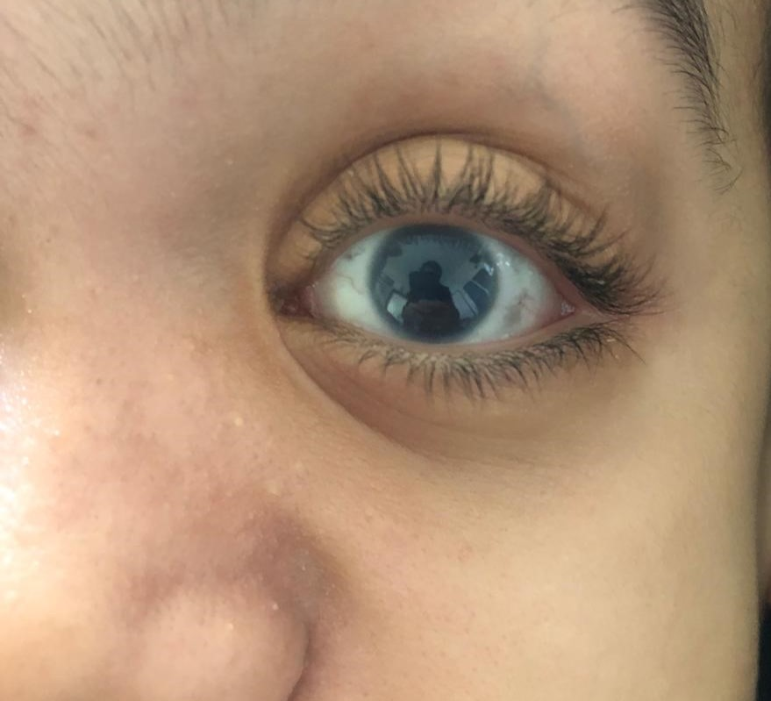
Figure 1 : Photography of a child with MPS1 showing a mild corneal opacity

Patient | Age (years) | Pachymetry (µm) | IOP (ADJ) (mmHg) | C/D ratio
1 | 6 | OD: 601  OS: 610 | 24  25 | 7/10  8/10
2 | 8 | OD: 593  OS: 585 | 29  21 | 8/10  5/10
3 | 14 | OD: 661  OS: 560 | 59  51 | 9/10  4/10
Table 1: Clinical characteristics of the three patients diagnosed or with suspicion of glaucoma Note. OD = Right Eye (Oculus Dexter); OS = Left Eye (Oculus Sinister); IOP = Intraocular Pressure; ADJ = Adjusted; C/D = Cup-to-Disc ratio.
Regarding the patients management:
From a pediatric perspective: all patients are receiving enzyme replacement therapy : the average age of treatment initiation is approximately 4 years.
From an ophthalmological perspective: treatment was based on medical therapy: a combination of prostaglandin (PG) and beta-blockers for patients 1 and 2, and quadruple therapy for patient 3 combined with oral acetazolamide. The outcome was marked by normalization of intraocular pressure (IOP) in patients 1 and 2, and a decrease in IOP in patient 3.
Quarterly follow-up was established to monitor progress under treatment: with stabilization of IOP and C/D ratio in all patients.
It should also be noted that patient 2 discontinued treatment against medical advice, without any significant change in their IOP or C/D ratio.

Discussion
MPS I is an autosomal recessive disorder caused by α-L-iduronidase deficiency [1]. Clinical manifestations include dysmorphic facial features, cardiovascular and respiratory problems, musculoskeletal and neurological issues, and intellectual disability [2]. Treatment relies on enzyme replacement therapy, currently available in Morocco, as well as hematopoietic stem cell transplantation for certain subtypes of MPS I, improving patients' life expectancy and quality of life [3].
Ocular manifestations include: Corneal opacity, observed in the majority of patients with MPS I and caused by the accumulation of GAGs in the corneal layers and disruption of collagen fiber alignment in the stroma [4]. Refractive errors, particularly hyperopia, are also found. Atrophy or swelling of the optic nerve head is less frequent. Ocular motility abnormalities are also present. MPS type 1 patients may have retinopathy with pigmentary retinal degeneration and associated electroretinogram changes [5].
Glaucoma has been reported to have an association with MPS I [6]. One study demonstrated that patients newly diagnosed with glaucoma exhibited higher levels of glycosaminoglycans (GAGs) compared to individuals without the disease, suggesting a link between GAG concentration and glaucoma development [7]. In open-angle glaucoma, abnormal deposition of GAGs within the trabecular meshwork (TM) may impede aqueous outflow, whereas in angle-closure glaucoma, excessive GAG accumulation in anterior segment structures and/or the presence of ciliary body cysts could play a contributory role [6,8].
The reported prevalence of glaucoma in individuals with MPS I varies between 2.1% and 12.5% [4]. Diagnosing this condition presents several challenges, such as limited ocular visibility and increased corneal thickness [9]. These difficulties primarily arise from the common occurrence of corneal opacification in children with MPS I, which obscures the evaluation of optic disc cupping, and from the unusually thick corneas that can affect intraocular pressure (IOP) measurements [10]. Additionally, potential psychomotor impairments in affected children often hinder reliable visual field testing and interpretation.
In our study, patients were classified as glaucoma suspects based on elevated IOP measurements combined with characteristic signs of glaucomatous optic neuropathy identified through OCT imaging.
Our findings emphasize not only the complexity of diagnosing and monitoring glaucoma in MPS I patients but also the critical importance of early detection and comprehensive diagnostic assessment [2]. Whenever feasible, evaluations should include measurements of IOP, corneal thickness, optic disc morphology, and the iridocorneal angle.
A more precise assessment of intraocular pressure (IOP) can be achieved by combining applanation and air-puff tonometry measurements [6]. Evaluation of corneal thickness, the anterior chamber, and the iridocorneal angle is best performed using anterior segment topography and optical coherence tomography (OCT), supplemented by ultrasound biomicroscopy (UBM) when necessary [11]. Furthermore, posterior segment OCT or optic nerve ultrasonography enables detailed assessment of optic disc morphology in patients with MPS.
Management of glaucoma in patients with mucopolysaccharidoses (MPS) generally follows established clinical guidelines. First-line therapy typically consists of topical hypotensive agents or laser trabeculoplasty. In cases where target IOP is not achieved, surgical interventions such as trabeculectomy, non-penetrating deep sclerectomy, or alternative glaucoma procedures should be considered [12]. Beyond conventional management, hematopoietic stem cell transplantation (HSCT) has demonstrated potential benefits for glaucoma control, although evidence remains preliminary and requires further investigation [13].
While enzyme replacement therapy (ERT) is regarded as a safer alternative to HSCT, its impact on ocular manifestations of MPS appears variable and often limited [14]. Corneal clouding in MPS I may remain stable following ERT [6], and scleral thickness may also show minimal change [6]. The modest efficacy of ERT in ocular disease is likely related to the restrictive nature of the blood–retina barrier and the avascularity of the cornea, both of which limit enzyme diffusion to ocular tissues.
As therapeutic advances continue to improve life expectancy in patients with MPS I, the prevalence of glaucoma is expected to increase. However, current evidence regarding the safety and effectiveness of anti-glaucoma interventions in this population remains scarce due to limited case reporting. In a multicenter retrospective analysis evaluating medical management of 12 eyes affected by glaucoma in MPS patients, IOP reduction was achieved in seven eyes, one case showed limited improvement, two cases discontinued therapy, and one eye demonstrated IOP reduction following keratoplasty [15].
In our cohort, a significant improvement in IOP was observed during follow-up under medical therapy alone. These findings are consistent with prior reports showing favorable IOP and visual outcomes following anti-glaucoma treatment in MPS [6]. Nevertheless, other studies have indicated suboptimal responses to standard therapies, underscoring the need for individualized management strategies and further clinical evaluation [6,16].

Conclusion
MPS type I is a rare but severe disorder with significant ocular complications [1]. Abnormal accumulation of GAGs may cause glaucoma in MPSs patients by aﬀecting functions and structures of eye, including trabecular meshwork, cornea, ciliary body and sclera. Clinical manifestations and shortened life span could hamper diagnosis of glaucoma in MPSs patients and block knowledge accumulation on the beneﬁts and risks of anti-glaucoma therapies. Despite the fact that cases of glaucoma in MPSs patients were rarely reported, prevalence of glaucoma in MPSs patients (ranged from 2.1% to 12.5%) indicated that glaucoma in MPSs patients was worthy of attention and further study so that quality of life for MPSs patients could be improved. Early diagnosis and interdisciplinary management are essential for visual preservation [2]. Comprehensive evaluation and personalized treatment can enhance the quality of life [3].
Ethical Approval:
As per international standards or university standards written ethical approval has been collected and preserved by the author(s).
Consent
As per international standards, parental written consent has been collected and preserved by the author(s).
Disclaimer (Artificial intelligence)
Author(s) hereby declare that NO generative AI technologies such as Large Language Models (ChatGPT, COPILOT, etc.) and text-to-image generators have been used during the writing or editing of this manuscript.

References
[1] Ashworth JL, Biswas S, Wraith JE, Lloyd IC. Mucopolysaccharidoses and the eye. *Surv Ophthalmol.* 2006;51(1):1–17.
[2] Ashworth JL, Biswas S, Wraith JE, Lloyd IC. The ocular manifestations of the mucopolysaccharidoses. *Eye.* 2015;29(4):552–563.
[3] Imani M. Williams, Roberto Pineda, Vamsee K. Neerukonda et Anna M. Stagner. Mucopolysaccharidosis Type I–Associated Corneal Disease: A Clinicopathologic Study. Am J Ophthalmo, 2021-11-01, Vol 231, 39-47.
[4] Fenzl CR, Teramoto K, Moshirfar M. Ocular manifestations and management recommendations of lysosomal storage disorders I: mucopolysaccharidoses. Clin Ophthalmol. 2015 Sep 7;9:1633-44.
[5] Ganesh A, Bruwer Z, Al-Thihli K. An update on ocular involvement in mucopolysaccharidoses. Curr Opin Ophthalmol. 2013;24(5):379–388.
[6] Kong, Weijing & Zhang, Jing & Lu, Cheng & Ding, Yingxue & Meng, Yan. Glaucoma in mucopolysaccharidoses. Orphanet Journal of Rare Diseases. 2021. 16:312.
[7] Maric VD, Bozic MM, Cirkovic AM, Stankovic SD, Marjanovic IS, Grgurevic AD. Serum heparan sulfate and chondroitin sulfate concentrations in patients with newly diagnosed exfoliative glaucoma. PeerJ. 2019;7: e6920.
[8] Ahmed TY, Turnbull AM, Attridge NF, Biswas S, Lloyd IC, Au L, Ashworth JL. Anterior segment OCT imaging in mucopolysaccharidoses type I, II, and VI. Eye (Lond). 2014;28(3):327–36
[9] Sato T, Nishimura G, Ishii T. Ocular complications of mucopolysaccharidosis type I. *Am J Ophthalmol.* 2002;133(4):481–487
[10] McGrath O, Sornalingam K, Aslam T, Ashworth J. Changes in Corneal Clouding Over Time in Patients With Mucopolysaccharidosis. Cornea. 2023 Aug 1;42(8):992-999
[11] Javed A, Aslam T, Ashworth J. Use of new imaging in detecting and monitoring ocular manifestations of the mucopolysaccharidoses. Acta Ophthalmol. 2016;94(8):e676–82
[12] Blanco AA, Bagnasco L, Bagnis A, Barton K, Baudouin C, Bengtsson B, Bron A, Cordeiro F: European Glaucoma Society Terminology and Guidelines for Glaucoma, 4th Edition - Chapter 3: Treatment principles and options Supported by the EGS Foundation: Part 1: Foreword; Introduction; Glos-sary; Chapter 3 Treatment principles and options. Br J Ophthalmol 2017, 101(6):130–195
[13] Aldenhoven M, Wynn RF, Orchard PJ, O’Meara A, Veys P, Fischer A, Valayan-nopoulos V, Neven B, Rovelli A, Prasad VK, et al. Long-term outcome of Hurler syndrome patients after hematopoietic cell transplantation: an international multicenter study. Blood. 2015;125(13):2164–72.
[14] Summers CG, Fahnehjelm KT, Pitz S, Guﬀon N, Koseoglu ST, Harmatz P, Scarpa M. Systemic therapies for mucopolysaccharidosis: Ocular changes following haematopoietic stem cell transplantation or enzyme replace-ment therapy - a review. Clinic Exp Ophthalmol. 2010;38(1 (Supplment s1)):34–42
[15] Ashworth J, Flaherty M, Pitz S, Ramlee A. Assessment and diagnosis of suspected glaucoma in patients with mucopolysaccharidosis. Acta Ophthalmol. 2015;93(2):e111-117
[16] A. Hamma, M. Bousalah. Glaucoma and mucopolysaccharidosis type I: Report of two children. Jour Fr Ophtalmo, 2016-11-01, Vol 39, Nm 9, P 259-260.

