CHALLENGES AND OPPORTUNITIES TOWARDS CATAYSING PRODUCTION AND COMMERCIALIZATION OF TAMARIND FRUIT IN KENYA

ABSTRACT

There is limited information on how to catalyze Tamarind production and commercialization in Kenya despite the growing demand in the domestic and export markets due to its multiple uses. The objective of this study was to conduct a situational analysis on production and commercialization in Tamarind in Kenya and to identify bottlenecks and opportunities which may help catalyze the scaling up of production and commercialization of Tamarind. An exploratory study design using selected literature and interviews with farmers, transporters, traders and extension staff in the Coastal regional of Kenya were used to collect data. The results show that Tamarind fruits are underutilized, mainly collected in the wild in semi-arid areas of the country and marketed through informal channels. Mombasa is the terminal market for tamarind sourced from Kenya and Uganda, from where domestic consumers and exporters obtain their supplies. Key challenges were found to be lack of organized production, long maturity periods, lack of quality planting materials, distant markets, limited value addition and inadequate promotion by government institutions. Increasing demand in local restaurants for tamarind drinks, flavoured foods and sauces as well as the export markets provide opportunities to scale up production in Kenya. The findings suggest that catalyzing the production and commercialization of tamarind in the country requires collaboration between public and private sector actors. The structure of such a collaboration should focus on development and strengthening the following value chain links namely; research into early maturing varieties and model nurseries as source of quality planting materials; domestication and production by farmers in orchards; aggregation centres for assurance of volumes and quality; processing and value addition and linkages domestic and export markets.

Key Words: Tamarind value chain, scaling-up, production, commercialization

INTRODUCTION

Tamarind or Tamarindus indica L. of the Fabaceae, subfamily Caesalpinioideae, family Leguminosae (Fabaceae) is an important food in the tropics (Caluwe et al., 2010). Several authors have suggested different geographical areas as the origin of the tamarind tree. Tamarind fruit was at first thought to be produced by an Indian palm, as the name tamarind comes from a Persian word
‘tamara-i-hindi’, meaning ‘date of India’ (Morton, 1987; El-Siddig et al., 2006; Rao et al., 2012).
However, other authors consider Tamarind native to tropical Africa from Sudan, Ethiopia, Kenya,
Tanzania, Sudan through the Sahel in West Africa (NAS, 1979). Von Maydel (1986) and Hocking (1993) report Tamarind originated in Madagascar from where it is thought to have been introduced in South East Asia. It grows in more than 50 countries of the world. The major areas of production are in Asian countries like India, Thailand, Bangladesh, Sri Lanka, Malaysia, Indonesia, and in Africa, Mexico, Costa Rica, USA, Brazil and Australia. India is the largest producer and exporter of Tamarind mainly to USA and Europe (Kumar & Bhattacharya., 2008). It is a multi-purpose tree and almost every part is used either for nutritional, medicinal or industrial value (Rao et al. (2012). Some of the most common products produced from Tamarind include juice, pulp, powder, chutney, pickles, sauces, sugar coated candies and tamarind kernel powder (TKP). Tamarind comes in two main varieties; sweet and sour (Naeem et al., 2017). Sweet tamarind is harvested ripe and usually consumed fresh, while the sour tamarind is usually processed into a range of value added products (El siddig., 2006, Kumar & Bhattacharya, 2008). The fruit is slightly curved and contain about 55% pulp, 34% seed, and 11% shell, and the fiber in a pod (El-Siddig et al., 2006; Kumar & Bhattacharya., 2008).
The tamarind tree has the ability to grow in poor soils in semi-arid conditions because of their nitrogen fixing capability and withstanding long periods of drought makes them as ideal low input, high yielding trees (Felker, 1981). For instance, in Uganda, Buyinza et al (2010) reported that the tamarind tree was found both on farms and in the wild. Ecologically, it combines well with cereal crops. Tamarind regenerates well, and has traditionally been protected during bush clearing by farmers. The trees found on farms were initially in the wild but after clearing land for farming, they were retained as boundary markers, contour hedges or scattered on cropland.
In Africa Tamarind is found in Eastern and West Africa, where the leading producers are Sudan, Egypt, Nigeria and Madagascar (SMEbluepages, 2024). Although not significantly commercialized in comparison to Asia, the tree has various uses in different parts of Africa wwere it is mainly harvested from the wild. Van der Stege et al (2011) and Chimsah et al (2020) describe Tamarind as important in traditional diets in rural West Africa countries across the Sahel and Savannah.
In East Africa, Mbunde et al. (2018) reported that Tamarind is used as juice and flavours in homes and hotels and also found that Tamarindus Indica isolates collected from various regions in the country as a good source of antioxidants. In Uganda, Ebifa-Othieno et al. (2017) reported that Tamarind is self-propagated and local communities in Northern and Eastern Uganda have great indigenous technical knowledge on its uses. They also report that Tamarind was grown in homesteads. Long maturity periods and inadequate commercialized were major challenges limiting exploitation of its economic potential in Uganda (Buyinza and Badru, 2010).
In Kenya, Betser (1999) and Wanjau et al. (2025) have reported that Tamarind is mainly in the dry arid and arid lands in Coastal, Eastern and Northern rangelands where it is used as traditional juice, porridge and food flavours.
Tamarind fruit value chain is not yet well developed since these fruits are mainly found in the wild. There is limited documentation on which nodes of the value chain need to be developed and bottlenecks and opportunities for strengthening Tamarind production and commercialization. of. The objective of this paper was to identify challenges and opportunities for catalyzing production and commercialization of Tamarind fruit in Kenya.

METHODOLOGY

Study area
This study was conducted in the county of Makueni in South Eastern Kenya and Taita Taveta, Kilifi, Mombasa and Kwale in Coastal Kenya. These regions were purposively selected based on secondary literature on production areas for Tamarind in Kenya and previous observations in open air markets. Eastern and Coastal Kenya are mainly Semi Arid and humid climatic conditions where Tamarind grows in the wild and homesteads. Mombasa is the largest bulking market for Tamarind in Kenya.

Research design
The study Saunders et al. (2016).employed a qualitative and exploratory research design (Exploratory design is an indepth study of a topic using secondary and primary data and provides insights for future interventions. Exploratory design seeks to understand processes, actors and institutional dynamics around a phenomenon under investigation (Creswell & Poth, 2018).

Participants
Participants for the study included farmers, retail traders, transporters, hotels and extension staff
Who were purposively identified using snowball sampling technique (Heckathon, 2015). This technique uses chain referral approach to recruit subsequent participants since actors in the Tamarind value chain particularly farmers and traders are not well known.

Data collection
Secondary data, key informant interviews and observations were used to collect data. Before participation, the study’s purpose, procedures, and confidentiality measures were clearly explained to all participants. Interviews were conducted face-to-face in homesteads, markets, hotels and in agricultural extension staff offices. Interviews and discussions were audio-recorded with consent and later transcribed verbatim for analysis. Semi structures open-ended questions encouraged participants to describe their experiences freely, while allowing the researchers flexibility to probe for depth and clarity. The study was guided by three research questions, namely;
- Which areas produce Tamarind in Kenya?
- Who are the actors at different nodes of Tamarind production and marketing?
- What are the different uses of Tamarind?
- What are the key challenges limiting Tamarind production and commercialization?

Table 1: Data collection and sample size for different respondents
Data collection method | Category ofparticipants | Sample size
Literature review | authors | 30
Interviews | Farmers | 18 (14 men, 4 women)
 | Transporters | 3
 | Hotels/ restaurants | 5
 | Extension staff | 4
Observations | Homesteads, markets  restaurants  supermarkets | 18  20  5  2

Data Analysis
The NVivo qualitative data analysis software was used to code data from respondents, common phrases were grouped and emerging themes were used for analysis.

RESULTS AND DISCUSSION

Table 2: Responses of different actors on Tamarind production and commercialization

Actor | Which areas (Counties) produce Tamarind in Kenya? | Who are the actors at different nodes of production and marketing? | What are the different uses of Tamarind | What are the key challenges limiting production and commercialization
Farmers | Makueni, Taita Tavetta, Kwale, Kilifi, Kitui, Machakos | Farmers, collectors, traders, transporters, retailers | Juice (Ukwaju), flavour in porridge, snack, herbal medicine | - Long maturity period  - Too tall- difficult to manage  - Lack of nurseries  - Distant markets  - Lack of knowledge on value addition  - Lack of extension advice  - Lack of processing facilities
Retail traders | Makueni, Taitta Tavetta, Kwale, Lamu, Kilifi | Farmers, collectors, traders, transporters, retailers,  Processors  Exporters | Juice (Ukwaju), flavour in porridge, snack,  Herbal medicine | - Low volumes.  - Lack of domestic production -collection in the wild.  - Lack of aggregation centres.  - Consumers lack awareness on benefits
Transporters | Kitui, Tharaka, Baringo, West Pokot, Homabay, Turkana, Kilifi, Makueni, Taita Taveta, Lamu | Farmers, collectors, traders, transporters, retailers | Juice (Ukwaju), flavour in porridge and food snack, herbal medicine | - Lack of production as a crop on farms  - Distant collection points  - Low volumes
Hotels/ restaurants | Kilifi, Mombasa, Kwale, Lamu | Traders,  Supermarkets | Juice (Ukwaju), flavour in porridge and food, sauce | - Low volumes  - Low consumer awareness
Extension staff | Makueni, Taita Tavetta, Kwale, Kilifi, Kitui, Tharaka, Lamu | Farmers, collectors, traders, transporters, retailers | Juice (Ukwaju), flavour in porridge, snack, herbal medicine | - Lack of data on farmers  - Lack of quality planting seedlings  - Long maturity period  - Too tall- difficult to manage  - Lack of farm orchards  - Lack of prioritization  - Lack of processing facilities

Table 3: Emerging themes from interviews and review of secondary data

No | Themes | Source codes
1 | Production | Lack of data on farmers and organised production
1 | Production | Lack of nurseries for quality seedlings
1 | Production | Lack of early maturing cultivars
1 | Production | Not prioritized by extension staff
2 | Commercialization | Distant markets
2 | Commercialization | Processing facilities
2 | Commercialization | Lack of aggregation centres
2 | Commercialization | Lack of knowledge on utilization and value addition
3 | Challenges | Production, varieties, markets,value addition, promotion, consumer awareness

Production areas

Tamarind trees are found mainly in the wild woodlands in arid and semi arid regions regions of Kenya namely; Kitui, Tharaka Nithi, Makueni, Kilifi,Baringo, West Pokot, Turkana, Homa Bay, Taita Taveta, Kwale and Lamu Counties (Table 2). Betser (1999) also reported that in Tharaka, Tamarind was harvested between July and October (short rain period). Tamarind tree starts fruiting (Figure 1) from 10-14 years (Morton, 1999; Buyinza et al., 2010) and can produce up to 225 Kg of tamarind in a season (FAO, 1998). In India, improved improved cultivar in Tamil Nadu, yields about 263 kg/tree. (Rao et al., 2012).
In Kenya, the lack of nurseries to avail planting materials is a real challenge limiting organized production. The Kenya Agricultural and Livestock
Research Organization (KALRO) has recently established nurseries for seedlings at its centres in Muguga, Katumani, Mptwapa, Matuga, Kakamega, Alupe, Perkerra and Kibos (Figure1). These nurseries will be used as source of planting materials by farmers in the country. Interviews carried out with County government extension staff indicate that Tamarind has not yet been prioritised as a farm crop in Kenya neither is it documented in the Ministry of Agriculture reports. Given the increasing consumer demand in hotels and restaurants mainly in coastal Kenya and global prominence of Tamarind as an export tree crop, the production stage of the value chain should move from the wild (Figure 2) to on-farm cultivation and strengthened through promoting farm production of both the sweet and sour tamarind varieties. Institutional farms, namely Agricultural Training Centres (ATCs), Kenya Forestry Service, Kenya Forestry Research Institute, Prisons and schools could be used as production hubs. These farms should also be linked to the necessary support services, namely, access to an efficient tamarind seed system, Good Agricultural Practices (GAPS), post-harvest handling and value addition technologies, financing, and most importantly, certification. Productiion and commercialization of tamarind for domestic and export markets could further be augmented through national and County government policy frameworks, development assistance programs, private sector investment. Production could further be catalysed through research on early maturing varieties, genetic conservation and desirable market traits. These interventions will be useful in protecting the tamarind tree from the threat of extinction due to human activities such as charcoal burning and timber common in semi-arid ecosystems.

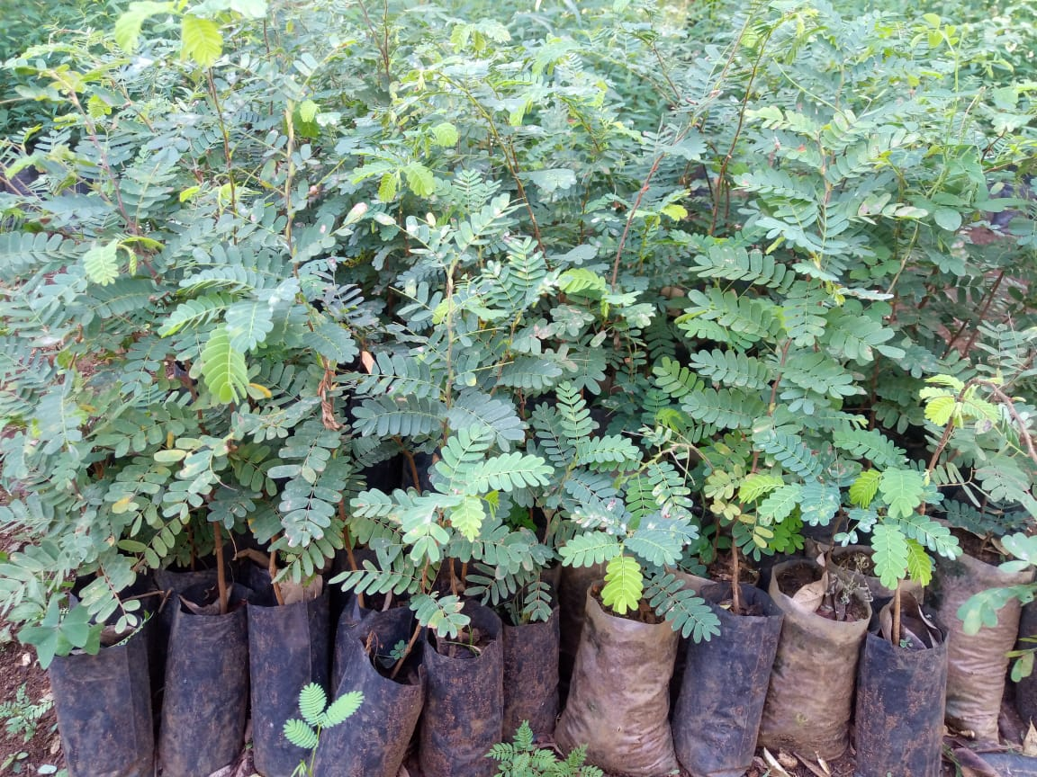
Figure 1: Tamarind seedlings in a Nursery at KALRO

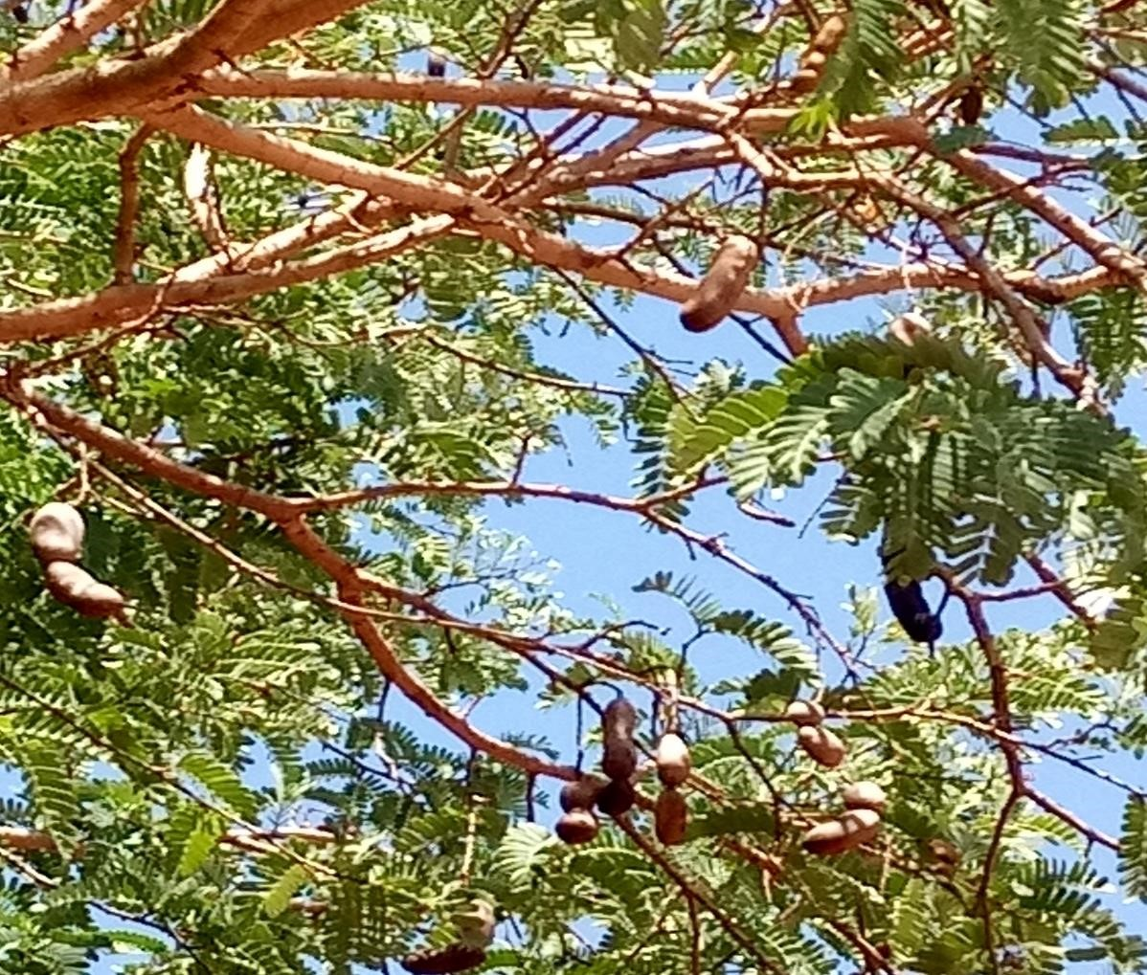
Figure 2: Tamarind tree with mature pods in Taita Taveta wood lands Kenya

Actors and Tamarind value chain nodes

Collection / bulking

In Kenya, the pods are harvested when the skin is brittle and the pulp is red-brown in colour and sticky in texture. Interviews carried out with various actors (Table 2) revealed that Tamarind value chain comprises farmers, collectors, traders, transporters, brokers, wholesalers, retailers, exporters and consumers (hotels and restaurants).
(Figure 3). The fruits are collected from different locations in Kenya and transporters revealed that Tamarind is sourced also from Eastern and Northern Uganda and sold in local markets and some specialty super markets. The largest market and destination for Tamarind trade in Kenya is in Kongowea market in Mombasa. The scattered nature of these sources makes it more difficult to aggregate trade volumes and hence with organized production, the need for aggregation centres within production hubs will be an important link in the value chain.

Trade
Consumption
collection
Production
Producers
Wild
Collectors
assemblers
Brokers
Exporters
Traders
/
Transporter

Retailers
Wsalers
consumers

Figure 3: Tamarind value chain in Kenya

Post-harvest handling

The ripe pods vary in length from around 2-17 cm and in diameter from 2-3.2 cm with 1-12 seeds
(Morton, 1999). After harvesting pods, the brittle skin are peeled off. Betser (1999) and traders interviewed report that after harvesting the pods, four grades of tamarind fruit are prepared and bagged both either on farm or at collection centres, according to orders. There are:
- Grade 1: dehusked, de-seeded and no fibres
- Grade 2: dehusked, de-seeded with fibres
- Grade 3: dehusked, with seed and fibres
- Grade 4: with husk, seed and fibres.
Most of the tamarind traded locally is of grade 3 quality (figure 4). However, export market requires grade 2 (dehusked, de-seeded with fibres). Dehusked tamarind with seed stores for up to six months before it is attacked by weevils, whereas de-seeded tamarind can be stored for around
2 years (Betser., 1999). Handling can have an impact on health and on entry into export markets. For instance, the U.S. government (FDA, 1999) keeps a list of organisations which are permitted to import tamarind (fresh and processed) due to the filth (insect, rodent, bird, cat/dog damage, mould) commonly found in tamarind. A competitive and market-oriented tamarind value chain in
Kenya should have a traceability, safety and quality assurance system in place.
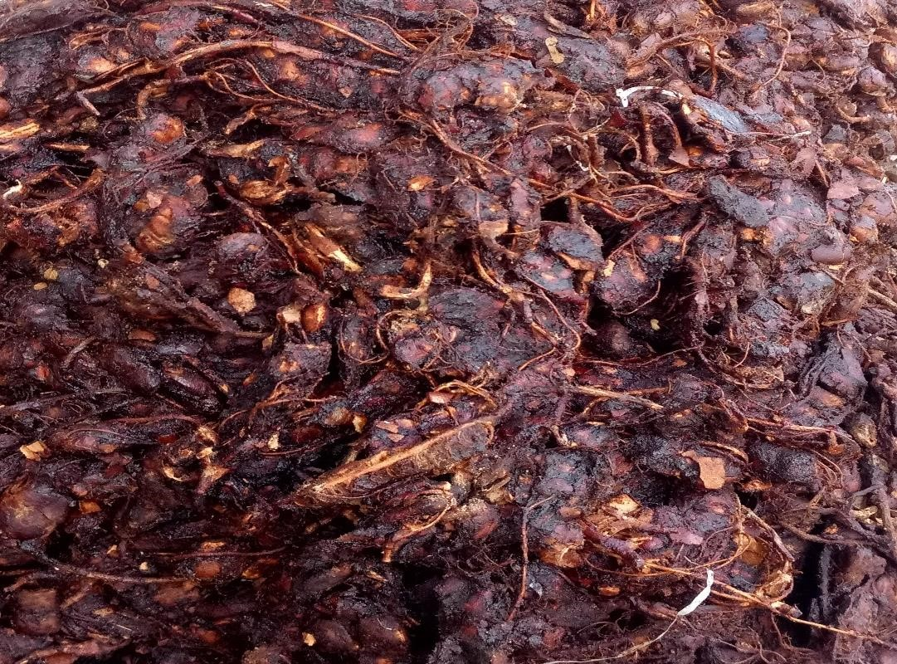
Figure 4: Dehusked Tamarind with seed and fibres

Value addition and processing

There is very little value addition and industrial processing that takes place in the country apart from Tamarind juice. Tamarind fruits are sold at Kongowea municipal market where both whole sale and retail takes place, while juices are sold in some specialty Mombasa restaurants (Tarboush, Barka cafe, Little chef, Muvita cafe). Besides tamarind juice, there are many other value added products and uses of various parts of Tamarind tree (Caluwe et al., 2010; Rao et al., 2012) which actors in the Tamarind value chain in Kenya could target. Product diversification, quantity, quality and branding should be the focus for locally produced Tamarind.

Existing and potential markets

Tamarind is traded almost entirely through informal channels. The traders interviewed revealed that in Mombasa, Tamarind fruits are also exported to the Middle East, Italy, India, Thailand, Philippines, Somalia and Tanzania from where value added products such as flavours, sauce, spice, flour, sweet chutney, kernel oils are made. However, official Statistics on trade volumes are scanty. Lack of information is a bottleneck along the tamarind marketing chain. Traders mentioned that they found it difficult to identify exporters, particularly those traders who do not have coastal networks. Hence the need for vertical and horizontal linkages among actors to share information especially on quantity, quality and price..

Tamarind products and uses

Interview with respondents show that in Kenya, Tamarind is mainly used for juice commonly known as Ukwaju in Coastal region. Other uses mentioned are flavour in drinks, food, as sauce and snack. Most farmers report Tamarind use as herbal concoction (medicine) in treatment of various conditions (Table 2).

Pulp: The pulp which accounts for 55% of the fruit has various uses in many countries. It is eaten fresh; used in preparation of drinks and alcoholic beverages, for seasoning, as a food component, to flavour confections, curries and sauces, and is a main component in juices and certain beverages and can also be processed into jam and sweets (El-Siddig et al., 2006; Caluwe et al., 2010). Seeds: Tamarind seed is a by-product of the tamarind pulp industry in the form of tamarind kernel powder (TKP), is used as a sizing material in the textile, paper, and jute industries and its gelling cum adhesive characteristics of the decorticated seed powder are used in food and pharmaceutical industries (El-Siddig et al., 2006; Kumar and Bhattacharya, 2008; Caluwe et al., 2010). Tamarind seeds are reported to give amber-coloured oil, free of smell and sweet to taste, and is also used in varnishes and paints. Flour from the seed may be made into cake and bread.
Roasted seeds are claimed to be superior to groundnuts in flavour (ICRAF, 2007).
Seed testa: The testa is reported to contain tannin and colouring matter used in dyeing and tanning has been suggested (El-Siddig et al., 2006).
Leaves and Flowers: Tamarind flowers and leaves can be eaten as vegetables and are prepared in a variety of dishes (ICRAF, 2007).Tamarind trees growing in woodlands are often eaten by wild animals, such as camels, elephants or giraffes, for which tamarind is a preferred plant, perhaps because of its high crude protein content (El-Siddig et al., 2006). In the southern states of India, cooked seeds of tamarind are fed to draught animals (ICRAF, 2007)
Bark: The bark is rich in tannins of up to 70%, and is used in the tanning industry. The bark is used for tanning hides and in dyeing (Morton, 1987; El-Siddig et al., 2006).

Nutritional value of Tamarind fruit

Tamarid fruit is rich in energy, carbohydrates, protein, vitamins and minerals (Table 4).
The fruit has a high content of Vitamins B_{1,} B₂ and B₃ as well as folate. It is also a good source of magnesium (26%), iron (22%), Phosphorus (16%) and potassium (13%) as well as zinc (1%).

Table 4: Nutritional value of Tamarind fruit per 100g

Energy | 239 kcal (1,000 kJ)
Carbohydrates | 62.5 g
Sugars | 57.4
Dietary fiber | 5.1 g
Fat | 0.6 g
Protein | 2.8 g
Vitamins | Quantity (%DV)
Thiamine (B1) | 37% (0.428 mg)
Riboflavin (B2) | 13% (0.152 mg)
Niacin (B3) | 13% (1.938 mg)
Pantothenic acid (B5) | 3% (0.143 mg)
Vitamin B6 | 5% (0.066 mg)
Folate (B9) | 4% (14 μg)
Choline | 2% (8.6 mg)
Vitamin C | 4% (3.5 mg)
Vitamin E | 1% (0.1 mg)
Vitamin K | 3% (2.8 μg)
Minerals | Quantity (%DV⁾
Calcium | 7% (74 mg)
Iron | 22% (2.8 mg)
Magnesium | 26% (92 mg)
Phosphorus | 16% (113 mg)
Potassium | 13% (628 mg)
Sodium | 2% (28 mg)
Zinc | 1% (0.1 mg)
Source: USDA, 2017

Essential amino acid profile of Tamarind

Amino acid profiles of tamarind show that the proteins contain fairly balanced essential amino acid levels (Table 5). In terms of protein content and WHO standards, tamarind seeds score well for 3 of the 8 essential amino acids. Tamarind seeds could therefore be used as a less expensive source of protein to help alleviate protein malnutrition which is widespread in many developing countries (El-Siddig et al., 2006)

Table 5: Essential Amino acid profile of Tamarind compared to WHO Ideal standard

Amino acid | Tamarind seed /Ideal x 100%
Threonine | 75.00
Valine | 82.00
Methionine + cysteine | 140.00
Leucine | 90.00
Isoleucine | 97.50
Phenylanine + tyrosine | 160.00
Lysine | 110.91
Tryptophan | 25.00
Source: Glew at al., 1997.

Health benefits: Use in medicine

Anti-oxidant activity

The human body produces many free radicals due to metabolic activity which could predispose inflammatory diseases and therefore anti-oxidants are important in cleaning the system from these radicals. Tamarind seeds, leaves and flowers have been shown to have high content of phenolic compounds with potential for many biological uses (Soong et al., 2004; Tsuda et al., 2004). Martinello et al. (2006) reports the potential of tamarind extracts in diminishing the risk of atherosclerosis development in humans, which is the main contributor for the pathogenesis of myocardial and cerebral infarction.

Anti-inflammatory activity

Anti-inflammatory properties of tamarind fruit pulp were reported by Fook et al. 2005) and could have to potential to address the abnormal accumulation of elastase, a serine proteinase from human neutrophil, which causes acute and chronic inflammation diseases

Anti-microbial activity

Al-Fatimi et al (2007) showed that extracts from T. indica flowers showed antibacterial activity against four bacteria (Staphylococcus aureus, Bacillus subtilis, Escherichia coli and Pseudomonas aeruginosa). These results could have important implications in medical use.
Other useful properties of Tamarind reported include: Anti-fungal (El-Siddig et al., 2006), Anti helmintic (El-Siddig et al., 1999), Anti-viral for water melon, cow pea and tobacco mosaic virus (El-Siddig et al., 1999, Anti diabetic (El-Siddig et al., 2006), Anti nematodal and Anti molusciscidal ((Imbabi &Abu-Al-Futuh (1992) cited in El-Siddig et al., 2006).

Traditional medicine
Tamarind is used in herbal medicine in many parts of the world as shown in Table 6.

Table 6: Traditional uses of Tamarind

Country | Tamarind part used | Herbal use | References
Eastern Africa  (Kenya, Uganda, Tanzania, Sudan, Egypt, Madgascar) | Pulp, leaves, bark, | Diarrhoea, stomack problems, blood sugar problems, wound healing, constipation, respiratory problems | Interviews,  Ebifa-Othieno et al. (2017), Karar et al 2017
West Africa  (Nigeria, Mali, Benin, Senegal) | Pulp, leaves, bark | Diarrhoea, stomack problems, blood sugar problems, wound healing, urinary problems, constipation, respiratory problems | Van der Stege et al (2011), Chimsah et al.. (2020)
India | Seeds | Anti-diabetic; diarrhea; oil for pimples, hair dressing | El-Siddig et al.( 2006)
Indonesia | Leaves, pulp | Laxative; hearmohoids; antiseptic; dysentery; throat infections; intestinal worms | El-Siddig et al.( 2006); Morton (1987)
Brazil | Leaves | Liver ailments; cardiac and blood sugar problems | El-Siddig et al.( 2006)
West Africa | Leaves | Rheumatism; ulcers | El-Siddig et al.( 2006)
Philipines | Leaves, bark, flower | Cough remedy; Eye infections; wounds | El-Siddig et al.( 2006)
 | Rootsdigestive tract problems, chest ailments |  | Morton (1987)
Source: Compiled from Caluwe et al., (2010)

Challenges limiting production and commercialization
The results of this study reveal that Tamarid value chain in Kenya is still undeveloped and largely informal and hence low production and commercialization. Key challenges include:
- Tamarind grows in the wild
- Long maturity periods of up to 10 years
- Lack of data on number of farmers and number of trees
- Lack of Nurseries for quality seedlings
- Limited knowledge on product diversification
- Lack of prioritization and promotion by extension services and institutions
- Lack of aggregation centres and distant markets
- Limited consumer awareness on uses and benefits

Opportunities for catalyzing production and commercialization
Based on findings from this study, several opportunities exist for catalyzing Tamarind production and commercialization in Kenya. Some of the recommended interventions as depicted in Figure 5 may include:
- Focus on research solutions to strengthen seed system and production

- Conservation of tamarind germplasm.
- Multiplication and availing quality seedlings
- Tamarind agronomic practices.
- E Early maturing varieties
- Explore potential of dwarf rootstocks to shorten maturity periods.
- .
- Market research and economic analysis of Tamarind
2. Promotion of Tamarind production in orchards.
3. Establishment of farmers aggregation centres for quantity and quality management.
4. Linkages to domestic and export markets through value addition and product diversification.

.

Trade
Consumption
collection
Production
Seeds
/
seedlings
system
Producers
hubs
Aggregator

Wholesale
Input supply
Export
market
Processing
/
value
addition
Retailers
Exporters
consumers
Ministry of Agriculture

KALRO
KEBS
;
Ministry of Trade
KEFRI
,
KEPHIS

Figure 5: Envisioned Tamarind value chain in Kenya

CONCLUSION

This study investigated challenges and opportunities towards catalyzing production and commercialization of Tamarind fruit in Kenya. An exploratory study design using selected literature and interviews with farmers, transporters, traders and extension staff in the Coastal regional of Kenya were used to collect data. The results show that Tamarind fruits are mainly collected in the wild in semi-arid areas of the country and marketed through informal channels. Mombasa is the terminal market for tamarind sourced from Kenya and Uganda, from where domestic consumers and exporters obtain their supplies. Key challenges were found to be lack of organised production, long maturity periods, lack of quality planting materials, distant markets, limited value addition and inadequate promotion by government agencies. Increasing demand in local restaurants for tamarind juice and sauces as well as growing demand by export markets provide opportunities to scale up production in Kenya. The findings suggest that catalysing the production and commercialization of tamarind in the country requires collaboration between public and private sector actors. The structure of such a collaboration should focus on development and strengthening the following value chain links: An efficient Seed / seedling system as a source of quality planting materials; organized production by farmer cooperatives, aggregation centres for assurance of volumes and quality; processing, value addition and product diversification; an efficient distribution system of wholesalers and retailers, particularly supermarkets; exporters and consumers. The agenda for further research should prioritize propagation of dwarf rootstocks, model nurseries for availing early maturing cultivars and promotion of Tamarind orchard farming.

ACKNOWLEDGEMENT

The author is greatly indebted to various authors for citation of their scholarly works in this review. Special appreciation to various actors who participated in the interviews and provided insights on the Tamarind value chain. The field study was supported by Director-General Kenya Agricultural and Livestock research Organization.

CONSENT
As per international standards or university standards, Participants’ written consent has been collected and preserved by the author(s).

CONFLICT OF INTEREST

The author declares that there is no conflict of interest.

Disclaimer (Artificial intelligence)
Option 1:
Author(s) hereby declare that NO generative AI technologies such as Large Language Models (ChatGPT, COPILOT, etc.) and text-to-image generators have been used during the writing or editing of this manuscript.
Option 2:
Author(s) hereby declare that generative AI technologies such as Large Language Models, etc. have been used during the writing or editing of manuscripts. This explanation will include the name, version, model, and source of the generative AI technology and as well as all input prompts provided to the generative AI technology
Details of the AI usage are given below:
1.
2.
3.

REFERENCES

Al-Fatimi M., Wurster M., Schröder G. and Lindequist U. (2007). Antioxidant, antimicrobial and cytotoxic activities of selected medicinal plants from Yemen. Journal of Ethnopharmacology, 111, 657-666.
Betser L. (1999). Rapid Reconnaissance Market Survey on Tamarind in Kenya. ICRAF.
Buyinza M and Badru L. (2010). Economic valuation of Tamarind (Tamarindus Indica L )
Production System : Green Money from Drylands of Eastern Uganda. Small-Scale Forestry. DOI:10.1007/s11842-010-9118-y.
Caluwe E.D, Halamova K. and Van Damme P. (2010). Tamarindus indica L. – A review of traditional uses, phytochemistry and pharmacology. AFRIKA FOCUS, Vol 23, 1:53-83.
Chimsah, F. A., Nyarko, G., & Abubakari, A. H. (2020). A review of explored uses and study of nutritional potential of tamarind (Tamarindus indica L.) in Northern Ghana.
Creswell, J.W. and Poth, C.N. (2018) Qualitative Inquiry and Research Design Choosing among Five Approaches. 4th Edition, SAGE Publications, Inc., Thousand Oaks.
Ebifa-Othieno, E., Mugisha, A., Nyeko, P and Kabasa, J. D. (2017). Knowledge, attitudes and practices in tamarind (Tamarindus indica L.) use and conservation in Eastern Uganda. Journal of ethnobiology and ethnomedicine, 13(1), 5.
El-Siddig K., Ebert G. and Lüdders P. (1999). Tamarind (Tamarindus indica L.): a Review on a Multipurpose Tree with Promising Future in the Sudan. Journal of Applied Botany – Angewandte Botanik, 73, 202-205.
El-Siddig K., Gunasena H.P.M., Prasa B.A., Pushpakumara D.K.N.G., Ramana K.V.R., Vijayanand P. and Williams, J.T. (2006). Tamarind – Tamarindus indica L. Fruits for the future 1. Southampton Centre for Underutilized Crops, Southampton, UK, 188p.
FAO (1988). Fruit Bearing Trees. Technical notes. FAO-SIDA Forestry Paper 34:165–167.
Felker P. (1981). Uses of tree legumes in semiarid regions. Economic Botany, 35:174–185.
Fook, J. M. S. L. L., Macedo, L. L. P., Moura, G. E. D. D., Teixeira, F. M., Oliveira, A. S., Queiroz, A. F. S and Sales, M. P. (2005). A serine proteinase inhibitor isolated from Tamarindus indica seeds and its effects on the release of human neutrophil elastase. Life sciences, 76(25), 2881-2891.
Glew R.H., VanderJagt D.J., Lockett C., Grivetti L.E., Smith G.C., Pastuszyn A. and Millson M. (1997). Amino Acid, Fatty Acid, and Mineral Composition of 24 Indigenous Plants of Burkina Faso. Journal of Food Composition and Analysis, 10, 205-217.
Heckathorn, D. D. (2015). Snowball versus Respondent-driven Sampling. Sociological Methodology, 41, 352-366. https://doi.org/10.1111/j.1467-9531.2011.01244.x

Hocking D. (1993). Trees for Drylands. Tamarindus indica L., Family Leguminosae: Caesalpinoideae. Oxford and IBH Publishing Co., New Delhi, 305–7.
http://www.indianspices.com.
ICRAF (2007). World Agroforestry Centre. ICRAF Agroforestry Tree Database: Tamarindus indica L., URL http:// www.worldagroforestrycentre.org.
Imbabi E.S. and Abu-al-futuh I.M. (1992). Investigation of the molluscicidal activity of Tamarindus indica L. International . Journal of. Pharmacology, 30(2): 157–60.

Karar, M.G.E and Kuhnert, N.(2017). Herbal Drugs from Sudan: Traditional Uses and Phytoconstituents. Pharmacogn Rev. 2017 Jul-Dec;11(22):83-103. doi: 10.4103/phrev.phrev_15_15. PMID: 28989244; PMCID: PMC5628527. Available at https://pmc.ncbi.nlm.nih.gov/articles/PMC5628527/
Martinello F., Soares S.M., Franco J.J., Santos A.C, Sugohara. A., Garcia S.B., Curti C. and
Morton J. (1999). Tamarind. In: Fruits of warm climates p115-121. Miami, Florida. Website: http://www..hort.purdue.edu/newcrop/morton/tamarind.html
Mbunde, M., Mdegela, R. H., Laswai, H. S and Mabiki, F. P. (2018). Quantification of phenolics, flavonoids and antioxidant activity of Tamarindus indica from selected areas in Tanzania. Asian Journal of Natural Product Biochemistry, 16(1), 22-28.
Naeem, N., Nadeem, F., Azeem, M. W., & Dharmadasa, R. M. (2017). Tamarindus indica–A review of explored potentials. International Journal of Chemical and Biochemical Sciences, 12(2017), 98-106.
NAS (1979). Tropical Legumes: Resources for the Future. Washington DC, 117–21.
Kumar C.S and Bhattacharya S. (2008) Tamarind Seed: Properties, Processing and Utilization.
Critical Reviews in Food Science and Nutrition, 48, 1-20.
Rao S.Y. and Mathew, MK. (2012) Tamarind. Woodhead Publishing Limited. Cambridge.
Saunders, M., Lewis, P. and Thornhill, A. (2016) Research Methods for Business Students. 7th Edition, Pearson, Harlow.
Soong Y.Y. and Barlow P.J. (2004). Antioxidant activity and phenolic content of selected fruit seeds. Food Chemistry, 88, 411-417.
Tsuda T., Watanabe M., Ohshima K., Yamamoto A., Kawakishi S. and Osawa T. (1994). Antioxidative Components Isolated from the Seed of Tamarind (Tamarindus indica L.). Journal of Agricultural and Food Chemistry, 42, 2671-2674.
Tamarind Statistics in Africa. 2024. Available at: https://smebluepages.com/tamarind-industry-statistics-in-africa/.
Van der Stege C, Prehsler S, Hartl A, Vogl CR.(2011). Tamarind (Tamarindus indica L.) in the traditional West African diet: not just a famine food. Fruits. 2011;66(3):171-185. doi:10.1051/fruits/2011025.
Von maydell M. J (1986). Trees and Shrubs of Sahel; Their Characteristics and Uses. Deutsche.
Geseuschft Fuer Techhische Zusammenarboit, Eschborn, Germany, 111.
Wanjau, R. W., Luvanda, A., Okeyo, M and Cheboiwo, J. (2025). Ecological distribution and commercial exploitation of Tamarindus Indica in Kenya: A review. Journal of Innovation, Technology and Sustainability, 3(1), 44-62.

