Original Research Article
Preparation of all solid waste low-carbon cementitious materials using response surface methodology

Abstract: To achieve the green and low-carbon transformation of the building materials industry and promote the resource utilisation of industrial solid waste, this study uses silicon-aluminium solid waste, such as fly ash and slag powder, as the main raw materials, and uses carbide slag and desulfurization gypsum as composite activators. The Box Behnken design in response surface methodology (RSM) is used to optimize the proportion of geopolymer cementitious materials for all solid waste. The system investigated the effects of fly ash content (10%~30%), carbide slag content (8%~20%), and desulfurization gypsum content (5%~10%) on the 3D and 28 day compressive strength of cementitious materials, and established a quadratic regression model with the 28-day compressive strength as the response value. The results showed that the model fitting effect was good (R ²=0.8847), and there were significant interactions between various factors. The theoretical optimal ratio obtained through model optimisation is 20% fly ash, 14% carbide slag, and 7.5% desulfurization gypsum (with the remainder being slag powder). The 28-day compressive strength of the cementitious material prepared under these conditions can reach 27.72 MPa. This all-solid-waste system not only avoids the high-temperature calcination process in traditional cement production, significantly reducing carbon emissions, but also achieves "waste treatment" by incorporating activators such as carbide slag and desulfurization gypsum into the category of solid waste utilization. It has the dual advantages of low cost and environmental friendliness, and has broad application prospects in the field of non-structural materials in civil engineering.
Keywords: Response surface; Solid waste cementitious materials; Carbide slag; Desulfurization gypsum.
- Introduction
In recent years, the use of industrial solid waste to prepare solid waste-based cementitious materials has become a research hotspot in the field of building materials^{[1]}. At present, relevant research mainly focuses on strong alkalis (such as NaOH, KOH) and liquid activators such as water glass. However, these activators have poor applicability and generally high costs in the construction methods of "dry mixing transportation and on-site mixing" in road engineering^{[2–4]}. Therefore, some studies have begun to shift towards replacing chemical activators with alkaline solid wastes such as carbide slag and red mud to achieve green, low-carbon, and cost control. Calcium carbide slag (CS) is a waste residue generated during the hydrolysis of calcium carbide to produce acetylene. Its main component is calcium hydroxide, with a pH value usually above 13 and strong alkalinity^{[5,6]}. Desulfurized gypsum (DSG) is a by-product of coal-fired flue gas desulfurization, rich in calcium sulfate components, and has the potential to stimulate in alkaline environments. The storage of the above-mentioned alkaline solid wastes not only occupies land, but also poses sustained pressure on the regional ecological environment, and urgently requires a path for resource utilization. In the research of solid waste cementitious materials, the optimization of mix proportions has a decisive impact on the final mechanical properties and engineering applicability of the materials^{[7]}. Compared with traditional alkali-activated cement, all solid waste cementitious materials mainly use industrial by-products such as carbide slag and desulfurization gypsum as the main activating components, which not only further reduces the preparation cost of cementitious materials, but also realizes the collaborative resource utilization of various solid wastes^{[8–11]}.
Response surface methodology (RSM) is an efficient optimization method that takes into account the interaction between experimental random errors and factors^{[12,13]}. This method can continuously analyse the levels of various factors by fitting the functional relationship between response and design variables, and use this to analytically solve for the optimal combination of multiple factors that meet the conditions^{[14–16]}. This study used a response surface Box Behnken design experiment to reveal the influence of single and interactive factors of steel slag, carbide slag, and desulfurization gypsum content on the 28-day compressive strength of cementitious materials, and established a response surface regression model to optimize the parameters of each factor. The results can be used to guide the resource utilization of industrial solid wastes such as slag and fly ash, alleviate the supply pressure of traditional cementitious materials, and reduce carbon emissions in the cementitious material industry^{[17–20]}.
- Experimental Materials and Methods
The materials used in the experiment include fly ash, slag powder, carbide slag, desulfurization gypsum, coal gangue, and water.
2.1 Experimental Raw Materials
（1）Fly Ash
From table 1， the main components, such as SiO₂, Al₂O₃, and CaO, account for more than 85% of the total mass fraction.The low CaO content classifies it as low-calcium fly ash. According to the standard "Fly Ash for Cement and Concrete" (GB/T 1596-2017), this fly ash is classified as Grade II. The specific performance indicators are listed in Table 2. Fly ash is a powder obtained by burning coal from Pingdingshan mining area in Henan Province for power generation. Its chemical composition was analyzed by XRF, as shown in Table 1, the main components, such as SiO₂, Al₂O₃, and CaO, account for more than 85% of the total mass fraction. The low CaO content classifies it as low-calcium fly ash. According to the standard "Fly Ash for Cement and Concrete" (GB/T 1596-2017), this fly ash is classified as Grade II. The specific performance indicators are listed in Table 2.

Chemical Composition | SiO₂ | CaO | Al₂O₃ | Fe₂O₃ | SO₃ | MgO | K₂O | LOI
Content/% | 61.26 | 1.43 | 31.54 | 3.21 | 0.42 | 0.46 | 0.74 | 0.94
Table. 1 Chemical composition of fly ash

Performance Index | Standard Value (Grade II) | Measured Value
Density /（g/cm3） | ≤2.6 | 2.2
Activity Index/% | ≥70.0 | 87.4
Fineness (45 µm sieve residue, %)/% | ≤30.0 | 18.3
Loss on Ignition（LOI）/% | ≤8.0 | 5.1
Table. 2Performance index of fly ash

（2）Granulated Blast Furnace Slag Powder
The granulated blast furnace slag powder (abbreviated as GGBFS) is S95-grade. According to the standard "Granulated Blast Furnace Slag Powder for Cement and Concrete" (GB/T 18046-2017), its performance indicators meet the requirements for S95-grade slag powder. The test results are shown in Table 3.

Performance Index | Standard Value (S95 Grade) | Measured Value
Density/（g/cm3） | ≥2.8 | 2.91
Specific Surface Area/（m2/kg） | ≥400 | 434
Activity Index/% | ≥95 | 97.5
Loss on Ignition（LOI） | ≤1.0 | 0.6
Table. 3 Performance index of granulated blast furnace slag powder

The chemical composition of the granulated blast furnace slag powder was analyzed using XRF, and the results are shown in Table 4. The main components, such as SiO₂, Al₂O₃, and CaO, account for more than 85% of the total mass fraction.
Chemical Composition | SiO₂ | Al₂O₃ | CaO | Fe₂O₃ | Na₂O | K₂O | TiO₂ | MgO | LOI
成分占比/% | 34.74 | 14.85 | 38.47 | 0.43 | 0.49 | 0.65 | 0.74 | 8.76 | 0.87
Table. 4 Chemical composition of granulated blast furnace slag powder

（3）Carbide slag
Calcium carbide slag is an industrial solid waste mainly composed of calcium hydroxide obtained by hydrolyzing calcium carbide to obtain acetylene gas. It comes from Lingshou County, Hebei Province, and is alkaline. Its chemical composition was characterised by XRF, and the results are shown in Table 5.
Chemical Composition | CaO | SiO₂ | P₂O₅ | CI | Al₂O₃ | Fe₂O₃ | K₂O
Content/% | 90.73 | 3.29 | 2.83 | 1.11 | 1.08 | 0.37 | 0.59
Table. 5 Chemical composition of carbide slag

（4）Desulfurization gypsum
An industrial solid waste obtained by absorbing SO2 generated from coal combustion with lime and limestone was provided by Zhengzhou Guoneng Xingyang Thermal Power Company. Its chemical composition was characterised by XRF, and the results are shown in Table 6. Wet dark yellow soil-like particles need to be pre-treated before use. They should be dried in a vacuum drying oven at 45 ° C for 24 hours, cooled, and ground in a small ball mill for 30 minutes before passing through a 70 mesh square sieve. According to the "Methods for Chemical Analysis of Gypsum" (GB/T 5484-2012), chemical analysis was carried out on it, and the attached water content was measured to be 14%, and the content of calcium sulfate dihydrate was 75%.
Chemical Composition | SO₃ | CaO | SiO₂ | Al₂O₃ | MgO | Fe₂O₃ | K₂O
Content/% | 54.92 | 38.97 | 2.24 | 1.49 | 0.84 | 0.56 | 0.98
Table. 6 Chemical composition of desulfurization gypsum

2.2 Experimental design
In this experiment, coal gangue aggregate with a thickness of less than 2mm is used instead of standard sand. The ratio of solid waste cementitious material to coal gangue is 1:1.5, and the water-cement ratio is 0.52. According to the requirements and steps of GB/T17671-1999 "Test Method for Strength of Cement Mortar (ISO Method)", the test block is formed by weighing the material with an electronic scale that meets the test accuracy, pouring the evenly mixed powder into a mixing pot, adding water, and stirring according to the procedure until the corresponding time is reached. The mixed material is divided into two parts and loaded into a 40mm × 40mm × 160mm test mold. It is then compacted and smoothed on a cement mortar compaction table to make the surface smooth. After being cured in a standard curing box for 1 day, the mold is removed and numbered. The test piece is taken out after continuing to cure for 3 days and 28 days, and the surface moisture is wiped dry before conducting compressive strength testing according to the specifications. Using the 28 day compressive strength value as the response value, the optimal level combination between different factors was predicted through response surface optimization. The factors and levels are shown in Table 7.
Factor | Coding | Level
Factor | Coding | -1 | 0 | 1
Fly Ash /% | A/% | 10 | 20 | 30
Carbide Slag /% | B/% | 8 | 14 | 20
Desulfurization Gypsum /% | C/% | 5 | 7.5 | 10
Table 7 Factors and Levels
- Results and Discussion
The response surface optimization test group and compressive strength results are shown in Table 8. Under the optimal combination of the test, the compressive strength of the sand specimens can reach 27.5MPa at 28 days, demonstrating excellent mechanical properties. It can be observed that:
Comparing the specimens S9F1C1D1-1 (8% carbide slag) and S9F1C2D1-3 (20% carbide slag), it can be found that when the dosage of fly ash and desulfurization gypsum is fixed, the 3D compressive strength (16.3MPa) of S9F1C2D1-3 with higher carbide slag dosage is slightly lower than that of S9F1C1D1-1 (18.9MPa), but its strength growth from 3D to 28d (8.6MPa) is more significant. This shows that, within a certain range, the higher calcium carbide slag content provides a more adequate alkaline environment for the system. Although it may slightly delay the formation rate of early gel, it promotes the more thorough depolymerization of the precursor, so that more silicoaluminal monomers participate in the polymerization reaction in the later period, thus bringing a higher strength development rate.
Comparing the specimens S8F2C1D1-9 (desulfurization gypsum 5%) and S8F2C1D1-11 (desulfurization gypsum 10%), it can be observed that the 3D compressive strength (18.2 MPa) of S8F2C1D1-11 with an increase in desulfurization gypsum content to 10% is significantly higher than that of S8F2C1D1-9 (13.9 MPa) with a content of 5%. This is mainly because the sulfate ion provided by desulfurization gypsum in an alkaline environment can effectively stimulate the early hydration of slag and other phases and accelerate the formation of gel. However, the 28-day strength (23.2MPa) of S8F2C1D1-11 is actually lower than that of S8F2C1D1-9 (25.1MPa), indicating that excessive sulfate may lead to the generation of excessive expansive products such as ettringite in the later stage, causing micro damage to the already formed matrix structure and inhibiting the continuous growth of strength.
Overall, the dosage of carbide slag and desulfurization gypsum as composite activators has a significant impact on the strength development sequence of solid waste cementitious materials. Calcium carbide slag is the key to maintaining an alkaline environment and ensuring the continuous deepening of polymerization reactions; And desulfurization gypsum mainly plays the role of an early strength activator. From the fact that S8F2C2D1-16 reached its highest strength (27.5MPa) at 28 days of age, it can be concluded that when the dosage of the two is at an optimal equilibrium point (such as 14% carbide slag and 7.5% desulfurization gypsum in this experiment), they can synergistically optimize the early and long-term mechanical properties of the material.
Serial number | Fly Ash /% | Carbide Slag /% | Desulfurization Gypsum /% | 3-day compressive strength /MPa | 28-day compressive strength MPa
S9F1C1D1-1 | 10 | 8 | 7.5 | 18.9 | 25.1
S7F3C1D1-2 | 30 | 8 | 7.5 | 14.6 | 21.6
S9F1C2D1-3 | 10 | 20 | 7.5 | 16.3 | 24.9
S7F3C2D1-4 | 30 | 20 | 7.5 | 16.4 | 20.2
S9F1C2D1-5 | 10 | 14 | 5 | 14.2 | 25.7
S7F3C2D1-6 | 30 | 14 | 5 | 15.9 | 24.4
S9F1C2D1-7 | 10 | 14 | 10 | 14.0 | 24.7
S7F3C2D1-8 | 30 | 14 | 10 | 15.5 | 24.2
S8F2C1D1-9 | 20 | 8 | 5 | 13.9 | 25.1
S8F2C2D1-10 | 20 | 20 | 5 | 14.3 | 22.8
S8F2C1D1-11 | 20 | 8 | 10 | 18.2 | 23.2
S8F2C2D1-12 | 20 | 20 | 10 | 17.0 | 22.4
S8F2C2D1-13 | 20 | 14 | 7.5 | 16.6 | 25.8
S8F2C2D1-14 | 20 | 14 | 7.5 | 15.4 | 27.3
S8F2C2D1-15 | 20 | 14 | 7.5 | 17.3 | 26.3
S8F2C2D1-16 | 20 | 14 | 7.5 | 16.4 | 27.5
S8F2C2D1-17 | 20 | 14 | 7.5 | 17.4 | 26.8
Table 8 Test Schemes and Compressive Strength Values

Response surface analysis was conducted on the 28 day compressive strength value, and the analysis image is shown in Figure 1. When the content of calcium carbide slag is 14% and the content of desulfurization gypsum remains unchanged, the compressive strength at 28 days shows a trend of first increasing and then decreasing with the increase of fly ash content, indicating the existence of an optimal fly ash content (about 20%); Keeping the fly ash content constant, as the desulfurization gypsum content increases, the 28 day strength also shows a trend of first increasing and then decreasing, indicating that there is also an optimal range for the desulfurization gypsum content. When the fly ash content is 20% and the desulfurization gypsum content remains unchanged, the 28 day compressive strength first increases and then slightly decreases with the increase of calcium carbide slag content; Keeping the amount of carbide slag constant, as the amount of desulfurization gypsum increases, the 28 day strength also shows a similar change pattern, further confirming the significant interaction between carbide slag and desulfurization gypsum. When the content of desulfurization gypsum is 7.5%, keeping the content of calcium carbide slag unchanged, the 28 day strength first increases and then decreases with the increase of fly ash content; Keeping the amount of fly ash constant, as the amount of carbide slag increases, the 28 day strength also shows a similar trend, indicating that there is also a synergistic effect between fly ash and carbide slag.
It should be pointed out that the change rule of 28 d compressive strength in this system is highly consistent with the development of 3 d strength, indicating that the development of late strength mainly depends on the structure and quantity of gel formed by early geological polymerization reaction, and the late strength growth is essentially the result of further crosslinking, hardening and densification of early gel. Calcium carbide slag and desulfurization gypsum, as composite activators, can synergistically promote the depolymerization and re polymerization of aluminosilicate precursors at appropriate dosages, forming a stable three-dimensional network structure and achieving excellent mechanical properties.
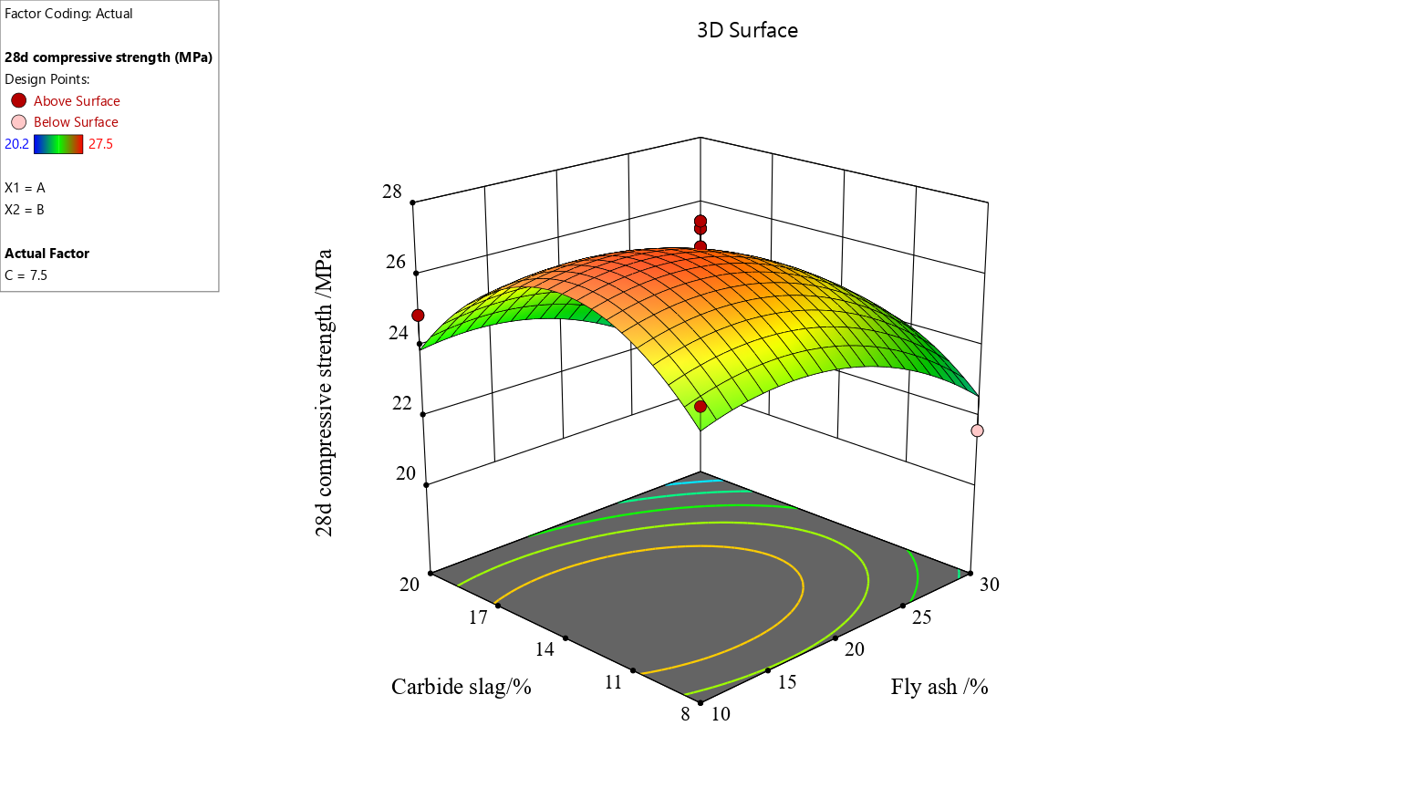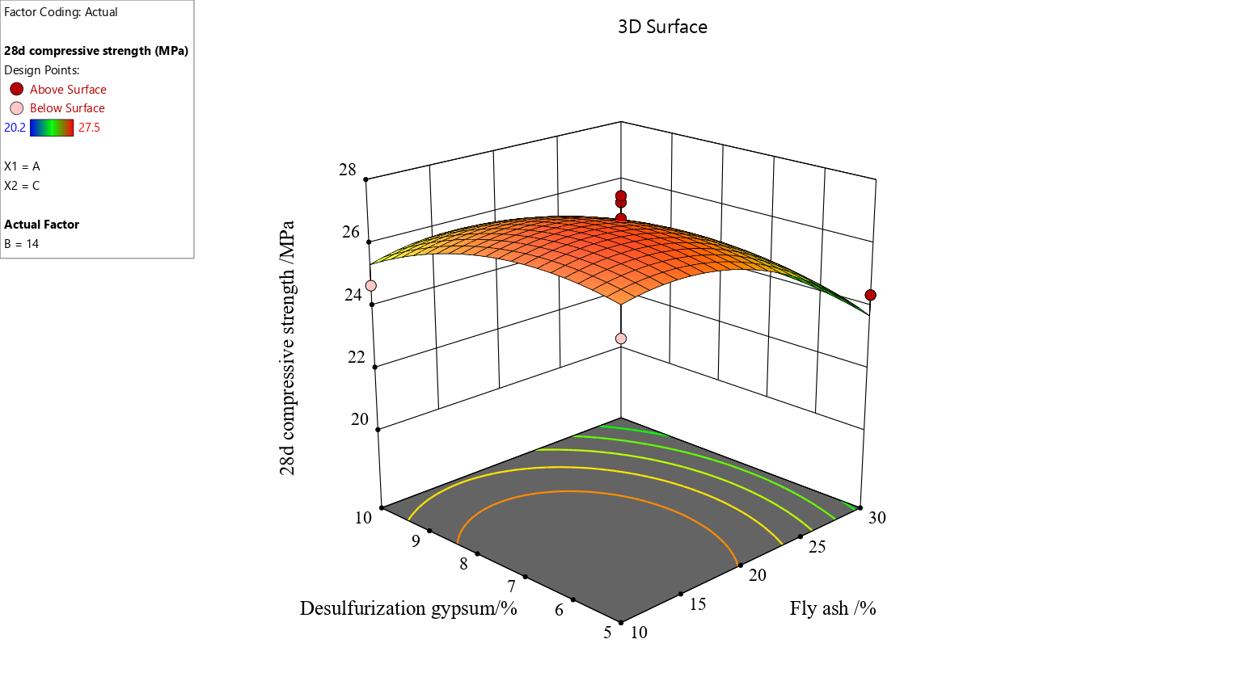

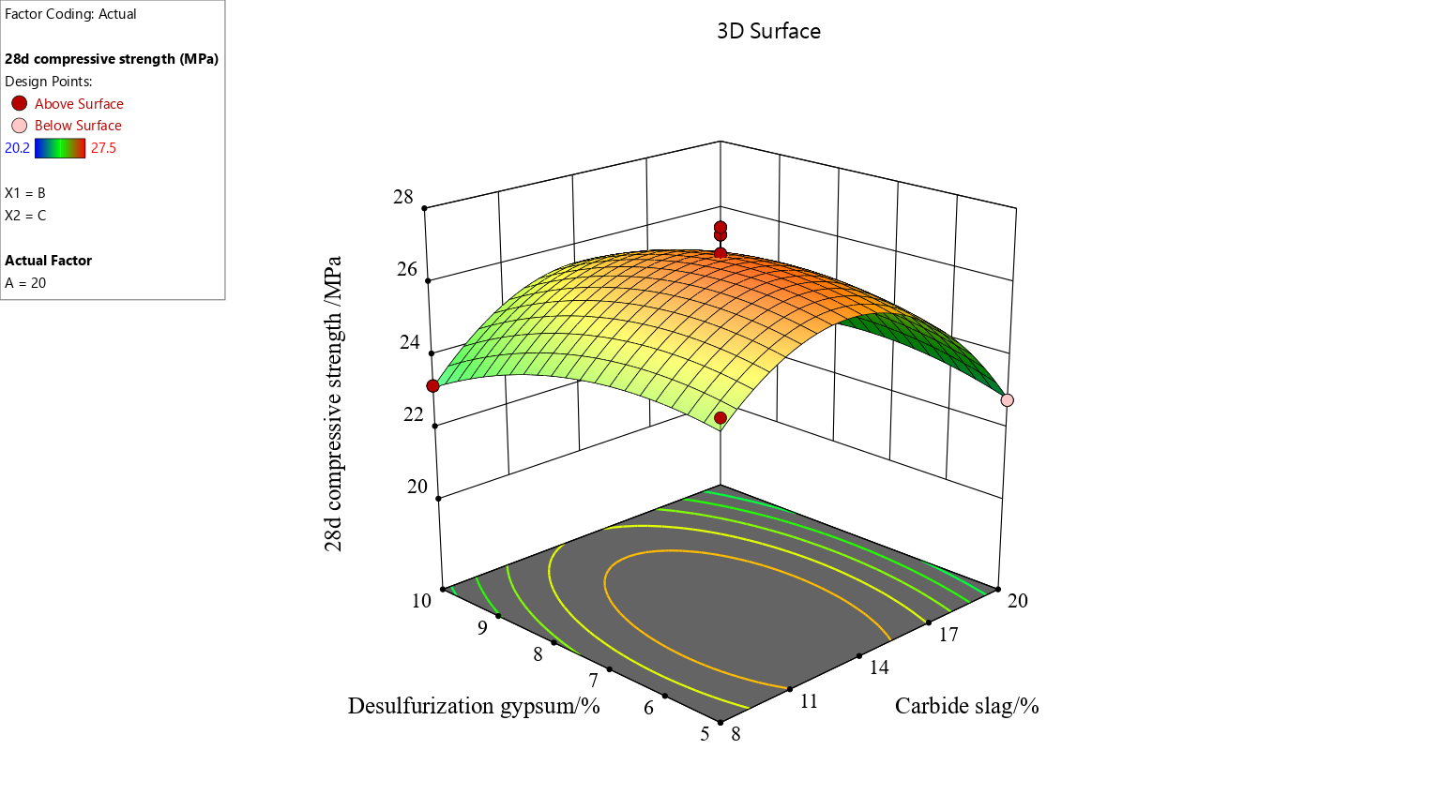
Figure 1 Response Surface Analysis Diagram

The fitted correlation equation is y=26.74-1.25A-0.5875B-0.4375C-0.3000AB+0.2000AC+0.3750BC-1.21A2-2.58B2-0.7825C2，R2=0.8847 Approaching 1 indicates a good fitting effect of the model. By optimizing the proportion of solid waste cementitious materials through the fitted response surface, the optimal level combination obtained from the optimization is: fly ash 27.2%, slag 52.8%, carbide slag 13.1%, desulfurization paste 6.9% according to the fitting equation, with a compressive strength of 27.72 MPa at 28 days.

Source | Sum of Squares | Degree Of Freedom | Mean Square | F Value | Significance Level
Model | 57.75 | 9 | 6.42 | 5.97 | 0.0140 | significant
A | 12.50 | 1 | 12.50 | 11.63 | 0.0113
B | 2.76 | 1 | 2.76 | 2.57 | 0.1530
C | 1.53 | 1 | 1.53 | 1.42 | 0.2715
AB | 0.3600 | 1 | 0.3600 | 0.3349 | 0.5809
AC | 0.1600 | 1 | 0.1600 | 0.1488 | 0.7111
BC | 0.5625 | 1 | 0.5625 | 0.5233 | 0.4929
A² | 6.14 | 1 | 6.14 | 5.71 | 0.0482
B² | 28.08 | 1 | 28.08 | 26.12 | 0.0014
C² | 2.58 | 1 | 2.58 | 2.40 | 0.1654
Residual | 7.52 | 7 | 1.07
Lack of Fit | 5.55 | 3 | 1.85 | 3.75 | 0.1169 | not significant
Pure Error | 1.97 | 4 | 0.4930
Cor Total | 65.28 | 16
Table 9 Analysis of Variance for Quadratic Model Test Results

4.Conclusion
Through response surface methodology optimization design, a fully solid waste geopolymer cementitious material with a compressive strength of 27.5 MPa at 28 days was successfully prepared using fly ash and slag powder as the main silicon-aluminium raw materials, and carbide slag and desulfurization gypsum as composite activators. The optimal ratio is 20% fly ash, 14% carbide slag, 7.5% desulfurization gypsum, and the remaining components are slag powder. This research achievement provides an important theoretical basis and a practical path for the development of high-performance, low-cost, green and low-carbon new cementitious materials.
The fully solid waste geopolymer developed in this study exhibits significant advantages. The production of traditional Portland cement heavily relies on limestone calcination, which not only consumes a large amount of non-renewable mineral resources, but is also one of the main industrial sources of global carbon dioxide emissions. In contrast, geological polymerization reactions are achieved through alkaline excitation under conditions close to room temperature, completely avoiding the high-temperature calcination process. This means that if such materials are widely used in non structural or secondary structural fields such as civil engineering, road base, prefabricated components, etc., they can directly replace traditional cement in equal or partial quantities, thereby significantly reducing the huge carbon emissions caused by cement production from the source and providing a feasible technical route for the building materials industry to achieve deep decarbonization. This system has an economy that is incomparable to traditional alkali activated materials and ordinary cement. Firstly, all of its core components - fly ash, slag powder, carbide slag, desulfurization gypsum, and even aggregate coal gangue - are bulk industrial solid waste with extremely low raw material acquisition costs, and can even achieve negative costs (i.e. disposal fees converted into raw material value). Secondly, it abandons expensive and corrosive chemical activators such as water glass and sodium hydroxide, and instead uses solid waste materials such as carbide slag (providing OH ⁻ alkaline environment) and desulfurization gypsum (providing SO ₄² ⁻ excitation effect), achieving the goal of "treating waste with waste". The fundamental change in the composition of this raw material has significantly reduced the overall preparation cost of the material, greatly enhancing its attractiveness in market price competition and clearing economic barriers for its industrial application.
This technology achieves the synergy of multiple environmental benefits. On the one hand, it converts various industrial solid wastes that urgently need to be treated (such as carbide slag, desulfurization gypsum, fly ash, slag) into high-value-added building materials, which is a model of resource recycling and effectively reduces the occupation of land resources and potential risks to the ecological environment caused by solid waste storage. On the other hand, its "no calcination" ambient temperature preparation process directly avoids the CO ₂ produced by limestone decomposition and fossil fuel combustion. It is estimated that the carbon dioxide emissions from producing one ton of this type of geopolymer cementitious material may be less than 20% of traditional Portland cement. This not only conforms to the national concept of "zero waste city" construction, but also actively responds to the specific practice of the "dual carbon" strategic goal. It is worth noting that the activator of this system itself is also solid waste, which is one of the core innovations of the technical route. The main component of carbide slag is Ca (OH) ₂, and its strong alkalinity is sufficient to break the Si-O and Al-O bonds in the glass structure of fly ash and slag, initiating polymerization reactions. The Ca²⁺and SO²⁻ in desulfurization gypsum can not only promote the generation of products such as ettringite in alkaline environments, which helps to establish early strength, but also may modulate and optimise the formation of geological polymer network structure. This composite excitation mechanism, based on solid waste not only ensures the mechanical properties of the material, but also elevates the depth and breadth of solid waste resource utilisation to a new level.
In summary, this study successfully developed a geopolymer cementitious material system using solid waste as raw material. It has demonstrated significant comprehensive advantages in replacing cement, reducing costs, energy conservation and carbon reduction, and solid waste resource utilisation. Although further research and engineering verification are still needed in terms of long-term durability, volume stability, and standardised applications, there is no doubt that this technology provides a promising solution for building a green, low-carbon, and sustainable building material system, with broad industrial application prospects and significant social, environmental, and economic benefits. Future work should focus on scaling up experiments, developing relevant material standards, and exploring their applicability in specific engineering scenarios to drive this green technology from the laboratory to large-scale engineering applications.

Disclaimer (Artificial intelligence)

Author(s) hereby declare that NO generative AI technologies such as Large Language Models (ChatGPT, COPILOT, etc.) and text-to-image generators have been used during the writing or editing of this manuscript.
Bibliography
[1] SHAH I H,MILLER S A,JIANG D,et al. Cement substitution with secondary materials can reduce annual global CO₂ emissions by up to 1.3 gigatons[J]. Nature Communications, 2022, 13(1): 5758.
[2] DU H,XU D, LI X, et al. Application of molten iron desulfurization slag to replace steel slag as an alkaline component in solid waste-based cementitious materials [J]. Journal of Cleaner Production, 2022, 377: 134353.
[3] ZHAO Y, ZHOU X, ZHOU Q, et al. Development of full-solid waste environmentally binder for cemented paste backfill[J]. Construction and Building Materials, 2024, 443: 137689.
[4] XU Z, LI C, XIAO B, et al. Development of slag-based filling cementitious materials and their application in ultrafine tailing sand filling[J]. Construction and Building Materials, 2024, 452: 138966.
[5] LI K, LI X, YAO J, et al. Innovative synthesis of low-carbon cemented backfill materials through synergistic activation of solid wastes: An integrated assessment of economic and environmental impacts[J]. Case Studies in Construction Materials, 2024, 20: e03203.
[6] XU D, LIU J, DU H, et al. Performance optimization and carbon reduction effect of solid waste-based cementitious materials from iron and steel metallurgical slags and ammonia-soda residue[J]. Chemical Engineering Journal Advances, 2024, 17: 100584.
[7] CHEN T, GAO Y, LI Y, et al. The strength, reaction mechanism, sustainable potential of full solid waste alkali-activated cementitious materials using red mud and carbide slag[J]. Construction and Building Materials, 2024, 449: 138454.
[8] YANG J, WEI H, QUAN Z, et al. A global meta-analysis of coal mining studies provides insights into the hydrologic cycle at watershed scale[J]. Journal of Hydrology, 2023, 617: 129023.
[9] GAO L, LIU Y, XU K, et al. A short review of the sustainable utilization of coal gangue in environmental applications[J]. RSC Advances, 2024, 14(53): 39285-39296.
[10] KARACAN C Ö, FIELD R A, OLCZAK M, et al. Mitigating climate change by abating coal mine methane: A critical review of status and opportunities[J]. International Journal of Coal Geology, 2024, 295: 104623.
[11] LIU J, WANG Z, XIE G, et al. Resource utilization of municipal solid waste incineration fly ash-cement and alkali-activated cementitious materials: A review[J]. Science of The Total Environment, 2022, 852: 158254.
[12] JI P, LIN H, LI S, et al. Technical system and prospects for precise methane extraction in the entire life cycle of coal mining under the goal of “carbon peak and carbon neutrality"[J]. Geoenergy Science and Engineering, 2024, 238: 212855.
[13] WANG J, LIU X, ZHANG Z, et al. Synergistic utilization, critical mechanisms, and environmental suitability of bauxite residue (red mud) based multi-solid wastes cementitious materials and special concrete[J]. Journal of Environmental Management, 2024, 361: 121255.
[14] ZHU C, TAN H, DU C, et al. Enhancement of ultra-fine slag on compressive strength of solid waste-based cementitious materials: Towards low carbon emissions[J]. Journal of Building Engineering, 2023, 63: 105475.
[15] LI K, ZHU L, WU Z, et al. Properties of Cemented Filling Materials Prepared from Phosphogypsum-Steel Slag–Blast-Furnace Slag and Its Environmental Effect[J]. Materials, 2024, 17(14): 3618.
[16] WANG Y, HUANG X, ZHANG S, et al. Utilization of ultrafine solid waste in the sustainable cementitious material for enhanced performance[J]. Construction and Building Materials, 2024, 417: 135239.
[17] LI Y, LUO Y, ZHOU H, et al. Preparation of environmental-friendly cementitious material from red mud and waste glass sludge by mechanical activation[J]. Construction and Building Materials, 2024, 423: 135861.
[18] LIU J, WANG Z, XIE G, et al. Resource utilization of municipal solid waste incineration fly ash-cement and alkali-activated cementitious materials: A review[J]. Science of The Total Environment, 2022, 852: 158254.
[19] WANG J, LIU X, ZHANG Z, et al. Synergistic utilization, critical mechanisms, and environmental suitability of bauxite residue (red mud) based multi-solid wastes cementitious materials and special concrete[J]. Journal of Environmental Management, 2024, 361: 121255.
[20] CHANG N, LI H, LIU W, et al. Improved macro-microscopic characteristic of gypsum-slag based cementitious materials by incorporating red mud/carbide slag binary alkaline waste-derived activator[J]. Construction and Building Materials, 2024, 428: 136425.

