Amplitude Modulation and Coexisting Attractors in a Slow-Fast Duffing System

.
ABSTRACT

This paper aims to investigate the influence of amplitude modulation and coexisting attractors on the formation mechanism of complex bursting oscillations in slow–fast coupled nonlinear systems. Taking a modified three-dimensional van der Pol–Duffing system as the research object, a parametric excitation with frequency far less than the natural frequency is introduced into the system, establishing a slow–fast system model with two-scale coupling characteristics in the frequency domain. Regarding the excitation term as a slow-varying parameter, the equilibrium points, limit cycles, and their bifurcation structures in the fast subsystem are systematically analyzed, revealing the coexistence conditions of different attractors and their impact on the dynamics of the full system.

When the modulation amplitude is relatively small, the slow evolution process of the system becomes notably extended, showing typical quasi-static relaxation–oscillation characteristics. As the modulation amplitude increases, these oscillations vanish rapidly, and the system transitions to a steady equilibrium or an aperiodic oscillatory state. Further investigation reveals that the coexistence of multiple attractors in the fast subsystem can result in diverse bursting behaviors of the full system: trajectories may remain within a single attraction basin or sequentially traverse several basins, thereby generating merged bursting oscillations. Moreover, due to the inertia effect, trajectories may directly cross parameter regions associated with specific attractors, leading to the disappearance of corresponding bifurcation phenomena. When the excitation frequency decreases to a sufficiently low value, previously vanished attractors may re-emerge. If the interval between two types of codimension-1 bifurcation points is extremely narrow, the system may also display compound bursting patterns analogous to those caused by codimension-2 bifurcations.

The research in this paper reveals the synergistic influence mechanism of coexisting attractors in slow-fast systems on relaxation oscillations and bursting dynamics under amplitude modulation conditions, enriching the multiscale dynamical theory of nonlinear oscillators and providing new theoretical references for the study of modulation-induced dynamical evolution in other complex nonlinear systems.

Keywords: (Amplitude modulation; slow-fast system; coexisting attractors; bursting oscillations; Duffing system; nonlinear dynamics)

- INTRODUCTION

Relaxation oscillations (Szmolyan, P. & Wechselberger, M.,2004, Ginoux, J. M. & Letellier, C.,2012, Liu W et al.,2003, Van Der Pol, B. & Van Der Mark, J.,1928, Krupa, M. & Szmolyan, P.,2001) represent a class of nonlinear dynamical phenomena widely observed in nature and engineering systems, characterized by periodic bursts and slow variations under the coupling of fast and slow variables (Peña, M. & Kalnay, E.,2004, Abramov, R. V.,2011, Omelchenko, I., Rosenblum, M. & Pikovsky, A.,2010). This oscillatory form is commonly present in laser outputs, neuronal firing, chemical reactions, self-excited oscillation circuits, and other systems, holding significant importance for understanding the time-domain behavior and energy evolution mechanisms of complex systems. Due to the frequent accompaniment of multi-time-scale coupling, nonlinear feedback, and bifurcation mutations (Demirci, A et al.,2025) in relaxation oscillations, research on their mechanisms has remained a key topic in nonlinear science.
Among the numerous models describing nonlinear oscillatory behaviors, the Duffing system (Ge, Z. M. & Ou, C. Y.,2007, Li, Z et al., 2015, Agrawal et al., 1998) and its variants are widely adopted due to their concise structure and rich dynamical characteristics. This system not only exhibits continuous evolution processes from periodic oscillations to period-doubling bifurcations (Syta et al.,2014) and chaotic attractors (Farmer, J. D.,1928) but also reveals complex dynamical behaviors under slow-fast coupling (Farmer, J. D.,1928, Ghosh, I.,2025, Chabar, N et al.,2025) through the introduction of external modulations. In recent years, with the development of slow-fast system theory (Lobry, C et al.,1999, Koch, D. & Koseska, A.,2024, Huzak, R et al.,2025), researchers have begun to analyze the evolutionary features of nonlinear systems from a multi-time-scale perspective, with particular attention to the influence of external modulations (such as amplitude modulation and frequency modulation) on system bifurcations and dynamical patterns. Among these, amplitude modulation (Farmer, J. D.,1928, Khodaei, A et al.,2025, El Jbari, M., & Moussaoui, M.,2025) has been proven to be an effective dynamical control mechanism, capable of prolonging the system's quasi-static slow processes(Siedel, S., & Gu, T.,2024), altering bifurcation structures, and even inducing abrupt changes and disappearance of oscillations.
On the other hand, an increasing number of studies indicate that multiple attractors (including equilibrium points, limit cycles, and hidden attractors) may coexist simultaneously within the fast subsystem, where the mutual influence among these attractors profoundly reshapes the system’s global dynamical structure. The simultaneous existence of various attractors in the fast domain may lead to trajectory switching between different attracting basins in the full system, generating bursting oscillations, multi-stable coexistence, trajectory jumps, and other complex phenomena. However, systematic research on the interactions among “amplitude modulation–slow–fast coupling–attractor coexistence” remains insufficient, especially in the frequency-domain two-scale framework, where the influence mechanism on the formation and disappearance of relaxation oscillations lacks in-depth exploration.
Drawing from this foundation, our investigation employs an adapted three-dimensional van der Pol–Duffing system (Kuiate, G. et al., 2018) as the primary focus. We integrate low-frequency parametric forcing to develop a dual-scale coupling framework in the frequency domain, treating the forcing component as a gradually evolving variable, and performing a detailed examination of the fast subsystem’s steady states, periodic orbits, and bifurcation features. Through slow–fast analysis and phase diagram transformation methods, the influence laws of amplitude modulation intensity and coexisting attractor structures on the evolution of bursting oscillation (Oveleke, K. S. et al., 2022, Nandi, M. K. et al., 2024) patterns are revealed. The study indicates that under low modulation amplitude, the system undergoes prolonged relaxation oscillations with evident time delay characteristics; as the modulation amplitude increases, these oscillations vanish rapidly, driving the system toward steady or non-periodic dynamic states. The coexistence of multiple attractors in the fast subsystem can induce multiple bursting solutions or merged bursting behaviors, and when trajectories directly cross certain parameter intervals, bifurcation effects temporarily disappear; when the excitation frequency is sufficiently low, these attractors may reappear.

The primary research objective of this paper is to reveal the synergistic mechanism of coexisting attractors in slow-fast systems on bursting oscillation dynamics under amplitude modulation conditions. The research outcomes not only enrich the theoretical framework of nonlinear systems under multi-time-scale coupling (Lazri, A et al.,2024) conditions but also provide new ideas and methods for understanding and controlling complex dynamical behaviors under amplitude modulation.

2.Mathematical Model and the Bifurcations

The three-dimensional nonlinear system mathematical model is given as follows:
$$\dot{x}=-x+y+w$$
$$\dot{y}=-ay+bz-x^{2}y$$
$$\dot{z}=-y+z$$
Where $x,y,z$ are the state variables of the system,and $w=A\sin{(Ωt)}$ is the slow-varying external excitation, with Ω taken to be far below the system’s inherent frequency, aiming to analyze how the two-scale interaction affects the system’s behavior, and $a b$ are the system parameters.
To calculate the equilibrium points (Nash Jr, J.,1950), set:
$$\dot{x}=0,\dot{y}=0,\dot{z}=0$$
yielding
$$-a\left(x-w\right)+b\left(x-w\right)-x^{2}\left(x-w\right)=0$$
$$y=x-w$$
$$z=x-w$$
The equilibrium points can be expressed as $E\left(x,y,z\right)=E(x_{0},x_{0}-w,x_{0}-w)$,where $x_{0}$ satisfies $-a\left(x_{0}-w\right)+b\left(x_{0}-w\right)-{x_{0}}^{2}\left(x_{0}-w\right)=0$.
If $y=0$ an equilibrium point varying with parameter $w$ is obtained:
$$E_{0}\left(x,y,z\right)=E_{0}(w,0,0)$$
If $y≠0$ and $b-a≥0$, a pair of symmetric equilibrium points is obtained:
$$E_{±}\left(x,y,z\right)=E_{±}(±\sqrt{b-a},±\sqrt{b-a}-w,±\sqrt{b-a}-w)$$
A linearization of the system around its equilibrium states is performed, yielding the Jacobian matrix used for stability assessment.
$$J=\left[\begin{matrix}-1 & 1 & 0 \\ -2xy & -a-x^{2} & b \\ 0 & -1 & 1\end{matrix}\right]$$
System stability is inferred from the roots of the corresponding characteristic polynomial.
$$p\left(λ\right)=λ^{3}+\left(a+x^{2}\right)λ^{2}+\left(b+2xy-1\right)λ+\left(-a+b-x^{2}-2xy\right)=0$$
where
$$p_{2}=a+x^{2}$$
$$p_{1}=b+2xy-1$$
$$p_{1}=b+2xy-1$$
According to the Hurwitz criterion (DeJesus, E. X. & Kaufman, C.,1987, Bodson, M.,2020, Ho, M. T., Datta, A. & Bhattacharyya, S. P.,1998) if all coefficients are positive and the constant term is zero:
$$p_{1}>0$$
$$p_{2}>0$$
$$p_{0}=-a+b-x^{2}-2xy=0$$
a fold bifurcation (Kuznetsov, Y et al.,2004, Kadar, F., Stepan, G. & Habib, G.,2025, Gritli, H.,2012)may occur, leading to an exchange of stability at the equilibrium points.
If all coefficients are positive and the product of coefficients$p_{1}$ and $p_{2}$ equals the constant term $p_{0}$,
$$p_{2}>0$$
$$p_{0}>0$$
$$p_{0}=p_{1}p_{2}$$
a Hopf bifurcation (Marsden, J. E., & McCracken, M.,2012) may occur, generating a limit cycle.( He, J. H.,2005).
Figure 1 illustrates the variations in the system's equilibrium points and their stability with the bifurcation parameter $w$ , with fixed system parameters $a=-0.1,b=3.0$. This figure is drawn using numerical continuation methods, utilizing software to track equilibrium branches. The horizontal axis represents parameter $w$ ,and the vertical axis represents state variable $x$. The blue solid lines represent stable equilibrium branches, and the blue dashed lines represent unstable equilibrium branches. The red points mark bifurcation points, where "PF" denotes fold bifurcations and "H" denotes Hopf bifurcations. The symmetric structure in the figure reflects the approximate symmetry of the system near $w=0$.

When $1.04881<\left|w\right|<1.76068$, there exists a stable equilibrium branch corresponding to equilibrium point $E_{0}\left(x,y,z\right)=E_{0}(w,0,0)$, and two horizontal unstable equilibrium branches corresponding to equilibrium points $E_{±}\left(x,y,z\right)=E_{±}(±\sqrt{b-a},±\sqrt{b-a}-w,±\sqrt{b-a}-w)$. At $\left|w\right|=1.76068$, i.e., points ${PF}_{1}$ and ${PF}_{2}$ , transcritical bifurcations (Buonomo, B.,2015) occur, transforming the stable equilibrium point $E_{0}$ into an unstable one, and the unstable equilibrium point $E_{-}$ into a stable one. The subsequently transformed stable equilibrium points undergo supercritical Hopf bifurcations at $\left|w\right|=2.18665$, i.e., points $H_{1}$ and $H_{4}$, generating a stable limit cycle, which further encounters the already transformed unstable equilibrium point $E_{0}$ and eventually disappears.

Oscillations from a single period to a double period. Subsequently, the parameter w continues to change, triggering a continuous period-doubling bifurcation cascade: from the period-2 cycle bifurcating to a period-4 cycle, then to period-8, period-16, and higher-order period-doubling cycles. This cascade process is self-similar, with the parameter intervals between bifurcation points shrinking in a geometric proportion, and the convergence rate governed by the Feigenbaum constant $δ≈4.6692$.Specifically, the parameter differences between adjacent bifurcation points $Δw_{n}$ satisfy $\lim_{n→∞}{{Δw_{n}}/{Δw_{n+1}}}=δ$, leading to the infinite accumulation of bifurcation points within a finite parameter interval. In the narrow interval where |w|＜1.04881, this rapid accumulation of the cascade highlights the system's parameter sensitivity; when the cascade accumulates to the critical point, the system dynamics abruptly shift from ordered period-doubling behavior to chaotic states, forming a chaotic attractor, accompanied by positive Lyapunov exponents (Dingwell, J. B.,2006,Dingwell, J. B.,2006, Wolf, A et al.,2006), as shown in Figure 2, which quantifies the exponential divergence rate of adjacent trajectories, confirming the chaotic behavior. In the center of this interval, chaotic phenomena may appear intermittently through intermittency windows or periodic windows, where brief periodic behaviors are embedded in the chaotic background, further enriching the dynamical complexity.

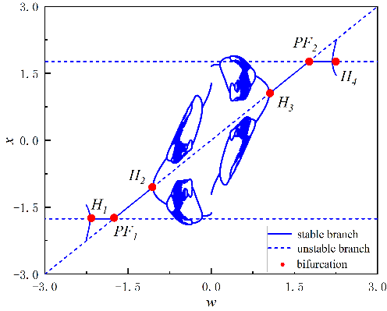
Fig. 1. Bifurcation diagram of equilibrium points versus parameter $w$ for $a=-0$.1,$b=3.0$
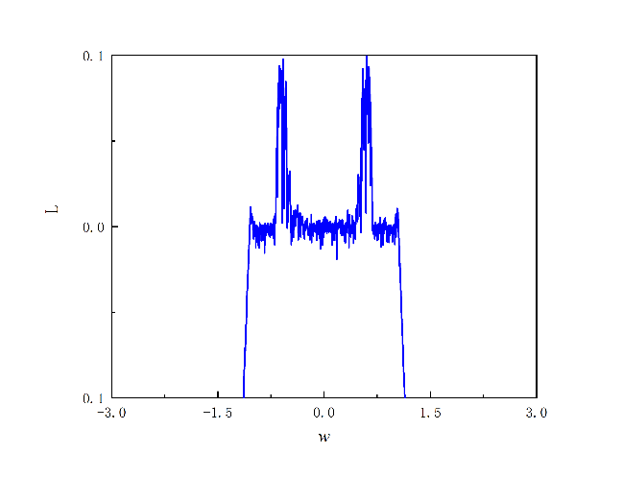
Fig. 2. Dependence of the Lyapunov spectrum on parameter $w$ when$a=0.1$ and $b=3.0$.

2.Dynamical Evolution and Pattern Transition Mechanism

The previous section examined the system’s single-parameter bifurcation characteristics. When $\left|w\right|＜1.04881$, the system exhibits a unique chaotic attractor associated with two supercritical Hopf bifurcation points positioned at both ends. Accordingly, for $\left|A\right|＜1.76068$, this isolated chaotic attractor predominantly governs the overall dynamics. As $|w|$ increases but remains below $1.76068$, the system develops a central chaotic attractor accompanied by two stable equilibrium branches on either side, indicating that within this range, the trajectory is affected not only by the chaotic component but also by the adjacent equilibrium states. When $\left|w\right|＜ 3$, the system demonstrates a central chaotic zone along with equilibrium branches that undergo stability transitions and limit cycles arising from Hopf bifurcations, thereby contributing to a more intricate dynamical evolution.

3.1 Localized Oscillation Dynamics

First, the case where $|A|＜1.04881$ is discussed. Figure 3 illustrates the time series plot (Goswami, B.,2019), phase diagram (Okamoto, H., & Massalski, T. B.,1990), and the superposition of the transformed phase diagram with the one-parameter bifurcation diagram under fixed parameter $A = 0.75$. Figure 3.a describes the evolution of the system state variable x with time t, where the trajectory of x exhibits a clear periodic oscillation pattern. Figure 3b describes the evolution trajectory of the system state variables x and y, with the phase diagram presenting a closed, elliptical curve cluster, indicating the existence of a stable attractor.

In Figure 3c, the Hopf bifurcation occurs at $|w|=1.04881$, while when $|A|＜1.04881$, no bifurcations occur within the region, so the system is only influenced by the central chaotic attractor, and the system trajectory undergoes periodic oscillations solely under the influence of the chaotic attractor.
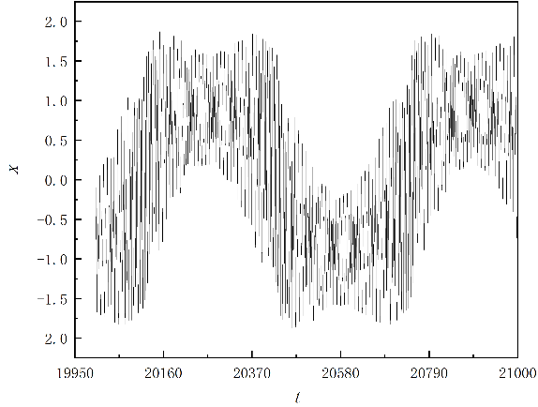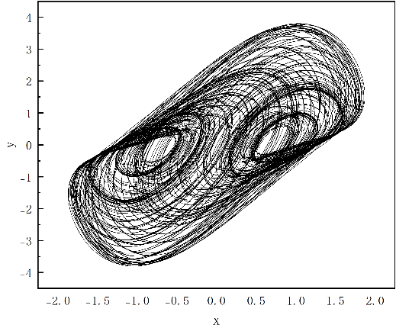
(a) (b)

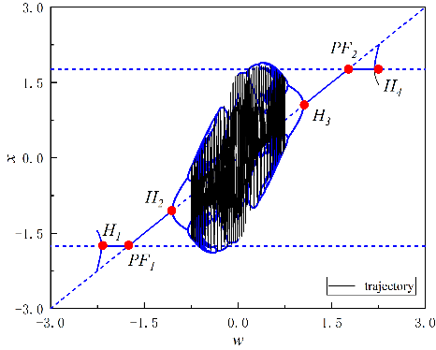
(c)
Fig. 3. Time series, phase diagram, and combined bifurcation–phase diagram of the system for $A=0.75$, showing periodic oscillations.

3.2 Multi-Stable Interaction and Delayed Transition

Figure 4 illustrates the time series plot, phase diagram, and the superposition of the transformed phase portrait with the one-parameter bifurcation diagram under fixed parameter $A=1.2$.

As shown in Figure 4c, a Hopf bifurcation takes place when $|w|$ reaches $1.04881$. For $|A|＜1.76068$, the system trajectory passes through the bifurcation point, where it is affected jointly by the chaotic attractor and the stable equilibrium branch $E_{0}$. Starting from $w=-1.2$, the trajectory initially follows the stable branch $E_{0}$. Upon approaching$w=-1.04881$ (denoted as point $H_{1}$), a Hopf bifurcation occurs, converting the previously stable branch $E_{0}$ into an unstable one. Owing to the delayed dynamic response (Nowlis et al., 1990), the trajectory does not immediately deviate from the bifurcation point but continues to evolve along the newly unstable branch for a short interval. Around $w=0.25$, the system begins to exhibit oscillations under the influence of the chaotic attractor, eventually settling again on $E_{0}$, which regains stability through another Hopf bifurcation. The system demonstrates symmetry; therefore, when $w$ decreases, a similar trajectory evolution is observed.
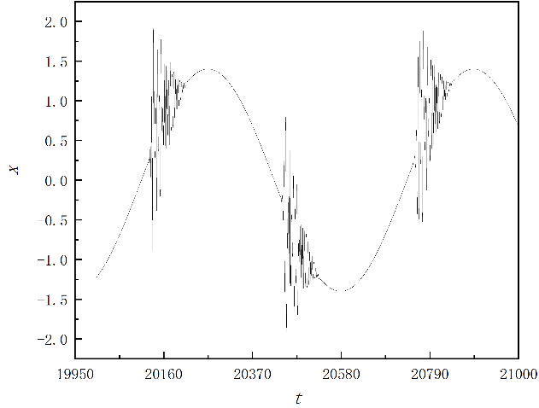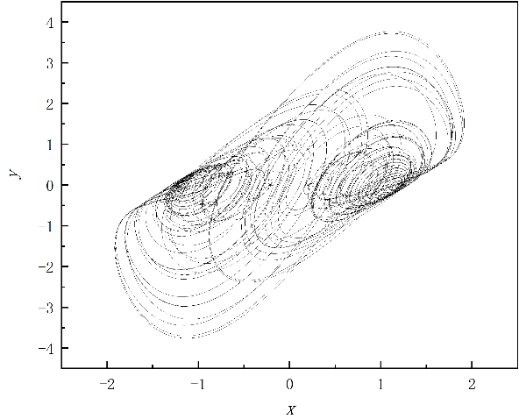
(a) (b)

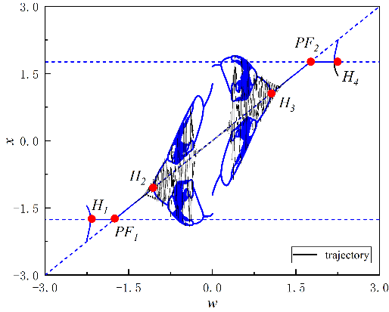
(c)
Fig. 4 Time series, phase diagram, and combined bifurcation–phase diagram of the system for $A=1.2$, showing periodic oscillations.

3.3 Global Chaotic Evolution and Complex Bursting

Figure 5 illustrates the time series plot, phase diagram, and the superposition of the transformed phase diagram with the one-parameter bifurcation diagram under fixed parameter $A=2.2$.

In Figure 5c, the Hopf bifurcations are observed at$|w|=1.04881$ and $|w|$=2.18665, while a transcritical bifurcation takes place at $|w|=1.76068.$ For $|A|<3$, the system trajectory successively passes through these bifurcation points, leading to increasingly intricate dynamical behaviors. Starting from $w=-1.2$, the trajectory is initially governed by the stable equilibrium branch $E0$ and progresses along it. When w approaches $-1.04881$ (point $H_{1}$), a Hopf bifurcation arises, converting the previously stable branch $E_{0}$ into an unstable one.Owing to the system’s delayed feedback response (Nowlis et al., 1990), the trajectory does not immediately diverge from the bifurcation but temporarily follows the now unstable branch. As $w$ increases toward zero, the motion gradually exhibits oscillatory behavior under the effect of the chaotic attractor and finally settles onto $E_{0}$, which regains stability as a consequence of the Hopf bifurcation.With 𝑤 continuing to rise and approaching $1.76068$(point ${PF}_{2}$), a transcritical bifurcation takes place. However, due to the delay mechanism, the system’s path persists for a while along the unstable branch before transitioning to a limit cycle. When 𝑤 reaches approximately $2.18665$, it converges onto the transformed stable branch $E_{+}$ through the Hopf bifurcation process. Conversely, as $w$ decreases back to $1.76068,$ the influence of the transcritical bifurcation causes the trajectory to move from $E_{+}$ toward $E_{0}$, restoring the equilibrium to stability again and resulting in a reciprocal dynamic evolution.
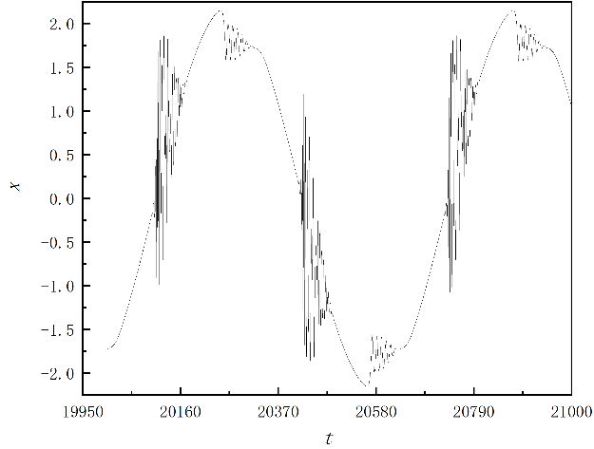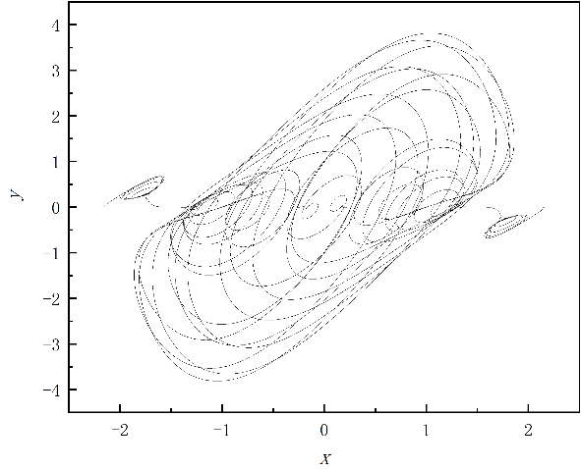
(a) (b)

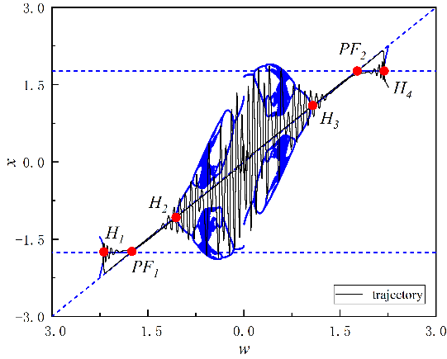
(c)
Fig. 5. Time series, phase diagram, and combined bifurcation–phase diagram of the system for $A=2.2$, showing periodic oscillations.

4. Conclusion

This study focuses on the interaction mechanism between amplitude modulation and coexisting attractors in a nonlinear slow–fast system, aiming to clarify their influence on bursting and relaxation oscillations. Based on a modified three-dimensional Van der Pol–Duffing oscillator, a two-scale coupled model was established and analyzed using the fast–slow decomposition and numerical continuation. The main conclusions can be summarized as follows:
(1) Amplitude modulation plays a dual role in shaping the slow–fast dynamics.
When the modulation index is low, the system exhibits an extended quasi-static slow process, indicating that amplitude modulation effectively regulates the slow subsystem. However, as the modulation amplitude increases, relaxation oscillations gradually weaken and eventually disappear. This transition suggests that strong modulation can destroy the balance between fast and slow subsystems, leading to an abrupt change in oscillatory behavior.
(2) The coexistence of attractors in the fast subsystem is the key origin of complex bursting oscillations.
Analysis of the equilibrium points, limit cycles, and their bifurcations reveals that multiple coexisting attractors can generate diverse bursting patterns through basin switching. System trajectories may move between different attraction basins, producing hybrid or merged bursting behaviors. When the trajectory directly crosses the parameter intervals associated with certain attractors, the corresponding bifurcation effects vanish, a phenomenon referred to as inertial crossing.
(3) The coupling between amplitude modulation and coexisting attractors introduces a new nonlinear mechanism.
Amplitude modulation not only alters the system’s energy flow but also restructures the interactions among multiple attractors. When the modulation frequency is sufficiently low and the modulation index is large, the system exhibits attractor merging and the disappearance of relaxation oscillations, revealing a new mechanism of modulation-induced disappearance of oscillations.
(4) The findings have potential implications for vibration control and complex system analysis.
Amplitude modulation provides an effective means to regulate the oscillatory amplitude and rhythm in nonlinear systems, while the identification of coexisting attractors offers theoretical guidance for controlling multistability in nonlinear circuits, mechanical oscillators, and biological rhythmic models.
In summary, this work elucidates the cooperative influence of amplitude modulation and attractor coexistence on the bursting and relaxation dynamics of a slow–fast nonlinear oscillator. The revealed mechanisms enrich the theoretical framework of modulation-driven nonlinear dynamics and offer new perspectives for the analysis and control of multi-scale nonlinear systems. Future work may extend these findings to other forms of modulation (e.g., frequency or mixed modulation) and noise-driven perturbations to further generalize the understanding of complex multi-scale behaviors.

Disclaimer (Artificial intelligence)
Author hereby declare that NO generative AI technologies such as Large Language Models (ChatGPT, COPILOT, etc.) and text-to-image generators have been used during the writing or editing of this manuscript.

References

Kuznetsov, Y. A., Meijer, H. G., & van Veen, L. (2004). The fold-flip bifurcation. International Journal of Bifurcation and Chaos, 14(07), 2253-2282.
Li, Z., Chen, D., Zhu, J., & Liu, Y. (2015). Nonlinear dynamics of fractional order Duffing system. Chaos, Solitons & Fractals, 81, 111-116.
Liu, W., Xiao, D., & Yi, Y. (2003). Relaxation oscillations in a class of predator–prey systems. Journal of Differential Equations, 188(1), 306-331.
Lobry, C., Sari, T., & Touhami, S. (1999). Fast and slow feedback in systems theory. Journal of Biological Systems, 7(03), 307-331.
Marsden, J. E., & McCracken, M. (2012). The Hopf bifurcation and its applications (Vol. 19). Springer Science & Business Media.
Nash Jr, J. F. (1950). Equilibrium points in n-person games. Proceedings of the National Academy of Sciences, 36(1), 48-49.
Okamoto, H., & Massalski, T. B. (1990). Binary alloy phase diagrams. ASM International, Materials Park, OH, USA, 12, 3528-3531.
Omelchenko, I., Rosenblum, M., & Pikovsky, A. (2010). Synchronization of slow-fast systems. The European Physical Journal Special Topics, 191(1), 3-14.
Peña, M., & Kalnay, E. (2004). Separating fast and slow modes in coupled chaotic systems. Nonlinear Processes in Geophysics, 11(3), 319-327.
Syta, A., Litak, G., Lenci, S., & Scheffler, M. (2014). Chaotic vibrations of the Duffing system with fractional damping. Chaos: An Interdisciplinary Journal of Nonlinear Science, 24(1).
Krupa, M., & Szmolyan, P. (2001). Relaxation oscillation and canard explosion. Journal of Differential Equations, 174(2), 312-368.
Van Der Pol, B., & Van Der Mark, J. (1928). LXXII. The heartbeat considered as a relaxation oscillation, and an electrical model of the heart. The London, Edinburgh, and Dublin Philosophical Magazine and Journal of Science, 6(38), 763-775.
Wolf, A., Swift, J. B., Swinney, H. L., & Vastano, J. A. (1985). Determining Lyapunov exponents from a time series. Physica D: Nonlinear Phenomena, 16(3), 285-317.
Szmolyan, P., & Wechselberger, M. (2004). Relaxation oscillations in R3. Journal of Differential Equations, 200(1), 69-104.
Bodson, M. (2020). Explaining the Routh–Hurwitz criterion: A tutorial presentation [focus on education]. IEEE Control Systems Magazine, 40(1), 45-51.
Nowlis, S. M., Mandel, N., & McCabe, D. B. (2004). The effect of a delay between choice and consumption on consumption enjoyment. Journal of Consumer Research, 31(3), 502-510.

Demirci, A., Peker-Dobie, A., Ozemir, C., & Ahmetolan, S. (2025). Hopf bifurcation in the shadow of extinction: Collaborating with epidemic dynamics through lethal mutations and declining ancestor infections. BioSystems, 248, 105406.
Oyeleke, K. S., Olusola, O. I., Kolebaje, O. T., Vincent, U. E., Adeloye, A. B., & McClintock, P. V. E. (2022). Novel bursting oscillations in a nonlinear gyroscope oscillator. Physica Scripta, 97(8), 085211.
Nandi, M. K., Valla, M., & Di Volo, M. (2024). Bursting gamma oscillations in neural mass models. Frontiers in Computational Neuroscience, 18, 1422159.
Khodaei, A., Jahan, K., Babu, G. H., Ahammad, S. H., Sharma, J., Hossain, M. A., ... & Nabil, A. A. (2025). Optimization of the performance parameters of the Giga passive optical networks for high transmission data rates with various modulation schemes. Journal of Optical Communications, 45(s1), s941-s953.
El Jbari, M., & Moussaoui, M. (2025). The hybrid pulse amplitude width modulation scheme: high efficiency technique for dimmable VLC systems. Journal of Optical Communications, 45(s1), s2151-s2168.
Ghosh, I., Fatoyinbo, H. O., & Muni, S. S. (2025). Time series analysis of coupled slow–fast neuron models: From Hurst exponent to Granger causality. Chaos: An Interdisciplinary Journal of Nonlinear Science, 35(10).
Chabar, N., Amazioug, M., & Shah, A. S. (2025). Generating three transparency windows, Fano-resononce and slow/fast light in magnomechanical system through an auxiliary microwave cavity. arXiv preprint arXiv:2504.11535.
Lazri, A., Panteley, E., & Loría, A. (2024). Analysis and Control of Multi-Time-Scale Modular Directed Heterogeneous Networks. IEEE Transactions on Control of Network Systems, 12(1), 661-672.
Siedel, S., & Gu, T. (2024). Toward a complete understanding of quasi-static bubble growth and departure. Proceedings of the National Academy of Sciences, 121(16), e2317202121.
Koch, D., & Koseska, A. (2024). Ghost cycles exhibit increased entrainment and richer dynamics in response to external forcing compared to slow-fast systems. arXiv preprint arXiv:2403.19624.
Huzak, R., Jardón-Kojakhmetov, H., & Kuehn, C. (2025). Ergodicity in planar slow-fast systems through slow relation functions. SIAM Journal on Applied Dynamical Systems, 24(1), 317-345.

