Case Report

Bilateral Supernumerary Roots in the Maxillary Third Premolars of a Dog: A Case Report

ABSTRACT

Anatomical variations in canine dentition, including supernumerary roots, are uncommon but clinically significant, since, among other issues, these structures can accelerate the process of alveolar bone resorption or require a more complex extraction procedure to prevent root fracture. This report describes a rare bilateral occurrence of supernumerary roots in the maxillary third premolars (107 and 207) of a 15-year-old female dog. Radiographic evaluation confirmed three distinct roots per tooth. The teeth were extracted due to severe periodontal disease affecting the supporting structures. This case emphasizes the importance of routine intraoral radiographs in veterinary dentistry for detecting anatomical anomalies and contributes to the understanding of dental variations in dogs.

Keywords: Canine dentition; maxillary premolars; periodontal disease; intraoral radiography; supernumerary roots.

1. INTRODUCTION

The dental anatomy of dogs is well documented in the literature, including specific formulas for both deciduous and permanent dentition (Merck manual, 2025; Soltero-Rivera, 2024). In adult animals, the maxillary arch consists of incisors, canines, premolars and molars. The maxillary third premolar (PM3; teeth 107 and 207, according to the modified Triadan numbering system) typically presents two roots: one mesiobuccal and one distal. However, anatomical variations, such as the presence of supernumerary roots, may occur, although such variations are uncommon in maxillary premolars (Lacerda et al., 2000). This anomaly has already been reported in Irish Setter dogs (Mulherin & White, 2021), cats (Emslie & Tutt, 2020) and humans (Gandhi & Patil, 2013). Studies have reported an approximate prevalence of 6.3% for supernumerary roots in dogs, affecting mainly the incisors but also occasionally premolars (Pavlica et al., 2001). These anomalies are clinically relevant, as they may complicate dental procedures such as extractions and endodontic treatments, emphasizing the importance of radiographic diagnosis. The present case report describes a bilateral variation in a female dog, contributing to the understanding of dental anomalies in canines.

2. PRESENTATION OF CASE

A 15-year-old, 28-kg, spayed mixed-breed female dog was presented to the veterinary clinic in August 2025 for a routine oral examination. The owner did not report any specific clinical signs such as pain, dysphagia, chewing difficulty, or halitosis. The medical history indicated an up-to-date vaccination protocol and no previous systemic diseases.
During a detailed oral examination, advanced periodontal disease associated with grade II gingivitis was observed, with no radiographic or clinical evidence of dental fractures or abscesses. Based on these findings, dental scaling and polishing were performed under general anesthesia (pre-anesthetic medication: Acepromazine [0.02 mg/kg IM] and Methadone [0.3 mg/kg IM]; anesthetic induction: Propofol [4 mg/kg IV] to effect; Anesthetic maintenance: Isoflurane in oxygen at 2%; Local block: Bupivacaine 0.5% [2 mg/kg, regional]), followed by full-mouth intraoral radiographic evaluation.

Radiographs evidence revealed a bilateral anatomical variation in the maxillary third premolars (107 and 207), each presenting three distinct roots instead of the two typically described (Figure 1). The images showed well-defined root contours, with the supernumerary roots located in the mesiopalatal region and exhibiting morphology similar to the mesiobuccal roots. Despite this uncommon anatomical finding, there were no radiographic signs of endodontic involvement.
Conversely, severe alveolar bone loss was identified, predominantly affecting the furcation areas, consistent with advanced-stage periodontal disease. Diffuse bone rarefaction, discontinuity of the lamina dura, and significant loss of periodontal support were also observed. The remaining teeth showed normal anatomy and radiographic appearance for the species.

Due to the severe compromise of the periodontal supporting structures, characterized by marked bone loss and furcation involvement, extraction of the maxillary third premolars (107 and 207) was performed. The procedure was completed without intraoperative complications, and examination of the extracted material confirmed the presence of three distinct roots in each tooth (Figure 2). Postoperative care included implementation of oral hygiene management protocols, periodic professional prophylaxis, and annual radiographic follow-up to monitor bone healing and prevent recurrence of periodontal disease.

3. discussion

Dental anatomical variations in dogs, including supernumerary roots, represent developmental anomalies that may be associated with genetic, environmental, or idiopathic factors (Lacerda et al., 2000; Verstraete & Terpak, 1997). Although more frequently described in deciduous teeth—such as cases of biradicular maxillary canines (Assiry, 2019; Guler, 2012) - reports involving permanent teeth remain sporadic. In a study conducted with 285 dogs, supernumerary roots were identified in 18 animals, predominantly affecting incisors but also occasionally occurring in premolars (Pavlica et al., 2001). Similar cases in the literature include the description of a supernumerary root in the mandibular second molar of a Staffordshire Terrier, with no associated clinical manifestations (Collados et al., 2025).

In the present case, the bilateral occurrence of the anomaly suggests a probable genetic origin, possibly hereditary, although no familial history was available to confirm this hypothesis. From a clinical perspective, the presence of additional roots may increase the risk of root fractures during extraction procedures and complicate endodontic therapy, which may require specific techniques such as multirooted sectioning. Furthermore, such variations can predispose the patient to periodontal disease due to the increased complexity of maintaining adequate hygiene in these areas, highlighting the need for of continuous monitoring.

Radiographic diagnosis proved to be essential, consistent with current recommendations for the use of imaging in veterinary dentistry (Freeman, 2021). Veterinarians should be aware of such anomalies when planning extractions or other dental procedures, and always consider full-mouth radiography in older patients with periodontal disease. This case underscores the value of routine intraoral radiographs, through which dental anomalies may be detected that would otherwise remain underdiagnosed.

4. Conclusion

The present report describes a rare bilateral anatomical variation consisting of supernumerary roots in the maxillary third premolars of a female dog, without immediate clinical repercussions. These anomalies are clinically significant, as they can complicate dental procedures such as extractions and endodontic treatments, highlighting the critical role of diagnostic imaging in veterinary dentistry and contributing to the understanding of dental anomalies in dogs. Furthermore, future studies with a genetic approach may help elucidate the etiology of such variations.

DISCLAIMER (ARTIFICIAL INTELLIGENCE)
Author(s) hereby declare that NO generative AI technologies such as Large Language Models (ChatGPT, COPILOT, etc) and text-to-image generators have been used during writing or editing of manuscripts.

ETHICAL APPROVAL
Animal Ethics committee approval has been collected and preserved by the author(s).

COMPETING INTERESTS
Authors have declared that no competing interests exist.

References

Assiry, A. (2019). Bi-Rooted Primary Maxillary Canines: A Case Report. Journal Of Medical Case Reports, 13(1), 261. DOI: https://doi.org/10.1186/s13256-019-2174-9
Collados, J., Fuertes-Recuero, M. & Rice, C. A. (2025). Presence Of A Supernumerary Root Of The Right Mandibular Second Molar In A Staffordshire Terrier: A Case Report. Veterinary Research Communications, 49(99), 4-5. DOI : https://doi.org/10.1007/s11259-025-10669-0
Emslie, R. S. & Tutt, C. L. C. (2020). Supernumerary maxillary fourth premolar teeth in five related burmese cats. Journal of feline medicine and surgery open reports, 6(2). DOI: https://doi.org/10.1177/2055116920946278
Freeman, A. (2021). Introduction to dental radiography in cats and dogs. In practice, 43(6), 300-310. DOI: https://doi.org/10.1002/inpr.78
Gandhi, B. & Patil, A. C. (2013). Root Canal Treatment of a Mandibular Second Premolar with Three Roots and Canals–An Anatomic Variation. Journal of Dentistry, 10(6), 569.
Guler, C. (2012). Double-Rooted Maxillary Primary Canine: A Case Report And Literature Review. Annals of Health Sciences Research,1(2), 57-59.
Lacerda, M., Oliveira, S., & Queiroz, D. (2000). Variações Anatômicas Na Dentição De Cães Sem Raça Definida (Anatomical variations in the dentition of mongrel domestic dogs). Ciencia Rural, 30, 655-659. DOI: https://doi.org/10.1590/S0103-84782000000400016
Merck Veterinary Manual. (2025). Dentition, Dog. Available At: https://www.merckvetmanual.com/multimedia/image/dentition-dog [Accessed 13 August 2025].
Mulherin, B. L. & White, R. (2021). Unerupted supernumerary mandibular fourth premolar in a dog. Journal of veterinary dentistry, 38(3), 152-160. DOI: https://doi.org/10.1177/08987564211052102
Pavlica, Z, Erjavec, V & Petelin, M. (2001). Teeth Abnormalities In The Dog. Acta Veterinaria, 70, 65–72.
Soltero-Rivera, M. (2024). Dentition And Dental Nomenclature Of Animals. Available At: https://www.merckvetmanual.com/digestive-system/dental-development-and-anatomy/dentition-and-dental-nomenclature-of-animals [Accessed 13 August 2025].
Verstraete, F., & Terpak, C. (1997). Anatomical Variations In The Dentition Of The Domestic Cat. Journal Of Veterinary Dentistry, 14, 137-140. DOI: https://Doi.Org/10.1177/089875649701400403

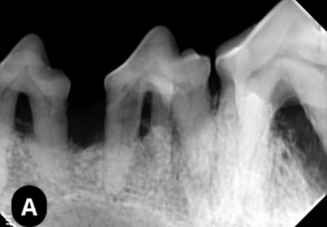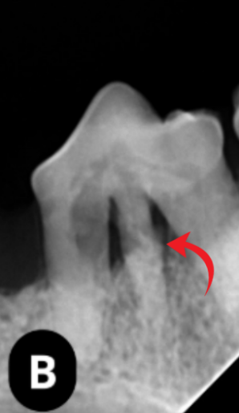

Figure 1. (A) Digital intraoral radiograph obtained using the bisecting-angle technique. (B) Digital intraoral radiograph obtained using the Clark technique, demonstrating the presence of an accessory root (arrow).

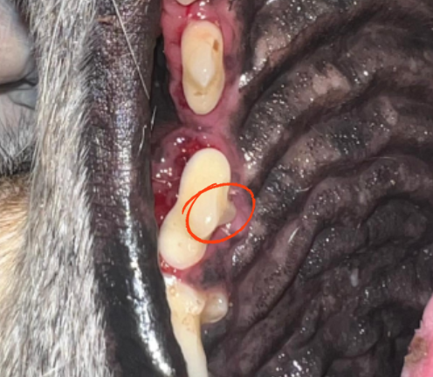

Figure 2. Photographic image of the upper right third premolar (107), highlighting the evident supernumerary root (circled area).

