Evaluation of Pre-Analytical Elements Affecting the Rejection of Hematology Samples at Masvingo Provincial Laboratory, Zimbabwe

ABSTRACT
Background:
Pre-analytical errors are the leading source of laboratory inaccuracies worldwide, accounting for over 60% of all diagnostic testing errors. In hematology, sample quality is critically dependent on correct collection, labeling, and transport practices. Errors during this phase not only delay diagnosis but also waste resources and compromise patient safety. Despite ongoing laboratory quality improvement initiatives in Zimbabwe, limited data exist on the prevalence and causes of hematology sample rejection in provincial hospitals.
Objective:
The present study determine the prevalence, causes, and clinical implications of hematology sample rejection at Masvingo Provincial Hospital Laboratory, Zimbabwe, and to assess how pre-analytical variables influence sample rejection trends.
Methods:
A retrospective descriptive study was conducted using data from the hematology section of Masvingo Provincial Hospital Laboratory covering the period January–December 2024. Records from the sample rejection logbook and Laboratory Information Management System (LIMS) were reviewed. Parameters analyzed included total number of hematology samples received, number and reasons for rejection, source of samples, and time of occurrence.
Results:
A total of 6,364 hematology samples were processed during the study period, of which 72 were rejected, giving an annual rejection rate of 1.13%. Monthly rejection rates fluctuated between 0.2% and 3.0%, with the highest rates observed in June, July, and October 2024. The leading causes of sample rejection were clotted samples (28%), wrong sample tubes (18%), lipemic samples (14%), and insufficient volume (14%). Other causes included hemolysis (11%) and mismatched specimen details (13%). Most rejected samples originated from the Pediatric Ward (32%) and Antenatal Clinic (19%), indicating higher vulnerability among these clinical areas.
Conclusion:
Pre-analytical variables significantly affect hematology sample rejection at Masvingo Provincial Hospital Laboratory. While documentation and labeling practices appear satisfactory, technical errors—particularly clotting and use of incorrect tubes—remain a challenge. Strengthening staff competency through continuous professional training, regular quality audits, and improved transport logistics will help reduce rejection rates and improve the reliability of hematology results.
Keywords: Pre-analytical errors, Hematology, Sample rejection, Laboratory quality, Zimbabwe

INTRODUCTION
Clinical laboratory testing plays a pivotal role in modern medicine, providing critical information that influences more than 70% of medical decisions regarding diagnosis, prognosis, and therapeutic management. However, the accuracy of test results is highly dependent on the quality of the specimen analyzed. The pre-analytical phase—encompassing all steps from test requisition, patient identification, sample collection, labeling, handling, and transport to the laboratory—is widely recognized as the most vulnerable stage in the total testing process. Estimates suggest that 60–80% of laboratory errors originate during this phase, far exceeding those occurring during the analytical or post-analytical phases [1-2]. In hematology laboratories, the integrity of blood specimens is particularly susceptible to pre-analytical factors because cell morphology, stability, and count accuracy depend on precise collection and handling conditions. Common pre-analytical issues include improper mixing with anticoagulants, under- or over-filling of collection tubes, sample clotting, hemolysis, mislabeled specimens, and prolonged transportation times. Such factors can render samples unsuitable for analysis, leading to sample rejection. The consequences are multifold: repeat venipuncture, delayed turnaround times, patient discomfort, waste of consumables, and financial strain on healthcare institutions [3].
Globally, sample rejection rates vary widely—from 0.3% in highly automated reference laboratories to over 10% in resource-limited settings. In low- and middle-income countries (LMICs), including those in sub-Saharan Africa, infrastructural limitations, inconsistent phlebotomy training, and weak transport systems exacerbate pre-analytical errors. In Zimbabwe, the National Laboratory Services Directorate under the Ministry of Health and Child Care has emphasized quality management systems (QMS) to improve laboratory reliability and accreditation readiness. Yet, despite these efforts, pre-analytical errors remain under-reported and under-investigated, particularly in provincial laboratories that serve as referral hubs for surrounding districts [4]. Masvingo Provincial Laboratory is a key diagnostic center supporting healthcare delivery for a wide catchment area that includes multiple district hospitals and peripheral clinics. The laboratory processes a substantial number of hematology specimens daily, ranging from full blood counts to malaria and differential analyses. Anecdotal reports from internal audits have suggested an upward trend in hematology sample rejections—mainly attributed to clotting, underfilled tubes, and incorrect labeling. However, systematic data on the magnitude and determinants of these pre-analytical problems have not been formally documented. Without empirical evidence, it is difficult to design targeted interventions to improve laboratory performance and achieve the goals of the Zimbabwe National Quality Assurance Programme [5]. This study, therefore, sought to investigate the impact of selected pre-analytical variables on hematology sample rejection rates at Masvingo Provincial Laboratory, Zimbabwe. By identifying the most frequent causes of rejection and their associated factors—such as collection source, sample transport delay, and staff training frequency—this research aims to provide evidence-based insights for strengthening laboratory quality systems. The findings are expected to inform corrective actions, guide policy in sample handling practices, and ultimately enhance the reliability of hematology testing across provincial and district laboratories in Zimbabwe.

METHODOLOGY

Research design
A retrospective cross-sectional study design was utilized for this research. This approach was the most appropriate as it allowed for the analysis of existing data over a defined period, facilitating the examination of preanalytical variables and their association with sample rejection rates. By analyzing historical data, the study was able uncover patterns and trends without the need for prospective data collection.

Study setting
The research was conducted at Masvingo Provincial Laboratory, a prominent healthcare facility in the Masvingo region selected due to its significance in hematology testing and the observed variability in sample rejection rates. The laboratory serves a diverse patient population, providing an ideal context to study the impact of preanalytical factors on sample quality through historical records.

Study population
The study population consist of all patient samples submitted for hematology testing at Masvingo Provincial Laboratory over a one-year period. This means it included samples that were accepted and those that were rejected due to various preanalytical errors. The study incorporated key informant interviews to gather qualitative insights from three laboratory personnel and three other healthcare providers. By including both accepted and rejected samples, the study aimed to provide a comprehensive understanding of the factors contributing to sample rejection.

Sample size and sampling procedure
Sample size measures the number of individual samples measured or observations used in a survey or experiment (Zambani, 2018). All patient samples that were run per month were reviewed, comprising both accepted and rejected samples.

Data collection instruments, their validity and reliability
Data was collected using a standardized data extraction form designed to capture relevant information regarding preanalytical variables, including specimen collection techniques, handling, and transportation conditions. The data extraction form was developed based on existing literature and expert consultations to ensure content validity. Its reliability was assessed through a pilot test, aiming for a Cohen's kappa coefficient of 0.78 or higher, indicating substantial agreement among reviewers.

Pretesting of instruments
Pretesting of the data extraction form was conducted with a subset of 20 patient records prior to the main data collection. This process allowed for the identification of potential issues in the form's clarity and relevance. Feedback from the pre-test lead to necessary revisions, enhancing the instrument's effectiveness in capturing accurate data.

Inclusion criteria
In this study, we focused on a diverse group of patients whose samples are collected at Masvingo Provincial Hospital Laboratory. This included both adults and children, allowing us to capture a wide range of demographics that reflect our community. The time frame for the data collection extended throughout the year 2024, which allowed for a comprehensive analysis. This study only focused on hematology samples, such as those for complete blood counts and coagulation tests, to keep our focus sharp and relevant. The main interest lied in the preanalytical phase, which includes patient preparation, specimen collection, handling and transportation. By examining these factors, the main aim was to uncover how they affect sample rejection rates in the lab.

Exclusion Criteria
Any samples that were rejected before January 2024 were not be included, as they fell outside our study's timeframe. Certain patient populations were excluded, particularly those with known hematological disorders, since their conditions could skew our results. Furthermore, the research did not consider analytical and post-analytical variables, such as those related to actual test performance and interpretation of results, as the primary focus was on the pre-analytical phase.

Data collection procedure
Data collection was carried out over a four-week period. Trained research assistants reviewed the laboratory’s historical records and extracted relevant data from the selected patient files. They ensured meticulous attention to detail to maintain the accuracy and integrity of the data collected. The data was organized systematically for analysis, with all identifying information anonymised to protect patient confidentiality

RESULTS

Prevalence of hematology sample rejection at Masvingo Provincial Hospital laboratory

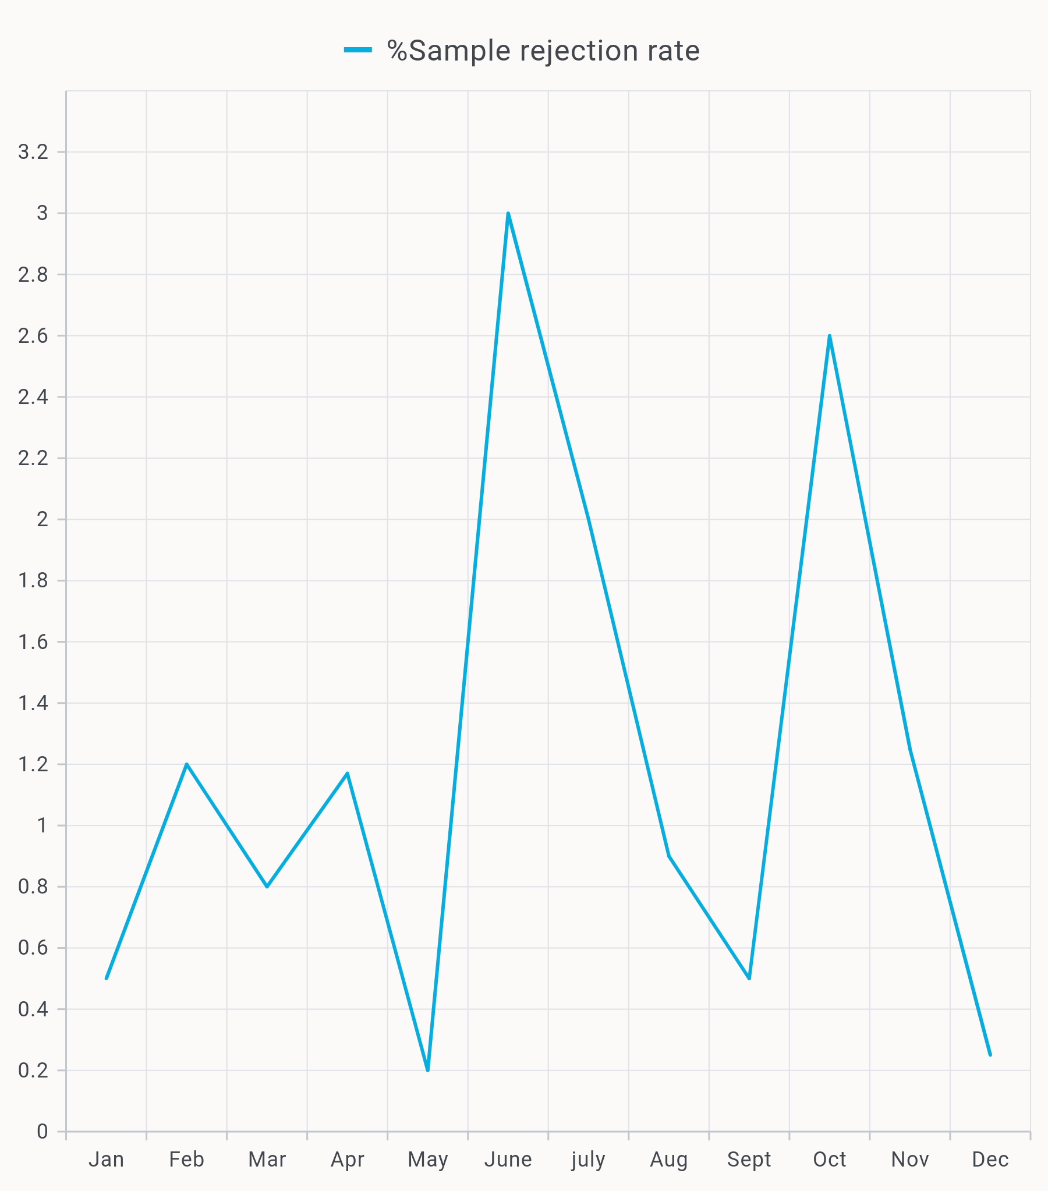
Figure 1: Hematology sample rejection at Masvingo Provincial Hospital

The monthly rejection rates for Hematology fluctuated between 0.2% and 3.0%. The highest rejection rates were in June, July and October 2024, whereas the lowest rejection rate was in May 2024.

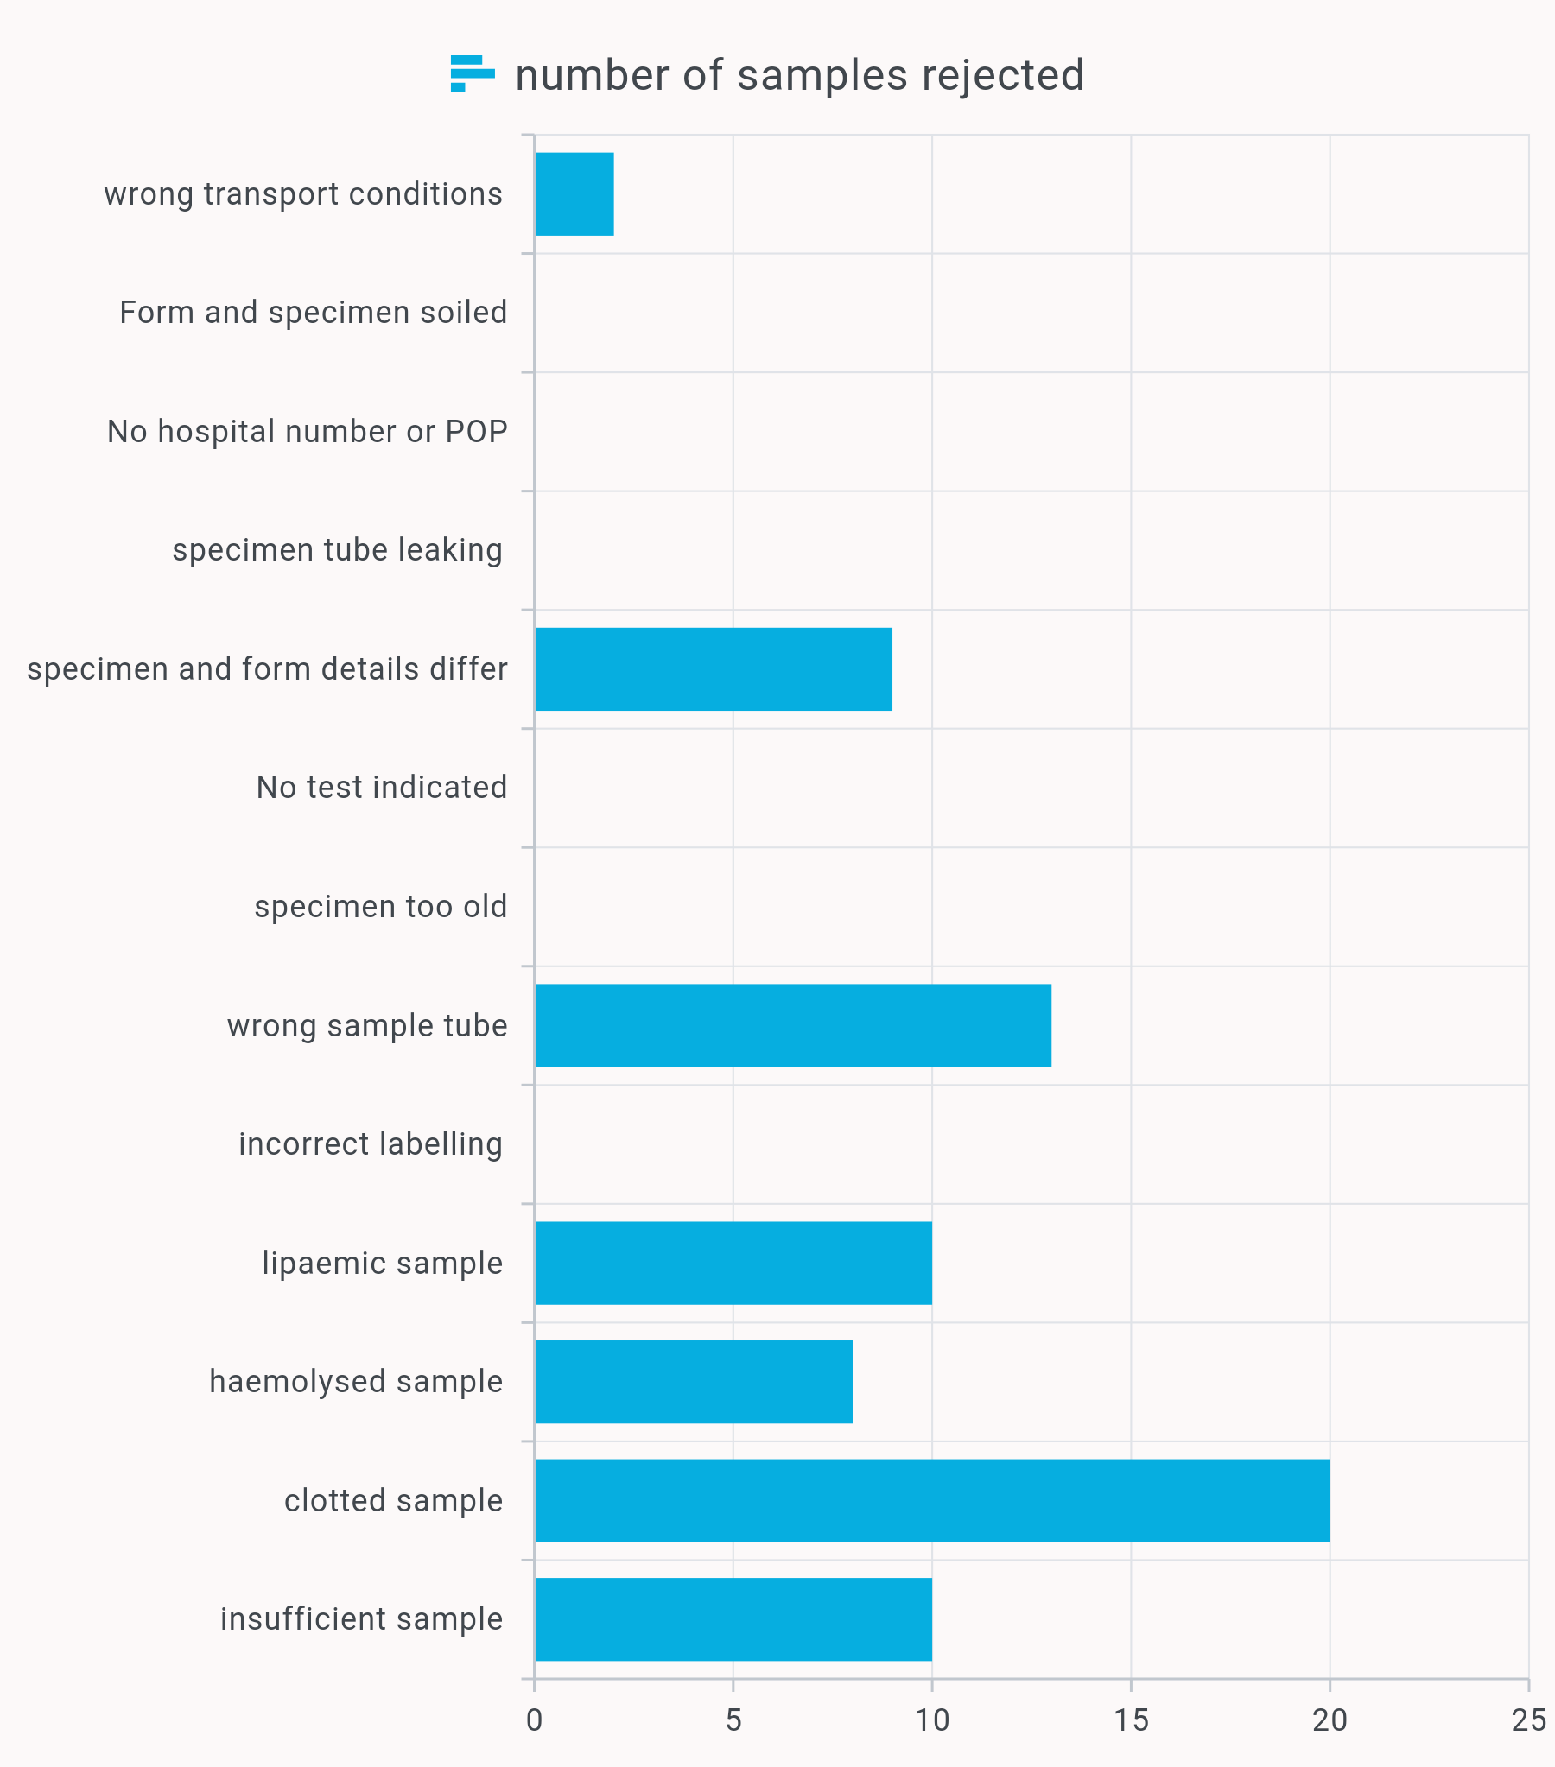
Figure 2: Most common reasons for sample rejection at Masvingo Provincial Hospital

Clotted samples were found to be the leading cause of rejection in hematology with a total of 20 samples, which constitute 28% of all rejected samples. This was followed by wrong sample tubes (18%), lipaemic samples (14%) and insufficient samples (14%). Eight samples were rejected because they were hemolyzed. Also, nine samples were rejected because specimen and form details differed and another two samples were rejected because of wrong transport conditions. There were no samples rejected because the hospital number or proof of payment was missing, incorrect labelling, specimen tube was leaking, form and specimen were soiled, no test was indicated and specimen was too old.

Table 1: Analysis of the locations of blood taking
WARD | NUMBER OF SAMPLES REJECTED | PERCENTAGE OF REJECTION
Pediatric Ward | 23 | 32
Antenatal Clinic | 14 | 19
Post Natal Ward | 10 | 14
Out-Patient Department | 10 | 14
Other Wards | 15 | 21

Analysis of the locations of blood taking showed that most of the rejected samples came from the pediatric ward followed by the antenatal Clinic. Others such as Post Natal Ward and the outpatient department contributed to 10 and 8 rejected samples. The rest of the wards at the hospital had 20 rejected samples combined

DISCUSSION

Prevalence of Hematology Sample Rejection
The findings of this study revealed an overall hematology sample rejection rate of 1.13% at Masvingo Provincial Hospital Laboratory for the year 2024. Although this percentage appears relatively low, it represents a meaningful quality indicator that warrants attention, particularly in a busy provincial laboratory setting. The rate aligns with international benchmarks, which typically range between 0.3% and 2% in well-performing laboratories, yet it remains higher than the ideal rejection rate of below 1% recommended for continuous quality improvement [6]. Monthly fluctuations were observed, with rejection rates ranging between 0.2% and 3.0%, peaking in June, July, and October 2024. These variations may be attributed to seasonal workload changes, staff rotations, or variations in adherence to standard operating procedures (SOPs). For instance, the months with higher rejection rates could coincide with increased patient load, staff shortages, or newly assigned personnel unfamiliar with sample handling protocols. Such temporal patterns underscore the importance of continuous monitoring and staff retraining to minimize preventable pre-analytical errors [7]. The relatively higher rejection rates observed in certain months are comparable to findings from other regional studies. For example, a study in Nigeria reported a 2.6% rejection rate for hematology samples, with notable peaks during periods of high clinical demand. Similarly, South African provincial laboratories have reported periodic spikes in rejection rates linked to inconsistent phlebotomy practices and lapses in transport logistics. Thus, the rejection rate observed at Masvingo Provincial Hospital Laboratory, while moderate, reflects broader systemic challenges common in resource-constrained laboratory networks [8].

Major Causes of Hematology Sample Rejection
Analysis of rejection causes showed that clotted samples were the leading reason for rejection (28%), followed by wrong sample tubes (18%), lipemic samples (14%), and insufficient samples (14%). Other less frequent causes included hemolysis, mismatched specimen details, and improper transport conditions. Notably, there were no rejections due to missing hospital numbers, proof of payment, incorrect labeling, or soiled forms, indicating that administrative compliance with documentation has improved [9]. Clotted samples remain one of the most common pre-analytical errors in hematology worldwide. This typically occurs when blood is not adequately mixed with anticoagulant (EDTA) or when there is a delay between collection and mixing. Such clots can lead to inaccurate cell counts or obstruct the analyzer, necessitating sample rejection and recollection. The predominance of clotted specimens at Masvingo may reflect gaps in phlebotomy training, improper tube inversion practices, or delayed sample transport from collection points to the laboratory [10].
The use of wrong sample tubes (18%) highlights a need for stricter adherence to phlebotomy protocols and color-code awareness. Each laboratory test requires specific anticoagulants and additives, and inappropriate tube selection can compromise test validity. This challenge is often observed in settings where staff rotation leads to inexperienced personnel collecting samples for specialized tests. Lipemic and hemolyzed samples accounted for a combined 27% of rejections. Lipemia is often due to non-fasting samples or poor patient preparation, while hemolysis results from excessive pressure during venipuncture, small-bore needles, or rough handling. Both conditions affect plasma clarity and interfere with hematology analyzer performance. The identification of these errors signals the need for enhanced patient pre-test instructions and improved phlebotomy technique supervision [11].

Clinical and Patient Implications
Sample rejection is not merely a laboratory inconvenience—it has direct implications on patient care. The analysis of sample sources showed that the Pediatric Ward accounted for the highest proportion of rejected samples (32%), followed by the Antenatal Clinic (19%), Postnatal Ward (14%), and the Outpatient Department (14%). The high rejection rate in the pediatric ward could be due to the challenges of obtaining adequate blood volumes from infants and young children, which often leads to underfilled or clotted samples. Similarly, in the antenatal and postnatal units, physiological changes in pregnancy and the urgency of sample collection may contribute to suboptimal handling [12]. These findings have significant implications. Recollection delays patient management decisions, especially for vulnerable populations such as neonates and pregnant women, where timely hematological assessment is critical. Repeated venipunctures also increase discomfort, risk of anemia in neonates, and resource wastage. Furthermore, persistent rejections can undermine clinician confidence in laboratory services, ultimately compromising the perceived reliability of diagnostic outcomes [13-14]. The absence of rejections due to missing labels or soiled specimens is commendable and reflects adherence to basic laboratory identification protocols. However, the persistence of clotted and underfilled samples suggests that technical rather than administrative factors are now the major contributors to pre-analytical errors. Strengthening continuous professional development for phlebotomists, enforcing sample adequacy checks at collection points, and improving feedback between laboratory and clinical departments could effectively reduce these rejections [16].

Comparison with Other Studies and Quality Improvement Implications
The overall pattern of findings aligns with existing literature indicating that the majority of laboratory errors occur before analysis. In a Tanzanian study, clotted samples constituted 33% of all hematology rejections, closely mirroring the 28% observed in this study. Similarly, insufficient volume and wrong tube usage were recurrent issues across African laboratories where workload pressure and limited supervision persist [17]. The relatively low annual rejection rate (1.13%) at Masvingo Provincial Hospital suggests that quality control systems are in place but can be enhanced. Implementing root cause analysis (RCA) for recurring rejection types, along with regular audits and phlebotomy refresher courses, could further minimize pre-analytical waste. Moreover, introducing sample transport time monitoring—using barcoded timestamps or courier logs—could help reduce delays that contribute to clotting and hemolysis [18-19]. From a quality management perspective, hematology sample rejection should continue to serve as a key performance indicator (KPI) within the laboratory’s quality assurance framework. Tracking this indicator over time will help assess the effectiveness of interventions and guide accreditation readiness under programs such as Zimbabwe National Quality Assurance Programme (ZINQAP) and WHO-Afro SLIPTA (Stepwise Laboratory Improvement Process Towards Accreditation) [6].

CONCLUSION
This study assessed the impact of pre-analytical variables on hematology sample rejection at Masvingo Provincial Hospital Laboratory and revealed that, although the overall annual rejection rate (1.13%) was relatively low, several preventable factors continue to compromise sample quality and workflow efficiency. The most frequent causes of rejection were clotted samples, wrong sample tubes, lipemic specimens, and insufficient sample volume, highlighting persistent challenges in phlebotomy practice and specimen handling. Rejection rates fluctuated across the year, with notable peaks in June, July, and October 2024, suggesting that seasonal workload variations, staff turnover, or lapses in adherence to standard operating procedures may influence pre-analytical performance. Furthermore, the pediatric and antenatal units contributed the highest proportion of rejected samples, underscoring the technical difficulties of specimen collection in vulnerable patient groups such as children and pregnant women.
These findings underscore the need for strengthened pre-analytical quality control measures, including continuous staff training, improved communication between clinical wards and the laboratory, and strict adherence to specimen collection and transport protocols. Periodic audits, timely feedback, and monitoring of rejection trends should form part of the laboratory’s quality assurance system to maintain diagnostic reliability. Minimizing pre-analytical errors is essential not only for improving laboratory efficiency but also for enhancing patient safety and clinical outcomes. Sustained commitment to quality management, supervision, and education at all stages of the specimen journey will ensure that the Masvingo Provincial Hospital Laboratory continues to deliver accurate, timely, and trustworthy hematological results.
Ethical Approval and Consent:
Ethical approval was be obtained from the institutional review board prior to the commencement of the study. Given the retrospective nature of the research, informed consent from patients was not required. However, confidentiality was maintained throughout the process, with all data anonymised and securely stored to protect patient privacy. The study will adhered to ethical guidelines for research involving human subjects. Also, approval to carry out the study was obtained from the management at Masvingo provincial hospital laboratory.

Disclaimer (Artificial intelligence)
Author(s) hereby declare that NO generative AI technologies such as Large Language Models (ChatGPT, COPILOT, etc.) and text-to-image generators have been used during the writing or editing of this manuscript.

REFERENCES
- Sikaris K. A. (2017). Enhancing the Clinical Value of Medical Laboratory Testing. The Clinical biochemist. Reviews, 38(3), 107–114.
- Marzinke, M. A., Clarke, W., Dietzen, D. J., Hoofnagle, A. N., McMillin, G. A., & Willrich, M. A. V. (2022). The VALIDity of Laboratory Developed Tests: Leave it to the experts?. Journal of mass spectrometry and advances in the clinical lab, 27, 1–6. https://doi.org/10.1016/j.jmsacl.2022.12.002
- Iqbal, M. S., Tabassum, A., Arbaeen, A. F., Qasem, A. H., Elshemi, A. G., & Almasmoum, H. (2023). Preanalytical Errors in a Hematology Laboratory: An Experience from a Tertiary Care Center. Diagnostics (Basel, Switzerland), 13(4), 591. https://doi.org/10.3390/diagnostics13040591
- Mesganaw, B., Hassen, F., Molla, H., & Misganaw, K. (2024). Laboratory specimen rejection rate and associated factors among referred specimens at Debre Markos Referral Hospital, Ethiopia: prospective cross-sectional study. The Pan African medical journal, 47, 112. https://doi.org/10.11604/pamj.2024.47.112.33795
- Tatendaishe Chinyoka & Emmanuel Ifeanyi Obeagu. (2025). Prevalence and Correlation of Red Blood Cell Indices and Iron Deficiency Anemia among Patients Tested at Masvingo Provincial Hospital, Zimbabwe . Asian Hematology Research Journal, 8(2), 101–109. https://doi.org/10.9734/ahrj/2025/v8i2200
- Berta, D. M., Chane, E., Tarekegn, A. M., Cherie, N., Mulatie, Z., Kelem, A., Addisu, B., & Teketelew, B. B. (2025). Assessment of Hematology Laboratory Specimen Rejection Rate and Associated Factors at Northwest, Ethiopia. Health science reports, 8(6), e70925. https://doi.org/10.1002/hsr2.70925
- Elgebli, A., Hall, J., & Phipps, D. L. (2024). Protocols versus practice: unravelling clinical checking variations in community pharmacies in England-a multi-method study. International journal of clinical pharmacy, 46(5), 1114–1123. https://doi.org/10.1007/s11096-024-01743-9
- Inalegwu, A., Phillips, S., Datir, R., Chime, C., Ozumba, P., Peters, S., Ogbanufe, O., Mensah, C., Abimiku, A., Dakum, P., & Ndembi, N. (2016). Active tracking of rejected dried blood samples in a large program in Nigeria. World journal of virology, 5(2), 73–81. https://doi.org/10.5501/wjv.v5.i2.73
- Dikmen, Z. G., Pinar, A., & Akbiyik, F. (2015). Specimen rejection in laboratory medicine: Necessary for patient safety?. Biochemia medica, 25(3), 377–385. https://doi.org/10.11613/BM.2015.037
- Arul, P., Pushparaj, M., Pandian, K., Chennimalai, L., Rajendran, K., Selvaraj, E., & Masilamani, S. (2018). Prevalence and types of preanalytical error in hematology laboratory of a tertiary care hospital in South India. Journal of laboratory physicians, 10(2), 237–240. https://doi.org/10.4103/JLP.JLP_98_17
- Krasowski M. D. (2019). Educational Case: Hemolysis and Lipemia Interference With Laboratory Testing. Academic pathology, 6, 2374289519888754. https://doi.org/10.1177/2374289519888754
- Rooper, L., Carter, J., Hargrove, J., Hoffmann, S., & Riedel, S. (2017). Targeting Rejection: Analysis of Specimen Acceptability and Rejection, and Framework for Identifying Interventions in a Single Tertiary Healthcare Facility. Journal of clinical laboratory analysis, 31(3), e22060. https://doi.org/10.1002/jcla.22060
- Obeagu, G. U., Altraide, B. O., & Obeagu, E. I. (2025). Iron deficiency anemia in pregnancy and related complications with specific insight in Rivers State, Nigeria: a narrative review. Annals of medicine and surgery (2012), 87(6), 3435–3444. https://doi.org/10.1097/MS9.0000000000003224
- Obeagu, G. U., & Obeagu, E. I. (2025). Complications of anemia in pregnancy: An updated overview for healthcare professionals. Medicine, 104(35), e44246. https://doi.org/10.1097/MD.0000000000044246
- Getawa, S., Aynalem, M., Melku, M., & Adane, T. (2022). Blood specimen rejection rate in clinical laboratory: A systematic review and meta-analysis. Practical laboratory medicine, 33, e00303. https://doi.org/10.1016/j.plabm.2022.e00303
- Atay, A., Demir, L., Cuhadar, S., Saglam, G., Unal, H., Aksun, S., Arslan, B., Ozkan, A., & Sutcu, R. (2014). Clinical biochemistry laboratory rejection rates due to various types of preanalytical errors. Biochemia medica, 24(3), 376–382. https://doi.org/10.11613/BM.2014.040
- Aquino, J. B., & Damian, K. B. (2025). Pre-analytical Factors Influencing Blood Sample Rejection Rate in the Hematology Laboratory of the Philippine General Hospital from 2018 to 2022: A Cross-sectional Study. Acta medica Philippina, 59(11), 30–36. https://doi.org/10.47895/amp.vi0.9961
- Martin-Delgado, J., Martínez-García, A., Aranaz, J. M., Valencia-Martín, J. L., & Mira, J. J. (2020). How Much of Root Cause Analysis Translates into Improved Patient Safety: A Systematic Review. Medical principles and practice : international journal of the Kuwait University, Health Science Centre, 29(6), 524–531. https://doi.org/10.1159/000508677
- Getawa, S., Aynalem, M., Melku, M., & Adane, T. (2023). Blood specimen rejection rate in clinical laboratory: A systematic review and meta-analysis. Practical laboratory medicine, 33, e00303.

