Original Research Article

A Comparative Analysis of Vitamin D Deficiency-Related Symptoms and Disorders among Vegetarian and Non-vegetarian Individuals

.
ABSTRACT

Aims: To analyze vitamin D deficiency-related symptoms and disorders among vegetarian and non-vegetarian individuals.
Introduction-Vitamin D is a fat-soluble essential micronutrient crucial for maintenance of bone health, dental strength, immune function and overall well-being. Although Indians are living in a tropical climate with an abundance of sunlight, vitamin D deficiency symptoms and related disorders are prevalent across the population. The comparative cross-sectional study assessed the prevalence of vitamin D deficiency-related symptoms and disorders among vegetarian and non-vegetarian adults of rural and urban areas in Varanasi District, Uttar Pradesh, India
Methodology: Samples were selected using simple random sampling method. Data collected from a sample of 200 individuals, i.e.100 each from both vegetarian and non-vegetarian populations through survey using a structured questionnaire. The collected data were analyzed using SPSS software for statistical findings.
Results: The outcomes revealed that symptoms related to vitamin D deficiency, such as fatigue, Muscle pain, Bone and joint pain are prevalent among both the dietary groups with vegetarians showing slightly higher percentages. However, the overall distribution of deficiency-related symptoms and disorders was similar across both groups. While clinical signs and symptoms provided useful evaluations to study the vitamin D deficiency-related symptoms and disorders, future studies should incorporate serum 25-hydroxyvitamin D/25(OH)D level for a more objective and accurate assessment of vitamin D status to determine the deficiency.
Conclusion: Dietary patterns influence vitamin D intake but, factors such as sun exposure, skin pigmentation, and supplement use have greater effects on vitamin D levels. This study underscores the urgent need for public health interventions endorsing Screening, adequate sunlight exposure, dietary fortification and supplementation strategies to be applicable for all individuals regardless of their dietary habits.

Keywords: Vitamin D, Deficiency symptom, Dietary habit, Sunlight exposure, Public health

1. INTRODUCTION
Individuals’ nutritional intake and overall health are significantly affected by their dietary habits. India has a significant population with diverse dietary habits, including vegetarian and non-vegetarian. Due to deep-rooted cultural, religious, and regional influences, dietary habit varies, leading to a wide variation in food choices (ICMR, 2022). Vitamin D is a fat-soluble essential micronutrient primarily responsible for increasing intestinal absorption of calcium and phosphate, along with numerous other biological functions. Adequate vitamin D intake is critical for proper immune function, maintenance of bone health and overall well-being (Holick, 2017). Deficiency of vitamin D has been associated with various health concerns, i.e., bone diseases, compromised immune function, increased susceptibility to certain chronic diseases like cardiovascular diseases and certain cancers (Bouillon et al., 2019) (Judd and Tangpricha, 2009). Classical clinical signs such as rickets, delayed motor milestones in children, bony deformities, diffused bone pain, proximal muscle weakness, mood disturbance (Cashman et al., 2016) and frequent falls in adults are specific for moderate-to-severe deficiency, but mild or subclinical deficiency may be asymptomatic or present with non-specific symptoms i.e., fatigue, myalgia, mood disturbance. These symptoms may significantly impact the quality of life of an individual and may go unnoticed as they overlap with other morbidity and comorbidity conditions.
In recent times, there has been a growing trend towards vegetarianism driven by various factors such as cultural beliefs, ethical considerations, and health concerns (Leitzman, 2014). Dietary differences between vegetarians and non-vegetarians are relevant to vitamin D status because natural dietary sources of preformed vitamin D i.e., vitamin D₃(cholecalciferol) are concentrated in fatty fish, egg yolk and animal fats, whereas many vegetarian diets containing plant foods having no preformed vitamin D i.e., some plants contain ergosterol derivatives convertible to vitamin D₂(ergocalciferol) (Calvo et al., 2004). Clinical studies and meta-analyses indicate that vitamin D₃ is generally more effective at raising circulating 25-hydroxy vitamin D (calcifediol) concentration- the Circulating form of vitamin D in blood produced by the liver, therefore it is more bioavailable than vitamin D₂, which has practical implications when interpreting deficiency risk among dietary groups and planning supplementation or fortification strategies (Tripkovic et al.,2012).
While national reports such as from the Indian Council of Medical Research (ICMR) and global reviews from WHO-region meta-analyses report a very high prevalence of vitamin D deficiency in India i.e., nearly 90% and globally it counts for 15.7% adults with severe deficiency. there is no publicly available data that stratifies prevalence by vegetarian versus non-vegetarian dietary groups (Mogire et al., 2020). This underscores the rationale for our comparative study, which aims to assess and compare the prevalence of vitamin D deficiency-related symptoms and disorders among vegetarian and non-vegetarian individuals. By understanding the dietary influences on vitamin D deficiency-related symptoms and disorders, this research seeks to inform public health strategies and dietary recommendations to mitigate the risk of vitamin D deficiency-related symptoms and disorders and to understand other morbidity conditions for the better health and well-being of the population.

2. OBJECTIVES
The present study was undertaken with the following objectives:
a. To assess the prevalence of vitamin D deficiency-related symptoms and disorders among vegetarian and non-vegetarian individuals.
b. To determine the association between dietary habits and vitamin D deficiency-related symptoms and disorders.

3. HYPOTHESIS
H₀: There is no significant association between dietary habits and vitamin D deficiency-related symptoms and disorders.
H₁: There is a significant association between dietary habits and vitamin D deficiency-related symptoms and disorders.

4. methodology
The study adopted a cross-sectional design to assess the prevalence of vitamin D deficiency related symptoms and disorders among adults with different dietary practices. Two hundred adults comprising of 100 each with vegetarian and non-vegetarian dietary practice were selected by simple random sampling technique from urban and rural areas of Varanasi District of Uttar Pradesh, India. Individuals on vitamin D or calcium supplements, Pregnant and lactating women were excluded from the study. Data related to demographic and socio economic profile of the respondents was collected using a pre-tested structured questionnaire. Based on clinical signs, symptoms and self reported disease conditions the prevalence of vitamin D deficiency-related symptoms and disorders were recorded. The collected data were analyzed using SPSS software for statistical figures. The association between dietary habits and vitamin D deficiency-related symptoms and disorders was established by chi-square test.

5. results and discussion

  - Demographic Data
The demographic characteristics of the participants, providing an overview of their basic background details such as age, gender and other relevant socio-demographic factors were studies and presented in Table1. These variables help in understanding the composition of the sample and aid in interpreting the study results.
Table 1. Demographic and Socio-Economic Characteristics of the Samples
Variables | Category | Vegetarian (n=100) | Non-Vegetarian (n=100) | Total (N=200)
Age Group(Year) | 18-21 | 30(30%) | 28(28%) | 58(29%)
Age Group(Year) | 22-25 | 44(44%) | 38(38%) | 82(41%)
Age Group(Year) | 26-30 | 26(26)% | 34(32%) | 60(30%)
Gender | Male | 48(48%) | 52(52%) | 100(50%)
Gender | Female | 52(52%) | 48(48%) | 100(50%)
Residence | Urban | 56(56%) | 58(58%) | 114(57%)
Residence | Rural | 44(44%) | 42(42%) | 86(43%)
Education Level | Illiterate | 0(0%) | 0(0%) | 0(0%)
Education Level | Primary | 0(0%) | 0(0%) | 0(0%)
Education Level | Secondary | 0(0%) | 0(0%) | 0(0%)
Education Level | Higher Secondary | 30(30%) | 26(26%) | 56(28%)
Education Level | Graduate | 48(48%) | 46(46%) | 94(47%)
Education Level | Post Graduate | 22(22%) | 28(28%) | 50(25%)
Socio-economic status (Kuppuswamy socio-economic scale) | Upper | 8(8%) | 10(10%) | 18(9%)
Socio-economic status (Kuppuswamy socio-economic scale) | Upper Middle | 26(26%) | 32(16%) | 58(29%)
Socio-economic status (Kuppuswamy socio-economic scale) | Lower Middle | 36(36%) | 34(17%) | 70(35%)
Socio-economic status (Kuppuswamy socio-economic scale) | Upper Lower | 22(22%) | 18(9%) | 40(20%)
Socio-economic status (Kuppuswamy socio-economic scale) | Lower | 8(8%) | 6(3%) | 14(7%)

It has been seen from the table that a total of 200 samples were taken, being equally divided into vegetarian and non-vegetarian groups. The maximum number of samples was in the age group of 22-25years. An equal number of individuals were taken from both genders to mitigate the gender factor affecting the vitamin D deficiency-related symptoms. More samples (57%) were from urban areas, suggesting an urban-centric nature of the study group. More than half of the samples (58%) of the urban sample were non-vegetarian, which may be due to accessibility of non-vegetarian food, higher purchasing power, modern lifestyle and exposure to new cuisines. In terms of educational qualification, 57% samples were graduates, followed by 28 % with higher secondary education and 27% postgraduates with no sample below higher secondary education, indicating a relatively educated cohort and may have greater health awareness and also may know the importance of sunshine and may also taking supplements regardless of their dietary habit which may be a critical negative factor during access the role of dietary habit in vitamin deficiency-related symptoms and diseases. According to 2023 Kuppuswamy’s socioeconomic scale, most respondents were in the lower middle class, i.e., 35% followed by 29% upper middle class, while only a few belonged to the upper and lower classes, which were 9% and & 7% respectively. This illustrates a varied representation across different economic strata but, more respondents from the middle strata, which may also be a key factor determining their dietary habits and food choices. Both vegetarians and non-vegetarians were nearly evenly represented across all demographic factors, indicating that dietary choices may not be significantly linked to age, gender, educational qualification, except for residence and socioeconomic class.

  - Vitamin D Deficiency-Related Symptoms in Both the Dietary Groups

The Vitamin D Deficiency-related Symptoms of the samples from both the dietary groups were recorded and presented in Figure 1.
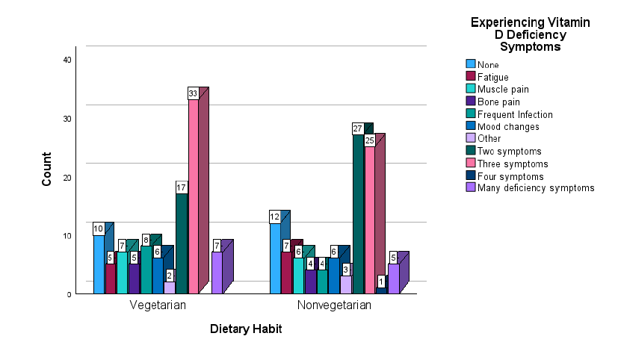Figure 1. Bar Graph Representing Vitamin D Deficiency-related Symptoms in Samples

The graph shows that more vegetarians are experiencing certain symptoms but, both dietary groups reported a significant number of vitamin D deficiency-related symptoms. This is to note that mood changes are the most commonly reported symptom in both groups, which may indicate the need to look after other related factors of mood changes i.e., physical, psychological and social factors; followed by muscle pain, bone pain and fatigue. More number of vegetarians are experiencing more than 3 symptoms, indicating there may be a relation between dietary habits and vitamin D deficiency-related symptoms. However, this could be influenced by a number of factors beyond diet, such as sun exposure, lifestyle and physical activity (Cashman et al., 2016). The general assumption is that vegetarians are at a higher risk of vitamin D deficiency because many of animal-based, such as fatty fish and egg yolk contain more bioavailable form of vitamin D (Calvo et al., 2004) and also some studies support this i.e., showing a lower vitamin D status in vegetarians and vegans compared to meat eaters (Crowe et al.,2011). Some research shows are against this concept and shows that other than diet alone, factors such as sun exposure, skin pigmentation, and intake of fortified foods and supplements are considered to have a greater influence on vitamin D levels (Hilger et al.,2014). Factors like limited sun exposure, darker skin colour and indoor lifestyle contribute to the higher prevalence of vitamin D deficiency, which is considered a global problem (Mogire et al., 2020). The findings of the present study also revealed almost similar prevalence of symptoms like bone pain, frequent infections, and mood changes across both groups, could reflect the impact of these other factors and may be indicative of various health complications, which may need further diagnosis.

  - Severity of Vitamin D Deficiency-Related Symptoms in Both the Dietary Groups

The graph plotted in Figure 2 illustrates the severity of vitamin D deficiency-related symptoms among vegetarian and non-vegetarian samples. It compares four categories of symptom severity i.e., None, Mild, Moderate and Severe across both the dietary groups.

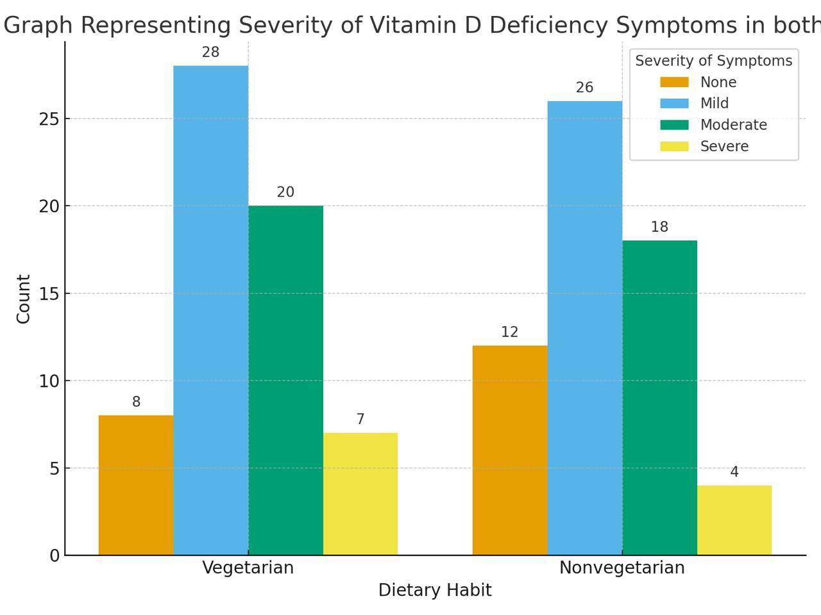
Figure 2. Bar Graph Representing the Severity of Vitamin D Deficiency-related Symptoms in both the Dietary Groups

The graph presented in Figure 2 shows that, a substantial number of participants in both dietary groups experience symptoms associated with vitamin D deficiency at different severity levels, indicating a widespread prevalence of the issue regardless of dietary habit (Holick, 2017). This finding aligns with research suggesting that factors other than diet can have a greater influence on vitamin D status. While a vegetarian or vegan diet may be a risk factor for vitamin D deficiency due less availability of natural and more bioavailable form of vitamin D in plant-based foods (Calvo et al., 2004), other factors such as limited sun exposure, skin pigmentation, and the use of supplements often play significant role in determining an individual’s vitamin D levels (Cashman et al., 2016), which is also demonstrated in graph. A study on serum 25(OH)D concentrations found no significant difference based on vegetarian status, concluding that factors like supplementation and sun exposure have a greater influence on vitamin D levels (Crowe et al., 2011).

  - Prevalence of Vitamin D Deficiency-Related Disorders in Both the Dietary Groups

Prevalence of various vitamin D deficiency-related disorders among both dietary groups was presented in Figure 3.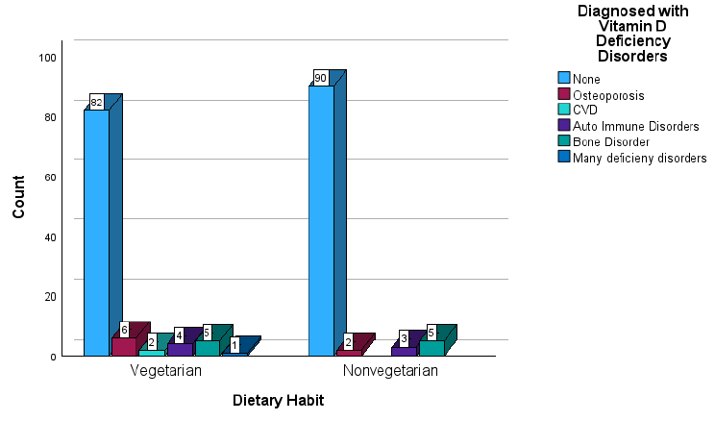
Figure 3. Bar Graph Representing the Prevalence of Vitamin D Deficiency-related Disorders In both the Dietary Groups

The graph suggests that many people, i.e., nearly 80-90% of the sample, especially a little more non-vegetarians are not diagnosed with any vitamin D deficiency-related disorders regardless of their dietary habits. It interestingly shows that a significant number of individuals, those having any disorder, have more individuals with osteoporosis, followed by other bone disorders and autoimmune disorders in both dietary groups. This suggests that vitamin D deficiency may not be a problem confined to a single dietary group. Thereby suggests that factors other than diet, such as geography, sun exposure, age, skin pigmentation or use of supplements, may play a more dominant role in determining an individual's vitamin D status (Hilger et al.,2014; Cashman et al., 2016). The environmental and lifestyle factors are often key contributors to vitamin D insufficiency than dietary intake alone, especially in modern societies where individuals spend more time indoors as vitamin D is a sunshine vitamin. (Bouillon et al.,2019). The graph notes that vitamin D deficiency-associated disorders are not highly prevalent in any dietary group but exist in only 10-15% of individuals in the sample, which may indicate that they may not have vitamin D deficiency or other co-morbid conditions or the individuals having the disorder were a result of other co-morbid conditions.

  - Association Between Dietary Habits and Vitamin D Deficiency-Related Symptoms and Disorders
Table 2 represents the association between dietary habits and various vitamin D deficiency-related symptoms and disorders established by the chi-square test of independence.
Table 2- Association between dietary habits and vitamin D deficiency-related variables
Sl. No. | Independent Variable | Dependent Variable | Degree of Freedom | P- Value
1 | Dietary Habit | Vitamin D deficiency-related symptoms | 10 | 0.731
2 | Dietary Habit | Severity of Vitamin D deficiency-related symptoms | 5 | 0.841
3 | Dietary Habit | Vitamin D Deficiency-Related Disorder | 5 | 0.356

The table shows the result of the chi-square test of independence, which was performed to examine the association between dietary habits and different Vitamin D deficiency–related outcomes. The result depicts that there is no statistically significant association between dietary habits and Vitamin D deficiency–related symptoms, as at the Degree of freedom(df) level 10, the P-value is 0.731, which is more than the threshold value 0.10. Similarly, no significant association was observed between dietary habit and the severity of Vitamin D deficiency–related symptoms, i.e., at df 5 value of P is 0.841, which is more than the alpha value 0.05. Furthermore, the relationship between dietary habits and Vitamin D deficiency–related disorders was also found to be statistically insignificant as the result of the chi-square test of independence at df 5, the P-value is 0.356, which is more than 0.05.
As all P-values obtained from the chi square test of independence were greater than the conventional significance level of 0.10 and 0.05 respectively, therefore the null hypothesis is accepted in each case and hereby the study reveal that dietary habit did not have a statistically significant influence on Vitamin D deficiency-related symptoms, severity, or disorders among the individuals, which further means that the participants’ diet alone might not be a decisive factor affecting Vitamin D levels. This outcome aligns with previous studies indicating dietary sources contribute only a limited portion of daily Vitamin D requirements, as adequate Vitamin D intake from diet alone is difficult and the majority of Vitamin D is synthesised endogenously through exposure to sunlight, therefore sunlight remains the main source (Kucan et al.,2022). Consequently, even individuals with healthy dietary habits may experience Vitamin D deficiency-related signs and symptoms if their sun exposure is insufficient. The absence of a significant relationship may also be attributed to factors such as: Limited dietary sources naturally rich in Vitamin D (Cashman et al., 2022), variations in absorption or metabolism of Vitamin D due to genetic or physiological factors or lifestyle behaviors such as indoor living, use of sunblock, or cultural dress practices that limit sunlight exposure or may result of other deficiency or disease condition with overlapping signs and symptoms.

6. CONCLUSION
This study concludes that vitamin D deficiency–related symptoms and disorders are prevalent across both vegetarian and non-vegetarian groups, indicating that the issue extends beyond dietary differences. Although vegetarians showed a slightly higher frequency of deficiency-related symptoms, the overall pattern across both groups remains comparable. These findings highlight that environmental and lifestyle factors such as rapid urbanisation, inadequate sun exposure, darker skin pigmentation, and lack of supplementation may play a more influential role in determining vitamin D status than diet alone.
Given these observations, there is an urgent need for policies and public health interventions that address vitamin D deficiency at the population level. Priority actions should include strengthening food fortification initiatives, promoting awareness on safe and adequate sun exposure, integrating routine serum 25-hydroxyvitamin D screening in healthcare settings, and encouraging affordable supplementation programmes. Embedding nutrition education within community health services can further support early identification and prevention of deficiency-related symptoms and disorders.
To enhance the scientific validity of future investigations, researchers should incorporate biochemical assessments particularly serum 25(OH) D levels rather than relying solely on self-reported clinical symptoms. Longitudinal and multi-regional studies are recommended to better understand causal pathways linking diet, lifestyle, sun exposure, and vitamin D status. Combining clinical indicators with biochemical measurements will strengthen the evidence base and contribute to more effective public health strategies aimed at improving vitamin D sufficiency and overall health outcomes across diverse population groups.

Consent
Written informed consent was taken from all the respondents.
Disclaimer (Artificial intelligence)
Author(s) hereby declare that NO generative AI technologies such as Large Language Models (ChatGPT, COPILOT, etc.) and text-to-image generators have been used during the writing or editing of this manuscript.

7. REFERENCES
- Indian Council of Medical Research. (2024). Dietary Guidelines for Indians, Available link : https://www.nin.res.in/dietaryguidelines/pdfjs/locale/DGI07052024P.pdf
- Holick, M. F. (2017). The vitamin D deficiency pandemic: Approaches for diagnosis, treatment and prevention. Reviews in Endocrine and Metabolic Disorders, 18(2), 153-165. https://doi.org/10.1007/s11154-017-9424-1
- Bouillon, R., Marcocci, C., Carmeliet, G., Bikle, D., White, J. H., Dawson-Hughes, B., Lips, P., Munns, C. F., Lazaretti-Castro, M., Giustina, A. and Bilezikian, J. P. (2019). Skeletal and extraskeletal actions of vitamin D: Current evidence and outstanding questions. Endocrine Reviews, 40(4), 1109-1151. https://doi.org/10.1210/er.2018-00126
- Judd, S. E. and Tangpricha, V. (2009). Vitamin D deficiency and risk for cardiovascular disease. American Journal of the Medical Sciences, 338(1), 40-44. https://doi.org/10.1097/MAJ.0b013e3181aaee91
- Cashman, K. D., Dowling, K. G., Skrabakova, Z., Gonzalez-Gross, M., Valtuena, J., De Henauw, S., Moreno, L. A., Damsgaard, C. T., Michaelsen, K. F., Molgaard, C. and others. (2016). Vitamin D deficiency in Europe: Pandemic? The American Journal of Clinical Nutrition, 103(4), 1033-1044. https://doi.org/10.3945/ajcn.115.120873
- Leitzmann, C. (2014). Vegetarian nutrition: Past, present, future. The American Journal of Clinical Nutrition, 100(1), 496S-502S. https://doi.org/10.3945/ajcn.113.071365
- Calvo, M. S., Whiting, S. J., & Barton, C. N. (2004). Vitamin D fortification in the United States and Canada: current status and data needs. The American journal of clinical nutrition, 80(6), 1710S-1716S.
- Tripkovic, L., Lambert, H., Hart, K., Smith, C. P., Bucca, G., Penson, S., Chope, G., Hyppönen, E., Berry, J., Vieth, R. and Lanham-New, S. A. (2012). Comparison of vitamin D₂ and vitamin D₃ supplementation in raising serum 25-hydroxyvitamin D status: A systematic review and meta-analysis. The American Journal of Clinical Nutrition, 95(6), 1357-1364. https://doi.org/10.3945/ajcn.111.031070
- Mogire, R. M., Mutua, A., Kimita, W., Kamau, A., Bejon, P., Pettifor, J. M., ... & Atkinson, S. H. (2020). Prevalence of vitamin D deficiency in Africa: a systematic review and meta-analysis. The Lancet Global Health, 8(1), e134-e142.
- Crowe, F. L., Steur, M., Allen, N. E., Appleby, P. N., Travis, R. C. and Key, T. J. (2011). Plasma concentrations of 25-hydroxyvitamin D in meat eaters, fish eaters, vegetarians and vegans: Results from the EPIC-Oxford study. Public Health Nutrition, 14(2), 340–346. https://doi.org/10.1017/S1368980010002454
- Hilger, J., Friedel, A., Herr, R., Rausch, T., Roos, F., Wahl, D. A., Pierroz, D. D., Weber, P. and Hoffmann, K. (2014). A systematic review of vitamin D status worldwide. British Journal of Nutrition, 111(1), 23-45. https://doi.org/10.1017/S0007114513001840
- Kucan, R., Salamon, A. S., Andronikov, D. and Benedik, E. (2022). Dietary sources of vitamin D, vitamin D supplementation, and its bio-viability. Central European Journal of Paediatrics. https://cejpaediatrics.com/index.php/cejp/article/view/315

