Original Research Article

Biological Activity and Docking Molecular of 2-(3-(4-Aryl)-1,2,4-Oxadiazol-5-yl)-Acetonitrile: Potential Antibacterial Agent Acting on Carbapenem Enzyme

.ABSTRACT

In this investigation, we report the study of molecular docking and the biological activity of
2-(3-(4-aryl)-1,2,4-oxadiazol-5-yl)-acetonitrile 3a-h obtained from ethyl-2-cyanoacetate 2 and different amidoximes. The obtained compounds were screened for in vitro antimicrobial activity against different strains, during which compounds 3c and 3f showed potent antimicrobial behavior against bacteria Staphylococcus aureus, Enterococcus faecalis, and K. pneumoniae. Regarding antifungal activity, compound 3f also showed better results against the fungi Candida utilis and Candida albicans, with an IC₅₀ of 312.5 μg/mL. On the other hand, when tested for in vitro antitumor activity, compounds 3f and 3g showed better inhibition power with a CC₅₀ of 50.12 μg/mL for Caco-2 (Caucasian colon adenocarcinoma) and a CC₅₀ of 37.64 μg/mL for Caco-2 (Caucasian colon adenocarcinoma), respectively. Oxadiazole compounds interact with receptors through cation-π, π-π stacking interaction, and, in the case of 1,2,4-oxadiazoles, hydrogen bonds. To determine the potential mode of action of the compounds, a molecular docking investigation was conducted. The molecular docking study was performed for four biological targets, PDB 4CJN (Staphylococcus aureus), PDB 6 MKI (Enterecoccus falaelis), PDB 2OV5 (Klebsiella pneumonial) and PDB 6l13 (Pseudomonas aeruginosa), the results were quite promising, highlighting compound 3g (2-(3-(4-bromophenyl)-1,2,4-oxadiazol-5-yl) acetonitrile) which showed lower binding energy for 4CJN, 6MKI and 6I13 receptors with values of -8.02, -6.72 and -7.96 kcal/mol, respectively. In this work, we examine through molecular docking and atomistic molecular dynamics how interatomic interactions between oxadiazoles and proteins explain biological activity.

Keywords: 1,2,4-oxadiazoles, molecular dynamics, molecular docking, binding energies, biological activity.

1. INTRODUCTION

In recent years, the incidence of antimicrobial infections has increased dramatically. There are several types of antimicrobial agents, including antibiotics, antifungal, antiviral, disinfectants, and food preservatives that either suppress the growth and multiplication of microbes or kill them [1]. The widespread use of antifungal and antibacterial drugs resulted in resistance to drug therapy against fungal and bacterial infections, which led to serious health hazards [2]. The resistance of wide-spectrum antifungal and antibacterial agents has initiated the discovery and modification of new antifungal and antibacterial drugs.
On the other hand, 1,2,4-oxadiazoles and their derivatives have gained considerable attention over the past few decades due to their chemotherapeutic value [1]. Many 1,2,4-oxadiazoles are found to be potent antimicrobial [2,3], analgesic [4], anti-inflammatory [5], anticonvulsant [6], antineoplastic [7], antimalarial [8], antiviral agents [9], some of them exhibited antiproliferative [10] and anticancer activity [11].
Hu and Chen [12], in the domain of computational chemistry, Density Functional Theory (DFT) has emerged as the preferred electronic structure theory for both molecular and extended systems. Concurrently, as described by Agu et al. [13], docking methodology has become a standard computational tool in drug design, aiding in predicting the binding modes and affinities of small molecules within specific receptor targets. This approach is instrumental in lead compound optimization and virtual screening studies to discover novel biologically active molecules.
The use of molecular modeling methods in drug discovery is well-established and can provide very useful information about promising molecules, drug-protein binding and interactions, and the mechanism of antibiotic resistance [14-17]. In this work, we evaluate through experimental in vitro antimicrobial activity and also the molecular docking and atomistic molecular dynamics how interatomic interactions between a series of 2-(3-(4-aryl)-1,2,4-oxadiazol-5-yl)-acetonitrile and proteins from Gram-negative and Gram-positive bacteria (S. aureus, P. aeruginosa, K. pneumoniae, and E. faecalis).

2. material and methods

2.1. In vitro microbial activity assay
The antimicrobial potential of the 2-(3-(4-aryl)-1,2,4-oxadiazol-5-yl)-acetonitrile (3a-h) obtained from the fruit seeds was tested against the bacteria Staphylococcus aureus (UFPEDA 02), Pseudomonas aeruginosa (UFPEDA 416), Klebsiella pneumoniae (UFPEDA 396), Enterococcus faecalis (UFPEDA 138), as well as the fungus Microsporum gypseum (UFPEDA 2565) and yeast Candida utilis (UFPEDA 1009). The microorganisms were kept in nutrient agar and stored at 4°C. The evaluation of antimicrobial activity was performed with the determination of minimum inhibitory concentration (MIC), as described elsewhere [18, 19]. The antimicrobials metronidazole (10 µg.mL⁻¹) and ketoconazole (50 µg.mL⁻¹) were used as positive controls.

2.2. In vitro antitumoral activity assay
The antiproliferative activities 2-(3-(4-aryl)-1,2,4-oxadiazol-5-yl)-acetonitrile (3a-h) were evaluated in the following human cancer cell lines: Vero (Kidney Cell Lines), MCF-7 (breast adenocarcinoma), and Caco-2 (Human colon adenocarcinoma). The cytotoxicity of all compounds was tested using a 3-(4,5-dimethyl-2-thiazolyl)-2,5 diphenyl-2H tetrazolium bromide (MTT) (Sigma Aldrich Co., St. Louis, MO, USA) reduction assay. All cancer cells were maintained in RPMI 1640 modified containing 2 mM L-glutamine, 10 mM HEPES, 1 mM sodium pyruvate, 4500 mg/L glucose, and 1500 mg/L sodium bicarbonate, SBF (20%), and antibiotics (penicillin 100U/mL, streptomycin 1mg/mL), at 37 °C with 5 % CO₂. For all experiments, tumor cells were plated in 96-well plates (1 × 10^4). Then, sample solutions at dilutions of 200, 100, 50, and 25µL/mL were added to each well in triplicate for 72 hours. At the end of this period, the medium with the diluted drug was removed and added to the MTT (3-(4,5-dimethylthiazol-2-yl)-2,5-diphenyltetrazolium bromide) solution at 1mg/mL in each well. After 4 hours of incubation, the MTT was removed and DMSO was added, so that the plate could be read and absorbance was measured at 540 nm in a plate spectrophotometer. The IC₅₀ values and their 95 % confidence intervals for two different experiments were obtained by nonlinear regression using the Graphpad Prism program (Intuitive Software for Science, San Diego, CA).

2.3. Molecular Docking Study
To select and characterize promising antibacterial compounds, computational methods like ADMET prediction, molecular docking calculations, and atomistic molecular dynamics simulations are used to evaluate their safety, effectiveness, and behavior within a biological system. ADMET prediction identifies compounds with favorable absorption, distribution, metabolism, excretion, and toxicity profiles.
ADMET predictions – Druglikeness criteria covered by Lipinski’s rules [20] and Ghose filter [21] were evaluated using freely available tools at the SwissADME portal [22].
Molecular Docking Calculations - Rigid receptor docking calculations were carried out using as ligands new synthesized 1,2,4-oxadiazoles-3,5-dissubstituted compounds. Penicillin Binding Proteins (PBP) of each respective Gram-negative and Gram-positive bacterium tested in clinical assays were selected as target for docking calculations: S. aureus (PDB ID: 4CJN) [23], P. aeruginosa (PDB ID: 6IJE) [24], K. pneumoniae (PDB ID: 2OV5) [25] and E. faecalis (PDB ID: 6MKI) [23] Ligand structures were drawn on PubChem [26] converted to a PDB file format using Openbabel [27] and submitted to a geometry optimization on Avogadro-1.2.0 [28] using MMFF94 force field using an energy criterion of 10⁻⁷ working with steepest descent algorithm. On MGLTools software [29], non-polar hydrogen atoms were merged on the structure, and atomic charges were computed using the Gasteiger method [30] for ligand and receptor structures.
Docking calculations were run using the hybrid global-local Lamarckian genetic algorithm [31] with 150 individuals per generation and 27000 generations as number maximum. 2,5x10⁷ energy calculation per generation and each simulation had 50 steps. For protein-ligand system having 2OV5 structure as receptor, docking procedure was repeated with 100 steps simulations. Crossover and mutation rates were fixed as 0,02 and 0,08, respectively. Local searches were executed with 300 steps. Similarity cluster criteria of 2 Å were adopted. A grid box of 86Å x 86Å x 86Å of dimension and 0.20 Å of spacing were built using Autogrid [32] program. Grid boxes were placed centered on active site of each receptor. On multimeric proteins only one monomer was taking for system preparation and docking studies. In order to assure docking protocol reproducibility, we made redocking of co-crystallized ligands in order to reproduce binding geometry and orientation on original binding site. Geometric coordinates of ligands were randomized on Autodock Vina package [33].

3. results and discussion

This study initially considered a general strategy for the preparation of 4-(3-(aryl)-1,2,4-oxadiazol-5-yl)-acetonitrile (3a-h) (Scheme 1). The procedure used to prepare 1,2,4-oxadiazole (3a-h) with yields ranging from 89-92% consisted of subjecting arylamidoximes (1a-h) and ethyl-2-cyanoacetate (2) to an O-acylation reaction followed by cyclodehydration, leading to compounds 3a-h. The preparation and characterization of 4-(3-(aryl)-1,2,4-oxadiazol-5-yl)-acetonitrile (3a-h) have already been reported in the literature [34]. However, the methodology for preparing the compounds used in this study is new.
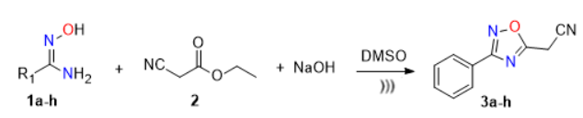
Scheme 1. Preparation of 4-(3-(aryl)-1,2,4-oxadiazol-5-yl)-acetonitrile (3a-h).

The present study assessed the antimicrobial properties of compounds 3a-h with MIC values representing the lowest concentration capable of visually inhibiting 100% of the growth of the tested microorganism [35]. The study included microorganisms of clinical importance, which are frequently involved in infectious conditions and in antimicrobial resistance events. These microorganisms (Table 1) are the bacteria S. aureus (UFPEDA 02), E. faecalis (UFPEDA 138), K. pneumoniae (UFPEDA 396), and P. aeruginosa (UFPEDA 416); and the fungi C. utilis (UFPEDA 1009), and C. albicans (UFPEDA 1007).

Table 1. Test microorganisms used in the activity
Gram-positive bacteria | Gram-negative bacteria | Fungi
Staphylococcus aureus (UFPEDA02) | Pseudomonas aeruginosa (UFPEDA416) | Candida utilis  (UFPEDA1009)
Enterococcus faecalis (UFPEDA138) | Klebsiella pneumoniae (UFPEDA396) | Candida albicans (UFPEDA1007)

Antimicrobial activity assessments conducted against Gram-negative and Gram-positive bacterial strains revealed that the newly synthesized 1,2,4-oxadiazole derivatives exhibited either superior inhibitory efficacy relative to standard reference antibiotics or achieved a high level of bacterial growth suppression, defined as 90–100% inhibition. The compounds 3a-f underwent antimicrobial biological evaluation against the bacteria Staphylococcus aureus, Bacillus subtilis, Enterococcus faecalis, and Klebsiella pneumoniae (Table 2). Compound 3f demonstrated good growth inhibition of Klebsiella pneumoniae, with an IC₅₀ of 19.5 μg/mL.

Table 2. Results of antimicrobial activity of 2-(3-(4-aryl)-1,2,4-oxadiazol-5-yl)-acetonitrile.
Entry | Compounds | Bacteria
Entry | Compounds | Gram-positive |  | Gram-negative
Entry |  | Staphylococcusaureus  (μg/mL) | Enterococcus faecalis  (μg/mL) | Pseudomonas aeruginosa  (μg/mL) | Klebsiella pneumonia(μg/mL)
1 | 3a | 312,5 | 156,2 | 625 | 625
2 | 3b | 2500 | 2500 | 625 | 2500
3 | 3c | 19,5 | 2500 | * | 312,5
4 | 3d | 156,2 | 156,2 | 312,5 | 156,2
5 | 3e | 2500 | 2500 | 2500 | 2500
6 | 3f | 39,0 | 19,5 | 156,2 | 19,5
* Activity not performed

According to the literature [36,37], derivatives containing homoaromatic compounds and leaving group (-Cl) with substituents exhibit antimicrobial properties. Subsequently, we will investigate the positions of the substituents and the influence of the position on the biological potential [38].
Comparing the antimicrobial activities for the bacteria Staphylococcus aureus, Enterococcus faecalis, and K. pneumoniae reported in the literature for the 1,2,4-oxadiazole analogues with the 1,2,4-oxadiazoles obtained in this work, it is clear that two compounds (3c and 3f) synthesized presented more promising results for the bacteria in question than those cited in the literature.
On the other hand, in this study, 5 compounds containing the 1,2,4-oxadiazole moiety were designed and prepared. The compounds (3a-f) were evaluated for mycelium growth inhibition tests against the two plant pathogenic fungi. The antifungal activity test results demonstrated that the target compounds exhibited antifungal activity against the tested plant pathogenic fungi. Compound 3f also demonstrated better results against the fungi Candida utilis and Candida albicans, with an IC₅₀ of 312.5 μg/mL (Table 3). The present study provides a research basis for the development of new antifungal drugs. This result corroborates what was described by Góreck, Kudelko, and Olesiejuk [43] when 1,2,4-triazole was obtained.

Table 3. Results of antifungal activity of 2-(3-(4-Aryl)-1,2,4-oxadiazol-5-yl)-acetonitrile.
Entry | Compounds | Fungi
Entry | Compounds | Yeasts
Entry |  | Candida utilis  μg/mL | Candida albicans  μg/mL
1 | 3a | 2500 | 1250
2 | 3b | 312,5 | 1250
4 | 3d | 1250 | 1250
5 | 3e | 2500 | 625
6 | 3f | 312,5 | 312,5

The antitumor activity of the compounds 3a, 3c, 3d, and 3g was evaluated using an MTT assay against three tumor cell lines: Vero, originating from the kidney of Cercopithecus aethiops (African green monkey), MCF-7 (mammary adenocarcinoma), and CaCO-2 (Caucasian colon adenocarcinoma) (Table 4). Among the compounds evaluated, those that showed the best inhibition power were compounds 3g with a CC₅₀ of 37.64 μg/mL and 3f with a CC₅₀ of 50.12 μg/mL for CaCO-2 (Caucasian colon adenocarcinoma).

Table 4. Results of antitumor activity of 2-(3-(4-aryl)-1,2,4-oxadiazol-5-yl)-acetonitrile
Entry | Compound | Vero μg/mL | MCF-7 μg/mL | CaCO-2 μg/mL
1 | 3a | 328,02 | 1860,1 | 193,84
2 | 3c | 2852,38 | 292,45 | 111,31
3 | 3f | 275,68 | 267,55 | 202,42
4 | 3g | 399,43 | 739,40 | 37,64

Four biological targets were chosen for the molecular docking study of the synthesized compounds: PDB 4CJN (Staphylococcus aureus), PDB 6 MKI (Enterococcus faecalis), PDB 2OV5 (Klebsiella pneumoniae), and PDB 6l13 (Pseudomonas aeruginosa) (Figure 1). The proteins were obtained from the Research Collaboratory of Structural Bioinformatics Protein Data Bank.
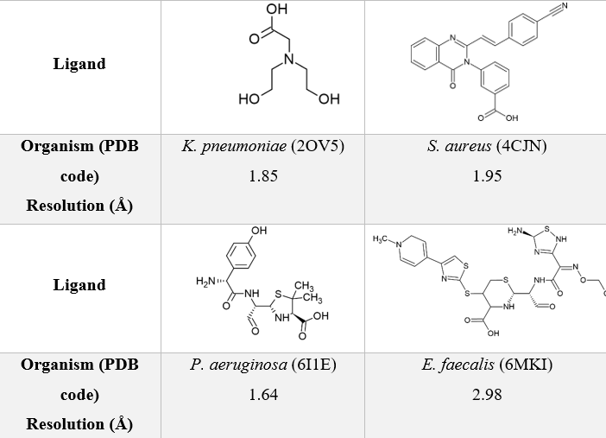
Fig. 1. Chemical structure of ligands co-crystalized with target proteins used in docking calculations. Structure resolution (Å) of each coordinate set is indicated.

Initially, the binding energy and inhibition constant for the compounds were calculated. The binding energy results are summarized in Table 5. Analyzing compounds 3a-h, compound 3g (2-(3-(4-bromophenyl)-1,2,4-oxadiazol-5-yl)acetronitrile) presented the lowest binding energy for the receptors 4CJN, 6MKI, and 6I13, with values ​​of -8.02, -6.72, and -7.96 kcal/mol, respectively. This is the binding energy required for the studied molecule to bind to the biological target. Therefore, when the interaction between a given biological target and different molecules is compared, the one that generates the lowest binding energy will theoretically represent the molecule that will exhibit the best biological activity. Therefore, comparing compound 3g with the three receptors that presented the lowest binding energy, it can be inferred that compound 3g binds better to the 4CJN receptor, with a binding energy value of -8.02 kcal/mol. For the 2OV5 receptor, the compound that presented the lowest energy was 3f (2-(3-(4-chlorophenyl)-1,2,4-oxadiazol-5-yl)acetronitrile), with -6.39 kcal/mol.

Table 5. Relative binding energies of oxadiazoles compounds at different protein-hosts.

Compounds | 2OV5 | 4CJN | 6I1E | 6MKI
3a | -2.00 | -1.00 | 0.50 | 7.50
3b | -2.20 | -1.20 | 0.30 | 7.20
3c | -2.10 | -1.30 | 0.20 | 7.00
3d | -2.30 | -1.40 | 0.10 | 6.80
3e | -2.40 | -1.50 | 0.00 | 6.70
3f | -2.50 | -1.60 | -0.10 | 6.50
3g | -2.60 | -1.70 | -0.20 | 6.30

The inhibition constant results corroborated the binding energy study between the ligand and the receptor, since the compounds that presented a lower inhibition constant also presented a lower binding energy. The data presented in Table 6 show that of the compounds evaluated (3a-i), compound 3g presented the best inhibitory activity for the three receptors 4CJN, 6MKI, and 6I1E, with Ki values ​​of 1.32, 11.78, and 1.47 μmolar, respectively. The lower the Ki value, the greater the inhibitor potency; consequently, the higher the inhibitor concentration in the fraction. Therefore, among the samples tested in series 3a–i, compound 3g proved to be the most potent. For the 2OV5 receptor, the compound that presented the greatest inhibitory power was compound 3f, with a Ki of 20.55 μmolar.

Table 6. Molecular docking results of compounds 3a-i
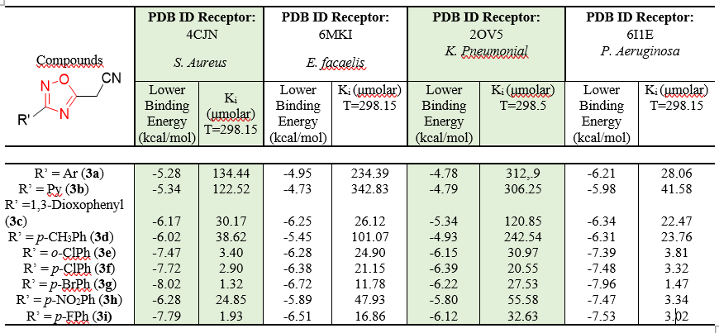

Structurally, these compounds differ in the substituents attached to the aromatic ring. Compounds with electron-withdrawing groups performed better. Regarding the electronegativity of the substituents present in compounds 3i, 3f, and 9g, the results do not show much correlation, since the compound with the p-bromine substituent (3g) had a lower binding energy than the compound with the p-fluorine substituent (3i).
Figure 2 shows the binding of the 4CJN receptor to the compound that performed best, compound 3g.
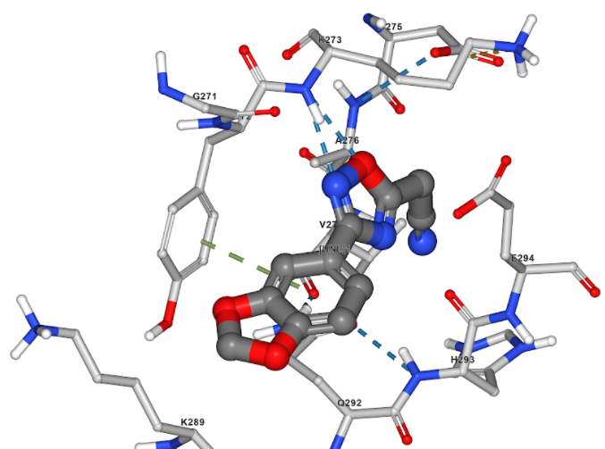
Fig. 2. Interaction of compound 3g with the 4CJN receptor.

In this sense, the evaluation of compounds 4a-c followed the Lipinski ‘Rule of Five’ (2004). Lipinski developed this rule from the analysis of 2,245 drugs that showed good standards of oral bioavailability, making it one of the main starting points in the development of new promising molecules. The study determines that a molecule will present a good standard of oral bioavailability when it satisfies a set of physicochemical parameters, which are: molecular mass (MM) less than 500 Daltons, partition coefficient (cLogP) less than 5, maximum of five hydrogen bond donor groups (nHBD), and maximum of ten hydrogen bond acceptor groups (nHBA) [39]. All the compounds of the present study satisfy all the specifications contained in the ‘Rule of Five’.
According to the data obtained (Table 7), it is possible to observe that the compounds in the first series (3a-f) all meet the characteristics of the rule of five, that is, molecular weight less than or equal to 500 g/mol; number of hydrogen acceptors less than or equal to 10; number of hydrogen donors less than or equal to 5; and lipophilicity coefficient (cLogp) less than or equal to 5.

Table 7. Pharmacokinetic properties results
Compounds | Molecular weight. | Hydrogen  Bonding  (acceptor) | Hydrogen Bonding  (donor) | TPSA  (A°)² | Log p | Lipsinisk Rules
3a | 185,18 | 4 | 0 | 62,71 | 62,71 | 0
3b | 186,17 | 5 | 0 | 75,60 | 75,60 | 0
3c | 229,19 | 6 | 0 | 81,17 | 81,17 | 0
3d | 199,21 | 4 | 0 | 62,71 | 62,71 | 0
3e | 219,63 | 4 | 0 | 62,71 | 62,71 | 0
3f | 219,63 | 4 | 0 | 62,71 | 62,71 | 0
3g | 264,08 | 4 | 0 | 62,71 | 62,71 | 0
3h | 230,18 | 6 | 0 | 108,53 | 108,53 | 0

For a drug to present a satisfactory result, it must be able to cross physiological barriers and be absorbed. One of the parameters analyzed in the in silico study was the log p (octanol-water partition coefficient), which evaluates the theoretical lipophilicity profile of the proposed structures. All compounds present cLogP values ​​less than 5, ranging from 1.5 to 2.5, which suggests good permeability in biological membranes and absorption [39]. The log p values ​​indicate good lipophilicity, normally between values ​​1 and 3 [40] (Figure 3).
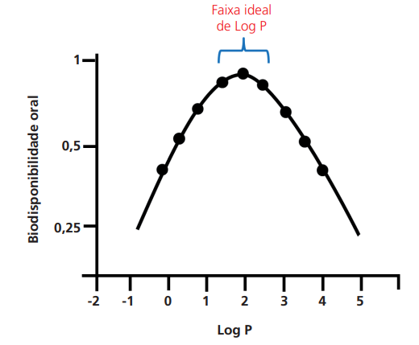
Fig. 3. cLogP values.

Some factors that influence the result are the increments present in the structures. It can be observed that the cLogp values ​​decreased with the increase in the electronegativity of the substituents of the compounds. The compound with the substituent p-chloro (3f) presented 2.15, and p-bromo (3g) 2.25.
And to finish, considering their huge glycosides therapeutic potentials, market prospects, and economic values, we expect that these compounds to continue to attract investment and research efforts and to achieve long-term success.

4. Conclusion

The in vitro evaluation of the synthesized compounds against different bacterial strains and a fungal strain demonstrated promising antimicrobial activity. Compounds 3a-f were subjected to antimicrobial biological evaluation against Staphylococcus aureus, Bacillus subtilis, Enterococcus faecalis, and Klebsiella pneumoniae. Compound 3f demonstrated good ability to inhibit the growth of Klebsiella pneumoniae, with an IC₅₀ of 19.5 μg/mL. Compound 3f also showed better results against the fungi Candida utilis and Candida albicans, with an IC₅₀ of 312.5 μg/mL.
Further, compounds 3a, 3c, 3d, and 3g showed inhibition potential against three tumor cell lines: Vero, originating from the kidney of Cercopithecus aethiops (African green monkey), MCF-7 (mammary adenocarcinoma), and CaCO-2 (Caucasian colon adenocarcinoma) by using the MTT method. Among the compounds evaluated, those that showed the best inhibition power were compounds 3g with a CC₅₀ of 37.64 μg/mL and 3f with a CC50 of 50.12 μg/mL for CaCO-2 (Caucasian colon adenocarcinoma).
Molecular docking studies were performed for four biological targets: PDB 4CJN, PDB 6MKI, PDB 2OV5, and PDB 6I13. Among the compounds studied, compound 3g (p-Br) showed the lowest binding energy for the receptors 4CJN, 6MKI, and 6I13 with values ​​of -8.02, -6.72, and -7.96 kcal/mol, respectively.

DISCLAIMER (ARTIFICIAL INTELLIGENCE)

The author (s) hereby declare that no generative AI technologies such as large language models (ChatGPT, Copilot, etc.) And text-to-image generators have been used during the writing or editing of this manuscript.

AcknowledgEments

The authors gratefully acknowledge FACEPE (APQ-1037-1.06/21) for financial support. The authors are also thankful to CNPq for their fellowships. FJSP acknowledges CENAPAD/SP for computational resources.

Competing interests

The authors have declared that no competing interests exist.

References
1. Salam MA, Al-Amin MY, Salam MT, Pawar JS, Akhter N, Rabaan AA, Alqumber MAA. Antimicrobial Resistance: A Growing Serious Threat for Global Public Health. Healthcare (Basel). 2023, 11, 13, 1946. DOI: 10.3390/healthcare11131946.
2. Osset-Trénor, P.; Pascual-Ahuir, A.; Proft, M. Fungal Drug Response and Antimicrobial Resistance. J. Fungi 2023, 9, 565. DOI: 10.3390/jof9050565
3. Biernacki K, Daśko M, Ciupak O, Kubiński K, Rachon J, Demkowicz S. Novel 1,2,4-Oxadiazole Derivatives in Drug Discovery. Pharmaceuticals (Basel). 2020, 13, 6,:111. DOI: 10.3390/ph13060111.
4. Dhameliya TM, Chudasma SJ, Patel TM, Dave BP. A review on the synthetic account of 1,2,4-oxadiazoles as anti-infective agents. Mol Divers. 2022, 26, 5, 2967-2980. DOI: 10.1007/s11030-021-10375-4.
5. Chawla G. 1,2,4-Oxadiazole as a privileged scaffold for anti-inflammatory and analgesic activities: a review. Mini Rev Med Chem. 2018,181536–1547. DOI: 10.2174/1389557518666180524112050.
6. Mohamed MFA, Marzouk AA, Nafady A, et al. Design, synthesis, and molecular modeling of novel aryl carboximidamides and 3-aryl-1,2,4-oxadiazoles derived from indomethacin as potent anti-inflammatory iNOS/PGE2 inhibitors. Bioorg Chem. 2020, 105, 104439. DOI: 10.1016/j.bioorg.2020.104439.
7. Mohammadi-Khanaposhtani M, Shabani M, Faizi M, Aghaei I, Jahani R, Sharafi Z, Shamsaei Zafarghandi N, Mahdavi M, Akbarzadeh T, Emami S, Shafiee A, Foroumadi A. Design, synthesis, pharmacological evaluation, and docking study of new acridone-based 1,2,4-oxadiazoles as potential anticonvulsant agents. Eur J Med Chem. 2016, 13, 112, 91-98. DOI: 10.1016/j.ejmech.2016.01.054.
8. Caneschi W, Enes KB, Carvalho de Mendonça C, de Souza Fernandes F, Miguel FB, da Silva Martins J, Le Hyaric M, Pinho RR, Duarte LM, Leal de Oliveira MA, Dos Santos HF, Paz Lopes MT, Dittz D, Silva H, Costa Couri MR. Synthesis and anticancer evaluation of new lipophilic 1,2,4 and 1,3,4-oxadiazoles. Eur J Med Chem. 2019, 1, 165, 18-30. DOI: 10.1016/j.ejmech.2019.01.001.
9. dos Santos Filho JM, de Queiroz e Silva DMA, Macedo TS, et al. Conjugation of N-acyl hydrazone and 1,2,4-oxadiazole leads to the identification of active antimalarial agents. Bioorg Med Chem. 2016, 24, 5693–5701. DOI: 10.1016/j.bmc.2016.09.013.
10. Kim J, Shin JS, Ahn S, Han SB, Jung YS. 3-Aryl-1,2,4-oxadiazole derivatives active against human rhinovirus. ACS Med Chem Lett. 2018, 667–672. DOI: 10.1021/acsmedchemlett 8b00134.
11. Carbone D, Parrino B, Cascioferro S, Pecoraro C, Giovannetti E, Di Sarno V, Musella S, Auriemma G, Cirrincione G, Diana P. 1,2,4-Oxadiazole Topsentin Analogs with Antiproliferative Activity against Pancreatic Cancer Cells, Targeting GSK3β Kinase. ChemMedChem. 2021,16, 3, 537-554. DOI: 10.1002/cmdc 202000752.
12. Shamsi F, Hasan P, Queen A, Shamsi F, Hasan P, Queen A, Hussain A, Khan P, Zeya B, King HM, Rana S, Garrison J, Alajmi MF, Rizvi MMA, Zahid M, Imtaiyaz Hassan M, Abid M. Synthesis and SAR studies of novel 1,2,4-oxadiazole-sulfonamide-based compounds as potential anticancer agents for colorectal cancer therapy. Bioorg Chem. 2020, 98,103754. DOI: 10.1016/j.bioorg.2020.103754.
13. Hu W, Chen M. Editorial: Advances in Density Functional Theory and Beyond for Computational Chemistry. Front. Chem. 2021, 9, 705762. DOI: 10.3389/fchem.. 2021.705762
14. Agu PC, Afiukwa CA, Orji OU, Ezeh EM, Ofoke IH, Ogbu CO, Ugwuja EI, Aja PM. Molecular docking as a tool for the discovery of molecular targets of nutraceuticals in disease management. Sci Rep. 2023,13, 1, 13398. Doi: 10.1038/s41598-023-40160-2. PMID: 37592012; PMCID: PMC10435576.
15. De Lima Silva MG, da Silva LYS, de Freitas TS, Rocha JE, Pereira RLS, Tintino SR, de Oliveira MRC, Bezerra Martins AOBP, Lima MCP, Alverni da Hora GC, Ramalho CLG, Coutinho HDM, Menezes IRA. Antibacterial effect and evaluation of the inhibitory effect against efflux pump in Staphylococcus aureus by abietic acid: In vitro and in silico assays. Process Biochemistry. 2022, 122, 363–372. DOI: 10.1016/j.procbio.2022.10.010.
16. Twidale RM, Hinchliffe P, Spencer J, Mulholland AJ. Crystallography and QM/MM Simulations Identify Preferential Binding of Hydrolyzed Carbapenem and Penem Antibiotics to the L1 Metallo-β-Lactamase in the Imine Form, J Chem Inf Model. 2021, 61, 5988–5999. DOI: 10.1021/acs.jcim.1c00663.
17. Gervasoni S, Spencer J, Hinchliffe P, Pedretti A, Vairoletti F, Mahler G, Mulholland AJ. A multiscale approach to predict the binding mode of metallo beta-lactamase inhibitors, Proteins: Structure, Function and Bioinformatics. 2022, 90, 372–384. DOI: 10.1002/prot 26227.
18. Hirvonen VHA, Weizmann TM, Mulholland AJ, Spencer J, Van Der Kamp MW. Multiscale Simulations Identify Origins of Differential Carbapenem Hydrolysis by the OXA-48 β-Lactamase, ACS Catal. 2022, 12, 4534–4544. DOI: 10.1021/acscatal. 1c05694.
19. Rocha DS, da Silva JM, Navarro DMAF, Camara CAG, De Lira CS, Ramos CS. Potential antimicrobial and chemical composition of essential oils from Piper caldense tissues, Journal of the Mexican Chemical Society, 2016, 60, 3, 148-151.
20. Lipinski CA, Lombardo F, Dominy BW, Feeney PJ. Experimental and computational approaches to estimate solubility and permeability in drug discovery and development settings, Adv Drug Deliv Rev. 2012, 64, 4–17. DOI: 10.1016/j.addr.2012.09.019.
21. Ghose AK, Viswanadhan VN, Wendoloski JJ. A knowledge-based approach in designing combinatorial or medicinal chemistry libraries for drug discovery. 1. A qualitative and quantitative characterization of known drug databases, J Comb Chem. 1999, 1, 55–68. DOI: 10.1021/cc9800071.
22. Daina A, Michielin O, Zoete V, SwissADME: A free web tool to evaluate pharmacokinetics, drug-likeness and medicinal chemistry friendliness of small molecules, Sci Rep. 2017, 7, 1. DOI: 10.1038/srep42717.
23. Erol M, Celik I, Temiz-Arpaci O, Kaynak-Onurdag F, Okten S. Design, synthesis, molecular docking, density functional theory, and antimicrobial studies of some novel benzoxazole derivatives as structural bioisosteres of nucleotides, J Biomol Struct Dyn. 2021, 39, 3080–3091. DOI: 10.1080/07391102.2020.1760134.
24. Bellini D, Koekemoer L, Newman H, Dowson CG. Novel and Improved Crystal Structures of H. influenzae, E. coli, and P. aeruginosa Penicillin-Binding Protein 3 (PBP3) and N. gonorrhoeae PBP2: Toward a Better Understanding of β-Lactam Target-Mediated Resistance, J Mol Biol. 2019, 431, 3501–3519. DOI: 10.1016/j.jmb.2019.07.010.
25. Malathi K, Anbarasu A, Ramaiah S Identification of potential inhibitors for Klebsiella pneumoniae carbapenemase-3: a molecular docking and dynamics study, J Biomol Struct Dyn. 2019, 37, 4601–4613. DOI: 10.1080/07391102.2018.1556737.
26. Kim S, Chen J, Cheng T, Gindulyte A, He J, He S, Li Q, Shoemaker BA, Thiessen PA, Yu B, Zaslavsky L, Zhang J, Bolton EE. PubChem in 2021: New data content and improved web interfaces, Nucleic Acids Res. 2021, 49, D1388–D1395. DOI: 10.1093/nar/gkaa971.
27. O’Boyle NM, Banck M, James CA, Morley C, Vandermeersch T, Hutchison GR. Open Babel: An open chemical toolbox. J Cheminform. 2011, 3, 1–14. DOI: 10.1186/1758-2946-3-33
28. Hanwell MD, Curtis DE, Lonie DC, Vandermeersch T, Zurek E, Hutchison GR. Avogadro: An advanced semantic chemical editor, visualization, and analysis platform, J Cheminform. 2012, 4, 17. DOI: 10.1186/1758-2946-4-17.
29. Morris GM, Ruth H, Lindstrom W, Sanner MF, Belew RK, Goodsell DS, Olson AJ. Software news and updates AutoDock4 and AutoDockTools4: Automated docking with selective receptor flexibility, J Comput Chem. 2009, 30, 2785–2791. DOI:10.1002/jcc.21256.
30. Gasteiger J, Marsili M. Iterative partial equalization of orbital electronegativity—a rapid access to atomic charges, Tetrahedron. 1980, 30, 3219–3228. DOI:10.1016/0040-4020(80)80168-2.
31 Morris GM, D.S. Goodsell DS, Halliday RS, Huey R, Hart WE, Belew RK, Olson AJ. Automated docking using a lamarckian genetic algorithm and an empirical binding free energy function, J Comput Chem. 1998, 19, 1639–1662. https://doi.org/10.1002/(SICI)1096-987X(19981115)19:14<1639::AID-JCC10>3.0.CO;2-B.
32. Forli S, Huey R, Pique ME, Sanner MF, Goodsell DS, AOlson AJ. Computational protein–ligand docking and virtual drug screening with the AutoDock suite, Nat Protoc. 2016,11, 905–919. https://doi.org/10.1038/nprot.2016.051.
33.Trott O, Olson AJ. Autodock vina: improving the speed and accuracy of docking with a new scoring function, efficient optimization, and multithreading, J Comput Chem. 2009, NA-NA. https://doi.org/10.1002/jcc.21334.
34. Espinel-Ingroff A, Barchiesi F, Cuenca-Estrella M, Pfaller MA, Rinaldi M, Rodriguez-Tudela Jl, Verweij PE. International and multicenter comparison of eucast and clsi m27-a2 broth posaconazole, and voriconazole. J. Clin. Microbiol. 2005, 43, 8, 3884-9. doi: 10.1128/JCM.43.8.3884-3889.2005.
35. Cunha F, Nogueira J, De Aguiar A. Synthesis and Antibacterial Evaluation of 3,5-Diaryl-1,2,4-oxadiazole Derivatives. Journal of the Brazilian Chemical Society, 2018, 29, 11, 2405-2416. DOI: 10.21577/0103-5053.20180118.
35. Huguet F, Melet A, Alves de Sousa R, Lieutaud A, Chevalier J, Maigre L, Deschamps P, Tomas A, Leulliot N, Pages JM, Artaud I. Hydroxamic Acids as Potent Inhibitors of FeII and MnIIE. Coli Methionine Aminopeptidase: Biological Activities and X‐ray Structures of Oxazole Hydroxamate-EcMetAP‐Mn Complexes. ChemMedChem. 2012, 7, 6, 1020-1030. DOI: 10.1002/cmdc.201200076.
36. Leemans E, Mahasenan KV, Kumarasiri M, Spink E, Ding D, O’Daniel PI, Boudreau MA, Lastochkin E, Testero SA, Yamaguchi T, Lee M, Hesek D, Fisher JF, Chang M, Mobashery S. Bioorg. Med. Chem. Lett. 2016, 26, 1011. DOI: 10.1016/j.bmcl.2015.12.041.
37. Górecki S, Kudelko A, Olesiejuk M. Antimicrobial Activity of 1,3,4-Thiadiazole Derivatives. Pharmaceuticals 2025, 18, 1348. DOI:10.3390/ph18091348.
38. Lipinski C, Hopkins A. Navigating chemical space for biology and medicine. Nature. 2004, 432, 7019, 855–861. doi: 10.1038/nature03193.
39. Lipinski CA. Rules off five in 2015 and beyond: Target and ligand structural limitations, ligand chemistry structure, and drug discovery project decisions. Elsevier, 101 (1), 8, 2016.
40. Bertsch E, Suñer S, Pinheiro S, Zamora WJ. Critical Assessment of pH-Dependent Lipophilicity Profiles of Small Molecules: Which One Should We Use and In Which Cases? 2023, 24, 24, e202300548. https://doi.org/10.1002/cphc.202300548.

APPENDIX

Graphical Abstract

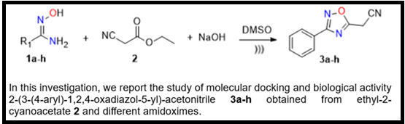

Spectrum

Figure 1 ¹H NMR spectrum (300 MHz) in CDCl₃ of the compound 3a

Figure 2 ¹³C NMR spectrum (75 MHz) in CDCl₃ of compound 3a

Figure 3 ¹H NMR spectrum (300 MHz) in CDCl₃ of compound 3b

Figure 4 ¹³C NMR spectrum (75 MHz) in CDCl₃ of compound 3b

Figure 5 ¹H NMR spectrum (300 MHz) in CDCl₃ of the compound 3c
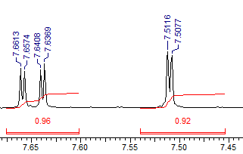

Figure 7 ¹H NMR spectrum (300 MHz) in CDCl₃ of the compound 3d

Figure 11 ¹³C NMR spectrum (75 MHz) in CDCl₃ of the compound 3g

Figure 12 ¹H NMR spectrum (300 MHz) in CDCl₃ of the compound 3h.

