Exploring Nonlinear Dynamics of Gross Cropped Area: An NNARX Model for Kerala, India

ABSTRACT
The present study develops a nonlinear Neural Network Autoregressive model with Exogenous inputs (NNARX) to model the Gross Cropped Area (GCA) in Kerala, India, using historical annual data from 1965-1966 to 2022-2023. The primary objective is to assess the predictive performance of NNARX models relative to benchmark Neural Network Autoregressive (NNAR) models by incorporating key climatic variables such as annual rainfall, minimum temperature, and maximum temperature as exogenous inputs. Several model configurations were examined, and the NNARX (2, 2) structure, which employs two lagged values of both endogenous and exogenous inputs, was identified as the optimal model based upon standard model selection criteria such as Akaike Information Criteria (AIC), Corrected AIC (AICc) and Bayesian Information Criteria (BIC) values. Model performance was evaluated using Mean Absolute Percentage Error (MAPE) and Root Mean Square Error (RMSE), with results showing that the NNARX (2, 2) model significantly outperformed the NNAR alternatives. The performance of the NNARX model underscores the importance of incorporating climatic factors to more accurately capture the nonlinear and dynamic relationships that influence agricultural land use. The findings highlight that climate variables play a crucial role in determining the cropping patterns and GCA in Kerala. Moreover, the results demonstrate that machine learning based time series approaches, such as NNARX, offer powerful tools for agricultural modelling, capable of providing more accurate and reliable forecasts. By offering a data-driven framework to predict production outcomes, assess the trade-offs of various management strategies, and create policies that support economic benefits, food security, and environmental sustainability, particularly in light of growing climate variability, these models can support evidence-based agricultural planning, effective resource allocation, and the development of sustainable development strategies..
Key words: Time Series, machine learning, neural network, climatic factors
INTRODUCTION
Kerala, often celebrated as “God’s Own Country,” is a land of remarkable geographic and cultural diversity, bounded by the majestic Western Ghats to the east and the Arabian Sea to the west. The state’s economy and the livelihood of a large section of its population are deeply rooted in agriculture and its allied sectors. However, this traditional dependence faces mounting challenges arising from rapid urbanization, shifting land-use patterns, and the growing impact of climatic variability. One of the key indicators of agricultural performance is the gross cropped area, which represents the total land area cultivated during a year, accounting for multiple cropping cycles. Changes in GCA reflect the intensity of agricultural activities and the state’s capacity to sustain crop production under varying socio-economic and environmental conditions. In Kerala, the GCA has witnessed considerable fluctuations over the decades, driven by both human induced transformations such as the conversion of farmland for residential and commercial purposes and natural factors, including variations in temperature, rainfall patterns, and extreme weather events. Analyzing the trends and determinants of GCA is therefore essential for understanding the evolving dynamics of Kerala’s agricultural sector and for framing effective strategies in resource management, sustainable land use, and evidence-based agricultural policymaking.
Traditional statistical models often struggle to accurately represent the complex, dynamic, and nonlinear relationships that exist between climatic variables and agricultural outputs. These models typically rely on rigid assumptions, which limit their ability to capture the subtle interactions and feedback effects inherent in real-world systems. In contrast, machine learning techniques have emerged as powerful tools for analyzing time series data, as they can learn directly from historical patterns and adapt to underlying nonlinearities without predefined functional forms. This study adopts a nonparametric, nonlinear machine learning framework implemented both with and without exogenous inputs to effectively address these complexities. Among various available approaches, neural network-based time series models are particularly advantageous because they can model intricate temporal dependencies and capture hidden relationships between variables that traditional methods might overlook. Therefore, the present study employs the neural network autoregressive model with exogenous variables to analyze the influence of climatic factors such as, temperature and rainfall on the cropping patterns of Kerala. By leveraging this advanced modelling approach, the study aims to evaluate the degree of climatic impact on agricultural activity and to construct a reliable, data-driven predictive model capable of forecasting Kerala’s Gross Cropped Area with improved precision and interpretability.
Unni (1983) conducted an in-depth analysis of cropping pattern trends in Kerala over a period of two decades and observed a notable transition from wetland crops, primarily rice, to garden land crops, especially coconut. The study also explored the technological feasibility of substituting coconut cultivation in traditional paddy fields, highlighting a major structural transformation in the state’s agricultural landscape. Later, Nair (2012) examined changes in land-use dynamics and reported that a significant share of Kerala’s household gardens had been converted into simplified cropping systems or small-scale plantations such as coconut and rubber. This shift was largely attributed to land fragmentation, increasing land transactions, and the limited size of individual holdings, which constrained crop diversity. Further extending these insights, Karunakaran (2014) analyzed the growth trends of major crops in Kerala and revealed a pronounced shift in the cropping pattern from food crops toward non-food commercial crops, with rubber emerging as a dominant choice. The study emphasized that farmers’ decisions were influenced not merely by price-related factors but also by non-price determinants, including rainfall variability, irrigation availability, and yield risk. Collectively, these studies underscore Kerala’s ongoing transformation from traditional food-based agriculture to a plantation-oriented cropping system.
Rejula and Singh (2015) examined the evolution of land use and agricultural patterns in Kerala during a period marked by rising food insecurity between 2012 and 2021. Their findings revealed a concerning yet distinct trend an increase in the area lying fallow, indicating a decline in active cultivation. The study further showed that the total cultivated area in Kerala has been consistently shrinking, with food crops being more adversely affected than non-food crops. This suggests a gradual yet steady shift in the agricultural landscape toward non-food or commercial cultivation. In a more extended historical context, Johnson (2018) analyzed land-use and cropping pattern changes in Kerala over six decades, from 1956–1957 to 2016–2017. The study identified a pronounced shift in land utilization, characterized by a decline in the net cultivated area and a simultaneous increase in land used for non-agricultural purposes such as settlements and infrastructure. Similarly, Shilpa and Prema (2024) reported a sharp decline in the share of food crops in Kerala’s gross cropped area from 56.85% in 1987–88 to 40.73% in 2019–20, while non-food crops expanded their share from 43.14% to 59.27% during the same period. These findings collectively highlight the state’s shift toward commercial and plantation crops at the expense of food crop cultivation. Akhisha et al. (2025a, 2025b) developed forecasting models for Kerala’s cropping intensity using an Autoregressive Integrated Moving Average model with exogenous predictors (ARIMAX) and a multivariate statistical approach based on the Vector Autoregressive (VAR) model. These models provide a robust quantitative framework for analyzing and forecasting future agricultural trends in the region. Ayyoob et al. (2025) present strong statistical evidence of substantial regional economic transformations within Kerala’s agricultural sector, emphasizing a marked structural shift from traditional food crops toward cash and plantation crops across various regions of the state. This transition reflects both changing economic priorities and the influence of climatic and socio-political factors on land-use decisions. In recent years, several researchers including Gupta et al. (2022, 2024), Sarkar and Kumar (2023), Mahapatra et al. (2024), and Irshad et al. (2024) have utilized statistical and machine learning–based modelling frameworks to investigate diverse aspects of agriculture, such as crop yield prediction, productivity assessment, and the intricate interactions between climate variability and agricultural performance. Collectively, these studies demonstrate the increasing relevance and effectiveness of data-driven analytical techniques in capturing the complex, nonlinear nature of agricultural systems. Despite this growing body of literature, there remains a significant research gap concerning the modelling of Gross Cropped Area (GCA) in Kerala using advanced nonlinear approaches. To date, no published study has specifically applied neural network–based time series frameworks, particularly the Neural Network Autoregressive model with Exogenous Variables, to analyze or forecast the GCA, underscoring the novelty and significance of the present research.

MATERIALS AND METHODS
Source of Data
Historical data for 58 years, from 1965-1966 to 2022-2023, on gross cropped area in lakh hectares was collected yearly from the Kerala state planning board's economic review (https://spb.kerala.gov.in). The information related to climatic factors (annual rainfall in mm, maximum temperature in degrees Celsius, and minimum temperature in degrees Celsius) was collected from the India Meteorological Department's official website (https://mausam.imd.gov.in) over the same period.
NNAR Model
A Neural Network Autoregressive model is an advanced forecasting technique that integrates the principles of traditional autoregressive (AR) time series models with the flexibility of neural networks. It employs a feed-forward neural network architecture that can effectively capture complex nonlinear relationships in time series data. Unlike conventional linear models, NNAR models can learn intricate patterns through adaptive weight optimization. The model typically uses a logistic sigmoid activation function to introduce nonlinearity and enhance prediction accuracy. The logistic sigmoid function, which maps input values between 0 and 1, is mathematically expressed as:
$f\left(x\right)=\frac{1}{1+e^{-x}}$ (1)
In real-world applications, time series data often exhibit nonlinear behaviours that traditional linear autoregressive (AR) models fail to capture effectively. The NNAR model addresses this limitation by detecting and modelling nonlinear patterns and complex interactions within the data. It is typically denoted as NNAR (p, k), where ‘p’ represents the number of lagged input values and ‘k’ denotes the number of hidden nodes in the neural network. This flexible structure enables the model to approximate nonlinear functions and improve forecasting accuracy. The mathematical representation of the NNAR model can be expressed as follows:
$y\left(t\right)=f\left(y\left(t-1\right),y\left(t-2\right),…,y\left(t-n\right)\right)+ε\left(t\right)$ (2)
Where, $y\left(t\right)$the target/output variable at time t, $y\left(t-1\right),y\left(t-2\right),…,y\left(t-n\right)$ are the lagged values of the output, $f\left(.\right)$ is a nonlinear function approximated by a neural network, $ε\left(t\right)$ is the error term.
NNARX Model
The Nonlinear Autoregressive model with Exogenous Inputs is a specialized neural network–based time series model designed to capture complex nonlinear dynamics in systems where the output depends not only on its own past values but also on the historical behaviour of one or more external (exogenous) variables. This model effectively integrates both internal and external temporal dependencies, enabling it to simulate real-world processes influenced by multiple interacting factors. NNARX models are particularly useful in fields such as agriculture, where climatic variables like rainfall and temperature, alongside past agricultural trends, play a significant role in determining outcomes such as crop yield, cropping intensity, or the gross cropped area over time.
Mathematically, the NNARX model can be expressed as:
$y\left(t\right)=f\left(y\left(t-1\right),y\left(t-2\right),…,y\left(t-n\right),x\left(t-1\right),x\left(t-2\right),…,x\left(t-m\right)\right)+ε\left(t\right)$ (3)
where, $x\left(t-1\right),x\left(t-2\right),…,x\left(t-m\right)$ are the lagged values and of the exogenous inputs and m represents the number of exogenous variables.
In this study, Gross Cropped Area (GCA) serves as the dependent variable, while the NNARX model incorporates exogenous inputs such as annual rainfall, minimum temperature, and maximum temperature. The key advantage of the NNARX approach lies in its flexibility and ability to capture complex, nonlinear relationships that conventional linear models may fail to represent accurately. For model selection, statistical criteria such as the AIC, AICc, and BIC are considered to identify the most suitable model structure. Model performance is further assessed using accuracy measures like MAPE and RMSE. Additionally, the Ljung–Box test (Ljung & Box, 1978) is employed as a residual diagnostic tool to detect autocorrelation.
RESULTS AND DISCUSSION
The state's average gross cropped area for the previous 58 years was 28.45 lakh hectares, with a standard deviation of 1.72 lakh hectares. According to reports, the highest Gross Cropped Area was 30.67 lakh ha in 1995-96, while the lowest was 25.16 lakh ha in 2022-2023. The average annual rainfall in the state for a 58-year period was 2801.98 mm, with a standard deviation of 414.68 mm. Data show that the highest annual rainfall was 3606.30 mm in 2021-2022, while the lowest was 1870.90 mm in 2016-17. Over a 58-year span, the state's maximum temperature averaged 30.76⁰ C, with a standard deviation of 0.408⁰ C. The lowest recorded maximum temperature in 1971-72 was 29.65⁰ C, while the highest recorded temperature in 1998-99 was 31.60⁰ C. The average minimum temperature in the state for the last 58 years was 22.77⁰ C, with a standard deviation of 0.416⁰ C. The highest recorded temperature was 23.51⁰ C in 2016-17, while the lowest was 21.71⁰ C in 1974-75. The variables under investigation's descriptive statistics are shown in Table 1 below
Table 1: Descriptive statistics of the variables
Variable | Mean | Std. Dev. | Min. | Max.
Gross Cropped Area (lakh ha) | 28.45 | 1.72 | 30.67 | 25.16
Annual Rainfall (mm) | 2801.98 | 414.68 | 1870.90 | 3606.30
Min. Temperature (⁰C) | 22.77 | 0.416 | 21.70 | 23.51
Max. Temperature (⁰C) | 30.76 | 0.408 | 29.65 | 31.60
The plots of the original data for Gross Cropped Area, Annual Rainfall, Minimum Temperature, and Maximum Temperature are presented in Figures 1(a) to 1(d), respectively.
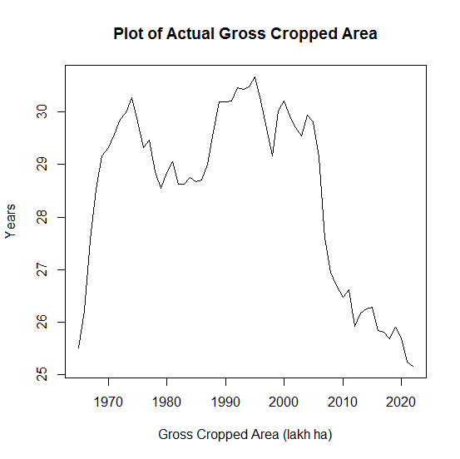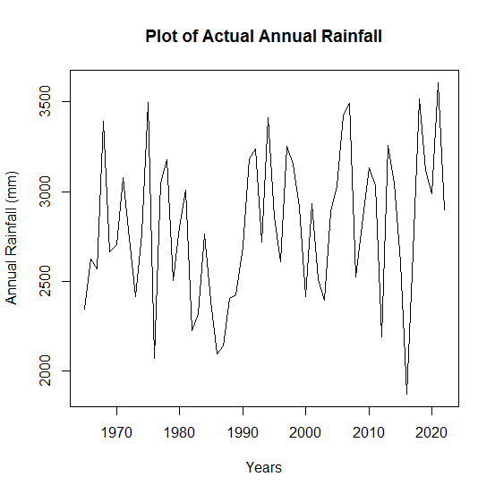
Fig. 1(a): Plot of original Gross Cropped Area | Fig. 1(b): Plot of Original Annual Rainfall
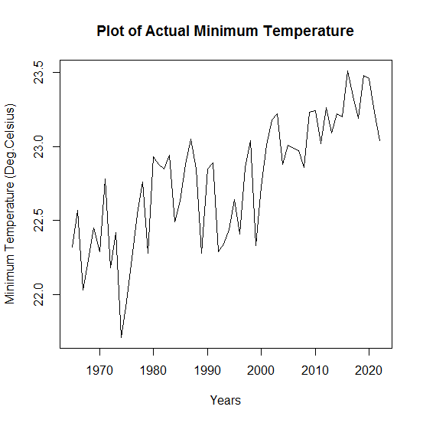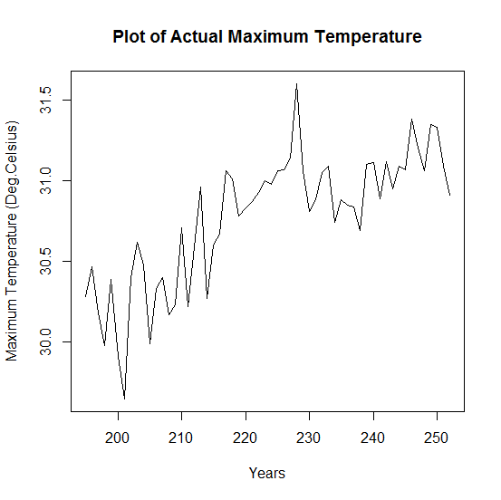
Fig. 1(c): Plot of original Minimum Temperature | Fig. 1(d): Plot of Original Maximum Temperature
The data consisted of a 10-year test set from 2013-2014 to 2022-2023 and a 48-year training set from 1965-1966 to 2012-2013. Through trial and error, different feed forward neural network models with Logistic sigmoid function as activation function were fitted to the data with and without using different combinations of exogenous factors and dependent variable lagged values. Based on the training data's AIC, AICc and BIC values, NNAR (4, 5) and NNARX (2, 2) were selected for further consideration. Table 2 below lists the model selection criteria.

Table 2: Model Selection Criteria
Model | AIC | AICc | BIC
NNAR (3,5) | 35.724 | 102.581 | 84.375
NNAR (4,4) | 25.703 | 84.794 | 72.483
NNAR (4,5) | 15.317 | 79.318 | 73.325
NNARX (1,2) | 8.885 | 11.685 | 21.983
NNARX (2,1) | 44.821 | 46.254 | 54.181
NNARX (2,2) | 6.262 | 10.999 | 23.103

Using such models, forecasts were made for the ensuing ten years, and the predicted values were contrasted with test results. After calculating RMSE and MAPE for the test data, NNARX (2, 2) was determined to be the best model and it outperformed the NNAR models. Table 3 below lists the model performance evaluation criteria.
Table 3: Model Performance Evaluation Criteria
Model | RMSE |  | MAPE
Model | Training data | Test data | Training data | Test data
NNAR (4, 5) | 1.1723 | 0.1803 | 0.4170 | 1.6078
NNARX (2, 2) | 0.2120 | 0.1785 | 0.4501 | 1.6633

In the NNARX (2, 2) model, an average of 20 networks were generated, each structured as a 5-2-1 feed-forward neural network comprising 15 connection weights. The model utilized two lagged values of the dependent variable (gross cropped area) along with two lagged values of each exogenous variable annual rainfall, minimum temperature, and maximum temperature as inputs. Consequently, the network consisted of five input nodes, two hidden nodes, and one output node representing the predicted GCA. This configuration enabled the model to effectively capture nonlinear dependencies between climatic factors and agricultural outcomes. The mathematical representation of the NNARX (2, 2) model is as follows:
$$GCA\left(t\right)=f\left\{\left(GCA\left(t-1\right),GCA\left(t-2\right),Rainfall\left(t-1\right),Rainfall\left(t-2\right), min.temp\left(t-1\right),min.temp\left(t-2\right),max.temp\left(t-1\right),max.temp\left(t-2\right)\right)\right\}+ε(t)$$
The model can be diagrammatically represented as given in Figure 2 below.
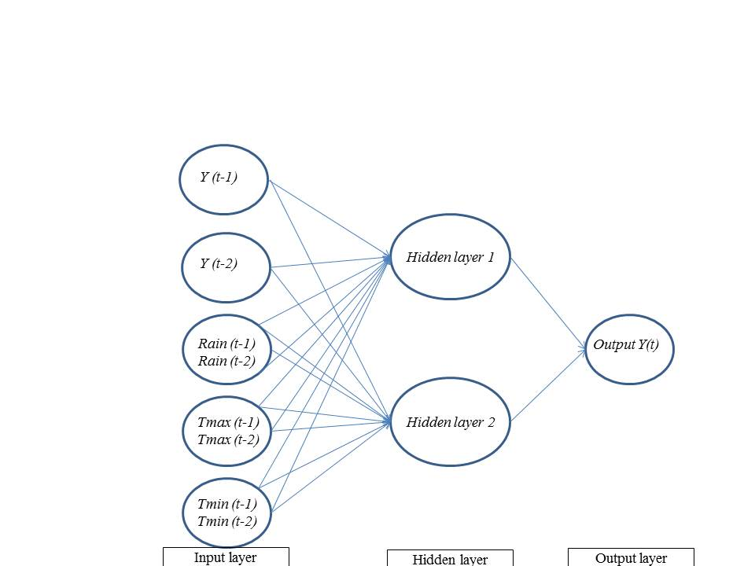
Fig. 2: Diagrammatic representation of NNARX (2, 2) Model
The chosen model NNARX (2, 2) was fitted to the original series of Gross Cropped Area and fitted values were obtained. A plot of the fitted values (in red colour) and original values (in black colour) is given in Figure 3 below.
Fig. 3: Plot of Original series and Fitted values
Using the Ljung-Box test for autocorrelation, residual diagnosis was completed. At one degree of freedom, the test yielded a Chi-squared value of 0.0011 with a probability value of 0.9735. This demonstrated unequivocally that there is no correlation between the errors.

CONCLUSION
Using long-term historical data covering 58 years (1965-1966 to 2022-2023), this study effectively illustrated the use of the nonlinear autoregressive model with and without exogenous inputs for estimating the gross cropped area in Kerala. The model successfully represented the nonlinear and dynamic interactions influencing agricultural land use in the state by including important climatic factors as exogenous inputs, such as yearly rainfall, minimum temperature, and maximum temperature. Based on selection criteria like AIC, AICc and BIC as well as evaluation measures like MAPE and RMSE, the NNARX (2, 2) model was the best performing structure among the many configurations studied. The model's accuracy in predicting GCA emphasizes the importance of data-driven approaches in agricultural forecasting and the substantial influence of climatic conditions on agricultural trends. The findings highlight how machine learning methods, such as NNARX, may assist evidence-based agricultural planning decision-making, particularly in climate-sensitive areas like Kerala. In the agricultural sector, this model can help stakeholders, planners, and policymakers develop adaptive solutions for resource allocation, land use, and climate resilience. To further improve model accuracy and applicability, future studies can investigate the integration of socio-economic variables, crop policy variables and higher-resolution temporal data.
DISCLAIMER (ARTIFICIAL INTELLIGENCE)

Author(s) hereby declare that NO generative AI technologies such as Large Language Models (ChatGPT, COPILOT, etc.) and text-to-image generators have been used during the writing or editing of this manuscript

REFERENCES
Akhisha, P. A., Sarkar, K. A., Dhakre, D. S., and Bhattacharya, D. (2025). Modelling Cropping Intensity of Kerala Using ARIMA with Exogenous Predictors. Journal of Scientific Research and Reports, 2025, 31 (2), 75-83.
Akhisha, P. A., Sarkar, K. A., Dhakre, D. S., and Bhattacharya, D. (2025). Forecasting of Cropping Intensity of Kerala in India: A Multivariate Approach. Journal of Scientific Research and Reports, 31 (2), 172-179.
Andreas, Wunsch., Tanja, Liesch., and Stefan, Broda. (2018). Forecasting groundwater levels using nonlinear autoregressive networks with exogenous input (NARX). Journal of Hydrology, Volume 567, 743-758.
Ayyoob, K. C., Bhattacharya D., Sarkar, K. A., and Dhakre, D. S. (2025). Regional Economic Shifts in Kerala’s Agricultural Landscape. Journal of Scientific Research and Reports, 31(5), 1055-1064.
Gupta, A. K., Sarkar, K. A., Dhakre, D. S., and Bhattacharya, D. (2022). Weather Based Potato Yield Modelling using Statistical and Machine Learning Technique. Environment and Ecology, 40 (3B), 1444—1449
Gupta, A. K., Sarkar, K. A., Dhakre, D. S., and Bhattacharya, D. (2024). Weather based crop yield prediction using artificial neural networks: A comparative study with other approaches. MAUSAM, 74(3), 825–832.
Johnson, D. (2018). Cropping Pattern Changes in Kerala, 1956–57 to 2016–17. Review of Agrarian Studies, 8(1):65-99
Karunakaran, N. (2014). Determinants of Changes in Cropping Pattern in Kerala. Journal of Rural Development, 33(4), 367–376.
Imandoust, S. B and Fahimifard, S. M. (2010). Application of NNARX to Agricultural Economic Variables Forecasting. Journal of Applied Sciences, 10(13)
Irshad M., Sarkar, K. A., Dhakre, D. S., and Bhattacharya, D. (2024). Comparative Analysis of Statistical Model and Machine Learning Algorithms in Forecasting Black Pepper Price of Kerala, Biological Forum-An International Journal, 16(8): 63-68.
Ljung, G. M., & Box, G. E. P. (1978). On a measure of lack of fit in time series models. Biometrika, 65(2), 297–303.
Mahapatra, S.K., Dhakre, D. S., Bhattacharya, D., and Sarkar, K. A. (2024) Forecasting of finger millet production in Odisha by ARIMA & ANN model: A comparative study. International Journal of Statistics and Applied Mathematics, 9(1), 276-281.
Nair, K, N. (2012). Agriculture and rural development; Decentralizes and local level development.
Rejula, K., & Singh, Rashmi. (2015). An analysis of changing land use pattern and cropping pattern in a scenario of increasing food insecurity in Kerala state. Economic Affairs, 60(1), 123-129.
Sarkar, K. A., and Kumar, R. R. (2023). Spatial and Temporal Trend Analysis for Maximum and Minimum Temperature Using Non-Parametric Techniques. International Journal of Bio-resource and Stress Management,14(3), 465-478
Shilpa, Mathew., A, Prema., & M, Hema. (2024). Cropping pattern and crop diversification in Kerala, India – a spatio-temporal analysis. Current Science, 126(4), 470-477.
Unni, J. (1983). Changes in the Cropping Pattern in Kerala: Some Evidence on Substitution of Coconut for Rice, 1960-61 to 1978-79. Economic and Political Weekly, 18(39), A100–A107.

