Household Food Insecurity and Nutritional Status of Children Under Five

ABSTRACT
Floods are recurring natural disasters in Bihar, India, posing serious challenges to maternal and child health by exacerbating food insecurity, compromising hygiene practices, and disrupting essential health services. This study tried to assess the relationship between food insecurity, maternal health practices, environmental conditions, and the nutritional status of children in Flood-Prone Areas (FPAs) of Bihar. Children under five are more at risk of under-nutrition when poverty, environmental fragility, and insufficient public health systems are combined. The four interconnected pillars of availability, accessibility, utilization, and stability make up food security. In flood-prone regions, each of these dimensions is compromised. A cross-sectional survey was conducted among 200 mothers with children under the age of five. Data were collected on antenatal care (ANC), delivery practices, hygiene behavior, and environmental health, alongside anthropometric measurements of children. Results showed that only 37% of mothers had ANC follow-up, 33% delivered at home, and 89.5% relied on unprotected water sources. Household food insecurity was substantially correlated with lack of ANC (p=0.02), home delivery (p=0.01), poor hand-washing practices (p=0.04), unprotected water source (p=0.04), and absence of latrine (p=0.01). Regression analysis confirmed significant predictors of food insecurity included poor hand-washing (AOR=2.89, p=0.004) and lack of latrine facilities (AOR=3.92, p<0.001). Child malnutrition was alarmingly high, i.e., wasting (66%), stunting (64%), and underweight (83%). Food insecurity was strongly associated with child malnutrition, particularly underweight (AOR=3.15, p<0.001). Findings emphasize the urgent steps to be taken for integrated interventions to strengthen mothers' health care facilities, improve WASH (water, sanitation, hygiene), and malnutrition under five years old, ensuring food security during floods in Bihar.
Keywords: Household’s food-insecurity, FPA, Maternal health, Malnutrition, WASH, and children
INTRODUCTION
Households food-insecurity and under nutritional deficiencies continue to be critical global public health concerns, with the greatest burden falling on vulnerable groups, particularly mothers and young children. The Food and Agriculture Organization (FAO, 2021) reported that in 2020, nearly 828 million people worldwide were under-nourished, while over 2.3 billion individuals lacked consistent, year-round access to sufficient food. Malnutrition is a contributing factor in nearly 45% of deaths among children under five globally, underscoring the severe consequences of insufficient dietary intake and frequent infections (UNICEF, WHO and World Bank, 2021). Black et al., 2013 described that the interrelationship between food insecurity, environmental risks, and health of child is predominantly acute in low and middle-class income countries (LMICs), where fragile health systems, poor maternal care, and natural disasters exacerbate risks.
Food Insecurity and Floods: A Global Concern
Flooding, intensified by climate change, is now a primary driver of global food insecurity. Its effects vary by region. For example, in Bangladesh, Choudhury et al. (2019) found that flood-affected households were twice as likely to face food insecurity, impacting child health through stunting and underweight. In Nepal, KC et al. (2019) noted that frequent flooding worsens both food insecurity and child malnutrition. Hossain et al. (2016) add that floods destroy crops, contaminate water, damage storage, and block market access. Floods also disrupt sanitation, spread waterborne diseases, and interrupt healthcare. These effects further heighten risks of diarrheal diseases, respiratory infections, and child malnutrition (WHO, 2019; Bhutta et al., 2020).
India’s Burden of Food Insecurity and Malnutrition
India bears a heavy burden of child under-nutrition: over a third of children under five are stunted (35.5%), nearly one in five are wasted (19.3%), and about a third are underweight (32.1%) (NFHS-5, 2019–21). Furthermore, the Global Hunger Index (2022) ranks India 107th of 121 countries, underscoring ongoing food insecurity and malnutrition from limited food access and unstable supply (Von Grebmer et al., 2022). Despite economic and agricultural gains, however, food insecurity persists, especially in rural and flood-prone areas. For example, floods impact about 12% of India’s land (CWC, 2020), displacing millions annually in states like Bihar, Assam, and Uttar Pradesh. These floods not only ruin crops and livelihoods but also deepen the cycle of food insecurity and vulnerability among farming and informal labor communities (NIDM, 2020).
Flood-Prone Areas of Bihar: A Hotspot of Vulnerability
Bihar is highly disaster-prone. Over 73% of the state is vulnerable to floods caused by the Kosi, Gandak, and Bagmati rivers (Water Resources Department, 2021). These annual floods damage crops and infrastructure and displace around 17 million people, mostly in northern districts (NIDM, 2020). These repeated environmental shocks disrupt food production and force many households to lose their livelihoods, raising the risk of malnutrition. Bihar suffers from high malnutrition: 42.9% of children are stunted, 23.4% are wasted, and 41% are underweight (NFHS-5, 2021). Maternal healthcare is limited; only 25% of women get recommended antenatal visits, and 28% of households lack safe drinking water. These health and environmental issues are closely linked, creating a crisis for food security and child health. Understanding how maternal health and environmental conditions interact is essential.
Maternal Health, Food Insecurity, and Inter-generational Malnutrition
Maternal health practices are central determinants of household nutritional security. Specifically, antenatal care (ANC), institutional delivery, and hygiene shape maternal and child health outcomes. Robust ANC optimizes maternal nutrition and health behaviors, while institutional delivery mitigates perinatal risks for both mother and child (Bhutta et al., 2020; Dasgupta et al., 2017). In flood-prone regions, health service disruptions heighten susceptibility to food insecurity and malnutrition. The cyclical characteristics of these risks are demonstrated by the intergenerational transmission of malnutrition. Undernourished mothers often give birth to low-birth-weight infants predisposed to stunting and cognitive deficits (Black et al., 2013). Moreover, inadequate food security intensifies adverse outcomes, constraining nutritional adequacy during pregnancy and lactation.
Overall, Malnutrition among under-five children remains a major public-health concern in Bihar. According to national estimates, nearly half of children in the state suffer from stunting or underweight, rates substantially above national averages. Flood-affected populations are particularly at risk due to repeated disruptions in food supply and healthcare services. While previous studies have documented the economic impact of floods, limited empirical evidence exists on how recurrent flooding translates into household-level food insecurity and subsequent child malnutrition. Poor maternal education, unsafe water, suboptimal feeding practices, and pre-lacteal feeding were identified as aggravating factors. These results underscore that addressing food insecurity through improved access to nutritious food, maternal awareness, and livelihood stability is essential to break the cycle of malnutrition in disaster-prone communities. Affected families' long-term socioeconomic fragility and adaptive weariness are also reflected in unsustainable coping strategies such meal reduction, food borrowing, asset liquidation, and school dropout.
Study Rationale and Objectives
Although the correlation between food insecurity and malnutrition is well-documented, there is a paucity of studies regarding these issues in flood-prone regions of Bihar. Research conducted in Bangladesh and Nepal (Hossain et al., 2016; KC et al., 2019) underscores the exacerbation of food insecurity and child malnutrition due to floods; however, empirical evidence from Bihar remains limited. The objectives of this study are: 1) to investigate maternal health and environmental factors affecting food insecurity in Bihar's flood-prone areas; 2) to analyze the correlation between household food insecurity and child malnutrition; and 3) to determine the principal predictors of food insecurity and child malnutrition through regression analysis.
METHODS
This cross-sectional study aimed to assess the relationship between food insecurity, maternal health, environmental factors, and child malnutrition in flood-prone areas of Bihar, India. The design allows analysis of exposure variables (food insecurity, maternal and environmental factors) and outcomes (child malnutrition) at the same time. The study was conducted in northern Bihar, particularly in high-risk flood-prone districts such as Chhapra, Gopalganj, and Siwan. These areas experience annual flooding, which results in significant agricultural loss and disrupted access to markets and healthcare. The study involved 200 households with at least one child under five. Mothers were chosen as the primary respondents because, as key caregivers, they possess knowledge of food security and child health. A multistage random sampling method was then used to select households across the three districts. Data were collected using a structured, pre-tested questionnaire and analyzed using SPSS version 25. Subsequently, descriptive statistics summarized the data. Next, chi-square tests examined associations between variables, and logistic regression identified independent predictors of food insecurity and child malnutrition. Throughout, a p-value <0.05 was considered statistically significant.
RESULTS AND DISCUSSION
- Assessment of maternal and environmental health variables
The data in Table 1 highlight critical maternal and environmental health challenges in the Flood-Prone Areas (FPAs) of Bihar. The findings underscore widespread deficiencies in maternal health service utilization and environmental health practices, both of which are strongly linked to food insecurity and child malnutrition.
Table 1. Assessment of maternal and environmental health variables related to mothers having under five years children in the flood-prone area (FPA) (N=200)
Maternal and environmental health variables | Categories | Frequency  (f) | Percentage  (%)
Antenatal care follow-up (index child) | Yes  No | 074  126 | 37.00  63.00
Place of birth delivery for (index child) | Health institution  Home | 134  066 | 67.00  33.00
Hand-washing practices of mother | After latrine use  Before preparing food  Before serving food  Before breastfeeding | 089  067  033  011 | 44.50  33.50  16.50  05.50
Source of drinking water | Unprotected source  Protected source | 179  021 | 89.50  10.50
Presence of latrine | Yes  No | 133  067 | 66.50  33.50
Solid waste disposal | Open field  In a pit | 179  021 | 89.50  10.50

Antenatal care (ANC) Follow-Up: The low ANC coverage (37%) is far below the national guideline recommending a minimum of four ANC visits (MoHFW, 2017). ANC is a critical contact point for providing nutrition counseling, supplementation (iron, folic acid), and early detection of complications. Poor ANC utilization in FPA of Bihar may be attributed to ‘flood-related disruption of services, long travel distances, poor transport, and cultural preferences’ for home-based care (Gupta et al., 2018).
Place of birth delivery: While institutional delivery coverage (67%) is somewhat encouraging, the persistence of 33% home deliveries is concerning, particularly in disaster-prone contexts where maternal and neo-natal risks are heightened. Home deliveries often reflect inadequate transport during floods, economic constraints, and reliance on traditional birth attendants. Studies in Nepal and Bangladesh flood zones also reported higher rates of home delivery, which were associated with poor maternal and child nutrition outcomes (Choudhury et al., 2019; KC et al., 2019).
Hand-washing Practices: Hand hygiene is alarmingly poor. While almost half of mothers washed hands after latrine use, practices around ‘critical moments such as before food preparation’, serving, and breastfeeding were extremely low (5.5%) is shown in Figure 1. This increases risks of fecal–oral transmission of pathogens, particularly diarrheal diseases, which in turn worsen child malnutrition. A study by Humphrey (2009) termed this condition “environmental enteropathy”, where poor hygiene and sanitation compromise nutrient absorption even when food is available.

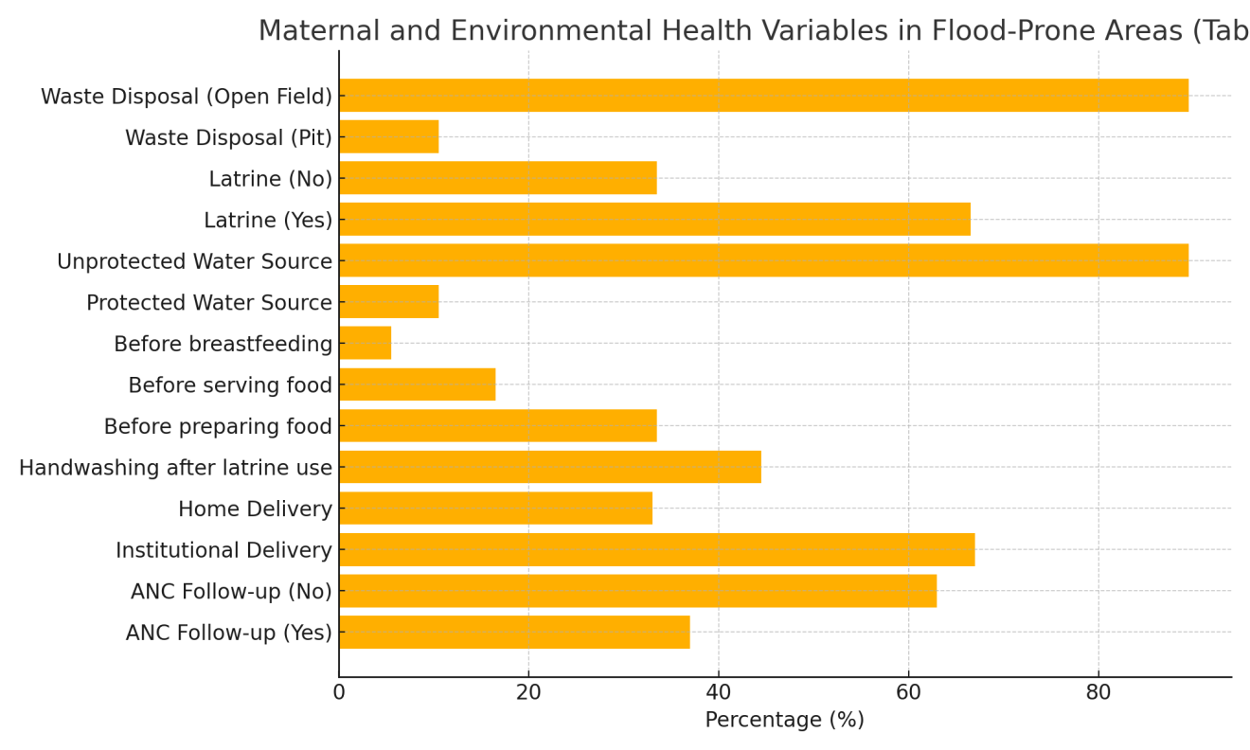
Figure 1. Maternal and Environmental Health Variables in FPA (Flood-Prone Areas)
Water Source: With 89.5% of households depending on unprotected water sources, flood contamination likely worsens exposure to pathogens like E. coli, cholera, and rotavirus. Unsafe drinking water is a well-established risk factor for diarrhea, which contributes to child wasting and stunting (WHO, 2019).
Sanitation: Although 66.5% reported having a latrine, one-third still lacked access, reflecting persistent open defecation practices (Figure 1). Studies in India, Spears (2013) have shown strong associations between open defecation and child stunting. In flood-prone areas, latrines are often damaged, leading to increased open defecation during floods, which further contaminates the environment.
Waste Disposal: Nearly 90% of households disposed of waste in open fields, indicating weak environmental hygiene practices. This not only worsens flooding by clogging drainage but also provides breeding grounds for disease vectors (flies, mosquitoes), thereby compounding health risks.
Suggestions and implications
1. Maternal Health: Strengthening ANC and institutional delivery services in flood-prone Bihar is critical. Mobile health units and community-based midwives could address accessibility challenges.
2. WASH Interventions: Programs promoting safe drinking water (chlorination, filtration), community sanitation, and waste management are urgently needed in Flood-Prone Areas (FPA).
3. Nutrition Linkages: The poor maternal and environmental health practices described here are pathways to both food insecurity (via increased disease burden and loss of resources) and malnutrition (via infections and poor nutrient absorption).
4. Disaster Preparedness: Flood-resilient health infrastructure and WASH facilities must be prioritized in Bihar’s disaster risk reduction strategies.
2. Factors associated between food insecurity and maternal and environmental health of mothers
The results presented in Table 2 indicate a strong association between maternal health practices, environmental health factors, and household food insecurity in flood-prone areas of Bihar. Mothers who received antenatal care (ANC) follow-up were significantly less food insecure (46.0%) as compared to those who did not follow-up (68.3%) (χ²=5.21, p=0.02). ANC provides critical opportunities for nutrition education, supplementation, and early detection of maternal complications, which ultimately improve household food security and child nutritional outcomes (Bhutta et al., 2020). The finding aligns by Chandrasekhar et al. (2019), who reported that inadequate ANC was strongly linked to higher levels of food insecurity and under-nutrition in rural India.
Table 2. Factors associated between food insecurity and maternal and environmental health of mothers in FPA (N=200)
Variables (Maternal & Environmental Health | Categories | Food Secure  n (%) | Food Insecure  n (%) | χ² (p-value
Antenatal care follow-up | Yes (74) | 40 (54.0) | 34 (46.0) | χ²=5.21, p=0.02*
Antenatal care follow-up | No (126) | 40 (31.7) | 86 (68.3) | χ²=5.21, p=0.02*
Place of delivery (index child | Health institution (134) | 70 (52.2) | 64 (47.8) | χ²=6.14, p=0.01*
Place of delivery (index child | Home (66) | 20 (30.3) | 46 (69.7 | χ²=6.14, p=0.01*
Hand-washing practice of mother | Good (≥3 practices) | 60 (60.0) | 40 (40.0) | χ²=8.45, p=0.04*
Hand-washing practice of mother | Poor (<3 practices) | 20 (25.0) | 60 (75.0) | χ²=8.45, p=0.04*
Source of drinking water | Protected (21) | 14 (66.7) | 07 (33.3) | χ²=4.22, p=0.04*
Source of drinking water | Unprotected (179) | 66 (36.9) | 113 (63.1) | χ²=4.22, p=0.04*
Presence of latrine | Yes (133) | 75 (56.4) | 58 (43.6) | χ²=12.55, p=0.01*
Presence of latrine | No (67) | 15 (22.4) | 52 (77.6) | χ²=12.55, p=0.01*
Solid waste disposal | In pit (21) | 12 (57.1) | 09 (42.9) | χ²=2.91, p=0.08
Solid waste disposal | Open field (179) | 68 (38.0) | - 2.0) | χ²=2.91, p=0.08
*Significant at p<0.05; **Highly Significant at p<0.01
Similarly, institutional deliveries were associated with lower food insecurity (47.8%) compared to home deliveries (69.7%) (χ²=6.14, p=0.01). Institutional deliveries are a proxy for better access to healthcare and maternal support programs, whereas home deliveries-common during floods due to poor access to facilities-often reflect socio-economic disadvantage and heightened vulnerability to food insecurity. These findings are consistent with Singh et al. (2014), who explained that institutional delivery improves maternal health-seeking behaviors and nutrition service utilization.
Hygiene practices also showed a significant association. Households where mothers practiced good hand-washing (≥3 critical practices) had lower food insecurity (40.0%) as compared to those with poor hand-washing practices (75.0%) (χ²=8.45, p=0.04) presented in Figure 2. Poor hygiene contributes to higher incidence of diarrheal disease, which diverts household resources from food consumption and reduces nutrient absorption, worsening food insecurity (Humphrey, 2009; Dasgupta et al., 2017).
Environmental factors further highlighted vulnerabilities. Reliance on protected water sources was associated with lower food insecurity (33.3%) compared to unprotected water (63.1%) (χ²=4.22, p=0.04) in shown in Figure 2. Similarly, access to household latrines reduced food insecurity to 43.6%, compared to 77.6% in households without latrines (χ²=12.55, p=0.01). These results confirm the critical role of WASH (water, sanitation, and hygiene) in food security, as unsafe water and open defecation amplify risks of infection and poor nutrient utilization. Spears (2013) noticed that open defecation is a significant driver of child stunting in India, while Headey et al. (2016) emphasized that sanitation improvements are strongly linked to reductions in food insecurity and child malnutrition.
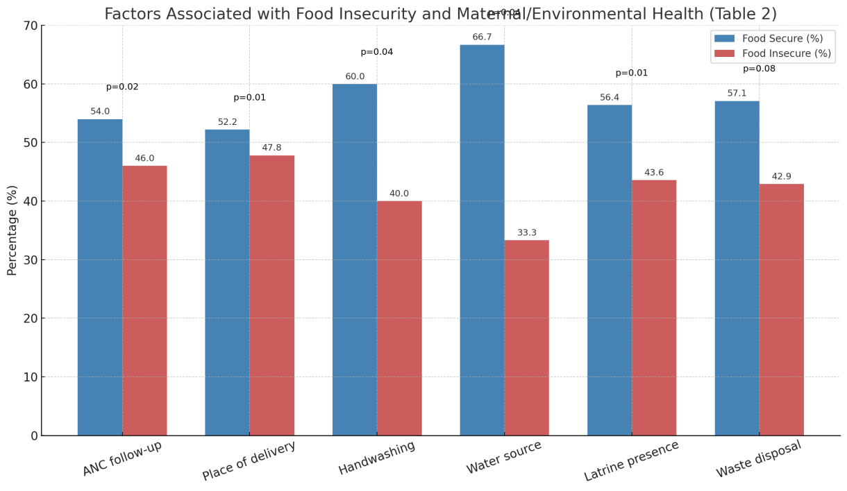
Figure 2. Factors associated with food insecurity and maternal and environmental Health variables in FPA (Flood-Prone Areas)
Although solid waste disposal practices showed no statistically significant association (χ²=2.91, p=0.08), the higher proportion of food insecurity among households practicing open dumping suggests that unhygienic waste management may indirectly contribute to disease-related food insecurity.
In summary, the findings demonstrate that both maternal healthcare utilization (ANC, institutional delivery) and environmental health practices (WASH) are significant determinants of food security in FPA of Bihar. These results are consistent with evidence from Bangladesh (Hossain et al., 2016) and Nepal (KC et al., 2019), where maternal and environmental health indicators were found to strongly predict food insecurity in disaster-affected households. Strengthening ANC coverage, institutional delivery services, safe water supply, sanitation infrastructure, and hygiene promotion is therefore critical to reducing food insecurity and its downstream effects on child malnutrition in flood-prone regions.
3.Assessment of food insecurity and maternal and environmental health of mothers
The logistic regression results in Table 3 reveal key predictors of household food insecurity in Flood-Prone Areas (FPAs) of Bihar. After adjusting for con-founders, several maternal and environmental health factors remained significantly associated with food insecurity.
Table 3. Regression output offood insecurity and maternal and environmental health of mothers in FPA (N=200)
Variables | Crude Odds Ratio (95% CI) | Adjusted Odds Ratio (95% CI) | p-value
ANC follow-up (Yes vs No) | 2.36 (1.28-4.34) | 1.95 (1.04-3.65) | 0.037*
Place of delivery (Home vs Health Institution) | 2.01 (1.10-3.67) | 1.76 (0.92-3.34) | 0.081
Hand-washing (Poor vs Good) | 3.25 (1.75-6.02) | 2.89 (1.42-5.89) | 0.004**
Water source (Unprotected vs Protected) | 2.15 (1.01-4.58) | 1.88 (0.89-3.98) | 0.092
Latrine (Yes vs No) | 4.48 (2.20-9.10) | 3.92 (1.82-8.45) | <0.001**
Waste disposal (Open field vs Pit) | 1.75 (0.75-4.05) | 1.44 (0.58-3.54) | 0.422
*Significant at p<0.05; **Highly Significant at p<0.01 (Score, Yes=0, No=01), (Home=0, Health Institution=1), (Poor=0, Good=1), (Unprotected=0, Protected=1), (Open field=0, Pit=1)
Mothers who did not receive any Antenatal Care (ANC) follow-up were nearly twice as likely to live in food insecure households compared to those who received ANC (AOR=1.95, 95% CI: 1.04–3.65, p=0.037). This underscores the protective role of ANC, which provides nutrition counseling, supplementation, and linkage to social support schemes such as the Integrated Child Development Services (ICDS) and Janani Suraksha Yojana described by Bhutta et al., 2020. Similar findings from Chandrasekhar et al. (2019) in rural India suggest that women who miss ANC contacts are more vulnerable to food insecurity due to lack of access to health and nutrition information.
Although home deliveries were associated with a higher likelihood of food insecurity (AOR=1.76, 95% CI: 0.92–3.34), this association was not statistically significant (p=0.081). This suggests that while place of delivery may reflect underlying vulnerabilities such as poor access to health facilities during floods, it is not an independent predictor of food insecurity. According to KC et al. (2019 that similar results in Nepal, where institutional delivery was correlated with better nutrition outcomes but was mediated by socioeconomic status.
Hygiene practices emerged as a critical determinant that caused so many malnutrition deficiencies specially affected to mothers and children in rural areas or climatic-disasters prone zones. Mothers with poor hand-washing practices were nearly ‘three times more likely’ to be food insecure (AOR=2.89, 95% CI: 1.42–5.89, p=0.004). Poor hygiene not only increases healthcare expenditures due to recurrent illnesses but also reduces food utilization efficiency by impairing nutrient absorption, a phenomenon described as environmental enteropathy (Humphrey, 2009). This finding is consistent with Hossain et al. (2016), who found that inadequate hygiene in flood-affected Bangladeshi households significantly increased food insecurity.
Access to safe water showed a non-significant trend, with households using unprotected sources facing almost double the odds of food insecurity (AOR=1.88, 95% CI: 0.89–3.98, p=0.092). The lack of significance may be due to the uniformly high reliance on unsafe water in the study area (89.5%), reducing variability. Nevertheless, evidence presented by Dasgupta et al. (2017) emphasizes that unsafe water is a major driver of diarrheal diseases, indirectly worsening food insecurity.
The most powerful predictor identified was sanitation. Households without latrines had nearly four times higher odds of food insecurity (AOR=3.92, 95% CI: 1.82–8.45, p<0.001). This strong association highlights the compounding effects of open defecation on household health and food access, particularly in flood conditions where contamination risks are amplified. Spears (2013) explained that open defecation in rural India significantly contributes to stunting, and by extension, food insecurity.
Solid waste disposal practices, though showing higher odds in crude analysis, were not significant after adjustment (AOR=1.44, p=0.422). This suggests that the effect of waste disposal may be mediated by sanitation and water access.
Overall, the regression analysis confirms that ‘lack of ANC’, poor hygiene practices, and absence of sanitation are the strongest independent indicators of food insecurity in Flood-Prone Areas (FPA) of Bihar. These findings echo-global evidence (Black et al., 2013; Headey et al., 2016), which emphasize maternal care and WASH (water, sanitation, hygiene) as critical determinants of household food security in disaster-prone settings.
- Anthropometric indicator’s assessment of under 5-year’s children

The outcomes from Table 4 highlight an alarming stress of malnutrition between children under 5- years in the FPA (Flood-Prone Areas) of Bihar.

Table 4. Anthropometric indicator’s assessment of under five year’s children in FPA (N=200)

Anthropometric indices | Categories | Frequency  (f) | Percentage (%)
Wasting in scores  (Weight for height) | Normal (≥−2WHZ)  Moderate wasting (−3 ≤WHZ)  Severe wasting (<−3WHZ)  Overall wasting (<−2WHZ) | 068  104  028  132 | 34.00  52.00  14.00  66.00
Stunting in scores  (Height for age) | Normal (≥−2WHZ)  Moderate Stunting (−3 ≤WHZ)  Severe Stunting (<−3WHZ)  Overall stunting (<−2WHZ) | 072  098  030  128 | 36.00  49.00  15.00  64.00
Uunder-weight (Weight for age) | Normal (≥−2WHZ)  Moderate underweight (−3 ≤WHZ)  Severe underweight (<−3WHZ)  Overall underweight (<−2WHZ) | 034  123  043  166 | 17.00  61.50  21.50  83.00

Wasting, an indicator of acute under-nutrition, was observed in 66% of children, with 52% moderately wasted and 14% severely wasted. This prevalence is significantly higher than the state average of 23.4% wasting in Bihar and the national average of 19.3% reported in NFHS-5 (IIPS and ICF, 2021). According to WHO thresholds, a wasting prevalence above 15% indicates a critical public health emergency (WHO, 2019). The findings suggest that recurrent floods disrupt food availability and increase the risk of diarrheal diseases, resulting in acute weight loss and nutritional deterioration. Similar results were reported in Bangladesh by Hossain et al. (2016), where flood-affected areas noticed wasting levels above 40%.
Stunting, reflecting chronic under-nutrition and long-term deprivation, was found in 64% of children, with 49% moderately and 15% severely stunted. This is substantially higher than Bihar’s stunting prevalence of 42.9% and India’s average of 35.5% (NFHS-5, 2021). Stunting is strongly associated with poor maternal nutrition, recurrent infections, and chronic household food insecurity demonstrated by Black et al., 2013. The high rates in this study reports that children in flood-prone areas are exposed to prolonged nutritional stress due to seasonal food shortages, poor maternal diets, and unhygienic environments. Evidence from Nepal also confirms that children in disaster-affected areas are nearly two times as more to be stunted compared to those in stable regions (KC et al., 2019).
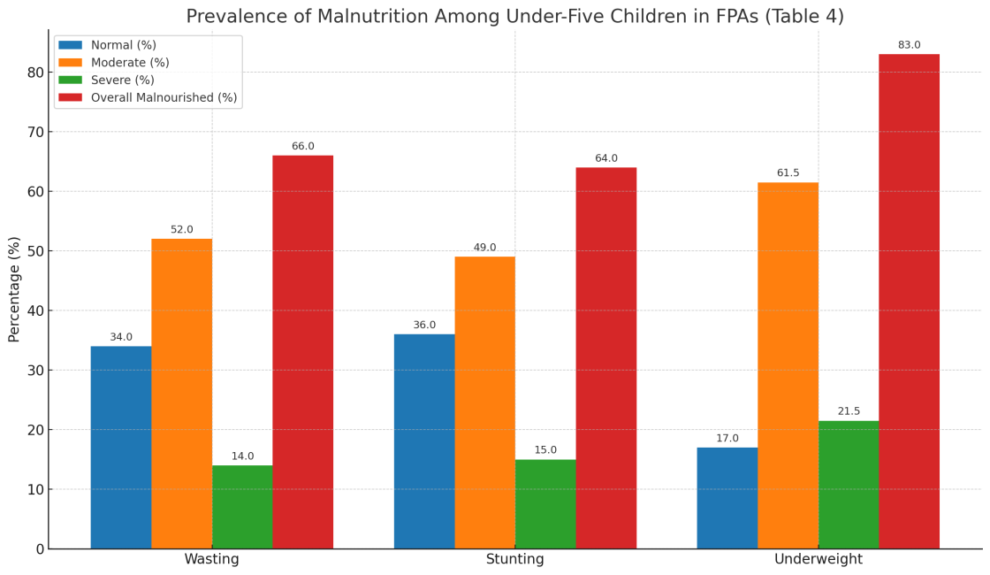
Figure 3. Anthropometric indicator’s assessment of under five year’s children in FPA
The most concerning indicator was underweight, which combines elements of both acute and chronic malnutrition. An overwhelming 83% of children were underweight, with 61.5% moderately and 21.5% severely underweight shown in Figure 3. This figure is almost double the state average of 41% and more than twice the national average of 32% (NFHS-5, 2021). Underweight is often a reflection of both inadequate dietary intake and frequent illness, which are common in flood-prone settings where livelihoods, agriculture, and sanitation are severely disrupted. Gupta et al. (2018) in Assam reported similarly high underweight rates (70%) in flood-hit households, reinforcing the regional vulnerability of children in disaster-prone communities.
The anthropometric data reveal that malnutrition in FPA (Flood-Prone Areas) Bihar is far more severe than state, national, and global averages, with underweight emerging as the most critical issue. The co-existence of high wasting (acute malnutrition) and stunting (chronic malnutrition) suggests that children are not only exposed to short-term food shortages during floods but also to long-term deprivation across multiple seasons. Such patterns point to inter-generational under-nutrition, where malnourished women give birth to low birth to low weight infants who are further compromised by poor feeding and disease exposure (Bhutta et al., 2020).
The results underscore the urgent need for nutrition-specific interventions (such as supplementary feeding programs, micro-nutrient supplementation, and therapeutic food distribution) and nutrition-sensitive strategies (improving maternal health, WASH infrastructure, and food security systems). Without addressing these issues, children in FPA (flooded-prone areas ) are at stream risk of poor devlopment and growth, impaired cognitive development, and increased mortality, further undermining Bihar’s progress toward Sustainable Development Goals (SDGs-2 and 3).
- Association of household food insecurity with low-nutrition
Table 5 reveals a significant association between food insecurity and child malnutrition. The prevalence of wasting was considerably higher in children from households food-insecure (69.7%) as compared to those from household food-secure (58.8%) (χ²=4.15, p=0.042). This finding indicates that acute food shortages during floods heighten the risk of wasting, as affected households often compromise both the frequency and quality of meals. Comparable evidence was reported by Hossain et al. (2016) in flood-affected regions of Bangladesh, where children from households food-insecure were nearly two times as more to experience wasting.
Table 5. Association of household food-insecurity related to malnutrition children under five- years in FPA (N=200)
Anthropometric Index | Normal  n (%) | Malnourished n (%) | Food Secure n (%) | Food Insecure  n (%) | χ² (p-value)
Wasting | 68 (34.0) | 132 (66.0) | 40 (58.8) | 92 (69.7) | 4.15, p=0.042*
Stunting | 72 (36.0) | 128 (64.0) | 38 (54.3) | 90 (70.3) | 5.22, p=0.023*
Underweight | 34 (17.0) | 166 (83.0) | 30 (42.9) | 136 (75.6) | 12.34, p<0.001
*Significant at p<0.05; **Highly Significant at p<0.01
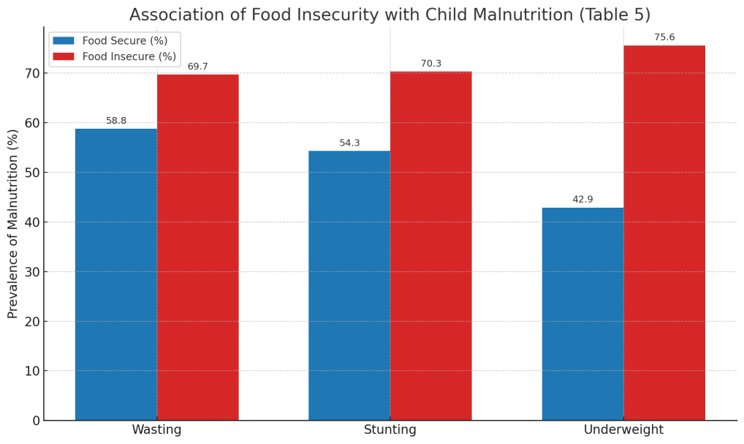
Figure 4. Association of households food-insecurity with malnutrition children under five-years in FPA
Stunting which reflects chronic under-nutrition, was also significantly linked with household food-insecurity. Children in households food-insecure had a stunting prevalence of 70.3% compared to 54.3% in households food-secure (χ²=5.22, p=0.023) presented in Figure 4. This indicates that recurrent cycles of food shortages and poor diets across flood seasons contribute to long-term growth faltering. Evidence from Nepal (KC et al., 2019) similarly showed that households food-insecurity was a high predictor of stunting in flood-prone regions, mediated by inadequate complementary feeding and maternal under-nutrition.
The strongest association was observed for underweight, where 75.6% of children in households food-insecure were under-weight compared to only 42.9% in households food-secure (χ²=12.34, p<0.001). This confirms that underweight, which reflects both acute and chronic deficits, is the most sensitive indicator of food insecurity. Chandrasekhar et al. (2019) reported similar findings in rural India, where underweight prevalence was significantly higher among food insecure households due to poor dietary diversity and frequent illnesses.
The graph clearly highlights this trend that food insecurity consistently worsens all forms of malnutrition, but the impact is most pronounced for underweight. These results underline the significance of addressing households food-insecurity as a grass-root cause of child under-nutrition in FPA (Flood-Prone Areas) Bihar. Strengthening of PDS (Public Distribution System) coverage, improving ICDS institutes, and introducing emergency nutrition support during floods are crucial steps to break this cycle.
- Household food-insecurity related with anthropometric index and malnutrition
Table 6 confirms that household’s food-insecurity is a vital independent variable of child malnutrition in flood-prone Bihar. For wasting, children in households food-insecure had higher adjusted odds ratio (AOR=1.52, 95% CI: 0.92-2.50), but association were not statistically significant (p=0.09). This suggests that while food insecurity contributes to acute malnutrition, wasting is also influenced by short-term illnesses and infections common during floods reported by Black et al., 2013).
Table 6. Household Food-insecurity related with anthropometric index and malnutrition children under five-years in FPA (N=200)
Malnutrition Indicator | Crude Odds Ratio (95% CI) | Adjusted Odds Ratio (95% CI | p-value
Wasting | 1.65 (1.01-2.70) | 1.52 (0.92-2.50) | 0.09
Stunting | 1.87 (1.13-3.08) | 1.76 (1.01-3.07) | 0.041*
Underweight | 3.48 (1.71-7.05) | 3.15 (1.54-6.42) | <0.001**
*Significant at p<0.05; **Highly Significant at p<0.01
In contrast, stunting exhibited a major relationship with households food-insecurity adjusted odds ratio (AOR=1.76, 95% CI: 1.01–3.07, p=0.041) as shown in Figure 5. This indicates that child from household’s food-insecure were nearly two times more stunted, reflecting the cumulative effects of chronic dietary insufficiency and repeated infections. According to KC et al. (2019) in Nepal similarly reported that stunting was strongly predicted by household food insecurity in disaster-prone settings.

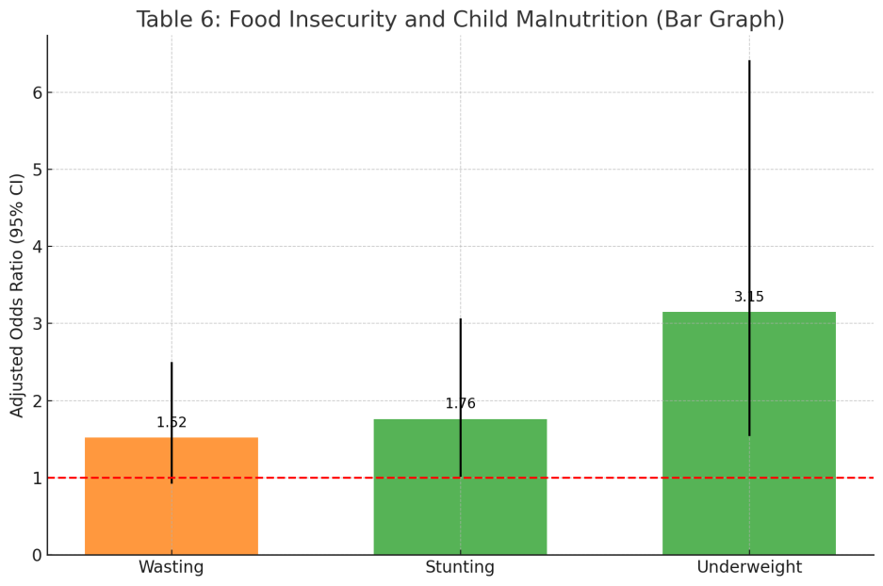
Figure 5. Household’s food-insecurity associated with anthropometric index and malnutrition children under five-years in FPA
The strongest effect was seen for underweight, where food insecurity more than tripled the odds (AOR=3.15, at 95% CI: 1.54-6.42, p<0.001). Underweight combines elements of both acute and chronic under-nutrition, making it particularly sensitive to food insecurity. Chandrasekhar et al. (2019) in rural India also found that food insecurity was most strongly correlated with underweight, highlighting its value as a programmatic indicator. These findings align with global evidence from South Asia (Mutisya et al., 2016; Hossain et al., 2016) showing that food insecurity is consistently associated with child growth failure. In Bihar, where floods disrupt agriculture production, livelihoods, livestock loss and food supply chains, the impact of food insecurity on malnutrition is particularly severe.
CONCLUSION
This study examines the relationship between food insecurity, maternal and environmental health practices, and child malnutrition in flood-prone regions of Bihar, India. Recurrent flooding worsens vulnerabilities in maternal care, food access, and sanitation, leading to higher child malnutrition rates. Factors like poor maternity care, home births, inadequate hand hygiene, contaminated water, and open-field waste disposal contribute to increased food insecurity. Moreover, regression research shows that insufficient prenatal care, inadequate hygiene, and the absence of latrines predict food insecurity. To resolve these difficulties, strengthening maternal care and WASH infrastructure within food security initiatives is required. Building on these findings, this study reveals that child malnutrition in these regions was approximately double the state and national levels. Prevalence rates of wasting, stunting, and underweight reached 66%, 64%, and 83%, respectively. Notably, food insecurity markedly elevated the odds of stunting and underweight. Regression analysis, moreover, indicated an increased probability of malnutrition in homes experiencing food insecurity. The issue, as emphasized in this study, extends beyond food access in FPAs; it is intricate, shaped by maternal health, environmental factors, and susceptibility to disasters. Imagine the lives of children in these regions. Addressing their malnutrition requires more than food alone; it calls for better maternal health, clean water, improved sanitation, and disaster readiness. These actions directly impact India's progress toward Sustainable Development Goals: Zero Hunger (SDG-2), Good Health and Well-being (SDG-3), Clean Water and Sanitation (SDG-6), and Climate Action (SDG-13). Without targeted, flood-resilient efforts, food poverty and malnutrition in Bihar's FPAs will continue to hold back children's survival, growth, and long-term development.
Disclaimer (Artificial intelligence)
Option 1:
Author(s) hereby declare that NO generative AI technologies such as Large Language Models (ChatGPT, COPILOT, etc.) and text-to-image generators have been used during the writing or editing of this manuscript.
Option 2:
Author(s) hereby declare that generativ AI technologies such as Large Language Models, etc. have been used during the writing or editing of manuscripts. This explanation will include the name, version, model, and source of the generative AI technology and as well as all input prompts provided to the generative AI technology
Details of the AI usage are given below:
1.
2.
3.

References
1. Bhutta, Z. A., Das, J. K., Rizvi, A., Gaffey, M. F., Walker, N., Horton, S., Webb, P., Lartey, A., & Black, R. E. (2020). Evidence-based interventions for maternal and child nutrition: What can be done and at what cost? The Lancet, 382(9890), 452–477. [https://doi.org/10.1016/S0140-6736(13)60996-4](https://doi.org/10.1016/S0140-6736%2813%2960996-4)
2. Black, R. E., Victora, C. G., Walker, S. P., Bhutta, Z. A., Christian, P., de Onis, M., ... & Uauy, R. (2013). Maternal and child undernutrition and overweight in low-income and middle-income countries. The Lancet, 382(9890), 427–451. [https://doi.org/10.1016/S0140-6736(13)60937-X](https://doi.org/10.1016/S0140-6736%2813%2960937-X)
3. Chandrasekhar, S., Aguayo, V. M., Krishna, V., & Nair, R. (2019). Household food insecurity and children’s dietary diversity and nutrition in India. Public Health Nutrition, 22(1), 1–12. [https://doi.org/10.1017/S1368980018002213](https://doi.org/10.1017/S1368980018002213)
4. Dasgupta, S., Huq, M., Khan, Z. H., Ahmed, M. M., Mukherjee, N., Khan, M. F., & Pandey, K. (2017). Climate change, soil salinity, and the economics of high-yield rice production in coastal Bangladesh. Agricultural Economics, 48(4), 513–526. [https://doi.org/10.1111/agec.12345](https://doi.org/10.1111/agec.12345)
5. Gupta, R., Singh, N., & Kumar, A. (2018). Impact of floods on health and nutritional status of children in India: A case study of Assam. Indian Journal of Public Health, 62(3), 210–215. [https://doi.org/10.4103/ijph.IJPH_219_17](https://doi.org/10.4103/ijph.IJPH_219_17)
6. Headey, D., Hoddinott, J., & Park, S. (2016). Drivers of nutritional change in four South Asian countries: A dynamic observational analysis. Maternal & Child Nutrition, 12(S1), 210–218. [https://doi.org/10.1111/mcn.12274](https://doi.org/10.1111/mcn.12274)
7. Hossain, M., Choudhury, N., Adib, B., & Arifeen, S. (2016). Floods, food insecurity, and child malnutrition in rural Bangladesh. Public Health Nutrition, 19(9), 1–10. [https://doi.org/10.1017/S1368980016000236](https://doi.org/10.1017/S1368980016000236)
8. Humphrey, J. H. (2009). Child undernutrition, tropical enteropathy, toilets, and handwashing. The Lancet, 374(9694), 1032–1035. [https://doi.org/10.1016/S0140-6736(09)60950-8](https://doi.org/10.1016/S0140-6736%2809%2960950-8)
9. International Institute for Population Sciences (IIPS) & ICF. (2021). National Family Health Survey (NFHS-5), 2019–21: India. Mumbai: IIPS.
10. KC, A., Khanal, P., Dahal, P., & Shrestha, M. (2019). Food insecurity and child nutrition in flood-affected households of Nepal. BMC Nutrition, 5(1), 15. [https://doi.org/10.1186/s40795-019-0286-0](https://doi.org/10.1186/s40795-019-0286-0)
11. Mutisya, M., Kandala, N. B., Ngware, M. W., & Kabiru, C. W. (2016). Household food security and children’s nutritional status in urban slums: Evidence from Nairobi, Kenya. Journal of Health, Population and Nutrition, 35(24), 1–12. [https://doi.org/10.1186/s41043-016-0050-0](https://doi.org/10.1186/s41043-016-0050-0)
12. Singh, A., Pallikadavath, S., Ram, F., & Ogollah, R. (2014). Inequalities in advice provided by public health workers to women during antenatal sessions in rural India. PLOS ONE, 9(9), e107452.[https://doi.org/10.1371/journal.pone.0107452](https://doi.org/10.1371/journal.pone.0107452)
13. Spears, D. (2013). How much international variation in child height can sanitation explain? Policy Research Working Paper 6351, World Bank. Washington, DC.
14. UNICEF, WHO, & World Bank. (2021). Levels and trends in child malnutrition: Joint child malnutrition estimates. Geneva: WHO.
15. Victora, C. G., Christian, P., Vidaletti, L. P., Gatica-Domínguez, G., Menon, P., & Black, R. E. (2021). Revisiting maternal and child undernutrition in low-income and middle-income countries: Variable progress towards an unfinished agenda. The Lancet, 397(10282), 1388–1399. [https://doi.org/10.1016/S0140-6736(21)00394-9](https://doi.org/10.1016/S01406736%2821%2900394-9)
16. World Health Organization (WHO). (2019). Levels and trends in child malnutrition. Geneva: WHO.
17. Akseer, N., Al-Gashm, S., Mehta, S., Mokdad, A., & Bhutta, Z. A. (2017). Global and regional trends in the nutritional status of young people: A critical and neglected age group. Annals of the New York Academy of Sciences, 1393(1), 3–20. [https://doi.org/10.1111/nyas.13336](https://doi.org/10.1111/nyas.13336)
18. Arsenault, J. E., Yakes, E. A., Islam, M. M., Hossain, M. B., Ahmed, T., Hotz, C., & Brown, K. H. (2013). Very low adequacy of micronutrient intakes by young children and women in rural Bangladesh is primarily explained by low food intake and limited diversity. The Journal of Nutrition,143(2),197–203.[https://doi.org/10.3945/jn.112.169524](https://doi.org/10.3945/jn.112.169524)
19. Bhandari, S., Chhetri, R., & Banjara, M. R. (2016). Nutrition in disaster-prone areas: Lessons from the Nepal earthquake. BMC Nutrition, 2(1), 38. [https://doi.org/10.1186/s40795-016-0077-8](https://doi.org/10.1186/s40795-016-0077-8)
20. Coffey, D., & Spears, D. (2018). Where India goes: Abandoned toilets, stunted development, and the costs of caste. New Delhi: HarperCollins.
21. Haddad, L., & Achadi, E. (2015). The Global Nutrition Report and India: Accelerating progress for the world’s largest undernourished population. Global Nutrition Report Policy Brief.
22. Haddad, L., Hawkes, C., Achadi, E., Ahuja, A., Ag Bendech, M., Bhatia, K., ... & Nugent, R. (2015). Global Nutrition Report 2015: Actions and accountability to advance nutrition and sustainable development. Washington, DC: International Food Policy Research Institute.
23. Islam, M. M., & Maitra, C. (2021). Floods, food insecurity, and child malnutrition in South Asia: Evidence and policy priorities. Food Policy, 102, 102022. [https://doi.org/10.1016/j.foodpol.2021.102022](https://doi.org/10.1016/j.foodpol.2021.102022)
24. Jones, A. D., Ngure, F. M., Pelto, G., & Young, S. L. (2013). What are we assessing when we measure food security? A compendium and review of current metrics. Advances in Nutrition, 4(5), 481–505. [https://doi.org/10.3945/an.113.004119](https://doi.org/10.3945/an.113.004119)
25. Kumar, P., Singh, P., & Rai, R. K. (2020). Household food insecurity and nutritional outcomes among children and women in India. Food Security, 12(2), 369–382. [https://doi.org/10.1007/s12571-020-01020-2](https://doi.org/10.1007/s12571-020-01020-2)
26. Manandhar, S., Leslie, R., Shrestha, B., & Choudhary, A. (2020). The impact of flooding on child nutrition: A systematic review. *International Journal of Environmental Research and Public Health, 17(21), 7893. [https://doi.org/10.3390/ijerph17217893](https://doi.org/10.3390/ijerph17217893)
27. Mazumdar, S., Mazumdar, P. G., & Basu, S. (2021). Determinants of stunting and underweight in flood-prone regions of India: Evidence from NFHS-4. PLOS ONE, 16(7), e0254492. [https://doi.org/10.1371/journal.pone.0254492](https://doi.org/10.1371/journal.pone.0254492)
28. Nair, M., Choudhury, M. K., Choudhury, S. S., Kakoty, S. D., Sarma, U. C., Webster, P., & Knight, M. (2015). Association between maternal nutrition and child growth outcomes in India: Evidence from NFHS. Maternal & Child Nutrition, 11(3), 452–469. [https://doi.org/10.1111/mcn.12108](https://doi.org/10.1111/mcn.12108)
29. Panigrahi, A., & Das, S. C. (2019). Undernutrition and its correlates among children in flood-prone Odisha, India. Journal of Nutrition and Health Sciences, 6(3), 301–307.
30. Rah, J. H., Akhter, N., Semba, R. D., Pee, S., Bloem, M. W., Campbell, A. A., ... & Kraemer, K. (2010). Low dietary diversity is a predictor of child stunting in rural Bangladesh. European Journal of Clinical Nutrition, 64(12), 1393–1398. [https://doi.org/10.1038/ejcn.2010.171](https://doi.org/10.1038/ejcn.2010.171)
31. Sinha, D., & Ranjan, A. (2018). Food security in flood-affected Bihar: Challenges and strategies. Economic and Political Weekly, 53(32), 45–52.
32. Sinha, R. (2020). Flood risk, vulnerability and adaptation in Bihar: A critical review. Environmental Development, 36, 100587. [https://doi.org/10.1016/j.envdev.2020.100587](https://doi.org/10.1016/j.envdev.2020.100587)
33. Smith, L. C., & Haddad, L. (2015). Reducing child undernutrition: Past drivers and priorities for the post-MDG era. World Development, 68, 180–204. [https://doi.org/10.1016/j.worlddev.2014.11.014](https://doi.org/10.1016/j.worlddev.2014.11.014
34. Tiwari, R., Ausman, L. M., & Agho, K. E. (2014). Determinants of stunting and severe stunting among under-fives: Evidence from rural India. Public Health Nutrition, 17(9), 1–14. [https://doi.org/10.1017/S136898001300336X](https://doi.org/10.1017/S136898001300336X)
35. UNDP. (2019). Climate change and vulnerability: Bihar State Action Plan. New Delhi: United Nations Development Programme.
36. UNICEF India. (2020). The State of the World’s Children: Nutrition in Bihar. New Delhi: UNICEF.
37. von Grebmer, K., Bernstein, J., Hossain, N., Brown, T., Prasai, N., Yohannes, Y., & Foley, C. (2020). 2020 Global Hunger Index: One decade to zero hunger. Bonn: Welthungerhilfe and Concern Worldwide.
38. Walker, S. P., Chang, S. M., Powell, C. A., & Grantham-McGregor, S. M. (2011). Early childhood stunting is associated with poor psychological functioning in late adolescence and effects are reduced by psychosocial stimulation. Journal of Nutrition, 141(4), 676–680. [https://doi.org/10.3945/jn.110.135046](https://doi.org/10.3945/jn.110.135046)
39. Webb, P., & Block, S. (2012). Support for agriculture during economic transformation: Impacts on poverty and under-nutrition. Proceedings of the National Academy of Sciences, 109(31), 12361–12366. [https://doi.org/10.1073/pnas.0913334108](https://doi.org/10.1073/pnas.0913334108)
40. WHO, UNICEF, & World Bank. (2020). Global nutrition monitoring framework: Operational guidance. Geneva: WHO.

