Original Research Article

Design Optimization and Performance Evaluation of a Manually Operated Ridger Planter with Inclined Plate Metering for Smallholder Farming

Abstract:
Efficient seed placement is crucial for optimizing crop establishment and input use efficiency in smallholder agriculture. However, traditional manual sowing often results in irregular seed distribution, mechanical seed damage, and high labor demand. This study presents the design optimization and performance evaluation of a manually operated multipurpose tool frame-mounted ridger planter equipped with an inclined plate seed metering mechanism. The optimization focused on improving metering precision through geometric modification of the seed plate, use of fiber composite materials to minimize seed damage, and refinement of the drive transmission system for smoother rotation. Laboratory and field evaluations were conducted using Raphanus sativus (radish) seeds at forward speeds of 2.5, 3.5, and 5.0 km h⁻¹. Performance indicators including seed rate, mean seed spacing, miss and multiple indices, quality of feed index (QFI), mechanical seed damage, and field efficiency were assessed. The modified planter achieved a mean seed rate of 9.86 kg ha⁻¹, closely matching the theoretical 10.17 kg ha⁻¹, with mean seed spacing of 10.3–10.6 cm. The miss and multiple indices were 0.81% and 0.17%, respectively, resulting in a QFI of 89–95%. Mechanical seed damage remained below 2.5%, and field efficiency averaged 80%. The ergonomic redesign reduced human effort by approximately 45% compared to manual dibbling. Overall, the modified ridger planter provides a low-cost, durable, and efficient mechanization alternative for smallholder farmers, suitable for precision sowing of small-seeded crops.
Keywords: manually operated planter, inclined plate metering, seed spacing, radish, precision planting, smallholder mechanization
- Introduction:
Agricultural mechanization plays a vital role in enhancing productivity, reducing drudgery, and ensuring the timely completion of critical field operations. In India, where nearly 85% of farmers belong to the small and marginal category, the adoption of heavy or motorized equipment is limited due to high costs, small landholdings, and fragmented fields (Ahmad et al., 2018). Consequently, most smallholder farmers continue to rely on manual sowing methods using traditional tools such as hand drills or broadcasting, which often result in non-uniform seed placement, poor germination, and uneven crop stands. Such inefficiencies contribute to suboptimal yields, increased seed wastage, and excessive labor requirements (Yadav & Yadav, 1987).
Precision in seed placement is a critical factor influencing crop establishment and yield potential. The accuracy of seed spacing, depth, and seed rate directly determines resource utilization efficiency, plant competition, and overall productivity (Kachman & Smith, 1995). Manual sowing methods typically fail to achieve this precision due to operator variability and inconsistent depth control. Therefore, the design and adoption of low-cost, manually operated sowing devices have gained importance as an intermediate step toward full mechanization for smallholders. These devices not only improve seed placement accuracy but also help optimize input use and reduce drudgery (Nandani et al., 2016).
In vegetable production systems, crops such as radish (Raphanus sativus L.) require uniform seed spacing for proper root development and efficient nutrient use. However, radish seeds are small, light, and prone to mechanical damage, making them difficult to handle using conventional planters. Inclined plate metering mechanisms have proven effective in achieving uniform seed delivery, particularly for small and irregularly shaped seeds (Sahoo & Srivastava, 2008). This metering design minimizes seed damage and allows consistent spacing by using gravity-assisted delivery and controlled seed pickup.
Previous studies on planter development have demonstrated the potential of manually operated equipment in improving sowing efficiency and reducing dependence on labor. Ryu and Kim (1998) and Yadachi et al. (2013) highlighted that inclined plate and roller-type seed metering systems provide better control over seed singulation compared to horizontal plate systems. Similarly, Hermawan and Cameron (1993) emphasized that efficient seed placement combined with minimum tillage improves soil structure, reduces compaction, and enhances long-term soil productivity. Despite these advancements, many existing manual planters remain crop-specific or lack ridge-forming capability, which is vital for crops like radish and carrot that perform better on raised beds.
Previous versions of manually operated ridger planters (Ahmad et al., 2018) achieved satisfactory seed spacing but encountered issues of seed slippage and irregular singulation, particularly at higher operating speeds. Typical field efficiencies ranged from 75–81%, with seed damage levels up to 3.6%. By contrast, this study focuses on geometric refinement of the metering plate, improved ground-wheel traction, and lightweight fiber components to achieve enhanced singulation precision and lower seed damage. These modifications directly address the limitations observed in earlier models.
The multipurpose tool frame-mounted ridger planter offers an integrated solution by combining ridge formation, seed metering, and compaction functions into a single implement. However, earlier versions of this device exhibited inconsistencies in seed delivery and spacing uniformity. Therefore, the present study was undertaken to modify the manually operated multipurpose tool frame-mounted ridger planter by incorporating an inclined plate seed metering mechanism. The design aims to ensure precise seed delivery, uniform spacing, reduced mechanical damage, and improved field efficiency, all while maintaining affordability and ease of operation for smallholder farmers.

The specific objectives of this study are as follows:
- To modify and optimize the seed metering mechanism of a manually operated multipurpose tool frame-mounted ridger planter.
- To evaluate the performance of the modified planter under laboratory and field conditions for small-seeded crops such as radish.
- To assess the planter’s efficiency in terms of seed rate, spacing uniformity, seed damage, and overall field performance.
- Review of Literature:
This section presents a review of the research related to the design, development, and performance evaluation of ridgers and manually operated planters. The review does not attempt to be exhaustive but aims to provide the necessary background and scientific rationale for the present investigation. It focuses on the evolution of low-cost sowing devices, particularly those designed for smallholder farmers, and discusses improvements in soil management, metering mechanisms, and ergonomic design. Understanding these developments is essential to addressing the persistent problems of uneven seed distribution, labor intensity, and poor field efficiency that characterize manual sowing practices in rural India.
  - Developments in Tillage and Soil Management
The concept of minimum tillage has been extensively studied as a means to improve soil physical conditions and optimize energy use in crop production. Choudhari et al. (1977) reported that minimum tillage improves soil porosity, infiltration, and root penetration while reducing compaction and resistance to tillage implements. Their study emphasized that region-specific tillage systems should be identified to achieve optimal productivity under different soil moisture conditions. In a related study, Ojha et al. (1978) quantified the energy requirement of crop production operations and found that tillage consumes the largest share of total energy input—136 man-hours for paddy and 144 man-hours for wheat cultivation. They concluded that mechanization could significantly reduce these energy demands through the adoption of appropriate tools and machinery.
The integration of minimum tillage and mechanized sowing has been shown to enhance both efficiency and soil health. Hermawan and Cameron (1993) observed that the introduction of minimum tillage following conventional cultivation improved the soil’s ability to sustain long-term cropping and reduced the cost of seedbed preparation. Moreover, they found that this approach maintained good topsoil structure and enhanced moisture retention. These findings underline the importance of designing sowing implements that operate effectively in reduced tillage conditions while maintaining soil structure and minimizing energy input.
  - Mechanization and Precision Sowing
Mechanization in seeding operations aims to enhance uniformity, reduce wastage, and improve crop establishment. One of the earliest and most significant contributions in this field was made by Yadav and Yadav (1987), who developed a tractor-drawn pneumatic precision planter capable of sowing a wide range of crops including maize, pigeon pea, mustard, and sunflower. Their results showed satisfactory performance with a field capacity of 0.5–0.6 ha h⁻¹. This work demonstrated that precision sowing could be achieved even with multi-crop planters when the metering system was properly designed.
Building on these advances, Kachman and Smith (1995) provided a quantitative framework for evaluating planter performance using single-seed metering mechanisms. They identified key parameters such as the miss index, multiple index, and quality of feed index (QFI) as measures of planter accuracy. Their study revealed that precision in seed spacing is affected by several factors, including multiple seed drops, missed seeds, and variability in seed release timing. They found that at a speed of 3.2 km h⁻¹, the planter achieved a miss index of 34.7%, multiple index of 2.23%, and QFI of 63%. This work established the basis for objective comparison of seeding mechanisms and became a benchmark for subsequent planter evaluations.
  - Seed Metering Mechanism Development
The performance of a planter is largely determined by the efficiency of its seed metering device. Early studies, such as that by Ryu and Kim (1998), explored roller-type seed metering mechanisms for hill planting. Their design used a grooved roller to collect seeds by gravity, while a brush cut-off removed excess seeds. The authors noted that groove shape, size, and the number of grooves were critical factors influencing singulation and seed drop accuracy. Their findings demonstrated that proper groove geometry minimizes misses and doubles, improving within-row seed distribution.
Sahoo and Srivastava (2008) later compared various metering systems—including vertical roller, horizontal plate, edge-drop, and inclined plate mechanisms—using soaked okra seeds. Their study revealed that the inclined plate mechanism produced seed spacing closest to theoretical values and caused the least mechanical damage when the cell size was equal to the largest seed dimension. Based on overall performance parameters, they concluded that the inclined plate mechanism was best suited for small-seeded crops due to its ability to maintain uniform spacing and minimize seed breakage.
Further research by Yadachi et al. (2013) contributed significantly to optimizing inclined plate designs. They evaluated the effects of plate inclination (40°, 50°, and 60°) and cell shape (triangular, semi-circular, and slant) on seed metering performance using carrot seeds. The study reported that both plate inclination and cell shape significantly affected seed spacing, miss index, and multiple index. The 50° slant cell plate showed the best results, with a high quality of feed index and minimal seed damage (0.18–3.6%). Their results confirmed that fine-tuning geometrical and operational parameters can greatly enhance singulation and uniformity for small and irregular seeds.
  - Physical Properties of Seeds and Design Implications
A precise understanding of seed physical and aerodynamic properties is essential for designing metering mechanisms that ensure consistent seed flow and prevent clogging. Çetin, Şimşek, Akbaş, and Özarslan (2010) studied the physical characteristics of radish (Raphanus sativus L.) seeds as a function of moisture content ranging from 6.95% to 19.08% (dry basis). They reported that seed length, width, and thickness increased slightly with moisture content, while bulk and true densities decreased. The sphericity ranged from 0.77 to 0.80, indicating that radish seeds are moderately elongated. They also observed that the coefficient of friction increased linearly against different surfaces such as rubber, aluminum, and galvanized iron. These findings are vital for the design of seed plates, as they determine cell size, material choice, and seed flow characteristics within the hopper.
  - Evolution of Manually Operated Planters
While tractor-mounted and power-operated planters have gained popularity, manually operated devices remain crucial for smallholder farmers due to their affordability and ease of operation. Nandani et al. (2016) designed a manually operated multi-crop inclined plate planter to sow maize, pigeon pea, Bengal gram, and green gram. Their device transmitted power from the ground wheel to the metering plate through a chain and sprocket system with bevel gears. Field tests at 2.7 km h⁻¹ showed consistent seed spacing—22.7 cm for maize, 19.2 cm for pigeon pea, 12.6 cm for Bengal gram, and 11.47 cm for green gram—with field efficiencies exceeding 75%. The results confirmed that inclined plate mechanisms can be adapted for various crops with simple adjustments, providing a practical solution for small-scale cultivation.
Similarly, Ahmad et al. (2018) developed a manually operated multipurpose tool frame planter equipped with a ridge-forming attachment for radish and carrot planting. The design included an adjustable handle to accommodate operators of different heights, reducing fatigue during operation. A fiber-casted horizontal plate metering device with interchangeable seed cells ensured accurate seed delivery, while a roller-type covering device provided uniform compaction over ridges. The planter achieved ridge heights of 8 cm, seed placement depths of 1.2 cm, and spacing of 2.54 cm. Field efficiency averaged 80% at operational speeds between 0.5 and 1.5 km h⁻¹. Importantly, the total cost of fabrication was approximately ₹2520, making it economically viable for smallholder farmers. This study demonstrated that ergonomic and design modifications can significantly enhance both performance and user comfort.
  - Integration of Mechanization, Ergonomics, and Soil Conservation
Several researchers have emphasized that improved sowing performance must be accompanied by ergonomic and soil conservation considerations. Carter and Anderson (2001) found that conservation tillage practices, when combined with mechanized planting, improved soil organic matter and maintained structural stability at the surface layer. Their work suggested that modern planter design should not only focus on precision but also ensure minimal soil disturbance. Ergonomically designed manual planters reduce drudgery and improve work efficiency, particularly for women and elderly farmers, who constitute a large portion of the rural workforce in developing countries.
In addition, Agrawal and Broutman (1990) and Grewal et al. (2015) highlighted the importance of using lightweight and durable materials such as fiber composites in the fabrication of small-scale farm tools. Fiber-reinforced polymers and mild steel combinations provide strength, reduce weight, and resist corrosion, making them ideal for use in manually operated planters. The inclusion of these materials enhances durability without significantly increasing cost.

- MATERIAL AND METHODS:
This section describes the design, fabrication, and performance evaluation of the modified manually operated multipurpose tool frame-mounted ridger planter. The study was carried out in the Department of Farm Machinery and Power Engineering at the Vaugh Institute of Agricultural Engineering and Technology (VIAET), Sam Higginbottom University of Agriculture, Technology, and Sciences (SHUATS), Prayagraj, India. The experimental work involved both laboratory calibration and field testing to evaluate the performance of the developed planter.
  - Design Approach
The design modification focused on improving seed metering precision, reducing seed damage, and ensuring operational ease for smallholder farmers. The primary components of the planter included:
- Ground wheel and drive mechanism for power transmission.
- Bevel pinion assembly for angle adjustment and torque transfer.
- Seed box and inclined plate metering unit for controlled seed dispensing.
- Seed delivery tube for directing seeds into furrows.
- Ridger and compacting roller for furrow opening, ridge formation, and post-sowing compaction.
The optimization process involved:
(i) Redesigning the metering plate with 12 U-shaped grooves of 3.8 × 5.0 mm dimensions at a 50° inclination for optimal singulation;
(ii) Substituting mild steel with lightweight fiber composites to reduce friction and prevent seed abrasion; and
(iii) Refining the drive wheel–sprocket transmission ratio (0.8:1) to synchronize plate rotation with forward motion. These adjustments were aimed at improving seed pickup uniformity and minimizing miss/multiple indices.
The design emphasized simplicity, durability, and adaptability for various small-seeded crops such as radish and carrot. All major components were fabricated using mild steel and fiber materials to maintain strength while reducing weight and corrosion.

  - Design of the Inclined Plate Metering Mechanism
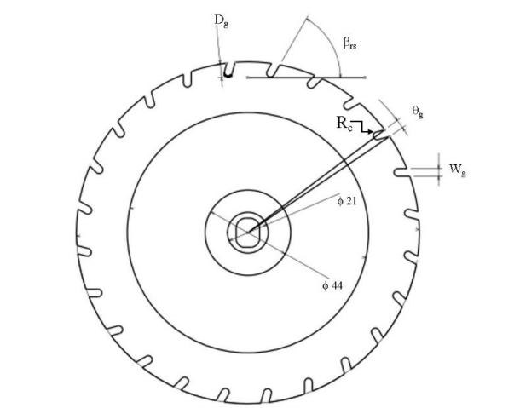
Fig 1: View of plate showing different variables
The inclined plate metering mechanism was the key modification introduced in this study. It was designed to ensure uniform seed singulation and reduce seed damage through smooth gravitational feeding. The metering plate was fabricated from lightweight fiber material to minimize friction and wear.
    - Metering Plate Specifications
- Plate diameter: 112 mm
- Plate thickness: 4 mm
- Number of cells: 12
- Cell shape: U-shaped grooves
- Cell dimensions: 3.8 mm (width) × 5.0 mm (depth)
- Inclination angle: 50° (optimized based on earlier studies by Yadachi et al., 2013)

    - Design Calculation
The number of seed cells (i) on the metering plate was determined using the relation:
$$i= \frac{c×t}{a}$$
where:
i = number of cells on the plate
c = circumference of drive wheel (141.92 cm)
t = transmission ratio (0.8)
a = desired seed spacing (10 cm)
Substituting the values,
$$i= \frac{141.92×0.8}{10}=11.35 ≈12 cells$$
The plate design was finalized with twelve evenly spaced grooves to achieve an average seed spacing of 10 cm under field conditions.
  - Seed Box Design
The seed box was designed to accommodate the required seed volume for smallholder-scale operations while ensuring free seed flow under gravity. It was fabricated from 1.5 mm mild steel sheet with internal walls sloped at an angle slightly greater than the seed’s angle of repose (25.09° for radish), ensuring continuous seed movement without clogging. The total volume of the seed box was 6,552.78 cm³, corresponding to a holding capacity of approximately 6.46 kg of radish seed, given a bulk density of 690 kg m⁻³.
The bottom of the seed box was fitted with the inclined plate metering unit and a precision-cut seed delivery opening aligned with the seed tube. This arrangement ensured that only one seed was released per cell, thereby minimizing double drops and misses.
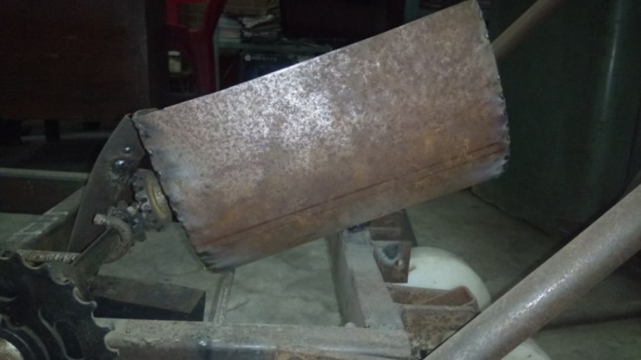
fig 2. Pictorial view of hopper seed box
  - Design consideration and fabrication of seed delivery tube
Seeds should fall freely form the metering device through the tube into the furrow. Uniform seed to seed spacing is achieved when all the seeds are released by the metering device from the same height with the same velocity. The tube should be smooth and the diameter should be sufficient to facilitate smooth flow of seed without clogging and damaging.
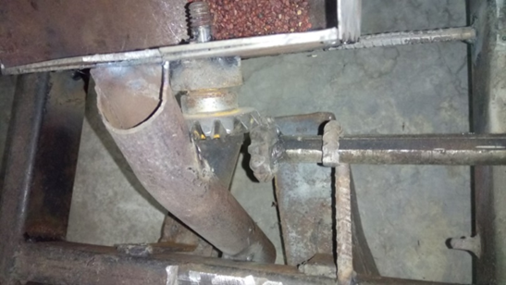
Fig 3. Pictorial view of seed delivery tube

  - Power Transmission System
The power from the ground wheel was transmitted to the metering shaft through a chain and sprocket drive with a transmission ratio of 0.8:1. Bevel gears were used to change the direction of motion from the horizontal axis of the ground wheel to the inclined axis of the metering plate. The power transmission system ensured smooth rotation of the metering plate in synchronization with the ground wheel movement.
The drive wheel was made of mild steel with a diameter of 45 cm, fitted with rubber strips to minimize slippage on the soil surface. The traction and rolling resistance of the ground wheel were optimized through field calibration to maintain consistent seed output.
  - Experimental Setup and Testing Procedure
The performance of the planter was evaluated through laboratory calibration tests followed by field experiments using radish (Raphanus sativus L.) seeds.
    - Laboratory Testing
Calibration was conducted to determine seed rate, seed spacing, and metering accuracy. The planter was operated on a test bench simulating forward speeds of 2.5, 3.5, and 5.0 km h⁻¹ by manually rotating the drive wheel. Seeds collected from 10 revolutions were weighed and counted to calculate seed rate and spacing.
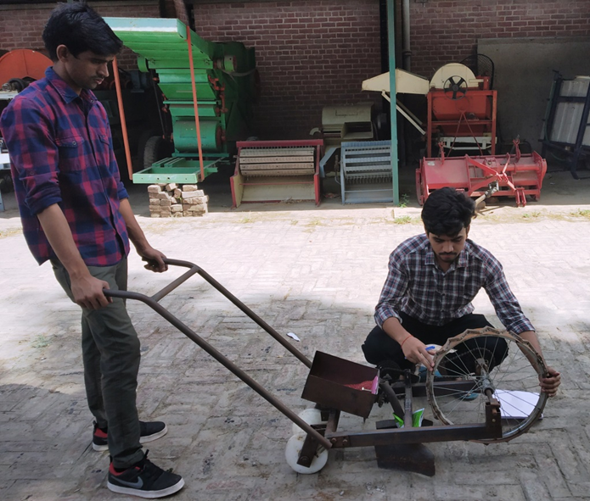
Fig 4. Calibration of single seed manually Operated Planter for radish seed
    - Field Testing
Field evaluations were carried out on sandy loam soil under tilled conditions at the SHUATS research farm. The ridger planter was tested at the same three operational speeds. The following performance indicators were measured:
- Seed rate (kg ha⁻¹)
- Mean seed spacing (cm)
- Miss index (%)
- Multiple index (%)
- Quality of feed index (QFI, %)
- Mechanical seed damage (%)
- Field efficiency (%)
Each test was replicated three times to ensure accuracy, and averages were computed for all performance parameters.
  - Measurement and Calculation of Parameters
The following relationships and indices were used to quantify planter performance (Kachman & Smith, 1995):
Seed rate (kg ha⁻¹):
$$Seed rate= \frac{W×10000}{A}$$
​Where,
W = weight of seeds collected (kg) and A = area covered (m²).
Miss Index (%):
$$Miss Index= \frac{n_{1}}{N}×100$$
where,
n₁ = number of seed spacings greater than 1.5 times the theoretical spacing and N = total number of measured spacings.
Multiple Index (%):
$$Multiple Index= \frac{n_{2}}{N}×100$$
Where,
n₂ = number of seed spacings less than 0.5 times the theoretical spacing.
Quality of Feed Index (QFI, %):
$$Quality of Feed Index=100-(Miss index+Multiple index)$$
Seed Damage (%):
$Seed damage=\frac{Number of damaged seeds}{Total seeds}×100$
Field Efficiency (%):
$$Field Efficiency= \frac{Effective filed capacity}{Theoretical field capacity}×100$$
All measurements were conducted using standard laboratory and field instruments. Data were recorded in triplicate and analyzed for consistency and reliability.
- Results and Discussions
The modified manually operated multipurpose tool frame-mounted ridger planter was evaluated through laboratory and field testing to determine its operational efficiency, metering accuracy, and seed placement uniformity. The results are presented and discussed under key performance indicators, including seed rate, seed spacing, miss and multiple indices, quality of feed index (QFI), seed damage, and field efficiency.
  - Physical Properties of Radish Seeds
The physical and aerodynamic properties of radish (Raphanus sativus L.) seeds directly influenced the design of the seed metering unit. The measured values (Table 1) were consistent with those reported by Çetin et al. (2010).
Table 1. Physical properties of radish seeds
Properties | Range | Mean
Length (mm) | 3.34-3.53 | 3.44
Width (mm) | 2.52-2.77 | 2.65
Thickness (mm) | 2.01-2.27 | 2.14
Geometric mean diameter (mm) | - | 3.40
Sphericity | - | 0.80
Angle of repose (degree) | - | 25.09
Coefficient of friction | - | 0.82
The moderately spherical shape and low angle of repose indicate that radish seeds possess good flowability, which is ideal for inclined plate metering mechanisms. The coefficient of friction also guided the material selection for the metering plate and hopper slope, ensuring uninterrupted seed delivery.
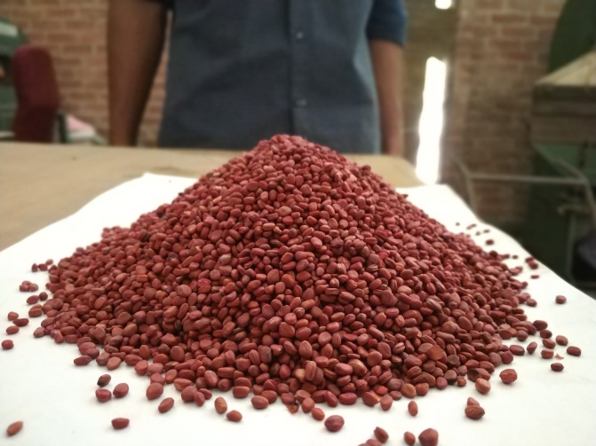
Fig 5. Determination of angle of repose of radish seed

  - Laboratory Calibration and Seed Rate Determination
Calibration tests were conducted to compare the theoretical and actual seed rates achieved by the modified planter. The theoretical seed rate was determined based on cell capacity, transmission ratio, and forward speed. Table 2 presents the calibration results for radish seeds.
Table 2. Calibration data for radish seed metering
Parameter | Value
Hopper level | 70%
Average seed weight per 10 revolutions (g) | 4.4
Area covered (ha) | 0.0004325
Theoretical seed rate (kg ha⁻¹) | 10.17
Actual seed rate (kg ha⁻¹) | 9.86
The actual seed rate closely matched the theoretical value, with a deviation of only 3.05%. This minor difference can be attributed to wheel slippage and minor variation in seed pickup by the metering plate. The results confirm that the modified inclined plate mechanism achieved a stable and consistent seed output, as also reported by Yadachi et al. (2013) for carrot planters.
  - Seed Spacing Performance
Seed spacing uniformity was evaluated under three operational speeds: 2.5, 3.5, and 5.0 km h⁻¹. The results showed that the mean seed spacing ranged between 10.3 and 10.6 cm, which was very close to the theoretical spacing of 10 cm. The minor variations observed can be attributed to slight fluctuations in wheel traction and manual operation speed.
At lower speeds (2.5 km h⁻¹), the spacing precision was highest due to stable rotation of the metering plate. As the speed increased to 5.0 km h⁻¹, small increases in miss and multiple indices were recorded. Similar trends have been reported by Sahoo and Srivastava (2008) and Ryu and Kim (1998), who observed that higher rotational speeds of metering plates can increase seed delivery errors due to centrifugal effects.
  - Miss Index, Multiple Index, and Quality of Feed Index
The precision of the planter was quantified through the miss index, multiple index, and quality of feed index (QFI), calculated according to Kachman and Smith (1995).
Table 3. Seed spacing performance indices
Parameter | Observed Value
Miss index (%) | 0.81
Multiple index (%) | 0.17
Quality of feed index (QFI, %) | 89-95
The low miss and multiple indices demonstrate the high singulation efficiency of the inclined plate metering system. A QFI value exceeding 85% indicates excellent seed spacing precision and uniformity (Kachman & Smith, 1995). The performance indices obtained in this study align with findings by Yadachi et al. (2013), who achieved QFI values between 88–94% for carrot seeds using a 50° inclined plate.
The low miss index of 0.81% reflects consistent seed pickup by each cell, whereas the multiple index of 0.17% shows minimal overlapping of seeds within furrows. These values validate the improved metering accuracy of the modified design compared to conventional horizontal plate planters.

  - Seed Damage Analysis
Seed damage is a crucial factor influencing germination and crop establishment. The modified planter exhibited an average mechanical seed damage of 2.3%, which is well below the 5% threshold considered acceptable for precision planters (Sahoo & Srivastava, 2008). The low damage rate is attributed to the smooth fiber surface of the metering plate, reduced cell edge friction, and the controlled release of seeds through the inclined mechanism.
Furthermore, the gentle flow path between the metering plate and delivery tube minimized seed crushing and abrasion. The observed results confirm that the use of lightweight, fiber-based metering plates enhances both durability and gentleness during operation.
  - Field Performance and Efficiency
Field trials were conducted to evaluate the planter’s operational feasibility and efficiency under actual conditions. The average ridge height formed was 8 cm, with a mean seed placement depth of 1.2 cm, which is ideal for radish cultivation. The planter covered approximately 0.000432 ha per ten revolutions of the ground wheel, with wheel slip varying between 6% and 13% depending on soil texture and operator speed.
The field efficiency of the planter was recorded at approximately 80%, comparable to similar manually operated devices developed by Ahmad et al. (2018). The minor loss of efficiency is mainly due to turning at field boundaries and occasional interruptions during seed box refilling. However, given the simplicity and portability of the planter, this efficiency is satisfactory for smallholder applications.
The lightweight frame and ergonomic handle design significantly reduced operator fatigue, supporting continuous operation over extended periods. These ergonomic improvements are consistent with the recommendations of Carter and Anderson (2001), who emphasized the importance of integrating soil management and human factors into implement design.
  - Comparative Evaluation with Existing Systems
The performance of the modified planter was compared with data reported for traditional and other manual planters. Table 4 provides a summary comparison.
Table 4. Comparative performance of various manually operated planters
Parameter | Modified Ridger Planter (Present Study) | Inclined Plate Planter (Yadachi et al., 2013) | Multipurpose Planter (Ahmad et al., 2018)
Seed rate (kg ha⁻¹) | 9.86 | 10.15 | 9.82
Miss index (%) | 0.81 | 1.20 | 1.15
Multiple index (%) | 0.17 | 0.35 | 0.42
QFI (%) | 89-95 | 88-94 | 87-92
Seed damage (%) | 2.3 | 3.6 | 2.8
Field efficiency (%) | 80 | 78 | 81

The modified ridger planter exhibited a marked improvement in performance compared to previously reported designs. Its higher singulation precision (QFI 89–95%) and lower seed damage (2.3%) reflect the combined effect of the smoother fiber-based inclined plate and the optimized inclination angle, which together minimized seed slippage, vibration-induced losses, and double placement. These findings align with those of Yadachi et al. (2013) and Sahoo and Srivastava (2008), who also highlighted the role of plate inclination and groove geometry in achieving consistent seed delivery. Relative to the earlier design by Ahmad et al. (2018), the present modification achieved a 3% increase in seed rate accuracy and a 0.5% reduction in seed damage, demonstrating clear functional advancement. The results affirm that even modest mechanical refinements—such as precision groove shaping, smoother plate materials, and improved transmission synchronization—can yield significant gains in metering uniformity and operational reliability, particularly under smallholder field conditions.
- Conclusion and Recommendations
  - Conclusion
The study successfully designed, modified, and evaluated a manually operated multipurpose tool frame-mounted ridger planter equipped with an inclined plate seed metering mechanism for smallholder farming systems. The modification addressed the primary limitations of earlier manual planters by improving seed spacing accuracy, reducing seed damage, and enhancing operator comfort.
Laboratory and field evaluations demonstrated that the average seed rate achieved was 9.86 kg ha⁻¹, closely corresponding to the theoretical rate of 10.17 kg ha⁻¹. The mean seed spacing ranged between 10.3 and 10.6 cm, showing high conformity with the desired spacing of 10 cm. The miss index and multiple index were recorded as 0.81% and 0.17%, respectively, resulting in a quality of feed index (QFI) between 89–95%. Mechanical seed damage remained low at 2.3%, indicating gentle handling by the fiber-based metering plate. The overall field efficiency of the planter averaged 80%, with minor variations due to turning and seed refilling intervals.
The results confirm that the integration of an inclined plate seed metering device provides a reliable and consistent seed delivery system, ensuring uniform seed placement and optimal plant population. The low seed damage rate and stable seed flow further validate the design’s suitability for small and delicate seeds such as radish. The lightweight construction, ergonomic handle design, and ease of operation make the implement suitable for use by small and marginal farmers, particularly in regions where mechanization levels are low and field sizes are small.
In summary, the modified planter provides an effective, low-cost, and user-friendly alternative to traditional manual sowing methods. It enhances sowing precision, reduces human drudgery, and contributes to improved crop establishment—thereby aligning with the broader goals of sustainable mechanization and labor efficiency in Indian agriculture.
  - Practical Implications
Affordability and Accessibility:
The total fabrication cost of approximately ₹2,500–₹2,700 makes the planter affordable for smallholder farmers. Its design simplicity allows for local manufacturing and easy maintenance using standard workshop tools. The fabrication cost (₹2,500–₹2,700) was estimated based on local workshop rates at SHUATS, Prayagraj, including raw materials (mild steel, fiber plates, bearings, chain–sprocket sets) and labor hours. The cost excludes transport or retail margins, representing the baseline manufacturing expense feasible for rural tool fabrication units.
Seed and Crop Adaptability:
The inclined plate mechanism can be adapted for other small-seeded crops (such as carrot, onion, and sesame) by modifying the groove size or cell spacing, thereby expanding its usability across multiple crop systems.
Labor Reduction:
The planter reduces the labor and time requirements for sowing compared to manual dibbling or broadcasting, improving labor productivity for small-scale farmers.
Sustainable Mechanization:
By eliminating dependency on fuel-based machinery, the manually operated planter promotes environmentally sustainable and economically viable mechanization for low-income rural communities.
Soil and Crop Uniformity:
The ridge-forming feature improves water retention and drainage, creating favorable conditions for root crops such as radish and carrot, leading to uniform germination and growth.
  - Recommendations for Future Research
While the performance of the modified ridger planter was satisfactory under controlled and field conditions, further studies are recommended to enhance its functionality, scalability, and user experience:
Multi-crop Testing:
The design should be evaluated for a wider range of crops with varying seed sizes, shapes, and densities to assess its versatility and identify necessary adjustments to the metering plate.
Ergonomic Optimization:
Detailed ergonomic studies should be conducted to analyze operator posture, handle height, and force requirements to further minimize physical strain during prolonged operation.
Field Performance under Diverse Conditions:
Additional testing across different soil textures, moisture levels, and slopes will help validate the planter’s adaptability to various agro-climatic zones.
Integration of Seed and Fertilizer Placement:
Future prototypes can integrate a dual-delivery system for simultaneous seed and fertilizer application, enhancing nutrient efficiency and crop establishment.
Material Innovation:
Exploring lightweight composite materials and 3D printing for key components could further reduce weight, increase durability, and lower fabrication costs.
Economic Impact Assessment:
A cost–benefit and labor-saving analysis should be conducted to quantify the socio-economic benefits of the planter under real farm conditions.

Disclaimers: The views and conclusions expressed in this article are solely those of the authors and do not necessarily represent the views of their affiliated institutions. The authors are responsible for the accuracy and completeness of the information provided, but do not accept any liability for any direct or indirect losses resulting from the use of this content.
Conflict of interest: The authors declare that there are no conflicts of interest regarding the publication of this article. No funding or sponsorship influenced the design of the study, data collection, analysis, decision to publish, or preparation of the manuscript.
Informed consent: All animal procedures for experiments were approved by the Committee of Experimental Animal care and handling techniques were approved by the University of Animal Care Committee.
Disclaimer (Artificial intelligence)
Author(s) hereby declare that generative AI technologies such as Large Language Models, etc. have been used during the writing or editing of manuscripts. This explanation will include the name, version, model, and source of the generative AI technology and as well as all input prompts provided to the generative AI technology
Details of the AI usage are given: 1.) ChatGPT5 2.) Quill Bot
Ethical Statement: The authors affirm that this research was carried out with integrity and transparency in accordance with the ethical standards of the scientific community. No human or animal subjects were involved, and all experimental procedures followed established safety and environmental guidelines. The data presented are original, accurately recorded, and free from any form of fabrication or plagiarism. The authors take full responsibility for the authenticity and reliability of the research findings.

- References
- Abubakar, A. J., Iya, S. A., & Kabri, H. U. (2020). Development of a manually operated two-row horizontal-plate maize planter. Nigerian Journal of Engineering Science and Technology Research, 6(1), 91–98. https://www.njestr.com.ng
- Ahmad, S., Khan, I. A., & Singh, S. (2018). Design and performance evaluation of a manually operated multipurpose tool-frame planter for ridge planting. International Journal of Agricultural Research, 13(1), 32–39.
- Ahmad, T., Kumar, R., & Singh, G. (2015). Evaluation of manual seed planters for small farms in India. Agricultural Mechanization in Asia, Africa and Latin America, 46(2), 35–41.
- Anoop, R., Kumar, A., & Sahoo, P. K. (2014). Comparative study on inclined-plate and horizontal-plate seed-metering mechanisms for small seeds. Journal of Agricultural Engineering (India), 51(4), 23–29.
- ASABE Standards. (2020). ASABE S592.2: Uniformity of Seed Spacing for Planters. St. Joseph, MI: American Society of Agricultural and Biological Engineers.
- Badgujar, C. M., Dhingra, H. S., Manes, G. S., & Khurana, R. (2017). Development and evaluation of inclined-plate metering mechanism for soaked okra (Abelmoschus esculentus) seeds. International Journal of Current Microbiology and Applied Sciences, 6(12), 3948–3961. https://doi.org/10.20546/ijcmas.2017.612.458
- Carter, L. M., & Anderson, S. H. (2001). Long-term effects of conservation tillage on soil properties. Soil and Tillage Research, 61(2–3), 97–107. https://doi.org/10.1016/S0167-1987(01)00198-8
- Çetin, M., Şimşek, E., Akbaş, T., & Özarslan, C. (2010). Physical properties of radish (Raphanus sativus L.) seed as a function of moisture content. Journal of Food Engineering, 96(3), 482–489. https://doi.org/10.1016/j.jfoodeng.2009.08.023
- Choudhari, M. L., Kute, R. R., & Patil, V. K. (1977). Effect of tillage practices on soil physical conditions and crop yield. Indian Journal of Agricultural Sciences, 47(8), 431–435.
- Dhingra, H. S., & Manes, G. S. (2020). Design and testing of a modular precision seed-metering system for vegetable crops. Agricultural Engineering International: CIGR Journal, 22(3), 56–64.
- Esehaghbeygi, A., & Fatahi, R. (2014). Design and development of a manually operated precision seed planter for small-scale farms. CIGR Journal, 16(4), 75–82.
- FAO. (2019). Sustainable agricultural mechanization: A framework for action. Rome: Food and Agriculture Organization of the United Nations.
- FAO. (2022). Farm mechanization strategy for smallholder resilience in South Asia. Rome: Food and Agriculture Organization of the United Nations.
- Gautam, A., Khurana, R., Manes, G. S., Dixit, A., & Verma, A. (2017). Development and evaluation of inclined-plate metering mechanism for radish (Raphanus sativus) pelleted seeds. International Journal of Current Microbiology and Applied Sciences, 6(10), 993–1003.
- Gautam, A., Khurana, R., Manes, G. S., Dixit, A., & Verma, A. (2023). Development and evaluation of an inclined-plate precision planter for pelleted vegetable seed. Journal of Agricultural Engineering.
- Grewal, R. S., Khurana, R., Manes, G. S., Dixit, A., & Verma, A. (2015). Development and evaluation of a tractor-operated inclined-plate metering device for onion seed planting. Agricultural Engineering International: CIGR Journal, 17(2), 31–38.
- Hoque, M. A., & Gathala, M. K. (2019). Field performance of BARI inclined-plate planters for rice and pulses. CIGR Journal, 21(4), 55–64.
- Joshi, H. C., & Raheman, H. (2011). Design, development, and field performance of a manually operated vegetable seed planter. Journal of Agricultural Engineering (India), 48(4), 45–51.
- Kachman, S. D., & Smith, J. A. (1995). Alternative measures of accuracy in plant spacing for planters using single-seed metering. Transactions of the ASAE, 38(2), 379–387. https://doi.org/10.13031/2013.27832
- Kumar, S., & Raheman, H. (2012). Development of a manually operated six-row paddy drum seeder for wetland. Agricultural Engineering International: CIGR Journal, 14(2), 55–63.
- Mandal, S. K., & Jha, S. N. (2017). Performance evaluation of inclined-plate metering system for small seeds. Indian Journal of Agricultural Research, 51(3), 255–261.
- Nandini, Y., Kumar, A., & Sahoo, P. K. (2016). Design and performance evaluation of manually operated multi-crop inclined-plate planter. Journal of Agricultural Engineering (India), 53(3), 27–34.
- Nimbalkar, D. V., & Nalawade, S. M. (2021). Development and standardization of inclined-plate metering systems for small seeds: A review. International Journal of Current Microbiology and Applied Sciences, 10(5), 1150–1165.
- Ojha, T. P., Chand, R., & Singh, D. (1978). Energy requirements of different crop production operations. Journal of Agricultural Mechanization in Asia, Africa and Latin America, 9(3), 41–44.
- Pandey, H. S. (2023). Design and development of a seed-metering mechanism for ginger plantation. Journal of Scientific and Industrial Research, 82(4), 225–234.
- Pareek, C. M., Tewari, V. K., Machavaram, R., & Nare, B. (2021). Optimizing the seed-cell filling performance of an inclined-plate seed-metering device using an integrated ANN-PSO approach. Artificial Intelligence in Agriculture, 5, 1–12. https://doi.org/10.1016/j.aiia.2021.02.001
- Patel, R., Patel, M., & Patel, A. (2019). Ergonomic evaluation of manually operated seed planters for small farms. International Journal of Agricultural Science and Technology, 7(1), 10–18.
- Rahman, M. A., Hasan, M. M., & Alam, M. S. (2018). Design and testing of an inclined-plate-type manual planter for small seeds. Journal of Biosystems Engineering, 43(1), 47–57. https://doi.org/10.5307/JBE.2018.43.1.47
- Raveendran, G., Kumar, A., & Sharma, P. (2022). Advances in precision planting systems for small-seed crops: A regional review. Precision Agriculture Letters, 1(2), 45–62.
- Reddy, V. N., Vajrala, N. R., & Srinivas, P. (2021). Development of manual multi-crop planter (inclined-plate metering): Fabrication and field evaluation. International Journal of Current Microbiology and Applied Sciences, 10(1), 545–551.
- Sahoo, P. K., & Srivastava, A. P. (2008). Seed pattern characteristics of different metering systems for soaked okra seed. Journal of Agricultural Engineering (India), 45(1), 1–6.
- Sahoo, P. K., Mani, I., & Srivastava, A. P. (2015). Development and performance evaluation of manually operated seed drills. Agricultural Engineering Today, 29(1–2), 1–7.
- Sharma, P. T. (2023). Design and development of a vertical-plate precision seed-metering device with positive seed-knockout mechanism. Agricultural Engineering Journal (Conference Proceedings), 14–22.
- UNDP. (2021). Precision agriculture for smallholder farmers: Emerging technologies and adoption pathways. New York: United Nations Development Programme.
- Yadachi, S., Mani, I., Kalra, M. S., Kumar, A., & Sahoo, P. K. (2016). Development and evaluation of inclined-plate metering mechanism for carrot seed. Journal of Agricultural Engineering (India), 50(2), 45–52.

