Original Research Article
Enhancement of Storage Life and Visual Quality of Marigold (Tagetes erecta L.) Flowers Through Cold Room Storage

Abstract:
The study titled “Enhancement of Storage Life and Visual Quality of Marigold Flowers Through Cold Room Storage” was conducted at New Leaf Dynamic Technologies Pvt. Ltd., Pune, Maharashtra, India, during the 2024 monsoon season to evaluate the effectiveness of cold storage (4°C and 95% RH) in extending the shelf life and maintaining the quality of African marigold (Tagetes erecta L.) flowers. Freshly harvested, uniform marigold blooms were collected from a farmer’s field in Belle Village and subjected to two treatments: T₁ storage at ambient room conditions, and T₂ storage in a cold room. Parameters such as flower weight, shrivelling, rotting percentage, appearance, colour, and overall storage-life were recorded daily and analyzed using a Factorial completely randomized design (FCRD) with three replications. Results revealed that marigold flowers stored under cold conditions (T₂) maintained their visual freshness, colour brightness, and physical firmness for a longer duration compared to those kept at room temperature (T₁). Weight loss, shrivelling, and rotting were negligible in cold-stored flowers even after 8 days, whereas flowers stored at ambient conditions showed severe deterioration, reaching 100% shrivelling and 60.2% rotting by the eighth day. The overall storage-life was extended to 8 days under cold storage, with an additional post-storage life of 2 days at room temperature, compared to only 3 days for flowers kept under ambient conditions. The findings confirm that cold storage significantly retards metabolic and microbial activities, reducing respiration, transpiration, and ethylene production, thereby preserving the visual appeal and marketability of marigold flowers. Hence, maintaining marigolds at 4°C and 95% relative humidity is an effective, low-cost postharvest strategy to minimize losses, enhance flower quality, and ensure better shelf-life for commercial distribution.
Keywords: Marigold, Temperature, Relative Humidity, Cold Storage, Shelf life, Post-storage life.
Introduction:
The African marigold (Tagetes erecta L.), a member of the Asteraceae (Compositae) family, is one of the most widely cultivated loose flowers, commonly used in religious ceremonies and social events. Marigolds are available in various shades, with yellow and orange being the most prevalent. These flowers possess a strong, distinctive fragrance and are valued for their applications in cosmetic treatments (Jadhav et al., 2014). When the plant is burned, it acts as a natural insect and fly repellent. Additionally, marigold pigments are sometimes extracted and utilized as natural food colourants for human consumption.
Marigold (Tagetes erecta L.) is widely cultivated across various regions of the country, particularly in the plains, and holds the largest area and production share among loose flower crops (Anonymous, 2017). Its popularity is attributed to its adaptability to diverse soil types and climatic conditions, along with an extended blooming period. A mild climate during growth enhances flowering, whereas high temperatures negatively impact flower production. The major marigold-producing states include Karnataka, West Bengal, Tamil Nadu, and Maharashtra. Marigold flowers are commonly used in weddings, religious festivals, and social events due to their wide range of attractive colours, shapes, and sizes, as well as their good keeping quality. These flowers are rich in natural carotenoids, particularly xanthophyll (Naik et al., 2005). Carotenoids are known to benefit human eyes and skin by reducing the risk of vision loss, coronary heart disease, and cancer (Bee Ling and Norhaizan, 2019). Commercially, carotenoids extracted from marigold flowers are utilized in pharmaceuticals, dietary supplements, food colourants, and animal feed additives. Marigold flower extracts have been shown to contain high levels of phenolics, flavonoids and carotenoids, and when applied to fruits such as peach, a 30% extract treatment significantly reduced weight loss and decay incidence while maintaining firmness, soluble solids and antioxidant enzyme activities during ambient storage. Such bioactive-rich extracts are increasingly recognised as eco-friendly post-harvest treatments to delay senescence and extend shelf life of fresh produce by suppressing respiration, transpiration and microbial attack (Hanif et al. 2025; Lekshmi et al. 2025). Like other horticultural crops, flowers are highly perishable because of their delicate tissues and high moisture content, leading to postharvest losses ranging from 20–50%, and in some developing countries, even up to 100% (Salunkhe et al., 1990). The extent and nature of postharvest damage vary with each crop and cultivar (VIRESH, 2021).
Marigold are becoming commercially significant as a natural source of carotenoid pigments. The main pigment found in its flowers is xanthophyll, primarily lutein, which constitutes about 80–90% of the total pigment content, mainly in the form of esters of palmitic and myristic acids. The ground petals (blossom or petal meal) or their extracts often saponified to enhance absorption are incorporated into poultry feed (Bosam et al. 2003). These marigold-based products are marketed under names such as “Aztec marigold” or as marigold extract labelled “Adoptinal.”
Marigold flowers reach harvest maturity about 2½ months after transplanting. The plants keep flowering for another 2 to 2½ months after the initial harvest. It is best to harvest the blooms at their full size in the evening, taking a small portion of the stalk along with them. The average yield of African marigold (Tagetes erecta L.) ranges between 11 and 18 tonnes per hectare (https://agritech.tnau.ac.in/horticulture/horti_flower%20crops_marigold.html)
Rapid cooling and maintaining an appropriate temperature are essential for preserving the freshness and vitality of cut and loose flowers. Refrigerated storage allows growers to extend the storage-life of flowers, thereby enhancing their marketability. Temperature is regarded as the most critical factor influencing the quality and lifespan of flowers (Cevallos and Reid, 2001; Leonard et al., 2001; Gul et al., 2007; Waseem Shashri et al., 2009; Shashri and Tahir, 2011). At reduced temperatures, the respiration rate of flowers decreases, leading to slower utilization of stored energy (Van Dorn and De Witte, 1991; Cevallos and Reid, 2001; Waseem Shashri et al., 2009). Additionally, proper storage and packaging systems are vital for maintaining the freshness of the produce while also reducing transportation costs (Senapati et al., 2016).
Objective:
- To evaluate the effect of cold storage (4°C and 95% RH) on the storage-life and quality parameters of marigold flowers in comparison to those stored under ambient room conditions.
Materials and Methods:
Healthy marigold flowers cultivated in Belle Village, Pune District, Maharashtra, India, were utilized for this study conducted in October 2024. Fully bloomed and 80% open flowers were harvested at 4:00 PM and transported within 1 hour and 30 minutes in an air-conditioned vehicle to the cold storage facility of New Leaf Dynamic Technologies Pvt. Ltd. in Belle Village. The flowers were immediately prepared for experimentation upon arrival. During harvesting, the ambient temperature was recorded at 25.6°C. Flowers were carefully chosen for uniformity, free from any defects, and graded accordingly. The experiment involved two treatments flowers stored in a cold room at 4°C and 95% relative humidity, and flowers maintained under ordinary (ambient) room conditions.
Treatment Details
Treatments | Treatment Details
T1 | Control : Flower stored at ordinary (Ambient) room conditions
T2 | Flower stored in a cold room (4°C Temperature and 95% Humidity)

Each treatment was replicated three times. After 8 days of cold storage, the flowers were transferred to room conditions. Observations for various parameters, including appearance, shrivelling percentage, weight loss, rot percentage, and storage-life (in days), were recorded daily at 6:00 PM. Weight loss was measured by weighing ten flower samples on a laboratory digital balance prior to storage and reweighing them daily (Jadhav et al., 2018).
Colour quality was evaluated on a 4-point rating scale, with 1 denoting 100% (very good), 2 indicating 75% (good), 3 representing 50% (low), and 4 corresponding to 25% (very low).
Parameters monitored
Observations on post-harvest parameters such as flower weight (lb), shrivelling percentage, rot percentage, appearance, and colour fading were recorded daily. Data on flowering parameters were collected each day following the first day of storage, and the cumulative results were analyzed statistically.
Statistical analysis
The experiment was conducted using a completely randomized design with three replications. The collected data were statistically analyzed using analysis of variance (ANOVA). Valid conclusions were drawn only on significant differences between treatment means at 5 per cent level of significance.
Results and Discussion
This study was carried out at New Leaf Technologies Pvt. Ltd. in Belle, Pune, Maharashtra, India, to assess the storage-life of marigold flowers under room and cold storage conditions. Parameters such as flower weight (lb), percentage of shrivelling and rotting, flower appearance, colour, and the duration of storage-life under both conditions were evaluated.
Weight of ten flowers (lb)
Table. 1 Weight of Marigold flowers at ordinary (Ambient) room conditions and inside cold storage conditions
Treatments | Storage Period (Days) |  |  |  |  |  |  |  |  | Mean
 | 1 | 2 | 3 | 4 | 5 |  | 6 | 7 | 8
T1 | 0.280 | 0.260 | 0.220 | 0.200 | 0.190 |  | 0.180 | 0.170 | 0.160 | 0.208
T2 | 0.280 | 0.280 | 0.280 | 0.280 | 0.280 |  | 0.280 | 0.270 | 0.270 | 0.278
Mean | 0.280 | 0.270 | 0.250 | 0.240 | 0.235 |  | 0.230 | 0.220 | 0.215
 | S.Em |  |  |  |  | CD 5%
Treatment (T) | 0.004 |  |  |  |  | 0.011
Storage (S) | 0.007 |  |  |  |  | 0.021
Interaction (T×S) | 0.010 |  |  |  |  | 0.030

The data clearly showed that the average weight of ten flowers (Table 1) was significantly higher in treatment T2, with the maximum average weight recorded on days 7 and 8 under cold room conditions. In contrast, the lowest average weight of ten flowers was observed statistically in treatment T1 (Jadhav, 2018).
Shrivelling percentage
Table. 3 Shrivelling percentage of Marigold flowers at ordinary (Ambient) room conditions and inside cold storage conditions
Treatments | Storage Period (Days) |  |  |  |  |  |  |  |  | Mean
 | 1 | 2 | 3 | 4 | 5 |  | 6 | 7 | 8
T1 | 0.000 | 0.000 | 0.000 | 13.300 | 25.720 |  | 80.760 | 100.000 | 100.000 | 39.973
T2 | 0.000 | 0.000 | 0.000 | 0.000 | 0.000 |  | 0.000 | 0.000 | 0.000 | 0.000
Mean | 0.000 | 0.000 | 0.000 | 6.650 | 12.860 |  | 40.380 | 50.000 | 50.000
 | S.Em |  |  |  |  | CD 5%
Treatment (T) | 0.005 |  |  |  |  | 0.015
Storage (S) | 0.011 |  |  |  |  | 0.031
Interaction (T×S) | 0.015 |  |  |  |  | 0.044

Treatment T2 showed that the no shrivelling percentage was observed during the first 8 days under cold room conditions. Conversely, treatment T1 recorded the statistically lowest average weight of ten flowers (Table 2). The storage system was found to play a crucial role in maintaining the freshness of the flowers (Kader, 2002). Additionally, modified atmosphere (MA) has been extensively used to delay the wilting of fresh flowers (Bishop et al. 2007; Jadhav, 2018).
Rot percentage

Table. 2 Rot percentage of Marigold flowers at ordinary (Ambient) room conditions and inside cold storage conditions

Treatments | Storage Period (Days) |  |  |  |  |  |  |  |  | Mean
 | 1 | 2 | 3 | 4 | 5 |  | 6 | 7 | 8
T1 | 0.000 | 0.000 | 0.000 | 0.000 | 13.300 |  | 26.600 | 40.200 | 60.200 | 17.538
T2 | 0.000 | 0.000 | 0.000 | 0.000 | 0.000 |  | 0.000 | 0.000 | 0.000 | 0.000
Mean | 0.000 | 0.000 | 0.000 | 0.000 | 6.650 |  | 13.300 | 20.100 | 30.100
 | S.Em |  |  |  |  | CD 5%
Treatment (T) | 0.016 |  |  |  |  | 0.047
Storage (S) | 0.032 |  |  |  |  | 0.093
Interaction (T×S) | 0.046 |  |  |  |  | 0.132

The findings clearly indicated that treatment T2 exhibited the not rot percentage were found, followed by T1 (Table 3), at the conclusion of the experiment under cold room conditions. Conversely, the highest rot percentage, 60.2%, was recorded for T1 under ordinary (ambient) room conditions. The positive effects of modified atmosphere (MA) storage included delayed senescence linked to physiological and biochemical changes, such as reduced respiration rate, lower ethylene production, slower softening, and decreased ethylene sensitivity. Elevated carbon dioxide levels also suppressed the growth of certain fungi, consistent with the observations of Kader (2002) and Jadhav (2018).
Appearance
Table. 4 Appearance of Marigold flowers at ordinary (Ambient) room conditions and inside cold storage conditions
Treatments | Storage days (Days)
 | 1 | 2 | 3 | 4 | 5 | 6 | 7 | 8
T1 | VG | VG | VG | G | L | VL | VL | VL
T2 | VG | VG | VG | VG | VG | VG | VG | VG
(VG- Very Good, G- Good, L- Low, VL- Very Low)
Flowers stored under cold storage in treatment T2 exhibited a significantly better appearance, followed by T1 (Table 4). In contrast, under ordinary (ambient) room conditions, T1 showed the most deteriorated appearance by day 3 of storage. Modified atmosphere (MA) storage enhanced product quality and helped minimize potential biochemical changes (Waringthon and Soni, 2014; Jadhav, 2018).
Colour
Table. 5 Colour of Marigold flowers at ordinary (Ambient) room conditions and inside cold storage conditions
Treatments | Storage days (Days)
 | 1 | 2 | 3 | 4 | 5 | 6 | 7 | 8
T1 | 1.00 | 1.00 | 1.33 | 2.00 | 2.38 | 3.30 | 4.30 | 4.38
T2 | 1.00 | 1.00 | 1.00 | 1.00 | 1.00 | 1.00 | 1.00 | 1.20
The data indicated that treatment T2 effectively preserved the flower colour in cold storage compared to treatment T1 (Table 5) (Jadhav, 2018).
Storage-life

Table. 6 Storage life of Marigold flowers at ordinary (Ambient) room conditions and inside cold storage conditions
Shelf-life at Ordinary (Ambient) room storage | Shelf-life inside the Cold room storage
3 days | 8 days

Treatment T2 exhibited the longest storage-life of 8 days, while flowers kept under ordinary (ambient) room conditions had the shortest storage-life of only 3 days (Table 6). Statistically, the maximum storage-life of 8 days was observed in T2 under cold storage, followed by T1 (Jadhav, 2018).
Post-storage life
Table. 7 Post storage life of Marigold flowers at ordinary (Ambient) room conditions and inside cold storage conditions
Post storage life at Ordinary (Ambient) room storage | Post storage life outside the Cold room storage
0 days | 2 days

The post-storage life of flowers was recorded as 2 days at room temperature after being removed from the cold room (Table 7), with the maximum post-storage life of 2 days observed under treatment T2. Maintaining low temperatures during storage is crucial for preserving flowers, as it not only inhibits bacterial and fungal growth but also reduces enzyme degradation and ethylene production, lowers transpiration and respiration rates (Van Dorn and De Witte, 1991; Cevallos and Reid, 2001; Waseem Shashri et al., 2009; Jadhav and Gurav, 2018), and delays various senescence processes (ASHRAE, 1994). The storage systems played a pivotal role in the preservation of the freshness of the produce (Waringthon and Soni, 2014; Jadhav, 2018).
This study is important to the scientific community because it provides practical information on improving the storage and shelf life of marigold flowers. The results show that maintaining flowers under cold storage conditions helps reduce weight loss, shrivelling, and spoilage while retaining their freshness and colour. These findings can be useful for farmers, traders, and researchers in developing better postharvest handling and storage methods.
Conclusion
The study demonstrated that cold storage at 4°C and 95% relative humidity significantly enhanced the storage-life and quality of marigold flowers compared to ambient room conditions. Flowers stored in the cold room showed minimal weight loss, shrivelling, and rotting, while maintaining better colour and appearance. The cold-stored marigolds achieved a shelf life of 8 days, with an additional post-storage life of 2 days at room temperature. In contrast, flowers kept at ambient conditions lasted only 3 days. Therefore, cold storage proved highly effective in prolonging the freshness and marketability of marigold flowers.

Disclaimer (Artificial intelligence)
Option 1:
Author(s) hereby declare that NO generative AI technologies such as Large Language Models (ChatGPT, COPILOT, etc.) and text-to-image generators have been used during the writing or editing of this manuscript.
Option 2:
Author(s) hereby declare that generative AI technologies such as Large Language Models, etc. have been used during the writing or editing of manuscripts. This explanation will include the name, version, model, and source of the generative AI technology and as well as all input prompts provided to the generative AI technology
Details of the AI usage are given below:
1.
2.
3.

References:
Anonymous. (2017). Indian Horticulture Database published by National Horticulture Board, Gurugram, Haryana.
Ashrae. (1994). Handbook. Atlanta: American Society of Heating, Refrigerating and Air-Conditioning Engineers (ASHRAE).
Bee Ling Tan and Mohd Esa Norhaizan(2019). Carotenoids: How Effective Are They to Prevent Age-Related Diseases.Molecules.,24(9): 1801.
Bishop, C. F. H., Gash, A. J., Mathas, E., & Finlayson, I. (2007, December). Use of modified packaging with cut flowers. In International Conference on Quality Management in Supply Chains of Ornamentals 755 (pp. 515-518).
Bosma, T. L., Dole, J. M., & Maness, N. O. (2003). Optimizing marigold (Tagetes erecta L.) petal and pigment yield. Crop Science, 43(6), 2118-2124.
Cevallos, J. C., & Reid, M. S. (2001). Effect of dry and wet storage at different temperatures on the vase life of cut flowers.
Gul, F., Tahir, I., & Sultan, S. M. (2007). Effect of storage temperature on post-harvest performance of Amaryllis belladonna L. cv. Rosea Scapes. JOURNAL OF PLANT BIOLOGY-NEW DELHI, 34(1), 43.
Hanif, M., Azam, M., Khan, M. A., Zahid, T., Ali, B., Akram, M. T., ... & Abd-Allah, E. F. (2025). Investigating the effect of marigold flower extract on bioactive compounds, antioxidants and postharvest quality and shelf life of peach during storage. Journal of Food Measurement and Characterization, 19(3), 1837-1850.
https://agritech.tnau.ac.in/horticulture/horti_flower%20crops_marigold.html
Jadhav, P. B. (2018). Extension of the storage-life of marigold cv. Calcutta Gainda using cold room. International Journal of Current Microbiology and Applied Sciences, 7(12), 832-43.
Jadhav, P. B., & Gurav, N. P. (2018). Extension of storage and post-storage shelf-life of fig fruit. International Journal of Research & Review, 5, 25-34.
Jadhav, P. B., Alka Singh, A. S., Mangave, B. D., Patil, N. B., Patel, D. J., Dekhane, S. S., & Kireeti, A. (2014). Effect of organic and inorganic fertilizers on growth and yield of African Marigold (Tagetes erecta L.) Cv. Pusa Basanti Gainda.
Kader, A. A. (2002). Postharvest technology of horticultural crops (Vol. 3311). University of California Agriculture and Natural Resources.
Lekshmi, S. G., Sethi, S., Asrey, R., Singh, K. P., Kumar, R., Sindhu, P. M., ... & Goswami, A. K. (2025). Comprehensive characterization of biodegradable edible films activated with rose and marigold extracts and application of active edible coatings to extend the postharvest storage life of guava. Food Research International, 203, 115895.
Leonard, R. T., Nell, T. A., Suzuki, A., Barrett, J. E., & Clark, D. G. (2001). Evaluation of long term transport of Colombian grown cut roses.
Naik, H.B., Patil, A.A., Basavarj, N., Patil, V.S. (2005). Stability analysis for growth, yield and flower colour (Xanthophyll) in African marigold (Tagetes erecta L.). Kar. J Hort.,1(3):28-36.
Salunkhe D. K., Bhat N. R. and Desai, B. B.(1990). "Preface". Postharvest Biotechnology of Flowers and Ornamental plants. Springer-Verlag Berlin Heidelberg, New York, USA.192p.
Senapati, A. K., Raj, D., Jain, R., & Patel, N. L. (2016). Advances in packaging and storage of flowers. Commercial horticulture, 34, 473-488.
Shahri, W., & Tahir, I. (2011). An effective storage protocol for improving the postharvest performance in cut spikes of Consolida ajacis Nieuwl cv. Violet blue. Scientia Horticulturae, 129(1), 154-158.
van Doorn, W. G., & de Witte, Y. (1991). Effect of dry storage on bacterial counts in stems of cut rose flowers. HortScience, 26(12), 1521-1522.
VIRESH, M. B. (2021). Enhancing the storage life of marigold (Tagetes erecta L.) flowers using preservatives and packaging materials (Doctoral dissertation, DIVISION OF FLORICULTURE AND LANDSCAPING ICAR-INDIAN AGRICULTURAL RESEARCH INSTITUTE NEW DELHI).
Waseem Shahri, W. S., Inayatullah Tahir, I. T., & Fahima Gul, F. G. (2009). Effect of dry and wet storage at cool temperatures on postharvest performance of Consolida ajacis cv. Violet blue spikes.
Yimyong, W., & Soni, P. (2014). Effects of modified atmosphere packaging on quality of cut Dendrobium orchid. J. Food Agric. Environ, 12(1), 408-411.
Figure 1: Interval Day-wise Photographs
 | 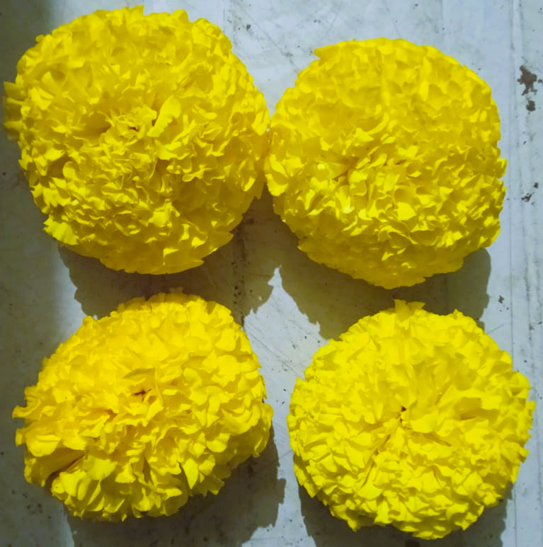
Day-2 (Inside Cold Storage at 4°C & 95% RH)
 | 
Day-4 (Inside Cold Storage at 4°C & 95% RH)

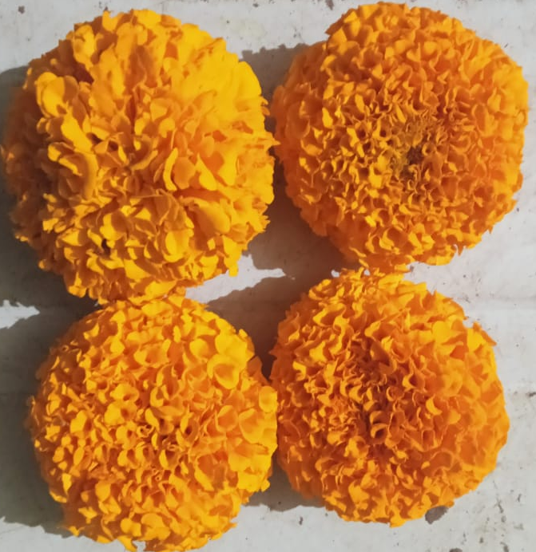 | 
Day-6 (Inside Cold Storage at 4°C & 95% RH)
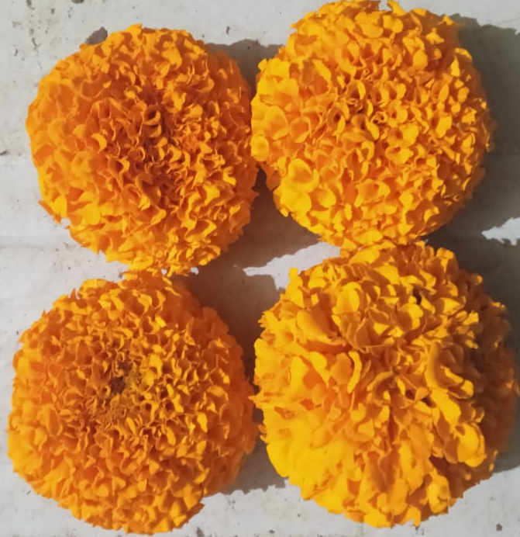 | 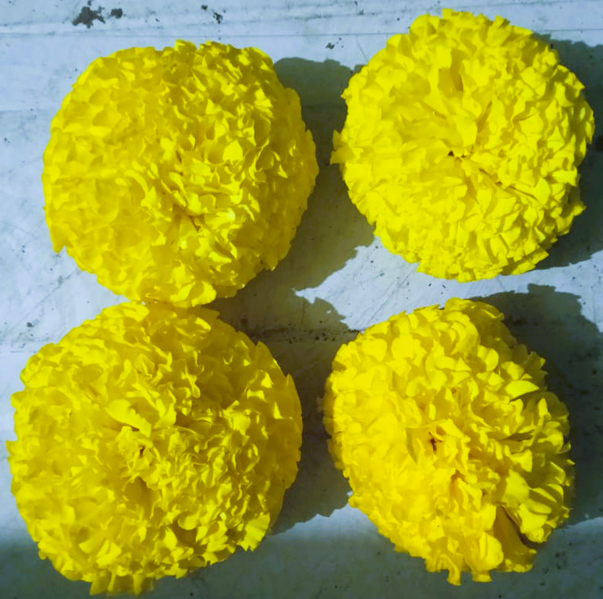
Day-8 (Inside Cold Storage at 4°C & 95% RH)

Figure 2 : Photographs of Stored Marigold Flowers in the Cold Room
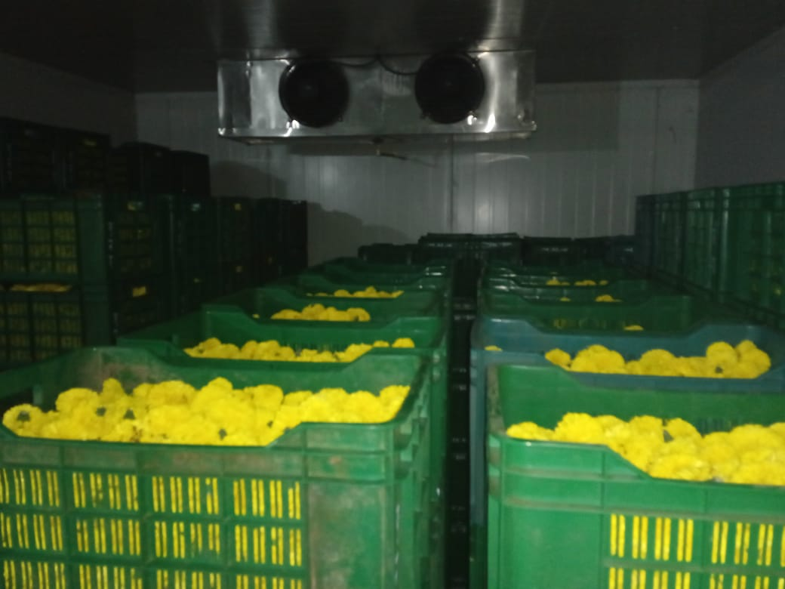 | 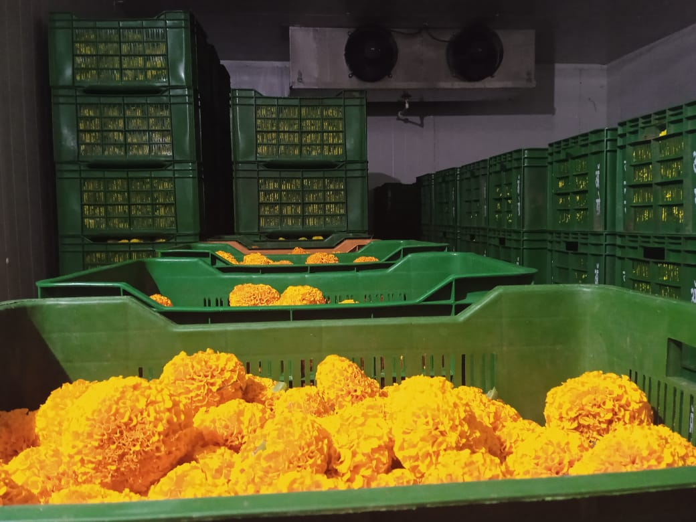
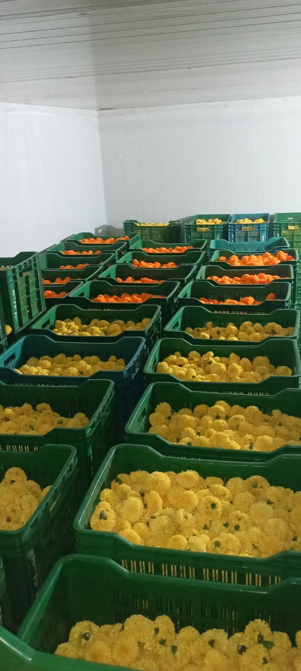 | 