SALINITY STRESS MITIGATION IN RICE VARIETY CO 51 THROUGH PLANT GROWTH REGULATORS

ABSTRACT
Salinity is one of the major abiotic stresses that adversely affect crop quality and productivity. About 21.5 million ha of land area is salt-affected in Asia; with India having 8.6 million ha which is a major soil problem. Rice has been identified as salt susceptible especially during seedling stage. Salinity is detrimental to seed germination, seedling growth and vigor leading to reduction in yield. To overcome this, various plant growth regulators were tried for improving seed germination and seedling vigour in rice under salinity.The major outcome of this study was reduced seed germination percentage and seedling vigour under different levels of salinity stress compared to control. In case of gibberellic acid treatment, the higher germination percentage of 91 was observed in 50 ppm (T₃) while higher seedling root length of 3.30 cm was found in 100 ppm (T₄) and shoot length 6.30 cm was found in 300 ppm (T₆) at 12th DAS. Higher vigour index was found in 200 ppm (T₅).In case of salicylic acid treatment, the higher germination percentage of 88 was observed in 50ppm (T₇). However, higher seedling root length of 3.45cm was noted in 200ppm (T₁₀) and shoot length of 4.80 cm was found in 50ppm (T₇) at 12th DAS. Highest vigour index was found in 50 ppm (T₇).In case of kinetin, the higher germination percentage of 84 was found in 100ppm (T₁₃), while the higher seedling root length of 1.96 cm was found in 10 ppm (T₁₂), seedling shoot length of 3.30 cm (T₁₂),and higher vigour index was found in 10 ppm (T₁₂).Among all the hormones, the higher germination percentage of 91 was noted in 50 ppm (T₃) of gibberellic acid (GA) as compared to control 97.00 percent. While seedling root length of 3.45 cm was found at 200 ppm (T₁₀) in salicylic acid, higher mean shoot length of 6.30 cm was recorded in gibberellic acid. Similarly, seedling height maximum of 9.36 cm was recorded in 300 ppm (T₆) in gibberellic acid and maximum vigour index of 785 was found in 200 ppm (T₅) of gibberellic acid.
INTRODUCTION
Rice is the world’s most important food crop and a primary source of food for more than half the world’s population. It is one of the important cereal crops ranks second in consumption, which supports more than three billion people and represents 50 to 80 percent their daily calorie intake (Khush, 2005). In Asia, more than 90% rice is grown and consumed by the world population. Rice is one of the top five major carbohydrate crops for the world’s population, particularly in Asia. Rice accounts for 35–75% of the calories consumed by more than 3 billion Asians. It is cultivated around 154 million hectares annually or on about 11% of the world’s cultivated land (Rajakumar, 2013). Rice is the most important food crop in the world, which accounts for more than 21 % of the calories needs of the world population and up to 76 per cent of the calorific intake of the population of south East Asia. Out of 329 million hectares of cultivable land in the country, around 175 million hectares (53 per cent) is suffering from degradation in some form or the other. There are 7.61 M ha of salt affected soils in India as per the Ministry of Agriculture, GOI. In India the salt affected areas are Haryana, parts of Punjab, Rajasthan, Uttar Pradesh, Gujarat, Maharashtra, Madhya Pradesh, Karnataka, Andhra Pradesh and Tamil Nadu.
Soil salinity is major problem in arid and semi-arid regions, where rainfall is insufficient to leach salt and excess of sodium ion down and out of root zone. In Asia, around 21.5million ha of cultivable land was affected by salinity. India is the largest rice growing country accounting for about one third of the world acreage under the crop cultivation. But this crop has been identified as salt susceptible. India had 8.6 million ha of salinity affected cultivable land (Misra and Niragidave 2013). Whereas, in Tamil Nadu, the area which affected by salinity is around 6 lakh ha. Salinity affected areas are Chengalpattu, Salem, Thanjavur, Trichy, Tirunelveli, Dharmapuri and Ramanathapuram (Vadivel et al., 2001). These areas are major rice cultivated belt in Tamilnadu. CO-51 is a popular rice variety with medium duration cultivated all over Tamil Nadu and also sensitive to salinity. Thus, enhancing the germination associated traits of this variety would have practical utility from the farmers of point of view. Therefore, this study has been conducted.
Salinity is not a unique problem to India, but a global issue and salinity affects virtually all aspects of rice growth in varying degree at all stages from germination to maturity especially in seedling and flowering stages leading to yield reduction reported by Rao et al (2002) and Zeng et al. (2003). Salinity stress was imposed in reduction division stage leads to poor translocation of assimilates from the leaves to grain. The seedling and flowering stages are critically affected by the salinity through irrigation water observed by Rad et al. (2012). Chourey et al. (2003) revealed that Salinity stress triggers the expression of several osmo responsive genes and proteins in rice tissues. There has been a variation in the response of rice plant to salinity with its growth stages according to quantity and period of exposure to salt. Among the most commonly cultivated rice, young seedlings were more susceptible to salt stress (Flowers and Yeo 1981 and Lutts et al., 1995). Seed treatments not only improved the germination rate and time but also enhanced seedling vigor as indicated by higher leaf score, root length and seedling fresh and dry weights (Farooq et al., 2007). Plant hormones play an important role in alleviating salt stress and help in creating the adaption mechanism (Harris et al., 2002). Foliar application of plant hormones generally stimulated the accumulation of carbohydrates leading to increase the germination percentage and related characters under salt stress reported by Noushina et al. (2011). Tania and Shukla (2011) reported application of Brassinosteroids help to increase the salt tolerance in rice under salinity stress at the germination, vegetative and reproductive growth stages. Plant endogenous cytokinin content induced the germination and growth in the rice. GA increases the germination under salinity conditions (Li and Tang, 2002). In rice (Basra et al., 2005) salicylic acid pre-treatment improved growth and resulted in higher resistance of plants to salinity, so that it increased germination percentage, seedling vigor index and growth parameters of the seedlings (Anwar et al., 2013). With this background, this research project was carried out with the objectives (i) To study the effect of salt stress on seed germination and associated traits in popular rice variety- CO 51 (ii) To improve the seed germination and related traits of popular rice variety CO 51 under salinity using plant growth regulators.

MATERIALS AND METHODS
The research trial was carried out under controlled growth chamber conditions. The laboratory screening was done by incubating the rice variety CO 51 under salt stress along with different plant growth regulators viz., gibberellic acid, salicylic acid, and kinetin. Rice variety CO-51 was obtained from the Agricultural College And Research Institute, Eachangkottai. The rice variety CO-51 was used in the screening for salinity stress and application of plant growth regulators (gibberellic acid, kinetin and salicylic acid) for mitigation of salt stress. The initial germination, root length, shoot length, seedling length, vigour index and dry matter production were carried out in the laboratory in petri plates with salt solutions (120mM NaCl) used for screening the salt tolerance and application of plant growth regulators for mitigation of salt stress.

Seed Germination studies
Well filled, undamaged and uniform sized fifty CO 51 seeds were placed in petri plates lined with filter paper of 12cm diameter. The filter papers were moistened with 15ml of salt solution (120mM NaCl) and respective concentrations of different hormones along with control. Seeds of each group were then soaked for 24h. The petri plates were placed in racks and the petri plates were kept in opened conditions to ensure optimum light and aeration to all the treatments for twelve days, after which the observations were recorded.

Table 1. Details of different concentrations of plant hormones used in this experiment

Treatment s | Name and Concentration of different PGR | Treatment s | Name and Concentration of different PGR
T₁ | Absolute control (without stress) | T₈ | *SA 100ppm
T₂ | Control (stress 120mM NaCl) | T₉ | *SA 150ppm
T₃ | *GA 50ppm | T10 | *SA 200ppm
T₄ | *GA 100ppm | T11 | *K 1ppm
T₅ | *GA 200ppm | T12 | *K 10ppm
T₆ | *GA 300ppm | T13 | *K100ppm
T₇ | *SA 50ppm | T14 | *K 200ppm
*GA = Gibberellic acid; *SA = Salicylic acid; *K = Kinetin
Germination percentage (%)
The germination was recorded on the 12thday after incubation. Number of seeds germinated was expressed as percentage under each treatment.
 | Number of normal germinated seedlings
Germination percentage = | ---------------------------------------------------- | X 100
 | Number of seeds kept for germination

Seedling root length (cm) and Seeding shoot length (cm)
The root and shoot length of 6th and 12th day old seedling was measured from fifty seedlings in the CO 51variety from each replication and the calculated mean was expressed in cm.

Seedling length (cm)
The seedling length was measured from tip of the primary leaf to tip of the root and the mean length was calculated and expressed as seedling length in centimeter on the 12thday after incubation.

Vigour Index
Vigour Index of twelve days old seedling was worked out by using the following formula given by Abdul-Baki and Anderson (1973).
Vigour Index = Germination percentage x (Root length + Shoot length)

EXPERIMENTALRESULTS& DISCUSSIONS

Optimization of salinity:

Under the stress conditions, the seed germination and seedling characters like root length, shoot length, seedling length and dry matter production was observed on 6th and 12th day after sowing. Various parameters associated with germination also been taken and the data generated from the study are furnished in tables and Fig 1. the results are elaborated.

Table 2: Effect of salinity on seed germination and seedling characters under different concentrations.

Treatments | Germination percentage |  | Root length(cm) |  | Shoot Length(cm) |  | Fresh  weight (g) | Dry  weight (g)
Treatments | 6 DAS | 12 DAS | 6DAS | 12 DAS | 6DAS | 12 DAS | 12 DAS | 12DAS
Control(T₁) | 90.0 | 94.0 | 3.10 | 4.24 | 2.60 | 5.96 | 2.70 | 0.83
30mM(T₂) | 84.0 | 87.5 | 2.50 | 3.95 | 1.20 | 4.63 | 2.44 | 0.60
60mM(T₃) | 87.0 | 80.0 | 2.60 | 4.28 | 0.86 | 4.33 | 2.46 | 0.59
90mM(T₄) | 58.6 | 62.0 | 1.50 | 3.23 | 0.40 | 3.55 | 2.13 | 0.60
120mM(T₅) | 50.6 | 54.5 | 1.18 | 2.67 | 0.72 | 3.20 | 2.00 | 0.56
150mM(T₆) | 34.3 | 37.2 | 0.70 | 2.22 | 0.87 | 2.75 | 1.76 | 0.57
180mM(T₇) | 24.0 | 28.0 | 0.20 | 0.98 | 0.20 | 0.81 | 0.70 | 0.26
Mean | 61.2 | 63.3 | 1.68 | 3.08 | 0.97 | 3.60 | 2.02 | 0.57
SEd | 0.261 | 0.284 | 0.036 | 0.044 | 0.028 | 0.051 | 0.027 | 0.001
CD @5% | 0.531 | 0.509 | 0.071 | 0.089 | 0.054 | 0.101 | 0.049 | 0.002

From the observations, it is evident that there is delayed germination by 12 DAS, and 50% germinated at 120 mM salinity (Table-2). LD50 (lethal dose 50) is important which has practical implication that helps rice breeders to grow rice variety CO 50.

Various parameters associated with germination also been taken after the application of plant growth regulators under salinity and the data generated from the study are furnished in tables and the results are elaborated under appropriate headings.
Seed germination percentage, seedling root length, shoot length and seedling length:
Seed germination percentage, seedling root length, shoot length and seedling length with 120 mM salt stress and growth regulator application are are presented in tables 3 and 4. All the parameters seed germination, seedling length etc., are higher in 12DAS compared to the respective 6 DAS (Tables 3 and 4).
Growth regulator affect in salt stress:
Among the 3 growth regulators used, GA appears to ameliorate salt stress the best.
GA affect: Among the 4 concentrations of GA used, 50ppm (T3) yielded maximum seed germination and 200pm (T6) resulted is longest shoot length and seedling length in 12 DAS (Tables 3, 4 and Fig. 2).
SA affect: Similar to the effect of GA, 50 ppm (T7) resulted in the highest seed germination, as well as increased shoot and seedling length and higher root length in 200 ppm (T10) at 12 DAS (Tables 3, 4 and Fig.3).
Kinetin affect: Contrary to the affect of GA and SA, high concentration of K100 ppm (T13) enabled maximum seed percent seed germination, while low concentration (T12) allowed seed shoot and root length and seedling length (T11) (Tables 3, 4 and Fig. 4).

Vigour Index

Vigour Index was the product of germination percentage and seedling height. The analysis on the effect of salinity stress on vigour index with different concentrations of different hormones levels at 6th and 12th days after sowing. Vigour index at 6th and 12thdays after sowing was high in absolute control (576.6 and 1008.8) but in stress was very low (196.35 and 315.0).
The vigour index ranges from 627.9 to 785.8 in GA, while the GA shows lower vigour index of 627.90 (T₃) and the higher vigour index of 785.5 (T5). For SA, the vigour index ranges from 611.38 to 704.00, while SA shows the lower vigour index of 611.38 (T10) and the higher vigour index of 704.00 (T₇). For kinetin, the vigour index ranges from 287.82 to 415.54, while the lower vigour index of 287.82 (T14) and the higher vigour index of 415.54 (T₁₂) (Table 2.).

Table 3. Effect of gibberellic acid, salicylic acid and kinetin on Germination (%) andSeedling root length (cm) under 120Mm of NaCl
S.No | Treatments | Germination percentage(%) |  |  | Seedling root length(cm)
S.No | Treatments | 6 DAS | 12 DAS | Mean | 6 DAS | 12 DAS | Mean
1. | Absolute control (without stress) (T₁) | 95.00 | 97.00 | 96.0 | 2.98 | 3.86 | 3.42
2. | Control (120mM NaCl stress) (T₂) | 51.00 | 63.00 | 57.0 | 1.50 | 1.98 | 1.74
3. | GA 50ppm (T₃) | 84.00 | 91.00 | 87.5 | 2.30 | 3.18 | 2.74
4. | GA 100ppm (T₄) | 82.30 | 90.20 | 86.0 | 2.60 | 3.30 | 2.95
5. | GA 150ppm (T₅) | 72.40 | 89.30 | 80.8 | 2.05 | 2.52 | 2.28
6. | GA 200ppm (T₆) | 70.00 | 78.20 | 74.1 | 2.03 | 3.06 | 2.54
7. | SA 50ppm (T₇) | 86.00 | 88.00 | 87.0 | 3.20 | 3.20 | 3.20
8. | SA 100ppm (T₈) | 72.00 | 83.00 | 77.5 | 2.77 | 2.77 | 2.77
9. | SA 150ppm (T₉) | 83.00 | 87.00 | 85.0 | 2.92 | 2.92 | 2.92
10. | SA 200ppm (T₁₀) | 72.00 | 77.00 | 74.5 | 3.45 | 3.45 | 3.45
11. | Kinetin 1ppm (T₁₁) | 63.00 | 69.00 | 66.0 | 1.56 | 1.69 | 1.62
12. | Kinetin 10 ppm (T₁₂) | 72.00 | 79.00 | 75.5 | 1.78 | 1.96 | 1.87
13. | Kinetin 100 ppm (T₁₃) | 79.00 | 84.00 | 81.5 | 0.70 | 0.94 | 0.82
14. | Kinetin 200ppm (T₁₄) | 76.00 | 82.00 | 79.0 | 0.52 | 0.86 | 0.69
SEd |  | 0.186 | 0.269 |  | 0.086 | 0.091
CD@5% |  | 0.507 | 0.762 |  | 0.124 | 0.135

Table 4. Effect of gibberellic acid, salicylic acid and kinetin on Seedling shoot length (cm) and Seedling length (cm) under 120mM of NaCl
S.NO | Treatments | Seedling shoot length(cm) |  |  | Seedling length(cm)
S.NO | Treatments | 6 DAS | 12 DAS | Mean | 6 DAS | 12 DAS | Mean
1. | Absolute control (without stress) (T₁) | 3.09 | 6.54 | 4.81 | 6.07 | 10.40 | 8.23
2. | Control (120mM NaCl stress) (T₂) | 2.35 | 3.02 | 2.68 | 3.85 | 5.00 | 4.45
3. | GA 50ppm (T₃) | 2.46 | 3.72 | 3.09 | 4.76 | 6.90 | 5.83
4. | GA 100ppm (T₄) | 2.12 | 5.14 | 3.63 | 4.72 | 8.44 | 6.58
5. | GA 150ppm (T₅) | 2.23 | 6.28 | 4.25 | 4.28 | 8.80 | 6.54
6. | GA 200ppm (T₆) | 2.87 | 6.30 | 4.58 | 4.90 | 9.36 | 7.13
7. | SA 50ppm (T₇) | 1.12 | 4.80 | 2.96 | 3.82 | 8.00 | 5.91
8. | SA 100ppm (T₈) | 1.10 | 4.76 | 2.93 | 3.51 | 7.53 | 5.52
9. | SA 150ppm (T₉) | 0.87 | 4.67 | 2.77 | 3.37 | 7.59 | 5.48
10. | SA 200ppm (T₁₀) | 0.96 | 4.49 | 2.72 | 3.50 | 7.94 | 5.72
11. | Kinetin 1ppm (T₁₁) | 1.62 | 2.96 | 2.29 | 3.18 | 5.26 | 4.22
12. | Kinetin 10 ppm (T₁₂) | 0.76 | 3.30 | 2.03 | 2.54 | 4.65 | 3.59
13. | Kinetin 100 ppm (T₁₃) | 1.08 | 3.18 | 4.81 | 1.78 | 4.12 | 2.95
14. | Kinetin 200ppm (T₁₄) | 1.60 | 2.65 | 2.68 | 2.12 | 3.51 | 2.81
SEd |  | 0.097 | 0.106 |  | 0.101 | 0.129
CD@5% |  | 0.213 | 0.241 |  | 0.225 | 0.282
Table 5. Effect of gibberellic acid, salicylic acid and kinetin on Seedling vigour and dry matter production (g) under salinity 120 mM of NaCl.
S.NO. | Treatments | Seedling vigour |  | Mean | Dry matter production  (g)
S.NO. | Treatments | 6 DAS | 12 DAS | Mean | 12 DAS
1. | Absolute control (without stress)(T₁) | 576.60 | 1008.8 | 792.7 | 0.86
2. | Control (120mM NaCl stress) (T₂) | 196.30 | 315.00 | 255.6 | 0.38
3. | GA 50ppm (T₃) | 399.80 | 627.90 | 513.8 | 0.57
4. | GA100ppm (T₄) | 388.40 | 761.20 | 574.8 | 0.51
5. | GA 150ppm (T5) | 309.80 | 785.80 | 547.8 | 0.29
6. | GA 200ppm (T6) | 343.00 | 731.90 | 537.4 | 0.46
7. | SA 50ppm (T7) | 328.50 | 704.00 | 516.2 | 0.30
8. | SA 100ppm (T8) | 252.72 | 624.90 | 438.8 | 0.45
9. | SA 150ppm (T9) | 279.71 | 660.33 | 470.0 | 0.32
10. | SA 200ppm (T10) | 226.80 | 611.38 | 419.0 | 0.42
11. | Kinetin1ppm (T11) | 200.34 | 320.85 | 260.5 | 0.32
12. | Kinetin10 ppm (T12) | 182.88 | 415.54 | 299.2 | 0.35
13. | Kinetin100 ppm (T13) | 140.62 | 346.08 | 243.3 | 0.33
14. | Kinetin 200ppm (T14) | 161.12 | 287.82 | 224.4 | 0.24
SEd |  | 4.978 | 6.734 |  | 0.024
CD@5% |  | 11.312 | 13.412 |  | 0.031

Germination percentage (%)

Considering the performance of the different hormones,T₃ of gibberellic acid (GA) recorded maximum values for germination percentage under salinity, it is considered as best hormone under salinity. Plant hormones are considered as key regulators to seed germination and development (Davies, 1987). Gibberellic acid (GA) is well known to induce the synthesis of A- amylase and hydrolysis of starch in rice seeds (Palmiano and Juliano, 1972). These observations support the results obtained in the present study as the increasing in germination percentage under salt stress with plant hormones could be a representation to select a genotype for better mitigation for salinity stress.Salinity stress had three fold effects which reduced water potential, causing ion imbalance and disturbances in ion homeostasis and toxicity as reported by Hajer et al. (2006).The reason for the decrease in germination percentage may be attributed to decreased water imbibitions by seeds caused by lowered water potential of the growing medium, as pointed out by Poljak off - Mayber et al. (1994).

Seedling root length (cm)
The adverse effects of salt stresses on germination per cent also reflected on shoot and root growth of rice seedling. Application of plant hormones under salt stress condition the seedling root length was higher in salicylic acid of (T₁₀) at 12th day after sowing.

Seedling shoot length (cm)
Salinity decreased germination percent, root length, callus size, coleoptile length, seedling growth, plant height, and dry weight decreased with increasing levels of salinity in rice reported by Tania and Shukla 2011. In this current study, higher shoot length was recorded in gibberellic acid treatment (T₁₀) at 12th day after sowing.

Seedling length (cm)
The shoot length and root length of the rice seedlings grown in salt solutions declined indicating that the salinity stress not only affected germination but also the seedling height. Maximum seedling height was observed in treatment T₆ of gibberellic acid. Some of the similar findings observed by Ruan et al. (2002); Mathew and Mohanasarida, 2005 and Anwar et al. (2013) in rice.

Vigour index
Previous work done by Poljakoff-Mayber et al. (1994) in the herb, Seashore Mallow reported that the selection of genotypes merely based on the seedling germination and height may be deceptive. Hence, the parameters viz.,Vigour Index under salt stress was taken in to consideration for categorizing the best plant hormones and best concentration of each hormone treatment under salt tolerant in rice. In the present study was T₅of gibberellic acid in 12th day after sowing was higher in vigour index.

Figure 1. Observation on 12th day under control and different concentrations of salinity on variety CO-51
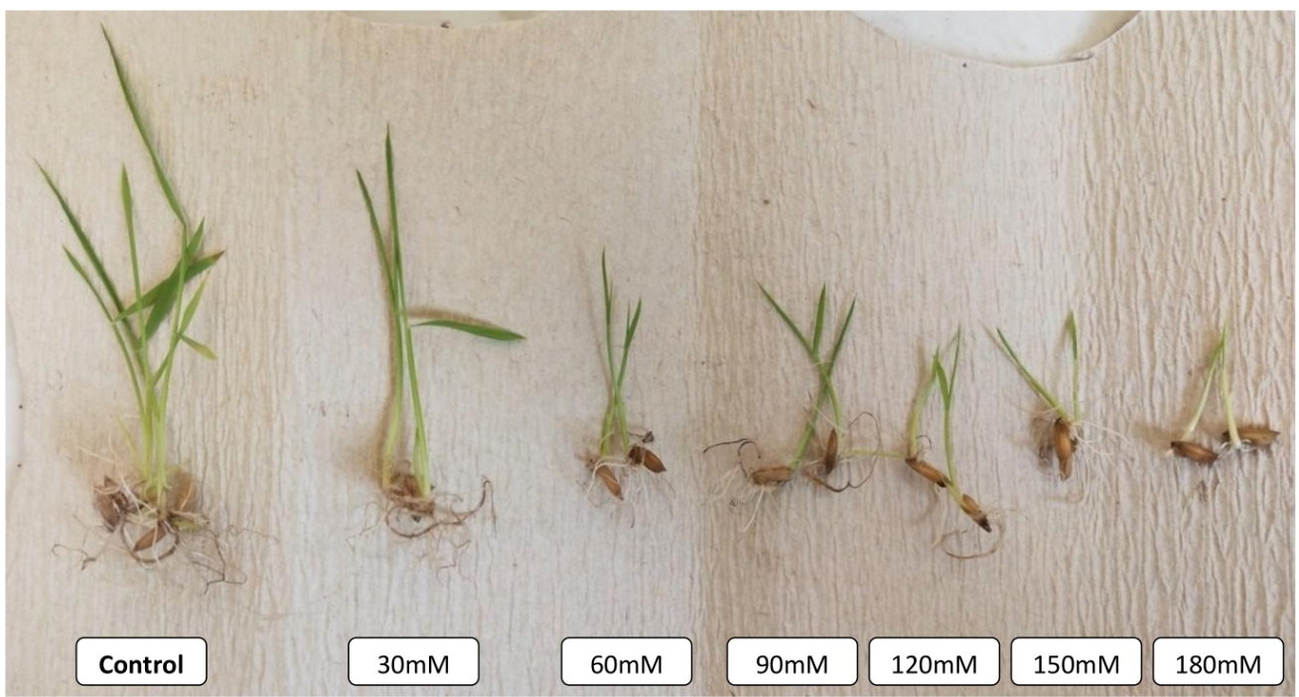

Figure 2.Observation on 12thday under salinity with treatment of different concentrations
of Gibberellic acid on variety CO-51

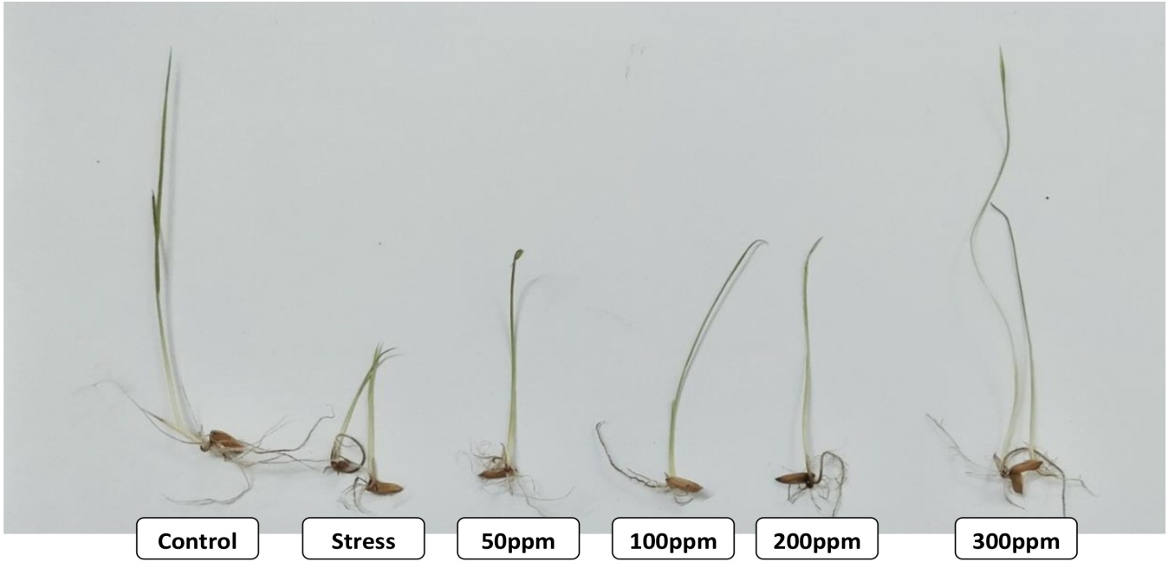

Figure 3.Observation on 12thday under salinity with treatment of different concentrations
of Salicylic acid on variety CO-51
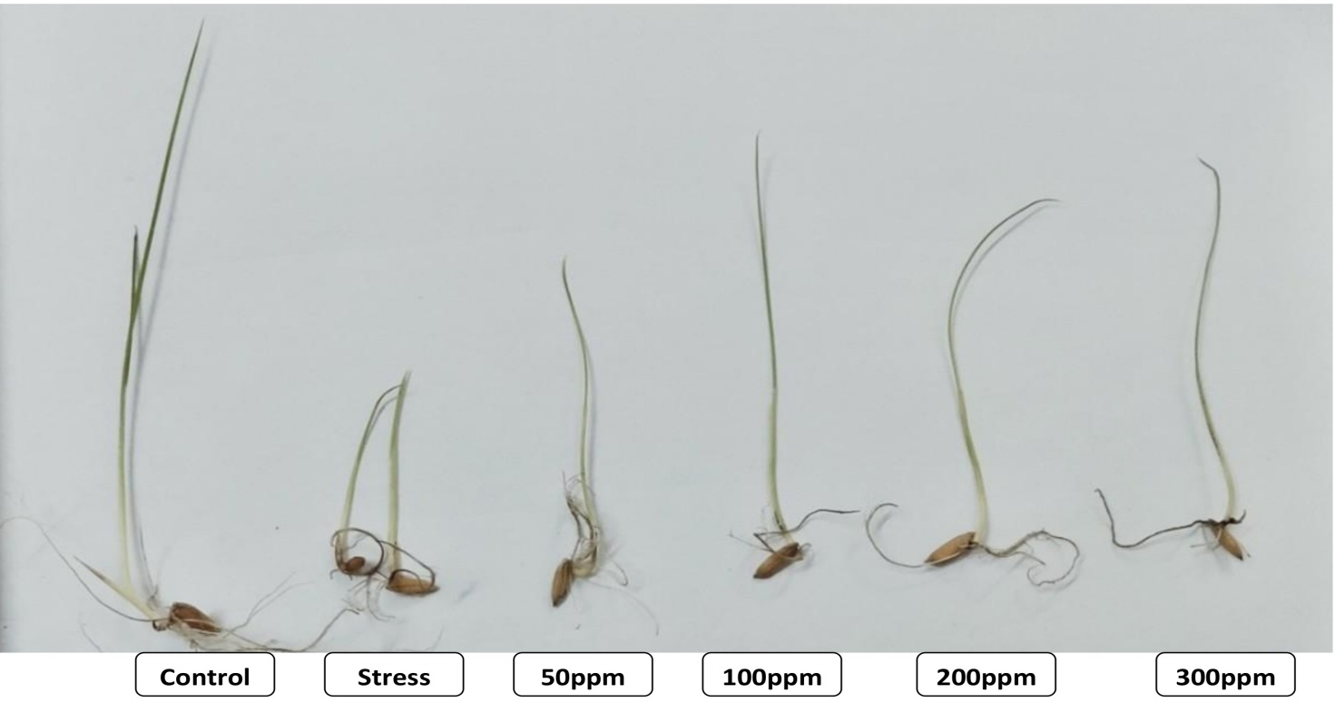

Figure 4.Observation on 12thday under salinity with treatment of different concentrations
of Kinetin on variety CO-51
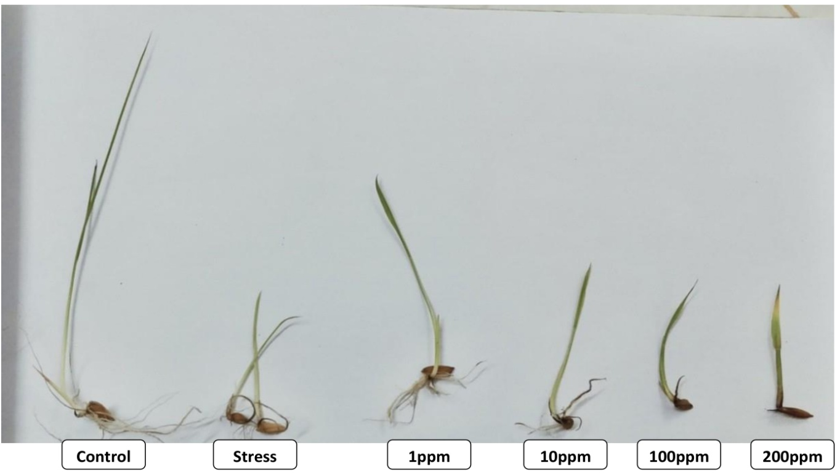

COMPETING INTERESTS
Authors have declared that they have no known competing financial interests OR non-financial interests OR personal relationships that could have appeared to influence the work reported in this paper.
Details of the AI usage are given below:
1. Author(s) hereby declare that NO generative AI technologies such as Large Language Models (ChatGPT, COPILOT, etc.) and text-to-image generators have been used during the writing or editing of this manuscript.
REFERENCES
Abdul - Bakiand Anderson.1973.Vigour determination in soybean and seed multiple criteria.
Crop Sci. 13:630–633.
Anwar, S., M. Iqbal, S. Hammadraza and N. Iqbal. 2013. Efficacy of seed preconditioning with salicylic and ascorbic acid in increasing vigor of rice (Oryza sativa L.) seedling. Pak. J. Bot., 45(1): 157-162
Basra, S. M. A., M. Farooq, R. Tabassum and N. Ahmed. 2005. Physiological and biochemical aspects of seed vigor enhancement treatments in fine rice (Oryza sativa L.). Seed Sci. Technol., 33: 623-628.
Chourey, K., S. Ramani and S. K. Apte. 2003. Accumulation of LEA proteins in salt (NaCl) stressed young seedlings of rice (Oryza sativa L.) cultivar Bura Rata and their degradation during recovery from salinity stress. J. Plant Physiol., 160: 1165-1174.
Davies, P. J. 1987. The plant hormones: their nature, occurrence, and functions. In: Plant hormones and their role in plant growth and development, (Ed: P.J. Davies). Martinus Nijhoff Publishes, Dordrecht, The Netherlands, 1-11
Farooq, M., S. M. A. Basra and M. B. Khan. 2007. Seed priming improves growth of nursery seedlings and yield of transplanted rice. Arch. Agron. Soil Sci., 53: 315-326.
Flowers, T. J and A. R. Yeo. 1981. Variability in the resistance of sodium chloride salinity with in rice (Oryza sativa L.) varieties. New Phytology, 88: 363 – 373.
Hajer, A. S., A. Malibari, Al-Zahrani and O. A. Almaghrafi. 2006. Responses of three tomato cultivars to sea water salinity. 1. Effect of salinity on the seedling growth. Afr. J. Biotechnol., 5(10):855 – 861.
Harris, D., R. S. Tripathi and A. Joshi. 2002. On-farm seed priming to improve crop establishment and yield in dry direct-seeded rice In: Direct seeding: Research strategiesand opportunities. (eds.) Pandey, S., M. Mortimer, L. Wade, T. P. Tuong, K. Lopes and B. Hardy. International Rice Research Institute, Philippines,: 231-240.
Khush,G.S.2006.What it will to take of seed 5.0 billion rice consumers in 2030. Plant Mol. Biol.,59:1–6.
Li, J. Y and Y. Q. Tang. 2002. Relation of change in content of plant endogenous cytokinin to germination and growth of ratooning buds in hybrid rice. Hybrid Rice, 17:50-52.
Lutts, S., J. M,Kinet and J.Bouharmont. 1995. Effects of salt stress ongrowth, mineral nutrition and proline accumulation in relation to osmotic adjustment in rice (Oryza sativa L.) cultivars differing in salinity resistance. Plant Growth Regul., 19: 207-218.
Majid GhorbaniJavid,Ali Sorooshzadeh and,FoadMoradi.2011.The role ofphytohormones in alleviating salt stress in crop plants. AJCS 5(6):726-734.
Mathew, J and K. Mohanasarida. 2005. Seed priming on crop establishment and seedling vigour in semi-dry rice (Oryza sativa L.). Res. Crops, 6: 23-25.
Misra, A. K and Niragidave. 2013. Impact of soil salinity and erosion and its overall impact on India. International Journal of Innovative Research in Engineering and Science. 3(2):12-17.
Noushina, I., R. Nazar, M. Iqbal, R. Khan, A. Masood and N. A. Khan. 2011. Role of gibberellinsinregulationofsourcesinkrelationsunderoptimalandlimitingenvironmental conditions. Current science, 100(7): 998-1001.
Palmiano, E. P and B. O. Juliano. 1972. Biochemical changes in the rice grain during germination. Plant Physiol., 49: 751-756.
Poljakoff-Mayber, A and J. Gale. 1975. Morphological and anatomical changes in plants as response to salinity stress. In: Plants in saline environment and ecological studies, New York. 95 – 117.
Rad, H. E., F. Aref and M. Rezae. 2012. Response of rice to different salinity levels during different growth stages. Research Journal of Applied Science, Engineering and Technology, 4: 3040-3047.
Rajakumar, R. 2013. A study on the effect of salt stress in the seed germination and biochemical parameters of rice (Orizya sativa L.) under in vitro condition. Asian journal of plant science and research, 3(6): 20-25
Rao, S. S. R., B.V. Vardhini, E. Sujathaand and S. Anuradha. 2002. Brassinosteroids – A new class of phytohormones. Current Science, 82, (10):1239-1245.

Ruan, S., Q. Xue and R. Tylkowska. 2002. Effects of seed priming on germination and health of rice (Oryza sativa L.) seeds. J. Seed Sci. Tech., 30: 451-458.
Tania, D and Y. M. Shukla, 2011. Effect of brassinolide on biochemical constituents in rice (Oryza sativa L.) under salinity stress. Asian J. Exp. Chem., 6 (1): 22-25.
Vadivel,A.,P.Singaram,A.Rajarajan,P.SavathiryandT.M.Thiyagarajan.2001.In:SalineSoilandLandManagement,Dept.ofSoilandAgric.Chem.andCrop Management Center, TNAU, Coimbatore.
Yeo, A.R., M.E. Yeo and T.J. Flowers, 1988. Selection of lines with high and low sodium transport from within varieties of inbreeding species: Rice (Oryza sativa L.). New Phytol., 110: 13-19.
Zeng,L.,S.M.LeschandC.M.Grieve.2003.Ricegrowthandyieldrespondtochangesin water depth and salinity stress. Agric. Water Manag., 59: 67 – 75.

