Unveiling Environmental Racism: Evolution and Impacts on Scientific Research

.
ABSTRACT

Aims: The objective of this study was to analyze the evolution of the concept of environmental racism and its impacts on scientific production, highlighting its consolidation as a field of research and its contributions to the promotion of socio-environmental justice.
Place and Duration of Study: The study was conducted from March to October 2025 at the Escola de Reference em Ensino Fundamental e Médio Doctor Benjamin Caraciolo (EREFEM Doctor Benjamin Caraciolo), located in the municipality of Sanharó, in the state of Pernambuco, Brazil.
Methodology: The methodology adopted was descriptive and exploratory, combining quantitative and qualitative methods. Data collection was carried out using the Web of Science (WOS) database, with descriptors related to environmental racism and environmental justice, covering the period from 2015 to July 2025. After applying inclusion and exclusion criteria, 498 articles were analyzed. The data were organized in Microsoft Excel, while co-authorship, co-occurrence, and co-citation network analyses were conducted using VOSviewer software, and representative graphs were produced in SigmaPlot 16.
Results: The results indicated a significant growth in publications addressing environmental racism, particularly from 2018 onwards, with a strong concentration in countries of the Northern Hemisphere especially the United States, which leads in both the volume of articles and the formation of collaborative networks. Brazil stands out as the main representative of South America, although its contribution remains modest.
Conclusion: The analysis shows that environmental racism has become a consolidated and interdisciplinary field, with significant growth since 2018, especially in Northern Hemisphere countries such as the United States. Although Brazil stands out in Latin America, its international presence remains limited. The central role of environmental justice connects the topic to public health, climate change, gentrification, public policies, and structural inequalities, highlighting its multidimensional nature.

Keywords: Environmental Inequality, Socioenvironmental Justice, Social Vulnerability, Justice.

1. INTRODUCTION

Environmental issues are deeply intertwined with historical patterns of social inequality, revealing how certain populations disproportionately bear the burden of ecological degradation. Within this context, the concept of environmental racism has emerged as a crucial analytical framework to understand the intersection between race, environment, and power structures (Kaufman; Hajat, 2021; Salas, 2021).
Originating in the United States during the 1980s, the term gained prominence following the publication of the seminal report Toxic Waste and Race in the United States, which exposed the racialized geography of hazardous waste disposal (Chavis, 1987; Bullard, 1994). Subsequent research consolidated environmental racism as a structural phenomenon, showing how marginalized communities are systematically exposed to environmental hazards due to discriminatory policies and socioeconomic exclusion (Bullard, 2008; Hicken et al., 2021).
In recent years, the notion of environmental justice has expanded this debate by emphasizing both equitable access to a healthy environment and active participation in decision-making processes (Seguin, 2013; Pellow, 2025; D’Evelyn et al., 2022). From this perspective, environmental injustice is not an incidental outcome but the result of historically produced social hierarchies that shape urban planning, resource allocation, and environmental governance (Rocha; Vasconcelos, 2022; Sze, 2006). The integration between environmental justice and sustainable development has become essential to address these disparities, especially in countries marked by profound social inequalities (Rocha; Vasconcelos, 2022).
Scholars have highlighted the structural and cultural dimensions of environmental racism, often describing it as a form of slow violence a process of gradual and invisible harm disproportionately affecting racialized communities (Nixon, 2011; Hicken et al., 2021). Empirical studies confirm these patterns: Alvarez (2023), for instance, found a strong correlation between racial inequality indices and exposure to air pollutants in the United States, revealing how racism is embedded in environmental risk distribution. Similar dynamics can be observed in Latin America, where environmental hazards frequently overlap with racialized territories, but remain comparatively underexplored in academic research.
Furthermore, contemporary scholarship has shed light on the discursive and ideological mechanisms that sustain environmental racism (Ide et al., 2023). Alvarez and Rendón (2025) describe “epistemic maneuvers” such as scientific neutrality and victim-blaming, which serve to legitimize environmental harm against marginalized groups. Bugden (2024) argues that “color-blind environmental racism” operates as a cultural barrier by denying racial inequalities and undermining support for environmental justice policies. These perspectives reveal that overcoming environmental racism requires not only regulatory and political interventions but also cultural transformations capable of challenging hegemonic narratives (Kronenberger et al., 2025; Trott, 2025).
Despite the growing international literature, there is still an imbalance in the geographical distribution of research, with a predominance of studies from the Global North, particularly the United States, and relatively fewer contributions from countries like Brazil, where the phenomenon is highly relevant but underrepresented in scientific debates (Adom et al., 2025). Addressing this gap is crucial for advancing a more comprehensive and inclusive understanding of environmental racism, especially in contexts marked by colonial legacies, social inequities, and environmental vulnerabilities. Therefore, this study aims to analyze the scientific production on environmental racism, mapping its thematic and geographical trends while highlighting the need to expand research in contexts of the Global South. By doing so, it seeks to contribute to a broader, more equitable, and critical discussion on the socio-environmental challenges of our time.
2. material and methods

This research adopts a descriptive and exploratory approach, based on quantitative and qualitative methods, focusing on conducting bibliometric and scientometric analyses of the scientific production related to environmental racism.

2.1 Collection of bibliographic data

The data collection was conducted using the Web of Science (WOS) databases, considered among the most relevant for mapping international scientific literature. Search criteria were defined based on descriptors related to the topic, with temporal and linguistic filters established to ensure the representativeness and consistency of the results.
For data collection, a structured search strategy was employed in the Web of Science databases, using the following search string: ("Environmental Racism" OR "Environmental Justice") AND ("Social Inequality" OR "Racism" OR "Structural Racism" OR "Vulnerable Communities").
The criteria and filters applied in the Web of Science database are described in Table 1.

Table 1. Criteria and filters applied in the WOS bibliographic research.
Criterion | Description
Inclusion of Keyword | Title-Abstract-Keywords
Time Frame | 2015 ≤ july de 2025
Document Type | Limited to Articles

After applying the criteria established in Table 1, a new screening was conducted to exclude articles considered irrelevant to the study’s objectives. The final dataset was exported in .txt format, containing the complete records and cited references, ensuring the integrity of the information for subsequent analyses.
The obtained data were initially organized and processed in Microsoft Excel, which was used for tabulation, filtering, and structuring of the information. For the analysis of collaboration, co-authorship, co-citation, and term co-occurrence networks, the VOSviewer software will be employed, widely recognized for bibliometric and scientometric studies. Illustrative graphs were constructed using SigmaPlot 16, enabling clear visualization of trends, patterns, and the evolution of scientific production during the investigated period.

2.2 Scientific Mapping

In this study, bibliometric data were extracted from the web of science database, encompassing the total number of publications, the annual distribution of articles, scientific production by countries, institutions, and authors, as well as the most relevant journals. For the scientometric analysis, three main approaches were employed, processed using the VOSviewer software: (1) co-authorship, aimed at identifying collaboration networks among countries, institutions, and authors; (2) co-occurrence, focused on determining the most impactful keywords; and (3) co-citation, which highlights the authors, journals, and documents most frequently cited together.

2.3 Data Processing

The first step in using the VOSviewer software consisted of standardizing synonymous terms, ensuring that each concept was represented by a single designation. Subsequently, the necessary parameters were configured in VOSviewer to obtain the different analysis networks:
- Co-authorship networks: these constitute visual representations of collaborations established between countries, institutions, and authors in scientific production. Three networks were generated using the full counting method. The first focused on organizations, adopting minimum criteria of 3 documents per institution and 1 citation. The second focused on countries, with parameters of at least 2 documents and 10 citations per country. Finally, the third network analyzed authors, considering a minimum of 2 documents per author and 10 citations.
- Co-occurrence network: this corresponds to a visual representation of the frequency of association between terms, keywords, or concepts within a set of publications. The unit of analysis adopted was “all keywords,” applying the full counting method. The minimum number of occurrences was set at 10, and the total number of keywords included in the visualization was limited to 49 to optimize the interpretation of the results.
- Co-citation networks: these map the relationships between articles, authors, and scientific journals based on the frequency with which they are cited together in other publications. Three distinct networks were generated: the first involving cited authors, using the full counting method with a minimum of 20 citations per author; the second concerning journals, requiring at least 90 co-citations.

3. results and discussion

3.1 Advancement of publications on environmental racism

By applying the search string (keywords) in the Web of Science (WoS) database, a total of 723 publications were identified for the period from 2015 to July 2025. After applying the inclusion and exclusion criteria (Table 1), 498 publications were selected, totaling 26,798 cited references. The annual average number of publications during the analyzed period was approximately 66 articles per year. The results show that scientific production related to environmental racism has experienced continuous growth since 2018 (Figure 1), registering an increase of more than tenfold when comparing the years 2015 and 2024 (Fig. 1).

3.2 Research institutions and countries that have conducted studies on environmental racism

The analysis of research institutions involved in publications on environmental racism highlights a scenario in which scientific production is concentrated in a small number of organizations. Among the 613 mapped institutions, only 33 show a significant volume of publications, revealing the predominance of well-established research centers on the topic.
The prominence of the Universities of Michigan, California Berkeley, and Washington (Fig. 2), which account for the highest outputs 16 and 14 publications respectively, suggest the existence of specialized groups and well-structured collaborative networks, particularly in countries with a tradition in socioenvironmental studies.

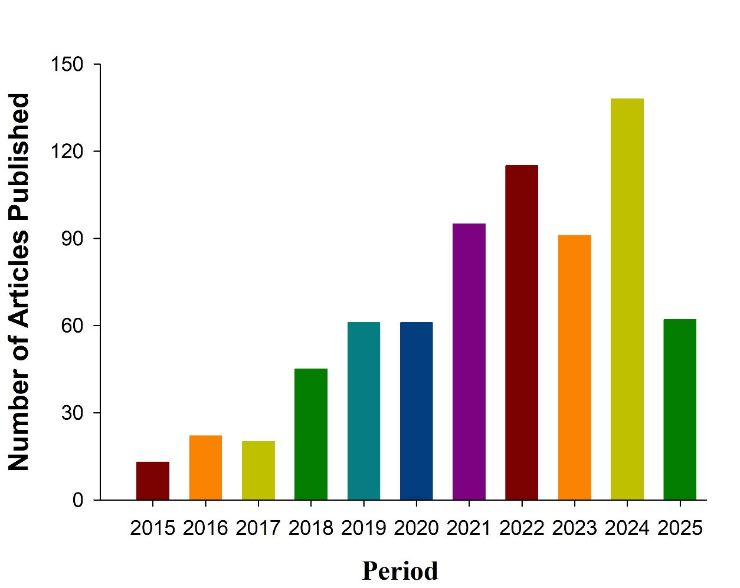
Figure 1. Annual distribution of the number of scientific articles on environmental racism, from 2015 to July 2025.

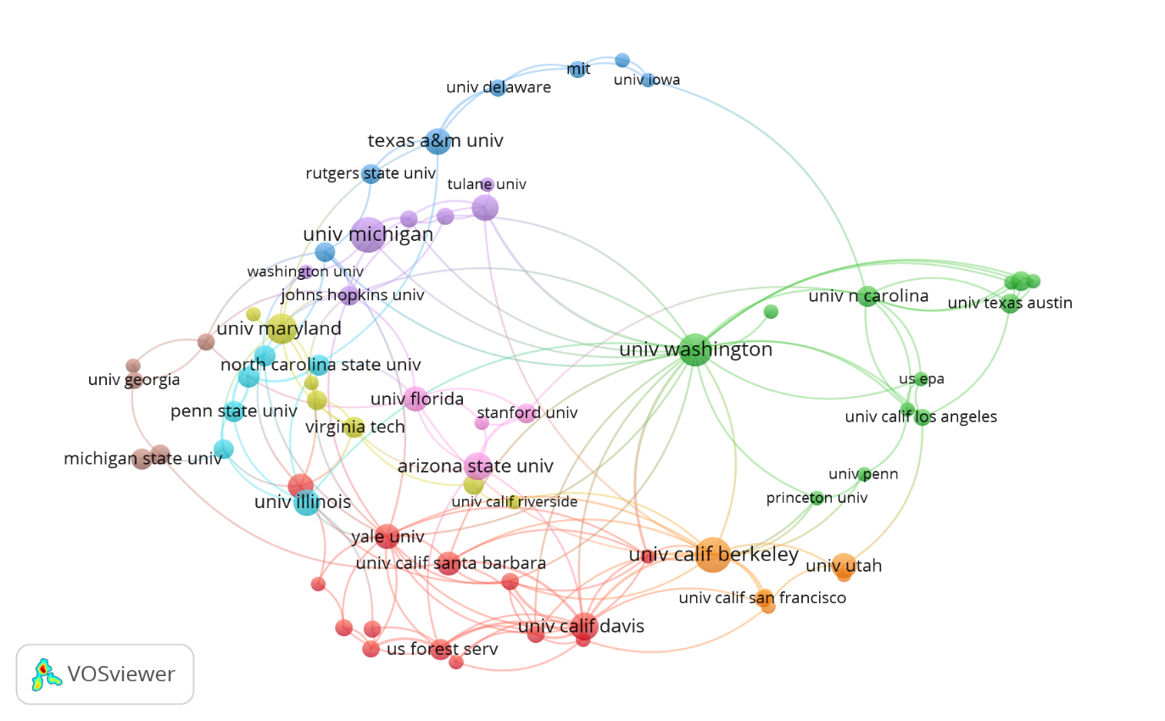
Figure 2. Scientific co-authorship network of research institutions that studied environmental racism, from 2015 to July 2025.
This concentration may be associated both with the greater funding available for research focused on socioenvironmental justice and with the consolidation of academic agendas historically committed to the critical analysis of environmental inequalities. On the other hand, the high number of institutions with only occasional participation in the topic highlights the growing interest of the scientific community but also points to the need to strengthen international collaboration and expand the geographical distribution of scientific production on environmental racism, especially in regions historically more affected by these inequalities.
A total of 61 countries were involved in research on environmental racism during the analyzed period. The United States stood out as the country with the highest number of publications on the topic, totaling 359 articles, followed by Brazil with 31 publications and the United Kingdom with 25, contributing to the highest publication densities (Fig. 3).

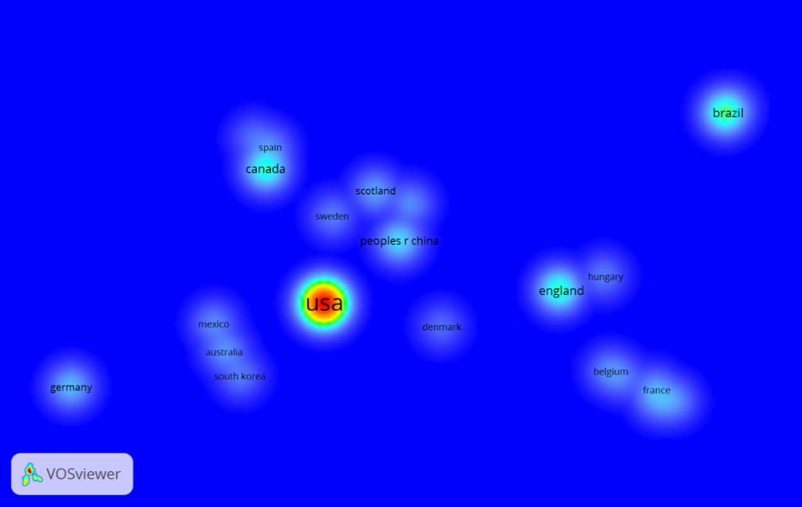
Figure 3. Density map of scientific publications by country on environmental racism, from 2015 to July 2025.

The analysis of interactions between countries, conducted using the VOSviewer software, revealed the formation of eight collaborative groups: the green group (United States, Australia, Mexico, and South Korea); the red group (Belgium, France, Finland, Italy, Kenya, and South Africa); the blue group (Spain, Canada, and Ecuador); the yellow group (Denmark, England, and Hungary); the purple group (Brazil and Portugal); the light blue group (Colombia and Germany); the orange group (Nigeria and Scotland); and the brown group (Sweden and China), as illustrated in figure 4.
The analysis of scientific collaboration networks shows that research on environmental racism is characterized by a strong concentration in certain countries, with the United States standing out for leading in publication volume and playing a central role in the coordination of global networks. The presence of countries such as Australia, Mexico, and South Korea in the same cluster suggests well-established partnerships in projects and research agendas with an emphasis on socioenvironmental justice.

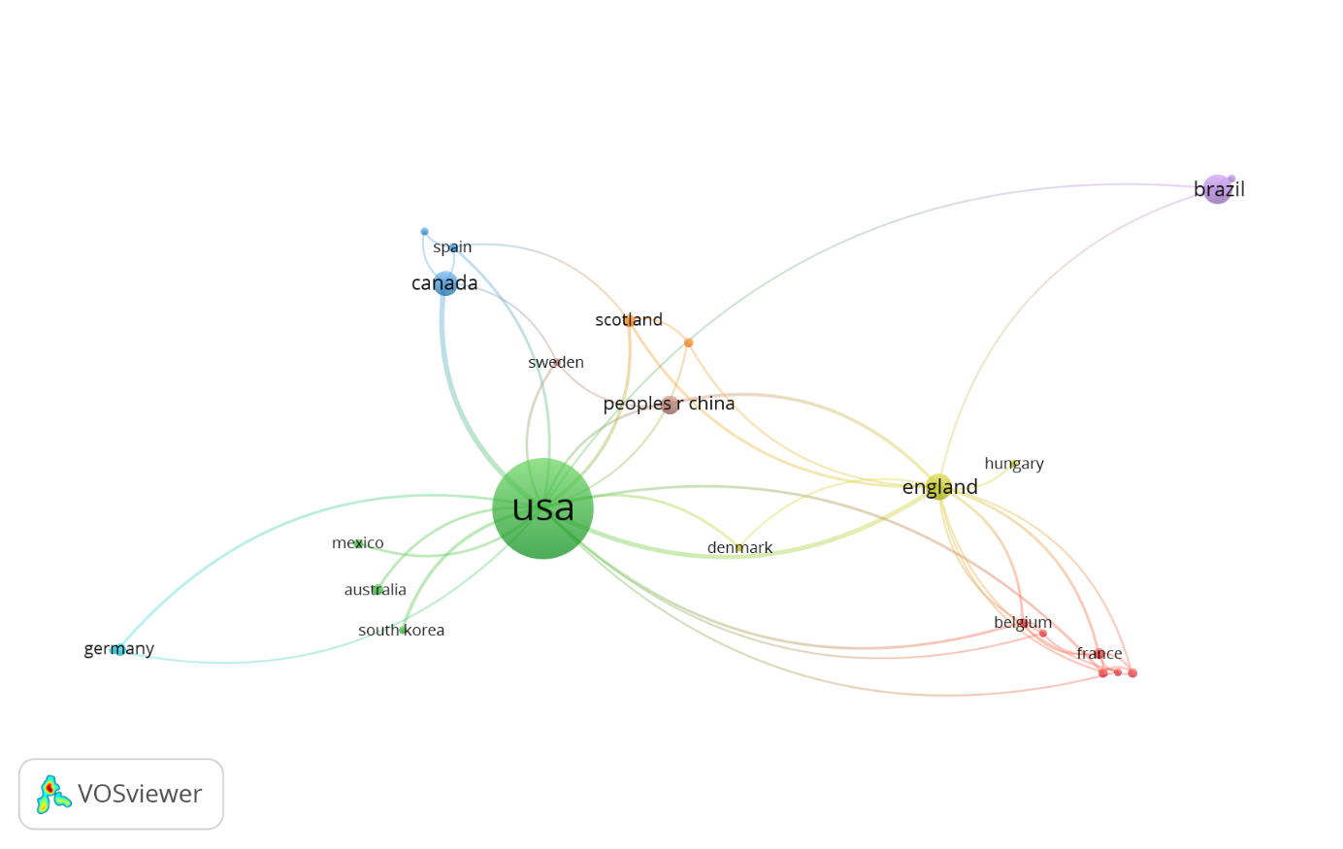
Figure 4. Co-authorship network among countries that published scientific articles on environmental racism, from 2015 to July 2025.

The cluster that includes Belgium, France, Finland, Italy, Kenya, and South Africa indicates a transcontinental network, possibly influenced by cooperation programs between Europe and Africa focused on issues related to environmental inequality.
It is also observed that Brazil, the main representative of South America, is included in the purple group alongside Portugal, a relationship that may reflect linguistic and historical ties facilitating bilateral collaborations. Smaller clusters, such as those involving Spain, Canada, and Ecuador (blue group) and Denmark, England, and Hungary (yellow group), demonstrate specific scientific interactions, likely resulting from joint projects or thematic affinities.
Despite the diversity of countries involved, it is noted that the distribution of scientific production still shows significant asymmetries, with a concentration of articles in Northern Hemisphere nations and low participation from Global South countries, highlighting the need to expand international cooperation and strengthen research networks on environmental racism.

3.3 Authors and Their Contributions to the Advancement of Studies on Environmental Racism

The results obtained highlight the participation of 1,404 authors in the articles considered in the bibliometric and scientometric analyses. The authors who stood out the most in terms of the number of publications and citations on the topic during the analyzed period are presented in Table 2.
The analysis of the co-citation network among authors revealed the formation of three distinct groups, highlighting the collaborative structure and theoretical connections in the field of environmental racism. The author Laura Pulido stands out, simultaneously belonging to the red and green groups, indicating her relevance and interdisciplinary influence in the field. Her presence in multiple clusters suggests that her contributions bridge different lines of research, playing a central role in consolidating the theoretical framework on environmental racism, as illustrated in figure 5.
Table 2. Five most prominent authors in the Web of Science database on environmental racism research, indicating the number of articles published (NAP) and the number of citations (NC), from 2015 to July 2025.
Authors | NAP | NC | Institution | Country
Mohai, Paul | 5 | 177 | Universidad de Michigan | United States
Campbell, Heather | 5 | 20 | Geol Survey New foundland & Labrador | Canada
Mullenbach, Lauren | 4 | 106 | Universidad de Oklahoma | United States
Grineski, Sara | 4 | 93 | Universidad de Utah | United States
Pulido, Laura | 3 | 822 | Universidad do Oregon | United States

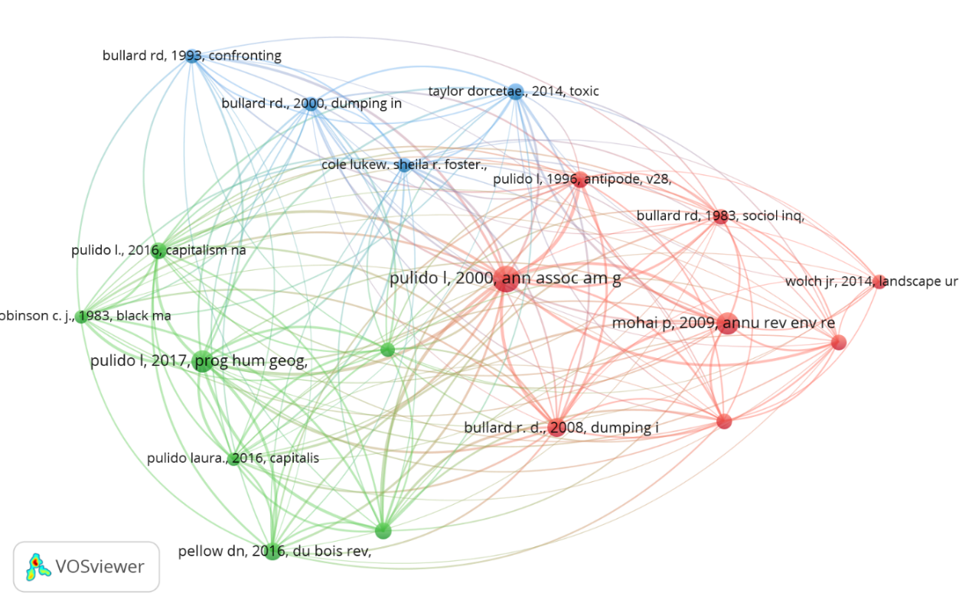
Figure 5. Co-citation network among researchers investigating environmental racism from 2015 to July 2025.

3.4 Study of journals and keyword co-occurrence associated with environmental racism

The analysis of scientific production revealed a total of 498 articles on environmental racism distributed across 297 journals, demonstrating the breadth of the topic in the academic landscape. The journal Environmental Justice stands out, accounting for 41 publications, confirming its position as a reference and central hub in debates on socioenvironmental justice (Table 3).

Table 3. Five leading journals with publications on environmental racism, considering the number of articles published (NAP) and the number of citations (NC) from 2015 to July 2025.
Journals |  | NAP | NC
Environmental Justice |  | 41 | 562
Environmental Sociology |  | 15 | 197
Local Environmental |  | 11 | 123
Annals of the American Association of Geographers |  | 7 | 275
Antipode |  | 6 | 229

This predominance suggests that the journal serves as the main platform for disseminating research specifically on environmental racism, gathering a significant number of citations (NC = 562), which reinforces its relevance and impact in the field. Other journals, such as Environmental Sociology and Local Environment, also stand out, albeit with a lower volume of publications, highlighting the diversification of editorial spaces that host studies on the topic. The presence of titles such as Annals of the American Association of Geographers and Antipode indicates the interdisciplinary nature of research on environmental racism, integrating sociological, geographical, and political approaches, and demonstrating the progressive strengthening of this line of investigation during the analyzed period.
The co-citation network of journals highlights the formation of three main clusters, reflecting different approaches to environmental racism (Fig. 6).

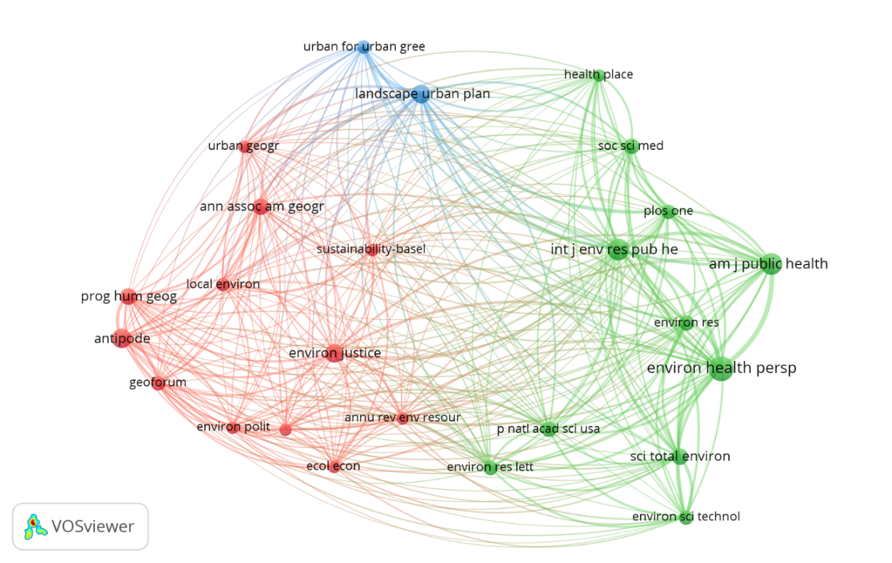
Figure 6. Co-citation network of journals that published studies on environmental racism from 2015 to July 2025.

The red cluster concentrates journals in the fields of geography, urban studies, and environmental justice, such as Environmental Justice, Local Environment, Antipode, Progress in Human Geography, and Geoforum, representing a critical and socio-spatial strand of the research.
The green cluster brings together journals focused on environmental health, public policies, and applied sciences, with emphasis on Environmental Health Perspectives, American Journal of Public Health, and International Journal of Environmental Research and Public Health, indicating a strong link between environmental racism, public health, and socioenvironmental impacts.
The blue cluster, composed of journals such as Urban Forestry & Urban Greening and Landscape and Urban Planning, addresses technical and applied aspects, with an emphasis on urban planning and green infrastructure.
The centrality of journals such as Environmental Health Perspectives and American Journal of Public Health demonstrates their relevance in connecting different research areas, reinforcing the interdisciplinary nature of scientific production on the topic and the growing integration of territorial, social, and health dimensions in the debate on environmental injustices.
The keyword co-occurrence network highlights the centrality of the term “environmental justice,” emphasizing it as a structuring concept in studies on environmental racism (Fig. 7).
Around it, four main clusters can be observed:
- The red cluster, which gathers critical discussions on socioenvironmental inequalities, climate change, intersectionality, and climate justice;
- The green cluster, associated with environmental health, population impacts, and vulnerability of specific groups, including terms such as exposure, air pollution, health disparities, and COVID-19.
- The blue cluster, which includes words related to social vulnerability, public policies, and structural racism; and
- The purple cluster, which concentrates concepts related to urban dynamics, such as cities, urban, and gentrification.
This structure demonstrates that scientific production on the topic is highly interdisciplinary, connecting socioeconomic, urban, health, and climate aspects, and reaffirming environmental racism as a structural phenomenon linked to issues of equity, public health, and climate change.

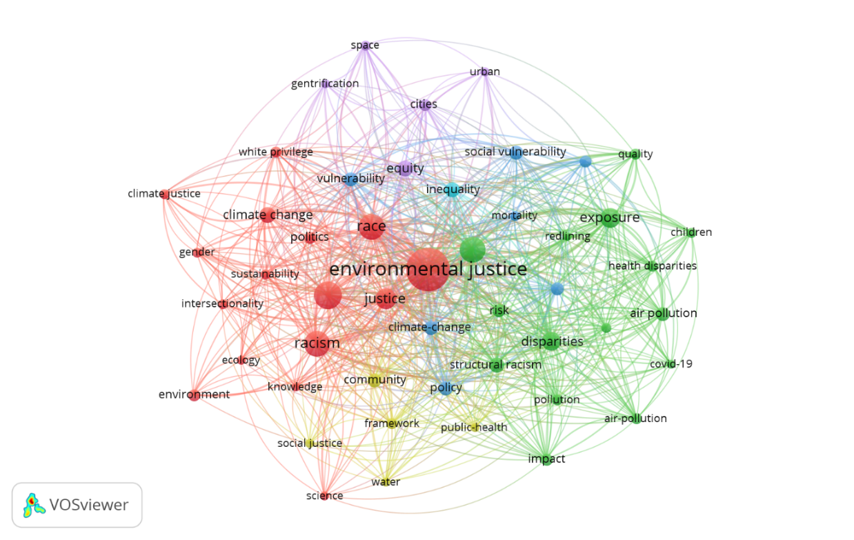
Figure 7. Keyword co-occurrence network in studies on environmental racism from 2015 to July 2025.

4. Conclusion

The bibliometric and scientometric analysis conducted revealed that environmental racism has consolidated as an interdisciplinary field of research, experiencing significant scientific growth in recent decades. The marked increase in publications since 2018 demonstrates the strengthening of academic interest in the topic, in response to social demands for socioenvironmental justice.
The results indicated a strong concentration of scientific production in countries of the Northern Hemisphere, particularly the United States, which plays a central role in collaboration networks and knowledge dissemination. Although Brazil holds a prominent position in Latin America, it still shows low representativeness on the international stage, highlighting the need to increase investment in research and strengthen cooperation networks.
The analysis of journals and keywords highlighted the centrality of the concept of environmental justice, connecting environmental racism to debates on public health, climate change, gentrification, public policies, and structural inequalities. This thematic multiplicity confirms the multifaceted nature of the phenomenon, which is not limited to environmental issues but encompasses social, economic, racial, and territorial dimensions.
Considering these findings, it is concluded that a critical understanding of environmental racism is essential to address the historical and structural inequalities affecting vulnerable populations. The implementation of inclusive public policies, combined with the strengthening of national and international scientific production, constitutes an indispensable path to promoting socioenvironmental justice and ensuring the collective right to a healthy and equitable environment.

Disclaimer (Artificial intelligence)
Option 1:
Author(s) hereby declare that NO generative AI technologies such as Large Language Models (ChatGPT, COPILOT, etc.) and text-to-image generators have been used during the writing or editing of this manuscript.
Option 2:
Author(s) hereby declare that generativ AI technologies such as Large Language Models, etc. have been used during the writing or editing of manuscripts. This explanation will include the name, version, model, and source of the generative AI technology and as well as all input prompts provided to the generative AI technology
Details of the AI usage are given below:
1.
2.
3.

References

Adom, R. K., Afuye, G. A., Kalumba, A. M., & Simatele, M. D. (2025). Integrating the Perspectives of Youth, Women, and Marginalised Communities in Addressing Global Environmental Management Challenges. Environmental Management, 1-22. https://link.springer.com/article/10.1007/s00267-025-02254-7
Alvarez, C. H. 2023. Structural Racism as an Environmental Justice Issue: A Multilevel Analysis of the State Racism Index and Environmental Health Risk from Air Toxics. Journal of Racial and Ethnic Health Disparities, v. 10, n. 1, p. 244–258. https://link.springer.com/article/10.1007/s40615-021-01215-0
Bugden, D. 2024. Environmental Inequality in the American Mind: The Problem of Color-Blind Environmental Racism. Social Problems, v. 71, p. 1–19. https://doi.org/10.1093/socpro/spac005
Bullard, R. D. 1984. Dumping in Dixie: Race, Class, and Environmental Quality. Boulder: Westview Press.
Bullard, R. D. 2008. The Quest for Environmental Justice: Human Rights and the Politics of Pollution. San Francisco: Sierra Club Books.
Chavis, B. F. 1987. Toxic Waste and Race in the United States. New York: United Church of Christ Commission for Racial Justice.
D’Evelyn, S. M., Jung, J., Alvarado, E., Baumgartner, J., Caligiuri, P., Hagmann, R. K., ... &
Hicken, M. T., Miles, M., Haile, S & Esposito, M. 2021. Linking History to Contemporary State-Sanctioned Slow Violence through Cultural and Structural Racism. Annals of the American Academy of Political and Social Science, v. 694, n. 1, p. 48–58. https://journals.sagepub.com/doi/10.1177/00027162211005690
Ide, T., Johnson, M. F., Barnett, J., Krampe, F., Le Billon, P., Maertens, L., ... & Vélez-Torres, I. (2023). The future of environmental peace and conflict research. Environmental Politics, 32(6), 1077-1103. https://doi.org/10.1080/09644016.2022.2156174
Kaufman, J. D., & Hajat, A. (2021). Confronting environmental racism. Environmental Health Perspectives, 129(5), 051001. https://doi.org/10.1289/EHP9511
Hicken, M. T., Miles, M., Haile, S & Esposito, M. 2021. Linking History to Contemporary State-Sanctioned Slow Violence through Cultural and Structural Racism. Annals of the American Academy of Political and Social Science, v. 694, n. 1, p. 48–58. https://journals.sagepub.com/doi/10.1177/00027162211005690

Kronenberger, E. J., Mullenbach, L. E., & Stanis, S. A. W. (2025). Examining environmental justice in legacy city climate action planning. Climate and Development, 1-9. https://doi.org/10.1080/17565529.2025.2459065
Nixon, R. Slow Violence and the Environmentalism of the Poor. Cambridge: Harvard University Press, 2011.

Alvarez Noli, K., & Rendón, M. G. (2025). Epistemic maneuvers as mechanisms of environmental racism: how pesticide exposure is sustained against Mexican farmworkers. Environmental Sociology, 11(3), 306-323.

Pellow, D. N. (2025). What is critical environmental justice?. John Wiley & Sons.

Rocha, J. S., & Vasconcelos, P. E. A. (2022). Justiça ambiental e desenvolvimento sustentável: soluções ao racismo ambiental no Brasil. Revista Direito Ambiental e sociedade, 12(3).
Salas, R. N. (2021). Environmental racism and climate change—missed diagnoses. New England Journal of Medicine, 385(11), 967-969.
Sze, J. (2006). Noxious New York: The racial politics of urban health and environmental justice. MIT press.

Trott, C. D. (2025). Rewriting the climate story with young climate justice activists. Geographical Research, 63(1), 134-152. https://doi.org/10.1111/1745-5871.12662

