The Prevalence of Bovine Fascioliasis in a Slaughter Slab at Ekpoma, Edo State, Nigeria

Abstract
Aims: The study aimed to determine the prevalence of bovine fascioliasis through examination of liver from slaughtered cattle and the analysis of faecal samples for the characteristics of eggs of Fasciola spp. at the Ekpoma slaughter slab in Edo State, Nigeria.
Study design: The study was cross-sectional, conducted in September, 2024.
Methodology: A total of 136 adult cattle (120 males and 16 females) were examined for fascioliasis. From each cattle, about 3 g of stool samples were analyzed qualitatively by the sedimentation technique, while liver samples were grossly examined through tissue palpation and incision for adult flukes.
Results: The results of fecal sample analysis showed a prevalence of 40% refer to Table 1 for correct figure, which is higher than the 14.7% observed from the gross examination of the liver tissues. The severity index of infections showed a predominance of mild infection, 14.7% compared to 1.47% obtained for moderate and heavy infections respectively Rewrite the percentages with respect to the corrections in Table 2. Prevalence based on sex indicated no statistically significant difference (P > 0.05).
Conclusion: The findings showed a variation in the prevalence of fascioliasis based on the method of examination. In the determination of a minimal sample size using the formula n = Z²P(1 –P)/ d², the study suggests that the P value which is derived from a previous prevalence study should be based on feacal examination instead of the gross examination of the liver. Consider deleting this highlighted statement and insert “It reveal that prevalence study should be based on faecal analysis rather than on gross examination of liver tissues” It emphasizes the zoonotic urgency for effective strategies to control bovine fascioliasis. Measures such as routine diagnosis and regular veterinary-supervisory deworming schedules are vital to reducing the prevalence of the disease in cattle. Consider deleting the highlighted sentence/ rephrasing as follows: “There is, therefore, a need for application of control measures to secure both the animal and human lives through regular deworming and control of snail intermediate hosts.”

Keywords: Bovine fascioliasis, prevalence, public health, deworming.

INTRODUCTION
Bovine fascioliasis is a Lymnaeid-water-snail-borne parasitic disease of ruminants caused by two main species of trematodes: Fasciola gigantica and F. hepatica (Opio et al., 2021). The two species are morphologically similar. F. hepatica measures about 30 mm in length and 15 mm in width, while F gigantica 75 mm by 15 mm. The adults of both are large enough to be seen grossly (Center for Disease Control, 2019). Their infections cover a wide spectrum of mammalian definitive hosts such as ruminants, rodents, lagomorphs as well as humans (Center for Disease Control, 2019). The Lymnaeid water-snails serve as vector of Fasciola parasites. The snails live in either temporary or permanent, shallow, clear-water or freshwater environment with little current (Johnson, 2025). Infection in a definitive animal host is by the consumption of vegetation that bears encysted metacercaria, which excyst in the host’s intestine and migrates to the liver where it develop to maturity (Antonio et al., 2018). In humans, infection is by the ingestion of contaminated vegetables and water, and occasionally by the consumption of undercooked or raw liver products of cattle (Mas-Coma et al., 2019). The economic losses as a result of this disease in infected animals are much and include damage to the liver (rot), retardation of growth with the consequent reduction in meat production and decreased milk yield as well as infertility in cattle (Rana et al., 2014).
The predisposing factors which affect the population of the parasite on pasture are rainfall and temperature. Increased rainfall improves the development of the fluke eggs and the intermediate life cycle within the snail’s habitat. Temperature above 15°C results in rapid parasite multiplication (Bardsley, 2020).
Nevertheless, there are reports of differences in seasonal prevalence of fascioliasis in Nigeria. In Oyo state, for instance, Adedokun et al. (2008), reported a rainy season prevalence of 52.3%, and in dry season, 21% was obtained. There are equally variations in prevalence of fascioliasis based on site of examination for the determination of the parasites??. What do you mean by site of examination...? For example, by the examination of eggs of Fasciola in the faeces of cattle, Sunday et al. (2024) reported a prevalence of 27.5%. In a postmortem examination of the liver in Oyo State, Nigeria, Ahmad et al. (2020) reported a prevalence of 15% in Zamfara State, Nigeria. Not clear. Oyo State & ZAmfara State at the same time??
The determination of prevalence of fasciolias in Nigeria are traditionally by methods of postmortem examination of the liver tissues for adult Fasciola parasites and by the examinations of the content of the gall bladder and feacal spelling samples for eggs of the parasites.
This study considers that the traditional practice of cattle rearing in Nigeria could affect the outcome of prevalence of the parasites. Cattle rearing is done in Nigeria by herders who have wealth of experience in livestock farming and can identify many infections in animals. The herders have access to stock remedies such as ectoparasiticides, anthehelmintics, antiprotozoal, and nutritional supplement which they can use without veterinary supervision. They resort to treating animals based on their own experience or through advice provided by fellow farmers, resulting in using veterinary drugs incorrectly (Gulwako et al., 2023). With the indiscriminate use of anthelmintics, cattle on routine deworming could be disposed for slaughter, without the consideration of the expected withdrawal period. The objective of the study was to determine the prevalence of fascioliasis at postmortem through examination of liver of slaughtered cattle, as well as through feacal spelling examination. The study also investigated the severity index of infection of the liver tissues of cattle at the peak of the rainy season in Epkoma, Edo State, Nigeria.

Materials and Methods

Study Area
This study was conducted in a slaughter slab of an abattoir at Ekpoma, the Headquarter of Esan West Local Government Area in Edo State, Nigeria. Ekpoma lies on the geographical coordinate of latitudes 6°43' and 6°45' North and longitudes 6°6' and 6°8' east of the Greenwich meridian time. Ekpoma has a population of over 290,000 people. The Local Government Area occupies a land mass of 502km² (194sqmi). In Ekpoma, the month with the highest rain is September, with an average rainfall of 9.1 inches use SI Unit (mm). Throughout the year, the temperature typically differs from 63°F to 87°F maintain °C and is rarely below 57°F or above 91°F maintain °C . Ekpoma possesses tropical savannah vegetation with an average annual temperature of 30.5°C and annual rainfall of about 19.23 mm (7.57 inches). The area within and around Ekpoma is covered by cropland, trees, grassland and shrubs. The economy of Ekpoma is largely dependent on crop and livestock farming.

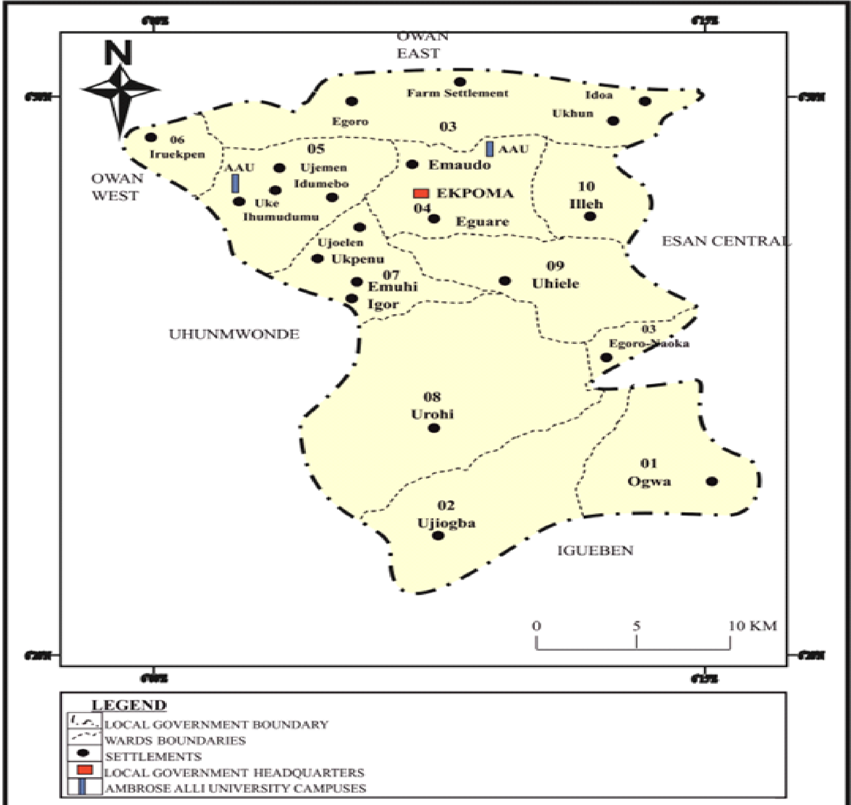

Figure 1: Esan West Local Government Area (the Study area)
Source: www.researchgate.net

Sample Size Determination
The Thursfield (2018) standard technique was used to determine the sample size. A previous data from the study area, Edo-taiwo and Ikpoboyuwa (2021) reported a prevalence 9.71% (approximately 10%) n = Z²P(1 –P)/ d²
Where; n = required sample size, P = expected prevalence, z = desired level of confidence (95%) which standard value is 1.96, d = absolute precision (5%).
n = 1.96² × 0.0971(1- 0.0971)/0.05²
= 3.8416 × 0.0971 × 0.9029/0.0025
= 0.3369/0.0025
n =134.76 (Approximately 135)
Study population
Ekpoma Slaughter Slab accommodates cattle presented for slaughter reared in the study area and those brought alive for sale from the Northern parts of Nigeria, which were transported by road and sometimes allowed to graze from one neighboring town to another. These cattle are the White Fulani breed. About ten cattle are slaughtered daily. A total of 136 adult cattle comprising 120 males and 16 females were examined at ante-mortem and postmortem inspection.
The sexes of the cattle were noted at ante mortem examination, assessed by the presence of mammary gland in the females and testicles in the males which were either castrated or intact.
Collection of faecal samples
The slaughter slab was visited for sample collection every workday (Monday to Friday) in the month of September, 2024. The cattle were slaughtered between 6:00 am and 9:00 am. The faecal samples were taken either during ante mortem examination or from the rectum after slaughter, and placed in a properly labeled specimen bottle using day and number format e.g. D1/01. The samples obtained were placed in a cold box and immediately taken to the Laboratory of the Department of Zoology, Faculty of Life Sciences, Ambrose Alli University, Ekpoma, Edo State, Nigeria, for further analysis.
Parasitological examination of faecal specimen.
Microscopic faecal examination for the detection of eggs in faeces was done by the sedimentation technique as described by Lynda et al, (2025). Using a digital weighing balance, approximately 3 g of faeces was weighed into a labeled container. A total of 40 mL distilled water was measured and poured into the labeled 100 ml measuring cylinder. The faecal sample and water were mixed thoroughly using a spatula, and the suspension was filtered with a double layer of gauze or cheesecloth? into another container. The filtered material was poured into a test tube and allowed to sediment for 5 minutes 5. The supernatant (liquid) was carefully removed with a pipette, and the sediment was re-suspended in 5mL of water. This was allowed to stand for 5 minutes, the supernatant was discarded carefully and the sediment was stained by adding a drop of Methylene blue 5 minutes is short of this process. The dye stained the faecal particles a deep blue or green Methythene blue cannot stain green, leaving the trematode egg unstained. Using a pipette, a drop of the stained sediment was transferred to a microscopic slide and covered with a cover slip. The sample was examined under a microscope at X10 magnification for focus and X40 magnification for clarity of egg morphology. Identification of egg of Fasciola spp.was based on the size and color of the eggs, under methylene blue stain, egg of Fasciola becomes golden colored which differentiate from eggs of Paramphistomum that remains colourless (CDC, 2018).
Statistics
The prevalence was calculated by simple percentages. Give the formula of Prevalence. Explain and give formula for “severity index” The prevalence of infection between sexes of cattle were determined using chi-square (symbol of chi-square) test. No mention of this test and its significance in the “Results” at all. The 95% confidence was used to establish significance (P>0.05).

RESULTS
The result of prevalence of bovine fascioliasis at slaughter slab in Ekpoma is presented in Table 1. By diagnostic method, examination of the liver samples recorded a prevalence of 14.7% (20) while fecal consistency with spelling analysis detected a higher prevalence of 40% (54) No! refer to the formula & Table 1. Note: everything (positive + negative) MUST total to 136 (100%). Follow this and make up for Table 2. The values in the text must change as well. Male cattle had a prevalence of 37% (62), while females had a higher prevalence of 75% (12). Check this statement again.
Table 1: Prevalence of bovine fascioliasis in a slaughter slab at Ekpoma
Sex | No. of cattle examined | Positive by liver examination (%) | Positive by fecal examination (%)
Male | 120 | 18 (15) 18/136 (13.2) | 44 (37) 44/136 (32.7)
Female | 16 | 2 (12.5) 2/136 (1.5) | 10 (62.5) 10/136 (7.4)
Total | 136 | 20 (14.7) 20/136 (14.7) | 54 (40) 54/136 (39.7)

The severity of the infections (Table 2) show a mild infection was recorded for 20 animals (14.7%). Only 2 animals (1.47%) No! calculate and insert the right figures were recorded for both moderate and heavy infections.
Table 2: The severity index of bovine fascioliasis in the liver
Sex | No. of cattle examined | Mild infection (%) < 30 flukes | Moderate infection(%) 31 – 50 flukes | Heavy infection (%) > 50 flukes | Total prevalence (%)
Male | 120 | 14 (12) | 2 (1.7) | 2 (1.7) | 18 (15)
Female | 16 | 2 (12.5) | 0 (0) | 0 (0) | 2 (12.5)
Total | 136 | 20 (14.7) | 2(1.7) | 2 (1.7) | 24 ( 17.65)

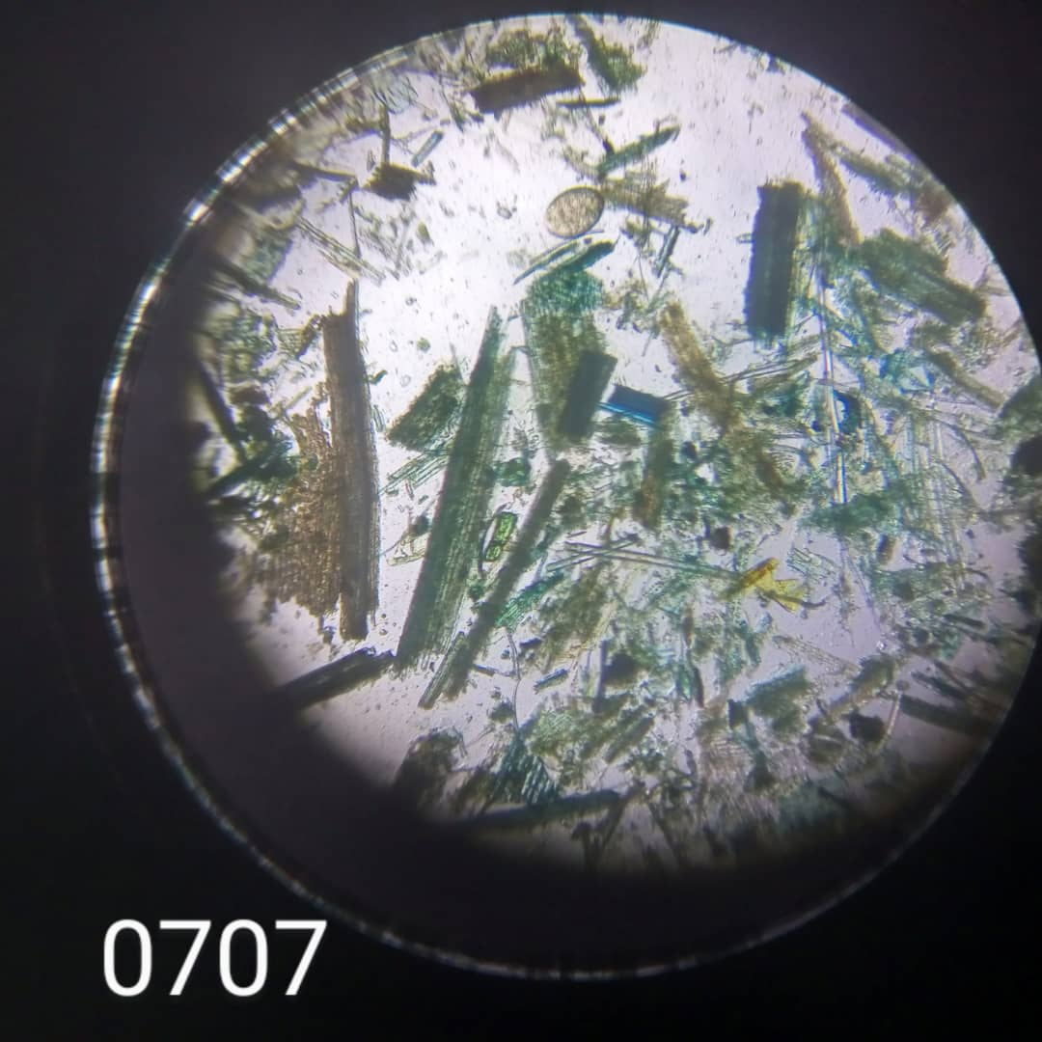
Plate 1: Showing the egg of a Fasciola gigantica (arrow). Filtered through double cheesecloth and this much debris?
DISCUSSION
This study was carried out in September, the peak of rainy season in Ekpoma. It was a period when there were favourable factors for the thriving of Fasciola eggs in the environment, with a consequent increase in transmission of the disease.
In this study, the examination of the liver showed a lower prevalence of 14.7% compared to faecal analysis, 40%. There are trends of higher prevalence of bovine fascioliasis recorded by feacal spelling examination than by postmortem examination of the liver. A few reports by liver examination showed 31% in Egypt (Elshraway and Mahmoud, 2017), 16.5% in Bayolali, Indonesia (Kurnianto et al., 2022), and 9.89% in Edo State, Nigeria (Edo-taiwo and Ehimuan, 2022). The 40% prevalence by feacal spelling examination recorded in this study is lower than the 47.0% reported in Abuja by Ogbaje et al. (2024). Much higher prevalence of 74.10% was reported by Yaro et al. (2022) in Akwa Ibom State, 76.00% found by Oyebamiji et al. (2021) in Ibadan, 84.40% prevalence recorded by Omoleye et al.(2021) in Akure and 72.1% in Gombe State (Yuguda et al., 2024).
The variation in prevalence may be attributed to several factors, including geographical differences, environmental conditions, and diagnostic methods employed in each study and the management practices of livestock. This study points to the arbitrary use of stock drugs by herdsmen without veterinary supervision; such animals could be sold for slaughter after a pool treatment, without consideration for a period of withdrawal of the medicine administered.
It is expected that after successful treatment, the killed adult fluke disintegrate, making it inaccessible in the liver tissues during postmortem inspection. However, research has proven that the eggs of Fasciola may be released from the disintegrating fluke cattle and be detected in feaces spelling for up to three weeks following anthelmintic medication (Bardsley 2020). This may account for the higher prevalence by faecal samples than by liver examination. The study considered the morphological similarity between the eggs of Fasciola and that of Paraphistome under the microscope. The identification of egg of Fasciola spp. was based on the size and color of the eggs. Under methylene blue stain, egg of Fasciola becomes golden colored which differentiate from eggs of Paramphistomum that remains colourless (CDC, 2018). (Figure 1).
The severity of infections recorded in this study was mild, (14.7%) when compare to 1.47% recorded for moderate and heavy infection. This aligns with the findings of Kurnianto et al. (2022), who reported that most cattle in Boyolali, Indonesia, were primarily affected by mild Fasciola species infections, with moderate and heavy infections being less common. The predominance of mild infections in this study can be attributed to routine deworming and other preventive measures reducing severe infections. While such practices may not eliminate infections entirely, they help keep parasite burdens low, leading to a higher prevalence of mild cases.
Furthermore, this study observed no significant difference (p>0.05) where is the value in the Results? in prevalence based on sex. This finding aligns with the results of Iboyi et al. (2017), which showed no significant difference (p>0.05) in the infection rates between male and female cattle slaughtered in Minna.???
However, in this investigation, female cattle had a higher prevalence compared to males, which is consistent with the findings of Ayele et al. (2018) and Swarnakar and Sanger (2014) who reported higher Fasciola infection rates in females and lower in males. The higher prevalence in female observed might be because female animals at different reproductive physiological state such as pregnancy and lactation are immunologically suppressed from increased blood cortisol level which favours the chance of exposure of females to Fasciola infection (Ayele et al., 2018).
This study discloses a disparity in the prevalence of fascioliasis in cattle, with more positive samples obtained by feacal spelling examination than by the gross examination of the liver. It also highlights few cases of heavy infection, suggestive of regular re-infection and anthelmintic medication. He study recommends routine diagnosis and regular deworming schedules to check the prevalence of the disease in cattle. Make a statement about the role of the Lymaeid snail in the transmission of the disease and the public health significance.

REFERENCES
Adedokun, O.A., Ayinmode, A.B. and Fagbemi, B.O. (2008). Seasonal prevalence of Fasciola gigantica infection among the sexes in Nigerian cattle. Vet. Res. 2:12-12.
Ahmad I, Yakubu Y, Chafe UM, Bolajoko BM, Muhammad U (2020). Prevalence of fasciolosis (Liver flukes) infection in cattle in Zamfara, Nigeria: A slaughterhouse surveillance data utilizing postmortem examination. Vet Parasitol Reg Stud Report. doi: 10.1016/j.vprsr.100483. PMID: 33308732.
Antonio A. Vázquez, Pilar Alda, Manon Lounnas, Emeline Sabourin, Annia Alba, Jean-Pierre Pointier and Sylvie Hurtrez-Boussès. (2018). Lymnaeid snails hosts of Fasciola hepatica and Fasciola gigantica (Trematoda: Digenea): a worldwide review. CAB Reviews 13, No. 062
Ayele, Y., Wondmnew, F., and Yeshiwas, T. (2018). The prevalence of bovine and ovine fasciolosis and the associated economic loss due to liver condemnation in and around Debire Birhan, Ethiopia. SOJ Immunology, 6(3): 1-11.
Bardsley, M. (2020). Fascioliasis in cattle. A good understanding of the epidemiology of fasciolosis is a key to controlling the liver fluke. https://www.veterinarypractice.com/article/fasciolosis-in-cattle. Accessed 12/12/2024.
CDC-Centers for Disease Control (2018). "CDC - Fasciola - General Information Frequently Asked Questions (FAQs)". www.cdc.gov. Accessed 12/12/2024. Not cited in the text
Centers for Disease Control (2019). "CDC - Fasciola - General Information Frequently Asked Questions (FAQs)". www.cdc.gov. Accessed 12/12/2024.
Edo-Taiwo, O. and Ehimuan, O. O. (2022). Fascioliasis in cattle slaughtered in government and privately-owned abattoirs in Ikpoba/Okha LGA, Edo State, Nigeria. NigerianJournalofAnimalProduction:49(6):97–106.
Elshraway, N.T., and Mahmoud, W.G. (2017). Prevalence of fascioliasis (liver flukes) infection in cattle and buffaloes slaughtered at the municipal abattoir of ElKharga, Egypt. Veterinary World.10(8): 914-917.
Gulwako, M.S., Mokoele, J.M., Ngoshe, Y.B. and Naidoo V. (2023). Evaluation of the proper use of medication available over the counter by subsistence and emerging farmers in Mbombela Municipality, South Africa. BMC Vet Res 19, 83. https://doi.org/10.1186/s12917-023-03634
Johnson, P. D. (2025). Sustaining America’s Aquatic Biodiversity-Freshwater Snail Biodiversit and Conservation.https://.www.pubs.ext.vt.edu/420/420-530/420-530.html. Retrieved 17/10/2025.
Kurnianto, H., Ramanoon, S.Z., Aziz, N.A.A., and Indarjulianto, S. (2022). Prevalence, risk factors, and infection intensity of fasciolosis in dairy cattle in Boyolali, Indonesia. Veterinary World.15 (6): 1438-1448.
Lynda, M. G., Dennis, E. J., Mark, T. F., and Jørgen, H. (2025). Faecal examination of farm animals for helminth parasites.The RVC/FAO guide to veterinary diagnostics parasitology. Retrieved 11/10/2025.
Mas-Coma, S., Bargues, M.D., and Esteban, J.G. (2012). "Human fasciolosis.". In Dalton, JP (ed.). Fasciolosis. Wallingford, Oxon, UK: CABI Pub. pp. 411–434.
Ogbaje, L.J., Malann, Y.D., Azare, B.A., Njoku, M., and Jegede, O.C. (2024). Prevalence of fascioliasis in slaughtered cattle in six Area Councils in the Federal Capital Territory, Abuja, Nigeria. The Zoologist, 24: 14-17.
Omoleye, O.S., Qasim, A.M., Olugbon, A.S., Adu, O.A., Adam, Y.V., and Joachim, C.O. (2021). Fascioliasis in slaughtered cattle from abattoirs in Ondo State, Nigeria. VomJournalofVeterinarySciences.9: 47-53.
Opio LG, Abdelfattah EM, Terry J, Odongo S, Okello E ( 2021). Prevalence of Fascioliasis and Associated Economic Losses in Cattle Slaughtered at Lira Municipality Abattoir in Northern Uganda. Animals (Basel).11(3):681. doi: 10.3390/ani11030681. PMID: 33806313; PMCID: PMC7999142.
Oyebamiji, D.A., Sodeeq, F.O., Datti, P.E., and Hassan, A.A. (2021). Co-infection Fasciola and Dicrocoelium in the gall bladder of cows butchered in Ibadan abattoir, Oyo State, Nigeria. Nigerian Journal of Parasitol. 42 (1): 68-74.
Rana, M. A. A., Roohi, N. and M. A. K. (2014). Fascioliasis in Cattle- A Review. The Journal of Animal and Plant Sciences. 24(3): 668-675.
Sunday, O., Oluwaseun, E., Osereime, A., Emmanuel, A., and A deola, A. (2024).. Prevalence and associated risk factors of bovine fasciolosis in cattle in Oyo state, Nigeria: Bovine fascioliosis in Oyo State. Tropical Veterinarian. 42 (1): 45-55.
Swarnakar, G., and Sanger, B. (2014). Epidemiological study of liver fluke (Trematoda: Digenea) in domestic ruminants of Udaipur district. International Journal of Current Microbiology and Applied Science, 3(4): 632-640.
Thrusfield, M. (2018). Veterinary Epidemiology, John Wiley & Sons: Hoboken, NJ, USA.
Yaro, C. A., Abdulazeez, T. M., Afia, U. U., Udoudom, I. H., Onoja Abutu, A. E., and Opara, K. N. (2022). Status of Bovine Fascioliasis and Dicrocoeliasis in cattle slaughtered in abattoirs, Akwa Ibom State, Nigeria. Nig. J. Parasitol, 43(2): 335344.
Yuguda, Amina Umar, Mahmud Yerima Iliyasu, Hadiza Mudi (2024): Aisha Muhammad, Sam Mao Panda, and Adamu Babayo Samaila.. “Prevalence and Intensity of Fascioliasis in Cattle Slaughtered at Central Abattoir Gombe, Gombe State, Nigeria”. South Asian Journal of Parasitology 7 (4):321-32.
References not in the Reference List
Iboyi et al. (2017)

