Comparative Analysis of Traditional and Industrial Agroforestry Systems among Farmers in Coimbatore District, Tamil Nadu

ABSTRACT
Agroforestry serves as a sustainable land-use system that integrates trees with crops and livestock to enhance productivity, livelihood, and ecological stability (Nair, 1993; Leakey, 2014). In Tamil Nadu, both traditional and industrial agroforestry systems play a crucial role in improving rural incomes and resource use efficiency. The present study comparatively analyses the structure, functioning, and socio-economic outcomes of traditional and industrial agroforestry among farmers in the Coimbatore district. Results revealed that industrial agroforestry systems dominate the study area, accounting for 56.67% of respondents, with teak, eucalyptus, and casuarina being the preferred species for timber and pulp industries. Traditional systems, including home gardens and agrosilvicultural models, constituted 43.33% and were characterized by diversified income sources and ecological resilience. While industrial systems provided quicker economic returns through contract farming, they also exposed farmers to market risks and environmental challenges (Jambulingam & Fernandes, 1986 and Mbow et al., 2014). Conversely, traditional systems ensured long-term sustainability and food security but faced constraints in market access and financial support (Altieri, 2004; Paudel & Pandey, 2013). Key challenges across both systems included financial limitations, policy barriers, and labour constraints. The study suggests that hybrid models integrating industrial efficiency with traditional sustainability can maximize both income and ecological benefits. Strengthened institutional support, financial credit facilities, and market linkages are vital to promote balanced and resilient agroforestry adoption in Tamil Nadu (Arnold and Dewees, 1997 and Pretty, 2003).

Keywords: Agroforestry, Industrial systems, Traditional systems, Socio-economic analysis, Sustainability

INTRODUCTION
Agroforestry has been widely recognized as a land-use practice that harmonizes economic productivity with environmental sustainability (Nair, 1993, Leakey, 2014). It integrates trees, crops, and livestock in spatial or temporal arrangements that sustain soil fertility, biodiversity, and livelihoods. Traditional agroforestry systems in India, including those in Tamil Nadu, have long supported household needs for food, fodder, and fuelwood (Arnold & Dewees, 1997, Paudel & Pandey, 2013). However, with agricultural commercialization and industrial demand, farmers are increasingly adopting industrial agroforestry models focusing on fast-growing tree species for pulpwood, timber, and biomass industries (Jambulingam & Fernandes, 1986).
The shift from traditional to industrial systems raises questions about ecological resilience, income security, and social well-being. Therefore, a comparative study is necessary to understand the socio-economic and environmental implications of both systems (Altieri, 1995 and Waldron et al., 2017).
Agroforestry represents an integrated approach to land use where trees, crops, and livestock coexist to enhance productivity, biodiversity, and sustainability (Nair, 1993; Leakey, 2014). It bridges the gap between agriculture and forestry, offering both ecological and socio-economic advantages for smallholder farmers (Altieri, 2004). In Tamil Nadu, the practice of agroforestry has evolved through centuries of traditional knowledge and has recently diversified into industrial forms driven by commercial demand.
Industrial agroforestry systems, promoted through contract farming and private sector collaboration, have significantly expanded due to their ability to generate faster returns and provide raw materials for paper, plywood, and timber industries (Jambulingam & Fernandes, 1986 and Murniati et al., 2001).
In contrast, traditional agroforestry systems, such as homegardens and agrosilvicultural models, remain integral to rural livelihood security and ecological balance (Paudel & Pandey, 2013). These systems ensure food, fodder, and fuel availability while maintaining soil fertility and landscape resilience (Pretty, 2003).
Despite their benefits, the adoption and sustainability of both traditional and industrial agroforestry systems face multiple challenges. Farmers encounter financial barriers, market uncertainties, and institutional constraints that influence their participation and long-term benefits (Arnold & Dewees, 1997 and Agarwal, 2001).
Moreover, industrial monocultures although profitable pose risks to biodiversity and ecosystem health if not properly managed (Mbow et al., 2014). The growing pressure of land-use change and climate variability further intensifies these issues, necessitating balanced and adaptive agroforestry models (Waldron et al., 2017).
Understanding the comparative dynamics of these two systems is therefore crucial for designing effective interventions and sustainable livelihood strategies.
This study seeks to examine the structural, functional, and socio-economic characteristics of traditional and industrial agroforestry systems in Tamil Nadu, identifying key constraints faced by farmers and offering practical recommendations for improvement.
By integrating scientific insights with farmers’ experiences, this research aims to support policies that promote equitable growth, environmental sustainability, and enhanced rural resilience through agroforestry
METHODOLOGY
Selection of the District and Block
Coimbatore district was selected purposively because the area under industrial and traditional agroforestry practices is higher among farmers. Two blocks Karamadai and Annur blocks were selected based on the number of farmers. A total of 30 respondents were randomly selected based on their adoption of traditional agroforestry and industrial agroforestry systems
FINDINGS AND DISCUSSION
Structure and Functioning of Agroforestry Systems in Coimbatore
Industrial Agroforestry Systems
Industrial agroforestry systems dominate the study area, representing 56.67% of total respondents. Among them, commercial timber plantations (26.67%) particularly of Teak (Tectona grandis), Eucalyptus spp., and Casuarina equisetifolia widely practiced due to high market returns (Jambulingam & Fernandes, 1986). The contract farming (16.67%) with paper and plywood industries has increased as companies seek reliable raw material supply. Farmers receive technical guidance and assured buyback arrangements, offering a sense of financial security (Murniati et al., 2001). Additionally, integrated agroforestry with high-value crops (13.33%) combines timber trees with crops such as banana and guava, enhancing profitability and resource utilization (Molnar et al., 2013).
The preference for industrial systems is mainly driven by short rotation cycles, quick financial returns, and established market linkages (Waldron et al., 2017). However, monoculture practices can threaten biodiversity and soil fertility if ecological considerations are neglected (Mbow et al., 2014).

It is inferred thar distribution of agroforestry system types among farmers in Tamil Nadu. It visually shows that industrial agroforestry dominates particularly commercial timber plantations and contract farming, while traditional systems still hold a significant share for livelihood and ecological
Traditional Agroforestry Systems
Traditional agroforestry systems account for 43.33% of the respondents and remain vital for smallholder livelihoods. The most common forms include homegardens (20%), agrosilvicultural systems (13.33%), and traditional plantations (10%).
Homegardens, typical of rural Tamil Nadu, represent integrated systems producing fruits, vegetables, and fodder within small landholdings, thus ensuring household nutrition and resilience (Paudel & Pandey, 2013). These systems rely heavily on indigenous knowledge and community management, reflecting social capital in resource use (Pretty, 2003; Agarwal, 2001).
While economic returns from traditional systems are gradual, they offer significant ecological benefits such as soil conservation, microclimate regulation, and carbon sequestration (Leakey, 2014; Jhariya et al., 2015, Goswami, et al (2023). This findings conformity with Kumar and Nair (2022).
Table 1. Socio-Economic Analysis of Traditional and Industrial Agroforestry
N 30
Aspect | Traditional Agroforestry | Industrial Agroforestry
Income Source | 43%  farmers rely on diversified income sources, ensuring long-term benefits but slower returns | 56%  (Farmers obtain faster returns but face market price fluctuations).
Market & Value Chain | 25%  depend on local markets; limited access to large buyers | 20%  benefit from contract farming; however, they face price volatility and contractual risks.
Social & Livelihood Aspects | 17%  emphasize food security, social sustainability, and community participation | 10%  contribute to rural economic growth but face land-use changes and biodiversity loss.
Employment & Labour Dynamics | 15%  depend on family labour and community support, reducing external costs. | 14%  depend on seasonal labour; mechanization reduces long-term employment.
Fig.2
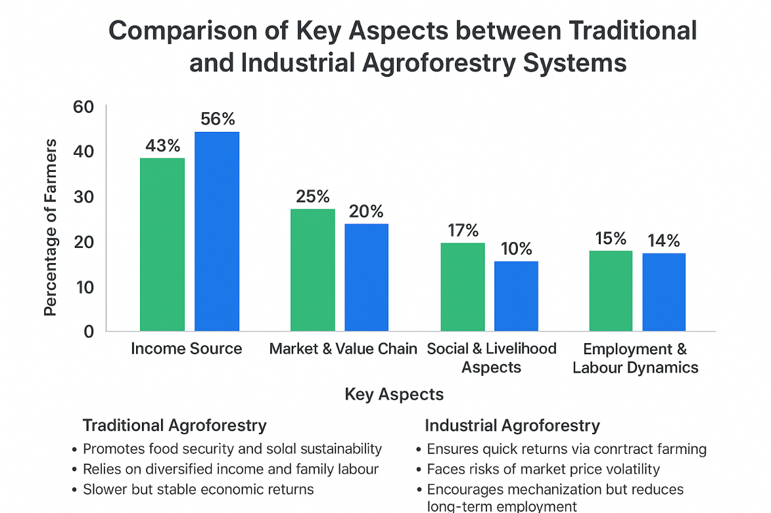
This analysis supports earlier findings that traditional systems maintain social equity and ecological resilience (Altieri, 2004; Meinzen-Dick & Quisumbing, 2013), while industrial systems enhance commercial potential and short-term incomes (Arnold & Dewees, 1997; Waldron et al., 2017). The findings conformity with Chavan, et al. (2021).

Table 2. Major Constraints Faced by Farmers in Agroforestry Systems
N 30
Constraint | Traditional Agroforestry (%) | Industrial Agroforestry (%)
Financial Constraints | 25.3 | 24.1
Institutional & Policy Barriers | 22.8 | 21.9
Market & Price Risks | 18.6 | 23.7
Environmental & Sustainability Issues | 15.8 | 19.5
Labour Challenges | 17.5 | 10.7
Financial Constraints | 25.3 | 24.1

Financial Constraints
From the table inferred that 24.70% of the farmers expressed that limited access to institutional credit and high establishment costs hinder both traditional and industrial agroforestry (Murniati et al., 2001).
Institutional and Policy Barriers
22.35% of the farmers revealed that lack of clear agroforestry policies and weak coordination between forestry and agricultural institutions create uncertainty (Agarwal, 2001).
Market and Price Risks
One third of the farmers (21.17%) stated that industrial farmers face contractual disputes and market fluctuations, consistent with observations by Arnold & Dewees (1997).
Environmental Issues
Below one third of the (17.64%) farmers faced the constraints such as Industrial monocultures degrade soil and reduce biodiversity (Mbow et al., 2014; Leakey, 2014).
Labour Challenges
14.12% of the farmers expressed the traditional systems depend heavily on family labour, while industrial systems experience peak-season shortages (Jhariya et al., 2015).
Strategies to Overcome Constraints
- Financial Support and Credit Accessibility
- Labour Management and Skill Development
- Market Linkages and Price Stabilization
- Sustainable Environmental Practices
- Policy and Institutional Support
CONCLUSION
Both traditional and industrial agroforestry systems contribute uniquely to rural livelihoods in Coimbatore district. Traditional systems offer ecological resilience, food security, and social cohesion, while industrial systems provide higher income and stronger market integration. However, industrial models carry risks of monoculture and environmental degradation. Adopting a hybrid model that combines the ecological sustainability of traditional systems with the economic potential of industrial systems is ideal for Tamil Nadu’s context. Strengthened institutional support, targeted financing, capacity-building, and value-chain linkages will be crucial to achieving a balanced and sustainable agroforestry transition (Leakey, 2014; Waldron et al., 2017; Mbow et al., 2014).

References
- Agarwal, B. (2001). Participatory exclusion, community forestry, and gender: An analysis for South Asia and a conceptual framework. World Development, 29(10), 1623–1648.
- Altieri, M. A. (1995). Agroecology: The Science of Sustainable Agriculture. CRC Press, Boca Raton.
- Altieri, M. A. (2004). Agroecology: The Science of Sustainable Agriculture (2nd ed.). CRC Press, Boca Raton.
- Arnold, J. E. M., & Dewees, P. A. (1997). Farms, Trees, and Farmers: Responses to Agricultural Intensification. Earthscan Publications, London.
- Chavan, S. B., Keerthika, A., Dhyani, S. K., Handa, A. K., & Newaj, R. (2021). Agroforestry for doubling farmers’ income: A review of pathways and strategies in Indian context. Agroforestry Systems, 95(5), 873–888.
- Goswami, S., Chaturvedi, O. P., & Handa, A. K. (2023). Socio-economic and ecological assessment of agroforestry practices in southern India. Environment, Development and Sustainability, 25(7), 6781–6798.
- Jambulingam, R., & Fernandes, E. C. M. (1986). Tree-crop interactions and soil fertility: The case of eucalyptus in India. Agroforestry Systems, 4(4), 29–38.
- Jhariya, M. K., Bargali, S. S., & Raj, A. (2015). Possibilities and Perspectives of Agroforestry in Chhattisgarh. In Agroforestry for Biodiversity and Ecosystem Services (eds. K. Jose & P. G. R. Chariar), pp. 237–257.
- Kumar, B. M., & Nair, P. K. R. (2022). The role of agroforestry in achieving the Sustainable Development Goals (SDGs) in India. Current Science, 122(4), 445–454.
- Leakey, R. R. B. (2014). Agroforestry: The future of global land use. In Agroforestry: The Future of Global Land Use (eds. P. K. R. Nair & D. Garrity), Springer, Dordrecht, pp. 1–11.
- Mbow, C., Smith, P., Skole, D., Duguma, L., & Bustamante, M. (2014). Achieving mitigation and adaptation to climate change through sustainable agroforestry practices in Africa. Current Opinion in Environmental Sustainability, 6, 8–14.
- Meinzen-Dick, R. S., & Quisumbing, A. R. (2013). Closing the knowledge gap: How agriculture can contribute to gender equality. IFPRI Discussion Paper.
- Molnar, T., Kahn, P., Ford, T., & Funk, C. (2013). Tree crops, a permanent agriculture: Concepts from the past for a sustainable future. Resources, 2(4), 457–488.
- Murniati, Garrity, D. P., & Gintings, A. N. (2001). The contribution of agroforestry systems to reducing farmers' dependence on the resources of adjacent national parks: A case study from Sumatra, Indonesia. Agroforestry Systems, 52(3), 171–184.
- Nair, P. K. R. (1993). An Introduction to Agroforestry. Kluwer Academic Publishers, Dordrecht.
- Paudel, N. S., & Pandey, S. S. (2013). Traditional agroforestry practices in the central mid-hills of Nepal: A case study from Gulmi District. Agroforestry Systems, 87(3), 539–554.
- Pretty, J. (2003). Social capital and the collective management of resources. Science, 302(5652), 1912–1914.
- Waldron, A., Justicia, R., Smith, L. E., & Sanchez, M. V. (2017). Agroforestry can enhance food security while meeting other sustainable development goals. International Journal of Agricultural Sustainability, 15(3), 99–106.

