Original Research Article

Studies on effect of terminal heat stress on seed yield and its mitigation in chickpea (Cicer arietinum L.)

Abstract
A field experiment was conducted during 2021–22 at the National Seed Project, Seed Unit, University of Agricultural Sciences, Raichur, to investigate the impact of terminal heat stress on seed yield in chickpea and to explore suitable mitigation strategies. High temperatures during early, late, and very late sowing periods directly influenced the vegetative and anthesis stages, thereby reducing crop productivity. To counteract these effects, foliar spraying of heat stress mitigating chemicals was employed. The experiment was laid out in a split plot design with three sowing dates and ten foliar spray treatments, each replicated twice. Spraying was carried out at two critical growth stages—vegetative (35–40 DAS) and anthesis (50–60 DAS). Observations were recorded on growth and yield parameters. The interaction between sowing dates and foliar sprays significantly influenced these parameters. Plant height was 39.65 cm and 43.7 cm, number of primary branches 5.40 and 5.40 and secondary branches 13.2 and 15.97 at 60 DAS and maturity, respectively. The crop recorded 53.0 days to 50% flowering, 99.0 days to maturity, a plant population of 241.50, 127.20 pods per plant, 100-seed weight of 23.50 g, seed yield per plant of 8.38 g, seed yield per hectare of 1746.00 kg and a harvest index of 123.20. Among treatments, plants sprayed with salicylic acid @ 400 ppm at early sowing recorded the highest growth and yield, proving most effective in mitigating terminal heat stress in chickpea.
Key words: chickpea, dates of sowing, heat stress, foliar spray

INTRODUCTION
Chickpea (Cicer arietinum L.) is an annual legume and is the third most consumed legume crop, which is widely cultivated as a winter crop for its typically yellow-brown, pea like seeds in arid and semi-arid areas around the world. Chickpea (Cicer arietinum L.) belongs to genus Cicer, tribe cicerace, family sp. Fabaceae and subfamily Faboideae. Chickpea popularly known as gram, bengal gram, homes, chhola, garbanzo bean is one of the first seed legumes to be domesticated by humans in old world.
Heat stress in chickpea arises from increased temperatures beyond optimal ranges during growth, exacerbated by late planting due to intensive cropping in India. This delay shifts the maturity period into hotter summer temperatures, impacting flowering and podding stages crucial for yield. High temperatures (35°C) during these stages drastically reduce seed yield due to adverse effects on pollen viability, fertilization, and plant metabolism. Foliar spray, delivering nutrients directly to the crop canopy, mitigates soil fertilization limitations and enhances crop growth, making it a modern management strategy. Addressing water deficit and nutrient uptake challenges during rabi season in chickpea cultivation is essential for overcoming heat stress and achieving optimal yields.
MATERIAL AND METHODS
A field experiment was conducted at the seed production block, Seed Unit, Monitoring Agricultural Resources, University of Agricultural Sciences, Raichur, Karnataka. The crop was sown at three different times to achieve normal (October 1st fortnight), late (November 1st fortnight ) and very late sowing (December 1st fortnight) conditions (Plate 1) in split-plot design with ten foliar spray treatments viz., control, salicylic acid (800 ppm and 400 ppm), ascorbic acid (10 ppm), KCl (1%), thiourea (400 ppm), cycocel (1000 ppm), KNO3 (0.3%), chickpea magic (8g/1), gibberellic acid (100ppm) each treatments was replicated twice in a split plot design during rabi season 2020-22. Spraying was done at two stages of crop growth i.e., at vegetative (35-40 DAS) and anthesis stage (50-60 DAS) in all dates of sowing.
Plant height (cm), number of primary branches, and number of secondary branches were measured at 60 DAS and maturity from five randomly tagged plants per treatment. Days to 50% flowering and days to maturity (75-80% pods mature) were recorded. Plant population per hectare was derived from total plants counted in net plots. Number of pods per plant, 100 seed weight (g), and seed yield per plant (kg) were determined from harvested samples. Seed yield per hectare (kg/ha) was computed using plot seed yields. Harvest index (%) was calculated following Donald (1962).
RESULTS AND DISCUSSION
Growth parameters
In the study, the interaction between sowing date and heat stress mitigating chemicals showed non-significant effects on plant height. Plants sown in the normal sowing period (October 1st fortnight) and sprayed with salicylic acid @ 400 ppm (D₁T₃) exhibited the tallest plants (44.90 cm at 60 DAS and 47.90 cm at harvest), followed by normal sowing with gibberellic acid @ 100 ppm (D₁T₁₀) (43.70 cm at 60 DAS and 46.25 cm at harvest). Very late sowing without any spray had the shortest plants (26.80 cm at 60 DAS and 27.85 cm at harvest). Salicylic acid likely promoted stem elongation through cell division and expansion. Number of primary branches (Table 1) also showed non-significant variation across treatments. Normal sowing with salicylic acid (D₁T₃) resulted in the highest number of primary branches (5.80 at 60 DAS and 5.90 at harvest), followed by normal sowing with gibberellic acid (D₁T₁₀) (5.30 at 60 DAS and 5.40 at harvest). Very late sowing without spray recorded the lowest number of primary branches (3.50 at 60 DAS and 3.50 at harvest) (Table 1). Salicylic acid may have stimulated auxin production, leading to increased primary branching in chickpea (Yadav et al., 1998). Similarly, the number of secondary branches did not significantly differ among treatments. Normal sowing with salicylic acid (D₁T₃) resulted in the highest number of secondary branches (16.90 at 60 DAS and 17.10 at harvest), followed by normal sowing with gibberellic acid (D₁T₁₀) (15.70 at 60 DAS and 15.80 at harvest). Very late sowing without spray had the fewest secondary branches (8.30 at 60 DAS and 8.40 at harvest). Salicylic acid likely played a role in auxin-mediated secondary branch development in chickpea (Yadav et al., 1998). Days to 50% flowering showed no significant differences. Normal sowing with gibberellic acid (D₁T₁₀) resulted in the earliest flowering (46.50 days), followed closely by normal sowing with salicylic acid (D₁T₃) (47.50 days) (Table 2). Very late sowing without spray delayed flowering the most (56.50 days). Gibberellic acid promoted early floral bud initiation, reducing flowering time under heat stress (Bokode et al., 2006). Days to maturity also did not differ significantly among treatments. Normal sowing with gibberellic acid (D₁T₁₀) led to the shortest maturity period (96.50 days), followed by normal sowing with salicylic acid (D₁T₃) (97.50 days). Very late sowing without spray required the longest time to maturity (102.50 days).

Yield parameters
In the study, the interaction between sowing date and heat stress mitigating chemicals showed non-significant differences in plant population (Fig 1). Normal sowing with salicylic acid @ 400 ppm (D₁T₃) resulted in the highest plant population (286.50), followed by normal sowing with gibberellic acid @ 100 ppm (D₁T₁₀) (278.50). Very late sowing without spray had the lowest plant population (204.00). Salicylic acid improved plant population by 15.5% even under very late sowing, attributed to antioxidant enzyme activity (Joseph et al., 2010). For number of pods per plant (Table 3) (Fig 2) (Plate 2), normal sowing with salicylic acid (D₁T₃) had the most pods (158.60), followed by normal sowing with gibberellic acid (D₁T₁₀) (134.90). Very late sowing without spray had the fewest pods (80.30). Salicylic acid increased pods by 36.8% under very late sowing, enhancing auxin production and reducing flower drop (Khan et al., 2010). Regarding 100 seed weight (Table 3) (Plate 3), normal sowing with salicylic acid (D₁T₃) had the highest weight (26.70 g), followed by normal sowing with gibberellic acid (D₁T₁₀) (26.30 g). Very late sowing without spray had the lowest weight (18.20 g). Salicylic acid enhanced 100 seed weight due to increased auxin and cytokinin production (Sadeghipour and Aghaei, 2012). Seed yield per plant (Table 3) was highest with normal sowing and salicylic acid (D₁T₃) (8.71 g), followed by normal sowing and gibberellic acid (D₁T₁₀) (8.58 g). Very late sowing without spray had the lowest yield (5.78 g). Salicylic acid increased yield components under late sowing by enhancing stress enzyme activity (Avinash et al., 2020). Seed yield per hectare (Table 3) followed a similar trend, with normal sowing and salicylic acid (D₁T₃) producing the highest yield (2179.70 kg/ha), followed by normal sowing and gibberellic acid (D₁T₁₀) (2171.20 kg/ha). Very late sowing without spray had the lowest yield (1463.60 kg/ha).
CONCLUSION
It can be concluded that, heat stress adversely affects the growth and seed yield of chickpea. Among the treatments, sowing done at October 15th and plants sprayed with salicylic acid @ 400 ppm twice at vegetative and anthesis stage was found to be better in obtaining significantly higher growth and seed yield parameters in chickpea variety JG-11 under heat stress conditions.
REFERENCES
Ali, E. A., & Mahmoud, A. M. (2013). Effect of foliar spray by different salicylic acid and zinc concentrations on seed yield and yield components of mung bean in sandy soil. Asian Journal of Crop Science, 5(1), 33–40.
Anonymous. (2021). FAO STAT, Online Agriculture Statistics. Retrieved from http://www.faostat.org
Avinash, J. R., Patil, R. P., & Rathod, S. P. (2020). Influence of foliar application of pulse magic, PGRs and nutrients on growth parameters and yield of pigeonpea. Journal of Pharmacognosy and Phytochemistry, 9(5), 3304–3307.
Bokade, N., Bhalekar, M. N., Gupta, N. S., & Deshpande, A. (2006). Effect of growth regulators on growth and yield of tomato in summer. Journal of Maharashtra Agricultural University, 31(1), 64–65.
Devi, K. N., Vyas, A. K., Singh, M. S., & Singh, N. G. (2011). Effect of bioregulators on growth, yield and chemical constituents of soybean (Glycine max). Journal of Agricultural Science, 3(4), 151–159.
Donald, C. M. (1962). In search of yield. Journal of the Australian Institute of Agricultural Science, 28, 171–178.
Joseph, B., Jini, D., & Sujatha, S. (2010). Insight into the role of exogenous salicylic acid on plants grown under salt environment. Asian Journal of Crop Science, 2(4), 226–235.
Karim, F. M., Mohammed, Q. M., & Khursheed, S. (2011). Effect of foliar application of salicylic acid on growth, yield components and chemical constituents of wheat. Jordan Journal of Agricultural Sciences, 173(3640), 1–16.
Kaur, S., Gupta, A. K., & Kaur, N. (1998). Gibberellin A3 reverses the effect of salt stress in chickpea (Cicer arietinum L.) seedlings by enhancing amylase activity and mobilization of starch in cotyledons. Plant Growth Regulation, 26(2), 85–90.
Khademian, R., & Yaghoubian, I. (2018). Growth of chickpea (Cicer arietinum) in response to salicylic acid under drought stress. Journal of Biological and Environmental Sciences, 12(3), 255–263.
Khan, N., Syeed, S., Masood, A., Nazar, R., & Iqbal, N. (2010). Application of salicylic acid increases contents of nutrients and antioxidative metabolism in mung bean and alleviates adverse effects of salinity stress. International Journal of Plant Biology, 1, 1–8.
Konsens, I., Ofir, M., & Kigel, J. (1991). The effect of temperature on the production and abscission of flowers and pods in snap bean (Phaseolus vulgaris L.). Annals of Botany, 67(5), 391–399.
Kumar, J., & Abbo, S. (2001). Genetics of flowering time in chickpea and its bearing on productivity in semiarid environments. Advances in Agronomy, 72, 107–138.
Leslie, C. A., & Romani, R. J. (1986). Salicylic acid: A new inhibitor of ethylene biosynthesis. Plant Cell Reports, 5(2), 144–146.
Negewo, A. S. (2016). Effect of hydro and osmo priming on yield and yield components of chickpea (Cicer arietinum L.). African Journal of Agricultural Research, 11(32), 3027–3036.
Rajabi, L., Sajedi, N. A., & Roshandel, M. (2013). Response of yield and yield components of dryland chickpea to salicylic acid and super absorbent polymer. Journal of Crop Production Research, 4(4), 343–353.
Rathore, P. S., & Sharma, S. K. (2003). Scientific Pulse Production (Vol. 3, No. 5, p. 92). Yash Publishing House, Bikaner, Rajasthan.
Sadeghipour, O., & Aghaei, P. (2012). Comparison of autumn and spring sowing on performance of chickpea (Cicer arietinum L.) varieties. International Journal of Biosciences, 2(6), 49–58.
Safai. (2013). Determining the most suitable irrigation cycle and the best amount of foliar of salicylic acid on the quantitative and qualitative performance of mung bean. M.Sc. (Agri.) Thesis, Islamic Azad University of Zahedan, 2(5), 68.
Sharma, K. D., Pannu, R. K., Tyagi, P. K., Choudhary, B. D., & Singh, D. P. (2007). Water use efficiency and yield of chickpea genotypes as influenced by soil moisture availability. Indian Journal of Plant Physiology, 12, 168–172.
Sujatha, K. B. (2001). Effect of foliar spray of chemical and bioregulators on growth and yield of greengram (Vigna radiata L.). M.Sc. (Agri.) Thesis, Tamil Nadu Agricultural University, Coimbatore, India.
Summerfield, R. J., Hadley, P., Roberts, E. H., Minchin, F. R., & Rawsthorne, S. (1984). Sensitivity of chickpeas (Cicer arietinum) to hot temperatures during the reproductive period. Experimental Agriculture, 20(1), 77–93.
Vasanthi, B. G., Srinivasappa, K. N., Manjunath, B., Padmavathi, M., & Savita, S. M. (2017). Evaluation of Bengal gram varieties in medium black soils of Devanahalli taluk, Bangalore rural district. Trends in Biosciences, 10, 5848–5850.
Xiang, X., & Fu, J. R. (1995). The ways to increase vigour of wampee (Clausena lansium) seeds. Journal of Tropical and Subtropical Botany, 5(4), 39–44.
Yadav, V. S., Yadav, S. S., & Panwar, J. D. S. (1998). Effect of planting time on physiological attributes and grain yield in desi and kabuli chickpea genotypes. Indian Journal of Plant Physiology, 3, 292–295.

Table 1. Effect of dates of sowing and heat stress mitigating chemicals on plant height, number of primary branches and number of secondary branches in chickpea
Treatments | Plant height (cm) |  |  |  |  |  |  |  | Primary branches |  |  |  |  |  |  |  | Secondary branches
Treatments | At 60 DAS |  |  |  | At maturity |  |  |  | At 60 DAS |  |  |  | At maturity |  |  |  | At 60 DAS |  |  |  | At maturity
Treatments | D₁ | D₂ | D₃ | Mean | D₁ | D₂ | D₃ | Mean | D₁ | D₂ | D₃ | Mean | D₁ | D₂ | D₃ | Mean | D₁ | D₂ | D₃ | Mean | D₁ | D₂ | D₃ | Mean
T₁ | 32.25 | 29.25 | 26.8 | 29.43 | 35.65 | 32.95 | 27.85 | 32.15 | 3.9 | 3.7 | 3.5 | 3.7 | 3.9 | 3.7 | 3.5 | 3.7 | 9.5 | 9.3 | 8.3 | 9 | 9.8 | 9.5 | 8.4 | 9.2
T₂ | 39.8 | 37.05 | 33.65 | 36.83 | 43.65 | 41.35 | 37.7 | 40.9 | 4.9 | 4.9 | 4.5 | 4.77 | 4.9 | 4.9 | 4.5 | 4.77 | 14.9 | 13.7 | 11.9 | 13.5 | 15.1 | 14.9 | 12.1 | 14.3
T₃ | 44.9 | 43.4 | 39.65 | 42.65 | 47.9 | 46.7 | 43.7 | 46.1 | 5.9 | 5.7 | 5.4 | 5.67 | 5.9 | 5.7 | 5.4 | 5.67 | 16.9 | 15.1 | 13.2 | 15.07 | 17.1 | 16.5 | 14.3 | 15.97
T₄ | 37.9 | 35.9 | 32.5 | 35.43 | 40.2 | 38.7 | 34.2 | 37.7 | 4.3 | 4.2 | 3.9 | 4.13 | 4.3 | 4.2 | 3.9 | 4.13 | 13.6 | 12.5 | 10.2 | 12.1 | 13.6 | 12.9 | 10.9 | 12.47
T₅ | 34.95 | 31.85 | 29.55 | 32.12 | 37.25 | 35.6 | 32.15 | 35 | 4.1 | 3.9 | 3.3 | 3.77 | 4.1 | 3.9 | 3.3 | 3.77 | 11.9 | 10.2 | 9.2 | 10.43 | 11.9 | 10.2 | 9.2 | 10.43
T₆ | 36.15 | 34.55 | 32.05 | 34.25 | 42.95 | 39.5 | 37.75 | 40.07 | 4.2 | 4.1 | 3.9 | 4.07 | 4.2 | 4.1 | 3.9 | 4.07 | 13.3 | 12.1 | 10.3 | 11.9 | 13.3 | 12.1 | 10.5 | 11.97
T₇ | 36.1 | 34.15 | 32.55 | 34.27 | 42.35 | 38.95 | 35.25 | 38.85 | 4.2 | 4.1 | 3.9 | 4.07 | 4.2 | 4.1 | 3.9 | 4.07 | 12.5 | 11.3 | 10.1 | 11.3 | 13.1 | 12.9 | 11.5 | 12.5
T₈ | 38.05 | 35.3 | 33.5 | 35.62 | 42.5 | 39 | 36 | 39.17 | 4.5 | 4.4 | 4.1 | 4.33 | 4.5 | 4.4 | 4.1 | 4.33 | 13.9 | 12.6 | 11.2 | 12.57 | 14.1 | 12.9 | 11.9 | 12.97
T₉ | 39.4 | 35.85 | 33.25 | 36.17 | 43.15 | 41.15 | 37.8 | 40.7 | 5.1 | 4.9 | 4.6 | 4.87 | 5.1 | 4.9 | 4.6 | 4.87 | 15.2 | 14.2 | 13.1 | 14.17 | 15.9 | 14.9 | 13.2 | 14.67
T₁₀ | 43.7 | 38.95 | 36.85 | 39.83 | 46.25 | 43.2 | 40.05 | 43.17 | 5.3 | 5.2 | 5.1 | 5.2 | 5.4 | 5.2 | 5.1 | 5.23 | 15.7 | 14.6 | 13.1 | 14.47 | 15.8 | 14.9 | 13.3 | 14.67
Mean | 38.32 | 35.63 | 33.04 |  | 42.15 | 39.71 | 36.25 |  | 4.64 | 4.51 | 4.22 |  | 4.65 | 4.51 | 4.22 |  | 13.74 | 12.56 | 11.11 |  | 13.97 | 13.17 | 11.52
 | D | T | D x T |  | D | T | D x T |  | D | T | D x T |  | D | T | D x T |  | D | T | D x T |  | D | T | D x T
SEm± | 0.004 | 0.545 | 0.945 |  | 0.004 | 0.512 | 1.06 |  | 0.004 | 0.067 | 0.117 |  | 0.003 | 0.067 | 0.117 |  | 0.006 | 0.19 | 0.329 |  | 0.005 | 0.195 | 0.339
CD @ 5% | 0.017 | 1.583 | NS |  | 0.015 | 1.777 | NS |  | 0.015 | 0.197 | NS |  | 0.011 | 0.197 | NS |  | 0.027 | 0.552 | NS |  | 0.02 | 0.568 | NS
NS: Non-significant
Sowing window
D₁ = Normal date of sowing
D₂ = Late date of sowing
D₃ = Very late date of sowing
Mitigation treatments
T₁: Control
T₂: Salicylic acid (800 ppm)
T₃: Salicylic acid (400 ppm)
T₄: Ascorbic acid (10 ppm)
T₆: Thiourea (400 ppm)
T₇: Cycocel (1000 ppm)
T₈: KNO₃ (0.3%)
T₉: Chickpea magic (8g/l)
T₁₀: GA₃ (100ppm)

Table 2. Effect of dates of sowing and heat stress mitigating chemicals on days to 50 % flowering and days to maturity in chickpea
Treatments | Days to 50% flowering |  |  |  | Days to maturity
Treatments | D₁ | D₂ | D₃ | Mean | D₁ | D₂ | D₃ | Mean
T₁ | 52.00 | 54.50 | 56.50 | 54.33 | 98.50 | 100.00 | 102.50 | 100.33
T₂ | 49.50 | 50.50 | 54.50 | 51.50 | 98.50 | 99.50 | 102.00 | 100.00
T₃ | 47.50 | 49.50 | 53.00 | 50.00 | 97.50 | 98.50 | 101.00 | 99.00
T₄ | 50.50 | 51.50 | 53.00 | 51.67 | 98.50 | 98.50 | 102.00 | 99.67
T₅ | 51.50 | 54.50 | 56.50 | 54.17 | 99.00 | 99.50 | 102.00 | 100.17
T₆ | 51.50 | 54.50 | 56.50 | 54.17 | 97.50 | 98.50 | 101.50 | 99.17
T₇ | 50.50 | 54.00 | 56.00 | 53.50 | 98.50 | 99.50 | 102.50 | 100.17
T₈ | 51.00 | 53.00 | 55.50 | 53.17 | 97.50 | 98.50 | 101.50 | 99.17
T₉ | 49.50 | 51.50 | 55.00 | 52.00 | 98.50 | 98.50 | 101.50 | 99.50
T₁₀ | 46.50 | 48.50 | 52.00 | 49.00 | 96.50 | 98.50 | 99.50 | 98.17
Mean | 50.00 | 52.20 | 54.85 |  | 98.05 | 98.95 | 101.60
 | D | T | D x T |  | D | T | D x T
SEm± | 0.150 | 0.330 | 0.580 |  | 0.132 | 0.307 | 0.532
CD @ 5% | 0.510 | 0.970 | NS |  | 0.405 | 0.891 | NS
NS: Non-significant
Sowing window
D₁ = Normal date of sowing
D₂ = Late date of sowing
D₃ = Very late date of sowing
Mitigation treatments
T₁: Control
T₂: Salicylic acid (800 ppm)
T₃: Salicylic acid (400 ppm)
T₄: Ascorbic acid (10 ppm)
T₆: Thiourea (400 ppm)
T₇: Cycocel (1000 ppm)
T₈: KNO₃ (0.3%)
T₉: Chickpea magic (8g/l)
T₁₀: GA₃ (100ppm)

Table 3. Effect of dates of sowing and heat stress mitigating chemicals on yield parameters in chickpea
Treatments | 100 seed weight (g) |  |  |  | Seed yield per plant (g) |  |  |  | Seed yield per ha (kg) |  |  |  | Harvest index
Treatments | D₁ | D₂ | D₃ | Mean | D₁ | D₂ | D₃ | Mean | D₁ | D₂ | D₃ | Mean | D₁ | D₂ | D₃ | Mean
T₁ | 23.5 | 22.1 | 18.2 | 21.27 | 6.13 | 5.9 | 5.78 | 5.94 | 1956 | 1923 | 1463 | 1781 | 79.14 | 76.67 | 76.13 | 77.31
T₂ | 24.6 | 24.9 | 22.6 | 24.03 | 8.34 | 8.14 | 7.78 | 8.09 | 2086 | 2059 | 1579 | 1908 | 118.6 | 116.65 | 113.9 | 116.38
T₃ | 26.7 | 25.1 | 23.5 | 25.1 | 8.71 | 8.52 | 7.92 | 8.38 | 2179 | 2167 | 1746 | 2031 | 128.9 | 127.01 | 123.2 | 126.37
T₄ | 26.1 | 24.3 | 22.3 | 24.23 | 8.32 | 8.06 | 7.44 | 7.94 | 2057 | 2052 | 1563 | 1891 | 110.6 | 107.21 | 103.31 | 107.04
T₅ | 24.2 | 23.1 | 19.9 | 22.4 | 7.11 | 6.84 | 6.14 | 6.7 | 1986 | 1983 | 1501 | 1824 | 90.12 | 88 | 83.21 | 87.11
T₆ | 25.1 | 24.2 | 20.3 | 23.2 | 7.26 | 7.8 | 7.36 | 7.47 | 2031 | 2030 | 1556 | 1872 | 109.4 | 105.77 | 99.23 | 104.8
T₇ | 25.3 | 24.8 | 21.4 | 23.83 | 8.22 | 7.22 | 6.32 | 7.25 | 2026 | 2021 | 1549 | 1865 | 90.9 | 86.7 | 84.5 | 87.37
T₈ | 25.6 | 24.9 | 22.5 | 24.33 | 7.38 | 7.32 | 6.72 | 7.14 | 2067 | 2050 | 1573 | 1897 | 116.8 | 112.8 | 106.3 | 111.97
T₉ | 26.7 | 25.1 | 23.6 | 25.13 | 7.52 | 7.38 | 7.2 | 7.37 | 2169 | 2160 | 1616 | 1982 | 119.7 | 117.6 | 108.3 | 115.2
T₁₀ | 26.3 | 25.9 | 22.9 | 25.03 | 8.58 | 8.24 | 6.92 | 7.91 | 2171 | 2165 | 1657 | 1998 | 128.5 | 125.3 | 123.4 | 125.73
Mean | 25.41 | 24.44 | 21.72 |  | 7.75 | 7.54 | 6.95 |  | 2073 | 2061 | 1580 |  | 109.27 | 106.37 | 102.15
 | D | T | D x T |  | D | T | D x T |  | D | T | D x T |  | D | T | D x T
SEm± | 0.007 | 0.372 | 0.644 |  | 0.004 | 0.113 | 0.196 |  | 0.53 | 29.93 | 51.85 |  | 0.018 | 1.604 | 2.779
CD @ 5% | 0.024 | 1.079 | NS |  | 0.018 | 0.329 | 0.469 |  | 2.04 | 86.86 | 150.45 |  | 0.061 | 4.655 | NS
NS: Non-significant
Sowing window
D₁ = Normal date of sowing
D₂ = Late date of sowing
D₃ = Very late date of sowing
Mitigation treatments
T₁: Control
T₂: Salicylic acid (800 ppm)
T₃: Salicylic acid (400 ppm)
T₄: Ascorbic acid (10 ppm)
T₆: Thiourea (400 ppm)
T₇: Cycocel (1000 ppm)
T₈: KNO₃ (0.3%)
T₉: Chickpea magic (8g/l)
T₁₀: GA₃ (100ppm)

Fig. 1. Effect of dates of sowing and heat stress mitigating chemicals on plant population at harvest in chickpea

Fig. 2. Effect of dates of sowing and heat stress mitigating chemicals on number of pods per plant in chickpea

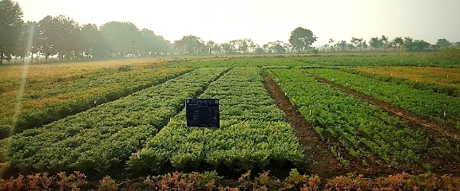
Normal sowing (D₁) Late sowing (D₂) Very late sowing (D₃) 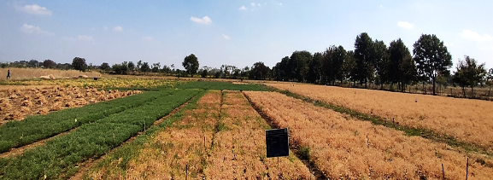
Plate 1: General view of experimental plot

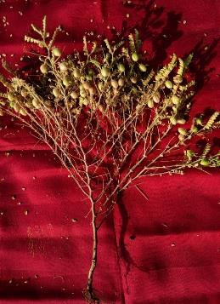 | 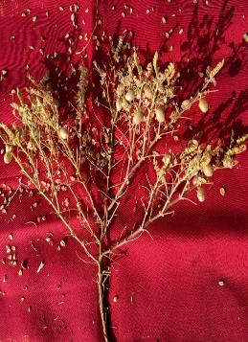
D₁T₃ : Normal sowing + Salicylic acid @ 400 ppm | D₁T₁ : Normal sowing + Control
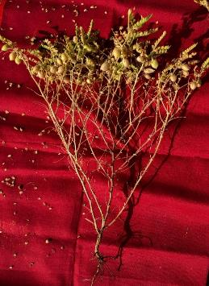 | 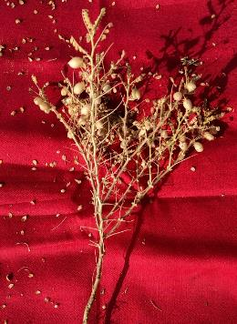
D₃T₃ : Very late sowing + Salicylic acid @ 400 ppm | D₃T₁ : Very late sowing + Control
Plate 2: Effect of dates of sowing and heat stress mitigating chemicals on number of pods/plant
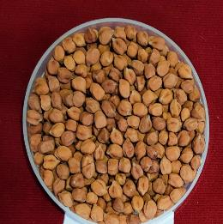 |  | 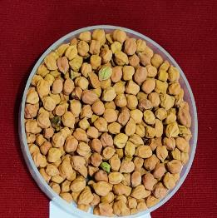
D₁T₃ : Normal sowing + Salicylic acid @ 400 ppm |  | D₁T₁ : Normal sowing + Control
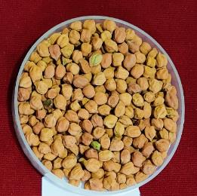 |  | 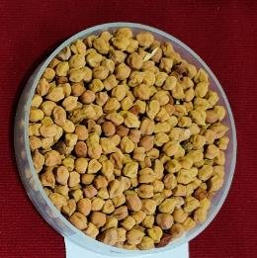
D₃T₃ : Very late sowing + Salicylic acid @ 400 ppm |  | D₃T₁ : Very late sowing + Control
Plate 3: Effect of dates of sowing and heat stress mitigating chemicals on seed weight

