Original Research Article
Effect of Different Liquid Biofertilizers on Growth, Yield and Economics of Chickpea (Cicer arietinum L.)

ABSTRACT
Though Chickpea plays a crucial role in food security providing essential nutrients, achieving optimal yields and profitability remains challenging due to nutrient deficiencies, suboptimal soil health, and the environmental impact of chemical fertilizers. Biofertilizers, which contain beneficial microorganisms like Rhizobium and phosphate-solubilizing bacteria (PSB)., etc offer a sustainable alternative by enhancing nutrient uptake and soil fertility. Pre-sowing seed treatment with various biofertilizers has shown promise in improving chickpea productivity by boosting growth and development. This study has shown that dual inoculation with Rhizobium and phosphate-solubilizing bacteria (PSB) enhanced crop growth thereby, increasing seed yield per plant followed by an inoculation with just PSB and then Rhizobium culture. This resulted in a grain yield boost of 15.27 – 18.16% whereas a net monetary return of ₹85376.5 ha⁻¹ when the control treatment only gave ₹69675 ha⁻¹ reducing the dependency on the chemical fertilizers, contributing to a more sustainable agricultural practice.
Keywords: Liquid Biofertilizers, Chickpea, Seed inoculation, Net monetary returns
INTRODUCTION
Chickpea (Cicer arietinum L.) not only plays a crucial role in food security but also serves as a key protein source in vegetarian diets. It also adds to the economic status of the country as it accounts for almost about 50% of the country’s pulse production. Despite its economic and ecological significance, chickpea productivity remains suboptimal due to various biotic, abiotic, and nutritional constraints (Balai K. et al., 2017; Ngangom B. et al., 2016). Yield levels are adversely by poor soil fertility, imbalanced use of chemical fertilizers, and declining soil health, which in turn influence the expression of yield-related traits and quality characteristics such as seed protein content, seed weight, and micronutrient density (Ngangom B. et al., 2016, Karande V. et al., 2025; Balai K. et al., 2017). The quest for sustainable and resource-efficient strategies to enhance chickpea yield and quality has thus gained momentum, particularly in the context of climate variability and increasing food demands (Nahusenay G. et al., 2024; Kajal et al., 2024).
In recent decades, biofertilizers have emerged as a promising alternative to conventional chemical fertilizers in legume-based cropping systems (Ngangom B. et al., 2016; Singh R.K. et al., 2024). Biofertilizers, defined as formulations containing living micro-organisms such as Rhizobium, Phosphate-Solubilizing Bacteria (PSB), Potassium-Solubilizing Bacteria (KSB) and others, facilitate nutrient availability, enhance plant growth, and improve soil fertility through nitrogen fixation, phosphate solubilization, and other synergistic mechanisms (Ngangom B. et al., 2016; Verma G. et al., 2019; Durge S.U. et al., 2024).
Comprehensive meta-analyses and recent field trials show that integrated application of biofertilizers significantly increases the number of pods per plant (up to 73% vs. control) and grain yield (up to 52% higher than control), with corresponding increases in grain weight, protein content, harvest index, and seed nutrient density (Nabati J. et al., 2025, Nahusenay G. et al., 2024 and Sharma A. et al., 2024).
Seed inoculation is the most common and effective practice for applying biofertilizers in crop cultivation. The process typically involves coating seeds with cultures of Rhizobium, PSB, or mixed biofertilizer consortia using adhesive such as gum Arabic or jaggery solution to encourage adherence and microbial viability (Mahto R.K. et al., 2025). For optimal results, biofertilizer treatments in chickpea should be integrated with recommended chemical fertilizer doses (RDF), organic amendments (e.g., farm yard manure, vermicompost), and precision agronomic management (Sharma A. et al., 2024 and Mahto R.K. et al., 2025).
Hence, this study was performed with the objective of studying the effect of seed inoculation with biofertilizers on the yield and economic benefits of chickpea,

MATERIALS AND METHODS:
The experiment was conducted at the Student Instructional Farm (SIF), Chandra Shekhar Azad University of Agriculture, Technology and Sciences, Kanpur, Uttar Pradesh. Geographically, The SIF was located at altitude of approximately 126 meters above the mean sea level, located within the geographical coordinates of 26.490N latitude and 80.310E longitude. The mean annual rainfall is about 816 mm. The region experiences a subtropical climate characterized by hot summers, a monsoon season and mild winters. The research farm soils are generally classified as alluvial, with texture varying from sandy loam to clay loam, having a pH range of 7.8 to 8.1, and moderately fertility status. The chickpea variety KGD 1168 was subjected to a randomized block design with three replications and in ten treatments of which T₀ was control, T₁₀ was Thiram (State recommended package of practices) and all others inoculated with various biofertilizers alone and in consortia. Each of the doses of the biofertilizers used and details of the experiment are specified in the table 1.
Table 1: Details of Treatments and layout of experiment
S. No. | Symbol | Description of Treatments
1 | T₁ | Control (No Spray)
2 | T₂ | Rhizobium culture @ 20 ml/kg Seed
3 | T₃ | EM (Effective Microorganisms) Culture@ 20 ml/kg Seed
4 | T₄ | PSB (Phosphate Solubilizing Bacteria) @ 20 ml/kg Seed
5 | T₅ | KSB (Potassium Solubilizing Bacteria) @ 20ml/kg Seed
6 | T₆ | Azospirillum @ 20ml/kg Seed
7 | T₇ | Pseudomonas @ 20ml/kg Seed
8 | T₈ | Rhizobium + PSB @ 20 ml/kg Seed
9 | T₉ | Rhizobium + KSB @ 20ml/kg Seed
10 | T₁₀ | Thiram @ 1.5 gm/kg Seed
The crop was sown during consecutive Rabi seasons; 2023-24 and 2024-25. After shade drying, the treated seeds were sown as per the technical programme. For better growth of the crop, all recommended agronomic packages of practices were applied. The roughing operation as done at different vegetative stages. The recommended dose of fertilizers @20:40:40 kg/ N:P:K (Half as basal dose at the time of sowing and other half as top dressing) was applied uniformly to all the plots. Appropriate and timely irrigation and intercultural operations were also taken care of during the 35 DAS and 60 DAS. Various yield and its attributing characters were studied at various stages along with the other economic parameters which include:
- Physiological parameters: The characters of the crop at the maturity stage that were observed for the purpose of the study were Field emergence, Days to 50% flowering, Days to maturity, Number of primary branches per plant, Number of secondary branches per plant, Leaf area index, Chlorophyll intensity, Plant height, Number of pods per branch, Number of pods per plant, Seed yield per plant, Seed yield per plot, Seed yield per hectare, Biological yield per plant, Harvest Index.
- Economic Parameters: The economic factors that were recorded for the study include:
- Gross returns: Gross monetary returns were calculated by multiplying the seed yield per hectare by the prevailing market price of the produce, expressed in ₹ ha⁻¹.
- Net monetary return: Net monetary returns were obtained by deducting the total cost of cultivation from gross monetary returns to evaluate economic feasibility, i.e. Net returns = Gross returns – Cost of cultivation
- Benefit to cost ratio: The benefit-cost ratio was calculated to assess the profitability of each treatment following the formula:
$$B:C=\frac{Net monetary return( ₹ {ha}^{-1})}{Total cost of cultivation ( ₹{ ha}^{-1})}$$
A ratio greater than one indicates economic viability of the treatment.
All of the observations are analysed by Analysis of Variance (ANOVA) and the significance of the overall differences among the treatments was determined by using the 'f test. Conclusion was drawn at 5 per cent probability level.
RESULTS AND DISCUSSION:
- Effect on crop and growth characters
Seed inoculation with biofertilizers resulted in notable improvements in various crop growth parameters. While field emergence rates showed limited variation across treatments, the combination of Rhizobium and PSB (T₈) consistently exhibited the highest emergence rate of 97.83%, followed by PSB alone (T₄) at 96.38% and Rhizobium (T₂) at 95.31%. The untreated control (T₁) had the lowest emergence rate at 92%, which was consistent across both years, with the Thiram treatment (T₁₀) slightly higher at 92.47%. Additionally, the T8 treatment significantly delayed both flowering and maturity, reaching 124 and 157 days respectively, with PSB (T₄) showing similar but slightly reduced durations. This delay was strongly correlated between days to 50% flowering and days to maturity, indicating that biofertilizer application extends the vegetative growth period, thereby lengthening the overall crop cycle. In terms of vegetative growth, plants treated with the Rhizobium + PSB consortium (T₈) achieved significantly greater height (72.91 cm), along with higher numbers of primary and secondary branches per plant (7.85 and 9.55 respectively) compared to the control (T₁), which recorded the lowest values. The PSB treatment also performed comparably to T₈ for these traits.
Moreover, T₈ yielded the highest number of pods per branch and total pods per plant, recording an average of 155.49 pods, surpassing PSB (148.07) and the control (105.57), highlighting a substantial increase in reproductive output. The positive relationship between branch number and pod formation was evident, as more branches provided additional nodes for pod development.
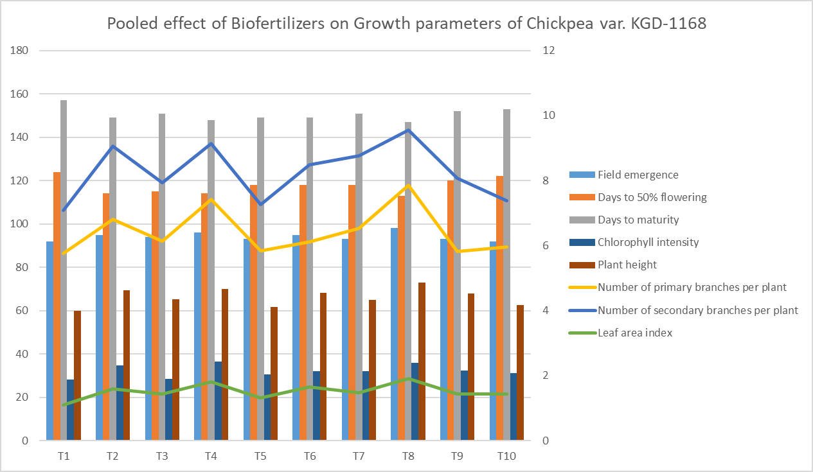
These improvements in plant growth and yield components are attributable to the enhanced availability and uptake of essential nutrients like nitrogen and phosphorus facilitated by biofertilizer inoculation. This enriched nutrient status promotes vegetative vigor, leading to higher branching and pod production, culminating in increased yield.
Figure: 1: Pooled effect of Biofertilizers on Growth parameters of Chickpea var. KGD-1168

Table 2: Crop growth characters of chickpea as influenced by seed inoculation with different biofertilizers

Parameters | Field emergence | Days to 50% flowering | Days to maturity | Number of primary branches per plant | Number of secondary branches per plant | Leaf area index | Chlorophyll intensity | Plant height | Number of pods per branch | Number of pods per plant
Treatments
Control (T₁) | 92 | 124 | 157 | 5.76 | 7.08 | 1.10 | 28.07 | 59.87 | 21.74 | 105.57
Rhizobium culture (T₂) | 95 | 114 | 149 | 6.80 | 9.06 | 1.59 | 34.70 | 69.34 | 26.37 | 146.23
EM Culture (T₃) | 94 | 115 | 151 | 6.14 | 7.94 | 1.43 | 28.61 | 65.21 | 22.78 | 125.13
PSB (T₄) | 96 | 114 | 148 | 7.42 | 9.14 | 1.81 | 36.38 | 69.92 | 30.10 | 148.07
KSB (T₅) | 93 | 118 | 149 | 5.85 | 7.27 | 1.31 | 30.55 | 61.66 | 26.73 | 113.34
Azospirillum (T₆) | 95 | 118 | 149 | 6.11 | 8.49 | 1.66 | 32.17 | 68.14 | 27.72 | 132.54
Pseudomonas (T₇) | 93 | 118 | 151 | 6.53 | 8.77 | 1.47 | 32.09 | 64.83 | 25.06 | 132.99
Rhizobium + PSB (T₈) | 98 | 113 | 147 | 7.85 | 9.55 | 1.91 | 36.00 | 72.91 | 31.01 | 155.49
Rhizobium + KSB (T₉) | 93 | 120 | 152 | 5.82 | 8.08 | 1.44 | 32.28 | 67.98 | 23.94 | 123.54
Thiram (T₁₀) | 92 | 122 | 153 | 5.96 | 7.39 | 1.43 | 31.17 | 62.63 | 24.40 | 111.66
Mean | 94 | 118 | 151 | 6.42 | 8.28 | 1.51 | 32.20 | 66.25 | 25.99 | 129.46
SE(m) | 1.12 | 1.78 | 1.24 | 0.23 | 0.26 | 0.04 | 0.70 | 1.57 | 0.68 | 4.08
CD 5% | 3.33 | 5.30 | 3.70 | 0.67 | 0.78 | 0.12 | 2.09 | 4.67 | 2.03 | 12.11
Interaction (Y×T) | NS | NS | NS | NS | NS | NS | NS | NS | NS | NS

In case of biofertilizers, the biofertilizer inoculation enhanced the nitrogen, phosphorus and all other major nutrient for enhanced vegetative growth and thus the increased plant height, number of primary and secondary branches, number of pods per plant and finally, the yield. Similar results were also reported by Rabieyan et al., 2011; Alotaibi et al., 2024 in Barley; Kant et al., 2024 in Urdbean; Sharma A. et al., 2024 and Nabati et al., 2025.
- Effect on and yield and Harvest Index
The combined application of Rhizobium and phosphate-solubilizing bacteria (PSB) significantly enhanced chickpea yield components compared to individual treatments and controls. The highest biological yield per plant was obtained with the Rhizobium + PSB consortium (T₈) at 99.58 g, surpassing PSB alone (T₄) at 95.58 g, while the untreated control (T₁) exhibited the lowest yield at 69.67 g - a difference of approximately 30 g. Thiram treatment (T₁₀) followed closely behind the control at 74 g. The elevated biomass in T₈ was corroborated by enhanced physiological attributes, including a leaf area index of 1.91 and chlorophyll content of 36.00, underscoring improved nutrient assimilation efficiency.
Similarly, seed yield per plant was highest in T₈ (44.42 g), with T₄ showing comparable performance (42.39 g). The control recorded the lowest seed yield at 29.31 g, amounting to a 51% reduction relative to T₈. These differences were statistically significant, with a critical difference (CD) of 4.86 g affirming the superiority of the combined inoculum. Seed yield correlated positively with biological yield and harvest index, the latter measuring the allocation efficiency of biomass towards seed production. T₈ achieved a harvest index of 46.65%, notably higher than PSB (44.78%) and control (38.95%), reflecting superior partitioning efficiency. At the plot scale, T₈ produced the maximum seed yield (2753.83 g), outperforming PSB (2627.97 g) and Rhizobium alone (2617.84 g). The control recorded the lowest yield (1806.47 g), with Thiram slightly higher (1892.32 g). The seed yield per hectare averaged 2268.06 kg, with T₈ achieving the highest value, indicating enhanced agronomic efficiency and economic return.
Enhanced nitrogen fixation by Rhizobium, coupled with improved phosphorus availability via PSB, likely facilitated superior nutrient uptake and photosynthetic efficiency, promoting robust plant growth and yield enhancement. This parameter is strongly correlated with Seed Yield per Plant, and is the core factor driving the Net Monetary Return and Benefit-Cost Ratio, indicating the highest return on investment. These results align with previous studies that emphasize the synergistic effects of biofertilizer consortia in improving yield attributes and resource use efficiency. Provenance in literature from Pramanik and Behra (2012); Nazo and Singh M.P. (2023); Kant et al., 2024 in Urdbean; Nabati et al., 2025; and Sharma et al., 2024 substantiates the pivotal role of combined biofertilizer inoculation in optimizing chickpea productivity.
Table 3: Yield attributes of chickpea as influenced by seed inoculation with different biofertilizers
Parameters | Seed yield per plant (g) | Seed yield per plot (g) | Seed yield per Hectare (Kg) | Biological yield per plant | Harvest Index
Treatments
Control (T₁) | 29.31 | 1806.47 | 1838.91 | 70.84 | 38.95
Rhizobium culture (T₂) | 42.22 | 2617.85 | 2680.66 | 94.78 | 42.63
EM Culture (T₃) | 35.33 | 2268.74 | 2219.00 | 90.90 | 38.98
PSB (T₄) | 42.39 | 2611.31 | 2591.10 | 95.33 | 44.78
KSB (T₅) | 30.58 | 2202.59 | 2178.48 | 86.38 | 42.01
Azospirillum (T₆) | 36.32 | 2396.08 | 2388.63 | 92.57 | 42.14
Pseudomonas (T₇) | 38.38 | 2202.59 | 2218.57 | 85.47 | 41.47
Rhizobium + PSB (T₈) | 44.42 | 2770.54 | 2647.20 | 99.40 | 46.65
Rhizobium + KSB (T₉) | 35.72 | 1902.94 | 1892.03 | 77.50 | 41.90
Thiram (T₁₀) | 30.47 | 1892.33 | 1908.79 | 74.00 | 41.35
Mean | 36.51 | 2267.14 | 2256.34 | 86.72 | 42.08
SE(m) | 1.64 | 79.70 | 85.67 | 4.10 | 0.77
CD 5% | 4.86 | 236.81 | 254.53 | 12.18 | 2.30
Interaction (Y×T) | NS | NS | NS | NS | NS

- Effect on Economics
Seed bio-priming significantly influenced key economic parameters, including gross returns, net monetary returns, and the benefit-cost (B:C) ratio. These economic gains were largely driven by improvements in seed and biological yields resulting from biofertilizer inoculation. Among all treatments, the combined Rhizobium + PSB inoculation (T₈) yielded the highest net monetary return of ₹86,083.90, closely followed by PSB alone (T₄) at ₹83,449.45. The untreated control (T₁) produced the lowest net return of ₹69,739.35. Correspondingly, the highest B:C ratio was observed in T₈ (2.86), which was not statistically different from T₄ (2.79), but significantly exceeded those of other treatments, highlighting the economic viability of biofertilizer application. These findings corroborate earlier reports by Thenua et al., (2010); Deva et al., (2018) in Rice; Kumari K. et al., (2020); Sarkar et al., (2021) in Wheat; Kant et al., (2024) in Urdbean; Bam et al., (2022), and Sharma A. et al., (2024), who documented enhanced economic profitability linked to biofertilizer use in pulse and legume cultivation. Both studies attributed the increased returns to the cumulative effects of improved nutrient uptake, higher biomass accumulation, and consequent yield enhancement, underscoring biofertilizers as an effective strategy for sustainable intensification and financial returns in crop production.
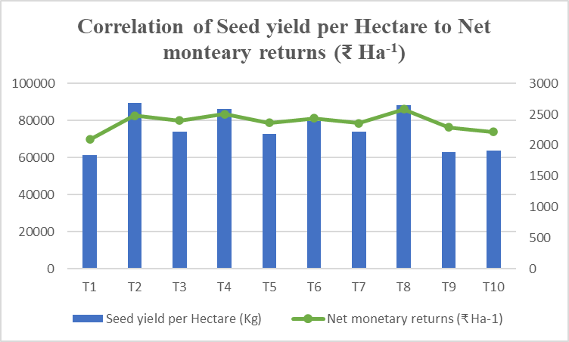
Table 4: Economics (₹ Ha⁻¹) of chickpea as influenced by seed inoculation with different biofertilizers
Parameters | Net monetary returns (₹ Ha⁻¹) | Benefit cost ratio
Treatments | Net monetary returns (₹ Ha⁻¹) | Benefit cost ratio
Control (T₁) | 69739.36 | 2.37
Rhizobium culture (T₂) | 82649.98 | 2.76
EM Culture (T₃) | 80066.65 | 2.72
PSB (T₄) | 83449.45 | 2.79
KSB (T₅) | 78694.83 | 2.68
Azospirillum (T₆) | 81124.68 | 2.65
Pseudomonas (T₇) | 78639.05 | 2.59
Rhizobium + PSB (T₈) | 86083.90 | 2.86
Rhizobium + KSB (T₉) | 76313.76 | 2.75
Thiram (T₁₀) | 73796.15 | 2.49
Mean | 79055.78 | 2.66
SE(m) | 1850.42 | 0.06
CD 5% | 5497.87 | 0.17
Interaction (YxT) | NS | NS
Figure 2: Bar chart depicting trendline between Net monetary returns (₹ Ha⁻¹) and Seed yield per Hectare
CONCLUSION:
Different biofertilizer seed priming influenced significant effects on all the growth and economic traits. Amongst all of the seed treatments, combined inoculation of Rhizobium and PSB has shown maximum growth, seed yield and harvest index along with the net returns and B:C ratio and control treatment being the least. The economic analysis also revealed substantial net returns and a favourable benefit-cost ratio, making biofertilizers an attractive option for farmers seeking to enhance profitability while maintaining environmental stewardship. The findings of this study provide valuable insights for developing optimized protocols for biofertilizer application in chickpea cultivation, which can be scaled up to support sustainable agriculture practices and improve food security. Future research should focus on refining these protocols under diverse agroclimatic conditions to ensure broader applicability and adoption.

References:
Alotaibi MM, Aljuaid A, Alsudays IM, Aloufi AS, AlBalawi AN, Alasmari A, Alghanem SMS, Albalawi BF, Alwutayd KM, Gharib HS, Awad-Allah MMA. Effect of Bio-Fertilizer Application on Agronomic Traits, Yield, and Nutrient Uptake of Barley (Hordeum vulgare L.) in Saline Soil. Plants (Basel). 2024 Mar 25;13(7):951.
Balai K.; Jajoria M.; Verma R.; Deewan P.; Bairwa S.K.; (2017). Nutrient content, uptake, quality of chickpea and fertility status of soil as influenced by fertilization of Phosphorus and Zinc, Journal of Pharmacognosy and Phytochemistry. 2017;6(1):392-398.
Bidyarani N.; Prasanna R.; Babu S.; Hossain F.; Saxena A.K. (2016). Enhancement of plant growth and yield in chickpea (Cicer arietinum L.) through Novel Cyanobacterial and biofilmed inoculants, Microbiological Research, Volumes 188-189,2016:97-105.
Deepranjan Sarkar, Sonam Singh, Manoj Parihar, Amitava Rakshit, Seed bio-priming with microbial inoculants: A tailored approach towards improved crop performance, nutritional security, and agricultural sustainability for smallholder farmers, Current Research in Environmental Sustainability, Volume 3, 2021, 100093.
Deva S.; Rao Ch.V.; Vinayalakshmi P.; (2019). Effect of liquid biofertilizers on yield and economics of rice, International Journal of fauna and Biological Studies. 2019;6(4):42-43.
Fatima, Z., Bano, A., Sial, R. and Aslam, M. 2008. Response of chickpea to plant growth regulators on nitrogen fixation and yield. Pakistan Journal of Botany 40(5): 2,005–2,013.
Effect of fertility levels and biofertilizers on the productivity and profitability of chickpea (Cicer arietinum).
Gaurav Verma, Deen Dayal Yadav, V K Sharma, Amit Kumar, Ramesh Kumar Singh, Pravin Kumar Upadhyay and Gaurendra Gupta, Effect of fertility levels and biofertilizers on agro-physiological performance, productivity and quality of chickpea (Cicer arietinum L.), Indian Journal of Agricultural Sciences, 2019, 89 (9): 1482–6.
Gupta, S. C.; and Seema, Sahu.; (2012). Response of chickpea to micronutrients and biofertilizers in vertisol. Legume Research, 35(3): 248-251.
https://hectar.blog/global-chickpea-market-outlook-2024-25-record-australian-production-signals-bearish-trends
https://www.reportlinker.com/dataset/46365a620c469d9b1699cbd03c2e33b7bdc62586
Jain, L. K.; Singh, P.; and Balyan, J. K.; (2006). Productivity and profitability of chickpea (Cicer arietinum L.) cultivation as influenced by biofertilizers and phosphorus fertilization. Indian Journal of Dryland Agricultural Research and Development, 21(2): 201-203.
Kajal, P. K. Sharma, Arjun Lal Prajapat, Mahaveer Prasad Ola*, Ramesh Chand Choudhary and Garima, Optimizing Fertilizer and Biofertilizer Levels for Enhanced Chickpea (Cicer arietinum L.) Growth and Yield, Chemical Science Review and Letters, 2024, 11 (41), 152-156.
Khan, M. S.; Zaidi, A.; Wani, P. A.; (2007). Role of phosphate-solubilizing microorganisms in sustainable agriculture a review, Agronomy for Sustainable Development.27(1): 29–43.
Kumar S.; Kumar A.; Kumar S.; Kumar V.; Pal Y.; Shukla A.K.; (2016). Effect of Rhizobium, PSB and P-levels on Growth, Yield attributes and Yield of Urdmean (Vigna mungo L.), Journal of Pure & Applied Microbiology. 2016;10(4):3093-3098.
Kumari K.; Poonia S.; Purushottam; Tomar A.; Kumar R.; Dhyani B.P.; Kumari S.; (2020). Effect of Phosphorus Solubilizing Bacteria and Rhizobium on Growth and Yield of Legume plants (Vigna radiata L. and Vigna mungo L.), International Journal of Current Microbiology and Applied Sciences. 2020; 9(11):332-341.
Mahto Rohit Kumar, B. S. Chandana, Singh Rajesh Kumar, Kumar Arun, Kumar Sudhir, Yadav Renu, Dey Debashish, Hamwieh Aladdin, Kumar Rajendra. Symbiotic nitrogen fixation for sustainable chickpea yield and prospects for genome editing in changing climatic situations, Frontiers in Plant Science; 16 – 2025.
Nabati, J., Nezami, A., Yousefi, A. et al. Biofertilizers containing plant growth promoting rhizobacteria enhance nutrient uptake and improve the growth and yield of chickpea plants in an arid environment. Scientific Reports 15, 8331 (2025).
Nahusenay G, Wolde G, Tena W, Tamiru T. Chickpea (Cicer arietinum L.) growth, nodulation, and yield as affected by varieties, Mesorhizobium strains, and NPSB fertilizer in Southern Ethiopia. Frontiers in Plant Science. 2024 Apr 24;15:1372082.
Rajendra Bam, Sharoj Raj Mishra, Subodh Khanal, Prakash Ghimire, Suman Bhattarai, Effect of biofertilizers and nutrient sources on the performance of mungbean at Rupandehi, Nepal, Journal of Agriculture and Food Research, Volume 10, 2022, 100404.
Sakshi U Durge, Geetanjali A Kamble, ST Ingle, Seeta P Gavali and DB Patel, Effect of bioinoculants on growth promoting attributes and yield of chickpea, International Journal of Advanced Biochemistry Research 2024; SP-8(10): 493-497.
Sharma A.; Bochalya R.S.; Choudhary K.; Devi R.; Dhatwalia R.K.; Kumar R.; Meenakshi. (2024). Effect of different fertility levels and bio-fertilizers on growth, yield and economics of chickpea (Cicer arietinum L.) in mid hills of Himachal Pradesh, International Journal of Research in Agronomy, 2023; SP-7(9):170-173.
Singh R.K., Singh S.R.K., Tripathi Uttam, Shrivastava Varsha, Kantwa C.R., Kumar Sushil (2024). Biofertilizer and Inorganic Fertilizers Effect on Favorable Characters for Productivity of Chickpea in Bundelkhand of Madhya Pradesh. Legume Research. 47(5): 850-854.
Vishal Karande, JS Bisen, Devendra Turkar, Navneet Satankar. Impact of organic and bio-fertilizers on growth and yield of chickpea (Cier arietinum L.). International Journal of Research in Agronomy. 2025;8(6S):19-22.

