Whitefly associated plant viral diseases and their interactions

Abstract:
Plant-infecting viruses must have an efficient means to move from one plant host to another. There are more than 2000 virus species and those affecting plants include viruses of at least 21 families and 8 unassigned genera, many of which cause important diseases of various plants that humans grow for food and/or fibre. The study aims to investigate Whitefly-associated plant viral diseases and their interactions. Viruses that manage to pass through the gut into the haemolymph and then to the salivary glands are known as persistent. There are two sub-classes of persistent viruses: propagative and circulative. Schematic representation illustrating putative modes of interaction of ipomoviral virions with putative receptors located in the whitefly maxillary stylet. Four possible scenarios are suggested including, virion binding through dimer or monomer, formed by the virus-encoded P1b protein, formed by the virus-encoded P1 protein, direct binding of the virion to the putative whitefly receptors located on the cuticle lining the maxillary stylet.

- Introduction
There are more than 2000 virus species and those affecting plants include viruses of at least 21 families and 8 unassigned genera, many of which cause important diseases of various plants that humans grow for food and/or fiber (Hull, 2014). In addition, many plant viruses have been found associated with non-cultivated plants and new plant viruses are being discovered every day. Virus diseases make up 47% of the new emerging diseases affecting plants (Anderson et al., 2004). Thus, plant infecting viruses are very successful.
In order to survive, plant-infecting viruses must have an efficient means to move from one plant host to another. To do so, the great majority of plant viruses utilize specific vectors to ensure their ability to move from one plant to another, and to ensure their survival, plant viruses encode for specific proteins that facilitate this process (Kritzman et al., 2002; Moreno et al., 2012; Moritz et al., 2004).
Although there are different types of plant-associated organisms including fungi, nematodes and various types of invertebrates that serve as vectors for different plant viruses, the majority of plant viruses utilize specific plant feeding insects as their primary vector (s), and here we focus on insect-transmitted plant viruses. Proteins encoded by different plant viruses have been identified to specifically interact with their respective insect vectors and facilitate virus transmission (Ammar et al., 2009; Hogenhout et al., 2008; Ng and Falk, 2006).
In particular, geminiviruses may constitute a family of plant viruses who are in the process of acquiring, or loosing abilities to interact actively with their insect vector, the whitefly Bemisia tabaci, to a point reminiscent of a host-pathogen relationship. This assumption is particularly pertinent when examining the relationship between B. tabaci and begomoviruses.
(Henryk and Murad, 2012).
Whiteflies transmit begomoviruses in a persistent, circulative manner, criniviruses, ipomoviruses, and torradoviruses in a semi-persistent manner, and carlaviruses in a non-persistent manner. Over the past few decades, the spread of whiteflies has significantly contributed to the dissemination of whitefly-borne plant viruses. Notable whitefly-borne viruses, including tomato yellow leaf curl virus, African cassava mosaic virus, cotton leaf curl Multan virus, and tomato chlorosis virus, have become major disease agents worldwide. Shi-Xing Zhao et al., 2025.
- Insect vectors for plant viruses:
- Insect vectors of plant viruses are found in 7 orders of the class Insecta.
- The majority of vectors are found in the two orders of insects with pierce-sucking mouthparts. (Anna, et al., 2015).
Hemiptera (300)
Thysanoptera (6).
- Other vector species are found in five orders of chewing insects:
Coleoptera (30)
Orthoptera (10),
Lepidoptera (4),
Diptera (2)
Dermaptera (1)

- Taxonomic Position of Whitefly
Kingdom : Animalia
Phylum : Arthropoda
Class : Insecta
Order : Hemiptera
Family : Aleyrodidae
Genus : Bemisia
Species : tabaci
The whitefly was first reported in Greece (David, 2002).
4) Whitefly species:
1) Greenhouse whitefly - Trialeurodes vaporariorum
2) Silverleaf whitefly - Bemisia argentifolii
3) Sweet potato whitefly - Bemisia tabaci
4) Bandedwing whitefly - Trialeurodes abutilonea
5) Spiralling white fly - Aleurodicus dispersu

- There are 3 important species. About 114 viruses are transmitted by these 3 spp.
Sweet potato whitefly- Bemisia tabaci -108 viruses
Greenhouse whitefly- Trialeurodes vaporariorum -3 viruses
Bandedwing whitefly- Trialeurodes abutilonea -3 viruses
Most plant viruses depend on vectors for their survival and spread. Most vectors are piercing-sucking insects that transmit plant viruses.
- whitefly-transmitted virus species,
90% belong to the Begomovirus genus,
6% to the Crinivirus genus
4% are in the Closterovirus, Ipomovirus or Carlavirus genera.
- Other named, whitefly-transmitted viruses that have not yet been ranked as species are also documented (David, 2002).

- Mode of transmission of viruses by whitefly:
- Viruses that manage to pass through the gut into the haemolymph and then to the salivary glands are known as persistent. There are two sub-classes of persistent viruses: propagative and circulative.
- Propagative viruses are characterized by replication and systemic invasion of vector insect tissues prior to transmission via salivary glands.
- Propagative viruses are able to replicate in both the plant and the insect (and may have originally been insect viruses), whereas circulative cannot.
- Begomoviruses have single-stranded DNA genomes and are circulative, persistently transmitted plant viruses.
- Semi-persistent viral transmission involves the virus entering the foregut of the insect.
- Crinivirus, Ipomovirus, Carlavirus and Torradovirus have singlestranded RNA genomes and are non-circulative viruses, thus, whiteflies remain viruliferous only by continuous uptake of the virus from the plant sap.
Circulative Transmission: Begomoviruses
- These viruses are single stranded closed circular DNA.
- Many begomoviruses have a bipartite genome: this means that the genome is segmented into two segments (referred to as DNA A and DNA B) that are packaged into separate particles.
- Both segments are generally required for successful symptomatic infection in a host cell but DNA B is dependent for its replication upon DNA A.
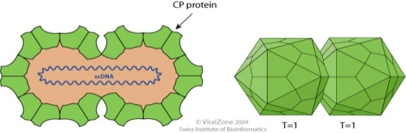
Movement of begomovirus in different parts of whitefly
oesophagus with in 10 Min

Midgut after 40 min

They cross the filter chamber and the midgut area into the haemolymph after 90 min

Translocate into the primary salivary glands (PSGs) where they can be detected 4–7 h after the onset of feeding
Minimum of 8 h (latent period) require from the beginning of ingestion until virus can be transmitted to plants.
The amount of Tomato yellow leaf curl virus(TYLCV) accumulating in individual 4–7 day-old adult B. tabaci, B or Q biotypes, during continuous feeding on infected tomato plants reaches a limit after 12–48 h, not exceeding about 600 million viral genomes.
Amazingly, this amount remains nearly constant while the insects continue to feed on infected plants, and they have the potential to ingest about 600 million viruses every 24 h, implying mechanisms controlling the viral amounts in the insect. (Wen-Qiang Xia et al., 2018).

- Model of begomovirus trafficking in epithelial cells of whitefly midgut.

Following clathrin-mediated endocytosis, begomoviruses are first delivered to early endosomes after clathrin-mediated endocytosis, then transported directly to the basal membrane of midgut epithelial cells. The fusion between virus-containing endocytic vesicles and early endosomes is mediated by Rab5 and the CORVET complex. Then, some of the viral particles may be transported to the basal membrane by tubular vesicles induced by Snx12. Whether some viral particles are transported to lysosomes remains uncertain (Fig. 1).

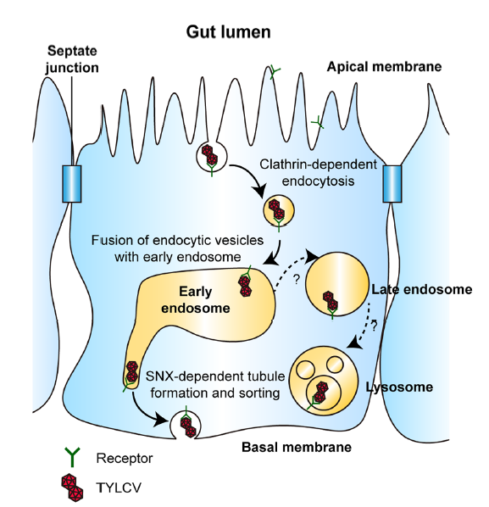
Fig 1: Begomovirus trafficking in epithelial cells of whitefly midgut.

Persistent circulative transmission pathway for begomoviruses (red colour particles) acquired and transmitted by whitefly (B. tabaci) vector (Fig. 2). After acquisition, viruses reach to the gut via food canal where viruses interact with hsp (heat shock proteins), which help the virions in crossing gut epithelia to reach the haemolymph, where virus particles interact with GroEL protein (light blue colour) secreted by primary symbiotic bacteria in the bacteriocytes (bc). After that, virions enter into the salivary glands (Sg) and transmit to the host plants through salivary secretion during feeding. Secondary symbiotic bacteria (dark blue) present in most of the body cavity of insects and influence virus-vector interactions. (Priyanka and Sangeeta 2017).

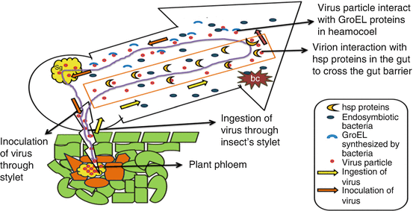
Fig 2: Interaction of virus particles with different proteins in heamocoel.

Non circulative transmission:
- Genus: Crinivirus
Family: Closteroviridae
- Viruses with a linear, positive-stranded ssRNA genome that is up to 20 kb and encapsidated in very long and flexuous particles.
- Bipartite genomes that add up to 7,500–19,500 nucleotides in length.
- The genome of criniviruses is composed of two molecules that are independently encapsidated. RNA-1 encodes proteins involved in replication, and RNA-2 (and RNA-3) encodes proteins involved in viral encapsidation, movement, and vector transmission.
- Two different genera transmitting criniviruses.
Bemisia (B. tabaci)
Trialeurodes (T. vaporariorum and T. abutiloneus).

Table 1: Whitefly transmission specificity of criniviruses:

Whitefly Vector | diseases
Banded wing whitefly (T. abutilonea) | Abutilon yellows virus(AYV)  Lettuce chlorosis virus (LCV)  Tomato chlorosis virus (ToCV)
Greenhouse whitefly (T. vaporariorum) | Beet pseudo yellows virus (BPYV)  Strawberry pallidosis associated virus (SPaV) Tomato chlorosis virus (ToCV)  Tomato infectious chlorosis virus (TICV)
Silverleaf whitefly (B. tabaci biotype B) | Cucurbit yellow stunting disorder virus (CYSDV)  Sweet potato sunken vein virus (SPSVV) Tomato chlorosis virus (ToCV)
Sweet potato whitefly (B. tabaci biotype A) | Lettuce infectious yellows virus (LIYV)  Tomato chlorosis virus (ToCV)

- Genus: Ipomovirus
Family: Potyviridae
- Ipomovirus are non-enveloped, with flexuous and filamentous geometries.
- The diameter is around 12-15 nm, and may have a variety of lengths depending on the species (200-300 nanometers (nm): 500-600 nm: 650-900 nm).
- The capsid has helical symmetry with a pitch of 3.4 nm. They induce characteristic inclusion bodies (pinwheels) within infected plant cells
Diseases transmitted by Ipomovirus
Cassava brown streak virus (CBSV)
Cucumber vein yellowing virus (CVYV)
Squash vein yellowing virus (SqVYV)
Sweet potato mild mottle virus (SPMMV)

- Genus:Carlavirus
Family: Betaflexiviridae
- The virions are non enveloped, filamentous, 610–700 nanometers (nm) and 12–15 nm in diameter.
- The linear 5.8–9 kilobase genome is positive sense, single-stranded RNA.
- The 3’ terminus is polyadenylated. In some species the 5’ end is capped.
- The genome encodes 3 to 6 proteins including a coat protein located at the 3' end and an RNA-dependent RNA polymerase located at the 5' end of the genome.
Diseases transmitted by carlavirus
Cowpea mild mottle virus (CpMMV)
Melon yellowing-associated virus (MYaV)

- Genus:Torradovirus
Family: Secoviridae
- Non-enveloped, about 30 nm in diameter, T=pseudo3 icosahedral capsid. Genome segments are encapsidated separately into two different types of particle similar in size.
Tomato torrado virus (ToTV)
Tomato chocolate virus (ToChV)
Tomato necrotic dwarf virus (ToNDV)

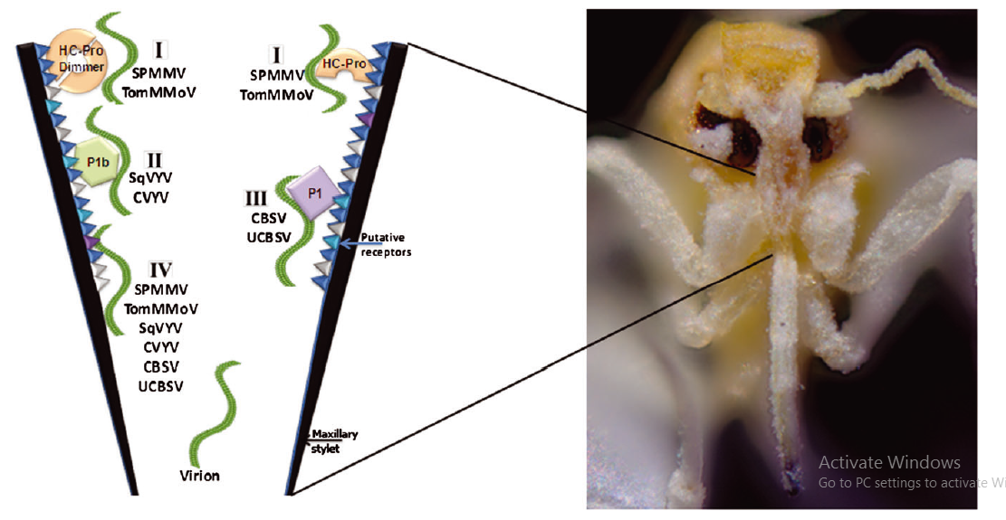
Fig 3. Non circulative transmission of different viruses
Schematic representation illustrating putative modes of interaction of ipomoviral virions with putative receptors located in the whitefly maxillary stylet (Fig- 3). Four possible scenarios are suggested: (I) virion binding through a virus-encoded HC-Pro ‘bridge’ dimer or monomer [relevant to Sweet potato mild mottle virus (SPMMV) and Tomato mild mottle virus (TomMMoV)]; (II) virion binding through a ‘bridge’ formed by the virus-encoded P1b protein [relevant to Squash vein yellowing virus (SqVYV) and Cucumber vein yellowing virus (CVYV)]; (III) virion binding through a ‘bridge’ formed by the virus-encoded P1 protein [relevant to Cassava brown streak virus (CBSV) and Ugandan cassava brown streak virus (UCBSV)]; (IV) direct binding of the virion to the putative whitefly receptors located on the cuticle lining the maxillary stylet. This option is relevant for all of the described ipomoviruses. Dombrovsky et al., 2014.

References:

Ammar, el-D., Tsai, C.W., Whitfield, A.E., Redinbaugh, M.G and Hogenhout, S.A., 2009. Cellular and molecular aspects of rhabdovirus interactions with insect and plant hosts. Annual Review of Entomology.54,447–468.
Anderson, P.K., Cunningham, A.A., Patel, N.G., Morales, F.J., Epstein, P.R and Daszak, P., 2004. Emerging infectious diseases of plants: pathogen pollution, climate change and agro technology drivers. Trends Ecol.Evol.19,535–544.
Anna, E.W., Bryce, W., Dorith, R. 2015. Insect vector-mediated transmission of plant viruses. Virology. 479-480: pp. 278–289.
David, R.J. 2002. Plant Viruses Transmitted by Whiteflies: European Journal of Plant Pathology.
Dombrovsky, A., Reingold, V and Antignus, Y. 2014. Ipomovirus – an atypical genus in the family Potyviridae transmitted by whiteflies Pest Management Science ; 70: 1553–1567
Henryk, C and Murad, G. 2012. Back to Basics: Are Begomoviruses Whitefly Pathogens. Journal of Integrative Agriculture. 2012, 11(2): 225-234.
Hogenhout, S.A., Ammar,el-D., Whitfield, A.E., Redinbaugh,M.G., 2008. Insect vector interactions with persistently transmitted viruses. Annual Review Phytopathology.46, 327–359.
Hull, R., 2014. Matthew's Plant Virology. Academic Press, USA p. 1056.
Kritzman, A., Gera, A., Raccah, B., van Lent, J.W and Peters, D., 2002.Theroute of tomato spotted wilt virus inside the thrips body in relation to transmission efficiency. Archives of Virology.147, 2143–2156.
Moreno, A., Tjallingii, W.F., Fernandez-Mata, G and Fereres, A., 2012. Differences in the mechanism of inoculation between a semi-persistent and anon-persistent aphid-transmitted plantvirus. Journal General Virology. 93,662–667.
Moritz, G., Kumm, S and Mound, L., 2004. Tospovirus transmission depends on thrips ontogeny. Virus Research.100,143–149.
Ng, J.C and Falk, B.W., 2006. Virus–vector interactions mediating non-persistent and semi-persistent transmission of plant viruses. Annual Review of Phytopathology.44,183–212.
Priyanka, V and Sangeeta, S. 2017. Transmission of Begomoviruses. Asia and Africa. 51-69.
Shi-Xing Zhao, Su-Dan Wang, Yin-Quan Liu, Li-Long Pan 2025. Modulation of Plant Interactions with Whitefly and Whitefly-Borne Viruses by Salicylic Acid Signaling Pathway: A Review. Viruses. 7;17(6):825.
Wen-Qiang Xia et al., 2018. Intracellular trafficking of begomoviruses in the midgut cells of their insect vector. PLOS. Pathogens. Pp. 1-25.

