Incidence and Severity of Pod Sucking Bugs on Pigeon Pea in Farmer Fields of Telangana State

ABSTRACT
A survey was conducted in two major pigeonpea growing districts of Telangana viz., Warangal and Vikarabad at flowering stage and pod formation stage of the crop during kharif, 2024. In Telangana, four species of pod sucking bugs viz., Clavigrallagibbosa, Riptortuspedestris, Nezaraviridula and Anoplocnemissppwere diagnosed for infesting pigeonpea crop at all the surveyed locations. The maximum incidence of pod sucking bugs was recorded at the pod formation to maturation stage of the crop. The maximum incidence of Clavigrallagibbosawas recorded during pod formation stage and ranged from 0.80 to 2.25 egg masses, 5.97 to 7.35 nymphs and 4 to 5.45 adults per plant, and also maximum incidence of Riptortuspedestris was recorded during pod formation stage and ranged from 0.20 to 0.51 egg masses, 0.35 to 1.90 nymphs and 0.98 to 2.24 adults per plant, The maximum incidence of Nezaraviridulaand Anoplocnemisspp were recorded during pod formation stage and ranged from 0.04 to 0.07 egg masses, 0.13 to 0.16 nymphs and 0.49 to 0.50 adults per plant and 0.01 to 0.04 adults per plant, respectively.In surveyed districts, the percentage of pod damage was recorded highest in Gavicherla village (32.4%), followed by Gandhinagar (30.1%), and the least percentage of pod damage was recorded in Kodangal (7.4%), followed by Venkatapur (8.9%). In all the surveyed locations across both districts, Clavigrallagibbosa is found to be highly dominant with 78-80 per cent followed by Riptortuspedestris, Nezaraviridula, and Anoplocnemis spp.
Keywords: Incidence, Pigeonpea, Pod Sucking bugs, Roving survey, Severity.
1. INTRODUCTION
Pigeonpea (Cajanuscajan L. Millsp.) popularly known as tur, red gram or arhar, is one of the major pulse crop of the tropics and subtropics endowed with several unique characteristics. It is the fourth most important pulse crop grown in the world and also the second most important pulse crop of India after chickpea (Sunilkumaret al., 2024). It is the most versatile legume crop with diversified uses viz., food, feed, fodder and fuel (Anonymous, 2024). The productivity and production of pigeonpeaare hampered by biotic and abiotic causes. The most prominent biotic stress causing losses in storage and the field are insect infestations. Pigeon pea is infested by around 300 insect species from 8 orders and 61 families, from seedling to harvest and storage (Davies and Lateef, 1977). The relative economic importance of insects and diseases varies from one area to another depending upon the local agronomic practices, the environment and the cropping patterns. The pests that cause significant damage in one location (major pest status) are considered minor pests in other locations. Flower chafer beetle (Oxycetonia versicolorFabricius) on the verge of becoming a major pest on cotton in the Telangana region of India reported by (Daravathet al.,2020). Some pests are widely distributed and cause economic reduction while others are restricted in distribution and are confined to a few areas. Moreover, the pest scenario of the crops is changing year after year and more and more new pests are being added to the existing list. Heavy infestation and damage by invasive thrips species, Thripsparvispinus (Karny) first of its kind reported on chilli in Telangana state of India (Veeranna et al., 2022)
In recent years in pigeonpea, the pod sucking bug Clavigrallagibbosa has become a significant threat to quality grain production (Chakravarty et al., 2016). The pest has assumed to be causing major economic losses in early, mid early, medium and late pigeon pea cultivars. The pod bug alone recorded 25 to 40% damage in pigeon pea and also reported that pod and grain weight were reduced by as much as 27 and 30 times, respectively at a population density of 12 nymphs/plant (Adatiet al., 2007). Infestation by Clavigrallagibbosa often results in shriveled or malformed seeds, leading to significant yield losses (Nath et al.,2008). Various pod sucking bug species attack pigeon pea during its reproductive stage. The most prevalent among them include the spiny brown bug (Clavigralla spp.), riptortus bug (Riptortus spp.), green stink bug (Nezaraviridula), lablab bug (Coptosomacribaria) and giant coreid bug (Anoplocnemis spp.) (Sharma et al., 2010). Though the area and production of pigeonpea in major pigeonpea growing districts of Telangana are increasing, the prevalence of the pod sucking bugs are not documented properly. Hence, survey for the pod sucking bugs incidence, species dominance and their natural enemies in the major pigeonpea growing districts of Telangana state would help in formulating suitable management practices and the timely management of the pod bugs.

2. MATERIAL AND METHODS
To document the pod sucking bugs incidence and extent of damage caused by pod sucking bugs on pigeonpea in all the major pigeonpea growing districts of Telangana, a roving survey was conducted in Warangal and Vikarabad districts of Telangana during kharif, 2024. Three mandals of Warangal district viz., Sangem, Duggondi and Parvathagiri and three mandals of Vikarabad district viz., Tandur, Basheerabad and Kodangal were selected where highest pigeonpea cultivation. From each mandal, two villages were selected, and from each village, three fields were selected for the study area (Table1).Observations on the number of podsucking bugs per plant and percent of pod damage by different species of pod sucking bugs were recorded from five randomly selected plants from each location at both flowering and pod formation stage. Further, egg mass of pod sucking bugs from each location were collected and observations on the emergence of egg parasitoids were recorded.
Vector maps of the geographical position of location data were developed in QGIS with grid coordinates expressing latitude and longitude format. At first, the district vector map was developed denoting each surveyed district in Telangana; further, each district map was developed denoting surveyed areas (Fig. 1).
Table 1 The following locations were selected to determine the severity of pod sucking bugs on Pigeon pea in Warangal and Vikarabad district of Telangana.
S. No | District | Mandal | Village | GPS Coordinates  (Latitudes & Longitudes) | No. of fields
1 | Warangal | Sangem | Gavicherla | 17.8675° N, 79.6794° E | 3
1 | Warangal | Sangem | Gandhinagar | 17.8603° N, 79.7199° E | 3
1 | Warangal | Duggondi | Duggondi | 18.0141° N, 79.8067° E | 3
1 | Warangal | Duggondi | Venkatapur | 18.0100° N, 79.8061° E | 3
1 | Warangal | Parvathagiri | Parvathagiri | 17.7542° N, 79.7045° E | 3
1 | Warangal | Parvathagiri | Doulathnagar | 17.7554° N, 79.7596° E | 3
1 | Warangal |  |  | Total fields | 18
2 | Vikarabad | Tandur | Tandur | 17.2377° N, 77.5919° E | 3
2 | Vikarabad | Tandur | Antaram | 17.2313° N, 77.5921° E | 3
2 | Vikarabad | Basheerabad | Basheerabad | 17.2184° N, 77.4417° E | 3
2 | Vikarabad | Basheerabad | Khasimpur | 17.2078° N, 77.5182° E | 3
2 | Vikarabad | Kodangal | Kodangal | 17.1670° N, 77.5978° E | 3
2 | Vikarabad | Kodangal | Udimeswar | 17.1363° N, 77.6048° E | 3
2 | Vikarabad |  |  | Total fields | 18
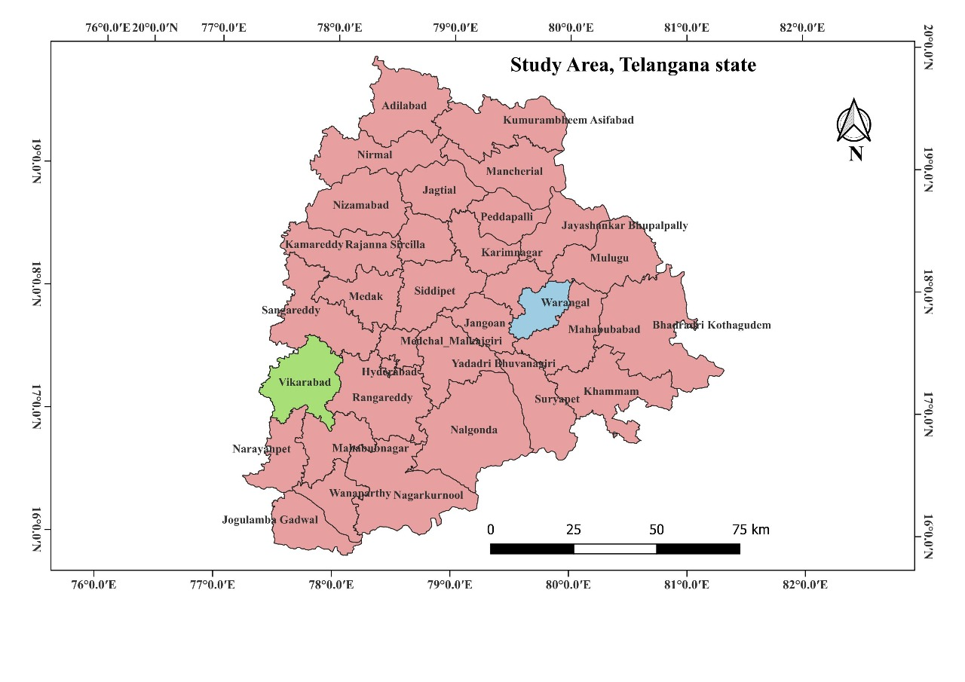
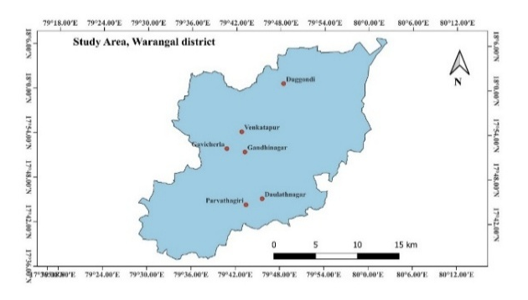Surveyed villages in the Warangal district
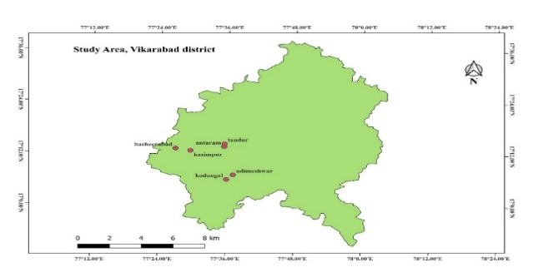
Surveyed villages in the Vikarabad district
Telangana state map indicating study area

Fig. 1. Locations of surveyed areas for the incidence of pod sucking bugs in pigeonpea in
Telangana region of India

3. RESULTS AND DISCUSSION
3.1 Incidence of pod sucking bugs on pigeonpea in Warangal district
In Warangal district, the incidence of Clavigrallagibbosa on pigeonpea revealed that high incidence was recorded in Gavicherla village of Sangem mandal (at flowering stage, 0.87 egg masses, 2.4 nymphs and 1.4 adults/ plant and at pod formation stage, 3.5 egg masses, 9.3 nymphs and 6.7 adults/ plant). The incidence of Riptortuspedestris on pigeonpea revealed that high incidencewas recorded in Gavicherla village of Sangem mandal (at flowering stage, 0.27 egg masses, 0.53 nymphs and 0.6 adults/ plant and at pod formation stage, 1.8 egg masses, 5.7 nymphs and 7.9 adults/ plant). The incidence of Nezaraviridulaon pigeonpea revealed that at the flowering stage, maximum population was recorded in Gavicherla village of Sangem mandal (no egg masses, 0.07 nymphs and 0.4 adults/ plant) and at the pod formation stage, maximum population was recorded from Gandhinagar village of Sangem mandal (0.07 egg masses, 0.27 nymphs and 0.87 adults/ plant) (significantly low population). The incidence of Anoplocnemissppon pigeonpea revealed that it is not observed at the flowering stage, but it was observed at the pod maturation stage in Gavicherla village of Sangem mandal with 0.04 adults/ plant (very negligible population)(Table 2 & Table 3). The overall mean incidence of pod sucking bugs revealed that the peak incidence was recorded during pod formation stage than flowering stage. Among all the surveyed locations of the Warangal district, maximum infestation was noticed by Clavigrallagibbosa, followed by Riptortuspedestris, Nezaraviridulaand Anoplocnemisspp(Fig. 2). But in Gavicherla village of Sangem mandalRiptortuspedestrisis found to be dominant along with Clavigrallagibbosa.
In the Warangal district, the percentage of pod damage was recorded as highest in Gavicherla village (32.4%), followed by Gandhinagar (30.1%), and the lowest percentage of pod damage was recorded in Venkatapur (8.9%), followed by Duggondi (10.7%)(Table 3).
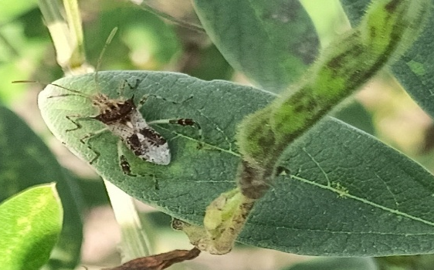  Clavigrallagibbosa | 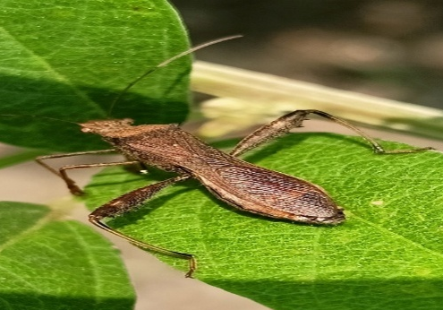  Riptortuspedestris
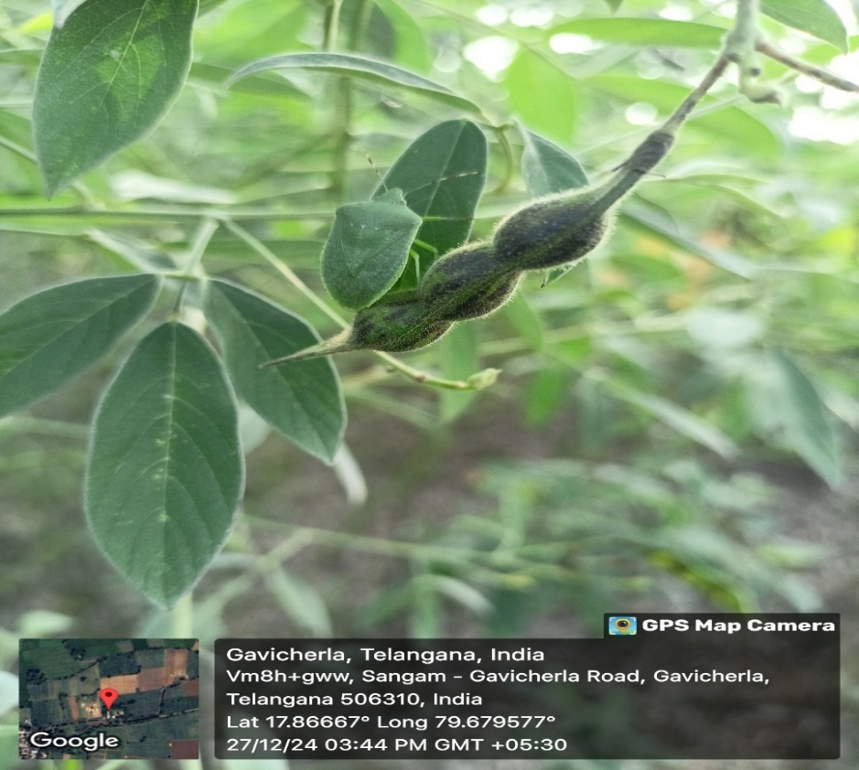  Nezaraviridula | 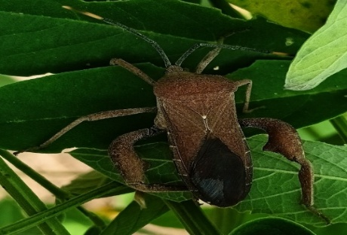  Anoplocnemisspp
Fig. 2 Different pod sucking bug species identified in farmer fields during roving survey in Waranagal and Vikarabad districts
3.2 Incidence of pod sucking bugs on pigeonpea in Vikarabad district
In Vikarabad district, the incidence of Clavigrallagibbosa on pigeonpea revealed that high incidence was recorded in Basheerabad village of Basheerabad mandal (at flowering stage, 0.6 egg masses, 0.87 nymphs and 1.53 adults/ plant and at pod formation stage 1.06 egg masses, 9.4 nymphs and 6.8 adults/ plant). The incidence of Riptortuspedestris on pigeonpea revealed that high incidencewas recorded in Basheerabad village of Basheerabad mandal (at flowering stage, 0.07 egg masses, 0.6 nymphs and 0.47 adults/ plant) and at pod formation stage, maximum population was recorded from Khasimpur village of Basheerabad mandal (0.13 egg masses, 0.8 nymphs and 1.67 adults/ plant). The incidence of Nezaraviridulaon pigeonpea revealed that at the flowering stage, maximum population was recorded in Basheerabad village of Basheerabad mandal (0.13 egg masses, 0.07 nymphs and 0.2 adults/ plant) at pod formation stage, maximum population was recorded from Antaram village of Tandur mandal (0.13 egg masses, 0.47 nymphs and 0.8 adults/ plant) (significantly low population). The incidence of Anoplocnemissppon pigeonpea revealed that it is not observed at both flowering stage and pod formation stage(Table 4).The overall mean incidence of pod sucking bugs revealed that the peak incidence was recorded during pod formation stage than flowering stage. Among all the surveyed locations of the Vikarabad district, maximum infestation was noticed by Clavigrallagibbosa, followed by Riptortuspedestris, Nezaraviridulaand Anoplocnemis spp.
In the Vikarabad district the percentage of pod damage was recorded highest in Basheerabad village (23.1%) followed by Antaram (18.8%) and the lowest percentage pod damage was recorded in Kodangal (7.4%) followed by Udimeshwar (11.1%)(Table 5).
A study was conducted to study emergence of egg parasitoids from egg mass of pod sucking bugs. Egg masses were collected from all the surveyed locations of Warangal and Vikarabad districts during the flowering and pod formation stage, and kept in the laboratory for observing the emergence of egg parasitoids, viz., Gryonclavigrallae (Hymenoptera: Scelionidae), for two months. No emergence of egg parasitoids was noticed from the collected egg masses from different locations.
Initial incidence of pod sucking bugs on pigeonpea crop in farmer fields was noticed at the vegetative stage and continued up to pod formation and pod maturation stage till harvesting. The maximum infestation found at pod formation stage in both Warangal and Vikarabad districts, it is due to lack of awareness about pod sucking bugs incidence and damage caused, no awareness on effective insecticides for controlling pod bugs, cultivating local susceptible varieties, adoption of poor management practices, high weed condition in the field and farmers are adopting management practices to control pod borers only. The present findings were in accordance with those of Kumari et al. (2023), who found that tur pod bug infestation appeared in the 32nd SMW and was maximum at the pod development stage of the crop. The bug population varied from 1.96 to 6.51, 0.72 to 6.21 and 2.07 to 6.63 bugs/plant in Mahendergarh, Rewari and Gurugram districts, respectively. These results were in accordance with Uddin et al. (2013) who reported that, green stink bugs infestation occurred at the vegetative stage, flowering stage and fruiting stages in different locations of Bangladesh, causing minor damage to the crop.
Four different species of pod sucking bugs viz., Clavigrallagibbosa, Riptortuspedestris, Nezaraviridula, Anoplocnemissppwere observed infesting pigeonpea crop at all the surveyed locations of Warangal and Vikarabad districts. Among four different species of pod sucking bugs, Clavigrallagibbosa was the dominant species and reported high incidence with 70-80%. The present findings in agreement with Minja et al. (1999) who reported the pod sucking bugs were dominated by Clavigrallatomentosicollis (Stal), damage levels of pod sucking bugs were more in Malawi (caused 69% of total seed damage) and Kenya (43%).
In both the surveyed districts, the percentage of pod damage was recorded highest in Gavicherla village (32.4%), followed by Gandhinagar (30.1%), and the least percentage of pod damage was recorded in Kodangal (7.4%), followed by Venkatapur (8.9%). Khamoriyaet al. (2017) concluded that maximum per cent grain damage by pod bugs was observed in Tikari (16.90%) followed by Tariya (16.09%), Narayanpur (16.00%) Ramna (13.55%) and minimum per cent grain damage by pod bugs was observed in Narottampur (12.30%) village.
4. CONCLUSION
In all the surveyed locations, the maximum incidence of pod sucking bugs in pigeonpea were recorded at pod formation stage than flowering stage it is due to lack of awareness among farming community about pod sucking bugs incidence and damage. Among four different species of pod sucking bugs, Clavigrallagibbosa is found to be highly dominant followed by Riptortuspedestris, Nezaraviridula, and Anoplocnemissppand these pod sucking bugs cause up to 32.4 % pod damage in surveyed locations.
COMPETING INTERESTS DISCLAIMER:
Authors have declared that they have no known competing financial interests OR non-financial interests OR personal relationships that could have appeared to influence the work reported in this paper.

REFERENCES
- Sunilkumar, N.M., Kamthane, J., Mallikarjun, N., Bulla, G., Goudappa, S.B., Rayudu, B.T. et al. (2024).Transplanting in redgram for resource effective crop production to unleash the potential yield. Indian Farming, 74(3), 80-84.
- Anonymous. (2024). Available online: https://www.dpd.gov.in/Annual%20Report%20%202023-24%2014.01.2025.pdf.
- Davies J.C. and Lateef S.S. (1977). Pulse Entomology. Annual Report Part-A Pigeon pea Entomology, ICRISAT, Hyderabad (AP), India.
- Daravath, V., Kasbe, S.S. and Musapuri, S. (2020). Flower chafer beetle (Oxycetonia versicolor Fabricius) on the verge of becoming a major pest on cotton in Telangana region of India: a first report. Journal of Entomology and Zoology Studies,8, 242-246.
- Veeranna, D., Reddy, R.U., Moguloju, M. and Padmaja, G. (2022). Report on heavy infestation and damage by invasive thrips species, Thripsparvispinus (Karny) on chilli in Telangana state of India. The Pharma Innovation Journal, 11(7),3845-3848.
- Chakravarty, S., Agnihotri, M., Kumar, L. and Ahmad, M.A. (2016). Influence of weather parameters on natural egg parasitization of pod bug, ClavigrallagibbosaSpinola (Hemiptera: Coreidae) on pigeon pea. The Bioscan, 11(3), 1759-1763.
- Adati, T. Tamo, M. Yusuf, S.R., Downham, M.C.A., Singh, B.B. and Hammond, W. (2007). Integrated pest management for cowpea cereal cropping systems in the West African savannah. International Journal Tropical Insect Science, 27(1), 123-137.
- Nath, P., Singh, R.S., Keval, R. and Singh, P.S. (2008). Effect of intercropping and application of biopesticides on the pod and grain damage by pod borer complex in pigeon pea.Journal of Applied Zoological Research, 19, 111-19.
- Sharma, O.P., Gopali, J.B., Yelshetty, S., Bambawale, O.M., Garg, D.K. and Bhosle, B.B. (2010). Pests of pigeon pea and their management, NCIPM, LBS building. New Delhi: IARI.
- Singh NK, Thakur A, Srivastava OP. (2008). Evaluation of certain newer insecticides against insect pest complex on pigeon pea (Cajanuscajan (L.) Millsp.). Journal of Applied Zoological Researches, 19(1), 46-49.
- Kumari, S., Singh, B. and Dumra, N. (2023). To survey the incidence of insect-pests of pulses in South-West Haryana. The Pharma Innovation Journal, 12(9), 432-437.
- Uddin, M.S., Rahman, M.M., Alam, M.Z., Awal, A. and Mazed, M.A. (2013). Insect pests of yard long bean (Vignaunguiculatasubsp. Sesquipedalis L.) in major growing areas of Bangladesh. The Agriculturists, 11(2), 66-73.
- Minja, E.M., Shanower, T.G., Songa, J.M., Ongaro, J.M., Kawonga, W.T., Mviha, P.J.,et al.1999. Studies of pigeonpea insect pests and their management in Kenya, Malawi, Tanzania and Uganda. African Crop Science Journal, 7(1), 59-69.
- Khamoriya, J., Keval, R., Chakravarty, S. and Mishra, V.K. (2017). Survey of the farmers’ fields for studying the extent of damage caused by major insect pests on long duration pigeon pea in different villages of Varanasi region. Journal of Experimental Zoology India, 20(2), 1071-1073.

Table 2. Incidence of pod sucking bugs on pigeonpea in Warangal district during flowering stage.
Mandal | Village | Variety | No.ofClavigrallagibbosa/ Plant |  |  | No.ofRiptortuspedestris/ Plant |  |  | No.ofNezaraviridula / Plant
Mandal | Village | Variety | E M | N | A | E M | N | A | E M | N | A
Sangem | Gavicherla | Local varieties, WRG 97 (Warangal Kandi),Local varieties | 0.87 | 0.24 | 1.4 | 0.27 | 0.53 | 0.6 | 0 | 0.07 | 0.4
Sangem | Gandhinagar | ICPL 87119 (Asha), Local varieties | 0.2 | 0.53 | 0.2 | 0.07 | 0.4 | 0.07 | 0.07 | 0 | 0.33
Duggondi | Duggondi | WRGE 93, WRGE 121, WRG 97 (Warangal Kandi) | 0.2 | 0.27 | 0.3 | 0 | 0.2 | 0.27 | 0 | 0 | 0.2
Duggondi | Venkatapur | WRG 97 (Warangal Kandi), WRGE 93, WRG 255 | 0.13 | 0.27 | 0.1 | 0 | 0.07 | 0.07 | 0.13 | 0 | 0.13
Parvathagiri | Parvathagiri | ICPL 87119 (Asha), Local varieties, WRG 97 (Warangal Kandi) | 0.67 | 1.06 | 0.4 | 0.27 | 0.33 | 0.53 | 0.07 | 0.07 | 0.13
Parvathagiri | Daulath Nagar | WRGE 93, WRG 255, Local varieties | 0.34 | 0.7 | 0.8 | 0.2 | 0 | 0.46 | 0 | 0 | 0.2
 |  | MEAN | 0.40 | 1.02 | 0.53 | 0.13 | 0.25 | 0.33 | 0.04 | 0.02 | 0.23
E M= Egg masses, N= Nymphs, A=Adults
Table 3. Incidence and pod damage of pod sucking bugs on pigeonpea in Warangal district during pod stage.
Mandal | Village | Variety | No.ofClavigrallagibbosa / Plant |  |  | No.ofRiptortuspedestris / Plant |  |  | No.ofNezaraviridula / Plant |  |  | pod damage (%)
Mandal | Village | Variety | E M | N | A | E M | N | A | E M | N | A | pod damage (%)
Sangem | Gavicherla | Local varieties, ICPL 87119 (Asha), Local varieties | 3.5 | 9.3 | 6.7 | 1.8 | 5.7 | 7.9 | 0.2 | 0.27 | 0.6 | 32.4
Sangem | Gandhinagar | ICPL 87119 (Asha), Local varieties, WRGE 97 (Warangal Kandi) | 2.9 | 8.6 | 5.9 | 1.13 | 4.47 | 3.4 | 0.07 | 0.27 | 0.87 | 30.1
Duggondi | Duggondi | WRGE 93, WRGE 121, WRG 255 | 1.4 | 4.9 | 4.5 | 0.07 | 0.07 | 0.2 | 0.03 | 0 | 0.13 | 10.7
Duggondi | Venkatapur | WRGE 97 (Warangal Kandi), WRGE 93, WRGE 121 | 1.1 | 5.7 | 4.1 | 0 | 0 | 0 | 0 | 0 | 0.4 | 8.9
Parvathagiri | Parvathagiri | Local varieties, WRGE 93, WRG 255 | 2.7 | 7.7 | 5.8 | 0 | 0.33 | 0.73 | 0.07 | 0.2 | 0.27 | 16.8
Parvathagiri | Daulath Nagar | WRGE 97, Local varieties, ICPL 87119 (Asha) | 1.9 | 7.9 | 5.7 | 0.07 | 0.87 | 1.2 | 0.03 | 0.2 | 0.7 | 17.3
 |  | MEAN | 2.25 | 7.35 | 5.45 | 0.51 | 1.90 | 2.24 | 0.07 | 0.16 | 0.49 | 19.4
E M= Egg masses, N= Nymphs, A=Adults

Table 4. Incidence of pod sucking bugs on pigeonpea in Vikarabad district during flowering stage.
Mandal | Village | Variety | No.ofClavigrallagibbosa / Plant |  |  | No.ofRiptortuspedestris / Plant |  |  | No.ofNezaraviridula / Plant
Mandal | Village | Variety | E M | N | A | E M | N | A | E M | N | A
Tandur | Tandur | Local varieties, TDRG-59 (Telangana Kandi 3), BSMR 736 | 0.4 | 0.8 | 1.3 | 0.07 | 0.27 | 0.07 | 0.07 | 0 | 0.2
Tandur | Antaram | ICPL 87119 (Asha), TDRG 4, PRG-176 (Ujwala) | 0.47 | 0.93 | 1.5 | 0 | 0.13 | 0 | 0 | 0 | 0.2
Basheerabad | Basheerabad | WRGE 97 (Warangal Kandi), Local varieties, TDRG 4 | 0.6 | 0.87 | 1.5 | 0.07 | 0.6 | 0.47 | 0.13 | 0.07 | 0.2
Basheerabad | Khasimpur | ICPL 87119 (Asha), Local varieties, PRG-176 (Ujwala) | 0.47 | 0.87 | 1.1 | 0.07 | 0.07 | 0.4 | 0 | 0.07 | 0.07
Kodangal | Kodangal | TDRG-59 (Telangana Kandi 3), BSMR 736, TDRG 4 | 0.07 | 0 | 0.2 | 0 | 0 | 0.07 | 0 | 0 | 0
Kodangal | Udimeswar | PRG-176 (Ujwala), BSMR 736, WRGE 97 | 0.13 | 0 | 0.3 | 0 | 0 | 0 | 0 | 0 | 0.07
 |  | MEAN | 0.36 | 0.57 | 0.98 | 0.035 | 0.18 | 0.17 | 0.03 | 0.02 | 0.12
E M= Egg masses, N= Nymphs, A=Adults
Table 5. Incidence and pod damage of pod sucking bugs on pigeonpea in Vikarabad district during pod stage.
Mandal | Village | Variety | No.ofClavigrallagibbosa / Plant |  |  | No.ofRiptortuspedestris / Plant |  |  | No.ofNezaraviridula / Plant |  |  | pod damage (%)
Mandal | Village | Variety | E M | N | A | E M | N | A | E M | N | A | pod damage (%)
Tandur | Tandur | PRG-176 (Ujwala), Local varieties, BSMR 736 | 1.13 | 6.27 | 3.6 | 0.4 | 0.33 | 0.67 | 0.07 | 0 | 0.7 | 16.1
Tandur | Antaram | Local varieties, ICPL 87119 (Asha), WRGE 97 (Warangal Kandi) | 1 | 6.7 | 4.9 | 0.4 | 0.4 | 1.4 | 0.13 | 0.47 | 0.8 | 18.8
Basheerabad | Basheerabad | Local varieties, ICPL 87119 (Asha), TDRG 4 | 1.06 | 9.4 | 6.8 | 0.27 | 0.33 | 0.8 | 0 | 0.2 | 0.67 | 23.1
Basheerabad | Khasimpur | Local varieties, WRGE 97 (Warangal Kandi), PRG-176 (Ujwala) | 0.8 | 7.06 | 5.7 | 0.13 | 0.8 | 1.67 | 0.07 | 0.13 | 0.4 | 16.7
Kodangal | Kodangal | TDRG-59 (Telangana Kandi 3), TDRG 4 | 0.4 | 3.2 | 1.5 | 0 | 0.13 | 0.67 | 0 | 0 | 0.2 | 7.4
Kodangal | Udimeswar | BSMR 736, WRGE 97, TDRG-59 (Telangana Kandi 3) | 0.4 | 3.2 | 1.5 | 0 | 0.13 | 0.67 | 0 | 0 | 0.2 | 11.1
 |  | MEAN | 0.80 | 5.97 | 4 | 0.2 | 0.35 | 0.98 | 0.04 | 0.13 | 0.5 | 15.5
E M= Egg masses, N= Nymphs, A=Adults

